International Journal of Latest Technology in Engineering, Management & Applied Science
Online E- Journal ISSN 2278-2540 www.ijltemas.in

*Print, Manually Fill, Scan and upload through final submission system. Date: May 8, 2026__
*This is mandatory that this Declaration is signed by Authors

Author (s) Declaration
- I/We hereby state that article authored by me/us is an original contribution. It has not neither been submitted for publication nor published elsewhere in any print/electronic form. It does not infringe on the right of others and does not contain any libelous or unlawful statements.
- I/We assign all the copyright of this article to the journal wherever required I/We have taken Permission from the copyright holder and acknowledged the source.
- I / We represent that I / We have taken the consent from our University / Institution / Employer / Project Guide / Supervisor / Research Committee before publishing our article with International
Journal of Latest Technology in Engineering, Management & Applied Science (IJLTEMAS)
- I/We have not assigned copyright to publish this article to any other journal.
- I/ We fully understand the Terms and Conditions / Policies given or International Journal of Latest Technology in Engineering, Management & Applied Science (IJLTEMAS)
- Only I / We are responsible for impact / outcomes of this publication decision and I / We will not ask for refund or pursue any legal action against said personalities International Journal of Latest Technology in Engineering, Management & Applied Science (IJLTEMAS), India for the same.
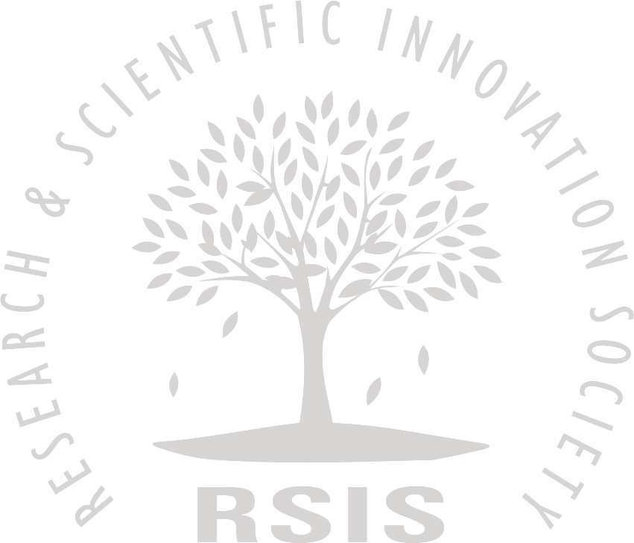
- I / We confirm that we are satisfied with Authenticity / Validity / Originality of International Journal of Latest Technology in Engineering, Management & Applied Science (IJLTEMAS) and in case of refusal of our publication by our University / Institution / Employer / Project Guide / Supervisor / Research Committee, I / We will not ask for refund or pursue any legal action against said personalities or International Journal of Latest Technology in Engineering , Management & Applied Science (IJLTEMAS), India for the same .
- In case of a paper by multi-authored article, I/corresponding author have obtained permission to enter into agreement and assign copyright from all the co -authors, in writing and all the co-authors have thoroughly read and agreed with above warranties and authorization.
- I/We permit editors to publish the article in the journal or in any other means with editorial amendment, if any to make it suitable for publication. Further, I/We hereby assign copyright to the publisher for its publication in any form/language including all media, and exclusive right to use the matter for the life of the work. Publisher may assign its rights under this Agreement.
- I / We accept that in case of any Copyright Infringement claim being filed and proven against my / our published article in future, then International Journal of Latest Technology in Engineering , Management & Applied Science (IJLTEMAS), India have complete rights to remove my / our article from the index immediately without prior notice, and I / We will not ask for refund or pursue any legal action against said personalities or International Journal of Latest Technology in Engineering , Management & Applied Science (IJLTEMAS), India for the same.
- I/We agree to indemnify the Editors/Publisher of the journal against all claims or action arising from any breach of warranty on my/our behalf in this agreement.
- I / We are aware that International Journal of Latest Technology in Engineering, Management & Applied Science (IJLTEMAS) ISSN (Online): 2278-2540 is assigned by National Science Library, New Delhi, India.
- I / We represent that I / We have taken the consent from our Co Authors before publishing our article with International Journal of Latest Technology in Engineering, Management & Applied Science (IJLTEMAS)

Name(s) of Author(s): Araja, Kaycee N., Canta, Roshelle D., Pantas, Abel A., Tisuela, Bel Patrice T.

Unique Manuscript ID (UMI) of Manuscript: N/A

Title of Paper: Exploring the Influence of Game-Based Learning Tools to the Students’ Level of Engagement in Social Studies of Humanities and Social Sciences students at Tanauan, Institute Inc.

Corresponding Author

ARAJA, KAYCEE N.

