WOMEN ENTREPRENEURSHIP IN INDIA: OBSTACLES AND OPPORTUNITIES

Abstract
Women Entrepreneurship (WE) in India has emerged as a significant contributor to economic growth and social development. This research highlights WE in India and also focuses on the challenges and opportunities faced by women entrepreneurs in India. The research discusses the current scenario of WE in India and reviews various literature to gain insights into the topic. The research incorporated the primary quantitative and secondary qualitative data collection methods to examine the perception of various groups of individuals concerning WE and also determine the challenges and opportunities faced by women entrepreneurs. The primary data is analysed using statistical analysis methods, and the secondary data is analysed using thematic analysis. The findings underscore the need for targeted interventions to empower women entrepreneurs, enabling them to overcome obstacles and leverage opportunities for sustainable growth and development. Based on these findings, the research has also provided actionable recommendations to boost women’s entrepreneurial activities in India.

Keywords: Women Entrepreneurship, India, Gender Barriers, Financial Access, Socio-Cultural Challenges, Government Initiatives, Economic Growth, Gender Equality

Table of Contents
1. Introduction 4
2. Women Entrepreneurship in India: Current Scenario 4
3. Significance of the Study 5
4. Aim and Objectives of the Study 6
5. Review of Literature 6
5.1 Overview of Women Entrepreneurs in India 6
5.2 Factors Affecting Women’s Entrepreneurial Activities 6
5.3 Government Initiatives to Boost Women’s Entrepreneurship 7
5.4 Conceptual Framework 8
5.5 Literature Gap 8
6. Methodology 8
7. Data Analysis 9
7.1 Results of Primary Analysis 9
7.2 Thematic Analysis 15
7.2.1 Challenges Faced by Women Entrepreneurs in India 15
7.2.2 Opportunities and Strengths of Women Entrepreneurs 16
7.2.3 Policy and Support Initiatives of Government to Encourage Women Entrepreneurs 16
7.2.4 Key Policy Recommendations to Encourage Women Entrepreneurship 17
8. Discussion 17
9. Conclusion 17

1. Introduction
Women Entrepreneurship (WE) can be described as the management of business operations by a woman or a group of women. Entrepreneurial activities are known to contribute to the economy's development and growth. Similarly, women’s entrepreneurship also leads to the development and growth of society. It has gained significant attention in recent years. Women contribute to half of the population; hence, they should be motivated to participate in economic activity. However, they face many challenges when participating in economic activity. This research will examine the challenges and strengths of women entrepreneurs in India. The research will also provide recommendations for various stakeholders to enhance entrepreneurial activities among women in India.

2. Women Entrepreneurship in India: Current Scenario
The start-up companies in India are ranked third-largest worldwide and are steadily growing. Women entrepreneurs play a notable role in the growth of start-up businesses in India. Due to increased educational opportunities, accessibility of capital, and supportive regulatory policies for women entrepreneurs in India are significantly growing. Women entrepreneurs are creating employment opportunities in India. According to studies, women entrepreneurs have created job opportunities for around 27 million people in the country, notably contributing to India’s growth and development. Approximately 15.7 million women-led enterprises are established in India, constituting 22 per cent of the entire entrepreneurial sector. Women entrepreneurship has led to innovation and development in technologies in the country. A few successful women entrepreneurs in India are Falguni Nayar, Kiran Mazumdar Shaw, Vandana Luthra, and Radhika Ghai Aggarwal.
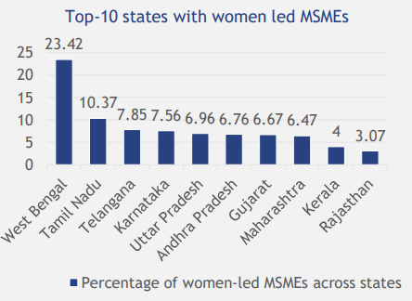
Figure 1: State-wise Women-led Entrepreneurs in India
(Source: NITI Aayog, 2022)
The figure depicts the top ten state-wise women-lend enterprises in India during the year 2022. According to the figure, West Bengal has the highest number of women-led enterprises, constituting 23.42%, whereas Sikkim has the lowest number of women-led enterprises, constituting 0.04%. Despite growth in women’s entrepreneurial activities, “Women Entrepreneurs” still face social and cultural barriers in India. The patriarchal mindset of the country and gender discrimination are some barriers for women to undertake entrepreneurial activities. These problems are more visible, particularly for women from lower-income groups and rural areas.

3. Significance of the Study
This research highlights the present scenario in the WE sector in India and the gender disparities that women restrict women from participating in economic activities. As already stated, women constitute half of the country’s population. Encouraging women to participate in entrepreneurial activities will enhance their standard of living as well as improve the country’s standard of living. This research study also highlights the opportunities and challenges faced by women entrepreneurs in India, which can help to formulate strategies and recommendations for various stakeholders such as financial institutions, government, and “Women Entrepreneurs” to enhance women’s entrepreneurial activities in India.

4. Aim and Objectives of the Study
Aim
This research study aims to examine the challenges and strengths of women’s entrepreneurial activities in India and provide actionable recommendations to enhance WE in India.
Objectives
- To identify the obstacles faced by women entrepreneurs in starting and growing their businesses in India
- To assess the opportunities for women entrepreneurs to overcome these obstacles in India
- To study the government policy recommendations to encourage women entrepreneurs
- To recommend suggestions for the advancement of WE in India

5. Review of Literature

5.1 Overview of Women Entrepreneurs in India
Women's entrepreneurship has gained attention in recent years. Entrepreneurs are a major contributor to innovation, growth, and development. Similarly, Women entrepreneurs significantly contribute toward diverse innovation, growth, and development. They enhance their standard of living as well as contribute toward the household economy and ultimately contribute to the national economy. Due to rapid digitalization and globalization, India’s entrepreneurial sector has evolved and developed, particularly the women-led entrepreneurial sector in India. Women from different backgrounds and income groups are actively participating in these activities and promoting the cultural heritage of the country through cottage industries that include handicrafts and food products. Thus, encouraging women entrepreneurs is essential for the country’s development.

5.2 Factors Affecting Women’s Entrepreneurial Activities
Several factors affect WE in India. Education and access to financial support are primary factors that affect women entrepreneurs. Apart from these factors, opportunities and risks involved in businesses, the capability of women entrepreneurs, and social capital also affect women’s perception of entrepreneurial activities. These factors motivate women to undertake economic activities. Women’s behavioural aspect also affects their entrepreneurial activities. The BIG 5 Personality model analyses the characteristics of individuals. This model helps to understand how qualities such as adaptability, openness, optimism, and cognitive feasibility affect the intentions of women to participate in entrepreneurial activities.
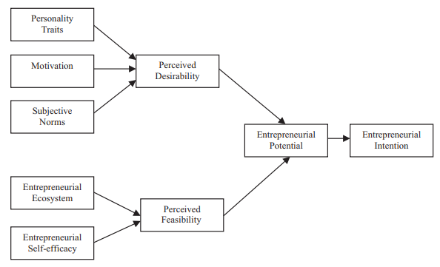
Figure 2: Elements that Impact WE
(Source: Chhabra et al. 2020)
The above image shows various factors responsible for affecting women’s intention to undertake entrepreneurial activities. According to the figure, both personal characteristics and market scenarios affect women’s entrepreneurial decisions. However, women entrepreneurs in India face severe challenges while undertaking entrepreneurial activities. Barriers to accessing finances, resource scarcity, high competition, social restrictions, and lack of management practices limit women entrepreneurs to enhance their business activities. Hence, the government and other institutions, such as financial institutions, are required to take appropriate policy measures to encourage more women to participate in economic activities.

5.3 Government Initiatives to Boost Women’s Entrepreneurship
The government of the nation has already undertaken several policies to support women entrepreneurs in India. For instance, the government has taken the initiative under which women entrepreneurs can access credit without providing collaterals. The government has taken major steps to assist micro, small, and medium-sized enterprises (MSMEs) led by women and support them in their business activities. Furthermore, the government has initiated several schemes to provide training and development to women entrepreneurs to enhance their business management practices. The government has also created marketing hubs for women to promote their businesses. Despite these initiatives, women entrepreneurs still face barriers in Indian society to participate in entrepreneurial activities.

5.4 Conceptual Framework
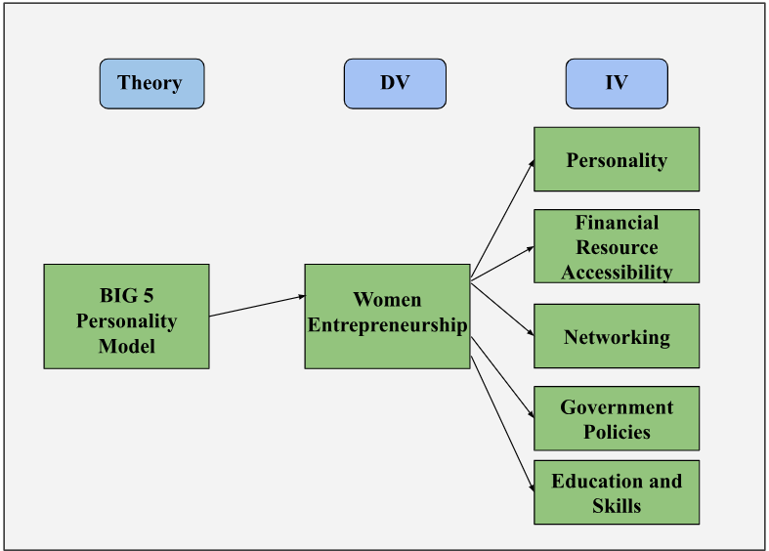
Figure 3: Conceptual Framework
(Source: Self-Developed)

5.5 Literature Gap
The existing research studies highlight the opportunities and obstacles of women entrepreneurs. However, there is a gap in the literature in terms of providing country-specific recommendations for women’s entrepreneurial activities. Stated differently, there are fewer studies providing strategies and suggestions to the government as well as women entrepreneurs to boost their entrepreneurial activities.

6. Methodology
The utilization of methodology in research helps to analyse and gain insights into the topic. This research has incorporated a Deductive Research Approach. This approach helps the research to analyse a larger population and gain insights into it. A Pragmatism Research Philosophy is used in this research. Pragmatism research philosophy is used to develop hypotheses and address social issues. The researcher has employed an Explanatory Research Design in the research. This research design helps to understand the relationship among various variables. The Mixed Method has been incorporated into the research study to collect data that includes both Primary Quantitative and Secondary Qualitative Data. The primary quantitative data is collected by surveying 51 participants. A purposive sampling method is incorporated into the research. This sampling technique helps to gain insights from various groups regarding WE in India. Women entrepreneurs, aspiring women entrepreneurs, and participants from NGOs who are working on women’s empowerment are included in the sample size of this research. The secondary qualitative data is collected from peer-reviewed journals, articles, books, and reports to understand the obstacles and opportunities of women in India. The mixed method provides a thorough knowledge of the topic. The primary quantitative data has been analysed based on the gathered responses on Google Form Pie Charts, and the secondary qualitative data is analysed through Thematic Analysis. Hence, the chosen method has helped in gaining comprehensive insights into the topic.

7. Data Analysis

7.1 Results of Primary Analysis
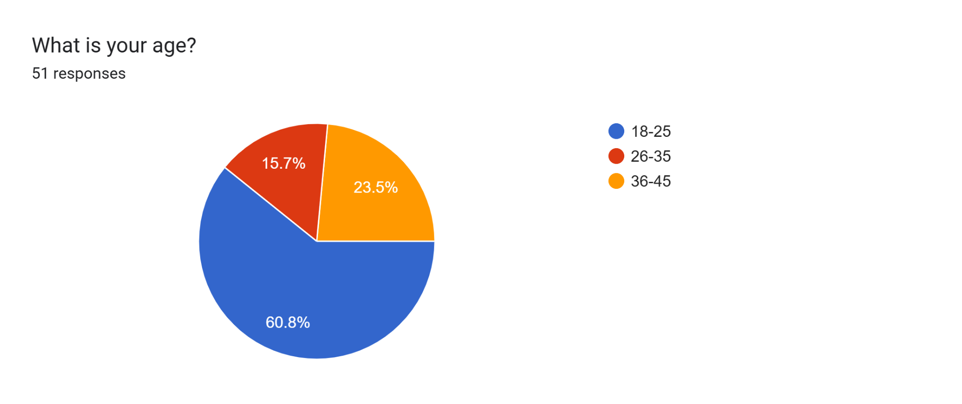
Figure 4: Age of the Participants
(Source: Google form)
It can be seen from the upper graphical representation that most of the participants that are around 60.8% of the participants belong to the 18 to 25 age group.
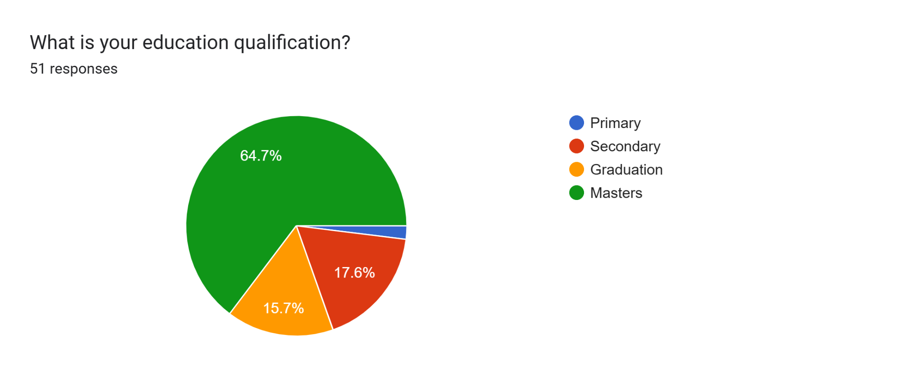
Figure 5: Education of the Participants
(Source: Google form)
The education of the participants of this study is highlighted in the upper graph. It shows that 64.7% which is the highest number of participants hold a master's degree.
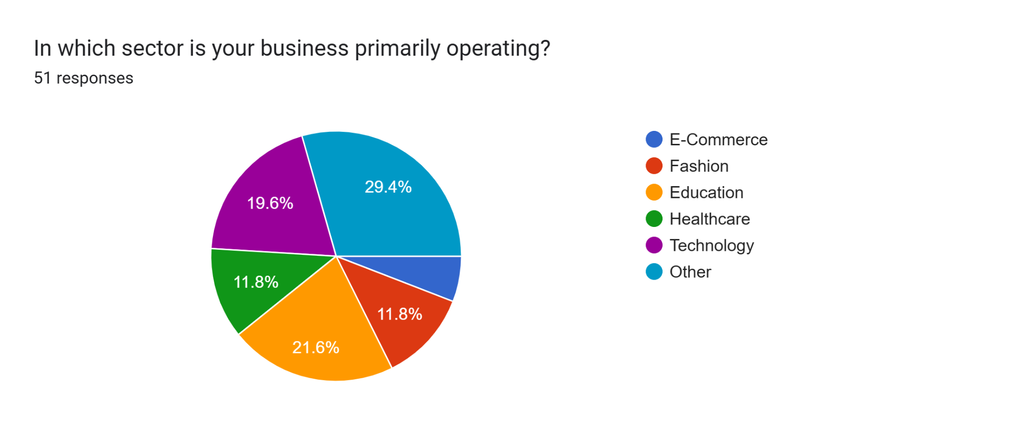
Figure 6: Sector Operating by the Participants
(Source: Google form)
The maximum participants of in this study are 21.6% and 19.6% in Education Sectors and technological sectors. 11.8% of candidates are both in the healthcare sector and fashion sectors.
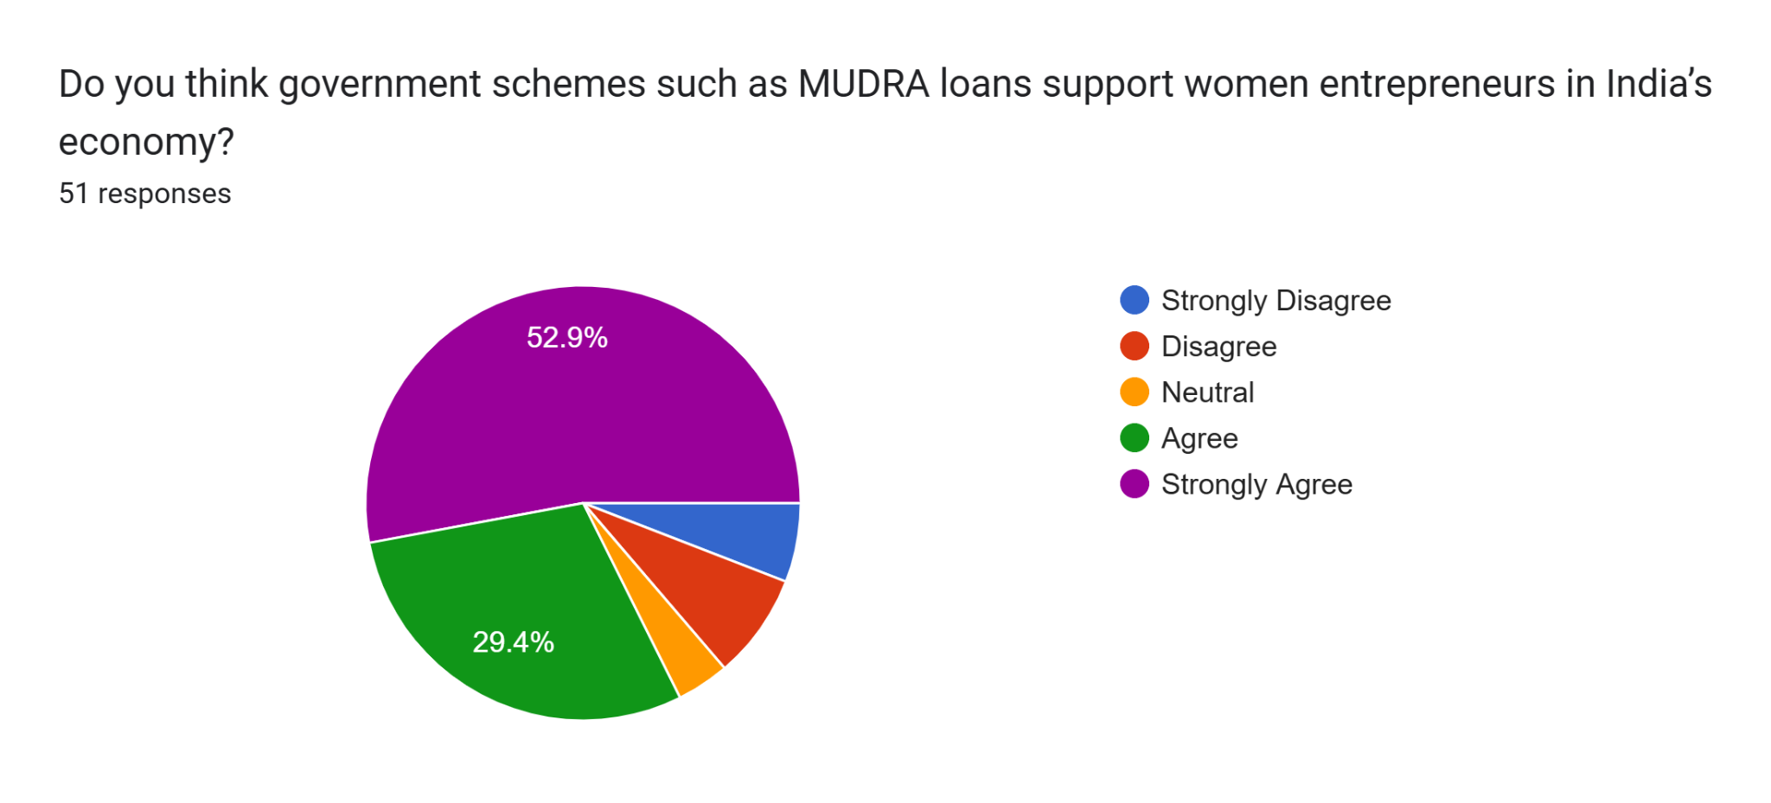
Figure 7: Government Scheme Supports Indian Women Entrepreneurs
(Source: Google form)
It can be seen that 52.9% and 29.4% of the candidates strongly agree and agree that government schemes help women entrepreneurs in India.
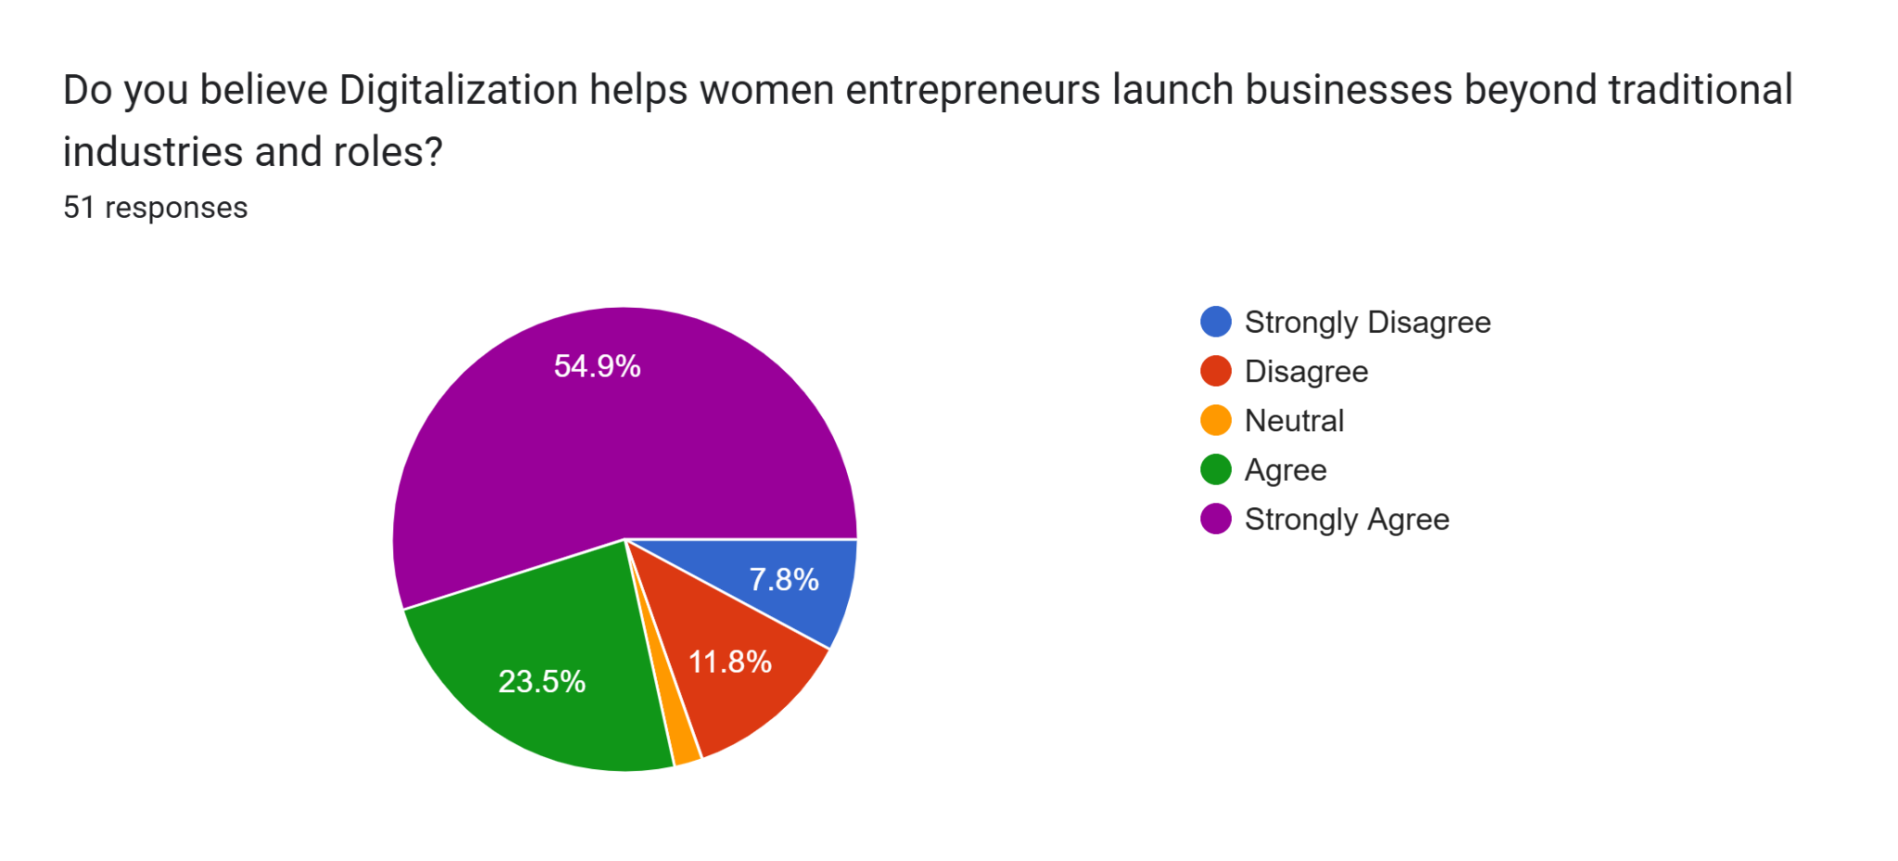
Figure 8: Digitalisation Helps Women Continue Their Business Rather Than Traditional
(Source: Google form)
Among 51 participants, most of them that is 54% of them agreed with the fact that digitalisation helps women to continue their business beyond traditional industries and roles.
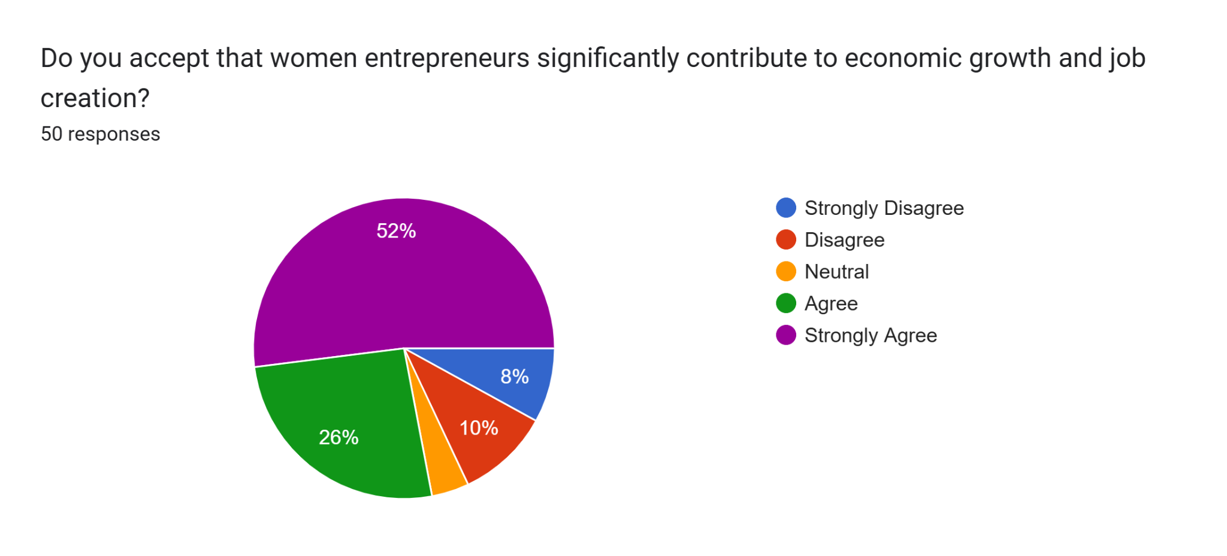
Figure 9: Women Entrepreneurs' Contribution in Economic Growth and Job Creation
(Source: Google form)
According to the upper pie chart, it shows that 52% of the candidates agreed that women entrepreneurs serve the country a economic growth and job creation.
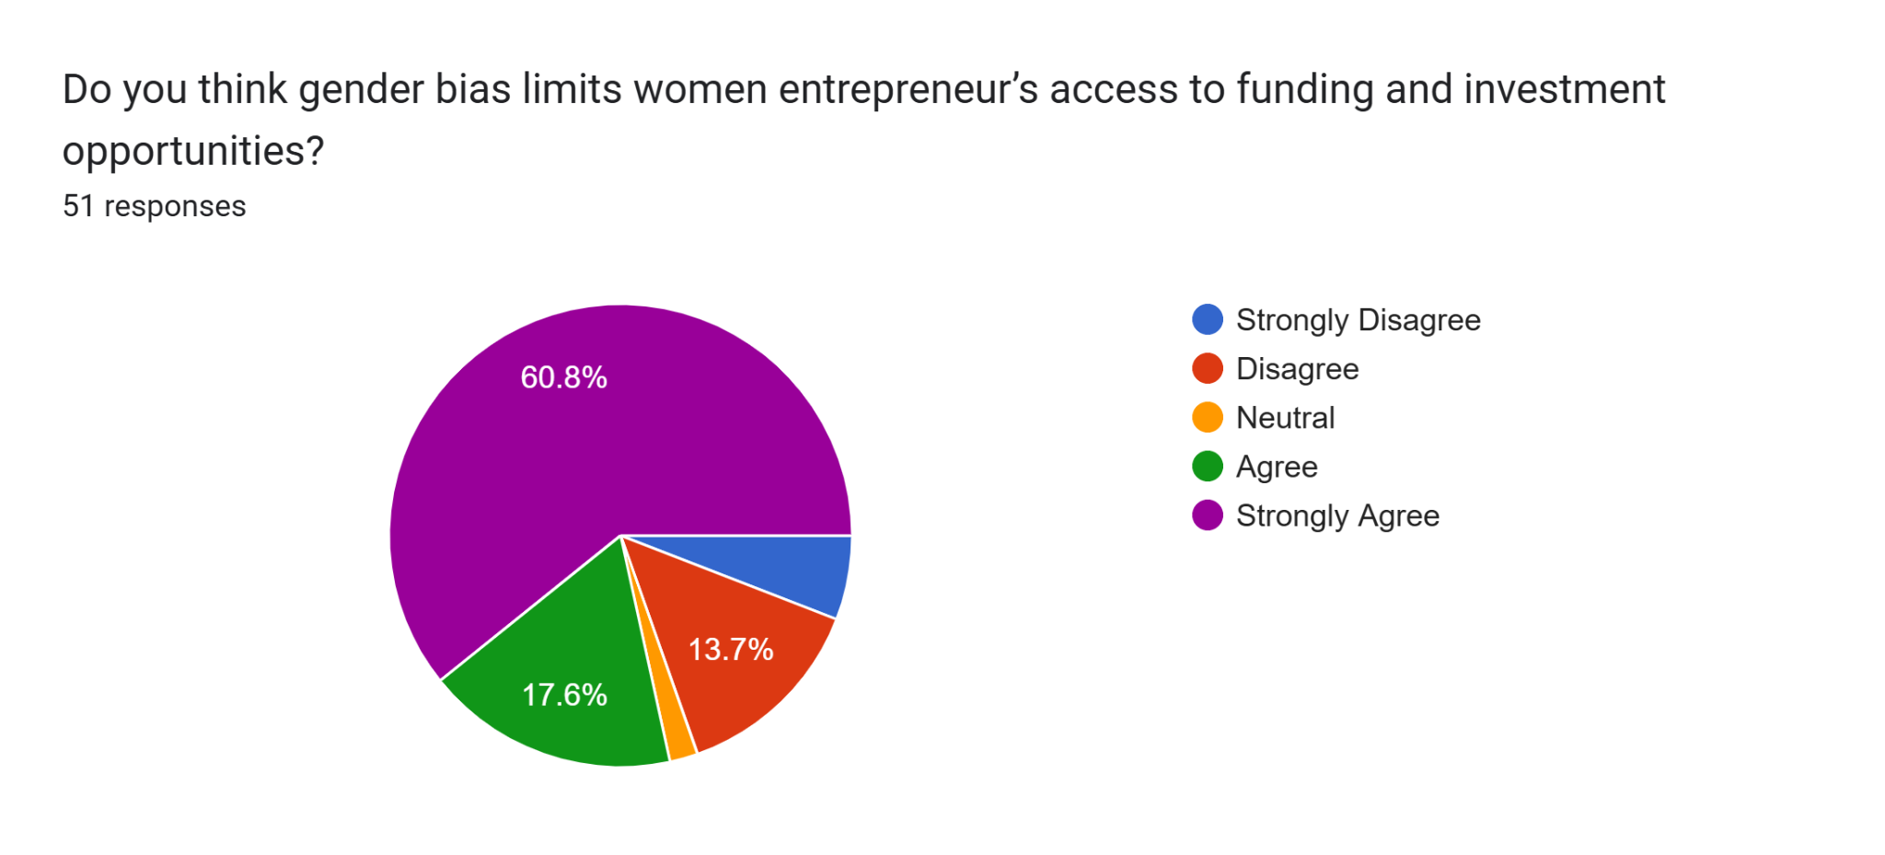
Figure 10: Gender Bias Limits to Access Funding and Investment
(Source: Google form)
Most of the participants, around 60.8% strongly agree with this statement that gender bias limits the access the women to investment and funding opportunities.
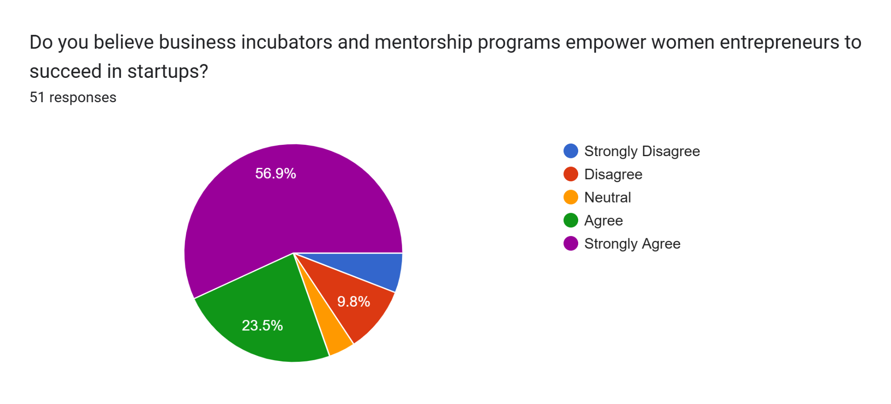
Figure 11: Mentorship Programs Empower Women Startup
(Source: Google form)
Some of the candidates that are 9.8% disagree with the fact that mentorship programs help to empower women’s business start-ups. However. A huge number of participants that is 56.9% and 23.5% Strongly agree and agree with this statement.
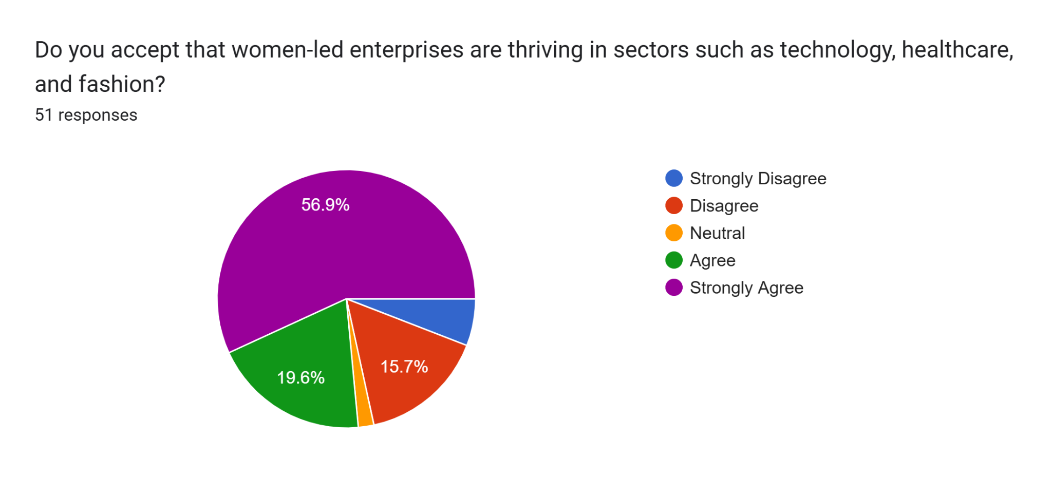
Figure 12: Women Thrive in Various Industries
(Source: Google form)
Most of the participants, 56% agree that women thrive in several sectors such as technology, healthcare and many others in India.
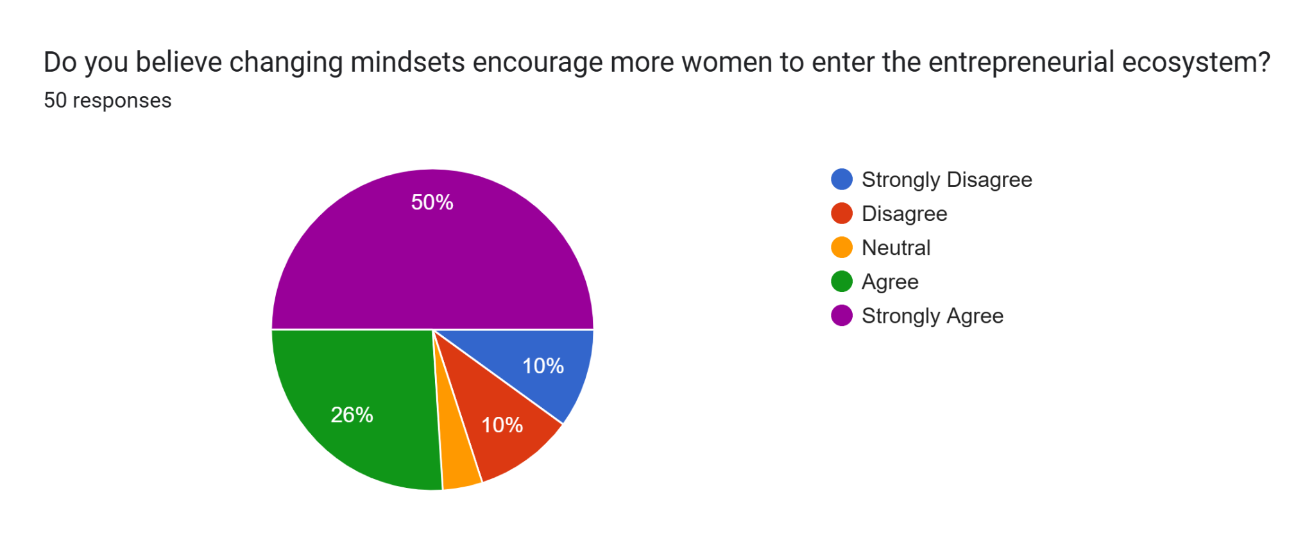
Figure 13: Changing Mindsets Encourage Women Leader
(Source: Google form)
The maximum number of participants, 50% and 26% strongly agree and agree that changing the mindset helps to encourage women leaders.
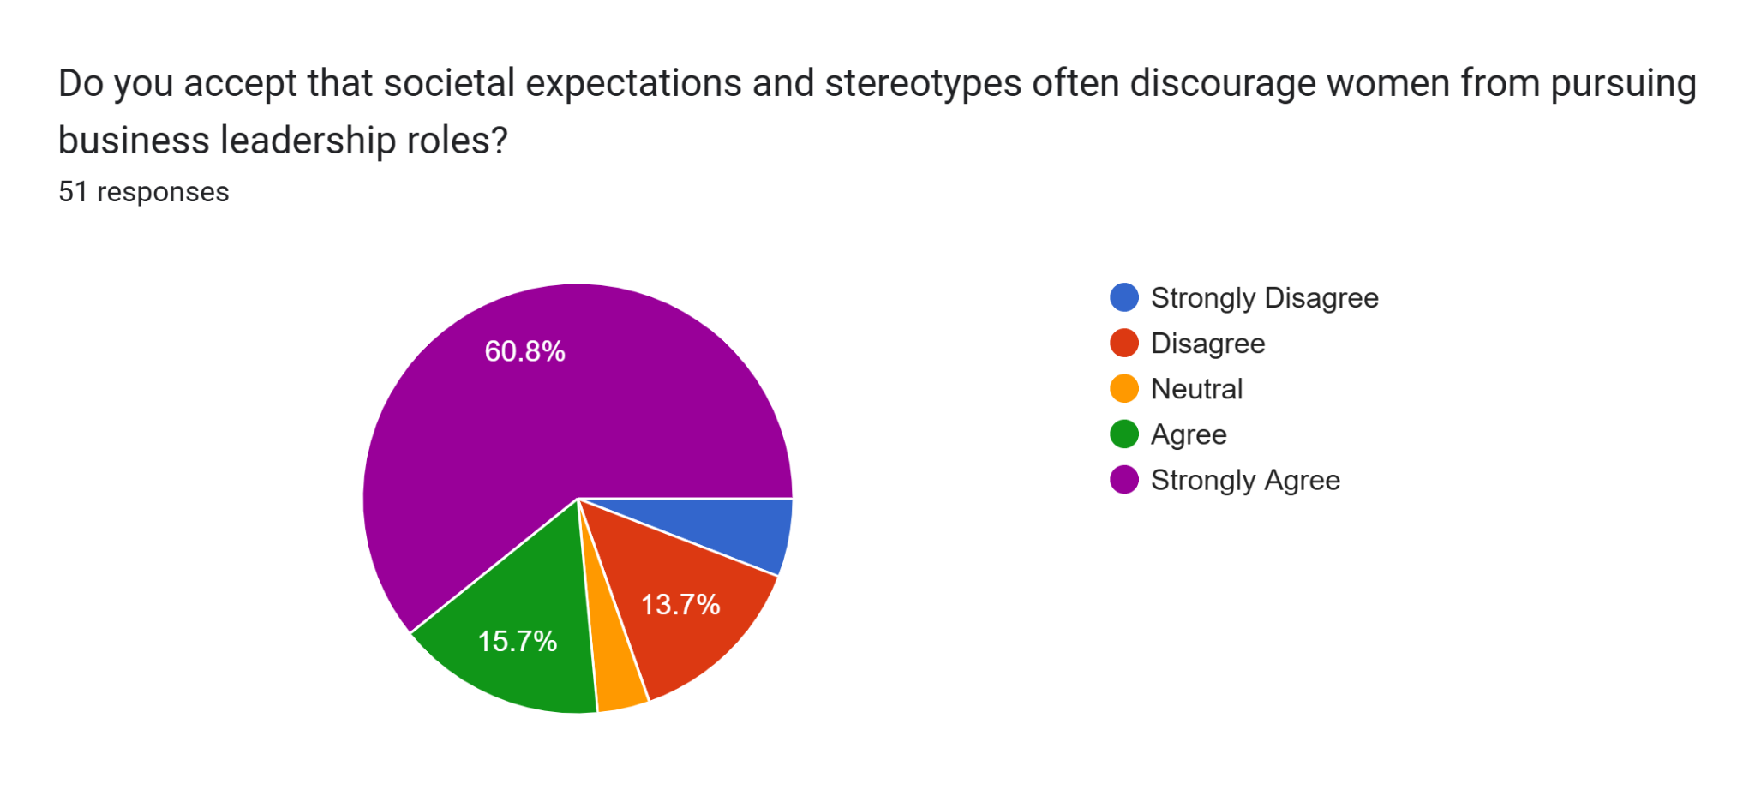
Figure 14: Societal Norms Discourage Women Leaders
(Source: Google form)
Societal Experience and the stereotypes mentality discourage women leaders and 60.8% that is most of the participants ats strongly agree with this fact.
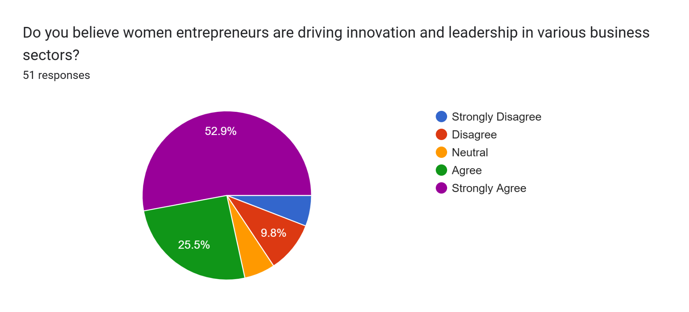
Figure 15: Women Drive Innovation and Leadership
(Source: Google form)
52.9% of the participants strongly agree that women improve innovation and leadership, especially in India.

7.2 Thematic Analysis

7.2.1 Challenges Faced by Women Entrepreneurs in India
Women in Indian society face severe barriers in sociocultural aspects. Indian society is dominated by men, due to which women had to rely on men to gain permission to participate in entrepreneurial activities. Conventionally, women were meant to stay and take care of their houses and were not allowed to participate in decision-making activities. Thus, due to this mindset, “Women Entrepreneurs” face problems in India. Traditional financial institutions require collaterals to access credit. However, women do not possess such collaterals and hence face challenges while accessing credit. Moreover, complex loan application procedures also make it difficult for women to access formal financial institutions.
Networking opportunities are necessary for any business to expand in the competitive market. However, “Women Entrepreneurs” in India do not have such opportunities, particularly in rural areas. These “Women Entrepreneurs”, hence, fail to maintain their pace and expand their business operations in the competitive market. Women in India lack education, particularly vocational education that can enhance their business management practices. Moreover, women in rural areas lack basic education as well. Education, skill development, and training are required for women to improve their entrepreneurial activities. “Women Entrepreneurs” also face regulatory barriers since the government does not have appropriate policies to safeguard “Women Entrepreneurs”.

7.2.2 Opportunities and Strengths of Women Entrepreneurs
Women entrepreneurs have innovative thinking and develop creative ideas that help them to expand their businesses. These ideas help them to develop the latest technologies, products, and services. Women entrepreneurs, unlike male entrepreneurs, show concern for the environment and society. They try to improve society along with their businesses. Women entrepreneurs often create networks to help other women and encourage them to participate in entrepreneurial activities. Self-help groups (SHGs) and cooperative banks are certain initiatives taken by Women Entrepreneurs to support and promote WE. They also address environmental issues and adhere to environmental laws during their production activities.
WE also enables women to achieve economic independence, which enhances their self-esteem and confidence. Moreover, women entrepreneurs have great adaptability and can adapt to any situation and crisis. They have high resilience and institutions which they utilize to assess risks. “Women Entrepreneurs” also have high dedication and commitment to their work and try to enhance their business activities. Women also use their prior working experience as a strength to enhance their present entrepreneurial activities.

7.2.3 Policy and Support Initiatives of Government to Encourage Women Entrepreneurs
Government policies and initiatives should be strengthened to encourage women entrepreneurs in India. The government has already taken various initiatives, such as collateral-free credit access and flexible loan procedures for women in India since most women entrepreneurs do not have collaterals. The government has also set up marketing hubs for women. However, women entrepreneurs still face barriers during their entrepreneurial activities. The government should ensure more flexibility in financial institutions to provide them with financial support. The government should also formulate policies for easy access to resources. Women entrepreneurs often face obstacles and a scarcity of resources. Women entrepreneurs often face discrimination at various levels of society. Ensuring gender equality can reduce the gender gap, which will further reduce discrimination and help women elevate their social position. Providing adequate collaboration and networking chances can enhance their business operations. Furthermore, the government should also provide training and skill development programs to educate women and improve their business and financial management practices.

7.2.4 Key Policy Recommendations to Encourage Women Entrepreneurship
Empowerment of women entrepreneurs is required to motivate women to participate in entrepreneurial activities. Women often face discrimination, due to which they lack the motivation and willpower to participate in economic activities. Providing appropriate financial services encourages women to participate and expand their business operations. Furthermore, providing tax benefits and subsidies will also encourage WE. Increasing microfinance options, self-help groups, and cooperative banking systems will boost women’s entrepreneurial activities. Moreover, enhancing social capital, networking, and collaborating opportunities will help women entrepreneurs improve their business and financial management skills, which are crucial to sustaining in the competitive market. Awareness programs, campaigns, workshops, and seminars will increase networking opportunities as well as enhance the knowledge, skills, and experience of women entrepreneurs. Additionally, providing training and skill development opportunities will motivate women to participate in entrepreneurial activities.

8. Discussion
The primary quantitative and secondary qualitative analysis findings indicate the obstacles and strengths faced by women entrepreneurs in India. According to the primary analysis finding, most respondents believed that women lead to economic growth and the creation of jobs. They also believed that digitalization, government support, and mentorship programs enhance their business activities and encourage more women to participate in economic activities. However, most participants also believed that societal biases and gender discrimination restrict them from accessing financial resources and participating in entrepreneurial activities. The secondary analysis findings showed similar results. According to the secondary analysis, discrimination, sociocultural bias, challenges in accessing financial resources, and lack of education are some obstacles faced by women entrepreneurs in India. However, innovation, leadership, resilience, and adaptability strengthen WE. The Indian government is required to take action to enhance WE in India.

9. Conclusion
This research highlighted the various obstacles and opportunities faced by women entrepreneurs in India. The research provided an overview of the current situation of women entrepreneurs in India. The research also incorporated peer-reviewed journals, articles, books, and reports to gain insights into factors affecting WE and initiatives that the government has already undertaken to boost WE. The researcher utilized primary and secondary data to analyse the data through statistical analysis methods and thematic analysis methods. These analyses provided some actionable recommendations for the government and key stakeholders to enhance the entrepreneurial activities of women in India.

Bibliography Cardella GM, Hernández-Sánchez BR, Sánchez-García JC. Women entrepreneurship: A systematic review to outline the boundaries of scientific literature. Frontiers in psychology. 2020 Jul 17;11:1557.https://www.frontiersin.org/articles/10.3389/fpsyg.2020.01557/pdf
Mittal T. The rise of women in entrepreneurial roles in India. The Economic Times. 2024 Mar 8 [cited 2025 February 18]; Available from: https://economictimes.indiatimes.com/small-biz/entrepreneurship/the-rise-of-women-in-entrepreneurial-roles-in-india/articleshow/108317138.cms?from=mdr
NITI Aayog. Decoding government support to women entrepreneurs in India [Internet]. NITI Aayog. 2022 [cited 2025 Feb 18]. Available from: https://www.niti.gov.in/sites/default/files/2023-03/Decoding-Government-Support-to-Women-Entrepreneurs-in-India.pdf
Saraswat R, Lathabahvan R. A study on Women Entrepreneurship in India. Mukt Shabd Journal. 2020;9:3422-32.https://www.researchgate.net/profile/Remya-Lathabhavan/publication/342094983_A_study_on_Women_Entrepreneurship_in_India/links/5f37805b299bf13404c57752/A-study-on-Women-Entrepreneurship-in-India.pdf
Kirve J. Women entrepreneurship in India–problems and prospects. International Research Journal of Marketing & Economics. 2020;7(2):328-34.https://www.academia.edu/download/62250047/50_Jyoti_Kirve20200302-80168-1ibnswf.pdf
Rani G, Natarajan C. Women entrepreneurship in India. Our Heritage. 2020;68(54):1260-7.https://www.academia.edu/download/64903759/9884.pdf.pdf
Arafat MY, Ali J, Dwivedi AK, Saleem I. Social and cognitive aspects of women entrepreneurs: Evidence from India. Vikalpa. 2020 Dec;45(4):223-39.https://journals.sagepub.com/doi/pdf/10.1177/02560909211015457
Chhabra S, Raghunathan R, Rao NM. The antecedents of entrepreneurial intention among women entrepreneurs in India. Asia Pacific Journal of Innovation and Entrepreneurship. 2020 Mar 17;14(1):76-92.https://www.emerald.com/insight/content/doi/10.1108/APJIE-06-2019-0034/full/pdf
Sahoo C. Women Entrepreneurship in India: An Insight into Problems, Prospects and Development. International Journal of Engineering Research & Technology. 2020;9(09).https://www.academia.edu/download/86320358/women-entrepreneurship-in-india-an-insight-into-problems-prospects-and-development-IJERTV9IS090224.pdf
Kumar S, Singh N. Entrepreneurial prospects and challenges for women amidst COVID-19: a case study of Delhi, India. Fulbright Review of Economics and Policy. 2021 Dec 14;1(2):205-26.https://www.emerald.com/insight/content/doi/10.1108/frep-09-2021-0057/full/pdf
Hall JR, Savas-Hall S, Shaw EH. A deductive approach to a systematic review of entrepreneurship literature. Management Review Quarterly. 2023 Sep;73(3):987-1016.https://www.researchgate.net/profile/Selen-Savas-Hall/publication/360260172_A_deductive_approach_to_a_systematic_review_of_entrepreneurship_literature/links/627d85a4107cae2919a1267b/A-deductive-approach-to-a-systematic-review-of-entrepreneurship-literature.pdf
Wills J, Lake RW. Introduction: The power of pragmatism. ATISM. 2020 May 4:1.https://ore.exeter.ac.uk/repository/bitstream/handle/10871/120934/PDF%20version%20pre-pub%20Introduction%20Wills%20and%20Lake.pdf?sequence=1
Bentouhami H, Casas L, Weyler J. Reporting of “theoretical design” in explanatory research: A critical appraisal of research on early life exposure to antibiotics and the occurrence of asthma. Clinical Epidemiology. 2021 Aug 27:755-67.https://www.tandfonline.com/doi/pdf/10.2147/CLEP.S318287
Campbell S, Greenwood M, Prior S, Shearer T, Walkem K, Young S, Bywaters D, Walker K. Purposive sampling: complex or simple? Research case examples. Journal of research in Nursing. 2020 Dec;25(8):652-61.https://www.ncbi.nlm.nih.gov/pmc/articles/PMC7932468/
Wallwey C, Kajfez RL. Quantitative research artifacts as qualitative data collection techniques in a mixed methods research study. Methods in Psychology. 2023 Nov 1;8:100115.https://www.sciencedirect.com/science/article/pii/S2590260123000061
Mashapure R, Nyagadza B, Chikazhe L, Msipa N, Ngorora GK, Gwiza A. Challenges hindering women entrepreneurship sustainability in rural livelihoods: Case of Manicaland province. Cogent Social Sciences. 2022 Dec 31;8(1):2132675.https://www.tandfonline.com/doi/pdf/10.1080/23311886.2022.2132675
Nandal N, Nandal DN, Aarushi D. Women Social Entrepreneurs: A growing trend in Indian Economy. International Journal of Advanced Science and Technology. 2020;29:2246-53.https://www.researchgate.net/profile/Aarushi-Kataria/publication/362518796_Women_Social_Entrepreneurs_A_growing_trend_in_Indian_Economy/links/62ee1b1c0b37cc344774b98d/Women-Social-Entrepreneurs-A-growing-trend-in-Indian-Economy.pdf
Dhaliwal A, Sahay A. Factors influencing the success of women entrepreneurs in Emerging Markets: A Study of Indian women entrepreneurs. Journal of Asia Entrepreneurship and Sustainability. 2020 May 1;16(2):21-72.https://www.researchgate.net/profile/Amandeep-Dhaliwal-3/publication/350787013_Factors_influencing_the_success_of_women_entrepreneurs_in_Emerging_Markets_A_Study_of_Indian_women_entrepreneurs/links/6071b637299bf1c911c1e195/Factors-influencing-the-success-of-women-entrepreneurs-in-Emerging-Markets-A-Study-of-Indian-women-entrepreneurs.pdf
SUTRADHAR DD, BARMAN DM. A SWOC ANALYSIS ON WOMEN ENTREPRENEURSHIP STATUS IN MEGHALAYA. InPCC (p. 219).https://pccdimapur.com/wp-content/uploads/2024/04/PCCJEC-Vol-13-2023_compressed.pdf#page=228
Maity S, Sahu TN. Women entrepreneurs and determinants of their success: An empirical study. SEDME (Small Enterprises Development, Management & Extension Journal). 2020 Jun;47(2):115-29.https://www.researchgate.net/profile/Tarak-Sahu/publication/352771169_Women_Entrepreneurs_and_Determinants_of_Their_Success_An_Empirical_Study/links/651be55d321ec5513c2d1609/Women-Entrepreneurs-and-Determinants-of-Their-Success-An-Empirical-Study.pdf
Sasan M. Women Entrepreneurship in India-Problems and Prospects. International Journal of Advances in Engineering and Management. 2022;4(5):454-8.https://ijaem.net/issue_dcp/Women%20Entrepreneurship%20in%20India%20Problems%20and%20Prospects.pdf Appendix Survey Questionnaire 1. What is your age? 18-25 26-35 36-45 2. What is your education qualification? Primary Secondary Graduation Masters 3. In which sector is your business primarily operating? E-Commerce Fashion Education Healthcare Technology Other 4. Do you think government schemes such as MUDRA loans support women entrepreneurs in India’s economy? Strongly Disagree Disagree Neutral Agree Strongly Agree 5. Do you believe Digitalization helps women entrepreneurs launch businesses beyond traditional industries and roles? Strongly Disagree Disagree Neutral Agree Strongly Agree 6. Do you accept that women entrepreneurs significantly contribute to economic growth and job creation? Strongly Disagree Disagree Neutral Agree Strongly Agree 7. Do you think gender bias limits women entrepreneur’s access to funding and investment opportunities? Strongly Disagree Disagree Neutral Agree Strongly Agree 8. Do you believe business incubators and mentorship programs empower women entrepreneurs to succeed in startups? Strongly Disagree Disagree Neutral Agree Strongly Agree 9. Do you accept that women-led enterprises are thriving in sectors such as technology, healthcare, and fashion? Strongly Disagree Disagree Neutral Agree Strongly Agree 10. Do you believe changing mindsets encourage more women to enter the entrepreneurial ecosystem? Strongly Disagree Disagree Neutral Agree Strongly Agree 11. Do you accept that societal expectations and stereotypes often discourage women from pursuing business leadership roles? Strongly Disagree Disagree Neutral Agree Strongly Agree 12. Do you believe women entrepreneurs are driving innovation and leadership in various business sectors? Strongly Disagree Disagree Neutral Agree Strongly Agree

