Hire Ready AI: An AI-Powered Resume Builder and Mock Interview Preparation System

1st Prof. Swati Mohite
Computer Engineering Trinity College of Engineering and
Research
Pune, Maharasthra swatighawate@gmail.com

4th Purva Tapare
Computer Engineering Trinity College of Engineering and
Research
Pune, Maharasthra taparepurva@gmail.com
2nd Om Gunturkar
Computer Engineering Trinity College of Engineering and
Research
Pune, Maharasthra omgunturkar@gmail.com

5th Dixita Jadhav
Computer Engineering Trinity College of Engineering and
Research
Pune, Maharasthra dixitajadhav10@gmail.com
3rd Mrinal More
Computer Engineering Trinity College of Engineering and
Research
Pune, Maharasthra moremrinal@gmail.com

Abstract— Preparing for job interviews can be an arduous task. This is due to the lack of structured, timely, and personalized support, which could help candidates to understand potential areas of improvement. To overcome this, we propose Hire Ready AI, an intelligent platform for Resume enhancement and Interview preparation. The system takes as input the candidate's profile and resume and dynamically generates interview questions. As the candidate responds, Hire Ready AI evaluates the candidate's answer across multiple dimensions such as content, grammar, organization, communication, confidence, resume consistency and natural language processing. A voice response is expected from the interviewee and will be transcribed using speech recognition. Then the text is also used as another source of input for the system to analyze the candidate's confidence, personality, and tone of job interviews. We perform simulation experiments on multiple mock interview sessions and evaluate the system performance. The results show that our proposed framework generates reliable responses, timely feedback, and personalized interview questions.
Keywords — Hire Ready AI, NLP, ML, Voice Analysis, IQG, Response Evaluation Model, Confidence Analysis, Real-time Feed-back System.

- Introduction
Preparing for job interviews is crucial for securing em-ployment. However, many candidates rely on traditional methods like studying written materials or enrolling in coach-ing programs, which often lack personalized feedback and immediate responses. This can lead to difficulties with com-munication, confidence, and organized preparation. Fortu-nately, advancements in artificial intelligence now enable the creation of simulated interview environments that provide real-time evaluations. Technologies such as natural language processing, machine learning, and speech recognition em-power these systems to analyze responses and offer valuable insights. This document introduces Hire Ready AI, a plat-form that consolidates resume building and interview prac-tice into a unified system. Its objective is to provide users with continuous feedback, helping them to systematically and effectively improve their performance. The platform also features adaptive learning systems that monitor user advancement and adjust question difficulty based on indi-
vidual performance. By pinpointing common areas of weakness, such as unclear explanations, a lack of structure, or low confidence, the system offers tailored advice for enhancement. It fur-ther simulates various interview settings, encompassing technical, behavioral, and HR interviews, to ensure com-prehensive preparation. This ongoing, personalized feed-back mechanism assists users in developing consistency, improving the quality of their responses, and cultivating the self-assurance necessary for effective performance in actual interviews.

- Literature review
With recent advancements in Artificial Intelligence, various platforms have emerged offering AI-powered interview preparation and resume analysis systems. These platforms simulate interview environments, conduct assessments, and offer feedback using Natural Language Processing (NLP), Machine Learning (ML), and speech recognition technologies.
Resume analysis tools utilize NLP techniques to extract and evaluate candidate information from resumes. While these platforms effectively identify skills and qualifications, they often lack comprehensive assessment of communication skills, confidence levels, and behavioral traits essential in interview scenarios.
Most existing platforms focus solely on either resume building or interview preparation, leading to fragmented user experiences. Additionally, some platforms rely on static question banks and predefined evaluation metrics, limiting personalization and adaptability to various job roles and industries.
Algorithmic bias, lack of transparency, and data privacy concerns are still key in the AI sphere, and an important aspect to consider when creating a AI-based interview preparation platform..
- System architecture
The architecture follows a layered client–server framework consisting of:
- User Interaction Layer

Accepts user inputs consisting of resume add, inter-view responses (textual content/voice), and shows outputs including generated questions, feedback, and performance rankings via an interactive interface.
- Utility Layer
The software layer methods user inputs, validates resume information, and manages interview waft. It ensures comfy conversation between the frontend and backend at the same time as dealing with session control and response formatting.
- Server Layer
The server handles incoming requests and routes them to suitable device components. It coordi-nates among the resume database, LLM module, NLP engine, and evalua-tion gadget to preserve efficient facts drift.
- AI Processing Module
This module utilizes LLMs, NLP, and speech analysis to generate personalized interview questions, assess response quality, and evaluate communication skills and confidence. This enables a comprehensive assessment of each candidate.
- Evaluation and Remarks Module
This element calculates performance ratings and stores consequences in databases. It affords based comments, in-clusive of strengths and weaknesses, and shows them at the dashboard for continuous consumer development.
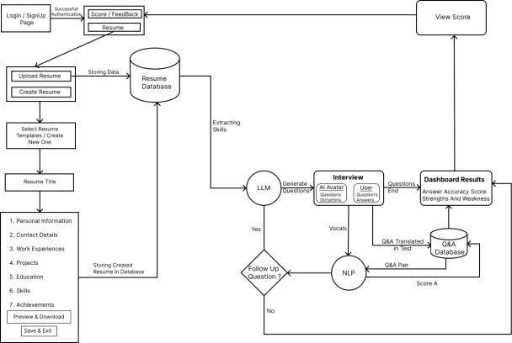
Figure 1: System Architecture

- Methodology
The system follows a sequential multimodal pipe-line:
- User registers/login and submits personal details along with resume data.
- System extracts relevant information and gen-erates context-aware interview questions using LLMs.
- User responds to questions through text or voice in-put.
- Voice responses are converted into text using speech
recognition technology.
- NLP processes analyze responses for accuracy, rel-evance, and fluency.
- Voice analysis evaluates tone, speech patterns, and confidence levels.
- System computes scores and generates struc-tured feedback reports.
- Results are stored in the database and displayed on the dashboard with strengths and weak-nesses.

- Mathematical model
To evaluate multimodal output quality, a composite scoring function is introduced:
Q=wTT+wCC+wFF+wRR
Where:
T=Text accuracy SCORE
C=Communication quality score
F= Confidence score
R = RESUME RELEVANCE SCORE WEIGHTS SATISFY:
𝑤T + 𝑤C + 𝑤𝐹 + 𝑤R = 1

This weighted evaluation ensures balanced assess-ment across modalities.
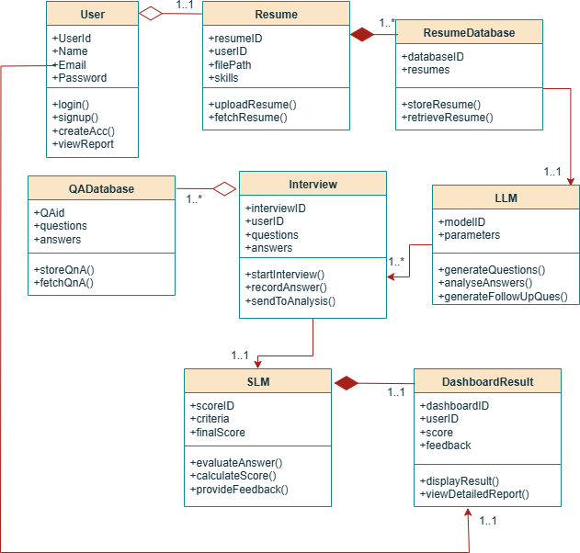

Figure 2: Class Diagram

- Experimental results and discussion

Testing of the prototype was conducted to verify the system's ability to generate relevant interview questions based on resume analysis, evaluate user responses, and provide personalized feedback. The system was successfully tested with both text and voice inputs, and responses were evaluated based on relevance, fluency, confidence, and coherence.

Multiple mock interview sessions were conducted with users from different backgrounds and skill levels to assess the performance of the system in real-world scenarios. The system was able to generate appropriate interview questions based on the examination of the resume data, and the responses provided by users were evaluated accurately. The system also provided personalized feedback based on the user's performance..

The system's integration and performance were analyzed, and the results indicated that the system was able to provide relevant interview questions and personalized feedback consistently. The system's response times were within the acceptable range, and the processing time for NLP models was moderate. The system was able to perform well under different scenarios, and the results were consistent across different users.
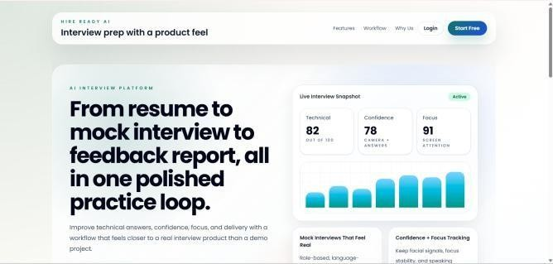

Figure 3: Home Page
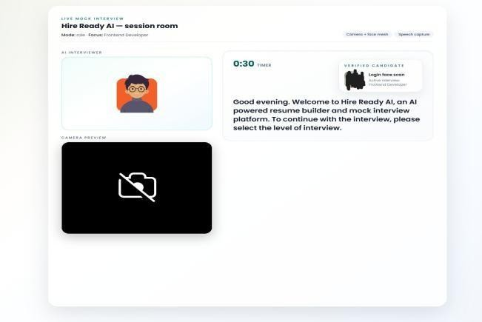
Figure 4: Interview Session
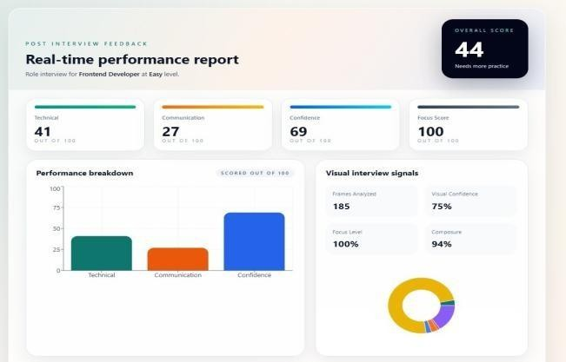
Figure 5: Generated Feedback
Performance Metrics
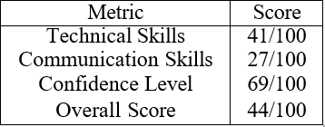

Table 1: Candidate Performance Metrics

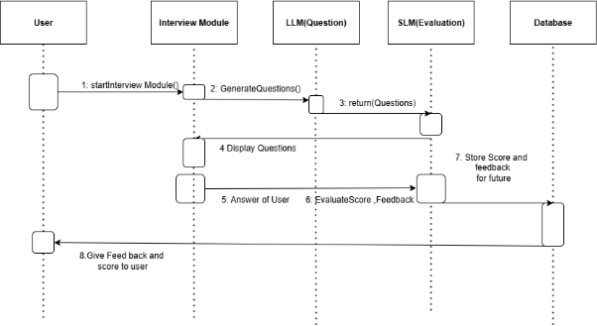

The comparison highlights the integrated nature of HireReady AI.

Figure 6: Sequence Diagram

- LIMITATION
Although the system exhibits promising results, several limitations still need to be addressed. The accuracy of the response evaluation heavily relies on the quality of speech recognition and user input. Variations in accents, background noise, and communication styles may affect confidence analysis. Moreover, the AI-generated evaluation may contain unintended biases and stereotypes introduced during the training process. Future work will focus on improving fairness, multilingual support, and domain-specific interview customization.
- CONCLUSION
HireReady AI – This document introduced Hire Ready AI, an artificial intelligence-driven platform aimed at help-ing individuals create resumes and prepare for interviews. Utilizing advanced techniques such as natural language processing, speech analysis, and machine learning, the plat-form offers instant feedback and assessments. Findings in-dicate that users can enhance their skills through ongoing practice and tailored advice. The system is built to be both scalable and flexible, catering to a diverse audience. In summary, Hire Ready AI proves to be a valuable resource for improving interview readiness.

Acknowledgment
The researchers express their heartfelt gratitude to the pro-ject supervisor and the Computer Engineering Department for their invaluable guidance and assistance throughout this re-search endeavor. The support from the institutional facilities and technical resources was instrumental in executing the proposed system.

References
- J. Manuel et al., “Q&AI: AI-powered mock inter-view bot,” IEEE, 2023.
- R. A. M. Rajeswari et al., “InterviewIQ: AI chat-bot for candidates,” IEEE, 2023.
- R. M. Marvaniya et al., “Smart Prep: AI-based in-terview system,” IJCS, 2023.
- Y. Liang et al., “Resume parsing using multi-task learning,” IEEE, 2023..
- S. V. Golande et al., “AI mock interview evalua-tor,” 2025.
- S. Mohanty et al., “Resumate: NLP-based recruit-ment system,” IEEE, 2023.

