ASSESSMENT OF ARTISANAL FISH FARMING ACTIVITIES AMONG RIVER NIGER COMMUNITIES IN KOGI STATE

Ali Peter Ocholi, Kunden Ishaya Samaila, Joshua Ibrahim Magaji
Alipeter790@gmail.com
Department of Geography, Faculty of Environmental Sciences, Nasarawa State University, Keffi-Nasarawa State, Nigeria

Abstract
This study examined the major activities and production trends of artisanal fish farming among communities along the River Niger using survey data collected in 2025. Descriptive statistics were employed to analyse respondents’ perceptions. Findings reveal that artisanal fish farming is a key livelihood activity, with 83% of respondents agreeing that it constitutes their primary source of income. Traditional fishing methods remain dominant, as indicated by 81% agreement, while 72% reported reliance on natural water bodies for fish breeding and rearing. However, 74% acknowledged a gradual increase in the use of modern aquaculture techniques. Fish preservation and processing practices were less consistent, with 68% participation and 29% indicating non-involvement. Regarding production trends, 90% of respondents observed a significant increase in fish production over the past five years, while 82% agreed that available resources support high production levels. Furthermore, 87% reported year-round fish availability, and 82% indicated that supply meets local demand. Notably, 87% affirmed that the River Niger still provides abundant fish resources. The study concludes that artisanal fish farming remains vital and moderately evolving, though constrained by limited modernization and infrastructural gaps, highlighting the need for sustainable management and technological advancement.
Keywords: Artisanal fish farming, River Niger communities, traditional fishing methods, modern aquaculture adoption, fish production trends, livelihood sustainability.

Introduction
Fisheries and aquaculture have become indispensable sectors in global food systems due to their immense contributions to food security, nutrition, employment generation, poverty reduction, and economic development. Globally, fisheries and aquaculture production reached approximately 223.2 million tonnes in 2022, with aquaculture contributing about 130.9 million tonnes, surpassing capture fisheries for the first time in history (FAO, 2024). Fish accounts for nearly 15% of the global intake of animal protein and serves as a primary source of nutrition for more than 3 billion people worldwide. In addition, over 61 million people are directly employed in fisheries and aquaculture activities globally, while millions more depend indirectly on fish processing, marketing, transportation, and related activities for their livelihoods (FAO, 2024). The growing global demand for fish products has further increased the relevance of sustainable fish farming practices, especially in developing countries where artisanal fisheries dominate local production systems (Barange et al., 2024).

In Africa, fisheries and aquaculture play major socio-economic roles by providing food, income, employment, and foreign exchange earnings. The continent produces millions of tonnes of fish annually, yet domestic demand still exceeds supply, leading to heavy fish importation in many countries. Nigeria is recognized as one of the largest consumers of fish in Africa, with fish accounting for about 40% of animal protein intake among many households (Adewumi & Olaleye, 2021). However, local fish production remains inadequate to meet increasing population demand. Nigeria requires over 3.6 million metric tonnes of fish annually but produces less than 1.2 million metric tonnes, thereby creating a significant supply deficit (Federal Department of Fisheries, 2023). Consequently, artisanal fisheries and small-scale fish farming have become important livelihood strategies in many rural and riverine communities. Studies have shown that artisanal fisheries contribute nearly 80% of Nigeria’s domestic fish production and employ millions of rural households directly and indirectly (Neiland et al., 2022).

Artisanal fish farming refers to small-scale, labor-intensive fish production and fishing activities carried out using traditional methods, local fishing gears, simple technologies, and family labor. It is usually characterized by low capital investment, small production capacity, dependence on natural water bodies, and limited access to modern preservation, storage, and transportation facilities (Oshinmagye et al., 2024). Artisanal fish farmers often operate in rivers, lakes, creeks, and floodplains where fish production activities include fish harvesting, processing, preservation, smoking, drying, and marketing. These activities provide employment opportunities, generate household income, improve nutrition, and support rural economies. In many riverine communities, artisanal fish farming also contributes significantly to women empowerment through fish processing and marketing activities.

Communities located along the River Niger in Kogi State are heavily dependent on fishing and fish farming activities for survival and economic sustenance. River Niger traverses several local government areas in Kogi State, including Lokoja, Idah, Koton-Karfe, and Ajaokuta, where fishing constitutes a major occupation among households. The river provides favorable ecological conditions for artisanal fish production due to its extensive water network and aquatic biodiversity. However, artisanal fish farmers in these communities face numerous constraints, including declining fish catch, poor access to credit facilities, inadequate fishing inputs, post-harvest losses, environmental pollution, flooding, weak extension services, and poor government intervention. Reports indicate that post-harvest fish losses in Nigeria range between 20% and 40% due to inadequate storage and processing facilities (FAO, 2023). Similarly, rising feed costs, obsolete fishing gears, and environmental challenges have reduced productivity and income among artisanal fish farmers in riverine areas (Oshinmagye et al., 2024). These persistent challenges threaten food security and the livelihoods of fishing households in Kogi State.

Therefore, assessing artisanal fish farming activities among River Niger communities in Kogi State is important for understanding the production systems, identifying constraints affecting fish farmers, and developing strategies for improving fish production, income generation, and sustainable livelihoods in the area. The findings of such a study would provide valuable information for policymakers, extension agents, and development organizations aimed at improving artisanal fisheries and rural development in riverine communities.
The objective of this study is to assess artisanal fish farming activities among River Niger communities in Kogi State. Specific objectives are to: examine the major activities of artisanal fish farming among communities along the River Niger; and assess the rate of fish production in the area.
Methodology
The study was carried out among River Niger communities in Kogi State, specifically Itobe in Ofu Local Government Area, Ega in Idah Local Government Area, and Udeke in Ibaji Local Government Area. These communities are located along the River Niger basin, which is characterized by fertile floodplains, seasonal flooding, and rich aquatic ecosystems that support both subsistence and commercial fishing activities. The major economic activities in the area include artisanal fishing, small-scale farming, fish processing, and local trading, with fishing serving as a primary source of livelihood for most households due to the proximity to the river and availability of diverse fish species.
This study utilized a descriptive survey design incorporating both quantitative and qualitative approaches to assess artisanal fish farming activities among the selected River Niger communities. The population of the study consisted of three thousand eight hundred and thirty-nine (3,839) fishing communities across the three selected areas. A sample size of 349 respondents was determined using Krejcie and Morgan (1970) statistical formula to ensure representativeness of the population. The respondents were selected through a multistage sampling technique, beginning with the purposive selection of the three communities, followed by proportionate sampling to determine the number of respondents from each community, and finally simple random sampling to select individual respondents to ensure fairness and reduce bias. Data were collected primarily through structured questionnaires, complemented by qualitative information obtained through informal interviews and observations to enrich the quantitative findings. Out of the 349 questionnaires distributed, 333 were successfully retrieved and found usable for analysis, representing a high response rate suitable for reliable interpretation.
Data collected were analysed using descriptive statistics, mainly simple percentages, to summarize respondents’ views on various aspects of artisanal fish farming activities such as production methods, challenges, and livelihood outcomes. The qualitative data were used to support and explain the quantitative results by providing contextual insights into the lived experiences of fishermen. The use of descriptive analysis allowed the study to clearly present patterns and trends in responses without complex statistical manipulation, making the findings easy to interpret and relevant for policy and development planning in the River Niger fishing communities.

Results
Table 1.1: Opinion of respondents on the major activities of artisanal fish farming among communities along the River Niger
S/N | Responses | SA | A | U | D | SD
1 | Artisanal fish farming is a primary source of livelihood for communities along the River Niger. | 157 (47%) | 120 (36%) | 7  (2%) | 27  (8%) | 22  (7%)
2 | Traditional fishing methods are commonly used by artisanal fish farmers in this areas. | 143 (43%) | 127 (38%) | 10 (3%) | 27  (8%) | 26  (8%)
3 | Fish farmers in this region rely on natural water bodies for breeding and rearing fish. | 140 (42%) | 100 (30%) | 13 (4%) | 43 (13%) | 37 (11%)
4 | The use of modern aquaculture techniques is increasing among artisanal fish farmers. | 113 (34%) | 133 (40%) | 7  (2%) | 33 (10%) | 47 (14%)
5 | Artisanal fish farmers regularly engage in fish preservation and processing activities. | 150 (45%) | 77 (23%) | 13 (4%) | 43 (13%) | 50 (15%)
Source: Field Survey, 2025

Table 1.1 presents the views of respondents regarding the major activities of artisanal fish farming among communities along the River Niger. The responses provide insights into the significance, methods, and evolving trends within artisanal fisheries in the area. A significant proportion of respondents (47%) strongly agreed that artisanal fish farming serves as the primary source of livelihood for communities along the River Niger, with an additional 36% agreeing. This indicates that a combined 83% of respondents acknowledge the vital role of fish farming in sustaining economic activities in these communities. However, a small percentage (2%) remained undecided, while 15% expressed disagreement to varying extents. These findings suggest that while artisanal fish farming is a crucial economic activity, there may be alternative or supplementary sources of livelihood for some individuals in the area.
Similarly, the data indicate that traditional fishing methods are predominantly employed by artisanal fish farmers. A total of 81% of respondents either strongly agreed (43%) or agreed (38%) with this statement, confirming the reliance on age-old fishing techniques. Only 16% disagreed, while 3% remained undecided. The widespread use of traditional methods may be attributed to cultural heritage, familiarity, and limited access to modern fishing technologies.
The dependency of fish farmers on natural water bodies for breeding and rearing fish was also examined. About 72% of respondents either strongly agreed (42%) or agreed (30%) with this notion, indicating a strong preference for natural water sources such as the River Niger. However, 24% of respondents either disagreed (13%) or strongly disagreed (11%), which suggests that a minority may have adopted alternative breeding techniques or supplementary aquaculture practices. The 4% undecided respondents indicate a potential gap in knowledge or exposure to alternative fish farming methods.
On the adoption of modern aquaculture techniques, responses were more varied. While 34% strongly agreed and 40% agreed, amounting to a total of 74%, a noticeable proportion (24%) either disagreed or strongly disagreed, and 2% remained undecided. This suggests a gradual shift towards modern aquaculture techniques but also reflects potential challenges such as inadequate access to technology, financial constraints, or reluctance to transition from traditional methods.
Regarding fish preservation and processing activities, 45% of respondents strongly agreed, and 23% agreed, leading to a total of 68% in favor of the statement. However, a relatively high percentage of 29% (13% disagreed, and 16% strongly disagreed) indicated that not all fish farmers engage in preservation and processing activities. This disparity may stem from inadequate infrastructure, lack of knowledge, or the immediacy of selling fresh fish due to market demands.
The analysis of these survey responses highlights critical aspects of artisanal fish farming along the River Niger. The dominance of traditional fishing methods and reliance on natural water bodies suggest that these communities continue to operate within conventional paradigms. While there is evidence of a shift toward modern aquaculture techniques, the pace of adoption remains moderate. Furthermore, fish preservation and processing practices appear inconsistent, indicating a need for improved infrastructure and training to maximize profitability and sustainability.

Table 1.2: Respondents view on the rate of fish production in the artisanal fish farming sector within the study area
S/N | Responses | SA | A | U | D | SD
6 | The rate of fish production in my community has increased significantly over the past five years. | 167 (50%) | 133 (40%) | 13 (4%) | 13 (4%) | 10 (3%)
7 | The availability of fishing resources in my community supports a high rate of fish production. | 150 (45%) | 123 (37%) | 3 (1%) | 23 (7%) | 30 (9%)
8 | There is an adequate supply of fish throughout the year in my community. | 167 (50%) | 123 (37%) | 10 (3%) | 17 (5%) | 13 (4%)
9 | The availability of fish in my community is sufficient to meet local demand. | 153 (46%) | 120 (36%) | 7 (2%) | 27 (8%) | 23 (7%)
10 | The River Niger still has an abundant supply of fish to sustain production in my community. | 177 (53%) | 113 (34%) | 10 (3%) | 20 (6%) | 13 (4%)
Source: Field Survey, 2025

Table 1.2 above presents respondents' views on the rate of fish production in artisanal fish farming among communities along the River Niger. The first statement assesses whether fish production has increased significantly over the past five years. A total of 167 respondents (50%) strongly agree, while 133 (40%) agree, indicating that a substantial majority (90%) believe there has been a notable increase in production. Only 13 respondents (4%) are undecided, and an equal number disagree, while 10 respondents (3%) strongly disagree. This overwhelmingly positive response suggests that the fish production rate has been on an upward trajectory in these communities, potentially due to improved fishing practices, increased investment, or favorable environmental conditions.
The second statement examines whether the availability of fishing resources supports a high rate of fish production. Here, 150 respondents (45%) strongly agree, while 123 (37%) agree, making up 82% of the respondents. A very small percentage (1%) remain undecided, while 23 respondents (7%) disagree, and 30 (9%) strongly disagree. Although the majority affirm the availability of resources, the presence of disagreement (16%) suggests that some communities may be experiencing resource depletion or challenges related to access.
The third statement assesses whether fish supply is adequate throughout the year. A significant proportion (87%) of respondents express agreement, with 167 (50%) strongly agreeing and 123 (37%) agreeing. Only 10 respondents (3%) are undecided, while 17 (5%) disagree and 13 (4%) strongly disagree. This suggests that fish supply is relatively stable, although the presence of some disagreement highlights that seasonal fluctuations or external factors might affect year-round availability in certain areas.
The fourth statement addresses whether the availability of fish is sufficient to meet local demand. The results indicate that 153 respondents (46%) strongly agree and 120 (36%) agree, collectively representing 82%. Three respondents (2%) are undecided, while 27 (8%) disagree, and 23 (7%) strongly disagree. Although the majority find the fish supply sufficient, the existence of nearly 15% of respondents who disagree suggests that some communities may struggle to meet their fish consumption needs, possibly due to population growth, market dynamics, or other environmental challenges.
The final statement evaluates whether the River Niger still has an abundant supply of fish to sustain production. Here, 177 respondents (53%) strongly agree, and 113 (34%) agree, adding up to 87%. Only 10 respondents (3%) remain undecided, while 20 (6%) disagree, and 13 (4%) strongly disagree. These figures indicate a strong belief that the River Niger still provides abundant fish resources, although concerns from a minority suggest that factors such as overfishing or environmental changes could be affecting fish availability.
The analysis of the survey results implies that fish production in artisanal fishing communities along the River Niger is generally perceived as increasing, with most respondents affirming the availability of fish resources and year-round supply. However, the presence of disagreement in each category highlights potential concerns, such as localized resource depletion, environmental challenges, or distribution inefficiencies. While the River Niger remains a vital source of fish for these communities, sustainable fishing practices and resource management strategies must be prioritized to ensure long-term productivity and food security.
Discussion
The findings presented in Tables 1.1 and 1.2 provide important empirical insights into the structure, practices, and productivity trends of artisanal fish farming communities along the River Niger. These results align with existing literature that emphasizes the critical socio-economic importance of artisanal fisheries in Nigeria and across sub-Saharan Africa.
Major Activities of Artisanal Fish Farming
The results in Table 1.1 indicate that artisanal fish farming constitutes a primary livelihood for the majority of respondents (83%). This finding corroborates earlier studies that identify artisanal fisheries as a cornerstone of rural livelihoods, contributing significantly to income generation, employment, and food security in Nigeria. For instance, artisanal fisheries account for a substantial share of domestic fish supply and support millions of people in both inland and coastal communities (Ojo et al., 2025; Oyetade et al., 2023). The strong reliance on this sector reflects limited alternative economic opportunities in riverine communities, reinforcing its role as an informal social safety net.
The dominance of traditional fishing methods reported by 81% of respondents further underscores the persistence of indigenous knowledge systems in artisanal fisheries. This aligns with evidence that small-scale fisheries in Nigeria are predominantly characterized by low-input, labour-intensive practices using simple gears such as nets and canoes (Ogunremi et al., 2023; Oshinmagye et al., 2024). While these methods are culturally embedded and cost-effective, they often limit productivity and efficiency when compared with modern aquaculture systems.
Similarly, the high dependence on natural water bodies (72%) for fish breeding and rearing reflects the ecological orientation of artisanal fishers. Inland water resources such as the River Niger provide essential habitats that sustain fish production and biodiversity in Nigeria (Central Bank of Nigeria, 2024; FAO, 2025). However, reliance on natural systems also exposes fishers to environmental risks, including seasonal variability, pollution, and overfishing.
The findings on the adoption of modern aquaculture techniques (74% agreement) suggest a gradual transition toward improved practices, although adoption remains uneven. This pattern is consistent with broader trends in sub-Saharan Africa, where small-scale fish farmers face barriers such as limited access to capital, inadequate infrastructure, and insufficient technical knowledge (Amponsah et al., 2025). These constraints may explain why a significant proportion of respondents still express reservations regarding modernization.
Fish preservation and processing practices were supported by 68% of respondents, but with notable dissent (29%). This highlights infrastructural and logistical challenges in post-harvest management. Previous studies suggest that inadequate storage facilities and reliance on traditional preservation methods such as smoking and drying that lead to substantial post-harvest losses in artisanal fisheries (Emere & Dibal, 2013; FAO, 1994). The inconsistency observed in this study suggests the need for improved cold-chain systems and processing technologies to enhance value addition and reduce waste.
Rate of Fish Production
The results in Table 1.2 reveal a generally positive perception of fish production trends. A substantial majority (90%) of respondents reported increased fish production over the past five years. This perceived growth may be attributed to incremental improvements in fishing practices, increased participation in aquaculture, and rising market demand for fish protein. National statistics also indicate ongoing efforts to boost fish production as part of broader agricultural and economic development strategies (Abdullahi et al., 2025).
The high level of agreement (82%) regarding the availability of fishing resources suggests that most communities still have access to productive fishing environments. However, the presence of dissenting views is noteworthy, as it may reflect localized resource depletion or inequitable access. Indeed, artisanal fisheries in Nigeria are increasingly threatened by environmental degradation, overfishing, and weak regulatory enforcement (Awolumate & Fregene, 2025).
The finding that 87% of respondents believe fish is available throughout the year indicates relative stability in supply, likely supported by the continuous productivity of the River Niger. Nonetheless, seasonal variations and environmental fluctuations remain inherent challenges in inland fisheries (Atawodi et al., 2024).
Similarly, the perception that fish availability meets local demand (82%) reflects a generally sufficient supply at the community level. However, this contrasts with national trends, which show a persistent gap between fish production and demand, necessitating substantial imports (Central Bank of Nigeria, 2024). This discrepancy may indicate that while local supply appears adequate in certain areas, broader distribution inefficiencies persist.
Finally, the strong agreement (87%) that the River Niger remains abundant in fish resources highlights continued confidence in the sustainability of the ecosystem. However, existing literature cautions that such optimism should be tempered by concerns about overexploitation and environmental stressors that could compromise long-term productivity (Ojo et al., 2025; Awolumate & Fregene, 2025).

Implications of the study
The findings demonstrate that artisanal fish farming along the River Niger is both economically vital and moderately evolving. While traditional practices remain dominant, there is evidence of gradual modernization and increasing production. However, persistent challenges including limited access to technology, inadequate processing infrastructure, and environmental pressures must be addressed to ensure sustainability.
Policy interventions should therefore prioritize capacity building, access to credit, technological innovation, and sustainable resource management. Strengthening these areas will not only enhance productivity but also secure the livelihoods of communities that depend heavily on artisanal fisheries.
Limitations of the Study
This this study acknowledge: (a) the reliance on self-reported perceptions rather than objective production data (e.g., catch records, market sales data); (b) the cross-sectional design, which does not allow causal inferences or the tracking of changes over time; (c) the focus on only three communities, which limits generalizability to other River Niger communities or other regions of Nigeria; (d) the absence of inferential statistical analysis; (e) the potential for social desirability bias (respondents may overstate production levels to appear successful); (f) the lack of environmental data (water quality, fish stock assessments) to verify claims about resource abundance.
Conclusion
This study examined the major activities and production trends of artisanal fish farming communities along the River Niger, with emphasis on respondents’ perceptions of livelihood dependence, fishing practices, and productivity. The findings clearly demonstrate that artisanal fish farming remains a critical socio-economic activity in the study area, serving as a primary source of livelihood for the majority of households. The high level of dependence on the sector underscores its importance in sustaining income, employment, and food security among riverine communities.
The study further reveals that traditional fishing methods and reliance on natural water bodies continue to dominate artisanal practices. While these approaches are deeply rooted in cultural heritage and local knowledge, they may limit productivity and efficiency. Nonetheless, there is growing evidence of a gradual shift toward modern aquaculture techniques, indicating increasing awareness and willingness among fish farmers to adopt improved practices, albeit at a moderate pace due to existing financial and technical constraints.
In addition, the findings highlight inconsistencies in fish preservation and processing activities, suggesting infrastructural deficiencies and limited access to improved post-harvest technologies. This gap has implications for value addition, income generation, and the reduction of post-harvest losses within the sector.
Regarding fish production, the study concludes that there is a generally positive perception of increased output, adequate fish supply, and sustained availability of fish resources in the River Niger. However, the presence of dissenting opinions signals emerging concerns related to resource sustainability, environmental pressures, and possible localized shortages. These concerns point to the need for proactive measures to prevent overexploitation and ensure long-term productivity.
Overall, the study concludes that while artisanal fish farming along the River Niger is vibrant and evolving, its sustainability depends on strategic interventions. There is a need to promote modern aquaculture technologies, improve access to credit and infrastructure, enhance fish processing and preservation systems, and implement effective resource management policies. Addressing these challenges will strengthen the sector’s capacity to contribute to food security, economic development, and the livelihoods of communities in the region.
Recommendation
To enhance artisanal fish farming along the River Niger, stakeholders should promote modern aquaculture techniques, improve access to finance and infrastructure, strengthen fish processing and market systems, enforce sustainable resource management, and expand capacity-building programs for fish farmers.

References
Abdullahi, A., Li, X., He, J., Song, C., Chinedu, D., & Li, H. (2025). The current situation and historical progression of fisheries and aquaculture in Nigeria: Strengths, weaknesses, challenges, and future prospects for investors. International Journal of Fisheries and Aquatic Studies, 13(6), 45–54.
Adewumi, A. A., & Olaleye, V. F. (2021). Fish production and aquaculture development in Nigeria: Challenges and prospects. Nigerian Journal of Fisheries and Aquaculture, 9(2), 45–56.
Amponsah, S. K., Azumah, D. D., & Agyakwah, S. K. (2025). Aquaculture in Africa: Production systems, challenges, and opportunities. In M. Atamanalp et al. (Eds.), Emerging trends in fisheries: Sustainable practices and new perspectives. IntechOpen.
Atawodi, J. C., Abovegodwin, G. O., Ngwamah, J. S., & Ugwoke, V. E. (2024). A critical review of fish production dynamics and sustainability in Nigeria.
Awolumate, S., & Fregene, B. T. (2025). Efficiency status in artisanal fishing amidst overfishing, pollution, and infrastructure development in Nigeria. Applied Sciences, Computing, and Energy Journal, 2(1).
Barange, M., Bahri, T., Beveridge, M., Cochrane, K., Funge-Smith, S., & Poulain, F. (2024). The state of world fisheries and aquaculture: Blue transformation in action. FAO Fisheries and Aquaculture Technical Report, 4(1), 1–210.
Central Bank of Nigeria. (2024). Fishery sector development initiative. Retrieved from https://www.cbn.gov.ng
Emere, M. C., & Dibal, D. M. (2013). A survey of methods of fish processing and preservation employed by artisanal fishermen in Kaduna City. Journal of Fisheries and Aquatic Science.
Federal Department of Fisheries. (2023). Annual fisheries statistics report in Nigeria. Federal Ministry of Agriculture and Food Security Report, 12(3), 18–33.
Food and Agriculture Organization (FAO). (1994). Fish processing and preservation in Africa. FAO Fisheries Technical Paper.
Food and Agriculture Organization (FAO). (2024). Global fisheries and aquaculture production statistics. FAO Fisheries Statistical Series, 18(2), 1–85.
Food and Agriculture Organization (FAO). (2025). The state of world fisheries and aquaculture 2025. Rome: FAO.
Food and Agriculture Organization. (2023). Global food security situation and nutrition report.FAO Food Policy Review, 19(1), 10–85.
Krejcie, R. V., & Morgan, D. W. (1970). Sample size determination table. Educational and psychological Measurement, 30(3), 607-610.
Neiland, A. E., Béné, C., & Ladu, B. M. (2022). Contribution of artisanal fisheries to rural livelihoods in Nigeria. African Journal of Agricultural Research, 17(5), 733–742.
Ogunremi, J. B., Onimisi, M. M., Oshinmagye, M. I., & Opaluwa, H. I. (2023). Socio-economic characteristics, artisanal methods, and constraints among fishers in the Lower River Niger, Nigeria. Nigerian Agricultural Journal, 54(1), 238–242.
Ojo, A. S., Akingbola, O. A., Gbadamosi, M. A., Samuel, O. O., Mustapha, S. D., Mustapha, A. A., Aboderin, E. O., Olabamiji, I. O., & Ajanaku, V. O. (2025). Assessing sustainable fishing strategies in Nigeria’s artisanal fisheries. Global Journal of Fisheries Science, 7(5), 153–166.
Oshinmagye, M. I., Ikponmwen, E. G., Mohammed, A. M., & Ogunremi, J. B. (2024). Artisanal practices, prospects, perception, and challenges among fishers in Lower River Niger, Nigeria. Nigerian Journal of Animal Production.
Oyetade, O. P., Akinsafe, N. B., Ojebiyi, W. G., Oyebamiji, B. A., Aminu, O. K., Jacob, O. O., Akinde, A. O., & Abraham, O. (2023). Economic analysis and poverty status of artisanal fishing households in Ogun State, Nigeria. AKSU Journal of Agriculture and Food Science, 7(3), 115–127.
APPENDICES
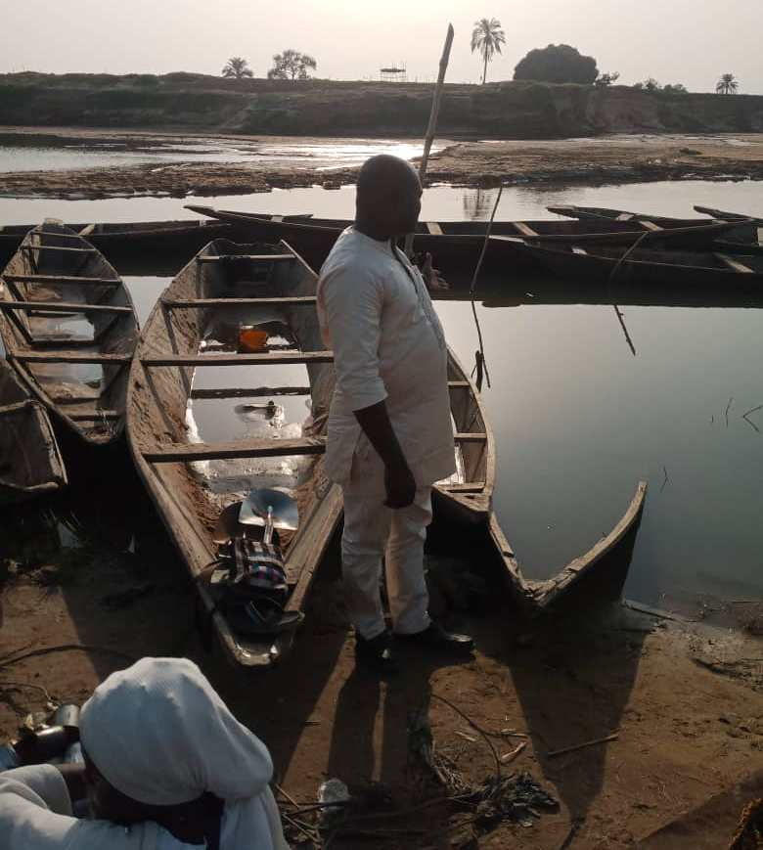
Plate 1: Artisanal fishing wooden canoes lined up along the River Niger in Kogi State
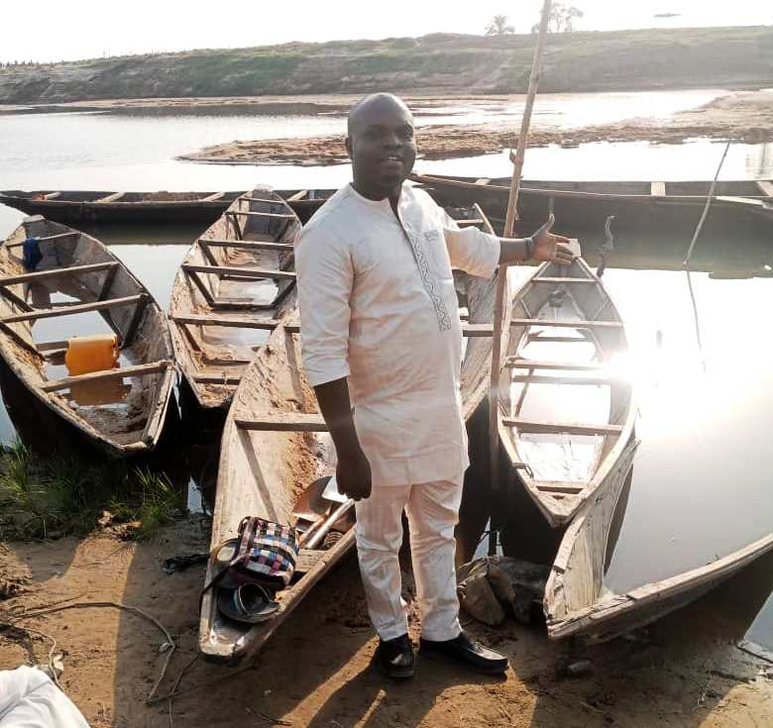
Plate 2: The structural features of artisanal fishing boats at Itobe.

