Unpacking the Complexities of Consumer Preference for Fresh Fruits

Ranjan M¹, J Dinesh¹
Karthick V², Logesh S²

- SRM University, Department of MBA, Faculty of Management, Chennai, Tamil Nadu Kattankulathur
- Tamil Nadu Agricultural University AC & RI, Vazhavachanur, Tamil Nadu

Abstract
Consumer preferences for fresh fruits are shaped by a multitude of intrinsic and extrinsic factors, including appearance, flavour, texture, shelf life, price, health and nutrition, convenience, seasonality, and demographic characteristics. Understanding these factors is crucial for growers, marketers, and policymakers to promote fruit consumption effectively. This paper provides a comprehensive overview of the key determinants influencing fresh fruit preferences, such as intrinsic attributes like color, taste, firmness, and shelf life, as well as extrinsic factors like price, perceived health benefits, convenience, and seasonality. The impact of demographic variables like age, geographical location, income, education, gender, and family structure on fruit choices is examined. The roles of supply chain efficiency and marketing strategies in meeting evolving consumer demands are also explored. Additionally, the paper discusses the future outlook, highlighting emerging trends like increased health awareness, demand for convenience, sustainability concerns, and the influence of online grocery shopping on shaping fruit preferences in the consumer market. Overall, this paper offers valuable insights into the complex interplay of factors driving consumer behavior towards fresh fruits, informing strategies to enhance fruit consumption and align with changing consumer expectations.
Keywords
Consumer Preference, Fresh Fruits, Factors, Organic
1. Introduction
The desire for fresh fruit reflects people's health status and food choices [1]. Fresh fruits are seen as essential for a balanced diet due to their nutritional and disease-prevention abilities [2], and studies have also identified consumers' increasing awareness about having fruits [3]. Besides vitamins, fiber, and minerals, fruits contain phytochemicals that can reduce the risk of major illnesses like cancer and heart disease, leading causes of death in industrialized nations [4]. However, modern lifestyles have changed consumer preferences to more convenient, minimally processed products, thereby influencing fresh fruit consumption [5]. Despite this, experts emphasize the choice to eat fresh fruits, which provide key nutrients and phytochemicals that help reduce the risk of chronic disease, such as heart disease, cancer, and obesity [3, 5].
Consumer preferences for fresh fruits are studied across marketing, psychology, post-harvest research, and emotional research fields [6]. Research shows that consumer beliefs, emotions, attitudes, and preferences significantly influence fruit choices. Understanding consumer attitudes and purchase behaviors towards fresh fruits is therefore critical for growers, marketers, and policymakers. Recent studies also reveal that fruit selection is influenced by produce quality, labeling, and price sensitivity across demographic groups. In addition, factors like taste preferences, health motivations, consumers' income level, and their geographic location influence their fruit consumption pattern [7]. Overall, many internal motivations and external factors in combination influence consumers' fresh fruit preferences [8].
Although numerous studies have identified the elements that shape consumer preferences for fresh fruits, the research remains fragmented, with most studies focusing on specific attributes. Consequently, a comprehensive synthesis integrating findings across diverse cultural and geographical contexts is still lacking. Moreover, there is a need to further explore the influence of emerging trends, such as expanding online shopping, evolving marketing strategies, and supply chain efficiency, on fruit consumers' purchasing decisions. Understanding the health benefits associated with fruit consumption and the persistent gap between recommended and actual fruit intake levels worldwide, it is necessary to understand the determinants of fruit preferences. Therefore, in this review, we aim to provide a comprehensive analysis of the factors shaping consumer preferences for fresh fruits by synthesizing evidence on intrinsic and extrinsic product attributes, demographic and socioeconomic characteristics, price sensitivity, preferences for organic versus conventional fruits, supply chain efficiency, and marketing strategies. Hence, by integrating these diverse perspectives, the study seeks to offer a consolidated understanding of consumer behaviour and identify key directions for future research and policy.
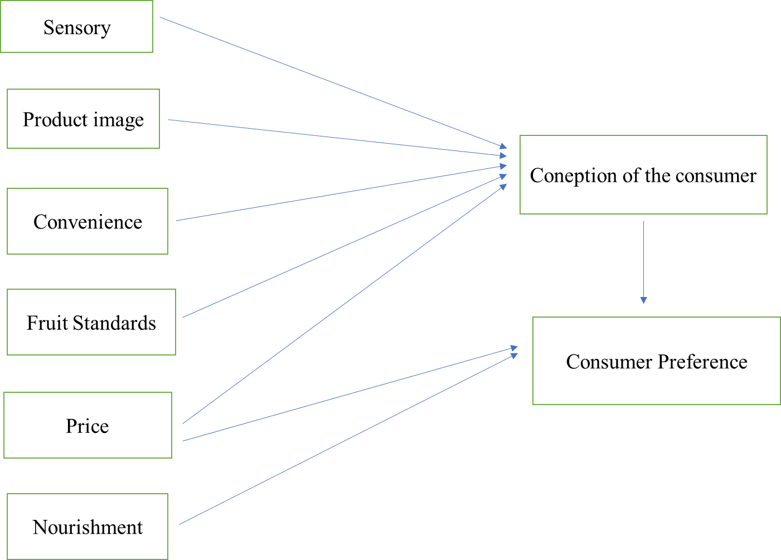
Fig 1: Evolving Consumer Preference
2. Conceptual framework
The conceptual framework (Fig 2) provides the overall view for this paper based on the premise of consumer preference. This study on factors influencing consumer preferences for fresh fruits, are hence discussed under the broad dimensions of: intrinsic attributes (appearance, flavor, texture, shelf-life), extrinsic factors (price, perceived health benefits, convenience, seasonality), demographic variables (age, location, income, education, gender, family dynamics), supply chain efficiency, marketing strategies, and emerging trends (health awareness, convenience demand, sustainability concerns, online grocery shopping) as key determinants.
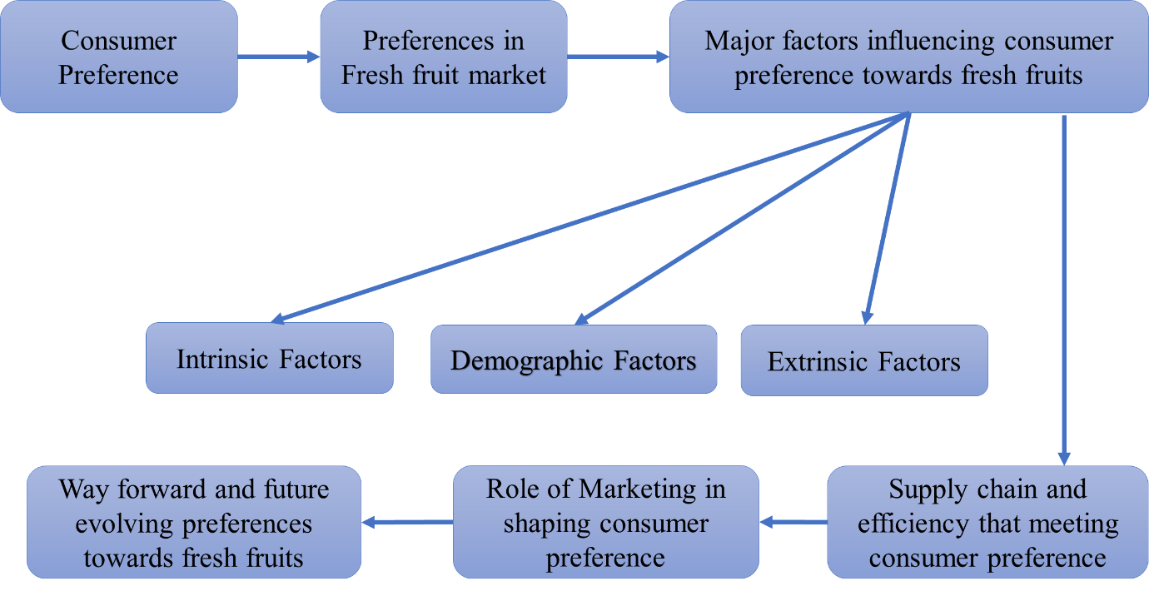
Fig 2: Conceptual framework
3. Methodology
This review employed the Preferred Reporting Items for Systematic Reviews and Meta-Analysis (PRISMA) framework to ensure a transparent and systematic identification, screening, and selection of relevant literature. The study used Google Scholar as the primary database to search literature because of the extensive availability of peer-reviewed articles across multiple disciplines related to consumer preferences for fresh fruits [10]. The literature included studies published from 2000 to 2025. The literature search used a combination of keywords such as “fresh fruits, consumer preference, fruit consumption, consumer behaviour, fruit choice, intrinsic and extrinsic attributes, marketing strategies, supply chain efficiency, and consumer attitudes”. These strings were used iteratively to maximize the number of relevant articles for the review. The articles for review are finalized after an inclusion and exclusion strategy to ensure the relevance and quality of selected literature. The search initially identified 1920 records, and after using automated filters in the database, 257 records were selected after using the criteria of inclusion and exclusion. After removing duplicate publications, 155 unique articles remained. Subsequently, titles and abstracts were screened to exclude irrelevant studies, followed by a full-text assessment based on the predefined eligibility criteria. Finally, 103 articles were selected for qualitative synthesis. The selected studies covered a broad range of themes, including consumer preferences, purchasing behaviour, fruit quality, marketing strategies, supply chain efficiency, pricing, and organic fruit consumption. The PRISMA flow diagram (Fig 3) illustrates the complete study selection process. To enhance the quality of the review, only peer-reviewed journal articles with clearly defined objectives, sound methodological approaches, and direct relevance to the study objectives were included.

Total literature
s

searched from Google scholar

(N= 1920)

Database: Google scholar rsccccccccccccs scholar

Total number of literatures
s

after inclusion and exclusion
criteria (N= 257)

Total number of
literature
s

after removal of duplicate
literature (N=

155)()

Total number of literatures after skimming abstract and
main text

= 103)
(
N

Total literatures included from google scholar for the study

= 103)
(
N

Excluded
#1663

Excluded
#102

Excluded
#52

IDENTIFICATION

SCREENING

ELIGIBILITY

INCLUDED

Fig 3: PRISMA flowchart depicting the search literature for a systematic review of Unpacking the complexities of consumer preference for fresh fruits

4. Trends in Fruit Consumption
Fruit consumption plays a key role in overall health, however, global and national trends of per capita fruit intake warrant attention [11]. On average, worldwide fruit consumption has increased slightly, but this may be largely due to population surge rather than actual growth in per capita intake [12]. In India, demand for fruits has been rising, driven by growing awareness of their nutritional benefits [13]. Government initiatives such as the National Horticultural Mission have also contributed to this increase in fruit production and consumption [14]. Additionally, India is a major producer of fruits like mangoes, bananas, papayas, and grapes [15]. However, despite growing demand and production, challenges remain in achieving the recommended fruit intake level, including inefficiencies in the supply chain which limit the distribution and availability of fresh fruits[16]. Consequently, actual fruit consumption remains below recommended dietary levels. Addressing these challenges requires improving the quality attributes preferred by consumers while enhancing the availability, accessibility, and affordability of fresh fruits across all population segments [17].
Fruit consumption patterns vary considerably across regions and over time [18]. Consumer awareness of the recommended daily intake of fruits is recognized as a key factor influencing consumption behaviour and dietary choices [19]. The consumption of berries has increased substantially in recent years, driven in part by growing consumer awareness of their health benefits and marketing emphasizing their antioxidant properties [20]. In contrast, consumption patterns in developed countries differ markedly; for example, apples remain the most widely consumed fruit in the United States, Europe, and Canada, primarily due to their affordability, versatility, and year-round availability [21].
Table 1: Trends in Fruit consumption
Trend | Descriptions | References
Growth in organic and sustainable fruit | Consumers are increasingly concerned about the environmental impact of agriculture and the ethical treatment of animals. As a result, they are showing a preference for organic produce and products with sustainability certification. This trend is being driven by a desire to reduce the use of harmful pesticides and herbicides, and to support farming practices that are better for the planet and its inhabitants. | [22, 23]
More fruit-based snacks and beverages | To satisfy the rising desire for convenience and health, fruits are integrated into portable snacks, such as smoothies, fruit leathers, and dried fruit, providing a simple and nutritious option for consumers. | [24]
Shift towards convenient fruit options. | Consumers today desire convenient and readily available fruit options that fit their fast-paced lifestyles. Examples of such options include pre-cut fruit, dried fruit, and snacks that provide both taste and convenience. | [25]
Increased consumption of fruits overall | In recent times, the consumption of fruit has been on the rise due to an increasing awareness of the benefits of healthy eating, leading people to prefer healthier dietary choices. | [26]

5. Factors Influencing Consumer Preference for Fresh Fruits

Maintaining a healthy and well-balanced lifestyle necessitates the incorporation of fruits into our daily dietary regimen. However, it has been observed that global fruit consumption falls short of the recommended levels, highlighting the pressing need to devise effective strategies to elevate fruit consumption [27]. A multitude of factors influence fresh fruit preferences, encompassing psychological, social, cultural, intrinsic, extrinsic, demographic, and economic considerations. Among these, intrinsic, extrinsic, and demographic factors exert a significant influence on consumer fruit consumption patterns. Gaining a comprehensive understanding of these factors is crucial for the fruit industry, policymakers, and health professionals to promote fruit consumption effectively and meet consumer demands [28]. By addressing the underlying determinants that shape fruit preferences, targeted interventions and initiatives can be implemented to encourage and facilitate increased fruit intake within the population.

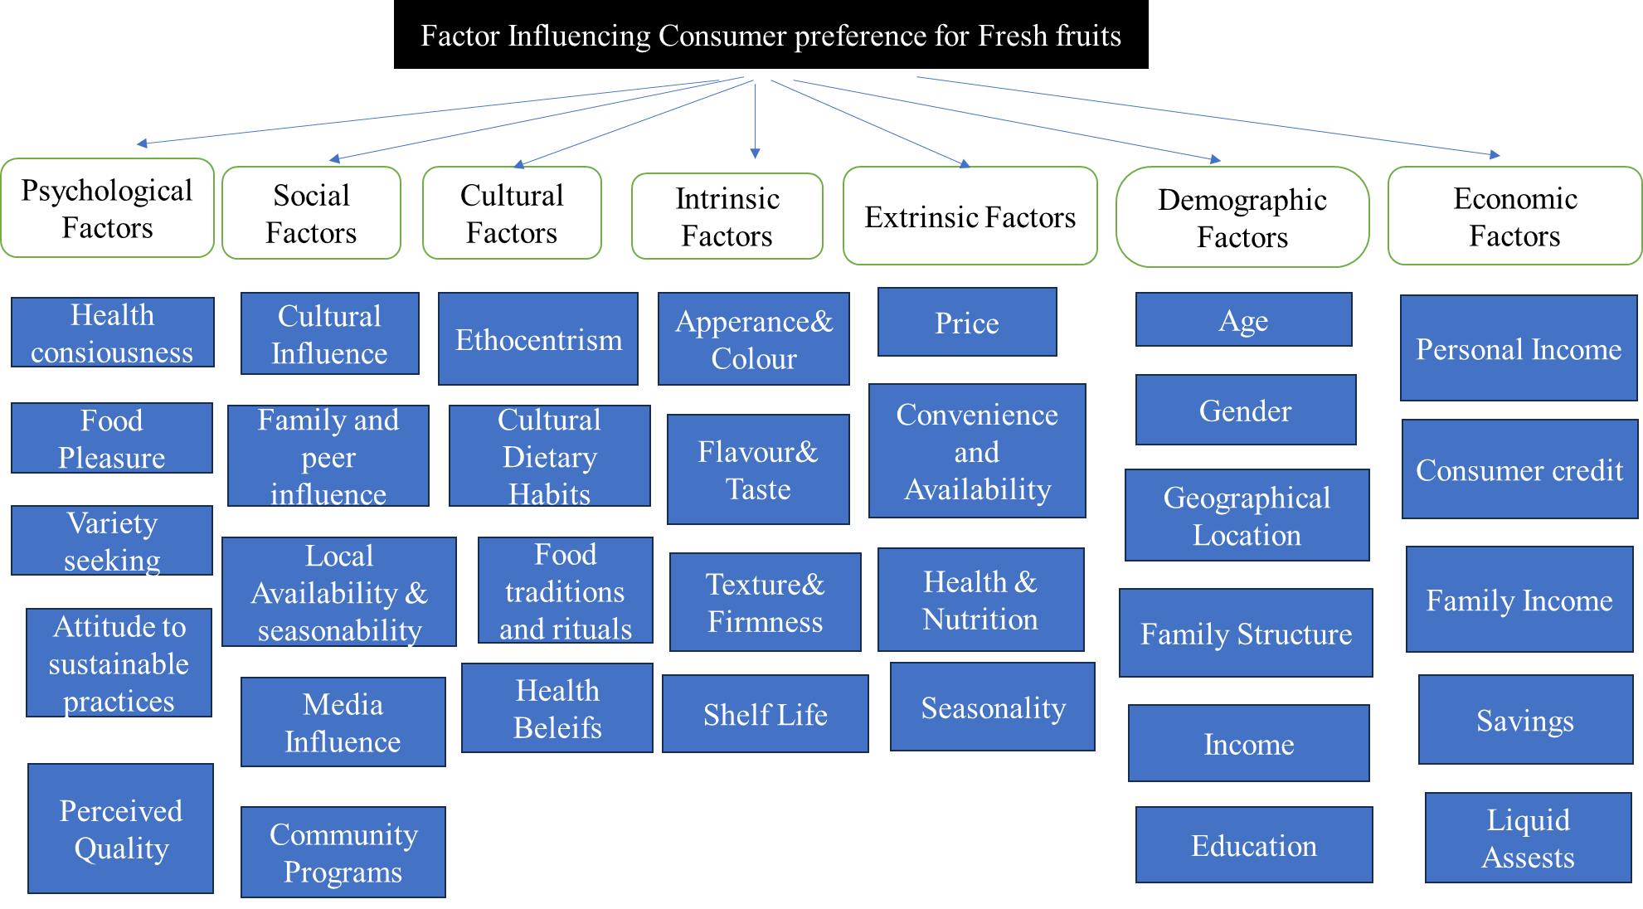

(Source: Author compilation)

Fig 4: Factors Influencing Consumer Preference for Fresh Fruits

5.1. Intrinsic Attributes
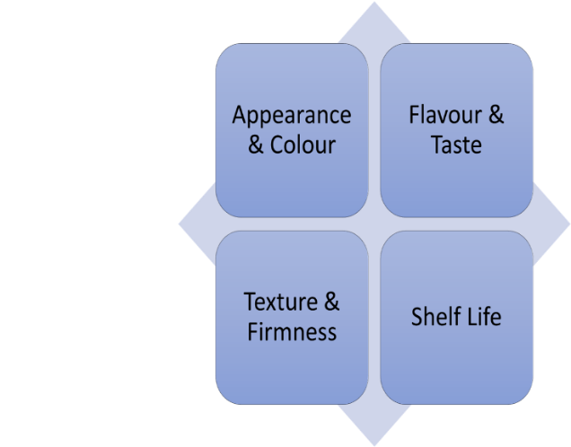
Fig 5: Components of intrinsic attributes
5.1.1. Appearance & Color
The visual appeal of fresh fruits, encompassing their appearance and color, plays a pivotal role in shaping consumer demand and acceptance. Consumers heavily rely on the outward appearance of fruits as a primary indicator of quality, and an attractive presentation can significantly sway their purchase decisions [29]. Cultural influences also come into play, with certain colors holding symbolic meanings or associations that can impact fruit preferences. For instance, in Asian cultures, the color red is often linked to prosperity and good fortune, potentially influencing the preference for red-hued fruits [30]. A product's evaluation by consumers is greatly influenced by their perception of its color, size, shape, and presence or absence of blemishes [31]. There is a consensus among consumers favoring uniform colors and an aversion towards irregular or mottled patterns, which are perceived as less desirable [32]. The interplay between these visual factors and consumer preferences underscores the significance of appearance and colour in driving the acceptance and demand for fresh fruits in the market.
5.1.2. Flavour & Taste
Appearance and taste are among the most influential intrinsic attributes affecting consumers' food choices and fresh fruit preferences. In addition to visual appeal, sensory characteristics such as sweetness, acidity, aroma, and flavour play a crucial role in determining consumer acceptance and overall eating experience [33]. Aroma and flavour are closely associated with fruit freshness and varietal characteristics, thereby significantly influencing purchasing decisions. For example, studies have shown that specific volatile compounds in strawberries enhance consumers' perception of sweetness, leading to greater acceptance and preference, highlighting the direct role of flavour in shaping consumer preferences [34].
5.1.3. Texture & Firmness
The texture and firmness of freshly picked fruits exert a profound influence on consumer preferences, as these characteristics are intrinsically linked to the overall quality and freshness of the produce, ultimately shaping purchasing decisions. A prime example is the widespread preference for fruits with appealing textures, such as crisp apples or juicy varieties that melt in the mouth, in contrast to less desirable options like peaches with an unappetizing texture [35]. Research indicates that fruit firmness serves as a crucial indicator of ripeness and quality, with these characteristics directly correlating to the degree of ripeness and often used by consumers to determine the freshness and quality of the fruit [36].
5.1.4. Shelf Life
Fresh fruits are known for their relatively short shelf life, which can lead to rapid spoilage, prompting consumers to favor fruits with a longer shelf life as they are perceived as fresher and of higher quality[37]. A longer shelf life affords consumers the luxury of time to fully enjoy the fruit without the risk of wastage due to spoilage [38]. The shelf life of a fruit can be influenced by various factors, such as its variety, maturity stage, and overall quality (Kader, 2002). Effective post-harvest protocols, including temperature regulation, humidity control, and suitable packaging, can significantly enhance the longevity of fruits, according to [39]. Cutting-edge packaging techniques, such as modified atmosphere packaging (MAP) and edible coatings, have demonstrated the potential to sustain freshness, extend the lifespan of fresh fruits, and minimize waste [40].
5.2. Extrinsic Attributes

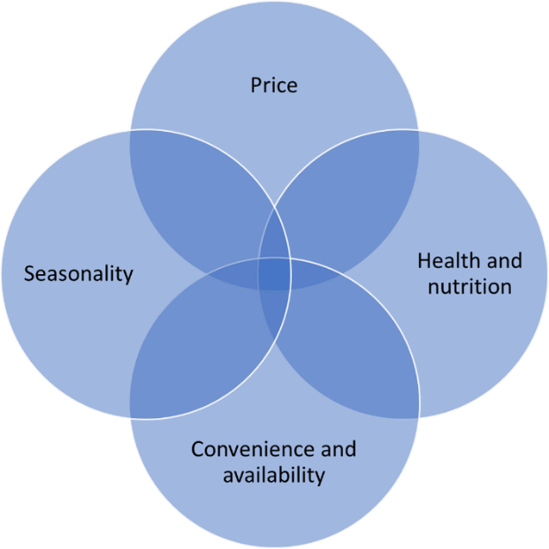
Fig 6: Components of extrinsic attributes
5.2.1. Price
Price is one of the most important extrinsic factors influencing consumer preferences and purchasing decisions for fresh fruits. High prices can discourage consumers from purchasing their preferred fruits, often leading them to substitute with more affordable alternatives [41]. However, price sensitivity varies across consumers and fruit categories, as strong preferences for particular fruit varieties may reduce the influence of price on purchasing decisions [42]. Although consumers are generally responsive to price changes, studies indicate that they are willing to pay a premium for fruits that possess desirable attributes or provide additional value. For instance, organic certification and ecolabels can justify higher prices when consumers trust the credibility of these labels [43,44]. Similarly, locally produced fruits often command premium prices because consumers associate them with freshness, quality, and support for local producers [45]. The relationship between price and purchasing behaviour is further shaped by consumers' perceptions of value and their income levels, particularly among low- and middle-income households [46]. Consequently, premium-priced fruits are frequently perceived as superior in terms of safety, nutritional quality, and taste compared to lower-priced alternatives, reinforcing consumers' willingness to pay higher prices for products they consider valuable [32,47].
5.2.2. Health and Nutrition
Health and nutritional attributes play a significant role in shaping consumer preferences for fresh fruits. Fruits perceived to be rich in essential nutrients, particularly vitamin C, such as oranges and grapefruits, are generally viewed more favorably by consumers [32,47]. Similarly, growing health consciousness has increased the demand for fruits associated with functional health benefits. Consumers seeking to enhance immunity and overall well-being often prefer fruits believed to be rich in antioxidants and other bioactive compounds. For instance, apples, grapes, and berries are valued for their anti-inflammatory properties due to their high concentrations of polyphenols and other beneficial phytochemicals [46,48]. In addition to nutritional considerations, food safety concerns also influence purchasing decisions. The presence of pesticide residues in conventionally grown fruits can reduce consumers' willingness to purchase such products, thereby increasing the preference for fruits perceived as safer and healthier alternatives, particularly organically produced fruits[28, 49].
5.2.3. Convenience and Availability
Many studies highlight convenience as a key aspect of food choices. Hectic lifestyles and extended work hours often lead to time constraints, influencing consumer decisions [50]. Due to this, individuals are increasingly turning toward convenient options like fresh, easy-to-use fruits and vegetable-based meals. Thus, it is evident that convenience is a key factor that shapes consumer preferences for fresh fruits, with a strong inclination towards options that require minimal preparation, such as pre-cutting, peeling, or slicing. These hassle-free choices not only heighten the willingness to purchase but also lead to an increased actual consumption [51].
5.2.4. Seasonality
Seasonality is a significant factor in consumer preference for fresh fruits. This is because the fruiting season is influenced by multiple factors, including climate, growth, and harvest time[52]. When it comes to customer demand for fruits, the adage "variety is the spice of life" is true. Demand noticeably increases during peak seasons when some fruits are in plenty [53]. As an illustration, consider this: although there is a desire for juicy strawberries during the warm months, the cool winter months bring a yearning for tart citrus fruits like oranges and grapefruits [54]. Because of the seasonal fluctuations in availability, these goods are more appealing and encourage consumers to try different flavors, which increases consumption [55]. In contrast, fruits that are grown unnaturally or in controlled environments may not have the same level of flavor and freshness [56]. This is why many consumers associate seasonal fruits with a superior taste and are more willing to invest in them [57].
6. Price and Willingness to Pay by the Consumer in Fresh Fruit Preferences
Several factors influence consumers' willingness to pay (WTP) for fresh fruits, such as perceived value, health benefits, and ethical or environmental considerations. Numerous studies have investigated consumers' willingness to pay for locally or organically grown fruits, which are often perceived as being of higher quality and more environmentally friendly [52, 58]. The impact of income and socioeconomic status on consumer preferences and willingness to purchase fresh fruits is significant. While lower-income households may be more price-sensitive, increasing their reluctance to pay premiums, higher-income households frequently demonstrate a greater willingness to acquire special or premium fruits [37]. Research has identified various factors that influence consumers' willingness to pay for fresh fruits, including product attributes such as variety, origin, size, and labeling (e.g., organic or eco-friendly), as well as store-related factors like customer reviews and seller reputation [59]. Studies indicate that consumers are willing to pay a premium for desirable quality attributes, particularly enhanced sweetness, while showing a greater willingness to compromise on attributes such as fruit firmness [60].
7. Organic vs Conventional Fruits (Preference in the Fresh Fruit Market)
7.1. Concerns towards Organic Fruits
The term "organic" not only appeals to consumers who prefer sustainable agricultural methods and the reduced use of chemicals but is also closely tied to environmental concerns, allowing this label to attract a conscientious customer base [61]. Consumer preferences for organic products are largely driven by perceptions regarding the reduced use of synthetic fertilizers, herbicides and pesticides in organic production systems. The demand for organic products is further influenced by socioeconomic characteristics, particularly income and education levels, which affect consumers' awareness, purchasing power, and attitudes toward organic food. In addition, health concerns serve as a major driver of organic fruit consumption, highlighting the interaction between consumer characteristics and product-related attributes in shaping purchasing decisions [62].
Despite the growing consumer preference for organic fruits, several concerns and uncertainties remain regarding their perceived benefits. Although studies consistently report lower levels of pesticide residues in organic fruits, the extent to which these differences translate into measurable human health benefits remains inconclusive [63]. Furthermore, comparisons between organic and conventionally grown fruits have revealed variations in nutrient composition, including vitamin C, protein, and other nutrients, as well as differences in pesticide and nitrate residues [64]. However, the magnitude and practical significance of these nutritional differences continue to be debated, creating uncertainty among consumers regarding the overall advantages of organic fruits over conventionally produced alternatives.
7.2. Concerns towards Conventional Fruits
According to proponents of conventional farming methods, annual yields are more cost-effective and efficient, even with the use of synthetic inputs. However, research has revealed differences in the nutrient content and biodiversity between conventionally grown and organic fruits [63]. Conventional fruit production often relies on pesticides, synthetic fertilizers, and intensive agricultural practices, which can lead to soil degradation, water pollution, and a decrease in biodiversity [65]. Consequently, consumers are increasingly valuing sustainable and environmentally friendly production methods, driving the demand for locally grown and organic fruits [66]. This shift in consumer preferences reflects a growing concern for the environmental impact of conventional agriculture and a desire for more sustainable and eco-friendly alternatives.
8. Demographic Factors Shaping Fresh Fruit Preferences
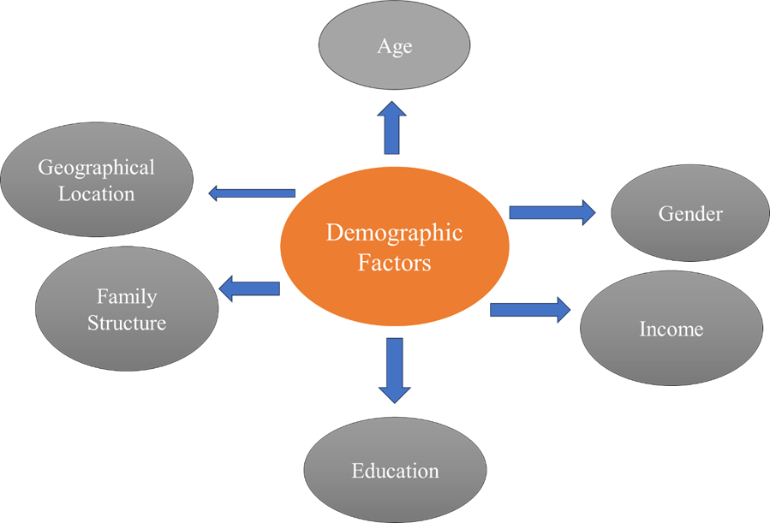
Fig 7: Components of Demographic factors
8.1. Age
Age has been examined as a determinant of consumer preferences for fresh fruits, although the evidence suggests its limited influence. Consumer preferences vary across different stages of life. For instance, children are more likely to select fruits based on visual appeal and appearance, while showing lower acceptance of fruits with undesirable textures, such as mushiness [69]. Among middle-aged adults, time constraints associated with work and family responsibilities can limit meal planning and preparation. Nevertheless, this group continues to place considerable importance on family health and nutrition, thereby maintaining a preference for fresh fruit consumption despite these challenges [50]. In contrast, older consumers often develop stronger preferences for familiar fruit varieties, as previous experiences and positive memories enhance their trust in known products. Consequently, they tend to be less willing to experiment with new or unfamiliar fruit varieties [68]. However, despite these age-specific differences in fruit selection and consumption behaviour, evidence from a Romanian study indicates that age does not significantly influence overall fruit and vegetable consumption patterns [67]. Collectively, these findings suggest that while age may shape certain aspects of consumer behaviour, it is not a dominant determinant of fresh fruit preferences.
8.2. Geographical Location
A study in Turkey demonstrated that fresh produce availability varies by region, with Western consumers having greater access compared to Eastern consumers [70]. Consumers choose fruits of the highest quality in their location and season, as long as there is a sufficient supply[71]. Tropical or Mediterranean climates boost fresh fruit intake and preference when compared to tropical locations[72]. Rural and remote consumers often struggle with lower availability and variety compared to urban areas with more grocery options. In summary, location impacts consumer access to fresh fruits.
8.3. Income
It seems that those with higher incomes are not as worried about the cost of fresh fruit when making purchases, highlighting a clear connection between income and preference, however, food safety, flavor, and freshness are all comparable to income[70]. Higher earners are usually able to select from a wider range of fresh food and are more likely to do so with quality, locally sourced, and environmentally friendly alternatives. These people are prepared to pay more for fruits that meet strict environmental criteria, especially if they are gathered fresh and very perishable [73]. However, low-income recipients could give price and accessibility more weight than other factors. In general, customers choose fruits that are more accessible and less expensive[74].
8.4. Education
The impact of education on consumer preferences for fresh fruit cannot be overstated. Those with a higher education level are more likely to understand the significant health benefits associated with eating fresh fruit. This knowledge is often translated into a preference for fresh fruit over processed or unprocessed options[73]. Better nutritional awareness (education) appears to be associated with higher fruit consumption. In a study of 500 American consumers, those who scored high on food knowledge ate more fruit per day than those who scored low[75]. Food contamination and spoiling are less likely to affect knowledgeable customers who are aware of food safety[46]. People with higher levels of education are more likely to pick fruit based on its nutritional value (e.g., fibre content and vitamin C content) and are also aware of the health advantages of fruit[70]. It seems that a person's level of education plays a role in their sensitivity to price, as they may be more willing to pay a higher cost for fruits of superior quality that are perceived to be healthier[76].
8.5. Gender
Gender has been identified as an important factor influencing consumer preferences for fresh fruits. Studies indicate that women are generally more motivated to consume fruits because of their perceived health benefits and are more likely to value attributes such as innovation, appearance, and aesthetic appeal when making fruit purchasing decisions [70,77]. In contrast, men tend to place greater emphasis on convenience and affordability [70]. Research also suggests that adherence to stereotypically masculine traits, such as physical toughness and prestige, may contribute to lower fruit consumption among some men [78]. However, men have been found to possess relatively greater skills related to fruit selection, storage, and preparation, which can positively influence their fruit consumption behaviour [79]. Overall, these findings highlight that men and women differ in the attributes they prioritize when choosing fruits, resulting in distinct consumption patterns and preferences.
8.6. Family Structure
When it comes to family dynamics, single parents often face unique challenges regarding fruits. Due to constraints on time and resources, they may struggle to provide their children with the fresh and delicious fruits they desire [80]. For single working parents, introducing new varieties of fruits that their children might reject can be a daunting task amidst the juggling of multiple responsibilities[81].
Families with children may place greater emphasis on teaching their kids about health, as children often dictate the choice of fruits for themselves and their families. This can impact the entire family, including those who dislike fruits and those with health-conscious lifestyles [82]. Assessing children's specific preferences for different fruit varieties becomes crucial to prevent rejection, as this factor commonly influences the acceptance or refusal of certain fruits [83].
Table 2: Demographic variable that influences Consumer preference towards fresh fruits with influence level and Rank
Rank | Demographic variable | Influence | Influence level | Data for influence | References
1 | Income | A greater desire for exotic or expensive fruits is correlated with higher income levels, as is the capacity to purchase a larger range of fruits. | High | Adults with high earnings averaged 0.9 servings of exotic fruits daily, but those with low incomes only consumed 0.3 servings (p<0.01). | [84].
2 | Geographical Location | Based on the region they live in; consumers have different options and availability when it comes to fruits. The reason for this is that the fruits that are available in a given location vary depending on the kind of fruit that is grown, how it is delivered, and the local climate. | Medium | 75% of consumers chose sweeter, juicier fruits in tropical parts of Africa, such as pineapples and mangoes, while 68% preferred sharper, tarter fruits, such as apples and citrus. | [85].
3 | Education | Higher education levels are associated with a greater understanding of nutrition and health, which affects preferences for and intake of fruit. | Medium | College graduates ate an average of 1.7 servings of fruit daily, whereas people with only a high school diploma consumed 1.1 servings (p<0.001). | [86].
4 | Age | Children's tastes in fruits shift from sweet ones to softer fruits with varying sizes as they become older, contingent on both physical and psychological changes. | Low | Sweeter fruits were favored by children (4–8) (79%) more than by adults (41–55) (p<0.001). Fruits with a sour taste were chosen by adults (68%) over children (29%) (p<0.001). | [87].
5 | Gender | Studies have shown that women tend to eat more fruits than men, although gender differences in preferences for certain fruits can be attributed to a variety of variables, including health consciousness and taste perception. | Low | Men ingested 1.0 servings of fruit per day on average, but women consumed 1.3 servings (p<0.05). Still, there were notable differences in preferences for particular fruits (p<0.01). | [88, 89].
6 | Family structure | Children's preferences and consumption of fruit are most strongly predicted by family factors, such as parental intake and availability at home. | Low | The availability of fruits at home (β=0.20, p<0.001) and the fruit consumption of parents were positively correlated with the fruit intake of their children (β=0.25, p<0.001). | [90, 91].

9. Role of Supply Chain Efficiency in Meeting Consumer Preferences
Efficient supply chain management is crucial for meeting consumer demand for fresh fruits [92]. Proper management ensures on-time delivery so consumers enjoy maximum freshness and quality [93]. It also reduces new product waste by preventing delays, mishandling, and damage during shipping [94]. Good management can improve forecasting and inventory control so stores stock the right fruits based on preferences [93]. It also decreases food waste and loss by addressing inefficiencies like improper packing, insufficient transportation, and lack of refrigeration. Furthermore, the growing emphasis on environmentally sustainable production and packaging highlights the need to integrate sustainability considerations throughout the supply chain. Therefore, it is evident that efficient supply chains also help satisfy export market demand for fresh fruits[92]. Overall, efficient supply chains support on-time delivery, reduce waste, maintain quality, and meet consumer expectations for appearance, taste, and nutrition [93].

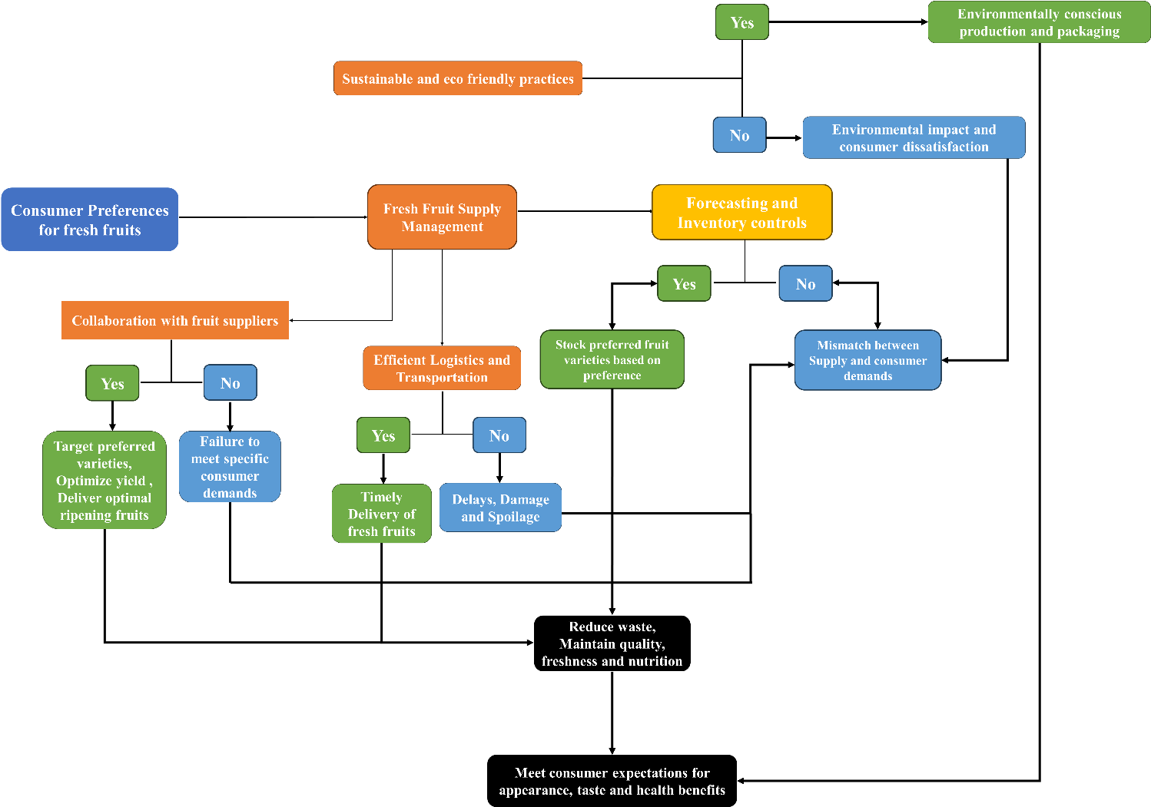
Fig 8: Supply chain efficiency and supply chains in meeting consumer preference
As consumer demand increasingly shifts toward high-quality and nutritious fruits, efficient supply chain management becomes essential for preserving product quality, reducing post-harvest losses, and maintaining a consistent supply of fresh produce [95]. Moreover, evolving consumer preferences have heightened the importance of supply chain activities in aligning market offerings with consumer expectations and supporting the growth of the fruit sector [96]. Effective collaboration among producers, suppliers, retailers, and distributors through information sharing, demand forecasting, and coordinated planning facilitates a better match between supply and consumer demand. Such collaboration enables suppliers to target preferred fruit varieties, optimize production, and deliver fruits at the desired stage of ripeness, thereby enhancing consumer satisfaction [97]. In addition, efficient logistics, inventory management, and distribution systems help minimize waste while ensuring the availability of high-quality fruits in the market. Therefore, the ability of the fruit industry to satisfy consumer preferences depends not only on the intrinsic characteristics of fruits but also on the efficiency of the supply chain, highlighting the need for strategies that integrate quality management, effective marketing, and sustainable production practices to achieve long-term sectoral growth and consumer satisfaction [98].

10. Role of Marketing in Shaping Fruit Preferences

In contrast to processed foods, fresh fruits are typically sold without any branding. Nonetheless, the significance of fruit sales and recognition proves that effective marketing can greatly enhance the desirability of these natural products [99]. Good product design and strategic sales locations are crucial for differentiating fruits in the market. For example, successful names for fruits such as Pink Lady apples, Cuties citrus, and Driscoll's strawberries create a unique identity and perception among consumers [100].

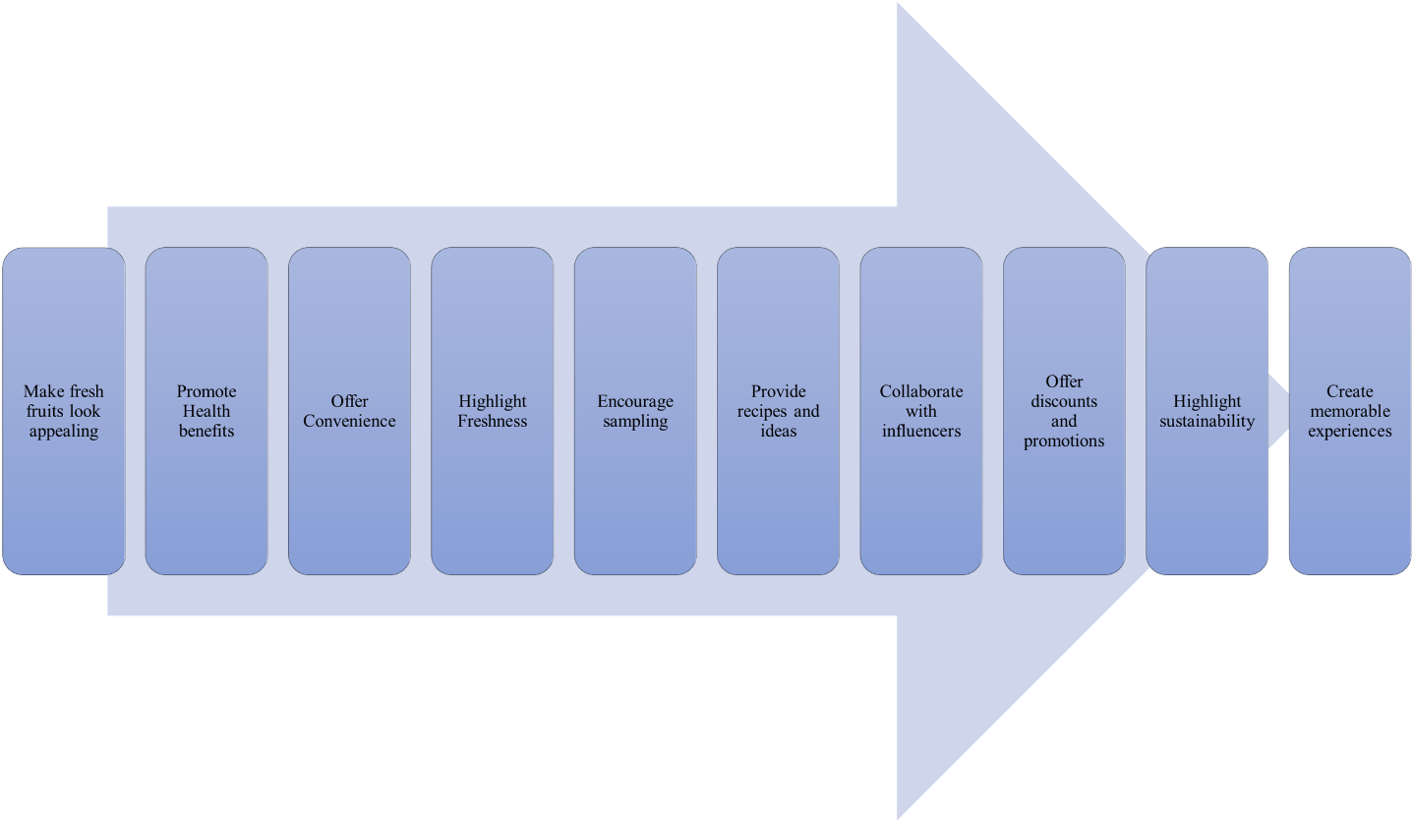

Fig 9: Marketing Strategies that enhance consumer preference

Implementing marketing techniques that address consumers' needs for convenience and added value can certainly influence their choice of favourite fruits. For instance, pre-cut and packaged fruit alternatives, as well as deliciously prepared fruit snacks and smoothies, make it easy for people to increase their daily fruit consumption. These convenient options not only provide children with fruit in their diet but also expose them to a variety of fruits [101].

A well-crafted marketing strategy (Fig 9) can successfully sway consumer preferences toward fresh produce by highlighting the health benefits of fruits and providing a range of in-store discounts, samples, and special promotions. Moreover, creatively designed displays, engaging tasting experiences, and enticing promotions encourage customers to explore the wide variety of fruits and make healthier choices. Additionally, this combination not only influences what consumers buy but also raises awareness and promotes trying and purchasing different types of fruits[102]. The packaging and labelling of fruits, which fall under marketing strategies, also significantly influence consumer preferences and purchasing decisions, and even eye-catching labels, vibrant packaging, and appealing colours can make fruits more attractive and intriguing for buyers to choose. Moreover, vital health and nutritional information on the labels can also affect consumer choices as it communicates the advantages of particular fruits[103].

Recent digital advancements like e-commerce platforms, digital tools, and AI-driven personalization have expanded the marketing opportunities for fresh fruits. Digital consumer behaviour studies show that convenience, variety, pricing incentives, and time-saving attributes are key motivators for purchasing fresh fruits online, particularly among younger and educated consumers [104]. Evidence from China’s online apple market highlights the strong influence of platform information like product origin, safety and eco-label certifications, sensory cues, store reviews, and product videos enhance consumer willingness to pay [105]. Beyond conventional digital marketing, AI and data-driven systems further reshape fruit preferences by enabling personalized recommendations, behavioural segmentation, and predictive targeting, which have been shown to increase engagement and transaction volumes for fresh produce [106].

11. Conclusion and way forward

The review highlights the complex array of factors shaping consumer preferences for fresh fruits, highlighting the influence of intrinsic qualities like appearance, flavour, texture, and shelf-life, as well as extrinsic factors such as pricing, perceived health benefits, convenience, and seasonality. Furthermore, demographic variables including age, location, income level, educational background, gender, and family dynamics contribute significantly to the diverse range of preferences observed. To cater to these varied demands, the review emphasizes the necessity of efficient supply chains that prioritize timely delivery, minimize waste, maintain product quality, and meet consumer expectations for freshness, taste, and nutritional value. Additionally, strategic marketing initiatives through branding, packaging, promotions, and product development can be crucial in shaping consumer perceptions and driving product adoption. As consumer awareness of health, sustainability, and ethical concerns grows, the review notes a discernible shift in preferences towards organic, locally-grown, and environmentally-friendly produce, driven by concerns over conventional agricultural practices.

Abbreviations

NHM National Horticulture Mission

PRISMA Preferred Reporting Items for Systematic Reviews and Meta-Analysis

W2P Willingness to Pay

SCM Supply Chain Management

MAP Modified Atmosphere Packaging

WTB Consumers’ Willingness to Buy

References
1. Webber, C.B., J. Sobal, and J.S. Dollahite, Shopping for fruits and vegetables. Food and retail qualities of importance to low-income households at the grocery store. Appetite, 2010. 54(2): p. 297-303.
2. Mukhamad, M., S.T.Y. Rahmat, P. Semerdanta, and H. Darmansyah, Implementation of McKinsey 7S management strategy concepts for startup business: Fruit combining. Russian Journal of Agricultural and Socio-Economic Sciences, 2020. 97(1): p. 133-141.
3. Lock, K., J. Pomerleau, L. Causer, D.R. Altmann, and M. McKee, The global burden of disease attributable to low consumption of fruit and vegetables: implications for the global strategy on diet. Bulletin of the World health Organization, 2005. 83: p. 100-108.
4. He, F.J., C.A. Nowson, M. Lucas, and G.A. MacGregor, Increased consumption of fruit and vegetables is related to a reduced risk of coronary heart disease: meta-analysis of cohort studies. Journal of human hypertension, 2007. 21(9): p. 717-728.
5. Rocha, A. and A. Morais. Role of Minimally Processed Fruit and Vegetables on the Diet of the Consumers in the XXIst Century. in International Conference on Quality Management of Fresh Cut Produce 746. 2007.
6. Kapoor, S. and N. Kumar, Fruit and vegetable consumers’ behavior: Implications for organized retailers in emerging markets. Journal of international food & agribusiness marketing, 2015. 27(3): p. 203-227.
7. Muhamad, Z.-M., N.A. Ruslan, N. Ibrahim, A. Saili, and N.A. Ismail. Factors affecting consumers’ choice in purchasing local fresh fruits: case of Melaka Tengah. in IOP Conference Series: Earth and Environmental Science. 2021. IOP Publishing.
8. Harker, F.R., F.A. Gunson, and S.R. Jaeger, The case for fruit quality: an interpretive review of consumer attitudes, and preferences for apples. Postharvest biology and technology, 2003. 28(3): p. 333-347.
9. He, C., L. Shi, Z. Gao, and L. House, The impact of customer ratings on consumer choice of fresh produce: A stated preference experiment approach. Canadian Journal of Agricultural Economics/Revue canadienne d'agroeconomie, 2020. 68(3): p. 359-373.
10. Page, M.J., J.E. McKenzie, P.M. Bossuyt, I. Boutron, T.C. Hoffmann, C.D. Mulrow, L. Shamseer, J.M. Tetzlaff, E.A. Akl, and S.E. Brennan, The PRISMA 2020 statement: an updated guideline for reporting systematic reviews. bmj, 2021. 372.
11. Kearney, J., Food consumption trends and drivers. Philosophical transactions of the royal society B: biological sciences, 2010. 365(1554): p. 2793-2807.
12. Micha, R., S. Khatibzadeh, P. Shi, K.G. Andrews, R.E. Engell, and D. Mozaffarian, Global, regional and national consumption of major food groups in 1990 and 2010: a systematic analysis including 266 country-specific nutrition surveys worldwide. BMJ open, 2015. 5(9): p. e008705.
13. Sandhya, Modified atmosphere packaging of fresh produce: Current status and future needs. LWT-Food Science and Technology, 2010. 43(3): p. 381-392.
14. Mason-D'Croz, D., J.R. Bogard, T.B. Sulser, N. Cenacchi, S. Dunston, M. Herrero, and K. Wiebe, Gaps between fruit and vegetable production, demand, and recommended consumption at global and national levels: an integrated modelling study. The Lancet Planetary Health, 2019. 3(7): p. e318-e329.
15. Evans, E.A., F.H. Ballen, and M. Siddiq, Mango production, global trade, consumption trends, and postharvest processing and nutrition. Handbook of mango fruit: production, postharvest science, processing technology and nutrition, 2017: p. 1-16.
16. Singh, Z. Lost fresh horticultural produce and maintenance of quality in supply Chain: Tropical and sub-tropical fruit. in II Southeast Asia Symposium on Quality Management in Postharvest Systems 1088. 2013.
17. Kumari, M., Estimation of demand supply gap and major constraints in production and marketing of major fruits and vegetables in Bihar, India. Int. J. Cur. Microb. Appl. Sci, 2017. 6(6): p. 2662-2672.
18. Guo, X., T. Tichar, B. Sikka, A. Bhoormal, K. Gesh, N. Sapna, K. Anand, and S. Kshyama, Scoping study on fruits and vegetables: results from India. 2021: Wageningen Economic Research.
19. Krebs-Smith, S.M., J. Heimendinger, B.H. Patterson, A.F. Subar, R. Kessler, and E. Pivonka, Psychosocial factors associated with fruit and vegetable consumption. American Journal of Health Promotion, 1995. 10(2): p. 98-104.
20. Basu, A., M. Rhone, and T.J. Lyons, Berries: emerging impact on cardiovascular health. Nutrition reviews, 2010. 68(3): p. 168-177.
21. Guenther, P.M., K.W. Dodd, J. Reedy, and S.M. Krebs-Smith, Most Americans eat much less than recommended amounts of fruits and vegetables. Journal of the American Dietetic Association, 2006. 106(9): p. 1371-1379.
22. Dettmann, R.L. and C. Dimitri, Who's buying organic vegetables? Demographic characteristics of US consumers. Journal of food products marketing, 2009. 16(1): p. 79-91.
23. Yiridoe, E.K., S. Bonti-Ankomah, and R.C. Martin, Comparison of consumer perceptions and preference toward organic versus conventionally produced foods: A review and update of the literature. Renewable agriculture and food systems, 2005. 20(4): p. 193-205.
24. Scott, M.L., S.M. Nowlis, N. Mandel, and A.C. Morales, The effects of reduced food size and package size on the consumption behavior of restrained and unrestrained eaters. Journal of consumer research, 2008. 35(3): p. 391-405.
25. Nielsen, A., Snack attack: what consumers are reaching for around the world. New York, USA, 2014.
26. STATE of the PLATE. 2015. https://fruitsandveggies.org/wp-content/uploads/2019/05/2015-State_of_the_Plate.pdf
27. Ledoux, T., M. Hingle, and T. Baranowski, Relationship of fruit and vegetable intake with adiposity: a systematic review. Obesity reviews, 2011. 12(5): p. e143-e150.
28. Schnettler, B., G. Lobos, E. Miranda-Zapata, M. Denegri, G. Ares, and C. Hueche, Diet quality and satisfaction with life, family life, and food-related life across families: A cross-sectional pilot study with mother-father-adolescent triads. International Journal of Environmental Research and Public Health, 2017. 14(11): p. 1313.
29. Jaeger, S.R. and H.J. MacFie, The effect of advertising format and means-end information on consumer expectations for apples. Food Quality and Preference, 2001. 12(3): p. 189-205.
30. Imram, N., The role of visual cues in consumer perception and acceptance of a food product. Nutrition & Food Science, 1999. 99(5): p. 224-230.
31. Aday, M.S. and U. Yener, Understanding the buying behaviour of young consumers regarding packaging attributes and labels. International Journal of Consumer Studies, 2014. 38(4): p. 385-393.
32. Poole, N. and L. Baron, Consumer awareness of citrus fruit attributes. British Food Journal, 1996. 98(1): p. 23-28.
33. Costell, E., A. Tárrega, and S. Bayarri, Food acceptance: The role of consumer perception and attitudes. Chemosensory perception, 2010. 3: p. 42-50.
34. Stiletto, A. and S. Trestini, Factors behind consumers' choices for healthy fruits: a review of pomegranate and its food derivatives. Agricultural and Food Economics, 2021. 9: p. 1-27.
35. Farcuh, M. and C. McPherson, Fruit Texture and the Science Behind It (FS-1189).
36. Barrett, D.M., J.C. Beaulieu, and R. Shewfelt, Color, flavor, texture, and nutritional quality of fresh-cut fruits and vegetables: desirable levels, instrumental and sensory measurement, and the effects of processing. Critical reviews in food science and nutrition, 2010. 50(5): p. 369-389.
37. Nayga Jr, R.M., Toward an understanding of consumers’ perceptions of food labels. The International Food and Agribusiness Management Review, 1999. 2(1): p. 29-45.
38. Giménez, A., F. Ares, and G. Ares, Sensory shelf-life estimation: A review of current methodological approaches. Food research international, 2012. 49(1): p. 311-325.
39. Prusky, D., Reduction of the incidence of postharvest quality losses, and future prospects. Food Security, 2011. 3: p. 463-474.
40. Mahajan, P., F. Oliveira, J. Montanez, and J. Frias, Development of user-friendly software for design of modified atmosphere packaging for fresh and fresh-cut produce. Innovative Food Science & Emerging Technologies, 2007. 8(1): p. 84-92.
41. Lin, B.-H., Food and Agricultural Commodity Consumption in the United States: looking ahead to 2020. 2003: US Department of Agriculture, Economic Research Service.
42. Sabbe, S., W. Verbeke, R. Deliza, V.M. Matta, and P. Van Damme, Consumer liking of fruit juices with different açaí (Euterpe oleracea Mart.) concentrations. Journal of food science, 2009. 74(5): p. S171-S176.
43. Onozaka, Y. and D.T. McFadden, Does local labeling complement or compete with other sustainable labels? A conjoint analysis of direct and joint values for fresh produce claim. American Journal of Agricultural Economics, 2011. 93(3): p. 693-706.
44. Xie, B., L. Wang, H. Yang, Y. Wang, and M. Zhang, Consumer perceptions and attitudes of organic food products in Eastern China. British food journal, 2015. 117(3): p. 1105-1121.
45. Adalja, A., J. Hanson, C. Towe, and E. Tselepidakis, An examination of consumer willingness to pay for local products. Agricultural and Resource Economics Review, 2015. 44(3): p. 253-274.
46. Drichoutis, A.C., P. Lazaridis, and R.M. Nayga Jr, Consumers' use of nutritional labels: a review of research studies and issues. Academy of marketing science review, 2006. 2006: p. 1.
47. Yue, C., F. Alfnes, and H.H. Jensen, Discounting spotted apples: investigating consumers' willingness to accept cosmetic damage in an organic product. Journal of Agricultural and Applied Economics, 2009. 41(1): p. 29-46.
48. Yahia, E.M., J. de Jesús Ornelas‐Paz, T. Emanuelli, E. Jacob‐Lopes, L.Q. Zepka, and B. Cervantes‐Paz, Chemistry, stability, and biological actions of carotenoids. Fruit and Vegetable Phytochemicals: Chemistry and Human Health, 2nd Edition, 2017: p. 285-346.
49. Williams, P.R. and J.K. Hammitt, A comparison of organic and conventional fresh produce buyers in the Boston area. Risk analysis, 2000. 20(5): p. 735-746.
50. Jabs, J. and C.M. Devine, Time scarcity and food choices: an overview. Appetite, 2006. 47(2): p. 196-204.
51. Ragaert, P., W. Verbeke, F. Devlieghere, and J. Debevere, Consumer perception and choice of minimally processed vegetables and packaged fruits. Food quality and preference, 2004. 15(3): p. 259-270.
52. Darby, K., M.T. Batte, S. Ernst, and B. Roe, Decomposing local: A conjoint analysis of locally produced foods. American Journal of Agricultural Economics, 2008. 90(2): p. 476-486.
53. Schroeter, C., L. House, and A. Lorence, Fruit and vegetable consumption among college students in Arkansas and Florida: food and culture vs. health knowledge. International Food and Agribusiness Management Review, 2007. 10(3): p. 63.
54. Williamson, S., A. Ball, and J. Pretty, Trends in pesticide use and drivers for safer pest management in four African countries. Crop protection, 2008. 27(10): p. 1327-1334.
55. Loebnitz, N., G. Schuitema, and K.G. Grunert, Who buys oddly shaped food and why? Impacts of food shape abnormality and organic labeling on purchase intentions. Psychology & Marketing, 2015. 32(4): p. 408-421.
56. Kader, A.A., Flavor quality of fruits and vegetables. Journal of the Science of Food and Agriculture, 2008. 88(11): p. 1863-1868.
57. Causse, M., C. Friguet, C. Coiret, M. Lépicier, B. Navez, M. Lee, N. Holthuysen, F. Sinesio, E. Moneta, and S. Grandillo, Consumer preferences for fresh tomato at the European scale: a common segmentation on taste and firmness. Journal of food science, 2010. 75(9): p. S531-S541.
58. Batte, M.T., N.H. Hooker, T.C. Haab, and J. Beaverson, Putting their money where their mouths are: Consumer willingness to pay for multi-ingredient, processed organic food products. Food policy, 2007. 32(2): p. 145-159.
59. Wang, H.H., X. Han, Y. Jiang, and G. Wu, Revealed consumers’ preferences for fresh produce attributes in Chinese online markets: A case of domestic and imported apples. Plos one, 2022. 17(6): p. e0270257.
60. Ikiz, D., R.K. Gallardo, A. Dhingra, and S. Hewitt, Assessing consumers’ preferences and willingness to pay for novel sliced packed fresh pears: A latent class approach. Agribusiness, 2018. 34(2): p. 321-337.
61. Willer, H. and J. Lernoud, The World of Organic Agriculture 2017. Statistics and Emerging Trends. 2017.
62. Rahman, S., M.A. Mele, Y.-T. Lee, and M.Z. Islam, Consumer preference, quality, and safety of organic and conventional fresh fruits, vegetables, and cereals. Foods, 2021. 10(1): p. 105.
63. Dangour, A.D., S.K. Dodhia, A. Hayter, E. Allen, K. Lock, and R. Uauy, Nutritional quality of organic foods: a systematic review. The American journal of clinical nutrition, 2009. 90(3): p. 680-685.
64. Bordeleau, G., I. Myers-Smith, M. Midak, and A. Szeremeta, Food Quality: A comparison of organic and conventional fruits and vegetables. 2002: Kongelige Veterinoer-og Landbohøjskole.
65. Reganold, J.P. and J.M. Wachter, Organic agriculture in the twenty-first century. Nature plants, 2016. 2(2): p. 1-8.
66. Pearson, D., J. Henryks, A. Trott, P. Jones, G. Parker, D. Dumaresq, and R. Dyball, Local food: understanding consumer motivations in innovative retail formats. British Food Journal, 2011. 113(7): p. 886-899.
67. Boca, G.D., Factors influencing consumer behavior in sustainable fruit and vegetable consumption in maramures county, Romania. Sustainability, 2021. 13(4): p. 1812.
68. Poole, N.D., L. Martı, and F.V. Giménez, Quality perceptions under evolving information conditions: Implications for diet, health and consumer satisfaction. Food policy, 2007. 32(2): p. 175-188.
69. Lanfer, A., K. Knof, G. Barba, T. Veidebaum, S. Papoutsou, S. De Henauw, T. Soós, L. Moreno, W. Ahrens, and L. Lissner, Taste preferences in association with dietary habits and weight status in European children: results from the IDEFICS study. International journal of obesity, 2012. 36(1): p. 27-34.
70. BULUT, O.D., Z.Ç. KAYSİM, and K. KARADAŞ, Determination of consumers’ fresh fruit and vegetable (FFV) purchasing preferences during the Covid-19 pandemic period: the case of Turkey. Ege Üniversitesi Ziraat Fakültesi Dergisi, 2022. 59(4): p. 567-577.
71. Lusk, J.L. and B.C. Briggeman, Food values. American journal of agricultural economics, 2009. 91(1): p. 184-196.
72. Lea, E., Food, health, the environment and consumers' dietary choices. Nutrition & dietetics, 2005. 62(1): p. 21-25.
73. Moser, R., R. Raffaelli, and D.D. Thilmany, Consumer preferences for fruit and vegetables with credence-based attributes: A review. International Food and Agribusiness Management Review, 2011. 14(1030-2016-82774): p. 121-142.
74. Gao, Z., L. House, F.G. Gmitter Jr, M.F. Valim, A. Plotto, and E.A. Baldwin, Consumer preferences for fresh citrus: impacts of demographic and behavioral characteristics. International Food and Agribusiness Management Review, 2011. 14(1030-2016-82898): p. 23-40.
75. Wardle, J., K. Parmenter, and J. Waller, Nutrition knowledge and food intake. Appetite, 2000. 34(3): p. 269-275.
76. Massaglia, S., D. Borra, C. Peano, F. Sottile, and V.M. Merlino, Consumer preference heterogeneity evaluation in fruit and vegetable purchasing decisions using the best–worst approach. Foods, 2019. 8(7): p. 266.
77. Pollard, J., S.L. Kirk, and J.E. Cade, Factors affecting food choice in relation to fruit and vegetable intake: a review. Nutrition research reviews, 2002. 15(2): p. 373-387.
78. De Visser, R.O. and E.J. McDonnell, “Man points”: Masculine capital and young men's health. Health psychology, 2013. 32(1): p. 5.
79. Levy, J. and G. Auld, Cooking classes outperform cooking demonstrations for college sophomores. Journal of nutrition education and behavior, 2004. 36(4): p. 197-203.
80. Dachner, N., L. Ricciuto, S.I. Kirkpatrick, and V. Tarasuk, Food purchasing and food insecurity: among low-income families in Toronto. Canadian Journal of Dietetic Practice and Research, 2010. 71(3): p. e50-e56.
81. Welch, N., S.A. McNaughton, W. Hunter, C. Hume, and D. Crawford, Is the perception of time pressure a barrier to healthy eating and physical activity among women? Public health nutrition, 2009. 12(7): p. 888-895.
82. Wyse, R., L. Wolfenden, and A. Bisquera, Characteristics of the home food environment that mediate immediate and sustained increases in child fruit and vegetable consumption: mediation analysis from the Healthy Habits cluster randomised controlled trial. International journal of behavioral nutrition and physical activity, 2015. 12(1): p. 1-9.
83. Beshara, M., A. Hutchinson, and C. Wilson, Preparing meals under time stress. The experience of working mothers. Appetite, 2010. 55(3): p. 695-700.
84. Rehm, C.D., J.L. Peñalvo, A. Afshin, and D. Mozaffarian, Dietary intake among US adults, 1999-2012. Jama, 2016. 315(23): p. 2542-2553.
85. Ruel, M.T., N. Minot, and L. Smith, Patterns and determinants of fruit and vegetable consumption in sub-Saharan Africa: a multicountry comparison. 2005: WHO Geneva.
86. Wang, X., Y. Ouyang, J. Liu, M. Zhu, G. Zhao, W. Bao, and F.B. Hu, Fruit and vegetable consumption and mortality from all causes, cardiovascular disease, and cancer: systematic review and dose-response meta-analysis of prospective cohort studies. Bmj, 2014. 349.
87. Cooke, L.J. and J. Wardle, Age and gender differences in children's food preferences. British journal of Nutrition, 2005. 93(5): p. 741-746.
88. Blanck, H.M., C. Gillespie, J.E. Kimmons, J.D. Seymour, and M.K. Serdula, Trends in fruit and vegetable consumption among US men and women, 1994–2005. Preventing chronic disease, 2008. 5(2).
89. Pollard, J., D. Greenwood, S. Kirk, and J. Cade, Motivations for fruit and vegetable consumption in the UK Women's Cohort Study. Public health nutrition, 2002. 5(3): p. 479-486.
90. Cullen, K.W., T. Baranowski, L. Rittenberry, C. Cosart, D. Hebert, and C. de Moor, Child-reported family and peer influences on fruit, juice and vegetable consumption: reliability and validity of measures. Health Education Research, 2001. 16(2): p. 187-200.
91. Hanson, N.I., D. Neumark-Sztainer, M.E. Eisenberg, M. Story, and M. Wall, Associations between parental report of the home food environment and adolescent intakes of fruits, vegetables and dairy foods. Public health nutrition, 2005. 8(1): p. 77-85.
92. Nakatani, J.K. and M.F. Neves, Supply chain planning and management method: the fruit purchasing company case. Revista Brasileira de Fruticultura, 2018. 40.
93. Balaji, M. and K. Arshinder, Modeling the causes of food wastage in Indian perishable food supply chain. Resources, Conservation and Recycling, 2016. 114: p. 153-167.
94. Wang, Y. and P.L. Zhang, Collaborative information research on fresh production under supply chain environment. Applied Mechanics and Materials, 2016. 851: p. 904-909.
95. Bisen, J., R. Patel, and K. Kundu, Marketing efficiency between traditional and modern supply chains of fruits and vegetables. Economic Affairs, 2018. 63(2): p. 441-447.
96. Chand, K., A. Suresh, M. Dastagiri, S. Kumar, and S. Mandal, Fruit marketing, its efficiency and supply chain constraints in India: A case study. 2021.
97. Yu, M. and A. Nagurney, Competitive food supply chain networks with application to fresh produce. European Journal of Operational Research, 2013. 224(2): p. 273-282.
98. Negi, S. and N. Anand, Supply chain efficiency: an insight from fruits and vegetables sector in India. Journal of operations and supply chain management, 2014. 7(2): p. 154-167.
99. Kleih, A.-K. and K. Sparke, Visual marketing: The importance and consumer recognition of fruit brands in supermarket fruit displays. Food Quality and Preference, 2021. 93: p. 104263.
100. Rickard, B.J., T.M. Schmit, M.I. Gomez, and H. Lu, Does the Name Matter? Developing Brands for Patented Fruit Varieties. 2011.
101. Pollard, C.M., M.R. Miller, A.M. Daly, K.E. Crouchley, K.J. O’Donoghue, A.J. Lang, and C.W. Binns, Increasing fruit and vegetable consumption: success of the Western Australian Go for 2&5® campaign. Public health nutrition, 2008. 11(3): p. 314-320.
102. Glanz, K., M.D. Bader, and S. Iyer, Retail grocery store marketing strategies and obesity: an integrative review. American journal of preventive medicine, 2012. 42(5): p. 503-512.
103. Grunert, K.G., L. Fernández-Celemín, J.M. Wills, S. Storcksdieck genannt Bonsmann, and L. Nureeva, Use and understanding of nutrition information on food labels in six European countries. Journal of public health, 2010. 18: p. 261-277.
104. C., S., & Mala, K. (2025). A comprehensive literature review on fresh fruits and vegetables marketing with reference to mobile app adoption. Asian Journal of Management and Commerce. https://doi.org/10.22271/27084515.2025.v6.i1n.581
105. Zhao, K., Shi, H., Zhang, Y. Y., & Sheng, J. (2021). Fresh Produce E-Commerce and Online Shoppers’ Purchase Intention. The Chinese Economy, 54, 415 - 429. https://doi.org/10.1080/10971475.2021.1890359
106. Marques, J. M. R., Torres, A., Behe, B., Langenhoven, P., & Boas, L. H. B. V. (2021). The Consumer Choice of Market for Fresh Fruits: A Study of Attitudinal Factors and Market Attributes. Journal of food distribution research, 52, 46-58. https://doi.org/10.22004/ag.econ.313451

