Matrix Rhythm Therapy Versus Interferential Therapy Combined with Lumbar Stabilization Exercises in Chronic Non-Specific Low Back Pain: A Randomized Comparative Trial
Lipika Mahajan¹, Dr. Deepak Yadav²
¹Student Researcher, MPT Musculoskeletal Disorders, Department of Physiotherapy, Dolphin (PG) Institute of Biomedical and Natural Sciences, Dehradun
²Guide, Heart-Lungs Transplant Physiotherapist, MPT Cardiopulmonary, Assistant Professor, Department of Physiotherapy, Dolphin (PG) Institute of Biomedical and Natural Sciences, Dehradun
ABSTRACT
Background: Chronic non-specific low back pain is a persistent musculoskeletal condition associated with pain, disability, impaired movement confidence, and reduced participation in daily life. Lumbar stabilization exercises are widely used in rehabilitation; however, the added value of different adjunct modalities remains uncertain.
Objective: To compare the effects of Matrix Rhythm Therapy and Interferential Therapy, each combined with lumbar stabilization exercises, on pain intensity, disability, and multidimensional pain perception in individuals with chronic non-specific low back pain.
Methods: Thirty participants with chronic non-specific low back pain were allocated to Matrix Rhythm Therapy plus lumbar stabilization exercises (MRT + LSE; n=15) or Interferential Therapy plus lumbar stabilization exercises (IFT + LSE; n=15). Interventions were delivered three times weekly for six weeks. Outcomes included the Numeric Pain Rating Scale (NPRS), Oswestry Disability Index (ODI), and McGill Pain Questionnaire, assessed at baseline and after intervention.
Results: Both groups improved after treatment. The MRT + LSE group showed larger mean reductions in NPRS (5.13 points), ODI (28.80 points), and McGill Pain Questionnaire scores (29.86 points) than the IFT + LSE group, which improved by 2.33, 18.00, and 17.27 points, respectively. Summary-based between-group analyses favored MRT + LSE for NPRS, ODI, and McGill outcomes.
Conclusion: Both interventions were associated with reductions in pain and disability; however, Matrix Rhythm Therapy combined with lumbar stabilization exercises produced greater improvements across all reported outcomes. Larger trials with corrected demographic reporting, allocation concealment, assessor blinding, and long-term follow-up are needed to confirm these findings.
Keywords: Chronic low back pain; Matrix Rhythm Therapy; Interferential Therapy; Lumbar stabilization; Physiotherapy; Rehabilitation.
Introduction
Low back pain is one of the most common musculoskeletal complaints encountered in clinical practice and remains a major contributor to disability, restricted activity, and health-care utilization.^{1,2,3} When symptoms persist for more than twelve weeks and no specific structural pathology is identified, the condition is commonly described as chronic non-specific low back pain.^{2,3} Its impact is not limited to pain intensity; patients frequently report reduced spinal mobility, impaired confidence in movement, fear of recurrence, and difficulty performing daily activities.⁴
Rehabilitation for chronic non-specific low back pain increasingly emphasizes active management.⁵ Lumbar stabilization exercises are designed to improve motor control and endurance of the deep trunk muscles, particularly the transversus abdominis, multifidus, diaphragm, and pelvic floor.^{6,7} These muscles contribute to segmental control and may reduce mechanical loading on pain-sensitive lumbar structures.^{6,7} Nevertheless, many patients with chronic pain require adjunctive strategies to reduce pain sufficiently to participate effectively in exercise.
Interferential Therapy is a commonly used electrotherapeutic modality for pain modulation.⁸ It is believed to reduce pain through stimulation of large-diameter afferent fibers, gate-control mechanisms, and possible endogenous opioid effects.^{8,9} In routine physiotherapy settings, it is often used before or alongside therapeutic exercise to improve patient comfort.
Matrix Rhythm Therapy is a mechanotherapeutic modality proposed to act through rhythmic oscillations applied to skeletal muscle and surrounding connective tissues.¹⁰ The therapy is intended to improve local tissue mobility, microcirculation, lymphatic drainage, and neuromuscular coordination.¹⁰ Although Matrix Rhythm Therapy has gained clinical use in musculoskeletal rehabilitation, comparative evidence against established modalities remains limited.^{10,11}
The present study compared Matrix Rhythm Therapy and Interferential Therapy, both combined with the same lumbar stabilization exercise program, in individuals with chronic non-specific low back pain. The primary focus was change in pain intensity, functional disability, and multidimensional pain perception after six weeks of intervention.
Methods
Study Design
A randomized comparative experimental study was conducted over a six-week intervention period. Participants were allocated to one of two active physiotherapy interventions: Matrix Rhythm Therapy combined with lumbar stabilization exercises or Interferential Therapy combined with lumbar stabilization exercises.
Population
Thirty participants with chronic non-specific low back pain were included, with 15 participants in each intervention group. Eligibility criteria included chronic low back pain lasting at least 12 weeks and baseline pain intensity of at least 4 on the Numeric Pain Rating Scale. Participants with spinal surgery, vertebral fracture, neurological deficits, systemic spinal pathology, pregnancy, or contraindications to electrotherapy were excluded.
Interventions
Group A received Matrix Rhythm Therapy for 20 minutes over the lumbar and paraspinal region, followed by supervised lumbar stabilization exercises. Group B received Interferential Therapy for 20 minutes over the lumbar region, followed by the same lumbar stabilization exercise program. Sessions were delivered three times per week for six weeks.
Outcome measures
Pain intensity was assessed using the Numeric Pain Rating Scale. Functional disability was measured using the Oswestry Disability Index. Multidimensional pain perception was measured using the McGill Pain Questionnaire. Outcomes were recorded at baseline and after completion of the six-week intervention.
Statistical Analysis
Descriptive statistics are presented as mean and standard deviation. Within-group changes were examined using paired t-tests. Effect size for within-group change was expressed as Cohen's dz. Between-group differences in improvement were calculated from reported summary statistics using independent-samples comparison of change scores. Hedges g was used to express standardized between-group effect size. A p-value of less than 0.05 was considered statistically significant. Because the original participant-level dataset was not available to the author of this manuscript draft, summary-based estimates should be verified before final journal submission.
Results
Within-group Outcomes
Outcome | Group | Baseline mean +/- SD | Post mean +/- SD | Mean improvement | 95% CI | t | p | Cohen dz
NPRS | MRT + LSE | 7.60 +/- 0.83 | 2.47 +/- 0.52 | 5.13 | 4.63 to 5.63 | 22.18 | <0.001 | 5.73
NPRS | IFT + LSE | 7.53 +/- 0.75 | 5.20 +/- 1.59 | 2.33 | 1.58 to 3.08 | 6.66 | 0.020 | 1.72
ODI | MRT + LSE | 50.93 +/- 4.19 | 22.13 +/- 3.90 | 28.80 | 26.29 to 31.31 | 24.60 | <0.001 | 6.35
ODI | IFT + LSE | 51.33 +/- 4.58 | 33.33 +/- 4.26 | 18.00 | 15.36 to 20.64 | 14.63 | <0.001 | 3.78
McGill Pain Questionnaire | MRT + LSE | 46.93 +/- 3.05 | 17.07 +/- 2.46 | 29.86 | 27.86 to 31.86 | 32.10 | <0.001 | 8.29
McGill Pain Questionnaire | IFT + LSE | 46.47 +/- 3.33 | 29.20 +/- 4.03 | 17.27 | 15.08 to 19.46 | 16.92 | <0.001 | 4.37
Table 1. Baseline, post-intervention, and within-group change scores.
Both intervention groups demonstrated improvements from baseline to post-intervention. Improvements were numerically larger in the Matrix Rhythm Therapy group across all measured outcomes.
Between-group Comparison of Improvement
Outcome | MRT + LSE improvement | IFT + LSE improvement | Mean difference | 95% CI | t | df | p | Hedges g
NPRS | 5.13 +/- 0.90 | 2.33 +/- 1.35 | 2.80 | 1.93 to 3.67 | 6.68 | 24.3 | <0.001 | 2.37
ODI | 28.80 +/- 4.53 | 18.00 +/- 4.77 | 10.80 | 7.32 to 14.28 | 6.36 | 27.9 | <0.001 | 2.26
McGill Pain Questionnaire | 29.86 +/- 3.60 | 17.27 +/- 3.95 | 12.59 | 9.76 to 15.42 | 9.12 | 27.8 | <0.001 | 3.24
Table 2. Summary-based between-group comparison of improvement scores.
The between-group estimates favored Matrix Rhythm Therapy combined with lumbar stabilization exercises. The largest standardized between-group effect was observed for the McGill Pain Questionnaire, followed by NPRS and ODI.
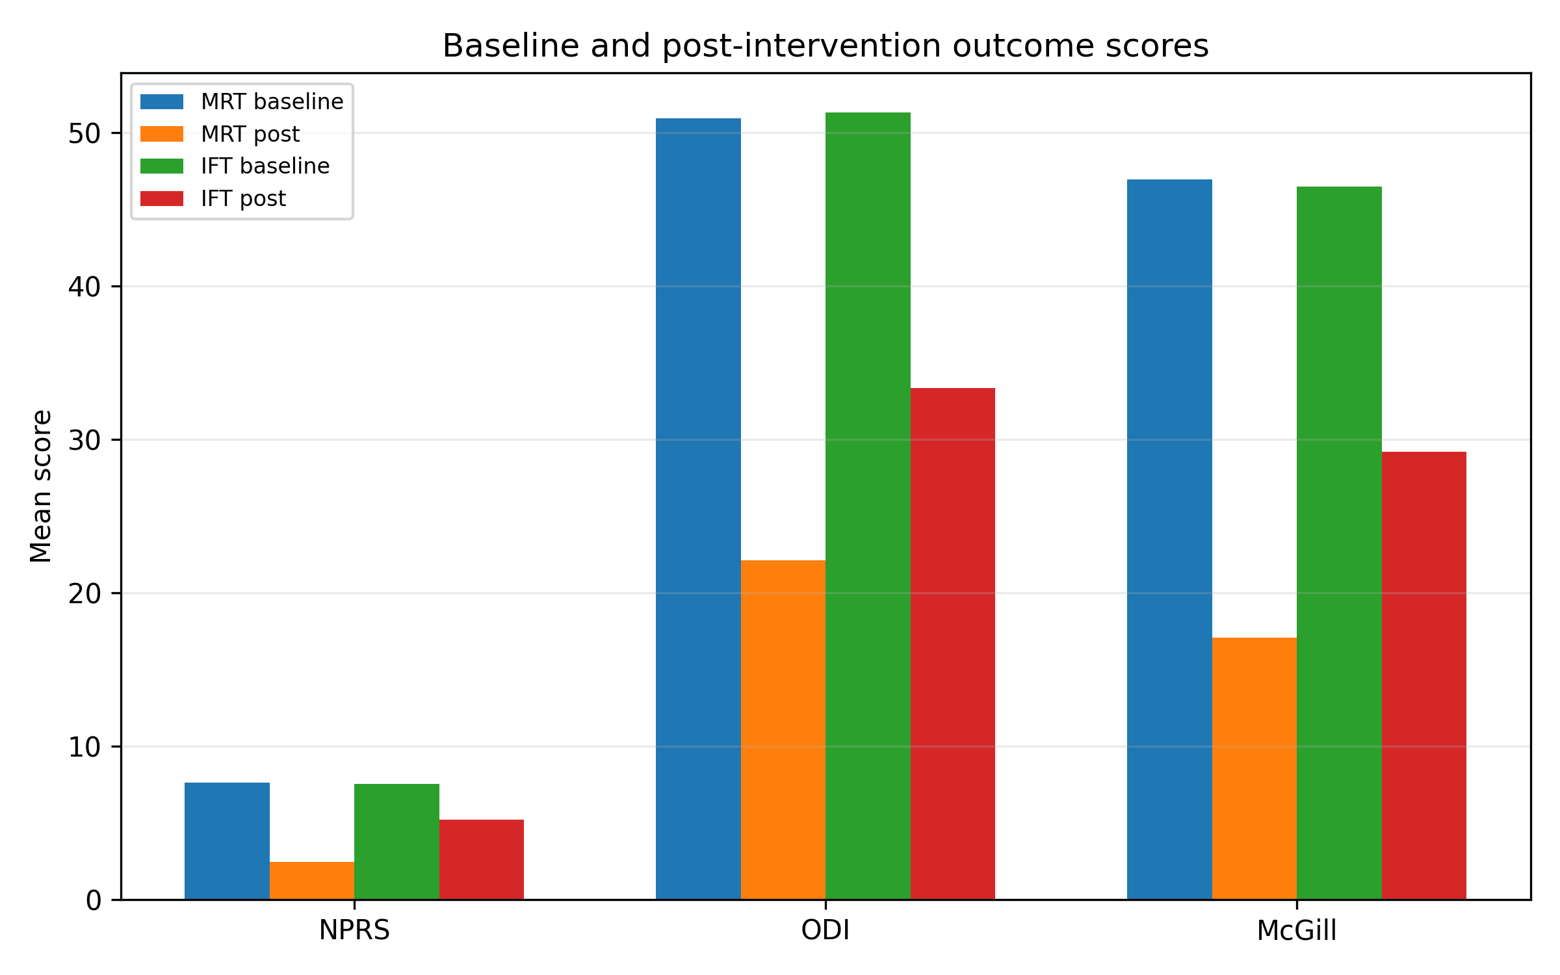
Figure 1. Mean baseline and post-intervention outcome scores by group.
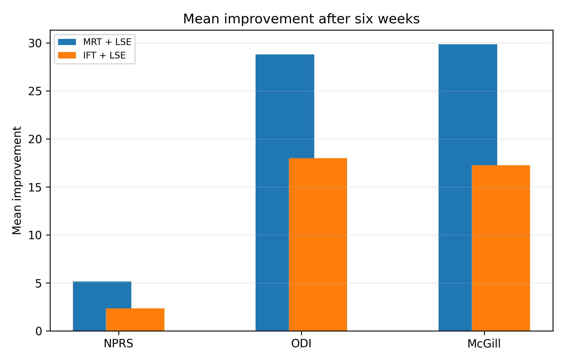
Figure 2. Mean improvement after six weeks by treatment group.
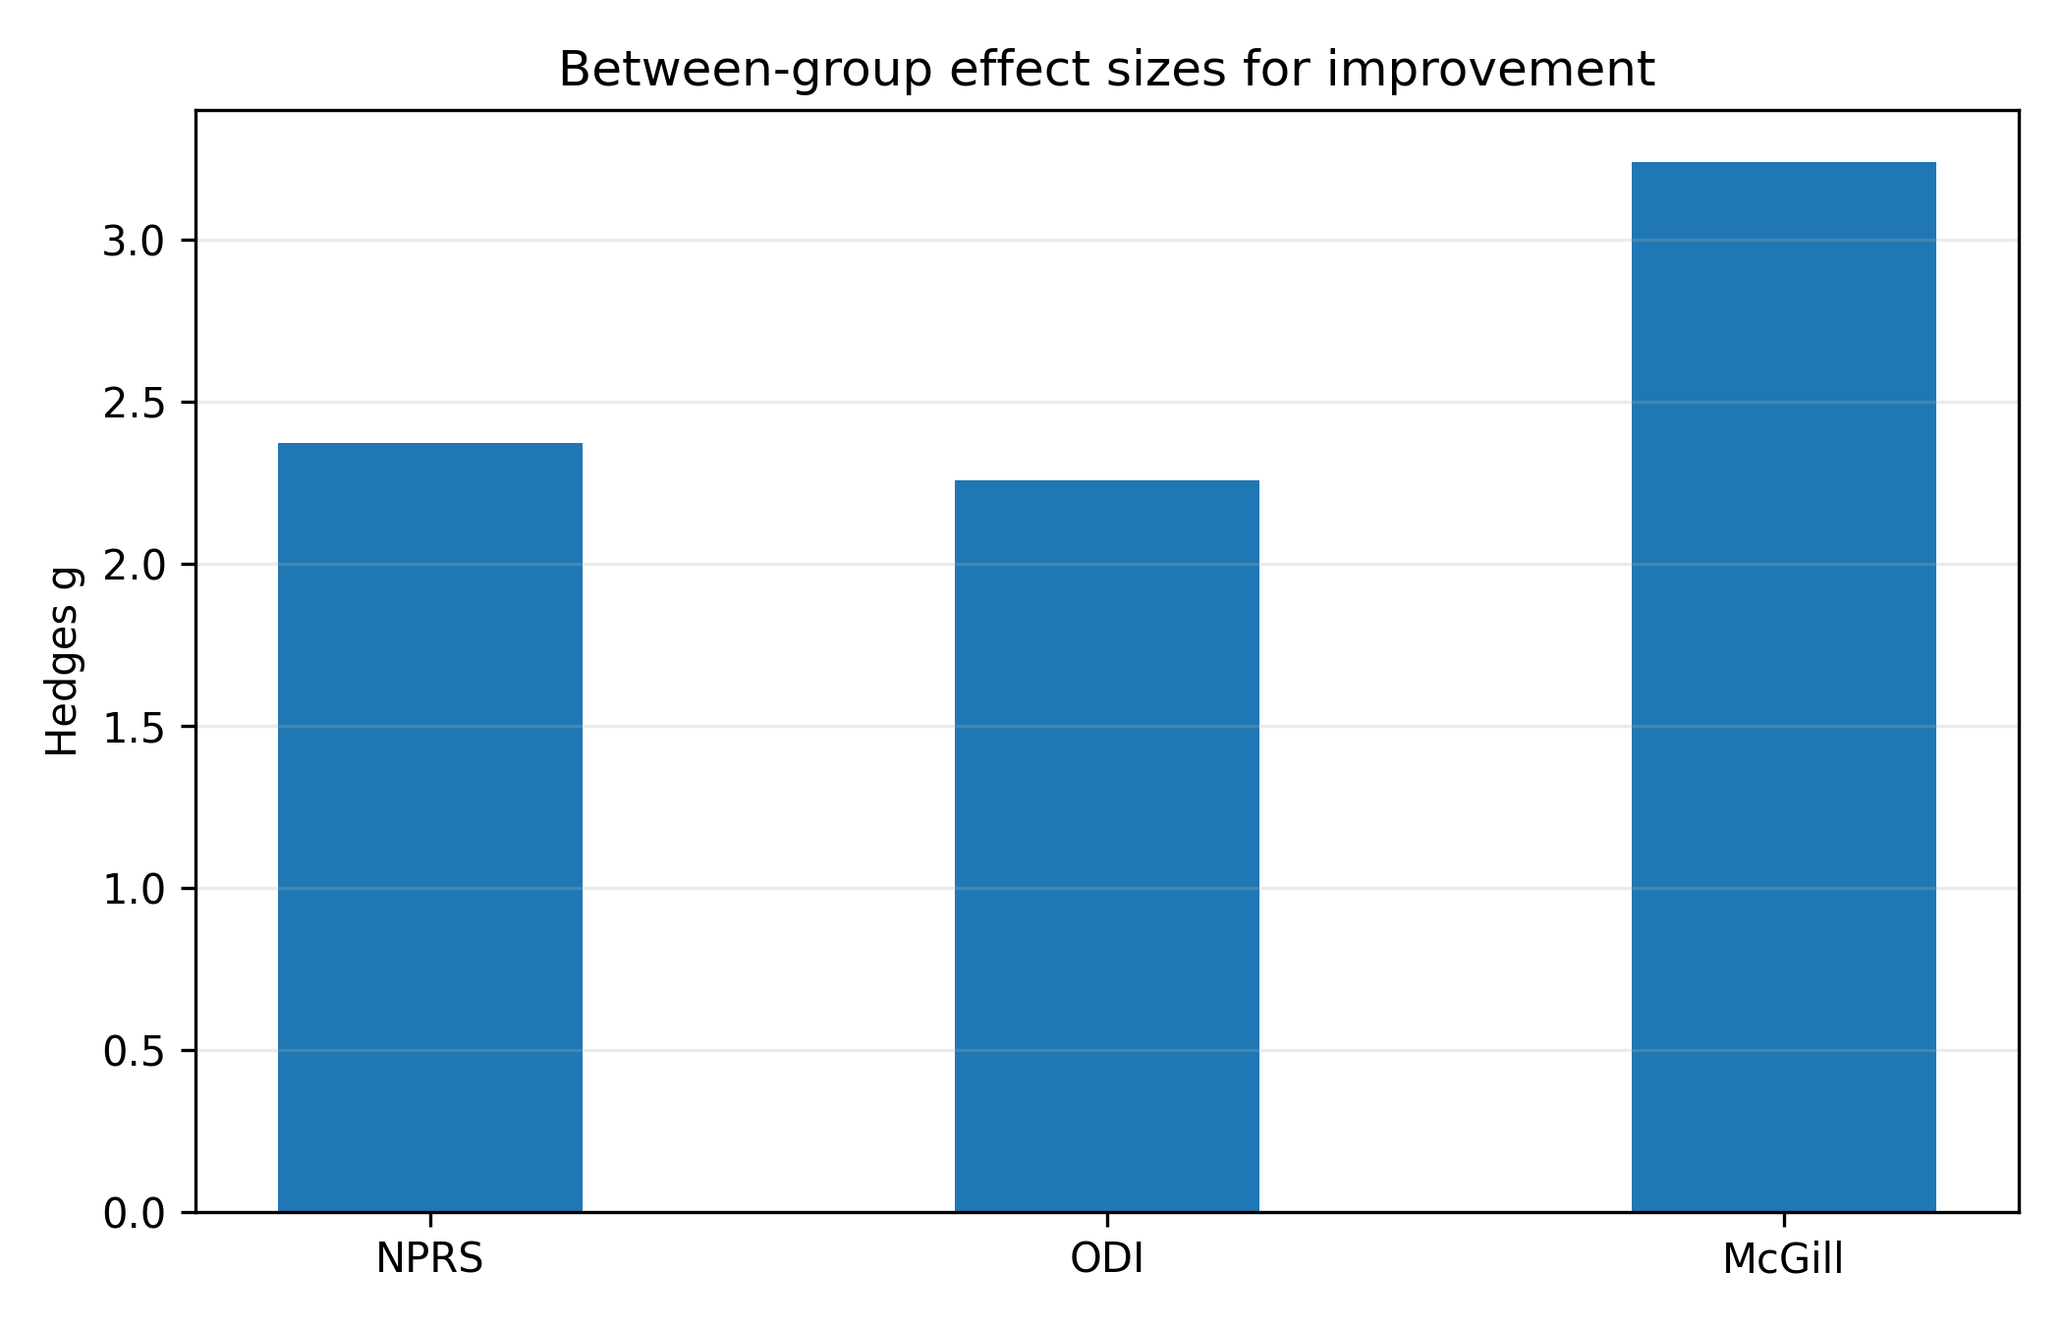
Figure 3. Summary-based between-group effect sizes expressed as Hedges g.
Discussion
This study found that both Matrix Rhythm Therapy and Interferential Therapy, when combined with lumbar stabilization exercises, were associated with meaningful improvements in pain intensity, disability, and pain perception among participants with chronic non-specific low back pain. The direction of findings was consistent across all three outcome measures, with greater improvement observed in the Matrix Rhythm Therapy group.
The larger reductions in pain and disability following Matrix Rhythm Therapy may reflect a treatment effect extending beyond short-term pain modulation.^{10,11} Matrix Rhythm Therapy is proposed to influence myofascial tone, local tissue mobility, microcirculation, and neuromuscular coordination. These effects may help reduce nociceptive input and improve tolerance to stabilization exercises. When participants are able to exercise with less discomfort, improvements in spinal control and functional performance may become more pronounced.^{6,7}
Interferential Therapy also improved outcomes, supporting its clinical role as an adjunct for pain relief in chronic low back pain rehabilitation.^{8,12,13} However, the magnitude of change was smaller than that observed in the Matrix Rhythm Therapy group. This may be because Interferential Therapy primarily targets sensory pain modulation, while chronic non-specific low back pain frequently involves motor control deficits, altered muscle activation, and myofascial restrictions that may require broader neuromuscular intervention.^{8,9}
The findings support the practical value of combining passive or adjunctive modalities with active rehabilitation. Lumbar stabilization exercises were common to both groups and likely contributed to improvements in spinal support, postural control, and confidence during movement.^{5,6,7,14} The results suggest that the choice of adjunct modality may influence the magnitude of clinical recovery.
Although the results are encouraging, they should be interpreted carefully. The study included only 30 participants, and the available dissertation report contained inconsistent age reporting. The absence of long-term follow-up also limits interpretation of durability. Future research should use adequately powered randomized controlled designs, transparent randomization and allocation procedures, assessor blinding, and objective measures of muscle function or physical performance.
Clinical Implications
- Matrix Rhythm Therapy may be considered as an adjunct to lumbar stabilization exercises in chronic non-specific low back pain rehabilitation.
- Interferential Therapy remains a useful pain-modulation modality, but improvements may be smaller when compared with Matrix Rhythm Therapy in this dataset.
- Active stabilization exercises should remain central to management, with adjunct modalities used to improve comfort, movement quality, and exercise participation.
- Clinicians should individualize modality selection according to patient presentation, tolerance, availability of equipment, and treatment goals.
Limitations
- Small sample size limits external validity.
- Participant-level demographic data were unavailable for this manuscript draft.
- Age reporting in the dissertation appears inconsistent with the inclusion criteria and must be corrected before submission.
- No long-term follow-up was reported.
- The between-group statistics in this draft are calculated from reported summary statistics and should be verified using the original dataset.
- Blinding, allocation concealment, and trial registration details were not clearly available in the provided dissertation text.
Conclusion
Matrix Rhythm Therapy and Interferential Therapy, when combined with lumbar stabilization exercises, were both associated with reductions in pain and disability among individuals with chronic non-specific low back pain. Matrix Rhythm Therapy produced greater improvements across NPRS, ODI, and McGill Pain Questionnaire outcomes in the available study results. These findings support further investigation of Matrix Rhythm Therapy as an adjunct to exercise-based rehabilitation, preferably through larger and methodologically rigorous randomized controlled trials.
Declarations
Ethics approval: Ethical approval was taken from the institutional Ethical Committee.
Consent to participate: Written informed consent was reported as part of the research protocol.
Conflict of interest: The authors declare none financial or non-financial competing interests.
Funding: No external funding is reported in the provided research.
Data availability: Data are available from the corresponding author on reasonable request, subject to institutional permission. The analysis in this draft is based on summary results reported in the research.
REFERENCES
- Vos T, Lim SS, Abbafati C, Abbas KM, Abbasi M, Abbasifard M, et al. Global burden of low back pain, 1990-2020: systematic analysis for the Global Burden of Disease Study. Lancet. 2020;396(10249):1204-1222.
- Airaksinen O, Brox JI, Cedraschi C, Hildebrandt J, Klaber-Moffett J, Kovacs F, et al. European guidelines for the management of chronic nonspecific low back pain. Eur Spine J. 2006;15(Suppl 2):S192-S300.
- Deyo RA, Weinstein JN. Low back pain. N Engl J Med. 2001;344(5):363-370.
- Vlaeyen JWS, Linton SJ. Fear-avoidance model of chronic musculoskeletal pain: 12 years on. Pain. 2012;153(6):1144-1147.
- Delitto A, George SZ, Van Dillen L, Whitman JM, Sowa G, Shekelle P, et al. Low back pain clinical practice guidelines. J Orthop Sports Phys Ther. 2012;42(4):A1-A57.
- Akuthota V, Nadler SF. Core strengthening. Arch Phys Med Rehabil. 2004;85(3 Suppl 1):S86-S92.
- Richardson CA, Hodges PW, Hides JA. Therapeutic Exercise for Lumbopelvic Stabilization. 2nd ed. Edinburgh: Churchill Livingstone; 2004.
- Fuentes JP, Armijo-Olivo S, Funabashi M, Miciak M, Dick B, Warren S, et al. Effectiveness of interferential current therapy in musculoskeletal pain. Phys Ther. 2010;90(9):1219-1238.
- Melzack R, Wall PD. Pain mechanisms: a new theory. Science. 1965;150(3699):971-979.
- Gohil DM, Kothari D, Baxi G, Palekar T. Comparison of matrix rhythm therapy versus Pilates on pain, lumbar flexibility, functional impairments, and pelvic inclination in chronic low back pain. Med J Dr DY Patil Vidyapeeth. 2023;16(Suppl 1):S126-S131.
- Özcan NT, Calik BB, Kabul EG. The effectiveness of matrix rhythm therapy in patients with chronic low back pain. Spine. 2021;46(12):781-787.
- Zuo C, Zheng Z, Ma X, Wei F, Wang Y, Yin Y, et al. Efficacy of core muscle exercise combined with interferential therapy in alleviating chronic low back pain in high-performance fighter pilots: a randomized controlled trial. BMC Public Health. 2024;24:700.
- Almeida N, Paladini LH, Korelo RG, Liebano RE, de Macedo ACB. Immediate effects of the combination of interferential therapy parameters on chronic low back pain: a randomized controlled trial. Pain Pract. 2020;20(6):615-625.
- Bhadauria EA, Gurudut P. Comparative effectiveness of lumbar stabilization, dynamic strengthening and Pilates exercises in chronic low back pain. Int J Physiother. 2017;4(2):70-76.

