AUTHOR DECLARATION
Publication/Manuscript Title: | AgriTrack: Digital Ordering Monitoring for Ttangkeut Green Farm
We, the undersigned proponents, hereby declare and certify that the manuscript titled above is an entirely original research and development work. It has not been published previously in any journal, proceedings, or academic platform, nor is it currently under review or consideration for publication elsewhere. Furthermore, all text, architectural designs, data, diagrams, and figures included within the manuscript are the direct results of our development and have not been closely copied, extracted, or duplicated from other sources without explicit, proper, and standard academic citation.
By appending our signatures below, we collectively acknowledge and confirm that each listed author has made substantial and direct contributions to the successful execution of this project. This includes active participation in requirements gathering, architectural framework design, front-end and back-end system development, agile testing phases, and the drafting or technical reviewing of this final manuscript. The sequence of authorship explicitly reflects our mutually agreed upon contributions.
We affirm that there are no financial, personal, commercial, or institutional conflicts of interest that could compromise, bias, or improperly influence the analysis, presentation, and metric evaluation of this work. The system deployment parameters were conducted strictly for academic validation, system testing, and operational optimization in collaboration with the designated farm management.
Author Name | Signature | Date Signed
Richard J. Barcelona Jr | 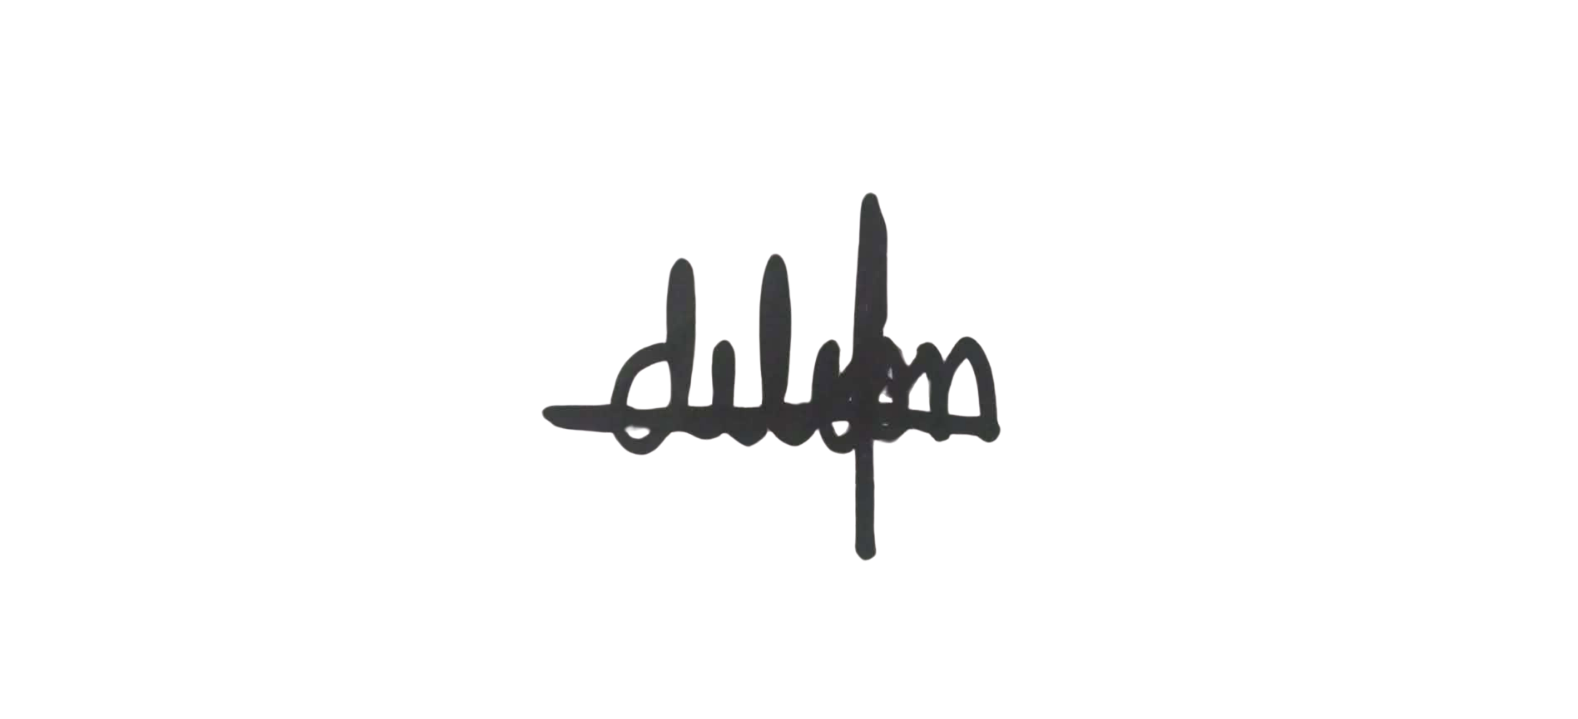 | 06/26/2026
Vincent T. De Leon | 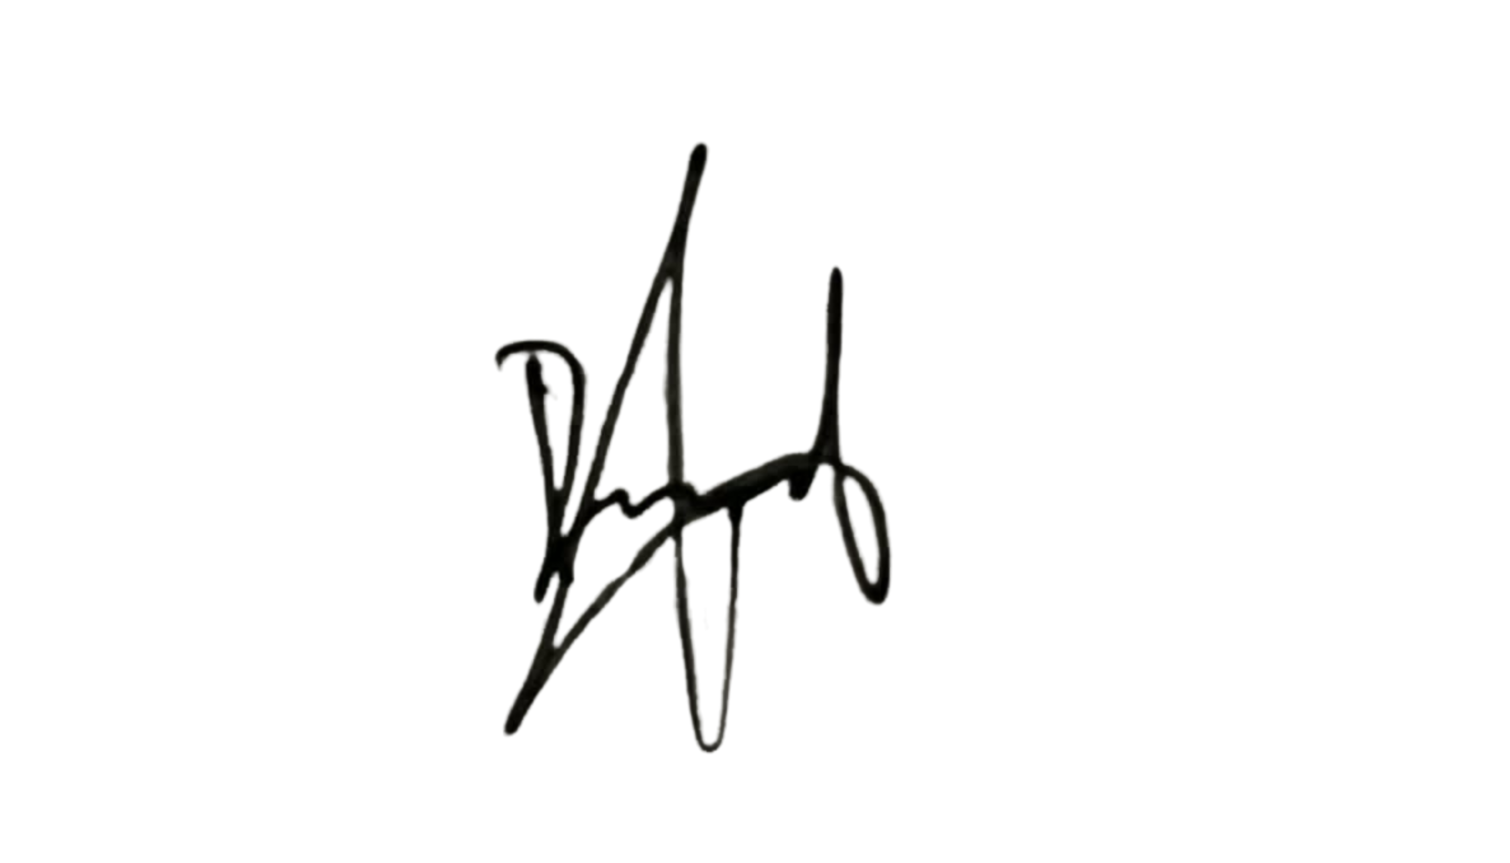 | 06/26/2026
Rodney R. Onias | 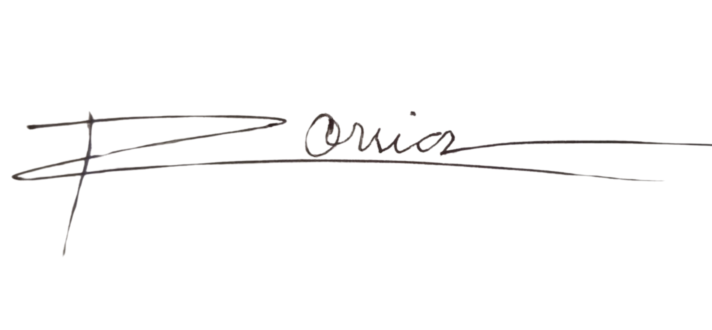 | 06/26/2026
Al Fadhl Q. Shuiaib | 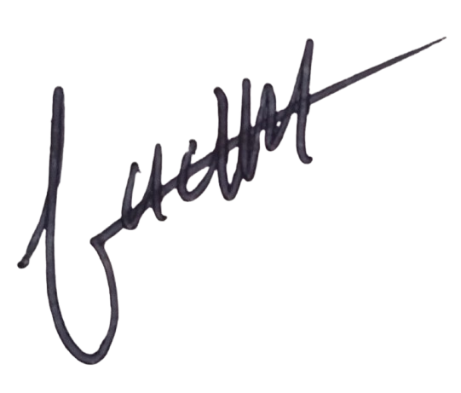 | 06/26/2026
Ruissan A. Ramos | 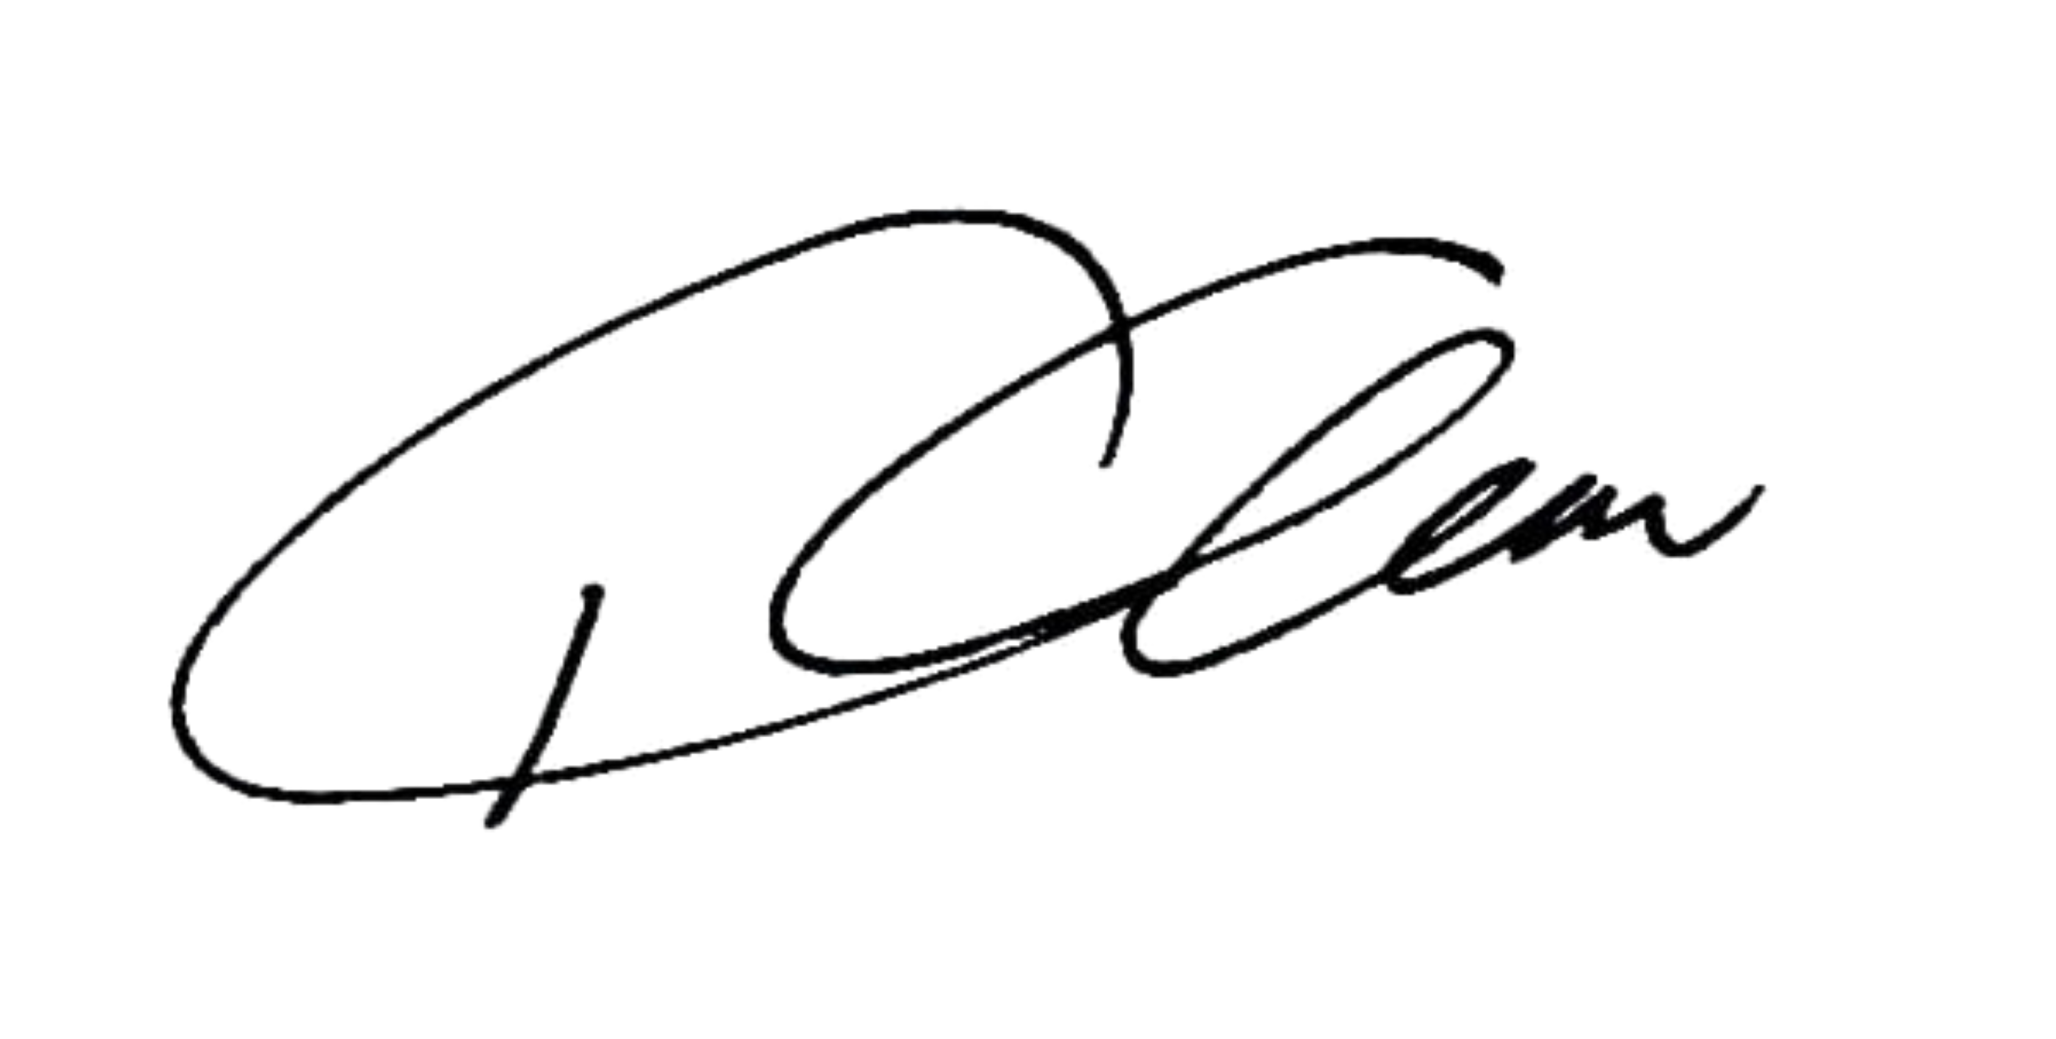 | 06/26/2026

