AgriTrack Digital Ordering Monitoring System For Ttangkkuet Green Farm.

Richard J. Barcelona Jr ¹, Vincent T. De Leon², Rodney R. Onias ³, Al Fadhl Q. Shuiaib ⁴, Ruissan A. Ramos⁵
Information Technology, Pangasinan State University, Alaminos City Campus
Rodney.onias123@gmail.com
The AgriTrack Digital Ordering Monitoring System for Ttangkkuet Green Farm is designed to resolve the challenges faced by the farm owner in managing their business operations. The system focuses on improving the way orders are handled by providing features such as order management, receipt printing, order tracking, customer reviews, and product customization. This study follows the Agile Methodology, which allows the system to be built step by step, with regular feedback to make sure it meets the needs of the users. The system includes important features such as a responsive web-based platform, real-time product availability tracking, manual confirmation and notifications, OTP verification, and digital payment options. To better understand the problems faced by the farm owner—such as receiving orders and writing receipts by hand—the researchers conducted interviews, direct observations, and reviewed related studies. A purposive sampling method was used to choose the right people to take part in the study. A total of 9 participants were selected, including the farm owner, business partners, and customers. To measure how well the system is accepted and used, a Likert Scale survey will be given to the participants. After collecting the responses, statistical analysis will be done to check the usability and performance of the system. By solving the issues in the current process, the AgriTrack Digital Ordering Monitoring System aims to improve how reservations and orders are managed. This will help make operations smoother and increase customer satisfaction at Ttangkkuet Green Farm.
Keywords—Tracking order, Managing Orders, customer reviews

I. INTRODUCTION
Throughout modern history, commerce has continuously evolved while maintaining its roots in traditional trading systems. In the past, people bought and sold goods through face-to-face interactions in local markets. Before the rise of technology, fresh produce such as fruits and vegetables was primarily distributed through small community vendors or direct farm sales [2], [4], [9]. As innovation progressed, businesses learned to adapt to new methods of selling and delivering goods. The emergence of the internet introduced e-commerce—an advanced platform that allows consumers to purchase products online with convenience and efficiency [1], [6], [7]. Today, e-commerce has transformed how people access fresh produce, enabling customers to order vegetables and fruits directly from farms or online marketplaces and have them delivered to their doorsteps [7], [10]. This evolution marks a significant milestone in connecting agricultural producers with consumers through digital technology [1], [6].
Urban communities increasingly rely on digital commerce platforms as they provide efficient and accessible ways for residents to purchase everyday goods [1], [7]. However, the system faces substantial challenges in product availability, delivery scheduling, and customer satisfaction. The combination of fluctuating demand and inconsistent supply of fresh produce often causes inefficiencies in the online fruit and vegetable market [8], [11]. Long delivery times and inconsistent product availability often lead to customer dissatisfaction in online produce shopping. Current systems for managing stock and order processing remain inefficient, causing delays and waste. Research shows that optimized inventory and ordering monitoring systems significantly reduce waiting times and improve overall shopping experiences [1], [6].
The AgriTrack Digital Ordering Monitoring System addresses these challenges through modern technological solutions that enhance customer convenience and operational accuracy in e-commerce [1], [7]. This study examines AgriTrack's development journey, focusing on its impact on user satisfaction and product freshness management. Through intelligent forecasting and automated logistics, AgriTrack predicts consumer demand and manages fresh produce inventory efficiently. The system utilizes real-time data and user feedback to continuously adjust stock levels and pricing, ensuring customers receive the freshest fruits and vegetables with maximum convenience [1], [6], [8].
The key element of AgriTrack lies in its user-friendly design, allowing customers to access the platform effortlessly through its web application interface. Users can conveniently browse available fruits and vegetables, place online orders, and track delivery progress. The developers designed the interface to accommodate users with varying levels of digital literacy, ensuring a smooth and accessible shopping experience for everyone [1], [5], [7]. Through its ordering and tracking features, the AgriTrack system streamlines the online shopping process while collecting valuable consumer data that aids in optimizing inventory and delivery algorithms. Aligned with modern e-commerce trends, this digital solution enhances operational efficiency and customer satisfaction by making the purchase of fresh produce faster, smarter, and more reliable [1], [6].
The deployment of AgriTrack offers comprehensive benefits to both farm owners and buyers, while simultaneously supporting sustainability goals [8], [12], [13]. The system features a dual-interface design: an administrator module for managing product restocking, inventory, users, and order tracking; and a user interface that allows for unrestricted purchasing. Customers can select from various vegetable categories, utilize multiple payment methods (debit card, credit card, or bank transfer), and receive automated e-receipts [1], [6], [7].
Objectives of the Study
The general purpose of this project is to design and develop an innovative AgriTrack Digital Ordering Monitoring System for Ttangkkuet Green Farm, which will streamline the ordering process, enhance customer convenience, and improve operational efficiency. Specifically, this study aims to:
- Identify and enhance the existing process of selling, marketing, and mapping farm products.
- Identify the difficulties encountered in the current manual process of selling and managing orders of the produce.
- Develop features for the system including automated order management, real-time stock monitoring, and secure checkouts.
- Determine the user-acceptance level of the developed system among stakeholders.
II. METHODOLOGY
The proposed system development utilizes the Agile methodology to combine descriptive and developmental approaches as the research framework. Surveys and interviews serve as descriptive research to obtain user feedback for system effectiveness evaluations. The Agile methodology, chosen for its iterative nature, flexibility, and emphasis on continuous improvement, consists of cyclical phases known as Sprints: Planning, Design, Development, Testing, and Review.
Fig. 1 Agile Methodology
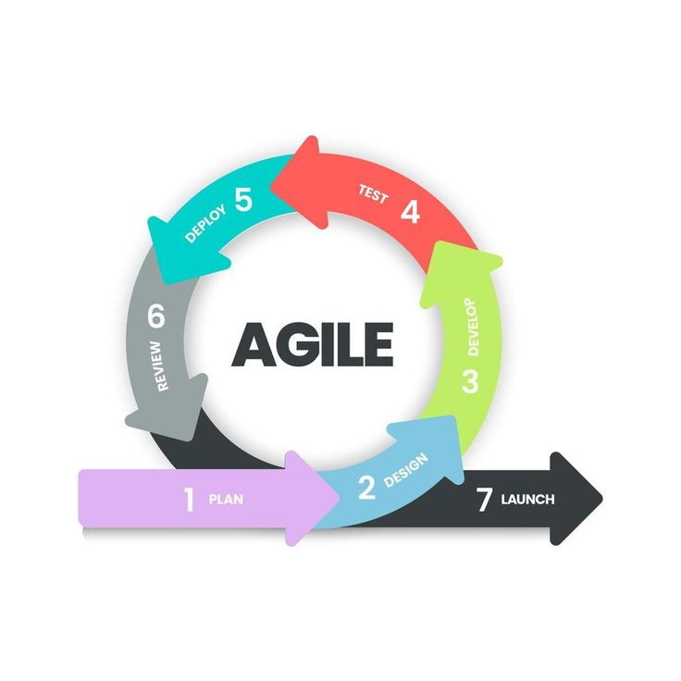

During the Planning phase, a combination of interviews and surveys collect data to define user stories and populate the product backlog for system needs identification. The Design phase involves close collaboration between stakeholders and developers to outline specific features using flowcharts for immediate validation. The Development phase involves using PHP in Visual Studio Code to build functional increments of the prototype until all requirements in the sprint backlog are satisfied. During the Review and Deployment phase, testing occurs to validate the software increment, followed by user training and system activation, which leads to immediate feedback loops and additional surveys that measure the system's adequacy and functional suitability.
The researchers analyzed the farm's existing business processes to identify operational bottlenecks. Primary data was gathered through an interview with the owner, Ms. Marilou Quitiquit, whose input revealed significant details regarding current operational obstacles. The findings highlighted a reliance on manual workflows, specifically for taking orders and checking inventory. On the other hand, customers face related challenges, such as receiving manually coded receipts and lacking a method to track their orders. These combined insights enabled the researchers to contextualize the findings and develop recommendations for system improvements. Additionally, a questionnaire was distributed to customers to rapidly acquire valuable information regarding their experiences.
Through the integration of these methodologies, tools, and technologies, the AgriTrack development process ensured a comprehensive, efficient, and user-centered solution for improving the shopping experience. By addressing key challenges in ordering, inventory, and tracking, the system aims to deliver a great experience in browsing and shopping.
AgriTrack System Features and Functional Capabilities To address the difficulties discovered during the business process review such as manual order taking, tracking absence, and inventory errors the AgriTrack system implements specific system features to modernize operations:
- Dual-Interface Platform: Includes an administrator control portal for restocking updates, user management, and inventory visibility, combined with an open client portal for unrestricted item access.

Fig. II Dual-Interface Platform: User Side
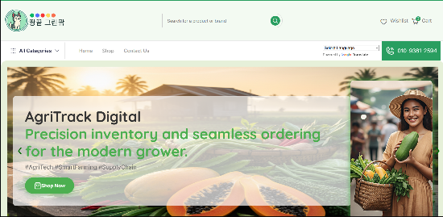
Fig. III Dual-Interface Platform: Admin Side
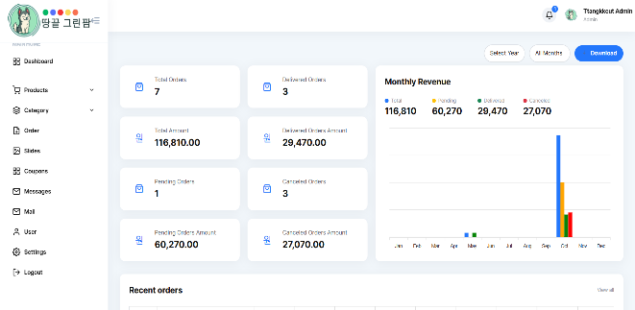
- Real-Time Availability Tracking: Monitors product quantities automatically within the centralized database, reducing waiting loops and minimizing stock conflicts.
Fig. IV Real-Time Availability Tracking
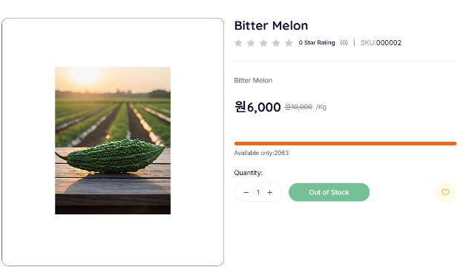
- Integrated Payments and E-Receipting: Embedded with secure digital checkouts (credit cards, debit cards, bank transfers) that automatically compile and print transactional receipts.
- Interactive Reviews and Customization: Contains fields for text reviews and product adjustments, allowing consumer data to assist in supply updates.

Fig. V Interactive Reviews and Customization
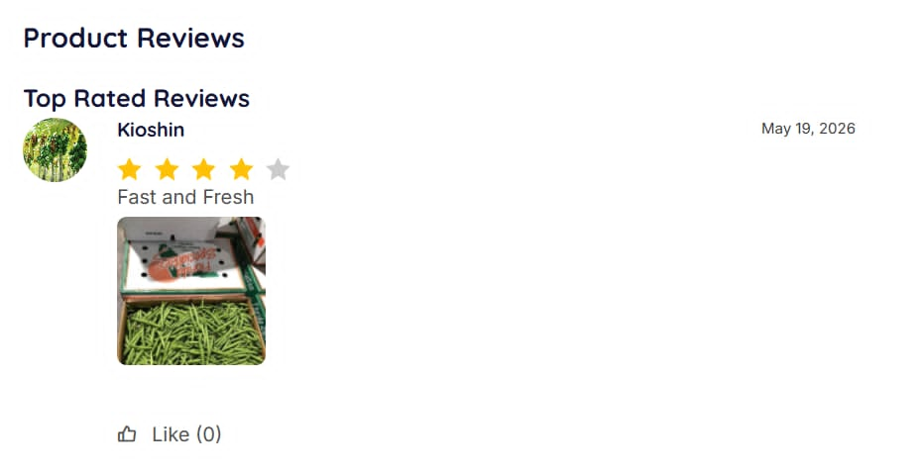
Environment and Respondents of the Study A purposive sampling method was used to choose the right people to take part in the study. A total of 9 participants were selected, structured across the specific deployment environment of the farm enterprise. Table I presents the profile of the respondents who participated in the investigation.

TABLE I. RESPONDENTS OF THE STUDY
Respondents | Number of respondents
Business Owner | 1
IT Experts | 2
Regular Customers | 7
Total | 10

Research Instrument and Statistical Treatment A survey questionnaire measured system acceptance and enhancement levels through a measurement scale designed based on Stanley Stevens' work. Statistical evaluation of the collected responses confirmed the system's usability through analysis methods. The researchers measured system assessment and improvement using a 5-point Likert Scale where Excellent received the highest rating of 5 while Poor had a lowest value of 1.
The weighted mean methodology allows more important data points to attain prominence in analyses. The set acceptance threshold for this system stood at 4.21 and above, which classified the system as Excellent. Statistical methods processed data from the Likert Scale survey which enabled meaningful conclusion-drawing along with statistical significance discovery and broad population reinterpretation. The scale and its statistical limits are illustrated in Table II below:

TABLE II. THE SCALE OF MEASUREMENT FOR ACCEPTANCE TEST Scale, Statistical Limits, Rating,
Scale Statistical limits Rating Interpretation
5 4.21 - 5.00 Excellent Accepted
4 3.41 – 4.20 Very Good Accepted
3 2.61 – 3.40 Good Accepted
2 1.81 – 2.60 Fair Not
1 1.00 – 1.80 Poor Not

III. RESULTS AND DISCUSSION
Fig. IV Three - Tier Architecture
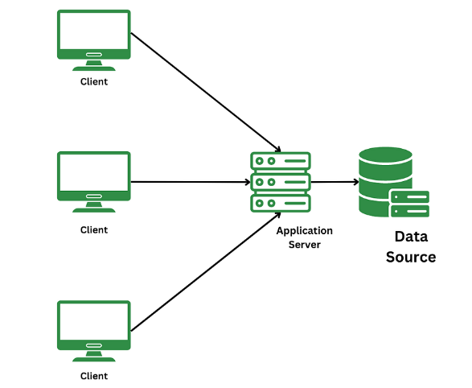
The proposed AgriTrack: Digital Ordering and Monitoring System utilizes a three-tier architecture, a well-established software application structure known for its scalability and efficiency. This architecture comprises the presentation tier, the application tier, and the data tier. In the proposed AgriTrack system architecture, the end users (consumers, riders, and admin) access the system online through the website application interface. The application server side accepts and processes various user-submitted requests such as ordering, inventory managing, and processing payments via this interface. The system efficiently processes these requests and stores user inputs securely in the database.
Presentation Tier In the proposed AgriTrack architecture, the presentation tier serves as the user-facing interface designed for a diverse consumer base. This tier encapsulates essential front-end functionalities, including user registration, product browsing, and payment gateway integration. It acts as the primary gateway for user interaction, allowing consumers to securely process payments and monitor order status throughout the delivery lifecycle. A combination of PHP programming with Visual Studio Code enabled the development team to create a visually appealing website that displays a variety of products, which simplified programming and testing. Shoppers gained an easy shopping experience on the system, which features a responsive design so the website can run on many various aspect ratios.
Application Tier The application tier functions as the system's logic engine, responsible for processing user inputs, optimizing performance, and enforcing data security. Core business logic, such as order request handling and inventory management, is centralized at this level to facilitate seamless communication between the user interface and data storage layers. By managing these critical tasks, the application tier ensures the system’s overall reliability and responsiveness to user demands.
Data Tier The data tier provides the structural foundation of the system, securely housing essential datasets related to products, users, logistics, and transactions. This tier focuses on data integrity and reliability, supporting the system’s long-term scalability and performance. By maintaining a robust database infrastructure, the data tier enables the system to handle high volumes of concurrent transactions and data queries with high efficiency. The integration of this three-tier architecture provides a scalable, secure, and efficient framework for the AgriTrack system.
IV. CONCLUSIONS
The development of the AgriTrack: Digital Ordering and Monitoring System successfully addressed the objectives of the study by providing a modern and efficient digital solution for Ttangkkuet Green Farm. Through the assessment of the farm’s existing processes, the study identified limitations in the traditional methods of selling, marketing, mapping products, and managing customer orders. The challenges encountered in the manual system, such as inefficient order tracking, inventory management difficulties, and limited customer accessibility, were thoroughly analyzed and considered during the system design and development.
To address these issues, the AgriTrack system was developed with key features including automated order management, real-time stock monitoring, secure checkout and payment processing, and an order tracking mechanism using unique tracking identifiers. These functionalities improved operational efficiency, enhanced customer convenience, and provided greater transparency throughout the purchasing process. The system's implementation on a web-based platform also enabled customers to access product information and services anytime, contributing to a more effective marketing and sales approach.
Furthermore, the system was developed using Agile Methodology, which promoted continuous stakeholder involvement and ensured that the resulting application met user requirements and expectations. The evaluation of the system revealed a positive level of user acceptance among stakeholders, indicating that AgriTrack is effective, reliable, and suitable for adoption. Overall, the AgriTrack: Digital Ordering and Monitoring System successfully streamlines the farm-to-consumer ordering process and establishes a scalable digital framework that supports the modernization and growth of agricultural commerce at Ttangkkuet Green Farm.
REFERENCES
[1] G. Taher, "E-Commerce: Advantages and Limitations," ResearchGate, 2021. Available: https://www.researchgate.net/publication/350235862
[2] A. B. Milford, G. Lien, and M. Reed, "Different sales channels for different farmers: Local and mainstream marketing of organic fruits and vegetables in Norway," Journal of Rural Studies, vol. 87, 2021. doi: 10.1016/j.jrurstud.2021.08.018
[3] P. Gittins and L. Morland, "Is Growing Better ripe for development? Creating an urban farm for social impact," International Journal of Entrepreneurship and Innovation, 2021. doi: 10.1177/14657503211000576
[4] P. Warsaw, S. Archambault, A. He, and S. Miller, "The Economic, Social, and Environmental Impacts of Farmers Markets: Recent Evidence from the US," Sustainability, vol. 13, no. 6, p. 3423, 2021. doi: 10.3390/su13063423
[5] Y. X. Lim and W. Zhang, "Examining the Impact of Source-product Congruence and Sponsorship Disclosure on the Communicative Effectiveness of Instagram Influencers," arXiv preprint, arXiv:2208.02453, 2022.
[6] VIPIN JAIN1, BINDOO MALVIYA, SATYENDRA ARYA (2021), An Overview of Electronic Commerce (e-Commerce). Retrieved on March 12, 2025 from https://www.researchgate.net/profile/Vipin-Jain-13/publication/351775073_An_Overview_of_Electronic_Commerce_e-Commerce/links/60a8d9af45851522bc0aed79/An-Overview-of-Electronic-Commerce-e-Commerce.pdf
[7] Zulkarnain Kedah (2023), Use of E-Commerce in The World of Business. Retrieved on March 12, 2025 from https://journal.pandawan.id/sabda/article/view/273/259
[8] Giller, K.E., Delaune, T., Silva, J.V. et al. (2021), The future of farming: Who will produce our food?. Retrieved on April 22, 2025 from https://doi.org/10.1007/s12571-021-01184-6
[9] Kamran Zendehdel, Brian W. Sloboda , and Eric Chad Horner (2021), Economic Impact Analysis of Farmers’ Markets in the Washington, DC Metropolitan Area: Evidence of a Circular Economy. Retrieved on April 22, 2025 from https://www.mdpi.com/2071-1050/13/13/7333
[10] Kusse Haile, Engida Gebre & Agegnehu Workye (2022), Determinants of market participation among smallholder farmers in Southwest Ethiopia: double-hurdle model approach. Retrieved on April 22, 2025 from https://doi.org/10.1186/s40066-022-00358-5
[11] Olaf Erenstein, Jordan Chamberlin and Kai Sonder (2021), Farms worldwide: 2020 and2030 outlook. Retrieved on April 22, 2025 from https://journals.sagepub.com/doi/epdf/10.1177/00307270211025539?src=getftr&utm_source=sciencedirect_contenthosting&getft_integrator=sciencedirect_contenthosting
[12] Peter Gittins, Leigh Morland (2021), Is ‘Growing Better’ ripe for development? Creating an urban farm for social impact. Retrieved on April 22, 2025 from https://journals.sagepub.com/doi/full/10.1177/14657503211000576#fn1-14657503211000576
[13] Phillip Warsaw, Steven Archambault, Arden He, Stacy Miller (2021), The Economic, Social, and Environmental Impacts of Farmers Markets: Recent Evidence from the US. Retrieved on April 22, 2025 from https://www.mdpi.com/2071-1050/13/6/3423

