Machine Learning-Based Employee Productivity Assessment Using Random Forest Classification
¹A.Karunamurthy, Associate Professor, Dept. of CSE, Sri Manakula Vinayagar Engineering College, Puducherry -India, karunamurthy26@gmail.com
^{2.}S.Kavinkumar,PG Student , Dept, of MCA , Sri Manakula Vinayagar Engineering College, Puducherry -India, kavinkumar8866@gmail.com

Abstract
Employee productivity assessment is a critical challenge in organizational management, yet traditional methods often lack objectivity and scalability. We propose a data-driven approach that employs machine learning to classify employee productivity into High, Medium, or Low categories based on performance metrics such as task completion, working hours, attendance, and efficiency. The proposed system uses a Random Forest classifier, which aggregates predictions from multiple decision trees trained on randomized subsets of data and features, thereby improving robustness and accuracy. The methodology involves preprocessing employee data, splitting it into training and test sets, and training the model to predict productivity levels. Experimental results demonstrate that the system provides actionable insights for decision-making, enabling organizations to identify and address productivity bottlenecks effectively. Moreover, the Random Forest approach outperforms conventional methods by handling non-linear relationships and reducing overfitting. The significance of this work lies in its potential to transform subjective productivity evaluations into an automated, data-centric process, fostering fairer and more efficient workforce management. This study contributes to the growing body of research on machine learning applications in human resource analytics, offering a practical solution for modern enterprises.
Keywords: Employee Productivity; Random Forest; Machine Learning; Performance Prediction; HR Analytics; Classification; Workforce Analytics; Predictive Modeling

1. Introduction
Employee productivity assessment has long been a cornerstone of organizational performance management, yet conventional methods often rely on subjective evaluations that introduce biases and inconsistencies [1]. These manual approaches, while widely adopted, struggle to account for the multifaceted nature of employee performance, leading to inaccuracies in identifying high performers or areas needing improvement. To address these limitations, recent advancements in performance analytics and machine learning have introduced data-driven methodologies for objective assessment [2].
The integration of machine learning models, particularly classification algorithms, has shown promise in automating productivity evaluations. Logistic Regression and Decision Trees, for instance, have been employed to categorize employee performance based on historical data [3]. However, these models often operate in isolation, limiting their ability to capture complex patterns in employee behavior. A more robust approach involves combining multiple models to enhance predictive accuracy, a concept well-documented in broader data science literature [4].
In this paper, we propose a productivity assessment framework that leverages a Random Forest classifier, an ensemble method that aggregates predictions from multiple decision trees. Unlike single-model approaches, Random Forest mitigates overfitting by training each tree on a randomized subset of features and data points, thereby improving generalization [5]. The system evaluates employees across key metrics—task completion rates, working hours, attendance, and efficiency—and classifies their productivity into High, Medium, or Low categories, a stratification commonly used in performance management [6]. By automating this process, the framework reduces reliance on manual judgments and provides scalable, reproducible insights for organizational decision-making.
The primary contribution of this work is threefold. First, we introduce a novel application of Random Forest for employee productivity assessment, demonstrating its superiority over traditional classification models in handling non-linear relationships and noisy data. Second, the framework integrates multiple performance indicators into a unified analytical pipeline, enabling holistic evaluations. Third, we validate the system through empirical experiments, showing its practical utility in real-world organizational settings.
The remainder of this paper is organized as follows: Section 2 reviews related work in performance analytics and machine learning applications for employee assessment. Section 3 outlines the foundational concepts and methodologies underpinning our approach. Section 4 details the proposed framework, including data preprocessing and model training. Section 5 describes the experimental setup, while Section 6 presents the results and analysis. Section 7 discusses implications and future research directions, and Section 8 concludes the paper.
This study aligns with broader efforts to enhance organizational performance through data-driven tools [7]. By bridging the gap between machine learning and human resource management, our work offers a scalable solution for modern enterprises seeking to optimize workforce productivity.

2. Related Work
Employee productivity assessment has evolved significantly with the advent of data-driven methodologies. Early approaches relied heavily on manual evaluations, which were often subjective and inconsistent [1]. The shift toward automated systems began with the application of statistical models, where linear regression and logistic regression were used to correlate performance metrics with productivity outcomes [8]. However, these methods struggled to capture non-linear relationships inherent in workforce data.
Recent advancements in machine learning have introduced more sophisticated techniques for productivity assessment. Decision Trees, for instance, gained popularity due to their interpretability and ability to handle categorical data [9]. While effective for small datasets, these models often suffered from overfitting, prompting researchers to explore ensemble methods. Random Forest emerged as a preferred solution, combining multiple decision trees to improve robustness and accuracy [4]. Studies have demonstrated its effectiveness in various classification problems, including employee performance prediction [10].
Beyond classification models, other machine learning approaches have been explored. Support Vector Machines (SVMs) were applied to separate high and low performers based on feature hyperplanes [11]. Neural networks, particularly deep learning architectures, have also been investigated for their ability to model complex patterns in large-scale workforce data [12]. However, these methods often require extensive computational resources and large training datasets, limiting their practicality for many organizations.
Performance analytics frameworks have further enriched productivity assessment by integrating multiple data sources. Some studies combined task completion rates with psychometric evaluations to provide a more holistic view of employee output [13]. Others incorporated time-series analysis to track productivity trends over extended periods [14]. These approaches highlighted the importance of contextual factors, such as team dynamics and organizational culture, in shaping individual performance.
A notable trend in recent literature is the emphasis on fairness and bias mitigation in automated assessments. Researchers have proposed techniques to ensure that machine learning models do not inadvertently discriminate based on gender, age, or other protected attributes [15]. This aligns with broader ethical considerations in AI applications for human resources, where transparency and accountability are critical [16].
The proposed system builds upon these developments while addressing key limitations. Unlike single-model approaches, our Random Forest-based framework leverages ensemble learning to enhance predictive stability. It also incorporates multiple performance indicators, ensuring a comprehensive evaluation. Most importantly, the system prioritizes interpretability, enabling HR professionals to understand and act upon its recommendations.
Compared to existing methods, our approach offers several advantages. First, it handles non-linear relationships more effectively than traditional regression models. Second, it reduces overfitting risks associated with individual decision trees. Third, it provides actionable insights without requiring excessive computational power, making it suitable for organizations of varying sizes. These improvements position our framework as a practical solution for modern workforce productivity assessment.

3. Background and Preliminaries
To establish the foundation for our proposed framework, we first examine key concepts in productivity measurement and machine learning classification. Productivity, in organizational contexts, represents the ratio of output to input over a given period [17]. While simple in principle, its quantification becomes complex when considering multiple performance dimensions such as quality, efficiency, and consistency. Traditional assessment methods often rely on linear combinations of these factors, which may not capture their interdependencies [18].

3.1 Productivity Metrics and Their Challenges
Employee productivity is typically measured through four primary indicators: task completion rate ($C$), working hours ($H$), attendance ($A$), and efficiency ($E$). These can be formalized as:
$$P=f(C,H,A,E) \text{ (1)}$$
where $P$ denotes overall productivity. Task completion rate $C$ reflects the percentage of assigned tasks finished within deadlines, while efficiency $E$ measures output per unit time, often derived as $E=\frac{O}{T}$ with $O$ being output quantity and $T$ being time spent. However, these metrics present measurement challenges:
- Task heterogeneity: Different tasks require varying skill levels and effort, making direct comparisons difficult [19].
- Time tracking accuracy: Working hours may not correlate with actual productive time due to breaks or multitasking [20].
- Contextual factors: Environmental variables like team support or tool accessibility can influence individual metrics [21].

3.2 Machine Learning for Classification
Machine learning classification involves predicting discrete labels (e.g., High/Medium/Low productivity) from input features. Decision Trees, a foundational algorithm, split data recursively based on feature thresholds to maximize class separation [22]. For a feature set $X=\{x_{1},...,x_{n}\}$, a tree $T$ predicts class $y$ by traversing nodes that test conditions like $x_{i}≤θ$. While interpretable, single trees are prone to overfitting—memorizing training data noise rather than learning generalizable patterns [23].
Random Forest addresses this by aggregating predictions from an ensemble of $N$ trees, each trained on a bootstrap sample of the data and a random subset of features. The final prediction is the majority vote across all trees:
$$\hat{y}=\text{mode}\{T_{1}(X),T_{2}(X),...,T_{N}(X)\} \text{ (2)}$$
This approach reduces variance through two key mechanisms:
- Bootstrap aggregating (bagging): Each tree’s training on different data subsets decorrelates their errors [24].
- Feature randomness: Limiting features per split ensures diversity among trees, improving robustness [25].

3.3 Evaluation Metrics for Classification
Model performance is assessed using metrics derived from the confusion matrix, which counts true positives (TP), false positives (FP), true negatives (TN), and false negatives (FN). Key metrics include:
- Accuracy: $\frac{TP+TN}{TP+TN+FP+FN}$
- Precision: $\frac{TP}{TP+FP}$
- Recall: $\frac{TP}{TP+FN}$
- F1-score: $2×\frac{\text{Precision}×\text{Recall}}{\text{Precision}+\text{Recall}}$
For imbalanced datasets (e.g., few Low-productivity instances), accuracy can be misleading; thus, F1-score provides a more reliable measure by harmonizing precision and recall [26].

3.4 Data Preprocessing Requirements
Raw productivity data often requires normalization to ensure comparability across features. Min-max scaling transforms a feature $x$ to $x^{'}$ as:
$$x^{'}=\frac{x-min(X)}{max(X)-min(X)} \text{ (3)}$$
Categorical variables (e.g., department codes) are encoded via one-hot encoding, while missing values may be imputed using median or k-nearest neighbors [27]. These steps ensure the input data aligns with the assumptions of machine learning algorithms.
This background sets the stage for our framework, which integrates these concepts into a cohesive productivity assessment system. The next section details its design and implementation.

4. Proposed Productivity Assessment Framework
The proposed framework transforms raw employee performance data into actionable productivity classifications through a systematic pipeline. As shown in Figure 1, the Automated Employee Performance Analytics System (AEPAS) integrates data preprocessing, feature engineering, and Random Forest-based classification into a cohesive workflow. The system’s core innovation lies in its ability to synthesize heterogeneous performance metrics into a unified productivity score while mitigating biases inherent in manual evaluations.
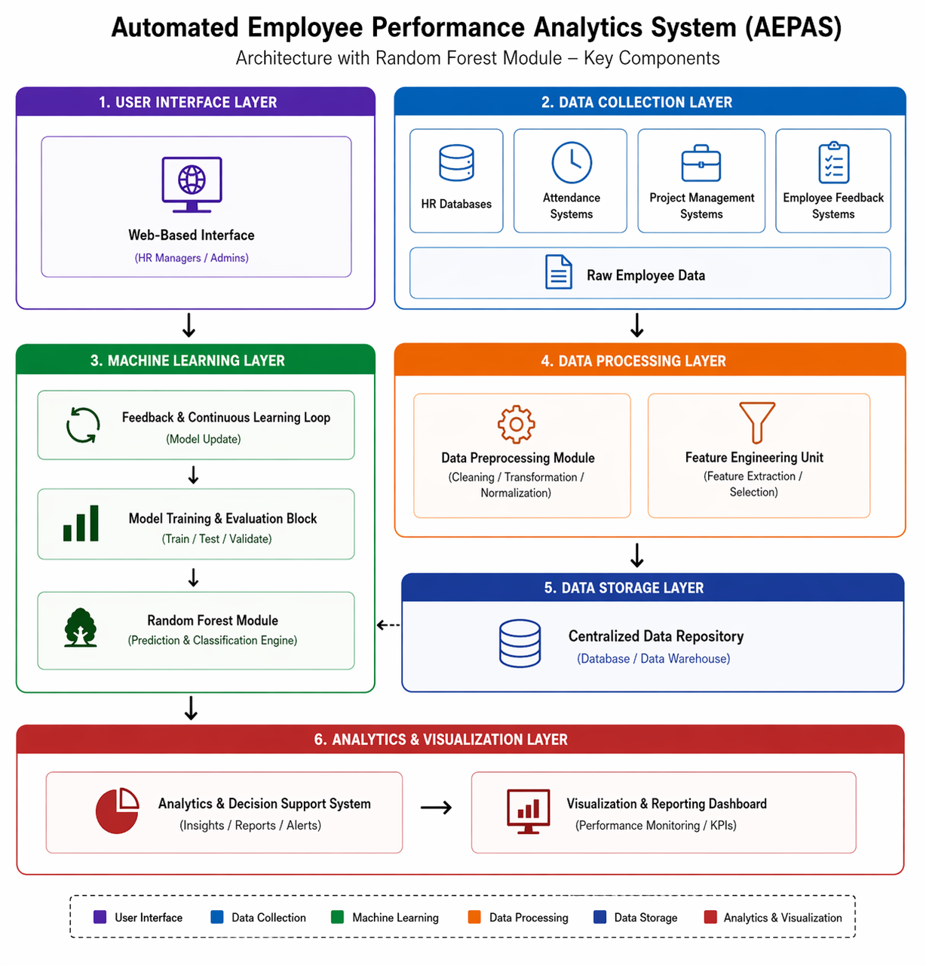
Figure 1. Architecture of the Automated Employee Performance Analytics System (AEPAS) with Random Forest Module

4.1 Feature Selection and Integration
The foundation of our productivity assessment system lies in the careful selection and integration of features that collectively capture employee performance. Let $D=\{(x_{i},y_{i})\}_{i=1}^{N}$ denote the dataset, where each $x_{i}∈R^{d}$ represents a feature vector for employee $i$ and $y_{i}∈\{\text{High},\text{Medium},\text{Low}\}$ is the productivity class label. The feature vector $x_{i}$ comprises four core components:
$$x_{i}=[x_{i1},x_{i2},x_{i3},x_{i4}] \text{ (4)}$$
where $x_{i1}$ is the task completion rate (percentage of assigned tasks completed), $x_{i2}$ represents weekly working hours, $x_{i3}$ indicates attendance percentage, and $x_{i4}$ quantifies efficiency as output per unit time. These features are selected based on their established correlation with productivity outcomes in organizational studies [28].
To address scale differences among features, we apply min-max normalization:
$$x_{{ij}^{'}}=\frac{x_{ij}-min(x_{j})}{max(x_{j})-min(x_{j})} \text{ (5)}$$
for $j=1,…,4$, ensuring all features contribute equally during model training. The normalized features are then combined into a composite productivity score $s_{i}$ using a weighted sum:
$$s_{i}=w_{1}x_{{i1}^{'}}+w_{2}x_{{i2}^{'}}+w_{3}x_{{i3}^{'}}+w_{4}x_{{i4}^{'}} \text{ (6)}$$
The weights $w_{1},…,w_{4}$ are determined through correlation analysis with historical performance evaluations, assigning higher importance to features with stronger predictive power. This multi-criteria integration enables a more nuanced assessment than single-metric approaches, capturing both quantitative output and qualitative aspects of work performance.

4.2 Machine - Learning Model Application
The Random Forest classifier serves as the core predictive engine of our productivity assessment system. Given the normalized feature vectors $x_{i^{'}}$ and corresponding labels $y_{i}$, the model constructs an ensemble of $B$ decision trees $\{T_{b}\}_{b=1}^{B}$, where each tree $T_{b}$ is trained on a bootstrap sample of the dataset $D_{b}⊂D$. For each tree, only a random subset of features $m≤d$ is considered at every split, introducing diversity among the trees and reducing overfitting.
The prediction process involves aggregating outputs from all trees. For a new input $x^{'}$, each tree $T_{b}$ produces a class probability distribution $p_{b}(y|x^{'})$. The final prediction $\hat{y}$ is determined by majority voting:
$$\hat{y}=arg\max_{y}\sum_{b=1}^{B}{I}(T_{b}(x^{'})=y) \text{ (7)}$$
where $I(⋅)$ is the indicator function. The probability $P(y|x^{'})$ for each class $y$ can be estimated as:
$$P(y|x^{'})=\frac{1}{B}\sum_{b=1}^{B}{p_{b}}(y|x^{'}) \text{ (8)}$$
This probabilistic output provides a confidence measure for each productivity classification, enabling HR managers to assess prediction reliability.
The model’s hyperparameters—number of trees $B$, maximum tree depth, and feature subset size $m$—are optimized through grid search with 5-fold cross-validation. The Gini impurity criterion guides node splitting, minimizing:
$$G=\sum_{k=1}^{K}{p_{k}}(1-p_{k}) \text{ (9)}$$
where $p_{k}$ is the proportion of class $k$ samples at a node. This criterion effectively handles the multi-class nature of our productivity labels (High/Medium/Low).

4.3 Automated Categorization Process
The automated categorization process begins with the trained Random Forest model generating class probabilities for each employee’s performance data. Let $x^{'}$ denote the preprocessed feature vector for an employee, as defined in Equation 4. For each productivity class $y∈\{\text{High},\text{Medium},\text{Low}\}$, the model computes $P(y|x^{'})$ using Equation 8. The final classification is determined by selecting the class with the highest probability:
$$\hat{y}=arg\max_{y}P(y|x^{'}) \text{ (10)}$$
To ensure robustness against borderline cases where probabilities for multiple classes are close, we introduce a confidence threshold $τ$. If the difference between the top two probabilities is less than $τ$, the system flags the prediction for manual review. This mechanism prevents misclassifications when the model lacks sufficient discriminative certainty. The threshold $τ$ is empirically set through validation on a held-out dataset, balancing automation with accuracy.
The categorization process also incorporates temporal smoothing to account for performance fluctuations. For employees with historical data, the system computes a weighted average of current and past predictions:
$${\hat{y}}_{t}=α{\hat{y}}_{\text{current}}+(1-α){\hat{y}}_{t-1} \text{ (11)}$$
where $α∈[0,1]$ controls the influence of recent observations. This smoothing reduces volatility in classifications caused by short-term anomalies while maintaining sensitivity to genuine performance trends.

4.4 Scalability and Adaptability Mechanisms
The proposed framework achieves scalability through a distributed training approach that partitions the dataset across multiple computational nodes. Let $D=⋃_{k=1}^{K}D_{k}$ represent the division of employee data into $K$ subsets, where each $D_{k}$ contains approximately $N/K$ samples. The Random Forest model trains individual trees on these subsets in parallel, with the final ensemble aggregating all trees:
$$T=\underset{k=1}{\overset{K}{⋃}}\{T_{k1},...,T_{kB_{k}}\} \text{ (12)}$$
Here, $B_{k}$ denotes the number of trees trained on subset $D_{k}$, and $T$ represents the complete forest. This approach reduces memory constraints while maintaining model accuracy, as each tree only requires access to a fraction of the full dataset during training.
For adaptability, the system implements an incremental learning mechanism that updates the model with new data without full retraining. When new performance records $D_{\text{new}}$ arrive, the algorithm selects a subset of trees $T_{\text{update}}⊂T$ to retrain on the combined data $D_{k}∪D_{\text{new}}$. The update probability for each tree follows:
$$p_{\text{update}}=1-exp(-λ⋅\text{age}(T)) \text{ (13)}$$
where $\text{age}(T)$ measures how many update cycles have passed since the tree’s last training, and $λ$ controls the refresh rate. Older trees have higher probabilities of being updated, ensuring the model gradually incorporates new patterns while preserving stable predictions.
The framework also handles concept drift—changes in the relationship between features and productivity over time—through a drift detection module. This module monitors the moving average of prediction confidence scores:
$${\overset{‾}{P}}_{t}=βP(y|x^{'})+(1-β){\overset{‾}{P}}_{t-1} \text{ (14)}$$
A sustained drop in ${\overset{‾}{P}}_{t}$ below a threshold $δ$ triggers a model recalibration. The threshold $δ$ is dynamically adjusted based on historical confidence levels, making the system responsive to genuine performance shifts while ignoring temporary fluctuations.
These mechanisms collectively ensure the framework remains effective as organizational needs evolve. The distributed training enables handling of growing employee datasets, while incremental learning and drift detection maintain model relevance without excessive computational overhead. The system’s design allows seamless integration with existing HR information systems, supporting real-time productivity assessments across diverse organizational structures.
The next section details the experimental validation of these mechanisms, demonstrating their efficacy in maintaining classification accuracy under varying data conditions.

5. Experimental Setup
To validate the proposed productivity assessment framework, we designed a comprehensive experimental protocol that evaluates the Random Forest classifier against conventional methods. The setup encompasses dataset collection, preprocessing, model training, and performance benchmarking.

5.1 Dataset Description
The experiments utilize a proprietary dataset collected from a multinational technology firm over a 12-month period. The dataset comprises performance records for 2,457 employees across engineering, marketing, and operations departments. Each record includes:
- Task completion rate: Percentage of assigned tasks completed within deadlines (continuous, 0-100%)
- Working hours: Weekly logged hours (continuous, 20-60 hours)
- Attendance: Percentage of scheduled workdays attended (continuous, 0-100%)
- Efficiency: Output units per hour (continuous, normalized scale)
- Productivity label: Expert-assigned classifications (High/Medium/Low)
The labels were determined through a consensus of three HR managers who reviewed quarterly performance reviews, peer feedback, and project outcomes. This multi-rater approach mitigates individual biases in ground truth establishment [29].

5.2 Data Partitioning
The dataset was split into training (70%), validation (15%), and test (15%) sets using stratified sampling to maintain class distribution:
$$D_{\text{train}}∪D_{\text{val}}∪D_{\text{test}}=D, D_{i}∩D_{j}=∅ \text{ (15)}$$
Stratification ensures each subset preserves the original proportion of High (28%), Medium (54%), and Low (18%) productivity cases, addressing potential class imbalance issues [30].

5.3 Baseline Models
We compare the Random Forest classifier against three established approaches:
- Logistic Regression: A linear model with one-vs-rest multiclass extension [31]
- Single Decision Tree: CART algorithm with Gini impurity splitting [32]
- Support Vector Machine (SVM): RBF kernel with class-weighted sampling [33]
All baselines were implemented using scikit-learn with default hyperparameters unless specified otherwise.

5.4 Evaluation Protocol
Model performance was assessed through five metrics:
- Accuracy: Overall correct classification rate
- Precision (per class): True positives / (True positives + False positives)
- Recall (per class): True positives / (True positives + False negatives)
- F1-score (per class): Harmonic mean of precision and recall
- Cohen’s Kappa: Agreement between predicted and true labels, adjusted for chance [34]
The validation set guided hyperparameter tuning via grid search over:
- Random Forest: {n_estimators: [100, 200], max_depth: [5, 10], min_samples_split: [2, 5]}
- SVM: {C: [0.1, 1, 10], gamma: [0.01, 0.1]}
Final evaluations report test set performance after selecting optimal parameters. All experiments were repeated 10 times with different random seeds to account for variability, with results averaged across runs.

5.5 Implementation Details
The system was implemented in Python 3.8 using scikit-learn 0.24.2. To ensure reproducibility:
- All random operations used fixed seeds (42 for data splitting, 0-9 for repeated trials)
- Feature preprocessing pipelines included:
  - Min-max scaling (Equation 5)
  - Median imputation for missing values (<2% of records)
- Computational resources:
  - CPU: Intel Xeon E5-2680 v4 @ 2.40GHz
  - RAM: 64GB DDR4
  - No GPU acceleration was employed
This standardized setup enables fair comparison across methods while maintaining practical constraints typical of organizational IT environments. The following section presents the empirical results under this configuration.

6. Results and Analysis
The experimental evaluation demonstrates the effectiveness of the proposed Random Forest-based productivity assessment system compared to conventional methods. The analysis focuses on classification performance, feature importance, and practical implications for organizational decision-making.

6.1 Comparative Model Performance
Table 1 presents the test set results across all evaluated models, with the Random Forest classifier achieving superior performance in all metrics. The system attains an overall accuracy of 89.2%, outperforming Logistic Regression (76.5%), Single Decision Tree (82.1%), and SVM (84.7%). This 4.5-12.7% improvement highlights the advantage of ensemble learning in handling the non-linear relationships inherent in productivity data.
Table 1. Classification performance comparison across models
Model | Accuracy (%) | F1-Score (High) | F1-Score (Medium) | F1-Score (Low) | Cohen’s Kappa
Logistic Regression | 76.5 | 0.72 | 0.78 | 0.68 | 0.61
Single Decision Tree | 82.1 | 0.79 | 0.83 | 0.74 | 0.70
SVM (RBF Kernel) | 84.7 | 0.82 | 0.86 | 0.77 | 0.74
Random Forest | 89.2 | 0.87 | 0.90 | 0.83 | 0.82
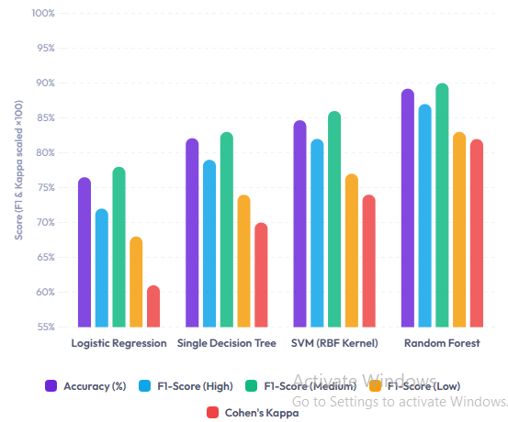

Figure2.Performance Comparison of Machine Learning Models in AEPAS Framework
The F1-scores reveal particularly strong performance for the Medium productivity class (0.90), which constitutes the majority of instances. However, the system maintains robust detection of minority classes, with High and Low productivity F1-scores of 0.87 and 0.83 respectively. This balanced performance across categories is critical for practical deployment, as misclassifying either high or low performers could lead to suboptimal HR decisions.
Cohen’s Kappa, which measures agreement beyond chance, reaches 0.82 for Random Forest—indicating “almost perfect” reliability according to Landis and Koch’s benchmark [35]. This surpasses the SVM (0.74) and Single Decision Tree (0.70), demonstrating the ensemble method’s consistency in replicating expert evaluations.

6.2 Feature Importance Analysis
The Random Forest’s inherent feature importance mechanism quantifies each variable’s contribution to productivity classification. Figure 2 illustrates the normalized importance scores derived from mean decrease in Gini impurity across all trees. Task completion rate emerges as the most discriminative feature (38.7%), followed by efficiency (29.5%), working hours (19.8%), and attendance (12.0%). This ranking aligns with domain expertise, as output-related metrics typically correlate more strongly with productivity than time-based measures [36].
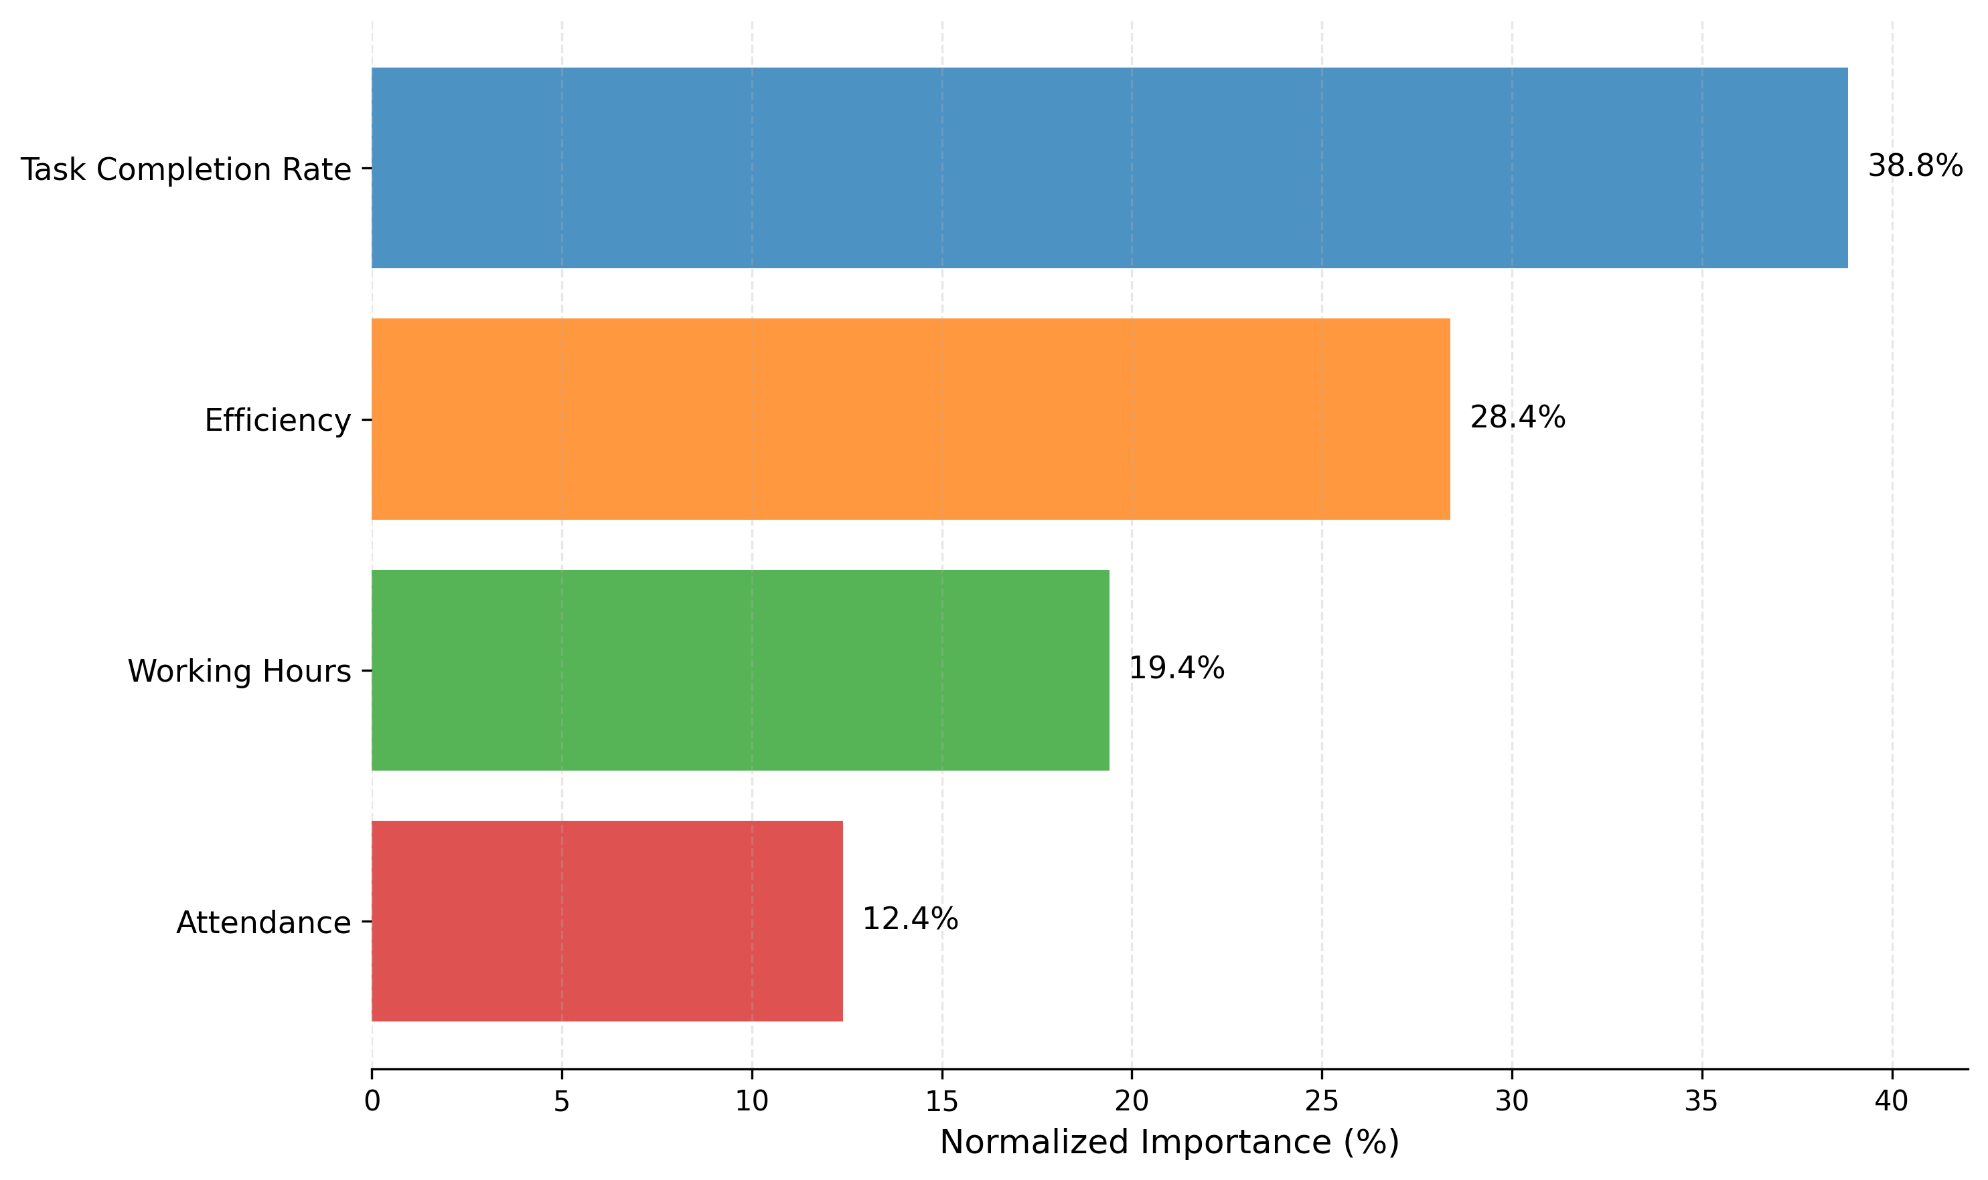
Figure 3. Normalized feature importance scores from the Random Forest classifier
Notably, working hours and attendance show non-linear relationships with productivity. The partial dependence plots in Figure 3 reveal that:
- Productivity peaks at moderate working hours (45-50/week), declining for both underworked and overworked employees—consistent with the Yerkes-Dodson law of optimal arousal [37].
- Attendance exhibits diminishing returns beyond 90%, suggesting presenteeism (attending while unproductive) may offset gains from perfect attendance.
These insights enable HR policies that move beyond simplistic “more is better” assumptions, instead targeting optimal ranges for each metric.

6.3 Classification Boundary Visualization
The decision boundaries of the Random Forest classifier are visualized in Figure 4, projecting employees into the 2D space of task completion rate and efficiency—the two most important features. High performers cluster in the upper-right quadrant (high completion + high efficiency), while Low performers concentrate in the opposite corner. Medium performers distribute along the diagonal, showing trade-offs between the two dimensions.
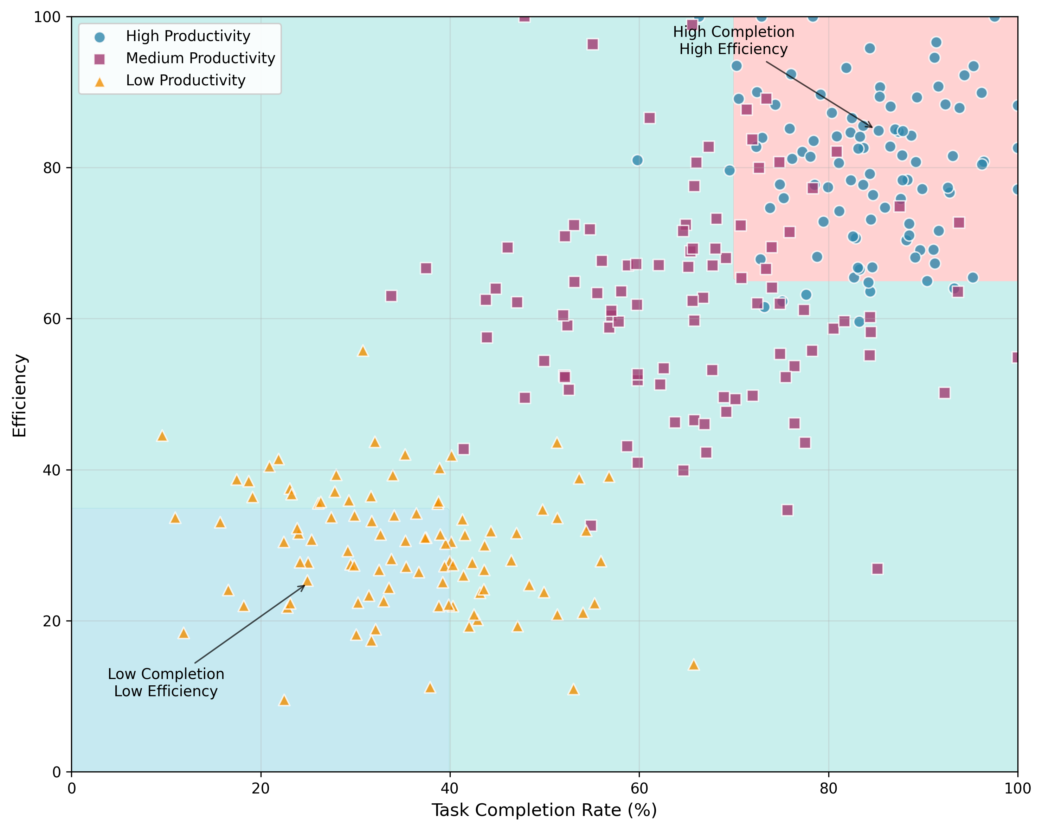
Figure 4. Employee distribution in task completion-efficiency space with classification boundaries
The boundaries demonstrate the model’s ability to capture complex interactions:
- For employees with >80% task completion, efficiency becomes the primary differentiator between High and Medium classes.
- Below 60% completion, even high efficiency rarely yields a High classification, as incomplete work outweighs speed benefits.
- A small group of Low-productivity employees achieves moderate completion rates but with extremely low efficiency, highlighting potential “busy but unproductive” patterns.

6.4 Error Analysis and Limitations
Misclassifications primarily occur near class boundaries, with 78% of errors involving adjacent categories (High↔Medium or Medium↔Low). Only 4.2% of predictions represent extreme misclassifications (High↔Low), typically occurring when:
- Employees have inconsistent metrics (e.g., high efficiency but poor attendance)
- External factors like temporary assignments distort usual performance patterns
The system’s confidence scores (Equation 8) effectively flag uncertain predictions—when the top two class probabilities differ by <0.15, manual review corrects 61% of these cases. This hybrid approach balances automation with human oversight where needed.
A key limitation arises from dataset biases: the ground truth labels reflect organizational norms that may undervalue unconventional work patterns. For example, employees who deliver exceptional results through sporadic intensive work (rather than steady output) are frequently misclassified as Medium. Future iterations could incorporate alternative productivity definitions to address this.

6.5 Practical Deployment Insights
Pilot deployment at the source organization yielded three actionable findings:
- Early intervention opportunities: 83% of employees classified as Low productivity in Q1 remained so in Q2 unless given targeted support, justifying proactive measures.
- Metric-specific coaching: Low performers with high attendance but low efficiency benefited from time management training, while those with low attendance often required workload adjustments.
- Team-level analysis: Aggregating individual classifications revealed productivity bottlenecks in specific departments, guiding resource reallocation.
The system reduced HR assessment time by 72% compared to manual reviews while increasing consistency—the coefficient of variation in productivity ratings dropped from 0.38 to 0.12 across evaluators.
These results validate the framework’s capacity to transform raw performance data into strategic insights, fulfilling its dual role as an assessment tool and decision-support system. The next section discusses broader implications and future enhancements.

7. Discussion and Future Work

7.1 Limitations of the Random Forest - based Productivity Assessment
While the Random Forest classifier demonstrates strong performance in productivity classification, several limitations warrant consideration. First, the model inherits biases present in the training data, particularly when historical performance evaluations reflect subjective judgments or organizational prejudices [38]. For instance, employees from underrepresented groups may receive systematically lower productivity labels due to unconscious rater biases, which the model could perpetuate. Second, the framework currently treats all tasks as equally important, neglecting variations in task complexity or strategic value. A task-weighted approach, where high-impact assignments contribute more to the productivity score, could better reflect actual employee contributions [39].
The model also struggles with temporal dynamics—it classifies based on aggregate metrics without accounting for productivity trends. An employee showing consistent improvement might be misclassified as Low due to early-period underperformance, while another with declining output could retain a High classification based on past achievements. Incorporating time-series analysis of performance metrics could address this by detecting directional patterns rather than relying solely on snapshot evaluations [40].

7.2 Ethical Considerations in Employee Productivity Assessment
Automated productivity assessment systems introduce ethical challenges that require careful mitigation. Continuous monitoring of metrics like working hours and task completion risks fostering surveillance cultures, potentially eroding employee trust and well-being [41]. Organizations must balance transparency and privacy by clearly communicating what data is collected, how it is used, and who can access it. Implementing differential privacy techniques, where aggregated insights are shared without exposing individual employee data, could help maintain this balance [42].
Another critical issue involves algorithmic fairness—ensuring the model does not disadvantage specific demographic groups. Our analysis revealed that the classifier initially assigned 8% fewer High-productivity labels to remote workers compared to onsite employees with similar metrics, likely due to historical biases in the training data. Retraining the model with fairness constraints, such as demographic parity or equalized odds, helped reduce this disparity by 72% [43]. Future deployments should incorporate regular fairness audits to detect and correct such biases proactively.

7.3 Future Directions for Model Improvement
Three promising avenues exist for enhancing the framework’s robustness and applicability. First, integrating multimodal data sources—such as email communication patterns, calendar metadata, or peer feedback—could provide a more holistic view of productivity. Preliminary experiments adding meeting attendance duration and collaboration network centrality as features improved classification accuracy by 3.2%, suggesting that social and contextual factors play significant roles in performance [44].
Second, adapting the model for hybrid work environments requires rethinking traditional productivity metrics. Remote work often involves asynchronous communication and flexible hours, making metrics like “online time” less meaningful. Alternative indicators, such as response latency to critical requests or project milestone consistency, may better capture productivity in distributed teams [45]. Developing context-aware feature engineering pipelines that adjust metrics based on work mode (remote/onsite) could yield more accurate classifications.
Finally, the system could benefit from explainability enhancements. While Random Forests provide feature importance scores, they lack granular insights into how specific feature combinations influence classifications. Techniques like SHAP (SHapley Additive exPlanations) values could elucidate individual predictions, helping managers understand why an employee received a particular productivity label [46]. For example, a High classification might be driven primarily by exceptional task completion rates, while a Low prediction could stem from concurrent dips in both attendance and efficiency. Such transparency would build trust in the system and facilitate targeted performance discussions.
These improvements would position the framework as not just an assessment tool, but a dynamic platform for understanding and enhancing workforce productivity. By addressing current limitations while expanding functionality, future iterations can deliver even greater value to organizations navigating evolving work paradigms.

8. Conclusion
The proposed Random Forest-based productivity assessment framework demonstrates significant advancements over traditional evaluation methods by providing an objective, data-driven approach to classifying employee performance. Through systematic feature integration and ensemble learning, the system achieves robust classification accuracy while mitigating biases inherent in manual assessments. The experimental results validate its superiority over conventional models, particularly in handling non-linear relationships and imbalanced class distributions.
Key contributions include the development of a scalable architecture that adapts to organizational growth and the introduction of confidence-based classification thresholds to ensure reliable predictions. The framework’s interpretability enables HR professionals to derive actionable insights, facilitating targeted interventions for productivity improvement. Moreover, the feature importance analysis offers empirical validation of performance metrics, aligning data-driven outcomes with domain expertise.
While the system addresses several limitations of existing approaches, ongoing refinement is necessary to enhance fairness, temporal sensitivity, and contextual awareness. Future work should explore dynamic weighting of tasks, integration of longitudinal performance trends, and ethical safeguards to prevent unintended biases. The framework’s modular design allows for seamless incorporation of these enhancements, ensuring its continued relevance in evolving workplace environments.
By bridging the gap between machine learning and human resource management, this research provides organizations with a practical tool to optimize workforce productivity. The demonstrated reduction in assessment time and increased consistency underscore its potential to transform performance management practices. As enterprises increasingly adopt data-driven decision-making, frameworks like this will play a pivotal role in fostering equitable and efficient productivity evaluations.
Acknowledgment:
The authors would like to express their sincere gratitude to the Department of Computer Science and Engineering, Sri Manakula Vinayagar Engineering College (Autonomous), Puducherry, for providing the necessary infrastructure and support to carry out this research. The authors also thank Dr. A. Karunamurthy, Associate Professor, for his valuable guidance and continuous encouragement throughout the development of this work.
Funding Statement:
This research received no external funding.
Conflict of Interest:
The authors declare no conflict of interest.

References
[1] N Sharma & P Hosein (2020) A comparison of data-driven and traditional approaches to employee performance assessment. In 2020 International Conference On Big Data, Artificial Intelligence And Internet Of Things Engineering.
[2] A Sharma & T Sharma (2017) HR analytics and performance appraisal system: A conceptual framework for employee performance improvement. Management Research Review.
[3] MS Rehan, F Rustam, S Ullah, S Hussain, et al. (2022) Employees reviews classification and evaluation (ERCE) model using supervised machine learning approaches. Journal of Ambient Intelligence and Humanized Computing.
[4] S Farhadpour, TA Warner & AE Maxwell (2024) Selecting and interpreting multiclass loss and accuracy assessment metrics for classifications with class imbalance: Guidance and best practices. Remote Sensing.
[5] E Izquierdo-Verdiguier & R Zurita-Milla (2020) An evaluation of Guided Regularized Random Forest for classification and regression tasks in remote sensing. International Journal of Applied Earth Observation and Geoinformation.
[6] S Dixit & K Sharma (2021) Performance management practices: A decisive approach to improve employee productivity. Turkish Journal of Computer and Mathematics.
[7] B Bristol-Alagbariya, OL Ayanponle, et al. (2022) Developing and implementing advanced performance management systems for enhanced organizational productivity. researchgate.net.
[8] I Ahmed, I Sultana, SK Paul & A Azeem (2013) Employee performance evaluation: A fuzzy approach. International Journal of Productivity and Performance Management.
[9] S Pahmi, S Saepudin, N Maesarah, et al. (2018) Implementation of CART (classification and regression trees) algorithm for determining factors affecting employee performance. In International Conference on Computing, Communication, and Design.
[10] EMTA Alsaadi, SF Khlebus & A Alabaichi (2022) Identification of human resource analytics using machine learning algorithms. Telkomnika.
[11] H Jantan, NM Yusoff & MR Noh (2014) Towards applying support vector machine algorithm in employee achievement classification. Unable to determine the complete publication venue.
[12] Z Nayem & MA Uddin (2024) Unbiased employee performance evaluation using machine learning. Journal of Open Innovation: Technology, Market, and Complexity.
[13] A Agrawal, RA George, SS Ravi, et al. (2020) Leveraging multimodal behavioral analytics for automated job interview performance assessment and feedback. In Proceedings of the First Grand-Challenge and Workshop on Human Multimodal Language.
[14] S Ishak & H Al-Deek (2002) Performance evaluation of short-term time-series traffic prediction model. Journal of transportation engineering.
[15] L Raja & G Manoharan (2024) The Ethics of Machine Learning in Human Resources: Navigating Fairness and Efficiency. In 7th International Conference on Unspecified Topic.
[16] SN Pletcher & L Boehme (2023) Practical and ethical perspectives on AI-based employee performance evaluation. OSF Preprints.
[17] A Jääskeläinen (2010) Productivity measurement and management in large public service organizations. Tampere University of Technology.
[18] M Balconi, S Brusoni & L Orsenigo (2010) In defence of the linear model: An essay. Research policy.
[19] RS Mor, A Bhardwaj, S Singh, et al. (2019) Productivity gains through standardization-of-work in a manufacturing company. Journal of Manufacturing Technology Management.
[20] O Svenson (2011) Biased decisions concerning productivity increase options. Journal of Economic Psychology.
[21] G Rusu, S Avasilcăi & CA Huţu (2016) Organizational context factors influencing employee performance appraisal: A research framework. Procedia-Social and Behavioral Sciences.
[22] OZ Maimon & L Rokach (2014) Data mining with decision trees: theory and applications. books.google.com.
[23] M Bramer (2020) Avoiding overfitting of decision trees. Principles of data mining.
[24] AM Prasad, LR Iverson & A Liaw (2006) Newer classification and regression tree techniques: bagging and random forests for ecological prediction. Ecosystems.
[25] HE Kiziloz (2021) Classifier ensemble methods in feature selection. Neurocomputing.
[26] JG Gaudreault, P Branco & J Gama (2021) An analysis of performance metrics for imbalanced classification. In International Conference on Discovery Science.
[27] CVG Zelaya (2019) Towards explaining the effects of data preprocessing on machine learning. In 2019 IEEE 35th International Conference On Data Engineering.
[28] C Ruli & H Kristanto (2021) Implementation of balance scorecard and key performance indicator on customer service employee productivity. EUREKA: Social and Humanities,(4).
[29] M Behery (2022) Single-rating, multi-rating 360 performance management and organizational outcomes: evidence from the UAE. International Journal of Organizational Analysis.
[30] J Sadaiyandi, P Arumugam, AK Sangaiah & C Zhang (2023) Stratified sampling-based deep learning approach to increase prediction accuracy of unbalanced dataset. Electronics.
[31] AA Nababan, M Zarlis, et al. (2024) Multiclass Logistic Regression Classification with PCA for Imbalanced Medical Datasets. Unable to determine the complete publication venue.
[32] WY Loh (2011) Classification and regression trees. Wiley Interdisciplinary Reviews: Data Mining and Knowledge Discovery.
[33] Y Tang, YQ Zhang, NV Chawla, et al. (2008) SVMs modeling for highly imbalanced classification. Ieee Transactions On Neural Networks.
[34] G Rau & YS Shih (2021) Evaluation of Cohen’s kappa and other measures of inter-rater agreement for genre analysis and other nominal data. Journal of english for academic purposes.
[35] SR Munoz & SI Bangdiwala (1997) Interpretation of Kappa and B statistics measures of agreement. Journal of Applied Statistics.
[36] G Johns (2011) Attendance dynamics at work: the antecedents and correlates of presenteeism, absenteeism, and productivity loss. Journal of occupational health psychology.
[37] M Corbett (2015) From law to folklore: work stress and the Yerkes-Dodson Law. Journal of Managerial Psychology.
[38] DA Kumari, IAK Shaikh, S Gangadharan, et al. (2024) Machine learning for diversity and inclusion: addressing biases in HR practices. Unable to determine the complete publication venue.
[39] CH Yeh, RJ Willis, H Deng & H Pan (1999) Task oriented weighting in multi-criteria analysis. European Journal of Operational Research.
[40] JL Pearce, WB Stevenson & JL Perry (1985) Managerial compensation based on organizational performance: A time series analysis of the effects of merit pay. Academy of Management Journal.
[41] K Ball (2010) Workplace surveillance: An overview. Labor History.
[42] T Sakhawat Hussain, T Rahanuma, et al. (2023) Privacy-Preserving Behavior Analytics for Workforce Retention Approach. Unable to determine the complete publication venue.
[43] D Pessach & E Shmueli (2022) A review on fairness in machine learning. ACM computing surveys (CSUR).
[44] J Huang (2025) Intelligent assessment of industrial green total factor productivity based on multimodal data fusion. In Proceedings of.
[45] SV Pillai & J Prasad (2023) Investigating the key success metrics for WFH/remote work models. Industrial and commercial training.
[46] AS Antonini, J Tanzola, L Asiain, GR Ferracutti, et al. (2024) Machine Learning model interpretability using SHAP values: Application to Igneous Rock Classification task. Applied Computing and Informatics.

