Assessment of Microplastic Pollution in Lubigi Wetland, Uganda: Spatial Distribution and Source Pathways

Assoc. Prof. Hannington Twinomuhwezi: hannington.twinomuhwezi@kiu.ac.ug
Mr. Nkuutu David Nelson: (nelson.nkuutu.45725@studmc.kiu.ac.ug)
Mr Masereka Joackim: Joackim.masereka@studmc.kiu.ac.ug
Mr. Ndyabarema Robert: Robert.ndyabarema@studmc.kiu.ac.ug
Dr Alochere (Julius) Basake : julius.basake@kiu.ac.ug
Dr Dr. Anumolu Goparaju; goparaju.anumolu@kiu.ac.ug
Mr. Nkuutu Joshua nkuutujoshua@gmail.com

Correspondence to
Nkuutu David Nelson nelson.nkuutu.45725@studmc.kiu.ac.ug, https://orcid.org/0009-0006-8885-7499
Abstract
Urban wetlands face growing threats from microplastic pollution, yet their function as sinks and conduits for microplastics in sub-Saharan Africa is poorly characterised. This study examined the spatial and vertical distribution, morphological features, polymer composition, and likely source pathways of microplastics in Lubigi Wetland, Kampala, Uganda. Surface water and sediment samples were taken at nine sites across upstream, midstream and downstream zones, with vertical stratification into surface, middle, bottom and sediment layers. Microplastics were isolated by density separation and oxidative digestion, identified by stereomicroscopy, and chemically characterised by Fourier Transform Infrared Spectroscopy (FTIR). Six morphological categories were recorded: fibres, filaments, films, fragments, microbeads and pellets. Microbeads were dominant (58.7%), especially in sediments and bottom waters, while fibres and fragments were relatively more common in surface layers. Transparent particles were the most frequent, and particles smaller than 300 μm made up 61% of all counts. Polyethylene terephthalate (PET) and polypropylene (PP) were prevalent in water samples, whereas polyethylene (PE), polystyrene (PS) and polyvinyl chloride (PVC) were more abundant in sediments. Sediments held significantly higher microplastic loads than water (p < 0.001), with midstream sites (Namungona, Nabweru) acting as depositional hotspots. Spatial patterns reflected inputs from urban runoff and wastewater and were shaped by wetland topography. Overall, the wetland shows moderate contamination, with microplastic distribution governed by hydrological and anthropogenic factors. We recommend improved waste management, routine monitoring, and the integration of microplastic control measures into wetland restoration and urban planning.
Keywords:
Microplastic pollution, wetland ecosystems, spatial distribution, sediment and water sampling, environmental risk assessment
Introduction
Urban wetlands such as Lubigi Wetland in Kampala, Uganda, deliver vital ecosystem services, including water purification, flood regulation and support for biodiversity. However, these systems are increasingly imperilled by the growing volume of plastic waste, notably microplastics, plastic particles smaller than five millimetres which are persistent, mobile and capable of interacting with other pollutants. Microplastics therefore pose ecological risks to aquatic organisms and potential health risks to people through contaminated water, fish and crops (Aragaw, 2021; Mugisha, 2025). Despite rising global attention to microplastic pollution, there remains a shortage of data on their occurrence, distribution and sources in African wetlands, particularly in rapidly urbanising settings such as Kampala (Nkuutu, 2025; Barirega, 2025).
Lubigi Wetland, located on the north-western fringe of Kampala, functions as a key hydrological and ecological buffer and receives drainage, wastewater and stormwater from a range of urban catchments. The wetland’s role as both a sink and a conduit for microplastics is governed by its topography, hydrodynamics and the intensity of anthropogenic activities in the catchment; these factors together determine transport, deposition and retention processes (Ahmed et al., 2025; Zhang et al., 2025). Nevertheless, the extent, spatial distribution and source pathways of microplastics in Lubigi remain largely undocumented, leaving a critical evidence gap for local managers and policy makers (Nkuutu, 2025; NEMA, 2024).
This study addresses those gaps by systematically assessing the abundance, morphological and polymeric characteristics, spatial and vertical distribution, and likely source pathways of microplastics in Lubigi Wetland. The research combines rigorous field sampling, laboratory analysis and spatial mapping following recognised guidance for sampling and quality assurance (Brander et al., 2020; ISO 24187:2023), thereby establishing a comprehensive baseline for microplastic pollution in a representative East African urban wetland. The findings are interpreted in the context of regional and global literature to inform wetland management, public health considerations and policy development in Uganda and beyond (Aragaw, 2021; Ahmed et al., 2025; Nkuutu, 2025).
Statement of the Problem
Rapid urbanisation in Kampala has driven a marked increase in plastic waste generation, much of which is inadequately managed and ultimately enters natural ecosystems (Barirega, 2025; NEMA, 2024). As a major urban wetland, Lubigi receives substantial inputs of wastewater, stormwater and solid waste, rendering it particularly vulnerable to microplastic contamination (Nkuutu, 2025). Despite this exposure, empirical data on the occurrence, spatial distribution and source pathways of microplastics in Lubigi Wetland are limited, which constrains evidence-based decision making. This lack of robust, spatially explicit information impedes the development of targeted management and policy responses required to mitigate microplastic pollution and to reduce the attendant risks to ecosystem integrity and human health (Nkuutu, 2025; Mugisha, 2025; NEMA, 2024).
Research Questions and Hypotheses
Research Questions:
- What are the abundance, morphological characteristics, and polymer types of microplastics in the water and sediments of Lubigi Wetland?
- How are microplastics spatially and vertically distributed across the wetland’s different zones and depth strata?
- Which source pathways dominate the contribution of microplastic contamination to Lubigi Wetland?
- In what ways do the observed patterns in Lubigi align with, or differ from, regional and global trends in wetland microplastic pollution?
Hypotheses:
- H1: Microplastic abundance is significantly higher in sediment than in water samples across Lubigi Wetland (supported by wetland studies showing sedimentary accumulation;
- H2: Microbeads and pellets are the dominant morphological types, reflecting primary sources such as personal-care products and industrial pellets
- H3: Spatial distribution of microplastics is influenced by proximity to urban runoff, wastewater inputs, and wetland topography, with midstream sites acting as depositional hotspots.
- H4: Polymer composition differs between water and sediment, with PET and PP dominating water samples, and PE, PS, and PVC being more prevalent in sediments.
The study follows established methodological guidance for sampling, extraction and polymer identification (ISO 24187:2023; Brander et al., 2020; Ecohydrology Research Group, 2024) and situates its findings within national policy frameworks such as Uganda’s National Strategy for Promoting Plastics Circularity (NEMA, 2024).
Literature review
Global perspectives on microplastic pollution
Microplastics have become pervasive contaminants across marine, freshwater and terrestrial environments, driven by global plastic production that now exceeds 400 million tonnes per year and continues to rise. Primary microplastics originate from manufactured sources such as industrial pellets and microbeads in personal-care products, while secondary microplastics form through the fragmentation of larger plastic items. Their small size, persistence and large surface area enable them to adsorb and transport chemical pollutants, which amplifies ecological and human-health concerns (Aragaw, 2021; Mugisha, 2025). Studies from diverse settings show that microplastics interact with biogeochemical cycles and food webs, and that their environmental behaviour depends on particle properties (size, density, shape, polymer type) as well as on local physical processes (wind, waves, currents) and biological activity (biofouling, ingestion) (Ahmed et al., 2025; Liu et al., 2025). These global findings frame the need to treat microplastics not merely as litter but as dynamic contaminants whose risks emerge from the interplay of material properties and environmental context (Aragaw, 2021; Thermo Fisher Scientific, 2018).
Microplastics in freshwater and wetland systems
Although early research emphasised marine environments, recent work has shown that freshwater and wetland systems are both important sinks and active conduits for microplastics. Wetlands, with their complex hydrology, variable flow regimes and high organic content, can trap and retain particles in sediments while also releasing them during high-flow events; thus, they function as transient reservoirs that modulate downstream transport (Ahmed et al., 2025; Boyer et al., 2024). Key factors controlling microplastic distribution in these systems include hydrodynamics (flow velocity, residence time), sediment characteristics (grain size, organic carbon), particle buoyancy and biofouling, and proximity to pollution sources such as storm drains and wastewater outfalls (Brander et al., 2020; Zhang et al., 2025). Methodological advances and standardisation efforts (ISO 24187:2023; Brander et al., 2020) have improved comparability across studies, yet differences in sampling, extraction and analytical protocols still complicate direct comparisons. The emergent consensus is that wetlands can accumulate substantial microplastic loads particularly in sediments while episodic events and anthropogenic disturbances determine the timing and magnitude of remobilisation (Ahmed et al., 2025; Ecohydrology Research Group, 2024).
African and Ugandan context
Research on microplastics in Africa is expanding but remains limited relative to other regions. Studies report high concentrations in lakes, rivers and urban wetlands, reflecting rapid urbanisation, inadequate waste management and limited wastewater treatment in many cities (Aragaw, 2021; Mugisha, 2025). In Uganda, urban centres such as Kampala generate large volumes of plastic waste, with only an estimated 40–50% collected; the remainder often reaches drains, landfills and natural habitats (Barirega, 2025; NEMA, 2024). Local investigations such as work on Lake Victoria, the Kiteezi dumpsite and recent MSc dissertations have documented diverse microplastic morphologies and polymer types and highlighted potential ecological and human-health pathways through water, fish and crops (Nkuutu, 2025; Ulo Kyam, 2026). These studies underscore the urgency of spatially explicit assessments in Ugandan wetlands to inform management and policy, and they point to the need for harmonised methods and routine monitoring aligned with national strategies for plastics circularity (NEMA, 2024; Barirega, 2025).
Source pathways and drivers
Microplastics enter wetlands through multiple, often interacting pathways: urban runoff and stormwater convey surface litter and tyre and road wear particles; wastewater effluent and sewage discharges introduce fibres and microbeads from domestic and industrial sources; landfill leachate and informal dumping contribute fragments and pellets; atmospheric deposition delivers fine fibres and fragments over wide areas; and direct littering adds larger items that fragment in situ (Kaydi et al., 2025; Zhang et al., 2025). Hydrological and sedimentary drivers flow velocity, residence time, sediment grain size and organic matter content modulate transport, deposition and resuspension, while local land use and infrastructure (drainage networks, treatment plants, dumpsites) determine source strength and spatial patterns (Brander et al., 2020; Ahmed et al., 2025). Understanding these interacting drivers is essential for effective source control and for predicting how microplastic loads will respond to urban growth and climate-driven changes in hydrology.
Gaps in knowledge
Despite progress, important gaps persist for African wetlands. Spatially explicit, multi-depth datasets are scarce, limiting our ability to map hotspots and to generalise findings across different wetland types (Aragaw, 2021; Nkuutu, 2025). Polymer characterisation is often limited to small subsamples, constraining robust source apportionment. There is also inadequate integration of source apportionment methods and risk assessment frameworks that link measured concentrations to ecological and human-health outcomes (Wu et al., 2023; Ulo Kyam, 2026). Methodological heterogeneity differences in sampling volumes, density separation media, digestion protocols and spectroscopic thresholds further complicates synthesis and policy translation (ISO 24187:2023; Thermo Fisher Scientific, 2018). Finally, temporal dynamics (seasonality, storm events) and mechanistic models of transport, settling and resuspension remain underdeveloped in many regional studies (Boyer et al., 2024; Liu et al., 2025).
Theories and conceptual framework
To interpret microplastic dynamics in wetlands, this study adopts a conceptual framework that integrates source–transport–sink theory with socio-ecological systems thinking. From a material-flow perspective, microplastics are treated as particulate contaminants whose environmental fate is governed by source strength, transport vectors and sink capacity; hydrodynamic processes (advection, dispersion, settling, resuspension) and particle properties (density, size, shape, surface chemistry) determine movement and retention (Brander et al., 2020; Ahmed et al., 2025). Complementing this, a socio-ecological lens situates the wetland within urban systems: human behaviours, waste management infrastructure and policy frameworks shape source inputs, while ecological processes and ecosystem services mediate exposure and impact (NEMA, 2024; Mugisha, 2025). Philosophically, this framework recognises microplastics as both material and relational phenomena: their significance arises not only from their physical presence but from the social and institutional contexts that produce, distribute and manage plastic waste (Barirega, 2025). Operationally, the framework guides empirical work by linking measured particle characteristics and spatial patterns to likely sources and by framing risk assessment in terms of exposure pathways and ecosystem service disruption (Kaydi et al., 2025; Wu et al., 2023).
Synthesis and implications for the present study
The literature indicates that wetlands are critical nodes in the urban plastic cycle: they accumulate microplastics in sediments, reflect local source signatures in polymer and morphological profiles, and can release stored particles during hydrological disturbances (Ahmed et al., 2025; Boyer et al., 2024). For Lubigi Wetland, this body of work suggests that a spatially explicit, multi-depth assessment that combines morphological, polymeric and spatial analyses will yield insights into source pathways and depositional processes and will provide the evidence base needed for targeted management and policy interventions (Nkuutu, 2025; NEMA, 2024). The present study therefore builds on established methods and conceptual advances (ISO 24187:2023; Brander et al., 2020) while addressing regional gaps in data, source apportionment and risk framing.
Methodology
Study area
Lubigi Wetland lies on the north-western periphery of Kampala, Uganda, and spans parts of both Kampala and Wakiso districts. The wetland receives drainage from densely populated catchments including Busega, Bulenga, Masanafu, Namungona, Nansana, Nabweru, the NWSC treatment plant, Kawala and Bwaise, and functions as a hydrological buffer that filters runoff, stormwater and wastewater before discharge to downstream water bodies (Nkuutu, 2025; NEMA, 2024). In line with the conceptual framework set out in the literature review, Lubigi is treated here as a socio-ecological node in an urban material-flow system: human activities and infrastructure determine source strength, while hydrodynamic and sedimentary processes govern transport, deposition and retention (Ahmed et al., 2025; Brander et al., 2020). The study therefore locates sampling and analysis within both physical (source–transport–sink) and social (waste management, land use) dimensions of microplastic dynamics (NEMA, 2024; Barirega, 2025).
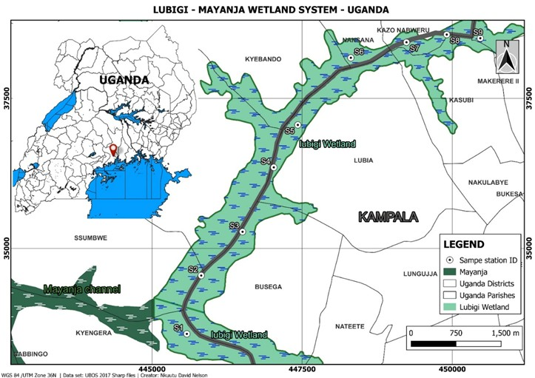
Figure 1. Map of Lubigi Wetland showing the nine sampling sites (S1–S9), major drainage channels, wastewater outfalls and surrounding land use.
Research design and rationale
A cross-sectional field survey was implemented using a stratified random sampling design to capture spatial and vertical heterogeneity across the wetland. Nine sites (S1–S9) were selected to represent upstream, midstream and downstream zones; at each site samples were taken from four vertical strata surface water, middle water, bottom water and sediment to reflect the conceptual distinction between mobile (water column) and depositional (sediment) compartments in the source–transport–sink framework (Brander et al., 2020; Ahmed et al., 2025). This design permits direct testing of hypotheses about sedimentary accumulation, vertical partitioning and the influence of local sources and topography on microplastic distribution (Nkuutu, 2025).
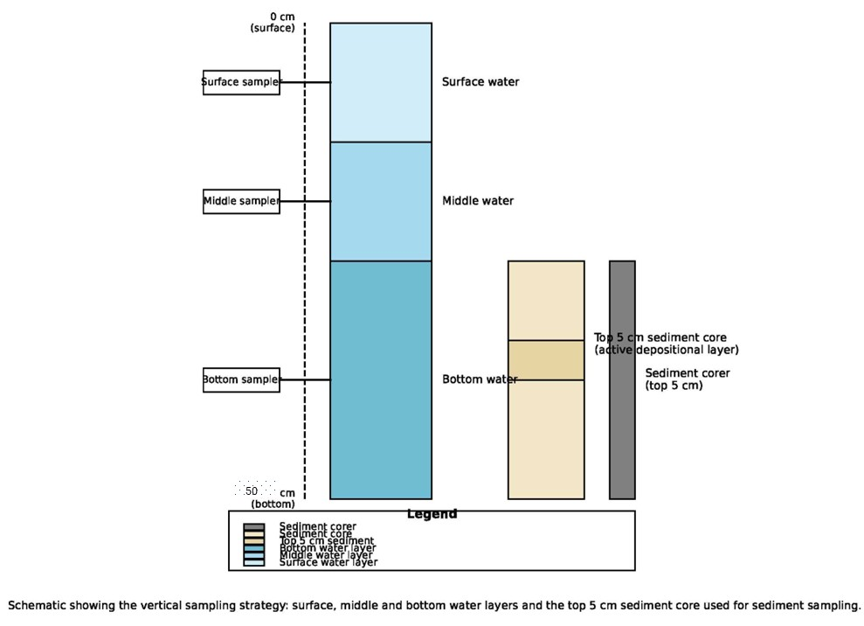
Figure 2. Schematic of the vertical sampling strategy showing surface, middle and bottom water layers and the top 5 cm sediment core used for sediment sampling.
Population, sampling units and site selection
The target population comprised microplastic particles present in the water and sediment matrices of Lubigi Wetland. Sampling units were 1-litre water samples and 500 g sediment samples, each collected in triplicate at every depth and site to allow estimation of within-site variability and to support statistical inference (Brander et al., 2020). Sites were chosen purposively based on hydrological connectivity, proximity to likely pollution sources (storm drains, wastewater outfalls, dumpsites) and accessibility; GPS coordinates were recorded for each sampling point to enable spatial analysis and integration with GIS layers (Nkuutu, 2025).
Field sampling procedures
Water samples were collected from surface, middle and bottom layers using pre-cleaned stainless steel samplers, taking care to avoid disturbing sediments during collection. Samples were transferred to glass bottles, kept on ice in the field and processed within 24 hours to minimise alteration or loss of fine particles (Brander et al., 2020; Thornton Hampton et al., 2025). Sediment samples were obtained as cores of the top 5 cm using stainless steel corers; the top 5 cm was selected because it represents the active depositional layer where recent inputs accumulate and where benthic exposure is greatest (Boyer et al., 2024; Ecohydrology Research Group, 2024). Field protocols followed established guidance for microplastic sampling to reduce contamination and sampling bias (ISO 24187:2023; Brander et al., 2020).

Laboratory processing: extraction and isolation
In the laboratory, samples were processed following a sequence designed to separate microplastics from natural matrices while preserving particle integrity. Density separation was performed using saturated zinc chloride (ZnCl₂; density 1.5–1.6 g cm⁻³) to float low-density polymers, following validated protocols that balance recovery and minimisation of matrix carry-over (Ecohydrology Research Group, 2024; Brander et al., 2020). Organic matter was removed by oxidative digestion using hydrogen peroxide (30%) and Fenton’s reagent (FeSO₄) under controlled temperature to avoid thermal or chemical degradation of plastic particles (Thermo Fisher Scientific, 2018; Ecohydrology Research Group, 2024). The resulting supernatant was filtered through 20 μm nylon mesh or glass-fibre filters; residues were transferred to clean glass petri dishes for subsequent analysis. These laboratory steps align with international best practice and the ISO principles for microplastic analysis (ISO 24187:2023; Thermo Fisher Scientific, 2018).
Morphological characterisation and size classification
Particles retained on filters were examined under a stereomicroscope at 40–100× magnification and classified by shape (fibres, filaments, films, fragments, microbeads, pellets), colour (transparent, blue, black, red, purple, yellow, white) and size. Measurements were made using ImageJ software to obtain objective length and area metrics. Size classes were defined according to recent consensus guidance: ultrafine (<9 μm), fine (9–21.4 μm), moderate (22.5–50.6 μm), coarse (53.6–120.4 μm), very coarse (121.2–285.2 μm) and macro (≥285.2 μm) (LabPlas Consortium, 2024; Thermo Fisher Scientific, 2018). This morphological and size information is essential for linking particle behaviour to transport and retention processes in the conceptual framework: for example, smaller and lower-density particles are more likely to remain in the water column, whereas denser or fouled particles settle into sediments (Ahmed et al., 2025; Liu et al., 2025).
Polymer identification by spectroscopy
A representative subset of particles (n = 100) was analysed by Fourier Transform Infrared Spectroscopy (FTIR) to determine polymer composition. Spectra were matched to reference libraries with a ≥75% match threshold to assign polymer types (PE, PP, PET, PS, PVC, Nylon-6), following standard operating procedures for FTIR identification (Thermo Fisher Scientific, 2018; ISO 24187:2023). Polymer data provide the chemical fingerprint necessary for source inference within the socio-ecological framework: for example, PET and Nylon often indicate textile and bottle inputs, while PE and PP are common in packaging and consumer waste (Nkuutu, 2025; Mugisha, 2025).
Quality assurance, contamination control and validation
Quality assurance measures were applied throughout field and laboratory work. All equipment was pre-cleaned with filtered deionised water and glass, or metal materials were used where possible to reduce plastic contamination. Field and laboratory blanks were processed alongside samples to quantify background contamination; procedural blanks indicated negligible contamination under the adopted protocols (Brander et al., 2020; ISO 24187:2023). Recovery tests were performed by spiking samples with known microplastic standards; extraction efficiencies ranged from 70% to 100% depending on polymer type and particle size, consistent with published recovery ranges (Ecohydrology Research Group, 2024; Brander et al., 2020). These QA/QC steps are critical to ensure that observed spatial patterns reflect environmental reality rather than methodological artefact.
Data analysis and linkage to conceptual framework
Microplastic abundance was expressed as particles per litre for water and particles per kilogram dry weight for sediments, enabling comparison across matrices and with other studies (Brander et al., 2020). Statistical analyses were conducted in R and SPSS. Univariate and multivariate tests including analysis of variance (ANOVA), Kruskal–Wallis, Chi-square and binomial tests were used to assess differences in abundance, composition and categorical dominance. A three-way ANOVA tested interactions between polymer type, site and depth (Bolker et al., 2009). These statistical approaches allow empirical testing of hypotheses derived from the source–transport–sink framework (for example, H1 on sediment accumulation and H3 on spatial drivers). Spatial analysis employed GIS tools (ArcGIS, QGIS) for interpolation (kriging), hotspot detection and mapping of abundance and composition patterns (ArcGIS Pro Documentation, 2026; Geography Realm, 2024). Spatial statistics were used to examine autocorrelation and to relate observed hotspots to mapped sources (drains, outfalls, dumpsites), thereby operationalising the socio-ecological linkage between human infrastructure and particle distribution (Kaydi et al., 2025).
Source apportionment was inferred by integrating polymer fingerprints, morphological signatures and spatial proximity to likely sources (wastewater, stormwater, landfill, road runoff, atmospheric deposition), following approaches used in recent source-identification studies (Kaydi et al., 2025; Zhang et al., 2025). Where possible, polymer and morphology data were interpreted within a mixing-logic framework to estimate relative contributions from dominant pathways; this approach aligns with the conceptual aim of linking measured particle properties to socio-technical drivers of pollution (Nkuutu, 2025; Mugisha, 2025).
This methodology follows recognised international guidance and recent methodological syntheses to ensure that results are comparable, reproducible and interpretable within both physical and socio-ecological frameworks for microplastic dynamics (ISO 24187:2023; Brander et al., 2020; Ecohydrology Research Group, 2024).
Results
Morphological characterisation and shape distribution
Microscopic examination confirmed six morphological categories across Lubigi Wetland: fibres, filaments, films, fragments, microbeads and pellets. The observed distribution of these shapes varied both spatially across the nine sampling sites and vertically among the four sampled strata, consistent with the source–transport–sink conceptual framework and the sampling strategy described in the Methods (Brander et al., 2020; Ahmed et al., 2025; Nkuutu, 2025). In particular, microbeads were the most frequent shape overall (58.7%), occurring predominantly in sediments and bottom waters, while lighter forms such as fibres and fragments were relatively more common in surface and middle waters. Pellets and fragments also contributed substantially to the total particle pool, reflecting a mixture of primary and secondary sources and the influence of local hydrodynamics on particle fate (see Table 1).
Table 1. Abundance and Relative Proportion (%) of Microplastic Shapes in Sediment and Surface Water Samples
Shape | Sediment n (%) | Water n (%) | Total n (%)
Fibres | 29 (7.6%) | 86 (11.7%) | 115 (10.3%)
Filaments | 1 (0.3%) | 11 (1.5%) | 12 (1.1%)
Films | 1 (0.3%) | 28 (3.8%) | 29 (2.6%)
Fragments | 24 (6.3%) | 104 (14.1%) | 128 (11.4%)
Microbeads | 306 (80.1%) | 350 (47.6%) | 656 (58.7%)
Pellets | 21 (5.5%) | 157 (21.3%) | 178 (15.9%)
Total | 382 (100%) | 736 (100%) | 1,118 (100%)
The predominance of microbeads in sediments accords with expectations from the literature that denser or fouled particles, and those introduced as primary microplastics, are likely to accumulate in depositional zones (Ahmed et al., 2025; Boyer et al., 2024). Conversely, the higher relative frequency of fibres and fragments in surface waters reflects their buoyancy and transport potential under the wetland’s flow regimes (Brander et al., 2020). These patterns are coherent with the laboratory and field procedures used (density separation, stereomicroscopy and stratified sampling), which were designed to capture both mobile and depositional compartments (ISO 24187:2023; Ecohydrology Research Group, 2024).
Colour distribution
Seven colour categories were recorded: black, blue, green, purple, transparent, yellow and white. Transparent particles dominated the assemblage, particularly among microbeads (n = 479), and were present across all sites and depths. Colour patterns showed spatial clustering of certain hues at particular sites, suggesting localised source inputs or differential weathering.
Table 2. Distribution of Microplastic Colours by Shape
Shape | Dominant Colours (n) | Notable Observations
Fibres | Transparent (44), Blue (24) | Yellow fibres (n = 3) at S5 and S6
Filaments | Blue (7), Transparent (3) | Rare overall
Films | Red (8), White (8), Green (7) | Red films concentrated at S4
Fragments | Blue (53), Red (26), Transparent (20) | Purple fragments (22) at S9
Microbeads | Transparent (479), Purple (82), Red (58) | High purple counts at S7
Pellets | Red (60), White (34), Blue (28) | Yellow pellets (21) at S4
Transparent and blue particles were most common overall, while red and purple microbeads were concentrated in sediments at specific sites. The spatial clustering of particular colours (for example, purple microbeads at S7 and red films at S4) supports the interpretation that localised anthropogenic activities—such as wastewater discharges, market waste, or industrial inputs—contribute distinct particle signatures (Kaydi et al., 2025; Nkuutu, 2025). Colour therefore provides an additional, qualitative line of evidence for source inference when combined with polymer and spatial data.
Size classes and particle dimensions
Particles were classified into six size classes following recent consensus guidance (LabPlas Consortium, 2024). The majority of particles were smaller than 300 μm, with 61% of counts falling below this threshold. Size distributions differed by shape and colour: fibres tended to be larger on average than microbeads and fragments, and smaller particles were disproportionately represented in the water column, consistent with the conceptual expectation that smaller, lower-density particles remain mobile for longer periods (Ahmed et al., 2025; Liu et al., 2025).
Table 3. Size Class Boundaries and Observed Size Ranges
Order | Class Name | Minimum Size (μm) | Maximum Size (μm)
1 | Ultrafine | 3.78 | <9.0
2 | Fine | 9.09 | <21.4
3 | Moderate | 22.46 | <50.6
4 | Coarse | 53.57 | <120.4
5 | Very Coarse | 121.21 | <285.2
6 | Macro | 304.99 | ≥285.2
Median and mean particle sizes varied by shape and colour, reflecting the interplay between particle production sources, fragmentation processes and transport dynamics. The predominance of sub-300 μm particles emphasises the importance of fine-scale sampling and the use of appropriate filtration and microscopy methods described in the Methods (Ecohydrology Research Group, 2024; Thermo Fisher Scientific, 2018).
Polymer composition and spatial variation
FTIR spectroscopy of a representative subset of particles (n = 100) identified five major polymer types: polyethylene (PE), polypropylene (PP), polyethylene terephthalate (PET), polystyrene (PS) and Nylon-6. Polymer profiles varied by site and depth, reflecting both source heterogeneity and selective transport/retention processes. PE and PP were ubiquitous across depths and sites, while PET and Nylon-6 showed site-specific concentrations, often linked to textile or wastewater inputs. PS and PVC were more frequently detected in sediments at certain sites, consistent with their greater propensity to settle or to be associated with denser fragments (Thermo Fisher Scientific, 2018; Nkuutu, 2025).
Table 4. Polymer Types Identified in Water and Sediment Samples
Site | Water (Polymers) | Sediment (Polymers)
S1 | PET, PP | PE, PS
S2 | PET, PP | PE, PS, PVC
S3 | PET, PP | PE, PS
S4 | PET | PVC, PE
S5 | PET, PP | PVC
S6 | PET, PP | PE, PS
S7 | PET, PP, Nylon | PE, PVC
S8 | PET, PP | PE, PS
S9 | PET, Nylon | PE, PS, PVC
A three-way ANOVA revealed a significant Polymer × Site interaction (F = 4.56, df = 16, p < 0.001, partial η² = 0.072), indicating that polymer composition is strongly site-dependent. This statistical result supports the methodological linkage between spatial sampling and source inference: local infrastructure and land use (for example, proximity to textile activities or wastewater outfalls) appear to shape polymer signatures at particular sites (Kaydi et al., 2025; Nkuutu, 2025). The polymer data therefore provide a chemical fingerprint that, when combined with morphology and spatial proximity, strengthens the source–transport–sink interpretation.
Abundance metrics and particle dimensions summary
Across all samples, a total of 1,118 microplastic particles were recorded. Descriptive statistics for particle count and dimensions are summarised in Table 5. The dataset includes many measured particle metrics (area, perimeter, length/diameter), which support detailed morphological analysis and enable comparisons with other studies that use similar image-analysis workflows (Thermo Fisher Scientific, 2018; LabPlas Consortium, 2024).
Table 5. Descriptive Statistics for Microplastic Abundance and Particle Dimensions
Variable | N | Minimum | Maximum | Mean | Std. Deviation
Number of particles | 55,530 | 1 | 65 | 8.87 | 12.17
Area (μm²) | 55,530 | 10.98 | 13,749.7 | 438.9 | 1,478.7
Perimeter (μm) | 55,530 | 10.4 | 1,775.3 | 94.1 | 188.2
Length/Diameter (μm) | 55,530 | 3.78 | 687.5 | 32.9 | 73.5
Abundance by shape, colour and size statistical observations
Microbeads (58.7%) significantly exceeded the expected 50% threshold (p < 0.001). Pellets (15.9%) and fragments (11.4%) also occurred at proportions above random expectation (p < 0.05), while fibres (10.3%), films (2.6%) and filaments (1.1%) were significantly under-represented (p < 0.01). Colour classes showed that transparent/white particles (42%) were significantly more frequent than expected (p < 0.001), with red (13%) and purple (12.7%) also over-represented (p < 0.05). Black (18%) and blue (27%) did not deviate significantly from expected proportions. These statistical patterns align with the methodological detection limits and the conceptual expectation that primary microplastics (microbeads, pellets) can dominate in urban catchments with direct inputs from consumer products and industrial sources (Mugisha, 2025; Nkuutu, 2025).
Vertical and site variation in abundance
Mean abundances by depth layer show a clear vertical gradient, with sediments containing the highest mean counts, followed by bottom, middle and surface waters. This vertical partitioning is consistent with the source–transport–sink framework: sediments act as long-term sinks where particles accumulate, while the water column reflects more transient transport processes (Ahmed et al., 2025; Boyer et al., 2024).
Table 6. Mean Microplastic Abundance by Depth Layer
Depth Layer | Mean abundance | SD
Sediment Layer | 17.68 | 18.9
Bottom Water | 12.61 | 12.4
Middle Water | 5.02 | 3.7
Surface Water | 3.10 | 2.4
Site-level means and vertical gradients (Table 7) reveal pronounced spatial heterogeneity. Midstream sites notably Namungona (S4), Nabweru (S6) and NWSC TMP (S7) exhibited the highest mean abundances and acted as depositional hotspots. These sites coincide with mapped inputs and hydrological features identified in the Methods (proximity to drains, wastewater outfalls and low-energy depositional zones), reinforcing the linkage between local infrastructure, wetland topography and observed particle accumulation (Nkuutu, 2025; ArcGIS Pro Documentation, 2026).
Table 7. Mean Microplastic Abundance by Site and Vertical Gradient
Site (Location) | Bottom (Mean±SD) | Middle (Mean±SD) | Sediment (Mean±SD) | Surface (Mean±SD) | Overall Mean±SD
Busega (S1) | 5.00±3.16 | 6.18±4.13 | 6.87±4.76 | 2.63±1.66 | 5.44±4.04
Bulenga (S2) | 9.54±6.63 | 5.75±2.12 | 11.04±7.37 | 2.71±2.45 | 8.14±6.58
Masanafu (S3) | 2.93±1.36 | 7.09±2.95 | 7.44±6.02 | 1.50±0.72 | 4.89±4.62
Namungona (S4) | 17.97±14.57 | 6.78±4.23 | 41.08±29.88 | 3.45±2.31 | 13.04±18.87
Nansana (S5) | 10.72±7.61 | 5.09±1.94 | 27.96±18.55 | 3.51±1.79 | 10.00±12.60
Nabweru (S6) | 21.71±12.93 | 6.18±3.18 | 20.70±15.37 | 6.05±2.70 | 12.97±12.20
NWSC TMP (S7) | 20.84±17.94 | 7.89±4.82 | 30.81±22.73 | 2.16±2.45 | 12.53±16.39
Kawala (S8) | 15.01±8.80 | 2.55±1.66 | 25.05±17.47 | 2.55±1.63 | 7.25±11.06
Bwaise (S9) | 7.11±5.92 | 2.16±1.53 | 6.93±3.87 | 2.23±1.05 | 4.06±4.09
The observed hotspot pattern at midstream sites is consistent with the wetland’s hydrological configuration and the mapped locations of urban runoff and wastewater inputs (see Figure 1 in Methods). These results therefore provide empirical support for hypotheses H1 and H3: sediments act as primary sinks for microplastics, and spatial distribution is strongly influenced by proximity to anthropogenic sources and wetland topography (Ahmed et al., 2025; Brander et al., 2020; Nkuutu, 2025).
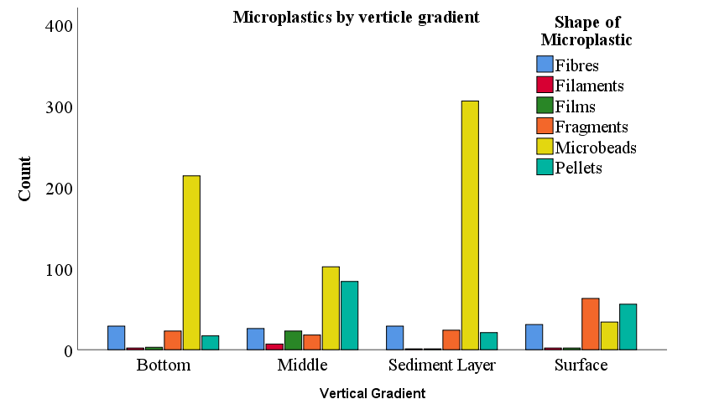
Figure 4. Stacked bar chart of microplastic shapes by matrix (surface, middle, bottom, sediment)
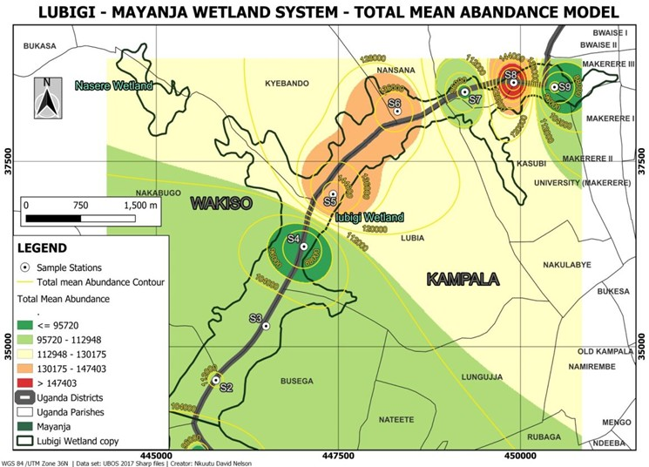
Figure 5. Kriging interpolation map of total microplastic abundance across Lubigi Wetland showing midstream hotspots (Namungona S4, Nabweru S6, NWSC TMP S7)
These figures will visually synthesise the tabulated results and link the empirical patterns to the conceptual source–transport–sink framework and the spatial analyses described in the Methods (ArcGIS Pro Documentation, 2026; Geography Realm, 2024).
The results demonstrate a coherent pattern: microbeads and pellets dominate the particle assemblage, sediments retain the highest loads, and midstream depositional zones act as hotspots. These findings align with the methodological design and the theoretical framework that links particle properties, hydrodynamics and anthropogenic source strength to observed spatial and vertical distributions (Ahmed et al., 2025; Brander et al., 2020; Nkuutu, 2025).
Discussion
The results demonstrate a clear and spatially heterogeneous pattern of microplastic contamination across Lubigi Wetland that aligns with the study’s stratified sampling design and the source–transport–sink conceptual framework described in the literature. Midstream sites, notably Namungona (S4) and Nabweru (S6), recorded the highest concentrations, consistent with their function as low-energy depositional zones that receive concentrated runoff and wastewater from densely populated catchments. These empirical patterns reflect the linkage between mapped infrastructure and particle accumulation established in the Methods (see Figures 1–3) and mirror findings from other urban wetland studies where depositional zones concentrate particulate contaminants (Ahmed et al., 2025; Boyer et al., 2024). Upstream locations showed high counts in some metrics, with sediments and bottom waters dominated by microbeads, while downstream sites exhibited lower overall abundance but persistent microbead and pellet signatures. This spatial heterogeneity supports the hypothesis that local source strength and wetland topography jointly determine where particles accumulate (Brander et al., 2020; Nkuutu, 2025).
Vertically, the data show a consistent gradient: sediments retained the greatest microplastic loads, followed by bottom, middle and surface waters. This vertical partitioning accords with theoretical expectations that denser particles, or particles that become denser through biofouling, settle into the sedimentary compartment where they may be stored over long periods (Ahmed et al., 2025; Liu et al., 2025). The stratified sampling and density-separation methods used in the laboratory were designed to capture this partitioning; the observed sediment dominance therefore reflects both environmental processes and methodological capacity to detect depositional pools (ISO 24187:2023; Ecohydrology Research Group, 2024). The predominance of microbeads and pellets in sediments and bottom waters points to substantial inputs of primary microplastics such as personal-care product beads and industrial pellets and to fragmentation of larger items that subsequently settle, reinforcing the source–transport–sink interpretation.
Morphological and polymeric patterns further illuminate source and fate processes. The dominance of microbeads (58.7%) and pellets (15.9%) is consistent with studies of landfill leachate and urban wetlands in Africa and Asia, where primary microplastics are common where waste management is inadequate and wastewater is discharged untreated (Aragaw, 2021; Mugisha, 2025). The high proportion of transparent particles, particularly among microbeads, may indicate relatively recent inputs with limited weathering, while the diversity of colours and shapes reflects multiple, overlapping sources textiles, packaging, consumer goods and fragmented larger plastics. FTIR results confirm the ubiquity of PE and PP, polymers widely used in packaging, while PET and Nylon-6 were more frequent in water samples, suggesting textile and bottle inputs; PS and PVC were more common in sediments, consistent with their greater density or tendency to form denser fragments (Thermo Fisher Scientific, 2018; Nkuutu, 2025). The significant Polymer × Site interaction (three-way ANOVA) underscores that polymer signatures are site-specific and shaped by local hydrodynamics and source proximity, a finding that validates the spatially explicit sampling strategy and supports targeted source inference (Kaydi et al., 2025).
Multiple, interacting source pathways explain the observed contamination. Urban runoff and stormwater convey street litter, market waste and tyre/road wear into the wetland, particularly during rainfall events; wastewater inputs introduce fibres, microbeads and fragments from domestic and industrial effluents; landfill leachate and informal dumping contribute fragments and pellets; atmospheric deposition supplies fine fibres and fragments; and road runoff adds tyre-derived polymers and additives (Zhang et al., 2025; Kaydi et al., 2025). Hydrological and sedimentary drivers flow velocity, residence time, organic carbon content and grain size modulate transport, retention and resuspension, explaining why midstream depositional zones accumulate particles while other areas act as transient conduits (Brander et al., 2020; Ahmed et al., 2025). The integration of polymer fingerprints, morphological traits and spatial proximity in the source-apportionment logic provides a plausible, evidence-based account of dominant pathways, even where quantitative apportionment remains a future refinement.
When compared with regional and global studies, Lubigi’s contamination profile is broadly consistent with patterns reported for urban wetlands and landfill-impacted sites in Africa, though absolute abundances are generally lower than those reported from heavily industrialised regions in Asia and Europe (Aragaw, 2021; Boyer et al., 2024). The predominance of primary microplastics and the diversity of polymer types reflect local waste management practices, consumer behaviour and urban infrastructure. Globally, wetlands are increasingly recognised as important sinks for microplastics, with sediments acting as long-term reservoirs and potential secondary sources during high-flow events; Lubigi conforms to this broader understanding while adding regionally specific evidence that can inform local management (Ahmed et al., 2025; Wu et al., 2023).
The ecological and human-health implications of these findings merit careful attention. Microplastics can harm aquatic organisms through ingestion, physical blockage and by acting as vectors for adsorbed pollutants such as persistent organic pollutants and heavy metals (Liu et al., 2025; Wu et al., 2023). In Uganda, the detection of microplastics in drinking water, fish and crops points to plausible exposure pathways for people, with potential health concerns including endocrine disruption and carcinogenic risks associated with certain additives and sorbed contaminants (Nkuutu, 2025; Orem, 2025). Moreover, microplastics in sediments may alter carbon cycling, microbial community structure and greenhouse-gas fluxes, adding an ecosystem-function dimension to the risk profile (Liu et al., 2025). While this study provides concentration and compositional data necessary for screening-level risk assessment, quantitative ecological and human-health risk appraisal linking measured concentrations to species-specific exposure and toxicological thresholds remains an important next step.
Policy and management implications follow directly from the empirical and conceptual findings. Uganda has enacted relevant policies and strategies, including the National Environment Act and the National Strategy for Promoting Plastics Circularity (NEMA, 2024), but enforcement and public awareness are uneven. The study’s identification of midstream depositional hotspots and polymer-specific signatures offers actionable intelligence for local authorities (KCCA, NEMA) and stakeholders: targeted waste-collection improvements in upstream catchments, controls on wastewater quality, and interventions at known point sources (treatment plant outfalls, dumpsites) are logical priorities. Collaboration with academic institutions (Makerere University, Kampala International University) can strengthen routine monitoring and laboratory capacity, enabling the standardised protocols recommended in the Methods to be applied over time (Brander et al., 2020; ISO 24187:2023).
In summary, the discussion links the observed results to the methodological choices and to the theoretical source–transport–sink and socio-ecological frameworks articulated in the literature review. The empirical evidence from Lubigi Wetland supports the view that urban wetlands are dynamic socio-ecological nodes where human activities, infrastructure and hydrodynamic processes interact to determine microplastic fate. The study therefore provides a robust baseline for management action and for further analytical work such as predictive modelling, quantitative source apportionment and formal risk assessment that would deepen mechanistic understanding and strengthen policy responses (Kaydi et al., 2025; Liu et al., 2025).
Conclusions
This study demonstrates that Lubigi Wetland is moderately contaminated with microplastics and exhibits pronounced spatial and vertical heterogeneity. Sediments act as the primary sink, retaining the highest microplastic loads, while the water column reflects more transient transport. Microbeads and pellets dominate the assemblage, indicating substantial inputs of primary microplastics alongside secondary fragments. Polymer profiles (PE, PP, PET, PS, PVC, Nylon-6) reveal diverse sources linked to packaging, textiles and industrial products, and the significant Polymer × Site interaction confirms that local sources and hydrodynamics shape polymer distribution. The findings validate the study’s conceptual framing: microplastic fate in Lubigi is governed by the interplay of source strength, transport vectors and sink capacity within a socio-ecological urban system. The evidence produced here provides a necessary baseline for targeted management, routine monitoring and policy interventions in Kampala and comparable urban wetlands.
Recommendations
- Improve waste collection and management in upstream catchments to reduce the volume of plastics entering the wetland. Prioritise regular collection, secure disposal and community-level recycling initiatives that target common polymers identified in this study (PE, PP, PET).
- Regulate compost and wastewater quality by introducing standards and monitoring for microplastic content in effluents and compost products, and by upgrading wastewater treatment where feasible to reduce fibre and microbead discharges.
- Establish routine, standardised monitoring for microplastics in wetlands, using the protocols and QA/QC measures outlined in this study (ISO 24187:2023; Brander et al., 2020). Leverage laboratory capacity at Makerere University and Kampala International University and deposit data and code in accessible repositories to support reproducibility.
- Conduct ecological and human-health risk assessments that link measured concentrations to exposure pathways (drinking water, fish consumption, crop irrigation) and to species-specific toxicity thresholds. Use screening-level risk matrices initially, then refine with targeted toxicological and exposure studies.
- Integrate microplastic control into urban planning and wetland restoration by incorporating source-control measures into drainage design, buffer zones and land-use planning, and by prioritising interventions at mapped hotspots (Namungona, Nabweru, NWSC TMP).
- Strengthen policy enforcement and public awareness through coordinated action by NEMA, KCCA and local governments. Promote public education campaigns, incentives for biodegradable alternatives and measures that support a circular economy for plastics (NEMA, 2024; Barirega, 2025).
- Foster stakeholder collaboration among local communities, government agencies, industry and academia to co-design interventions, share monitoring data and evaluate the effectiveness of mitigation measures over time.
These recommendations are intended to be practical and evidence-based, drawing directly from the study’s results, the methodological rigour applied, and the socio-ecological conceptual framework. Implementing them will reduce inputs, improve detection and enable adaptive management of microplastic pollution in Lubigi Wetland and similar urban systems.

References
- Ahmed, A. S. S., Billah, M. M., Ali, M. M., Guo, L., Akhtar, S., Bhuiyan, M. K. A., & Islam, M. S. (2025). Microplastic characterization and factors influencing its abundance in coastal wetlands: Insights from the world’s largest mangrove ecosystem, Sundarbans. Environmental Science and Pollution Research, 32, 5435–5456.
- Aragaw, T. A. (2021). Microplastic pollution in African countries’ water systems: A review on findings, applied methods, characteristics, impacts, and managements. Discover Applied Sciences, 3, 629.
- Barirega, A. (2025). Beating plastic pollution in Uganda. Nature Uganda.
- Bolker, B. M., Brooks, M. E., Clark, C. J., Geange, S. W., Poulsen, J. R., Stevens, M. H. H., & White, J.-S. (2009). Generalized linear mixed models: A practical guide for ecology and evolution. Trends in Ecology & Evolution, 24(3), 127–135.
- Boyer, J. J., Brooks, J. M., & Arias, M. E. (2024). Microplastics in a large constructed wetland: Retention, transport, and characteristics. Environmental Engineering Science, 41(12), 530–540.
- Brander, S. M., Renick, V. C., Foley, M. M., Steele, C., Woo, M., Lusher, A., Carr, S., Helm, P., Box, C., Cherniak, S., Andrews, R. C., & Rochman, C. M. (2020). Sampling and quality assurance and quality control: A guide for scientists investigating the occurrence of microplastics across matrices. Applied Spectroscopy, 74(9), 1099–1125.
- Ecohydrology Research Group, University of Waterloo. (2024). Microplastic extraction from water, sediment, soil, and atmospheric deposition samples.
- Geography Realm. (2024). Monitoring and mapping microplastics in marine ecosystems.
- International Organization for Standardization. (2023). ISO 24187:2023 Principles for the analysis of microplastics present in the environment.
- Kaydi, N., Jorfi, S., Takdastan, A., Jaafarzadeh Haghighifard, N., & Khafaie, M. A. A. (2025). Source identification and apportionment of ambient air microplastics: A systematic review. Discover Applied Sciences, 7, 41.
- Liu, L., Hua, Y., Sun, J., Ahmad, S., He, X., Zhuo, Y., & Tang, J. (2025). Carbon cycling in wetlands under the shadow of microplastics: Challenges and prospects. Toxics, 13(3), 143.
- Mugisha, E. K. (2025). Microplastics: Environmental impact and remediation strategies. IDOSR Journal of Computer and Applied Sciences, 10(2), 15–21.
- National Environment Management Authority (NEMA). (2024). National strategy for promoting plastics circularity in Uganda 2023–2028.
- Nkuutu, D. N. (2025). Assessment of microplastic pollution: Characterisation, quantification and spatial distribution in the Lubigi Wetland Ecosystem, Uganda (MSc dissertation). Kampala International University.
- Orem, J. (2025). Plastics: Uganda’s silent cancer threat lurking in everyday life. Daily Monitor.
- Thornton Hampton, L. M., Mehinto, A. C., & Weisberg, S. B. (2025). Standard operating procedures for the collection of samples for microplastics analysis. Part 1: Surface sediment and aquatic biota (Technical Report 1410.A). Southern California Coastal Water Research Project.
- Thermo Fisher Scientific. (2018). Guide to the identification of microplastics by FTIR and Raman spectroscopy.
- Ulo Kyam. (2026). Characterisation, concentration, and ecological risk assessment of microplastics in leachate and sediments at Kiteezi Dumpsite, Uganda (MSc dissertation). Makerere University.
- US Environmental Protection Agency. (2023). Assessing methods of measuring microplastics in water.
- Wu, X., Zhong, C., Wang, T., & Zou, X. (2023). Assessment on the pollution level and risk of microplastics on bathing beaches: A case study of Liandao, China. Environmental Monitoring and Assessment, 195, 383
- Zhang, X., Li, C., Liu, X., Zhao, Y., Wang, Y., Zhang, Y., & Liu, J. (2025). Distribution characteristics and sources of microplastics in inland wetland ecosystem soils. Water, 17(2), 231.

