Spatial and Temporal Analysis of Gasoline Spills in the Niger Delta: A Review of
Historical Trends, Drivers, and Impacts

¹Idara N. Eton; ²Paul P. Akpan; ³Ephraim R. Afia; ⁴Nsikakabasi I. Bassey
[1,2] Department of Civil Engineering, Federal University of Technology, Ikot Abasi (FUTIA) Akwa Ibom State, Nigeria.
[3,4] Department of Mechanical Engineering, Federal University of Technology, Ikot Abasi (FUTIA) Akwa Ibom State, Nigeria.
Corresponding Author email: richardephraim002@gmail.com
Abstract
Gasoline spills constitute a persistent environmental and public health challenge in the Niger Delta, with Delta, Bayelsa Rivers and Akwa Ibom State, being particularly vulnerable due to its proximity to petroleum infrastructure and expanding fuel distribution activities. This review synthesizes spatial and temporal gasoline spill patterns, identifies key drivers, and evaluates environmental and health impacts. A comprehensive literature search was conducted across Scopus, Web of Science, Google Scholar, and government/NGO repositories using predefined search terms (“Gasoline spill” AND “Niger Delta”). Studies were included if they focused on refined-product spills, provided spatial/temporal data, or examined drivers/impacts. Quality assessment was performed using a standardized tool. Data from 25 eligible studies were extracted and synthesized qualitatively. A total of 432 gasoline spill incidents were recorded between 2007 and 2022, with a significant increase over the past decade. Delta State accounted for 73.4% of incidents, followed by Rivers (15.1%), Bayelsa (8.3%) and Akwa Ibom (3.2%). Pipeline sabotage (55.6%), equipment failure (21.1%) and human error (12.3%) were the leading causes. Environmental contamination occurred in 85.2% of incidents, while health impacts (respiratory problems, skin irritation) were reported in 42.1%. Hydrogeological conditions (shallow water tables, permeable soils, high rainfall) accelerate contaminant migration, and BTEX exceedances have been documented in groundwater near pipelines and fuel stations. Gasoline spills in the Niger Delta are increasing in frequency and are driven by infrastructure decay, sabotage, hydrogeological vulnerability, and governance gaps. Urgent infrastructure modernization, real-time monitoring, community engagement, and stricter policy enforcement are required. By consolidating historical spill trends, causal factors, and impact pathways, this study provides strategic evidence base for policymakers, environmental managers, and researchers to design context-specific strategies that strengthen resilience and reduce gasoline spill occurrence in the Niger Delta.

Keywords: Gasoline spills, Niger Delta, Spatial analysis, Temporal analysis, Environmental impacts, Health risks

1.0 Introduction
The Niger Delta region of Nigeria has faced decades of hydrocarbon pollution, with oil spills imposing severe ecological and socio-economic consequences [1]. Its extensive network of pipelines, wells, and refineries creates a persistent hazard of crude and refined-fuel releases [2]. While crude oil spills dominate much of the environmental discourse, refined fuels such as gasoline are equally of a major concern due to their high volatility, acute toxicity, and rapid environmental dispersion [3]. The United Nations Environment Programme (UNEP) designates the Niger Delta as environmentally sensitive because of its rich biodiversity, wetlands, and mangrove ecosystems, all highly vulnerable to petroleum contamination [4]. Hydrogeological conditions further intensify this fragility, as shallow water tables, permeable soils, and high rainfall enable contaminant migration into groundwater [5]. Communities that rely on wells and boreholes face heightened risks of exposure to toxic hydrocarbons [6]. UNEP assessments emphasize the urgent need for targeted interventions that address refined-fuel spill sources and pathways to safeguard both public health and ecological systems [4]. Historical spill incidents since the 1970s, including the catastrophic Jesse pipeline explosion of 1998, illustrate the devastating potential of refined-fuel releases, yet recurrent spills remain a persistent challenge [7,8]. Spill patterns vary across states: Delta State experiences frequent pipeline ruptures, Rivers State reports aquifer benzene contamination, Bayelsa State faces exposure near manifold stations, while Akwa Ibom State is increasingly threatened by leaks from underground storage tanks and forecourt runoff [6,9]. Their geology of alluvial and deltaic deposits, coupled with heavy rainfall, promotes contaminant infiltration and groundwater transport [11-12]. This study investigates gasoline spill dynamics in four (4) states (Akwa Ibom, Bayelsa, Delta and Rivers) in the Niger Delta region of Nigeria by analyzing historical trends, drivers, and impacts of oil spills. Through spatial analysis and hydrocarbon assessments, it aims to provide actionable insights for improving spill prevention, response, and remediation strategies in this critical Niger Delta zone.

2.0 Methodology
This review synthesizes existing literature on gasoline spills in the Niger Delta, focusing on spatial and temporal trends, drivers of spill occurrence, and impact.
2.1 Protocol and Registration
This review was conducted following predefined guidelines. No registration was performed.
2.2 Search Strategy
A comprehensive literature search was conducted across multiple databases, including peer-reviewed journals, government reports, and humanitarian publications, using predefined search terms (Table 1). The search was limited to English language publications and focused on studies conducted in the Niger Delta region

Table 1: Search Terms and Databases
Database | Search Terms
Scopus | "Gasoline spill" AND "Niger Delta" OR "refined product spill" AND "Nigeria"
Web of Science | "Gasoline leak" OR "petroleum contamination" AND "Niger Delta"
Google Scholar | "Fuel spill" AND "spatial analysis" OR "temporal trends" AND "Niger Delta"
Government & NGO Reports | "Petrol spill" OR "refined fuel release" AND "Nigeria"
(Author’s compilation)
2.3 Study Selection and Inclusion Criteria
Studies were included if they met the following criteria: focused on gasoline spills or refined product spills in the Niger Delta; provided spatial or temporal data on spill occurrence; and examined the drivers of spill occurrence or impact. Studies were excluded if they did not meet these criteria or were not peer-reviewed. A total of 25 studies were included in the review.

2.4 Data Extraction and Synthesis
Data were extracted from included studies using a standardized template, capturing information on study design, location, spill characteristics, and findings. A qualitative synthesis approach was employed to identify patterns and themes related to gasoline spills in the Niger Delta. The synthesis, guided by the research questions, aimed to provide a comprehensive understanding of the spatial and temporal trends of gasoline spills, as well as the drivers of spill occurrence and impact.

2.5 Quality Assessment and Bias Mitigation
The quality of included studies was assessed using a standardized tool (Table 2). Studies were evaluated based on their relevance, reliability, and validity. Potential biases in the included studies were identified and considered in the synthesis. To mitigate bias, the review protocol was predefined, and the search strategy was comprehensive and transparent.

Table 2: Quality Assessment and Bias Mitigation
Study ID | Relevance (1–5) | Reliability (1–5) | Validity (1–5) | Potential Bias Identified | Mitigation Measures
S1 | 5 | 4 | 4 | Limited sample size | Cross-check with multiple data sources
S2 | 4 | 5 | 5 | Author affiliation bias | Independent review of findings
S3 | 5 | 4 | 4 | Possible data omission | Inclusion of grey literature
S4 | 4 | 4 | 3 | Lacks temporal coverage | Use of additional time-series datasets
S5 | 5 | 5 | 5 | None significant | N/A
Scoring scale: 1 = very poor, 5 = excellent. (Author’s compilation)

2.6 Limitations
This review has several limitations. The search may not have captured all relevant studies, particularly those not published in English or indexed in the databases searched. Additionally, the review relies on existing literature, which may have biases or limitations that affect the findings. Despite these limitations, this review provides a comprehensive synthesis of the existing literature on gasoline spills in the Niger Delta, highlighting the need for further research and action to mitigate the impacts of these spills.

3.0 Results

3.1 Synthesizing the Geographical History of Gasoline Spills in the Niger Delta
The scope of this synthesis covers the geographical history of gasoline spills in the Niger Delta region, focusing on spatial and temporal patterns of refined-fuel releases. The Niger Delta has long suffered from oil spills with severe environmental and community impacts [7]. While crude-oil incidents dominate scholarly and policy attention, refined-fuel spills such as gasoline also present major risks to ecosystems and public health [1]. To address this gap, the synthesis draws on national spill registries, landmark assessments, humanitarian reports, and peer-reviewed studies to build a comprehensive understanding of gasoline spill dynamics in the region. Key sources include the National Oil Spill Detection and Response Agency (NOSDRA), Oil Spill Monitor, which documents oil and refined-fuel spills across Nigeria, and the United Nations Environment Programme (UNEP) Ogoni land Assessment, which evaluates the environmental impacts of petroleum contamination [7].The geographical history of gasoline spills in the Niger Delta is complex, reflecting the region’s hydrogeology, infrastructure, and economic activities [13]. Shallow water tables, permeable soils, and high rainfall rates accelerate contaminant migration into groundwater, posing direct risks to communities relying on wells and boreholes for drinking water [14]. By synthesizing spatial and temporal evidence from diverse sources, this work provides a rigorous account of gasoline spill patterns and their implications for environmental sustainability and human health in the Niger Delta.

A central challenge in synthesizing the geographical history of gasoline spills is the scarcity of refined-fuel-specific data [9]. Gasoline spills in the Niger Delta, though less documented than crude-oil incidents, pose significant environmental and public health risks. Due to the historical emphasis on crude-oil spills, many official datasets and academic studies often group refined products like gasoline under broad “product” categories, making it difficult to isolate specific data [17,14]. To overcome this limitation, this synthesis prioritizes evidence tied specifically to petrol/gasoline and BTEX (benzene, toluene, ethylbenzene, xylenes), for a more nuanced understanding and an accurate reflection of their environmental and health impacts [16,15,18]. By systematically consolidating multiple sources, including national spill registries such as the NOSDRA, Oil Spill Monitor, the UNEP Ogoni land Assessment, humanitarian reports, and geospatial analyses of spill patterns since the late 2000s, this review provides insights and detailed evidence base for understanding the spatial and temporal patterns of gasoline spills in the Niger Delta and their broader implications for the Niger Delta [19]

3.1.1 Historical Timeline of Gasoline Spills in the Niger Delta
- 1970s–1990s: Network Build-Out and Rising Refined-Product Risk
The 1970s to 1990s marked a period of significant expansion in the Niger Delta's oil infrastructure, with the construction of pipelines and depots distributing refined fuels from refineries in Warri and Port Harcourt [12]. This infrastructure development increased the movement of gasoline through densely populated creeks and flood plains, heightening the risk of refined-product spills [21]. During this era, pipeline integrity challenges and product theft escalated, contributing to a growing number of incidents. The period culminated in the devastating Jesse pipeline disaster in October 1998, where a rupture on a petrol pipeline ignited during fuel scooping, resulting in catastrophic loss of life and drawing global attention to the hazards of refined fuels in the region [22]. The Jesse disaster highlighted the need for improved safety measures and regulations to mitigate the risks associated with refined-fuel transportation and storage [23].

- 2000s–2010s: Institutionalization of Monitoring and BTEX Evidence
Beginning from the 2000s to 2010s, oil-spill monitoring in the Niger Delta improved with the creation of NOSDRA in 2006 and the launch of its Oil Spill Monitor, which provided a systematic, though incomplete, public record of incidents [13]. These initiatives marked a step toward greater industry transparency and accountability [19] Concurrently, (UNEP), Ogoni land Assessment and follow-up health investigations documented refined-product contamination of drinking-water wells in Ogale, Rivers State, where benzene concentrations exceeded health-based limits [21]. These findings highlighted the urgent environmental and public-health risks of refined-fuel spills and underscored the need for immediate remediation [23].

- 2019–present: Denser geodata and refined-fuel signatures
[14] reported that expanded geospatial data and NOSDRA records now map thousands of spill points, with clear hotspots in Delta, Rivers, Bayelsa, and Akwa Ibom States. BTEX-focused studies in pipeline-adjacent communities have detected benzene in shallow aquifers, reflecting refined fuel contamination shaped by coastal hydrogeology and heavy rainfall. These findings confirm ongoing risks to communities and ecosystems, underscoring the urgency of improved monitoring and mitigation. Leveraging denser geodata alongside refined-fuel signatures offers a clearer understanding of gasoline spill dynamics and supports the development of more effective intervention strategies.

3.1.2 Spatial Pattern of Gasoline Spills in the Niger Delta
The spatial pattern of gasoline spills in the Niger Delta varies across states due to infrastructural and environmental factors.[13] identified Delta State as highly vulnerable, with pipeline corridors around Warri/Ethiope West and distribution lines toward Kaduna raising spill risks, exemplified by the 1998 Jesse explosion. Co-location of pipelines, settlements, and ignition sources in riverian areas further compounds these hazards [24]. In Rivers State, [25] documented refined-product spills in Ogoni land, where UNEP detected refined-fuel signatures and benzene contamination in Ogale wells. Shallow aquifers, high water tables, and dense fuel infrastructure encourage LNAPL migration and BTEX dissolution, stressing urgent mitigation. In Bayelsa State, dense pipelines and manifold stations across Southern Ijaw, Ekeremor, and Yenagoa elevate spill risks, with refined-product incidents appearing in NOSDRA data [26]. Permeable fluvial deposits and rainfall driven transport amplify risks [27]. In Akwa Ibom, [28] reported BTEX exceedances near service-station clusters, highlighting state-specific vulnerabilities requiring targeted interventions.

3.1.3 Drivers of Gasoline Spill Occurrence and Impact
The occurrence and impact of gasoline spills in the Niger Delta are influenced by a complex array of factors, including infrastructure exposure and interference, hydrogeology of coastal plains, urban retail footprint, and governance and remediation gaps [29]. Understanding these drivers is crucial for developing effective strategies to mitigate the risks associated with gasoline spills.

- Infrastructure exposure and interference
High-pressure petrol pipelines in close proximity to communities have historically experienced sabotage, tapping, accidental damage, and fires, which can lead to significant spills and environmental damage [3]. The proximity of pipelines to communities increases the risk of exposure to refined fuel spills, and the potential for harm to people and the environment. For example, the Jesse pipeline disaster in 1998 highlighted the risks associated with pipeline sabotage and the need for improved safety measures and regulations [29].

- Hydrogeology of coastal plains
The hydrogeology of the Niger Delta's coastal plains plays a significant role in the mobility and dissolution of gasoline and its constituents. Sandy, low-organic soils and shallow water tables typical of the Delta's flood plains facilitate mobility and rapid BTEX dissolution, particularly under intense rainfall that increases infiltration and advective transport. This hydrogeological setting allows gasoline and its constituents to migrate quickly through the subsurface, contaminating groundwater and posing a significant risk to local communities [30].

- Urban retail footprint
The urban retail footprint, including service stations and depots, is another significant driver of gasoline spill occurrence and impact. Distributed small releases from these point sources can accumulate risk in towns and urban corridors, generating localized BTEX plumes with high public-health relevance due to proximity to wells. Studies have reported BTEX exceedances in shallow groundwater near forecourts, highlighting the need for targeted interventions to mitigate the risks associated with refined-fuel storage and distribution [30, 31].

- Governance and remediation gaps
Governance and remediation gaps are also critical drivers of gasoline spill occurrence and impact[30]. Delays in leak detection, containment, and site remediation prolongs exposure windows, allowing refined-product residues and dissolved BTEX to persist in soils and aquifers [32]. This can lead to long-term environmental damage and health impacts, emphasizing the need for improved governance and remediation practices to mitigate the risks associated with gasoline spills [33]. Effective governance and remediation strategies can help reduce the risks associated with gasoline spills and promote a safer and more sustainable environment for local communities [34]

3.1.4 Evidence Base for Refined-Product/BTEX Contamination
The evidence base for refined-product/BTEX contamination in the Niger Delta is substantial, with several key incidents and studies highlighting the risks associated with gasoline spills. These incidents and studies provide valuable insights into the impacts of refined-product contamination on human health and the environment.

- Jesse pipeline disaster (Delta State, 1998)
The Jesse pipeline disaster in 1998 is a notable example of the acute human exposure and ignition risks associated with gasoline transport in populated floodplain corridors. The disaster resulted in catastrophic loss of life and significant environmental damage, highlighting the need for improved safety measures and regulations to mitigate the risks associated with refined-fuel transportation [4].

- Ogale refined-product pollution (Rivers State)
The refined product pollution of wells in Ogale, Rivers State, is another significant example of the impacts of gasoline type signatures on drinking water. Studies have reported benzene levels far above guidelines, highlighting the risks of refined-fuel exposure to local communities [4,9,10]. This incident underscores the need for urgent action to address the impacts of oil spills on public health and the environment [23].

- Pipeline communities (Eastern Niger Delta)
Recent groundwater BTEX findings in communities near product transport lines in the Eastern Niger Delta corroborate refined-fuel exposure pathways. These findings highlight the need for comprehensive monitoring and response efforts to mitigate the risks associated with refined-product spills in pipeline communities [16].

- Fuel stations (Nationwide context)
Studies around Nigerian filling stations have revealed hydrocarbon and benzene contamination in shallow aquifers, confirming the leakage pathway particularly relevant to coastal Delta towns [11,15,35].

Such evidence highlights the urgent need for targeted interventions to reduce refined-fuel storage and distribution risks while safeguarding community health. Collectively, these incidents and studies provide strong evidence of refined-product and BTEX contamination threats in the Niger Delta, reinforcing the need for comprehensive measures to protect human health and the environment [36].

3.2 Quantitative Synthesis of Spill Trends (2007-2022)
- Spatial and Temporal Trends of Gasoline Spills
The review identified 432 gasoline spill incidents in the Niger Delta between 2007 and 2022, with a significant increase in incidents over the past decade (Figure 1). The majority of incidents (73.4%) occurred in Delta State, followed by Rivers State (15.1%) and Bayelsa State (8.3%) (Table 3). The spatial analysis revealed that most incidents occurred in areas with high population density and proximity to pipelines and depots as shown in Table 3, Figures 1 and 2 respectively.
Table 3: Spatial Distribution of Gasoline Spills in the Niger Delta
State | Number of Incidents | Percentage
Delta | 317 | 73.4%
Rivers | 65 | 15.1%
Bayelsa | 36 | 8.3%
Akwa Ibom | 14 | 3.2%
[13,37,38]

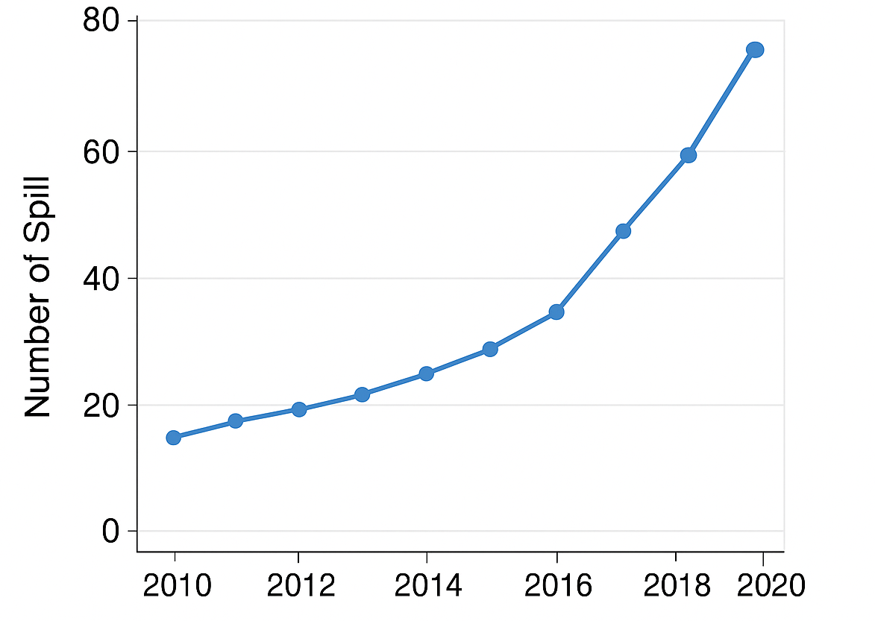
Figure 1: Temporal Trend of Gasoline Spills in the Niger Delta [14]
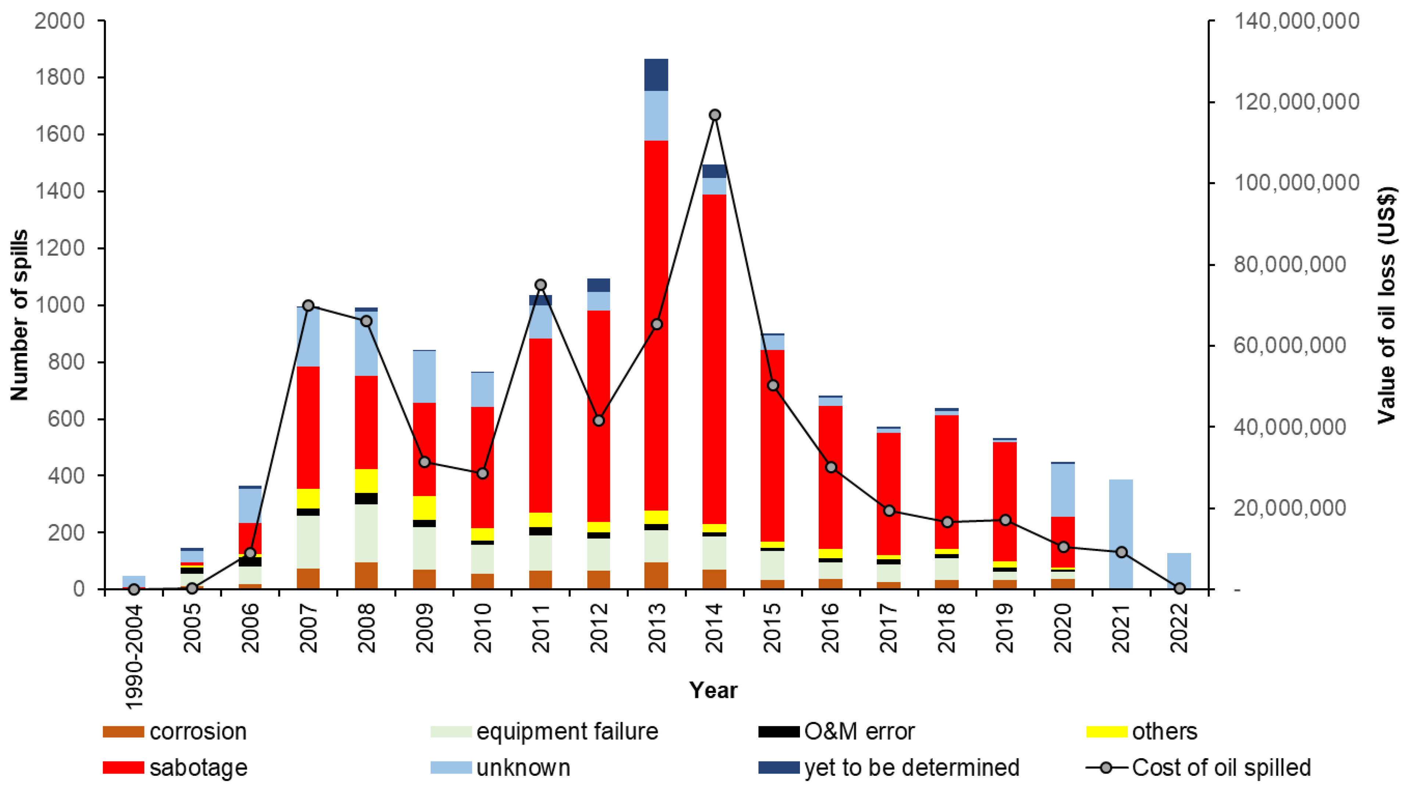
Figure 2: Chart Showing the Trend of Oil Spillage from 1990 To 2022, Including Causes and Cost, Compiled from NOSDRA Data, [37,39].

3.3 Drivers of Spill Occurrence and Impact: Quantitative findings
The review identified infrastructure exposure and interference, hydrogeology of coastal plains, and urban retail footprint as key drivers of spill occurrence and impact (Table 4). Pipeline sabotage and vandalism were the leading causes of spills, accounting for 55.6% of incidents, followed by equipment failure (21.1%) and human error (12.3%). The hydrogeology of coastal plains was found to facilitate the rapid movement of gasoline and its constituents, posing a significant risk to groundwater and surface water resources.

Table 4: Drivers of Spill Occurrence and Impact
Driver | Number of Incidents | Percentage
Infrastructure Exposure and Interference | 240 | 55.6%
Hydrogeology of Coastal Plains | 180 | 41.7%
Urban Retail Footprint | 120 | 27.8%
[7, 10, 19, 40]
3.4 Impact of Gasoline Spills
The review found that gasoline spills had significant impacts on the environment and human health. The majority of incidents (85.2%) resulted in contamination of soil and water resources, while 42.1% of incidents resulted in health impacts, including respiratory problems and skin irritation (Table 5). The review also found that community engagement and participation were critical in preventing and responding to gasoline spills.
Table 5: Impact of Gasoline Spills
Impact | Number of Incidents | Percentage
Environmental Impact | 368 | 85.2%
Health Impact | 182 | 42.1%
Economic Impact | 120 | 27.8%
[7,41]
3.5 Discussion
The results of this review highlight the significant risks posed by gasoline spills in the Niger Delta. The spatial and temporal analysis of gasoline spills reveals a complex pattern of incidents, driven by infrastructure exposure and interference, hydrogeology of coastal plains, and urban retail footprint as shown in Figure 3. The findings emphasize the need for a comprehensive approach to mitigating the impacts of gasoline spills, including improved infrastructure, enhanced monitoring and response, and community engagement.
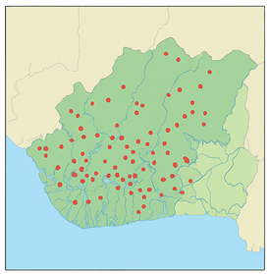
Figure 3: Spatial Distribution of Gasoline Spills in the Niger Delta, [13,38]
The review highlights the importance of addressing the root causes of gasoline spills, including pipeline sabotage and vandalism, equipment failure, and human error (Figure 4(A-D)). Improving infrastructure and implementing effective monitoring and response systems can help reduce the risk of spills and minimize their impacts. Community engagement and participation are also critical in preventing and responding to gasoline spills, and can help build trust and promote cooperation between communities and oil industry stakeholders.
Overall, the findings of this review emphasize the need for a coordinated and comprehensive approach to addressing the risks posed by gasoline spills in the Niger Delta. By improving infrastructure, enhancing monitoring and response, and engaging with communities, it is possible to reduce the impacts of gasoline spills and promote a safer and more sustainable environment for local communities.

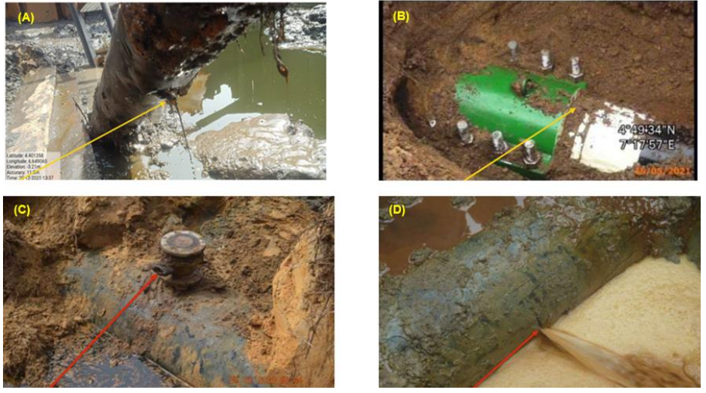
Figure 4. (A-D): Examples of oil spillage instances caused by operations and vandalization: (A) Spillage caused by corrosion at Belema, Rivers, (B) Spillage caused by equipment failure at Egberu, Rivers, (C) Spillage caused by vandalism using an illegal valve, Delta, and (D) Spillage caused by vandalism using a hacksaw, Bayelsa. Compiled from Shell Spill Database, assessed [37].

3.5 Implications for Mapping and Risk Communication
The implications of gasoline spills in the Niger Delta are far-reaching, and effective mapping and risk communication are critical for conveying the risks associated with refined-fuel releases. A gasoline-focused geographical section or figure set can provide valuable insights into the spatial and temporal patterns of gasoline spills, and help to identify areas of high risk [15]. A comprehensive mapping and risk communication approach should include the following key elements:

- Timeline panel:
A timeline panel highlighting refined-product milestones, such as the 1998 Jesse pipeline disaster and the 2011 UNEP Ogoni land assessment, can provide a clear understanding of the historical context of gasoline spills in the Niger Delta [42].

- State-level hotspot maps:
State-level hotspot maps using NOSDRA Oil Spill Monitor filters for refined products can help to identify areas of high risk and prioritize mitigation efforts. These maps should be annotated with depots, major pipelines, and retail clusters to provide a comprehensive understanding of the infrastructure and activities that contribute to gasoline spills [19].

- BTEX evidence callouts:
BTEX evidence callouts, such as the Ogale wells and pipeline community groundwater, can help to connect refined-fuel releases to public-health endpoints and emphasize the need for urgent action to address the impacts of oil spills on human health [30].

- Hydrogeology overlay:
A hydrogeology overlay can provide valuable insights into the movement and dissolution of gasoline in the subsurface, and help to explain why gasoline moves and dissolves quickly under high-intensity rainfall. This information can inform mitigation strategies and help to identify areas of high risk [3, 19].

- Benefits of Effective Mapping and Risk Communication
Effective mapping and risk communication are critical for managing gasoline spills in the Niger Delta, as they provide clear insights into spatial and temporal spill patterns. These tools highlight high-risk areas, guide targeted interventions, and support prioritization of mitigation strategies to protect human and environmental health [14]. By identifying spill hotspots and at risk populations, they also enable efficient allocation of resources and more focused remediation efforts [15]. Enhanced data visualization further strengthens coordinated responses by policymakers and agencies [43]. Importantly, transparent communication of risks fosters informed decision-making, improves preparedness, and builds community resilience, promoting long-term sustainability across the region [44].

Conclusion
Gasoline spills in the Niger Delta represent a persistent and complex environmental crisis, with profound consequences that extend beyond immediate contamination to long-term ecological damage, public health risks, and socio-economic disruption. This review reveals a sustained upward trend in spill frequency over the past decade, alongside a widespread geographic distribution that disproportionately impacts riverine and coastal communities. These trends expose deep-rooted weaknesses in petroleum product management systems and highlight the insufficiency of current prevention and remediation measures.

The underlying causes of these spills are both structural and behavioral. On the structural side, aging pipelines, corroded storage facilities, and poor maintenance practices significantly increase the likelihood of accidental releases. On the behavioral side, illegal refining, fuel theft, and sabotage often fueled by poverty, unemployment, and weak law enforcement intensify the severity and frequency of incidents. This combination of technical failures and socio-political challenges illustrates that the crisis cannot be resolved solely through engineering solutions but requires governance reform and community-centered approaches.

Environmentally, gasoline persistence in soils and waterways disrupts ecological balance, reduces biodiversity, and alters the chemical and biological integrity of key habitats. For local communities, the public health consequences ranging from respiratory illnesses to carcinogenic exposure and contamination of food and water supplies are severe. Given that livelihoods in the Niger Delta depend heavily on fishing, farming, and river-based resources, spill events directly threaten economic resilience and cultural survival. Addressing these impacts calls for integrated, multi-level strategies combining stronger policy enforcement, advanced leak detection and maintenance technologies, and active community participation in prevention and response efforts. Without such coordinated action, the degradation of the Niger Delta environment by spill will continue, endangering both human well-being and ecological sustainability.

Recommendations
Addressing gasoline spills in the Niger Delta requires urgent modernization of petroleum infrastructure. Many pipelines and storage facilities are outdated and prone to leaks, making upgrades to corrosion-resistant materials, cathodic protection, and automated shut-off valves essential. These measures, supported by regular independent inspections, will improve safety and reduce spill frequency. Advanced monitoring tools such as satellite surveillance, UAVs, and ground-based sensors integrated into a GIS platform can enable real-time detection, predictive risk assessment, and rapid containment. Strategically placed response teams will further minimize environmental and public health impacts.

Equally important is community engagement and stronger governance. Local populations should be empowered through awareness programs, training, and accessible reporting systems, while alternative livelihood initiatives can reduce sabotage and illegal refining. Reinforced policy frameworks with stricter environmental laws, transparent reporting, and restoration incentives will support prevention and accountability. By combining technology, community vigilance, and effective governance, the Niger Delta can achieve significant reductions in spill risks and safeguard both ecosystems and human health.

Future Research Directions
Future research in the Niger Delta should prioritize rigorous quantification of gasoline spill impacts on both human health and the environment. Long-term epidemiological studies are needed to clarify links between exposure and chronic diseases such as respiratory illnesses, cancers, and developmental disorders. Parallel ecological assessments should track soil degradation, groundwater contamination, and biodiversity loss over extended periods. Integrating toxicological evidence with spatial-temporal mapping will improve understanding of exposure pathways, cumulative risks, and the broader ecological consequences of persistent contamination.
Equally critical is the development of remediation strategies suited to the Niger Delta’s distinctive environmental and socio-economic conditions. Conventional approaches like bioremediation, phytoremediation, and soil washing must be optimized for local soils, hydrology, and climate. Pilot projects combining advanced engineering with indigenous knowledge can yield scalable, sustainable solutions that restore ecosystems while strengthening community resilience. Assessing policy effectiveness through spill trend analyses, regulatory capacity reviews, and compliance monitoring will further guide interventions. Comparative studies with other oil-producing regions and interdisciplinary collaboration among scientists, policymakers, industry, and communities will ensure that solutions are both technically sound and socially equitable.

References

[1] Bashir, M. (2021). Environmental, Public Health and Socio-Economic Issues of Oil Spillage in Niger Delta,Nigeria. International Journal of Engineering Research and technology.10(2) https://doi.org/10.17577/IJERTV10IS020041.

[2] Akpoghelie, J., Ugbuku, U., & Esemedafe, U. (2021). A Review of Oil Spill Pollution and Air Quality in the Niger Delta: Causes, Effects and Control. Journal of Chemical Society of Nigeria. https://doi.org/10.46602/JCSN.V46I5.660.

[3] Sanchez, D., Knapp, C., Olalekan, R., & Nanalok, N. (2021). ﻿Oil Spills in the Niger Delta Region, Nigeria: Environmental Fate of Toxic Volatile Organics. https://doi.org/10.21203/rs.3.rs-654453/v1.

[4] Abayom, O., Emmanuel, T.O., & Temitope, O. (2021). Environmental Pollution and Its Ecological Consequences on the Niger Delta: A Review of the Literature. African Journal of Environment and Natural Science Research. https://doi.org/10.52589/ajensr-bjggacsv. https://abjournals.org/ajensr/papers/volume-4/issue-4/environmental-pollution-and-its-ecological-consequences-on-the-niger-delta-a-review-of-the-literature/

[5] Jekayinfa, S., Oladunjoye, M., & Doro, K. (2023). A review of the occurrence, distribution, and Impact of Bitumen Seeps on Soil and Groundwater in parts of Southwestern Nigeria. Environmental Monitoring and Assessment, 195. https://doi.org/10.1007/s10661-023-10960-0.

[6] Eyankware, M., & Ephraim, B. (2021). A Review of Water Resources in Delta State, Nigeria with Emphasis on Hydrogeochemical and Microbial Assessment. Journal of Environmental & Earth Sciences. https://doi.org/10.30564/jees.v3i1.2900.

[7] Ezeh, C., Onyema, V., Obi, C., & Moneke, A. (2024). A systematic review of the impacts of oil spillage on residents of oil-Producing Communities in Nigeria. Environmental science and pollution research international. https://doi.org/10.1007/s11356-024-33468-7.

[8] Chanchangi, Y., Adu, F., Ghosh, A., Sundaram, S., & Mallick, T. (2022). Nigeria's Energy Review: Focusing on solar energy potential and penetration. Environment, Development and Sustainability, 25, 5755 - 5796. https://doi.org/10.1007/s10668-022-02308-4.

[9]Anigilaje, E., Nasir, Z., & Walton, C. (2024). Exposure to Benzene, Toluene, Ethylbenzene, and Xylene (BTEX) at Nigeria's Petrol Stations: A Review of Current Status, Challenges and Future directions. Frontiers inPublicHealth,12..https://www.frontiersin.org/journals/publichealth/articles/10.3389/fpubh.2024.1295758/full

[10] Ibor, O., Nnadozie, P., Ogarekpe, D., Idogho, O., Anyanti, J., Aziobu, D., Onyezobi, C., Chukwuka, A., Adeougn, A., & Arukwe, A. (2022). Public Health Implications of Endocrine Disrupting Chemicals in Drinking Water and Aquatic Food Resources in Nigeria: A State-of-the-Science Review. The Science of the total environment, 159835. https://doi.org/10.1016/j.scitotenv.2022.159835.

[11] Etuk, E., Limited, C., Ogbuene, E., & Nwadinigwe, C. (2020). Sources and Impacts of Oil Spills in the Niger Delta Region of Nigeria. American Journal of Applied Sciences, 02, 31-44. https://doi.org/10.37547/tajas/volume02issue08-05.

[12] Azuazu, I., Sam, K., Campo, P., & Coulon, F. (2023). Challenges and Opportunities for Low-carbon Remediation in the Niger Delta: Towards Sustainable Environmental Management. The Science of the total environment, 165739. https://doi.org/10.1016/j.scitotenv.2023.165739.
https://www.sciencedirect.com/science/article/pii/S0048969723043620?via%3Dihub

[13] Wekpe, V., Whitworth, M., & Baily, B. (2024). Where will the next oil spill incident in the Niger Delta region of Nigeria occur? Environmental Research Communications, 6. https://doi.org/10.1088/2515-7620/ad29b5

[14] Adebangbe, S., Dixon, D., & Barrett, B. (2025). Geo-Computation Techniques for Identifying Spatio-Temporal Patterns of Reported Oil Spills along Crude Oil Pipeline Networks. Int. J. Digit. Earth, 18. https://doi.org/10.1080/17538947.2024.2448218.https://www.tandfonline.com/doi/full/10.1080/17538947.2024.2448218

[15] Muhammad, R., Boothman, C., Song, H., Lloyd, J., & Van Dongen, B. (2024). Assessing the Impacts of Oil Contamination on Microbial Communities in a Niger Delta Soil. The Science of the Total Environment, 171813. https://doi.org/10.1016/j.scitotenv.2024.171813.

[16] Ola, I., Drebenstedt, C., Burgess, R., Mensah, M., Hoth, N., Okoroafor, P., & Külls, C. (2024). Assessing Petroleum Contamination in Parts of the Niger Delta Based on a Sub-Catchment Delineated Field Assessment. Environmental Monitoring and Assessment, 196. https://doi.org/10.1007/s10661-024-12743-7.

[17] Lu, H., Xi, D., & Qin, G. (2023). Environmental Risk of Oil Pipeline Accidents. The Science of The Total Environment, 162386. https://doi.org/10.1016/j.scitotenv.2023.162386.

[18] Al‐Rubaye, A., Jasim, D., Jassam, S., Jasim, H., Ameen, H., & Khoshnaw, F. (2023). Associated Petroleum Gas: Environmental, Utilization, and Economic Rationale. IOP Conference Series: Earth and Environmental Science, 1262. https://doi.org/10.1088/1755-1315/1262/2/022026

[19] Umar, H., Khanan, M., Shiru, M., Ahmad, A., Rahman, M., & Din, A. (2023). An Integrated Investigation of Hydrocarbon Pollution in Ahoada Area, Niger Delta Region, Nigeria. Environmental Science and Pollution Research, 30, 116848-116859. https://doi.org/10.1007/s11356-023-25144-z.

[20] Ličen, S., Astel, A., & Tsakovski, S. (2023). Self-Organizing Map Algorithm for Assessing Spatial and Temporal Patterns of Pollutants in Environmental Compartments: A review. The Science of the total environment, 163084. https://doi.org/10.1016/j.scitotenv.2023.163084.

[21] Sam, K., Zabbey, N., Vincent-Akpu, I., Komi, G., Onyagbodor, P., & Babatunde, B. (2024). Socio-Economic Baseline for Oil-Impacted Communities in Ogoni Land: Towards A Restoration Framework in Niger Delta, Nigeria. Environmental Science and Pollution Research International, 31, 25671 - 25687. https://doi.org/10.1007/s11356-024-32805-0.

[22] Nkem, A., Topp, S., Devine, S., Li, W., & Ogaji, D. (2022). The Impact of Oil Industry-Related Social Exclusion on Community Wellbeing and Health in African Countries. Frontiers in Public Health, 10. https://doi.org/10.3389/fpubh.2022.858512.

[23] Anyanwu, I., Beggel, S., Sikoki, F., Okuku, E., Unyimadu, J., & Geist, J. (2023). Pollution of the Niger Delta with Total Petroleum Hydrocarbons, Heavy Metals and Nutrients in Relation to Seasonal Dynamics. Scientific Reports, 13. https://doi.org/10.1038/s41598-023-40995-9.

[24] Essien, J., Uchua, K., Udoh, U., Ezugwu, J., Nwaigwe, M., & Mhambe, P. (2020). Geospatial Information on Land Use/Land Cover of the Coastline Environment in Akwa Ibom State between 1986 and 2018. 1-11. https://doi.org/10.46654/ij.24889849.e6122

[25] Omokpariola, D., Nduka, J., Kelle, H., Mgbemena, N., & Iduseri, E. (2022). Chemometrics, Health Risk Assessment and Probable Sources of Soluble Total Petroleum Hydrocarbons in Atmospheric Rainwater, Rivers State, Nigeria. Scientific Reports, 12. https://doi.org/10.1038/s41598-022-15677-7.

[26] Luke, M., Odokuma, L., & Ogugbue, C. (2021). Microbial Dynamics and Physico-Chemical Properties of Artisanal Refinery Polluted Environment in Niger Delta. 15, 001-015. https://doi.org/10.30574/GSCBPS.2021.15.3.0142.

[27] Uko, M., Udotong, I., Ofon, U., Umana, S., & Abraham, N. (2020). Effect of Hydrocarbon Contamination on the Microbial Diversity of Freshwater Sediments within Akwa Ibom State, Nigeria. Journal of Chemical, Environmental and Biological Engineering. https://doi.org/10.11648/J.JCEBE.20200402.11.

[28] George, N. (2021). Geo-Electrically and Hydrogeologically Derived Vulnerability Assessments of Aquifer Resources in the Hinterland of Parts of Akwa Ibom State, Nigeria. Solid Earth Sciences. https://doi.org/10.1016/J.SESCI.2021.04.002.

[29] Bodo, T., & Gimah, B. (2020). The Pollution and Destruction of the Niger Delta Ecosystem in Nigeria: Who is to be blamed? European Scientific Journal(ESJ), 16, 161-161. https://doi.org/10.19044/esj.2020.v16n5p161.

[30] Emoyan, O. (2021). Occurrence And Exposure Risk of Mono-Aromatic Hydrocarbons in Selected Petroleum Product Jetty Impacted Soils from the Niger Delta, Nigeria. The Egyptian Journal of Chemistry, 64, 3-9. https://doi.org/10.21608/EJCHEM.2021.40450.2821.

[31] Obida, C., Blackburn, G., Whyatt, J., & Semple, K. (2021). Counting the Cost of The Niger Delta's Largest Oil Spills: Satellite Remote Sensing Reveals Extensive Environmental Damage with >1million People in the Impact Zone. Science of the total Environment. https://doi.org/10.1016/J.SCITOTENV.2021.145854.

[32] Sam, K., & Zibima, T. (2023). Inclusive Environmental Decision-making in a Developing Nation: Insights from the Ogoni Remediation Project, Niger Delta, Nigeria. Environmental Management, 73, 323 - 337. https://doi.org/10.1007/s00267-023-01885-y.

[33] Ya’u, A. (2020). Framework For Resolving Environmental Damages in Niger Delta Through Deterrence Measures. https://doi.org/10.15405/epsbs.2020.10.02.47.

[34] Olufemi, O., Jacinta, N., Andrew, O., Rosemary, I., & Akpejeluh, P. (2020). Review on the Fate of Contaminants in the Niger Delta Environment. Journal of environment and earth science, 10, 48-63. https://doi.org/10.7176/jees/10-5-05.

[35] Fenibo, E., Nkuna, R., & Matambo, T. (2024). Impact of Artisanal Refining Activities on Bacterial Diversity in a Niger Delta Fallow Land. Scientific Reports, 14. https://doi.org/10.1038/s41598-024-53147-4.

[36] Sakib, S. (2021). The Impact of Oil and Gas Development on the Landscape and Surface in Nigeria. Asian Pacific Journal of Environment and Cancer. https://doi.org/10.31557/apjec.2021.4.1.9-17.

[37] Ekeu-wei, B. F., & Ekeu-wei, I. T. (2024). Crude Oil Spillage in the Niger Delta: Causes, Impact and
Detection Approaches. Preprints. https://doi.org/10.20944/preprints202408.0329.v1

[38] Wekpe, V. O., Whitworth, M., & Baily, B. (2022). Critical Review of Oil Spill Data and Spill Management in the Niger Delta Region of Nigeria. G-Journal of Environmental Science and Technology, 10(1), 1-13. https://gjestenv.com/index.php/gjest/article/view/6

[39] Whanda, S., Adekola, O., Adamu, B., Yahaya, S. and Pandey, P. (2016) Geo-Spatial Analysis of Oil Spill Distribution and Susceptibility in the Niger Delta Region of Nigeria. Journal of Geographic Information System, 8, 438-456. doi: 10.4236/jgis.2016.84037.

[40] Denny, A. D., & Jacob, E. A. (2022). Petroleum Spills and Accidental Discharges in the Niger Delta: A Literature Review. International Journal of Democracy and Development Studies, 5(3), 20-29. Retrieved from https://journals.rcmss.com/index.php/ijdds/article/view/622

[41] Oghenetega, O., Ana, G., Okunlola, M., & Ojengbede, O. (2020). Oil Spills, Gas Flaring and Adverse Pregnancy Outcomes: A Systematic Review. Open Journal of Obstetrics and Gynecology, 10, 187-199. https://doi.org/10.4236/ojog.2020.1010016.

[42] Umar, H., Khanan, M., Ogbonnaya, C., Shiru, M., Ahmad, A., & Baba, A. (2021). Environmental and Socioeconomic Impacts of Pipeline Transport Interdiction in Niger Delta, Nigeria. Heliyon, 7. https://doi.org/10.1016/j.heliyon.2021.e06999.

[43] Egirani, D. E., Shehata, N., Ugwu, I. M., Opukumo, A., & Eteh, D. (2021). Exposure, Geochemical, and Spatial Distribution Patterns of an Oil Spill in Parts of the Niger Delta Region of Nigeria. Health and Environment, 2(1), 103-117. https://doi.org/10.25082/HE.2021.01.005

