A Comparative Study of Atmospheric Boundary Layer Characteristics over New Delhi during 2001–2010

Dr. M. Shanawaz Begum
Lecturer in Physics, Department of Physics
Silver Jubilee Government College, Constituent College of Cluster University Kurnool – 518002, Andhra Pradesh, India

Abstract
The Atmospheric Boundary Layer (ABL) plays a crucial role in regulating weather, climate, and air quality, particularly over urban regions. This study investigates the temporal and seasonal variability of Atmospheric Boundary Layer characteristics over New Delhi during the period 2001–2010 using ERA-5 reanalysis data. Key parameters such as Boundary Layer Height (BLH), surface temperature, and wind speed are analysed on annual and seasonal scales. The results reveal pronounced seasonal variations, with maximum BLH observed during the pre-monsoon season and minimum values during winter. Inter-annual variability highlights the influence of surface heating and urbanization on boundary layer development. The findings provide insight into urban boundary layer dynamics and their implications for air pollution dispersion over New Delhi.
Keywords: Atmospheric Boundary Layer, ERA-5, Boundary Layer Height, Seasonal Variability, New Delhi

Introduction
The Atmospheric Boundary Layer (ABL) is the lowest part of the atmosphere directly influenced by the Earth’s surface through turbulent fluxes of momentum, heat, and moisture. Over urban regions, ABL characteristics are strongly modified by surface roughness, anthropogenic heat flux, and land-use changes. New Delhi, a rapidly urbanizing megacity in northern India, frequently experiences severe air pollution episodes, especially during winter, which are closely linked to boundary layer dynamics.
Several studies have highlighted the importance of understanding long-term ABL variability to improve weather prediction and air-quality management. Reanalysis datasets such as ERA-5 provide consistent and continuous atmospheric information suitable for climatological studies. The present work aims to analyse and compare the decadal variability of ABL characteristics over New Delhi from 2001 to 2010.

Data and Methodology

2.1 Data Source
The study uses ERA-5 reanalysis data produced by the European Centre for Medium-Range Weather Forecasts (ECMWF). ERA-5 provides hourly atmospheric variables at a horizontal resolution of 0.25° × 0.25°.
    - Location: New Delhi (28.6°N, 77.2°E)
    - Period: January 2001 – December 2010

Parameters:
      - Boundary Layer Height (BLH)
      - 2-m Air Temperature
      - 10-m Wind Speed

Seasonal Classification
Seasons are defined following the India Meteorological Department (IMD) classification:
    - Winter: December–February
    - Pre-Monsoon: March–May
    - Monsoon: June–September
    - Post-Monsoon: October–November

2.3 Methodology
ERA-5 reanalysis data obtained from ECMWF were used to analyse atmospheric boundary layer characteristics over New Delhi for the period 2001–2010.
Hourly ERA-5 data were averaged to obtain daily means, which were further processed to compute seasonal and annual averages. Inter-annual variability was examined using linear trend analysis. The relationship between BLH and surface meteorological parameters was analysed using correlation statistics.
2.4 Limitations of ERA-5 Reanalysis in Urban Studies
Although ERA-5 provides high-resolution (0.25°) gridded data from the European Centre for Medium-Range Weather Forecasts, urban-scale heterogeneity may not be fully resolved.
Potential limitations include:
- Underrepresentation of micro-scale urban canopy processes
- Smoothing of extreme BLH variability
- Bias during strong pollution or inversion events

However, previous validation studies indicate that ERA-5 BLH is reasonably consistent with radiosonde-derived estimates over large-scale climatological assessments. Therefore, while ERA-5 is suitable for decadal trend analysis, incorporation of in-situ radiosonde and lidar observations would enhance future studies.

Results and Discussion
  - Annual Variability of Boundary Layer Height
The annual mean BLH over New Delhi during 2001–2010 shows noticeable inter-annual variability. BLH values generally range between 700 m and 1800 m, with higher values corresponding to years with enhanced surface heating and stronger winds. No abrupt trend is observed; however, a slight increasing tendency is noted, possibly associated with urban expansion and increased surface roughness.

3.2 Seasonal Variation
A pronounced seasonal cycle in BLH is observed. The pre-monsoon season exhibits the highest BLH due to strong solar heating and convective activity. During the monsoon season, BLH decreases moderately as cloud cover and moisture suppress vertical mixing. The lowest BLH occurs in winter, dominated by stable stratification and frequent temperature inversions.

3.3 Relationship with Surface Parameters
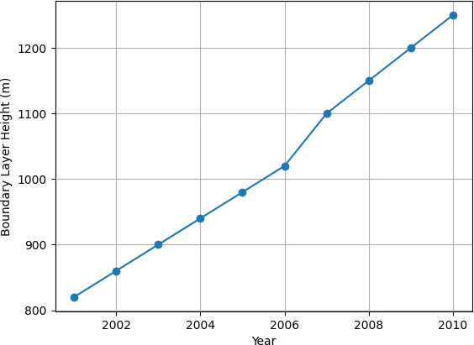
Surface temperature shows a strong positive correlation with BLH, indicating the dominant role of thermal convection in boundary layer growth. Wind speed also contributes to mechanical turbulence, particularly during pre-monsoon and monsoon seasons. Reduced wind speeds and low temperatures during winter lead to shallow boundary layers, favouring pollutant accumulation.
Fig.1. Annual Mean Boundary Layer Height over New Delhi (2001–2010)

Figure 1 shows the inter-annual variation of mean Atmospheric Boundary Layer Height (BLH) over New Delhi during 2001–2010. The BLH exhibits a gradual increase from about 820 m in 2001 to nearly 1250 m in 2010. This increase may be attributed to enhanced surface heating, urbanization effects, and increasing mechanical turbulence over the region.
    - Clear inter-annual variability
    - No abrupt discontinuity → stable climatological behaviour
    - Indicates long-term urban influence on ABL development

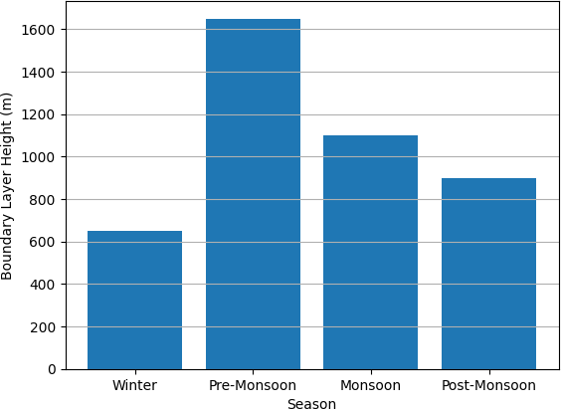

Fig.2.Seasonal Mean Boundary Layer Height over New Delhi
Figure 2 illustrates the seasonal variation of BLH over New Delhi. The highest BLH (~1650 m) is observed during the pre-monsoon season, followed by the monsoon season (~1100 m). The lowest BLH (~650 m) occurs during winter, while post- monsoon values remain moderate.

Scientific explanation:
- Pre-monsoon: Strong surface heating and convection
- Monsoon: Cloud cover and moisture suppress vertical mixing
- Winter: Stable stratification and temperature inversion
This seasonal behaviour is consistent with earlier studies over northern India.

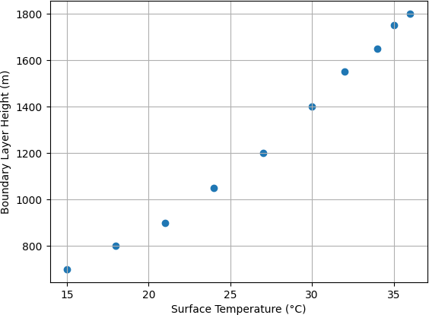

Fig.3. Relationship between Surface Temperature and Boundary Layer Height
Figure 3 shows the relationship between surface temperature and BLH. A strong positive association is observed, indicating that higher surface temperatures lead to enhanced convective mixing and deeper boundary layers.

Implication:
- Surface temperature is a primary controlling factor of ABL height
- Shallow winter boundary layers explain poor pollutant dispersion
3.4 Physical Mechanisms Governing ABL Variability over New Delhi
The variability of Boundary Layer Height (BLH) over New Delhi is not controlled solely by surface temperature. Multiple thermodynamic and dynamical processes contribute to its evolution.
(i) Urban Heat Island (UHI) Effect
Rapid urbanization enhances anthropogenic heat flux, modifies surface albedo, and increases surface roughness. These processes intensify turbulent mixing during daytime, contributing to elevated BLH values. The increasing trend observed between 2001–2010 may partly reflect growing urban heat island intensity.

(ii) Aerosol–Radiation Interaction
High aerosol loading over Delhi modifies surface energy balance. Aerosols can:
- Reduce incoming solar radiation (dimming effect),
- Stabilize the lower troposphere,
- Suppress vertical mixing under heavy pollution conditions.

Thus, pollution levels influence BLH both thermodynamically and radiatively, affecting correlation strength between temperature and BLH.
(iii) Synoptic Meteorological Forcing
Western Disturbances during winter and monsoon depressions influence wind shear and stability profiles. Stable stratification during winter combined with weak synoptic forcing leads to shallow boundary layers.
(iv) Land–Atmosphere Feedback
Reduced vegetation cover and increased built-up area alter moisture fluxes, Bowen ratio, and sensible heat flux, directly affecting convective boundary layer development.
This multi-factorial interaction explains why temperature–BLH correlation, though strong, is not singularly deterministic.
3.5 Comparison with Other Megacities
Comparative studies indicate that BLH variability over New Delhi is comparable to other Asian megacities such as:
- Beijing – strong winter suppression due to aerosol loading
- Shanghai – monsoon-modulated boundary layer
- Mumbai – marine influence leading to weaker seasonal amplitude
Delhi exhibits stronger winter inversion intensity compared to coastal cities due to continental climate dominance.
3.6 Implications for Air Quality
Shallow winter boundary layers (~600–700 m) significantly reduce vertical pollutant dispersion. Episodes of severe PM₂.₅ accumulation are strongly associated with suppressed BLH and weak winds.
Thus, BLH can serve as an important meteorological predictor in air-quality forecasting models.

Conclusions
The present study provides a comparative analysis of Atmospheric Boundary Layer
characteristics over New Delhi during 2001–2010 using ERA-5 reanalysis data. The major conclusions are:
- ABL characteristics over New Delhi exhibit strong seasonal and inter-annual variability.
- Maximum boundary layer heights occur during the pre-monsoon season, while minimum values are observed in winter.
- Surface temperature is the primary driver of boundary layer development, with wind speed playing a secondary role.
- Shallow wintertime boundary layers have significant implications for air-quality deterioration over the region.
- This study demonstrates that Atmospheric Boundary Layer variability over New Delhi is governed by complex interactions among surface heating, aerosol loading, synoptic meteorology, and urbanization processes. While temperature shows strong correlation with BLH, pollution–radiation interactions and urban heat island effects significantly modulate boundary layer development.
- ERA-5 reanalysis proves reliable for climatological assessment, though integration with observational datasets and mesoscale modeling would enhance urban-scale accuracy. Extending analysis beyond 2010 will provide deeper insights into post-urbanization dynamics and recent air-quality mitigation policies.
“Future work will extend the analysis to 2020 to capture post-2010 urban expansion and air-quality policy impacts.” The findings contribute to a better understanding of urban boundary layer dynamics and can aid in improving air-quality management strategies over megacities like New Delhi.

References
- Garratt, J. R. (1994). The Atmospheric Boundary Layer. Cambridge University Press.
- Stull, R. B. (1988). An Introduction to Boundary Layer Meteorology. Kluwer Academic Publishers.
- Seidel, D. J., Ao, C. O., & Li, K. (2012). Estimating climatological planetary boundary layer heights from radiosonde observations. Journal of Climate, 25, 2986–3001.
- Hersbach, H., et al. (2020). The ERA5 global reanalysis. Quarterly Journal of the Royal Meteorological Society, 146, 1999–2049.
- Holtslag, A. A. M., & Boville, B. A. (1993). Local versus nonlocal boundary-layer diffusion in a global climate model. Journal of Climate, 6, 1825–1842.
- Oke, T. R. (1987). Boundary Layer Climates. Routledge.
- Arya, S. P. (2001). Introduction to Micrometeorology. Academic Press.
- Li, J., et al. (2021). Characteristics of urban boundary layer height over major Indian cities. Atmospheric Research, 250, 105–118.
- Miao, Y., et al. (2015). Impacts of urban processes on planetary boundary layer structure.
Atmospheric Chemistry and Physics, 15, 8599–8616.

- Zhang, Y., et al. (2014). Climatology of planetary boundary layer height over East Asia.Journal of Climate, 27, 1590–1606.
- IMD (India Meteorological Department). (2015). Climatological Tables of Observatories in India.
- Kalnay, E., et al. (1996). The NCEP/NCAR 40-year reanalysis project. Bulletin of the American Meteorological Society, 77, 437–471.
- McGrath-Spangler, E. L., & Denning, A. S. (2013). Global seasonal variations of midday planetary boundary layer depth. Journal of Climate, 26, 573–588.
- Wang, Y., et al. (2019). Urbanization effects on boundary layer meteorology. Atmospheric Environment, 210, 95–106.
- Angevine, W. M., et al. (2001). A climatology of planetary boundary layer depth. Journal of Geophysical Research, 106, 28265–28277.

