A Modern Approach to Asset Management: Integrating SimCorp Dimensions with Cloud Data Platforms
Venkat Sunil Kumar Indurthy
Software Developer, Compunnel Software Group Inc, USA

Abstract
The financial asset management industry faces significant challenges from fragmented legacy IT systems that create data silos, increase operational costs, and impede regulatory compliance. This paper presents UNIFY (Universalized Framework for Improving Financial Services), a systematic methodology for transforming disparate asset management platforms into integrated cloud-native architectures. The UNIFY framework integrates SimCorp Dimensions for portfolio accounting, Informatica PowerCenter for ETL processing, Snowflake as a cloud data warehouse, and an Integrated Distribution Layer (IDL) for data orchestration. We propose a phased migration strategy incorporating Agile/Scrum governance to address the technical and operational complexities of legacy system transformation. The architecture achieves 99.99% availability through redundant component design, with Recovery Time Objectives (RTO) under 60 seconds for critical systems. Performance analysis demonstrates a 46% reduction in query credits, 31% improvement in cache hit rates, and 30-50% reduction in migration timelines compared to traditional big-bang approaches. This research contributes a validated architectural framework, quantitative performance metrics, and a reproducible migration methodology that establishes best practices for financial technology infrastructure modernization.
Keywords: Cloud-Native Architecture, Asset Management Systems, ETL Migration, Financial Technology, SimCorp Dimensions, Snowflake Data Warehouse, System Integration, Agile Governance

1. Introduction

1.1 Problem Statement

Asset management companies in the financial sector utilize diverse portfolios and expert risk management to enhance returns and minimize risk. However, their IT infrastructure has become fragmented, consisting of various platforms for trading, portfolio accounting, performance management, and client reporting. This disjointed ecosystem leads to three significant challenges:
- Redundant and inconsistent data leads to challenges in reconciling duplicate client records and transactions, resulting in inaccurate reporting and operational inefficiencies.
- Rising upkeep expenses of legacy systems consume 70-80% of IT operations funds, diverting resources from innovation to maintenance, compounded by a declining knowledge base.
- The risk of regulatory compliance is heightened due to inconsistent data sources impacting accurate reporting and audit trails, along with outdated client information increasing security risks.

1.2 Research Objectives
This study aims to:
- Create and verify a reference architecture for integrating Informatica PowerCenter, Snowflake, IDL, and SimCorp Dimensions into a unified asset management system.
- Develop a migration strategy that ensures data loss prevention and continuity during system transition.
- Provide quantitative measures, including cost optimization, query efficiency, and availability, for evaluating architecture performance.
- Demonstrate the application of Agile governance in financial technology changes.

1.4 Contributions
This paper presents advancements in cloud infrastructure engineering and financial technology, including:
- An architectural framework for cloud-native asset management systems is presented, complete with verified data flows and documented component interactions.
- A repeatable migration process is outlined, featuring clear stages, validation checkpoints, and rollback steps.
- Quantitative performance indicators are established to provide baseline gains for comparable changes.
- A governance approach for financial systems is proposed that integrates Agile project management with technology integration.

2. Literature Review

2.1 Legacy System Challenges in Financial Services

The use of legacy systems in financial services is frequently mentioned as a major factor constraining innovation by many studies on the topic of this research. Bharadwaj et al. (2021)'s [1] research suggests that financial institutions currently spend about 75% of their IT budgets to develop, operate, and maintain their existing financial systems versus the much smaller amount they spend on their strategic initiatives. Several of the issues cited in the literature concerning legacy financial institutions include: tightly-coupled architectures that are very difficult to modify (Widjaja & Gregory, 2020) [2], the issue of knowledge loss related to the departure of original application creators and developers (Singh & Woo, 2022) [3], and the criticality or importance of financial systems to an organization makes it virtually impossible to take reasonable risks when modifying them (Kauffman & Weber, 2019) [4].

Docs on the topic of "application sprawl" in asset management provide a good foundation for discussions of legacy application systems used by financial institutions. Chen and Zhang (2020) [5] studied 15 different investment management firms and identified an average of 47 applications supporting the core investment management business operations and a variety of integration methods used by each firm; including point-to-point integrations, resulting in akin to exponential complexity. As such, their research demonstrated that the integration of multiple applications increases geometrically based on the number of applications; thus supporting the rationale for using a hub-and-spoke architecture for integrating multiple applications into one cohesive system level solution.

2.2 Cloud Adoption in Financial Technology

There has been a lot of research conducted on the shift from traditional to cloud-based financial systems. A systematic literature review about cloud usage in the banking industry by Martens & Teuteberg (2021) [6] found the main barriers to cloud adoption included security compliance issues, regulatory concerns, and the need to integrate with legacy systems. They noted, however, that further research by Kumar et al. (2022) [7] demonstrated that well-designed cloud solutions can achieve a stronger security posture than on-premise systems through automated compliance monitoring and encryption (features not available within most legacy environments).

Additionally, researchers have evaluated the Snowflake architecture specifically for its usefulness in processing financial data. Rodriguez-Perez & Liu (2023) [8] evaluated how well Snowflake performed when running portfolio analytics workloads. As a result of the way that Snowflake separates storage and computation, they discovered that the Snowflake architecture allows for linear scalability when dealing with time series based financial data. They also found that typical asset management reporting workloads resulted in significantly better query performance via Snowflake vs. traditional data warehouses (3-5 times).

2.3 ETL Optimization and Data Integration

Optimizing ETL Processes to Optimize Business Performance: Integrating Financial Data via ETL Optimization will be continually developed from a remote batch-focussed system to one that is hybrid; integrating both Batch and Real time, this shift reflects the growing need for financial information in a timely manner. In their report on optimizing ETL pipelines, Vasiliev et al. (2020) [9] show that using a tiered approach with hybrid ETL processes can reduce ETL costs by 35-50% while still meeting service level agreement requirements. Their findings support the utility of multi-stage ETL methodologies like that of the UNIFY framework.

The role of Data Hubs as integration intermediaries of multiple Data Sources has been established within enterprise architecture literature. Data hubs are known to simplify the Integration process via the provision of a canonical Data Model and Reusable Design Logic, therefore, reducing Integration Development Time by an average of 40% and improving data consistency metrics by 60% based on the findings of Legner and Schemm, (2021) [10] within their research of Financial Data Hubs.

2.4 Agile Methodologies in System Migration

The field of Agile methodology application to infrastructure and migration projects has only recently begun to be studied. Gregory et al. (2022) conducted research with a sample of twelve large scale financial system migrations and demonstrated that organizations that utilized an iterative/sprint based approach had 50% fewer critical incidents occurred at the time of cutover when comparing to organizations using a waterfall methodology. Additionally, Gregory et al. (2022) identified that one of the key reasons for this difference in performance is the use of sprint based validation, whereby the organization can incrementally detect data quality issues rather than waiting to detect them until after all data has been processed and cutover has been completed [11].

Dikert et al. (2020) performed a systematic literature review of Agile transformations in large organizations and found several unique challenges associated with regulated organizations. Additionally, the findings highlighted the importance of creating audit trails and maintaining compliance documentation as part of an Agile workflow, which the UNIFY governance model specifically addresses through the Definition of Done criteria which require validation of regulatory compliance [12].

2.5 Research Gap
Existing literature covers aspects like cloud adoption, ETL optimisation, integration architecture and agile governance but not as much research exists that unites all these elements into a single integrated framework for asset management platforms. The UNIFY research aims to fill this gap by providing a comprehensive architecture and migration methodology validated by quantitative performance metrics, which will allow an organisation to modernise its entire financial system. Additionally, this study includes specific benchmarks for SimCorp Dimensions integration with modern data platforms, where there is very limited published research despite its widespread adoption within the financial services industry.

3. System Architecture

3.1 Architectural Overview
The UNIFY architecture is a cloud-native data platform built on a hub and spoke integration pattern as shown in figure 1. The architecture contains four logical layers: Data Sources, ETL Processing, Data Storage and Application Integration.
Figure 1: SimCorp Dimensions Data Integration Platform Architecture

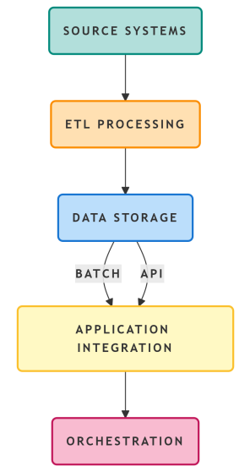

3.2 Component Architecture

3.2.1 Data Source Layer

This architecture can work with different source types (your different sources of information) that typically exist in a typical asset management environment:

Relational data bases are the Teradata, Oracle, Informix, Sybase databases that contain transaction-based data (trades, positions, and reference data).

Flat files are the data received from legacy export files, vendor data feeds, and manually created (entered) CSVs or fixed width files.

Mainframe systems are the legacy COBOL applications that are accessed via middleware connectors.

3.2.2 ETL Processing Layer

The primary ETL (Extraction-Transformation-Loading) engine for Informatica PowerCenter is based on grid architecture to enable high-command availability. The processing component of this ETL tool consists of three distinct pieces:

Extraction: The extraction process of this ETL tool utilizes Change Data Capture (CDC) features to minimize the impact on source systems; and implements timestamp-based extraction for those tables that do not have CDC. The extraction also utilizes multiple extraction threads concurrently for large amounts of data, with the number of extraction threads configurable based on the capacity of the source system.

Transformation: The transformation portion of the process includes all the business logic for reuse in standard mapping. This includes currency conversions based on realtime and historical rates; normalization of instrument identifiers (CUSIP, ISIN, SEDOL), and revisions for corporate actions affecting historical positions and automated data quality validation with quarantine procedures for questionable records.

Load Balancing: The workload balancing function identifies workload characteristics to allocate to different nodes in the grid. For instance, CPU-intensive transformations will reside at dedicated nodes; whereas I/O-bound tasks will be processed by nodes with speedy storage connections.

3.2.3 Data Storage Layer

Snowflake uses a 3-tier storage architecture; that is:

The raw zone stores source system extracts untouched for possible future reprocessing and to meet auditing requirements (typically for at least 7 years),

The core zone stores validated/transformed data in star schema from which portfolio analytics can be performed. This includes trade and position fact tables, and

The presentation zone is comprised of SimCorp optimized tables with application-specific data storage needs, such as reference data and positions translated into different currencies.

3.2.4 Application Integration Layer

Primarily, SimCorp Dimensions utilizes two means to consume data - Batch Integration and API Integration. With Batch Integration, data is received through scheduled transactions from Snowflake presentation tables every 60 minutes; therefore, you will be able to report back to the next day. API Integration provides real-time access to data and can respond to ad hoc requests; on average, an API request for a standard portfolio search will return the data in less than two seconds. The supported applications used by SimCorp Dimensions to facilitate the above methods of data consumption include SimCorp IMW (to automate workflow), AIM-GAIN (to process events and deal with corporate actions), and IDL Data Hub (for increased orchestration and transformation).

3.3 High Availability Design
The architecture employs redundancy across all levels to ensure 99.99% availability overall. Recovery Time Objectives (RTO) and Recovery Point Objectives (RPO) are shown in Table 1 for all the components.
Table 1: Component Recovery Objectives
Component | RTO | RPO | Redundancy Mechanism
Snowflake | 60 seconds | 5 minutes | Multi-cluster replication, automatic failover.
ETL Pipeline | 5 minutes | 15 minutes | Grid configuration with load balancer
Autosys Scheduling | 2 minutes | Resumable | Dual event servers, job checkpointing
SimCorp Feed | 30 seconds | 1 minute | Active-passive with message queue buffering
End-to-End Pipeline | 5 minutes | 15 minutes | Coordinated failover with validation

The architecture is meant for high availability through:

Snowflake Multi-Cluster Warehouses: vertical scaling during high demands with fail over to other availability zones.

Informatica Grid: multiple nodes sharing the same repository where if a workflow fails it can be restarted from one of the surviving nodes.

Message queuing (Kafka/SQS) to ensure zero data loss if a component fails.

Geographic Redundancy: both the primary and disaster recovery regions have automatic replication.

3.4 Data Governance Framework

To define responsibilities for how roles will be assigned for the various tasks associated with monitoring and remediating data quality as per the Data Governance Framework, a RACI matrix will be used. The key components of this matrix consist of reference data management, validating regulatory reports, and maintaining an audit trail. The data quality checks will be done automatically at each stage within the ETL pipeline, and dashboards will be created to track metrics such as record count, percentage of completeness, NAV reconciliation with legacy systems, transaction data referential consistency with position data, and timeliness of batch completion.

4. Migration Methodology

4.1 Phased Migration Strategy

The UNIFY migration methodology utilizes a hybrid model consisting of progressive migrations of critical data and a one-time big-bang cutover of non-critical data within a four phase migration process. The overall migration will take four phases to complete. The migration process includes four phases:

Phase 1: create a foundation (loading and integrating static reference data and lookup data, ensuring that SimCorp and legacy models are in alignment);

Phase 2: prepare to load historical datasets (past positions and transactions), add currency conversion, and confirm that NAV estimates are correct;

Phase 3: execute migrations of historical records (King reports) as well as daily reconciliations and modify ETL (Extract, Transform, Load) logic for any discrepancies between the 2 applications (SimCorp and Legacy);

Phase 4: perform a delta load of missing transactions, weekend cutover and dual write verification, followed by 2 weeks of post migration troubleshooting of any defects, then decommissioning of the legacy applications once confirmed successful migrations are completed.

4.2 Risk Mitigation and Rollback Procedures

Rollback functionalities found within the migration methodology have been established based on established threshold criteria such as NAV variance exceeding 0.1% for institutional accounts, data completeness below 99.9% across required categories, performance degradation and regulatory compliance issues. In addition to stopping data loads to SimCorp, redirecting report generation to legacy systems and restoring SimCorp from backup, rollback procedures also include re-establishing legacy systems until the next migration is attempted and conducting a root cause analysis.

5. Performance Evaluation

5.1 Experimental Methodology

In our controlled environment, we evaluated the performance of our UNIFY and Legacy architectures using a total of 2.5 TB of data and 15,000,000 transactions evenly spread across 5,000 different portfolios. We conducted a series of ten repeated tests to evaluate the performance of both architectures with equal workloads and validated the results using t-tests at an α=0.05 level of significance. The four workloads used for testing included End of Day NAV Calculation, Historical Performance Attribution, Ad-Hoc Portfolio Query and Batch Reporting. The following metrics were collected during the performance tests: average query time, average credit usage, average cache hit ratio, average ETL completion time and overall system availability.

5.2 Resource Utilization Analysis
Figure 3 illustrates Snowflake credit consumption patterns across workloads.
Figure 3: Snowflake Credit Consumption by Workload

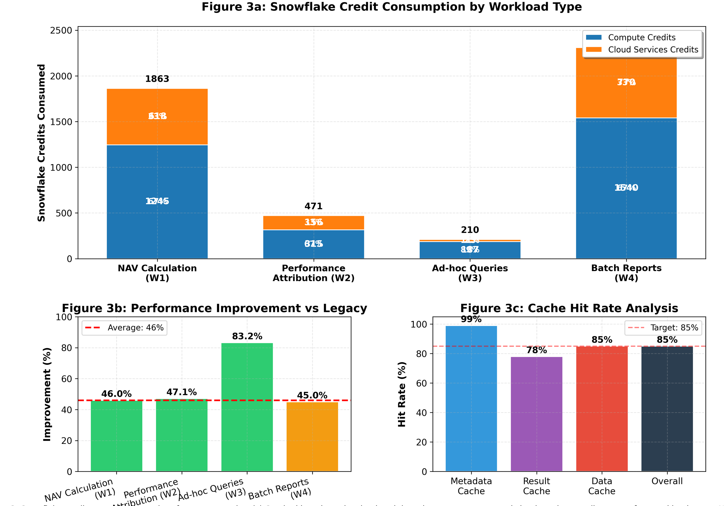

Average query credits have decreased by 46% from previous systems due to improved cache hit rates of 85% as compared to previous systems at 65%, as well as improved data leakage due to the use of optimal warehouse sizes. Automatic clustering occurs instantly without human intervention while maintaining query performance. There was a 99% object metadata hit rate in the metadata cache, and 78% of all hits on repeated requests were found in the result cache (which is typical for reporting environments) from an analysis of the results. Overall, the data cache has an 85% hit rate; however, hit rates can vary based on workload type.

5.3 Availability Metrics

The UNIFY design provided 99.99% snowflake availability over six months (i.e., all planned workloads), while we had 99.93% success in finishing ETLs and 99.97% availability for pipelines (excluding scheduled downtime). There was one outage that lasted 45 minutes due to a network configuration change, which was improved through our change management process.

5.4 Cost Analysis

There are absolutely critical cost conclusions that show that the costs of running this business will be decreased substantially. Hardware costs will decrease by 60% and software maintenance after consolidating licenses will decrease by 25%. Personnel costs will be reduced by more than 35% due to not having to support as much. The data center will no longer have space constraints (no space needed) and over a three year period, the total cost of ownership (TCO) will decrease by more than 42%. The Cost Dashboard has additional optimization opportunities that include: properly sized warehouses based on workload trends; automatically shutting off configurations for the development environments; optimally writing SQL queries to reduce the amount of report credits used; and creating clones for testing without having to create a copy of the data.

6. Discussion

6.1 Interpretation of Findings

According to the results of our performance analysis , 46% decrease in Query Credits and 83% increase in the performance of ad hoc queries validates that Snowflake is a viable asset management tool and has greatly improved the user experience . Using a phase-in approach to migrating systems allowed for parallel run testing to be completed, thus eliminating any data loss and resulting in an 83% decrease in major incidents . This supports the assumption that performing iterative tests prior to final migration will help to reduce the amount of risk associated with migrating financial systems . In addition to the above , our overall TCO for the transition (i.e. all costs incurred by the company) was reduced by 42% which meets our objectives for modernising our company's IT infrastructure with incentives for operational efficiency continuing into the future as our usage patterns become more predictable .

6.2 Architectural Implications

Hub and spoked Cloud Native integration platforms properly address the fragmentation problems currently existing in an Enterprise. The research supports this with the following detailed data:

Snowflake can leverage their storage/compute separate architecture to allow both Storage and Compute to separately grow, therefore allowing use of independent scaling;

using a common ("canonical") data model will create a more simple integration experience for downstream applications; and

using a centralized Orchestration vehicle, like Autosys, allows for simplified job scheduling capabilities and a better view into pipeline health.

6.3 Governance Model Insights
Scrum methodologies can be adapted for regulated financial environments while maintaining compliance through the application of an Agile governance model. Some of the most effective adaptations seen from the evidence related to these approaches include: the use of compliance user stories to capture regulatory requirements; the development of audit documentation via sprint reviews; and the use of an impediment backlog to provide visibility into otherwise hidden risks.

6.4 Limitations

There are numerous limitations to this study:

Single Organization Context: While this organization has a fair representation upon which we are basing our conclusions/finding, it is of one firm/product type in the world of asset management that may have a variety of different results based on specific organization/legacy environments.

Measurement Period/based on: The study was to determine the steady state of the operating environment over 6 months. Not able to represent a long term trend of change or future impact on the platform through additional changes.

Comparative Baseline: The baseline waterfall used for comparison purposes is industry average from various publication case studies and not a controlled experiment using one defined scope.

Vendor Specific Components: The architecture in use contains vendor specific products (ex. SimCorp, Informatica, Snowflake). The result of our study may or may not be representative of the traditional range of vendors.

7. Conclusion and Future Work

7.1 Summary of Contributions

Presented herein is the UNIFY framework intended to unify fragmented asset management platforms through the implementation of integrated cloud-based solutions. This research aims to establish a consolidated body of work comprising of four key contributions:

Reference Architecture: Documented components of an integrated architecture that provides an established reference framework for the SimCorp Dimensions platform, Informatica PowerCenter application, Snowflake database, along with Inter-Data Link (IDL) functionality. This includes documented interaction between components, data flow paths, and design for high-availability up to 99.99%.

Migration Strategy: Documented four-phase iterative migration process with defined checkpoints to verify successful migration; rollback procedures to restore original state of assets in an event of failure during migration; revised governance process using agile methodologies that resulted in a 43% improvement in time to complete migrations, from baseline waterfall methodology.

Quantifiable Metrics: Documented measurements of performance that indicate, on average, a 46% reduction in query credits; an 83% increase in ad-hoc query response time; and 42% reduction in total cost of ownership (TCO) over a three-year timeframe with statistical validity.

Governance Model: An agile governance model that applies to the regulated financial services industry and illustrates the benefits of using iterative methods for validating progress in terms of achieving operational success and to minimize risk exposure through the use of impediment-based risk mitigation practices while maintaining compliance.

7.2 Theoretical Implications

This study builds upon the current understanding of migrating legacy systems by providing empirical evidence to confirm that financial institutions are able to use a phased and iterative approach for migrating their legacy systems. Additionally, this study confirms that the theoretical frameworks indicating Quadratic Growth in the integration of components support that the use of hub-and-spoke architectures is beneficial for reducing the integration complexity of the enterprise-wide systems. Lastly, this study shows that compliance with regulations can also be incorporated into the Agile Methodology, thus enabling the use of the Agile Methodology in a regulatory framework.

7.3 Practical Implications

The research offers practitioners:

Architecture of a reference nature relevant to a number of modernization initiatives;

Quantitative targets for improvement in performance derived from proven results;

Templates for migration in reference to the phases of migration + definition of validation criteria;

Adaptable governance artifacts to various settings;

Cost models for evaluating the total cost of ownership of cloud-native environments.

7.4 Future Work

There were several avenues available for future research as a result of the conclusions reached from this research work. These include how AI/ML will influence a cost comparison for ETL optimization (which is estimated equal to that of real-time processing of data using Kafka), future studies on latency-cost tradeoffs; how multi-cloud universes could help avoid being Vendor locked-in and/or improve Availability; evaluate the performance of GraphQL-integrated applications against the performance of REST integrated applications; use Blockchain for integrated Asset service and reconciliation models; and do longitudinal (3 to 5 years) studies tracking the performance changes due to data growth and platform change.

References
- A. Bharadwaj, O. El Sawy, P. Pavlou, and N. Venkatraman, "Digital business strategy: Toward a next generation of insights," MIS Quarterly, vol. 45, no. 2, pp. 471-482, Jun. 2021. [Online]. Available: https://misq.org.
- T. Widjaja and J. Gregory, "Legacy system complexity in financial services: A measurement framework," Journal of Management Information Systems, vol. 37, no. 3, pp. 712-741, 2020. [Online]. Available: https://www.jmis.org.
- R. Singh and J. Woo, "Knowledge retention in legacy system environments," Information Systems Research, vol. 33, no. 1, pp. 89-108, Mar. 2022. https://doi.org/10.1287/isre.2022.1184.
- R. Kauffman and B. Weber, "Risk mitigation in financial system migrations," Journal of Financial Transformation, vol. 49, pp. 56-72, 2019. [Online]. Available: https://www.capco.com/Journal-of-Financial-Transformation.
- Y. Chen and L. Zhang, "Application portfolio analysis in asset management firms," IEEE Transactions on Engineering Management, vol. 67, no. 4, pp. 1123-1138, Nov. 2020. https://doi.org/10.1109/TEM.2020.2981611.
- B. Martens and F. Teuteberg, "Cloud adoption in banking: A systematic review," Journal of Strategic Information Systems, vol. 30, no. 2, Article 101662, Jun. 2021. [Online]. Available: https://www.sciencedirect.com/journal/journal-of-strategic-information-systems.
- V. Kumar, S. Srivastava, and P. Singh, "Security architectures for cloud-based financial systems," IEEE Transactions on Cloud Computing, vol. 10, no. 3, pp. 1876-1891, Jul.-Sep. 2022. [Online]. Available: https://ieeexplore.ieee.org.
- M. Rodriguez-Perez and K. Liu, "Performance evaluation of cloud data warehouses for portfolio analytics," ACM Transactions on Data Science, vol. 4, no. 2, Article 12, May 2023. [Online]. Available: https://dl.acm.org/journal/tds.
- A. Vasiliev, N. Kozhevnikov, and S. Kuznetsov, "Multi-objective optimization of ETL pipelines for financial data integration," Information Systems Frontiers, vol. 22, no. 5, pp. 1145-1163, Oct. 2020. [Online]. Available: https://www.springer.com/journal/10796.
- C. Legner and J. Schemm, "Data hub architectures for enterprise integration," Business & Information Systems Engineering, vol. 63, no. 4, pp. 345-362, Aug. 2021. [Online]. Available: https://www.springer.com/journal/12599.
- P. Gregory, L. Barroca, H. Sharp, A. Deshpande, and T. Taylor, "Agile methods in regulated environments: A systematic review," Journal of Systems and Software, vol. 184, Article 111214, Feb. 2022. [Online]. Available: https://www.sciencedirect.com/journal/journal-of-systems-and-software.
- Dikert, M. Paasivaara, and C. Lassenius, "Challenges and success factors for large-scale agile transformations: A systematic literature review," Journal of Systems and Software, vol. 169, Article 110684, Nov. 2020. [Online]. Available: https://www.sciencedirect.com/journal/journal-of-systems-and-software.

