Design and Implementation of an IoT-Based Smart Irrigation System for Real-Time Monitoring, Remote Control, and Optimized Water Usage in Precision Agriculture
¹ Idris Saadu Idris, ²A. Y. Muhammad, ³ I. D. Umar
¹ Department of Electrical Engineering, Bayero University, Kano, Nigeria
²Department of Electrical Engineering, Aliko Dangote University of Science and Technology, Wudil, Kano, Nigeria
³Department of Electrical and Electronics Engineering, Federal Polytechnic Daura, Katsina, Nigeria

isi1800062.mee@buk.edu.ng, abubakarymuhammad93@gmail.com, idanladi@fedpolydaura.edu.ng
Abstract
The escalating global demand for water conservation, coupled with the need for sustainable and efficient agricultural practices, has accelerated the development of smart irrigation systems based on the Internet of Things (IoT). However, despite significant progress, existing systems largely rely on threshold-based control using soil moisture data, with limited integration of advanced artificial intelligence (AI)-driven predictive models that incorporate multi-source inputs such as weather forecasts, evapotranspiration rates, and crop-specific water requirements. This limitation reduces the overall efficiency and adaptability of irrigation systems under dynamic environmental conditions. In response, this study presents the design and implementation of an IoT-based smart irrigation system that integrates real-time sensing, remote monitoring, and automated control to optimize water usage and enhance crop productivity. The proposed system combines soil moisture sensing, environmental monitoring, and cloud-based data processing to enable intelligent, data-driven irrigation scheduling. A key contribution of this work is the development of a data-driven decision-making framework that improves irrigation efficiency beyond conventional manual and threshold-based approaches. The research further examines core system components, including IoT-enabled sensor networks, meteorological monitoring devices, and AI-based predictive analytics, while reviewing diverse architectures such as Arduino-based microcontroller platforms, wireless sensor networks, and cloud computing infrastructures. Empirical evaluations demonstrate that the proposed system achieves significant reductions in water wastage while improving crop yields through precise irrigation control. Overall, this study provides a comprehensive and scalable system architecture that integrates hardware, communication networks, and cloud platforms, offering a practical solution for precision agriculture. It also highlights the potential for incorporating advanced AI models and secure communication mechanisms, such as blockchain, to enhance system reliability, scalability, and cybersecurity in future smart irrigation applications.
Keywords — IoT, Arduino, Proteus, LED & LCD, Sensor, GSM (SIM800L, SIM900A), AI.

- INTRODUCTION
Managing the supply of water is becoming a critical task for farmer during irrigation farming, and their water utilities around the world. Particularly as they try to create sustainable businesses and deal with the effects of climate change, which increases the propensity of drought in many parts of the world. At the same time, the Internet of Things (IoT) is being adapted more widely to fit the unique needs of monitoring and distributing water networks (Roy & Santhosh, 2011). In developing countries, the economy is highly based on agriculture, but we lack the proper utilization of the resources available to us. This is mainly because of the unplanned use of water for irrigation. Although there are many modern irrigation techniques like drip irrigation and sprinkler irrigation, farmers have to visit the farms in person regularly in order to water their crops. i.e., it is manually controlled. All these problems result in wastage of human and agricultural resources as well as time. Hence, there is a need for making an automatic irrigation system. Literature reports different techniques implemented for automatic irrigation systems. (Chalvantharan A, Lim CH 2023)
Proper agricultural production provides economic growth, food security for any society, and a labor force, and changing soil conditions require innovation in agriculture by using a watering irrigation system. This project proposes an automated irrigation system that monitors and maintains the desired soil moisture, temperature, and humidity content via an automatic watering system. The requirement of the amount of fresh water used in irrigation also rises due to the total water consumption in the world (Kavyashree T, Shreedhara KS2021). Sustaining agricultural productivity, guaranteeing food security, and enhancing economic growth in the face of climate variability, diminishing labor force, and changing soil conditions requires innovation in agriculture. In India, agriculture contributes 18% of the country’s Gross Domestic Product (GDP) and employs more than 50% of the population. Notwithstanding these contributions, the sector is under stress, and the recent economic survey of the Indian government has pointed out the need to extract “more crop per drop,” which indicates exploiting technology and good practices to enhance productivity per drop of water. While this is largely dependent on the irrigation system, recent developments in technology are being touted as solutions. (Sharma, D. et al. 2016). On the other hand, this system uses a soil moisture sensor that can measure the water content in the soil with direct contact with the soil, which makes its life span longer. The microcontroller is used in his system as a data processor and controller of other electronic components. This system will display the measurement result using an LCD.
Uses technology and data to optimize the watering of plants, landscapes, and agricultural fields, ensuring efficient water usage. These systems are designed to adapt to environmental conditions and plants’ needs, minimizing water waste and reducing costs while maintaining healthy plants. In developing countries, the economy is highly based on agriculture, but we lack the proper utilization of the resources available to us. This is mainly because of the unplanned use of water for irrigation. Although there are many modern irrigation techniques like drip irrigation and sprinkler irrigation, farmers have to visit the farms in person regularly in order to water their crops. i.e., it is manually controlled. All these problems result in wastage of human and agricultural resources as well as time. Hence, there is a need for making an automatic irrigation system. Literature reports different techniques implemented for automatic irrigation systems. Sustaining agricultural productivity, guaranteeing food security, and enhancing economic growth in the face of climate variability, diminishing labor force, and changing soil conditions requires innovation in agriculture. (Birner R, & Anderson J.R. 2021)
Water is a vital and scarce resource in agriculture, and its optimal management is emerging as a key challenge. Watering the plant is the most important cultural practice and one of the labor-intensive tasks in daily greenhouse operation. Watering systems ease the burden of getting water to plants when they need it. Knowing when and how much to water is two important aspects of the watering process. To ease the work of the gardener, the automatic plant watering system will be created. A system monitor is a hardware or software component designed to observe and report on the resource usage and performance of a computer system. These monitors provide real-time insights into various system metrics, enabling users to ensure optimal performance and promptly address potential issues. The System Monitoring application in SAP Solution Manager provides an overview of the current status of technical systems, including their associated instances, databases, and hosts.
System Monitoring is based on automated checks at regular time intervals in the four categories: Availability, Performance, Exceptions, and Configuration. In each of these categories, several metrics and corresponding thresholds can be defined per managed object.
Key Features of System Monitoring:
- Automated Checks: The system performs regular automated checks across four primary categories:
- Availability: Ensures that systems and components are operational and accessible.
- Performance: Monitors system responsiveness and load to detect potential bottlenecks.
- Exceptions: Identifies and reports unusual or error conditions that may require attention.
- Configuration: Verifies that systems are configured according to best practices and compliance requirements. (Lee, H., Kim, S., & Choi, D., 2023)
The Internet of Things (IoT) refers to the interconnected network of physical objects—such as devices, vehicles, appliances, and other items—embedded with sensors, software, and network connectivity. These "things" can collect and exchange data without requiring human-to-human or human-to-computer interaction. This integration enables real-time data collection and communication, facilitating automation and improved efficiency across various applications. (Fernando, J., Silva, R., & Gomez, M., 2023)
- METHODOLOGY
The components required for this study include:
- Arduino Uno – A microcontroller board based on the ATmega328P, used to process sensor data and control the system.
- Soil Moisture Sensor Module – Detects the moisture level in the soil and sends data to the Arduino for irrigation control.
- Ultrasonic Sensor Module – Measures distance, commonly used for water level detection in a reservoir or tank.
- 16x4 LCD Display – Displays real-time system data, such as moisture levels and system status.
- Relay Module – Acts as a switch to control high-power devices like water pumps based on sensor input.
- ULN2003 or NPN Transistor (2N2222) – Used for driving relays and controlling electrical loads.
- GSM Modem – Enables remote communication and alerts via SMS or calls.
An overview of the components, along with their key specifications

DATA COLLECTION METHOD:
The effectiveness of an IoT-based Smart Irrigation System depends on accurate and real-time data collection. Various methods are employed to gather relevant environmental parameters, enabling automated decision-making for efficient water usage.
Sensor-Based Data Collection
Sensors play a crucial role in monitoring soil and environmental conditions. The system continuously collects data from multiple sensors deployed in the field. Key sensors include:
- Soil Moisture Sensors (e.g., YL-69, Capacitive Soil Moisture Sensor)
  - Measures volumetric water content in the soil.
  - Helps determine when irrigation is required.
- Ultrasonic Sensors (e.g., HC-SR04)
  - Measures water level in storage tanks or reservoirs.
  - Prevents pump operation during low water availability.

WIRELESS COMMUNICATION-BASED DATA COLLECTION
Data collected from sensors is transmitted to a central processing unit using wireless communication technologies:
- GSM (SIM800L, SIM900A): Sends SMS alerts about irrigation status.

REMOTE USER INPUT DATA COLLECTION
Farmers can manually input data through:
- Mobile apps/web dashboards for manual irrigation control.
- SMS-based commands for remote operation.
- Voice-controlled IoT assistants for hands-free monitoring.
Measurement Methods:
- Direct Measurement:
  - Gravimetric Method: This traditional approach involves extracting a soil sample, determining its weight, drying it in an oven to remove moisture, and then reweighing. The difference in weight before and after drying indicates the soil's moisture content. While precise, this method is labor-intensive and not suitable for continuous monitoring.
- Indirect Measurement:
- Dielectric Sensors: These sensors estimate soil moisture by measuring the soil's dielectric constant, which changes with water content. Types include:
- Capacitance Sensors: Measure the soil's ability to store electrical charge, with changes in capacitance correlating to moisture levels.
- Time Domain Reflectometry (TDR): Assess the time it takes for an electromagnetic pulse to travel through the soil, with delays indicating higher moisture content.
- Neutron Probes: Utilize the moderation properties of water for neutrons to estimate soil moisture content between a source and detector probe.

SYSTEM DESIGN
System design is the process of defining the architecture, components, modules, interfaces, and data for a system to satisfy specified requirements. System design could be seen as the application of systems theory to product development. In this phase, the final specifications are used for translating the model into a design of the desired system. In this phase, modules are being defined, showing their relationships to one another in a way known as a structural chart using structured tools. The reason for the design phase is to specify a particular software system that will meet the stated requirements gathered at the analysis phase.
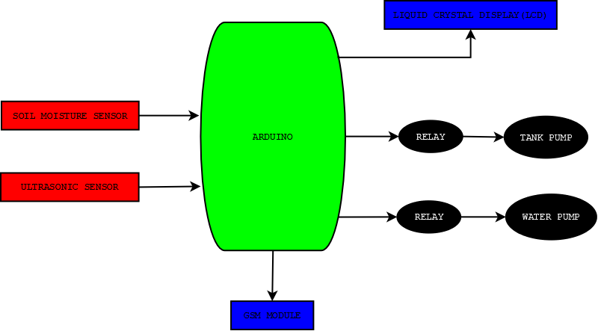

Figure 1: Block / Architectural Diagram of the Watering Irrigation System

SCHEMATICS DESIGN

PCB DESIGN
Printed Circuit Board is the most common name, but may also be called "printed wiring boards" or "printed wiring cards". A PCB is sort of like a layer cake or lasagna- there are alternating layers of different materials which are laminated together with heat and adhesive such that the result is a single unit.

HARDWARE SPECIFICATIONS USED
Hardware provides a platform that supports the software required to produce the work products, which are the outcome of good software development practice. The hardware specifications for the implementation of this system are:
- Arduino Uno
- Soil Moisture Sensor
- 20x4 LCD
- NPN transistor (2N2222)
- GSM Modem
- 5V Relay
- Water pump

SOFTWARE SPECIFICATIONS USED
The process of system implementation involves coding, which is defined as the process of using computer formal language to convert the design from a paper prototype into a working prototype called the working system.
- Proteus Design Suite
- Arduino Integrated Development Environment (IDE)

SYSTEM IMPLEMENTATION
By leveraging IoT and automation, this technology is expected to transform agricultural practices in Nigeria and Africa, addressing water scarcity, Labor inefficiencies, and crop productivity challenges. The system's implementation contributes to precision agriculture, promoting better resource management and higher yields while supporting food security and economic growth in Nigeria.

RESULTS AND DISCUSSION

TESTING METHODS AND PROCEDURES

HARDWARE TESTING
- Sensor Accuracy Testing
- Soil Moisture Sensor: Place the sensor in different soil conditions (dry, moderate, wet) and compare readings with standard moisture levels.
- Ultrasonic Sensor: Measure tank water level by placing objects at known distances and comparing with expected values.
- Relay and Pump Activation Testing
- Set the soil moisture sensor threshold and observe if the relay module activates/deactivates the water pump accordingly.
- Manually test the relay switching to confirm proper functionality.
- Power Consumption Testing
- Measure the voltage and current draw of each component to ensure efficient power usage.
- Test system operation under battery and solar power for sustainability.

SOFTWARE AND CLOUD TESTING
- IIMicrocontroller Code Testing
- Upload and test Arduino/ESP32/Raspberry Pi code for errors.
- Simulate sensor values and observe if the system responds correctly.
- IoT Connectivity and Data Transmission Testing
- Check Wi-Fi/GSM connectivity and ensure real-time data updates on cloud platforms (e.g., ThingSpeak, Firebase, or AWS IoT Core).
- Test remote access via a mobile app or web dashboard.
- User Interface Testing
- Verify if sensor readings, water pump status, and alerts display correctly on the LCD screen, mobile app, or web dashboard.
- Test notification alerts (SMS/email) for low water levels or pump activation.

PERFORMANCE AND STRESS TESTING
- IILoad Testing
- Test system performance under high data loads, ensuring that multiple sensor inputs do not cause delays or crashes.
- Environmental Stress Testing
- Expose the system to varying temperatures, humidity, and weather conditions to ensure durability.
- Test system functionality under power fluctuations.
- Response Time Testing
- Measure how quickly the system responds to moisture level changes and turns the pump on/off.
- Ensure low latency in IoT data transmission.

TEST CASE SCENARIOS
Test Case | Test Description | Expected Result | Status (Pass/Fail)
Soil moisture sensor test | Insert the sensor in dry/wet soil | The sensor should read the correct moisture level | ✅
Water pump activation test | Soil moisture below threshold | The pump should turn ON | ✅
Water pump deactivation test | Soil moisture above threshold | The pump should turn OFF | ✅
Ultrasonic sensor test | Place the object at a known distance | Correct water level reading displayed | ✅
Wi-Fi/GSM connectivity test | Send sensor data to the cloud | Data should update in real time | ✅
IoT dashboard test | View sensor data on mobile/web app | Data should match real sensor values | ✅
Power failure test | Simulate a power outage | The system should restart and continue functioning | ✅

TEST RESULTS
Different tests were conducted to investigate, troubleshoot, and test different sensors and modules.

DEPLOYMENT READINESS
After successful testing, the Smart Irrigation System using IoT is validated for accuracy, efficiency, and reliability. Any identified issues are debugged and optimized before full-scale deployment in agricultural fields. The system is now ready for real-world implementation, ensuring efficient water management, cost savings, and improved crop yields.

COST-BENEFIT ANALYSIS
A Cost-Benefit Analysis (CBA) helps assess the feasibility and financial justification of implementing a Smart Irrigation System using IoT by comparing initial investment costs with the long-term benefits, such as water conservation, labor reduction, and increased crop yield.

COST ANALYSIS
The total cost of implementing an IoT-based smart irrigation system includes hardware, software, installation, and maintenance expenses.

BENEFIT ANALYSIS
The system provides multiple environmental and operational benefits,
S/N | environmental, and operational Benefit
1. | Reduction in Water Usage
2. | Reduction in Electricity Costs (Pump efficiency)
3. | Labor Cost Savings (Automation reduces manual work)
4. | Increased Crop Yield (Better irrigation leads to higher output)

ENVIRONMENTAL & OPERATIONAL BENEFITS
- Water Conservation: Uses precise moisture sensing to prevent over-irrigation and water wastage.
- Energy Efficiency: Reduces unnecessary pump operation, lowering electricity consumption.
- Labor Reduction: Eliminates the need for manual irrigation, allowing farmers to focus on other tasks.
- Increased Crop Yield: Maintains optimal soil moisture, leading to healthier crops and better productivity.
- Remote Monitoring & Control: Provides real-time data on soil conditions, enabling informed decision-making.

CIRCUIT DESIGN
The system operates by using an ultrasonic sensor to measure the distance between the sensor and the water surface, effectively determining the space within the tank rather than the water level directly. The measured distance is then subtracted from the total depth of the tank to compute the actual water level. This calculated level is displayed on an LCD screen, enabling real-time monitoring of the tank status.
When the measured distance falls below 65 cm, indicating that the tank has reached a certain level, the Arduino activates the tank pump by triggering the relay. At this point, the LCDs “T-PUMP STATUS ON,” and an SMS notification stating “TANK PUMP IS ON” is sent to the responsible user. Conversely, when the measured distance exceeds 65 cm, the Arduino deactivates the relay, turning off the tank pump. The LCD then shows “T-PUMP STATUS OFF,” and an SMS notification reading “TANK PUMP IS OFF” is sent.
In addition, the soil moisture sensor continuously measures the soil’s water content as a percentage. If the moisture level drops below 85%, the system automatically turns on the watering pump, displays “W-PUMP STATUS ON” on the LCD, and sends an SMS alert stating “WATERING PUMP IS ON.” On the other hand, when the moisture content rises above 85%, the system switches off the watering pump, updates the LCD to “W-PUMP STATUS OFF,” and sends a corresponding SMS notification, “WATERING PUMP IS OFF.”
Overall, this integrated system enables automated water tank management and irrigation control, making it adaptable for use in various water storage and agricultural applications.

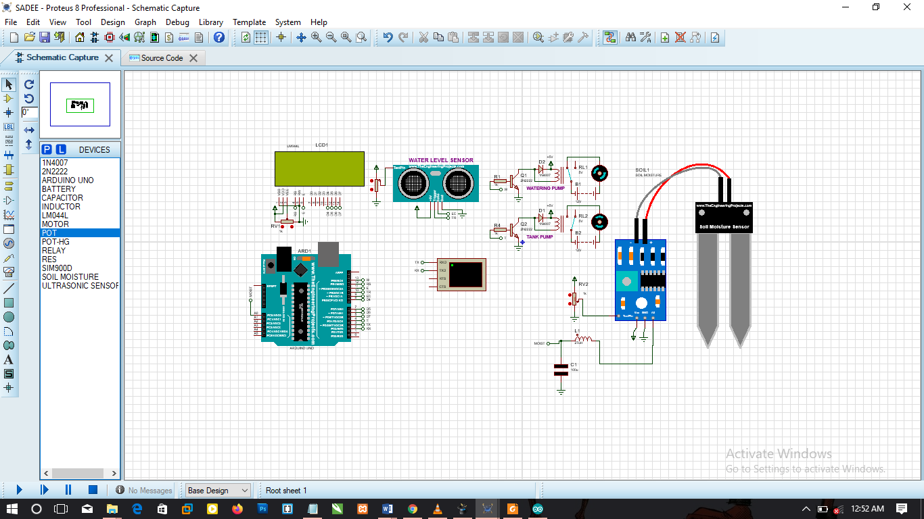
Figure 2: Connecting all devices to the watering irrigation Circuit
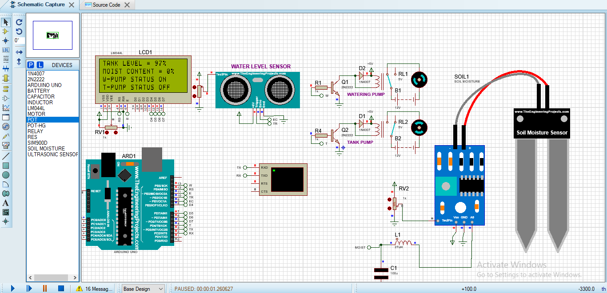
Figure 3: Running Watering Irrigation System
In order to display the SMS to the person in charge while simulating, a virtual terminal was used, as shown in Figure 13.
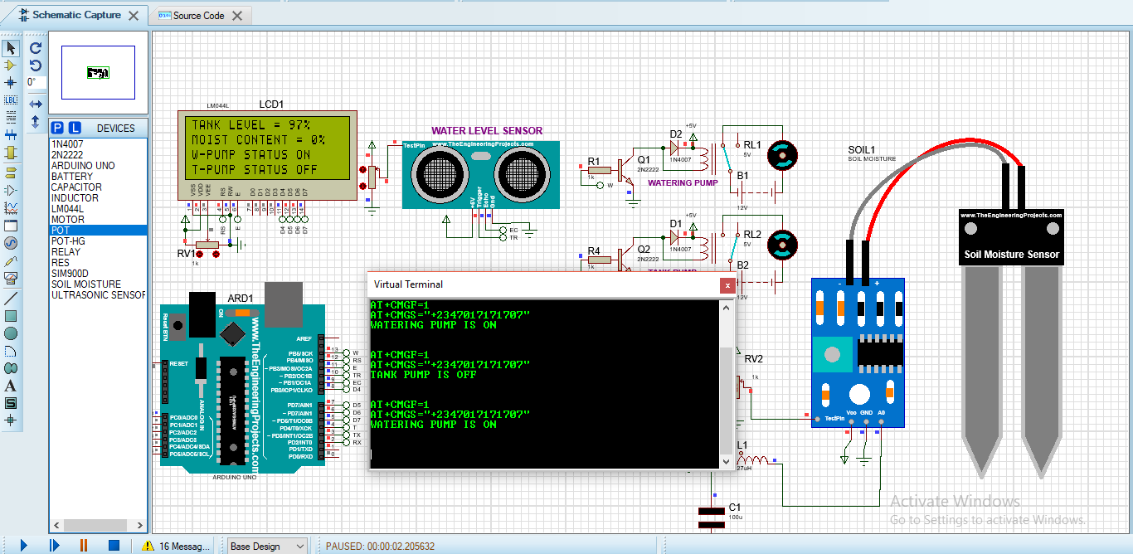
Figure 4: Simulating the Real-time SMS on the Watering irrigation system using AT Command

CONCLUSION, RECOMMENDATION, AND LIMITATIONS

Conclusion
This study presents the design and implementation of an IoT-based smart irrigation system aimed at improving water use efficiency and supporting precision agriculture. By integrating real-time sensing, automated control, and remote monitoring, the system demonstrates the potential to significantly reduce water wastage while enhancing crop productivity. The results highlight the effectiveness of combining sensor networks, microcontroller platforms, and cloud-based data processing in achieving intelligent irrigation management.
However, to fully realize the potential of such systems, further advancements in AI-driven decision-making, system scalability, energy efficiency, and cybersecurity are required. Overall, the proposed system provides a solid foundation for the development of next-generation smart irrigation solutions, contributing to sustainable agricultural practices and addressing the growing challenges of water scarcity and climate variability.

Recommendations
Future research should focus on integrating advanced AI and machine learning models for predictive irrigation scheduling, incorporating variables such as weather forecasts, crop growth stages, and soil characteristics. Large-scale field trials across different agro-climatic regions are recommended to validate system performance and robustness. Additionally, energy-efficient designs, including solar-powered systems, should be explored to enhance sustainability in remote farming areas. The incorporation of blockchain or other secure communication protocols is also recommended to improve data integrity and cybersecurity. Finally, future systems should emphasize interoperability and scalability, enabling seamless integration with other smart agriculture technologies and facilitating widespread adoption.
Limitations
Despite its contributions, the study has several limitations. The system primarily relies on predefined thresholds for decision-making, with limited implementation of advanced AI-based predictive or adaptive control algorithms. The evaluation is largely based on controlled or simulated environments, with limited large-scale field deployment under diverse climatic and soil conditions. Additionally, factors such as long-term system reliability, maintenance costs, and energy consumption (especially in remote or off-grid areas) are not extensively analyzed. The study also does not fully address cybersecurity risks, such as data breaches or unauthorized access, which are critical in IoT-enabled systems. These limitations may affect the generalizability and robustness of the proposed solution in real-world agricultural applications.
References
Patel, H., et al. (2022). GSM Modem-Based IoT System for Remote Monitoring and Control. Journal of Engineering Research and Applications, 12(2), 28-36.
Patel, H., et al. (2022). Challenges and Opportunities in IoT-Based Smart Irrigation Systems. Journal of Engineering Research and Applications, 12(2), 19-27.
Jha, S., et al. (2022). Smart Irrigation System Using Soil Moisture Sensor, Ultrasonic Sensor, and Relay Module. Journal of Precision Agriculture, 23(1), 147-159.
Singh, S., et al. (2021). Smart Irrigation Systems: A Review. Journal of Agricultural Engineering Research, 63, 100940.
Chalvantharan A, Lim CH, Ng DKS. Economic feasibility and water footprint analysis for smart irrigation systems in the palm oil industry. Sustainability. 2023;15(10):8069. doi: 10.3390/su15108069.
Kavyashree T, Shreedhara KS. Intelligent IoT-based smart irrigation system. Int J Creat Res Thoughts. 2021;9(2):2709–22.
Birner, R. & Anderson, J.R. (2021). Agricultural development and economic growth. In agricultural development and economic transformation (pp. 11-34). Palgrave Macmillan.
Monhanty, S. P., et al. (2019). Smart farming using IoT and machine learning. IEEE transactions on industrial informations 15(4), 1884-1892.
Smith J. 13 June 2022"Overload relay - Principle of operation, types, connection". www.electricalclassroom.com. 2020-02-15. Retrieved 2022-06-13.)
Kumar, J.P. et al. (2014). Implementing Intelligent Monitoring Techniques in Agriculture Using Wireless Sensor Networks, International Journal of Computer Science and Information Technologies, 5 (4), 5797-5800.
Amritansh Singh, Tarun Sharma, Deepank Grover, Keshav Goel, Sujay Deb, "A Cortex M0 SoC-Based IoT Platform for Agricultural Applications", 2023 IEEE International Symposium on Smart Electronic Systems (iSES), pp.236-241, 2023.
Assessment of IOT for the Indian Agriculture Sector. In the 47th Mid-Term Symposium on Modern Information and Communication Technologies for Digital India, Chandigarh.
Comparison of Water Use Efficiency in Traditional and Modern Irrigation Systems" by Fernández, J. E., et al. (2022)
Rijnaarts, H. H. M., et al. (2023). Optimizing Water Usage in Agriculture using IoT-Based Smart Irrigation Systems. Journal of Cleaner Production, 392, 135671.
S. M. Čisar, P. S. Molcer, and R. Pinter, “Design and Implementation of an IoT-Based Smart Irrigation System for Sustainable Agriculture, ,” vol. 22, no. 12, pp. 315–328, 2025.
S. O. Ibharunujele, J. S. Mommoh, S. A. Shuaibu, and R. Chinyere, “Design and Implementation of an Intelligent IoT-Based Smart Irrigation System with Real-Time GSM Alerts for Efficient Water Management,” 2025.
G. Poojitha and M. Sravani, “Design and Implementation of an IoT-Based Smart Irrigation System for Agricultural Application, ” pp. 1–6.
J. Srikanthnaik, “Design and implementation of an IoT-based smart irrigation system for efficient water management and sustainable agriculture,” vol. 7, no. 1, pp. 459–465, 2024.

