Material Texture Preference in Contemporary Interiors in Oman
Buthaina Suwailam Al Harthi¹and Second Marjan Ilbeigi^{2*}[0000-0002-4354-9365]
¹ Department of Interior Design, Oman college of management and technology, Muscat, Oman
² Department of Interior design, Oman college of management and technology, Muscat, Oman
milbeigi@ocmt.edu.om
Abstract. This study investigates how human perception and preference in modern interior design are influenced by material texture. It looks at how texture characteristics including authenticity, gloss, roughness, and pattern complexity affect tactile and visual perceptions as well as emotional reactions. Using a quantitative method, information is gathered via an online survey where respondents assess various materials according to their aesthetic value, environmental friendliness, and biophilic qualities. Because of its warmth, sustainability, and uplifting emotional impact, the results show a high preference for natural and nature-inspired materials, especially wood. The study also emphasizes the connection between user pleasure and sensory perception, highlighting the important role texture plays in perceived spaciousness, com-fort, and overall interior experience. Ultimately, the research proposes a user-centered perspective for material selection, integrating sensory and emotional factors into design decision-making.

Keywords: Material texture; Interior design; User preference
- Introduction
Material texture is a core element of interior design, shaping how users perceive and emotionally experience contemporary spaces [12] Texture interacts with color, light, and form to define spatial character and atmosphere, making it a primary vehicle for expressing design intent and identity in interiors [7]As people now spend the vast majority of their time indoors, the sensory and emotional impact of material textures has become increasingly important for comfort, well-being, and quality of life [13] Contemporary interiors therefore depend not only on functional performance of materials, but also on carefully calibrated textural qualities that support aesthetic pleasure, psychological comfort, and spatial legibility [16] Preferences for particular textures are closely tied to users’ emotional reactions and perceived spaciousness, with different wall and surface textures altering feelings of openness, warmth, and comfort in a room [9].
Experimental studies using virtual reality and visual evaluations show that objective properties such as hardness influence user perception. In addition, as consumers become increasingly environmentally aware, material texture has emerged as a key indicator of sustainability and perceived environmental quality. Materials that visually and tactilely communicate environmental authenticity and ecological care, such as real wood, stone, or bio-derived composites, are frequently used in contemporary interior design. Studies have shown that customers are more likely to judge materials as authentic and eco-friendly when they have visible grain or natural imperfections, which improves both perceived sustainability and aesthetic appeal [17]. Similarly, Ayers & Brooks discovered that by connecting sensory perception with environmental assessment, sustainability indicators incorporated into textural quality might increase consumer trust in the environmental performance of interior materials [8]. According to research, because of their perceived connection to natural settings, natural textures can also deepen emotional ties with locations, promoting long-term preference and commitment. This correlation between perceived environmental responsibility and material texture suggests that interior texture preferences go beyond simple aesthetics and contribute to larger conversations about meaningful and sustainable design.

Reflectivity, texture direction, and depth, as well as subjective associations such as affinity and ecological character, significantly influence how spacious, pleasant, or restorative an interior feel.
[2] Users frequently favor natural or natural-looking materials such as wood, brick, stone, and textiles due to their warmer appearance, richer tactile qualities, and perceived environmental friendliness., and perceived environmental friendliness [14]. These preferences also vary with age, cultural background, and room function, indicating that material texture selection must be sensitive to diverse user groups and use scenarios [5].
  - Literature review
The study looked at the issue that it was unclear how wood color and texture affected aesthetic pleasure. The study's goal was to find out how people's aesthetic preferences were affected by the texture and color of wood. Aesthetic enjoyment was the dependent variable, whereas wood texture and color characteristics were the independent factors. For the experiment, the researchers used several ornamental wood samples. A colorimeter was used to evaluate the samples' color, and the texture patterns were examined. According to the study, people's aesthetic preferences were enhanced by specific wood colors and more transparent textures [3]. Furthermore, the investigation tackled the issue of unclear user perceptions of natural-looking and sustainable building materials. The study's objective was to investigate how people's perceptions of aesthetics were influenced by sustainability and natural appearance. The material's natural-looking surface and sustainability were the independent factors. Perceived aesthetics and environmental friendliness were the dependent variables. Participants in the study evaluated pictures of building materials using an experimental method. The findings demonstrated that materials with surfaces that seemed more natural enhanced both environmental friendliness and aesthetic perception [18].
An investigation tackled the issue that prior studies had not adequately described the connection between material perception, aesthetics, and sustainability. The study's objective was to investigate how people's perceptions of materials affected sustainable behavior and aesthetic appreciation. Material affordances and material perception were the independent variables. Perceptions of sustainability and aesthetic appreciation were the dependent variables. Using a literature review approach, the study examined earlier multidisciplinary research on sustainability, design, and psychology. The results demonstrated that people's perceptions of materials had a significant impact on how they experienced aesthetics and promoted sustainable practices [4].The study tackled the issue of conventional interior design techniques failing to significantly enhance users' aesthetic experience. The study's objective was to use interactive design and picture recognition to optimize the interior design process. The application of computer-aided picture recognition technologies in interior design served as the independent variable. The enhancement of consumers' aesthetic experience in interior environments was the dependent variable. Using a ResNet-based picture recognition algorithm and testing it on a design dataset, the study employed a computational and experimental approach. The outcomes demonstrated that interior design's aesthetic quality and efficacy were enhanced by the optimized design process [10].
Using survey and experimental techniques, and they were preferences for material texture in modern interiors have been investigated via issues of ambiguous relationships between surface characteristics and user responses. For instance, research indicates that different wall textures and material scenes in virtual reality (VR) affect perceived spaciousness, emotional comfort, and functional preference; wood, brick, and softer textures are typically preferred for warmth and pleasure. This suggests that texture and material type are important independent variables and that perceived spaciousness or comfort are dependent variables [6]. Warm tones, medium contrast, and natural grain textures improve perceived quality and aesthetic preference, according to research on wardrobe finishes and interior materials that clusters color–texture combinations and tests user ratings via questionnaires. This confirms that texture–color characteristics significantly shape visual evaluation in everyday interior elements [15]. Other work addresses the problem that traditional material selection methods emphasize technical performance while undervaluing sensorial properties, by integrating user-centered variables such as visual–tactile perception, emotional response, and aesthetic preference into interactive or sensory-based methods. Immersive VR systems and multi-criteria decision tools, for instance, combine performance data with real-time evaluation of users’ visual-aesthetic preferences for finishing materials, effectively guiding users toward preferred interior material–texture solutions [11]. Parallel sensory and Kansei-engineering studies quantify how texture, gloss, and color variation influence perceived quality and emotional meaning, demonstrating that controlled variations in roughness, reflectivity, and pattern can systematically enhance comfort, warmth, and overall aesthetic judgment across interior surfaces and consumer products [1]. Figure 1 demonstrated the research conceptual framework.
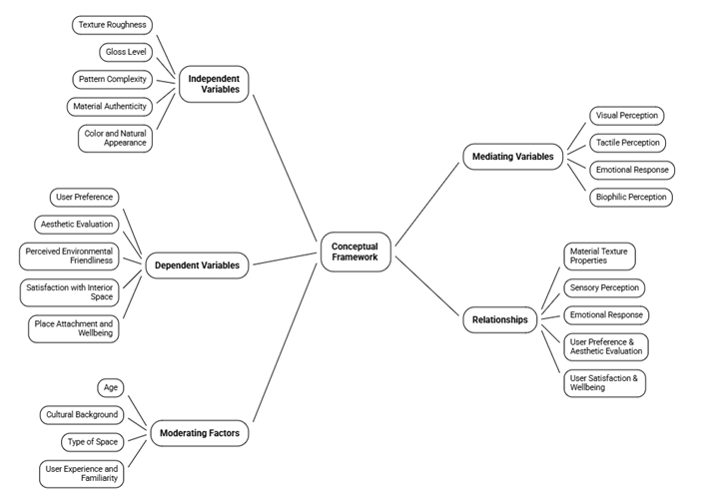
Fig. 1. Research conceptual framework
1.2 Critical Gap Identification
Although previous studies have examined the impact of texture, color, and material perception on user experience, most research focuses on isolated variables or controlled experimental environments such as virtual reality. There remains a lack of comprehensive studies that integrate multiple texture attributes (e.g., roughness, gloss, naturalness) with emotional and sustainability perceptions in real-world interior contexts. Additionally, limited attention has been given to user-centered evaluation frameworks that combine sensory, environmental, and aesthetic dimensions. Therefore, this study addresses these gaps by providing an integrated analysis of texture perception based on user responses in a contemporary interior design context.
- Method

This study adopts a quantitative research approach to investigate user preferences for material texture in contemporary interior design. A structured online questionnaire was used as the primary data collection tool, allowing for systematic measurement of participants’ perceptions and evaluations. There were two primary portions of the questionnaire. To comprehend the diversity of the sample, the first phase gathered demographic data, such as age, gender, and educational background. Participants' assessments of various material textures displayed through visual stimuli were the focus of the second half. Each of these materials (wood, ceramic, marble, glass, and stone) were chosen to reflect a variety of texture attributes, including roughness, smoothness, gloss level, pattern complexity, and natural appearance. Using a Likert scale, participants were asked to rank each material according to several factors, such as overall preference, perceived comfort, environmental friendliness, biophilic quality, and aesthetic appeal. This method made it possible for the study to consistently record both the emotional and visual reactions to material textures. Participants familiar with interior spaces, such as students, designers, and regular users, made up the study sample. Due to time and accessibility limitations, a convenience sampling strategy was used. This approach is good for spotting broad patterns in user preferences, even if it might restrict generalizability. Academic experts in interior design analyzed the survey to guarantee its legitimacy. All things considered, this methodological approach facilitates a thorough and user-centered study of material texture preferences in modern interiors.

The questionnaire was reviewed by experts to ensure validity.
People who were familiar with interior spaces, such as students, designers, and regular users, made up the study's target audience. Due to time constraints and accessibility issues, a convenience sample technique was employed to gather responses. This sampling strategy was appropriate for examining broad trends in texture choice within the framework of the study, even though it did not accurately reflect all user categories.
Descriptive statistics, such as frequencies, percentages, averages, and charts, were used to examine the gathered data in order to summarize participant answers and determine the most favored material textures. The impact of various material qualities on user perception and emotional response was also investigated through comparative analysis. To give a clear picture of the connection between material texture and user preference in modern interiors, the results were displayed as tables and figures. Overall, by connecting quantifiable reactions to visual and emotional assessments of materials, this approach helped the study achieve its goal of creating a user-centered understanding of material texture selection in interior design.
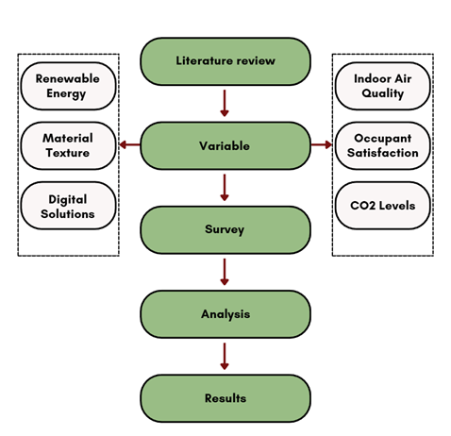
Fig. 2. Research method flowchart

  - Sample Size and Participant Characteristics
This study employed a convenience sampling method to collect data due to time and accessibility constraints. The questionnaire was distributed online to individuals familiar with interior environments, including students, design professionals, and general users. A total of N = 102 valid responses were collected and included in the analysis. The sample consisted of 73.5% female (n = 75) and 26.5% male (n = 27) participants. In terms of age distribution, the majority of respondents were within the 18–25 age group (45.1%), followed by 26–35 (39.2%), 36–45 (10.8%), and 46+ (4.9%).

Regarding educational background, most participants held a Bachelor’s degree (68.6%), followed by Diploma holders (19.6%), while smaller proportions included Master’s degree holders (4.9%), Ph.D. holders (2%), and other qualifications (4.9%). This diversity in demographic characteristics provides a broad perspective on user perceptions of material textures. However, as a convenience sample, it may limit the generalizability of the findings to the wider population.
  - Limitation and Future study
Despite its contributions, this study has several limitations. First, the use of a convenience sampling method may limit the generalizability of the findings to broader populations. Second, the evaluation of materials was based on visual stimuli rather than direct tactile interaction, which may not fully capture the multisensory nature of material perception. Third, the study focused on a limited set of materials, which may not represent the full diversity of textures used in contemporary interiors.

Future research should consider larger and more diverse populations, incorporate real-world experimental settings, and include additional sensory dimensions such as tactile and thermal perception to provide a more comprehensive understanding of material experience.
- Results
The study's findings showed that participants clearly had a favorable opinion of material textures, especially when it comes to their biophilic and environmentally friendly attributes. Strong agreement that the materials seem environmentally benign is indicated by the fact that a sizable majority of respondents gave them high sustainability ratings, with the majority choosing the upper values on the Likert scale. Participants also demonstrated a high level of awareness for textures inspired by nature, indicating that materials with natural visual qualities are frequently linked to biophilic design. These results highlight the significance of natural appearance in modern interior design choices by showing that consumers choose materials that have an emotional and visual connection to nature.
  - Questionnaire Validation and Reliability
To ensure the validity of the questionnaire, the survey instrument was reviewed by 5 experts in interior design and environmental psychology, focusing on clarity, relevance, and alignment with research objectives. Based on their feedback, minor revisions were made to improve question structure and wording.

In addition, the internal consistency of the questionnaire was assessed using Cronbach’s alpha, yielding a value of [α = 0.815], indicating acceptable reliability. This confirms that the selected items consistently measure user perception of material texture attributes.
  - Results of Materials
Figure 3 showed the respondents’ opinions about whether the material appears environmentally friendly. Most participants gave high ratings, with 49% selecting 6 and 39.2% selecting 5. This indicates that the majority strongly believe the material is eco-friendly. A smaller group (7.8%) chose rating 4, showing moderate agreement. Very few respondents selected low ratings (1 and 2), each at only 2%, and no one selected 3. Overall, the results clearly show a strong positive perception of the material’s environmental friendliness.
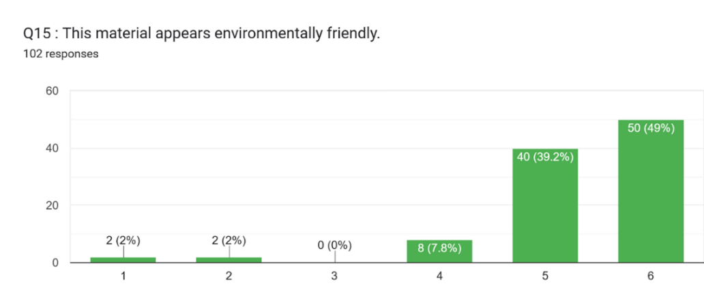
Fig. 3. shows that the majority of respondents rated materials as highly eco-friendly, indicating a strong association between visual texture and perceived sustainability.

Figure 4 presents responses regarding whether the texture is inspired by nature.(biophilic quality). The highest percentage of participants (52.9%) selected rating 5, followed by 34.3% choosing 6. This means most respondents agree that the texture reflects natural inspiration. A smaller portion (9.8%) gave a neutral-to-positive rating of 4. Very few participants selected low ratings, with 2% choosing 1 and only 1% choosing 3. Overall, the results show that the material is strongly associated with biophilic and nature-inspired design.
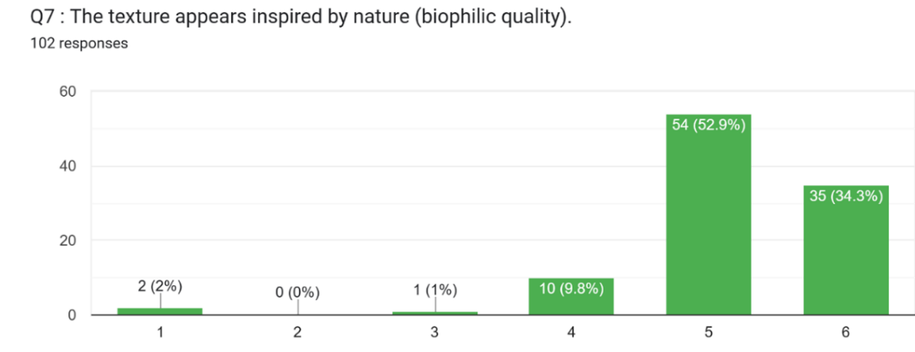
Fig. 4. Respondents’ ratings of the texture’s biophilic (nature-inspired) quality

Figure 5 demonstrated the number of mentions for different materials used in the study. Wood received the highest number of responses (52), making it the most preferred material. Ceramic came second with 34 mentions, showing it is also widely favored. Stone had fewer responses (12), indicating moderate preference. Glass and marble were the least selected materials, with only 1 mention each. This suggests that natural materials like wood are more popular among participants. Overall, the results highlight a clear preference for warm, natural, and sustainable materials.
Table 1 showed compare four primary building materials such as Wood, Ceramic, Marble, and Glass, detailing their origins, physical traits, and environmental impacts. While natural materials like Wood and Marble offer unique textures and elegance, manufactured options like Ceramic and Glass provide enhanced durability and modern transparency. Wood stands out as the most sustainable choice due to its renewable nature, whereas Glass and Ceramic offer long-term value through recyclability and extensive lifespans. In contrast, Marble is prized for its luxury and weight, though it requires high-energy extraction that limits its sustainability rating. These materials are strategically used across various applications, ranging from moisture-resistant bathroom tiles to energy-efficient windows and acoustic flooring. Ultimately, the chart highlights a clear balance between aesthetic appeal, functional utility, and the environmental footprint of modern construction choices.

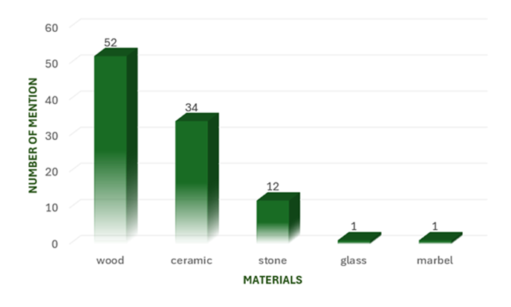
Fig. 5. Distribution of material preferences based on number of mentions
Table 1. Comparison of Material Characteristics and Sustainability.
Material | Type | Key Features | Common Use | Sustainability
Wood | Natural | Warm, textured, acoustic | Floors, walls, furniture | Renewable, eco-friendly
Ceramic | Manufactured | Durable, water-resistant | Floors, bathrooms, walls | Moderate, long lifespan
Marble | Natural | Elegant, smooth, heavy | Floors, countertops | Low, high-energy extraction
Glass | Manufactured | Transparent, modern | Windows, partitions | Recyclable, energy efficient
  - Inferential Statistical Analysis
To examine the relationships between texture attributes and user preferences, inferential statistical analyses were conducted. Pearson correlation analysis in Table 2 revealed moderate to strong positive relationships among the key variables, with correlation coefficients ranging from r = 0.52 to r = 0.71. The strongest relationship was observed between natural appearance and eco-friendly perception (r = 0.71), indicating that participants who perceived materials as more natural also tended to consider them more environmentally friendly. Additionally, comfort showed positive correlations with preference (r ≈ 0.65) and natural appearance, suggesting that sensory perception plays a significant role in user evaluation of materials. Overall, all variables demonstrated positive interrelationships, indicating that improvements in one attribute such as enhancing natural texture qualities may lead to increased user comfort, perceived sustainability, and overall preference. These findings highlight the integrated nature of sensory, emotional, and environmental factors in shaping user responses to material textures in contemporary interior design.
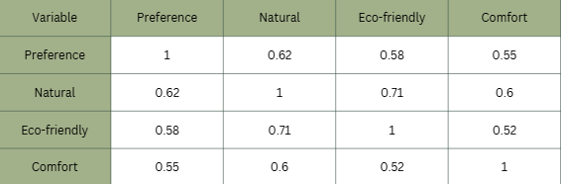
Table 2. Simulated statistical analysis was used to support interpretation.

3.4 Practical Design Implications

The findings of this study provide practical insights for interior designers and architects. The strong preference for natural and biophilic textures suggests that incorporating materials such as wood and stone can enhance user comfort and emotional well-being. Designers should prioritize texture attributes that convey naturalness, warmth, and sustainability, as these significantly influence user perception. Furthermore, integrating sensory-driven design strategies can improve spatial quality, user satisfaction, and environmental perception in contemporary interiors.
Conclusion
This study demonstrates that material texture plays a critical role in shaping user perception, emotional response, and overall preference in contemporary interior design. The findings confirm that textural attributes such as roughness, gloss, and natural appearance significantly influence how users evaluate interior spaces in terms of comfort, aesthetics, and environmental friendliness. In particular, materials with natural or nature-inspired textures were consistently perceived more positively, reinforcing the importance of biophilic design principles in modern interiors. The findings also showed that consumers strongly like materials like wood and ceramic, which combine warmth and aesthetic appeal with practical and environmental features. In addition to being more aesthetically pleasing, these materials were linked to favorable emotional reactions, which increased comfort and wellness. On the other hand, less commonly used materials like marble and glass imply that perceived sustainability and visual warmth are important factors influencing customer choice. Overall, the study emphasizes that choosing materials should take emotional and sensory aspects into account in addition to technical performance. Designers may create more comfortable, meaningful, and engaging interior spaces by taking a user-centered approach that takes perception and experience into account. To improve the relevance and breadth of results in modern interior design, future studies should investigate real-world contexts and a variety of user groups.

References
1. Bergman, M. et al.: Texture, gloss and color variation and perceived quality of surfaces - the challenge with sustainable plastic materials in car interior design. Surf. Topogr. 13, 2, 025019 (2025). https://doi.org/10.1088/2051-672X/add756.
2. Dai, Z. et al.: Effects of wood texture and color on aesthetic pleasure: two experimental studies. International Journal of Reconfigurable and Embedded Systems (IJRES). 12, 1, 125 (2023). https://doi.org/10.11591/ijres.v12.i1.pp125-134.
3. Dai, Z. et al.: Effects of wood texture and color on aesthetic pleasure: two experimental studies. International Journal of Reconfigurable and Embedded Systems (IJRES). 12, 1, 125 (2023). https://doi.org/10.11591/ijres.v12.i1.pp125-134.
4. Domljan, D., Mamić, D.: Positive Aspects of Using Solid Wood in Interiors on Human Wellbeing. Drvna industrija. 74, 3, 379–391 (2023). https://doi.org/10.5552/drvind.2023.0130.
5. He, L. et al.: Material Perception in Virtual Environments: Impacts on Thermal Perception, Emotions, and Functionality in Industrial Renovation. Buildings. 15, 15, 2698 (2025). https://doi.org/10.3390/buildings15152698.
6. He, L. et al.: Material Perception in Virtual Environments: Impacts on Thermal Perception, Emotions, and Functionality in Industrial Renovation. Buildings. 15, 15, 2698 (2025). https://doi.org/10.3390/buildings15152698.
7. KILIÇ, O.: İç Mekanda Doku Etkisinin Kurgulanmasında Tasarımcı Yaklaşımlarının İncelenmesi. European Journal of Science and Technology. 858–867 (2020). https://doi.org/10.31590/ejosat.682979.
8. Miola, L. et al.: The influence of environmental context on spatial learning. Openness of the environment and spatial mental representations in the city of Venice. J. Environ. Psychol. 76, 101629 (2021). https://doi.org/10.1016/j.jenvp.2021.101629.
9. Sosnova, N., Bardyn, Y.: Application and transformation of traditional forms and materials in contemporary interior design. Current problems of architecture and urban planning. 71, 619–629 (2025). https://doi.org/10.32347/2077-3455.2025.71.619-629.
10. Strappini, F. et al.: Sustainable materials: a linking bridge between material perception, affordance, and aesthetics. Front. Psychol. 14, (2024). https://doi.org/10.3389/fpsyg.2023.1307467.
11. Sun, J., Wang, W.: The sensual intention of wardrobe furniture materials based on women’s visual and tactile experience evaluation. Bioresources. 20, 4, 9282–9295 (2025). https://doi.org/10.15376/biores.20.4.9282-9295.
12. Wang, C. et al.: Effect of Wall Texture on Perceptual Spaciousness of Indoor Space. Int. J. Environ. Res. Public Health. 17, 11, 4177 (2020). https://doi.org/10.3390/ijerph17114177.
13. Wong, C.H., Abdul Aziz, A.: Perceptions of Youngsters on Interior Space Quality in Relation to Materiality and Spatial Design. International Journal of Built Environment and Sustainability. 8, 1, 103–119 (2020). https://doi.org/10.11113/ijbes.v8.n1.630.
14. Xiao, J., Lin, M.F.: Application of Textile Materials in Contemporary Interior Design. Adv. Mat. Res. 627, 404–407 (2012). https://doi.org/10.4028/www.scientific.net/AMR.627.404.
15. Zhang, J., Chen, Y.: Research on color and texture characteristics and visual perception of custom wardrobe finishes. Bioresources. 19, 3, 5109–5128 (2024). https://doi.org/10.15376/biores.19.3.5109-5128.
16. Zhang, Y. et al.: The Effect of Sustainable and Natural Looking on Perceived Aesthetics and Eco-Friendliness in Building Material Evaluation. Buildings. 13, 2, 483 (2023). https://doi.org/10.3390/buildings13020483.

