Development of a Disaster Risk Reduction Readiness (DRRR) Mobile Application
JOAN S. RAJAH¹
AMA University, Manila Philippines
University of San Jose Recoletos, Cebu Philippines
jsrajah@usjr.edu.ph
https://orcid.org/0009-0008-9028-5981
EDUARDO R. YU II²
AMA University, Manila Philippines
eduardoryuii@gmail.com
https://orcid.org/0009-0004-5050-5805
REAGAN B. RICAFORT³
AMA University, Manila Philippines
reagan.ricafort@ama.edu.ph
https://orcid.org/0009-0002-0816-1522
ABSTRACT
Disasters pose significant risks to communities, yet localized solutions for disaster preparedness are limited. Mobile technologies offer opportunities to develop an application like the DRRR focusing on the Disaster Risk Reduction Readiness (DRRR). This study addresses the need for a mobile application that enhances awareness and readiness for disasters. The study aims to develop a Disaster Risk Reduction Readiness (DRRR) mobile application that supports users in disaster preparedness through an interactive application. The Rapid Application Development (RAD) was used in this study particularly on requirement planning, user design, cutover, and construction. MIT App Inventor is used as a platform in the development of the DRRR Application. The use of 5-point Likert scale scoring in the evaluation of the development of the DRRR mobile application which derives from the ISO/IEC 25010 Systems and Software Quality Requirements and Evaluation (Square) Model. focusing on (1) Functional Suitability, (2) Performance Efficiency, (3) Usability (4) Reliability, (5) Security, (6) Maintainability, (7) Compatibility, (8) Portability and Overall Evaluation particularly on the different respondents like IT experts, DRRR Coordinator, LGU/Barangay Officials, Faculties, and Students. The DRRR mobile application provides hazard information, emergency kit checklists, evacuation maps, warning alerts, The results of the evaluation demonstrated improvements across all measures of the system development and become aware, ready during disasters thereby reducing the risk and severe impact of disasters.
Key Words: Development, Disaster Risk Reduction and Resilience (DRRR), ISO/IEC 25010 Systems and Software Quality Requirements and Evaluation (Square) Model, Mobile Application
INTRODUCTION
Disasters such as typhoons, floods, earthquakes, and fires have become increasingly frequent and severe worldwide, largely driven by climate change, urbanization, and population growth. This growing trend highlights the urgent need for effective disaster preparedness strategies to minimize loss of life and property (IPCC, 2023; UNDRR, 2022). In disaster-prone countries such as the Philippines, strengthening community readiness through education, early warning systems, and coordinated response mechanisms is essential in reducing disaster impacts and enhancing resilience (UNDRR, 2022; Dalisay & De Guzman, 2016). Disaster risk in the Philippines remains one of the highest globally due to its geographical location within the Pacific typhoon belt and the Pacific Ring of Fire. The country experiences frequent hydrometeorological and geophysical hazards such as typhoons, floods, earthquakes, and volcanic eruptions.
According to the Philippine Institute for Development Studies (PIDS, 2020), recurring disasters significantly affect education continuity, infrastructure stability, and community resilience. The Philippine Atmospheric, Geophysical and Astronomical Services Administration (PAGASA, 2023) further reports that the increasing intensity of typhoons due to climate change amplifies vulnerability in both urban and rural communities.
In response, the National Disaster Risk Reduction and Management Council (NDRRMC, 2022) emphasizes the importance of strengthening disaster preparedness, early warning systems, and community-based risk reduction strategies. However, despite these initiatives, there are persistent gaps in translating disaster knowledge into actionable preparedness behaviors, especially among students and local communities.
Recent advancements in mobile technology have introduced Disaster Risk Reduction and Management (DRRM) mobile applications as potential tools for improving disaster awareness and response. However, most existing systems remain fragmented, focusing primarily on single hazards and emergency response functions rather than holistic disaster readiness and preparedness systems (UNDRR, 2015; Cutter et al., 2016). In addition, many applications lack localization, offline capability, and behavioral evaluation mechanisms, limiting their effectiveness in developing country contexts such as the Philippines (Gaillard & Mercer, 2013).
Advances in mobile and digital technologies have introduced innovative approaches to disaster preparedness and education, where mobile applications serve as interactive and accessible platforms that deliver real-time alerts, risk information, and emergency coordination features, thereby improving user awareness and response capability (Reuter et al., 2017; Tan et al., 2021). Evidence further shows that these technologies enhance disaster literacy and community engagement, particularly in developing contexts such as the Philippines (Domingo & Manejar, 2018), although challenges remain in ensuring accessibility, usability, and large-scale adoption.
Despite global and local efforts in Disaster Risk Reduction (DRR), significant gaps persist in translating knowledge into effective preparedness actions, as disaster outcomes are influenced not only by natural hazards but also by community vulnerability and resilience (Shaw et al., 2013). The disconnect between scientific frameworks and local practices continues to limit the effectiveness of DRR initiatives (Gaillard et al., 2013), while the integration of cultural and community-specific contexts remains insufficient in many disasters planning efforts, leading to suboptimal preparedness outcomes (Kulatunga et al., 2010). Although mobile applications present promising solutions, their effectiveness is highly dependent on user-centered and context-sensitive design processes. Institutional mechanisms such as the Adelante Life Emergency Rescue Team (ALERT) of the University of San Jose–Recoletos demonstrate the importance of organized emergency response systems in supporting campus safety and disaster preparedness through trained personnel and coordinated operations (USJ-R, 2019; UNDRR, 2015). The ALERT team also promotes proactive disaster awareness through drills, training, and outreach activities (IFRC, 2018), yet there remains a need for more integrated technological systems that enhance coordination, communication, and real-time response efficiency.
Disaster Risk Reduction (DRR) mobile applications have become essential tools for enhancing emergency preparedness, risk communication, and community resilience, particularly in disaster-prone regions. The effectiveness of these systems is strongly influenced by the choice of development platform. Two commonly used platforms in DRR application development are MIT App Inventor and Flutter, which differ significantly in terms of development approach, scalability, and system capability.
MIT App Inventor is a block-based visual programming environment designed primarily for rapid prototyping and educational purposes. It enables users to develop functional mobile applications without requiring advanced programming skills, making it particularly suitable for academic DRR prototypes such as emergency SOS systems, incident reporting tools, and disaster awareness applications. Its strengths include ease of use, fast development cycles, and integration of basic mobile functionalities such as GPS, SMS, and cloud storage. However, its limitations include restricted interface customization, limited processing capacity, and reduced scalability for complex or enterprise-level DRR systems (Wolber et al., 2015).
In contrast, Flutter is a modern cross-platform development framework that uses the Dart programming language to build high-performance, production-ready mobile applications. It supports advanced DRR functionalities such as real-time hazard monitoring, GIS-based mapping, IoT integration, and AI-assisted disaster response systems. Flutter provides strong scalability, flexible UI design, and robust backend integration, making it suitable for institutional and government-level DRR deployments. However, it requires higher technical expertise and longer development time compared to block-based platforms (Google Developers, 2023).
Overall, MIT App Inventor is best suited for prototype development, educational DRR systems, and early-stage usability testing, while Flutter is more appropriate for scalable, real-world disaster management systems. This establishes a development continuum where MIT App Inventor supports conceptual design and Flutter enables full system implementation. Integrating both platforms in a prototype-to-production pipeline can enhance DRR innovation and bridge the gap between academic development and operational deployment.
Existing literature demonstrates that disaster risk reduction (DRR) mobile applications significantly contribute to improving preparedness awareness and self-reported readiness behaviors. Studies show that mobile apps enhance users’ risk perception, preparedness knowledge, and response efficacy through effective risk communication and interactive learning features. For instance, theory-driven research using Protection Motivation Theory found that mobile-based risk communication significantly predicts preparedness, cognition and self-efficacy, which are essential for disaster readiness. Additionally, systematic and scoping reviews confirm that mobile applications improve community awareness, facilitate informed decision-making, and support behavioral preparedness through alerts, guidance, and educational content. Educational DRRR applications further strengthen users’ ability to understand risks and take appropriate preparedness actions. Collectively, these findings indicate that mobile applications function not only as information dissemination tools but also as behavior-shaping interventions that translate awareness into actionable preparedness outcomes (Aisyah et al., 2026; Permana et al., 2025; Paul et al., 2021; UNESCO, 2023; Zhang et al., 2025).
A growing body of literature supports the effectiveness of mobile-based disaster risk reduction (DRRR) applications in enhancing preparedness awareness and self-reported readiness behaviors. Empirical studies demonstrate that mobile applications improve risk perception and preparedness cognition through structured risk communication and interactive learning features grounded in behavioral theories such as Protection Motivation Theory (Zhang et al., 2025). Additionally, mobile learning-based DRR systems have shown high levels of perceived usefulness, ease of use, and behavioral intention, indicating their capacity to influence user engagement and preparedness actions (De Leon et al., 2023).
At a broader level, systematic and scoping reviews confirm that mobile applications play a significant role in strengthening community preparedness and resilience by providing real-time alerts, educational modules, and emergency coordination tools (Aisyah et al., 2026; Permana et al., 2025). These technologies enhance awareness and support informed decision-making, which are critical precursors to effective disaster response. Furthermore, mobile technologies have been shown to facilitate inclusive risk communication and localized knowledge dissemination, thereby promoting behavioral preparedness and resilience outcomes (Paul et al., 2021). Gamified and feature-rich applications further reinforce this relationship by increasing user engagement and encouraging proactive preparedness behaviors (Sarmiento & Cruz, 2024).
Collectively, these studies indicate that DRR mobile applications function not only as information delivery platforms but as behavior-shaping interventions that translate awareness into actionable preparedness outcomes, particularly when supported by user-centered design and engagement-driven features.
In response to these challenges, this study aims to develop, and evaluate using the ISO/IEC 25010 Systems and Software Quality Requirements and Evaluation (Square) Model. of the Disaster Risk Reduction and Resilience (DRRR) mobile application using platforms such as MIT App Inventor. It seeks to identify DRRR knowledge and preparedness gaps among target users to inform system design, leading to the development of a functional prototype that visualizes system screens, flows, and interactions. The application will be evaluated using ISO/IEC 25010 software quality standards or the System Usability Scale (SUS) to assess usability and effectiveness, and recommendations will be formulated to improve its functionality, usability, and overall impact on disaster preparedness. The study is limited to hazards such as typhoons, earthquakes, and floods, and includes features such as hazard information, emergency hotlines, evacuation maps, and emergency kits, while excluding real-time government integration and GPS tracking, and is intended primarily as a prototype for evaluation and educational purposes.
This research contributes to Disaster Risk Reduction and mobile learning by promoting systematic, user-centered development approaches such as RAD, co-design, and Design Thinking that ensure stakeholder engagement and iterative refinement (Basadre et al., 2025; Nguyen et al., 2019;). It further integrates mobile technology with DRRR strategies by incorporating features that support hazard awareness and emergency preparedness, while bridging the gap between scientific DRRR frameworks and locally relevant, culturally sensitive applications. It also provides evidence-based insights into how mobile systems can improve disaster preparedness, response readiness, and user engagement. At the practical level, the application enhances student awareness and preparedness, supports educators in delivering DRRR concepts through interactive learning tools, and assists Local Government Units (LGUs) and Disaster Risk Reduction and Management Offices (DRRMOs) in disaster planning and communication. From a research perspective, it offers a structured foundation for integrating mobile application development with disaster education, contributing to future work in educational technology and community resilience initiatives
METHOD
This study utilized four phases of the Rapid Application Development (RAD) model These phases include Requirements Planning, User Design, Rapid Construction, and Cutover.
Figure 2. RAD DRRR APP
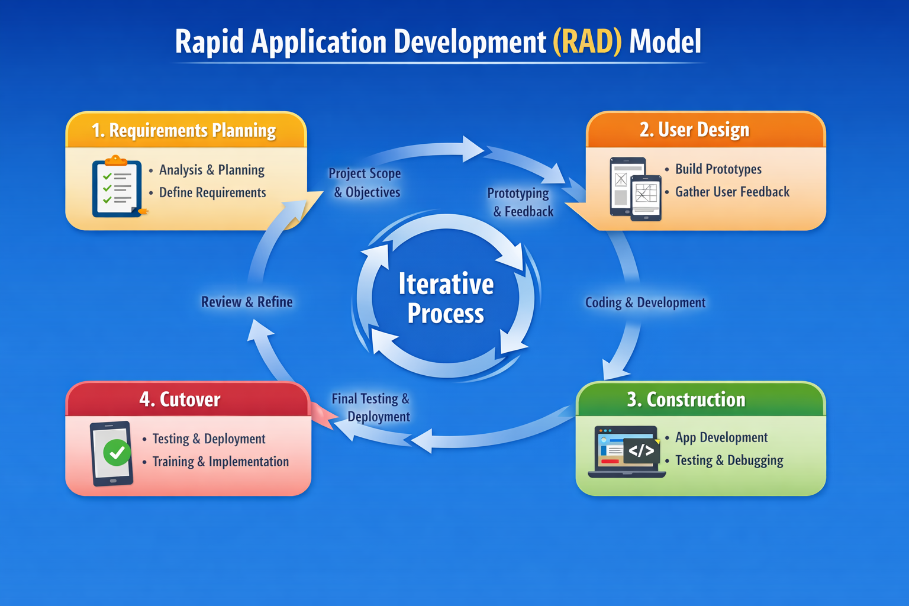
Figure 2 shows the different RAD Phases on the Development of the DRRR Mobile Application
Requirements Planning Phase
In this phase, the researchers identified the objectives and functional requirements of the DRR Mobile Application. Information was gathered through literature reviews, consultation with potential users, and analysis of disaster preparedness resources. The researchers determined the key features that the application should include, such as disaster alerts, safety guidelines, emergency contacts, evacuation information, and preparedness tips.
User Design Phase
During the user design phase, the researchers created prototypes and interface designs of the mobile application. Wireframes and user interface layouts were developed to visualize the structure and navigation of the system. Potential users evaluated the prototype to ensure usability, accessibility, and relevance of the system features. Feedback gathered from users helped refine the design and improve the overall functionality of the application.
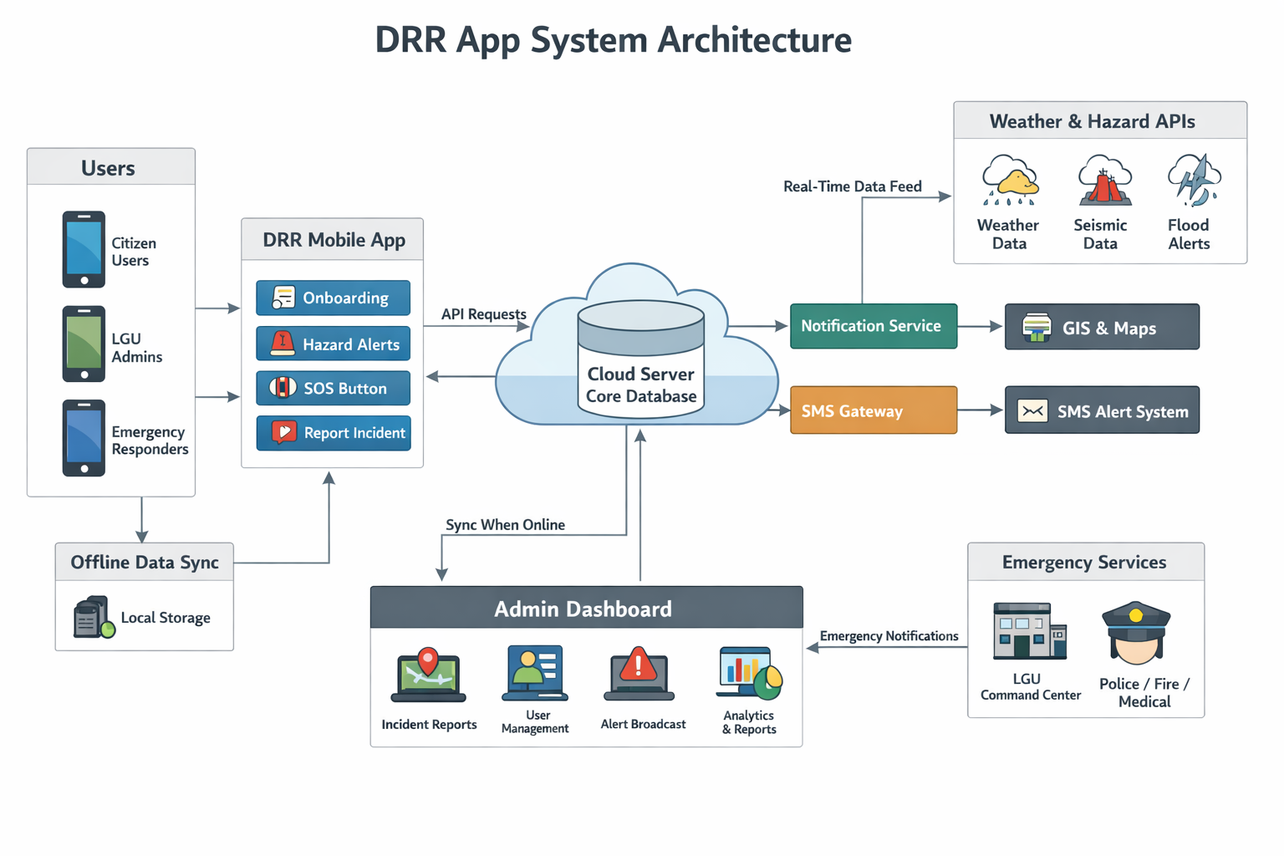
Figure 3. DRRR Mobile Application System Architecture
Figure 3 presents the high-level system architecture of a Disaster Risk Reduction (DRRR) mobile application designed to support hazard identification, risk assessment, and coordinated emergency response. The system integrates key modules including onboarding, hazard monitoring and alerts, SOS and incident reporting, and emergency services to enhance community preparedness and response. It leverages real-time hazard data through weather and hazard APIs, while SMS gateways and notification services ensure continuous dissemination of alerts even under limited connectivity. An administrative dashboard supports authorities in monitoring incidents and making data-driven decisions, while cloud computing provides scalable and resilient data storage and processing (NIST, 2011). Overall, the architecture demonstrates an integrated approach to disaster management by enabling timely communication, improved situational awareness, and strengthened coordination among users, responders, and local government units, aligning with principles of effective early warning and disaster risk reduction systems emphasized by UNDRR (2019), WMO (2018), ITU (2017), World Bank (2020), and FEMA (2021).

Construction Phase
In this phase, the actual development of the DRR Mobile Application was carried out using the MIT App Inventor. The Integrated Development Environment (IDE) utilized in this project is MIT App Inventor, a web-based platform developed by the Massachusetts Institute of Technology. It enables users to design and develop mobile applications through a visual, block-based programming approach, thereby reducing the complexity associated with traditional text-based coding. This environment supports rapid prototyping and is particularly beneficial in educational contexts, as it promotes computational thinking, problem-solving skills, and user-centered design. By providing an intuitive interface and real-time testing capabilities, MIT App Inventor facilitates the efficient creation of functional mobile applications, making it an appropriate tool for both novice and intermediate developers (Massachusetts Institute of Technology, n.d.). The system modules were developed and integrated to form the complete application.

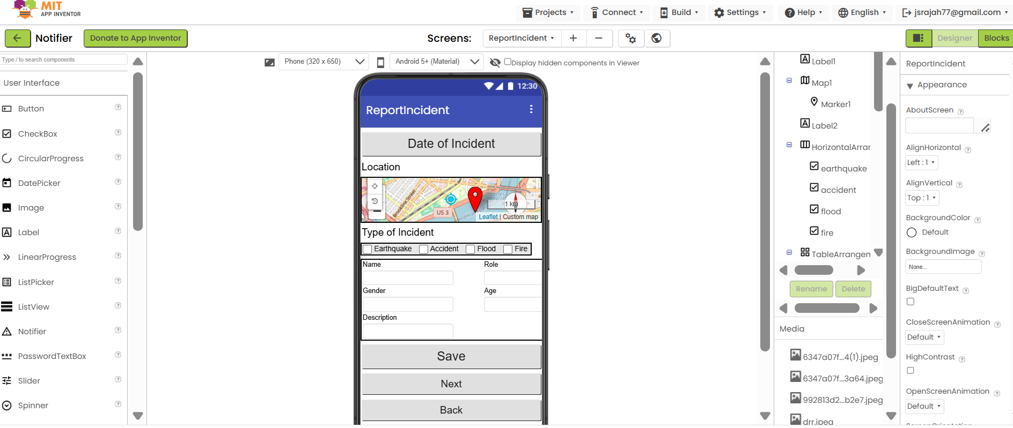
Figure 4. A User Interface Development of the DRRR App
Figure 4 presents the design interface of a mobile application developed using the MIT App Inventor integrated development environment (IDE). The application was created within the IDE’s visual development environment, which supports drag-and-drop component assembly and rapid prototyping of mobile applications. This demonstrates how the IDE facilitates structured and user-centered system development for emergency or disaster-related reporting functionality.
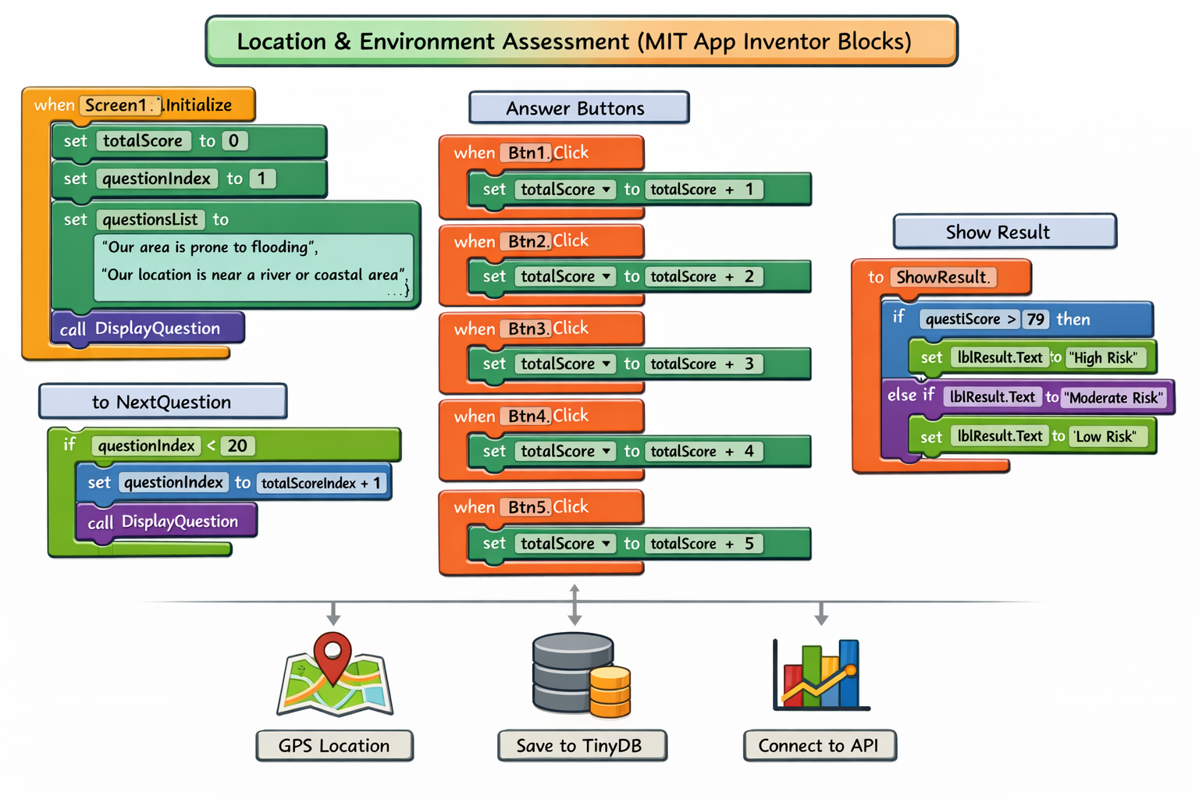
Figure 5: Location and Environment Risk Assessment
Figure 5 presents the workflow of a mobile Location and Environment Risk Assessment App developed using MIT App Inventor. The system guides users through a series of environmental questions using a Likert scale, computes a cumulative score, and classifies risk levels (low, moderate, high) through automated logic. It also integrates local storage and GPS-based location capture, supporting context-aware assessment and decision-making. For disaster education, the findings indicate that the app promotes active learning by engaging users in self-assessment, helping them better understand environmental risks and preparedness levels. This aligns with the view of David Alexander (2013) that awareness and risk perception are key to building disaster resilience. For emergency communication, the inclusion of location data enhances the relevance and accuracy of risk information, allowing users and authorities to better identify vulnerable areas. The United Nations Office for Disaster Risk Reduction (2020) highlights that localized and timely information improves response and coordination. From a user-centered design perspective, the step-by-step questioning, simple rating scale, and automated feedback reduce user effort and make the system easy to use. This reflects usability principles of the International Organization for Standardization (2011), particularly in terms of effectiveness and ease of interaction. Overall, the findings suggest that the app is an effective and user-friendly tool for enhancing disaster awareness, supporting communication, and enabling informed decision-making.
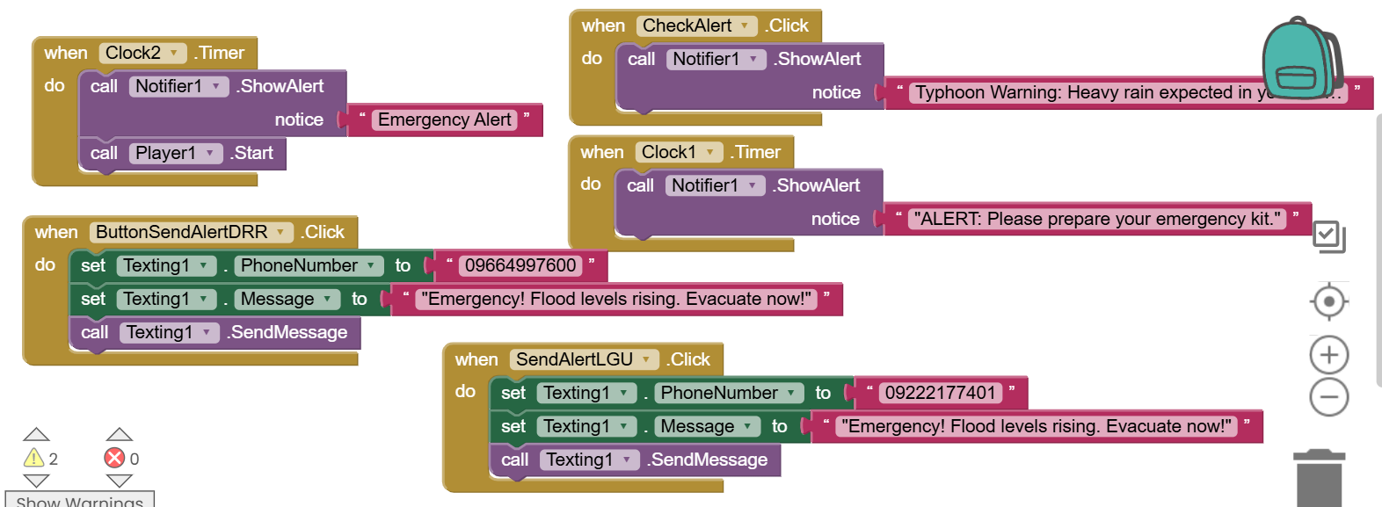
Figure 6: Send Alert to DRR Team/LGU
Figure 6 illustrates a mobile emergency alert application developed using MIT App Inventor that supports disaster preparedness and response through both automated and manual alert features. The use of timer-based notifications for emergency alerts and preparedness reminders demonstrates a proactive approach to risk communication, which is essential for improving awareness and early action during disasters. As noted by David Alexander (2013), timely and accessible information enhances community preparedness and resilience. The inclusion of a manual alert button and SMS functionality enables users to directly notify DRR teams and LGUs about urgent situations, such as flooding and evacuation needs. This reflects effective multi-channel communication, which is emphasized by the United Nations Office for Disaster Risk Reduction (2020) as critical for ensuring message delivery, particularly in areas with limited connectivity. In terms of disaster education, the application promotes continuous learning by providing regular reminders and hazard-specific alerts, helping users develop preparedness behavior. For emergency communication, the combination of automated and manual alerts enhances reliability and responsiveness. From a user-centered design perspective, the app’s simple interface and functional features align with usability principles of the International Organization for Standardization (2011), ensuring that users can easily understand and use the system during emergencies. Overall, the findings indicate that the application, despite its simplicity, effectively supports disaster preparedness, communication, and usability, making it a practical tool for disaster risk reduction.

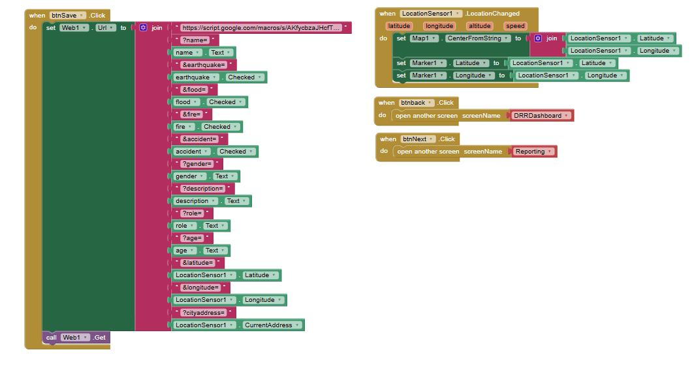
Figure 7: Report Incident
Figure 7 shows the block-based implementation of a disaster reporting feature developed using MIT App Inventor. The system collects user input (e.g., personal details and incident type) and combines it with real-time location data (latitude, longitude, and address) using a location sensor. These data are then sent to an external database through a web request, enabling real-time disaster reporting. This supports accurate and timely information sharing, which is essential for effective disaster response, as emphasized by the United Nations Office for Disaster Risk Reduction (2020). For disaster education, the feature encourages users to actively report incidents, helping them become more aware of hazards in their environment. For emergency communication, it enables fast, location-based reporting that improves coordination between the public and response teams. From a user-centered design perspective, the use of automatic location detection and simple input fields reduces user effort and improves usability, aligning with the standards of the International Organization for Standardization (2011). Overall, the findings show that the feature is a simple but effective tool for real-time reporting, communication, and user engagement in disaster risk reduction.
Cutover/Development Phase
The deployment of the Disaster Risk Reduction (DRR) Mobile Application utilized both hardware and software tools. A laptop or personal computer served as the primary platform for application design, coding, testing, APK compilation, and documentation. Android smartphones functioned as the deployment and end-user devices, leveraging the Android operating system developed by Google. The application was developed using MIT App Inventor, a web-based, block-based programming environment created by the Massachusetts Institute of Technology, which enables users to build mobile applications without extensive coding. For real-time testing and debugging, the MIT AI2 Companion was used, allowing developers to preview applications instantly via QR code or Wi-Fi connection. The final output of the development process was an Android Package (APK) file, specifically DRR_App.apk, which contains all necessary code, resources, and configurations required for installation and execution on Android devices.

ISO/IEC 25010 Software Quality Model
The ISO/IEC 25010 standard provides a comprehensive framework for evaluating software quality through eight primary characteristics, each composed of specific sub-characteristics (International Organization for Standardization and International Electrotechnical Commission, 2023). These characteristics guided the development of the evaluation instrument in this study.
- Functional Suitability – Refers to the degree to which the system meets user requirements in terms of correctness, completeness, and appropriateness of functions.
- Performance Efficiency – Evaluates the system’s responsiveness, resource utilization, and scalability under varying conditions.
- Compatibility – Examines the system’s ability to operate effectively with other systems, including interoperability and coexistence.
- Usability – Focuses on the ease of use of the system, including learnability, accessibility, and user satisfaction.
- Reliability – Assesses the system’s stability, availability, and fault tolerance during operation.
- Security – Evaluates the protection of information and data through mechanisms such as confidentiality, integrity, and authentication.
- Maintainability – Refers to the ease with which the system can be modified, improved, or corrected, emphasizing modularity and reusability.
- Portability – Examines the system’s adaptability across different environments, including ease of installation and transferability.
A 38-item questionnaire was adapted from the ISO/IEC 25010 Systems and Software Quality Requirements and Evaluation (Square) Model to evaluate the system’s performance, utilizing a five-point Likert scale with score interpretations ranging from 1-Poor, 2-Fair, 3-Good, 4-Very Good, 5-Excellent. The instrument was subjected to expert validation, yielding content validity index (CVI) values between 0.90 and 0.98, indicating that the items were highly relevant and well-aligned with the evaluation objectives. Subsequently, the questionnaire underwent pilot testing to determine its reliability, and the feedback obtained was used to enhance the clarity and consistency of the items.
Respondents of the Study
The respondents of this study were selected using a purposive sampling technique, wherein participants were deliberately chosen based on their expertise, roles, and relevance to the research objectives. The sample comprised selected IT experts, Disaster Risk Reduction (DRR) coordinators or members of the Emergency Response Team, Local Government Unit (LGU)/Barangay officials, faculty members, and students. These individuals were identified as appropriate respondents due to their direct involvement in disaster preparedness initiatives and their potential to utilize and evaluate the DRR mobile application. Their inclusion ensures that the data collected are derived from informed perspectives, thereby enhancing the validity and relevance of the study findings.

Table 1: Respondents of the Study for System Performance Evaluation
Role | Number of Respondents | Description
IT Experts | 3 | Who are working in software development.
DRRR Coordinator/Emergency Response Team | 2 | Who are active members in an organization with immediate response in times of disaster.
Barangay Officials/ LGU Officers | 1 | Who are assigned in the barangay or local government willing to serve during disaster.
Faculties | 3 | Who voluntarily serve during disaster in the school
Students | 11 | Who are affected during in times of disasters
RESULTS AND DISCUSSIONS
The developed mobile application is comprehensively examined in this section, encompassing a detailed presentation of its features, an evaluation of its performance based on the Software Quality Model, and the results of the overall respondents participating in the assessment conducted in accordance with the criteria established by the standards.
Key Features of the Developed Mobile Application for Disaster Risk Reduction
The developed Disaster Risk Reduction (DRRR) mobile application is designed to enhance user preparedness, safety awareness, and real-time responsiveness during emergency situations. It integrates essential functionalities that support proactive risk management, timely dissemination of hazard information, and efficient incident communication, thereby aligning technological innovation with community-based disaster resilience efforts.

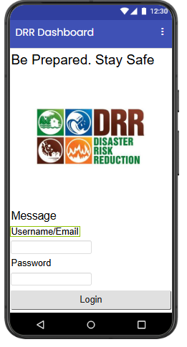
Figure 8: Onboarding
Figure 8 shows the onboarding feature enhances disaster preparedness by providing a structured entry point to the system through splash screens and secure authentication, allowing users to quickly access core disaster-related functionalities. This supports disaster education by guiding users in understanding how to properly use the application from the start, improves emergency communication by ensuring only authenticated and prepared users can access critical information efficiently, and reflects a user-centered design by offering a smooth, secure, and easy-to-navigate onboarding process that reduces barriers to system use. These findings align with disaster risk reduction principles emphasizing that usability, accessibility, and timely access to information are essential for effective emergency communication and user engagement in digital disaster systems (Alexander, 2013; Basadre et al., 2025).
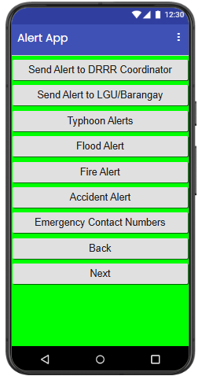
Figure 9: Hazard Alerts
Figure 9 shows the hazard alerts feature improves disaster preparedness by providing real-time, color-coded notifications that help users quickly understand risk levels and respond appropriately. This supports disaster education by improving users’ understanding of hazard severity and decision-making, strengthens emergency communication through timely and easily interpretable alerts, and reflects a user-centered design by presenting information in a simple, intuitive, and accessible format for rapid comprehension. These findings align with disaster risk reduction literature emphasizing that effective early warning systems and clear risk communication are essential for improving public awareness, response time, and safety during emergencies (Alexander, 2013; Basadre et al., 2025).
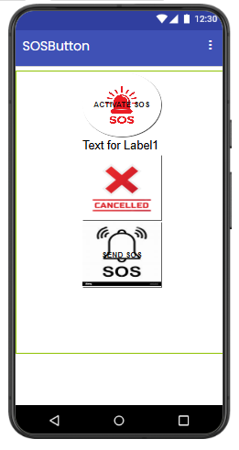
Figure 10: SOS Button
Figure 10 shows the SOS button feature enhances disaster preparedness by enabling users to immediately transmit distress signals with precise location data during emergencies. This supports disaster education by reinforcing appropriate emergency response behavior and situational awareness, strengthens emergency communication through rapid and location-based alert dissemination, and reflects user-centered design by providing a simple and accessible interface suitable for high-stress conditions. These findings align with disaster risk reduction principles emphasizing timely information exchange and effective communication as critical factors in emergency response effectiveness (Alexander, 2013; Basadre et al., 2025).
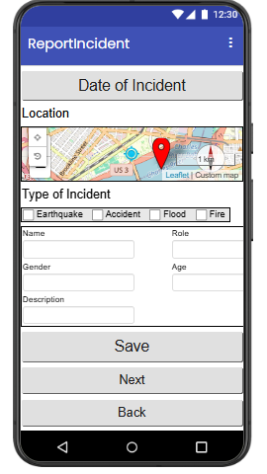
Figure 11: Report Incident
Figure 11 shows the “Report Incident” feature enhances disaster preparedness by enabling users to submit real-time, location-based emergency reports with supporting details such as incident type, description, and images. This supports disaster education through experiential learning, strengthens emergency communication by enabling timely and accurate information exchange, and reflects a user-centered design by providing an accessible and intuitive reporting mechanism for diverse users. These findings are consistent with disaster risk reduction literature emphasizing that effective digital reporting tools improve situational awareness, communication efficiency, and community participation in emergency response systems (Alexander, 2013; Basadre et al., 2025).

Table 2: Comparison of Features of DRR Mobile Applications (Global and Philippines)
DRR App / System | Country/Origin | Detailed Features | Platform
DisasterAlert (DisasterAWARE) | USA (Pacific Disaster Center) | Real-time multi-hazard alerts (earthquake, cyclone, flood, wildfire), geofencing notifications, global hazard mapping, situational awareness dashboards, offline access, risk analytics for decision support (Pacific Disaster Center, 2023) | Android, iOS, Web
Sachet App | India (NDMA) | Early warning alerts for floods, cyclones, earthquakes; geo-tagged notifications; multilingual interface; preparedness advisories; push notifications (National Disaster Management Authority, 2021) | Android, iOS
KNOW-DRR App | UNESCO | Interactive DRR learning modules, quizzes, gamified disaster education, preparedness training materials, offline learning content (UNESCO, 2022) | Android, iOS
CLEARS App | Philippines (DOST/Academic collaboration) | Landslide risk assessment using slope, soil, vegetation data; geospatial hazard scoring; LGU planning support; GIS-based outputs (DOST-PHIVOLCS & NAMRIA, 2022) | Mobile + Web
UP NOAH App / Platform | Philippines (UP Resilience Institute) | Flood, landslide, storm surge hazard maps; real-time rainfall and water level monitoring; GIS visualization; location-based hazard identification (UP Resilience Institute, 2023) | Web, Android, iOS
HazardHunterPH | Philippines (DOST-PHIVOLCS, NAMRIA) | Multi-hazard exposure checker; property-level risk assessment; interactive hazard mapping; downloadable reports (DOST-PHIVOLCS & NAMRIA, 2022) | Web (mobile responsive)
Project NOAH (Legacy System) | Philippines (DOST) | Early warning system; rainfall and river monitoring; flood forecasting; hazard mapping; disaster visualization dashboards (DOST, 2014) | Web, Mobile prototype
MapaKalamidad.ph | Philippines (Crowd-sourced system) | Community disaster reporting; real-time incident mapping; social media integration; citizen-generated hazard updates (Aitsi-Selmi et al., 2015) | Web, Mobile
Handa Platform (Emerging DRR System) | Philippines (DOST) | AI-powered disaster alerts; centralized DRR dashboard; emergency coordination tools; multi-hazard monitoring; integrated government data system (DOST, 2025) | Mobile + Web
Disaster Management App (Softecks) | Global | Disaster-type information, preparedness guides, safety tips, emergency response instructions, offline reference materials | Android
Global Platform for DRR (UNDRR/TechChange) | Global | DRR governance tools, policy tracking, stakeholder collaboration, knowledge sharing, resilience analytics dashboard (UNDRR, 2023) | Web, Mobile
DRR Prototype App (Research-based System) | Philippines | SOS emergency button, incident reporting, emergency checklist, alerts, GPS mapping (latitude/longitude), login system, disaster type info, flood-prone indicators, Google Sheets API storage, PAGASA/weather integration (Aitsi-Selmi et al., 2015) | Mobile

Table 2 presents a comparative analysis of existing Disaster Risk Reduction and Response (DRRR) applications and systems in terms of their country of origin, platform availability, and core functional features. The comparison highlights that most established DRRR solutions prioritize real-time hazard alerts, emergency communication, geolocation services, and multi-platform accessibility (e.g., mobile and web-based systems), reflecting a strong emphasis on operational readiness and user accessibility in disaster contexts.

The findings suggest that these foundational features are also likely to be incorporated into the developed prototype DRRR application, ensuring alignment with global standards and user expectations in disaster preparedness and response technologies. However, advanced capabilities such as Artificial Intelligence (AI) integration and data analytics-driven decision support are notably absent in the current prototype design. These features, which are increasingly present in more advanced DRR systems, could significantly enhance predictive capabilities, situational awareness, and adaptive response mechanisms.

Therefore, while the current prototype establishes a functional baseline consistent with existing DRRR applications, the integration of AI and data analytics is recommended as a future enhancement to improve system intelligence, responsiveness, and overall effectiveness in disaster risk reduction and management contexts.
Summary Results Evaluation using ISO/IEC 25010 or Software Product Quality Model
This subsection presents the summary of the evaluation results of the developed system ISO/IEC 25010 Software Product Quality Model, highlighting its performance across the defined quality characteristics as assessed by all respondents in accordance with the established criteria of the standard.

Table 3: System Performance Evaluation Summary
Indicators | Weighted Mean | Verbal Interpretation
Functional Suitability | 4.2 | Very Good
Performance Efficiency | 4.22 | Very Good
Compatibility | 4.0 | Very Good
Usability | 3.94 | Good
Reliability | 4.25 | Very Good
Security | 4.18 | Very Good
Maintainability | 4.0 | Very Good
Portability | 4.0 | Very good
Overall Weighted Mean | 4.210 | Very Good

The evaluation results using the ISO/IEC 25010 Software Product Quality Model show an overall “Very Good” (4.210) performance of the system. This means the system is generally effective, reliable, and suitable for use in disaster-related contexts. Disaster education: The system can effectively support learning by providing clear and useful disaster information, helping users improve preparedness awareness. Emergency communication: High reliability and efficiency indicate that it can be trusted to deliver important alerts and information during emergencies. User-centered design: Usability is rated “Good,” meaning the system is easy to use but still needs improvement to become more user-friendly and accessible. Overall: The system is a strong tool for disaster risk reduction, especially in education and emergency communication, but still needs minor improvements in usability.
Table 4: Descriptive Statistic of the System Performance Evaluation
Weighted Mean
Mean | 4.111111111
Standard Error | 0.040805924
Median | 4.18
Mode | 4
Standard Deviation | 0.122417773
Sample Variance | 0.014986111
Kurtosis | -2.176781415
Skewness | -0.276707839
Range | 0.31
Minimum | 3.94
Maximum | 4.25
Sum | 37
Count | 9
Largest(1) | 4.25
Smallest(1) | 3.94

The Table 4 shows descriptive statistics of the system performance evaluation indicating a generally high and stable assessment across respondents. The computed mean weighted score of 4.11 suggests that the system performance is rated as very good, aligning with standard interpretation scales used in system usability and performance evaluation studies where mean scores above 4.00 typically reflect strong acceptability and effectiveness (ISO/IEC, 2011; Brooke, 1996). The median (4.18) being slightly higher than the mean further indicates that at least half of the respondents’ provided ratings in the upper range, reinforcing a positive central tendency. The mode (4.00) confirms that the most frequent rating falls within the “very good” category, suggesting consistent user approval.
In terms of variability, the standard deviation (0.12) and variance (0.015) are notably low, indicating minimal dispersion among responses. This suggests a high level of agreement among evaluators, which is commonly interpreted as strong inter-rater consistency in system evaluation studies (Field, 2018). The range (0.31), with a minimum of 3.94 and maximum of 4.25, further supports the conclusion that responses are tightly clustered, indicating uniform perception of system performance.
Regarding distribution shape, the skewness value (-0.28) indicates a slight negative skew, meaning that responses are mildly concentrated toward higher ratings. This reflects a generally favorable evaluation pattern, consistent with user acceptance trends in technology assessment models such as the Technology Acceptance Model (Davis, 1989). The kurtosis value (-2.18) suggests a platykurtic distribution, meaning the responses are more evenly distributed and less peaked than a normal distribution, indicating the absence of extreme outliers and reinforcing overall stability in evaluations (Montgomery & Runger, 2014).

CONCLUSION
This study developed and evaluated a Disaster Risk Reduction Readiness (DRRR) mobile application aimed at enhancing preparedness, awareness, and response capabilities among key stakeholders. Implemented through the Rapid Application Development (RAD) methodology using MIT App Inventor, the system was assessed using the ISO/IEC 25010 software quality framework. Overall evaluation results indicate consistently positive ratings across all quality dimensions, with mean scores ranging from 3.63 to 3.95, interpreted as “Very Good.”
Findings suggest that the system performs well in terms of core functionality, responsiveness, and general stability, with relatively strong acceptance among students, faculty, and DRR experts. However, notably lower evaluations from LGU and barangay officials in several aspects indicate contextual and operational gaps, particularly in relation to practical deployment requirements in disaster management settings.
Despite these favorable outcomes, the system should be interpreted as a validated prototype with positive initial performance results, rather than a solution ready for full-scale implementation. The evaluation reflects controlled testing conditions and user perceptions rather than sustained real-world operational use.
Future improvements should focus on enhancing usability and system robustness, alongside strengthening integration of real-time information and response features. More importantly, extensive field testing, simulation in real disaster scenarios, offline and low-connectivity performance evaluation, security auditing, and alignment with formal disaster response systems are necessary before considering practical adoption. Overall, the study demonstrates strong potential for mobile-based disaster preparedness systems while underscoring the need for further empirical validation in operational environments.
Overall, the results demonstrate that the system performance is perceived as consistently very good, stable, and acceptable across all respondents, with strong agreement and minimal variability. This supports the conclusion that the system meets expected performance standards and is suitable for operational use in its intended context whether in disaster education and mobile research.
REFERENCES
- Aisyah, D. N., Rahman, F. M., Diva, H., Putra, B. S., Rizki, M. H., Bisri, M. B. F., & Manikam, L. (2026). Mobile-Enabled Technologies in Disaster Management: A Systematic Literature Review. Disaster Medicine and Public Health Preparedness, 20, e15. doi:10.1017/dmp.2025.10252
- Aitsi-Selmi, A., Murray, V., Wannous, C., Dickinson, C., Johnston, D., Kawasaki, A., Stevance, A., & Yeung, T. (2016). Reflections on a science and technology agenda for 21st century disaster risk reduction. International Journal of Disaster Risk Science, 7(1), 1–29. https://doi.org/10.1007/s13753-016-0081-x
- Alexander, D. E. (2013d). Resilience and disaster risk reduction: an etymological journey. Natural Hazards and Earth System Sciences, 13(11), 2707–2716. https://doi.org/10.5194/nhess-13-2707-2013
- Basadre, J. A., et al. (2025). Development of a campus disaster risk reduction response system using ADDIE model.
- Brooke, J. (1996). SUS: A “quick and dirty” usability scale. In P. W. Jordan, B. Thomas, B. A. Weerdmeester, & I. L. McClelland (Eds.), Usability evaluation in industry (pp. 189–194). Taylor & Francis.
- Cutter, S. L., Burton, C. G., & Emrich, C. T. (2010). Disaster resilience indicators for benchmarking baseline conditions. Journal of Homeland Security and Emergency Management, 7(1). https://doi.org/10.2202/1547-7355.1732
- Dalisay, S. N. M., & De Guzman, M. F. D. (2016). Risk communication and community participation in disaster preparedness: The case of the Philippines. International Journal of Disaster Risk Reduction, 19, 1–9. https://doi.org/10.1016/j.ijdrr.2016.08.001
- Davis, F. D. (1989). Perceived usefulness, perceived ease of use, and user acceptance of information technology. MIS Quarterly, 13(3), 319–340. https://doi.org/10.2307/249008
- De Leon, J., et al. (2023). Mobile learning systems for disaster preparedness: User acceptance and behavioral intention.
- Domingo, S. N., & Manejar, A. J. A. (2018). Disaster preparedness and local governance in the Philippines (PIDS Discussion Paper Series No. 2018-52). Philippine Institute for Development Studies. https://doi.org/10.62986/dp2018.52
- Department of Science and Technology. (2014). Project NOAH: Nationwide operational assessment of hazards. DOST–Project NOAH, Philippines. https://noah.up.edu.ph
- Department of Science and Technology. (2025). HANDA platform: Integrated disaster risk reduction system. https://www.dost.gov.ph
- Department of Science and Technology–Philippine Institute of Volcanology and Seismology (DOST-PHIVOLCS) & National Mapping and Resource Information Authority (NAMRIA). (2022). HazardHunterPH technical documentation. https://hazardhunter.georisk.gov.ph
- Federal Emergency Management Agency. (2021). Integrated public alert and warning system (IPAWS). https://www.fema.gov/emergency-managers/practitioners/integrated-public-alert-warning-system
- Field (2018) Discovering Statistics Using IBM SPSS Statistics (5th ed.).
- Gaillard, J. C. (2013). Disaster recovery: Issues and challenges. In R. Shaw (Ed.), Disaster recovery: Used or misused development opportunity (pp. 1–16). Springer.
- Gaillard, J. C., & Mercer, J. (2013). From knowledge to action: Bridging gaps in disaster risk reduction. Progress in Human Geography, 37(1), 93–114. https://doi.org/10.1177/0309132512446717
- Dialogo, G. G. (2023). Development of hazard safety tips mobile application in local dialect. Zenodo. https://doi.org/10.5281/zenodo.7619604
- Google Developers. (2023). Flutter documentation: Build apps for any screen. https://docs.flutter.dev/
- International Federation of Red Cross and Red Crescent Societies. (2018). Public awareness and public education for disaster risk reduction: Key messages. https://www.ifrc.org
- International Organization for Standardization. (2011). ISO 9241-210:2011 Ergonomics of human-system interaction—Human-centered design for interactive systems. ISO.
- International Organization for Standardization & International Electrotechnical Commission. (2023). ISO/IEC 25010: Systems and software quality requirements and evaluation—Product quality model. ISO. https://www.iso.org/standard/35733.html
- Intergovernmental Panel on Climate Change. (2023). Climate change 2023: Synthesis report. https://www.ipcc.ch/report/ar6/syr/
- International Telecommunication Union. (2017). Emergency telecommunications for disaster relief. https://www.itu.int/en/ITU-D/Emergency-Telecommunications/Pages/default.aspx
- Khan, A., Rahman, S., & Ali, M. (2025). Mobile-based disaster communication and community engagement: The case of PDMA Madadgar. Frontiers in Communication, 10, 1593319. https://doi.org/10.3389/fcomm.2025.1593319
- Kulatunga, U., Amaratunga, D., & Haigh, R. (2010). Impact of culture towards disaster risk reduction. International Journal of Strategic Property Management. https://journals.vilniustech.lt/index.php/IJSPM/article/view/5738
- Massachusetts Institute of Technology. (n.d.). MIT App Inventor. https://appinventor.mit.edu/
- Montgomery, D. C., & Runger, G. C. (2014). Applied statistics and probability for engineers (6th ed.). Wiley.
- National Disaster Management Authority. (2021). Sachet app: National emergency warning system. https://sachet.ndma.gov.in
- National Disaster Risk Reduction and Management Council. (2022). National disaster preparedness plan. https://ndrrmc.gov.ph
- National Institute of Standards and Technology. (2011). The NIST definition of cloud computing (SP 800-145). https://doi.org/10.6028/NIST.SP.800-145
- Nguyen, N., Author2, A. A., & Author3, B. B. (2019). User experience design for disaster management mobile application using design thinking approach
- Pacific Disaster Center. (2023). DisasterAWARE mobile application overview. https://www.pdc.org/disasteraware/
- Paul, B. K., Rashid, H., Islam, M. S., & Rahman, M. M. (2021). Disaster preparedness and response: Application of Protection Motivation Theory. International Journal of Disaster Risk Reduction, 52, 101950. https://doi.org/10.1016/j.ijdrr.2020.101950
- Permana, I., Dewi, R., & Budhiana, J. (2025). Mobile applications and community disaster preparedness: Insights from a scoping review. The Malaysian Journal of Nursing, 16(02), 147–157. https://doi.org/10.31674/mjn.2025.v16isupp2.017
- Philippine Atmospheric, Geophysical and Astronomical Services Administration. (2023). Climate and typhoon monitoring reports. https://www.pagasa.dost.gov.ph
- Philippine Institute for Development Studies. (2020). Disaster risk and resilience in the Philippines (PIDS Discussion Paper Series No. 2020-xx). https://www.pids.gov.ph
- Reuter, C., Hughes, A. L., & Kaufhold, M. A. (2018). Social media in crisis management: An evaluation and analysis of crisis informatics research. International Journal of Human–Computer Interaction, 34(4), 280–294. https://doi.org/10.1080/10447318.2017.1286761
- Bai, S., Zeng, H., Zhong, Q., Shen, Y., Cao, L., & He, M. (2024). Application of gamification teaching in disaster education: A scoping review. JMIR Serious Games, 12, e64939. https://doi.org/10.2196/64939
- Scolobig, A., Prior, T., Schröter, D., Jörin, J., & Patt, A. (2015). Towards people-centred approaches for effective disaster risk management. International Journal of Disaster Risk Reduction, 12, 1–9. https://doi.org/10.1016/j.ijdrr.2014.12.001
- Shaw, R., Mallick, F., & Islam, A. (2013). Disaster risk reduction approaches in Bangladesh. In R. Shaw, F. Mallick, & A. Islam (Eds.), Disaster risk reduction approaches in Bangladesh (pp. 65–90). Springer. https://doi.org/10.1007/978-4-431-54252-0_4
- Smith, J., & Tran, L. (2022). Mobile-enabled technologies in disaster management: A systematic review. Disaster Medicine and Public Health Preparedness, 16(4), 1–10. https://doi.org/10.1017/dmp.2021.252
- Tan, M. L., Prasanna, R., & Stock, K. (2021). Mobile applications in disaster management: A systematic review. International Journal of Disaster Risk Reduction, 58, 102214. https://doi.org/10.1016/j.ijdrr.2021.102214
- United Nations Office for Disaster Risk Reduction. (2015). Sendai framework for disaster risk reduction2015–2030.https://www.undrr.org/publication/sendai-framework-disaster-risk-reduction-2015-2030
- United Nations Office for Disaster Risk Reduction. (2019). Global assessment report on disaster risk reduction 2019. https://www.undrr.org/gar/gar2019
- United Nations Office for Disaster Risk Reduction. (2020). Hazard definition and classification review. https://www.undrr.org/publication/hazard-definition-and-classification-review.
- United Nations Office for Disaster Risk Reduction. (2022). Global assessment report on disaster risk reduction 2022: Our world at risk. https://www.undrr.org/gar2022
- University of San Jose–Recoletos. (2019). Adelante Life Emergency Rescue Team (ALERT). https://recoletos.ph
- University of the Philippines Resilience Institute. (2023). Nationwide operational assessment of hazards (NOAH) system. https://noah.up.edu.ph
- Wolber, D., Abelson, H., Spertus, E., & Looney, L. (2015). App Inventor 2: Create your own Android apps (2nd ed.). O’Reilly Media.
- World Bank. (2020). Lifelines: The resilient infrastructure opportunity. https://www.worldbank.org/en/topic/infrastructure/publication/lifelines-the-resilient-infrastructure-opportunity
- World Meteorological Organization. (2018). Multi-hazard early warning systems: A checklist. https://library.wmo.int/idurl/4/57513
- Zhang, Y., et al. (2025). Mobile technologies and disaster preparedness: A systematic review of behavioral outcomes.

