Herbal-Based Functional Foods and Their Hypoglycemic Activity: A Bibliometric Review
*Fauziah Putri Nasri, Fauzan Azima, Tuty Anggraini
Departement of Food Technology and Agricultural Product, Faculty of Agricultural Technology, Andalas University

ABSTRACT
Diabetes mellitus is a chronic metabolic disease with a rapidly increasing global prevalence and is closely associated with oxidative stress. The pathogenesis of type 2 diabetes mellitus (T2DM) is characterized by progressive insulin resistance and pancreatic β-cell dysfunction, in which oxidative stress plays a central role in disease development and complications. Herbal-based functional foods have gained increasing attention due to their antioxidant activity and hypoglycemic potential through mechanisms such as enzyme inhibition, enhanced insulin secretion, and modulation of inflammatory pathways. This study aims to analyze research trends and knowledge networks related to diabetes, oxidative stress, herbal remedies, functional foods, and antioxidants using a bibliometric approach. Data were obtained from the ScienceDirect database for the period 2010–2026 and analyzed using VOSviewer version 1.6.20 to visualize keyword co-occurrence and research trends. The results show that the keyword "diabetes" appeared 1,856 times and "oxidative stress" 1,247 times, indicating that they are the most dominant and highly interconnected nodes in the research network. The keyword "antioxidant" also plays a significant role in linking oxidative stress with herbal-based interventions. Recent trends indicate a shift from mechanistic studies toward applied research, particularly in the development of functional foods and herbal-based anti-diabetic products. Bioactive compounds such as flavonoids, polyphenols, alkaloids, and saponins exhibit hypoglycemic effects by enhancing insulin secretion, reducing insulin resistance, and regulating glucose metabolism. These findings highlight the strong potential of herbal-based functional foods as safe, effective, and affordable alternatives for diabetes prevention and management. Furthermore, the bibliometric evidence supports future research focusing on product standardization, clinical validation, and improved bioavailability.
Keywords: diabetes mellitus, herbal remedies, functional foods, antioxidants, VOSviewer
INTRODUCTION
Diabetes mellitus is a metabolic disorder characterized by elevated blood glucose levels due to impaired insulin secretion, insulin action, or both (Lu et al., 2024). This disease has become one of the world’s leading health concerns as the number of people affected continues to rise each year. Type 2 diabetes mellitus (T2DM) is characterized by progressive insulin resistance and pancreatic β-cell dysfunction (Elkhalifa et al., 2024), with a pathogenesis involving various interconnected mechanisms, including lipid metabolism disorders, hyperglycemia, and ectopic lipid deposition (Lu et al., 2024).
One of the primary mechanisms involved in the development of diabetes is oxidative stress. Oxidative stress occurs due to an imbalance between the production of free radicals and the body’s antioxidant system, which can lead to cellular and tissue damage (K, 2026). Hyperglycemia generates reactive oxygen species (ROS) through various biochemical pathways, including increased leakage of the mitochondrial electron transport chain, activation of the polyol pathway, formation of advanced glycation end-products (AGEs), activation of protein kinase C (PKC), and increased hexosamine flux (Bhatti et al., 2022). This oxidative stress contributes to diabetic complications such as neuropathy, nephropathy, and cardiovascular disease through mechanisms of endothelial and vascular dysfunction (An et al., 2023).
In recent years, the use of natural ingredients, particularly herbs, as functional foods has grown rapidly. Functional foods serve not only as a source of nutrition but also provide additional health benefits (Chuquizuta-Fernandez et al., 2026). Herbal ingredients such as ginger (Zingiber officinale), turmeric (Curcuma longa), and lemongrass (Cymbopogon citratus) are known to contain bioactive compounds such as flavonoids, phenolics, and essential oils that possess significant antioxidant activity and hypoglycemic potential (Venkateswaran et al., 2021).
Research indicates that polyphenol-rich food products can treat and manage type 2 diabetes mellitus through various mechanisms, including protecting pancreatic β-cells from glucose toxicity, promoting β-cell proliferation, reducing β-cell apoptosis, and inhibiting α-glucosidase or α-amylase (Naz et al., 2023). Recent research trends indicate a clear shift in focus from mechanistic aspects toward product development and clinical efficacy testing (Chuquizuta-Fernandez et al., 2026).
As the number of scientific publications on this topic increases, a method is needed to systematically analyze and map research trends. Bibliometric analysis is a quantitative approach used to evaluate research trends and relationships between topics within a scientific field (Yeung et al., 2018). One of the most widely used software tools for this purpose is VOSviewer, which enables the visualization of co-occurrence networks and the temporal evolution of research themes.
Therefore, this study aims to analyze research trends related to diabetes, oxidative stress, antioxidants, herbs, and functional foods using a comprehensive bibliometric approach. The results of this study are expected to serve as a scientific basis for the development of herbal-based functional food products, including spiced roasted coconut-based beverages with added ginger and lemongrass as potential hypoglycemic agents.
MATERIALS AND METHOD
Data Source and Search Strategy
This study employed a bibliometric approach to analyze research trends related to diabetes, oxidative stress, herbal medicine, antioxidants, and functional foods. Data were collected from the ScienceDirect database. The search was conducted using the following Boolean search string: “diabetes” OR “diabetes mellitus” OR “type 2 diabetes” AND “oxidative stress” OR “oxidative damage” AND “herbal” OR “medicinal plants” OR “phytochemicals” AND “functional food” OR “nutraceutical” AND “antioxidant” OR “antioxidants”. The search was limited to publications from 2010 to 2026, including research articles and review papers written in English.
Data Screening and Selection
A total of 7,268 records were initially retrieved from the database. The search was conducted using the following Boolean search string ("diabetes" OR "diabetes mellitus" OR "type 2 diabetes") AND ("oxidative stress" OR "oxidative damage") AND ("herbal" OR "medicinal plants" OR "phytochemicals") AND ("functional food" OR "nutraceutical") AND ("antioxidant" OR "antioxidants").
Bibliometric Analysis Parameters
The selected data were exported in RIS format and analyzed using VOSviewer software version 1.6.20. Keyword co-occurrence analysis was performed using author keywords. A minimum occurrence threshold of 10 was applied to ensure the inclusion of relevant and frequently used terms. A thesaurus file was used to merge similar terms, such as “antioxidant” and “antioxidants,” as well as “diabetes” and “diabetes mellitus.” The resulting keyword network was divided into several clusters based on co-occurrence relationships. Network visualization was used to illustrate the relationships between keywords, while overlay visualization was applied to identify temporal research trends.
RESULTS AND DISCUSSION
Publication Trends
The bibliometric data in this study were obtained from the ScienceDirect database using the keywords “diabetes,” “oxidative stress,” “herbal,” “functional food,” and “antioxidant,” covering the publication period from 2010 to 2026. A total of 7,268 publications were identified based on the initial search results.
Figure 2 illustrates the publication trends over the selected time period. The number of publications shows a fluctuating pattern; however, an overall increasing trend can be observed from 2010 to 2026. A significant rise in the number of publications is particularly evident after 2019.
The increase in scientific output in recent years may be associated with the growing global awareness of health issues, especially during and after the COVID-19 pandemic. During this period, there was increased interest in natural products, including herbal-based functional foods, due to their antioxidant properties and potential role in enhancing immune function.
Furthermore, the upward trend in publications reflects a shift in research focus from basic mechanistic studies toward applied research, including the development of functional food products. This indicates the increasing importance of integrating herbal-based bioactive compounds into strategies for managing chronic diseases such as diabetes mellitus.
Based on a literature search conducted using scientific databases with the keywords “diabetes,” “oxidative stress,” “antioxidant,” “herbal,” and “functional food,” a number of articles were identified and subsequently screened in stages. The screening process involved eliminating irrelevant articles, those without abstracts, and duplicate entries.
After the screening stage, articles that met the inclusion criteria were used as data in the bibliometric analysis. This process aimed to ensure that the analyzed data possessed high quality and relevance to the research topic. Consequently, the analysis results obtained could more accurately depict research trends.
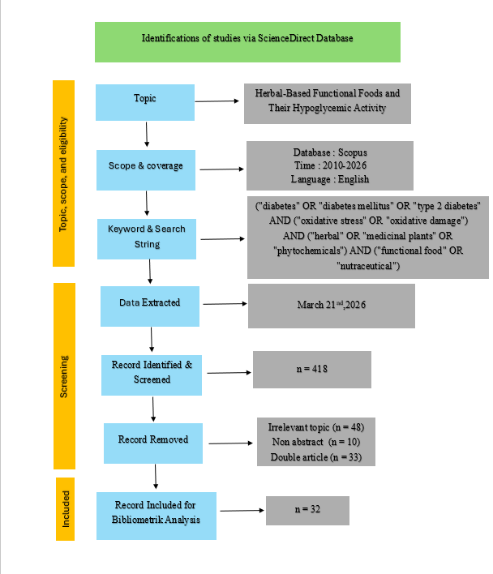
Figure 1. Flow diagram of the search strategy
The screening process is illustrated in Figure 1. From the initial 7,268 records retrieved, a number of studies were excluded due to duplication, lack of relevance, and absence of abstracts. After the screening process, 5,105 publications were retained for further analysis. This systematic selection ensured that only high-quality and relevant studies were included in the bibliometric mapping.

Research Publication Trends

Figure 2. Publication trends
The number of publications on topics such as diabetes, oxidative stress, antioxidants, herbal medicine, and functional foods shows a significant upward trend from 2010 to 2025. A particularly sharp increase is observed during the 2020–2025 period, indicating growing research interest in the use of natural substances as therapeutic agents.
Analysis of Top Contributing Publishers
Table 1 presents the top contributing journals in the research field. It can be observed that the Journal of Ethnopharmacology has the highest number of publications 458, followed by the Journal of Functional Foods 242 and International Journal of Biological Macromolecules 231. These journals are well-known for publishing studies related to natural products, bioactive compounds, and functional foods, which align closely with the research topic
In addition, journals such as Biomedicine & Pharmacotherapy and Phytomedicine also contribute significantly, indicating strong interdisciplinary research involving pharmacological and biomedical approaches. The presence of journals like Food Chemistry and Food Bioscience highlights the growing interest in food-based approaches to managing chronic diseases such as diabetes mellitus
Overall, the distribution of publications across these journals demonstrates that research on herbal-based functional foods and their hypoglycemic activity is highly multidisciplinary, integrating aspects of food science, pharmacology, and biomedical research
Table 1. Top Contributing Journals
No. | Journal | Publication | Percentage
1 | Journal of Ethnopharmacology | 458 | 9.0%
2 | Journal of Functional Foods | 242 | 4.7%
3 | International Journal of Biological Macromolecules | 231 | 4.5%
4 | Biomedicine & Pharmacotherapy | 198 | 3.9%
5 | Phytomedicine | 176 | 3.4%
The top five journals accounted for approximately 25.5% of total publications, indicating a moderately concentrated research field.

Keyword co-occurrence network and overlay
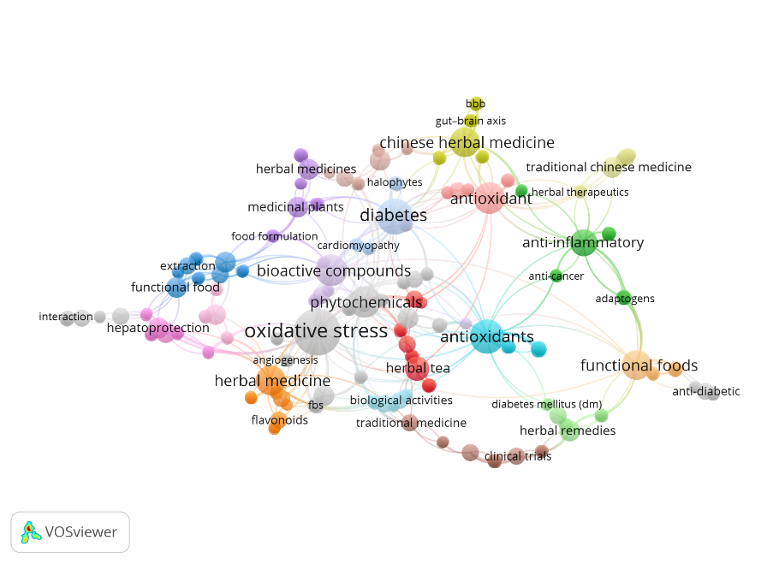
Figure 3. Keyword co-occurrence network
Based on VOSviewer analysis, the keyword "diabetes" appeared 1,856 times with a total link strength of 4,789, while "oxidative stress" appeared 1,247 times with a total link strength of 3,456. These two keywords represent the most dominant and highly connected nodes in the network.
The keyword "antioxidant" appeared 847 times with a total link strength of 1,245, indicating its crucial role in linking oxidative stress and herbal-based interventions. A total of 5 clusters were identified: cluster 1: diabetes and metabolic disorders, cluster 2: oxidative stress mechanisms, cluster 3: antioxidants and bioactive compounds, cluster 4: herbal medicine and medicinal plants, cluster 5: functional foods and therapeutic applications.
The keywords “oxidative stress” and “diabetes”.
Additionally, the keywords “antioxidants” and “antioxidant” occupy strategic positions connecting various clusters. This suggests that antioxidants are a key component of the research, particularly in relation to efforts to reduce oxidative stress. Antioxidants are known to neutralize free radicals, thereby potentially reducing cellular damage and improving metabolic conditions in individuals with diabetes.
Another cluster identified includes keywords such as “phytochemicals,” “bioactive compounds,” and “flavonoids,” indicating a research focus on active compounds derived from natural sources. These compounds serve as key components in producing biological effects, including antioxidant and hypoglycemic activity.
Furthermore, the keywords “herbal medicine,” “medicinal plants,” and “Chinese herbal medicine” form a distinct cluster, indicating that medicinal plants are a primary source in research related to diabetes therapy. This reinforces that herbal-based approaches are widely used in the development of natural antidiabetic agents.
On the application side, a cluster involving the keywords “functional foods,” “herbal remedies,” and “anti-diabetic” is evident. This cluster indicates that research is not only focused on mechanisms but has also expanded toward the development of functional food products with health benefits.
Additionally, the emergence of keywords such as “anti-inflammatory,” “anti-cancer,” and “clinical trials” indicates that research is also moving toward biological testing and clinical applications, signaling efforts to further evaluate the efficacy of herbal ingredients.
Overall, the results of the network visualization indicate that research in this field is multidisciplinary, encompassing aspects of disease mechanisms, bioactive compounds, and the development of functional food products. The strong interconnections between clusters suggest that an approach based on natural ingredients with antioxidant activity holds great potential for diabetes management. Thus, the development of a beverage based on spiced roasted coconut with the addition of ginger and lemongrass as a functional food has a strong scientific basis, as it aligns with research trends emphasizing the use of herbal bioactive compounds as hypoglycemic agents.
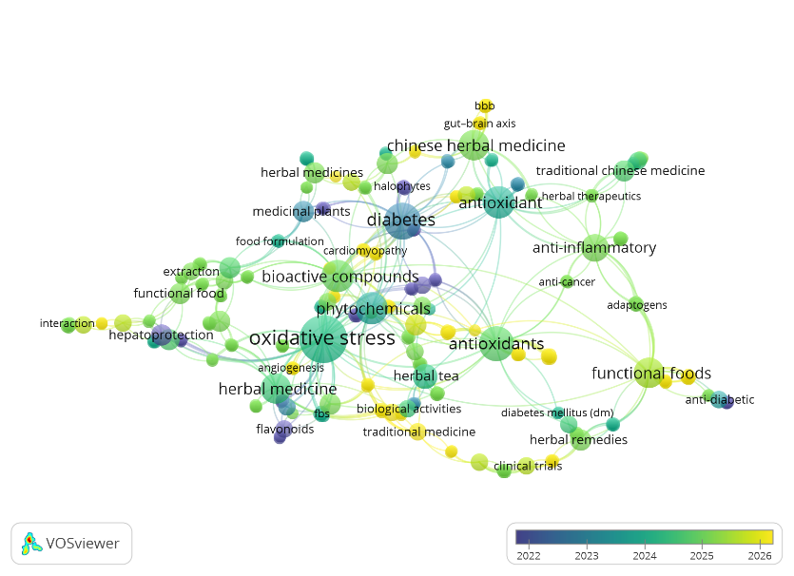
Figure 4. Keyword co-occurrence overlay
Relevance To Previous Research
Based on the results of publication trend analysis and network visualization, it is evident that research on the use of herbal ingredients as functional foods with antioxidant and antidiabetic properties is a rapidly growing field.
This supports the development of an instant beverage made from roasted coconut with added ginger and lemongrass as a functional food product. The bioactive compounds in ginger and lemongrass, such as flavonoids and phenolic compounds, have the potential to provide antioxidant effects that can help lower blood glucose levels.
Thus, this research is strongly relevant to global research trends and contributes to the development of natural-ingredient-based functional food products as an alternative for diabetes management.
The bibliometric findings strongly support the development of herbal-based functional beverages, particularly those incorporating ginger (Zingiber officinale) and lemongrass (Cymbopogon citratus). Overlay visualization indicates that terms such as "functional beverage" and "clinical evaluation" have emerged as recent research trends, highlighting a shift toward applied product development.
Additionally, increasing attention to sensory evaluation and consumer acceptance suggests that modern research integrates bioactivity with product feasibility. This supports the development of spiced roasted coconut beverages as potential hypoglycemic functional products with both health benefits and market potential.
LIMITATIONS
This study has several limitations. First, the analysis was limited to the ScienceDirect database, which may not fully represent all relevant publications available in other databases such as Scopus or Web of Science. Second, the search strategy relied on specific keywords, which may have excluded studies using alternative terminology. Third, this study did not differentiate between types of diabetes or experimental approaches (in vitro, in vivo, or clinical studies). Future research is recommended to include multiple databases and more comprehensive analytical approaches.
CONCLUSION
Bibliometric analysis indicates that research on diabetes is closely linked to oxidative stress and antioxidant activity. Diabetes mellitus, characterized by progressive oxidative stress, requires a multifaceted approach that combines glucose management strategies with interventions targeting oxidative stress and inflammatory pathways (Dua et al., 2025).
Recent research indicates a trend toward the development of herbal-based functional foods as an alternative in diabetes management. Bioactive compounds from herbs demonstrate potential through multiple mechanisms, including inhibition of carbohydrate-digesting enzymes, increased insulin secretion, reduced oxidative stress, and modulation of the inflammatory response (Naz et al., 2023).
Thus, the development of herbal-based beverage products holds great potential for further development as functional foods with health benefits. Further research is needed to standardize the extraction and formulation of herbal products, conduct clinical trials to validate product efficacy, evaluate long-term safety and interactions between compounds, and optimize the bioavailability of active compounds through innovative delivery technologies. The integration of traditional knowledge with modern scientific validation opens up great opportunities for the development of complementary and alternative therapies.
REFERENCES
Lu, X., Xie, Q., Pan, X., Zhang, R., Zhang, X., Peng, G., Zhang, Y., Shen, S., & Tong, N. (2024). Type 2 diabetes mellitus in adults: pathogenesis, prevention and therapy. Signal Transduction and Targeted Therapy. https://doi.org/10.1038/s41392-024-01951-9
Elkhalifa, A. M. E., Nazar, M., Ali, S. I., Khursheed, I., Taifa, S., Mir, M. A., Shah, I. H., Malik, M., Ramzan, Z., Ahad, S., Bashir, N., Elamin, E., Bazie, E. A., Ahmed, E. M., Alruwaili, M., Baltoyour, A. W., Alarfaj, A., Bataj, I. A. A., Arabe, A. M. A., & Nabi, S. (2024). Novel Therapeutic Agents for Management of Diabetes Mellitus: A Hope for Drug Designing against Diabetes Mellitus. Life. https://doi.org/10.3390/life14010099
K, Mugisha Emmanuel (2026). Interplay Between Oxidative Stress and Antioxidant Defenses in the Pathogenesis and Management of Diabetes Mellitus. Idosr Journal of Science and Technology. https://doi.org/10.59298/idosr/jst/26/113.1320
Bhatti, J. S., Sehrawat, A., Mishra, J., Sidhu, I. S., Navik, U., Khullar, N., Kumar, S., Bhatti, G. K., & Reddy, P. (2022). Oxidative stress in the pathophysiology of type 2 diabetes and related complications: Current therapeutics strategies and future perspectives. Free Radical Biology & Medicine. https://doi.org/10.1016/j.freeradbiomed.2022.03.019
An, Y., Xu, B.-T., Wan, S., Ma, X., Long, Y., Xu, Y., & Jiang, Z.-Z. (2023). The role of oxidative stress in diabetes mellitus-induced vascular endothelial dysfunction. Cardiovascular Diabetology. https://doi.org/10.1186/s12933-023-01965-7
Chuquizuta-Fernandez, J. M., Mosilot-Acosta, V. S., Alvites-Chuquizuta, L. L., Filho, L. N. C. e-C., Ferreira, N., Chagas-Junior, G. C., Culqui-Arce, C., Cayo-Colca, I. S., Maicelo, J., Castro-Alayo, E. M., & Balcázar-Zumaeta, C. R. (2026). Current trends and knowledge mapping on functional foods: bibliometric analysis and review. Frontiers in Food Science and Technology. https://doi.org/10.3389/frfst.2026.1762291
Venkateswaran, M., Jayabal, S., Hemaiswarya, S., Murugesan, S., Enkateswara, S., Doble, M., & Periyasamy, S. (2021). Polyphenol-rich Indian ginger cultivars ameliorate GLUT4 activity in C2C12 cells, inhibit diabetes-related enzymes and LPS-induced inflammation: An in vitro study. Journal of Food Biochemistry. https://doi.org/10.1111/jfbc.13600
Naz, R., Saqib, F., Awadallah, S., Wahid, M., Latif, M. F., Iqbal, I., & Mubarak, M. S. (2023). Food Polyphenols and Type II Diabetes Mellitus: Pharmacology and Mechanisms. Molecules. https://doi.org/10.3390/molecules28103996
Yeung, A. W. K., Heinrich, M., & Atanasov, A. (2018). Ethnopharmacology—A Bibliometric Analysis of a Field of Research Meandering Between Medicine and Food Science? Frontiers in Pharmacology. https://doi.org/10.3389/fphar.2018.00215
Tumilaar, S. G., Hardianto, A., Dohi, H., & Kurnia, D. (2024). A Comprehensive Review of Free Radicals, Oxidative Stress, and Antioxidants: Overview, Clinical Applications, Global Perspectives, Future Directions, and Mechanisms of Antioxidant Activity of Flavonoid Compounds. Journal of Chemistry. https://doi.org/10.1155/2024/5594386
Agede, O., Sanni, N., Alaofin, W., Oyedepo, D., & Aiyedun, O. (2025). Herbal Interventions in the Management of Diabetes Mellitus: A Comprehensive Review of the Glucose Lowering Properties of African Bush Mango. The Medical Journal of Zambia. https://doi.org/10.55320/mjz.52.3.695
Obeagu, E. I. (2026). Unraveling the connection: Inflammatory markers and diabetes mellitus pathogenesis. Medicine. https://doi.org/10.1097/MD.0000000000047338
Hu, Z., Su, Y., Jia, J., Bian, X., Gu, Y., Lv, G., Chen, S., & Jiang, N. (2025). Mulberry – Nutritional Value, Health Benefits, and its Applications in Food, Biomaterials, and Medicine: A Systematic Review with Bibliometric Analysis. Natural Product Communications. https://doi.org/10.1177/1934578X251314698
Nguyen, H. L., Sae‐Eaw, A., Tran, D., Prinyawiwatkul, W., & Chulikhit, Y. (2025). A Systematic Review of Evidence-Based Health Benefits of Oroxylum indicum and Its Functional Food Potential. Foods. https://doi.org/10.3390/foods14203465
Puspitojati, E., Waluyo, W., Rahayu, N. A., & Saputra, H. (2025). Ginger, lemongrass, and stevia tea: antioxidant activity, alpha-glucosidaseinhibitory, and sensory quality. Food Research. https://doi.org/10.26656/fr.2017.9(1).070
Fatima, K., Tehseen, S., Ashfaq, F., Bilal, A., Khalid, M. Z., Khalid, W., & Madilo, F. K. (2024). Development and storage stability studies of functional fruit and vegetable-based drinks incorporated with polyphenols extracted from herbs and spices. International Journal of Food Properties. https://doi.org/10.1080/10942912.2024.2317740
Santoso, F., Sunardi, J., Ignatia, F., & Gunawan-Puteri, M. D. P. T. (2021). THE IMPACTS OF FORMULATION AND STORAGE ON α-GLUCOSIDASE INHIBITORY ACTIVITY OF LEMONGRASS, GINGER, AND BLACK TEA FUNCTIONAL BEVERAGES. Journal of Pharmaceutical Sciences and Community. https://doi.org/10.24071/jpsc.002637
Alkan, G., Erol, N. M. K., Yıkmış, S., Er, H., Öğüt, S., & Yinanç, A. (2025). Kombucha’s functional features and fermentation dynamics: a bibliometric assessment in sustainable food production. Frontiers in Sustainable Food Systems. https://doi.org/10.3389/fsufs.2025.1593348
Gong, Y., Tian, X., Ma, X., Xing, J., Ji, Z., Gao, X., Chen, Z., Hu, F., Yin, D., Li, F., Sheng, C., Liu, Y., & Shi, S. (2025). New insights into the pharmacological mechanisms of Jinqi Jiangtang Tablets in the treatment of type 2 diabetes mellitus: A multi-omics approach combined with experimental validation. Journal of Ethnopharmacology. https://doi.org/10.1016/j.jep.2025.120020
Dua, A., Kumari, R., Singh, M., Kumar, R., Pradeep, S., Ojesina, A., & Kumar, R. (2025). Metabolic Dysfunction-Associated Steatotic Liver Disease (MASLD): the interplay of gut microbiome, insulin resistance, and diabetes. Frontiers in Medicine. https://doi.org/10.3389/fmed.2025.1618275
Porro, C., Benameur, T., Cianciulli, A., Vacca, M., Chiarini, M., Angelis, M. D., & Panaro, M. A. (2024). Functional and Therapeutic Potential of Cynara scolymus in Health Benefits. Nutrients. https://doi.org/10.3390/nu16060872
Yeh, M., Huang, J., Dai, C., Huang, C.-F., Yu, M., & Chuang, W. (2024). Metabolic dysfunction-associated steatotic liver disease and diabetes: the cross-talk between hepatologist and diabetologist. Expert Review of Gastroenterology & Hepatology. https://doi.org/10.1080/17474124.2024.2388790
Shi, W., Li, X., Zhao, X., Jiang, J., Wang, C., Fan, G., & Lou, Y. (2025). Bibliometric analysis of global research trends and development prospects of Smilax glabra Roxb using CiteSpace. Frontiers in Plant Science. https://doi.org/10.3389/fpls.2025.1651650
Belosludtsev, K. N., Belosludtseva, N. V., & Dubinin, M. V. (2020). Diabetes Mellitus, Mitochondrial Dysfunction and Ca2+-Dependent Permeability Transition Pore. International Journal of Molecular Sciences. https://doi.org/10.3390/ijms21186559
Kaur, R., Kaur, M., & Singh, J. (2018). Endothelial dysfunction and platelet hyperactivity in type 2 diabetes mellitus: molecular insights and therapeutic strategies. Cardiovascular Diabetology. https://doi.org/10.1186/s12933-018-0763-3
Dilworth, L., Facey, A., & Omoruyi, F. O. (2021). Diabetes Mellitus and Its Metabolic Complications: The Role of Adipose Tissues. International Journal of Molecular Sciences. https://doi.org/10.3390/ijms22147644

RESPONSE TO REVIEWER

Dear Reviewer,
We sincerely thank you for your valuable comments and constructive suggestions. We have carefully revised the manuscript accordingly. Below is a summary of the revisions:
1. The methodology section has been expanded, including a complete Boolean search string and detailed screening process.
2. Bibliometric parameters such as keyword occurrence and total link strength have been added.
3. Table 1 has been revised and expanded for clarity.
4. Quantitative data have been included to strengthen the results.
5. References have been corrected and standardized.
6. A limitations section has been added.
7. The discussion has been strengthened to better connect the findings with functional product development.
We believe the manuscript has been significantly improved and meets the journal requirements.
Sincerely,
Authors

