RICE HUSK ASH AS A SUITABLE AGGREGATES FOR CONCRETE PRODUCTION AND SUSTAINABLE BUILDING MATERIAL IN
ENUGU STATE URBAN, SOUTHEAST NIGERIA

OZOEMENA CHIBUEZE ROMANUS¹, CHIBUEZE JULIET CHIMAKASIEMOBI²
¹Department of Architecture, ESUT
²Department of Architecture, ESUT

ABSTRACT
Rise husk ash, a by- product from the burning of rice husk during the parboiling process, is a great threat to the environment causing damage to the land and the surrounding areas in which it is dumped. Nigeria being a major rice producing country, creates about 5.2million tons of rice and 1.2 tons of rice husk annually, most of which is disposed in nearby rivers or lands of the rice mills. Though, finding and giving a suitable application of this by product may have a great impact on reducing pollution, reuse and economic benefits for the society. In this paper, the potentiality of Rice Husk Ash is discussed as a sustainable building material. The objectives of this paper are to identify the physical properties of rice husk ash, to examine the various application of rice husk ash as a sustainable building material and to investigate the use of RHA as a sustainable building material in Enugu urban area. The study observed that 63.5 percent of building developers and owners of industries uses rice husk ash as additive in block production and 21.5 percent of them use it as waterproof agent in building foundation. Based on the findings of the study, the study recommends that rice husk ash stabilized concrete block can be a potential alternative which will be sustainable not only by its cost and energy efficiency, but also by turning agricultural waste into block producing material.
Keyword: Rice Husk Ash, Aggregates, Concrete, Sustainable, Building material, Enugu State Urban

1.0 INTRODUCTION
Rice milling generates a by-product known as husk. Rice husks are the hard protective coverings of rice grains which are separated from the grains during milling process. Rice husk is an available waste material in all rice producing countries, and it contains about 30%–50% of organic carbon (Padma 2014). In the course of a typical milling process, the husks are removed from the raw grain to reveal whole brown rice which upon further milling to remove the bran layer will yield white rice. The estimated total volume of milled rice produced worldwide reached over 502 million metric tons in the 2022/2023 crop year (Statista 2023). Rice husk constitutes about 20% of the weight of rice and its composition is as follows: cellulose (50%), lignin (25%–30%), silica (15%–20%), and moisture (10%–15%). Bulk density of rice husk is low and lies in the range 90–150 kg/m³ (Bhupinder 2022).
Rice husk is mostly treated as waste in most developing countries like Nigeria where there is little or no knowledge of the potential uses. The potential use of rice husk in the construction industry for instance is now been discussed. Construction industry relies heavily on conventional materials such as cement, sand and granite for production of concrete. Concrete is the basic civil engineering composite. The quality of concrete is determined by the quality of paste/mix. It is the world’s most consumed man-made material. Its great versatility and relative economy in filling wide range of needs has made it a competitive building material. The demand for concrete for today’s infrastructural development is rising day-by -day. In light of this, the non-availability of natural resources to future generation has also been realized. Concrete production is not only a valuable source of societal development but also a significant source of employment. Following a natural growth in population, the amount and type of waste materials have increased accordingly creating thus environmental problems. Historically agricultural and industrial wastes have created waste management and pollution problems. Different alternative waste materials and industrial by-products such as fly ash, bottom ash, recycled aggregates, crumb rubber, saw dust, brick bats and so on, were replaced with natural aggregates. Although these materials are traditionally considered as primitive and therefore inferior to more highly processes in terms of safety, durability, performance, occupants health and comfort with respect to environmental issue, consumption of environmental products and energy within the construction industry has created a significant demand for raw materials and for production thereby contributing to the many environmental problems associated with diverse ecosystem (Ali and Kshipra 2016).
The huge amount of rice husk wasted on a daily bases creates a great threat to the environment not only by being disposed in nearby lands or rivers of rice mills, but also due to inefficient burning process and creating pollution to the environment. Because of all these factors, by giving rice husk a suitable application like sustainable component of Building Material, both economic and environmental problem can potentially be addressed.
1.2 STATEMENT OF THE PROBLEM
Throughout the world, concrete is being widely used for the construction of most of the buildings, bridges, roads and so on. Hence, it has been properly labeled as the backbone to the infrastructure development of a nation (Obilade 2014). Currently, Nigeria is taking major initiatives to improve and develop its infrastructure by constructing express highways, coastal roads, power projects and industrial structures to emerge as a major economic power and it has been estimated that the infrastructure segment in Nigeria is expected to see investments to the tune of $1 trillion by the year 2030 (Federal Ministry of budget and economic planning, 2022). To meet out this rapid infrastructure development, a huge quantity of concrete is required. Unfortunately, Nigeria’s boarder is short for importation of cement, and the cost of its owned produced cements has skyrocketed. The main ingredient of concrete and the demand for it exceeds the supply and makes the construction activities very costlier. Hence, currently, the entire construction industry is in search of a suitable and effective product that would considerably minimize the use of cements and ultimately reduces the construction cost.

1.3 AIM AND OBJECTIVES
This research aim at reviewing the potential uses of rice husk ash as a sustainable building material.
The objectives are:
- to identify the physical properties of rice husk ash (RHA).
- to examine the various application of rice husk ash as a sustainable building material.
- to investigate the use of RHA as a sustainable building material in Enugu urban.
1.4 RESEARCH QUESTION
1. what are the uses of rice husk ash as a sustainable building material in Enugu urban?

1.5 SIGNIFICANCE OF THE RESEARCH
This research is of prime importance to the government, organized private sector, manufacturers of building materials, cement production industries and entrepreneurs for wealth creation by venturing into production of rice husk ash incorporation with cement which will in turn meet the rising demand for cement and eventually crash down the cost. The effect will not only reduce the cost of housing in Nigeria but also that of road construction and provide massive employment.

2.0 MATERIALS AND METHODS
2.1 Study area
Enugu Urban is the most developed urban area in Enugu state. It is one of the states in south eastern Nigeria, its capital is Enugu. The state was created in 1991 from the old Anambra State. Enugu state is located within latitude 06⁰ 00’N and 07⁰ 00’N and longitude 07⁰ 00’E and 07⁰ 45’E.
The State shares borders with Abia State and Imo State to the South, Ebonyi state to the east, Benue state to the Northeast, Kogi State to the northwest and Anambra State to the west. Enugu state is made up of 17 local government areas. There are 18 prominent residential areas in the urban. These are Abakpa, Trans-Ekulu, Nike, GRA, Ogui, Asata, New Layout, Achara Layout, Ugwuaji, Maryland, Awkanaw, Uwani, Agbani, and Coal Camp.

2.2 Methodology
Survey research method was adopted for this study. Questionnaire was used especially to ascertain the use of rice husk ash in any way as building material, this represents the survey research method.
2.2.1 Research population and sampling frame
The population of the study is 722, 664 respondents which is estimated population of the study. They are made up of population from the three local government area in the Enugu urban. (Enugu East, Enugu North, and Enugu South). It comprises the building developers and rice mill owners in the study area.
2.2.2 Population and sample size
The Cochran sample size formula for the 722,664 population was used to determine sample size for the study.
N=z²pq/d²
Where:
N = the desired sample size
Z = standard normal size at 95% confidence interval (1.96)
P = proportion attributes of a population (50%)
q=1-p (50%)
d= desired precision (0.05) n= (1.96)²* (0.50) * (0.50)/ (0.5)²n=384.16
Rounding off to the nearest hundredth, n= 400. The 400 respondents were breakdown into two groups which represent the building developers (272) and rice mill owners (128).
2.2.3 Methods of Data Analysis
An indepth literature review, frequencies and percentages were adopted in analyzing the collected data of the study.

3.0 Results and findings
3.1 Results
To estimate the application of rice husk ash as building material, the following were reviewed and observations from respondents were obtained and analyzed.
3.1.1 Physical properties of rice husk ash (RHA)
Rice husk ash is grayish-black in color due to unburned carbon. At burning temperatures of 550–800 °C, amorphous silica is formed, while crystalline silica is produced at higher temperatures. The specific gravity of RHA varies from 2.11 to 2.27; it is highly porous and light weight, with a very high specific surface area (Mehran and Kshipra, 2016). RHA is a lightweight, bulky, and highly porous material with a density of around 180–200 kg/m3 (Zou and Yang, 2019). The specific gravity of RHA powder is between 2 and 2.5, depending on the fineness. As the pozzolanic reactivity of RHA depends on its fineness, the physical properties and gradation of RHA are important and they must be controlled to acquire the best performance. Table 1 shows the physical properties of RHA reported by several researchers. Fig. 1 shows images of RHA as received and after burning at 700 °C for 6 h (Della, 2002).
3.1.2 Chemical properties of RHA
RHA, obtained by burning the biomass, is known to have an amorphous nature with high silica, and show a high pozzolanic reaction when used as binder to produce concrete (Singh, Das, Singh and Dwivedi, 2020). In a thorough study, it was found that the pozzolanic nature of RHA refines the pore structure in mortar and concrete, which significantly reduces permeability against water, sulfate, and chloride penetration (Chopperla, Yamuna, Bahurudeen, Santhanam and Gopinath, 2021).

Table 1: physical properties of RHA reported by several researchers.
Property | Chindaprasirt etal. (2008) | De sensale (2010) | Chatveera and lertwattanaruk (2010) | Gastaldini etal. (2014)
Particle size (um) | 10 | 8 | - | -
Specific gravity | 2.23 | 2.06 | 2.02 | 2.11
Blaine fineness (cm²/g) | - | - | 6,200 | -
Surface area (cm²/g) | - | 2,880,000 | 1,100,00 | 188,900
Fig 1: RHA as received and after burning at 700 °C
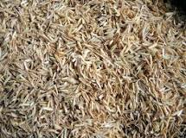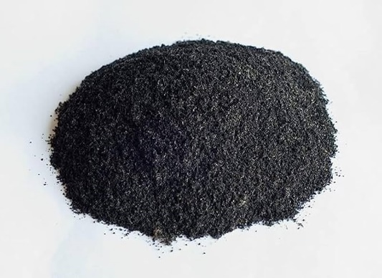
(a) (b)

3.1.3 Application of Rice Husk Ash (RHA) as a sustainable building material
1. Used in steel industries
2. Due to fine insulating properties of rice husk like low thermal conductivity, high melting point, low bulk density high porosity, it used for the production of high-quality steel. It is also used as a coating over the molten metal in the tundish and in ladle which acts as a very good insulator and does not allow quick cooling of metal.
3. Used in cement and construction industries
4. Blended cement is produced by using rice husk ash for fulfilling the increasing need for building material. Rice husk ash is a highly reactive pozzolan. Rice husk ash mainly used a replacement of silica fume or as an admixture in manufacturing of low-cost concrete block.
5. Use of rice husk ash as silica source
6. Due to large silica content in rice husk ash, extraction of silica is economical. Silica is used in rubber industries as a reinforcing agent, in cosmetics, in toothpastes, in food industries as an anti-caking agent. There is a growing demand for fine amorphous silica in the production of high-performance cement and concrete, use in bridges, marine environments, nuclear power plants
etc. Silica aerogels prepared from Rice Husk Ash (RHA) finds application in super thermal insulators, catalyst supports and dielectric materials. It can be an economically viable raw material for the production of silicates and silica.
7. Other uses 8. Indian Space Research Organization has successfully developed a technology for producing high purity silica from RHA that can be used in manufacturing of silicon chip in industry. RHA used in vulcanizing rubber. Use of Rice Husk to synthesize High-Performance Phosphors. Other uses of Rice Husk (RH) are in control of insect pests in Stored Food Stuffs. RHA has been found to be effective as an oil spill absorbent, and for use in waterproofing chemicals, flame retardants, and as a carrier for pesticides and insecticides, (Mehran and Kshipra 2016).
3.1.4 Collection of Administered Questionnaires
In the survey, questionnaires administered to building developers, and owners of industries in the study area were completed and returned as shown in figure 2 below.
Figure 2: Population of the respondents
Source: field survey, (2024)
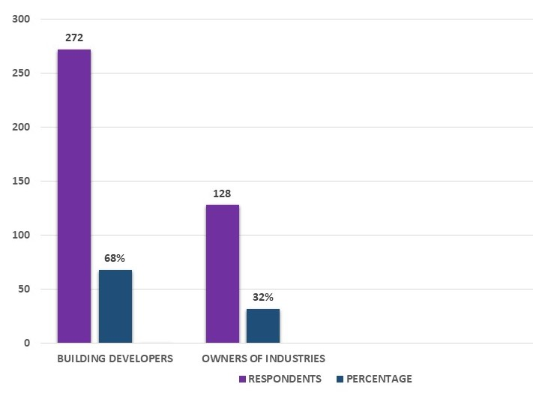
From the above figure, it is observed that 100% of distributed questionnaires were completed and returned with 68% as building developers and 32% as owners of industries. The level of response was highly satisfactory.

Table 2: Demographic characteristics of the Respondents
Source: field survey, (2024)
 | FREQUENCY | PERCENT
Age group
20-29 | 217 | 53.3
30-39 | 124 | 31.0
40-49 | 34 | 8.5
50 and above | 25 | 6.3
Total | 400 | 100
Sex
Male | 292 | 73
Female | 108 | 27
Total | 400 | 100
Level of education
No formal education | 4 | 1.0
Primary | 8 | 2.0
Secondary | 102 | 25.5
Tertiary | 286 | 71.5
Total | 400 | 100
Marital status
Married | 258 | 64.5
Single | 133 | 33.3
Separated | 6 | 1.5
Widow/widower | 3 | 0.8
Total | 400 | 100
Occupation
Block manufacturer | 175 | 43.8
Architect | 14 | 3.5
Paint manufacturer | 75 | 18.8
Building engineer | 136 | 34.0
Total | 400 | 100
Table 2 shows that majority of the respondents are between the ages of 20-39 (84.3%), a number of male 73%, tertiary as the highest level of education 71.5%, married respondents 64.5%, and block manufacturers as 43.8%.
The use of rice husk ash in as a sustainable building material in Enugu Urban
This section addresses research objective 3 which is “to investigate the use of RHA as a sustainable building material in Enugu urban”. The following observations were obtained from respondents and analyzed in fig 3.

Fig 3: The use of rice husk ash as a sustainable building material in Enugu Urban
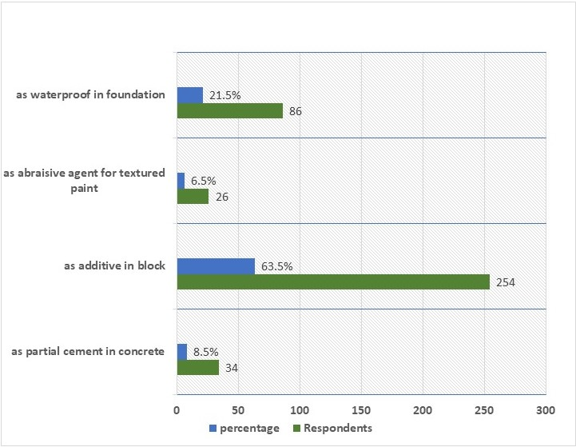
Source: field survey, (2024)
Figure 3 above seeks to find out the use of rice husk ash as sustainable building material in Enugu. 63.5% of the respondents says they use RHA as additive in block production. 21.5% of the respondents responded that they use RHA as waterproof in foundation. 6.5% of the respondents says that they us rice husk hash as abrasive agent for textured paint. While 8.5% of the respondents use RHA as partial cement in concrete. This result is in line with that of Singh et al (2020) who opined that RHA showed a high pozzolanic reaction when used as binder to produce concrete.

4.0 CONCLUSION AND RECOMMENDATIONS
The use of RHA as aggregate in concrete industry offers sustainability, environmental-friendly, and energy-saving alternative of cement and enhances the use of recycled waste as construction materials (Ganta, Ramesh and Rama 2022). The production, processing, and usage of RHA should be followed by the guidelines and standard practices to achieve the best performance. Upon reviewing the existing literature and observation from questionnaire, the following conclusions can be drawn:
1. Rice husk Ash Stabilized Concrete Block can be a potential alternative which will be sustainable not only by its cost and energy efficiency, but also by turning agricultural waste into block producing material.
2. Use of rice husk ash as waterproof in foundation
3. As abrasive agent for textured paint
4. Used in cement and construction industries
5. Use of rice husk ash results good effect on compressive strength.
6. Use of these materials are environment friendly.
7. Use of rice husk ash is also cost effective.

REFERENCES

Ali T., Saand A., Bangwar D., Buller A. and Ahmed Z. (2021). Durability Properties of Aerated
Concrete Incorporating Rice Husk Ash (RHA) as Partial Replacement of
Cement. Crystals 2021, 11, 604.

Bhupinder S. (2022). Waste and Supplementary Cementitious Materials in Concrete.
Handbook of sustainable concrete and industrial waste management, 2022

Bhupinder S. (2018). Rice husk ash, waste and supplementary cementitious materials in
concrete.

Chatveera B. and Lertwattanaruk P. (2010). Durability of conventional concretes containing
black rice husk ash. Received 3 November 2009, Revised 5 July 2010, Accepted 7
August 2010.

Chindaprasirt P, and S. Rukzon (2008). Strength, porosity and corrosion resistance of ternary

blend Portland cement, rice husk ash and fly ash mortar. Thailand Received 5 May 2007,

Revised 19 June 2007, Accepted 28 June 2007.

Chopperla, S.T.; Yamuna, V.; Bahurudeen, A.; Santhanam, M.; Gopinath, A. (2021). Durability of concrete with agro-waste: A local approach to sustainability. Green Material, 7, 84–96.

De Sensale G. R (2010), Effect of rice-husk ash on durability of cementitious materials.
Revised 26 April 2010, Accepted 10 July 2010, Available online 15 July 2010.

De Sensale GR (2006). Strength development of concrete with rice-husk ash. Cement Concr
Compos 28(2):158–160

Gastaldini A.L, da Silva, M.P., Zamberlan, F.B., Mostardeiro Neto, C.Z., (2014). Total shrinkage,
chloride penetration, and compressive strength of concretes that contain clear-colored
rice husk ash. https://doi.org/10.1016/j.conbuildmat.2013.12.044.
Federal Ministry of Budget and Economic Planning, (2022). https://nationalplanning.gov.ng

Mehran Ali and Kshipra Kapoor (2016) A Review Study on Use of Rice Husk Ash as Partial
Replacement with Cement in Concrete. International Journal of Latest Research in
Engineering and Computing (IJLREC) Volume 4, Issue 5, Page No. 5-8 September-
October 2016 www.ijlrec.com

Mounika G, Bhaskar R and Kalyana R (2022). Rice husk ash as a potential supplementary
cementitious material in concrete solution towards sustainable construction. February
2022 Innovative Infrastructure Solutions 7(1):51 DOI: 10.1007/s41062-021-00643-5

Nafizur R, Nasif S and Monjur Parvez (2020). Rice Husk Ash Stabilized Block as a Sustainable
Construction Material for Green Building, MUJIB YEAR SPECIAL PUBLICATION

Obilade I.O (2014). Use of rice husk ash as partial replacement for cement in concrete.
ISSN2305-8269, sept. 2014. Vol. 5. No. 04

P. Padma Rao (2014), A Study on Use of Rice Husk Ash in Concrete, IJEAR Vol. 4, Issue Spl-2,
Jan - June 2014, ISSN: 2348-0033 (Online) ISSN: 2249-4944 (Print).

Rahman ME, Muntohar AS, Pakrashi V, Nagaratnam BH, and Sujan D (2014) Self compacting
concrete from uncontrolled burning of rice husk and blended fine aggregate. Mater
Des55:410–415
Singh, N.B.; Das, S.; Singh, N.P.; Dwivedi, V. Hydration of bamboo leaf ash blended Portland cement. Indian Journal of Engineering and Material Science, 14, 69–76.
Statista (2023), https://www.statista.com/statistics/617136/digital-population-worldwide

Yanping Z and Tiankui Yang (2019). Rice Husk, Rice Husk Ash and Their Applications
Wilmar Global Research and Development Center, Shanghai, China

