TITLE OF THE STUDY:

“Efficacy Of Preoperative Topical Flurbiprofen And Topical Nepafenac In Maintaining Intraoperative Mydriasis During Cataract Surgery-A Comparative Study”

ABSTRACT

Background:

Cataract surgery requires adequate and sustained papillary dilation for safe and effective outcomes, Intraoperative miosis commonly occurs due to prostaglandin release following surgical manipulation, increasing the risk of complications. Topical non-steroidal anti-inflammatory (NSAIDS) are used preoperatively to inhibit prostaglandin synthesis and maintain intraoperative mydriasis. Flurbiprofen is a conventional NSAID, while nepafenac, a newer prodrug, offers superior corneal penetration and intraocular bioavailability. This study aims to compare topical flurbiprofen and nepafenac in maintaining intraoperative mydriasis during cataract surgery.

Objectives of the study:
- To compare the efficacy of topical flurbiprofen and topical nepafenac in maintaining intraoperative mydriasis during cataract surgery.
- To estimate the grade of analgesia in cataract surgery.

Materials and methods:
A total of 200 patients scheduled for elective small incision cataract surgery (SICS) were allocated into two groups. Pre-operatively, all patients received one drop of tropicamide 0.8% and phenylephrine 5% (combination), 4 times, at an interval of 15 minutes on the day of surgery. Group A received topical flurbiprofen 0.03% and Group B received topical nepafenac 0.1%, administered preoperatively at standardized interval of 15 mins. Both vertical and horizontal pupil diameter was measured preoperatively, immediately prior to surgery, and at defined surgical stages (before entry into anterior chamber and after intraocular lens implantation)

Results: This study showed that both groups achieved satisfactory baseline mydriasis

before incision. Mean intraoperative pupil diameter was significantly larger in the nepafenac group compared to the flurbiprofen group at critical stages of surgery(p < 0.05).Group B demonstrated less pupil constriction from baseline and required fewer rescue dilation maneuvers. There was no significant difference in surgical time or intraoperative complications between the two groups. The mean pupillary diameter of the two groups were comparable at the beginning of surgery (p=0.34). The mean change in the pupillary diameter was 1.86±0.71mm in the Nepafenac group and
1.77±0.72mm in the Flurbiprofen group.

Conclusion: The current study highlights that pre-operative use of topical nepafenac (0.1%)appears more effective than topical flurbiprofen(0.03%) in maintaining stable intraoperative mydriasis during cataract surgery. Its stronger inhibition of prostaglandin-mediated miosis may contribute to improved surgical conditions without increasing complications.
Keywords:Intraoperativemydriasis,Flurbiprofen,Nepafenac,Topicalnon- steroidal anti-inflammatory drugs(NSAIDs), Prostaglandin-mediated miosis

INTRODUCTION

Scientific Background
The process of achieving and maintaining adequate pupillary dilatation has long been regarded as a central prerequisite for safe and controlled cataract surgery. Surgeons rely on a well-dilated and stable pupil to manipulate delicate intraocular tissues, emulsify the opacified lens, and implant an intraocular lens without undue stress on the iris or zonules. Despite pharmacological mydriasis achieved preoperatively with anticholinergic and sympathomimetic agents, the intraoperative environment frequently challenges the stability of the pupil.^{[1]}
Mechanical manipulation, fluidic turbulence, and the inflammatory response triggered during cataract surgery can lead to progressive intraoperative miosis. Even minimal pupillary constriction may complicate capsulorrhexis creation, increase the risk of iris trauma, prolong surgical duration, and contribute to postoperative complications such as inflammation, pain, and cystoid macular edema.^{[1,2]} Consequently, additional pharmacological strategies have been explored to maintain stable intraoperative mydriasis.
Topical nonsteroidal anti-inflammatory drugs (NSAIDs) have emerged as important adjuncts because of their ability to inhibit cyclooxygenase-mediated prostaglandin synthesis. Prostaglandins released during surgical manipulation of the iris and ciliary body are potent mediators of intraoperative miosis. Tissue trauma during surgery stimulates rapid prostaglandin release, leading to contraction of the iris sphincter muscle and progressive pupillary constriction.^{[2]}
Preoperative administration of topical NSAIDs helps suppress this prostaglandin surge, thereby reducing the severity of surgically induced miosis. Among the commonly used ophthalmic NSAIDs, flurbiprofen and nepafenac have been widely studied for their anti-inflammatory properties and their ability to maintain mydriasis

during cataract surgery.^{[2,3]}
Flurbiprofen is one of the earliest ophthalmic NSAIDs used in clinical practice. It acts by non-selectively inhibiting cyclooxygenase-1 and cyclooxygenase-2 enzymes, thereby reducing prostaglandin synthesis. Its established efficacy in maintaining pupillary dilatation during cataract surgery has made it a standard component of many preoperative protocols.^{[3]} However, its effectiveness depends on adequate ocular surface retention and anterior chamber penetration. Questions remain regarding its ability to sustain effective intraocular concentrations during prolonged or complex surgeries.[^{3,4]}
Nepafenac, a newer-generation topical NSAID, differs pharmacologically from traditional agents such as flurbiprofen. It is formulated as a prodrug that is converted to amfenac within ocular tissues, particularly in the ciliary body and retina. This property allows improved tissue penetration and greater intraocular bioavailability.[4] By delivering active drug deeper within ocular tissues, nepafenac may provide more sustained suppression of prostaglandin synthesis during surgery. Its reduced surface irritation also contributes to improved patient tolerance and compliance with preoperative dosing regimens^{.[4,5]}
Although both flurbiprofen and nepafenac aim to prevent intraoperative miosis, their pharmacokinetic profiles and tissue penetration characteristics differ significantly. Flurbiprofen primarily exerts its action at the ocular surface and anterior segment, whereas nepafenac achieves broader intraocular activity through enzymatic conversion within ocular tissues^{.[5]} These differences may influence their relative efficacy in maintaining stable mydriasis during cataract surgery, particularly in procedures involving extensive manipulation or increased inflammatory response.
With advances in cataract surgical techniques, including smaller incisions, higher vacuum settings, and greater phacoemulsification energy modulation, the need for

stable intraoperative mydriasis has become increasingly important.[5,6] Patient- related factors such as age, iris rigidity, chronic ocular inflammation, previous intraocular surgery, and systemic medications may further affect pupillary behavior during surgery^{.[6,7]} Inadequate pharmacological maintenance of mydriasis may necessitate the use of mechanical devices such as iris hooks or pupil expansion rings, which can increase surgical time, cost, and tissue trauma.

Objectives and Hypothesis
The objective of this study was to compare the efficacy of topical flurbiprofen and topical nepafenac in maintaining intraoperative mydriasis during cataract surgery.
The study hypothesized that topical nepafenac would provide superior maintenance of intraoperative mydriasis compared with topical flurbiprofen because of its enhanced intraocular penetration and sustained inhibition of prostaglandin synthesis.

METHODOLOGY

Study Design

The study was conducted as a prospective comparative study carried out in 200 patients attending the Ophthalmology Department of K.H. PATIL Institute of Medical Sciences (GIMS), Gadag, Karnataka scheduled for cataract surgery (SICS). Prior to commencement, the study protocol, synopsis, informed consent form, and patient information sheet were reviewed and granted approval by two independent institutional bodies: the Academic & Scientific Review Committee (ASRC) and the Institutional Ethical Committee (IEC) of Gadag Institute of Medical Sciences (Approval Ref: GIMS/IEC/ /2024, dated26-02-2024).

Inclusion Criteria:
- Patients of either sex diagnosed with senile cataract.within the age group of 50 to 80 years scheduled for elective Small Incision Cataract Surgery (SICS)at KHPIMS, Gadag.

- Patients demonstrating good preoperative pupillary dilatation, defined as a pupil diameter greater than 6 mm following standard mydriatic instillation.

Exclusion Criteria:
- Patients with coexisting ocular pathologies such as glaucoma, uveitis, iris atrophy, floppy iris syndrome, or pseudo exfoliation syndrome.
- Patients with pre-existing pupillary abnormalities or conditions predisposing to miosis, such as Horner's syndrome.
- Patients with a known history of hypersensitivity or allergic reactions to NSAIDs (Flurbiprofen, Nepafenac) or any other medications used in the study protocol.
- Patients with a history of previous ocular surgery or significant trauma in the eye scheduled for operation.
- Patients who had used topical or systemic NSAID medications within 30 days prior to the scheduled surgery.
- Patients with poorly dilating pupils despite the use of standard mydriatic agents.

Randomisation

This study comprised of 200 patients, who were divided into two arms of 100 each (arms A and B). The randomization sequence was likely generated using a computer- based random number generator or a randomization table to maintain allocation concealment.Patients in arm A received Nepafenac (0.1%) while those in arm B received Flurbiprofen (0.03%) eye drops, which was provided after removing labels, wrapping them with white paper and coding them as A and B. A designated resident who was not involved in the study was assigned the work of enrolling participants and putting eye drops.

Blinding
The operating surgeon and the patients undergoing surgery were unaware of the type ofdrugadministered.

Study Sample Size

The sample size was calculated a priori using a formal power analysis to ensure the study had adequate statistical power to detect a clinically significant difference between the two intervention groups. The calculation was based on data extracted from a previous similar study, which reported mean pupillary diameters and standard deviations for Flurbiprofen (7.86 ± 0.78 mm) and Nepafenac (8.23 ± 0.95 mm)

groups. The following parameters were used for the calculation: an alpha(α) error of
0.05 (corresponding to a 95% confidence level, Zα = 1.96), a beta (β) error of 0.20 (corresponding to 80% statistical power, Zβ = 0.84), and the mean difference (0.37 mm) between the two groups. The pooled standard deviation was calculated to be0.86
mm. Using the formula for comparing two independent means, the initial sample size was calculated to be approximately 85 participants per group. Accounting for an estimated dropout rate of 10%, the sample size was inflated to 93 per group and subsequently rounded up to 100 participants per group for practicality. Consequently, the total final sample size for the study was determined to be 200 participants, with 100 individuals in each of the two comparative arms.

Study Groups
- Group A: This group received preoperative topical Flurbiprofen 0.03% eye drops.
- Group B:This group received preoperative topical Nepafenac 0.1% eye drops.

Primary Outcome Parameters:

- Change in Pupillary Diameter: The vertical and horizontal pupillary diameters were measured intraoperatively at two critical time points:
  - TimePointT1: Immediately before entry into the anterior chamber.

  - Time Point T2: After the implantation of the posterior chamber intraocular lens (PC IOL).
The difference in pupillary diameter between T1 and T2 constituted the primary measure of efficacy for each drug in maintaining mydriasis.

Secondary Outcome Parameters:

Postoperative Analgesia: The grade of postoperative pain was assessed using two standardized scales immediately following the completion of surgery:
  - Visual Analog Scale (VAS):A10-point scale where 0 represented "no pain" and 10 represented "worst pain possible."
  - Verbal Pain Scale (VPS):A categorical scale describing pain intensity as "No Pain," "Mild," "Moderate," "Severe," "Very Severe," or "Worst Possible."

Study Procedure
The study procedure was systematically executed in a series of steps. After obtaining ethical clearance, potential participants were screened in the OPD. Eligible patients
were admitted one day prior to surgery. Following a detailed explanation of the study, written informed consent was obtained in both English and the local language. A comprehensive preoperative evaluation was performed, including recording of best- corrected visualacuity (using Snellen'schart), detailed anterior and posterior segment examination via slit-lamp bio microscopy and ophthalmoscopy, and general physical examination.
On the day of surgery, participants received a standardized preoperative regimen. All patients received a combination of Phenylephrine 5% and Tropicamide 0.8% eye drops, instilled four times at 15-minute intervals for mydriasis.Prophylacticantibiotic drops (Moxifloxacin 0.5%) were administered as per protocol. According to their randomized group assignment, participants received either Flurbiprofen 0.03% or Nepafenac 0.1% eye drops. The NSAID drops were instilled four times, once every half-hour, commencing two hours before surgery, with the final drop administered half an hour before the peribulbar anesthesia block.
In the operating theatre, under sterile conditions and following peribulbar anesthesia, the vertical and horizontal pupillary diameters were meticulously measured using Castroviejo calipers at the two predefined surgical stages (T1 and T2).All cataract surgeries were performed by experienced surgeons using the standardized SICS technique.Immediatelyuponconclusionofthesurgery,beforethepatientlefttheOT, the postoperative pain assessment was conducted using the VAS and VPS.

Statistical analysis was performed using the Statistical Package for the Social Sciences (SPSS) software, version 25.Descriptive statistics were calculated for all variables; continuous variables like age and pupillary diameter were expressed as mean and standard deviation(SD),while categorical variables like sex and pain scores were expressed as frequencies and percentages. Inferential statistics were employed to test the study hypotheses. An unpaired student's t-test was used to compare the mean change in pupillary diameter (from T1 to T2) between Group A and Group B, as the primary outcome was a continuous variable. For comparing categorical outcomes, such as the distribution of pain score categories between the two groups, the Chi-

square test was applied. A p-value of less than or equal to 0.05(p≤0.05)was considered statistically significant for all tests, indicating that the observed differences
were unlikely to be due to chance alone.

RESULTS
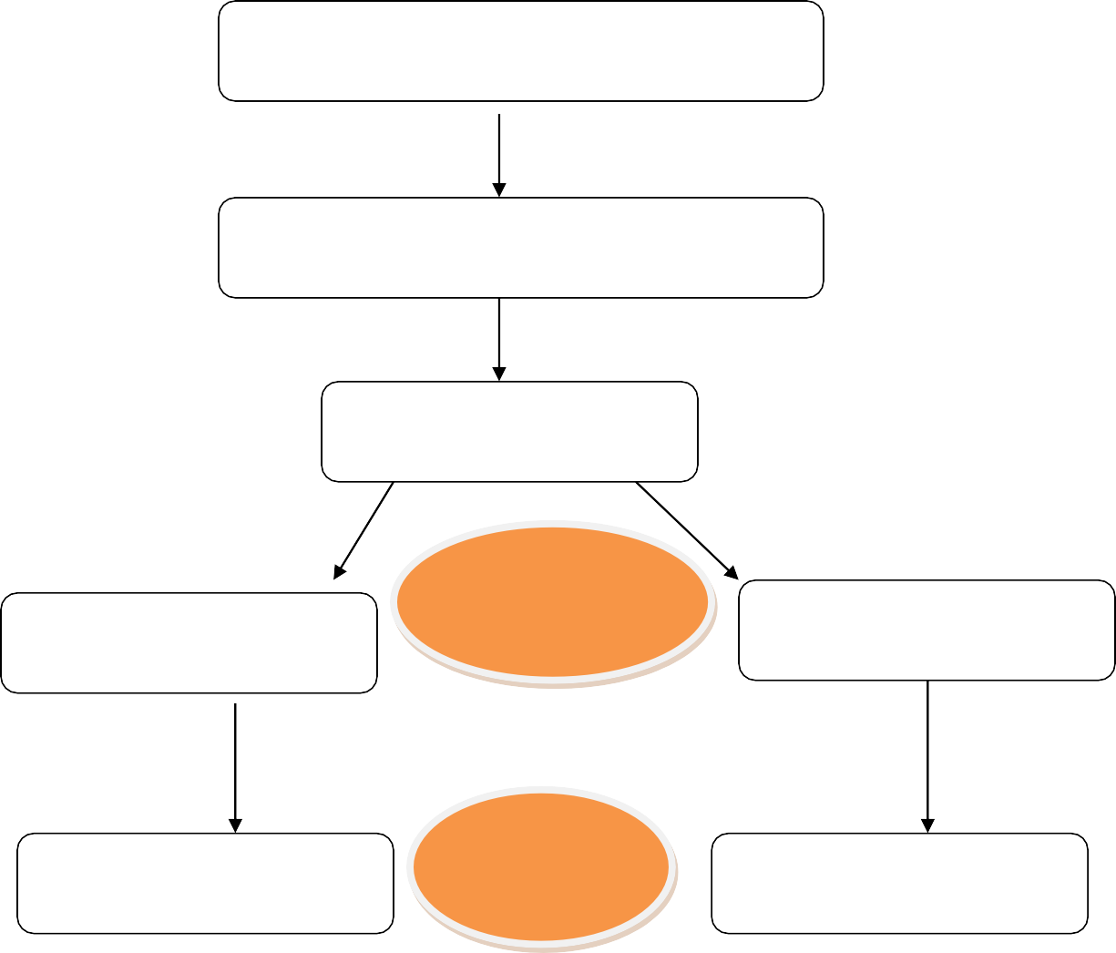
A total 200 patients were included in the study, 100 patients were randomly allocated into each group (Figure 1).
Assessed for eligibility (N=200) scheduled for cataract surgery
Enrollment Excluded = 0
Randomization and allocation
ALLOCATION
Nepafenac 0.1% N=100
Flurbiprofen 0.03% N=100
Analysed n=100
ANALYSIS
Analysed n=100

The demographic characteristics of each group (Table 1). There was no significant difference in age, gender, and laterality of eye operated on among the two groups.

Table 1: Demographic characteristics of patients.

Parameter | Flurbiprofen (n=52) | Nepafenac (n=52)
Age (years)
Mean±SD | 64.92±10.91 | 62.53±8.5
Gender
Male | 45 | 58
Female | 55 | 42
Laterality of eye
Right | 62 | 54
Left | 38 | 46
Table 2 depicts pupillary diameter. Preoperative average pupillary diameter was almost similar in both groups (7.86 mm and 8.23mm in the flurbiprofen and the nepafenac groups, respectively). The difference in pupillary size after surgery was not statistically significant (p = 0.47) (6.09±0.74mm and 6.36±1.0mm in the flurbiprofen and the nepafenac groups, respectively). The total reduction in pupil diameter from the beginning to the end of surgery was also statistically not significantly (p= 0.76) different between the flurbiprofen group (1.77±0.72mm) and the nepafenac group (1.86±0.71mm).

Table 2: Pupillary diameter at different stages of cataract surgery.

Parameter | Flurbiprofen (n=100) | Nepafenac (n=100) | P Value
Before anterior chamber  entry | 7.86±0.78 | 8.23±0.95 | 0.34
After surgery | 6.09±0.74 | 6.36±1.00 | 0.47
Change from baseline | 1.77±0.72 | 1.86±0.71 | 0.76
Percentage of loss | 22.54±4.3 | 22.65±3.27 | 0.48

Figure2: verbal pain intensity scale

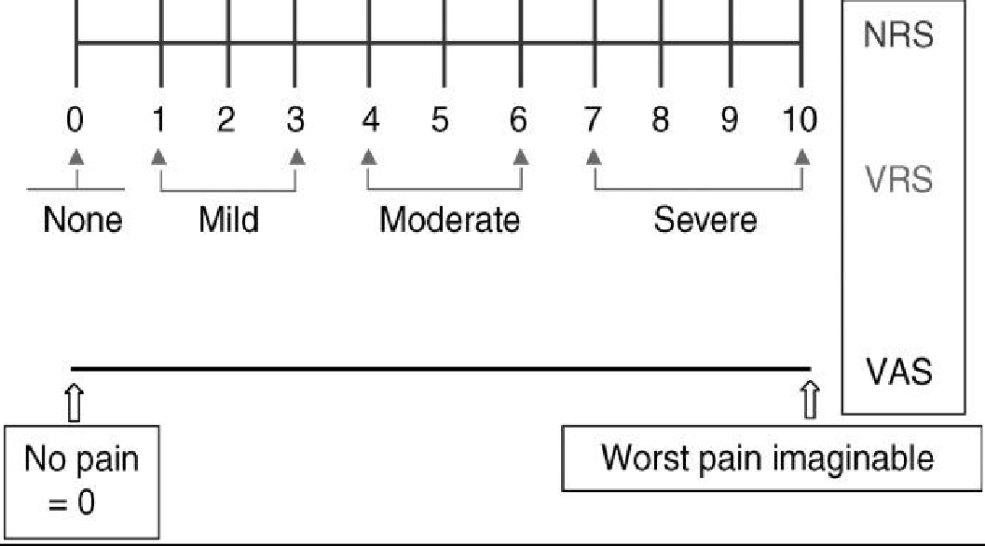

DISCUSSION

Miosis due to surgical trauma is one of the most important obstacles that come in the way of a successful cataract surgery. It leads to difficulty in nucleus delivery and makes the eye more vulnerable to serious intraoperative and postoperative complications.^{[11]}
Topical Non-Steroidal Anti-Inflammatory Drugs (NSAIDs) are important group of drugs which help cataract surgeons to reduce intraoperative miosis, and are beneficial in controlling postoperative pain and inflammation^{.[11]} Several studies compared the effects of topical NSAIDs with placebo in inhibiting miosis during cataract surgery^{.[12-} ^{14]} Many comparative studies showed similar therapeutic efficacy of various ophthalmic NSAIDs with only minor differences in preventing intraoperative miosis.^{[13,15-17]} The timing regarding installation of NSAIDs drops is still a controversial issue, but the common practice is using topical NSAIDs prior to surgery for desired effects^{.[18]}

Interpretation of Findings
The present study demonstrated that topical nepafenac 0.1% was more effective than topical flurbiprofen 0.03% in maintaining intraoperative mydriasis during cataract surgery. Although both drugs were effective in reducing surgically induced miosis, the nepafenac group showed significantly lesser reduction in pupillary diameter at various stages of surgery, particularly toward the end of the procedure.

The superior efficacy of nepafenac may be explained by its unique pharmacological profile. Nepafenac is a prodrug that readily penetrates the cornea due to its neutral structure and is subsequently converted intraocularly into amfenac, a potent cyclooxygenase inhibitor. This allows enhanced tissue penetration, prolonged intraocular activity, and sustained suppression of prostaglandin synthesis. In contrast, flurbiprofen acts directly on the ocular surface and anterior segment, which may limit its intraocular bioavailability during prolonged surgical manipulation.

The findings of the present study are consistent with previous studies by Sarkar et al., Shrivastava et al., Rodríguez-García et al., and Cervantes-Coste et al., all of which demonstrated better maintenance of pupillary diameter with nepafenac compared with other NSAIDs or placebo. Similar observations regarding reduced intraoperative

miosis and improved surgical visualization with nepafenac have also been reported in phacoemulsification and SICS procedures.

Maintenance of adequate mydriasis is essential for safe cataract surgery because intraoperative miosis increases the risk of complications such as posterior capsular rupture, vitreous loss, iris trauma, and prolonged surgical time. Better maintenance of pupillary dilatation in the nepafenac group may therefore contribute to improved surgical ease and reduced intraoperative complications.

The present study also supports the role of topical NSAIDs as valuable adjuncts in cataract surgery. By inhibiting prostaglandin-mediated inflammatory pathways, these agents help maintain stable intraoperative mydriasis while also providing postoperative anti-inflammatory and analgesic benefits. Although flurbiprofen remains an effective and widely used ophthalmic NSAID, nepafenac appears to offer an advantage because of its improved ocular penetration and prolonged duration of action.

Limitations

The present study had certain limitations. First, the study was conducted at a single center with a limited sample size, which may restrict the statistical power and external validity of the findings. Second, pupillary diameter measurements were obtained using Castroviejo calipers rather than computerized imaging systems, which could introduce observer-related measurement variability.

The study primarily included patients undergoing small incision cataract surgery (SICS); therefore, the results may not fully reflect outcomes in phacoemulsification or more complex cataract procedures. Variations in surgical duration, cataract density, surgeon experience, and intraoperative manipulation may also have influenced pupillary dynamics.

Additionally, postoperative inflammatory outcomes, patient comfort, and long-term visual outcomes were not extensively evaluated. The study also did not assess the cost- effectiveness of nepafenac compared with flurbiprofen, which may be relevant in

resource-limited settings. Inclusion of diabetic patients and variations in systemic inflammatory status may have further influenced the degree of intraoperative miosis.

Generalizability

Despite these limitations, the findings of the present study are clinically relevant and may be generalized to routine cataract surgeries, particularly in patients undergoing SICS. The consistency of the present results with multiple national and international studies strengthens the reliability of the findings.

The demonstrated superiority of nepafenac in maintaining intraoperative mydriasis suggests that it may be particularly beneficial in patients at higher risk of intraoperative miosis, such as elderly individuals, diabetics, patients with small pupils, or cases anticipated to involve prolonged surgical manipulation.

However, broader multicentric randomized controlled trials with larger sample sizes and standardized surgical techniques are required before definitive recommendations can be universally applied. Future studies comparing different NSAID regimens, dosing schedules, and combinations with intracameral mydriatics may further clarify the optimal strategy for maintaining mydriasis during cataract surgery.

CONCLUSION

The current study highlights topical nepafenac proved to be more effective than topical flurbiprofen in maintaining intraoperative mydriasis during cataract surgery, while exhibiting comparable safety and analgesic efficacy.
- Both groups were comparable with respect to baseline demographic variables and pre-operative pupil diameter, ensuring that the observed differences were attributable to the pharmacological effects of the study drugs rather than confounding factors.
- A higher proportion of patients in the nepafenac group maintained adequate mydriasis throughout the surgical procedure, which facilitated better surgical visualization and ease of nucleus manipulation.
- Intraoperative complications were minimal and comparable between the two groups, suggesting that both drugs are safe for use in cataract surgery.
- Assessment of patient comfort using the verbal pain intensity scale revealed no statistically significant difference between the two groups, indicating a similar analgesic profile. No serious drug-related adverse effects were observed in either group.
- Hence, nepafenac can be considered a preferable non-steroidal anti- inflammatory agent for routine use in cataract surgeries to achieve better intraoperative pupillary stability

REFERENCES

- Zhao X, Xia S, Wang E, Chen Y. Comparison of the efficacy and patients' tolerability of Nepafenac and Ketorolac in the treatment of ocular inflammation following cataract surgery: A meta-analysis of randomized controlled trials. PLoS One. 2017 Mar 2;12(3):e0173254. doi: 10.1371/journal.pone.0173254. PMID: 28253334; PMCID: PMC5333896.
- Lane SS, Modi SS, Lehmann RP, Holland EJ. Nepafenac ophthalmic suspension 0.1% for the prevention and treatment of ocular inflammation associated with cataract surgery. J Cataract Refract Surg. 2007 Jan;33(1):53-8. doi: 10.1016/j.jcrs.2006.08.043. Erratum in: J Cataract Refract Surg. 2007 Apr;33(4):564. PMID: 17189793.
- Kim SJ, Flach AJ, Jampol LM. Nonsteroidal anti-inflammatory drugs in ophthalmology. SurvOphthalmol. 2010 Mar-Apr;55(2):108-33. doi: 10.1016/j.survophthal.2009.07.005. PMID: 20159228.
- Flach AJ. Nonsteroidal anti-inflammatory drugs in ophthalmology. Int Ophthalmol Clin. 1993 Fall;33(4):1-7. doi: 10.1097/00004397-199303340- 00003. PMID: 8258490.
- Donnenfeld ED, Perry HD, Wittpenn JR, Solomon R, Nattis A, Chou T. Preoperative ketorolac tromethamine 0.4% in phacoemulsification outcomes: pharmacokinetic-response curve. J Cataract Refract Surg. 2006 Sep;32(9):1474-82. doi: 10.1016/j.jcrs.2006.04.009. PMID: 16931258.
- Heier J, Cheetham JK, Degryse R, Dirks MS, Caldwell DR, Silverstone DE, Rosenthal A. Ketorolac tromethamine 0.5% ophthalmic solution in the treatment of moderate to severe ocular inflammation after cataract surgery: a randomized, vehicle-controlled clinical trial. Am J Ophthalmol. 1999 Mar;127(3):253-9. doi: 10.1016/s0002-9394(98)00413-9. PMID: 10088733.
- Roberts CW. Pretreatment with topical diclofenac sodium to decrease postoperative inflammation. Ophthalmology. 1996 Apr;103(4):636-9. doi: 10.1016/s0161-6420(96)30641-6. PMID: 8618764.

- Solomon KD, Cheetham JK, DeGryse R, Brint SF, Rosenthal A. Topical ketorolactromethamine0.5%ophthalmicsolutioninocularinflammationafter cataract surgery. Ophthalmology. 2001 Feb;108(2):331-7. doi: 10.1016/s0161- 6420(00)00543-1. PMID: 11158809.
- Wolf EJ, Braunstein A, Shih C, Braunstein RE. Incidence of visually significant pseudophakic macular edema after uneventful phacoemulsification in patients treated with nepafenac. J Cataract Refract Surg. 2007 Sep;33(9):1546-9. doi: 10.1016/j.jcrs.2007.05.018. PMID: 17720068.
- Mohammad-Rabei H, Sabbaghi H, Emamverdi M, Karimi S, Ramezani A, Nikkhah H, Kheiri B, Yaseri M, Sheibani K, Bahreini R. The effect of topical ketorolac tromethamine on macular thickening after phacoemulsification in diabetic patients. BMC Ophthalmol. 2023 Jul 14;23(1):320. doi: 10.1186/s12886-023-03077-y. PMID: 37452330; PMCID: PMC10347851.
- Akpek EK, Karadayi K. Ketorolac tromethamine 0.5% ophthalmic solution in the treatment of moderateto severeocularinflammation after cataract surgery: a randomized, vehicle-controlled clinical trial. Am J Ophthalmol. 1999 Nov;128(5):662-3. doi: 10.1016/s0002-9394(99)00333-5. PMID: 10577550.
- Flach AJ. Cyclo-oxygenase inhibitors in ophthalmology. SurvOphthalmol. 1992Jan-Feb;36(4):259-84.doi:10.1016/0039-6257(92)90095-b.PMID:
1549810.

- Gamache DA, Graff G, Brady MT, Spellman JM, Yanni JM. Nepafenac, a unique nonsteroidal prodrug with potential utility in the treatment of trauma- induced ocular inflammation: I. Assessment of anti-inflammatory efficacy. Inflammation. 2000 Aug;24(4):357-70. doi: 10.1023/a:1007049015148.PMID: 10850857.
- Walters T, Raizman M, Ernest P, Gayton J, Lehmann R. In vivo pharmacokinetics and in vitro pharmacodynamics of nepafenac, amfenac, ketorolac, and bromfenac. J Cataract Refract Surg. 2007 Sep;33(9):1539-45. doi: 10.1016/j.jcrs.2007.05.015. PMID: 17720067.
- Blaydes JE Jr, Kelley EP, Walt JG, DeGryse RE, Harper DG, Novack GD. Flurbiprofen0.03%forthecontrolofinflammationfollowingcataract

extraction by phacoemulsification. J Cataract Refract Surg. 1993 Jul;19(4):481-7. doi: 10.1016/s0886-3350(13)80611-6. PMID: 8355154.
- el-Harazi SM, Ruiz RS, Feldman RM, Villanueva G, Chuang AZ. A randomized double-masked trial comparing ketorolac tromethamine 0.5%, diclofenac sodium 0.1%, and prednisolone acetate 1% in reducing post- phacoemulsification flare and cells. Ophthalmic Surg Lasers. 1998 Jul;29(7):539-44. PMID: 9674003.
- Yüksel B, Karti Ö, Kusbeci T. Topical nepafenac for prevention of post- cataract surgery macular edema in diabetic patients: patient selection and perspectives. Clin Ophthalmol. 2017 Dec 11;11:2183-2190. doi: 10.2147/OPTH.S132810. PMID: 29269999; PMCID: PMC5730051
- Asano S, Miyake K, Ota I, Sugita G, Kimura W, Sakka Y, Yabe N. Reducing angiographic cystoid macular edema and blood-aqueous barrier disruptionafter small-incision phacoemulsification and foldable intraocular lens implantation: multicenter prospective randomized comparison of topical diclofenac 0.1% and betamethasone 0.1%. J Cataract Refract Surg. 2008 Jan;34(1):57-63. doi: 10.1016/j.jcrs.2007.08.030. PMID: 18165082.
- Donegan RK, Lieberman RL. Discovery of Molecular Therapeutics for Glaucoma: Challenges, Successes, and Promising Directions. J Med Chem. 2016 Feb 11;59(3):788-809. doi: 10.1021/acs.jmedchem.5b00828. Epub 2015 Sep25.PMID:26356532;PMCID: PMC5547565.
- Iftikhar M,Abariga SA, Hawkins BS, Zafar S, MirTA, Jampel H,Woreta FA. Pharmacologic interventions for mydriasis in cataract surgery. Cochrane Database Syst Rev. 2021 May 27;5(5):CD012830. doi: 10.1002/14651858.CD012830.pub2. PMID: 34043237; PMCID: PMC8158329.

