Decolonial Aesthetics in Filipino Cosmetic Brands: Model Representation and Shade Inclusivity
Abdul Rafi Buat
Mohammad Hizam Tabao
Mindanao State University, Main Campus - Marawi
buat.ap267@s.msumain.edu.ph
tabao.mb015@s.msumain.edu.ph

Abstract. The Philippine beauty industry is shaped by a colonial history that has valued Eurocentric and foreign ideals such as fair skin and Western features. This has standed as a critical point in redefining beauty standards through local Filipino cosmetic brands. This research analyzed how four Filipino beauty brands namely BLK Cosmetics, ISSY, Sunnies Face, and Strokes address Eurocentric beauty representations in their foundation products with a focus on model representation and shade inclusivity. Using a descriptive qualitative design, the analysis utilized visual materials from the brands’ official Shopee storefronts to evaluate the use of foreign versus local models, the availability of dark shades, and the adoption of decolonial aesthetics. The results have indicated that BLK Cosmetics employed local models across all shade categories to reflect Filipino identities whereas ISSY and Sunnies Face provide extensive dark shades yet incorporate foreign models for lighter shades which suggests a hybrid approach. Strokes demonstrated limited inclusivity with fewer dark shades and minimal local representation. The results revealed a tension between colonial legacies and efforts to embrace indigenous beauty. The analysis calls for the need for brands to adopt decolonial aesthetics by prioritizing diverse Filipino skin tones and features offering implications for brand owners to align products with consumer demands for inclusivity and for researchers to explore postcolonial influences in beauty standards further.
Keywords: Beauty Representation, Eurocentric beauty, Inclusivity, Colonial influence.
Introduction
The global beauty industry has long been a site of cultural contestation where standards of beauty are shaped, reinforced, and challenged. In the Philippines, a country with a history of Spanish and American colonization, eurocentric beauty ideals have deeply influenced societal perceptions of attractiveness. These ideals are characterized by fair skin, Western facial features, and light-colored eyes which have been perpetuated through media, advertising, and cosmetic products, often marginalizing indigenous Filipino features and darker skin tones. The cosmetic industry, particularly through its marketing strategies and product offerings, plays a big role in either reinforcing or subverting these Eurocentric standards.
The preference for fair skin in the Philippines reflects a colonial legacy that equates lightness with status. As Rondilla and Spickard (2007) noted, skin tone remains a powerful marker of social value in Asian American communities, with lighter skin often perceived as more desirable (Rondilla and Spickard, 2007). This mindset extends to the Philippine cosmetic market, where skin-lightening products dominate, driven by consumer demand for Eurocentric looks (Euromonitor International, 2020). Advertising plays a key role in this dynamic with many brands featuring foreign or mixed-race models to project a “global” image. Li et al. (2008) have observed that Caucasian models are frequently used in Asian beauty advertisements to symbolize modernity and prestige, a practice that can alienate local consumers and reinforce colonial hierarchies.
Local Philippine beauty brands such as BLK Cosmetics, ISSY, Sunnies Face, and Strokes, have emerged as influential players in the beauty market, catering to Filipino consumers with products like foundations that promise inclusivity. There is a growing push for inclusivity in the Philippines, especially among younger consumers who value products that reflect their natural skin tones. Filipino consumers are increasingly seeking brands that offer diverse shade ranges and celebrate local beauty (Euromonitor International, 2023). Local brands have the chance to lead this shift by featuring Filipino models and offering foundations that suit the country’s diverse complexions. Still, the persistence of foreign models in ads suggests some brands may prioritize Western appeal over local pride. The extent to which these brands challenge or perpetuate Eurocentric beauty standards remains underexplored. Such as the choice of models in advertising campaigns whether foreign or local, can show a brand’s alignment with either colonial or decolonial aesthetics. Decolonial aesthetics advocate for rejecting Euro-American cultural dominance and embracing indigenous beauty ideals that reflect local identities (Mignolo and Quijano, 2000). In contrast, the use of foreign models with Eurocentric features may reinforce colonial hierarchies of beauty, thus perpetuating colorism and self-rejection among Filipino consumers. This study seeks to investigate how selected Philippine beauty brands navigate these dilemmas in their foundation products, focusing on model representation, shade ranges, and how they subvert to decolonial aethetics.
1.1 Research Questions
This study aims to analyze how selected Philippine beauty brands represent beauty in their foundation products and whether they challenge Eurocentric standards. Specifically, it seeks to:
- How do these local beauty brands use foreign models and local models in their products?
- How many dark shades are being advertised by the local cosmetics brands?
- How do these local beauty brands employ decolonial aesthetics to subvert Eurocentric shade ranges and model representation?
1.2 Theoretical Framework
1.2.1 Hybridity by Homi Bhabha (1994).
This theory explains how colonized societies create hybrid identities by blending indigenous and colonial influences in their society. According to Bhabha (1994), hybridity refers to the dynamic process through which new cultural identities emerge from the interaction between the colonizer and the colonized. It arises when colonial power attempts to impose a singular cultural identity onto the colonized but fails, producing something that is both familiar and new. This hybrid space resists fixed, essentialist definitions of identity and culture, and instead emphasizes fluidity, transformation, and in-betweenness. In this study, this theory was used to determine the utilization of foreign models and local models simultaneously.
1.2.2 Theory of Colonial Psychological Oppression by Frantz Fanon (1962).
Fanon (1962) defines colonial psychological oppression as a form of internalized oppression wherein the oppressed come to believe the ideologies of the oppressor about themselves and their cultural group. Through systematic denigration of the colonized group’s culture, language, and identity, colonizers establish the superiority of their own culture and implant feelings of inferiority and shame in the colonized, ultimately resulting in the colonized internalizing these negative views.
1.2.3 Decolonial Aesthetics by Mignolo and Quijano (2000).
This theory believes in rejecting Eurocentric standards and embracing indigenous beauty ideals. The text defines decolonial aesthetics as not merely a new artistic genre, but a process of confronting and unlearning the imposed Euro-American cultural values and aesthetic standards. It is rooted in decoloniality to counter the dominance of Western modernity and its associated values. In this study, the researchers analyzed how local beauty brands in the Philippines shift away from the Eurocentric influences in beauty standards on the brands’ products.
1.3 Significance of the Study
The study could be beneficial to the brand owners, consumers, and researchers:
Brand Owners. The findings of the study can help brand owners to produce a product that the majority of the consumers need. It will let the brand owners to be more cognizant of the choices of shades that will be manufactured and depart from the eurocentric standards of makeup.
Consumers. The findings of the study can assist the consumers on giving insight of color inclusivity a brand can provide to the market. Consumers will be aware of rejecting eurocentric narratives in beauty standards that local brands should include darker shades to complement the complexion of Filipinos.
Researchers. The findings of the study will be useful to the researchers that are interested in the field of postcolonialism. This study can also be utilized by future researchers in expanding the study on postcolonial influences in beauty standards in the Philippines.
1.4 Scope and Limitation
The study primarily focused on the foundation product lines of selected local cosmetic brands in the Philippines, specifically BLK Cosmetics, ISSY, Sunnies Face, and Strokes. These brands were chosen due to their strong presence in the Philippine beauty industry and their popularity among a diverse range of consumers. The selection of Shopee as the data source ensured the accessibility and consistency of marketing materials across all brands.
The analysis centered on the visual representation of models featured in the foundation product posters. Special attention was given to the models’ physical facial features, including but not limited to skin tone, facial structure, nose shape, lip size, and eye shape. These features were examined to identify patterns of representation and to assess whether the brands employed a range of diverse or homogenized beauty standards in their marketing. This analysis aimed to understand the extent to which the selected brands reflect or challenge colonial beauty norms through their visual aesthetics.
1.5 Review of Related Literature
1.5.1 Local Studies
Ladia (2022), there is a xenocentric mindset towards consumerism in the Philippines. Filipinos have a fad for international brands seeing them as superior to their local counterparts. Consequently, local businesses are seen as second-class while foreign brands are often exotified. This bias can be again linked back to the people’s colonial background as well as the lack of nationalism and favouring the “other”. The colonial and white saviour mentality created the need to assimilate and feel a part of the elite upper-class of society. Other brands apart from GRWM cosmetics have also started to include more representation by adding more shades to their skin products as well as utilising their choice and casting of models. There is a reformation in the Filipino industry as companies are now choosing people who are diverse in skin tones. This diverse representation extended to promotional posts as well as their product packaging. The inclusivity extended not only by including women of different sizes but also representing men, hijabis and those with skin conditions like Vitiligo, etc. Ten years ago these faces would not have been shown in the industry. The path to normalising looks that are outside the eurocentric standards is underway. The narrative of what is considered beauty is taking a step in the right direction.
Furthermore, Catu et al., (2023) stated that many Filipinos possess naturally dark hair, warm brown eyes, and sun-kissed complexions, often referred to as kayumanggi, which reflect the country’s rich indigenous heritage. However, historical colonization and contemporary media influences have contributed to the internalization of a beauty standard that equates whiteness with power, affluence, and physical attractiveness. As a result, white, blemish-free skin has become an idealized trait within Filipino society, commonly perceived as the standard of beauty. In contrast, brown skin is often viewed as less desirable, perpetuating a hierarchy of skin tones that dates back to the colonial era, when native Filipinos were deemed inferior to their lighter-skinned colonizers.
The legacy of Western colonization remains deeply embedded in the Filipino cultural identity, particularly in the preference for lighter skin tones over the natural kayumanggi complexion. This internalized preference reflects a broader rejection of indigenous racial identity, fostering a sense of cultural dissonance. Furthermore, this hierarchical portrayal of skin tone not only idealizes whiteness but also marginalizes non-white and lower-class Filipino women, reinforcing the notion that lighter skin is synonymous with beauty, intelligence, social power, and economic status. In the postcolonial era, mass media continues to be a powerful force in perpetuating colorism. Television personalities, celebrities, and influencers frequently reinforce the glorification of light-skinned individuals, both male and female, thereby solidifying colorist ideals within the broader social consciousness. This ongoing portrayal underscores the need for a critical re-evaluation of beauty standards in the Philippines and a more inclusive representation of Filipino identities across all skin tones.
In the study entitled, "Buying Beauty: The Influence of Colonial Mentality on Filipino Women’s Cosmetic Purchases" by Mendoza (2019), the impact of colonial mentality on beauty product preferences is examined through the lens of Fanon’s (1962) colonial psychological oppression and social identity theory. Mendoza conducted a qualitative study, interviewing 25 Filipino women aged 20–35 and analyzing advertisements from three local cosmetic brands on social media platforms from 2017 to 2018. The findings showed that 80% of participants preferred products associated with Western beauty ideals, such as skin-lightening creams, influenced by advertisements featuring light-skinned models. The study showed how colonial mentality fosters a preference for Eurocentric features, marginalizing indigenous Filipino appearances. Mendoza’s work is relevant to the current study by underscoring the psychological impact of Eurocentric advertising which is similar to the investigation into model representation and shade inclusivity in brands like ISSY, and reinforces the relevance of Fanon’s framework.
Another study has also been conducted focusing on the FIlipino Beauty Industry. The study by David (2020) entitled, "Skin Deep: Colorism and the Filipino Beauty Industry" by David (2020), explored the colorism in the Philippine cosmetic market using postcolonial theory and Homi Bhabha’s (1994) concept of hybridity. David employed a mixed-methods design, combining a survey of 200 Filipino consumers with a content analysis of 50 cosmetic advertisements from 2018 to 2019, focusing on skin-lightening products. The results indicated that 70% of advertisements featured light-skinned or mixed-race models, perpetuating Eurocentric ideals, though some brands began incorporating Filipino cultural elements, reflecting hybrid identities. The survey revealed that 60% of respondents felt pressure to conform to lighter skin ideals. This study aligns with the current research’s exploration of hybridity in model representation and the persistence of Eurocentric standards in brands like Strokes, providing a foundation for analyzing how local brands navigate colonial and decolonial aesthetics.
1.5.2 Foreign Studies
The study by Li et al. (2008) entitled, "Skin Lightening and Beauty in Four Asian Cultures" (2008), investigated the pervasive promotion of light skin across Asian beauty markets, framing it within postcolonial theory and social comparison theory. Through a qualitative content analysis of 200 beauty advertisements from China, Japan, South Korea, and India, collected between 2005 and 2007, the researchers focused on model characteristics and product messaging. Their findings revealed that 80% of advertisements featured light-skinned or Caucasian models, positioning skin-lightening products as symbols of modernity and reinforcing Eurocentric beauty standards while marginalizing darker skin tones. This study directly connects to the current research’s examination of foreign model use in Philippine cosmetic brands like Sunnies Face, with its postcolonial lens complementing the current study’s use of Fanon’s (1962) and Mignolo’s (2000) theories to explore how colonial beauty hierarchies are perpetuated globally, including in the Philippine context.
Building on the theme of colonial beauty standards, the study entitled "Is Lighter Better? Skin-Tone Discrimination Among Asian Americans" by Rondilla and Spickard (2007), focused on the psychological and social impacts of these standards within the Asian American community. Employing Fanon’s (1962) colonial psychological oppression theory and critical race theory, the authors used a mixed-methods approach, conducting interviews with 50 Asian American women and analyzing beauty product advertisements in the U.S. from 2000 to 2005. The results showed that 70% of advertisements featured light-skinned models, and interviewees reported feelings of inferiority due to darker skin, highlighting internalized oppression perpetuated by the cosmetic industry’s colorism. This study extends Li et al. 's findings by emphasizing the personal toll of Eurocentric ideals, aligning closely with the current study’s use of Fanon’s theory to investigate the psychological impact of Eurocentric model representation on Filipino consumers, particularly in brands like BLK Cosmetics. Rondilla and Spickard’s focus on internalized oppression provides a bridge to understanding how similar dynamics may influence Filipino consumer perceptions in the context of local beauty advertising.
Expanding the scope to a global perspective, the study entitled "Yearning for Lightness: Transnational Circuits in the Marketing and Consumption of Skin Lighteners" by Glenn (2008), explored how colonial histories shape beauty ideals across diverse regions. Using postcolonial feminism and globalization theory, Glenn conducted a comparative ethnographic study across Africa, Asia, and the Americas, interviewing 100 consumers and analyzing skin-lightening product marketing from 2000 to 2007. The findings indicated that 85% of advertisements featured light-skinned models, reflecting colonial legacies that equate whiteness with prestige and driving consumer preferences worldwide. Glenn’s work complements Rondilla and Spickard’s focus on psychological oppression by situating it within a broader transnational framework, illustrating how global marketing reinforces Eurocentric standards. This global lens directly supports the current study’s examination of foreign model use in Philippine cosmetics, with Glenn’s postcolonial feminist approach enhancing the current study’s decolonial aesthetics framework (Mignolo & Quijano, 2000) to challenge colonial beauty norms in brands like ISSY and Strokes. Together, these studies show the pervasive influence of colonial beauty ideals across different contexts and showing the need for Philippine brands to adopt inclusive practices to counter these global trends.
Methodology
2.1 Research Design
This study used a descriptive qualitative research design. This approach was used for the analyzation of the selected local cosmetic brands’ posters of their foundation product in terms of models used and availability of their shades and its employment of decolonial aesthetics in their brand. This study follows the design used by This study follows the design used by Tate (2009), who employed a descriptive qualitative approach to analyze aesthetic representations of Black women in media and popular culture. Her work critically examined how beauty standards reflect and reinforce racialized hierarchies, making it an appropriate methodological foundation for analyzing the models, shade ranges, and aesthetic choices in local cosmetic brand posters from a decolonial perspective.
2.2 Source of data
The data collection process involved obtaining visual materials specifically featuring foundation or base products and second base, from selected local beauty brands. These images were sourced directly from the official online storefronts of the respective brands, as presented on the Shopee application. The use of official sources ensured the accuracy and authenticity of the promotional content analyzed in the study.
2.3 Data Gathering Procedure
Phase 1
In this phase, the researchers distinguished the patterns in skin tone, facial features, and eye color of each model in the posters, The researchers assessed the process of each brand and the arrangement of the visibility and desirability of foreign and local appearances in their advertising strategies for their foundation product.
Phase 2
In this phase, the researchers conducted a visual analysis of the foundation posters that were produced by each selected local cosmetic brand here in the Philippines. The focus will be on identifying and categorizing the types of models that were featured in each poster, specifically distinguishing between foreign and native models. In this phase, it aims to examine how these brands represent beauty through their model choices, and whether these representations reflect, reinforce, or challenge colonial beauty standards.
Phase 3
In this phase, the researchers examined the visual elements of these posters produced by local beauty brands to identify the presence of decolonial aesthetics. The analysis focused on three key aspects: the inclusivity and diversity of foundation shade offerings, the representation of local or native models, and the overall visual strategies that reflect or challenge Eurocentric ideals. Particular attention is paid to how these elements contribute to the change of beauty standards by centering Filipino identities and skin tones.
2.4 Ethical Considerations
This study acknowledged the privacy of the models that are shown in the analysis of the study without mentioning any personal information. The evaluation focuses solely on visual elements relevant to the research questions such as skin tone facial features and shade categories. The researchers did not comment on any statements that could harm or ruin the reputation of the brand and the models that would not coincide with the analysis of the study.
To uphold ethical integrity, the researchers ensure that the data collection process using publicly available materials from the brands’ official Shopee storefronts complies with fair use principles. The visual materials are analyzed in their original context without alteration to preserve authenticity and avoid misrepresentation. The study acknowledges the cultural sensitivity of examining beauty standards in a postcolonial context taking care to approach the topic with respect for Filipino identities and the historical implications of colonial influences. Transparency is maintained by clearly documenting the methodology and data sources allowing for accountability in the research process. These ethical measures collectively ensure that the analysis contributes to academic discourse on beauty standards in the Philippines without causing harm to individuals or brands involved.
Results and Discussion
- How do these local beauty brands use foreign models and local models in their products?
The results indicate the representation strategies employed by selected cosmetic brands in featuring foreign and local models across defined shade categories. Product shades were classified into three groups: light/fair, medium, and deep/tan. Table 1.1 presents the frequency of foreign model appearances in promotional materials produced by each local cosmetic brand.
Table 1.1 Foreign Models used in Local Cosmetic Brands.
Local Cosmetic Brands | Dark/Deep Shade | Medium Shade | Fair/Light Shade
BLK Cosmetics | N/A | N/A | N/A
ISSY | 3 | 4 | 6
Sunnies Face | 4 | 1 | 3
Strokes | 1 | N/A | 3
The table above illustrates the varying strategies employed by local cosmetic brands in representing local and foreign models within their foundation product advertisements. BLK, which features no foreign models in its promotional content, highlights a reliance on local models to convey diversity in beauty standards and skin tone representation. In contrast, ISSY includes a total of fourteen (14) foreign models out of twenty-seven (27) individuals featured, with a notable concentration of foreign models appearing in the lighter foundation shades. Only three (3) foreign models are depicted using the brand’s darkest available shade, excluding the “tan deep warm” variant.
The incorporation of foreign models in these advertisements reflects an influence from Western cosmetic branding practices, where shade ranges have expanded to promote inclusivity across diverse skin tones. This approach not only aligns with global beauty standards but also signals an effort by local brands to appeal to a broader, more international consumer base.
Sunnies Face features an equal distribution of foreign and local models, with foreign models predominantly represented in both the lighter and darker shade categories. This practice suggests a preference for utilizing foreign models to depict a broader range of skin tones, rather than employing local models with comparable complexions. This trend, observed across the selected brands except for BLK, demonstrates a consistent pattern of combining local and foreign representations. Such an approach serves a dual purpose: acknowledging local beauty standards while simultaneously appealing to a global audience. Below are selected examples of foreign models featured by each local cosmetic brand in their promotional materials.
Figure 1.1 Foreign Model for ISSY Shade Fair Olive and Fair Light Olive.
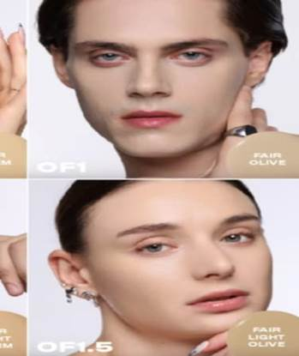
Figure 1.2 Foreign Models for ISSY Shades Fair Neutral, and Light Fair Neutral
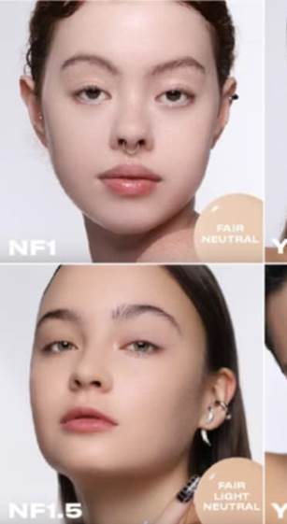
Figure 1.3 Foreign Models for Sunnies Face Shades, Santal, Fawn, Palisander, and Carob.
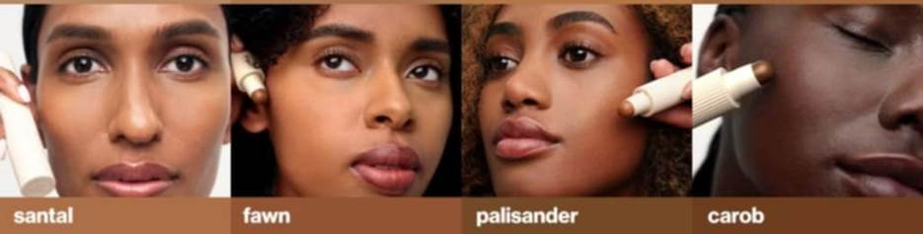

Table 1.2 Local Models used in Local Cosmetic Brands.
Local Cosmetic Brands | Dark/Deep Shade | Medium Shade | Fair/Light Shade
BLK Cosmetics | 2 | 2 | 2
ISSY | 6 | 5 | 3
Sunnies Face | N/A | 6 | 1
Strokes | 2 | 3 | N/A
As shown in the table above, Filipino models are predominantly featured in the medium shade category of foundation products across the selected local cosmetic brands. This aligns with the general association of Filipino skin tones with various shades of tan. Notably, Strokes did not include any local models in the fair shade category, highlighting a gap in local representation within that segment.
According to Ladia (2022), the preference for light skin in the beauty industry has contributed to the misrepresentation of the Filipino population. The frequent use of light-skinned models and celebrities has led to a lack of visibility for individuals with darker complexions. This overrepresentation of lighter skin tones not only creates an unrealistic beauty standard but also marginalizes the appearance of the majority of Filipinos.
The study also reveals a limited product range across local brands, further contributing to the issue of inclusivity. In the findings discussed here, many Filipino models were represented in medium to dark foundation shades. An exception is BLK Cosmetics, which featured Filipino models in its lighter shade offerings. This strategy represents both fair-skinned Filipinos, often referred to as “Mestizas” and those with medium to dark complexions, offering a broader and more inclusive depiction of local beauty without resorting to foreign model representation. The following images present examples of Filipino models featured by each local cosmetic brand.
Figure 1.4 Local Model for BLK Cosmetics Shade Toast.
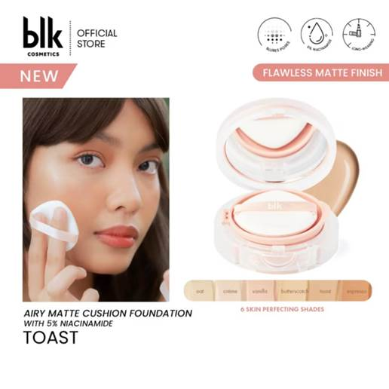
Figure 1.5 Local Models for ISSY shade, Tan Deep Neutral, and Deep Neutral.
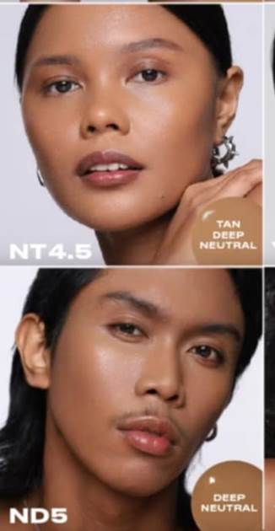
Figure 1.6 Local Model For Strokes shade Medium 3.
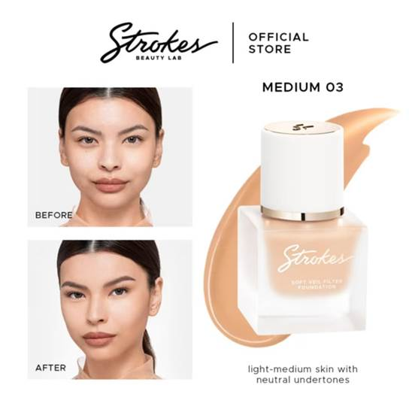
- How many dark shades are being advertised by the local cosmetics brands?
The study examined the number of dark foundation shades promoted by the selected cosmetic brands on their official websites. While all analyzed brands included at least one dark shade in their product range, the availability and variety of these shades differed across brands. Table 2 provides a summary of the dark shades advertised by each brand.
Table 2.1 Dark Shades in Local Cosmetic Brands.
Local Cosmetic Brands | Dark Shades | Light Shades | TOTAL
BLK Cosmetics | 3 | 3 | 6
ISSY | 9 | 18 | 27
Sunnies Face | 8 | 8 | 16
Strokes | 3 | 6 | 9
The table above outlines the number of dark foundation shades available from each local cosmetic brand. Among the brands analyzed, ISSY offers the highest number of dark shades, with a total of nine (9), followed closely by Sunnies Face, which offers eight (8) dark shades. This notable availability suggests that local cosmetic brands are increasingly open to developing products that cater to individuals with darker skin tones, a demographic that constitutes a significant portion of the Filipino population.
As noted by Ladia (2024), countries such as the Philippines which have historically adhered to Western beauty standards that are beginning to witness shifts in visual signifiers within the beauty industry. When brand campaigns successfully promote more inclusive standards, they often serve as models for other companies, fostering a more positive and progressive industry environment. Furthermore, this shift can lead to increased consumer demand for brands to uphold more ethical and inclusive practices.
- How do these local beauty brands employ decolonial aesthetics to subvert Eurocentric shade ranges and model representation?
The analysis of the selected Philippine cosmetic brands reveals varying degrees of engagement with decolonial aesthetics, as defined by Mignolo and Quijano (2000), in their efforts to subvert Eurocentric shade ranges and model representation. Decolonial aesthetics involves rejecting imposed Euro-American cultural values and embracing indigenous beauty ideals that reflect local identities. Based on the analysis of foundation product advertisements sourced from the brands’ official Shopee storefronts, it demonstrates that while some brands make significant strides toward inclusivity and local representation, others continue to reflect colonial influences, particularly in their use of foreign models and limited dark shade offerings.
Table 2.1 illustrates the shade ranges offered by the selected brands, with ISSY providing the highest number of dark shades (9 out of 27 total shades), followed by Sunnies Face (8 out of 16), BLK Cosmetics (3 out of 6), and Strokes (3 out of 9). The substantial number of dark shades from ISSY and Sunnies Face indicates a deliberate effort to cater to the diverse skin tones of Filipinos, particularly those with kayumanggi (sun-kissed) complexions, which are emblematic of the country’s indigenous heritage. This aligns with decolonial aesthetics by prioritizing shade inclusivity that reflects the natural diversity of Filipino skin tones, challenging the Eurocentric emphasis on fair skin noted by Li et al. (2008), who found that 80% of Asian beauty advertisements promoted light skin as a symbol of modernity. ISSY’s extensive dark shade range, for instance, responds to the growing consumer demand for products that celebrate local beauty, as highlighted by Euromonitor International (2023), which notes younger Filipinos’ preference for brands reflecting their natural complexions.
In terms of model representation, Tables 1.1 and 1.2 reveal a mixed approach. BLK Cosmetics stands out by exclusively using local models across all shade categories (2 in dark, 2 in medium, and 2 in light), as seen in examples like Figure 1.4 (local model for BLK Cosmetics Shade Toast). This strategy embodies decolonial aesthetics by centering Filipino identities and rejecting foreign models with Eurocentric features, which often perpetuate colonial hierarchies (Mignolo & Quijano, 2000). By featuring local models, including those with medium to dark complexions, BLK Cosmetics counters the marginalization of indigenous appearances noted by Mendoza (2019), who found that 80% of Filipino women preferred products tied to Western ideals due to advertisements featuring light-skinned models. BLK’s approach also addresses Ladia’s (2022) observation that the overrepresentation of light-skinned models misrepresents the Filipino population, offering a more inclusive depiction of beauty that includes mestiza and morena complexions.
Conversely, ISSY and Sunnies Face incorporate a significant number of foreign models, particularly for lighter shades. ISSY features 14 foreign models out of 27 total models, with 6 in fair/light shades while Sunnies Face uses 8 foreign models across shades, with 3 in fair/light categories. This reliance on foreign models with Eurocentric features, partially undermines decolonial aesthetics by reinforcing colonial beauty hierarchies that equate lightness with prestige, as described by Glenn (2008), whose study found that 85% of global skin-lightening advertisements featured light-skinned models. However, both brands balance this by including local models in medium and dark shade categories, suggesting a hybrid approach, as per Bhabha’s (1994) theory. David (2020) similarly noted hybrid identities in Philippine cosmetic advertisements, where brands incorporate Filipino cultural elements alongside Eurocentric models, showing a negotiation between local pride and global appeal. ISSY’s and Sunnies Face’s inclusion of local models in darker shades indicates a step toward decolonial aesthetics, but their use of foreign models for lighter shades suggests a lingering alignment with colonial standards.
Strokes presents a more limited engagement with decolonial aesthetics, with only 3 dark shades and a reliance on foreign models for fair/light shades and no local models in this category. The use of local models for medium and dark shades shows some effort to represent Filipino skin tones, but the limited dark shade range and absence of local models in lighter shades restrict its decolonial impact. This is similar with Rondilla and Spickard’s (2007) findings that 70% of beauty advertisements in the U.S. featured light-skinned models, perpetuating colorism and internalized oppression among darker-skinned individuals. Strokes’ approach suggests a partial adherence to Eurocentric standards, which may alienate consumers seeking authentic Filipino representation.
Overall, the selected brands demonstrate varying commitments to decolonial aesthetics. BLK Cosmetics leads by exclusively using local models and offering a balanced shade range, effectively challenging Eurocentric standards and centering Filipino identities. ISSY and Sunnies Face show progress through their extensive dark shade offerings and inclusion of local models in medium to dark categories, but their use of foreign models for lighter shades reflects a hybrid identity that partially upholds colonial aesthetics. Strokes is behind with limited dark shades and minimal local representation in fair shades, indicating a stronger alignment with Eurocentric norms. These findings align with Ladia’s (2022) observation of a reformation in the Filipino beauty industry toward inclusivity, driven by brands that promote diverse skin tones and challenge colonial legacies. However, the persistence of foreign models, as seen in ISSY, Sunnies Face, and Strokes, underscores the need for further decolonial efforts to fully subvert Eurocentric beauty standards, as advocated by Mignolo and Quijano (2000), ensuring that Filipino beauty is celebrated in its full diversity.
Conclusion
The analysis reveals varied approaches to addressing colonial influences and adopting decolonial aesthetics. BLK Cosmetics demonstrates a strong commitment to representing Filipino identity by exclusively using local models across all shade categories, with an equal distribution of three dark and three light shades, effectively reflecting the diverse skin tones of the population, including kayumanggi complexions. ISSY and Sunnies Face offer nine and eight dark shades, respectively, indicating responsiveness to diverse Filipino skin tones, yet their use of foreign models for lighter shades suggests a partial adherence to Eurocentric standards, blending local and global appeal. Strokes, with only three dark shades and no local models in the fair shade category, show limited progress in challenging colonial beauty norms, prioritizing lighter shades that align with Western ideals. These findings show a tension between colonial legacies and efforts to promote inclusivity. Thus, showcasing the need for greater representation of indigenous Filipino features in advertising to fully embrace local identities.
The findings have significant implications for brand owners, consumers, and researchers aiming to redefine beauty standards in the Philippines, but the analysis is constrained by certain limitations. Focusing solely on foundation products from four brands, sourced from their Shopee storefronts, limits the scope to a specific product category and distribution platform, and potentially overlooking broader trends in the cosmetic industry. Additionally, the reliance on visual analysis of advertisements restricts insights into consumer perceptions and experiences. To address these limitations, future research should expand to include other cosmetic products, such as lipsticks or concealers, and incorporate consumer perspectives through surveys or interviews to evaluate the impact of marketing strategies. Examining the role of social media campaigns and influencer marketing could further clarify how brands balance local and global beauty expectations. Brands can foster cultural acceptance of indigenous identities if we prioritize local models and developing shade ranges that encompass the full diversity of Filipino complexions. The Philippine beauty industry has the opportunity to establish a more inclusive standard of beauty, moving away from colonial influences to ensure that all Filipino skin tones and features are represented and valued.
References
Bhabha, H. K. (1994). The location of culture. Routledge. https://shorturl.at/yG8S5.
David, E. J. R. (2020). Skin deep: Colorism and the Filipino beauty industry. The Asia Pacific Journal of Anthropology, 21(4), 326–343. https://doi.org/10.1080/14442213.2020.1783952.
Euromonitor International. (2020). Beauty and personal care in the Philippines. Euromonitor International. https://shorturl.at/oTDMz.
Euromonitor International. (2023). Beauty and personal care in the Philippines. Euromonitor International. https://shorturl.at/LDn4G.
Fanon, F. (1962). Black skin, white masks. Grove Press. https://shorturl.at/sLrQP.
Glenn, E. N. (2008). Yearning for lightness: Transnational circuits in the marketing and consumption of skin lighteners. Gender & Society, 22(3), 281–302. https://doi.org/10.1177/0891243208316089.
Ladia M. (2022) Globalising Beauty Impacts of the Cosmetics Industry on Filipino Female Ideals. [Undergraduate Thesis, Institute of Art, Design and Technology, Dun Laoghaire].
Li, E. P. H., Min, H. J., Belk, R. W., Kimura, J., & Bahl, S. (2008). Skin lightening and beauty in four Asian cultures. Advances in Consumer Research, 35, 444–449. https://shorturl.at/Nvgss.
Mendoza, R. A. (2019). Buying beauty: The influence of colonial mentality on Filipino women’s cosmetic purchases. Philippine Journal of Psychology, 52(1), 87–110.
Mignolo, W., & Quijano, A. (2000). The geopolitics of knowledge and the colonial difference. South Atlantic Quarterly, 99(1), 57–96. https://doi.org/10.1215/00382876-99-1-057
Rondilla, J. L., & Spickard, P. (2007). Is lighter better? Skin-tone discrimination among Asian Americans. Rowman & Littlefield Publishers.

APPENDIX A: BLK Cosmetics Cushion Foundation Posters
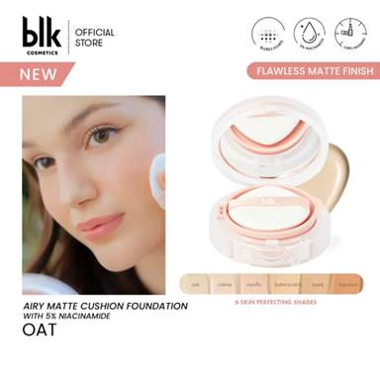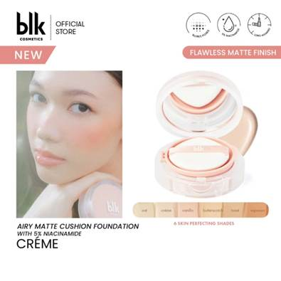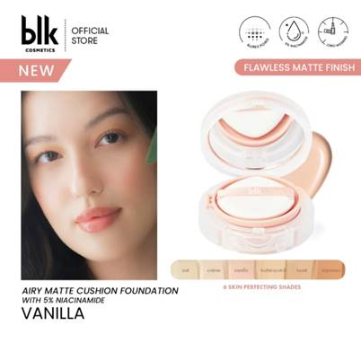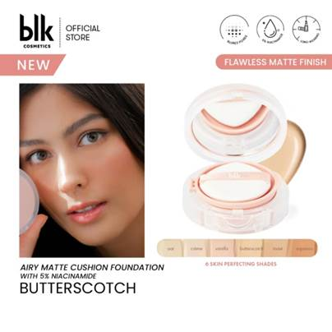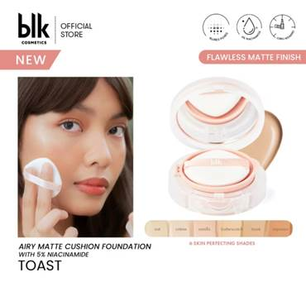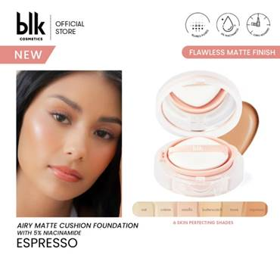

APPENDIX B: ISSY Active Foundation Posters
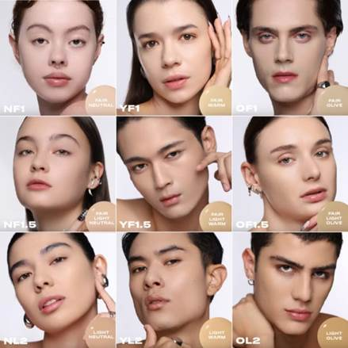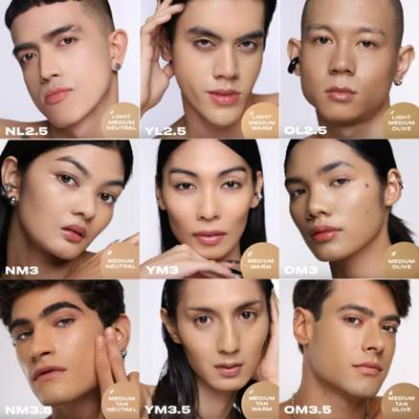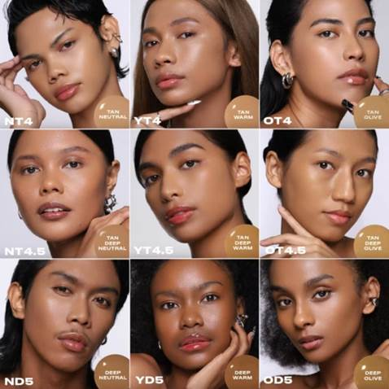

APPENDIX C: SUNNIES FACE Multistick Posters
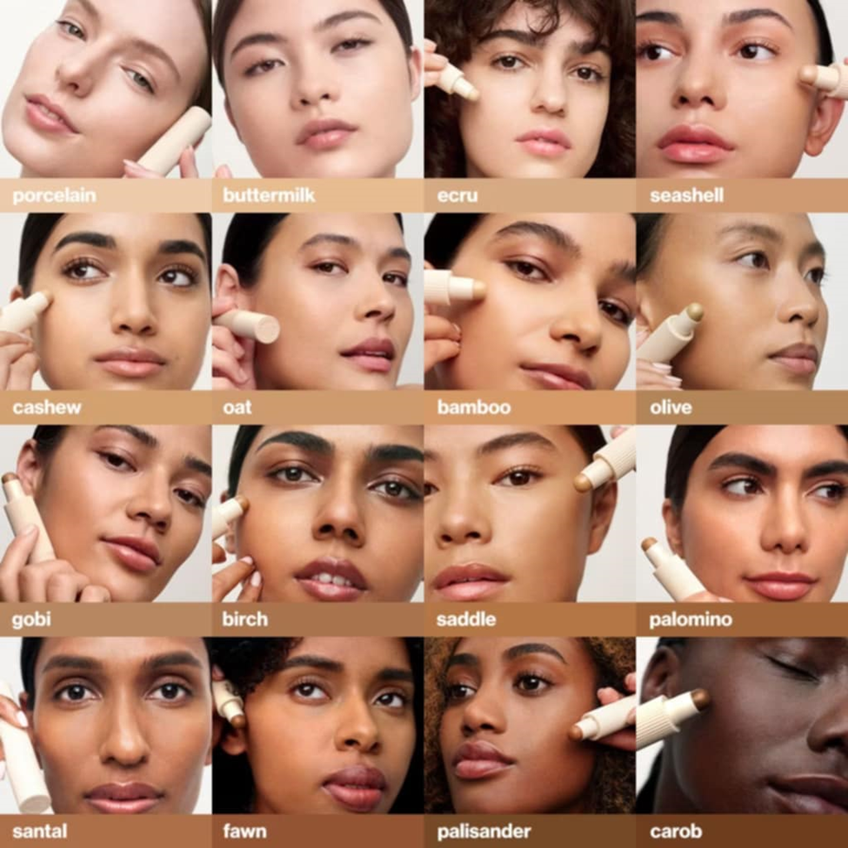

APPENDIX D: Strokes Soft Veil Filter Foundation Posters
