Governing the Pandemic: Biopolitics, Governmentality, and Calculative Technologies in Malaysia

ABSTRACT
Covid-19 is a very delicate pandemic that intertwined material, economic, social, and political conundrums altogether. Not only it has compromised our basic standards on how we distinct and connect to each other, but it has almost shattered the distinction between individual and community. This paper examines the use of calculative technologies as deployed by the Malaysian government as instruments to govern its citizens during the pandemic. While most of the present literature looked at these instruments as the ultimate tools to flatten the curve; they ignore the power relation between these calculative technologies and the people based on biopolitics: it was used to coerce the population to live their lives under certain specific COVID-19 guidelines. Such efforts by the Malaysian government demonstrated how authorities enforced calculative technology throughout the epidemic and how the pandemic's governance differs in terms of biopolitics. The way the government emphasize the pandemic through its calculative technologies has been demanding. Such approaches of practising social distancing, wearing a mask, self-quarantine among others show that the authority obliged their citizen to be the target and subjected to these approaches and measures in their daily lives; which put them under the authority of governmentality.

Keywords: COVID-19, Malaysia, biopolitics, calculative technologies, governmentality

- Introduction

“An explosion of numerous and diverse techniques for achieving the subjugations of bodies and the control of populations”
(Foucault, 1990)

Covid-19 is a very delicate pandemic that intertwined material, economic, social, and political conundrums altogether. Not only it has compromised our basic standards on how we distinct and connect to each other, but it has almost shattered the distinction between individual and community. Having said that, this so-called ‘new normal’ teaches us how to physically isolate ourselves from those we used to live with and implicitly connects those who wished to protect their privacy. As such, societal challenges on connection and isolation are inextricably linked with the biopolitical matters of life and death during the pandemic (Kim, 2021).
Like many other countries in the world, Malaysia has implemented an unprecedented approach to control such crises on the premise of preventing and flattening the curve against the pandemic through calculative technologies. This paper examines the use of calculative technologies deployed by a government as an instrument to govern its citizens during the pandemic. While most of the present literature were looking at these instruments as the ultimate tools taken by the state to flatten the curve; they ignore the power relation between these calculative technologies and the people based on biopolitics: in which it was used to coerce the populations to live their life under certain specific COVID-19 guidelines. Muhamad Khair et al., (2021) for instance, suggested that other than the movement control order (MCO), the community-based mitigation through the union of the community before the achievement of the herd immunity should be attainable and adequate to the community. They also suggested that communities should be empowered to be part of this governance process (Muhammad Khair et al., 2021). Hashim et al., argued that the first two waves of the pandemic in Malaysia were successfully handled by the government due to the preparedness and planning, active case detection, the public health and hospital system, strict enhanced MCO, and comprehensive contact tracing (Hashim et al., 2021). Nonetheless, they argued that Malaysia best achieves its goal of herd immunity through the vaccination program rather than getting it naturally.
Even though there is limited literature on Malaysian’s knowledge, attitudes, and practices against COVID-19, research conducted by Azlan et al., found that most Malaysian have positive attitudes when it comes to the successful control of COVID-19, the ability of Malaysians to tackle the pandemic, and the way the government was dealing with the disease (Azlan et al., 2020). That being said, most Malaysian have already taken safety measures even before the MCO started by avoiding crowds and exercising proper hygiene. Nonetheless, it is highly recommended by Azlan et al., that regular messaging and better-designed health learning programs are needed to shape the degree of knowledge, mindsets, and norms among Malaysian (Azlan et al., 2020). However, according to Md Shah et al., due to the political crisis in Malaysia, people, in general, are not well prepared to battle COVID-19 as they were told that the virus was well contained in the meantime. On that note, the compulsion of health control at all entrances, isolated special quarantine areas, the emplacement of thermal scanners, and the foundation of special funds due to COVID-19 were taken by the Malaysian government (Md Shah et al., 2020). Even though this literature demonstrated a number of calculative technologies used by the Malaysian government, it is however neglected its biopolitical implications.
This paper will focus on governmentality and biopolitics as coined by Foucault to analyze the Malaysian government’s mitigation approaches during the pandemic. Governmentality as proposed by Foucault study on the approach taken by the state to control or govern its people. Biopolitics, on the other hand, was the means for the neoliberal government to administer its people and monitor the basics of life like birth, mortality, reproduction, safety, and security through extensive technologies of government like surveillance, data, and control
Governmentality which included political rationality, the exercise of power, and techniques of the organization is basically portraying the ‘how’ to exercise the power, of governing (Gordon, 1991). Foucault explained that governmentality is “understood in the broad sense of techniques and procedures for directing human behaviour. Government of children, government of souls and consciences, government of a household, of a state, or of oneself” (Foucault, 1997). As such, by using the governmentality approach, this paper is seeking the answer of what or who is to be governed? how must they be governed? why do they have to be governed? or to what extent must they be governed? It is important to note that, due to the realization of the authorities, people still required the intervention of government despite they initially had a certainty of its own; its own internal ways which were free from government; with its own regularities of descent, infirmity, and decease. At this point, the citizens are no longer just a legal subject that abides by law nor that they are detached persons whose behavior need to be disciplined and shaped, but they are indeed “existing within a dense field of relations between people and people, people and things, people and events” (Rose, O’Malley and Valverde, 2006).
Nonetheless, it is noteworthy to mention that, the government is a realm of intertwined elements like strategies, approaches, and systems in which these elements aim to make sure that programs are operable through the connection that is linked between the authorities and the activities of individuals and groups (Rose and Miller, 1992). As such, the government’s schemes and its political rationalities are capable to be installed through government technologies. Rose and Miller argue that, “government depends upon calculations in one place about how to affect things in another” (Rose and Miller, 1992). Knowledge like what kind of assets, wellness, misconduct, and ages of individuals among others must be transferred and collected within the authorities before it can be used in the state’s calculations. Such calculations by a certain type of actors turn them into power as it provides them with the power to engage in certain calculations while claiming the legitimacy of the schemes as they are considered ‘in the know’ about that which they seek to govern (Rose and Miller, 2013). Having said that, by having the data of everything that is linked to the pandemic; the government is able to take into action to place its policies within the public sphere without much resistance from the public. As such, a state is implementing its power to its people through biopolitics. This can be seen in many states in the world during the COVID-19 pandemic.
The ‘technologies and procedures’ that developed the notion of appropriate means of governing populations included cost-budget assessment, accountability, performance management, and many more. Such use of calculative techniques has been used in natural disaster circumstances for quite some time as a controlling and surveillance apparatus. These manners according to Jayasinghe et al., are crucial to governmentality and biopolitics during COVID-19 as “the application of which creates a particular form of ‘public visibility’ and ‘rationale’ to events and activities such as “what is good, healthy, normal, virtuous, efficient or profitable” and make the society governable at a distance” (Jayasinghe et al., 2021). At this point, self-governance as imposed by the government is considered as an intervention of biopolitical.

- Method

The qualitative approach is employed in this study. Since most of the data regarding COVID-19 has been prepared by the government of Malaysian and well accessible to the public, this research is focusing more on content analysis. From the data taken from the government, content analysis helps this research to quantify and examine the existence meaning and linkage of COVID-19-related policies and their consequences to the public. As such, this research found a double standard approach when it comes to the punishment for those who were not abiding the law and regulations that are meant to mitigate the pandemic, between the public and policymakers.

- The COVID-19 in Malaysia
COVID-19 initially started in Wuhan, China back to the end of 2019. It was then spread to at least more than 200 states with at least 298,234,751 cases with 5,482,712 fatalities recorded to date. The first case in Malaysia was detected on 25th January 2020 which started the first wave of the pandemic in the state with 3 positive cases of tourists from China and ended with 22 cases on the 15th January. The second wave endured between 27th February and 30th June 2020 involved massive local transmission among the attendees of the religious event with more than 3,370 cases recorded (Che Mat et al., 2020) while the current third wave began on 8th September 2020 (Rampal and Lew, 2021).
With the occurrence of two major clusters and higher infectious mutation of the virus, both the federal and state governments have implemented several strategies to fight this pandemic. The very first MCO and its subsequent phases of the Conditional Movement Control Order (CMCO) and Recovery Movement Control Order (RMCO); the MySejahtera (Federal) Selangkah (Selangor state); PGCare (Penang state) and Qmunity (Sarawak state) applications (figure 1); the vaccination programs and the mandatory use of mask among others are among the calculative techniques that were enforced by the Malaysian government that needs to be strictly followed.

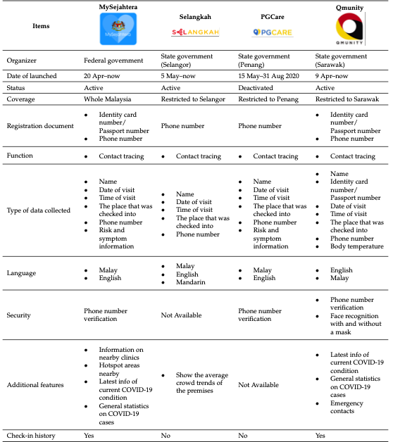
Figure 1: The comparison of COVID-19 contact tracing applications in Malaysia. Source: Khair, Lee and Mokhtar, 2021.

- Calculative technologies in daily life in Malaysia

3.1 MySejahtera
Since the very first case recorded in Malaysia, the government has been trying to be transparent to its people by announcing the number of daily cases, recovery and fatality accordingly (Figure 2). Not only there is data of cases for all 13 states, but the government also announced each cluster that emerged in the country to keep the public aware of the risk and for the call of mass-testing like in the case of the Sri Petaling and Sivagangga clusters. In the first wave of COVID-19 in Malaysia, the Malaysian government has focused on the number of infected cases and fatalities to construct the public discourse on the virus while trying to contain the pandemic. These data produce the visibility for the daily circumstances and crises faced by both the authority and the public; at the same time justified the government’s constant interference in public lives during the pandemic. Figures of the positive cases and fatalities were made as the benchmark to evaluate and convey the efficiency of initial responses. Additionally, lowering the number of infected cases and fatalities were disclosed to the people as one of the major reasons to flatten the curve. The authorities were concerned about these numbers as it was a vital calculation that would determine lockdown enforcement. Flattening the curve significantly justified the government enforcement on lockdown whereas proceeding with the compliance of lockdown was then compelled.
Like Korea, the Malaysian government has imposed a mandatory use of a mobile health application called ‘MySejahtera’ to mitigate the pandemic, even strictest. ‘MySejahtera’ is an application developed through strategic cooperation between the National Security Council (NSC), the Ministry of Health (MOH), the Malaysian Administrative Modernization and Management Planning Unit (MAMPU), Malaysian Communications and Multimedia Commission (MCMC), and Ministry of Science, Technology and Innovation (MOSTI). Not only the application allows the users to perform health self-assessment on themselves and their families, but it also authorizes the government to track and trace the infection by allowing the MOH to contain and isolate the infected persons (Othman and Babulal, 2020). In addition to that, the application is in the line with the Prevention and Control of Infectious Diseases Act 1988 (Act 342) and supported by Section 22 of the Prevention and Control of Infectious Diseases Act 1998 (Act 342) and Section 233 of the Communication and Multimedia Act 1998 (Act 588) for an offense of providing any false information.
That being said, the application has put all Malaysian under the surveillance of the authority. To begin with, for a person to register to MySejahtera, an individual needs to give his/her personal information. As for prevention purposes, everyone is required to scan a barcode for data collection for every time they wish to enter: malls, public transportation, restaurants, any public places even for events like wedding reception among others. Nonetheless, MySejahtera can also be used “to assist in the automated visitor registration process; to reduce congestion among visitors; preventing infection from spreading by increasing compliance with the new standards” (Hasan, Mohamed and Yusoff, 2020). The following months after the introduction of the MySejahtera, at least more than 9000 cases were detected through the application and it has covered more than 24.5 million users all over Malaysia (Chan et al., 2021).
For the purpose of establishing a self-governable community, strict behavioral control measures like COVID-19 standard of procedure (SOP) compliance and non-compliance fines for the public were enforced by the authority. Subsequently, a violation of the COVID-19 standard operating procedure (SOP) may result in RM10,000 compound. Indeed, a report has gone viral when an individual was issued with RM 10,000 fine for failing to scan his MySejahtera application at a restaurant he went to (Zolkepli, 2021). In some other cases, users were faced with some other problems after forgetting to ‘Check Out’ in MySejahtera. Eyra Zaharah, a TikTok user shared to her account when her mother was barred from boarding the airplane for her family vacation as she forgot to press check-out on the application before the flying time for almost two weeks (Fong, 2021). A man on the other hand was marked as a ‘casual contact’ after he forgets to check out on his MySejahtera. Yoo Wei How was reported to learn that his status on MySejahtera has changed to ‘casual contact’ after he had forgotten to check out from the hospital he last visited (Tan, 2021).

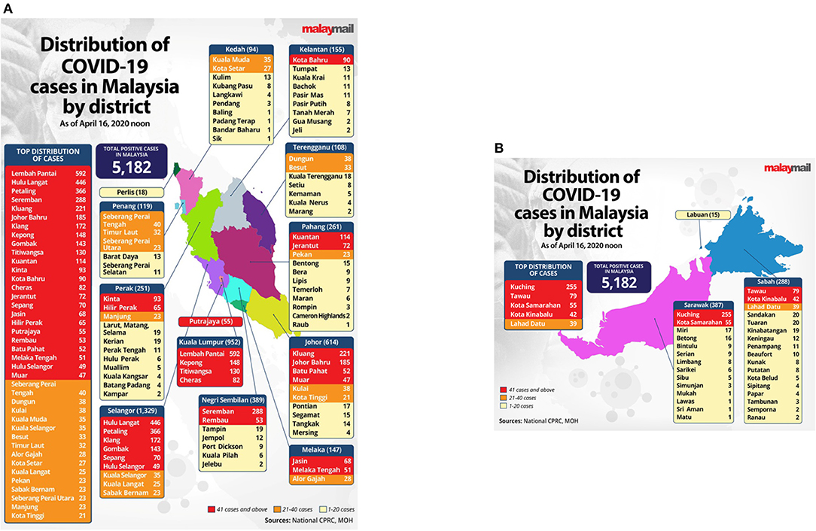
Figure 2: Distribution of COVID-19 cases in Malaysia by district. Source: Malaymail

3.2 Movement Control Order (MCO)
Begun way back to 18th March to 31st December 2020, the Malaysian government has at least enforced seven phases of MCO to mitigate the risk of the pandemic (Figure 3). Each phase indicated the level of its severity with its measures to lessen the risk accordingly. Phase 1 initially started from March 18th to 31st 2020 for about two weeks; followed by the extension of another two weeks into phase 2 from 1st April to the 14th before it was then extended to another two weeks into phase 3 from 15th April to 28th. The government then announced another two weeks of MCO into phase 4 from 29th April to 12th May 2020. Starting from 4th May onward the said MCO was then converted to a CMCO until 9th June with some sectors being allowed for partial opening before it was converted to RMCO from 10th June to 31st August 2020. The economic, hospitality, tourism, and religious sectors were reopened with strict SOP (Figure 4).
The first two MCOs were the strictest approaches taken by the government in which, the government closed all the educational institutions, places of worship, and nonessential sectors and banned outdoor sports or activities. Fully operations were only granted to the manufacturing, service sectors which were related to the essential needs and food production besides agriculture. These restrictions were under the recommendation of the Malaysian National Security Council (MNSC); under the Police Act 1967 and the Prevention and Control of Infectious Disease Act 1988 (Act 342) (Yassin, 2020). Hashim et al., argued that the respected MCOs were not only enforced through the Prevention and Control of Infectious Disease Act 1988 but were also supported by “Section 11(2) of the Act; the Minister of Health may, by regulations made under this Act, prescribe the measures to be taken to control or prevent the spread of any infectious disease within or from an infected local area” (Hashim et al., 2021). An authorized officer on the other hand may also under Section 11(3):

“Order any person or class or category of persons living in an infected local area or in any part thereof to subject himself or themselves to isolation, observation, or surveillance, the period of which is being specified according to circumstances, or to any other measures as the authorized officer considers necessary to control the disease”.
(Hashim et al., 2021)

Nonetheless, such extreme measure taken by many governments all around the world raises some concerns regarding the violation of individual rights while many were doubtful of its effectiveness. Such an approach although recommended by the World Health Organization (WHO) was an unprecedented public health standard and beyond its regulations in epidemic control.

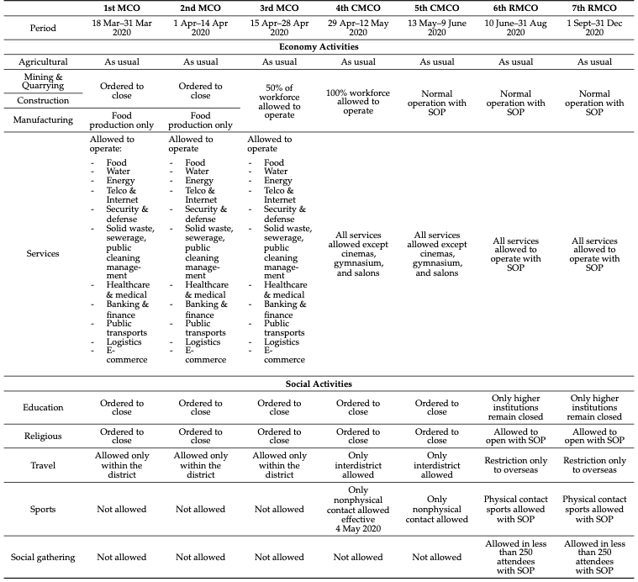
Figure 3. The phases of the movement control order (MCO) in Malaysia. Source: Khair, Lee and Mokhtar, 2021.

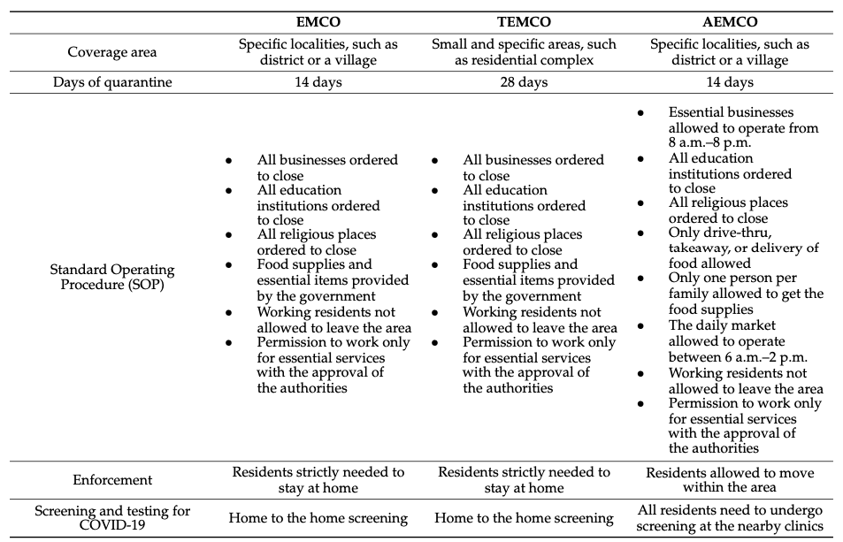
Figure 4. The different approaches taken by the Malaysian government in containing the local infection of Covid-19. Source: Khair, Lee and Mokhtar, 2021.

Accordingly, both the interstate and inter-district travel were prohibited unless authorized. At this point, only the head of the family was permitted to travel within 10km distance to shop for groceries while both police and military were placed throughout the states and borders to monitor the movement of the people. Seven individuals were compounded RM2000 each on 4th June 2021 for an offense of exceeding the limit of the permitted passengers in one car (Ali, 2021). In addition to that, the Malaysian government has imposed regulated travel bans whereas all the foreigners or tourists were barred from entering Malaysia except for approved travel and 14 days mandatory self-quarantine to the returnees in MOH-designated places (Kaur, 2020).

3.3 Mandatory Quarantine
Many countries including Malaysia have authorized isolation and mandatory quarantine. Learning from China, these approaches although may be deemed brutal were the most significant tools to contain the disease (Tang B et al., 2020). The Malaysian government has designated and gazette the quarantine places according to Section 15 (1) Prevention and Control of Infectious Disease Act 1988 (Act 342) (NADMA, 2020). These centers included the training center, hotels, technical institutes, community colleges, and former National Service camps.
Starting from the 1st June 2020 however, a new policy has been imposed by the Malaysian government in which any individual that enters Malaysia through the International Entry Point (PMA) are required to bear 50% of the quarantine cost for every citizen whereas the non-citizens need to pay for the full payment. As such, individuals that are subjected to the quarantine will be referred to as Person Under Surveillance (PUS) (NADMA, 2020). The quarantine period as ruled by the MOH is up to 14 days or any period stipulated by the ministry with the maximum rate of RM150 per person per day for the quarantine center. As the global spread was getting uncontrolled, the government brought back Malaysian from all over the world through charted flights in which all the returnees were quarantined for 14 days during which they will be undergoing the PCR-test twice and released after tested negative for both tests. For an offense of violating the mandatory quarantine, a person can be issued a compound by the Malaysian authority.
A form four student for instance was slapped with a RM5000 compound for the violation of sub-section 22(b) of Act 342 for a person under investigation (PUI); for refused of the quarantine (Dermawan, 2021). A Penang teen on the other hand was compounded with a RM5000 summon under the offense of removing the quarantine wristband (Sinnappan, 2021). However, one of the Malaysian Cabinet ministers was caught in a heated debate by the Malaysian when the opposition Member of Parliament (MP) claimed in Parliament that Khairuddin, the Plantation Industries and Commodities Minister did not comply with the 14-day quarantine after flying back home from Turkey. Malaysians on social media were outraged at the double standard SOP when it comes to the policymaker (The Straits Times, 2020) In fact, it was reported that “the Attorney General’s Chamber (AGC) has decided that “No Further Action” (NFA) will be taken against him” (Zack, 2020). In another report, the health director-general clarified that “the top officials of the ministry were in the dark about Plantation Industries and Commodities Minister Mohd Khairuddin Aman Razali’s violation of home quarantine rules” (Bernama, 2020).

3.4 The Mandatory-Mask’s Ruling
Wearing a face mask is one of the attempts to hinder the spread of the virus. As of 17 August 2020, at least more than 50 countries require people to wear a face mask when leaving home (Al Jazeera, 2020). In addition to that, the World Health Organization (WHO) has also recommended the use of a medical mask to reduce the spread of SARS-CoV-2, the virus that causes COVID-19 in its interim guidance. However, the WHO also emphasized that; “a mask alone, even when it used correctly, is insufficient to provide adequate protection or source control” (WHO, 2020).
Like some of these states, the Malaysian government has made it compulsory for the public to wear face masks in public areas with a maximum RM 1000 fine started from the 1st August 2020. According to the Senior Defence Minister Ismail Sabri Yaakob, an offence oved the mandatory mask decree can be subject to the Prevention and Control of Infectious Diseases Act 1998 of a maximum fine of RM 1000 or a penalty of six months’ imprisonment, or both fine and jail (Code Blue, 2020). As such, the Medical Practitioners Coalition Association of Malaysia president Dr Raj Kumar Maharajah said that, “wearing face masks helps keep the infectivity rate or the R-naught (RO) rate under 1.0, which means that the probability of an infected person spreading it to others can be minimized” (The Straits Times, 2020).
On the 3rd October 2021, Ismail Sabri once again restated that the mask wearing in the country is to be remained as Malaysian in particular have accepted that COVID-19 is an endemic. He was reported to state that, “I feel that we will come to a point where mask-wearing becomes a culture here. Malaysian will develop a norm in terms of wearing face masks, just like people in Japan, South Korea and China … COVID-19 will remain among us, like dengue and other disease” (Anis and Kaos JR, 2021). On the 14th December 2021, regardless of the drop in number of the infection, the government was reported that wearing mask will be part of other compulsory SOPs. Having said that, the Deputy Health Minister II, Aaron Ago Dagang reported that; 95% of the respondents of a study on SOP compliance conducted by the health ministry’s research division absolutely agreed that the new norms should be remained (Jamal, 2021).

- Disapproval of the Malaysian government’s use of calculative technologies
On several occasions, the Malaysian’s COVID-19 SOPs were faced with clashes which resulted in escalating criticism of the ways the government was handling the pandemic. To begin with, the government was criticized for its unclear and inconsistent instructions on the SOPs for the CMCO. Lee Lam Thye, chairmain of Alliance for Safe Community was reported saying that the enforcement, loss, and reimposition of SOPs in accordance with different sectors, activities, and geographical boundaries led to confusion among the public because of the inconsistencies. He stated that “for instance, under the latest round of CMCO, it is illegal for more than two family members to travel together to buy groceries but it is ok for a greater number of people, unrelated to each other, to be at a gym … SOPs must be clear and precise to avoid another kind of CMCO” (Arumugam, 2020).
In addition to that, numbers of MPs raised the issue of double standards in the government’s SOPs. Syed Saddiq for instance questioned the RM3000 fine charged on an expatriate who was not wearing a mask while trying to enter business premises, when others have been slapped with higher fines prior to this. He said that, “Malay traders in rural areas have been fined RM50,000. I know the government will say, Syed Saddiq, this is the (provision under the) law, we are no longer in an Emergency” (The Sun, 2021). Mike Chong on the other hand urged that the government to not practicing double standards in the implementation of COVID-19 SOPs. Following to the approval of home quarantine to Deputy Federal Territories Minister Datuk Seri Edmund Santhara Kumar after his return from New Zealands; Chong said that the explanation is not acceptable as “The SOP must be the same for every Malaysian regardless of their background or position … There should be no exceptions, the government came up with the SOPs, so they must ensure that the implementation is fair to everyone” (Bedi, 2021).
The government was also condemned for not using targeted calculative approaches to protect vulnerable groups like the poor. Ong Bee Lian said that (Perimbanayam, 2021),

“Many have been hit hard by the pandemic. Various industries are significantly affected, and many families are facing food insecurity as a result of it. Some of the M40 families have become the B40 groups after struggling through the pandemic for almost two years. It’s not easy staying afloat in the present situation”
Muhammad Nor Abdullah who was born without arm has lurched into desperation. He who was surviving by selling packed ‘nasi lemak’ at a roadside stall every morning has lost his income during the lockdown while the aid he received from the government was not enough. Following the white flag campaign that emerged on social media, Mohamad Nor then hang a white flag outside the window of his rented house. With many come and aided him with rice, boxes of biscuits, water and cooking oil with some even offered to help pay his rental he said that “it was so unexpected. So many people reached out to help, support and also encourage me” (Ng, 2021). The white flag campaign aims to help people who are in need. It began as Malaysian society’s response to the growing suicides due to economic hardships because of the pandemic. At least, 468 suicides have been reported by the police in the first five months of year 2021 (Ng, 2021).

- Biopolitics, State Power, and Public Resistance
Many Malaysians were angry with the government now more than when the pandemic first broke out. Frustrations over how the government enforced the MCO restriction and the confusion between the EMCO in Selangor and Kuala Lumpur were among the most heated debate over the internet. Rants about how the MCO is managed or why there are too many flip flops in policies taken by the authority was a never-ending topic. Accordingly, hashtag campaigns were launched on social media which enable many Malaysians to express their sentiments on many issues. Many were then joining the cause as to oppose the powerful elites. #AntaraDuaDarjat (#BetweenTwoStatus) and #DengkiKe (#AreYouJelous) were the protest against double standards in the enforcement of COVID-19 SOPs. As public disappointment grew, hashtag campaigns like #KerajaanGagal (#FailedGovernment), #KerajaanZalim (#CruelGovernment) and #KerajaanPembunuh (#MurdererGovernment) were then started.
When reports came out within the second and third MCOs on the internet that the elites including ministers, MPs and celebrities were flaunting SOPs; the law abide of average Malaysian citizen became furious with the elites parade their special treatment to not following the non-compliance of SOPs. In fact, the authorities either delayed or gave minimal punishment to these elites despite there was a commotion of the wrongdoings (Leong and Rosli, 2021). Pictures (Figure 5) of ministers attended a wedding reception of an MP’s daughter in another state gained at least 6700 likes and 9200 retweets.
The increasing public disappointment with the way the government handling the pandemic were then followed by the hashtags campaign of #KerajaanBodoh (#StupidGovernment), #KerajaanGagal (#FailedGovernement), #KerajaanPembunuh (#MurdererGovernement), #KerajaanBangsat (#BastardGovernment), and #KerajaanZalim (#CruelGovernment). Leong and Rosli argued that, “While the hashtags #AntaraDuaDarjat and #DengkiKe reflected the public’s statement of their unhappiness with the situation, these subsequent hashtags outwardly accused the government of failing its citizens and causing untold misery” (Leong and Rosli, 2021). It was because of the uprising of the daily cases despite the public were put under two MCOs with the number hike to 17,786 in 31 July 2021 from just 2,985 new cases in 13 January 2021.
When the public lost their hope with the government, some of the netizens chose to help others by started a welfare campaign like #KitaJagaKita (#WeTakeCareOfOurselves), #BenderaPutih (#WhiteFlag) and #RakyatJagaRakyat (#CitizensTakeCareOfCitizens). The idea of #KitaJagaKita was first mooted by Hanna Alkaf on Twitter on 17 March 2020 in which she collaborated with some volunteers. Its objective is to “works to list and verify organizations and initiatives working with marginalised groups in Malaysia, so that the public may channel funds to those who need it most during this MCO” (KitaJagaKita, 2021). At the same time, the #BenderaPutih emerged which it urged those who needed help to fly a white flag in front of their house. Families or individual that are lining with hunger or need any assistance were asked to put a white flag or any white cloth outside their resident to signal that they need helps. A website was then developed where people can see the map of Malaysia where both white flag and food banks are marked so that it can help other people to find those who are affected and those who like to help easily (The Indian Express, 2021).
Zulkiflie Samsudin one of those who flew the white flag was reported saying that, “I was sad that I could not provide for my family as the head of the household due to financial difficulties. So I flew the white flag after seeing the campaign on social media. Surprisingly, aid has been puring in and I am able to support my family for month” (Rodzi, 2021). Since January, the Health Ministry recorded more that 122,000 calls on its help hotline, seeking for psychological and emotional support due to the loss of jobs and family problems. At the same time, between January and March, 336 suicide cases have recorded by the authorities; an average of four cases daily. This is more than half of what was reported in 2020 alone (Rodzi, 2021).

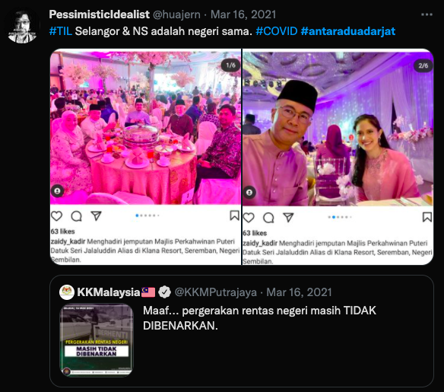
Figure 5: ministers attending wedding reception of an MP’s daughter despite the ban of inter-state travel by the Health Ministry.

While Malaysians are facing with the pandemic, we also witnessed an unprecedented political turmoil and uncertainty. The Pakatan Harapan (PH) coalition which see the coalition between the former Prime Minister (PM) Mahathir Mohamad and his old rival Anwar Ibrahim had scored a stun election victory in 2018. PH managed to oust Barisan Nasional (BN) from power after more than six decades of authoritarian leadership. Not only the PH won the federal election, but BN only won two less developed state of Perlis and Pahang (Nadzri, 2018). However, less than in two years, this new government is out while the old ruling party back in power. Famously known as ‘Langkah Sheraton’ (Sheraton Move) saw the overthrow of the elected Pakatan Harapan government when MPs started to change their party support which eventually caused the loss of parliamentary majority. It was believed that, the take over of the elected government were engineered by Muhyiddin, Mahathir’s own deputy and Azmin Ali, Anwar Ibrahim’s deputy. National media were reported that several MPs from both Mahathir and Anwar’s parties publicly gathered at the Sheraton Hotel prior to the collapse of the PH government and resulted in the appointment of Muhyiddin as the new PM (Bowie, 2021). Mahathir then promised to seek an urgent parliament sitting to contest Muhyiddin’s support. However, not only that the king refused to see him it was reported that “Mahathir accuses Muhyiddin of plotting for a long time to take the premiership, and questions if government involving the former ruling party would be ready to pursue graft cases against its politicians” (Reuters, 2020). The former PM of Barisan Nasional, Najib Razak on the other hand accused Muhyiddin as power crazy. While supporting the dissolution of the Johor state elections so that the mandate will be return to the people to choose, he added that; “what is power-crazy is betraying your own coalition and the party founder through the Sheraton Move to become Prime Minister” (The Star, 2022).
While jiggling between the coronavirus pandemic and these political turmoil before the premiership was then take over by the new PM Ismail Sabri in 2021; Muhyiddin then declared the state emergency. The King of Malaysia, Sultan Abdullah declared a months-long state of emergency to fight coronavirus pandemic following the request of then PM Muhyiddin Yassin; this allows the PM to suspend the parliament. However, critics claimed that through the declaration it allows Muhyiddin to cling to power although his government is already weakened (BBC, 2021). Although Muhyiddin promised that he was committed to hold a general election once the pandemic situation is under control; Mahathir criticized the state declaration saying the government is no longer has its right to rule. Mahathir argued that, “the proclamation of a state emergency removes the last vestige of democratic rights of the people … this government is not the government they (people) elected. It is a backdoor government” (Khaliq, 2021).
Initially, when the parliament is suspended, it means that any political activities and elections are not granted while the state was granted with greater power. Najib Razak criticized that, “Declaring Emergency to suspend Parliament, implementing half-baked MCO to make the people suffer just to avoid losing a confidence vote in Parliament is also being power crazy” (The Star, 2022). Having said that, it is important to note that, in more than 50 years it was the first time that a national emergency has been proclaimed while this is the second time the parliament has been suspended since its independence from Britain in 1957 (Reuters, 2021). Following the state emergency, the government were given the rights to precede laws without the approval of the parliament. In addition to that, Muhyiddin and his government can approve the expenditure “necessary to ensure public security without a parliamentary vote” (Reuters, 2021). Furthermore, the government can also introduce ordinances, a temporary law that take effect immediately. A legal expert, Nik Ahmad Kamal said that, “the constitution is more or less suspended, as a substantial part of it can be overridden by emergency law” (Reuters, 2021). The proclamation of state emergency was answered with sceptical by the public since Muhyiddin came to power with a thin majority and was facing with threats from coalition allies particularly the Barisan Nasioanl to withdraw their support which may lead to snap election. In addition to that, the proclamation was made not more than 10 months of Muhyiddin step into the premiership. Bridget Welsh, an honorary research associate from the University of Nottingham’s Asia Research Institute in Malaysia argued that,

“The sense is that they need to move away from having to constantly be destabilized, so they’re relying on the levers that can potentially give them the space to stay in office. But …the narrative that they’re using the that this will help them with COVID”
(Peter, 2021)

Wong Chin Huat, a political scientist from Sunway University, Malaysia also agreed by stated that:

“This is not a situation where the whole country is in chaos. So the real reason (for) all this is really for him (Muhyiddin) to keep his power, so that the prime minster doesn’t have to face parliament, and to have a free hand to run the country until the emergency is over”
(Peter, 2021)

Unfortunately, while Malaysian is facing with the pandemic, political bargain is vigorously happening backdoor. Not only state government in Kedah, Johore, Perak, Malacca, Sabah, Sarawak, and Negeri Sembilan fell there is also series of appointments of political personalities that linked to corporations as an effort to get political endorsement from allies. Other than that, there is also several occasions of leaked recordings of PH high-level meetings which led to the coup and the dismissal of Mahathir from his own party (Wei, 2020). The refusal of the new government of the Perikatan Nasional to convene the parliament is not only limited its ability to respond. But, Wei argued that:

“In the only parliamentary session so far, on 18 May, cut short to only half a day, no supplementary billy were passed. This also means that there is no mechanism for checks and balances currently in place to discuss the COVID-19 policies and measures introduced by the government, including the RM260 billion stimulus package. As shown by other countries, the Malaysian parliament could have adopted the practice of virtual conferences or restrict the number of member present in plenary”.
(Wei, 2020)

6. Conclusion
This paper has demonstrated how the Malaysian government deployed a range of calculative technologies during the COVID-19 pandemic, including contact-tracing applications, movement control orders, mandatory quarantine measures, and mask-wearing regulations. While these interventions were justified as necessary public health responses to contain the spread of the virus, they also functioned as mechanisms of governance that extended state authority into the everyday lives of citizens. Through the lens of Foucault’s concepts of governmentality and biopolitics, these measures can be understood not merely as health policies but as technologies of power that rendered the population visible, measurable, and governable.
The findings suggest that calculative technologies enabled the state to regulate conduct by encouraging individuals to internalize and comply with prescribed norms of behavior. Citizens were expected to monitor their movement, report their health status, adhere to social distancing regulations, and accept varying degrees of surveillance in the name of collective security. In this sense, governance during the pandemic relied not only on coercive enforcement and legal sanctions but also on the production of self-disciplined and self-regulating subjects. The widespread use of data collection, contact tracing, and risk calculations exemplified how biopolitical governance operates through the management of life, health, and security at the population level.
At the same time, the Malaysian case reveals the tensions and contradictions inherent in biopolitical governance. Public dissatisfaction over inconsistent policy implementation, allegations of double standard, and the broader political instability that accompanied the pandemic exposed the limits of state legitimacy and public trust. These controversies demonstrate that the effectiveness of calculative technologies depends not only on their technical capacity but also on perceptions of fairness, transparency, and accountability.
Ultimately, this study argues that the pandemic provided an opportunity for the expansion of governmental power through biopolitical mechanism. Although these measures were introduced to mitigate a public health crisis, they also reinforced state capacity to monitor, regulate, and shape citizen behavior. The Malaysian experience therefore highlights how emergencies can become sites where public health imperatives, political authority, and technologies of governance, raising important questions about the long-term implications of surveillance, state power, and democratic accountability in times of crisis.

References
Anis, M. N., & Kaos, J., Jr. (2021). ‘Masking up is here to stay.’ The Star. https://www.thestar.com.my/news/nation/2021/10/03/masking-up-is-here-to-stay
Arumugam, T. (2021). Lee: Malaysians need clear, precise directives on SOP. https://www.nst.com.my/news/nation/2020/10/634359/lee-malaysians-need-clear-precise-directives-sop
Aw, S. B., Teh, B. T., Ling, G. H. T., Leng, P. C., Chan, W. H., & Ahmad, M. H. (Eds.). (2021). The COVID-19 Pandemic Situation in Malaysia: Lessons Learned from the Perspective of Population Density. International Journal of Environmental Research and Public Health.
Azlan, A. A., Hamzah, M. R., Sern, T. J., Ayub, S. H., & Mohamad, E. (Eds.). (2020). Public knowledge, attitudes and practices towards COVID-19: A cross-sectional study in Malaysia. PLoS ONE.
BBC News. (2021). Malaysia declares Covid state of emergency amid political challenges. BBC News. https://www.bbc.com/news/55625448
Bedi, R. S. (2021). Govt should not practise double standards in implementing Covid-19 SOPs, says MCA. The Star. https://www.thestar.com.my/news/nation/2021/03/29/govt-should-not-practise-double-standards-in-implementing-covid-19-sops-says-mca
BERNAMA (Ed.). (2020). Minister breaks quarantine: We are not infromed - Health D-G. BERNAMA. https://bernama.com/en/general/news_covid-19.php?id=1873587
Bowie, N. (2021). The duo who stole Malaysia’s democracy. Asia Times. https://asiatimes.com/2021/02/the-duo-who-stole-malaysias-democracy/
CodeBlue. (2020). Starting Aug 1, Masks Mandatory In Public Areas With Max RM1,000 Fine. Code Blue. https://codeblue.galencentre.org/2020/07/23/starting-aug-1-masks-mandatory-in-public-areas-with-rm1000-fine/
Coronavirus. (2022). Worldometer. https://www.worldometers.info/coronavirus/
Dermawan, A. (2021). Student under PUI gets RM5,000 compound for breaking quarantine. New Straits Times. https://www.nst.com.my/news/nation/2021/05/693603/student-under-pui-gets-rm5000-compound-breaking-quarantine
Desk, E. (2021). Explained: The white flag campaign in Malaysia, triggered by Covid-19 distress. The Indian Express. https://indianexpress.com/article/explained/white-flag-campaign-malaysia-covid-7391999/
Fong, F. (2021). Mother Misses Family Vacation After Forgetting To ‘Check Out’ In MySejahtera. The Rakyat Post. https://www.therakyatpost.com/news/malaysia/2021/11/20/mother-misses-family-vacation-after-forgetting-to-check-out-in-mysejahtera/
Foucault, Michael. (1970). The Order of Things: An Archaeology of the Human Sciences. Tavistock.
Foucault, Michel. (1972). The Archaeology of Knowledge. Tavistock.
Foucault, Michel. (1977). Discipline and Punish: The Birth of the Prison. Random House.
Foucauly, M. (1977). Discipline and Punish: The Birth of the Prison. Random House.
Hashim, J. H., Adman, M. A., Hashim, Z., Radi, M. F. M., & Kwan, S. C. (Eds.). (2021). COVID-19 Epidemic in Malaysia: Epidemic Progression, Challenges, and Response (Vol. 9). frontiers in Public Health.
Jamal, A. A. (2021). Face masks to remain compulsory despite dip in Covid cases, govt says. Malaysia Now. https://www.malaysianow.com/news/2021/12/14/face-masks-to-remain-compulsory-despite-dip-in-covid-cases-govt-says/
Jayasinghe, K., Jayasinghe, T., Wijethilake, C., & Adhikari, P. (Eds.). (2021). Bio-Politics and Calculative Technologies in COVID-19 Governance: Reflections From England. International Journal of Health Policy and Management.
Jazeera, A. (2020). Which countries have made wearing face masks compulsory? Al Jazeera. https://www.aljazeera.com/news/2020/8/17/which-countries-have-made-wearing-face-masks-compulsory
Khair, N. K. M., Lee, K. E., & Mokhtar, M. (Eds.). (2021). Community-Based Monitoring in the New Normal: A Strategy for Tracking the COVID-19 Pandemic in Malaysia. International Journal of Environmental Research and Public Health.
Khaliq, R. ul. (2021). Malaysia’s Mahathir criticizes state of emergency. Anadolu Agency . https://www.aa.com.tr/en/asia-pacific/malaysia-s-mahathir-criticizes-state-of-emergency/2114090
Kim, Y. (Ed.). (2021). Bio or Zoe?: dilemmas of biopolitics and data governmentality during COVID-19 (Vol. 35). Routledge.
KitaJagaKita. (2021). Soalan-Soalan Lazim/FAQ. KitaJagaKita. https://kitajagakita.com/soalan-soalan-lazim-faq.html
Leong, P. P. Y., & Rosli, A. A. (2021). Hashtag Campaigns during the COVID-19 Pandemic in Malaysia: Escalating from Online to Offline. ISEAS Publishing. https://www.iseas.edu.sg/wp-content/uploads/2021/11/TRS21_21.pdf
Miller, N. R. A. (Ed.). (1992). Political Power beyond the State: Problematics of Government (Vol. 43, Issue 2). Wiley.
Miller, P., & Rose, N. (Eds.). (2006). Governing economic life. Routledge.
Minister Khairuddin slapped with RM1k compound for quarantine violation. (2020). The Star. https://www.thestar.com.my/news/nation/2020/08/22/minister-khairuddin-slapped-with-rm1k-compound-for-quarantine-violation
Nadzri, M. M. N. (Ed.). (2018). The 14th General Election, the Fall of Barisan Nasional, and Political Development in Malaysia, 1957–2018. Journal of Current Southeast Asian Affairs. https://journals.sub.uni-hamburg.de/giga/jsaa/article/download/1151/1151-1189-1-PB.pdf
Ng, E. (2021). Malaysians suffering amid lockdown fly white flag for help. AP News. https://apnews.com/article/malaysia-coronavirus-pandemic-business-health-780c55ef2da87111849e2fa941e10cf4
Perimbanayagam, K. (2021). “Kita jaga kita” is not just a phrase. New Straits Times. https://www.nst.com.my/news/nation/2021/09/728751/kita-jaga-kita-not-just-phrase
Peter, Z. (2021). Motivation Behind Malaysia’s State of Emergency Questioned. Voa News. https://www.voanews.com/a/east-asia-pacific_motivation-behind-malaysias-state-emergency-questioned/6200719.html
Rampal, L., & Liew, B. S. (Eds.). (2021). Malaysia’s third COVID-19 wave - a paradigm shift required. Med J Malaysia.
Reuters Staff. (2020). Malaysia confirms first cases of coronavirus infection. Reuters. https://www.reuters.com/article/china-health-malaysia/malaysia-confirms-first-cases-of-coronavirus-infection-idUSL4N29U03A
Rodzi, N. H. (2021). Malaysians launch white flag campaign to signal distress without begging. The Straits Times. https://www.straitstimes.com/asia/se-asia/malaysians-launch-white-flag-campaign-to-signal-distress-without-begging
Rose, N., O’Malley, P., & Valverde, A. M. (Eds.). (2006). Governmentality. Annu. Rev. Law Soc. Sci.
Shah, A. U. M., Safri, S. N. A., Thevadas, R., Noordin, N. K., Rahman, A. A., Sekawi, Z., Ideris, A., & Sultan, M. T. H. (Eds.). (2020). COVID-19 outbreak in Malaysia: Actions taken by the Malaysian government. International Journal of Infectious Diseases.
Sinnappan, A. (2021). Penang teen who removed Covid-19 quarantine wristband fined RM5,000. The Vibes. https://www.thevibes.com/articles/news/28912/penang-teen-who-removed-his-pink-covid-19-quarantine-wristband-caught-and-fined-rm5000
Sipalan, J., Latiff, R., & Macfie, N. (2021). Explainer: Why a state of emergency raises concerns in Malaysia. Reuters. https://www.reuters.com/article/us-healthcare-coronavirus-malaysia-emerg-idUSKBN29H1HE
Tan, Y. A. (2021). Man Labels As ‘Casual Contact’ After He Forgets To Check Out On MySejahtera. Weird Kaya. https://weirdkaya.com/man-labels-as-casual-contact-after-he-forgets-to-check-out-on-mysejahtera/
Tang, B., Xia, F., Tang, S., Bragazzi, N. L., Li, Q., & Sun, X. (Eds.). (2020). The effectiveness of quarantine and isolation determine the trend of the COVID-19 epidemics in the final phase of the current outbreak in China. International Journal of Infectious Diseases.
The Star. (2022). Betraying own coalition in Sheraton Move to become PM is power crazy, says Najib. The Star. https://www.thestar.com.my/news/nation/2022/02/05/betraying-own-coalition-in-sheraton-move-to-become-pm-is-power-crazy-says-najib
The Straits Times. (2020a). Malaysia implements mandatory mask-wearing in crowded places from Aug 1. The Straits Times. https://www.straitstimes.com/asia/se-asia/malaysia-implements-mandatory-mask-wearing-in-crowded-places-from-aug-1
The Straits Times. (2020b). Past comes back to haunt Malaysian minister at centre of no-quarantine kerfuffle. The Straits Times. https://www.straitstimes.com/asia/se-asia/past-comes-back-to-haunt-malaysian-minister-at-centre-of-no-quarantine-kerfuffle
The Sun. (2021). MP raises issue of ‘double standards’ in issuance of compounds. The Sun. https://www.thesundaily.my/home/mp-raises-issue-of-double-standards-in-issuance-of-compounds-XK8518264
WHO. (2020). Mask use in the context of COVID-19. World Health Organization. https://apps.who.int/iris/bitstream/handle/10665/337199/WHO-2019-nCov-IPC_Masks-2020.5-eng.pdf?sequence=1&isAllowed=y
Zack, J. (2020). Khairuddin gets off, no further action for breaking quarantine. The Star. https://www.thestar.com.my/news/nation/2020/10/21/khairuddin-gets-off-no-further-action-for-breaking-quarantine
Zolkepli, F. (2021). Man fined RM10,000 for not registering details when visiting restaurant. The Star. https://www.thestar.com.my/news/nation/2021/03/12/man-fined-rm10000-for-not-registering-details-when-visiting-restaurant

Retrieved from www.worldometers.info/coronavirus/ on 6th January 2022.
Retrieved from www.reuters.com/article/china-health-malaysia/malaysia-confirms-first-cases-of-coronavirus-infection-idUSL4N29U03A on 31st December 2021.
Retrieved from www.mysejahtera.malaysia.gov.my/faq_en on 31st December 2021.
Retrieved from The Prime Minister’s Special Massage on COVID-19 re-emergence risk. https://www.pmo.gov.my/2020/03/perutusan-khas-yab-perdana-menteri-mengenai-COVID-19-mac-2020/ on 31st December 2021.
Retrieved from Reuters. Wuhan Lockdown “Unprecedented”, Shows Commitment to Contain Virus: WHO Representative in China. https://www.reuters.com/article/us-china-health-who/wuhan-lockdown-unprecedented-shows-commitment-to-contain-virus-who-representative-in-china-idUSKBN1ZM1G9 on 1st January 2022.
EMCO: Enhanced Movement Control Order; TEMCO: Targeted Enhanced Movement Control Order; AEMCO: Administrative Enhanced Movement Control Order.
Nasi lemak is a national dish originating in Malay cuisine that served with fragrant rice cooked in coconut milk and pandan leaf. Commonly found in Malaysia, it is usually serves in breakfast.

