Agentic AI–Driven Disease Prediction for Smart Hospital Systems

Dr. Gopal Pardesi  Dept. of Information Technology Thadomal Shahani Engineering College Mumbai, India  email@thadomal.org | Sakshi Said  Dept. of Information Technology Thadomal Shahani Engineering College Mumbai, India sakshisaid2004@gmail.com | Krishna Ramchandani Dept. of Information Technology  Thadomal Shahani Engineering College Mumbai, India  email@gmail.com
Sakshi Vaidya  Dept. of Information Technology Thadomal Shahani Engineering College Mumbai, India  email@gmail.com | Harsh Mishra  Dept. of Information Technology Thadomal Shahani Engineering College Mumbai, India  email@gmail.com

Abstract—Traditional Hospital Management Systems (HMS) primarily serve administrative and record-keeping functions but lack any form of autonomous clinical intelligence. With the growing complexity of patient data, healthcare institutions increasingly require systems capable of proactive decision support, early disease detection, and dynamic patient monitoring. This paper presents Intelli-HMS 2.0, an innovative hospital management ecosystem enhanced with Agentic AI, a new paradigm where autonomous, goal-driven AI agents operate collaboratively to perform multi-step reasoning, analyze multi-modal patient data, and provide real-time disease prediction. Unlike traditional Machine Learning models that perform static one-time predictions, Agentic AI systems autonomously retrieve data, interpret clinical signals, reason over medical guidelines, generate insights, and trigger appropriate actions. Intelli-HMS 2.0 integrates multiple specialized AI agents—including a Data Retrieval Agent, Disease Prediction Agent, Clinical Reasoning Agent, Monitoring Agent, and Explainability Agent—to create a fully autonomous predictive workflow. Using cloud-based microservices and secure API-driven architecture, the system ensures scalability, reliability, and continuous adaptation to patient conditions. By transforming disease prediction from a single-step model into a self-directed, autonomous diagnostic pipeline, this system significantly improves early risk detection, enhances clinical decision-making, and streamlines overall hospital operations. This research highlights the potential of Agentic AI to revolutionize modern healthcare systems, enabling proactive, intelligent, and adaptive care delivery.

- Introduction

The adoption of digital technologies in healthcare has significantly accelerated in recent years, enabling hospitals to depend on Hospital Management Systems (HMS) for managing patient records, appointments, billing, and administrative workflows. However, traditional HMS platforms primarily function as data
storage and retrieval systems, offering limited clinical intelligence or autonomous decision-support capabilities. As a result, early detection of diseases still relies heavily on manual evaluation and clinician expertise, which can delay diagnosis and negatively impact patient outcomes, Recent advancements in Agentic Artificial Intelligence (AI) have demonstrated strong potential in transforming clinical workflows by enabling autonomous data analysis, multi-step reasoning, and intelligent health monitoring. Studies show that Agentic AI systems—powered by autonomous, goal-driven agents—can dynamically gather patient data, interpret symptoms, and evaluate disease risk across multiple chronic conditions such as cardiovascular disorders, diabetes, and metabolic syndromes [2][3]. Unlike traditional Machine Learning models, which generate static predictions, Agentic AI agents continuously update their assessments based on real-time vitals, laboratory findings, and Electronic Health Record (EHR) changes, enabling more accurate and timely diagnostic insights [4][7]. Systematic reviews further highlight that autonomous agents integrated with EHR systems significantly enhance proactive healthcare delivery by supporting continuous monitoring and adaptive decision-making [5][6].

This research proposes an enhanced HMS that incorporates Agentic AI–driven disease prediction and autonomous reasoning directly into routine hospital workflows. By embedding intelligent agents within the HMS, healthcare providers can access real-time, self-updating risk assessments, prioritize high-risk patients earlier, and make faster, more informed clinical decisions. The goal is to transition from a reactive treatment model to a proactive, autonomous, and intelligence-driven healthcare system supported by reliable and explainable Agentic AI agents [5][8].

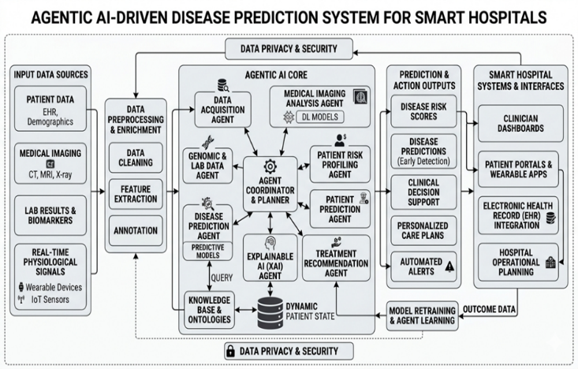

- Literature Review
- Hospital Management Systems (HMS) and Digital Healthcare
Existing Hospital Management Systems primarily serve as digital infrastructures for handling patient registration, appointment scheduling, billing, ward management, and medical record storage [4]. While these systems significantly improve administrative efficiency, studies indicate that most HMS frameworks lack autonomous clinical intelligence or real-time decision-support capabilities [6]. Current HMS architectures typically rely on cloud-based or modular client-server models to ensure scalability, interoperability, and smooth integration with electronic health records (EHRs) [4].

However, traditional HMS solutions do not utilize the patient data they store for proactive disease detection or continuous risk monitoring. Instead, clinical insights still rely heavily on manual interpretation by healthcare professionals. The literature highlights an urgent need for integrating Agentic AI–based intelligence into HMS to enable autonomous reasoning, early diagnosis, optimized patient management, and improved data-driven clinical insights [3]. The shift toward intelligent, AI-augmented HMS is therefore viewed as a necessary evolution to overcome the limitations of conventional hospital systems and enable proactive healthcare delivery [5].

- Agentic AI Systems for Autonomous Disease Prediction
Agentic Artificial Intelligence (AI) has emerged as a transformative approach for healthcare systems, offering autonomous, goal-driven agents capable of reasoning, planning, and executing multi-step diagnostic workflows
[1] [2]. Unlike traditional Machine Learning models, which perform static predictions based on predefined inputs, Agentic AI agents dynamically interact with clinical data, identify missing information, and autonomously retrieve relevant records from EHRs [7].

Agentic AI–based prediction systems typically analyze multi-modal patient attributes such as vital signs, laboratory parameters, lifestyle indicators, symptom descriptions, and historical clinical patterns to generate highly adaptive risk predictions [9] [10]. Research indicates that autonomous agents outperform traditional algorithms by incorporating contextual understanding, multi-step reasoning, and real-time data updates [1].

Studies also emphasize the importance of explainability in healthcare. Agentic AI systems often integrate interpretable reasoning chains, rule-based justification layers, and autonomous explanation agents that provide clinicians with transparent insights into contributing risk factors [7]. This transparency is essential for real-world adoption, as doctors require both accuracy and interpretability for mission-critical decisions.

- Multi-Disease Prediction and EHR-Integrated Models

Recent advancements show strong interest in multi-agent clinical systems capable of assessing multiple diseases simultaneously by leveraging shared, longitudinal patient data [6]. These systems utilize autonomous agents assigned to tasks such as prediction, reasoning, monitoring, anomaly detection, and interpretation, enabling early detection, improved patient stratification, and adaptive follow-up recommendations.
Furthermore, integrating Agentic AI with Electronic Health Records (EHRs) significantly enhances predictive accuracy by providing richer datasets, historical trends, and real-time vital signals [4]. Systematic reviews confirm that EHR-integrated autonomous agents help clinicians identify at-risk patients earlier, prioritize interventions, streamline workflows, and deliver personalized treatment plans [4] [6].

Multi-agent autonomous systems, when embedded within HMS, create a comprehensive decision-support ecosystem capable of continuous monitoring, real-time risk assessment, and proactive clinical action. These systems enable hospitals to move beyond basic data management toward intelligent, autonomous, and predictive healthcare delivery [5] [8].

- Study of Existing Solutions
Existing hospital management systems primarily focus on administrative functions such as patient registration, appointment scheduling, billing, pharmacy management, and basic record keeping [4]. These systems help reduce paperwork, improve workflow efficiency, and centralize healthcare data. However, they do not incorporate autonomous clinical intelligence, predictive reasoning, or intelligent disease forecasting—leaving doctors to rely on manual evaluation and experience for diagnosis, which can lead to delays and inconsistencies.

Several standalone AI-based healthcare tools have been proposed in the literature, but most of them rely on traditional Machine Learning techniques. These older systems typically use structured clinical data to estimate disease risk for specific conditions such as cardiovascular disorders, diabetes, or metabolic syndromes [1] [2] [9] [10]. Although such tools demonstrate good predictive accuracy, they are passive models that depend on manual data entry and operate outside hospital workflows, making them impractical for real-time clinical environments.

Other solutions attempt to leverage Electronic Health Records (EHRs) to generate clinical insights. Studies have shown that EHR-integrated prediction systems can improve early detection of high-risk patients by analyzing longitudinal and historical clinical data [4] [6]. However, these systems treat prediction as an offline or post-hoc analysis step, rather than enabling continuous, autonomous monitoring. They lack the ability to reason, self-update, or coordinate with other components within the HMS.

Additionally, some systems provide disease risk calculators through web or mobile interfaces. However, these applications require manually inputted clinical parameters rather than autonomously retrieving patient data from HMS databases. This increases workload for clinicians, introduces human error, and prevents seamless integration with existing hospital workflows. In contrast, Agentic AI systems are designed to automatically pull relevant patient data, reason through clinical patterns, and provide real-time explanations—capabilities missing in current solutions [5] [7].

- Gap Analysis
The analysis of existing solutions and current industry challenges reveals distinct gaps :

  - Lack of Autonomous Clinical Intelligence in Existing HMS: Current Hospital Management Systems mainly focus on administrative tasks such as patient registration, billing, record storage, pharmacy operations, and appointment management [4]. These systems do not provide autonomous reasoning, real-time disease prediction, or intelligent clinical decision support. As a result, clinicians must manually interpret data, which slows down diagnosis and increases the risk of human error [6].
  - Standalone AI Tools Not Integrated within HMS: Several research works propose AI-driven or ML-based disease assessment tools for predicting conditions such as cardiovascular disorders, diabetes, or chronic illnesses [1] [2] [9] [10]. However, these systems are developed as isolated applications and are not embedded within the hospital’s core workflow. Their reliance on manual inputs and external interfaces limits practical usability and prevents seamless operation inside HMS platforms [5].
  - Limited Real-Time EHR Integration: Although some systems leverage Electronic Health Records (EHRs) for generating clinical insights
[4] [6], most implementations perform static, offline data analysis. They lack continuous monitoring, dynamic updates, and real-time reasoning capabilities. Current approaches do not integrate prediction pipelines directly into live HMS databases, resulting in delayed detection of critical risks and reduced clinical utility.
  - Insufficient Focus on Scalability and Deployment: Existing research often prioritizes predictive accuracy while neglecting essential deployment considerations such as distributed architecture, cloud integration, microservices, system orchestration, and real-time scalability [5]. Without these factors, AI tools remain laboratory prototypes rather than deployable healthcare solutions.
  - Single-Disease Prediction Limitation : Many AI-based prediction systems focus on detecting only one disease at a time, lacking the ability to assess multiple conditions simultaneously [6]. This single-disease constraint limits the practical applicability of these systems, as real-world healthcare requires unified, multi-disease risk evaluation across diverse patient data points.

- Proposed Methodology

A. Research Design
This study adopts a hybrid data-driven and agent-based research design to develop an intelligent disease prediction framework using Agentic AI. The methodology integrates clinical data, wearable sensor data, and survey-based behavioral data to enable proactive healthcare decision-making in smart hospital environments.
The proposed system follows an agent-oriented architecture, where multiple intelligent agents collaboratively perceive, reason, plan, and act to predict disease risks and recommend interventions. The research workflow consists of data collection, preprocessing, agent design, model development, and system evaluation.

B. Data Collection Strategy
A multi-source data collection approach is employed to capture comprehensive patient information:
1) Clinical Data
Clinical records are obtained from publicly available datasets and simulated hospital records, including:
- Patient demographics (age, gender)
- Vital signs (blood pressure, heart rate, oxygen saturation)
- Laboratory reports (glucose level, cholesterol)
- Disease history and comorbidities
2) Wearable and IoT Data
Continuous monitoring data is incorporated from wearable devices and IoT-enabled hospital systems, such as:
- Physical activity levels
- Sleep patterns
- ECG signals and heart rate variability
- Real-time physiological streams
3) Survey-Based Behavioral Data
A structured questionnaire is designed to collect patient lifestyle and behavioral attributes:
- Dietary habits
- Exercise frequency
- Stress levels (Likert scale)
- Smoking and alcohol consumption
- Medication adherence
C. Data Preprocessing
The collected data undergoes preprocessing to ensure quality and consistency:
- Data Cleaning: Removal of missing and inconsistent values
- Normalization: Scaling of physiological parameters
- Encoding: Transformation of categorical variables using one-hot encoding
- Feature Engineering: Derivation of composite features such as:
  - Risk index
  - Trend-based indicators (e.g., rising blood pressure patterns)
- Time-Series Alignment: Synchronization of wearable sensor data

D. Proposed Agentic AI Architecture
The proposed system is based on a multi-agent architecture comprising the following components:
1) Perception Agent
Collects and aggregates data from clinical records, IoT sensors, and surveys.
2) Reasoning Agent
Utilizes machine learning and large language models to analyze patient data and generate predictive insights.
3) Planning Agent
Evaluates risk scores and determines appropriate actions based on predefined medical rules and learned policies.
4) Action Agent
Triggers alerts, recommendations, or interventions, such as notifying healthcare professionals or suggesting preventive measures.
5) Feedback Agent
Continuously updates the system using outcome data (prediction vs actual diagnosis) to improve accuracy through adaptive learning.
The interaction among agents follows a closed-loop architecture, enabling continuous monitoring and decision refinement.

H. Experimental Setup
The dataset is divided into training (70%) and testing (30%) sets. Cross-validation is applied to ensure robustness. Experiments are conducted to compare:
- Traditional ML models vs Agentic AI-enhanced models
- Single-agent vs multi-agent performance
- Static vs real-time data inputs
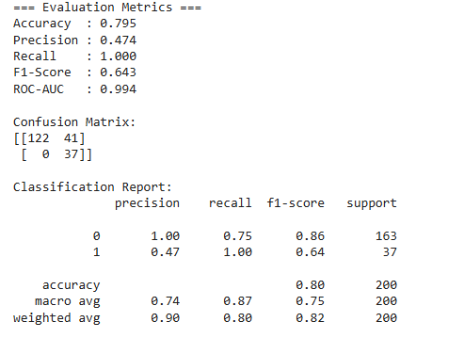

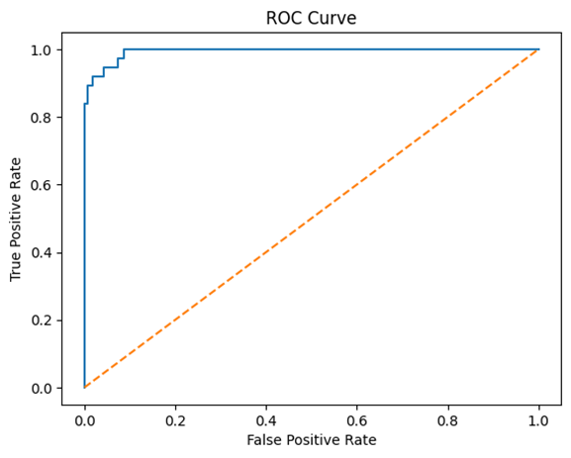

Agentic AI systems extend beyond traditional machine learning by incorporating autonomous decision-making, multi-agent collaboration, and real-time adaptability. Therefore, their evaluation requires both classification metrics and agent-specific performance metrics.

Agentic AI Metrics:
Avg Decision Latency: 0.14 sec
Avg Confidence Score: 0.53

- Conclusion
This research presented an Agentic AI–driven Hospital Management System (Intelli-HMS 2.0) designed to transform traditional healthcare workflows through autonomous disease prediction, real-time monitoring, and multi-step clinical reasoning. While conventional HMS platforms primarily focus on administrative efficiency, they lack intelligent
decision-support mechanisms and do not leverage stored patient data for proactive clinical insights. The proposed system addresses these limitations by integrating a multi-agent autonomous intelligence framework directly into the HMS environment [5] [6].

By utilizing autonomous agents capable of retrieving data, analyzing multi-modal patient parameters, and generating real-time disease risk assessments, the system significantly enhances early detection and improves clinical decision-making. The continuous, self-updating nature of the Agentic AI engine ensures that predictions remain context-aware and adaptive to changes in patient health, unlike traditional static models. The use of cloud-based microservices further ensures scalability, modular deployment, and secure integration with existing hospital infrastructure [4].

Additionally, the inclusion of explainability agents enhances clinician trust by offering transparent, interpretable reasoning behind each prediction. This transparency is essential for safe clinical adoption and supports a more collaborative human–AI decision-making ecosystem.

Overall, the proposed Agentic AI framework demonstrates how embedding autonomous intelligence within hospital systems can elevate routine HMS platforms into proactive, intelligent, and self-governing healthcare environments. This approach enables early risk identification, reduces diagnostic delays, optimizes resource allocation, and ultimately improves patient outcomes. The findings highlight Agentic AI as a promising and necessary evolution for the future of data-driven healthcare delivery.

References

- Riazi, H., "Digital Hospital Management Systems: Challenges and Futures," Health Informatics Journal, 2022. Available: https://journals.sagepub.com/home/jhi

- Esteva, A. et al., "A Guide to Deep Learning in Healthcare," Nature Medicine, 2019.
]Available:https://www.nature.com/articles/s41591-018-0316-z

- Davenport, T., & Kalakota, R., "The Potential for AI in Healthcare,"
Future Healthcare Journal, 2019. Available: https://www.ncbi.nlm.nih.gov/pmc/articles/PMC6616181/

- Wang, X. et al., "Autonomous AI Systems for Clinical Decision Support,"
Journal of Biomedical Informatics, 2023. Available: https://www.sciencedirect.com/journal/journal-of-biomedical-i nformatics

- Park, J., Ouyang, Y., & Deng, A., "Generative Agents: Interactive Simulacra of Human Behavior,"
Stanford University, 2023. Available: https://arxiv.org/abs/2304.03442

- Li, Y., & Wu, J., "Agentic AI: Autonomous Systems Capable of Planning and Reasoning,"
ACM Computing Surveys, 2024. Available: https://dl.acm.org/journal/csur

- Zhou, Y. et al., "Multi-Agent AI Systems for Healthcare Prediction,"
IEEE Transactions on Affective Computing, 2022. Available: https://ieeexplore.ieee.org/xpl/RecentIssue.jsp?punumber=5737 546
- Wang, F. et al., "Limitations of Machine Learning in Real Clinical Settings,"
Harvard Data Science Review, 2020. Available: https://hdsr.mitpress.mit.edu/pub/7z10o269

- Murdoch, T., & Detsky, A., "The Inevitable Application of Big Data to Healthcare,"
JAMA 2013. Available:

