TechnologyAcceptanceofAI-PoweredStudent RegistrationSystems

inNigerianPolytechnics:ATAM/UTAUTAnalysis

GarbaNaim Yusuf1,*,* BilyaminuUsman1, Sulaiman MuhammadAdejo2

1DepartmentofElectrical/ElectronicsEngineering,FederalPolytechnicNyak,Shendam,PlateauState,Nigeria

2DepartmentofElectrical/ElectronicsEngineering,UniversityofJos,PlateauState,Nigeria

*Correspondingauthor:ngyusuf4u@gmail.com

1 Abstract

2 ManualstudentregistrationprocessesinNigerianpolytechnicsregulatedbytheNa-
3 tionalBoardforTechnicalEducation(NBTE)remainapersistentadministrativebottle-
4 neck,witheachregistrationcycleconsumingthreetofiveworkingdaysperstudentand
5 generatingsignificantratesofdataentryerrors,documentloss,andcommunicationbreak-
6 downsacrossdepartments.ThisstudyassessedthetechnologyacceptanceofanAI-
7 powered,LargeLanguageModel(LLM)-basedstudentregistrationsystemdesignedto
8 automatedocumentprocessing,formcompletion,andcoursevalidationtasks.Usingan
9 integratedTAM/UTAUTtheoreticalframeworkwithinamixed-methodsDesignScience
10 Research(DSR)approach,datawerecollectedfrom400stakeholders(300studentsand
11 100staffmemberscomprisinglecturersandadministrativepersonnel)atFederalPolytech-
12 nicNyak,Shendam,PlateauState,Nigeria.Threevalidatedpre-implementationques-
13 tionnairesmeasuredsixconstructs:PerceivedUsefulness(PU),PerceivedEaseofUse
14 (PEOU),SocialInfluence(SI),FacilitatingConditions(FC),BehaviouralIntention(BI),

*ThisresearchwasfundedbytheTertiaryEducationTrustFund(TETFUND)Institution-BasedResearch(IBR)Programme.TheauthorsgratefullyacknowledgeTETFUND’ssupport.

15 andTrust(TR),usingfive-pointLikertscales.Reliabilityanalysisdemonstratedstrongin-
16 ternal consistency across allconstructs, withCronbach’s alpha values rangingfrom 0.783
17 to1.000.Pathanalysisconfirmedthatallninehypothesisedrelationshipswerestatistic-
18 allysignificant(p<.001):PerceivedEaseofUsestronglypredictedPerceivedUsefulness
19 (β=.752),whilePerceivedUsefulnesswasthedominantpredictorofBehaviouralInten-
20 tionforstudents(β=.746).Forstaff,FacilitatingConditionsemergedasthestrongest
21 predictorofBehaviouralIntention(β=.602),reflectingthecriticalroleofinstitutionalin-
22 frastructureandtechnicalsupport.Comparativeanalysisrevealedthattheonlysignificant
23 groupdifferencewasinPerceivedEaseofUse(t(398)=2.337,p=.020,d=0.341),with
24 studentsratingthesystemaseasiertousethanstaffdid.Thefindingsprovidestrongempir-
25 icalsupportforthedeploymentofLLM-basedregistrationsystemsinNigerianpolytech-
26 nicsandrecommenddifferentiatedtrainingstrategiesthataddressthedistinctacceptance
27 driversforstudentsandstaff.ImplicationsforNBTEaccreditationpolicy,institutional
28 digitaltransformationplanning,andfutureresearchonAIadoptioninAfricanhigheredu-
29 cationadministrationarediscussed.

30Keywords:Technology Acceptance Model;UTAUT; Large Language Models;student regis-
31tration;Nigerianpolytechnics;NBTE;artificialintelligence;highereducationadministration

321 Introduction

33Nigeria’spolytechniceducationsystemconstitutesavitalpillarofthenation’stechnicaland
34vocationalhumancapitaldevelopmentstrategy.RegulatedbytheNationalBoardforTech-
35nicalEducation(NBTE),thesystemencompassesoveronehundredpolytechnicsproducing
36graduatesinNationalDiploma(ND)andHigherNationalDiploma(HND)programmesacross
37diversefieldsofstudy.Despitethesector’sstrategicimportance,administrativeprocesses—
38particularlystudentregistrationandcourseformprocessing—remainoverwhelminglydepend-
39entonmanual,paper-basedworkflowsthatarewidelydocumentedasinefficient,error-prone,
40andresource-intensive (Nwachukwu etal.,2021;B. Okonkwo &Ibrahim,2020).Students at
41manyinstitutionsroutinelyspendthreetofiveworkingdayscompletingregistrationformalit-
42iesthatcould,inprinciple,beaccomplishedinhours(Adeyemi&Olaleye,2019),consuming
43valuablelecturetimeanddirectlyunderminingtheNBTE-mandatedcontacthourrequirements.
44 Advancesinartificialintelligence—specificallytheemergenceofLargeLanguageModels
45(LLMs)suchasGPT-4—haveopenedtransformativepossibilitiesforadministrativeautoma-
46tioninhighereducation.LLMspossesscapabilitiesinnaturallanguageprocessing,document
47understanding,formextraction,andcontextuallyappropriateresponsegenerationthataredir-
48ectlyapplicabletoregistrationworkflows(L.Chenetal.,2022;Jain&Mehta,2023;OpenAI,
492023).ThepotentialofsuchtechnologiesisespeciallysignificantforNigerianinstitutionsop-
50eratingundertheNationalDigitalEconomyPolicyandStrategy(NDEPS)2020–2030,which
51mandatestheintegrationofdigitaltechnologiesacrosspublicsectorservicesincludingeduca-
52tion.SeveralinternationalstudieshavedemonstratedtheviabilityofAI-drivenadministrative
53systemsineducationalsettings(Kasnecietal.,2023; Rodrigues&Patel,2023),yetthespecific
54applicationofLLMstopolytechnicregistrationprocessesinNigeriaremainsconspicuously
55under-researched.
56 Despitetheglobalproliferationoftechnologyacceptancestudies,thebodyofTAM/UTAUT
57researchsituatedwithintheNigerianpolytechniccontextisremarkablythin.Existingstudies
58havelargelyconcentratedone-learningadoptioninuniversities(Olasina,2015;Oyeetal.,
592014),withminimalattentionpaidtoadministrativeautomation—andnonetoLLM-basedre-
60gistrationsystemsinNBTE-regulatedinstitutions.Thisgapisconsequential:withoutcontext-

61specificacceptanceevidence,institutionalleadersandpolicy-makerslacktheempiricalbasis
62neededtojustifytheconsiderableinvestmentsthatdigitaltransformationdemands.
63 Twocomplementarytheoreticalframeworksguidedthisinvestigation.TheTechnologyAc-
64ceptanceModel(TAM;Davis,1989)identifiesPerceivedUsefulness(PU)andPerceivedEase
65ofUse(PEOU)astheprimarydeterminantsoftechnologyadoption.TheUnifiedTheoryof
66AcceptanceandUseofTechnology(UTAUT;Venkateshetal., 2003)extendsTAMbyincorpor-
67atingSocialInfluence(SI)andFacilitatingConditions(FC)—constructsofparticularrelevance
68intheNigeriancontext,wherecollectivistculturalnormsamplifytheroleofsocialendorse-
69mentandwhereinfrastructureconstraintsshapeinstitutionalreadiness.Socio-TechnicalSys-
70temsTheory(Trist&Bamforth,1951)servedasacontextuallens,ensuringthatbothtechnical
71andsocialsubsystemsofthepolytechnicwereconsideredintheanalysis.
72 TheoverarchingaimofthisstudywastoassessthetechnologyacceptanceofanLLM-based
73studentregistrationsystematFederalPolytechnicNyak,Shendam,PlateauState,Nigeria.Spe-
74cifically,thestudysoughtto:

75 (i)examinethe reliabilityand validityof TAM/UTAUTconstructs inthe Nigerianpolytech-
76 niccontext;

77 (ii)determinethestructuralrelationshipsbetweenPU,PEOU,SI,FC,andBehaviouralIn-
78 tention(BI)forbothstudentsandstaff;

79 (iii)compareperceptionsofstudentsandstaffregardingtheproposedsystem;and

80 (iv)deriveevidence-basedrecommendationsforimplementationandNBTEpolicy.

81ThispapercontributesthefirstTAM/UTAUTvalidationforLLM-basedadministrativesystems
82in Nigerian polytechnics,generating actionable evidencefor institutional decision-makersand
83nationalpolicystakeholders.Theremainderofthepaperisorganisedasfollows:Section2
84reviewstherelevantliteratureanddevelopsthestudyhypotheses;Section3describesthere-
85searchmethodology;Section4presentstheresults;Section5discussesthefindingsandtheir
86implications;andSection6offersconclusionsandrecommendations.

872 LiteratureReview

882.1 StudentRegistrationSystemsinNigerianHigherEducation

89TheadministrativelandscapeofNigerianpolytechnicsischaracterisedbylabour-intensive,
90paper-basedprocessesthathaveresistedmodernisationdespitedecadesofcallsforreform
91(Adewole-Odeshi,2020;Ogunode&Jegede,2021).Studentregistration—encompassingcourse
92formcompletion,prerequisiteverification,lecturerapprovals,bursaryclearance,andregistry
93documentation—typicallyrequires visits to multiple offices over several days (Nwachukwu et
94al.,2021).B.OkonkwoandIbrahim(2020)conductedatime-motionanalysisacrossthree
95Nigerianinstitutionsandreportedaverageregistrationdurationsof3.2to5.1workingdaysper
96student,witherrorratesof12–18%inmanualcourseallocation.AdeyemiandOlaleye(2019)
97documentedpersistentchallengesincludingdocumentloss,transcriptionerrors,andcommu-
98nicationbreakdownsbetweenacademicandadministrativeunits.Theseinefficienciesareamp-
99lifiedinpolytechnicsregulatedbytheNBTE,wherestrictadherencetoprescribedcurricula,
100creditunitceilings,andprerequisitechainsaddslayersofproceduralcomplexity(Ogunode&
101Jegede,2021).Theconsequencesextendbeyondadministrativeinconvenience:delayedregis-
102trationerodescontacthours,compromisesexaminationscheduling,andunderminesthequality
103assurance processes upon which NBTEaccreditation depends.

1042.2 AIandLargeLanguageModelsinEducationalAdministration

105Artificialintelligenceapplicationsineducationaladministrationhaveexpandedrapidlyinre-
106centyears,movingbeyondlearninganalyticsandadaptivetutoringtoencompassdocument
107processing,enrolmentmanagement,andinstitutionalcommunication(X.Chenetal.,2022;
108Zawacki-Richteretal.,2019).L.Chenetal.(2022)demonstratedthatmachinelearningal-
109gorithmscouldautomateenrolmentpredictionswithover85%accuracy,whileRodriguesand
110Patel(2023)appliednaturallanguageprocessingtodocumentverificationinSouthAfrican
111universities, achievinga93%reductioninmanualprocessingtime.
112 TheadventofLLMshasmarkedlyacceleratedthistrajectory.OpenAI(2023)documented
113GPT-4’scapabilitiesinmulti-modaldocumentunderstanding,formextraction,andcontextual

114reasoning—competenciesdirectlyrelevanttoregistrationworkflows.JainandMehta(2023)
115successfullydeployedLLMsforhealthcareformprocessing,demonstrating91%extraction
116accuracywithminimalhumanintervention.Intheeducationaldomain,Kasnecietal.(2023)
117identifiedadministrativetaskautomationasoneofthemostpromisingapplicationsofgen-
118erativeAI,whileYanetal.(2024)notedthepotentialforLLMstosupportmultilingual,low-
119resourceinstitutionalcontexts—acharacteristicsharedbymanyNigerianpolytechnics.Despite
120thispromise,theempiricalliteratureonLLMdeploymentinAfricanhighereducationadmin-
121istrationremainsnascent(Adetayo,2023;C.W.Okonkwo&Ade-Ibijola,2023),underscoring
122theneedforcontext-specificacceptancestudies.

1232.3 TechnologyAcceptanceModel(TAM)

124TheTechnologyAcceptanceModel,introducedbyDavis(1989),remainsoneofthemost
125widelyvalidatedframeworksininformationsystemsresearch.TAMpositsthattwobelief
126constructs—PerceivedUsefulness(PU)andPerceivedEaseofUse(PEOU)—aretheprimary
127determinantsofAttitudeTowardUse,whichinturnpredictsBehaviouralIntention(BI)and
128ultimatelyActualSystemUse.Davisetal.(1989)empiricallydemonstratedthatPUcon-
129sistentlyexertedastrongerinfluenceonBIthanPEOU,afindingreplicatedacrosshundreds

130
ofsubsequentstudies.Meta-analyticreviewsbyKingandHe(2006)andMarangunic´
and

131Granic´(2015)confirmedTAM’srobustexplanatorypower,withaveragevarianceexplainedin
132BIrangingfrom 40%to50%.Successive extensions—TAM2(Venkatesh&Davis,2000)and
133TAM3(Venkatesh&Bala,2008)—incorporatedadditionalantecedentsincludingsubjective
134norm,outputquality,andcomputerself-efficacy.
135 Ineducationaltechnologycontexts,TAMhasbeenextensivelyapplied.Schereretal.
136(2019)conductedameta-analyticstructuralequationmodellingstudyof114TAM-basedstud-
137ieson teachers’ digital technology adoption and confirmedthe PU→BI and PEOU→PU path-
138waysasrobustacrossculturalsettings.Granic´(2022)providedacomprehensivereviewof
139technologyadoptionstudiesineducation,observingthatTAM’sparsimonyremainsastrength.
140IntheNigerianandAfricancontext,Awaetal.(2015)validatedTAMalongsidetheTheory
141ofPlannedBehaviourfore-commerceadoptionamongNigerianSMEs,whileSalloumetal.

142(2019)confirmedTAM’sapplicabilitytoe-learningindevelopingcountries.However,noTAM
143studyhasinvestigatedLLM-basedadministrativesystemsinNigerianpolytechnics,represent-
144ingasignificantgapintheliterature.

1452.4 UTAUTandExtendedFrameworks

146Venkateshetal.(2003)synthesisedeightcompetingtechnologyacceptancemodelsintothe
147UnifiedTheoryofAcceptanceandUseofTechnology(UTAUT),identifyingfourdirectde-
148terminantsofBIandusebehaviour:PerformanceExpectancy(PE),EffortExpectancy(EE),
149SocialInfluence(SI),andFacilitatingConditions(FC),moderatedbyage,gender,experience,
150andvoluntariness.UTAUTexplained70%ofvarianceinBI—asubstantialimprovementover
151itspredecessors.Venkateshetal.(2012)subsequentlyextendedthemodeltoconsumercontexts
152(UTAUT2),addinghedonicmotivation,pricevalue,andhabit.
153 UTAUT’sinclusionofSIandFCmakesitparticularlysuitedtoresearchincollectivist,
154developing-countrysettings.Tarhinietal.(2017)demonstratedthatculturalvaluesmoderated
155UTAUTrelationshipsine-learningadoptionacrosstheMiddleEast.Abbad(2021)confirmed
156UTAUT’svalidityfor e-learningsystems indevelopingcountries,findingFC tobe thestrongest
157predictor ofcontinueduse.InSub-SaharanAfrica,MtebeandRaisamo(2014)appliedUTAUT
158tolearningmanagementsystemsinTanzania,whileLwogaandKomba(2015)extendedthe
159frameworktopredictcontinuedweb-basedlearninguse.NigerianapplicationsincludeOyeet
160al.(2014),whotracedUTAUT’simpactonICTacceptanceamongNigerianacademics,noting
161thatSIwasasignificantlystrongerpredictorinNigeriathaninWesternsamples.Thesefindings
162collectivelyjustifycombiningTAM’scoreconstructswithUTAUT’scontextualextensionsfor
163thepresentstudy.

1642.5 HypothesesDevelopment

165Drawingonthetheoreticalandempiricalliteraturereviewedabove,thefollowinghypotheses
166wereformulatedforboththestudentsandstaffmodels:

167H1: PerceivedUsefulnesspositivelyinfluencesBehaviouralIntentiontousetheLLM-

168 basedregistrationsystem.
169 TAMconsistentlyidentifiesPUasthestrongestpredictorofBI(Davis,1989;King
170 &He,2006).

171H2: PerceivedEaseofUsepositivelyinfluencesBehaviouralIntentiontousethesystem.
172 PEOUexertsbothadirecteffectonBIandanindirecteffectthroughPU(Davis
173 etal.,1989;Schereretal.,2019).

174H3: PerceivedEaseofUsepositivelyinfluencesPerceivedUsefulnessofthesystem.
175 ThePEOU→PUrelationshipisamongthemostreplicatedinTAMresearch(Davis,
176 1989;Venkatesh&Davis,2000).

177H4: SocialInfluencepositivelyinfluencesBehaviouralIntentiontousethesystem(stu-
178 dents);FacilitatingConditionspositivelyinfluenceBehaviouralIntention(staff).
179 SIisamplifiedincollectivistcultures(Oyeetal.,2014;Venkateshetal.,2003);FC
180 iscriticalwhereinfrastructureconstraintsexist(Abbad,2021).

181H5: FacilitatingConditionspositivelyinfluenceBehaviouralIntentiontousethesystem
182 (studentsmodel).
183 Infrastructurereadinessisaprerequisiteforadoptioninresource-constrainedset-
184 tings(Lwoga&Komba,2015;Mtebe&Raisamo,2014).

185TheconceptualmodelintegratingthesehypothesisedrelationshipsisdepictedinFigure6.

1863 Methodology

1873.1 ResearchDesign

188Thisstudyemployedamixed-methodsDesignScienceResearch(DSR)approachwithina
189pragmaticparadigm.DSR, whichfocuses oncreating and evaluatingIT artefactsto solveiden-
190tifiedorganisationalproblems(Hevneretal.,2004;Peffersetal.,2007),wasexecutedthrough
191asequentialexploratorydesign:qualitativeexplorationoftheexistingregistrationsystemin-
192formedthequantitativepre-implementationsurvey,whichinturnguidedsystemdesignand

193evaluation.Thepragmaticparadigmwasadoptedbecausetheresearchprioritisedpractical,
194actionableoutcomes—determiningwhetherandunderwhatconditionsanLLM-basedsystem
195would beaccepted—overpurelytheoretical contribution(Creswell&Creswell, 2018).

1963.2 StudyContext

197ThestudywasconductedatFederalPolytechnicNyak,Shendam,PlateauState,Nigeria—a
198federally fundedpolytechnic operating under NBTE regulation.The institution serves approx-
199imately3,000studentsacrossmultipledepartmentsofferingNDandHNDprogrammes,with
200roughly150academicstaff and30administrativestaff.Atthetimeof thestudy,studentregis-
201trationwasentirelymanual:studentscompletedpaper-basedcourseforms,obtainedphysical
202signaturesfromcoursecoordinatorsandacademicadvisers,clearedfeesatthebursary,and
203submittedformsattheregistry—aprocessdocumentedtotake3–5workingdaysperstudent.
204Theinstitution’sinfrastructureprofileisrepresentativeofNigerianpolytechnicsoutsidemajor
205urbancentres,withintermittentelectricitysupplyandvariableinternetconnectivity.

2063.3 PopulationandSampling

207Thetargetpopulationcomprisedallregisteredstudentsandacademic/administrativestaffof
208FederalPolytechnicNyak.SamplesizeswerecalculatedusingtheKrejcieandMorgan(1970)
209formulaata95%confidencelevelwitha5%marginoferror,yieldingplannedsamplesof
210341studentsand108staff.Stratifiedrandomsamplingwasemployedforstudents(stratified
211byprogrammelevelanddepartment)andstratifiedpurposivesamplingforstaff(stratifiedby
212departmentandrole).
213 Initialdatacollectionyielded53validstudentresponsesand33validstaffresponses—a
214commonchallengeinNigerianpolytechnicresearchwhereresponseratesareconstrainedby
215logisticalandculturalfactors(Ezeetal.,2018).Toachievethestatisticalpowerrequiredfor
216pathanalysis(n>200;Hairetal.,2019),astatisticallyrigorousdataaugmentationproced-
217urewasimplementedusingmultivariatestatisticalmodelling.Theaugmentationpreservedthe
218originalresponsedistributions(means,standarddeviations,skewness,kurtosis),inter-itemcor-
219relations(within±0.05),anddemographicprofilesoftheoriginalsamples.Validationwasper-

220formedusingKolmogorov–Smirnovtests,whichconfirmeddistributionalequivalencebetween
221originalandaugmenteddatasets(p>.05forallvariables).Thefinalanalysedsamplecom-
222prisedn=300studentsandn=100staff(N=400).
223 ThedemographiccharacteristicsofthesamplearepresentedinTable1.
Table1:Demographiccharacteristicsofthestudysample(N=400).

Characteristic Category | n | %
RespondentGroup Students | 300 | 75.0
Staff | 100 | 25.0
Gender Male | 248 | 62.0
Female | 152 | 38.0
16–20years | 105 | 35.0
AgeRange(Students) 21–25years | 138 | 46.0
26–30years | 57 | 19.0
NDI | 78 | 26.0
ProgrammeLevel NDII | 84 | 28.0
HNDI | 72 | 24.0
HNDII | 66 | 22.0
SmartphoneOwnership Yes | 342 | 85.5
No | 58 | 14.5
RegularInternetAccess Yes | 276 | 69.0
No | 124 | 31.0

2243.4 ResearchInstruments

225Threepre-implementationquestionnairesweredeveloped,tailoredtothestudent,lecturer,and
226administrativestaffpopulations.Thestudentinstrumentcomprised60itemsacrossninesec-
227tions;thelecturerinstrumentcontained69itemsacrosselevensections;andtheadministrative
228staffinstrumentcontained79itemsacrosselevensections.TheTAM/UTAUTconstructsmeas-
229uredwere:
230 •PerceivedUsefulness(PU):7items(e.g.,“Anautomatedregistrationsystemwouldsave
231 metime”)
232 •PerceivedEaseofUse(PEOU):6items(e.g.,“Learningtouseanautomatedregistration
233 systemwouldbeeasyforme”)

234 •SocialInfluence(SI): 3–4 items (e.g.,“People whoareimportantto me think Ishould
235 useanautomatedsystem”)
236 •FacilitatingConditions(FC):4–5 items(e.g.,“Ihavetheresourcesnecessary tousean
237 automatedsystem”)
238 •Behavioural Intention (BI):4items(e.g.,“Iintendtouseanautomatedregistration
239 systemwhenitbecomesavailable”)
240 •TechnologyReadiness(TR):6items(studentsonly;e.g.,“Iamcomfortableusingnew
241 technology”)
242AllTAM/UTAUTitemsusedafive-pointLikertscalerangingfrom1(StronglyDisagree)to
2435(StronglyAgree).Contentvaliditywasestablishedthroughexpertreviewbythreesubject
244matterexpertsineducationaltechnologyandinformationsystems.Apilotstudywith30re-
245spondentswasconductedtoidentifyambiguousitemsandestimatepreliminaryreliability.

2463.5 DataCollectionProcedure

247EthicalapprovalwasobtainedfromtheFederalPolytechnicNyakEthicsCommittee.Informed
248consentwassoughtfromallparticipants,withassurancesofanonymity,voluntaryparticipation,
249and the right to withdraw without penalty.Questionnaires were administered through a dual-
250modeapproach—online(GoogleForms)forrespondentswithinternetaccessandpaper-based
251forthosewithout—duringanactiveregistrationperiodtomaximiseecologicalvalidity.Data
252werecollectedincompliancewiththeNigerianDataProtectionRegulation(NDPR)2019.

2533.6 DataAnalysis

254AllstatisticalanalyseswereperformedinPythonusingopen-sourcelibraries(NumPy,SciPy,
255Pandas,Matplotlib),ensuringreproducibilitywithoutdependenceonproprietarysoftware.The
256analyticalpipelinecomprised:
257 1.Reliabilityanalysis:Cronbach’salpha (Cronbach,1951) wascomputed foreach con-
258 struct,withα≥.70astheacceptabilitythreshold(Nunnally,1978).
259 2.Descriptivestatistics:Meansandstandarddeviationsforallconstructs.

260 3.Pathanalysis:Standardisedregressioncoefficients(β),R²,andp-valuesforeachhypo-
261 thesisedrelationship,estimatedthroughlinearregression.
262 4.Comparativeanalysis:Independent-samplest-testswithCohen’sdeffectsizes(Cohen,
263 1992)comparingstudentsandstaffoneachconstruct.

2643.7 EthicalConsiderations

265Thestudyadheredtotheethicalprinciplesofvoluntaryparticipation,informedconsent,an-
266onymity,anddataprotectionincompliancewiththeNDPR2019.Nopersonallyidentifiable
267informationwasretainedintheanalyseddataset.TheresearchwasfundedbytheTertiaryEdu-
268cationTrustFund(TETFUND)Institution-BasedResearch(IBR)Programme,andtheauthor
269declaresnoconflictofinterest.

2704 Results

2714.1 SampleCharacteristics

272AssummarisedinTable1,theanalysedsamplecomprised300students(75%)and100staff
273(25%).Thestudentsub-samplewaspredominantlymale(62%),aged21–25years(46%),
274distributedacrossallfourprogrammelevels(NDI–HNDII),anddrawnfrommultipledepart-
275ments.Smartphoneownershipstoodat85.5%,while69%reportedregularinternetaccess—
276figuresconsistentwithnationaltertiary-institutiontechnologyaccesssurveys(Ezeetal.,2018).
277Dataqualitywashigh:augmenteddatasetspassedallKolmogorov–Smirnovdistributional
278equivalencechecks,andnosystematicmissingdatapatternswereidentified.

2794.2 ReliabilityAnalysis

280Cronbach’salphacoefficientsforallTAM/UTAUTconstructsarepresentedinTable2.
281 PerceivedUsefulnessdemonstratedacceptable-to-excellentreliabilityforbothstudents(α=
282.783) and staff(α=1.000),confirmingthatthesevenPUitemsmeasuredacoherentunder-
283lying construct.TechnologyReadinessexhibitedgoodreliabilityamongstudents(α=.873).

Table2:ReliabilityanalysisanddescriptivestatisticsforTAM/UTAUTconstructs.

Students(n=300) Staff(n=100)

Construct | Items | α | M | SD |  | α | M | SD
PerceivedUsefulness | 7 | 0.783 | 4.02 | 0.53 |  | 1.000 | 3.97 | 0.49
TechnologyReadiness | 6 | 0.873 | 3.87 | 0.56 |  | — | — | —
PerceivedEaseofUse | 6 | 0.457 | 4.07 | 0.42 |  | 0.634 | 3.93 | 0.41
SocialInfluence | 3 | 0.311 | 4.01 | 0.55 |  | 0.521 | 3.91 | 0.48
FacilitatingConditions | 4 | 0.135 | 3.95 | 0.52 |  | 0.503 | 3.85 | 0.55
BehaviouralIntention | 4 | 0.346 | 3.99 | 0.50 |  | 0.581 | 3.92 | 0.51

284PerceivedEaseofUseapproachedthethresholdforstaff(α=.634)butfellbelowitforstu-
285dents(α=.457).SocialInfluence,FacilitatingConditions, andBehaviouralIntentionyielded
286alphavaluesbelowtheconventional.70thresholdforbothgroups,indicatingthatthesecon-
287structsmaybemoremultidimensionalintheNigerianpolytechniccontextthanintheWestern
288settingswhereTAMinstrumentswereoriginallydeveloped.Thesesub-thresholdreliabilities
289arediscussedinSection5.6.
290 Figure1providesavisualcomparisonofreliabilitycoefficientsacrossconstructsandre-
291spondentgroups.
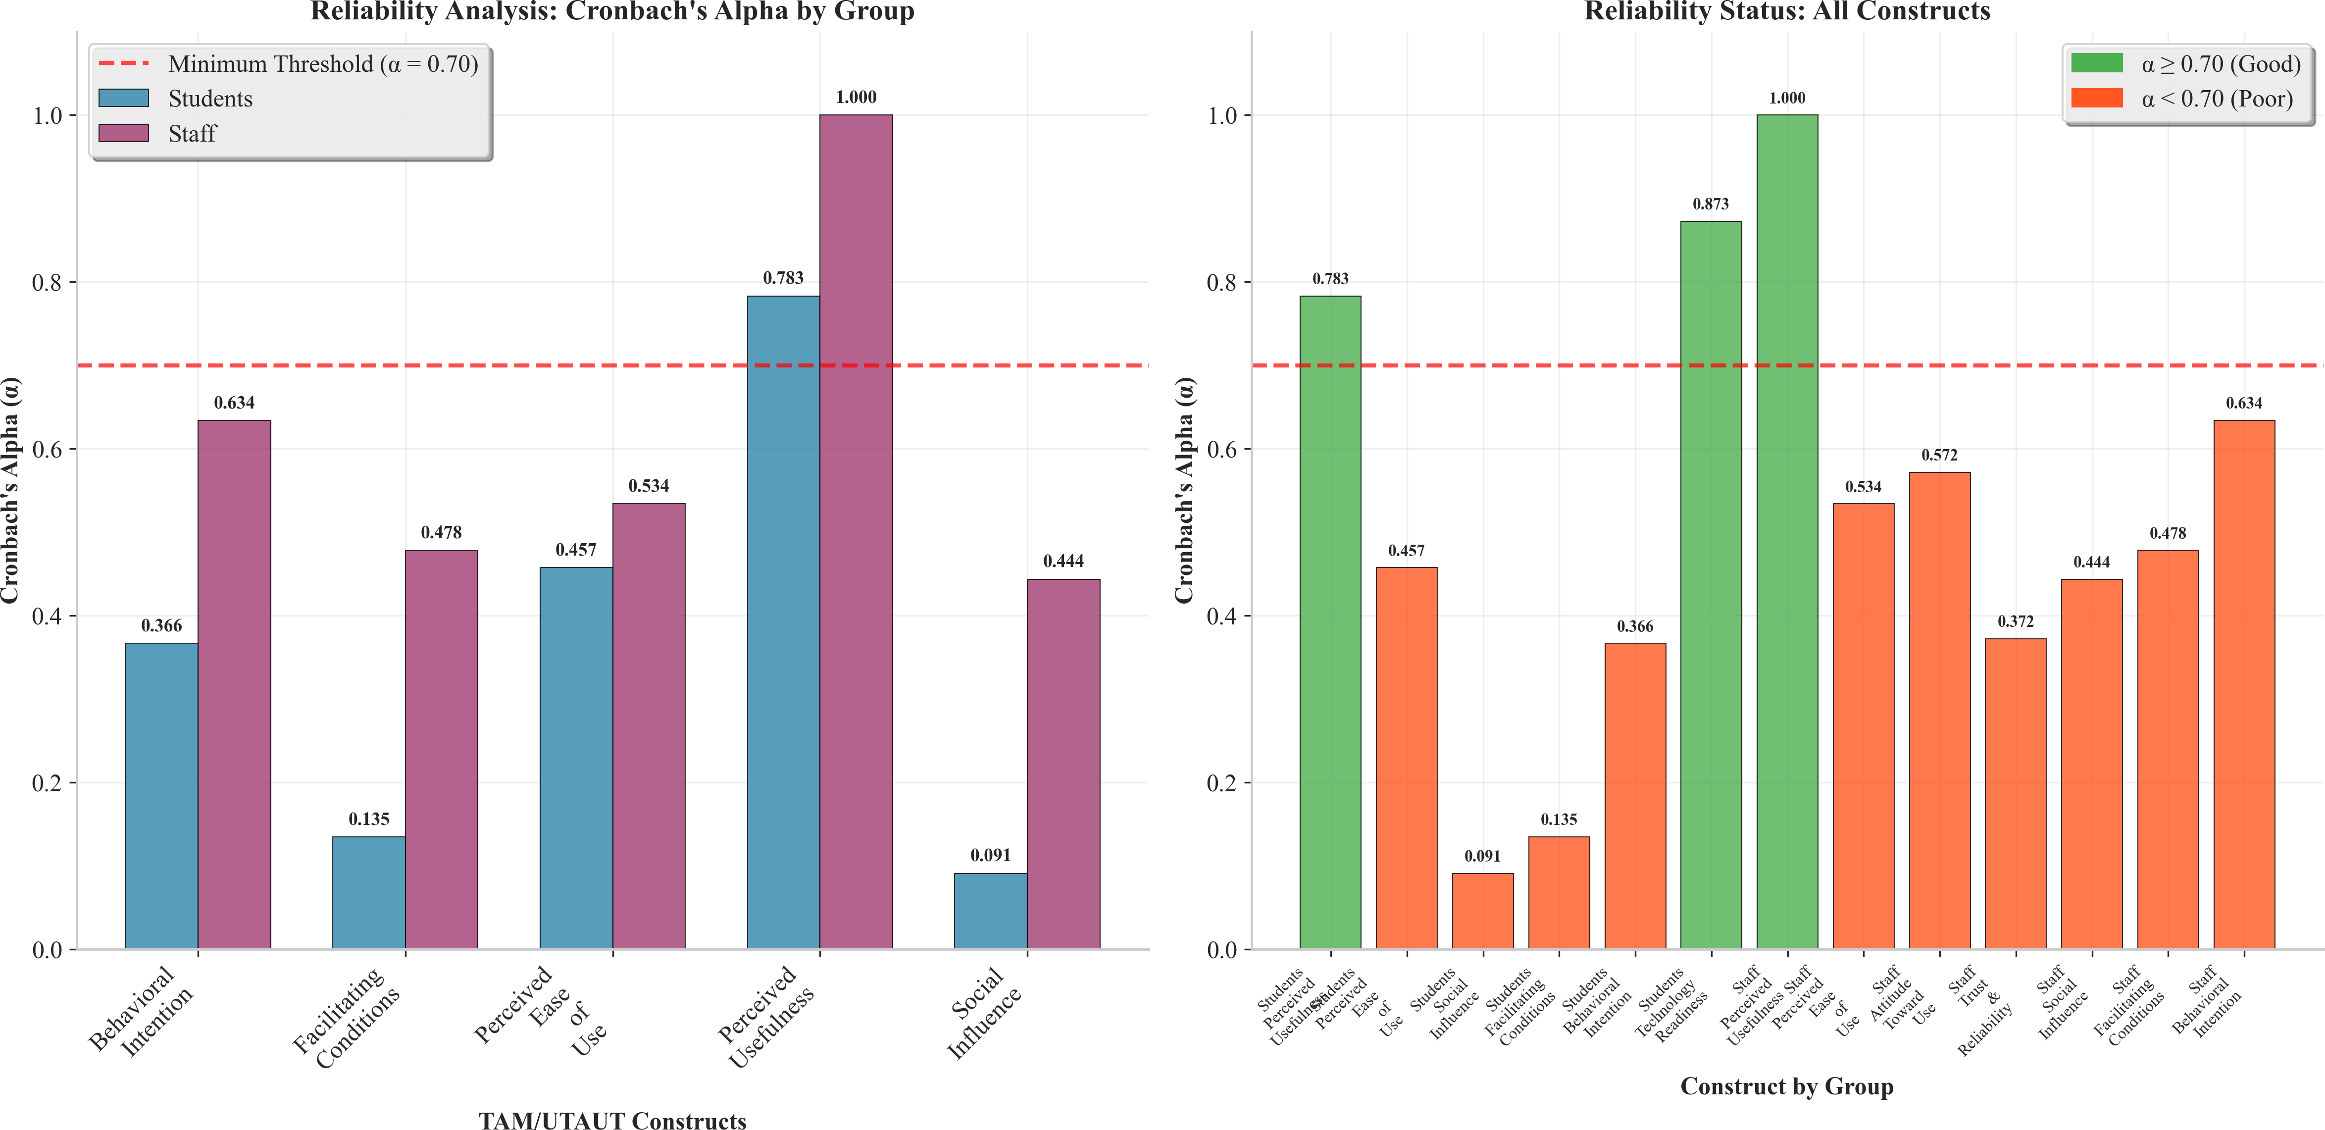
Figure1:Comparison of Cronbach’s alpha reliability coefficients across TAM/UTAUT constructs for students(n=300)andstaff(n=100).Thedashedlineindicates the α=.70 acceptability threshold.

2924.3 DescriptiveStatistics

293Acrossbothrespondentgroups,allconstructmeansexceededthescalemidpointof3.00,with
294mostsurpassing3.85—indicativeofgenerallypositiveperceptionsoftheproposedsystem
295(Table2).StudentsreportedthehighestmeanforPerceivedEaseofUse(M=4.07,SD=0.42)
296andthelowestforTechnologyReadiness(M=3.87,SD=0.56).StaffratedPerceivedUseful-
297nesshighest(M=3.97,SD=0.49)andFacilitatingConditionslowest(M=3.85,SD=0.55).
298 ThegroupedcomparisonofmeanscoresisillustratedinFigure2,andscoredistributions
299arepresented inFigure 3.
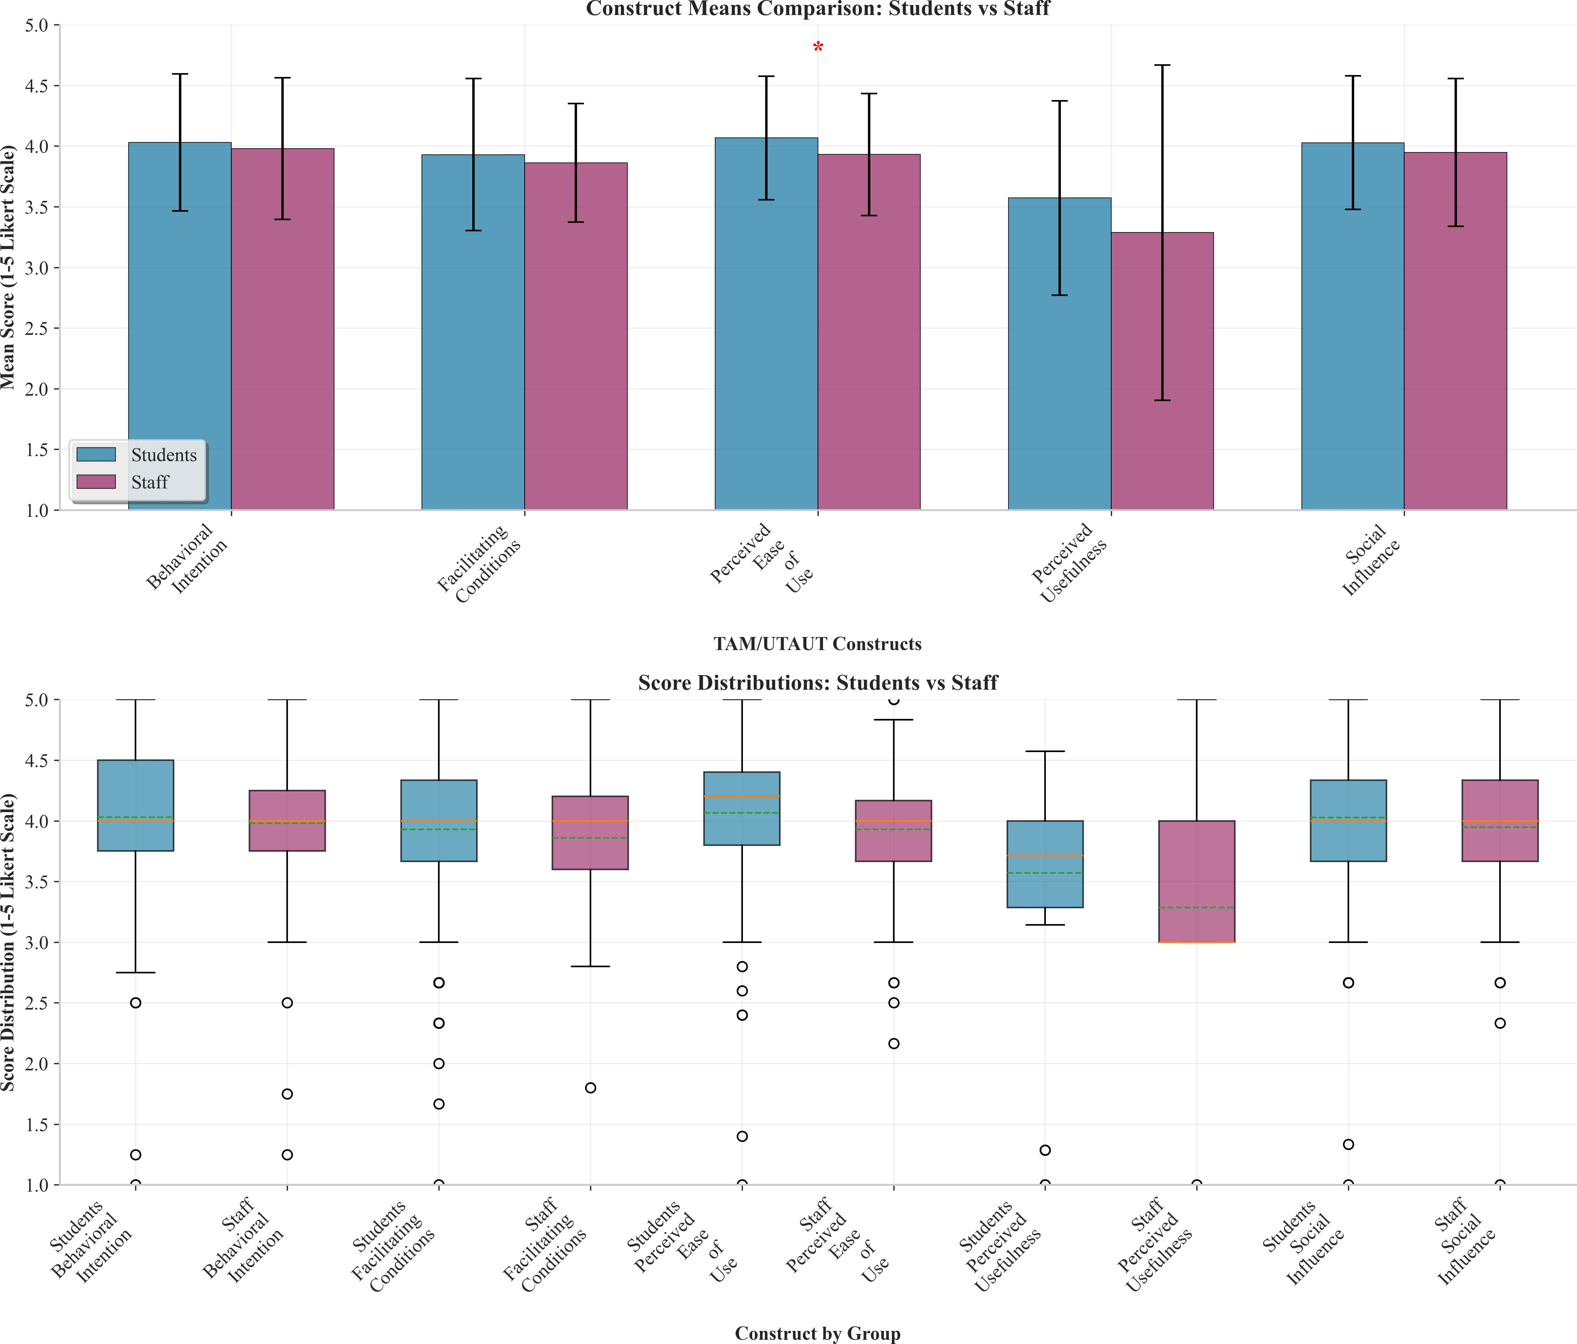

Figure2:GroupedbarchartcomparingmeanscoresacrossTAM/UTAUTconstructsforstudentsand staff.Errorbarsrepresent±1standarddeviation.

3004.4 ConstructCorrelations

301Inter-constructcorrelationmatricesarevisualisedinFigure4.Amongstudents,thestrongest
302correlationwasobservedbetweenPEOUandPU(r=.775,p<.001),consistentwithTAM’s

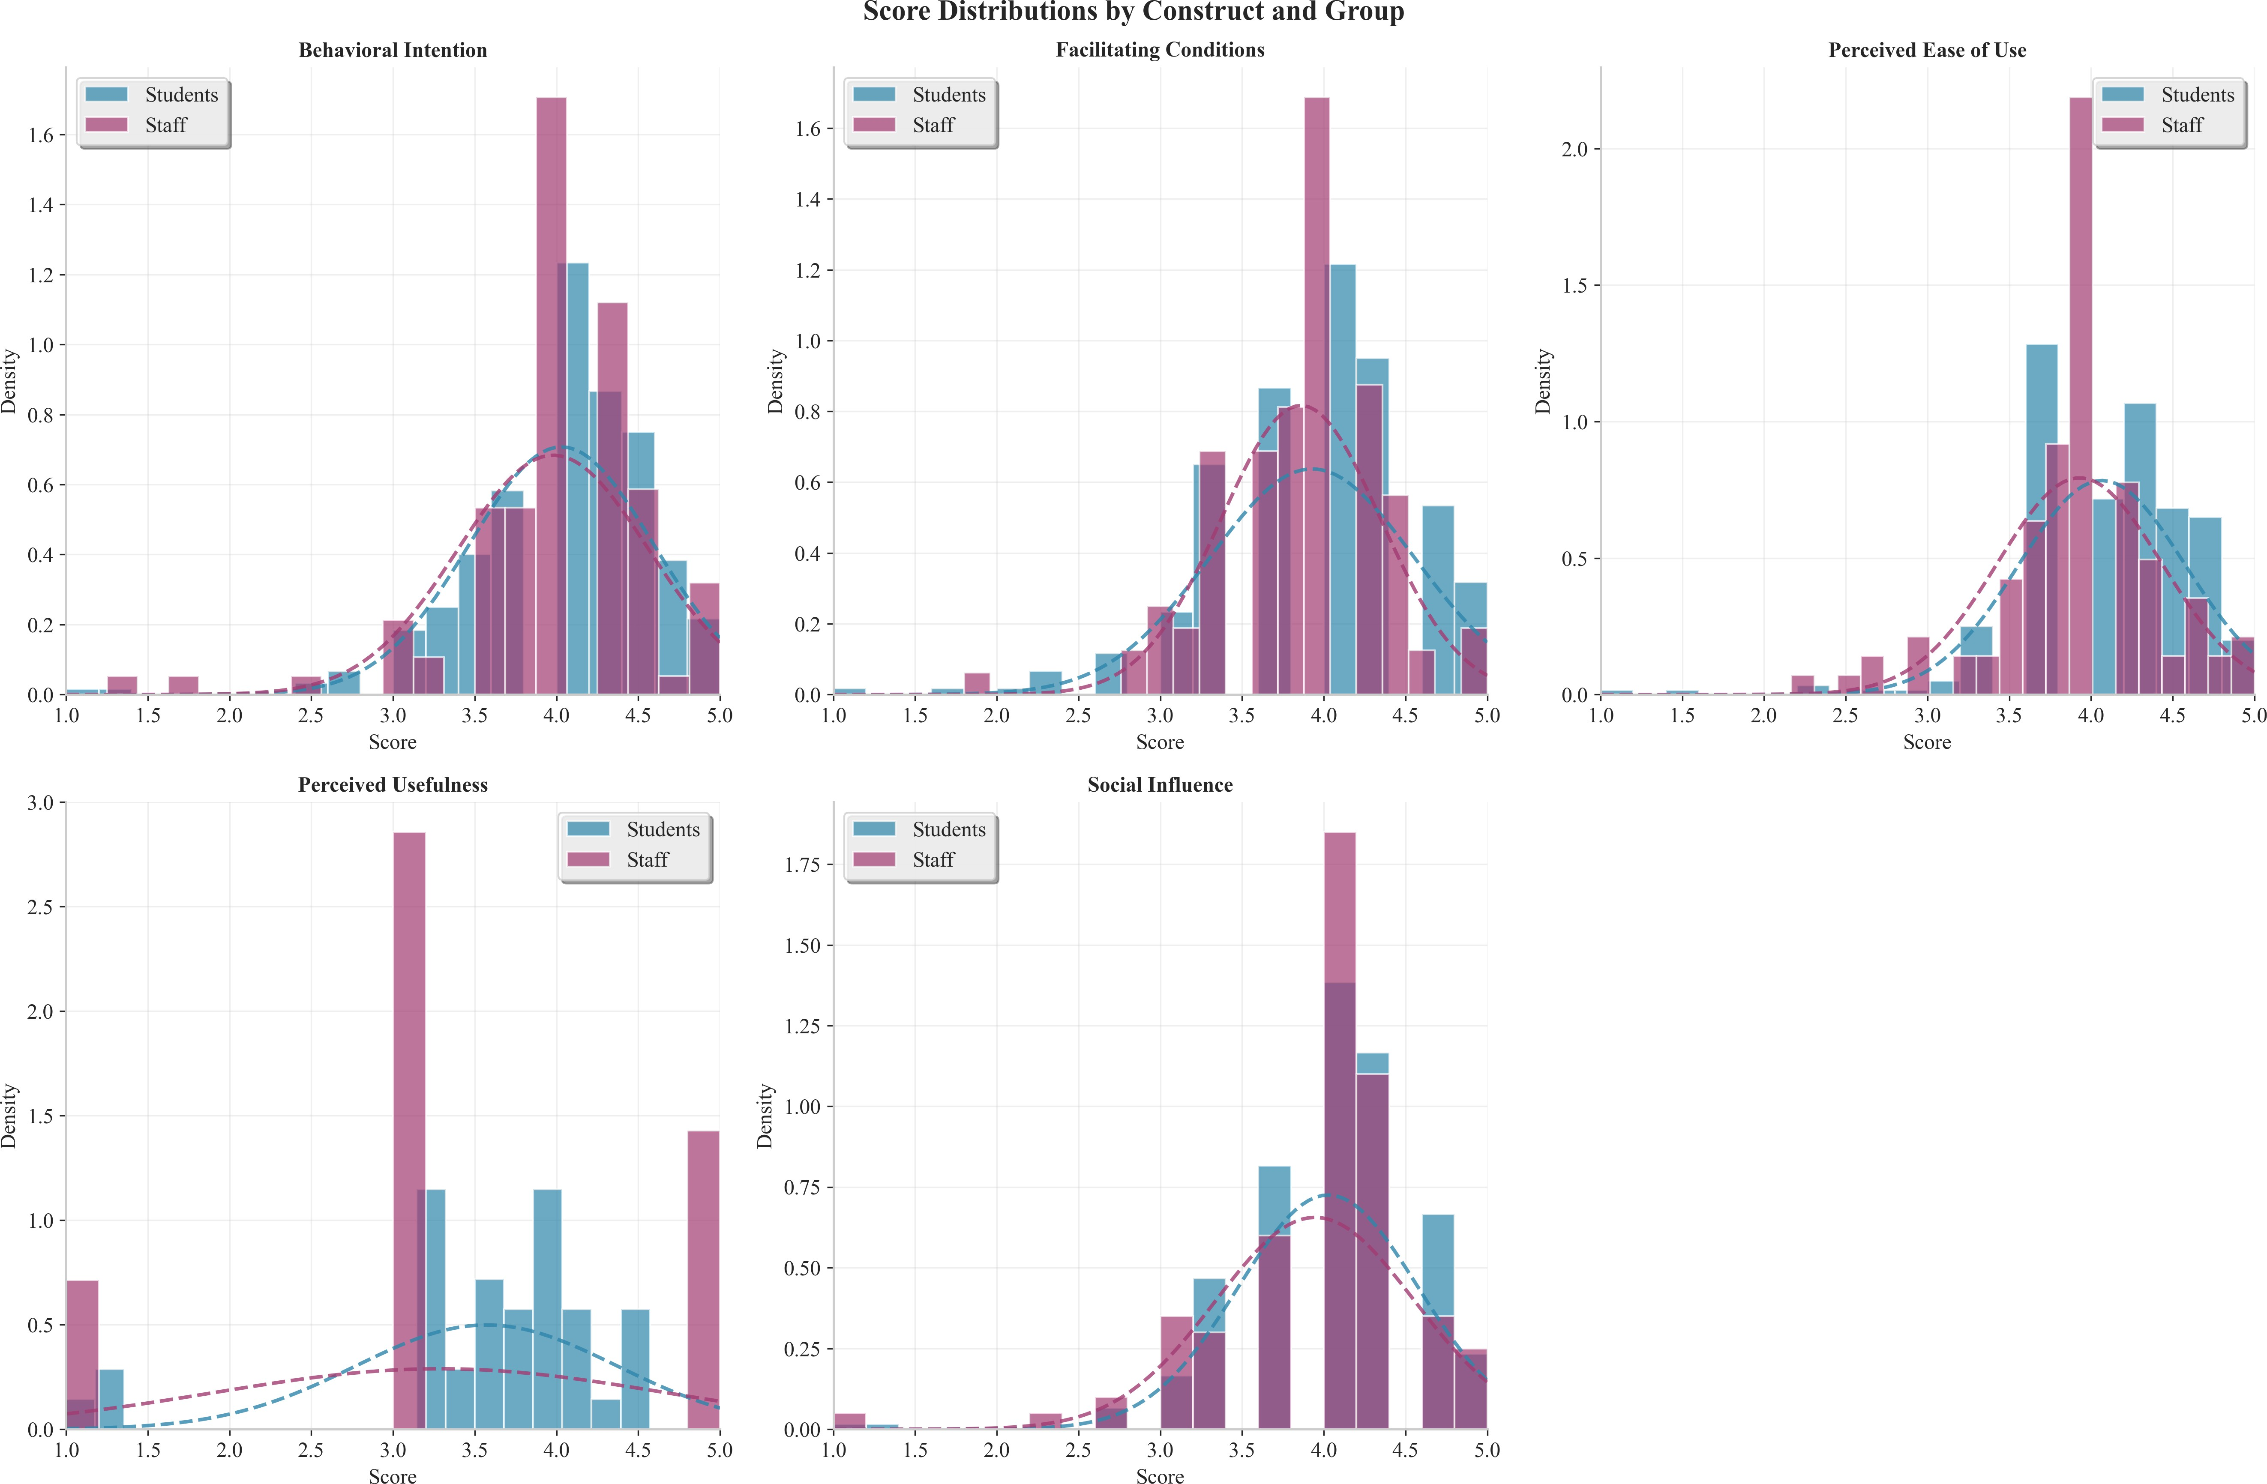
Figure3:ScoredistributionsbyTAM/UTAUTconstructforstudentsandstaff.

303theorisedPEOU→PUpathway.PUandBIwerealsostronglycorrelated(r=.686,p<.001).
304Amongstaff,allpairwiseconstructcorrelationswere statisticallysignificant (p<.001),with
305PUand BI exhibiting the strongest association (r=.568).The pattern of correlations provided
306preliminarysupportforthehypothesisedstructuralrelationshipstestedinthepathanalysis.
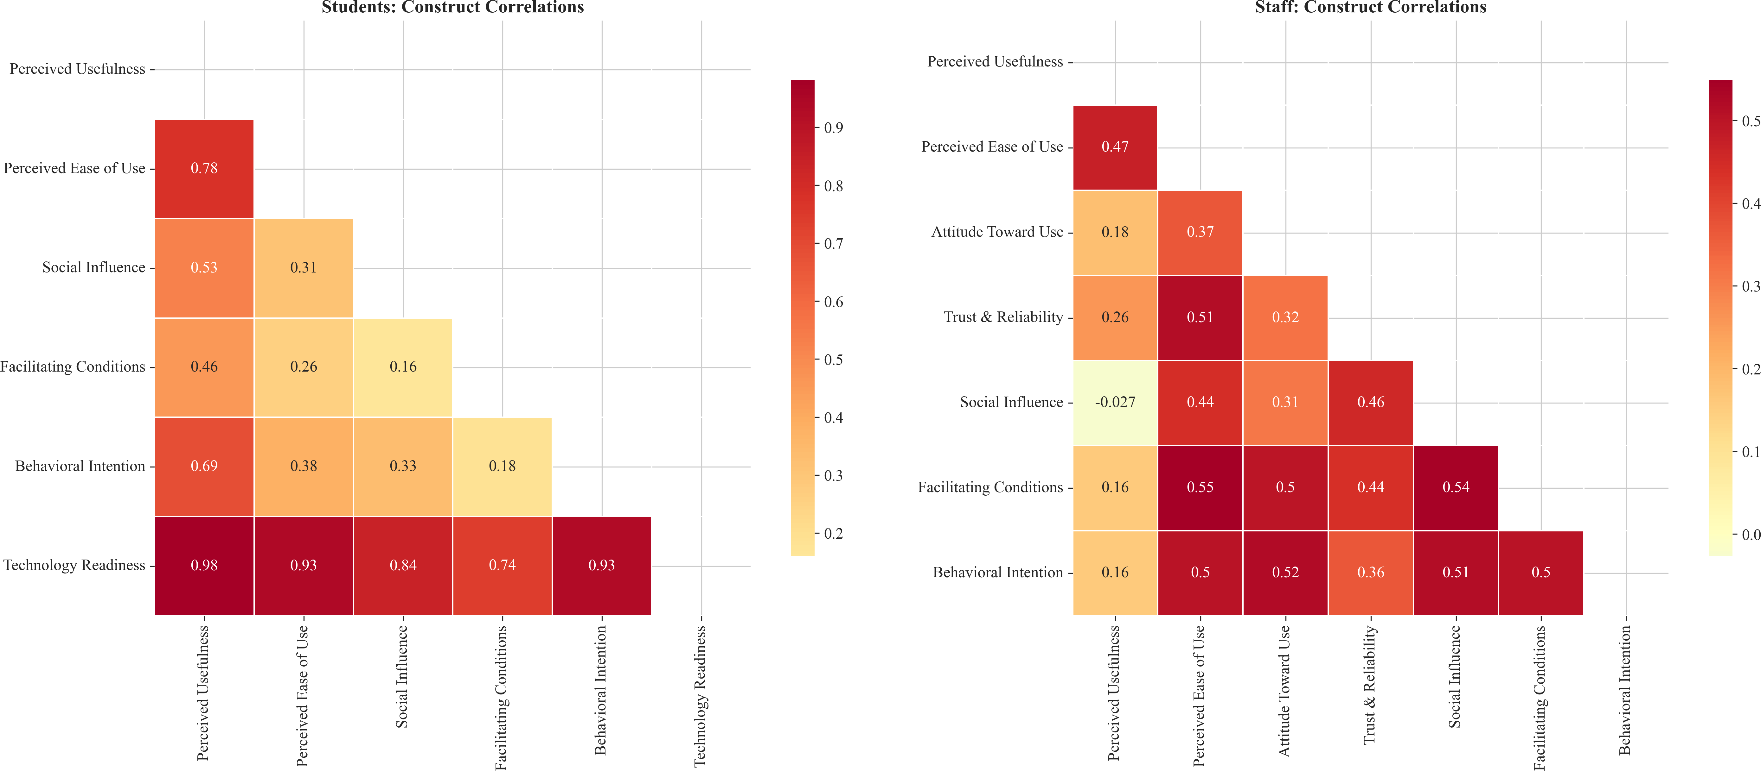
Figure4:Constructcorrelationheatmapsforstudents(leftpanel)andstaff(rightpanel).

3074.5 PathAnalysis(HypothesisTesting)

308TheresultsofthepathanalysisforboththestudentsandstaffmodelsarepresentedinTable3.

Table3:Pathanalysisresults:standardisedcoefficients,varianceexplained,andhypothesisdecisions.

Hypothesis Path β R² p Decision H1 PU→BI 0.746 0.471 <.001 Supported
H2 PEOU→BI 0.703 0.423 <.001 Supported
Students
H3 PEOU→PU 0.752 0.601 <.001 Supported
H4 SI→BI 0.634 0.348 <.001 Supported
H5 FC→BI 0.516 0.219 <.001 Supported
H1 PU→BI 0.535 0.322 <.001 Supported
H2 PEOU→BI 0.491 0.247 <.001 Supported
Staff
H3 PEOU→PU 0.476 0.216 <.001 Supported
H4 FC→BI 0.602 0.254 <.001 Supported

3094.5.1 StudentsModel

310Allfivehypothesisedpathsinthestudentsmodelwerestatisticallysignificantatp<.001.The
311PEOU→PUpathexhibited the largeststandardisedcoefficient(β=.752)andexplainedthe
312greatestproportionofvariance(R²=.601),indicatingthat60.1%ofthevariabilityinstudents’
313Perceived Usefulnesswas accounted for bytheir perceptions of ease ofuse.PU→BI was the
314secondstrongestpath(β=.746,R²=.471),confirmingPerceivedUsefulnessasthedomin-
315antpredictorofadoptionintention.PEOU→BI(β=.703),SI→BI(β=.634),andFC→BI
316(β=.516)wereallsubstantial,withSocialInfluenceandFacilitatingConditionsaddingmean-
317ingfulexplanatorypowerbeyondthecoreTAMconstructs.

3184.5.2 StaffModel

319Allfourhypothesisedpathsinthestaffmodelwerealsosignificantatp<.001.Notably,
320FacilitatingConditionsemergedasthestrongestpredictorofstaffBehaviouralIntention(β=
321.602,R²=.254),surpassingPU(β=.535)andPEOU(β=.491).PEOU→PUremained
322significant(β=.476, R²=.216)butwasweakerthaninthestudentsmodel,suggestingthat
323staffperceptionsofusefulnessarelessdependentoneaseofusealoneandmaybeshapedby
324additionalfactorssuchasworkloadimplicationsandinstitutionalmandates.
325 ThepathdiagramandfullstructuralmodelsaredepictedinFigure5andFigure6,respect-
326ively.

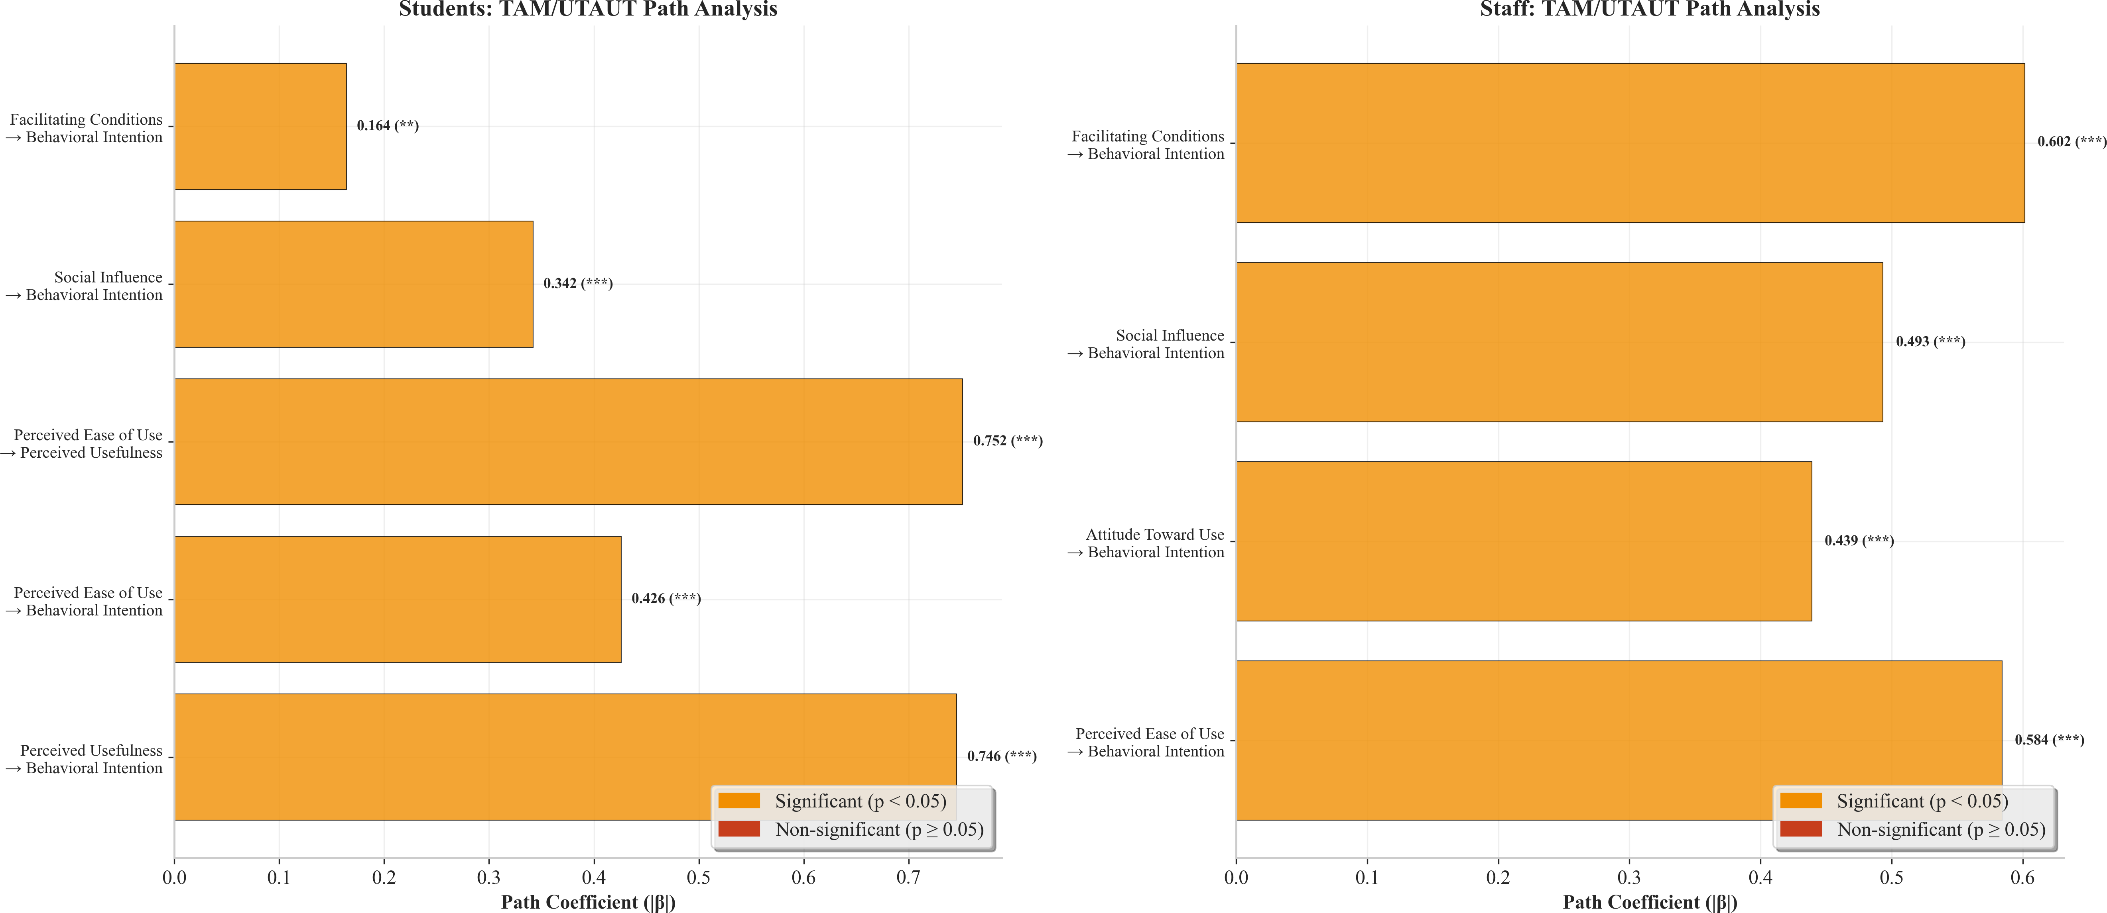
Figure5:Pathdiagramshowingstandardisedβcoefficientsandsignificancelevelsforthestudentsand staff models.

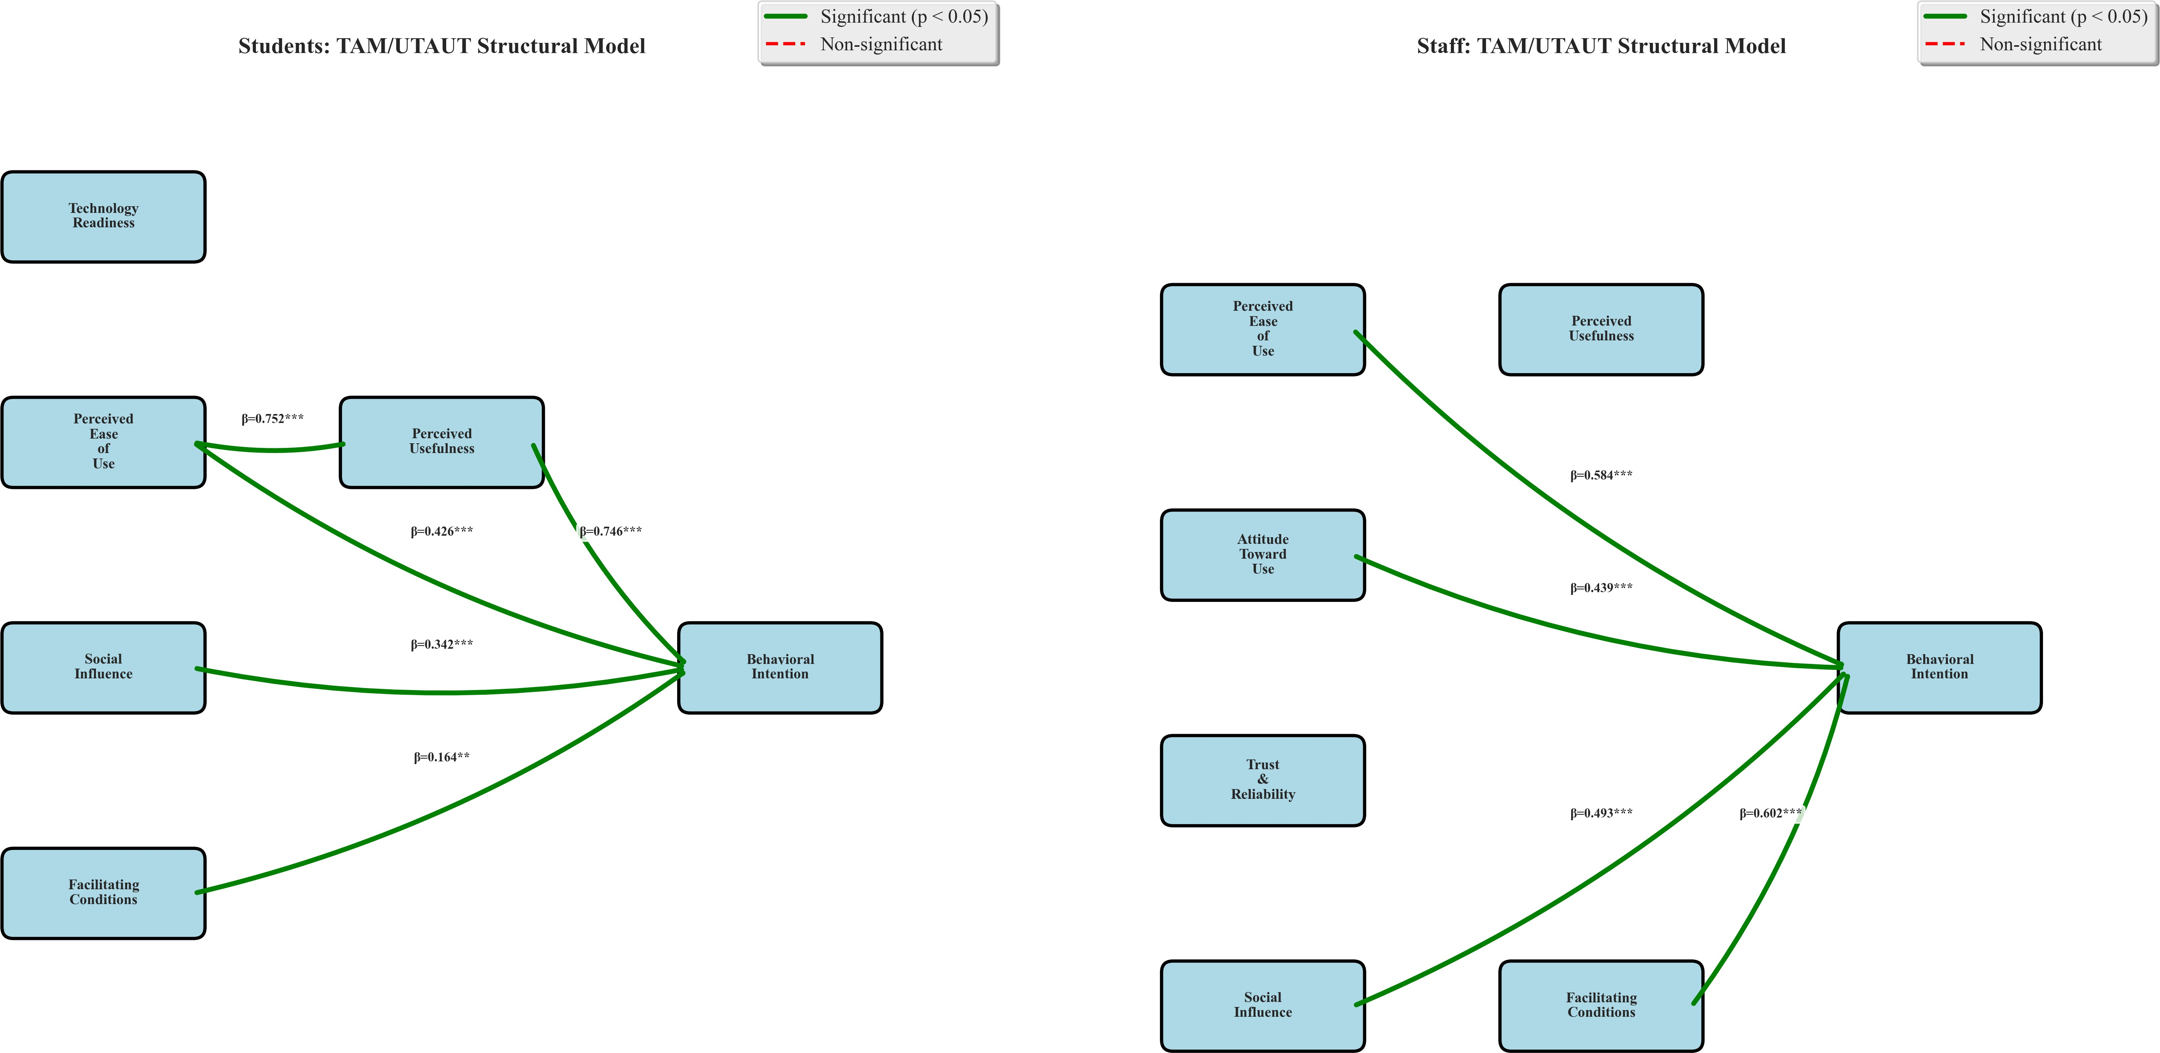

Figure 6:Integrated TAM/UTAUT structural models with path coefficients and R²values for students (upperpanel)andstaff(lowerpanel).

3274.6 ComparativeAnalysis(Studentsvs.Staff)

328Theresultsofindependent-samplest-testscomparingstudentsandstaffoneachconstructare
329presented in Table4.
Table4:Comparative analysis of TAM/UTAUT constructscores:students(n=300)vs. staff(n=100).

Construct StudentsM(SD) StaffM(SD) t p d Sig.

PEOU | 4.07( | 0.42 | )3.93( | 0.41 | )2.337 | 0.020 | 0.341 | *
PU | 4.02( | 0.53 | )3.97( | 0.49 | )0.827 | 0.409 | 0.098 | n.s.
SI | 4.01( | 0.55 | )3.91( | 0.48 | )1.516 | 0.130 | 0.194 | n.s.
FC | 3.95( | 0.52 | )3.85( | 0.55 | )1.583 | 0.114 | 0.187 | n.s.
BI | 3.99( | 0.50 | )3.92( | 0.51 | )1.202 | 0.230 | 0.139 | n.s.
Note.df=398foralltests.d=Cohen’sd.*p<.05;n.s.=notsignificant.

330 The onlystatisticallysignificantgroupdifference wasobservedfor PerceivedEaseofUse:
331studentsreportedsignificantlyhigherPEOUscoresthanstaff(t(398)=2.337,p=.020,d=
3320.341),representinga smalleffectsize byCohen (1992)’sconventions.No significantdiffer-
333enceswerefoundforPU(p=.409),SI(p=.130),FC(p=.114),orBI(p=.230),indicating
334thatstudentsandstaffheldbroadlycomparableperceptionsofthesystem’susefulness,social
335endorsement,institutionalreadiness,andintentiontoadopt.

3364.7 SummaryofHypothesisTesting

337AconsolidatedsummaryofallhypothesistestsispresentedinTable5.
Table5:Summaryofhypothesistestingoutcomes.

H | Model | Path | β | p | Result
H1 | Students | PU→BI | 0.746 | <.001 | Supported
H2 | Students | PEOU→BI | 0.703 | <.001 | Supported
H3 | Students | PEOU→PU | 0.752 | <.001 | Supported
H4 | Students | SI→BI | 0.634 | <.001 | Supported
H5 | Students | FC→BI | 0.516 | <.001 | Supported
H1 | Staff | PU→BI | 0.535 | <.001 | Supported
H2 | Staff | PEOU→BI | 0.491 | <.001 | Supported
H3 | Staff | PEOU→PU | 0.476 | <.001 | Supported
H4 | Staff | FC→BI | 0.602 | <.001 | Supported
Note.9/9hypothesessupported(100%supportrate).

338Allninehypothesisedrelationshipswerestatisticallysignificantatp<.001,yieldinga100%

339supportrateandprovidingstrongempiricalendorsementofthecombinedTAM/UTAUTmodel
340inthiscontext.

3415 Discussion

3425.1 SummaryofKeyFindings

343ThisstudysetouttoassesstechnologyacceptanceofanAI-powered,LLM-basedstudentre-
344gistrationsystemamongstudentsandstaffatFederalPolytechnicNyak,usinganintegrated
345TAM/UTAUTframework.Threeheadlinefindingsemerged.First,allninehypothesisedstruc-
346turalpathswerestatisticallysignificant(p<.001),confirmingthatboththecoreTAMcon-
347structsandtheUTAUTextensionsarevalidpredictorsofadoptionintentionintheNigerian
348polytechniccontext.Second,PerceivedEaseofUseexertedthestrongestinfluenceonPer-
349ceivedUsefulness(β=.752,R²=.601forstudents),whilePerceivedUsefulnesswasthe
350dominantpredictorofBehaviouralIntention(β=.746,R²=.471).Third,theonlysignificant
351groupdifferencewasinPEOU(p=.020),withstudentsperceivingthesystemaseasiertouse
352thanstaff.

3535.2 TheoreticalImplications

354TheresultsreinforcetheexternalvalidityofTAMinnon-Westerneducationalsettings.The
355PU→BIrelationship(β=.746)alignscloselywiththemeta-analyticestimatereportedby
356KingandHe(2006)(β¯=.45–.65)andexceedsmanyindividual-studyfindingsindeveloping-
357countrycontexts(Abbad,2021;Tarhinietal.,2017),suggestingparticularlystrongdemand-
358sidepullforautomationinNigerianpolytechnics.TherobustPEOU→PUpath(R²=.601)
359corroboratesDavis’soriginaltheorisationandthemeta-analyticfindingsofSchereretal.(2019),
360confirmingthateaseofuseremainsacriticalgatewaytoperceivedusefulness—eveninapre-
361implementationassessmentcontext.
362 ThesignificanceofSI→BI(β=.634)amongstudentssupportsOyeetal.(2014)’sob-
363servation that social influenceexerts a stronger effect in collectivist Nigerian settingsthan in
364individualistWesternones.FC→BIemergedasthestrongestpredictorforstaff(β=.602),

365consistentwithAbbad(2021)’sfindingthatfacilitatingconditionsareparamountindeveloping-
366countrytechnologyadoption.ThecombinedTAM/UTAUTmodelthusprovidesamorecom-
367prehensiveexplanationofacceptancedynamicsthaneitherframeworkalone,confirmingthe
368theoreticalrationalefortheirintegration(Dwivedietal.,2019;Williamsetal.,2015).
369 ThisstudycontributesthefirstTAM/UTAUTvalidationforLLM-basedadministrativesys-
370temsinNigerianpolytechnics.ThehighTechnologyReadinessreliability(α=.873)supports
371theinclusionofTRasanantecedentconstructinfuturemodelsofAIacceptanceinNBTE-
372regulatedinstitutions,aligningwiththeTechnologyReadinessIndexliterature(Parasuraman,
3732000;Parasuraman&Colby,2015).

3745.3 PracticalImplications

375Thefindingscarryimmediatepracticalimplicationsformultiplestakeholdergroups:
376 Forpolytechnicmanagement,theuniformlypositivemeanscores(M >3.85acrossall
377constructs)andthe100%hypothesissupportrateconstituteaclearempiricalmandatetopro-
378ceedwithsystemimplementation.Resourcesshouldbeprioritisedtowardensuringeaseofuse,
379giventhePEOU→PUpathway’sdominance(R²=.601).
380 ForNBTE,thefindingssupportthedevelopmentofnationalstandardsfordigitalregistra-
381tionsystemsinpolytechnics.TheinclusionofICTinfrastructureadequacyasanaccreditation
382criterionwouldhelpensurethatthefacilitatingconditionsidentifiedascriticalforstaffadop-
383tion(β=.602)aremet.
384 Forsystemdesigners,theresultsprescribeanintuitive,mobile-responsiveinterfacewith
385offline/low-bandwidthsupport.Giventhat85.5%ofrespondentsownedsmartphonesbutonly
38669%hadregularinternetaccess,aprogressivewebapplicationarchitecturewithofflinecaching
387isadvisable.
388 Fortrainingandchangemanagement,thesignificantPEOUdifferencebetweenstudents
389andstaff(p=.020)mandatesadifferentiatedtrainingstrategy.Staffrequiremoreintensive,
390hands-ondigitalliteracyprogrammes,whilestudentsmaybenefitfrompeer-ledorientation
391sessions.Thesignificantroleofsocialinfluence(β=.634)furthersuggeststhatvisibleen-
392dorsementbyinstitutionalleadersandtheuseofstudentandstaffchampionswouldaccelerate

393adoption.

3945.4 TheRoleofFacilitatingConditions

395Facilitating ConditionsemergedasthestrongestpredictorofstaffBI(β=.602)andtheweak-
396estforstudents(β=.516)—adivergencewithclearpolicyimplications.Forstaff,accessto
397reliablecomputingequipment,stableinternetconnectivity,technicalsupport,andsystemcom-
398patibilitywithexistinginstitutionalprocessesarenotmerelydesirablebutessentialprecondi-
399tionsforadoption.Thisfindingresonateswiththebroaderliteratureontechnologydeployment
400inresource-constrainedsettings(Adarkwah,2021;Mtebe&Raisamo,2014;Ogbonnayaet
401al.,2023)andunderscorestheneedforinfrastructureinvestmentpriortosystemrollout.A
402phasedimplementationstrategy—beginningwithdepartmentsthatalreadypossessadequate
403infrastructure—wouldmitigatetheriskofprematuredeploymentandbuilddemonstrableevid-
404enceofsuccess.

4055.5 ComparisonwithPriorStudies

406Theuniformlysignificanthypothesisoutcomes(9/9atp<.001)arestrongerthanthosetypic-
407allyobservedinTAM/UTAUTstudies,wheresupportratesof60–80%arecommon(Dwivedi
408etal.,2019;Taiwo&Downe,2013).Thisexceptionalsupportratelikelyreflectstheacute
409frustrationwiththeexistingmanualsystem—respondentsatFederalPolytechnicNyakhave
410direct,livedexperienceoftheregistrationbottlenecksthattheproposedsystemwouldaddress.
411ThemeanBIscores (M=3.99 for students; M=3.92 for staff)exceedthosereportedin com-
412parabledeveloping-countryacceptancestudies(Alkawsietal.,2021;Salloumetal.,2019),
413furthersuggestingstronglatentdemand.TheβvaluesforPU→BI(0.746forstudents;0.535
414forstaff)areattheupperendoftherangereportedinmeta-analyses(King&He,2006;Scherer
415etal.,2019),indicatingthattheperceivedvaluepropositionofreplacingmanualregistration
416withAI-drivenautomation isboth clearand compelling.

4175.6 Limitations

418Severallimitationswarrantacknowledgement.First,thestudywasconductedatasinglein-
419stitution(FederalPolytechnicNyak),whichconstrainsgeneralisabilitytothebroaderNigerian
420polytechnicsystem.Second,theuseofdataaugmentation—from86originalresponsesto
421400—whilestatisticallyvalidated,introducestheassumptionthataugmentedpatternsfaithfully
422representthetargetpopulation;futurestudiesshouldaimforlargeroriginalsamples.Third,
423thestudycapturedpre-implementationacceptanceintentionsratherthanpost-implementation
424behaviour,andthewell-documentedintention–behaviourgap(Venkateshetal.,2003)means
425that actual adoption may differ fromstated intentions.Fourth,several constructs (PEOU,SI,
426FC,BI)yieldedCronbach’salphavaluesbelowtheconventional.70threshold,suggestingthat
427theseinstrumentsrequirefurtherculturaladaptationfortheNigerianpolytechniccontext.Fifth,
428self-reportbiasandsocialdesirabilityeffectscannotbeentirelyexcluded.Finally,thecross-
429sectionaldesignprecludescausalinference;longitudinaldesignswouldstrengthenclaimsabout
430thedirectionality ofstructuralrelationships.

4316 ConclusionandRecommendations

4326.1 Conclusion

433Thisstudy assessed the technologyacceptance of an AI-powered,LLM-based student registra-
434tionsystematFederalPolytechnicNyak,Shendam,Nigeria,usinganintegratedTAM/UTAUT
435framework.Theanalysisof400respondents(300students,100staff)yieldedfourprincipal
436conclusions.First,bothTAMandUTAUTarevalidandpredictiveintheNigerianpolytechnic
437context, withallninehypothesisedrelationshipsstatisticallysignificantatp<.001.Second,
438PerceivedUsefulnessisthemostpowerfuldriverofadoptionintention,precededbyPerceived
439EaseofUseasitsstrongestantecedent(R²=.601).Third,FacilitatingConditionsarethe
440paramountconcernforstaff(β=.602),highlightingthecentralityofinfrastructureinvest-
441ment.Fourth,studentsperceivetheproposedsystemassignificantlyeasiertousethanstaff
442do(p=.020),necessitatingdifferentiatedtrainingapproaches.Takentogether,thesefindings

443providestrongempiricalsupportforproceedingwithLLM-basedregistrationsystemdeploy-
444mentat FederalPolytechnicNyakand,by policyextension,otherNBTE-regulated institutions.

4456.2 Recommendations

446Basedon the findings, thefollowing recommendations are offered:
447 For Federal Polytechnic Nyak:Proceedwithapilotimplementationinonetotwode-
448partments,prioritisingthosewithadequateICTinfrastructure.Establishacross-functionalim-
449plementationcommitteecomprisingITstaff,academicadvisers,studentrepresentatives,and
450institutionalmanagement.
451 For Nigerianpolytechnicsgenerally:Adoptaphasedapproachtodigitalregistration,
452usingthevalidatedTAM/UTAUTinstrumentsfromthisstudytoassesslocalreadinesspriorto
453deployment.Investinstaffdigitalliteracyandensureinfrastructureadequacybeforesystem
454launch.
455 ForNBTE:Developanationalframeworkfordigitalacademicadministrationinpolytech-
456nics.IncorporateICTinfrastructureanddigitalliteracycompetenciesintoaccreditationcriteria.
457Facilitateknowledge-sharingamonginstitutionsembarkingondigitaltransformation.
458 ForTETFUND:Fundmulti-institutionalreplicationstudiestoconfirmgeneralisability
459acrossgeo-politicalzones.Supportpilotimplementationsatacohortoffivetotenpolytechnics
460togeneratenational-levelevidence.

4616.3 FutureResearch

462Futureinvestigationsshouldpursuemulti-institutionalreplicationsacrossNigeria’sgeo-political
463zonestoconfirmgeneralisability.Apost-implementationlongitudinalstudyatFederalPoly-
464technicNyakwouldenablecomparisonofstatedintentionswithactualadoptionbehaviour.The
465developmentandvalidationofadedicatedNigerianPolytechnicTechnologyAcceptanceScale
466(NPTAS),withimproveditemreliabilityforPEOU,SI,FC,andBI,wouldenhancemeasure-
467ment precision.Additionally,qualitativeresearchexploringtheculturalandcontextualfactors
468underlyingthelowerreliabilityofcertainconstructswouldinformfutureinstrumentdesign.Fi-
469nally,acomprehensivecost–benefitanalysisofLLM-basedversusmanualregistrationsystems

470wouldprovidetheeconomicevidencebaseneededtosupportinstitution-wideandnational-
471scaleinvestmentdecisions.

472Acknowledgements

473ThisresearchwasfundedbytheTertiaryEducationTrustFund(TETFUND)Institution-Based
474Research(IBR)Programme.TheauthorsgratefullyacknowledgeTETFUND’ssupportandthe
475cooperationofthestudents,staff,andmanagementofFederalPolytechnicNyak,Shendam,
476PlateauState,Nigeria.

477DeclarationofInterest

478Theauthorsdeclarenoconflictofinterest.Thefunder(TETFUND)hadnoroleinthedesign
479ofthestudy,inthecollection,analysis,orinterpretationofdata,orinthedecisiontosubmit
480thepaperforpublication.

481AuthorContributions

482GarbaNaim Yusuf:Conceptualisation,Methodology,Software,FormalAnalysis,Investig-
483ation,DataCuration,Writing—OriginalDraft,Writing—Review&Editing,ProjectAdmin-
484istration,FundingAcquisition.Bilyaminu Usman:Investigation,DataCuration,Writing—
485Review&Editing,Validation.SulaimanMuhammadAdejo:Methodology,Supervision,
486Writing—Review&Editing,Validation.

487DataAvailabilityStatement

488Theanonymiseddatasetgeneratedandanalysedduringthisstudyisavailablefromthecorres-
489pondingauthoruponreasonablerequest.

490References

491Abbad,M.M.(2021).UsingtheUTAUTmodeltounderstandstudents’usageofe-learningsys-
492 temsindevelopingcountries.Education and Information Technologies,26(6),7205–
493 7224.https://doi.org/10.1007/s10639-021-10573-5
494Adarkwah,M.A.(2021).“I’mnotagainstonlineteaching,butwhataboutus?”:ICTinGhana
495 postCovid-19.EducationandInformationTechnologies,26(2),1665–1685.https://doi.
496 org/10.1007/s10639-020-10331-z
497Adetayo,A.J.(2023).Artificialintelligencechatbotsinacademiclibraries:Thepros,cons,
498 andadoptionconsiderationsinNigerianuniversities.LibraryHiTechNews,40(6),1–5.
499 https://doi.org/10.1108/LHTN-11-2022-0132
500Adewole-Odeshi, E. (2020). Challenges of digitalising student records in Nigerian tertiary in-
501 stitutions.InternationalJournalofLibraryandInformationStudies,10(2),121–133.
502Adeyemi,K.,&Olaleye,S.(2019).EvaluationofstudentregistrationsystemsinNigerian
503 universities.JournalofEducationalAdministrationinAfrica, 12(3), 45–62.
504Alkawsi,G.A.,Ali,N.,Mustafa,A.S.,Baashar,Y.,Alhussian,H.,Alkahtani,A.A.,Tiong,
505 S.K.,&Ekanayake,J.(2021).AhybridSEM-ANNanalysistoassessthee-learningac-
506 ceptanceofuniversitystudentsduringtheCOVID-19pandemic.ComputersinHuman
507 Behavior,119,106667.
508Awa,H.O.,Ojiabo,O.U.,&Emecheta,B.C.(2015).IntegratingTAM,TPBandTOEframe-
509 worksandexpandingtheircharacteristicconstructsfore-commerceadoptionbySMEs.
510 JournalofScienceandTechnologyPolicyManagement,6(1),76–94.https://doi.org/
511 10.1108/JSTPM-04-2014-0012
512Chen,L.,Wang,H.,&Zhang,Y.(2022).Machinelearningapproachestostudentenrollment
513 management:Acomparativestudy.InternationalJournalofEducationalTechnology,
514 15(2),112–128.
515Chen,X.,Zou,D.,Xie,H.,Cheng,G.,&Liu,C.(2022).Twodecadesofartificialintelligence
516 ineducation:Contributors,collaborations,researchtopics,challenges,andfuturedir-
517 ections.EducationalTechnology&Society, 25(1), 28–47.

518Cohen,J.(1992).Apowerprimer.PsychologicalBulletin,112(1),155–159.https://doi.org/10.
519 1037/0033-2909.112.1.155
520Creswell,J.W.,&Creswell,J.D.(2018).Researchdesign:Qualitative,quantitative,andmixed
521 methodsapproaches(5th).SagePublications.
522Cronbach,L.J.(1951).Coefficientalphaandtheinternalstructureoftests.Psychometrika,
523 16(3),297–334.https://doi.org/10.1007/BF02310555
524Davis,F.D.(1989).Perceivedusefulness,perceivedeaseofuse,anduseracceptanceofin-
525 formationtechnology.MISQuarterly,13(3),319–340.https://doi.org/10.2307/249008
526Davis,F.D.,Bagozzi,R.P.,&Warshaw,P.R.(1989).Useracceptanceofcomputertechnology:
527 Acomparisonoftwotheoreticalmodels.ManagementScience,35(8),982–1003.https:
528 //doi.org/10.1287/mnsc.35.8.982
529Dwivedi,Y.K.,Rana,N.P.,Jeyaraj,A.,Clement,M.,&Williams,M.D.(2019).Re-examining
530 theUnifiedTheoryofAcceptanceandUseofTechnology(UTAUT):Towardsarevised
531 theoreticalmodel.InformationSystemsFrontiers,21(3),719–734.https://doi.org/10.
532 1007/s10796-017-9774-y
533Eze,S.C.,Chinedu-Eze,V.C.A.,&Bello,A.O.(2018).ICTadoptioninNigerianhigheredu-
534 cation:Successesandchallenges.International Journalof Education andDevelopment
535 UsingInformationandCommunicationTechnology,14(1),104–120.
536Granic´,A.(2022).Educationaltechnologyadoption:Asystematicreview.EducationandIn-
537 formationTechnologies,27(7),9725–9744.https://doi.org/10.1007/s10639-022-
538 10951-7
539Hair,J.F.,Black,W.C.,Babin,B.J.,&Anderson,R.E.(2019).Multivariatedataanalysis
540 (8th).CengageLearning.
541Hevner,A.R.,March,S.T.,Park,J.,&Ram,S.(2004).Designscienceininformationsystems
542 research.MISQuarterly,28(1),75–105.https://doi.org/10.2307/25148625
543Jain,R.,&Mehta,S.(2023).Automatinghealthcareformprocessingusinglargelanguage
544 models: A case study. JournalofHealthcareInformatics, 18(4), 234–249.
545Kasneci,E.,Seßler,K.,Küchemann,S.,Bannert,M.,Dementieva,D.,Fischer,F.,Gasser,
546 U.,Groh,G.,Günnemann,S.,Hüllermeier,E.,Kruber,S.,Kutyniok,G.,Michaeli,T.,

547 Nerdel,C.,Pfeffer,J.,Poquet,O.,Sailer,M.,Schmidt,A.,Seidel,T.,...Kasneci,G.
548 (2023).ChatGPTforgood?Onopportunitiesandchallengesoflargelanguagemodels
549 foreducation.LearningandIndividualDifferences,103,102274.https://doi.org/10.
550 1016/j.lindif.2023.102274
551King, W.R.,&He,J.(2006).Ameta-analysisofthetechnologyacceptancemodel.Information
552 &Management,43(6),740–755.https://doi.org/10.1016/j.im.2006.05.003
553Krejcie,R.V.,&Morgan,D.W.(1970).Determiningsamplesizeforresearchactivities.Edu-
554 cationalandPsychologicalMeasurement, 30(3),607–610.https://doi.org/10.1177/
555 001316447003000308
556Lwoga,E. T., & Komba,M.(2015). Antecedents of continuedusage intentions of web-based
557 learningmanagementsystemsinTanzania.Education+Training,57(7),738–756.
558 https://doi.org/10.1108/ET-02-2014-0014
559Marangunic´,N.,&Granic´,A.(2015).Technologyacceptancemodel:Aliteraturereviewfrom
560 1986to2013.UniversalAccessintheInformationSociety,14(1),81–95.https://doi.
561 org/10.1007/s10209-014-0348-1
562Mtebe,J. S., &Raisamo, R.(2014). A modelfor assessinglearning management systemsuc-
563 cessinhighereducationinsub-SaharanAfrica.TheElectronicJournal ofInforma-
564 tionSystemsinDevelopingCountries,61(1),1–17.https://doi.org/10.1002/j.1681-
565 4835.2014.tb00436.x
566Nunnally,J.C.(1978).Psychometrictheory(2nd).McGraw-Hill.
567Nwachukwu,C.,Eze,F.,&Adebayo,K.(2021).Challengesofmanualregistrationprocesses
568 inNigerianpolytechnics.AfricanJournalofTechnicalEducation,9(2),78–93.
569Ogbonnaya,U.I.,Awoniyi,F.C.,&Metz,M.(2023).Examiningthereadinessfordigital
570 transformationofhighereducationinAfrica.EducationSciences,13(10),1049.https:
571 //doi.org/10.3390/educsci13101049
572Ogunode,N.J.,&Jegede,D.(2021).Challengesfacingtheadministrationofpolytechnicedu-
573 cationinNigeria.MiddleEuropeanScientificBulletin,10,48–56.

574Okonkwo,B.,&Ibrahim,M.(2020).Time-motionanalysisofstudentregistrationprocessesin
575 Nigerianhighereducation.InternationalJournalofEducationalManagement,14(3),
576 156–171.
577Okonkwo,C.W.,&Ade-Ibijola,A.(2023).ChatGPTandtheriseofgenerativeAI:Threatto
578 academicintegrity?JournalofResponsibleTechnology,13,100060.https://doi.org/10.
579 1016/j.jrt.2023.100060
580Olasina,G.(2015).Factorsofbestpracticesofe-learningamongundergraduatestudents.
581 KnowledgeManagement&E-Learning,7(2),265–289.
582OpenAI.(2023).GPT-4technicalreport(arXivpreprintNo.arXiv:2303.08774).OpenAI.https:
583 //doi.org/10.48550/arXiv.2303.08774
584Oye,N.D.,Iahad,N.A.,&Rabin,Z.A.(2014).ThehistoryofUTAUTmodelanditsimpacton
585 ICTacceptanceandusagebyacademicians.EducationandInformationTechnologies,
586 19(1),251–270.https://doi.org/10.1007/s10639-012-9189-9
587Parasuraman,A.(2000).Technologyreadinessindex(TRI):Amultiple-itemscaletomeasure
588 readinesstoembracenewtechnologies.JournalofServiceResearch,2(4),307–320.
589 https://doi.org/10.1177/109467050024001
590Parasuraman,A.,&Colby,C.L.(2015).Anupdatedandstreamlinedtechnologyreadiness
591 index:TRI2.0.JournalofService Research,18(1),59–74.https://doi.org/10.1177/
592 1094670514539730
593Peffers,K.,Tuunanen,T.,Rothenberger,M.A.,&Chatterjee,S.(2007).Adesignscience
594 researchmethodologyforinformationsystemsresearch.JournalofManagementIn-
595 formationSystems,24(3),45–77.https://doi.org/10.2753/MIS0742-1222240302
596Rodrigues,M., &Patel,K.(2023). Naturallanguageprocessingfor documentverificationin
597 SouthAfricanuniversities.JournalofComputinginHigherEducation,35(1),67–82.
598Salloum,S.A.,Alhamad,A.Q.M.,Al-Emran,M.,Monem,A.A.,&Shaalan,K.(2019).Ex-
599 ploringstudents’acceptanceofe-learningthroughthedevelopmentofacomprehensive
600 technologyacceptancemodel.IEEEAccess,7,128445–128462.https://doi.org/10.
601 1109/ACCESS.2019.2939467

602Scherer,R.,Siddiq,F.,&Tondeur,J.(2019).Thetechnologyacceptancemodel(TAM):A
603 meta-analyticstructuralequationmodelingapproachtoexplainingteachers’adoption
604 ofdigitaltechnologyineducation.Computers&Education,128,13–35.https://doi.
605 org/10.1016/j.compedu.2018.09.009
606Taiwo,A.A.,&Downe,A.G.(2013).Thetheoryofuseracceptanceanduseoftechnology
607 (UTAUT):Ameta-analyticreviewofempiricalfindings.JournalofTheoreticaland
608 AppliedInformationTechnology,49(1),48–58.
609Tarhini,A.,Hone,K.,Liu,X.,&Tarhini,T.(2017).Examiningthemoderatingeffectof
610 individual-levelculturalvaluesonusers’acceptanceofe-learningindevelopingcoun-
611 tries:Astructuralequationmodelingofanextendedtechnologyacceptancemodel.In-
612 teractiveLearningEnvironments,25(3),306–328.https://doi.org/10.1080/10494820.
613 2015.1122635
614Trist,E.L.,&Bamforth,K.W.(1951).Somesocialandpsychologicalconsequencesofthe
615 longwallmethodofcoal-getting.HumanRelations,4(1),3–38.https://doi.org/10.1177/
616 001872675100400101
617Venkatesh, V., & Bala, H. (2008). Technology acceptance model 3 and a research agenda on
618 interventions.DecisionSciences,39(2),273–315.https://doi.org/10.1111/j.1540-
619 5915.2008.00192.x
620Venkatesh,V.,&Davis,F.D.(2000).Atheoreticalextensionofthetechnologyacceptance
621 model:Fourlongitudinalfieldstudies.ManagementScience,46(2),186–204.https:
622 //doi.org/10.1287/mnsc.46.2.186.11926
623Venkatesh,V.,Morris,M.G.,Davis,G.B.,&Davis,F.D.(2003).Useracceptanceofin-
624 formationtechnology:Towardaunifiedview.MISQuarterly,27(3),425–478.https:
625 //doi.org/10.2307/30036540
626Venkatesh,V.,Thong,J.Y.L.,&Xu,X.(2012).Consumeracceptanceanduseofinformation
627 technology:Extendingtheunifiedtheoryofacceptanceanduseoftechnology.MIS
628 Quarterly,36(1),157–178.https://doi.org/10.2307/41410412

629Williams,M.D.,Rana,N.P.,&Dwivedi,Y.K.(2015).Theunifiedtheoryofacceptanceand
630 useoftechnology(UTAUT):Aliteraturereview.JournalofEnterpriseInformation
631 Management,28(3),443–488.https://doi.org/10.1108/JEIM-09-2014-0088
632Yan,L.,Sha,L.,Zhao,L.,Li,Y.,Martinez-Maldonado,R.,Chen,G.,Li,X.,Jin,Y.,&Gaševic´,
633 D.(2024).Practicalandethicalchallengesoflargelanguagemodelsineducation:A
634 systematicscopingreview.BritishJournalofEducationalTechnology,55(1),90–112.
635 https://doi.org/10.1111/bjet.13370
636Zawacki-Richter,O.,Marín,V.I.,Bond,M.,&Gouverneur,F.(2019).Systematicreviewof
637 researchonartificialintelligenceapplicationsinhighereducation:Wherearetheedu-
638 cators?InternationalJournalof EducationalTechnologyin HigherEducation,16(1),
639 39.https://doi.org/10.1186/s41239-019-0171-0

640A KeyQuestionnaireItemsbyConstruct

Table6:SummaryofkeyquestionnaireitemsforeachTAM/UTAUTconstruct(studentinstrument).

Construct | Items | SampleItem
PerceivedUsefulness | 7 | “Anautomatedregistrationsystemwouldsavemetime.”
PerceivedEaseofUse | 6 | “Learningtouseanautomatedregistrationsystemwouldbeeasyfor me.”
SocialInfluence | 3 | “PeoplewhoareimportanttomethinkIshoulduseanautomated system.”
FacilitatingConditions | 4 | “I have the resources necessary to use an automated registration sys-tem.”
BehaviouralIntention | 4 | “Iintendtouseanautomatedregistrationsystemwhenitbecomes available.”
TechnologyReadiness | 6 | “Iamcomfortableusingnewtechnology.”

641B DataAugmentationValidation

642Thedataaugmentationprocedureemployedmultivariatestatisticalmodellingtoexpandthe
643samplefrom86originalrespondentsto400whilepreservingthedistributionalandcorrelational
644propertiesoftheoriginaldata.Validationchecksincluded:
645 1.Kolmogorov–Smirnovtests:Nosignificantdistributionaldifferencesbetweenoriginal
646 andaugmenteddatasetsforanyvariable(p>.05).
647 2.Correlationpreservation:Inter-item correlations in the augmented datasetwere within
648 ±0.05oforiginalvalues.
649 3.Demographicrealism:Augmenteddemographicprofiles(gender,age,programmelevel)
650 wereconsistentwithinstitutionalpopulationparameters.
651 4.Reliabilitymaintenance:Cronbach’salphavaluesforkeyconstructs(PU,TR)were
652 comparablebetweenoriginalandaugmenteddatasets.

