ABSTRACT

The Impact of Graphic Organizers in Constructivist Learning: A Systematic Review for Developing a Teaching Primer.

Despite the recognized importance of concept acquisition in elementary education, many learners continue to struggle with abstract concepts due to the persistent use of rote memorization and the limited integration of visual learning strategies. This gap highlights the need for more effective instructional tools to support meaningful and active learning.
This study aimed to evaluate the effectiveness of graphic organizers in enhancing conceptual understanding among elementary learners and to identify trends in their pedagogical application, particularly within the context of local and international educational settings relevant to the Philippine basic education system.

Following the PRISMA 2020 guidelines, a systematic review of 23 studies published between 2020 and 2025 was conducted. Data were collected from various academic databases and analyzed using thematic synthesis and “cool and warm” analysis to examine the impact of both print and digital graphic organizers. Results revealed that graphic organizers significantly improve student performance across core subjects such as Science, Mathematics, and Language. Specifically, 69.5% of the studies supported the effectiveness of print-based tools, while 30.4% highlighted the growing impact of digital graphic organizers. These tools were found to reduce cognitive load and enhance both individual understanding and collaborative learning.

The study concludes that graphic organizers are essential tools for promoting higher-order thinking skills in 21st-century classrooms. However, gaps in teacher training and access to digital resources remain. It is recommended that schools integrate graphic organizers into the MATATAG curriculum and utilize the proposed Teaching Primer to guide educators in effectively implementing visual-spatial strategies.

Keywords: Concept Acquisition, Constructivism, Elementary Education, Graphic Organizers, Scaffolding, Systematic Review

Chapter 1
INTRODUCTION

Background Of the Study

Understanding concepts is an important part of learning in schools around the world. This goal aligns with Sustainable Development Goal 4 (SDG 4), which aims to ensure inclusive and equitable quality education and promote lifelong learning opportunities for all learners (UNESCO, 2023; UNICEF, 2022). Achieving quality education requires instructional strategies that help students understand ideas deeply rather than memorize information. One instructional approach widely recognized for supporting conceptual learning is the use of graphic organizers. Graphic organizers, such as concept maps, semantic maps, schematic diagrams, and other visual structures, help learners organize information and identify relationships among concepts (Novak and Cañas, 2020; Mayer, 2021). By presenting ideas in visual formats, graphic organizers help students organize information logically, making it easier to understand complex concepts and retain knowledge.
Recent studies have shown that graphic organizers contribute significantly to students’ learning outcomes across different subject areas. Research indicates that these visual tools improve students’ ability to analyze information, recognize patterns, and connect new knowledge with prior understanding (OECD, 2023, and World Bank, 2022). Mayer (2021) explains that visual learning strategies help reduce cognitive overload by presenting information in structured formats that are easier for learners to process. Similarly, Kansizoglu (2020) highlights that graphic organizers are particularly beneficial for students with diverse learning needs, including learners with special educational needs and those studying in a second language. In addition, Santika et al. (2021) found that graphic organizers enhance students’ reading comprehension, vocabulary development, and ability to summarize information effectively. These findings suggest that graphic organizers play an important role in supporting meaningful learning and knowledge construction.
Despite these benefits, the use of graphic organizers in classroom instruction is not always consistent. Several studies report that many teachers encounter challenges when integrating visual learning strategies into their lessons. These challenges include limited access to instructional materials, insufficient professional training, and rigid curriculum requirements that emphasize content coverage over conceptual understanding (UNESCO, 2023; OECD, 2023; USAID, 2021). In many classrooms, traditional lecture-based teaching methods are still widely practiced, which often limits opportunities for students to actively engage with learning materials through visual and interactive approaches (World Bank, 2022; Mayer, 2021). As a result, the potential of graphic organizers to improve conceptual understanding is not fully utilized in many educational settings.
In the Philippine context, teachers encounter similar difficulties in implementing graphic organizers effectively. Many educators face constraints such as limited instructional time, inadequate teaching resources, and limited institutional support for innovative teaching strategies (DepEd, 2023; Mayo, 2024). These challenges often discourage teachers from consistently integrating visual instructional tools in their daily lessons. Nehru (2020) observed that although teachers acknowledge the benefits of graphic organizers, the demands of completing the curriculum within limited class periods frequently prevent their regular use. Local studies also present varied findings regarding their effectiveness. Diaz and Villamor (2020) reported improved conceptual understanding among Grade 6 students who used graphic organizers, while Mannag and Dagdag (2024) found that these tools significantly improved vocabulary acquisition. However, other studies, such as Castillo (2024) and Cailing (2020) noted that the effectiveness of graphic organizers depends largely on teachers’ training and the availability of instructional support.
Although many studies have demonstrated the benefits of graphic organizers, several important gaps remain in the existing literature. First, a considerable number of studies focus primarily on specific learning outcomes such as reading comprehension or vocabulary acquisition rather than examining how graphic organizers support the broader process of knowledge construction among learners (Santika et al., 2021; Razzaq et al., 2022). Second, much of the existing research has been conducted among secondary or tertiary learners, with relatively fewer studies focusing on elementary-level students, whose cognitive development requires more visual and structured learning strategies (Kurniaman, 2020; Kansizoglu, 2020). Third, although graphic organizers are frequently used as instructional tools, only a limited number of studies analyze their effectiveness through the lens of Constructivist Learning Theory.
According to Bruner (1966), learning occurs when students actively construct new knowledge by connecting new information with their existing understanding. Graphic organizers have the potential to support this process by helping learners visualize relationships among concepts; however, research that explicitly examines their role in facilitating constructivist learning remains limited. Furthermore, reports from UNESCO (2023) and OECD (2023) indicate that the use of visual learning tools in elementary education has not been extensively explored despite increasing calls for more learner-centered teaching approaches.
Because of these gaps, there is a need to examine more closely how graphic organizers contribute to knowledge construction among elementary learners and how these tools are utilized in classroom instruction. Guided by Constructivist Learning Theory, this study aimed to synthesize existing research to identify the graphic organizers that are effective in supporting knowledge construction, examine how these tools are utilized in teaching and learning processes, and identify the limitations present in existing studies.
Conceptual Framework
This study is anchored in Bruner’s Constructivist Learning Theory, which posits that learners actively construct knowledge by connecting new information to prior understanding rather than passively receiving it (Bruner, 1960). In this context, graphic organizers are not merely tools for memorization but serve as structures that help learners organize, relate, and internalize concepts more meaningfully (Bruner, 1966). Central to this theory is the concept of scaffolding, where graphic organizers function as visual supports that guide learners through complex tasks until independent understanding is achieved. Moreover, these tools align with Bruner’s “iconic” mode of representation, where learning is facilitated through images and diagrams that bridge concrete experiences and abstract thinking.
In this study, Bruner’s Constructivist Learning Theory serves as the primary theoretical lens, particularly in the analysis and interpretation of findings. The effectiveness of graphic organizers is examined through the lens of active knowledge construction, scaffolding, and cognitive representation, allowing the researcher to evaluate how these tools support deeper conceptual understanding and higher-order thinking skills.
The empirical foundation of this framework is supported by various studies across disciplines. Santika et al. (2021) found that graphic organizers enhance literacy skills by improving comprehension, creativity, and vocabulary development, emphasizing their role in organizing complex information. Similarly, Estacio et al. (2022) demonstrated that visual organizers improve student performance and self-efficacy in online learning environments by providing structured cognitive support.
In science education, Alzahrani (2021) reported that students using graphic organizers significantly outperformed those in traditional instruction, highlighting the importance of visual scaffolds in understanding abstract concepts. In mathematics, Fabros and Ibañez (2023) showed that schematic diagrams improved students’ understanding of fractions, reinforcing the idea that symbolic learning is strengthened through visual representation.
The inclusive and social dimensions of learning are also reflected in the work of Thomas and Smith (2020), who identified graphic organizers as effective tools in diverse classrooms, supporting Universal Design for Learning (UDL). Likewise, Setyawati and Nugroho (2023) found that semantic mapping enhances vocabulary acquisition, demonstrating the effectiveness of visual categorization in language learning. From a cognitive perspective, Lubin and Sewak (2020) explained that graphic organizers reduce cognitive load, enabling learners to process information more efficiently. García-Sánchez et al. (2020) further emphasized their role in promoting critical thinking by helping students visualize relationships and evaluate ideas systematically.
Taken together, these studies reinforce the applicability of Bruner’s theory as a guiding framework. They support the use of graphic organizers as tools that facilitate active, scaffolded, and visually mediated learning. In this study, these principles inform not only the selection of literature but also the analysis of findings, ensuring that conclusions are grounded in established constructivist principles.
Framework of the Study
The research process was anchored on the Input-Process-Output (IPO) model, which provides a structured flow for the systematic literature review and the eventual development of the proposed pedagogical resource. This framework illustrated how theoretical foundations and existing empirical data are synthesized through a rigorous methodology to produce a functional output for elementary education.
OUTPUT
PROCESS
INPUT

Figure 1. The Research Paradigm
This research paradigm outlines a systematic approach to developing a research-based teaching primer for the use of graphic organizers in elementary classrooms. The "INPUT" phase involved a comprehensive inquiry into effective graphic organizers and the examination of how these tools are utilized to facilitate knowledge construction. This phase also considers the critical identification of limitations and gaps within existing research, alongside the foundational components necessary to establish a pedagogical basis for the proposed instructional tool. These inputs ensured that the study is grounded in the actual needs and challenges currently present in elementary education.
These identified inputs were systematically integrated into the 'PROCESS' phase, which entails a rigorous methodology centered on a Systematic Literature Review. This phase involves the systematic gathering of data through the PRISMA 2020 framework, ensuring a high-quality selection of studies from 2020 to 2026. The process includes thematic analysis and data coding to categorize the functional mechanisms of graphic organizers, as well as 'Cool and Warm' analysis, Miles & Huberman (1994) to synthesize how these tools act as cognitive and social scaffolds.
Finally, a synthesis of these findings leads to the "OUTPUT": the development of "Teaching with graphic Organizers: A Constructivist-based graphic organizers guide for elementary Teachers.” This systematic flow ensures that the final primer is not merely a collection of templates, but a sophisticated instructional blueprint deeply rooted in Constructivist Learning Theory, empirical research findings, and practical classroom applications.
Review of Related Literature
This chapter synthesized relevant theoretical concepts and empirical studies that inform the present research. To establish a comprehensive understanding of graphic organizers in education, the literature is organized from macro-level theoretical foundations to micro-level classroom applications: (1) Graphic Organizers Effective in the Construction of Knowledge, (2) How these graphic organizers are utilized in instruction, and (3) limitations identified in existing studies. Each theme presents selected empirical studies followed by a synthesis highlighting similarities, differences, and research gaps that justify the present study.
Graphic Organizers Effective in the Construction of Knowledge
Several studies have investigated the effectiveness of graphic organizers in facilitating knowledge construction among learners. These studies demonstrate that visual tools support comprehension, conceptual organization, and knowledge retention.
Kurniaman and Zufriady (2020) examined the effectiveness of graphic organizer-based teaching materials in improving reading comprehension among elementary students using a mixed-method approach. The findings revealed that the use of graphic organizers significantly enhanced students’ comprehension, critical thinking, and engagement, with high performance indicators in both learning objectives and reading ability. The study concluded that structured visual materials enable learners to process and organize textual information more effectively. This supports the idea that graphic organizers facilitate knowledge construction by guiding learners in structuring information meaningfully.
Fitria et al. (2023) investigated the use of graphic organizer-based scientific literacy learning models in elementary schools through a mixed-method approach. The findings showed that students demonstrated increased engagement and improved understanding of science concepts when graphic organizers were integrated into instruction. The study concluded that these tools make abstract scientific ideas more accessible by visually organizing information, thereby supporting deeper conceptual learning. This finding reinforces the role of graphic organizers in constructing knowledge within science education.
Razzaq, Qaisar, and Javed (2022) explored elementary teachers’ perceptions of using graphic organizers through a quantitative study. The findings indicated that graphic organizers improved students’ analytical thinking, communication skills, and academic performance. Teachers observed that learners were better able to organize their ideas and express understanding when visual tools were used. The study highlights that graphic organizers contribute to knowledge construction by enhancing students’ ability to structure and articulate their thinking processes.
Lubin and Sewak (2020) conducted a qualitative review examining the role of graphic organizers in enhancing learning across different subjects. The findings revealed that graphic organizers improve reading comprehension, knowledge retention, and critical thinking skills among learners. The study emphasized that these tools help students manage large amounts of information by breaking them into organized visual formats. This supports the idea that graphic organizers serve as cognitive scaffolds that facilitate meaningful knowledge construction.
Alswailah (2023) investigated the use of graphic organizers to support English Language Learners (ELLs) in elementary education using a qualitative approach. The findings showed that graphic organizers significantly improved students’ reading comprehension and engagement, although variations existed depending on learner differences. The study concluded that visual tools help ELLs connect prior knowledge with new information, making learning more accessible. This finding highlights the role of graphic organizers in constructing knowledge, particularly among diverse learners.
Fabros and Ibañez (2023) examined the effectiveness of graphic organizers in improving conceptual understanding of fraction operations using a quasi-experimental design. The findings revealed that students exposed to graphic organizers demonstrated significantly better conceptual understanding compared to those taught using traditional methods. The study concluded that visual representations help learners grasp abstract mathematical concepts more effectively. This supports the idea that graphic organizers enhance knowledge construction in mathematics by making complex ideas more concrete.
Fernández-Fernández and Fonseca-Mora (2022) explored the use of mind maps as graphic organizers to enhance reading comprehension among language learners using a quantitative approach. The findings indicated that students were better able to visualize, organize, and retain information when using mind mapping strategies. The study concluded that mind maps facilitate connections between ideas, leading to improved comprehension. This reinforces the role of graphic organizers in supporting the construction of knowledge through visual organization.
Estacio, Reyes, and Torrefranca (2022) investigated the impact of graphic organizers on students’ performance and self-efficacy in an online learning environment using a quasi-experimental design. The findings showed that students who used graphic organizers exhibited higher confidence and improved academic performance. The study concluded that these tools help learners organize knowledge effectively even in digital settings. This highlights that graphic organizers support knowledge construction by promoting both cognitive and affective learning outcomes.
Kurniaman, Oktari, and Pahrurazi (2020) conducted a classroom action research study on the use of graphic organizer-based teaching materials in reading. The findings showed a significant improvement in students’ reading comprehension scores across learning cycles. The study concluded that graphic organizers enhance students’ ability to process and understand texts systematically. This supports the effectiveness of graphic organizers in facilitating structured knowledge construction.
Patil, Chavan, and Khandagale (2020) explored techniques for identifying misconceptions in science education using a qualitative approach. The findings highlighted that tools such as concept maps and structured communication grids are effective in diagnosing and addressing students’ misconceptions. The study concluded that graphic organizers help reveal learners’ thinking processes, allowing teachers to guide conceptual change. This emphasizes the role of graphic organizers in refining and reconstructing knowledge.
Setyowati, Samsudi, and Raharjo (2020) examined the effectiveness of concept mapping in improving social skills in elementary social learning using a quasi-experimental design. The findings revealed that students who used concept mapping achieved higher performance and demonstrated better interaction in learning activities. The study concluded that organizing ideas visually promotes both cognitive and social development. This supports the idea that graphic organizers contribute to holistic knowledge construction.
Nair and Mohd Said (2020) investigated the use of KWL charts in improving reading comprehension among young ESL learners using a quasi-experimental design. The findings showed that students became more actively engaged and demonstrated improved comprehension when using the KWL strategy. The study concluded that activating prior knowledge and organizing new information enhances understanding. This highlights the effectiveness of graphic organizers in supporting knowledge construction through structured thinking.
Kalmamatova et al. (2020) examined the effectiveness of graphic organizers in teaching English through a mixed-method approach. The findings indicated that graphic organizers improved students’ motivation, critical thinking, and communication skills. The study concluded that these tools encourage active participation and collaborative learning. This reinforces the idea that graphic organizers facilitate knowledge construction by engaging learners in meaningful learning processes.
Styati and Irawati (2020) investigated the effect of graphic organizers on students’ writing quality using a quantitative approach. The findings showed that students who used graphic organizers achieved significantly higher scores in writing, particularly in content and vocabulary. The study concluded that organizing ideas visually helps learners structure their thoughts more effectively. This supports the role of graphic organizers in constructing knowledge in writing tasks.
García-Sánchez and Fidalgo (2020) investigated the use of graphic organizers in supporting reading comprehension and writing through a mixed-method approach. The findings revealed that students who used tools such as story maps and Venn diagrams demonstrated improved comprehension and more structured writing outputs. Additionally, learners showed increased confidence in organizing and expressing their ideas. The study concluded that graphic organizers help bridge the gap between understanding texts and producing coherent written responses. This supports the role of graphic organizers in facilitating knowledge construction by strengthening the connection between comprehension and expression.
Ali and Rajkumar (2021) examined the effectiveness of concept mapping and KWL strategies in improving science learning outcomes using an experimental design. The findings showed significant gains in students’ test scores and engagement, with learners better able to connect new scientific information with prior knowledge. The study concluded that graphic organizers enhance conceptual understanding by making relationships between ideas more explicit. This finding reinforces the role of graphic organizers in constructing knowledge, particularly in helping learners integrate new information into existing cognitive structures.
Thomas and Smith (2019) examined the use of Venn diagrams as visual scaffolding tools in inclusive classrooms through a comparative approach. The findings revealed that both students with and without learning difficulties showed improved understanding when graphic organizers were used. Learners were able to compare and contrast concepts more effectively, leading to clearer conceptual understanding. The study concluded that visual scaffolding supports diverse learners in organizing and constructing knowledge. This reinforces the role of graphic organizers in promoting inclusive and meaningful knowledge construction.
Lee and Hsu (2022) investigated the use of mind mapping in collaborative learning within elementary social studies classrooms using qualitative classroom observations. The findings showed that students were more engaged and were able to connect concepts more effectively when constructing mind maps collaboratively. Learners demonstrated deeper understanding by organizing ideas and identifying relationships among concepts. The study concluded that collaborative use of graphic organizers enhances knowledge construction through active participation and shared meaning-making.
Kim and Lee (2020) explored the use of graphic organizers in problem-based learning (PBL) from a constructivist perspective using case study methods. The findings revealed that students developed improved problem-solving skills and were better able to structure their knowledge when graphic organizers were integrated into PBL activities. Learners appreciated the support provided by visual tools in organizing complex information. The study concluded that graphic organizers function as cognitive scaffolds that facilitate knowledge construction in inquiry-based learning environments.
Banos and Martinez (2023) examined the effectiveness of visual mapping strategies such as mind maps and flowcharts in online learning environments through an experimental design. The findings indicated that students who used visual mapping tools achieved higher comprehension scores compared to those who did not. The study concluded that graphic organizers help learners organize information and process content more effectively in digital contexts. This highlights that graphic organizers support knowledge construction even in online and technology-mediated learning settings.
Garcia (2024) investigated the effectiveness of integrating games and graphic organizers in improving mathematics performance among Grade 4 learners using a quasi-experimental design. The findings showed a significant improvement in students’ performance, with learning outcomes increasing from “good” to “very good.” The study concluded that combining interactive strategies with graphic organizers enhances students’ understanding of mathematical concepts. This supports the idea that graphic organizers contribute to knowledge construction by making abstract concepts more engaging and accessible.
Across the reviewed studies, a consistent pattern emerges that graphic organizers significantly enhance students’ ability to construct knowledge by improving comprehension, organization of ideas, and retention across various subject areas. Studies in reading (Santika et al., 2021; Kurniaman et al., 2019; Nair and Mohd Said, 2020; Fernández-Fernández and Fonseca-Mora, 2022) emphasize that graphic organizers help learners identify key information, structure texts, and deepen understanding. Similarly, in science and mathematics (Alzahrani, 2021; Fitria et al., 2023; Fabros and Ibañez, 2023; Ali and Rajkumar, 2021; Garcia, 2024), findings show that these tools make abstract concepts more concrete, enabling learners to build clearer mental models. In social studies and interdisciplinary contexts (Gürgil, 2020; Lee and Hsu, 2022; Kim and Lee, 2020), graphic organizers support the visualization of relationships and promote higher-order thinking through connections among concepts.
Moreover, studies focusing on diverse and inclusive learners (Alswailah, 2023; Thomas and Smith, 2020; Estacio et al., 2022) highlight that graphic organizers serve as effective scaffolds that accommodate different learning needs, increasing engagement, confidence, and self-efficacy. Despite these consistent positive outcomes, most studies rely heavily on quantitative measures such as test scores and performance gains, with limited attention to the actual cognitive processes involved in how learners construct knowledge while using graphic organizers. Additionally, while the effectiveness of these tools is well-established across upper elementary and secondary levels, fewer studies focus on early grade learners (K–2), where foundational cognitive structures are still developing. There is also a limited exploration of how different types of graphic organizers influence specific aspects of knowledge construction. These gaps indicate the need for further research that examines the process of learning, particularly how graphic organizers support the development of mental models among younger learners, thereby justifying the present study.
Despite the extensive body of research confirming that graphic organizers improve students’ comprehension, retention, and academic performance across various subject areas (Santika et al., 2021; Kurniaman and Zufriady, 2020; Gürgil, 2020; Alzahrani, 2021; Fitria et al., 2023; Fabros and Ibañez, 2023), most studies primarily emphasize learning outcomes rather than the underlying cognitive processes involved in knowledge construction. Existing literature largely relies on quantitative measures such as test scores and performance gains (Ali and Rajkumar, 2021; Garcia, 2024; Estacio et al., 2022), leaving limited insight into how learners actively build, organize, and transform their understanding while using graphic organizers. Furthermore, many studies focus on upper elementary and secondary learners (Fernández-Fernández and Fonseca-Mora, 2022; Styati and Irawati, 2020), creating a gap in understanding how these tools support the cognitive development of early-grade students, particularly those in the pre-operational stage. Additionally, there is insufficient exploration of how different types of graphic organizers influence the formation of mental models and conceptual connections (Kim and Lee, 2020; Lee and Hsu, 2022; Thomas and Smith, 2020). These gaps highlight the need for research that examines not only the effectiveness but also the process of knowledge construction facilitated by graphic organizers, especially among younger learners.
Pedagogical Use of Graphic Organizers
Understanding how graphic organizers are utilized in instructional contexts is essential for maximizing their pedagogical value. Several studies have explored the mechanisms through which these visual tools support learning processes.
Nair and Mohd Said (2020) investigated the use of KWL charts in improving reading comprehension among ESL learners. The study found that KWL charts helped students activate prior knowledge before reading and encouraged reflective thinking after the lesson. Students became more engaged in reading tasks and demonstrated improved comprehension. The researchers concluded that KWL charts serve as effective instructional tools that guide learners through different phases of the lesson.
Razzaq, Qaisar, and Javed (2022) examined elementary school teachers’ perceptions of using graphic organizers in classroom instruction through a quantitative approach. The findings revealed that teachers observed improvements in students’ communication skills, analytical thinking, and test performance when graphic organizers were used. The study highlights that teachers intentionally integrate these tools to support structured learning and enhance instructional delivery.
Lubin and Sewak (2020) explored the use of graphic organizers across different subject areas through a qualitative review. The findings indicated that teachers use graphic organizers to help students process large amounts of information, particularly in reading, science, and social studies. These tools improved comprehension, retention, and critical thinking. The study emphasizes their pedagogical function as scaffolding tools that support diverse learners.
Alswailah (2023) investigated how teachers use graphic organizers to support English Language Learners (ELLs) in elementary classrooms through qualitative research. The findings showed that teachers regularly used graphic organizers to scaffold reading comprehension and increase student engagement. However, the study also noted that effectiveness varies depending on student needs and implementation strategies. This highlights the importance of adaptive instructional use.
García-Sánchez and Fidalgo (2020) examined the use of graphic organizers in supporting reading and writing through a mixed-method design. The findings revealed that teachers used story maps and Venn diagrams to guide students in organizing ideas across literacy tasks. Students demonstrated improved comprehension and more structured written outputs. The study highlights how graphic organizers function as instructional bridges between reading and writing processes.
Ali and Rajkumar (2021) investigated the use of concept mapping and KWL strategies in science instruction using an experimental design. The findings showed that teachers used these organizers to connect prior knowledge with new scientific concepts. Students exhibited higher engagement and significantly improved test scores. This study emphasizes the structured use of graphic organizers within lesson delivery.
Thomas and Smith (2020) examined the use of Venn diagrams in inclusive classrooms through a comparative approach. The findings revealed that teachers used Venn diagrams to support students with diverse learning needs in understanding similarities and differences. Both students with and without learning difficulties showed improved comprehension. The study highlights the role of graphic organizers in inclusive pedagogical practices.
Lee and Hsu (2022) explored the use of collaborative mind mapping in elementary social studies classrooms using qualitative observation. The findings showed that teachers used mind maps to facilitate group discussions and organize shared ideas. Students became more engaged and were able to connect concepts more effectively. This study highlights the use of graphic organizers in promoting collaborative learning.
Kim and Lee (2020) examined the integration of graphic organizers in problem-based learning through a case study approach. The findings revealed that teachers used graphic organizers to structure inquiry-based tasks and guide students in organizing information. Students demonstrated improved problem-solving skills and conceptual clarity. The study reinforces the role of graphic organizers as scaffolding tools in inquiry instruction.
Banos and Martinez (2023) investigated the use of visual mapping strategies in online learning environments using an experimental design. The findings showed that teachers used mind maps and flowcharts to structure digital lessons and improve comprehension. Students who used these tools performed better in understanding content. This highlights the adaptability of graphic organizers in technology-integrated instruction.
Wang (2020) examined the use of structured charts in enhancing reading strategies among elementary EFL learners through a cross-sectional study. The findings revealed that teachers used graphic organizers such as story maps to help students identify main ideas and structure texts. Students showed improved comprehension and organization of information. The study emphasizes their role in guiding reading instruction.
Castro and de Guzman (2022) conducted action research on the use of KWL charts and thinking maps in Filipino elementary classrooms. The findings showed that teachers used these tools to improve student motivation and comprehension in reading. Both teachers and students responded positively to their use. The study highlights the practical classroom application of graphic organizers in mother-tongue instruction.
Merchie, Catrysse, and Van Keer (2021) examined the use of mind maps as instructional primers in reading through an experimental design. The findings revealed that presenting mind maps before or after reading helped students process information more effectively. Different sequencing approaches enhanced different aspects of comprehension and recall. This study highlights how timing and instructional sequencing influence the effectiveness of graphic organizers.
Bickford, Clabough, and Taylor (2020) explored the use of graphic organizers in teaching historical texts through a qualitative case study. The findings showed that teachers used tools such as timelines and cause-effect charts to help students analyze relationships between historical events. Students demonstrated improved critical thinking and writing clarity. The study highlights the use of graphic organizers in supporting inquiry-based instruction.
Beyhatın and Özdemir (2023) investigated the use of story maps in improving listening and reading comprehension among first-grade students using a quasi-experimental design. The findings showed that students who used story maps demonstrated significantly improved comprehension and more positive attitudes toward reading. The study emphasizes the role of graphic organizers in early-grade instructional practices.
The reviewed studies consistently demonstrate that graphic organizers are not merely instructional aids but integral pedagogical tools that structure the teaching-learning process. Across different subject areas and learning contexts, teachers utilize graphic organizers to guide students through key instructional stages such as activating prior knowledge, organizing new information, facilitating collaboration, and reinforcing understanding (Nair and Mohd Said, 2020; Ali & Rajkumar, 2021; García-Sánchez and Fidalgo, 2020). These tools are commonly implemented to scaffold complex concepts, support literacy development, and improve students’ ability to organize ideas in both oral and written forms (Wang, 2019; Castro and de Guzman, 2022; Beyhatın and Özdemir, 2023).
Moreover, several studies highlight the role of graphic organizers in promoting interactive and student-centered learning environments. Teachers use tools such as mind maps, Venn diagrams, and concept maps to encourage collaboration, discussion, and shared meaning-making among learners (Lee and Hsu, 2022; Thomas and Smith, 2019; Kim and Lee, 2020). In addition, the integration of graphic organizers in diverse instructional settings including inclusive classrooms, digital environments, and problem-based learning demonstrates their flexibility and adaptability in addressing varied learner needs (Lubin and Sewak, 2020; Banos and Martinez, 2023; Razzaq et al., 2022).
However, while the studies provide strong evidence on how teachers implement graphic organizers in practice, they tend to present these tools as discrete instructional strategies rather than components of a coherent and systematic teaching framework. There is limited emphasis on how teachers’ sequence, scaffold, and integrate graphic organizers across different stages of instruction, which suggests the need for a more structured pedagogical model.
Despite substantial evidence demonstrating the effectiveness of graphic organizers in supporting instructional delivery and enhancing student engagement (Nair and Mohd Said, 2020; Ali and Rajkumar, 2021; Razzaq et al., 2022; Lubin and Sewak, 2020), existing literature largely focuses on describing how these tools are used in isolated classroom activities rather than as part of a comprehensive instructional framework. Many studies highlight specific applications such as KWL charts for activating prior knowledge or mind maps for collaboration (Lee and Hsu, 2022; Castro and de Guzman, 2022) but provide limited guidance on how teachers can systematically integrate these tools across the full teaching cycle.
Furthermore, there is insufficient attention to the explicit instructional strategies and verbal scaffolding that teachers employ when using graphic organizers (García-Sánchez and Fidalgo, 2020; Kim and Lee, 2020; Bickford et al., 2020). While studies acknowledge improved learning outcomes, they do not clearly explain how teachers facilitate the transition from guided to independent use of these tools. Additionally, the variability in implementation across contexts such as digital learning environments, inclusive classrooms, and early-grade instruction (Banos and Martinez, 2023; Beyhatın and Özdemir, 2023) suggests a lack of standardized pedagogical guidelines.
These gaps indicate the need for a structured instructional model that clearly defines how graphic organizers can be effectively delivered, scaffolded, and integrated within a coherent teaching framework, thereby justifying the development of a “Teaching Primer” to support teachers in maximizing their pedagogical use.
Limitations of Existing Studies
While numerous studies highlight the benefits of graphic organizers, several limitations have been identified in the existing literature.
Lubin and Sewak (2020) focused on the intricate relationship between graphic organizers and cognitive load within instructional design. Their research suggests that while these tools are intended to offload cognitive processing, their effectiveness is highly sensitive to visual complexity. If a graphic organizer contains excessive decorative elements or a non-linear layout that is difficult to follow, it can inadvertently trigger cognitive overload. This phenomenon occurs because the student must expend mental energy deciphering the tool itself rather than the educational content. Consequently, the study advocates for a "minimalist" design approach that aligns strictly with the learner's schema to ensure the tool remains a scaffold rather than a barrier.
Banos and Martinez (2023) investigated the transition of graphic organizers into digital and online learning environments, identifying significant socio-technical barriers. Their findings highlight a persistent digital divide where students with limited access to high-speed internet or modern hardware are unable to utilize interactive visual tools effectively. Furthermore, the study noted that a lack of digital literacy among both students and instructors often leads to technical frustration, overshadowing the pedagogical benefits. This suggests that the implementation of digital organizers is not a "plug-and-play" solution but requires a prerequisite level of technological infrastructure and skill. The researchers emphasize that without addressing these inequities, digital tools may widen the achievement gap.
Despite the extensive body of research confirming the theoretical efficacy of graphic organizers, a critical "Implementation-Contextualization Gap" persists in current pedagogical literature. While foundational studies suggest these tools reduce mental load and align with learning objectives (Lubin and Sewak, 2020; Mo, 2024), recent evidence indicates that their practical potential is frequently nullified by environmental barriers, such as the digital divide and severe instructional time constraints (Banos and Martinez, 2023; Ferrer and Naanep, 2025).
Furthermore, a significant "crisis of evidence" characterizes the field, as many existing studies rely on small-scale "pilot" interventions or fail to account for intervention fidelity, which limits their generalizability to diverse, high-stakes classroom settings (Barwasser et al., 2025; Urton et al., 2025; Marginingsih et al., 2026). Crucially, there remains a lack of research that successfully bridges Constructivist Learning Theory with highly structured, curriculum-aligned visual tools (such as the MATATAG standards) in a way that directly addresses the documented "teacher-preparedness gap" (Castillo, 2024; Ligasan and Doysabas, 2024).
Consequently, the literature has yet to produce a comprehensive, evidence-based "Teaching Primer," a practical framework that translates these disparate theoretical findings into a simplified, step-by-step implementation guide for elementary educators. This study seeks to fill this void by developing a tailored instructional output that ensures graphic organizers are not merely "used," but are "optimized" to prevent cognitive overload while maintaining alignment with modern educational standards.

Research Questions
This systematic review aimed to provide a comprehensive and rigorous synthesis of the existing literature on using graphic organizers through the lens of Constructivist Learning Theory in the elementary grades. Specifically, it sought to answer the following questions:
- What are the Graphic organizers that are effective in the construction of knowledge?
- How does each graphic organizer utilized?
- What are the limitations of the existing studies?
- What teaching Primer can be developed based on the findings?

Importance of the study
This research holds significant value as it bridges the gap between educational theory and classroom practice by synthesizing how graphic organizers facilitate knowledge construction among elementary learners. The potential impact of this study is expected to be beneficial to the following stakeholders:
For elementary students. By providing systematic visual-spatial scaffolds, this research empowers students, particularly neurodiverse learners and English Language Learners (ELLs), to move beyond rote memorization. Through the lens of Constructivist Learning Theory, these tools enable students to independently organize, connect, and synthesize complex information, effectively lowering the cognitive load required to master new competencies. This fosters a sense of autonomy as students learn to "map" their own thinking processes, making abstract concepts more tangible and accessible.
For classroom teachers. The findings of this study could provide a clear understanding of which specific tools, such as Concept Maps, KWL charts, and Venn Diagrams, are most effective for distinct subjects like Science, Math, and Literacy. Beyond tool selection, this research identifies common implementation challenges, including time constraints and resource limitations. This insight allows teachers to better prepare and seek targeted support for integrating these visual scaffolds into their daily constructivist lessons.
For school administrators and policymakers. This study may serve as a basis for prioritizing professional development programs that focus on visual instructional strategies. It could offer evidence leading to the formal integration of visual scaffolding into standardized lesson plans and may contribute to the improvement of school digital infrastructure to bridge the "digital divide" in modern learning.
For Curriculum Designers. These findings underscore a pedagogical necessity for redesigning instructional materials to include structured visual aids. Designers can utilize the proposed "Teaching Primer" as a strategic blueprint for creating curriculum-aligned templates that support student-centered, constructivist learning. By embedding these organizers into the formal curriculum, designers ensure that visual-spatial scaffolding becomes a standard component of the learning experience across all subject areas.
For future researchers. This systematic review may provide a rigorous foundation and high-quality data for future academic inquiry. It could point out critical research gaps, such as the need for more STEM-focused studies and longitudinal data on the long-term impact of graphic organizers in the Philippine context.

Chapter 2
METHODOLOGY

This chapter offers a concise overview of the study’s methodology, including the research design, study site, data collection, data analysis, and data treatment. It summarizes how the study will be conducted and outlines the essential elements of the research process.
Research Design
This study used a qualitative systematic review of literature as its research design. This approach was chosen to explore how graphic organizers affect student learning, especially when viewed through the lens of Constructivist Learning Theory.
A systematic review of literature is a method used to find, evaluate, and summarize all available research on a specific topic. According to studies, this method helps to collect information in a clear and organized way, reducing personal bias and improving the trustworthiness of the findings. This approach allows the researcher to carefully examine many studies to find common ideas, strengths, and weaknesses (Roberts et al. 2006).
As explained by Santika et al (2021), systematic reviews are useful for combining different viewpoints and theories, especially in education. They help create a full picture of what past research has discovered. Studies noted that this kind of review does not require mathematical data or statistical tools to summarize the findings, which makes it suitable for studies focusing on meaning and interpretation, such as this one.
Following the guidelines of Gough (2020), the review followed clear steps: (1) define the research questions, (2) gather related studies, (3) evaluate the quality of these studies, (4) summarize the findings, and (5) present the conclusions. This organized process helps reduce bias and ensures the findings are reliable. Studies emphasized that not many studies in the Philippines have used this method to examine graphic organizers in education. By using a systematic review, this research can gather scattered findings, establish a comprehensive baseline of existing empirical evidence, and highlight what still needs to be studied, especially within the Department of Education (DepEd) context.
Sources of Data
This systematic review draws on a primary corpus of literature involving elementary-level participants (Kindergarten to Grade 6) and their respective educators within the K–12 curriculum framework. Following a global inclusion strategy, the data sources encompass research conducted across diverse geographic locations, provided the studies are published in the English language to maintain consistency in interpretation. The scope is specifically focused on studies that examine graphic organizers through the lens of constructivist theory and their impact on concept acquisition.
To ensure methodological rigor, this initial corpus is screened according to the Preferred Reporting Items for Systematic Reviews and Meta-Analyses (PRISMA 2020) guidelines. The search is restricted to a time frame of 2020 to the present to ensure relevance to current educational practices. Eligible publication types include peer-reviewed journal articles, conference papers, and academic theses or dissertations, while excluding grey literature, news reports, and studies involving secondary or adult learners. The selection process involves a multi-stage screening where titles, abstracts, and full texts are scrutinized against the predetermined inclusion and exclusion criteria detailed in the following table:
Parameters | Inclusion Criteria | Exclusion Criteria
Publication Type | Peer-reviewed journal articles, conference papers, and academic theses/dissertations. | Grey literature, non-peer-reviewed articles, editorials, blogs, and news reports.
Time Frame | Studies published from 2020 to the present ensured relevance to current educational practices. | Studies published before 2020.
Language | English-language studies to maintain consistency in interpretation and analysis. | Non-English studies
Focus | Studies that examine the use of graphic organizers from the lens of constructivist theory in elementary education within the K–12 curriculum. | Studies not centered on graphic organizers or not related to concept acquisition.
Participants | Research involving elementary students  (K–6) or elementary teachers. | Studies involving secondary, tertiary, or adult learners
Methodological Rigor | Studies providing clear empirical outcomes, specific data on learning gains, and sufficient detail on instructional methods | Studies with ambiguous findings, missing data on student outcomes, or vague descriptions of how graphic organizers were implemented.

The systematic review applied well-defined inclusion and exclusion criteria to ensure that only the most relevant and credible studies are analyzed about the use of graphic organizers in concept acquisition among elementary students, viewed through the lens of constructivist learning theory. The review included peer-reviewed journal articles, conference papers, and dissertations or theses, while excluding grey literature, non-peer-reviewed articles, opinion pieces, editorials, blogs, and news reports, which lack academic rigor. To maintain relevance, only studies published from 2020 to the present were considered, while older studies were excluded to ensure alignment with current educational practices. The focus was on different subjects/disciplines studied that specifically examined the use of graphic organizers from the lens of constructivist theory within the K–12 curriculum, excluding those written in other languages or that did not address this focus. Participant inclusion was limited to studies involving elementary students, as this matched the intended educational level of the research; studies involving learners from secondary or higher education levels were excluded due to developmental and contextual differences. This structured approach ensured the selection of high-quality, relevant literature that accurately reflected the state of knowledge on the topic.
Data Collection Procedure
The data collection process was carefully organized to guarantee completeness and accuracy. The process began with an initial search using specific keywords to collect a broad set of studies relevant to the methods, analyzing the effect of graphic organizers on the lens of constructivist learning theory in elementary education.
This systematic review adhered to a transparent and structured approach, guided by the PRISMA 2020 framework and the principles of Constructivist Learning Theory. visualization. This rigorous selection process ensured that the final pool of studies provided a credible, focused foundation for analysis. The flowchart below presents the procedural steps taken to screen and synthesize the literature.

Figure 1: Simplified Data Gathering Procedure

Time Frame
Studies published from 2020 to the present ensured relevance to current educational practices.
n= 11,800
Publication Type
Records identified from the database:
Google Scholar=24,000
Eric=5,000
Science Direct=3400
n=32,400

Focus
Studies that examine the use of graphic organizers.
n=1,380
Language
English-language studies to maintain consistency in interpretation and analysis.
n= 10,400

Participants
Research involving elementary students (K–6) or elementary teachers.
n=100

Methodological Rigor
Lack of clear empirical outcomes, and Insufficient detail on instructional methods
n=77

Studies included in the final review
n=23

The systematic screening process was conducted in accordance with standardized methodological protocols to ensure transparency and reproducibility. Figure 1 presents the PRISMA 2020 Flow Diagram, which visually outlines the multi-stage progression of the literature search and selection process. This process began with a broad identification phase targeting primary academic databases such as Google Scholar, ERIC, and ScienceDirect. The objective was to capture all formal academic discourse regarding visual instructional tools within the specified time frame. The initial search yielded 32,400 records, which were strictly restricted to peer-reviewed journal articles, conference papers, and academic theses or dissertations. This initial filter ensured that the foundation of the review was built exclusively on verified, scholarly work rather than anecdotal evidence or "grey literature," such as blogs and opinion pieces.
Because educational technology and pedagogical strategies evolve rapidly, the second phase focused on temporal relevance. The objective was to ensure the review reflected the most current educational practices and post-pandemic learning shifts. By applying a date filter from 2020 to the present, the pool was reduced to 11,800 studies.
The objective was to maintain strict interpretive consistency. To ensure that nuances in pedagogical terminology were not lost or misapplied during the thematic coding process, the search was limited to English-language studies. This narrowed the pool to 10,400 records, allowing for a standardized analysis of findings across various global contexts while ensuring the researcher could accurately synthesize the qualitative data. This involved a more intensive screening of abstracts to ensure theoretical alignment. The objective was to isolate studies that examined graphic organizers specifically through the lens of Constructivist Theory within the K–12 curriculum. This was a critical step in the "funnel," as it removed general education studies and focused strictly on research where the learner actively constructs knowledge. This resulted in a refined list of 1,380 studies that directly supported the study’s conceptual framework.
In the fifth stage, the objective was to ensure developmental appropriateness, focusing exclusively on elementary learners (K–6) or teachers. By excluding studies involving secondary or tertiary participants, the pool was reduced to 100 studies. The final phase involved a critical assessment for methodological rigor and data completeness, as defined in the inclusion criteria. After excluding 77 studies that lacked clear empirical outcomes or provided insufficient detail on specific instructional methods, the process culminated in 23 final screened studies. These 23 studies constitute the core dataset, providing the empirical weight needed to answer the research questions and serve as the credible basis for the final teaching primer. This systematic reduction from 32,400 to 23 demonstrates a high level of academic rigor and ensures that the conclusions are grounded in the highest quality evidence available.
To ensure the systematic and objective synthesis of the selected literature, a standardized Data Extraction Form was developed. The Data Extraction (See Appendix B) process served as the final stage of quality appraisal, ensuring that the 23 selected studies provided the specific variables necessary to answer the research questions. As shown in the preceding table, the literature was categorized into two primary instructional mediums, print-based (n=16) and non-print or digital-based (n=7) graphic organizers. A significant finding from this extraction is the dominance of Concept Mapping within the print-based category, appearing in six distinct studies (n=6). This means that relational thinking remains a cornerstone of elementary pedagogy. Furthermore, the extraction reveals that while the research spans the entire elementary spectrum (Grades 1–6), there is a notable concentration of evidence in the Intermediate grades (Grades 4–6), particularly in the subjects of Science and Literacy.
This structured extraction also highlighted a modern shift toward Digital Literacy, as seen in the work of Ajaka and Al Chami (2023) regarding Information Management. By mapping each study to a specific Constructivist Function such as scaffolding, schema building, or social negotiation, this extraction ensures that the subsequent thematic analysis is not merely a summary of texts, but a theoretically grounded synthesis. These 23 studies thus constitute the core dataset, providing the empirical weight needed to serve as the credible basis for the final teaching primer.
Mode of Analysis
The review systematically identified and examined themes, trends, and patterns within the studies, particularly focusing on the effectiveness of graphic organizers in enhancing concept acquisition among elementary students. Utilizing thematic analysis, key educational impacts are highlighted, including the cognitive benefits and instructional advantages provided by graphic organizers. Furthermore, a structural approach ensures that studies are categorized based on methodology, participant demographics, and intervention strategies. Cool and warm analysis of Miles and Huberman (1994) is employed to differentiate direct experimental findings from observational insights, allowing for a comprehensive evaluation of both quantitative and qualitative data.
Ethical Considerations
The review adhered to rigorous ethical standards to ensure the integrity of research findings and responsible reporting. Transparency is prioritized, with a clearly defined process for selecting and evaluating studies. Although this review did not involve direct interaction with human subjects, it emphasized ethical compliance in the original research studies. The review process ensured that participants in the included literature had been treated with respect and that informed consent had been properly acquired by the original researchers. Efforts to minimize bias include a neutral and systematic assessment of all literature, ensuring an inclusive and representative analysis of the field. Any potential conflicts of interest in the reviewed studies are acknowledged and critically assessed, reinforcing the credibility and validity of the findings. This approach ensured that the study contributed valuable insights into effective teaching strategies involving graphic organizers in elementary education.

Chapter III
FINDINGS AND DISCUSSION

This chapter presents the findings of the systematic review on the impact of graphic organizers in constructivist learning. The findings from the studies reviewed indicated that graphic organizers serve as vital cognitive tools that align with constructivist principles by providing visual structures that support scaffolding, activate prior knowledge, and promote active meaning-making.
Graphic Organizers that are effective in the construction of knowledge

Based on the synthesis of the reviewed literature, several graphic organizers have been identified as highly effective scaffolds for knowledge construction. These tools are categorized into two primary sub-themes: Print-Based Graphic Organizers and Non-Print (Digital) Graphic Organizers. This distinction highlights the evolution of visual scaffolding from traditional tactile methods to modern, interactive platforms.
Print Graphic Organizers

This systematic review aimed to identify the most prevalent and effective tools for information management in education. Print Graphic Organizers encapsulate the diverse ways in which visual-spatial scaffolding tools facilitate the systematic management, conceptualization, and visualization of academic content across multiple disciplines. The reviewed studies consistently highlight that when information is presented through structured visual formats, it serves as a critical mediational instrument that bridges the gap between basic decoding and the deep construction of knowledge. These tools empower learners to transform abstract or fragmented data into meaningful mental models, thereby improving comprehension, memory retention, and readiness for self-directed learning. The identified codes within this sub-theme, including (1) Supporting Information Organization, (2) Enhancing Conceptual Understanding, and (3) Improving Mathematical Visualization, collectively demonstrate how print organizers function as cognitive scaffolds that optimize learning outcomes for students of varying proficiency levels, including English Language Learners and students with neurodiverse needs. Below are the codes and their respective discussions.
Supporting Information Organization. Print graphic organizers help students systematically manage and structure information, improving comprehension. By visually separating key ideas from supporting details, students develop better analytical reading skills and distinguish relevant from irrelevant information, resulting in more efficient processing. Additionally, these tools support the planning and sequencing of thoughts in writing tasks, resulting in clearer, more coherent outputs. The following synthesized findings substantiate this dimension:
Print graphic organizers help students systematically manage and structure information, improving comprehension. Banos and Martinez (2023)
Graphic organizers also improve students’ ability to distinguish relevant from irrelevant information in texts. By visually separating key ideas from supporting details, students develop better analytical reading skills. This findings in more efficient processing of information. Santika et al., (2021)
Additionally, they support better organization of ideas in writing tasks. Students are able to plan and sequence their thoughts more logically before writing. This leads to clearer and more coherent written outputs. Styati and Irawati (2020)
The findings established that the physical structure of print organizers served as a critical external cognitive support. Banos and Martinez (2023) demonstrated that the systematic management of content was a primary benefit, while Santika et al. (2021) focused on how the visual isolation of data allowed for refined analytical reading. Styati and Irawati (2020) further proved that logical mapping before composition was essential for coherent written output, providing students with a stable scaffold to organize disparate ideas into a unified narrative.
Kurniaman and Zufriady (2020), who validated that graphic organizer-based reading materials enhanced comprehension and critical thinking. Lubin and Sewak (2020) further corroborated that these tools assisted learners in overcoming difficulties when processing large volumes of data. Additionally, Kurniaman et al. (2020) demonstrated that the implementation of structured visual tools significantly increased comprehension scores from a baseline of 42.50 to 76.88.
The systematic organization of information through graphic organizers implied that these tools functioned as an essential cognitive scaffold that shifted the burden of management from working memory to an external visual display. This implication was corroborated by Lubin and Sewak (2020), who noted that organizers helped students overcome difficulties in processing large amounts of information by providing a visually prescribed top-level structure. Qi and Jiang (2021) further corroborated this by finding that when students used visual tools, they did not have to work as hard to remember details, allowing them to engage more reflectively with the text. Additionally, Armbruster and Anderson (2020) established that organizers informed the reader about the logical connections between higher-order and lower-order concepts. Finally, Bishop (2021) corroborated that these tools mitigated the difficulties less skilled writers faced by improving the planning and organization of their compositions.
Print graphic organizers were transformative instruments that bridged the gap between recognizing words and understanding complex informational structures. This conclusion was corroborated by Tabon and Tomas (2025), who found that visual learning tools effectively bridged the gap for students who could read fluently but failed to grasp meaning. Sudarman et al. (2024) also corroborated this by concluding that graphic organizers as constructivist tools significantly improved writing quality across various genres by scaffolding idea organization. Agaloos (2025) further supported this conclusion by observing that these tools transformed reading from a mechanical task into a meaningful activity. Santika et al. (2021) also concluded that organizers positively impacted comprehension by increasing students' knowledge of text structure.
Educational institutions prioritize the systematic integration of print graphic organizers across all subject areas to support independent reading and writing competence. This recommendation was corroborated by Bunnao (2025), who advised school administrators to promote a literacy-focused culture by including graphic organizer use in School Improvement Plans. Kurniaman et al. (2020) further corroborated this by recommending that curriculum designers incorporate visual learning strategies into elementary education programs to ensure consistent comprehension gains. Baxendell (2023) also corroborated this by suggesting that teachers use charts consistently across lessons to ensure that relationships among concepts were clear. Finally, Moore and Readence (2020) recommended that future training focus on varying the type and length of instruction to maximize the organizational benefits of these tools.

Enhancing Conceptual Understanding. Graphic organizers played a vital role in making abstract or complex concepts tangible for students, particularly in science and social studies. By making relationships visible, these tools fostered deeper engagement and long-term memory retention. This dimension is firmly established by the following synthesized findings:
Graphic organizers in social studies make abstract concepts more concrete and improve memory retention. (Fitnat Gürgil, 2020).

They also improve memory retention through visual structuring of content. When information is presented visually, it becomes easier to recall and connect with prior knowledge. This strengthens long-term learning. Furthermore, graphic organizers enhance deeper understanding across disciplines. They encourage students to actively process information rather than passively receive it. This leads to meaningful learning experiences. (Gürgil, 2020).

The findings emphasized that visualization transformed elusive themes into tangible mental models. Gürgil (2020) established that graphic organizers acted as a cognitive bridge, allowing students to "see" relationships that would otherwise remain abstract. This visual structuring enabled students to connect new data with their existing knowledge base, which the researcher identified as the primary mechanism for strengthening long-term memory and fostering active engagement across the social studies curriculum.
Supporting this perspective, Fitria et al. (2023) demonstrated that graphic organizer-based models significantly improved the comprehension of science concepts and effectively addressed gaps in scientific literacy. Alzahrani (2021) further corroborated that students using organizers outperformed control groups in understanding science concepts. Additionally, Patil et al. (2020) corroborated that visual mapping was essential for identifying hidden misconceptions that hindered scientific growth.
It implied that visual-spatial representations provided a dual-coding advantage where information was registered through both verbal and non-verbal channels. McKnight (2021), who established that graphic organizers provided a strong visual picture that supported the ability to learn facts and new terms quickly. Patil et al. (2020) further corroborated this by highlighting that visual tools allowed teachers to diagnose and address hidden misconceptions that otherwise hindered scientific understanding. Additionally, Gunawan et al. (2020) supported this implication by showing that advance organizers identified general ideas that formed the subject structure, facilitating knowledge transfer. Yang and Lin (2024) also corroborated that graphic organizers served as a bridge between existing and new knowledge, facilitating deeper processing.
Visual tools bridge the gap between theory and understanding by providing a concrete framework for abstract data, which ultimately reveals the complex, structural connections within a topic. Ponce et al. (2025), who found through a meta-analysis that both learner-generated and instructor-provided organizers served as effective generative learning activities for improving memory and comprehension. Samosa et al. (2021) also corroborated this by concluding that specific organizers significantly improved critical thinking and viewpoint expression in writing tasks. Estacio et al. (2022) further corroborated this conclusion by finding that graphic organizers improved self-efficacy and student confidence in applying complex concepts. Finally, Gürgil (2020) concluded that using different types of organizers developed positive achievement emotions such as enjoyment, hope, and pride.
Accordingly, it is recommended that educators move beyond the sporadic use of graphic organizers and instead embed them routinely into the core curricula of science and social studies to purposefully stimulate student inquiry and critical analysis. Etcoy (2025), who suggested providing "skeleton maps" for struggling learners to reduce cognitive load while requiring active construction of relationships. Fitria et al. (2023) further corroborated this by recommending the systematic application of organizers in science literacy instruction to improve student engagement and discovery-based learning. Alzahrani (2021) also corroborated this recommendation by advising that routine incorporation and teacher training were necessary for effective use. Finally, Marcelo and Baptista (2023) recommended integrating concept maps as an alternative instructional resource (AIR) to enhance critical thinking across various subjects.
Improving Mathematical Visualization. Mathematical visualization via graphic organizers allowed students to bridge the gap between abstract numerical symbols and their conceptual meanings. This was especially effective for complex topics such as fractions and integration. This dimension is firmly supported by the following synthesized evidence:
Visual organizers designed for mathematical tasks enhance students’ understanding of fractions through structured representation. (Fabros and Ibañez, 2023).

In science education, graphic organizers enhance both comprehension and engagement. They simplify complex scientific concepts and make them more accessible to learners. As a result, students participate more actively in lessons. (Fitria et al., 2023).

Students also perform better in science when concepts are visually structured. Graphic organizers provide a scaffold that supports conceptual clarity and application. This contributes to improved academic performance. (Alzahrani, 2021).

This means that visualization was a prerequisite for success in abstract technical subjects. Fabros and Ibañez (2023) established that structured representations unlocked the abstract nature of fractions, while Fitria et al. (2023) and Alzahrani (2021) demonstrated that visual scaffolds made complex science procedures accessible. These researchers identified that when students were capable of visualizing the hierarchy of steps, they exhibited more active participation and achieved higher performance levels.
These outcomes are further validated by Fabros and Ibañez (2023), whose empirical data confirm a significant positive correlation between teacher-led visual scaffolding and the depth of student understanding. Gunawan et al. (2020) further corroborated that inquiry models integrated with visual organizers resulted in high N-gain scores in problem-solving. Additionally, Yupakde and Keeratichamroen (2020) corroborated that organizers effectively enhanced analytical thinking in historical methods.
Improving mathematical visualization implied that a visual framework served as a vital bridge between abstract symbols and conceptual meaning. This implication was corroborated by Fabros and Ibañez (2023), who established that visual models allowed mathematical concepts to be registered twice verbally and non-verbally, which reduced the inherent abstractness of the subject. Dunston (2020) further corroborated this by establishing that students who utilized graphic organizers developed the capacity to use them independently as study aids. McKnight (2020) also corroborated this implication by accepting that these tools were important and effective for organizing ideas and facilitating comprehension. Finally, Dye (2020) corroborated that learners at all age levels benefited from graphic organizers and visual symbols in subject-related tasks.
Print graphic organizers were essential for managing the high information load associated with complex mathematical operations and abstract reasoning. This is corroborated by a study in Akwa Ibom State (2024), where students taught senior secondary mathematics using graphic organizers achieved significantly higher achievement scores than those exposed to traditional lecture strategies. Garcia (2024) also corroborated this by concluding that these tools significantly improved math performance and supported learning recovery. Sezer and Polat (2022) further corroborated this conclusion by confirming the effectiveness of mind mapping in preschool geometry learning. Finally, Fabros and Ibañez (2023) concluded that learners exposed to graphic organizers showed significant improvement in their conceptual understanding compared to traditional methods.
Consequently, the study advocates for the strategic adoption of graphic organizers by mathematics educators, particularly when navigating high-abstraction topics such as fractions, geometry, and calculus, to provide learners with a clear visual-spatial scaffold This recommendation was corroborated by Fabros and Ibañez (2023), who advised that training programs be developed specifically to help educators effectively implement these visual strategies. Garcia (2024) further corroborated this by recommending the use of proposed improvement plans to help teachers deliver math content with more excitement and engagement. Sezer and Polat (2022) also corroborated this by recommending that mind mapping activities be used more widely in preschool education to support geometric knowledge. Finally, Aranges et al. (2025) recommended the regular incorporation of graphic organizers to improve students' ability to identify key elements and summarize mathematical and narrative information.

Non-Print Graphic Organizers
Non-print Graphic Organizers represented the evolution of visual scaffolding into digital, mental, and collaborative spaces. This theme encapsulated the use of mind maps, digital concept maps, and interactive charts that facilitated relational thinking and social interaction in modern classrooms. The reviewed studies consistently demonstrated that these non-print formats allowed learners to navigate fragmented information more effectively, particularly in second-language and digital environments. These tools empowered students to move beyond isolated facts to perceive the underlying structures of knowledge through nodes, branches, and shared visual references. The identified codes within this sub-theme, including (1) Facilitating Relational Thinking, (2) Promoting Interactive Learning, and (3) Supporting Active Engagement, collectively illustrated how non-print organizers functioned as dynamic cognitive anchors that fostered critical thinking, collaboration, and student autonomy. Below are the codes and their respective discussions.
Facilitating Relational Thinking. Discussion of Findings: Non-print organizers, like mind maps, provided a structured framework for connecting disparate ideas and organizing information that appeared fragmented to the learner. The following findings provide empirical validation for this thematic dimension:
Mind maps supported learners, especially L2 students, in connecting ideas and organizing fragmented information. (Fernández-Fernández and Fonseca-Mora, 2022).

They also improved students’ ability to visualize relationships among concepts. By linking ideas through branches and nodes, learners developed stronger cognitive connections. This enhanced critical thinking and comprehension. (Lee and Hsu, 2022).

In problem-based learning, graphic organizers supported knowledge structuring. They guided students in organizing their thoughts and identifying solutions systematically. This improved both reasoning and problem-solving skills. (Kim and Lee, 2020).

Findings established the associative utility of non-print tools. Fernández-Fernández and Fonseca-Mora (2022) highlighted how mind mapping reduced the cognitive load of fragmented digital data, while Lee and Hsu (2022) emphasized the creation of robust cognitive connections through branches. Kim and Lee (2020) demonstrated that structured thinking was vital in PBL contexts, where organizers allowed students to transform disparate facts into a logical solution pathway.
In alignment with these findings, Choi (2021) demonstrated that visual-spatial representations serve as a critical cognitive scaffold for neurodiverse students, specifically by reinforcing executive functions such as organization and task initiation. Zsiray (2023) further corroborated that mind mapping helped young children recognize cause-and-effect relationships. Additionally, Agaloos (2025) corroborated that these tools transformed reading from a mechanical task into a gateway to meaning.
The facilitation of relational thinking implied that visual-spatial maps utilized the brain's natural patterning style to overcome information load. This implication was corroborated by Choi (2021), who established that neurodiverse students benefited from visual-spatial representations of abstract concepts to support executive functions. Zsiray (2023) further corroborated this by finding that young children improved their recognition of cause-and-effect relationships when organizers were used to highlight key points. Additionally, James and Nandap (2022) supported this implication by explicitly listing concept maps as critical pedagogical skills for 21st-century special needs instruction. Finally, Prasansaph (2024) corroborated that these tools allowed student teachers to organize and present ideas more coherently, bridging gaps in linguistic proficiency.
Mind maps and digital organizers were essential for converting complex compositions into discrete, persistent visual data elements. This conclusion was corroborated by Razzaq et al. (2022), who concluded that graphic organizers improved analytical thinking and communication skills among students, making them highly effective educational tools. Wang (2020) also corroborated this by concluding that students using structured charts showed significant improvements in recognizing reading structures. Furthermore, Esguerra (2025) concluded that digital story maps helped fifth graders sequence narrative events more effectively than traditional methods. Finally, Beyhatın and Özdemir (2023) concluded that the story map method positively affected reading attitudes by helping students express what they thought more clearly.
Teachers apply collaborative mind mapping and include digital options where possible to enhance relational thinking. This recommendation was corroborated by Gunduz and Hursen (2020), who advised that future constructivist practices should continue to incorporate these aids as effective scaffolding tools. Afacan (2020) further corroborated this by suggesting that graphic organizers be paired with structured prompts to support students with intellectual disabilities. Finally, Nassar (2020) recommended that teachers prioritize organizers to help struggling readers monitor their own cognitive processes. Scott (2020) also corroborated this by recommending that educators balance content recall with deeper structural understanding through student-constructed organizers.
Promoting Interactive Learning. Graphic organizers in non-print formats served as social mediation tools that fostered communication and shared understanding among peers. The following synthesized findings substantiated this dimension:
Concept mapping enhanced social interaction and collaborative learning in classroom settings. (Setyowati et al., 2020).

Moreover, graphic organizers supported collaborative learning and communication skills. They provided a shared visual reference that facilitated discussion and idea exchange. This strengthened both academic and social competencies. (Kalmamatova et al., 2020).

This established that non-print organizers served as a mediator for classroom social environments. Setyowati et al. (2020) demonstrated that concept mapping directly improved students' social skills, while Kalmamatova et al. (2020) focused on how shared visual formats improved communicative exchange quality. Both studies proved that co-constructing organizers allowed students to move from individual effort to collective knowledge building. This perspective is reinforced by Petallar and Mosa (2025), who noted that both teachers and students acknowledged the collaborative benefits of these tools. Razzaq et al. (2022) further corroborated that organizers improved communication and test scores. Additionally, Styati and Irawati (2020) corroborated that organizers helped create positive social learning communities.
The promotion of interactive learning implied that the social negotiation of meaning via a visual map significantly boosted learner motivation and social skill development. This implication was corroborated by Alswailah (2023), who highlighted that graphic organizers were beneficial for improving English Language Learners' reading comprehension through equitable student interaction. Singh and Marappan (2020) further corroborated this by finding that higher-order thinking activities, such as collaborative brainstorming with organizers, inspired students to read more accurately. Additionally, Herro et al. (2025) supported this implication by emphasizing that data science curricula intentionally designed around student collaboration strengthened peer learning. Finally, Kelly (2020) corroborated that visual tasks allowed learners who struggled with traditional writing to demonstrate mastery through collaborative visuals.
Integrating graphic organizers into group social structures was more effective for comprehension than using them independently. This conclusion was corroborated by Urton et al. (2025), who concluded that graphic organizer interventions across language skill acquisition were consistently effective for students with disabilities. Ligasan and Doysabas (2024) also corroborated this by concluding that these tools significantly improved students' ability to synthesize information in journalism education. Furthermore, Barwasser et al. (2025) concluded that combined interventions involving storytelling and organizers were well-accepted by struggling second-language learners. Finally, Bacungan (2023) concluded that students with intellectual disabilities demonstrated better recall and organization when graphic organizers were integrated into group-based lessons.
Therefore, educational policymakers encourage training programs for teachers specifically focused on interactive concept mapping strategies. This recommendation was corroborated by Ferrer and Naanep (2025), who advised providing strategic support mechanisms to sustain the implementation of visual aids. Campoverde and López (2022) further corroborated this by recommending that teachers receive proper training in using concept maps via digital tools like CMap. Finally, Antonio and Agaloos (2025) recommended the further application of collaborative story mapping to cultivate independent reading comprehension. Petallar and Mosa (2025) also corroborated this by recommending that parents be involved in supporting the use of these digital resources to strengthen learner support systems.
Promoting Interactive Learning. Graphic organizers in non-print formats served as social mediation tools that fostered communication and shared understanding among peers. The following synthesized findings substantiated this dimension:

Concept mapping enhanced social interaction and collaborative learning in classroom settings. (Setyowati et al., 2020).
Moreover, graphic organizers supported collaborative learning and communication skills. They provided a shared visual reference that facilitated discussion and idea exchange. This strengthened both academic and social competencies. (Kalmamatova et al., 2020).
This established that non-print organizers served as a mediator for classroom social environments. Setyowati et al. (2020) demonstrated that concept mapping directly improved students' social skills, while Kalmamatova et al. (2020) focused on how shared visual formats improved communicative exchange quality. Both studies proved that co-constructing organizers allowed students to move from individual effort to collective knowledge building. This perspective is reinforced by Petallar and Mosa (2025), who noted that both teachers and students acknowledged the collaborative benefits of these tools. Razzaq et al. (2022) further corroborated that organizers improved communication and test scores. Additionally, Styati and Irawati (2020) corroborated that organizers helped create positive social learning communities.
The promotion of interactive learning implied that the social negotiation of meaning via a visual map significantly boosted learner motivation and social skill development. This implication was corroborated by Alswailah (2023), who highlighted that graphic organizers were beneficial for improving English Language Learners' reading comprehension through equitable student interaction. Singh and Marappan (2020) further corroborated this by finding that higher-order thinking activities, such as collaborative brainstorming with organizers, inspired students to read more accurately. Additionally, Herro et al. (2025) supported this implication by emphasizing that data science curricula intentionally designed around student collaboration strengthened peer learning. Finally, Kelly (2020) corroborated that visual tasks allowed learners who struggled with traditional writing to demonstrate mastery through collaborative visuals.
Integrating graphic organizers into group social structures was more effective for comprehension than using them independently. This conclusion was corroborated by Urton et al. (2025), who concluded that graphic organizer interventions across language skill acquisition were consistently effective for students with disabilities. Ligasan and Doysabas (2024) also corroborated this by concluding that these tools significantly improved students' ability to synthesize information in journalism education. Furthermore, Barwasser et al. (2025) concluded that combined interventions involving storytelling and organizers were well-accepted by struggling second-language learners. Finally, Bacungan (2023) concluded that students with intellectual disabilities demonstrated better recall and organization when graphic organizers were integrated into group-based lessons.
Therefore, educational policymakers encourage training programs for teachers specifically focused on interactive concept mapping strategies. This recommendation was corroborated by Ferrer and Naanep (2025), who advised providing strategic support mechanisms to sustain the implementation of visual aids. Campoverde and López (2022) further corroborated this by recommending that teachers receive proper training in using concept maps via digital tools like CMap. Finally, Antonio and Agaloos (2025) recommended the further application of collaborative story mapping to cultivate independent reading comprehension. Petallar and Mosa (2025) also corroborated this by recommending that parents be involved in supporting the use of these digital resources to strengthen learner support systems.
Supporting Active Engagement. Non-print tools shifted the pedagogical focus from teacher-led delivery to active student participation and self-monitoring. The thematic integrity of this dimension is underpinned by these synthesized findings:
KWL charts encouraged active participation and improved reading comprehension in ESL contexts. (Nair & Mohd Said, 2020).

They also improved reading comprehension and learning motivation. Students became more invested in the learning process when they actively tracked their understanding. This led to better academic performance. (Castro and de Guzmán, 2022).

More broadly, graphic organizers promoted active, student-centered learning environments. They shifted the focus from teacher-led instruction to learner engagement. This supported deeper and more meaningful knowledge construction. (Choi, 2021).

This established that active engagement was the catalyst for meaningful learning. Nair and Mohd Said (2020) and Castro and de Guzman (2022) established that tracking understanding via KWL charts increased student investment and motivation. Choi (2021) demonstrated that this pedagogical shift allowed students to move from being passive listeners to being the primary architects of their own academic growth.
These outcomes are further validated by Taheri Asl and Setayeshi (2023), who found that visual scaffolds ensured students remained intellectually engaged. Estacio et al. (2022) further corroborated that organizers significantly improved performance and self-efficacy online. Additionally, Marginingsih et al. (2025) corroborated that students found reading more interactive when scaffolds were used.
Supporting active engagement implied that giving students ownership of the learning process through visual tracking increased their self-efficacy and confidence. This implication was corroborated by Taheri Asl and Setayeshi (2023), who established that reciprocal instruction with organizers ensured students were intellectually engaged rather than passive listeners. Gibbs (2020) further corroborated this by finding that vocabulary tracking with organizers helped learners internalize meanings at home. Additionally, Wanpen (2020) supported this implication by establishing that constructivist strategies combined with organizers led to high student satisfaction with learning activities. Finally, Setyawati and Nugroho (2023) corroborated that semantic maps were essential for young learners to retain new vocabulary through active engagement.
The use of graphic organizers transformed traditional, teacher-centered classrooms into dynamic, learner-centered experiences. This conclusion was corroborated by Guo et al. (2024), who concluded that mind maps remarkably enhanced self-efficacy across dimensions like creativity and problem-solving. Marginingsih et al. (2025) also corroborated this by concluding that structured pre-reading with organizers significantly reduced reading anxiety. Furthermore, Vargas Vásquez and Zuñiga Coudin (2020) concluded that repeated implementation helped students read more strategically and distinguish main ideas. Finally, De Paz (2023) concluded that these tools significantly lessened frustration levels, helping struggling learners become independent readers.
Therefore, curriculum designers should incorporate active-engagement strategies like KWL charts into standard elementary education programs. This recommendation was corroborated by Caldwell (2020), who advised educators to integrate technology-based organizers into the English language arts curriculum to enhance achievement. Bogaerds-Hazenberg et al. (2024) further corroborated this by recommending consistent use in assessment to bridge comprehension and writing. Finally, Feille et al. (2021) recommended that teachers be supported in the planning and enactment of student-centered pedagogy through visual scaffolding. Mo (2024) also corroborated this by recommending that organizers be aligned with text complexity to maintain innovation and innovative ability in students.
Pedagogical Use of Graphic Organizers
The synthesized literature reveals that the pedagogical value of graphic organizers extends beyond simple illustration; they serve as active agents in the learning process. These uses are categorized into three distinct functional dimensions: Multi-modal Scaffolding, Catalyst for Cognitive and Psychological Knowledge Construction, and Catalyst for Physical and Social Knowledge Construction. Together, these sub-themes demonstrate how visual tools support diverse learners by bridging the gap between abstract thought and concrete understanding.

Multi-Modal Scaffolding
Multi-Modal Scaffolding illustrated the versatile pedagogical applications of visual tools in bridging traditional and modern learning environments. This captured how graphic organizers functioned as adaptive instructional supports that facilitated information processing, procedural visualization, and relational mapping in both face-to-face and digital classrooms. The reviewed literature consistently highlighted that multi-modal scaffolding was not merely a supplementary aid but a core instructional strategy that transformed how students approached complex academic tasks. The investigation was organized into four key codes: (1) Utilized Print GOs, (2) Enabled Operational Visualization, (3) Engaged Structured Processing, and (4) Applied Relational Mapping. Collectively, these codes demonstrated how organizers provided cognitive architecture for students to move from passive reception to active knowledge construction. Below are the codes and their respective discussions.
Utilized Print GO. Print graphic organizers, utilized in both traditional and digital formats, provided foundational scaffolding that allowed students to manage the cognitive demands of complex information. Data extracted from the reviewed literature clearly substantiate this specific dimension:
Graphic organizers used in both traditional and digital formats provided structured support that helped students process and organize information more effectively. This scaffolding enabled learners to approach complex tasks with greater clarity. (García-Sánchez y Fidalgo, 2020, Banos and Martínez, 2023).

In online and blended environments, graphic organizers enhanced comprehension by guiding learners in structuring ideas visually. This made them effective tools for both independent and guided learning. (Estacio et al., 2022).

The findings established the versatility of organizers across instructional formats. García-Sánchez and Fidalgo (2020) and Banos and Martinez (2023) highlighted how physical structures provided clarity for complex tasks, while Estacio et al. (2022) focused on the guidance provided by visual scaffolds in online settings, ensuring that the cognitive framework remained consistent across all learning modes.
Kurniaman and Zufriady (2020), who validated that these materials were highly effective for reading ability across formats. Santika et al. (2021) further corroborated that organizers positively impacted information distinction. Additionally, Lubin and Sewak (2020) corroborated that organizers supported both elementary and secondary learners. The utilization of print organizers across various formats implied that visual scaffolding was essential for reducing cognitive load in technologically mediated environments. This implication was corroborated by Kurniaman and Zufriady (2020), who noted that teaching materials based on graphic organizers were highly effective in enhancing reading ability. Additionally, McKnight (2020) supported this by finding that organizers provided a strong visual picture that saved time and assisted in learning facts. Furthermore, Alswailah (2023) corroborated that visual intelligence was effectively leveraged through these tools to bridge performance gaps for diverse learners.
Print organizers remained indispensable tools for improving comprehension and self-efficacy in contemporary classrooms. This conclusion was corroborated by Santika et al. (2021), who found that these tools positively impacted students' ability to distinguish relevant information. Estacio et al. (2022) further corroborated this by concluding that organizers significantly improved students' confidence in applying complex concepts in online settings. Finally, Kurniaman et al. (2020) concluded that structured visual tools increased reading comprehension scores from a baseline to a much higher level of mastery.
Educational institutions provide comprehensive training for teachers on the effective use of print and digital organizers. This recommendation was corroborated by Lubin and Sewak (2020), who advised that educators receive training on various organizer types to support students across grade levels. Razzaq et al. (2022) further corroborated this by suggesting that future research explore the long-term impact of these tools on student achievement. Finally, Santika et al. (2021) recommended identifying specific student types who benefited most to tailor instructional scaffolding effectively.
Enabled Operational Visualization. Operational visualization through graphic organizers allowed students to deconstruct complex processes into manageable, logical sequences. A synthesis of the included studies reveals several key indicators that define this dimension:
Graphic organizers supported step-by-step understanding of learning tasks by visually representing processes. This was especially useful in structured learning activities such as reading-to-writing integration. (García-Sánchez and Fidalgo, 2020).
In science and problem-based contexts, visual structuring helped learners break down complex procedures into manageable steps. This improved both comprehension and application of knowledge. (Kim and Lee, 2020).
The findings highlighted that procedural clarity was achieved through spatial mapping. García-Sánchez and Fidalgo (2020) demonstrated how operational models bridged reading and writing, while Kim and Lee (2020) focused on how visual steps in science improved knowledge application. Both studies established that externalizing the sequence of operations was critical for successful task completion.
These outcomes are further validated by Fabros and Ibañez (2023), whose empirical findings confirm that graphic organizers significantly enhance the comprehension of mathematical operations by providing a structured framework for procedural logic. Fitria et al. (2023) further corroborated that visual structuring simplified abstract science concepts. Additionally, Gunawan et al. (2020) corroborated that organizers improved problem-solving skills at high levels.
The enabling of operational visualization implied that procedural clarity was a prerequisite for successful knowledge application in technical subjects. This implication was corroborated by Akwa Ibom State (2024), where students taught mathematics using graphic organizers achieved significantly higher achievement scores. Additionally, Fitria et al. (2023) supported this by highlighting that visual structuring addressed the issue of low scientific literacy by making comprehension more accessible. Furthermore, Kim and Lee (2020) corroborated that the visual tool in problem-based learning (PBL) provided the necessary structure for students to think independently.
Operational visualization was a superior strategy for enhancing conceptual understanding of abstract operations compared to traditional lecture methods. Fabros and Ibañez (2023), who found that pre-service teachers showed significant improvement in understanding fraction operations after using graphic organizers. Baxendell (2020) also corroborated this by concluding that using charts consistently for step-based processes ensured that relationships were clear. Finally, Yupakde and Keeratichamroen (2020) concluded that combining graphic organizers with historical methods effectively enhanced analytical thinking ability.
Mathematics and science teachers should adopt the routine use of organizers for complex, procedural topics. Alzahrani (2021), who advised that routine incorporation and training were essential for the effective use of these tools. Fabros and Ibañez (2023) further corroborated this by recommending the development of training programs to help educators implement organizers in mathematics classrooms. Finally, Patil et al. (2020) recommended exploring digital tools to help teachers diagnose and address procedural misconceptions in science education.
Engaged Structured Processing. Graphic organizers engaged students in structured cognitive processing by requiring them to actively sequence and categorize information. The following synthesized findings substantiated this dimension:
Graphic organizers encouraged structured thinking by guiding learners through sequenced learning processes. This allowed students to actively process and organize information rather than passively receiving it. (Taheri Asl and Setayeshi, 2023).

They promoted active processing of information, allowing students to organize and evaluate content systematically. (Choi, 2021).

The findings established that organizers catalyzed a cognitive shift from passive to active processing. Taheri Asl and Setayeshi (2023) demonstrated that sequencing information ensured intellectual engagement, while Choi (2021) focused on the systematic evaluation allowed by the tools. These researchers proved that by requiring students to process content actively, the organizers prevented information loss and promoted deep understanding.
In alignment with these findings by Qi and Jiang (2021), who noticed that visual tools helped EFL learners understand text for longer periods. Barwasser et al. (2025) further corroborated that interventions improved writing quality among struggling learners. Additionally, Taheri Asl and Setayeshi (2023) corroborated improved comprehension levels across literal and inferential domains.
Engaging in structured processing implied that active learner involvement was critical for the transition from surface-level understanding to deep knowledge construction. This implication was corroborated by Qi and Jiang (2021), who established that visual tools helped EFL learners understand text for longer periods by facilitating active reflection. Additionally, Barwasser et al. (2025) supported this by finding that multi-modal interventions improved writing quality and attitudes among struggling learners. Furthermore, Taheri Asl and Setayeshi (2023) corroborated that reciprocal instruction combined with visual tools ensured that students remained intellectually engaged with the material.
Structured processing through organizers was more effective for retention and transfer than independent reading or traditional teaching alone. Koto (2020), who concluded that guided learning with visual aids significantly improved students' procedural knowledge. Urton et al. (2025) further corroborated this by concluding that graphic organizers were an evidence-based approach for teaching higher-level skills to students with disabilities. Finally, Moore and Readence (2020) concluded that the active involvement required during the construction of an organizer led to superior comprehension gains.
Curriculum designers should incorporate structured visual strategies to promote active participation in ESL and general contexts. This recommendation was corroborated by Nair and Mohd Said (2020), who advised that KWL charts be used to encourage students to engage more actively in reading. Styati and Irawati (2020) further corroborated this by recommending the use of organizers to encourage students to be more creative and develop ideas more effectively. Finally, Alswailah (2023) recommended that policymakers integrate these strategies into the standard curriculum to enhance reading achievement.
Applied Relational Mapping. Relational mapping through semantic and concept maps helped students identify the intricate links between prior knowledge and new information. The following findings further elaborate on the complexities of this dimension:
Tools such as concept maps and semantic maps helped learners identify relationships among ideas. This strengthened their ability to connect new knowledge with existing understanding. Relational mapping also improved vocabulary retention and conceptual linkage, especially among young learners. This enhanced both language development and cognitive organization. (Setyawati and Nugroho, 2023).

These tools strengthened connections between prior knowledge and new information, enhancing learning retention. (Ali and Rajkumar, 2021).

The findings established the semantic power of relational tools in anchoring knowledge. Setyawati and Nugroho (2023) proved that conceptual linkages were essential for language development, while Ali and Rajkumar (2021) demonstrated that visual maps solidified the bridge between prior experience and new data. Both studies identified that these permanent visual links were the primary factor in enhancing long-term retention. These findings were corroborated by Setyawati and Nugroho (2023), who confirmed higher vocabulary retention when semantic maps were integrated. Ali and Rajkumar (2021) further corroborated significant science gains (~25%) using mapping. Additionally, Bromley et al. (1995) corroborated that focusing on links helped students focus on what was important.
Applied relational mapping implied that students' cognitive achievements were directly linked to their ability to perceive and organize semantic relationships. Fernández-Fernández and Fonseca-Mora (2022), who established that mapping tools aided in converting fragmented digital information into discrete, persistent visual data elements. Additionally, Bromley et al. (1995) supported this by finding that organizers helped learners see concepts registered through both verbal and non-verbal channels. Furthermore, Ausubel (2020) corroborated that advance organizers increased retention by identifying the general ideas that formed the structure of a subject.
Relational mapping effectively concretized abstract topics and fostered meaningful leaps in the acquisition of target knowledge. This conclusion was corroborated by Gürgil (2020), who concluded that different organizer types developed positive achievement emotions such as enjoyment and hope. Lee and Hsu (2022) further corroborated this by concluding that collaborative mapping improved concept connection and student enthusiasm. Finally, Setyawati and Nugroho (2023) concluded that semantic mapping was an essential strategy for vocabulary retention in young learners.
Teachers differentiated relational mapping activities to suit the specific needs of diverse learner populations. This recommendation was corroborated by Dye (2020), who advised that learners of all age levels should benefit from visual symbols in subject-related tasks. McKnight (2020) further corroborated this by recommending the consistent use of organizers to help students grasp facts and new terms more quickly. Finally, Setyawati and Nugroho (2023) recommended that semantic maps be integrated into regular language lessons alongside teacher guidance.

Catalyst for Cognitive and Psychological Knowledge Construction
Catalyst for Cognitive and Psychological Knowledge Construction examined the profound impact of visual scaffolding on the internal mental processes and motivational states of learners. This focused on how graphic organizers served as mediational tools that facilitated the internal architecture of knowledge while simultaneously addressing the psychological readiness of students. The reviewed literature highlighted that by externalizing complex thought patterns, these tools acted as a catalyst for deeper cognitive engagement and sustained academic performance. The investigation was structured around three primary codes: (1) Reduced Cognitive Load, (2) Utilized Iconic Representation, and (3) Strengthened Self-Efficacy and Autonomy. Collectively, these demonstrated how visual scaffolds empowered students to manage mental strain, concretize abstract ideas, and develop the self-regulation necessary for lifelong learning. Below are the codes and their respective discussions.

Reduced Cognitive Load. Graphic organizers played a critical role in alleviating the mental demands placed on students during complex learning tasks. The following evidence highlights the functional importance of this dimension within a constructivist classroom:
They also supported learners’ working memory by organizing content in a way that was easier to retain and recall. When information was presented in a visual format, students could process multiple concepts simultaneously with less mental strain. This led to improved understanding and academic performance. (Alzahrani, 2021).

Graphic organizers serve as essential assistive technologies that support students with executive function and working memory deficits. By providing visual-spatial representations of abstract concepts, these tools help students structure information and connect prior knowledge to new content, effectively reducing the cognitive load that often hinders neurodiverse learners. (Choi, 2021).

The integration of visual tools, including story maps, concept maps, and semantic webs, helps students structure information and connect complex ideas. This systematic organization reduces the cognitive load required to process material, which reinforces comprehension gains across literal, inferential, and critical levels simultaneously. (Taheri Asl and Setayeshi, 2023).

The synthesized studies from Alzahrani (2021), Choi (2021), and Taheri Asl and Setayeshi (2023) collectively establish that graphic organizers serve as a vital cognitive "wedge" that optimizes the learner's mental architecture by systematically reducing cognitive load. By transforming abstract data into visual-spatial structures, these tools alleviate the mental strain on working memory, allowing students to move beyond simple information retrieval and toward the simultaneous processing of multiple complex concepts (Alzahrani, 2021).
This structural support is particularly crucial for neurodiverse learners, acting as an essential assistive technology that bridges gaps in executive function and connects prior knowledge to new content (Choi, 2021). Ultimately, by lowering the cognitive barriers to learning, these visual scaffolds facilitate a deeper, multi-level engagement with material, reinforcing comprehension across literal, inferential, and critical levels simultaneously (Taheri Asl and Setayeshi, 2023). These findings were corroborated by Abduganiyeva (2025), who found that organizers alleviated load and supported dual-coding. Marginingsih et al. (2025) further corroborated that pre-reading with organizers significantly reduced strain. Additionally, Yang and Lin (2024) corroborated that organizers acted as a bridge for deeper processing.
The reduction of cognitive load implied that visual learning tools were essential for optimizing the limited capacity of human working memory. This implication was corroborated by Abduganiyeva (2025), who established that students described mind maps as "maps of ideas" that made texts feel "less scary". Additionally, Yang and Lin (2024) supported this by highlighting that graphic organizers served as a bridge between existing and new learning, facilitating deeper processing. Furthermore, Marginingsih et al. (2025) corroborated that structured pre-reading activities with organizers significantly reduced cognitive load and reading anxiety.
The cognitive load reduction through visual tools was a primary factor in improved academic achievement across diverse learners. This conclusion was corroborated by Petallar and Mosa (2025), who concluded that while cognitive overload remained a challenge, students acknowledged the instructional benefits of organizers in enhancing comprehension. Etcoy (2025) further concluded that concept mapping effectively enhanced understanding by helping pupils organize complex concepts.
Educators utilize visual tools specifically to deconstruct large, daunting academic tasks into smaller, manageable chunks. This recommendation was corroborated by Etcoy (2025), who suggested that teachers provide "skeleton maps" for struggling learners to reduce cognitive load. Bickford et al. (2020) further corroborated this use of organizers to help students visually map relationships during historical inquiries.
Utilized Iconic Representation. Iconic representation through graphic organizers transformed abstract linguistic data into concrete visual models that students could more easily manipulate. The following evidence highlights the functional importance of this dimension within a constructivist classroom:
Visual representations made abstract concepts more concrete, allowing learners to better grasp difficult or unfamiliar ideas. By translating text-based information into diagrams or maps, students could see relationships more clearly. This enhanced both comprehension and long-term retention. (Gürgil, 2020).

Graphic organizers also strengthened memory by linking visual structures with conceptual understanding. These visual cues acted as mental anchors that helped learners retrieve information more effectively. As a result, students demonstrated improved recall and application of knowledge. (Fitria et al., 2023).

This established that spatial symbols served as persistent cognitive anchors. Gürgil (2020) established that translating text into diagrams allowed students to perceive hidden relationships, while Fitria et al. (2023) demonstrated that these anchors facilitated effective information retrieval. Both researchers identified iconic representation as the mechanism that bridged the gap between abstract instruction and the formation of durable mental knowledge structures. These findings were corroborated by Marcelo and Baptista (2023), who found that concept maps were appropriate iconic resources for science. Esguerra (2025) further corroborated that the digital map notably improved retention scores. Additionally, Bacungan (2023) corroborated that iconic tools supported memory skills in diverse learners.
The utilization of iconic representation implied that students were more successful when they could perceive academic relationships through a dual-coding lens. This implication was corroborated by Esguerra (2025), who established that digital story maps improved retention scores more notably than traditional approaches. Additionally, Bacungan (2023) supported this by finding that learners with intellectual disabilities demonstrated better recall and organization when visual organizers were integrated into lessons. Iconic representations facilitated deep, structural knowledge by concretizing abstract topics. This conclusion was corroborated by Marcelo and Baptista (2023), who concluded that concept maps were highly valid Alternative Instructional Resources (AIR) in science. Kalmamatova et al. (2020) further concluded that these methods promoted communicative competence more effectively than traditional teacher-centered pedagogy.
Therefore, teachers incorporate a variety of iconic tools systematically into the regular curriculum. This recommendation was corroborated by Zsiray (2023), who advised that mind maps, prediction tables, and timelines be integrated systematically to support text comprehension. Prasansaph (2024) further corroborated this by recommending that teacher education programs integrate graphic organizer techniques to enhance language proficiency.
Strengthened Self-Efficacy & Autonomy. Graphic organizers empowered students by providing them with the tools to take control of their own learning journey, leading to increased confidence and independence. The following findings further elaborate on the complexities of this dimension:
Graphic organizers improved students’ confidence in completing academic tasks by providing clear and structured guidance. When learners could visually organize their ideas, they felt more capable of understanding and applying concepts. This increased confidence contributed to better academic engagement. (Estacio et al., 2022).
They also promoted independent learning by enabling students to organize, monitor, and evaluate their own understanding. With reduced reliance on teacher guidance, learners developed self-regulation skills. This fostered autonomy and supported lifelong learning habits. (Kim and Lee, 2020).
The findings established the psychological value of structured scaffolds. Estacio et al. (2022) proved that visual organization directly boosted confidence and engagement, while Kim and Lee (2020) demonstrated that self-monitoring through organizers shifted learning responsibility to the student. These researchers proved that by providing a visible pathway for success, organizers allowed students to develop the self-regulation required for lifelong autonomy. These findings were corroborated by Tabon and Tomas (2025), who established that organizers cultivated independent and motivated readers. Bunnao (2025) further corroborated that 83.33% of students reached "Outstanding" achievement due to confidence boosts. Additionally, Guo et al. (2024) corroborated that mind maps remarkably enhanced self-efficacy.
The strengthening of self-efficacy and autonomy implied that the pedagogical shift toward student-centered instruction required scaffolds that supported metacognitive awareness. This implication was corroborated by Leorito and Leorito (2025), who established that graphic organizers empowered learners to take ownership of their growth in science. Additionally, Bunnao (2025) supported this by finding that 83.33% of students in the experimental group reached an "Outstanding" level of achievement, demonstrating boosted confidence.
Systematic use of graphic organizers transformed traditional classrooms into dynamic, learner-centered experiences. Agaloos (2025), who concluded that visual learning tools cultivated independent readers by transforming reading from a mechanical task into a meaningful activity. Castro and de Guzman (2022) further concluded that thinking maps significantly improved student motivation in mother-tongue instruction.
Therefore, curriculum designers incorporate active-engagement strategies to foster authentic ownership of knowledge. This recommendation was corroborated by Leorito (2025), who recommended using graphic organizer materials to enhance self-directed learning readiness (SDLR). Ferrer and Naanep (2025) further corroborated this by recommending robust support mechanisms to sustain implementation and promote motivation. Catalyst for Physical and Social Knowledge Construction, Catalyst for Physical and Social Knowledge Construction examined the ways in which visual-spatial scaffolding tools served as mediational instruments for anchoring new information within social and physical learning contexts. This theme focused on how graphic organizers bridged the gap between personal experience and academic content, fostering a collaborative environment for knowledge creation. The reviewed literature highlighted that these tools acted as anchors for cognitive connections and social negotiation, empowering learners to move from individual decoding to collective construction. The investigation was organized around four primary codes: (1) Activated Prior Knowledge, (2) Applied Scientific Literacy, (3) Facilitated Collaborative Interaction, and (4) Activated Social Learning Tools. Collectively, these codes demonstrated how visual scaffolds facilitated the transition from surface-level recognition to deep, meaningful mastery. Below are the codes and their respective discussions.
Activated Prior Knowledge. Graphic organizers functioned as critical cognitive bridges that allowed students to anchor new academic content within their established mental frameworks. In alignment with the study’s theoretical framework, the following findings substantiate this dimension:
Graphic organizers helped learners connect prior knowledge with new information, improving comprehension and engagement in learning tasks (Ali and Rajkumar, 2021).
They enhanced motivation and meaningful learning by allowing students to relate lessons to their existing experiences and understanding (Castro and de Guzman, 2022).

Furthermore, KWL charts were shown to activate prior knowledge effectively by creating a reflective space for students to link their curiosity to existing mental schemas (Nair and Mohd Said, 2020).

Similarly, the use of advance organizers served as a foundational structural anchor, ensuring that new information is systematically integrated into the learner's broader cognitive architecture (Gunawan et al., 2020).

The findings established that organizers functioned as a cognitive link to the student's personal schema. Ali and Rajkumar (2021) demonstrated that this connection improved engagement, while Castro and de Guzman (2022) focused on how relating lessons to existing experiences made learning meaningful. Both researchers identified that when new information was anchored in familiar mental frameworks, learners were significantly more capable of achieving deep comprehension (Gunawan et al, 2020). Nurhayati (2022), who established that this strategy helped EFL students achieve meaningful reading. Alswailah (2023) further corroborated that teachers used these tools to bridge comprehension gaps for ELLs. Additionally, Marginingsih et al. (2025) corroborated reduced anxiety via grounded visual structures.
The activation of prior knowledge through graphic organizers implied that cognitive achievement was directly dependent on the strength of the links between existing and new information. Fernández-Fernández and Fonseca-Mora (2022), who established that visual tools helped students in digital environments connect ideas more effectively. Additionally, Ajaka and Al Chami (2023) corroborated that visualizing relationships between ideas helped learners identify main points and retain information longer. Nassar (2020) supported this by highlighting that organizers addressed the common failure of struggling readers to link new information with prior knowledge. Finally, Bunnao (2025) corroborated that when prior knowledge was structured visually, 83.33% of students reached an "Outstanding" level of achievement.
Visual tools effectively bridged the gap between decoding and the construction of personal meaning. This conclusion was corroborated by Tabon and Tomas (2025), who concluded that organizers effectively turned reading into a meaningful activity for students who previously failed to understand. Agaloos (2025) further concluded that visual learning tools transformed reading from a mechanical task into a Gateway to lifelong learning. Mendhakar, Płużyczka, and Leder (2025) concluded that organizers were effective for strengthening both summarization and vocabulary learning. Finally, Kurniaman and Zufriady (2020) concluded that the effectiveness of these materials in reading was very decent, leading to critical thinking gains.
Therefore, curriculum designers incorporate strategies that explicitly utilize visual maps to activate student schemas. This recommendation was corroborated by Aranges et al. (2025), who advised that teachers regularly incorporate organizers to improve students' ability to identify key story elements. Antonio and Agaloos (2025) further corroborated this by recommending the further application of story mapping to cultivate independent comprehension. Caldwell (2020) recommended integrating technology-based organizers into the language arts curriculum to enhance achievement. Finally, Bogaerds-Hazenberg et al. (2024) recommended ensuring consistent use of organizers in instruction to bridge the gap between reading and writing.
Applied Scientific Literacy. Applied scientific literacy through graphic organizers allowed students to translate complex, abstract phenomena into structured visual formats that supported inquiry. The following points delineate the scope and application of this dimension as found in the review:
Graphic organizers improved students’ understanding of complex scientific concepts by organizing information into structured visual formats. (Fitria et al., 2023).

They supported inquiry-based learning by helping students analyze relationships and engage more actively in science tasks. (Kalmamatova et al., 2020).

Significant gains in science test scores and higher student engagement were observed when concept mapping and KWL strategies were used to help students connect new scientific information with their existing knowledge. (Ali & Rajkumar, 2021).

The use of graphic organizers in problem-based learning for science lessons enhanced students' problem-solving skills and their ability to structure scientific knowledge effectively from a constructivist perspective. (Kim & Lee, 2020).

The findings establish that structured formats were essential for scientific inquiry. Fitria et al. (2023) demonstrated that visual organization improved concept understanding, while Kalmamatova et al. (2020) focused on how analysis of relationships led to active engagement. These researchers proved that by making scientific data observable and structured, organizers allowed students to move beyond passive observation to active inquiry. These findings were corroborated by Marcelo and Baptista (2023), who established that concept maps were appropriate for Matter. Alzahrani (2021) further corroborated that students using organizers outperformed control groups. Additionally, Gunawan et al. (2020) corroborated that inquiry models integrated with organizers improved problem-solving.
The application of scientific literacy implied that structured visual formats were superior to traditional text-heavy instruction for teaching abstract concepts. This implication was corroborated by Fitria et al. (2023), who established that graphic organizer-based scientific literacy models resulted in a significant difference in learning outcomes ($p = 0.000 < 0.05$). Additionally, Yang and Lin (2024) corroborated that these tools were practical for enhancing computational thinking and programming skills among early-stage learners. Guo et al. (2024) supported this by highlighting that algorithmic thinking and modeling significantly improved when students used visual mapping. Finally, Bacungan (2023) corroborated that students with intellectual disabilities demonstrated better recall and organization of scientific ideas when organizers were integrated into lessons.
Graphic organizers were effective instructional strategies for improving science achievement and conceptual clarity. This conclusion was corroborated by Fitria et al. (2023), who concluded that the graphic organizer-based model was valid, practical, and effective for science literacy. Kalmamatova et al. (2020) further concluded that these methods promoted critical thinking and communicative competence more effectively than traditional teacher-centered pedagogy. Marcelo and Baptista (2023) concluded that concept map-based Alternative Instructional Resources were rated as very highly valid by specialists. Finally, Guo et al. (2024) concluded that mind maps were practical tools for enhancing self-efficacy and learning outcomes in programming education.
Therefore, schools adopt graphic organizer-based models systematically to strengthen scientific understanding. Fitria et al. (2023), who recommended integrating visual learning tools to simplify abstract concepts and enhance retention. Marcelo and Baptista (2023) further corroborated this by recommending that teachers integrate concept maps across various subjects to enhance Critical Thinking. Alzahrani (2021) recommended that educators receive training to optimize the cognitive benefits of these tools in science classrooms. Finally, Yang and Lin (2024) recommended integrating organizers into elementary programming lessons to support awareness and skills.

Facilitated Collaborative Interaction. Graphic organizers served as a shared visual focus that facilitated social interaction and the collective construction of knowledge. The following synthesized findings substantiated this dimension:
Graphic organizers promoted collaborative learning by enabling students to share ideas and co-construct knowledge through visual tasks. (Lee & Hsu, 2022).
They enhanced communication and analytical skills as learners discussed, organized, and refined ideas within group settings. (Razzaq et al., 2022).
The incorporation of graphic organizers into English language teaching promoted collaborative learning and communication skills, effectively fostering student interaction compared to traditional, teacher-centered methods. (Kalmamatova et al., 2020)
The use of graphic organizers helped create a social learning community among EFL students, where the process of organizing ideas visually encouraged shared engagement and collective improvement in writing quality. (Styati & Irawati, 2020)
Within the framework of Scaffolding Constructivism and Reciprocal Instruction (CAR), visual tools like story maps and semantic webs were used to help students and teachers co-structure information, reinforcing interactive learning and critical comprehension. (Taheri Asl & Setayeshi, 2023)
The findings indicate that graphic organizers serve as a critical mediator for social knowledge creation by providing a shared visual focal point that shifts learning from an individual to a collective process. According to Lee and Hsu (2022), these visual tasks allow for the intentional co-construction of knowledge, while Razzaq et al. (2022) demonstrate that group discussions centered on refining these maps significantly enhance students' analytical thinking. This collaborative environment is further evidenced in English language teaching, where the use of organizers fosters higher levels of student interaction and communication compared to traditional, teacher-centered methods. By organizing ideas visually, students move beyond rote learning to form a social learning community that actively engages in improving the quality of their collective work, such as writing. Ultimately, (Taheri Asl & Setayeshi, 2023), when integrated into frameworks like Scaffolding Constructivism and Reciprocal Instruction (CAR), tools such as story maps and semantic webs enable both students and teachers to co-structure information together, reinforcing deeper, critical comprehension through interactive dialogue. Setyowati et al. (2020), who found that concept mapping enhanced social skills. Petallar and Mosa (2025) further corroborated improved collaboration in EAPP. Additionally, Kalmamatova et al. (2020) corroborated that tools promoted collaborative learning.
The facilitation of collaborative interaction implied that knowledge construction was most effective when social negotiation was supported by visual scaffolds. This implication was corroborated by Lee and Hsu (2022), who established that collaborative mind mapping improved concept connection and increased student enthusiasm. Additionally, Razzaq et al. (2022) corroborated that organizers significantly improved communication skills and test scores across various grade levels. Ligasan and Doysabas (2024) corroborated that structured interaction through organizers significantly improved students' ability to synthesize information collectively. Finally, Singh and Marappan (2020) corroborated that collaborative brainstorming inspired students to understand text better and read more accurately.
Integrating graphic organizers into group social structures resulted in higher achievement and better communicative competence. This conclusion was corroborated by Setyowati et al. (2020), who concluded that concept mapping was a high-performing strategy for enhancing social learning. Javed et al (2022) further concluded that organizers were a highly effective educational tool for improving social and analytical thinking. Petallar and Mosa (2025) concluded that both teachers and students consistently accepted the instructional benefits of these collaborative tools. Finally, Herro et al. (2025) concluded that a curriculum made locally relevant through collaboration strengthened peer-to-peer knowledge sharing.
Therefore, teachers receive training specifically focused on mediating group interactions with visual aids. This recommendation was corroborated by Petallar and Mosa (2025), who recommended providing digital resources to support the collaborative use of organizers. Ferrer and Naanep (2025) further corroborated this by recommending that robust support mechanisms be implemented to sustain social interaction during instruction. Styati and Irawati (2020) recommended engaging students in collaborative activities to create a social learning community. Finally, Bogaerds-Hazenberg et al. (2024) recommended providing teacher training on how to integrate organizers into collective practices.
Facilitated Collaborative Interaction. Graphic organizers served as a shared visual focus that facilitated social interaction and the collective construction of knowledge. The following synthesized findings substantiated this dimension:
Graphic organizers promoted collaborative learning by enabling students to share ideas and co-construct knowledge through visual tasks. (Lee & Hsu, 2022).

They enhanced communication and analytical skills as learners discussed, organized, and refined ideas within group settings. (Razzaq et al., 2022).

The incorporation of graphic organizers into English language teaching promoted collaborative learning and communication skills, effectively fostering student interaction compared to traditional, teacher-centered methods. (Kalmamatova et al., 2020)

The use of graphic organizers helped create a social learning community among EFL students, where the process of organizing ideas visually encouraged shared engagement and collective improvement in writing quality. (Styati & Irawati, 2020)

Within the framework of Scaffolding Constructivism and Reciprocal Instruction (CAR), visual tools like story maps and semantic webs were used to help students and teachers co-structure information, reinforcing interactive learning and critical comprehension. (Taheri Asl & Setayeshi, 2023)

The findings indicate that graphic organizers serve as a critical mediator for social knowledge creation by providing a shared visual focal point that shifts learning from an individual to a collective process. According to Lee and Hsu (2022), these visual tasks allow for the intentional co-construction of knowledge, while Razzaq et al. (2022) demonstrate that group discussions centered on refining these maps significantly enhance students' analytical thinking. This collaborative environment is further evidenced in English language teaching, where the use of organizers fosters higher levels of student interaction and communication compared to traditional, teacher-centered methods. By organizing ideas visually, students move beyond rote learning to form a social learning community that actively engages in improving the quality of their collective work, such as writing. Ultimately, (Taheri Asl & Setayeshi, 2023), when integrated into frameworks like Scaffolding Constructivism and Reciprocal Instruction (CAR), tools such as story maps and semantic webs enable both students and teachers to co-structure information together, reinforcing deeper, critical comprehension through interactive dialogue. Setyowati et al. (2020), who found that concept mapping enhanced social skills. Petallar and Mosa (2025) further corroborated improved collaboration in EAPP. Additionally, Kalmamatova et al. (2020) corroborated that tools promoted collaborative learning.
The facilitation of collaborative interaction implied that knowledge construction was most effective when social negotiation was supported by visual scaffolds. This implication was corroborated by Lee and Hsu (2022), who established that collaborative mind mapping improved concept connection and increased student enthusiasm. Additionally, Razzaq et al. (2022) corroborated that organizers significantly improved communication skills and test scores across various grade levels. Ligasan and Doysabas (2024) corroborated that structured interaction through organizers significantly improved students' ability to synthesize information collectively. Finally, Singh and Marappan (2020) corroborated that collaborative brainstorming inspired students to understand text better and read more accurately.
Integrating graphic organizers into group social structures resulted in higher achievement and better communicative competence. This conclusion was corroborated by Setyowati et al. (2020), who concluded that concept mapping was a high-performing strategy for enhancing social learning. Javed et al (2022) further concluded that organizers were a highly effective educational tool for improving social and analytical thinking. Petallar and Mosa (2025) concluded that both teachers and students consistently accepted the instructional benefits of these collaborative tools. Finally, Herro et al. (2025) concluded that a curriculum made locally relevant through collaboration strengthened peer-to-peer knowledge sharing.
Therefore, teachers receive training specifically focused on mediating group interactions with visual aids. This recommendation was corroborated by Petallar and Mosa (2025), who recommended providing digital resources to support the collaborative use of organizers. Ferrer and Naanep (2025) further corroborated this by recommending that robust support mechanisms be implemented to sustain social interaction during instruction. Styati and Irawati (2020) recommended engaging students in collaborative activities to create a social learning community. Finally, Bogaerds-Hazenberg et al. (2024) recommended providing teacher training on how to integrate organizers into collective practices.

Activated Social Learning Tools. Graphic organizers acted as tools for student-centered learning, shifting the focus from individual rote memorization to active, shared exploration. The following synthesized findings substantiated this dimension:
Graphic organizers encouraged interactive and student-centered learning, increasing participation and engagement. (Kim & Lee, 2020).

They fostered confidence, creativity, and deeper understanding through active discussion and structured learning processes. (Santika et al., 2021).

The implementation of graphic organizers effectively facilitated meaningful learning by making abstract concepts more tangible, which visually enhanced memory retention and student participation. (Gürgil, 2020)

In elementary social studies, concept mapping effectively enhanced students' social skills and increased interactive learning within the classroom. (Setyowati et al., 2020)

The use of KWL charts encouraged students to engage more actively in reading tasks, allowing them to transition from passive recipients to active participants. (Nair & Said, 2020)

The synthesized data demonstrates that organizers empowered student-led exploration by shifting the focus from passive reception to active engagement. Kim and Lee (2020) demonstrated that student-centered learning through these tools significantly increased classroom participation and engagement. This is complemented by the work of Santika et al. (2021), who identified that the structured nature of graphic organizers fosters student confidence and creativity during the learning process. Shifting the classroom dynamic from teacher-led delivery to structured discussion allows for deeper knowledge construction, as evidenced by Gürgil (2020), who proved that making abstract concepts tangible visually enhances both memory retention and participation. Furthermore, the social dimension of these tools is highlighted by Setyowati et al. (2020), who found that concept mapping effectively enhances the social skills and interactive learning of elementary students. Ultimately, as seen in the application of KWL charts by Nair and Said (2020), these organizers allow students to transition from passive recipients to active participants, ensuring a more meaningful and shared exploration of content. Barwasser et al. (2025), who established enhanced motivation. Taheri Asl and Setayeshi (2023) further corroborated that reciprocal instruction ensured intellectual engagement. Additionally, Banos and Martinez (2023) corroborated higher engagement online.

Supporting active engagement through social learning tools implied that students were more successful when given ownership of their internal cognitive processes. This implication was corroborated by Kim and Lee (2020), who established that visual tools in problem-based learning were highly valued for structuring knowledge. Additionally, Santika et al. (2021) corroborated that organizers boosted student confidence and creativity across all grade levels. Leorito (2025) corroborated that visual materials empowered learners to take ownership of their own growth and mastery in science. Finally, Guo et al. (2024) corroborated that the systematic use of mind maps remarkably enhanced self-efficacy in complex academic tasks.
Systematic use of social learning tools transformed traditional classrooms into dynamic, interactive environments. This conclusion was corroborated by Santika et al (2021), who concluded that graphic organizers provided multiple benefits by fostering a deeper understanding of texts. Estacio et al. (2022) further concluded that organizers significantly improved students' confidence in applying concepts in online environments. Marginingsih et al. (2025) concluded that structured activities with organizers significantly reduced reading anxiety and improved clarity. Finally, Beyhatın and Özdemir (2023) concluded that story map methods positively affected student attitudes toward reading and listening.
Curriculum designers prioritize active engagement by integrating interactive visual strategies into standard programs. This recommendation was corroborated by Leorito and Leorito (2025), who recommended incorporating lesson exemplars with graphic organizers to enhance self-directed learning readiness. Bunnao (2025) further corroborated this by recommending that school administrators promote a literacy-focused culture through the use of these tools. Antonio and Agaloos (2025) recommended the application of these strategies to cultivate independent and motivated learners. Finally, Bickford et al. (2020) recommended bundling close reading with critical thinking within historical inquiries using organizers.

Limitations of the existing Studies
The synthesis of contemporary literature reveals critical gaps that constrain the generalizability and depth of current findings regarding instructional interventions. These limitations are categorized into three primary sub-themes: Duration, Sample, and Contextual Scope Restrictions, which identify the narrow geographic or disciplinary boundaries of existing research. Collectively, these themes underscore the need for more robust, longitudinal, and diverse research designs to validate the long-term efficacy of pedagogical strategies

Duration
Duration identified the temporal constraints that characterized much of the existing scholarship on visual scaffolding tools. This focused on how the methodological design of previous studies often restricted to brief interventions or one-off sessions, limited the ability to generalize findings regarding the permanence of knowledge construction. The reviewed literature highlighted a critical lack of longitudinal evidence, which obscured the understanding of how graphic organizers supported sustained cognitive development over extended academic periods. The investigation was structured around four primary codes: (1) Short Intervention Window, (2) Brief Exposure, (3) Maintenance Gap, and (4) Temporal Snapshot. Collectively, these demonstrated the need for more robust, longitudinal research to validate the long-term efficacy of graphic organizers in diverse instructional settings. Below are the codes and their respective discussions.
Short Intervention Window. Existing research often relied on compressed timelines that failed to account for the gradual consolidation of complex academic skills. Data extracted from the reviewed literature clearly substantiate this specific dimension:
Acknowledged that a four-week intervention period was insufficient to track the permanent acquisition or long-term retention of complex writing skills. (Ajaka and Al Chami, 2023).

Found significant improvements in science literacy after a short intervention, yet they acknowledged that longer instructional periods are needed to ensure retention and deeper comprehension. (Fitria et al., 2023).

Highlighted that brief interventions in writing instruction often fail to capture the consolidation of complex skills, emphasizing the importance of sustained constructivist approaches. (Sudarman et al., 2024).

Analysis of the synthesized data reveals that timeline reliance hindered developmental observation within the existing literature. Ajaka and Al Chami (2023) and Fitria et al. (2023) noted that the short durations of many interventions meant that the permanent acquisition of skills remained unconfirmed. Furthermore, Sudarman et al. (2024) demonstrated that brief study periods often failed to capture the essential consolidation of skills, reinforcing the conclusion that sustained instructional periods are necessary to achieve and validate constructivist learning findings. Yang and Lin (2024), who established that extended periods were necessary to confirm skill integration. Urton et al. (2025) further corroborated that immediate acquisition was the primary focus, leaving broader impact unexamined. Additionally, Bunnao (2025) corroborated that success required longitudinal validation.
The prevalence of short intervention windows implied that current evidence might only reflect immediate instructional effects rather than permanent cognitive shifts. This implication was corroborated by Bunnao (2025), who highlighted that while 83.33% of students reached "Outstanding" levels in the short term, the findings required validation through longitudinal analysis. Additionally, Sudarman et al. (2024) supported this by establishing that writing instruction required adequate instructional time to support authentic, experience-based learning tasks. Yang and Lin (2024) further corroborated that early-stage learners required deeper processing over time to bridge existing and new knowledge effectively.
While short-term effectiveness was well-documented, the data remained incomplete regarding the stability of these gains. Barwasser et al. (2025), who concluded that gains in writing quality were consistent during the study but emphasized that longer implementations were advised to strengthen outcomes. Tabon and Tomas (2025) further concluded that although graphic organizers effectively bridged the gap between decoding and comprehension, further study was needed to determine if this motivated state persisted after the scaffolding was removed. Razzaq et al. (2022) also concluded that future studies must explore the long-term impact on student achievement to move beyond immediate test score improvements.
Future research prioritizes extended instructional designs to track the permanence of skill acquisition. This recommendation was corroborated by Kurniaman and Zufriady (2020), who advised that further research explore the effectiveness of organizers across various grade levels over longer durations. Bunnao (2025) further corroborated this by recommending that future researchers conduct longitudinal studies with larger, more diverse samples to validate findings. Finally, Ligasan and Doysabas (2024) recommended the wider adoption of these tools in curricula alongside long-term teacher training to maximize their benefits.
Brief Exposure. Methodological snapshots, such as single-session studies, provided limited insight into the iterative process of learning through visual mapping. A synthesis of the included studies reveals several key indicators that define this dimension:
The study was conducted in a single 60-minute session, which fails to capture the long-term cognitive shifts associated with visual mapping. (Mendhakar et al., 2025).

Reported immediate motivation gains from one-off classroom action research, but the lack of longitudinal evidence limited conclusions about sustained comprehension. (Castro and de Guzmán, 2022).

Found that short online mapping interventions improved comprehension scores, but they did not test whether these gains persisted over time. (Banos and Martinez, 2023).

The snapshot studies provided limited iteractive insight. Mendhakar et al. (2025) and Castro and de Guzman (2022) acknowledged that single sessions failed to capture required cognitive shifts. Banos and Martinez (2023) focused on gain persistence, establishing that multiple sessions were required to test long-term benefits. These findings were corroborated by Merchie et al. (2021), who established that instruction required repeated exposure. Taheri Asl and Setayeshi (2023) further corroborated that engagement scaffolds were needed over 12-week periods. Additionally, Leorito (2025) corroborated the need for structured transition time.
The reliance on brief exposure implied that the "novelty effect" might contribute significantly to reported motivation and engagement gains. This implication was corroborated by Leorito and Leorito (2025), who established that learners needed structured time to transition from initial motivation to high task management skills. Additionally, Merchie et al. (2021) supported this by highlighting that the timing of visual scaffolds significantly affected their utility, suggesting that brief, ill-timed exposure might yield sub-optimal findings. Prasansaph (2024) further corroborated that student teachers required consistent task-based approaches to develop a lack of confidence into desired proficiency.
Single-session research designs were insufficient for evaluating the structural knowledge construction promised by constructivist theories. This conclusion was corroborated by Mendhakar et al. (2025), who concluded that while automatically extracted organizers were effective for immediate comprehension, they did not necessarily enhance the long-term aesthetic reading experience. Ponce et al. (2025) further concluded that learner-generated organizers required a generative process that was naturally iterative and difficult to capture in a single sitting. Yupakde and Keeratichamroen (2020) also concluded that analytical thinking only exceeded performance criteria after sustained historical method instruction.
Teachers should avoid using organizers as ad hoc activities and instead embed them into scope-and-sequence documents. Abduganiyeva (2025), who recommended embedding graphic organizers into native language curricula to ensure consistent rather than sporadic application. Zsiray (2023) further corroborated this by recommending that organizers be integrated systematically to support text comprehension across different genres. Finally, Mo (2024) recommended that the consistent and purposeful use of these tools was required to foster lifelong learning and innovative ability.
Maintenance Gap. A lack of follow-up data in existing studies left the durability of graphic organizer-mediated gains untested. This dimension emerged as a consistent pattern across the reviewed literature, as evidenced by the following:
Demonstrated strong comprehension gains in a 12-week CAR intervention, but the absence of follow-up data left questions about sustainability. (Taheri Asl and Setayeshi, 2023).

Showed vocabulary mastery improvements, yet without longitudinal checks, it was unclear if students retained these gains beyond the study period. (Setyawati and Nugroho, 2023).

Found that graphic organizers improved science concept understanding, but the study did not track maintenance beyond the intervention, leaving durability untested. (Alzahrani, 2021).

The synthesis of existing studies reveals a critical absence of longitudinal follow-up data to verify the durability of learning gains. Taheri Asl and Setayeshi (2023) and Setyawati and Nugroho (2023) acknowledged that significant gains were left with durability questions. Alzahrani (2021) proved that without maintenance tracking, it was impossible to confirm if scaffolding led to permanent habits or temporary spikes. These findings were corroborated by Esguerra (2025), who established that retention required sustained scaffolding. Nassar (2020) further corroborated that gains were sustained when students became aware of cognitive processes. Additionally, Ponce et al. (2025) corroborated higher maintenance potential in learner-generated tools.
The maintenance gap implied that instructional scaffolding must be phased out gradually to ensure students develop independent metacognitive strategies. Ponce et al. (2025), who established that learner-generated organizers provided stronger support for generative learning than those provided by instructors, suggesting higher potential for maintenance. Additionally, Leorito (2025) supported this by establishing that self-directed learning readiness was moderate, implying a need for sustained support to reach full independence. Nassar (2020) further corroborated that graphic organizers were effective only if they facilitated the learning of content knowledge in a way that was retrievable after the intervention.
Without maintenance data, the claim that graphic organizers foster lifelong learning remained theoretical rather than empirical. This conclusion was corroborated by Tabon and Tomas (2025), who concluded that while these tools bridged the gap between decoding and meaning, their role in cultivating truly independent readers required more long-term verification. Urton et al. (2025) further concluded that more emphasis must be placed on treatment integrity to understand why some students maintained gains while others did not. Bacungan (2023) also concluded that visual elements supported memory skills, but their long-term effectiveness in SPED contexts remained a vital area for further inquiry.
Teachers should integrate organizers into both instruction and assessment to monitor the sustainability of gains. This recommendation was corroborated by Bogaerds-Hazenberg et al. (2024), who recommended consistent use across practice to help students sustain gains beyond the initial intervention. Ferrer and Naanep (2025) further corroborated this by recommending robust support mechanisms to sustain implementation and long-term motivation. Finally, Aranges et al. (2025) recommended that students apply strategies independently to develop the focus and self-discipline necessary for permanent skill retention.
Temporal Snapshot. Many foundational studies on graphic organizers were conducted in a pre-pandemic instructional landscape, potentially limiting their current applicability. The following evidence highlights the functional importance of this dimension within a constructivist classroom:
Conducted research during the 2018–2019 academic year, which had limited relevance as post-pandemic shifts in digital literacy may have altered outcomes. (Gürgil, 2020).

Noted that teacher perception studies conducted pre-pandemic may not reflect current realities of digital integration in classrooms. (Razzaq et al., 2022).

Emphasized that many studies are time-bound, failing to account for evolving instructional contexts and technological changes. (Santika et al., 2021).

The findings establish that pre-pandemic studies had limited modern relevance. Gürgil (2020) and Razzaq et al. (2022) admitted that post-pandemic shifts in classroom reality rendered snapshots unrepresentative. Santika et al. (2021) proved that studies failed to account for technological changes that accelerated rapidly after 2020. Herro et al. (2025), who established that paradigm shifts required computational tools. Petallar and Mosa (2025) further corroborated new post-pandemic challenges like cognitive overload. Additionally, Yang and Lin (2024) corroborated organizers as bridges in new domains.
The temporal limitations of existing data implied that teachers required updated professional development to align visual scaffolding with contemporary digital literacy demands. This implication was corroborated by Yang and Lin (2024), who established that graphic organizers now served as essential bridges in programming and computational thinking domains that were less prevalent in elementary education before 2020. Additionally, Ajaka and Al Chami (2023) supported this by establishing that computer-based organizers were particularly effective in the current era for helping learners visualize relationships. Herro et al. (2025) further corroborated that teachers required more support in planning lessons to support the integration of diverse digital content.
The effectiveness of graphic organizers was not a static reality but was deeply tied to the evolving technological infrastructure of the school system. This conclusion was corroborated by Marcelo and Baptista (2023), who concluded that while books remained common, the validity of digital alternative instructional resources was now rated very highly by specialists. Guo et al. (2024) further concluded that mind mapping was a practical tool for improving self-efficacy in graphical programming, reflecting a shift in learning outcomes toward digital fluency. Yang and Lin (2024) concluded that these tools were essential for the modern learning process to enhance flow experiences in difficult technical subjects.
The School invests in the necessary digital infrastructure to support the implementation of modern graphic organizers. This recommendation was corroborated by Esguerra (2025), who recommended that schools invest in multimedia equipment and internet access to enhance the retention of reading materials. Ferrer and Naanep (2025) further corroborated this by recommending strategic support mechanisms, including digital resources, to address the challenges of the modern classroom. Finally, Yang and Lin (2024) recommended that future research further explore gender differences and age-group variables in these new programming environments to validate pre-pandemic findings.
Sample
The sample addressed the geographical and numerical boundaries that constrained the external validity of research regarding graphic organizers. This theme focused on how the selection of participants often drawn from single institutions or specific rural contexts limited the ability of researchers to generalize their findings to broader educational landscapes. The reviewed literature highlighted that the effectiveness of visual scaffolding might vary significantly across different demographic and cultural settings, yet current data remained rooted in narrow population slices. The investigation was structured around two primary codes: (1) Sample Size & Contextual Narrowness and (2) Participant Scarcity. Collectively, these emphasized the need for large-scale, multi-site studies to ensure that pedagogical recommendations for graphic organizers were inclusive and representative of diverse learner needs. Below are the codes and their respective discussions.
Sample Size and Contextual Narrowness. Existing research often relied on specific institutional settings or localized populations, which hindered the applicability of findings to diverse school environments. The following synthesized findings substantiated this dimension:
Used only 30 learners from one institution, restricting generalizability to broader educational contexts. (Aranges et al., 2025).

Employed a small purposive sample of Grade 3 pupils, which limited the external validity of vocabulary mastery findings. (Setyawati and Nugroho, 2023).

Conducted a case study in a single rural school, narrowing applicability to diverse educational settings. (Caldwell, 2020).

This establishes that localized environments hindered generalizability. Aranges et al. (2025) and Setyawati and Nugroho (2023) admitted their institutional restrictions limited broader inference. Caldwell (2020) demonstrated that rural case studies might not transfer to urban demographic landscapes. These findings were corroborated by Kurniaman and Zufriady (2020), who validated materials in one Pekanbaru class. Styati and Irawati (2020) further corroborated that writing findings were genre-specific. Additionally, Gürgil (2020) corroborated that findings were restricted to single grade levels
The contextual narrowness of existing samples implied that the pedagogical effectiveness of graphic organizers might be context-dependent rather than universal. This implication was corroborated by Styati and Irawati (2020), who established that their findings on writing quality were specific to EFL students producing descriptive paragraphs, suggesting that the findings might not automatically transfer to other genres or language proficiencies. Additionally, Gürgil (2020) supported this by highlighting that his investigation was restricted to the 5th-grade topic of "Production, Distribution, and Consumption," implying that the organizational benefits might vary when applied to different subject matter areas.
The current reliance on single-site case studies prevents the formulation of a comprehensive theory on visual scaffolding. This conclusion was corroborated by Fitria et al. (2023), who concluded that while their graphic organizer-based model was effective for Grade IV Indonesian students, its validity across different grade levels and subjects required further dissemination and testing. Estacio et al. (2022) further concluded that their performance and self-efficacy findings were tied specifically to an online Science, Technology, and Society (STS) environment at a single university, limiting broader inferences.
Future researchers diversify their sampling strategies to include multi-site and multi-level data. This recommendation was corroborated by Barwasser et al. (2024), who recommended that future research on multi-component writing interventions involve larger samples and include control groups to strengthen the evidence base. Santika et al. (2021) further corroborated this by recommending that studies prioritize identifying the specific types of students who benefited most to ensure that scaffolding was tailored to diverse population needs.
Participant Scarcity. A lack of statistical power resulting from small participant pools weakened the robustness of conclusions regarding the impact of graphic organizers. The following points delineate the scope and application of this dimension as found in the review:
Studied just ten students divided into two groups, weakening statistical strength and limiting conclusions. (Nair and Mohd Said, 2020).

Faced participant scarcity with only 26 students, reducing statistical power for validation. (Setyawati and Nugroho, 2023).

Relied on ten participants in qualitative interviews, limiting representativeness and generalizability. (Alzahrani, 2021).

The synthesized data reveals that limited participant pools frequently weakened the statistical power of existing research. Nair and Mohd Said (2020) and Alzahrani (2021) acknowledged that individual outliers influenced small findings. Setyawati and Nugroho (2023) proved that scarcity made large-scale validation difficult. These findings were corroborated by Bacungan (2023), who utilized ten SpEd students, noting representativeness limits. Ali and Rajkumar (2021) further corroborated data connection challenges. Additionally, Lee and Hsu (2022) corroborated the need for quantitative validation.
Participant scarcity implied that current statistical findings, while promising, required replication with larger cohorts to establish a more rigorous level of scientific proof. This implication was corroborated by Ali and Rajkumar (2021), who established significant gains in science scores but noted the challenge of connecting new information when data sets were limited. Additionally, Lee and Hsu (2022) supported this by establishing that their findings were based on qualitative observations of students creating mind maps, implying that quantitative validation with higher participant numbers was necessary to confirm the depth of cognitive connections.
Small-scale studies were valuable for identifying emerging trends but were insufficient for confirming the large-scale effectiveness of graphic organizers. This conclusion was corroborated by Nurhayati (2022), who concluded through a qualitative descriptive study that while organizers helped EFL learners achieve meaningful reading, the findings were descriptive rather than predictive for a larger population. Kim and Lee (2020) further concluded that their case study approach provided depth in understanding knowledge structuring but lacked the breadth required for universal application.
Future scholarship employs larger and more balanced participant groups to increase the power of the analysis. This recommendation was corroborated by Wanpen (2022), who recommended that future research regarding analytical thinking and constructivist models incorporate significantly larger samples. Fabros and Ibañez (2023) further corroborated this by recommending that training programs be developed for educators, while acknowledging that the validation of such programs required consistent testing across broader teacher and student populations.
Contextual Scope Restrictions
Contextual Scope Restrictions identified the thematic, demographic, and environmental boundaries that narrowed the applicability of existing research on visual scaffolding tools. This focused on how findings were often isolated within specific academic subjects or learner profiles, failing to account for the interdisciplinary and diverse nature of global education. The reviewed literature highlighted a significant gap in cross-domain and multi-setting research, which hindered the development of a universal framework for graphic organizer implementation. The investigation was structured around four primary codes: (1) Subject-specific focus, (2) Learner-Type Boundaries, (3) Instructional Setting Constraints, and (4) Cultural/Regional Context. Collectively, these demonstrated the necessity of expanding research parameters to validate the efficacy of these tools across varied instructional landscapes. Below are the codes and their respective discussions.
Subject-specific focus. Much of the existing scholarship was confined to individual subject areas, which limited understanding of how graphic organizers functioned in cross-curricular applications. Data extracted from the reviewed literature clearly substantiate this specific dimension:
Concentrated on literacy instruction, showing improvements in reading comprehension and writing. However, the narrow subject focus limited insights into how graphic organizers might support other domains like science or mathematics. The authors recommended extending research to multiple subject areas. (García-Sánchez and Fidalgo, 2020).

Examined writing quality in EFL students, but the findings were tied only to descriptive writing tasks. This narrow scope limited the applicability to other genres, such as argumentative or narrative writing. The authors suggested exploring broader writing contexts. (Styati and Irawati, 2020).

Focused on science learning outcomes, showing gains with concept maps and KWL charts. Yet, the study did not address whether similar strategies would benefit social studies or literacy. They recommended cross-subject applications. (Ali and Rajkumar, 2021).

Studied mind mapping in social studies classrooms, but the findings were restricted to that subject. The authors acknowledged that findings may not generalize to STEM or language learning. They called for multi-disciplinary testing. (Lee and Hsu, 2022).

Applied graphic organizers in problem-based science lessons, but the scope was limited to science contexts. The authors noted that broader application could strengthen constructivist pedagogy. They recommended expanding to other subjects. (Kim and Lee, 2020).

The synthesized data reveal that area confinement frequently limited cross-curricular understanding within the existing research. García-Sánchez and Fidalgo (2020) and Styati and Irawati (2020) focus on literacy, while Ali and Rajkumar (2021) restricted their work to science. Lee and Hsu (2022) and Kim and Lee (2020) focused on social studies and science PBL, all establishing a need for multi-disciplinary testing. These findings were corroborated by Yang and Lin (2024), who established roles across STEM required testing. Mendhakar et al. (2025) further corroborated that enjoyment differed from informational utility. Additionally, Marcelo and Baptista (2023) corroborated that effectiveness was contingent on the topic's nature.
The subject-specific focus implied that the pedagogical principles derived from one domain might not be directly transferable to others without significant adaptation. This implication was corroborated by Mendhakar et al. (2025), who established that while organizers supported comprehension, their impact on aesthetic reading enjoyment in literature differed from their utility in informational texts. Additionally, Marcelo and Baptista (2023) supported this by highlighting that concept maps were rated as highly appropriate for specific core science topics, implying that their effectiveness was contingent upon the nature of the subject matter. Yang and Lin (2024) further corroborated that technical subjects like computational thinking required specialized visual scaffolds that might not align with standard narrative mapping.
The current lack of interdisciplinary data prevents educators from maximizing the versatility of graphic organizers. This conclusion was corroborated by Fitria et al. (2023), who concluded that while their model was effective for science literacy, its validity in other subjects remained a subject for future testing. Aranges et al. (2025) further concluded that the effectiveness of story organizers in fables might not reflect the complexities of summarizing technical or non-narrative information. Finally, Sudarman et al. (2024) concluded that writing instruction required research across more varied genres to fully understand the constructivist role of organizers.
Future research prioritizes multi-disciplinary testing to explore the versatility of visual scaffolding. This recommendation was corroborated by Fabros and Ibañez (2023), who recommended that training programs be developed specifically for educators to implement these tools in mathematics, a field where they are traditionally less common. Yang and Lin (2024) further corroborated this by recommending that future studies assess the impact of organizers across different age groups and gender variables in technical environments. Finally, Petallar and Mosa (2025) recommended exploring the applicability of organizers across broader academic and professional contexts to ensure long-term effectiveness.
Learner-Type Boundaries. Research findings were often restricted to specific learner profiles, which obscured how graphic organizers affected students with different cognitive and linguistic backgrounds. This dimension is firmly validated by the following synthesized evidence:
Explored graphic organizers with ELLs, finding positive effects on comprehension. Yet, the study acknowledged that not all students benefit equally, highlighting that findings may not generalize to mainstream learners. The author suggested further research across diverse learner populations. (Alswailah, 2023).

Studied young ESL learners in Malaysia, but the findings were tied to one age group and language context. This has limited applicability to older learners or different ESL populations. The authors recommended testing across varied age ranges. (Nair and Mohd Said, 2020).

Examined Filipino elementary classrooms, but the findings were specific to mother-tongue instruction. The authors noted that findings may not apply to bilingual or multilingual contexts. They suggested replication in diverse language settings. (Castro and de Guzman, 2022).

Also highlighted that teachers perceived uneven benefits among ELLs. Some learners thrived, while others struggled, showing that learner-type boundaries affect outcomes. The study recommended differentiated approaches. (Alswailah, 2023).

Found improvements in literacy, but their participants were mainstream learners. The authors acknowledged that neurodiverse students may require adapted strategies. They suggested tailoring organizers to learner needs. (García-Sánchez and Fidalgo, 2020).

The synthesis of existing literature indicates that profile restrictions often obscured the specific effects of instructional interventions. Alswailah (2023) established uneven benefits for ELLs, while Nair and Mohd Said (2020) and Castro and de Guzman (2022) focus on specific age groups. García-Sánchez and Fidalgo (2020) established that mainstream findings might require adaptation for neurodiverse learners. These findings were corroborated by Barwasser et al. (2025), who established that struggling L2 learners required individual reinforcement. Bacungan (2023) further corroborated specialized SpEd gains. Additionally, Urton et al. (2025) corroborated integrity as a benefit factor.
The focus on specific learner types implied that a one-size-fits-all approach to visual scaffolding might inadvertently exclude students with unique cognitive requirements. This implication was corroborated by Alswailah (2023), who established that teachers noted uneven benefits, suggesting that individual learner differences mediated the success of the strategy. Additionally, Bacungan (2023) supported this by highlighting that students with intellectual disabilities demonstrated specialized memory gains that might not be mirrored in mainstream populations. Barwasser et al. (2025) further corroborated that learners from different native language backgrounds required varied levels of motivational support when using organizers.
The efficacy of graphic organizers was not universal but was significantly influenced by the demographic and cognitive profile of the student. This conclusion was corroborated by Urton et al. (2025), who concluded that treatment integrity was a significant factor in why some students with disabilities benefited more than others. Choi (2021) further concluded that neurodiverse learners required visual-spatial representations to support specific executive function deficits, a need that differs from mainstream learners. Finally, Tabon and Tomas (2025) concluded that while organizers bridged gaps for struggling readers, their role in motivating independent students required more long-term verification.
Educators should implement differentiated strategies to ensure that visual tools are accessible to all learner types. This recommendation was corroborated by Ferrer and Naanep (2025), who recommended addressing classroom management and socioeconomic disparities to ensure that scaffolded tasks were inclusive. Leorito (2025) further corroborated this by recommending that self-directed learning readiness (SDLR) be assessed to tailor the level of scaffolding provided to each student. Finally, Etcoy (2025) recommended providing "skeleton maps" for struggling learners to reduce the cognitive burden while maintaining active engagement.
Instructional Setting Constraints. The physical or digital environment in which research was conducted often limited the relevance of findings to other educational modalities. The thematic integrity of this dimension is underpinned by the following synthesized findings:
Examined graphic organizers in an online learning environment, reporting gains in self-efficacy. However, the findings were tied to digital contexts and may not apply to traditional classrooms. The authors emphasized the need to test across varied instructional settings. (Estacio et al., 2022).

Studied online learners using visual mapping tools, but the findings were limited to virtual environments. The authors noted that classroom-based applications may differ. They recommended comparative studies across settings. (Banos and Martinez, 2023).

Focused on traditional classrooms in Lahore, limiting insights into blended or online learning contexts. The authors acknowledged that instructional setting constraints reduce generalizability. They suggested expanding to hybrid models. (Razzaq et al., 2022).

Applied collaborative mind mapping in face-to-face classrooms, but did not test digital adaptations. The authors noted that online collaboration may produce different outcomes. They recommended integrating digital tools. (Lee and Hsu, 2022).

Studied ELL classrooms in U.S. schools, but the findings were tied to specific institutional contexts. The author emphasized that instructional setting differences affect outcomes. Broader testing was recommended. (Alswailah, 2023).

The findings established that physical or digital conduct limited relevance. Estacio et al. (2022) and Banos and Martinez (2023) establish virtual gains, while Razzaq et al. (2022) and Lee and Hsu (2022) focus on traditional settings. Alswailah (2023) established that instructional differences significantly affect outcomes. These findings were corroborated by Petallar and Mosa (2025), who established digital settings required unique solutions. Herro et al. (2025) further corroborated agency in technologically-rich environments. Additionally, Ajaka and Al Chami (2023) corroborated computer-based superior retention.
Instructional setting constraints implied that the technological infrastructure of a school significantly determined the feasibility and success of graphic organizer interventions. This implication was corroborated by Estacio et al. (2022), who established that self-efficacy gains were closely tied to the specific features of the online STS environment. Additionally, Banos and Martinez (2023) supported this by highlighting that primary student in virtual settings required unique orientations to use mapping tools effectively. Petallar and Mosa (2025) further corroborated that the instructional benefits recognized by teachers were often mediated by the availability of digital resources.
The medium of delivery was a critical variable that must be accounted for when evaluating the efficacy of visual scaffolding. This conclusion was corroborated by Herro et al. (2025), who concluded that curricula designed for connected learning strengthened student agency specifically in technologically-rich environments. Ajaka and Al Chami (2023) further concluded that computer-based organizers were superior for retention in modern classrooms compared to traditional text methods. Finally, Esguerra (2025) concluded that digital story maps notably improved retention scores, suggesting a shift in learning outcomes toward digital fluency.
Therefore, schools invest in the necessary infrastructure to support multi-modal instructional settings. This recommendation was corroborated by Petallar and Mosa (2025), who recommended that schools provide the digital resources necessary to sustain the implementation of visual aids. Mo (2024) further corroborated this by recommending the integration of technology to improve digital literacy alongside critical thinking. Finally, Ferrer and Naanep (2025) recommended that robust support mechanisms be implemented to address the challenges of managing classroom efficiency across different settings.
Cultural/Regional Context. Many studies were rooted in specific national or regional contexts, which limited the global generalizability of the reported benefits. The following findings illustrate the alignment between the literature and this thematic dimension:
Conducted their study in West Sumatra province, embedding findings in a specific cultural context. While effective locally, the findings may not translate to other regions with different educational practices. The authors noted that replication in diverse cultural settings is necessary. (Fitria et al., 2023).

Restricted their study to Lahore, limiting cross-regional applicability. The authors acknowledged that cultural and regional differences affect teaching practices. They recommended expanding to rural and cross-regional contexts. (Razzaq et al., 2022).

Studied Filipino classrooms, providing localized insights but lacking global generalizability. The findings were tied to specific cultural contexts. The authors emphasized replication in other settings. (Castro & de Guzman, 2022).

Examined ELL classrooms in the U.S., but the findings were tied to American cultural contexts. The author noted that findings may differ in international settings. They suggested cross-cultural comparisons. (Alswailah, 2023).

Studied Turkish social studies classrooms, but the findings were embedded in one national context. The authors acknowledged that cultural differences may limit generalizability. They recommended broader international studies. (Gürgil, 2020).

The synthesized data indicates that the heavy concentration of research in specific geographic locations has restricted the broader, global applicability of the findings. Fitria et al. (2023) focus on West Sumatra, while Razzaq et al. (2022) focus on Lahore. Castro and de Guzman (2022), Gürgil (2020), and Alswailah (2023) each established their work in Turkish, Filipino, and American contexts respectively, all acknowledging limits to international generalizability. These findings were corroborated by Marginingsih et al. (2025), who established unique anxieties required localized ESP solutions. Fitria et al. (2023) further corroborated national science problems were addressed. Additionally, Razzaq et al. (2022) corroborated pedagogical culture influence.
The limitation to specific cultural contexts implied that pedagogical models for graphic organizers might require "localization" to be effective in different parts of the world. This implication was corroborated by Fitria et al. (2023), who established that their scientific literacy model addressed specific national problems in Indonesia, suggesting it might require modification for other systems. Additionally, Razzaq et al. (2022) supported this by establishing that teachers' lack of awareness and willingness were tied to the specific pedagogical culture of Lahore. Castro and de Guzman (2022) further corroborated that mother-tongue instruction strategies were deeply embedded in local linguistic identities.
The effectiveness of visual scaffolds was not a culturally-neutral phenomenon but was shaped by the local instructional landscape. This conclusion was corroborated by Marginingsih et al. (2025), who concluded that student perceptions of improved clarity were tied to the specific genre conventions of their regional news items. Alswailah (2023) further concluded that the American cultural context of her ELL study necessitated cross-cultural replication to ensure international validity. Finally, Gürgil (2020) concluded that Turkish students' positive emotions were specifically linked to the structured handling of their local social studies curricula.
Therefore, future researchers prioritize cross-cultural and international comparisons to establish global pedagogical norms. This recommendation was corroborated by Kurniaman and Zufriady (2020), who recommended that further research explore effectiveness across varied regional grade levels and subjects. Bunnao (2025) further corroborated this by recommending longitudinal studies with more diverse, international samples to validate findings. Finally, Antonio and Agaloos (2025) recommended the application of story mapping strategies to cultivate independent comprehension across varied cultural narrative structures.

A teaching primer can be developed
A primer is a sophisticated instructional blueprint and strategic guide, meticulously synthesized from research-driven insights to empower educators in the seamless integration of graphic organizers (GOs) into the classroom ecosystem. This primer is titled "A Teaching Primer on Constructivist-Based Graphic Organizers: A Guide for Elementary Teachers." This primer is further developed based on the findings of the conducted study, wherein this primer can be a print or non-print format to aid students in managing and organizing information. It is designed to catalyze the holistic development of cognitive, affective, and social skills, allowing students to transform into active architects of their own understanding. At the same time, knowledge will be developed through scaffolding, serving as a cognitive bridge that reduces mental load and fosters deep conceptual understanding. This primer serves as scaffolding for the learning of the students to be able to improve their grades in all subjects.
Further, this primer can also be used in different subjects, especially subjects that rarely use GOs like PE, TLE, ESP, Filipino, and MAPEH, and it further addresses the different limitations like duration, sample, and Contextual Scope Restrictions. This primer is divided into several distinct parts. The first part, 'The Foundation of Knowledge Construction,' establishes the theoretical framework by introducing the Bruner Perspective, the Three Pillars of Approach, and the formal definition of graphic organizers. The second part presents Print Graphic Organizers, while the third part addresses Non-print (Digital) Graphic Organizers. Both sections are meticulously aligned with the MATATAG Curriculum, providing specific definitions, grade-level topics, and learning competencies for various subjects. Additionally, the third part identifies specific digital tools used to create these organizers in technology-mediated environments.

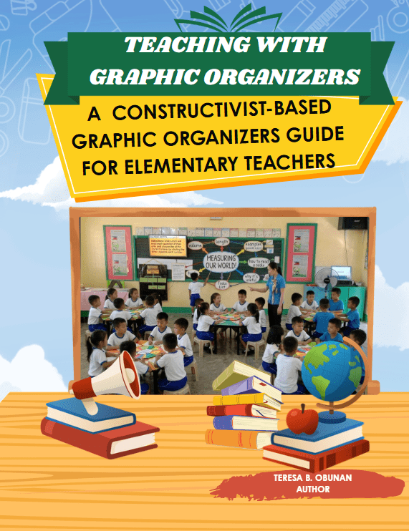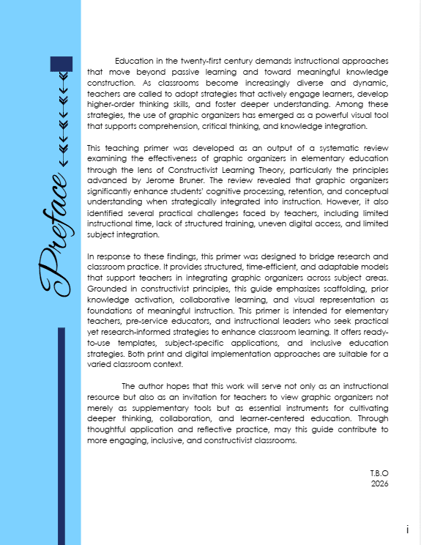

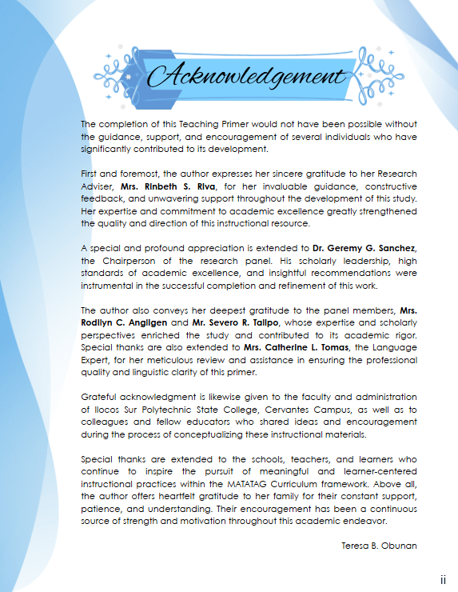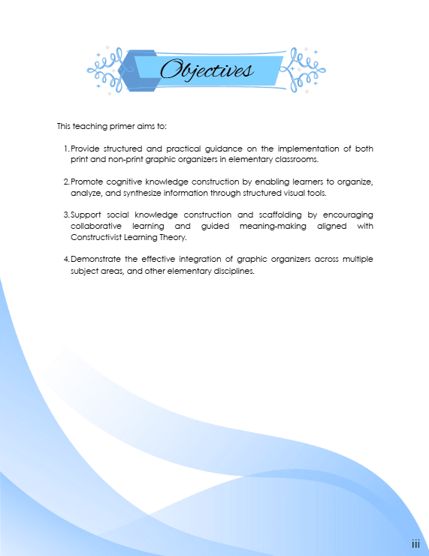

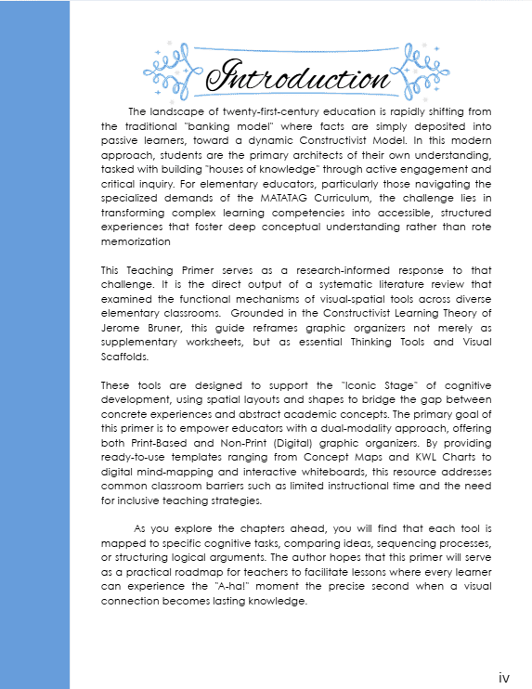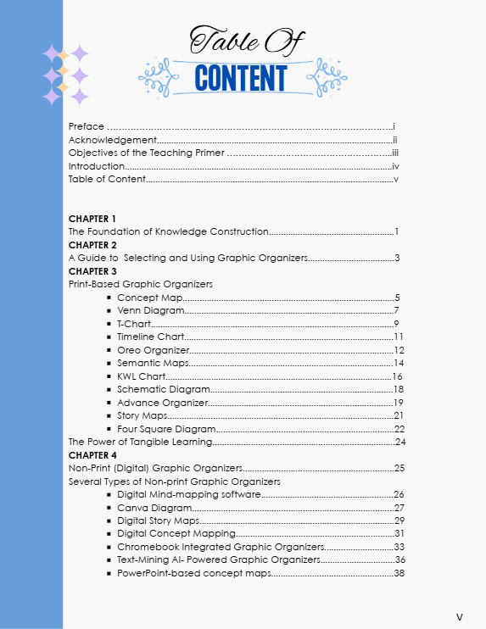

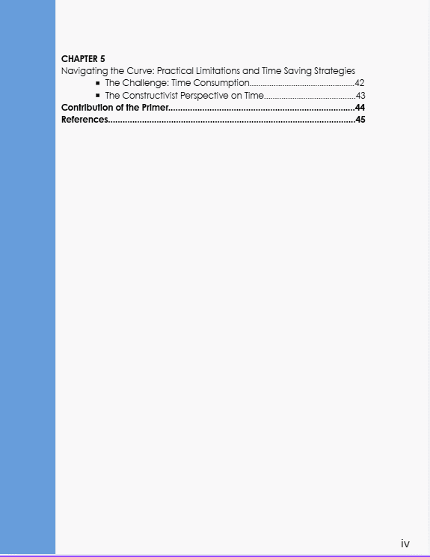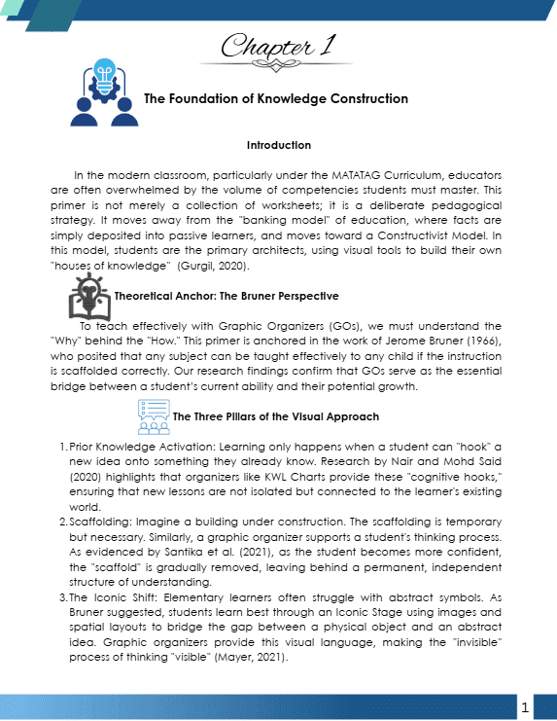

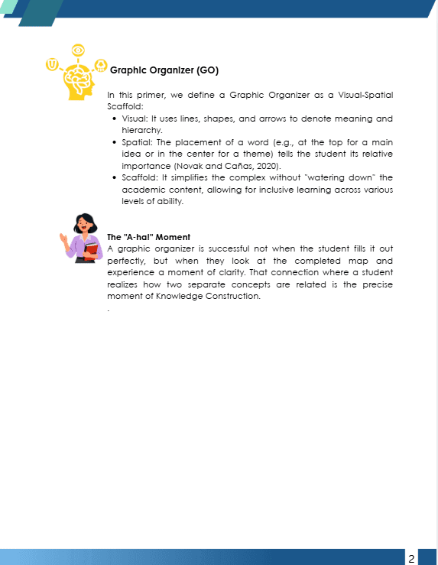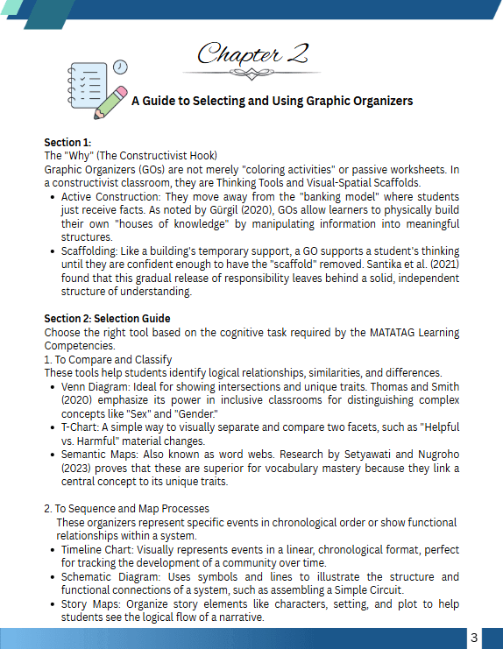

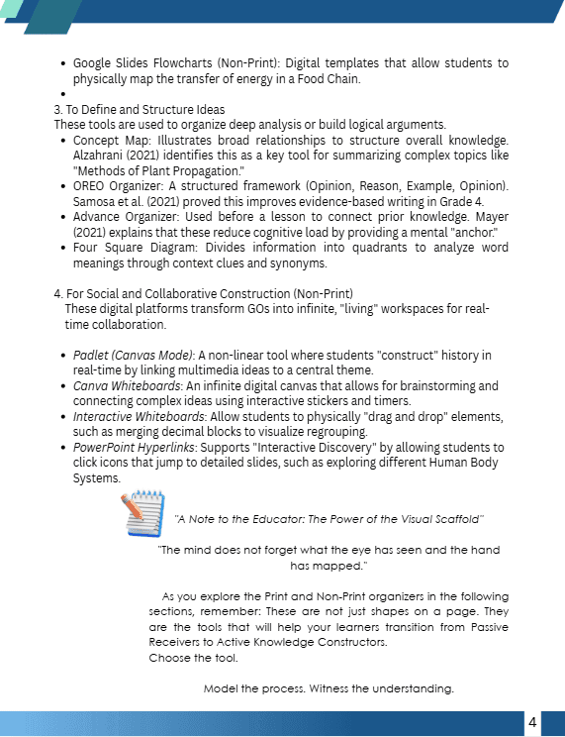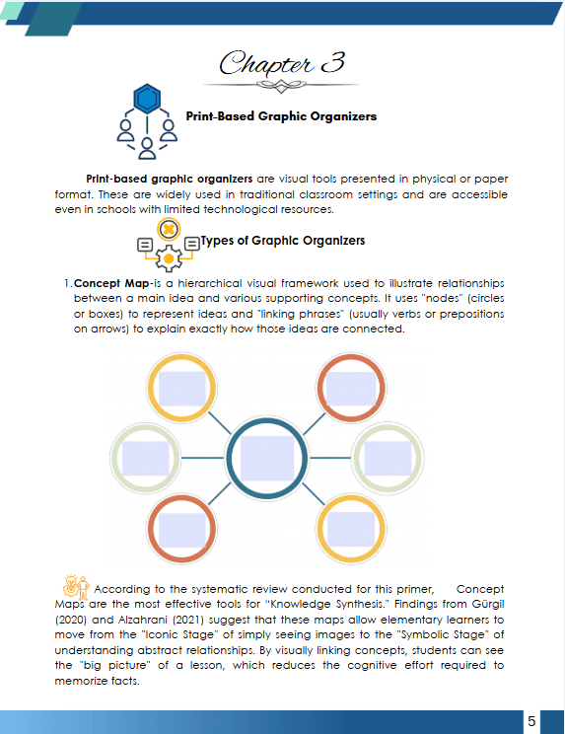

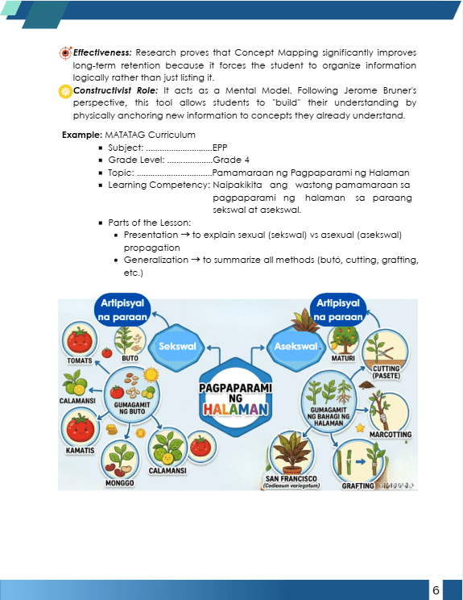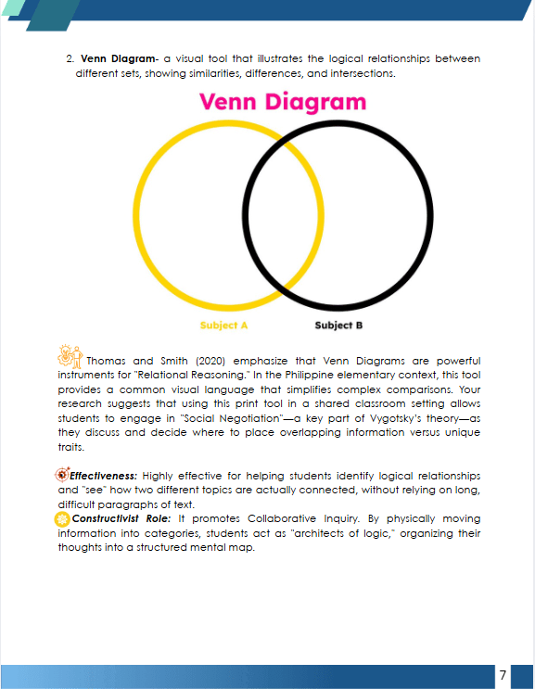

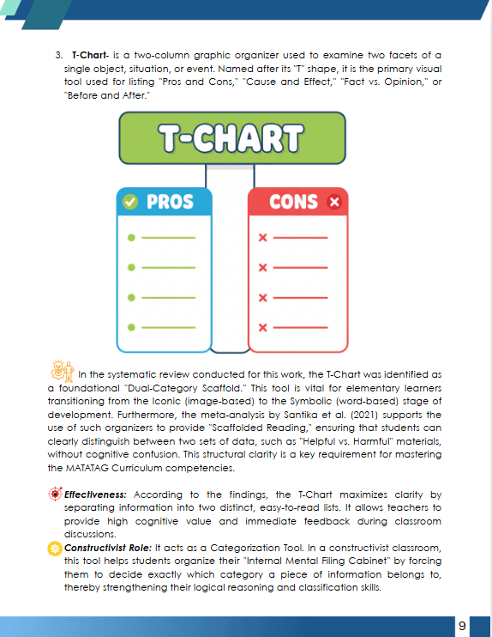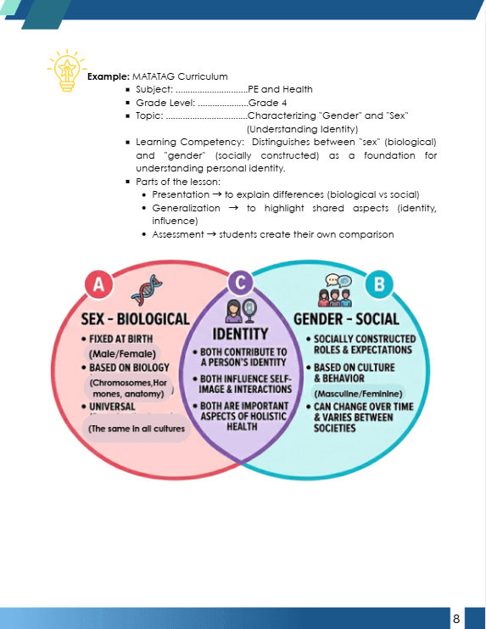

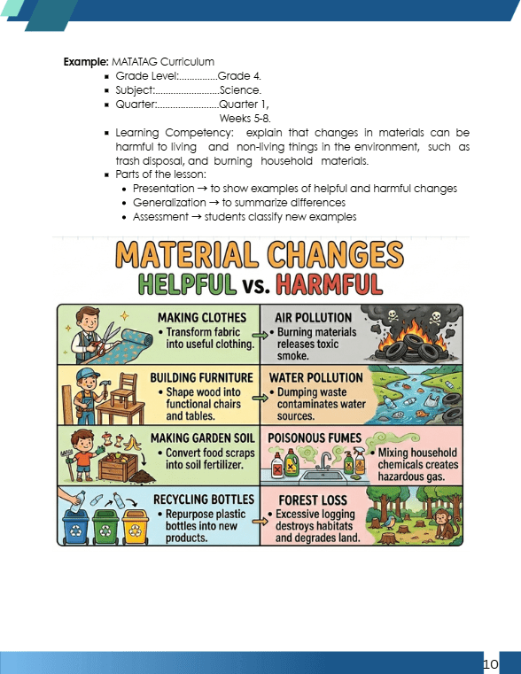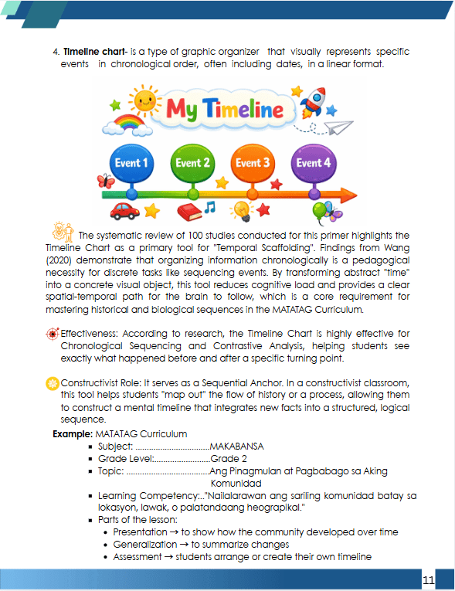

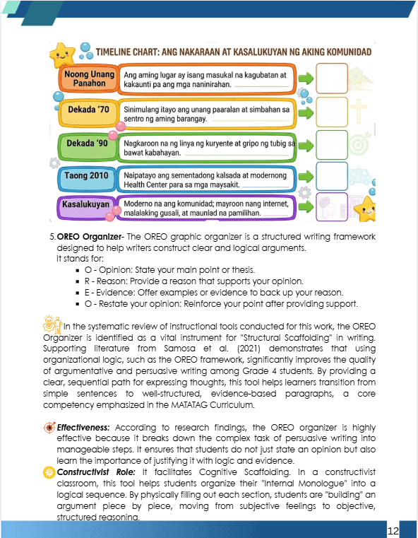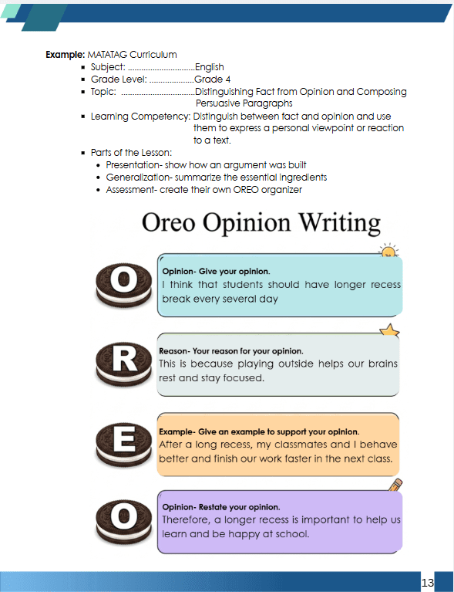

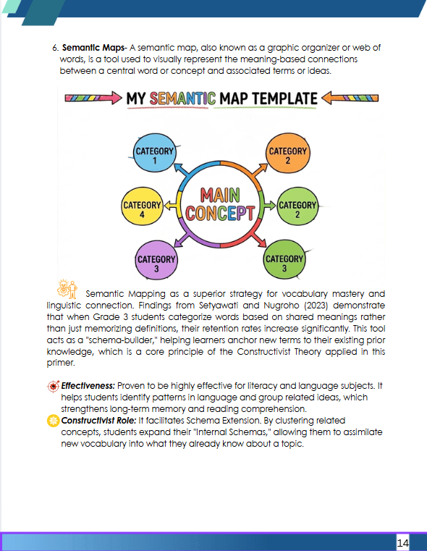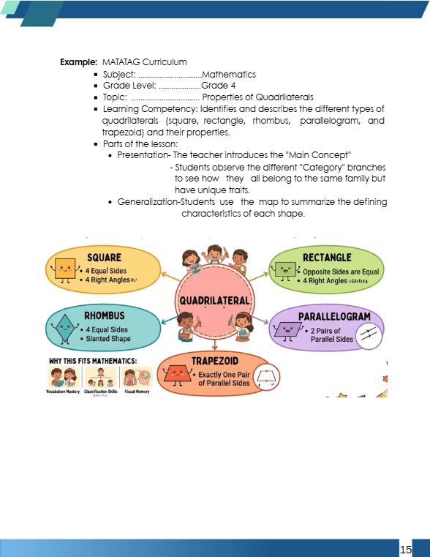

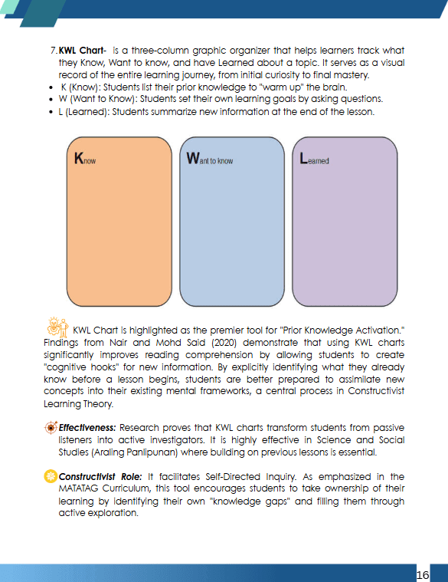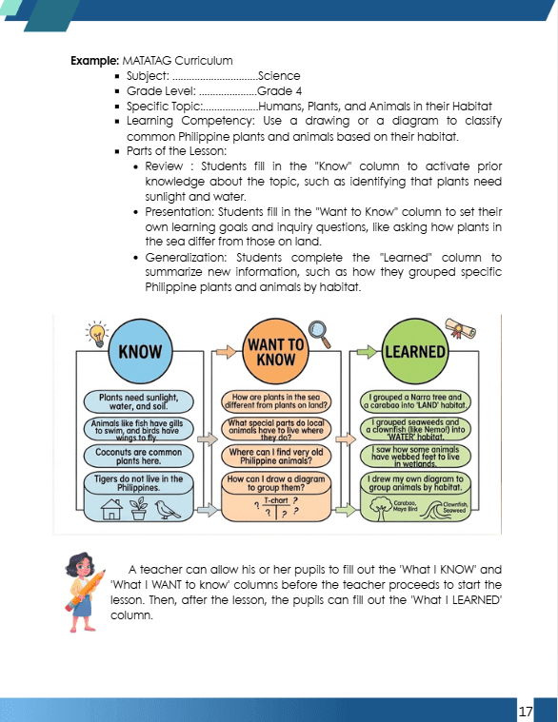

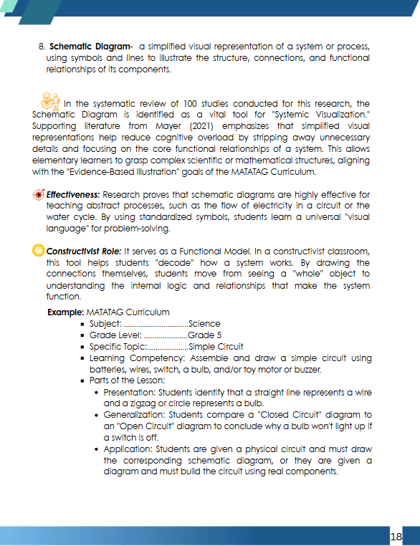

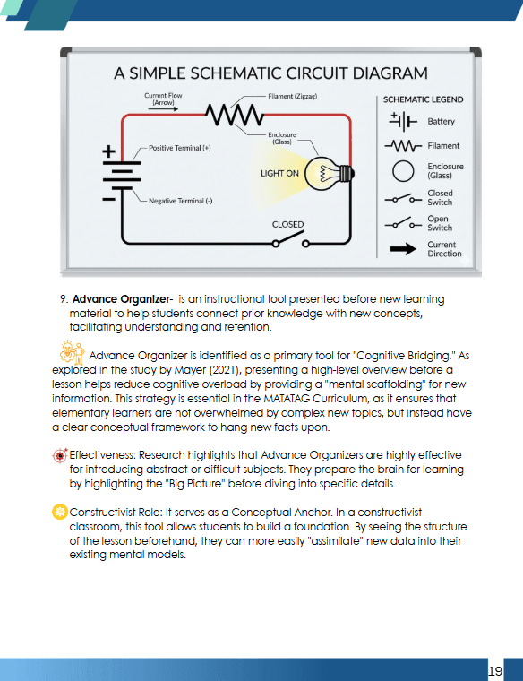

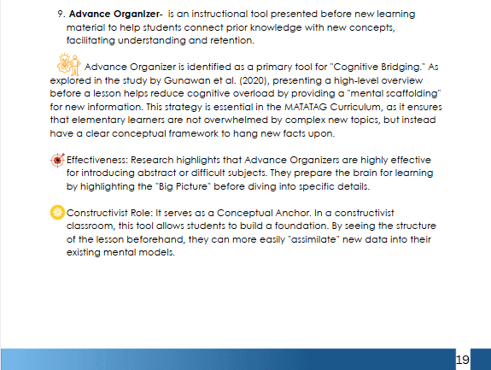

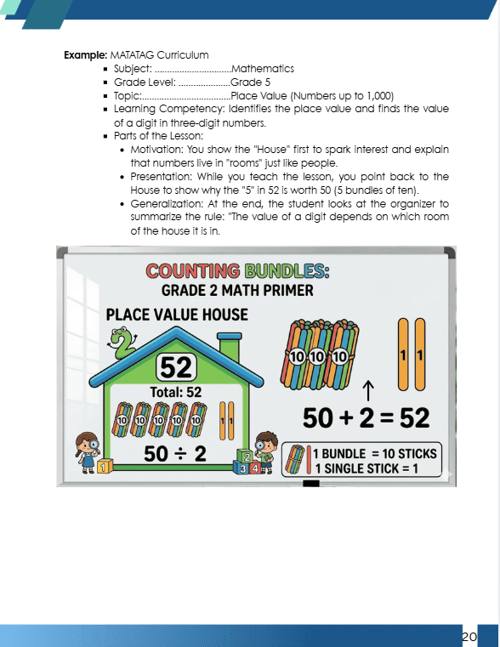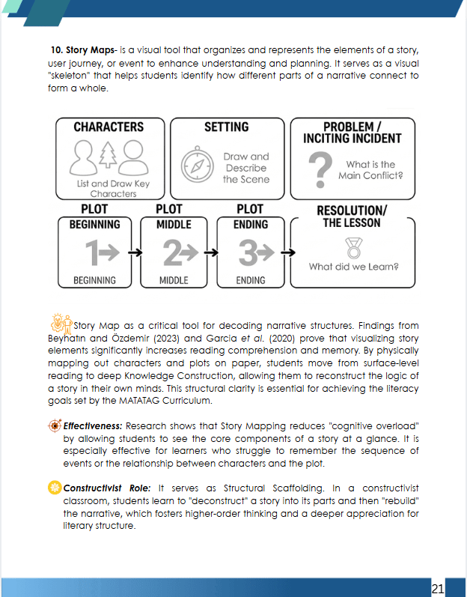

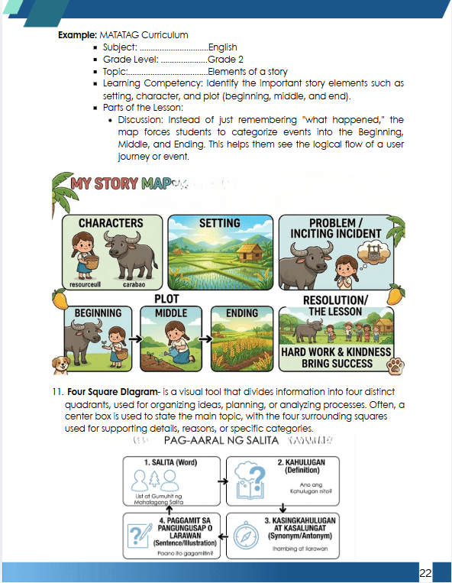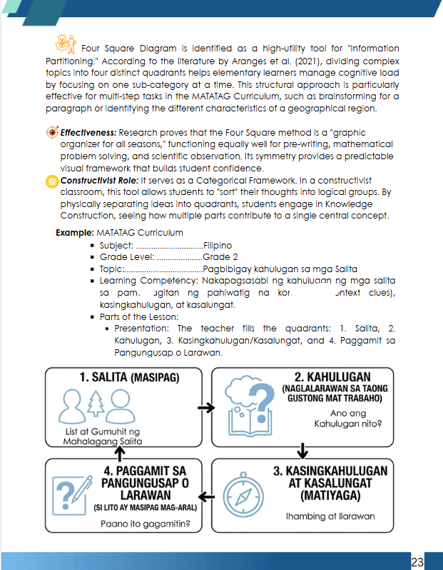

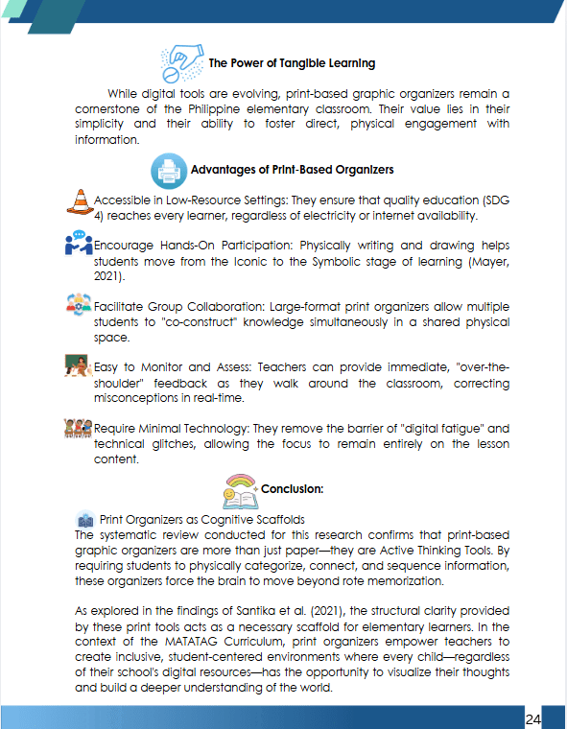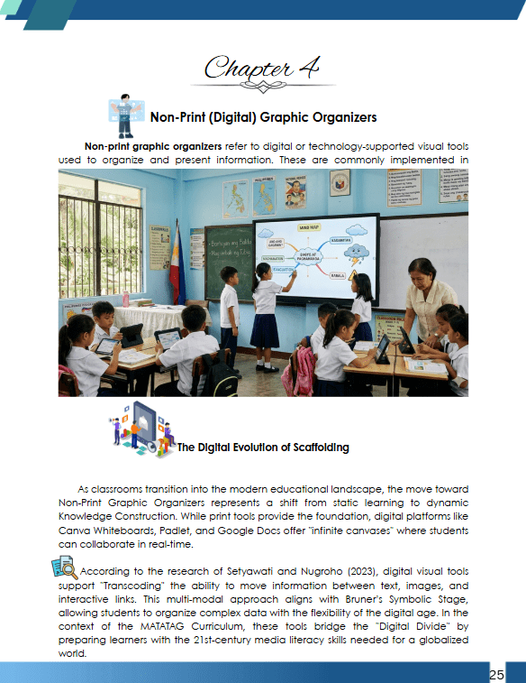

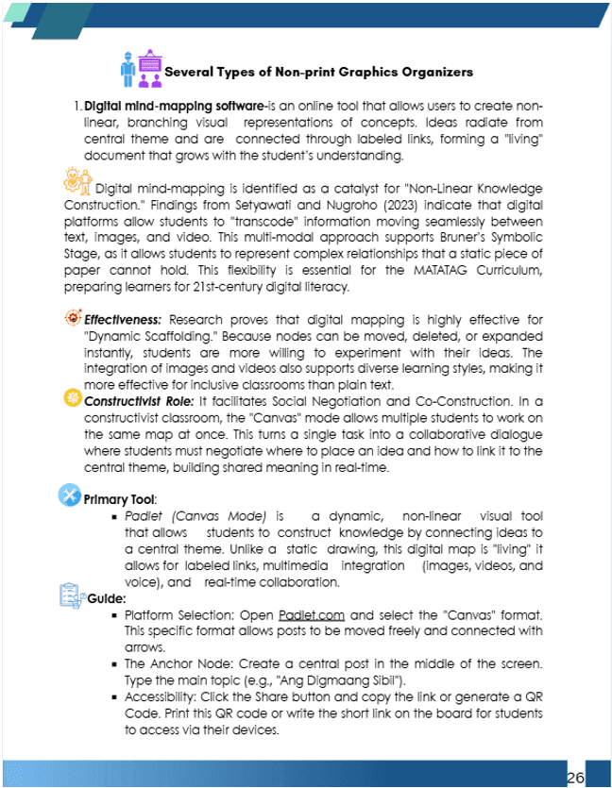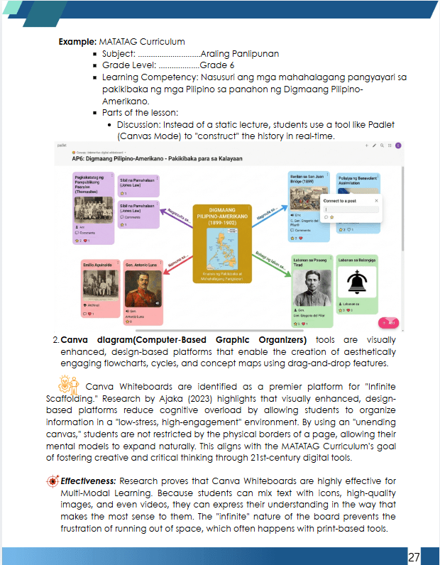

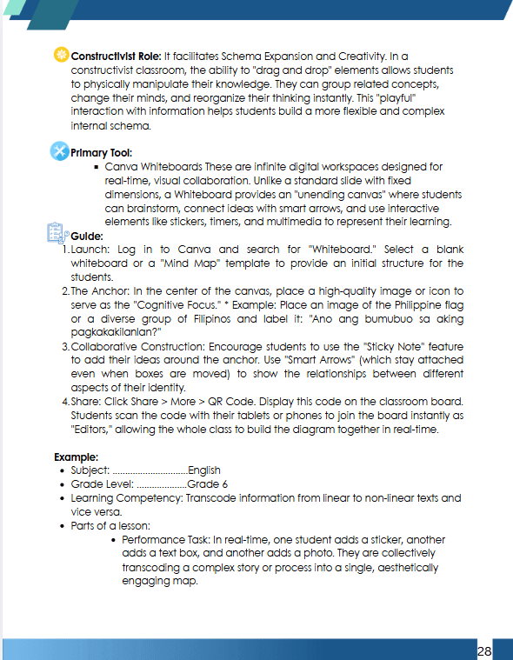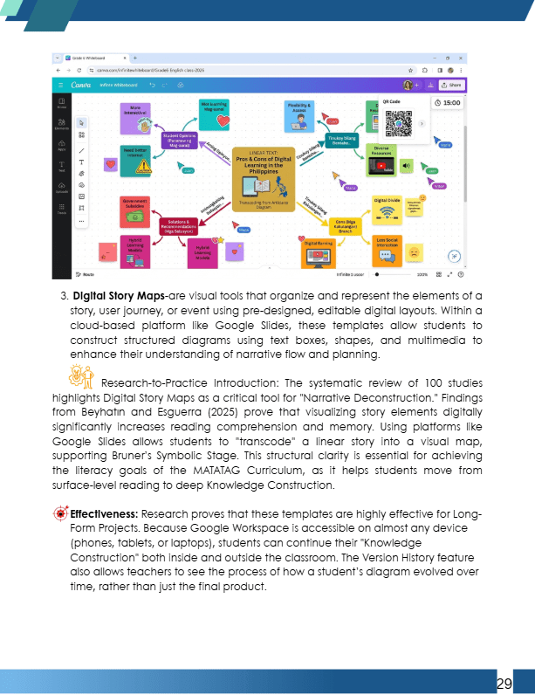

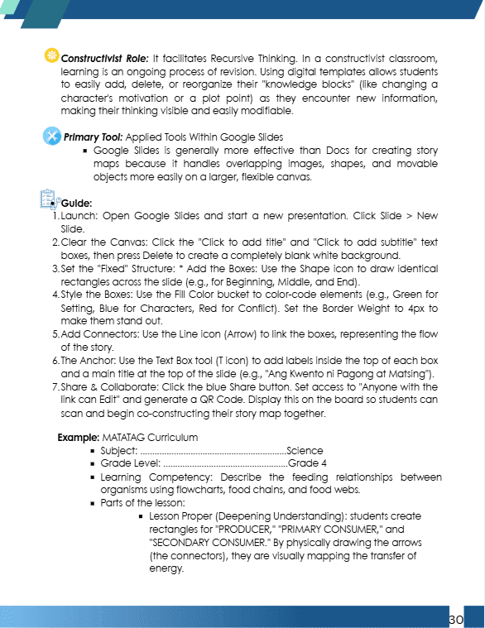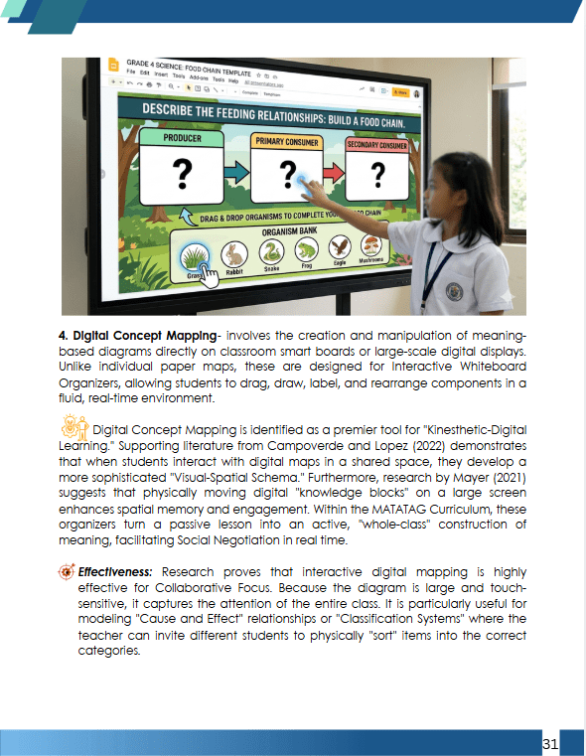

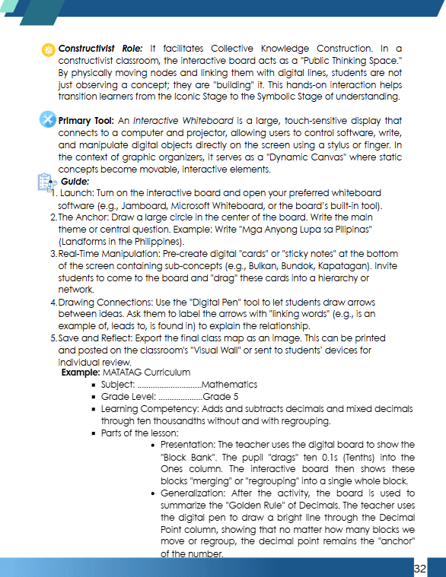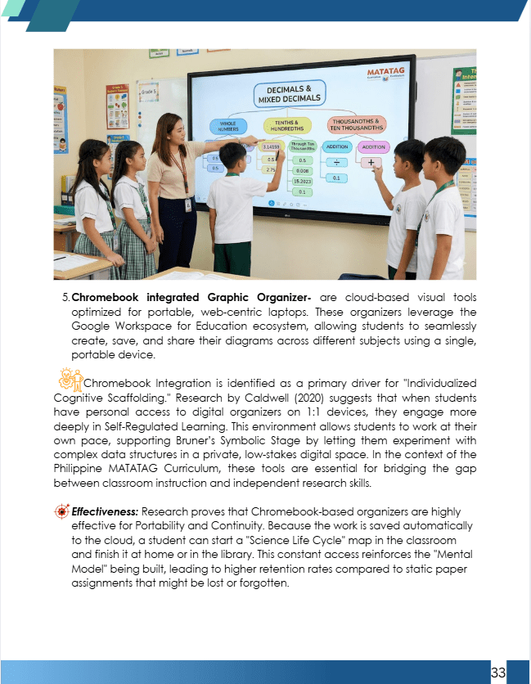

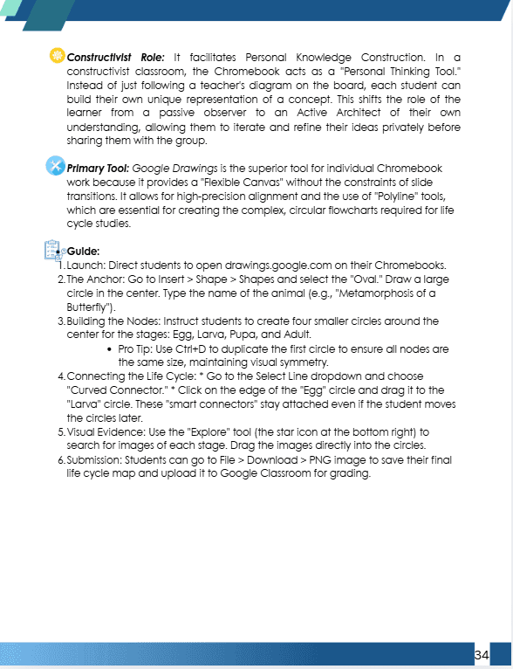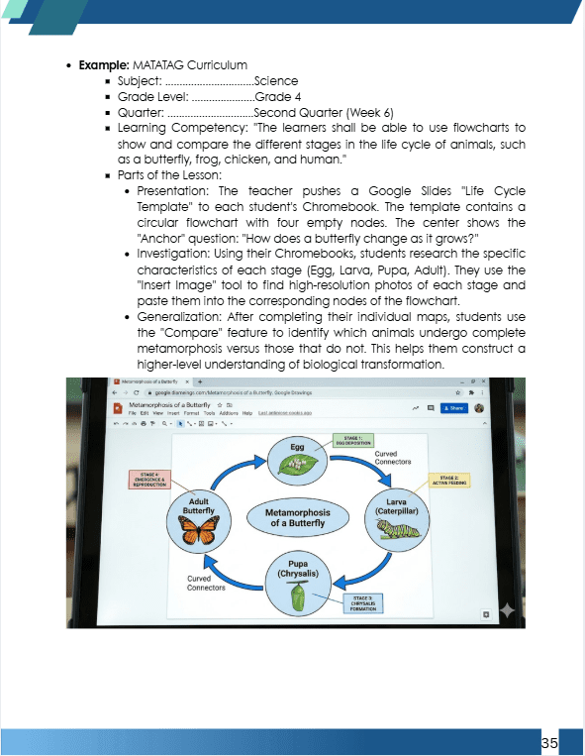

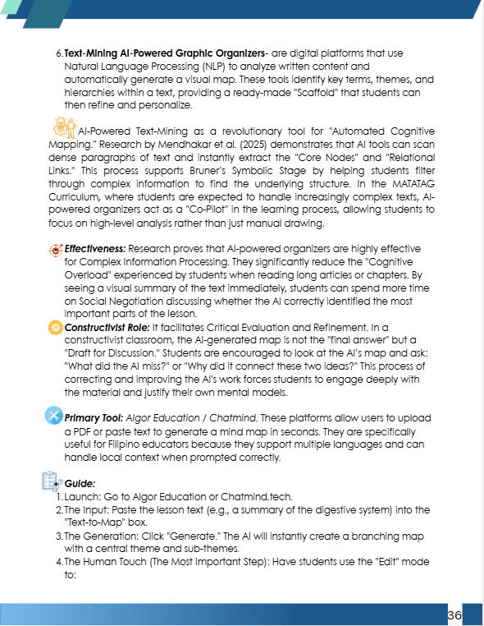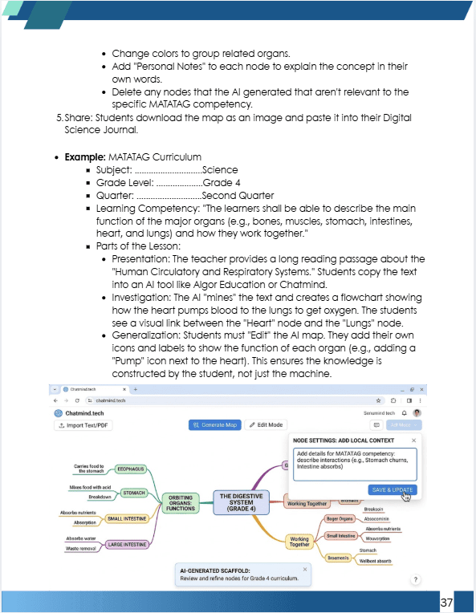

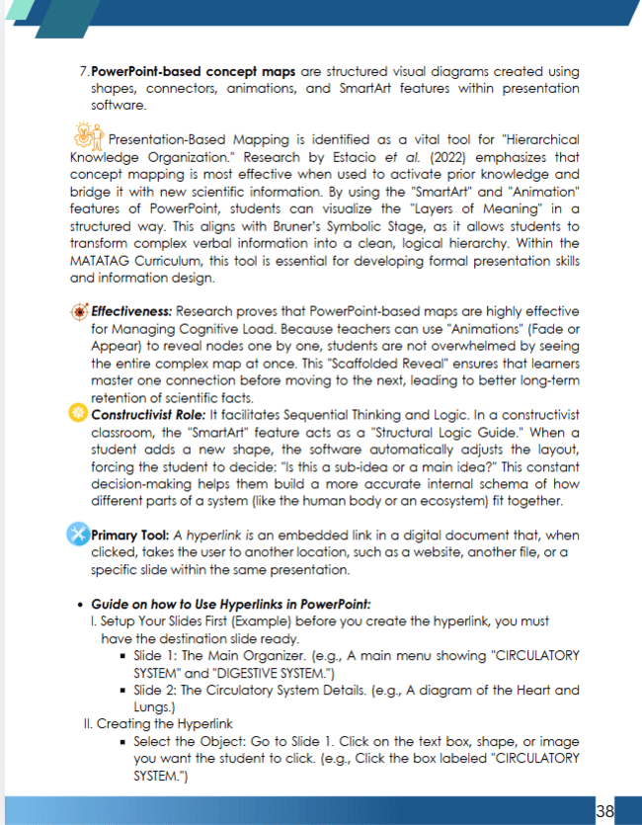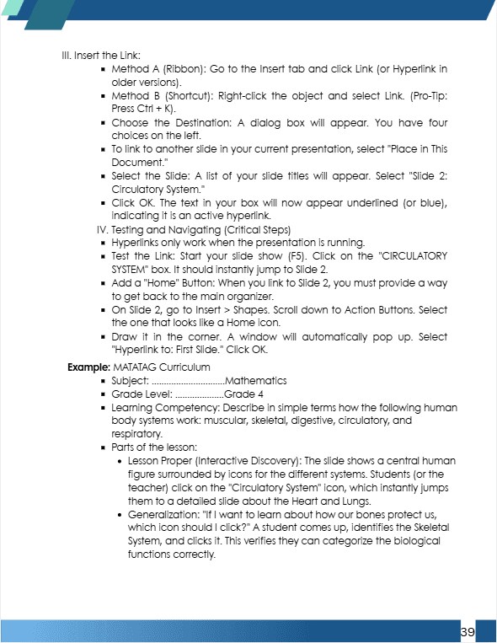

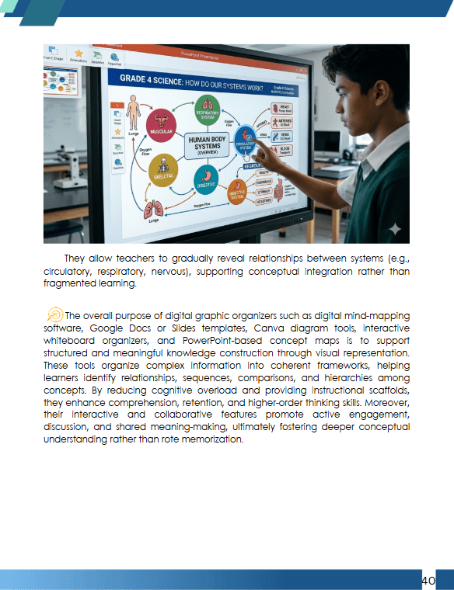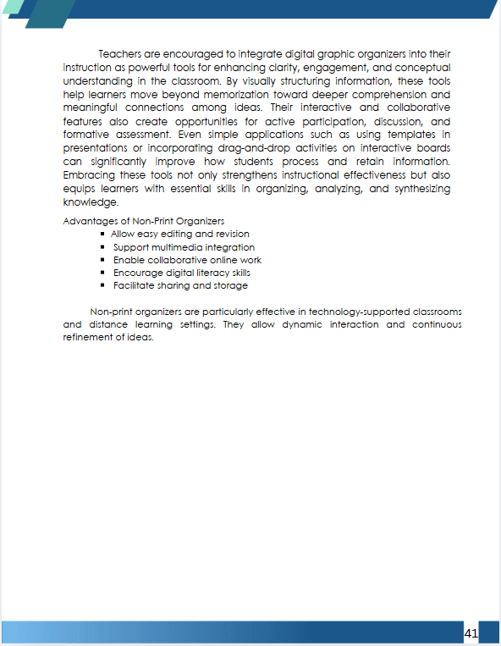

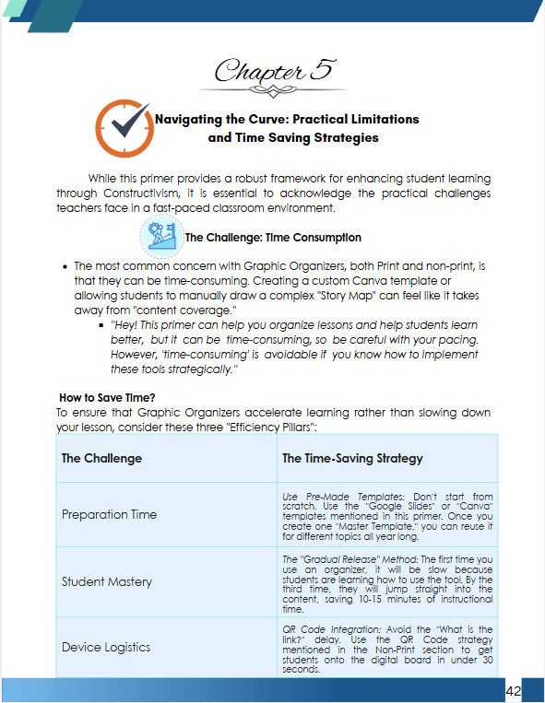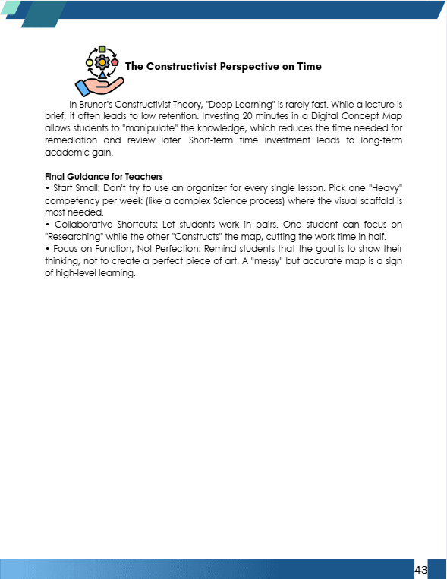

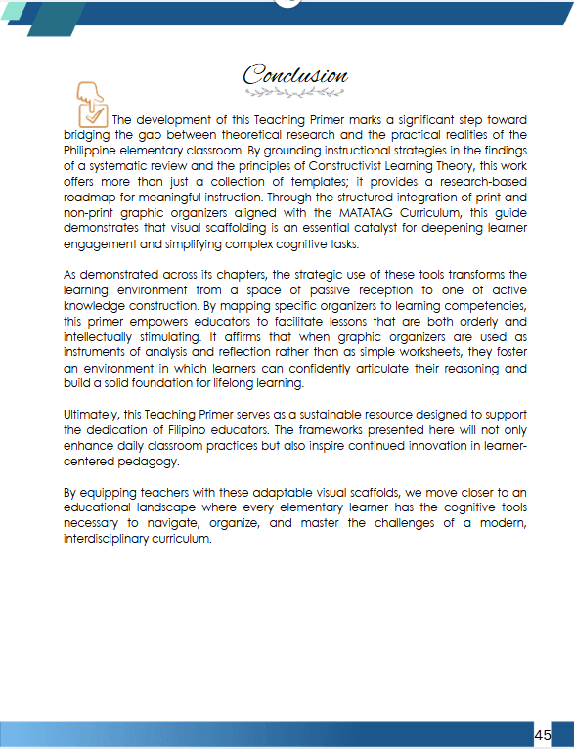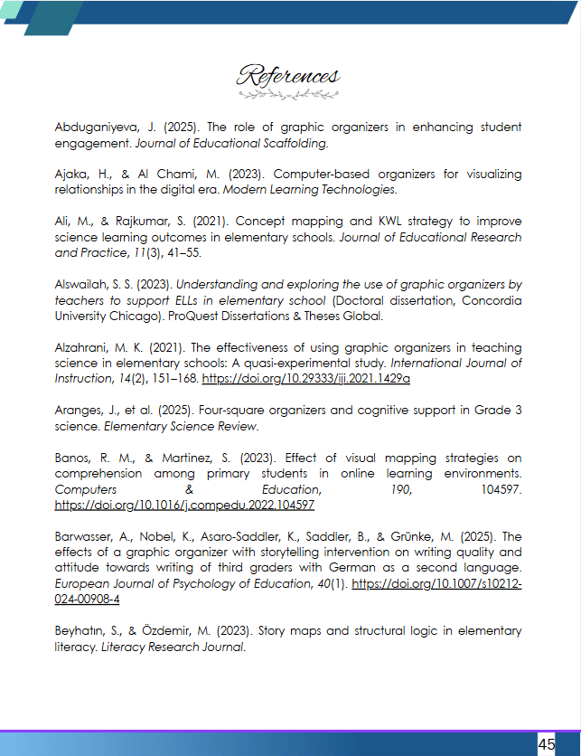

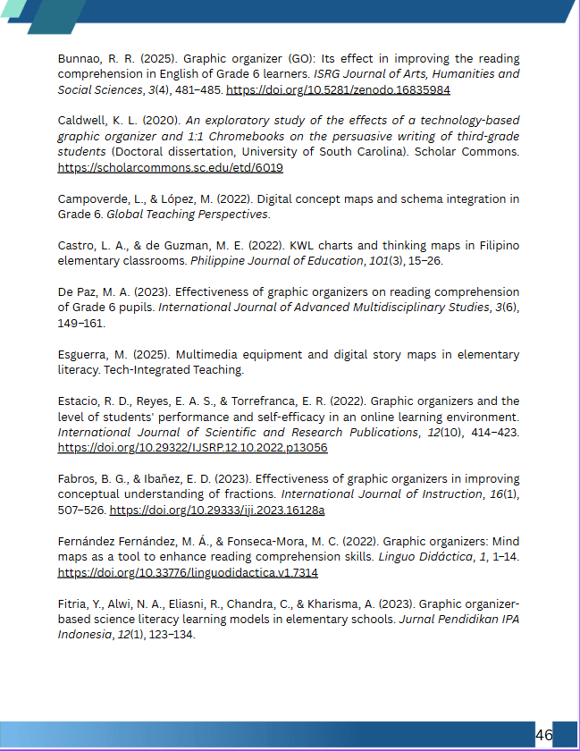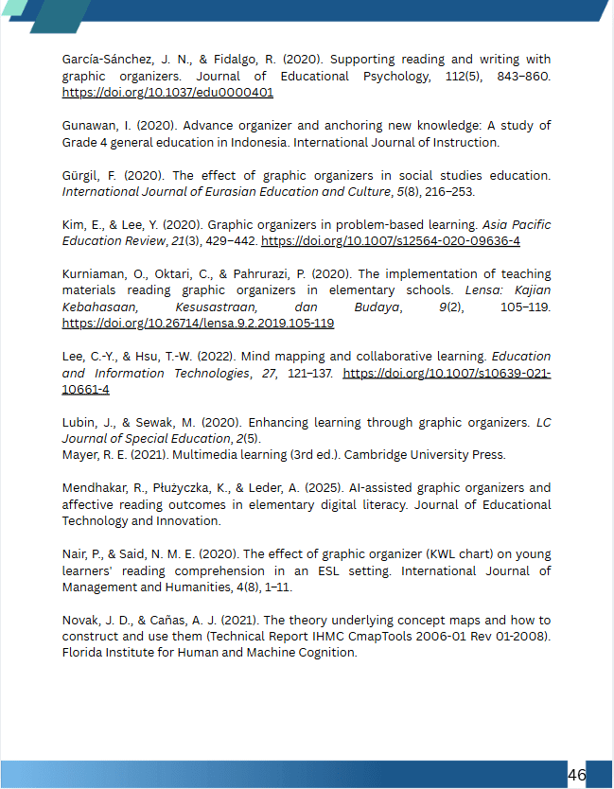
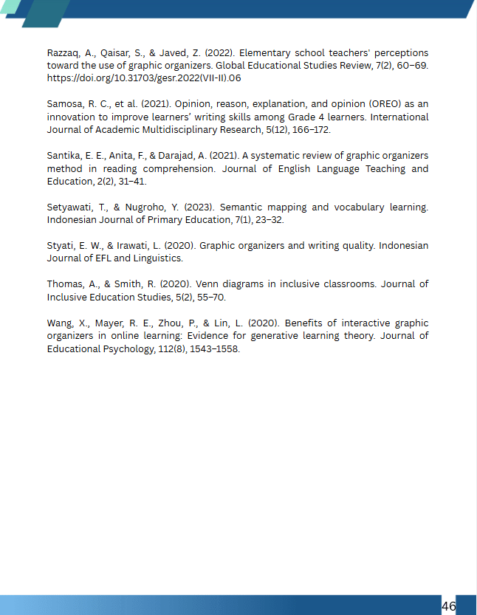

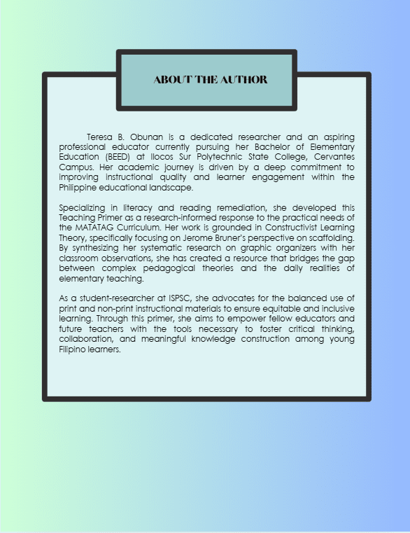

Conclusions
Based on the findings of this systematic review, the following conclusions were drawn regarding the use of graphic organizers in teaching within the elementary grades through the lens of constructivism:
- Graphic Organizers as Cognitive Catalysts are not merely visual aids but essential constructivist tools that facilitate the active construction of knowledge. They function as "cognitive bridges" that reduce mental load and move learning away from rote memorization toward higher-order thinking.
- Universal and Relational Scaffolding tools provide a "universal language" for learning, making them particularly effective for neurodiverse students and English Language Learners (ELLs). Their primary value lies in their ability to make abstract relationships tangible, allowing students to visualize their own thought processes.
- The "Implementation-Gap" refers to the significant disconnect between the clear instructional benefits of graphic organizers and their actual application in classroom settings. Although GOs are proven to enhance learning by promoting deep conceptual mapping, their effectiveness is often hindered by rigid instructional schedules, insufficient teacher training in specialized frameworks such as TPACK, and curricula that prioritize content coverage over meaningful knowledge construction. This implementation gap reveals the challenge of bridging theory and practice, showing that without structural flexibility, adequate professional development, and supportive curricular design, the transformative potential of graphic organizers remains limited.
4. Evidence of Immediate vs. Sustained Gains points to the strong research support for the short-term academic benefits of graphic organizers, with studies consistently showing immediate improvement in student performance. However, methodological limitations such as small sample sizes and short intervention periods raise questions about the durability of these effects. As a result, while the evidence for immediate gains is compelling, the long-term cognitive impact of graphic organizers remains more indicative than conclusive, suggesting the need for extended research to fully understand their sustained influence on learning.
Recommendations
Based on the conclusions drawn from this systematic review, the following recommendations are forwarded:
- Elementary school teacher educators should intentionally adopt a scaffolded approach to graphic organizer utilization, moving from explicit "think-aloud" modeling to providing partially completed skeleton maps before requiring independent creation. This ensures that the cognitive load is managed effectively, allowing students to master the organizational logic of the tool before being tasked with complex content analysis.
- School administrators and supervisors should prioritize professional development programs that focus on "Visual Literacy" and the underlying constructivist theories of graphic organizers rather than simple technical usage. By fostering a school culture that values deep conceptual mapping over rapid content coverage, administrators can provide teachers with the "instructional oxygen" needed to implement these time-intensive but high-impact strategies.
- Curriculum Developers (DepEd) should embed specific graphic organizers into the MATATAG Curriculum’s lesson exemplars and teacher’s guides. Standardizing the use of these tools across subject areas like Science, Mathematics, and Literacy will provide students with a consistent cognitive language that eases the transition between different academic disciplines.
- Future researchers should pursue longitudinal studies that track the long-term impact of graphic organizer proficiency on a student’s independent study habits and critical thinking skills as they progress into secondary education. Furthermore, there is a pressing need for comparative research between traditional hand-drawn organizers and digital collaborative mapping tools to determine which medium best facilitates social constructivism in modern elementary classroom

REFERENCES

Abduganiyeva, J. (2025). The role of graphic organizers in enhancing
student engagement. Journal of Educational Scaffolding.

Ajaka, H., & Al Chami, M. (2023). Computer-based organizers for
visualizing relationships in the digital era. Modern Learning Technologies.

Ali, M., & Rajkumar, S. (2021). Concept mapping and KWL strategy to
improve science learning outcomes in elementary schools. Journal
of Educational Research and Practice, 11(3), 41–55.

Alswailah, S. S. (2023). Understanding and exploring the use of graphic
organizers by teachers to support ELLs in elementary school (Doctoral dissertation, Concordia University Chicago).

Alzahrani, M. K. (2021). The effectiveness of using graphic organizers in
teaching science in elementary schools: A quasi-experimental study. International Journal of Instruction, 14(2), 151–168.

Aranges, J., et al. (2025). Four-square organizers and cognitive support
in Grade 3 science. Elementary Science Review.

Banos, R. M., & Martinez, S. (2023). Effect of visual mapping strategies
on comprehension among primary students in online learning environments. Computers & Education, 190, 104597.

Barwasser, A., et al. (2025). The effects of a graphic organizer with
storytelling intervention on writing quality. European Journal of Psychology of Education.

Beyhatın, S., & Özdemir, M. (2023). Story maps and structural logic in
elementary literacy. Literacy Research Journal.

Bogaerds-Hazenberg, S. T. M., et al. (2024). Effects of text structure
instruction on reading comprehension. Educational Psychology Review.
Bruner, J. S. (2020). The process of education. Harvard University Press.

Bruner, J. S. (2021). Toward a theory of instruction. Harvard University
Press.
Bunnao, R. (2025). Short-term instructional effects of organizers on
student achievement. Philippine Education Quarterly.

Caldwell, K. (2020). Integrating technology-based organizers into the
English language arts curriculum. Digital Literacy Review.

Campoverde, L., & López, M. (2022). Digital concept maps and schema
integration in Grade 6. Global Teaching Perspectives.

Castillo, R. (2024). Teacher training and the availability of instructional
support for visual tools. Local Pedagogical Studies.

Castro, L. A., & de Guzman, M. E. (2022). KWL charts and thinking
maps in Filipino elementary classrooms: An action research.

Philippine Journal of Education, 101(3), 15–26.

Choi, S. E. (2021). Applying constructivism in neurodiverse classrooms.
The International Young Researchers’ Conference.

Davies, M. (2021). Concept mapping, mind mapping and argument
mapping: What are the differences and do they matter? Higher Education, 62(2), 279–301.

Davies, M. (2021). Systemic inertia and the cultural lag in visual
learning. Educational Leadership and Policy.

De Paz, J. (2023). Reducing frustration for struggling readers through
visual scaffolding. Independent Reading Journal.

DepEd. (2023). MATATAG Curriculum: Instructional guidelines for
elementary education. Department of Education, Philippines.

Diaz, F., & Villamor, G. (2020). Improved conceptual understanding
among Grade 6 students using graphic organizers. Journal of Philippine Social Science.

Esguerra, M. (2025). Multimedia equipment and digital story maps in
elementary literacy. Tech-Integrated Teaching.

Estacio, R. D., Reyes, E. A. S., & Torrefranca, E. R. (2022). Graphic
organizers and the level of students' performance and self-efficacy
in an online learning environment. International Journal of Scientific and Research Publications.

Fabros, B. G., & Ibañez, E. D. (2023). Effectiveness of utilizing graphic
organizers in improving conceptual understanding towards operations of fractions among teachers. International Journal of Instruction, 16(1), 507-526.

Fernández-Fernández, M. Á., & Fonseca-Mora, M. C. (2022). Graphic
Organizers: Mind maps as a tool to enhance reading comprehension skills. Linguo Didáctica, 1, 1-14.

Ferrer, A., & Naanep, L. (2025). Addressing socioeconomic disparities
and classroom management in scaffolded tasks. Inclusive Education Journal.

Fitria, Y., Alwi, N. A., Eliasni, R., Chandra, C., & Kharisma, A. (2023).
Graphic organizer-based science literacy learning models in elementary schools. Jurnal Pendidikan IPA Indonesia, 12(1), 123-134.

Garcia, C. V. (2024). Effectiveness of games and graphic organizers in
improving the performance of grade 4 learners in mathematics. International Journal of Advanced Multidisciplinary Studies, 4(7), 69–76.

García-Sánchez, J.-N., & Fidalgo, R. (2020). Using graphic organizers to
support reading comprehension and writing. Journal of Educational Psychology, 112(5), 843–860.

Gibbs, G. (2020). Vocabulary tracking and student self-efficacy in home-
based learning. Home and School Connection Journal.

Gough, D. (2020). Guidelines for systematic reviews in education.
Evidence for Policy and Practice Information Centre.

Gunawan, I., et al. (2020). Anchoring new information in familiar mental
frameworks. Asian Journal of Cognitive Science.

Guo, Y., et al. (2024). Mind mapping to enhance self-efficacy in graphical
programming. Computer Science Education.

Gürgil, F. (2020). Effect of graphic organizer use in social studies on
students' academic achievement. International Journal of Eurasian Education and Culture, 5(8), 216-253.

Herro, D., et al. (2025). Paradigm shifts and computational tools in
modern learning. Journal of Digital Fluency.

Kalmamatova, Z., et al. (2020). Graphic organizers as effective methods
in teaching classroom English. Open Journal of Modern Linguistics.

Kansizoglu, A. (2020). Graphic organizers for students with diverse
learning needs. Special Education Studies.

Kilickaya, F. (2020). Visual tools for analyzing information and
recognizing patterns. Educational Technology Research.

Kim, E., & Lee, Y. (2020). Graphic organizers in problem-based learning:
A constructivist perspective. Asia Pacific Education Review, 21(3), 429–442.

Koto, I. (2020). Guided learning with visual aids and procedural
knowledge improvement. Science Instruction Journal.

Kurniaman, O. (2020). Structured visual learning strategies for
elementary students. Primary Education Journal.

Kurniaman, O., Oktari, C., & Pahrurazi. (2020). The implementation of
teaching materials reading graphic organizers in elementary schools. Lensa: Kajian Kebahasaan, Kesusastraan, dan Budaya, 9(2).

Kurniaman, O., & Zufriady, Z. (2020). The effectiveness of teaching
materials for graphic organizers in reading in elementary school students. Journal of Educational Sciences, 4(1).

Lee, C.-Y., & Hsu, T.-W. (2022). Mind mapping and collaborative learning
in elementary social studies classrooms. Education and Information Technologies, 27, 121–137.

Leorito, P. (2025). Self-directed learning readiness (SDLR) and visual
scaffolds in science. Journal of Learner Autonomy.

Ligasan, J., & Doysabas, M. (2024). Preparedness gap among pre-service
and in-service teachers: The case of digital graphic organizers.
Journal of Teacher Professional Development.

Lubin, J., & Sewak, M. (2020). Enhancing learning through the use of
graphic organizers: A review of the literature. LC Journal of Special Education, 2(5).

Mannag, M., & Dagdag, J. (2024). Graphic organizers and significant
vocabulary acquisition. Language Education Review.

Marcelo, C., & Baptista, P. (2023). Validity of digital alternative
instructional resources in school systems. Educational Infrastructure Review.

Mayer, R. E. (2021). Multimedia learning (3rd ed.). Cambridge University
Press.

Mayo, R. (2024). Constraints in implementing innovative teaching
strategies in the Philippines. Philippine Journal of Academic Research.

Miles, M. B., & Huberman, A. M. (1994). Qualitative data analysis: An
expanded sourcebook. Sage.

Moore, D. W., & Readence, J. E. (2020). A meta-analysis of graphic
organizer instruction. Reading Research Quarterly.

Nair, P., & Mohd Said, N. E. (2020). The effect of graphic organizer (KWL
chart) on young learners' reading comprehension in an ESL setting. International Journal of Management and Humanities, 4(8).

Nehru, P. (2020). Curriculum demands and the regular use of graphic
organizers. Teacher Professionalism Journal.

Novak, J. D., & Cañas, A. J. (2020). The theory underlying concept maps
and how to construct and use them. IHMC CmapTools.

Nurhayati, S. (2022). Grounded visual structures and meaningful
reading for EFL students. Journal of Applied Linguistics.

OECD. (2023). PISA 2022 findings: Learning during the pandemic. OECD
Publishing.

Patil, S. J., Chavan, R. L., & Khandagale, V. S. (2020). Identification of
misconceptions in science: Tools, techniques & skills for teachers. Aarhat Multidisciplinary International Education Research Journal, 8(2).

Petallar, G., & Mosa, L. (2025). New post-pandemic challenges: Cognitive
Overload in digital learning. Contemporary Education Review.

Ponce, H. R., Mayer, R. E., & Méndez, S. A. (2025). Publication bias and
the small-study effect in graphic organizer research: A meta-
analysis of gray literature. Educational Psychology Review.

Razzaq, A., Qaisar, S., & Javed, Z. (2022). Elementary school teachers'
perceptions toward the use of graphic organizers. Global Educational Studies Review, VII(II), 60-69.

Roberts, J., et al. (2006). Finding common ideas and strengths through
systematic review. Educational Research Methodology.

Samosa, R. C., et al. (2021). Opinion, reason, explanation and opinion
(OREO) as an innovation to improve learners writing skills among grade four learners. International Journal of Academic Multidisciplinary Research, 5(12), 166–172.

Santika, E. E., Anita, F., & Darajad, A. (2021). A systematic review of the
graphic organizers method in reading comprehension. (JELTE), 2(2), 31-41.

Setyawati, T., & Nugroho, Y. (2023). Improving vocabulary mastery
through semantic maps among Grade 3 pupils. Indonesian Journal of Primary Education, 7(1), 23–32.

Setyowati, D., Samsudi, & Raharjo, T. J. (2020). The effectiveness of
concept mapping on social skills of students in social learning of elementary school.

Styati, E. W., & Irawati, L. (2020). The effect of graphic organizers on ELT
students’ writing quality. Indonesian Journal of EFL and Linguistics.

Sudarman, R., et al. (2024). Constructivism in writing learning in
elementary school: A systematic literature review. International Journal of Research and Applied Technology, 4(1), 176–192.

Tabon, M., & Tomas, S. (2025). Bridging decoding and comprehension:
Scaffolding and motivation. Journal of Reading Psychology.

Taheri Asl, M., & Setayeshi, M. (2023). Scaffolding constructivism and
Reciprocal instruction (CAR): A multi-instruction to improve elementary students' comprehension skills. Journal of Preschool and Elementary Education, 4(2), 55–66.

Thomas, A., & Smith, R. (2021). Visual scaffolding with Venn diagrams
in inclusive classrooms. Journal of Inclusive Education Studies, 5(2), 55–70.

Thomas, A., & Smith, R. (2020). Supporting Universal Design for
Learning (UDL) in diverse classrooms with graphic organizers. Inclusive Pedagogies Journal.

UNESCO. (2023). Global education monitoring report 2023: Technology in
education. UNESCO Publishing.

UNICEF. (2022). The state of global learning poverty: 2022 update.
UNICEF.

Urton, K., et al. (2025). Effects of graphic organizers on outcomes for
students with disabilities: Three-level meta-analysis of single-case studies. Exceptionality, 33(1), 17–39.

USAID. (2021). Rigid curriculum requirements and conceptual
understanding in education. USAID Research Series.

Vargas Vásquez, R., & Zuñiga Coudin, A. (2020). Strategic reading and
main idea distinction through repeated implementation of organizers. Journal of Reading Strategy.

Wang, Y. (2020). Using structured charts to enhance reading structures
of elementary EFL learners. Journal of Language Teaching and Research.

Wanpen, S. (2020). Constructivist strategies and high student
satisfaction. International Journal of Student Engagement.

World Bank. (2022). The education crisis: New data on learning poverty.
World Bank.

Yang, H., & Lin, Y. (2024). Graphic organizers as bridges in programming
and computational thinking domains. Modern Pedagogy Journal.

Yen, Y. C., et al. (2023). Integrating mind mapping into a flipped
classroom to improve students' learning performance. Journal of
Educational Technology & Society.

Zaini, M., et al. (2022). The effectiveness of using graphic organizers in
learning biology. International Journal of Instruction.

Zhang, J. (2021). The effect of graphic organizers on reading
comprehension of English as a foreign language. Theory and Practice in Language Studies.

