MODERATING ROLE OF ORGANIZATIONAL FAIRNESS ON THE RELATIONSHIP BETWEEN JOB CHARACTERISTICS AND EMPLOYEE’S COMMITMENT IN NIGERIA NORTH EASTERN STATES UNIVERSITIES

Abstract
Employee’s commitment is crucial for institutional success, and job characteristics significantly influence it. The perception of fairness in organizational policies, procedures, and interpersonal treatment can enhance or weaken this relationship. Specifically, the study examined the effect of task variety, autonomy, and feedback on employee’s commitment as well as examined the moderating role of organizational fairness on the relationship between job characteristics and employee’s commitment in universities across Nigeria's North-Eastern states. This research employed a quantitative approach via structural equation modeling (SEM) with the help of Smart PLS 4 in analyzing the data that was obtained from the university’s employees. It was found out that job characteristics (task variety, autonomy, and feedback) and organizational fairness directly affect employee’s commitment at work place. Primarily, results shows that organizational fairness positively moderate the relationship between feedback job characteristic and employee’s commitment in Nigeria northeast universities. It is concluded that organizations in the region can leverage the understanding of the interplay between job characteristics, organizational fairness and employee commitment to design targeted interventions to help improve employee’s commitment. It was recommended that job characteristics attributes and organizational fairness be emphasized when dealing with staff in their institutions as it improved employee’s level of commitment.
Keywords: Organizational fairness, Job characteristics, Employee’s commitment

Introduction
Employee commitment is a critical factor in organizational success, particularly in academic institutions where staff dedication impacts institutional growth and better student outcomes. It propels productivity, boosts retention rates, enhances satisfaction, encourages innovation, and establishes a good reputation. Employee commitment is the term used to describe the emotional bond that employees have with the organization (Prosper et’al. 2025). The importance of human resources as a vital asset in the continually changing realm of organizational dynamics is immense (Victor, 2024). An employee's commitment to the organization will result in various effects on the workplace, which will be evident in the employee's performance (Gunanjar, et’al. 2024). An employee's performance will improve with greater commitment to his organization and decline with lesser commitment, and the reverse is true as well (Tachie-Donkoret’al. 2024). In the U.S. estimates suggest that only 33% of employees are actively engaged at work (select software reviews, 2025). Employee commitment can be strengthened by involving them in the creation of assessments and offering them opportunities for improved understanding of the entire process of organizational performance measurement. In the context of rapid changes in the business environment and intense global competition, organizations struggle to operate at their best without employee commitment to their jobs. One of the issues that many organizations struggle with is obtaining employees who are committed, competent, and willing to do their utmost to achieve the organization's goals (Prosper et’al. 2025).
However, job characteristics enables employees to have more control and responsibility for the execution of their job, based on their knowledge, skills, and abilities (Irherhimena, 2020). Therefore, to achieve job characteristics, jobs need to be redesigned to enhance the chances for employees to feel responsibility, achievement, growth, recognition, autonomy, significance of the work, feedback in the workplace, and better control. Job characteristics refer to the various aspects related to a job, including required knowledge and skills, mental and physical demands, and working conditions, which can be identified, defined, and evaluated (Enyindahet’al 2023). In Nigeria’s North-Eastern Universities, job characteristics play a vital role in shaping employee commitment (Irherhimena, et’al. 2020). However, the perception of organizational fairness in decision-making, reward distribution, and workplace interactions may influence this relationship. When fairness is perceived as high, employees are more likely to be engaged and committed; conversely, perceived unfairness may weaken the positive effects of job characteristics. Considering this moderating role, the study aims to provide insights into fostering a committed and motivated workforce through fair and transparent organizational practices.
Contextually, commitment from employees is a key element affecting the performance and sustainability of higher education institutions. Universities in Nigeria's North-Eastern states encounter distinct challenges, including security threats, resource limitations, high turnover of staff, infrastructure development deficit, low students’ enrolment. research and development output. These issues adversely affect the morale and commitment of staff (Umukoro & Egwakhe, 2019). Although job characteristics such as task variety, autonomy, and feedback impacts employee commitment, the differences in commitment levels among employees with similar job profiles indicate that there are additional moderating factors at play (Prosper et’al. 2025). One of these factors is the organizational fairness which entails how fair employees believe decision-making, allocation of resources, and interpersonal interactions within the organization are.
Theoretically, there are a number of studies conducted in relation to job characteristics and employees’ commitment which reported inconsistent findings. Among the studies that reported a positive association between the constructs includes: Umukoro and Egwakhe (2019); Enyindah and Joshua (2023); Saud, (2020); Obiora, et’al (2020); Ramliet’al, (2020); Gull and Mufti (2024);Onyike, and Orga (2024); Adegbaye and Mohammed (2024); Ifeanyi and Okeke (2024). Other studies that reported a negative association between job characteristics and employee commitment includes: Nwosu, (2013); Gaziet’al (2024); Gu et al. (2022). Baron and Kenny (1986) provide a resolution for the inconsistency findings in studies. Preacher, Rucker and Hayes (2007); Wong and Laschinger, (2013); Memon et al. (2019) clarified that moderator variables are usually brought in when the relationship between a predictor variable and a criterion variable is unexpectedly weak or inconsistent.
Methodologically, a review of the literature on employees' commitment indicates that the construct has been assessed mainly using measures such as Multiple Regression Analysis, Spearman’s Rank Order Correlation Coefficient in the previous studies. Lowry and Gaskin, (2014) observed that these measures offer limited modelling capabilities, have difﬁculty in detecting moderation effects, and are also ill suited to modelling latent variables, indirect effects (moderation). Though studies that used PLS-SEM may exist but to the best of the researcher knowledge none is found on job characteristics, employee commitment and organizational fairness in universities context suggesting paucity of research on the use of PLS SEM with regards to the variables of this study. To fill this gap, the present study adopted PLS SEM using Smart PLS 4 to assess this study variables. Generally, there is limited empirical research examining how organizational fairness moderates the relationship between job characteristics and employee commitment, particularly within the context of public universities in Nigeria's North-East. This gap hinders the development of context-specific strategies for improving staff retention and performance in the region's higher education sector. This study investigates how organizational fairness moderates the link between job characteristics and employee commitment in the north eastern states universities.
Objective of the Study
The following are the objectives of the study;
- to examine the effect of task variety job characteristics on employees' commitment in north eastern Nigeria universities
- to investigate the effect of autonomy job characteristics on employees' commitment in north eastern Nigeria universities
- to find out the effect of feedback job characteristics on employee’s commitment in north eastern Nigeria universities
- to examine the moderating role of organizational fairness on the relationship between job characteristics (task variety, autonomy and feedback) and employee commitment in north eastern Nigeria universities.
Literature Review
Concept of Employees commitment
No organization can function at maximum efficiency in the current highly competitive climate unless every employee is committed to the organization's goals (Ebikeseye & Dickson, 2018). Employee’s commitment is the term for the employees' sentimental ties to the business (Gunanjar, et’al. 2024; Yu,et’al. 2019; Ebikeseye & Dickson, 2018). Weber et.al., (2021) explained that every organization seeks employee commitment because it is crucial to the performance of the organization. Employee commitment was conceptually described in this study as a psychological state that ties people to their given responsibilities in relation to an organization's goals. Reynolds and tromp (2002) explained employee commitment as the level of connection an employee has to the organization and what is required for them to take an active interest in it. Nsoret’al (2024) explained employee commitment as a construct that consist of affective, continuance and normative commitments.

Overview of Job Characteristics
Job characteristics is considered for this study as an activity of remodeling jobs in a way that increases the opportunities for an employee to develop feelings of responsibility, achievement, growth, recognition, autonomy, the significance of the job, feedback in the work setting and having better control. Hackman and Oldham, (1976) explained that job characteristics are set of environmental variables that are widely thought to be important causes of employee job affection and behavior. Tamalero et al. (2012) explained it from the point of attributes of employee duties and include a number of responsibilities, various tasks, and the extent to which the job has characteristics that can make employees feel satisfied. Furthermore, for this study, job characteristics is bifurcated into skill variety and task significance (Khalil, 2017).
Concept of Organizational Fairness
According to Sembiring et al. (2020), organizational fairness is regarded as one of the fundamental characteristics that underpin an organization's success and has a positive link with employee performance. Improving employees' sense of commitment and belonging, whether directly or indirectly, will significantly boost their performance in a fair organization (Çelikt, 2022). According to Hu et al. (2024), organizational fairness is essential in forming organizational behaviors that are necessary for higher commitment and productivity. Employees' subjective perceptions of fair or unfair treatment within the company are based on their assessment of the input-output connection (Yimanet’al. 2024). An individual's opinion of the moral and ethical aspects of managerial action is known as perceived organizational fairness, and it reflects a subjective appraisal of moral principles and underlying expectations.
Conceptual Framework
The figure 2.1 depict the conceptual framework of this study in which job characteristics serves as the independent variable. Specifically, task variety, autonomy and feedback were the proxies considered from the job characteristics instruments by Hackman and Oldham, 1975. Employee commitment is considered as the dependent variable of the study and organizational fairness serve as the moderating variable of the study.
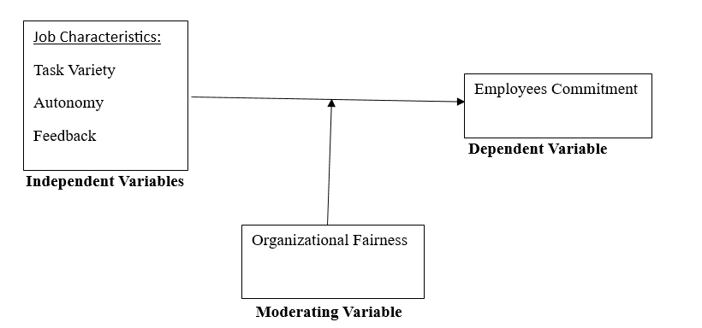
Figure 1. Conceptual Framework of the Study
This study employed the use of job characteristic theory and organizational justice theory in examining the relationship between the study variables considering the fact that the direction of the two theories align with the direction of the current study.
Methodology
North-Eastern Nigeria is one of the six geopolitical zones of the country, consisting of six states: Adamawa, Bauchi, Borno, Gombe, Taraba, and Yobe. The region is characterized by diverse ethnic groups, including the Kanuri, Fulani, Hausa, and Margi, among others. Its economy is primarily driven by agriculture, livestock farming, and trade, though it faces significant developmental challenges due to insurgency, poverty, and inadequate infrastructure. The region is home to several universities and higher education institutions, playing a crucial role in human capital development despite challenges.
For the purpose of this study descriptive survey research design was adopted using a structured questionnaire as an instrument for data collection. To measure job characteristics variable Hackman and Oldham, (1975) job diagnostic survey questionnaires was used. To measure employee’s commitment Allen and Meyer (1991) questionnaire items was used. To measure organizational fairness Leventhal (1980) questionnaire items was used. The population of this study comprised of all teaching and non-teaching staff of North East Nigeria Universities amounting to 27,957 employees based on Nigerian University system (NUC) statistical Digest, (2021). This research drawn it sample from the universities using the stratified sampling techniques. For the analysis of data Structural Equation Modelling SEM PLS with the help of Smart PLS 4 was employed because SEM better tests moderators and decreases the likelihood of Type II errors (Lowry & Gaskin 2014; Rucker, Preacher, Tormala & Petty, 2011).
Results and Discussion
This study adopted the use of two-step process including the assessment of a measurement model and the assessment of a structural model as suggested by Ismail and Mokhtar (2016), Mohseni et’al., (2016).
Assessment of the Model fit
Table 1. Model Fit
Model fit | Saturated model | Estimated model
SRMR | 0.070 | 0.070
d_ULS | 1.255 | 1.255
d_G | 0.280 | 0.280
Chi-square | 818.367 | 818.367
NFI | 0.925 | 0.925
Model fit is the average size of differences between the observed and model-implied correlation matrices, with smaller values denoting better model fit. A good model fit is indicated by a value of less than 0.08 for the Standardized Root Mean Square Residual (SRMR), an absolute goodness-of-fit metric. For this study the SRMR = 0.070 indicate a good model fit. To compliment the SRMR of this study the normed fit Index (NFI) was used which proposed model's improvement over an independence model. It holds that an adequate fit is usually indicated by values above 0.90. hence this study NFI is 0.925 indicating an adequate fit as can be seen in table 1.
Source: Smart PLS output, 2026
Discriminant Validity Assessment
To establish discriminant validity for this study Heterotrait-monotrait (HTMT) is used as recommended by (Henseler et al., 2015). Kline (2011) and Gold et’al (2001) explained that the HTMT value should not exceed 0.85 and 0.90 as the case may be otherwise it indicates discriminant validity problem. For this study the highest HTMT value is 0.754 which falls below the threshold values as can be seen in table 2 and that indicates no discriminant validity problems in this study.

Table 2. Heterotrait-monotrait ratio (HTMT) – Matrix
Variables | AU | EC | FB | OF | TV
AU
EC | 0.563
FB | 0.720 | 0.603
OF | 0.653 | 0.664 | 0.754
TV | 0.587 | 0.510 | 0.547 | 0.407
Source: Smart PLS output, 2026
Assessment of R- Squared
Assessment of coefficient of determination, which indicates the percentage of the variance in the endogenous variable that the exogenous variables explain collectively. As indicated in Table 3, the research model explains 33.3 percent of the total variance in employee’s commitment. This suggests that the four sets of exogenous latent variables (i.e., task variety, Autonomy, feedback, and organizational fairness) collectively explained 33.3 percent of the variance of the employee’s commitment. Hence, the endogenous latent variable showed acceptable levels of R-squared values as can be seen in table 3.
Table 3 R- Squared
Endogenous Variable | R-square | R-square adjusted
EC | 0.342 | 0.333
Source: Smart PLS Output, 2026
Assessment of Significance of the Structural Model
This study employed the use of standard bootstrapping using 5000 bootstrapped samples to assess the significance of path coefficients as suggested by (Ringle, et’al. 2015). Figure 1 and Table 4 shows the estimates for the structural model.
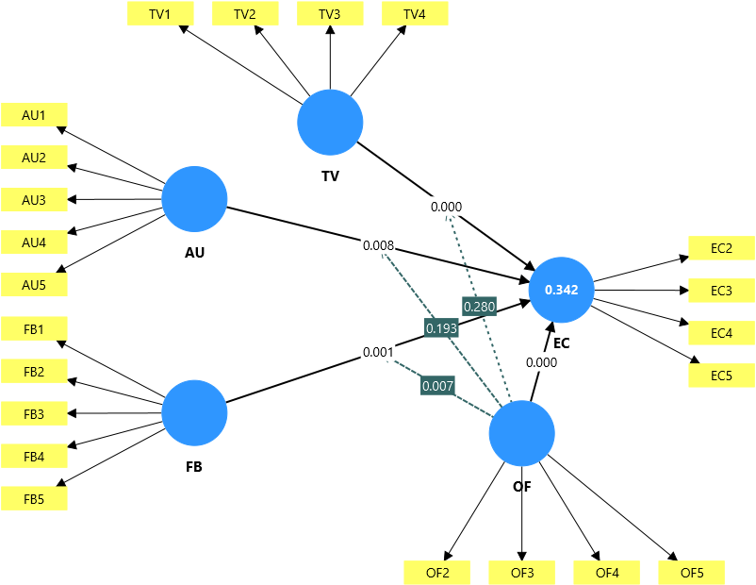
Figure 2. Structural Model
Hypothesis 1 of this study, hypothesized that there is no significant relationship between task variety job characteristic and employee’s commitment. Result (Table 4, Figure 1) revealed a significant positive relationship between task variety job characteristic and employee’s commitment at (β = 0.193, t-value = 4.616, p-value = 0.000), not supporting Hypothesis 1, contrary to the researcher expectation. Hypothesis 2 predicted no significant relationship exists between Autonomy job characteristic and employee’s commitment. Result revealed a significant positive relationship between Autonomy job characteristic and employee’s commitment at (β = 0.129, t-value = 2.655, p-value = 0.008), not supporting Hypothesis 2. Similarly, in examining the influence of feedback job characteristics on employee’s commitment, result indicated that feedback job characteristics had a significant Positive relationship with employee’s commitment at (β = 0.162, t = 3.340, p = 0.001), not supporting Hypothesis 3. Hypothesis 4 of this study predicted that organizational fairness has no significant relationship with employee’s commitment, result reveals that organizational fairness has significant positive relationship with employee commitment at (β = 0.254, t = 5.311, p = 0.000), hence hypothesis 4 was not supported.

Table 4. Structural Model Assessment
Hypothesis | Study Relationship | Original sample (O) | Sample mean (M) | Standard deviation (STDEV) | T statistics (|O/STDEV|) | P values | Remark
H2 | AU -> EC | 0.129 | 0.130 | 0.049 | 2.655 | 0.008 | Not Supported
H3 | FB -> EC | 0.162 | 0.161 | 0.048 | 3.340 | 0.001 | Not Supported
H4 | OF -> EC | 0.254 | 0.257 | 0.048 | 5.311 | 0.000 | Not Supported
H6 | OF x AU -> EC | -0.062 | -0.061 | 0.048 | 1.301 | 0.193 | Supported
H7 | OF x FB -> EC | 0.123 | 0.120 | 0.046 | 2.683 | 0.007 | Not  Supported
H5 | OF x TV -> EC | 0.048 | 0.049 | 0.044 | 1.081 | 0.280 | Supported
H1 | TV -> EC | 0.193 | 0.196 | 0.042 | 4.616 | 0.000 | Not Supported
Source: Smart PLS Output, 2026
Regarding the moderating role of organizational fairness in the relationship between task variety job characteristics and employees’ commitment, result indicated that organizational fairness had no significant moderating relationship with task variety and employees’ commitment at (β = 0.048, t = 1.081, p = 0.280). Hence, Hypothesis 5 was supported. Hypothesis 6 considered the moderating role of organizational fairness in the relationship between autonomy job characteristics and employees’ commitment, result indicated that organizational fairness had no significant moderating effect on the relationship between autonomy job characteristic and employee’s commitment at (β = - 0.062, t = 1.301, p = 0.193). this particular finding is in line with the researcher expectation as such, Hypothesis 6 was supported.
Regarding the moderating role of organizational fairness on the relationship between feedback job characteristic and employee’s commitment, result indicated that organizational fairness had a significant moderating effect on the relationship between feedback job characteristics and employee’s commitment at (β = 0.123, t = 2.683, p = 0.007). hence hypothesis 7 was not supported, the reason for the moderation may be attributed to the fact that the organizational fairness in the workplace through timely feedback is a fundamental requirement for the effective functioning of organizations (Asemota, 2024).

Determining the Strength of the Moderating Effects
Cohen’s (1988) effect sizes was employed in determining the strength of the moderating effects of organizational fairness on the relationship between job characteristics and employees Commitment. The strength of the moderating effects could be expressed using the formula below:
f 2 = | R² Included Moderator - R² Excluded Moderator
 | 1 - R² Included Moderator
Moderating effect sizes (f2) values of 0.02, 0.15 and 0.35 can be considered as small, medium and large respectively (Cohen, 1988). However, according to Chin et al. (2003), a low effect size does not necessarily mean that the underlying moderating effect is insignificant. “Even a small interaction effect can be meaningful under extreme moderating conditions, if the resulting beta changes are meaningful, then it is important to take these conditions into account” (Chin et al., 2003p. 211). Result of the strength of the moderating effects of organizational fairness is presented in Table 5.
Table 5: Strength of the Moderating Effects Based on Cohen’s (1988) Guidelines

 | R Squared
Endogenous Latent Variable | Included Moderator | Excluded Moderator | F-Squared | Effect Size
Employees Commitment | 0.342 | 0.326 | 0.02 | Small
Source: Smart PLS, Output 2026
Considering the above criteria the effect size for this study is small at (0.02) when rounded to the nearest value.
Conclusion and Recommendation
Job characteristics and organizational fairness are positively significantly related to employee commitment. The objective of this study was to investigate the moderating effect of organizational fairness between Job characteristics and employee commitment. Employee commitment is positively impacted by Job characteristics both directly and indirectly through organizational fairness, with the small buffering effect outweighing the direct influence. It was recommended that job characteristics attributes be emphasized when dealing with staff in their institutions as it improved employee’s level of commitment. The institutions management should pay less attention to the use of job characteristics autonomy and task variety because, it was found that they don’t have buffering effect when related with organizational fairness in affecting employee’s commitment in universities across north east Nigeria

References
Adegbaye, I.S. & Mohammed, H. (2024). Unveiling the Nexus between Job Characteristics, Organisational Support Perception and Librarians’ Commitment to Service Delivery. NDJLIS 5,(1),756-768
Enyindah, M. W. & Princewill, Joshua, S. (2023). Job Characteristics and Employee Commitment of Manufacturing Companies in Rivers State. Int. J. Business Management. 06(02), 37-48
Gazi, I.A., Yusof, F.M., Islam, A., Bin Amin, M., Bin Senathirajah,A. (2024). Analyzing the impact of employee job satisfaction on their job behavior in the industrial setting: An analysis from the perspective of job performance. Journal of Open Innovation: Technology, Market, and Complexity, 10, (4), 20-34
Gull,N.&Mufti,S.(2024).Impact of Employee Perceptions of Job Characteristics on Organizational Commitment dimensions in the Banking Sector: An Empirical Investigation. Journal of Emerging Technologies and Innovative Research 11(7), 734-744
Gunanjar,S.M, Asni, K.Z & Gunanjar, D.G. (2024). The Influence of Affective Commitment, Normative and Continuous Commitment on The Performance of Baitul Mal Aceh Employees. The International Journal of Engineering and Science (IJES)13 (2), 2319 – 1805
Ifeanyi, P., & Okeke, C.N (2024). Employee commitment and employee engagement in hospitality firms in Anambra State, Nigeria. International Journal of Business and Management Research 4(3),192-208
Irherhimena,S,A., Yemisi, T.B. & Gabriel, O. A. (2020). Job Characteristics Dimensions and Librarians' Affective Commitment. International Journal of Development Strategies in Humanities, Management and Social Sciences 10(1), 36-54
Ismail,S. & Mokhtar,M.S.S. (2016). Moderating Role of Perceived Benefit on the Relationship between Attitude and Actual Purchase. International Review of Management and Marketing, 6(S7) 22-28
Kamar, K., Novitasari, D., Asbari, M., Winanti, & Goestjahjanti, F. S. (2020). Enhancing Employee Performance During the Covid-19 Pandemic: The Role of Readiness for Change Mentality. Jurnal Dinamika Manajemen, 11(2), 154-166
Lowry, B.P & Gaskin, J. (2014). Tutorial Partial Least Squares (PLS) Structural Equation Modeling (SEM) for Building and Testing Behavioral Causal Theory: When to Choose It and How to Use It. IEEE Transactions on Professional Communication, (57), (2), 123- 146.
Nwosu, O.H., Chiamaka O.J.A. & Tochukwu, O.A. Job Characteristics as Predictors of Organizational Commitment Among Private Sector Workers in Anambra State, Nigeria. Journal Arts and Humanities 6(1):65-73
Onyike, J. U. & Orga, C. C. (2024). Job Characteristics and Employee Performance of Manufacturing Companies in Enugu State. Contemporary Journal of Management 6(1), 92-106. https://doi.org/10.5281/zenodo.10984480 Uga and Orga (202
Prosper, E. A & Anah, S.A. (2025). Organizational Justice and Employee Commitment in Oil and Gas Firms in South-South, Nigeria. International Journal of Innovative Finance and Economics Research 13(1):108-122,
Ramli, Y., Soelton, M.; Paijan, &Khotimah,N. (2024). The Effect of Job Characteristics towards the Organizational Commitment of the Employees. International Journal of Emerging Trends in Social Sciences 8, (1), 1-9, DOI: 10.20448/2001.81.1.9
Saud, R.T. (2024). The Effect of Job Characteristics on Organizational Commitment: The Role of Growth Need Strength in Nepali IT Companies. Journal of Business and Management Research 3,(1), 39-56
Tachie-Donkor, G., Mensah, G.T., & Eugene AmoakoNsowah, A. E. (2024). Staff Promotion and Employee Commitment to Work: A Survey in a Ghanaian University Library. Journal of Advocacy, Research and Education.11(2) 222-231
Umukoro and Egwakhe (2019). Job-Characteristics Dimensions and Employee Continuance Commitment. Global Journal of Management and Business Research 19(10), 96-101 Victor, O.S. (2024), National Innovation and Research Academia. International Journal of Empirical Studies and Statistical Models 6, (2), 34-47
Yiman,S. Mohammadi ,A. & Feng,T.Z. (2024). Organizational fairness, psychological capital and job performance: an empirical study based on science and technology SMEs. International journal of academic research in economics and management sciences 1 3, (3), 337-358

