Strategic Leadership and Organizational Performance in Nigerian Universities: The Mediating Role of Organizational Culture

Abstract
Strategic leadership has become increasingly important in higher education institutions due to growing demands for accountability, innovation, competitiveness, and institutional sustainability. Nigerian universities operate in a challenging environment characterized by inadequate funding, governance constraints, infrastructural deficiencies, industrial disputes, and increasing stakeholder expectations. These challenges have intensified the need for effective leadership capable of driving organizational performance through the creation of supportive institutional environments. This review examines the relationship between strategic leadership and organizational performance in Nigerian universities, with particular emphasis on the mediating role of organizational culture. The study adopts a systematic narrative review approach and synthesizes theoretical, conceptual, and empirical literature on strategic leadership, organizational culture, and organizational performance within higher education institutions. The review is anchored on Upper Echelons Theory, Resource-Based View, Transformational Leadership Theory, and Organizational Culture Theory to explain the pathways through which leadership influences institutional outcomes. Findings indicate that strategic leadership significantly enhances organizational performance through strategic vision, decision-making capability, human capital development, change management, and stakeholder engagement. The review further reveals that organizational culture serves as a critical mechanism through which leadership practices are translated into improved institutional outcomes. Organizational cultures characterized by trust, collaboration, innovation, accountability, and learning orientation contribute positively to academic excellence, research productivity, institutional reputation, staff effectiveness, student satisfaction, and community engagement. The study concludes that sustainable performance in Nigerian universities depends not only on effective leadership but also on the development of supportive organizational cultures that reinforce institutional goals and adaptability. The review proposes an integrated conceptual framework and identifies key implications for university management, policy formulation, and future research within the Nigerian higher education sector.
Keywords: Nigerian Universities; Organizational Culture; Organizational Performance; Strategic Leadership
1. Introduction
Higher Education Institutions (HEIs) are of critical importance in national development regarding the generation, dissemination and application of knowledge. Universities are expected to produce highly skilled graduates, do impactful research, promote innovation as well as contribute to socio-economic transformation (Trinh, 2023; Zaidan et al., 2025). The higher education sector has undergone tremendous transformation in the last few decades, due to globalization, technology, greater competition, shifting stakeholder priorities, and funding pressures (Gkrimpizi et al., 2023). These changes have forced university leaders to look for more strategic strategies in governance and management to sustain and make their university effectual. As a result, strategic leadership has become one of the most important drivers of the achievement of Universities' goals and the maintenance of their competitive advantage in an increasingly complex educational environment (Carmo et al., 2025).
Strategic leadership is the capacity of leaders to imagine the future, to define long-term goals, coordinate organisational resources, and motivate people to contribute to the institutional goals. Strategic leadership is different from the traditional administrative leadership because it is about predicting the changing environment, stimulating innovation and managing organizational change, and establishing conditions for sustainable performance (Schaedler et al., 2021). Strategic leadership in higher education institutions includes clarifying institutional visions, creating effective decision-making processes, involving stakeholders, developing key talents, and establishing institutional values to foster academic excellence and operational efficiency (Flori et al., 2025). Additionally, university leaders, including vice-chancellors, rectors, provosts, deans, and department heads, are now required to be strategic leaders who are expected to handle various problems in the context of modern universities.
The effectiveness of the performance of an organization is one of the most significant aspects of a successful institution of higher learning. When considering university performance, it is not just financial figures that come to mind, but also the many other aspects such as quality of teaching, output of research, student satisfaction, role of graduates in the job market, reputation, innovation, community engagement, and effective administration (Alyoussef, 2023). The performance of universities has a significant impact on the national development as the best performing universities play a key role in human capital development, scientific development and economic development. As a result, attention has turned to studying and designing what it takes to boost organizational performance in HEIs (David et al., 2021).
One of the factors that affect organizational performance is organizational culture which has attracted a lot of attention as a strategic asset that affects the behaviour of employees, institutional values and the effectiveness of the organization. Organizational culture is the collection of beliefs, values, norms, assumptions and practices that influence the behaviours of members in an organization (Zhang et al., 2023). It affects the way decisions are being made, the way employees relate to each other, the way conflicts are being dealt with, and the way organizational goals are being achieved. Organizational culture has an impact on academic productivity, staff engagement, innovation, collaboration, knowledge sharing, and institutional effectiveness within universities. Positive organizational culture can drive positive employee motivation, teamwork, continuous improvement, and successful implementation of strategic initiatives (Alsaqqa, 2024).
In a higher education institution, the linkage between strategic leadership and organizational culture is very significant. The role of strategic leaders is of critical importance in creating and reinforcing organizational values, norms, and in providing learning and innovation environments. Leaders create positive or negative organisational cultures through their actions, decisions and communiqués which have a positive or negative impact on the performance of their institutions (Pedraza-Rodríguez et al., 2023). Good strategic leadership can help create cultures with trust, accountability, collaboration and excellence that improve organization performance. On the other hand, weak leadership can lead to unhealthy cultures which can hinder the effectiveness of the institutions and reduce the satisfaction of the stakeholders (Anyia et al., 2025).
The critical role of strategic leadership and organizational culture is becoming more apparent in Nigerian universities with the many challenges facing the higher education sector. The current environment of Nigerian universities is one of underfunding, shortage of adequate infrastructural facilities, recurrent industrial action, political interference, brain drain, dwindled output of research, problem of governance and competition from private and international universities (Okai & Okai, 2025). These challenges have led to concerns about the effectiveness of universities to do their core functions. This has led to the recognition that, besides resources, the success of institutions depends on the quality of leadership and the robustness of organizational cultures in Universities (Akinwale et al., 2023).
Although there have been some attempts to reform the Nigerian universities to boost their efficiency, effectiveness, accountability and competitiveness, the performance of many of these universities is still marred by all these problems. Leadership issues in many instances have led to bad strategic planning, weak institutional governance, opposition to change and low employee morale (David et al., 2021). Moreover, the institutional development has been usually hampered by a rigid bureaucracy, low level of innovation, communication problems and lack of performance orientation in organizational culture (Akinwale et al., 2023). The above realities emphasize the importance of understanding how strategic leadership can impact organizational performance by fostering cultures that support it.
Previous research has been carried out to explore the linkage between leadership and organizational performance in various fields. Likewise, there has been much research on the effect of organizational culture on organizational outcomes (Kargas & Varoutas, 2015; Abujudeh, 2020). But, the mediation role of organizational culture between strategic leadership and organizational performance has received relatively little attention especially in the context of Nigerian universities (Abujudeh, 2020). This mediating mechanism is important to understand because it will give insight into the ways that leadership practices lead to better institutional outcomes in terms of cultural change and organizational alignment.
This review aimed to explore the mediating role of organizational culture in the relationship between strategic leadership and organizational performance in Nigerian universities and to critically examine the relationship. In particular, the review attempts to examine the theoretical underpinnings of strategic leadership, organizational culture and organizational performance; explore the various theoretical frameworks; review empirical studies from both international and Nigerian contexts; and propose a holistic framework that elucidates the significance of organizational culture to the effectiveness of strategic leadership in HEIs.
2. Methodology of the Review
2.1 Review Design and Approach
This study adopts a systematic narrative review approach to examine the relationship between strategic leadership, organizational culture, and organizational performance in HEIs, with particular emphasis on Nigerian universities. A systematic review approach was selected because it provides a structured and transparent method for identifying, evaluating, and synthesizing relevant literature from diverse sources. Unlike traditional narrative reviews that may rely heavily on subjective literature selection, systematic reviews employ explicit procedures that enhance the reliability, comprehensiveness, and reproducibility of findings (Gusenbauer & Gauster, 2024).
The review focuses on peer-reviewed journal articles, conference papers, books, book chapters, doctoral dissertations, policy reports, and institutional publications that address strategic leadership, organizational culture, organizational performance, and higher education management. Given the multidisciplinary nature of the study, literature from the fields of educational management, organizational behavior, strategic management, leadership studies, and public administration was considered. Particular attention was given to studies conducted within HEIs and developing-country contexts, especially those relating to Africa and Nigeria.
The review was guided by established systematic review principles and followed a structured process comprising literature identification, screening, eligibility assessment, data extraction, and synthesis (Obeng-Kyereh, 2026). The Preferred Reporting Items for Systematic Reviews and Meta-Analyses (PRISMA) framework was adapted to ensure transparency in the literature selection process.
2.2 Literature Search Strategy
A comprehensive literature search was conducted across multiple academic databases to identify relevant publications. The databases selected were chosen based on their extensive coverage of management, leadership, organizational studies, and higher education research. Searches were conducted using Google Scholar, Scopus, Web of Science, ScienceDirect, Emerald Insight, SpringerLink, Taylor & Francis Online, and JSTOR. The details of the databases consulted and the corresponding search terms are presented in Table 1.
The search strategy involved the use of keywords, Boolean operators, and combinations of search terms related to the major constructs under investigation. The primary search terms included “strategic leadership,” “organizational leadership,” “organizational culture,” “institutional culture,” “organizational performance,” “university performance,” “higher education institutions,” “university management,” and “Nigerian universities.” Boolean operators such as AND, OR, and NOT were employed to broaden or narrow the search results where necessary.
Table 1: Summary of Literature Search Databases and Search Terms
Database | Coverage Area | Search Terms Used
Google Scholar | Multidisciplinary scholarly literature | "Strategic Leadership" AND "Organizational Performance"; "Organizational Culture" AND "Universities"; "Strategic Leadership" AND "Nigerian Universities"
Scopus | Peer-reviewed journals and conference proceedings | "Strategic Leadership" AND "Higher Education"; "University Performance"; "Organizational Culture" AND "Higher Education Institutions"
Web of Science | High-impact scholarly publications | "Leadership" AND "Organizational Culture" AND "Performance"; "Strategic Leadership" AND "Universities"
ScienceDirect | Management, education, and social science research | "Strategic Leadership in Universities"; "Institutional Performance"; "Organizational Culture and University Effectiveness"
Emerald Insight | Leadership, management, and organizational studies | "Strategic Leadership" AND "Organizational Culture"; "Leadership Effectiveness" AND "Higher Education"
SpringerLink | Education, management, and social science literature | "University Management" AND "Performance"; "Strategic Leadership" AND "Academic Excellence"
Taylor & Francis Online | Social sciences and educational research | "Higher Education Leadership" AND "Organizational Effectiveness"; "Organizational Culture" AND "University Performance"
JSTOR | Historical and contemporary academic literature | "Organizational Culture in Higher Education"; "Leadership and Institutional Performance"
Reference Lists (Snowballing) | Additional relevant studies identified from cited references | References cited in selected articles and reviews on strategic leadership, organizational culture, and organizational performance
To ensure the inclusion of recent developments in the field, emphasis was placed on literature published between 2010 and 2025. However, seminal studies published before this period were also included where they provided important theoretical foundations or conceptual insights relevant to the review. Reference lists of selected articles were further examined through a snowballing technique to identify additional relevant studies that may not have been captured during the initial database searches.
2.3 Inclusion and Exclusion Criteria
To ensure the quality and relevance of the literature included in the review, predefined inclusion and exclusion criteria were established. The criteria were designed to ensure that only studies directly related to the review objectives were retained for further analysis.
Studies were included if they:
- Examined strategic leadership, organizational culture, organizational performance, or their interrelationships.
- Focused on HEIs, universities, or educational organizations.
- Were published in peer-reviewed journals, books, conference proceedings, dissertations, or recognized institutional reports.
- Were written in English.
- Provided empirical, theoretical, or conceptual evidence relevant to the review objectives.
- Were published between 2010 and 2025, except for foundational theoretical studies.
Studies were excluded if they:
- Focused exclusively on primary or secondary educational institutions without relevance to higher education.
- Were opinion articles, editorials, magazine publications, or non-academic sources lacking scholarly rigor.
- Did not address any of the key variables under investigation.
- Were duplicate publications retrieved from multiple databases.
- Were inaccessible in full-text format.
The application of these criteria ensured that only high-quality and relevant studies contributed to the final synthesis. The screening and eligibility assessment stages resulting from the application of these criteria are illustrated in Figure 1, which outlines the flow of studies from initial identification to final inclusion.
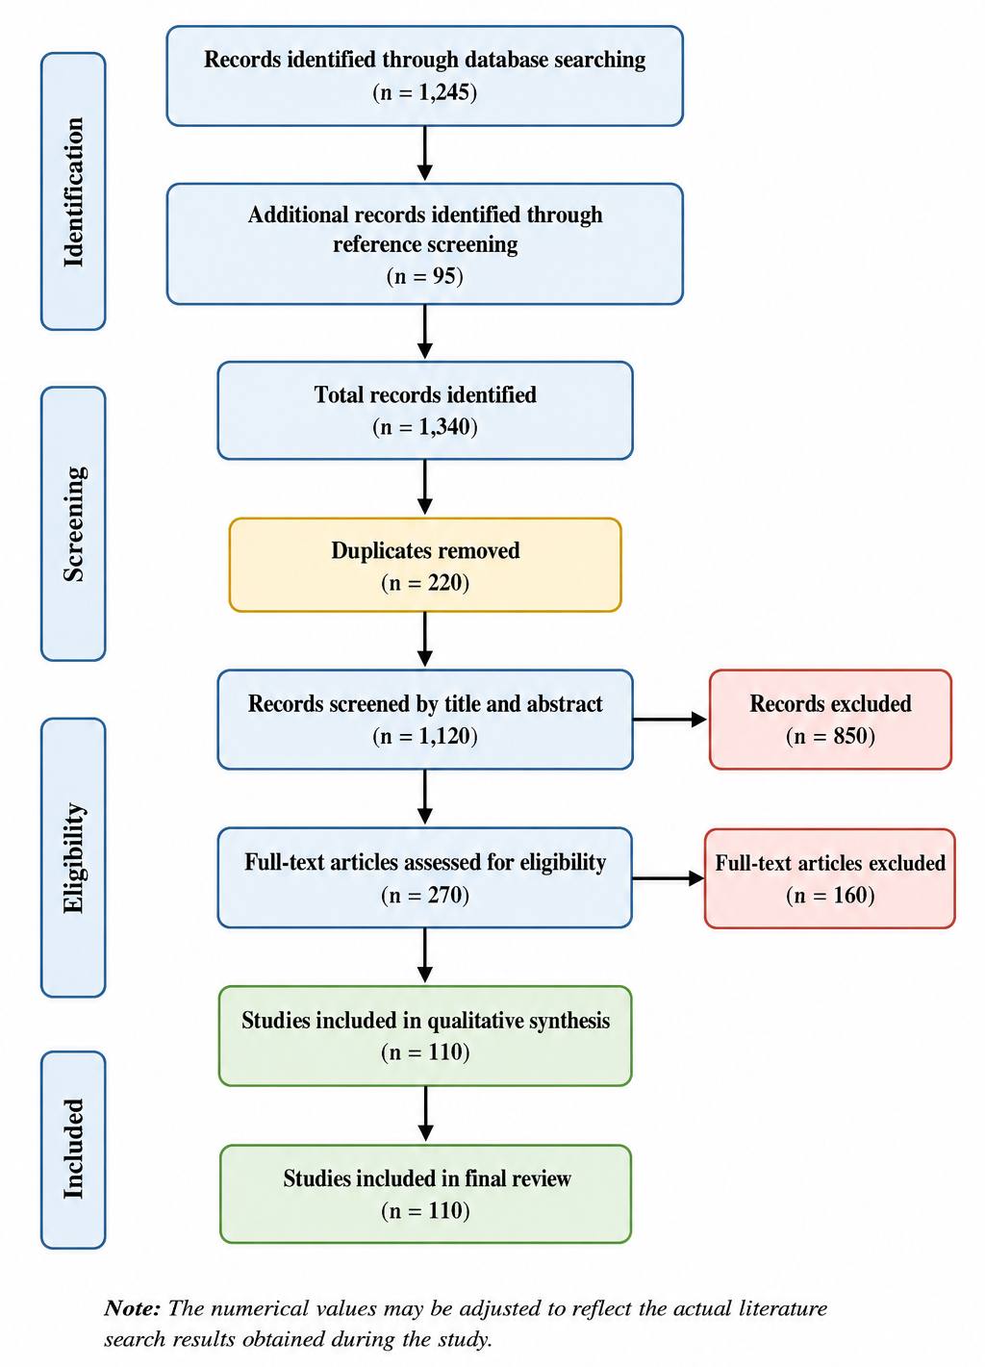
Figure 1: PRISMA Flow Diagram of Literature Selection Process
2.4 Data Extraction and Synthesis Procedures
Following the identification and selection of eligible studies, relevant information was systematically extracted using a structured data extraction framework. The extracted information included authorship, year of publication, country of study, research objectives, methodology, sample characteristics, theoretical framework, key findings, and recommendations. Additional information regarding the relationships among strategic leadership, organizational culture, and organizational performance was also documented.
The extracted data were analyzed using thematic synthesis techniques. This approach enabled the identification of recurring concepts, theoretical perspectives, empirical patterns, and emerging trends within the literature (Almeida, 2026). The synthesis process involved grouping studies into major thematic categories corresponding to the core constructs of the review: strategic leadership, organizational culture, organizational performance, and the mediating role of organizational culture.
Thematic analysis further facilitated the identification of areas of convergence and divergence across studies, highlighting similarities and differences in findings across geographical contexts and institutional settings. Particular attention was given to evidence from Nigerian universities and other developing-country contexts to provide context-specific insights (Naeem et al., 2023). The findings were subsequently integrated into a comprehensive conceptual framework illustrating the relationships among the key variables and their implications for organizational effectiveness in HEIs.
3. Conceptual Review
3.1 Strategic Leadership
3.1.1 Definitions and Evolution of Strategic Leadership
The concept of strategic leadership has come to play a crucial role in the field of modern organizational management, influencing the organization's direction, sustainability, and performance. It expanded the vision of traditional approaches to leadership that were mainly about supervision and operational management to include long-term planning, adaptation to the environment, innovation and organizational change (Afolayan et al., 2025). Leadership is especially significant in knowledge-intensive institutions like universities, as leaders are expected to respond to the fast-changing educational policies, technological developments, pressures from globalization, and stakeholder expectations.
Strategic leadership can be traced back to the strategic management literature which underscored the need for an organization to match its goals with environmental opportunities and threats. While early leadership theories emphasized traits, behaviours and situational factors, strategic leadership is a combination of these and involves strategic thinking and vision in the organization (Mohammad et al., 2024). As time went on, it became evident that leadership for organizational success would require more than operational efficiency, requiring a leader to be able to predict future challenges, marshal resources, and steer the organization to sustainable competitive advantage.
Strategic leadership has been defined by various scholars from different perspectives. There are commonalities among these definitions: creation of a vision, strategic decision-making, management of resources, adaptation of the organization, and influence on stakeholders. It is expected of strategic leaders to manage short-term operational needs, long-term institutional objectives, and to promote innovation and organizational learning (Sacavém et al., 2025).
3.1.2 Dimensions of Strategic Leadership
Strategic leadership is a multidimensional phenomenon that involves multiple interrelated abilities affecting the effectiveness of an organization. Strategic vision is the capacity of a leader to articulate and share a vision that is clear and compelling for the organization's desired future. A strategic vision serves as a compass, motivator and decision-making guide (Liu et al., 2022). In universities, strategic vision is used to coordinate the activities of teaching, research and administration in accordance with the institutional goals. Clear articulations of visions are more likely to create employee commitment and institutional coherence.
Decision making ability is the capacity to weigh alternatives, analyze risks and make sound decisions to achieve organizational goals. Strategic leaders use evidence-based decision making, input from others and analysis of the environment when making decisions (Deep, 2023). In HEIs, decision-making affects various aspects such as provision of resources, curriculum development, staff recruitment and policy implementation. Human Capital Development is aimed at improving the capacity of employees or staff in terms of their knowledge, skills, competencies and capabilities. The intellectual capital is one of the key assets of universities, and therefore staff development is of paramount importance. Strategic leaders invest in training and mentoring, research support and professional development programs to enhance institutional productivity and competitiveness (Okeke & Elegbede, 2024).
Universities face the challenge of staying relevant in the rapidly evolving higher education landscape in response to new technologies, policies, and societal needs. Change management is the capacity of leaders to initiate, manage and sustain change in organizations (Umar et al., 2025). Strategic leaders minimize resistance to change, articulate the value of innovation, and develop enabling conditions for institutional changes.
The interaction between universities and various stakeholders such as students, academic staff, government agencies, alumni, employers, industry partners, local communities etc. Stakeholder engagement is the process of establishing relationships with stakeholders for common goals (Liu et al., 2025). Managing communication and the involvement of stakeholders is a key element of strategic leadership that helps strengthen the legitimacy and performance of an organisation.
Together, these dimensions allow leaders to foster innovative, adaptive, and long-term successful organizations.
3.2 Organizational Performance in Universities
3.2.1 Concept and Dimensions of Organizational Performance
Organizational performance measures how well an organization is being managed and operated to meet the goals set by the organization. Prospects for performance in the corporate world are frequently assessed by economic metrics like profit, market share, and ROI (Return On Investment). But universities have wider goals of teaching, research, knowledge sharing and societal development (Owais & Kiss, 2025). Therefore, there is a multidimensional concept of organizational performance in higher education and quantitative and qualitative indicators must be taken into account.
The performance of a university is a measure of how well it is able to use its resources to attain the academic, administrative, research and societal objectives of the university. It includes such things as student success, research production, institutional reputation, stakeholder satisfaction, innovation, and community impact (Suranta & Setyaningsih, 2026). The multi-dimensionality of the performance of a university requires a multi-dimensional evaluation framework that reflects not only academic, but also non-academic performance.
The results of good organizational performance help ensure sustainability, competitiveness and the relevance of the institution to society. The better universities do, the more attractive they become for investments in the future; the more successful they are, the more they can recruit great faculty members; they are more likely to have more students; they are more likely to have international partnerships; and they are more likely to participate in national development.
3.2.2 Indicators of University Performance
As the higher education institution is a complex institution, several indicators of organization performance have been created. The most commonly used indicators are summarized in Table 2.
Table 2: Key Performance Indicators (KPIs) in HEIs
Performance Dimension | Key Indicators
Academic Excellence | Graduation rates, accreditation status, quality of teaching
Research Productivity | Publications, citations, patents, research grants
Institutional Reputation | National and international rankings, stakeholder perception
Staff Performance | Employee productivity, retention rates, professional development
Student Satisfaction | Student engagement, learning experience, employability
Community Engagement | Outreach programs, partnerships, social impact initiatives
Table 2 illustrates that organizational performance in universities goes beyond academic achievement, and encompasses research excellence, satisfaction of stakeholders and contributions to society.
Academic excellence is defined as the quality of teaching, delivery of the curriculum, students' learning outcomes and accreditation results. This is one of the major indicators of university performance directly reflecting the university's educational mission (Asamoah et al., 2025). Research productivity refers to the creation and sharing of new knowledge in publications, citations, patents, grants and collaborative projects. Research output improves the visibility of the institution and plays a major role in the rankings and reputation of the university (Adetayo et al., 2022). Institutional reputation is the image concurred by stakeholders about the quality, credibility and prestige of a university. A good reputation brings in students, professors, sources of finance, and foreign partnerships (Purevsuren et al., 2025).
Staff performance refers to the effectiveness of academic and non-academic staff, their commitment and productivity. Top performing staff play a part in excellent teaching, research and administrative effectiveness (Keltu, 2024). Student satisfaction contributes to the students' perceptions of the educational experience, learning environment, supporting services and overall experience at the University. Students who are satisfied are more likely to be successful academically and to recommend the school to their friends (Mendoza-Villafaina & López-Mosquera, 2024). The universities have responsibilities to society, such as through community service, knowledge transfer, consultancy and partnerships. Engaging with communities reflects the relevance of institutions and their social responsibility.
3.3 Organizational Culture
3.3.1 Concept and Characteristics of Organizational Culture
Organizational culture is the values, beliefs, assumptions, norms and practices that influence behaviour in an organisation. It is the sum total of the identity of organizational members and affects their work performance, decision making, and relationship management (Fietz & Günther, 2021). Organizational culture has been defined as “the way things are done” in an organization.
Organisational culture is defined by some characteristics, first, culture is shared within the organization among members and offers a common frame of reference to interpret organizational events. Second, culture is learned and transmitted by socialization processes. Thirdly, culture shapes behavior by setting norms and expectations. Fourth, culture can change in response to leadership actions and environment changes; overtime, it tends to be stable (Fernandes et al., 2023).
In universities, organizational culture exerts impact on academic values, professional ethics, communication modalities, innovation, collaboration and effectiveness of the university. A robust and positive culture fosters commitment, trust, creativity and performance, while a weak or negative culture can negatively impact the organization's performance.
3.3.2 Types of Organizational Culture
The Cameron and Quinn Competing Values Framework is one of the most popular models for organizational culture. The framework categorizes the organizational cultures into four broad categories. The culture types are shown in Figure 2 and summarised in Table 3, which lists some of their main features.
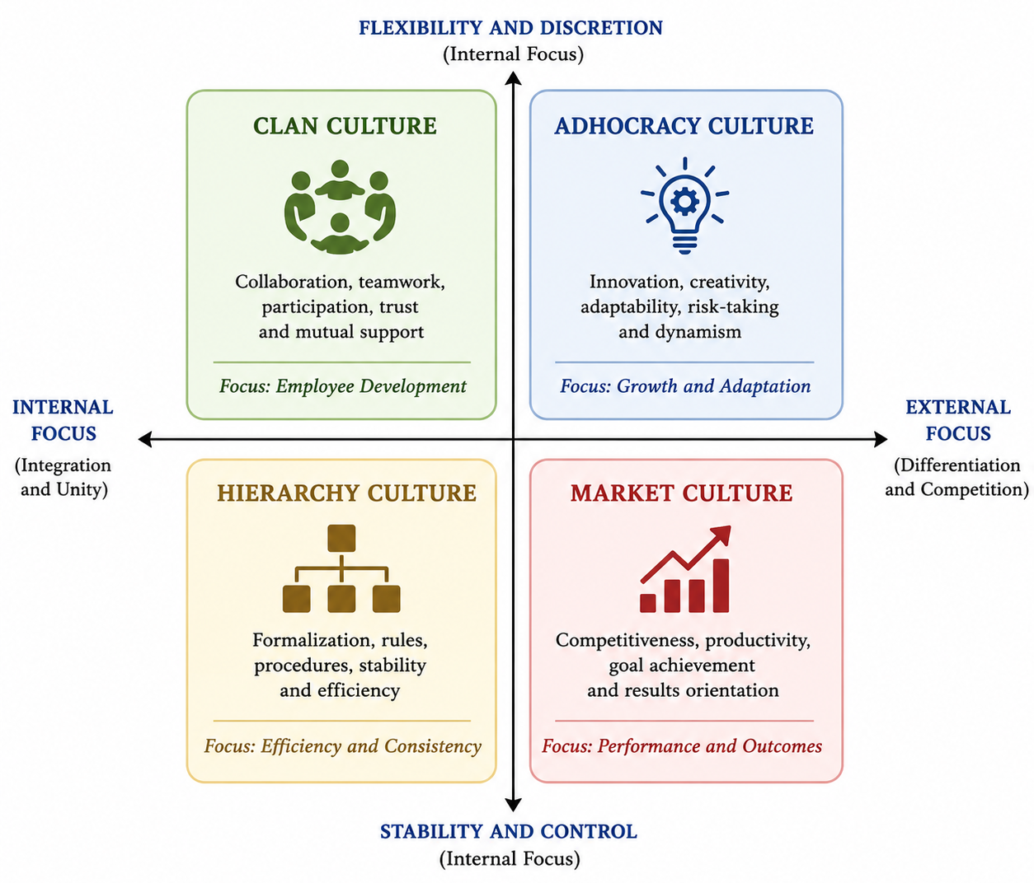
Figure 2: Types of Organizational Culture Based on the Competing Values Framework
Table 3: Characteristics of Organizational Culture Types
Culture Type | Key Characteristics | Leadership Style | Organizational Focus
Clan Culture | Collaboration, teamwork, participation | Mentor and facilitator | Employee development
Adhocracy Culture | Innovation, creativity, flexibility | Entrepreneur and innovator | Growth and adaptation
Market Culture | Competitiveness, productivity, results | Competitor and achiever | Performance and outcomes
Hierarchy Culture | Formalization, stability, control | Coordinator and administrator | Efficiency and consistency
The values of the clan culture are teamwork, trust, participation and employee development. In an organization with a clan culture, everyone acts as a member of an extended family and works together and supports each other. High employee commitment and effective knowledge sharing is generally seen in universities that have a strong culture of clans (Vasumathi et al., 2025). Adhocracy culture involves innovation, experimentation and adaptability. Institutions that work on this culture nurture creativity and taking risks to deal with changing environments successfully. These cultures are especially valuable in universities that are in research (Shahin et al., 2025). These cultures are especially valuable in universities with a research focus where innovation is a must.
Market culture focuses on competitiveness, productivity, and goal attainment. Organizations talk about tangible results and goals. Market culture can affect the priorities of universities such as rankings, research output, employment of graduates and satisfaction of stakeholders (Nderitu et al., 2021). Hierarchy culture has a strong focus on stability, established protocols, and regulations, along with enforcement structures. Such cultures can boost efficiency and consistency, but too much bureaucracy can stifle innovation and flexibility in universities.
3.3.3 Organizational Culture in Nigerian Universities
The culture of the Nigerian Universities is a blend of traditional academic values, bureaucratic administrative systems and new market-oriented practices. Many public universities historically have been hierarchical, wherein decision-making is centralised, formal processes are followed and people are under administrative control (Mtitu, 2025). These structures have helped to ensure institutional stability, but they have also been linked to slow decision making, lack of willingness to change and restricted innovation.
The recent changes in the higher education in Nigeria have promoted more collaborative and performance-based cultures. Rapidly changing competition among universities, demand for accountability, internationalization and technological developments have pushed universities to prioritize innovation, engagement with stakeholders, and performance improvement (Ogbaga et al., 2022; Moshtari & Safarpour, 2023). Thus, it is becoming more apparent in many universities that aspects of the clan culture, adhocracy, and market culture are emerging.
But issues like money shortages, industrial conflicts, political tensions and governance restrictions still impact on organizational culture in the industry. The role of strategic leadership is therefore, pivotal in the development of positive institutional cultures that promote academic excellence, research productivity, employee commitment and institutional sustainability (Mohammed et al., 2025). University leaders can have a significant impact on improving University performance and long-term institutional success by fostering cultures of trust, innovation, collaboration, and accountability.
4. Theoretical Review
Organizational leadership, organizational culture and organizational performance are interrelated constructs, which have been studied extensively in the organizational and management literatures from many perspectives (Jimoh, 2025). Theories serve as a basis to conceptualize the impact leadership can have on the outcomes of organizations and how it affects them. HEIs, especially the universities in Nigeria, have an important need to understand these theoretical positions, as a university is located in a complex world of funding limitations, technological advances, globalisation, policy changes and ever-changing expectations from stakeholders (Adewale & Ghavifekr, 2025). This review is based on four main theories: Upper Echelons Theory, Resource Based View (RBV), Transformational Leadership Theory and Organizational Culture Theory. These theories are combined to provide an understanding of the role of strategic leadership in an organisation's performance and the role of organisational culture as a mediating mechanism in the relationship.
4.1 Upper Echelons Theory
López-Muñoz and Escribá-Esteve (2017) have developed the Upper Echelons Theory to account for the relationship between organizational outcomes and the traits and choices of top-level management. It proposes that organisations are a reflection of their senior executives as their strategic choices are influenced by their own experiences, values, personalities, cognitive skills and perception of the environment. The theory suggests that leaders process and interpret organizational realities, which impacts decisions on strategy and organizational results.
The theory came about because they realized that the performance of the organization is not comprehensible without a focus on the people making strategic decisions. Leaders have varying experiences and backgrounds, leadership styles and values that influence the development of strategies and reactions to environmental challenges (Liden et al., 2024). For this reason, different people may be able to run different organizations with varying degrees of success.
In HEIs, vice-chancellors, rectors, provosts, deans and heads of department are key decision makers who have a major influence on the direction of the institution. These choices affect the allocation of resources, academic programs, research priorities, staff development programs, governance and stakeholder relations (O’Meara & Petzall, 2007). These decisions have an impact on both organizational culture and institutional performance.
The first stage of the integrated framework presented in Figure 3 (strategic leadership dimensions: strategic vision, decision-making capability, human capital development and change management, and stakeholder engagement) mirrors the relevance of Upper Echelons Theory to this review: strategic leadership dimensions are the drivers of organizational culture and performance (Tran & Khoa, 2025). The theory, therefore, gives a solid base to comprehend the effect of the role characteristics of leadership on organizational outcomes in Nigerian universities.
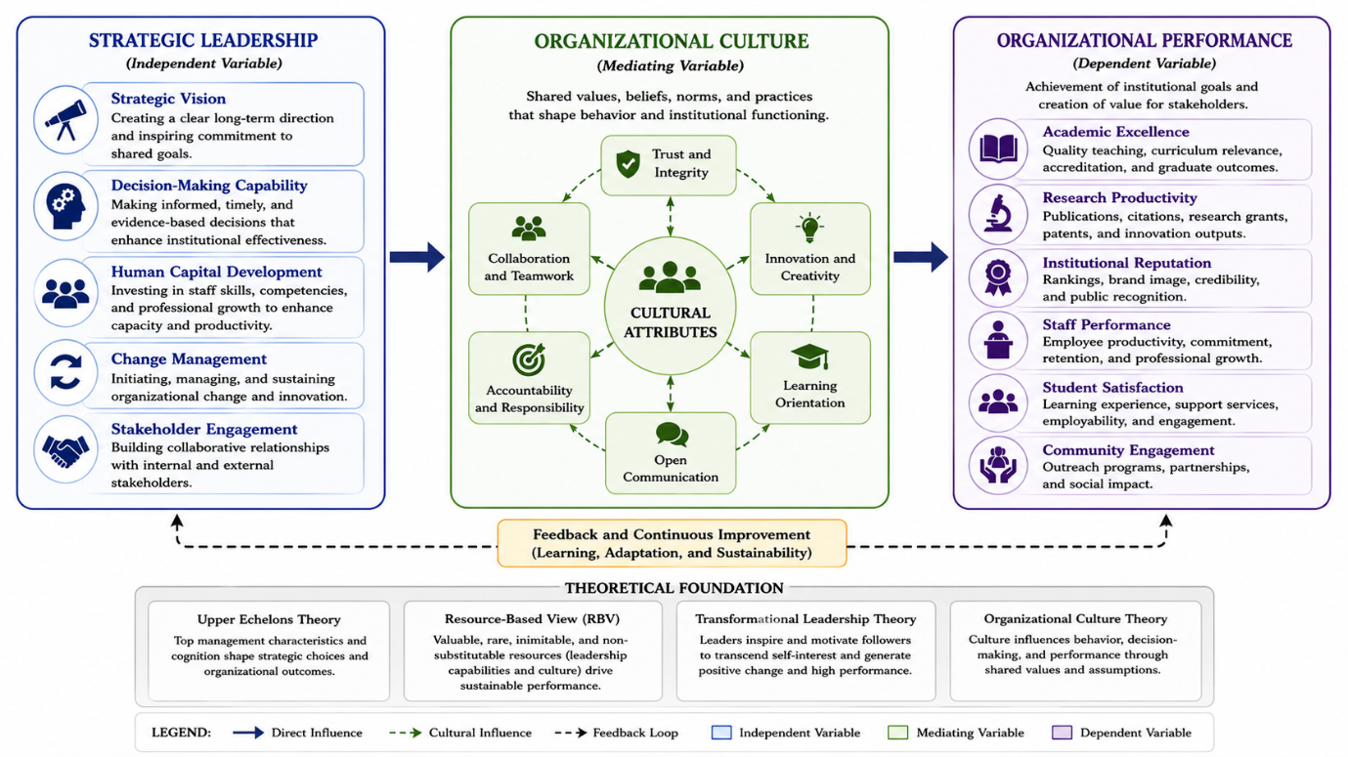
Figure 3: Integrated Theoretical Framework Linking Strategic Leadership, Organizational Culture, and Organizational Performance
4.2 Resource-Based View (RBV)
Resource Based View (RBV) theory proposes that an organisation's ability to be sustained, competitive and successful relies on the possession and development of valuable resources that are rare, inimitable and non-substitutable. RBV is different from theories placed emphasis on the external environment of the organization because the former emphasizes internal resources of the organization as the major determinants of performance (Mailani et al., 2024).vRBV sees organizational resources as either tangible or intangible resources. Tangible resources would involve physical facilities, technology and financial resources, while intangible resources would involve knowledge, leadership ability, organizational culture, reputation and intellectual capital (Kero & Bogale, 2023). The theory implies that if companies have unique and hard-to-replicate resources, they are more likely to perform better than other companies.
Strategic leadership and organizational culture are important intangible resources in HEIs. Good leadership promotes adaptability, innovation, and stakeholder trust within an organization, and a positive culture creates a commitment, collaboration, knowledge-sharing and organizational effectiveness among employees (Jerab & Mabrouk, 2023). They are hard to imitate by competing institutions because they are organic and develop over time based on unique experiences and interactions within organizations. The RBV perspective is directly aligned with the role of organizational culture in Figure 3. The framework proposes that strategic leadership plays a role in building effective organizational cultures that feature trust, innovation, collaboration, accountability, and a learning orientation. These cultural features are then used as organizational assets which in turn improve organizational functioning. Thus, it can be concluded that the academic excellence, research productivity and institutional sustainability rates of universities with good leadership and positive culture can be explained by RBV.
Moreover, RBV underscores the significance of investing in human capital development. As the universities are dependent on intellectual resources, those leaders who invest in training their staff members, Research and Development, knowledge management are more likely to improve the competitiveness and performance of their institutions.
4.3 Transformational Leadership Theory
Transformational Leadership theory states that the leader is the one who can motivate followers to go beyond their personal interests and collaborate as a team to reach organizational objectives. The key competencies of a transformational leader are the ability to develop engaging visions, inspire innovation, engender trust, and promote personal growth (Hernandez et al., 2026). The theory has four key aspects of transformational leadership: Idealized influence, Inspirational motivation, Intellectual stimulation, and Individualized consideration. Leaders are role models through idealized influence, which is defined by the way those in authority behave so as to earn the respect and trust of others. Inspirational motivation is about conveying a vision that inspires and motivates commitment and enthusiasm (Jun & Lee, 2023). Intellectual stimulation promotes creativity, critical thinking and innovation, and individualized consideration is mentoring and supporting employees' professional development.
The theories of transformational leadership are more applicable to universities because knowledge creation, innovation and intellectual development are key drivers of the University. A major challenge for the effective university leader is to encourage faculty, researchers and administrators to strive for excellence in teaching, research, and community service in the face of many institutional difficulties (Crawford et al., 2026). The theory also directly explains the relationship between strategic leadership and organisational culture, as seen in Figure 3. Transformational leaders shape organizational values, beliefs and norms by their behaviors and interactions with organizational members. Leaders fostering positive organizational cultures do so by building trust, promoting innovation, collaboration and shared commitment, and achieving institutional goals. Thus, the organizational culture serves as a channel of leadership impact on organizational performance (Crawford et al., 2026).
Transformational leadership is of significant value in the Nigeria context of universities as some of the challenges universities encounter include lack of adequate funding, lack of infrastructure, industrial conflicts and resistance to change. Leaders who are capable of inspiring commitment, encouraging innovation, and facilitating institutional change will be more likely to affect sustainable institutional improvement.
4.4 Organizational Culture Theory
Organizational culture is "a complex pattern of shared assumptions, beliefs, values, and norms established over time by the members of an organization. The following common beliefs affect how staff members see the world, interpret issues, and communicate with each other. The first level is the artifact, something that can be seen evidence of culture-like structures, symbols, rituals and observable behaviors (Bogale & Debela, 2024). The second level corresponds to espoused values, which are the stated values, goals and philosophies which direct organizational actions. The deepest level is fundamental assumptions, beliefs that are not conscious and fundamental in organizational behaviour and decision making (Vasumathi et al., 2025).
Organizational Culture Theory focuses on the impact of culture on the organization's functioning, from communication and collaboration to innovation, decision making, employee engagement and results. Good culture fosters employee engagement, organizational learning, and adaptability, while bad culture may hinder organizational effectiveness (Crawford et al., 2026). This study's organizational culture as mediator is directly based on the theory of Organizational Culture. Organizational culture is in a central role between strategic leadership and organizational performance as shown in Figure 3. Organizational culture is formed by the decisions, actions, and priorities of strategic leaders, which affect the level of attainment of organizational goals, and institutional goals in turn can affect organizational culture. Culture therefore becomes the link between leadership practices and organizational outcomes.
4.4.1 Relevance of the Theories to Nigerian Universities
The four theories discussed are complementary in providing the perspectives for understanding leadership and organizational effectiveness in universities in Nigeria. According to Upper Echelons Theory, the leadership of these universities has a direct impact on the strategic choices and institutional outcomes. This is especially significant given the governance inefficiencies, funding challenges and policy uncertainties that many Nigerian universities face, which call for effective leadership responses (Carpenter et al., 2004). The Resource Based View focuses on the intangible resources of an organisation, including its leadership competency, organisational culture, its reputation in the industry and its intellectual capital (Mailani et al., 2024). Universities increasingly look at these resources to measure institutional success as they compete for students and research funding, international partnerships and academic recognition.
Transformational Leadership Theory is also relevant since there is a need for an educational transformation in Nigerian universities to tackle new educational problems. Institutional development and competitiveness require leaders who can inspire innovation, promote collaboration and foster change (Adebola, 2025). Organizational Culture Theory helps us understand how institutional values, norms and assumptions impact organizational effectiveness. The organizational culture is a factor contributing to many challenges in Nigerian Universities such as; bureaucratic rigidity, resistance to innovation, poor accountability mechanism, etc (Ibrahim & Abiakam, 2020). So, it is an imperative to know about cultural dynamics to enhance the performance of the institutions.
4.4.2 Theoretical Integration
Although each theory contributes unique insights, none independently provides a complete explanation of how strategic leadership influences organizational performance. Therefore, this review adopts an integrated theoretical framework that combines the strengths of all four perspectives.
Upper Echelons Theory explains how leadership characteristics and strategic decisions influence organizational direction. Transformational Leadership Theory explains how leaders inspire employees and shape organizational values and behaviors. Organizational Culture Theory explains how these values and behaviors become embedded within institutional culture and subsequently influence organizational functioning (Adebola, 2025). Finally, the Resource-Based View explains how leadership capabilities and organizational culture become strategic resources that contribute to sustained organizational performance.
As illustrated in Figure 3, strategic leadership serves as the independent construct comprising strategic vision, decision-making capability, human capital development, change management, and stakeholder engagement. These leadership dimensions influence organizational culture by fostering shared values, collaboration, trust, accountability, innovation, and learning orientation (Jimoh, 2025). Organizational culture then acts as a mediating variable that influences key dimensions of organizational performance, including academic excellence, research productivity, institutional reputation, staff performance, student satisfaction, and community engagement (Mohammad et al., 2024).
The integrated framework presented in Figure 3 therefore provides a holistic explanation of the mechanisms through which strategic leadership contributes to organizational effectiveness in Nigerian universities. It recognizes that leadership influences performance not only through direct actions and decisions but also through the development of organizational cultures that support institutional excellence, adaptability, and sustainability.
5. Empirical Review
Empirical studies examining strategic leadership, organizational culture, and organizational performance have increased significantly over the past two decades. Researchers across different sectors and geographical contexts have sought to understand how leadership practices influence organizational outcomes and the role organizational culture plays in this relationship. Within HEIs, these constructs have attracted growing attention due to increasing demands for accountability, competitiveness, innovation, and institutional sustainability (Obeng-Kyereh, 2026).
5.1 Strategic Leadership and Organizational Performance
5.1.1 Evidence from Developed Countries
In the United Kingdom, Kebede et al. (2024) found that the strategic leadership positively affected the performance of schools and universities by helping to build institutional vision, strategic planning, and stakeholder engagement. They found that leaders who communicated their strategic goals and connected institutional resources to those goals were more effective in their organizations. Likewise, Davis (2024) noted that strategic leaders drive improvements in organizational performance through their ability to foster organizational learning, adaptability and strategic thinking. Their results indicated that adaptive and visionary leadership in institutions was more conducive to meeting challenges of environmental uncertainty and competition.
Ashkevari and Ghasemi (2023) carried out research in North American organisations that also illustrated the link between strategic leadership and both short-term operational efficiency and long-term sustainability of the organisation. The findings of the study revealed that the leadership behaviors of strategic vision, innovation and human capital development had a significant positive impact on the organizational performance indicators. In higher education, Riza et al. (2025) conducted a study in universities in Europe and concluded that strategic leadership improved academic performance, staff motivation, research productivity and institutional reputation. The study found that university leaders who fostered participation, innovation and collaboration performed better in terms of the organizational outcome.
As a whole, the findings from developed countries indicate that strategic leadership has a significant impact on the organization's performance through the processes of innovation, employee commitment and linking the resources of the organization to the strategic goals.
5.1.2 Evidence from Developing Countries
In developing countries, strategic leadership has also been found to have a positive relationship with organizational performance in research. Yet, in many of these studies, contextual issues like resource scarcity, governance constraints, and institutional instability are included that impact the effectiveness of leadership.
Their study Mohammed (2026) in the public institutions of Kenya revealed that strategic leadership had a significant impact on organizational performance in the areas of strategic planning, empowerment of employees and effective use of resources. Institutions with good leadership showed greater level of service delivery and operational efficiency.cThe result of the study conducted by Altynbassov et al. (2024) in Malaysian HEIs confirmed that strategic leadership had a positive effect on the performance of the institution due to improved innovation, cooperation of the stakeholders and the commitment of the employees. The results highlighted the need for leadership in change management and maintaining competitiveness in an organization. In South Africa, Nkomo and Kriek (2011) found that strategic leadership was a factor that enabled the sharing of knowledge, employee engagement and adaptability of the organization in order to become effective. The study emphasized the need for the leadership competencies in solving institutional problems in emerging economies.
Likewise, research in India and Ghana has shown that strategic leadership has a positive impact on organizational performance through fostering innovation, alignment, and resilience of organizations. This means that strategic leadership is still an important determinant of performance, irrespective of geographic location, but that contextual factors might affect the size of the effects.
5.1.3 Evidence from Nigerian Universities
Researchers in the Nigerian higher education sector have investigated the effect of leadership on institutions performance, some of these studies are briefed below.cThere are several studies that have looked at the effect of leadership on institutional performance in the Nigerian higher education sector, some of these studies are briefly summarised below. The majority of the studies show the positive correlation between strategic leadership and university effectiveness, university productivity and organizational sustainability.
According to Daramola (2025), strategic leadership practices had a significant effect on staff productivity and institutional performance in some of the Universities among the Nigerian Universities. The study found that strategic planning, employee development, and participatory decision making were strategies leaders reported using that led to better organizational outcomes.
Again, Jinga et al. (2024) found leadership effectiveness to have a positive impact on research productivity, commitment of employees, and institutional reputation in public universities. The authors recommended that leadership ability continues to be one of the critical factors for achieving success in universities in Nigeria. Another study conducted by Wahyuningtyas et al. (2024) also found that strategic leadership positively affected academic excellence and administrative efficiency by enhancing means of communication, engaging with stakeholders, and managing change. The results highlighted the need for visionary leadership to solve problems facing universities in Nigeria.
While these are all positive results, some research suggests that Nigerian universities are plagued by poor funding, political interference in governance, bureaucracy and political issues that limit the effectiveness of leadership. The factors underscore the importance of leadership practices that can create organizational cultures that promote institutional effectiveness.
5.2 Strategic Leadership and Organizational Culture
5.2.1 Leadership Influence on Culture Formation
There is ample literature that has emerged that suggests that leaders have a critical role in the development of organizational culture. Organizational culture is shaped by leadership actions, decisions, values, communication and behavioural expectations. Leaders shape the culture by setting organizational priorities, setting norms, allocating resources and rewarding desired behaviors.
Jerab and Mabrouk (2023) insisted that culture and leadership go hand-in-hand as culture is formed when leaders establish and reinforce organizational values, which then become ingrained as the organization's culture. Assumptions and beliefs influence employee actions and decisions and are formed by repeated actions and decisions under the leadership of the employee. This view is supported through empirical studies. Leadership styles were shown to have a significant impact on organizational culture in a variety of industries by Vasumathi et al. (2025). Organizations with participative and transformational leaders were more likely to have cultures that were built on trust, innovation and collaboration. In the same way, Iddrisu (2025) documented that leadership behaviours had a strong effect on the culture and attitudes of employees within the organisation. The results indicated that communication and employee involvement-initiating leaders fostered stronger and more positive organizational cultures.
In HEIs, the leadership has been demonstrated to have an impact on academic norms, academic practices, governance structure, and the values of the institution. The university leadership thus has a pivotal role to develop cultures that foster academic excellence and organizational efficiency.
5.2.2 Strategic Leadership Practices and Cultural Transformation
Strategic leadership is not just about creating culture, it is also about doing the transformation of the culture. In times of change, business units may need to experience a culture shift to be competitive and effective. Strategic leaders help to lead this transformation by bringing in new values, innovations and making organizational culture more in sync with strategic goals.
Jerab and Mabrouk (2023) revealed that the transformational aspects of leadership have a strong effect on cultural change through three dimensions: shared vision, trust and employee commitment. Well-led organizations with clear strategic direction are more likely to be on successful transformation. Cultural transformation is gaining importance in universities in the context of globalization, technological development and shifting stakeholder expectations. It has been found that strategic leaders who foster innovation, learning and teamwork are more successful in building adaptive organizational cultures (Kero & Bogale, 2023).
Moreover, studies in African universities also reveal that leadership-induced cultural shift positively influences employee satisfaction, productivity and competitiveness of the institution. The results further validate the need for strategic leadership as a facilitator of cultural change and organizational renewal.
5.3 Organizational Culture and Organizational Performance
5.3.1 Culture as a Driver of Institutional Effectiveness
There are many empirical studies that have established the relationship between organizational culture and organizational performance as one of the major factors. Culture impacts on employee behaviours, motivation, commitment, communication and innovation and therefore also on institutional effectiveness.
Tsai (2011) determined that organizational cultures with high scores on involvement, consistency, adaptability and mission orientation were correlated with high organizational performance. They found that high cultures improve employee engagement and organizational performance. Likewise, Flamholtz and Randle (2012) have found that firms with adaptive cultures routinely earn higher returns than firms with rigid or dysfunctional cultures. The authors found that culture is a key area of sustainable competitive advantage.
Within HEIs, organizational culture has an impact on the quality of teaching, research productivity, administrative efficiency, and satisfaction of stakeholders. An open, flexible, and supportive culture is associated with improved academic performance and operation within a university.
5.3.2 Evidence from the HE Institution
The research conducted in universities shows a positive relationship between the organizational culture and the performance of the institutions in a continuous manner. Alkhodary (2023) reported that educational institutions with clan and adhocracy cultures were more innovative, more satisfied among employees, and were more effective institutions. Ibrahim (2025) found that organizational culture had a significant effect on student satisfaction, faculty productivity and institutional performance. Those universities with a collaborative and supportive culture had better performance results. Likewise, Morales-Huamán et al. (2023) discovered that the organizational culture influenced the adaptability of the institution, the effectiveness of its leaders, and the success of the institution's strategy. The study highlighted organizational culture in harmony with the institutional goals.
Research at African universities has also shown that positive organizational cultures are associated with better staff commitment, better student results and higher research productivity. The results indicate that culture is still an important determinant of the performance of the university in various settings. The organizational culture was presented as a mediator in this study. In this study the organizational culture was introduced as a mediating variable.
5.4 Organizational Culture as a Mediating Variable
5.4.1 Empirical Evidence of Mediation Effects
Empirical research on organizational culture as a mediating factor between leadership and performance has been a growing area of recent study. It is assumed that leadership affects organizational outcomes indirectly through organizational culture.
Ginting et al. (2024) discovered that organizational culture partially played a role between leadership style and organizational performance. They found leadership behaviours had a strong effect on performance by impacting on employee attitude and organisational values. Similarly, Kamaluddin et al. (2026) reported that organizational culture mediated the effects of transformational leadership on organizational effectiveness. The results showed a significant positive influence of leadership developed cultures on employee performance and organizational results.
In tertiary education institutions, it has been found that strategic leadership has a positive impact on academic performance and institutional effectiveness as a result of creation of supportive organizational culture. Universities with great leadership and positive cultures are found to have better performance outcomes. The findings of this study offer evidence for the concept of organizational culture as a mediator between strategic leadership and organizational performance that was suggested in this review.
6. Discussion and Synthesis of Findings
The evidence from the previous sections shows that strategic leadership, organizational culture and organizational performance are highly interrelated concepts that have significant impact on the effectiveness and sustainability of HES (Akinwale et al., 2023). The strategic leadership literature consistently shows that strategic leadership impacts the success of organizations by means of institutional vision, effective decision making, human capital development, engaging with stakeholders, and managing change, in both developed and developing countries. The results further show, however, that leadership does not directly affect organizational performance. Instead, organizational culture functions as a key intervening mechanism between leadership practices and institutional outcomes (Adebola, 2025). The synthesized relationship among these constructs is presented in figure 4 which shows the relationship between strategic leadership and organizational culture and the relationship between organizational culture and organizational performance.
The review also shows that although many researchers have studied the leadership and culture-organisation relationship and its direct effects on organisational performance, few studies have looked at how organisational culture acts as a mediator between leadership and performance especially in the Nigerian universities (Daramola, 2025).
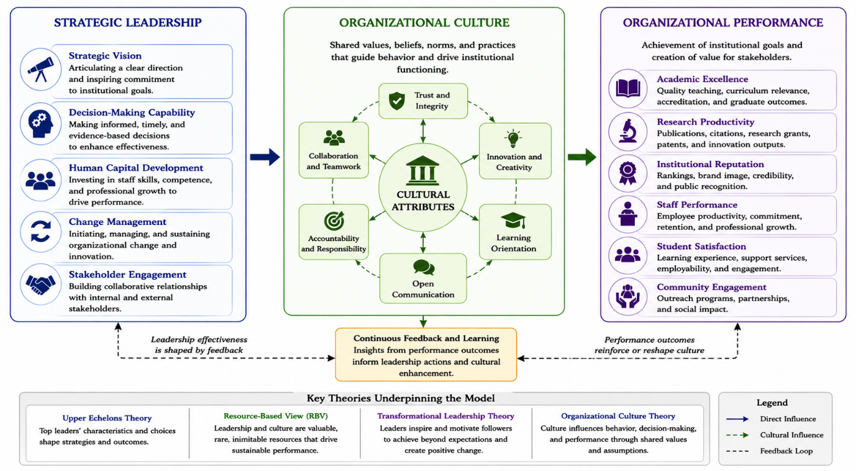
Figure 4: Synthesized Relationship among Strategic Leadership, Organizational Culture, and Organizational Performance
6.1 Strategic Leadership Practices in Nigerian Universities
The literature reviewed shows that strategic leadership is still one of the most crucial factors for the success of institutions in Nigerian universities. The context in which the leaders of universities are operating is becoming more complex than ever, with financial restrictions, technological changes, globalization, policy uncertainty, infrastructure gaps, and evolving expectations of stakeholders (Ibrahim, 2025). In these situations, good leadership is critical for guaranteeing institutional adaptability, competitiveness and sustainability. The results show that the key to effective university management is to establish a clear long-term vision and connect the work of the university with the long-term goals. Strategic vision is about direction and predicting future challenges and opportunities (Mohammed, 2026). Institutions with visionary leaders tend to be better prepared to enact reform, recruit resources, enhance academic quality, and build their stakeholders' confidence.
Another key finding is regarding decision making skills. Good leaders use evidence to make decisions that are transparent, accountable and effective at supporting institutional effectiveness. Strategic decision making is important in Nigerian universities because governance problems and limited resources are so prevalent that it is important to prioritize investments, manage risks and reach institutional goals (Okeke & Elegbede, 2024). The review also emphasizes the importance of human capital development. Universities are knowledge intensive institutions that rely greatly on the productivity and quality of academic and administrative staff. Leaders who make a high investment in staff development, research support, mentorship, and staff professional training make a significant contribution to institutional performance (Nkomo & Kriek, 2011). These investments lead to better staff competency, motivation and commitment, which in turn contribute to better teaching, research output and service provision.
In addition, the results indicated that good change management is fast becoming a critical thing in Nigerian universities. As technology rapidly evolves, organizations are forced to keep adapting their processes and strategies to meet the new demands of digital transformation and changing educational needs (Umar et al., 2025). Leaders who successfully lead change establish culture, nurture innovation, learning in the organisation and continuous improvement.
A stakeholder engagement was also identified as a key leadership practice. Universities engage with a variety of stakeholders such as students, staff, alumni, government, industry, accreditors and local community. Collaborative relationships with these stakeholders by strategic leaders contribute and strengthen institutional legitimacy, resource mobilization, and effectiveness.
6.2 Influence of Organizational Culture on Institutional Outcomes
The review also highlights the significant impact that organizational culture has on institutional results in HEIs. Organizational culture influences behaviours of employees, decision making process among employees, communication between employees and organizational priorities. Therefore, culture is a very strong influence on the effectiveness and sustainability of institutions (López-Muñoz & Escribá-Esteve, 2017). The results show that generally, universities that have positive organizational cultures have higher levels of employee commitment, innovation, collaboration, and productivity. Clan cultures foster a sense of community, teamwork, and trust among employees, which can lead to improved job satisfaction and cohesion. Adhocracy cultures promote innovativeness and creativity, crucial traits of research and institutional flexibility (Kebede et al., 2024). Market-oriented cultures value performance, accountability, and competitiveness, and hierarchy cultures add to stability and procedural consistency.
Indeed, the review indicates that overly hierarchical system can limit flexibility and innovation. A significant number of public universities in Nigeria remain to be operated in a highly bureaucratic setting where decision making is centralised and administrative process is rigid. These cultures can limit creativity, hinder the ability of institutions to react to change, and decrease employee engagement (Iddrisu, 2025). The research findings indicate that higher performing universities tend to have a combination of stability and flexibility. Collaborative, accountable, innovative, and learning institutions are more likely to be distinguished by their academic excellence, research productivity, student satisfaction, and stakeholders' confidence.
The results also revealed a significant impact of organizational culture on organizational performance in almost all of its aspects (Ginting et al., 2024). Values, norms and behaviors that are internalized in the organizational culture influence research productivity, the reputation of the institution, staff effectiveness, community engagement, and students' outcomes. As such, culture is not just a characteristic of an organization, but a strategic asset that can contribute to improving institutional competitiveness and sustainability.
6.3 Mediating Role of Organizational Culture
The most important results that have emerged from this review, is the existence of organizational culture as a mediator between strategic leadership and organizational performance. The findings indicate that leadership affects organizational performance beyond the direct effect of its strategic actions, but also by creating organizational values, beliefs, and practices that affect employees and the functioning of the organization (Carpenter et al., 2004). Strategic leadership impacts organizational culture through strategic vision, strategic decisions making, human capital development, change management and stakeholder engagement, as shown in Figure 4. These leadership behaviours foster cultural traits like trust, accountability, innovation, collaboration, learning orientation and shared commitment.
These attributes of culture shape an organization's performance when they're in place, through their impact on employee motivation, knowledge sharing, learning and operational effectiveness. Thus, organizational culture serves as a mechanism that brings leadership initiatives to produce tangible outcomes in institutions (Altynbassov et al., 2024). The review confirms previous studies which showed that organizational culture is an important mediating factor between leadership and performance. Positive culture in universities is associated with better performance, even in tough situations (Adewale & Ghavifekr, 2025). However, the outcomes of leadership initiatives can be less than optimal if an organization's culture is not receptive to change or if it does not align with institutional goals.
This is a significant finding in the area of university management. It implies that while leadership intervention to enhance policies, structures, or procedures can be important, it is not enough without interventions to develop organizational cultures that support it. Thus, besides strategic planning, leaders must also turn their attention to cultural development and transformation to improve institutions sustainably.
6.4 Emerging trends and future directions
The review highlights some trends that are changing the landscape of leadership and the organizational culture in HEIs. The spotlight on digital leadership is one of the trends. The use of digital technologies in teaching, learning, research and administration demands leaders who are able to lead technological change and promote innovation and adaptability (Asamoah et al., 2025). One of the new phenomena is the increasing significance of participatory and collaborative leadership. These days, the importance of shared governance, including the involvement of stakeholders and distributed leadership, to improve institutions' effectiveness is being increasingly acknowledged by contemporary universities. These approaches help to foster inclusive cultures of trust, engagement and collective responsibility within organizations.
Internationalization is also a major trend that is affecting the leadership and culture of universities (Adebola, 2025). The leaders need to foster cultures that are conducive to diversity and inclusiveness, as well as global competitiveness, especially as institutions look for partnerships worldwide, international students and research collaborations. The review also emphasises the growing significance of organisational resilience. In the context of economic instability, a public health crisis, technological disruption, and policy changes, universities are faced with uncertainties. An adaptive, innovative, and learning culture is thus a strategic priority for leaders to create.
Longitudinal relationships between Strategic leadership and organizational culture, and between organizational culture and organizational performance in Nigerian Universities should be investigated in future. Collaborative research between public and private institutions might be able to draw useful lessons from differences in context that impact on the effectiveness of public institutions (Bogale & Debela, 2024). Additionally, emerging models of leadership and their impact on the culture of an organization in digital transforming teaching and learning settings should be investigated. The findings of the synthesis strengthen the argument that organizational culture is an important link between strategic leadership and organizational performance.
7. Conclusion
The focus of this review was to investigate the relationship between strategic leadership and organizational performance in Nigerian universities, bearing strategic organizational culture in mind. The study theoretically drew on literature and empirical studies to examine the relationship that exists between leadership practices and organizational culture, and how culture influences institutional outcomes. The review was able to integrate the evidence from developed countries, developing countries and the higher education sector in Nigeria in order to gain a holistic perspective of the interactions between these constructs. The results reveal that strategic leadership is fundamental for improving the performance of the organization in the following aspects: strategic vision, effective decision making, human capital development, change management and stakeholder engagement. Such leaders have an advantage in navigating the rough seas of universities in an increasingly complicated and dynamic world, and are better equipped to grow and sustain their institutions. The review also shows, however, that leadership is not enough to ensure an organization's success. The leadership effectiveness is highly dependent on the organizational culture in which they work. Organizational culture was found to be an important factor that affects institutional effectiveness and a key factor by which leadership impacts institutional performance. Trustful and collaborative cultures, cultures of innovation, culture of accountability, culture of learning orientation have positive impact on academic excellence, research productivity, institutional reputation, staff performance, student satisfaction and community engagement. On the other hand, institutions in a culture with too much bureaucracy, not enough accountability, and an aversion to change can stymie institutional development. The review also emphasizes the need to regard organizational culture as a strategic asset for creating sustainable competitive advantage. Fostering positive organizational cultures can boost staff engagement, enhance the adaptability of the university, and promote organizational performance. The theoretical framework that was integrated in this review is found that organizational culture is a type of bridge between strategic leadership and organizational performance. In terms of practice, the study shows the importance of leadership development programs, cultural transformation programs and supportive policy frameworks in Nigerian universities. Institutional effectiveness and competitiveness in the international higher education market can be greatly enhanced by enhancing leadership capabilities and creating an organizational culture that emphasizes performance. The review has confirmed the importance of strategic leadership and organizational culture in driving organizational performance in Nigerian universities. The ability of an institution to be sustainable depends on the evolution of its visionary leadership, on its organizational culture's support, and on the enabling policy environment. Further research is needed to examine these connections in greater depth and complexity through more systematic and contextually relevant research designs and methods in order to contribute to knowledge and evidence-based decision making in higher education.
Reference
Abujudeh, S. (2020). Examining the impacts of organizational culture and leadership styles on the organizational performance indicators. Acta Medicinae Et Sociologica, 11(31), 39–54. https://doi.org/10.19055/ams.2020.11/31/4
Adebola, K. O. (2025). Transformative Educational Leadership: a catalyst for educational growth and development in South-West, Nigeria. International Journal of Research and Innovation in Social Science, IX(IIIS), 6136–6144. https://doi.org/10.47772/ijriss.2025.903sedu0444
Adetayo, A. J., Oketunji, I., & Hamzat, S. A. (2022). Mentoring support for librarians’ research productivity in southwestern Nigeria: A study of quantity of publications in quality outlets and online channels. The Journal of Academic Librarianship, 49(1), 102625. https://doi.org/10.1016/j.acalib.2022.102625
Adewale, A. S., & Ghavifekr, S. (2025). Challenges of leading change in higher education institutions: Evidence from Nigeria. Educational Management Administration & Leadership. https://doi.org/10.1177/17411432251334704
Afolayan, M. A., Lawal, O. R., Olayinka, E. G., Abdulganiyu, T. O., & Mustpha, J. (2025). Strategic leadership and organizational performance of selected Multinational Corporations (MNCs) in Nigeria. International Journal of Research and Innovation in Social Science, IX(XIV), 2319–2335. https://doi.org/10.47772/ijriss.2025.914mg00177
Akinwale, O. E., Kuye, O. L., & Akinwale, O. E. (2023). Trajectory of brain-drain and quality of work-life amongst Nigeria’s university lecturers: academic staff union of universities (ASUU) incessant strike in retrospect. International Trade Politics and Development, 7(2), 115–137. https://doi.org/10.1108/itpd-10-2022-0021
Alkhodary, D. A. (2023). Exploring the Relationship between Organizational Culture and Well-Being of Educational Institutions in Jordan. Administrative Sciences, 13(3), 92. https://doi.org/10.3390/admsci13030092
Almeida, F. (2026). Thematic analysis in qualitative research: Steps, benefits, and challenges. Zenodo (CERN European Organization for Nuclear Research). https://doi.org/10.5281/zenodo.18241378
Alsaqqa, H. H. (2024). Organizational Culture Relation with Innovation comment on “Employee-Driven Innovation in Health Organizations: Insights from a scoping Review.” International Journal of Health Policy and Management, 13, 8583. https://doi.org/10.34172/ijhpm.8583
Altynbassov, B., Bayanbayeva, A., Tolegen, M., & Zhamankarin, M. (2024). A comprehensive bibliometric analysis of trends in higher education leadership in the Global South, 2013-2023: Contemporary perspectives and developments. International Journal of Educational Research, 127, 102421. https://doi.org/10.1016/j.ijer.2024.102421
Alyoussef, I. Y. (2023). Acceptance of e-learning in higher education: The role of task-technology fit with the information systems success model. Heliyon, 9(3), e13751. https://doi.org/10.1016/j.heliyon.2023.e13751
Anyia, N., Senin, A. B. A., & Aziz, A. a. B. A. (2025). The role of strategic leadership on organizational culture and employees resilience. International Journal of Academic Research in Business and Social Sciences, 15(7). https://doi.org/10.6007/ijarbss/v15-i7/25993
Asamoah, M. K., Ansong, J. D., Mackin, E., Agyekum, B., & Eshun, S. N. (2025). The influence of quality assurance on achieving development education goals. Discover Education, 4(1). https://doi.org/10.1007/s44217-025-00694-1
Ashkevari, S. B., & Ghasemi, B. (2023). The Impact of Strategic Leadership on Organizational Performance with Regard to The Role of Organizational Innovation. Journal of Organizational Behavior Research, 8(2), 40–53. https://doi.org/10.51847/vsddnm6s8t
Bogale, A. T., & Debela, K. L. (2024). Organizational culture: a systematic review. Cogent Business & Management, 11(1). https://doi.org/10.1080/23311975.2024.2340129
Carmo, J. E. S., Lacerda, D. P., Klingenberg, C. O., & Piran, F. a. S. (2025). Digital transformation in the management of higher education institutions. Sustainable Futures, 9, 100692. https://doi.org/10.1016/j.sftr.2025.100692
Carpenter, M. A., Geletkanycz, M. A., & Sanders, W. G. (2004). Upper Echelons research revisited: Antecedents, elements, and consequences of top management team composition. Journal of Management, 30(6), 749–778. https://doi.org/10.1016/j.jm.2004.06.001
Crawford, E. R., Yoon, S., LePine, J. A., Buckman, B. R., & Rich, B. L. (2026). Integrating the motivational effects of transformational leadership on follower job Performance: A Personal Engagement perspective. Journal of Leadership & Organizational Studies. https://doi.org/10.1177/15480518261451520
Daramola, J. S. (2025). The Effect of Leadership Styles on Employee Performance in Higher Education: Evidence from a Tertiary Institution in Nigeria. International Journal of Research and Innovation in Social Science, IX(XIV), 2281–2300. https://doi.org/10.47772/ijriss.2025.914mg00174
David, I., David, E. G. O., & Okolie, U. C. (2021). University education and its impact on human capital development in Nigeria. Studi Sulla Formazione, 24(1), 113–125. https://doi.org/10.13128/ssf-12783
Davis, J. (2024). Role of Strategic Leadership in Fostering a Culture of Innovation within Organizations. International Journal of Strategic Management, 3(5), 1–13. https://doi.org/10.47604/ijsm.2886
Deep, G. (2023). Strategic decision-making: A crucial skill for business managers. World Journal of Advanced Research and Reviews, 20(3), 1639–1643. https://doi.org/10.30574/wjarr.2023.20.3.2463
Fernandes, P., Pereira, R., & Wiedenhöft, G. (2023). Organizational culture and the individuals’ discretionary behaviors at work: a cross-cultural analysis. Frontiers in Sociology, 8, 1190488. https://doi.org/10.3389/fsoc.2023.1190488
Fietz, B., & Günther, E. (2021). Changing organizational culture to establish sustainability. Controlling & Management Review, 65(3), 32–40. https://doi.org/10.1007/s12176-021-0379-4
Flamholtz, E. G., & Randle, Y. (2012). Corporate culture, business models, competitive advantage, strategic assets and the bottom line. Journal of Human Resource Costing & Accounting, 16(2), 76–94. https://doi.org/10.1108/14013381211284227
Flori, M., Raulea, E., & Raulea, C. (2025). Innovative leadership and sustainability in higher education management. Computers and Education Open, 9, 100272. https://doi.org/10.1016/j.caeo.2025.100272
Ginting, E., Nurhayati, P., & Sukmawati, A. (2024). The role of leadership style and organizational culture in enhancing employee performance. JPPI (Jurnal Penelitian Pendidikan Indonesia), 10(3), 1037–1047. https://doi.org/10.29210/020244614
Gkrimpizi, T., Peristeras, V., & Magnisalis, I. (2023). Classification of Barriers to Digital Transformation in Higher Education Institutions: Systematic Literature review. Education Sciences, 13(7), 746. https://doi.org/10.3390/educsci13070746
Gusenbauer, M., & Gauster, S. P. (2024). How to search for literature in systematic reviews and meta-analyses: A comprehensive step-by-step guide. Technological Forecasting and Social Change, 212, 123833. https://doi.org/10.1016/j.techfore.2024.123833
Hernandez, C., Nash, M. S., Chatman, R. D., & Bell, R. L. (2026). The transformational leadership style and managing change in the modern organization. American Journal of Management, 26(1). https://doi.org/10.33423/ajm.v26i1.8095
Ibrahim, H. (2025). The effect of organizational culture on faculty performance: An analytical study of a sample of lecturers at some colleges in the Kurdistan region of Iraq. Journal of Economics and Administrative Sciences, 31(150), 68–79. https://doi.org/10.33095/rd1aes30
Ibrahim, U. A., & Abiakam, C. V. (2020). The effect of organizational culture on the growth of private universities in Nigeria. The International Journal of Business & Management, 8(1). https://doi.org/10.24940/theijbm/2020/v8/i1/bm2001-043
Iddrisu, I. (2025). Understanding the nexus between organizational culture and trust: The mediating roles of communication, leadership, and employee relationships. Sustainable Futures, 9, 100555. https://doi.org/10.1016/j.sftr.2025.100555
Jerab, D. A., & Mabrouk, T. (2023). The role of leadership in changing organizational culture. SSRN Electronic Journal. https://doi.org/10.2139/ssrn.4574324
Jimoh, A. L. (2025). The effect of sustainable leadership on institutional innovation in higher education: the role of organizational learning culture. International Journal of Educational Management, 39(7), 1647–1661. https://doi.org/10.1108/ijem-07-2025-0552
Jinga, A. A., Hussen, J. O., Negash, H. G., & Estifanos, A. B. (2024). RETRACTED: Leadership behavior and organizational change management in selected public universities of Ethiopia: Exploring the impact of leadership influences and change processes. Heliyon, 10(19), e37149. https://doi.org/10.1016/j.heliyon.2024.e37149
Jun, K., & Lee, J. (2023). Transformational Leadership and Followers’ Innovative Behavior: Roles of Commitment to Change and Organizational Support for Creativity. Behavioral Sciences, 13(4), 320. https://doi.org/10.3390/bs13040320
Kamaluddin, K., Ridwan, A., M, N., & Munifa, M. (2026). Organisational culture and Transformational leadership style: Impact on employee performance. Annals of Human Resource Management Research, 6(1), 301–318. https://doi.org/10.35912/ahrmr.v6i1.3729
Kargas, A. D., & Varoutas, D. (2015). On the relation between organizational culture and leadership: An empirical analysis. Cogent Business & Management, 2(1). https://doi.org/10.1080/23311975.2015.1055953
Kebede, D. A., Werke, S. Z., & Kebede, T. A. (2024). Strategic leadership practices in emerging economies: a systematic review and empirical investigation. Cogent Business & Management, 11(1). https://doi.org/10.1080/23311975.2024.2418425
Keltu, T. T. (2024). The effect of human resource development practice on employee performance with the mediating role of job satisfaction among Mizan Tepi University’s academic staff in Southwestern Ethiopia. Heliyon, 10(8), e29821. https://doi.org/10.1016/j.heliyon.2024.e29821
Kero, C. A., & Bogale, A. T. (2023). A systematic review of Resource-Based view and dynamic capabilities of firms and future research avenues. International Journal of Sustainable Development and Planning, 18(10), 3137–3154. https://doi.org/10.18280/ijsdp.181016
Liden, R. C., Wang, X., & Wang, Y. (2024). The evolution of leadership: Past insights, present trends, and future directions. Journal of Business Research, 186, 115036. https://doi.org/10.1016/j.jbusres.2024.115036
Liu, J., Wang, X., Miao, W., & Wang, X. (2025). What factors enable sustainable university-industry collaboration communities? Evidence from a symbiosis theory perspective. Sustainable Futures, 10, 101166. https://doi.org/10.1016/j.sftr.2025.101166
Liu, M., Zhang, P., Zhu, Y., & Li, Y. (2022). How and When Does Visionary Leadership Promote Followers’ Taking Charge? The Roles of Inclusion of Leader in Self and Future Orientation. Psychology Research and Behavior Management, Volume 15, 1917–1929. https://doi.org/10.2147/prbm.s366939
López-Muñoz, J. F., & Escribá-Esteve, A. (2017). An upper echelons perspective on information technology business value. European Research on Management and Business Economics, 23(3), 173–181. https://doi.org/10.1016/j.iedeen.2017.02.003
Mailani, D., Hulu, M. Z. T., Simamora, M. R., & Kesuma, S. A. (2024). Resource-Based view theory to achieve a sustainable competitive advantage of the firm: Systematic literature review. International Journal of Entrepreneurship and Sustainability Studies, 4(1), 1–15. https://doi.org/10.31098/ijeass.v4i1.2002
Mendoza-Villafaina, J., & López-Mosquera, N. (2024). Educational experience, university satisfaction and institutional reputation: Implications for university sustainability. The International Journal of Management Education, 22(3), 101013. https://doi.org/10.1016/j.ijme.2024.101013
Mohammad, R. A., Alahmari, A. M. O., Faqih, R. H. A., Alshehri, A. I. A., & Al-Kahtani, S. M. (2024). Linking strategic intelligence, strategic leadership, strategic planning, and strategic thinking and business performance: the moderating effect of strategic flexibility. Discover Sustainability, 5(1). https://doi.org/10.1007/s43621-024-00670-z
Mohammed, A. (2026). Effect of strategic leadership practices on organizational performance in Service-Based Organizations in Kenya. International Journal of Business Strategies, 12(1), 49–59. https://doi.org/10.47672/ijbs.2883
Mohammed, A. B., Alsafadi, Y., Al-Okaily, M., Al-Hyasat, H., Al-Yahya, Y., & Masa’deh, R. (2025). Exploring the impact of organizational culture on the performance of information technology projects in Jordanian organizations. Telematics and Informatics Reports, 19, 100210. https://doi.org/10.1016/j.teler.2025.100210
Morales-Huamán, H. I., Medina-Valderrama, C. J., Valencia-Arias, A., Vasquez-Coronado, M. H., Valencia, J., & Delgado-Caramutti, J. (2023). Organizational Culture and Teamwork: A bibliometric perspective on public and private organizations. Sustainability, 15(18), 13966. https://doi.org/10.3390/su151813966
Moshtari, M., & Safarpour, A. (2023). Challenges and strategies for the internationalization of higher education in low-income East African countries. Higher Education, 87(1), 89–109. https://doi.org/10.1007/s10734-023-00994-1
Mtitu, E. A. (2025). Exploring factors for the introduction and implementation of quality assurance systems in selected higher education institutions in Tanzania. Cogent Education, 12(1). https://doi.org/10.1080/2331186x.2025.2455767
Naeem, M., Ozuem, W., Howell, K., & Ranfagni, S. (2023). A Step-by-Step process of thematic analysis to develop a conceptual model in qualitative research. International Journal of Qualitative Methods, 22. https://doi.org/10.1177/16094069231205789
Nderitu, J. W., Waiganjo, E., & Orwa, G. O. (2021). Effect of market culture and hierarchy culture on the implementation of corporate strategy in private chartered universities in Kenya. Journal of Business and Economic Development, 6(3), 133. https://doi.org/10.11648/j.jbed.20210603.12
Nkomo, S. M., & Kriek, D. (2011). Leading organizational change in the ‘new’ South Africa. Journal of Occupational and Organizational Psychology, 84(3), 453–470. https://doi.org/10.1111/j.2044-8325.2011.02020.x
O’Meara, B., & Petzall, S. (2007). How important is the role of the chancellor in the appointment of Australian vice‐chancellors and university governance? International Journal of Educational Management, 21(3), 213–231. https://doi.org/10.1108/09513540710738665
Obeng-Kyereh, M. (2026). A review of Quality assurance frameworks in African Universities: Implications for policy and practice. International Journal of Academic Research in Progressive Education and Development, 15(1). https://doi.org/10.6007/ijarped/v15-i1/26722
Ogbaga, C. C., Chia, T., Oyeniran, O. I., Welcome, M. O., Mangse, G., Athar, H., & Jellason, N. P. (2022). The need for Nigerian universities to collaborate for quality research output. In Lecture notes of the Institute for Computer Sciences, Social Informatics and Telecommunications Engineering (pp. 279–289). https://doi.org/10.1007/978-3-031-23116-2_24
Okai, O. N., & Okai, F. I. (2025). Management of Nigerian Universities in the 21st century for effective goal attainment. Faculty of Natural and Applied Sciences Journal of Basic and Environmental Research, 2(4), 118–135. https://doi.org/10.63561/jber.v2i4.1047
Okeke, S., & Elegbede, T. (2024). The Effects of Human Capital Development, Employee Coaching and Career Support on Organisational Commitment among Employees in Lagos, Nigeria. International Journal of Business and Technopreneurship (IJBT), 14(1), 21–34. https://doi.org/10.58915/ijbt.v14i1.285
Owais, L. Q., & Kiss, J. T. (2025). Examining the impact of performance measurement systems (PMSs) on the performance of the Jordanian industrial estates’ companies. Administrative Sciences, 15(9), 341. https://doi.org/10.3390/admsci15090341
Pedraza-Rodríguez, J. A., Ruiz-Vélez, A., Sánchez-Rodríguez, M. I., & Fernández-Esquinas, M. (2023). Management skills and organizational culture as sources of innovation for firms in peripheral regions. Technological Forecasting and Social Change, 191, 122518. https://doi.org/10.1016/j.techfore.2023.122518
Purevsuren, N., Norinpel, E., Nugjgar, P., Dolgor, G., Lkhagvasuren, T., Park, H., Altangerel, A., & Ravdansuren, C. (2025). An analysis of factors affecting university reputation: A case study of Mongolian universities. Sustainability, 17(14), 6397. https://doi.org/10.3390/su17146397
Riza, M. F., Hutahayan, B., & Chong, H. Y. (2025). Fostering high-performing organizations in higher education: the effect of participative leadership, organizational culture, and innovation on organizational performance and commitment. Cogent Education, 12(1). https://doi.org/10.1080/2331186x.2024.2448884
Sacavém, A., De Bem Machado, A., Santos, J. R. D., Palma-Moreira, A., Belchior-Rocha, H., & Au-Yong-Oliveira, M. (2025). Leading in the Digital Age: The role of Leadership in Organizational Digital transformation. Administrative Sciences, 15(2), 43. https://doi.org/10.3390/admsci15020043
Schaedler, L., Graf-Vlachy, L., & König, A. (2021). Strategic leadership in organizational crises: A review and research agenda. Long Range Planning, 55(2), 102156. https://doi.org/10.1016/j.lrp.2021.102156
Shahin, M. M. R., Chong, C. W., & Ojo, A. O. (2025). The role of adhocracy culture in open innovation in SMEs. Global Knowledge Memory and Communication. https://doi.org/10.1108/gkmc-05-2024-0315
Suranta, S., & Setyaningsih, T. (2026). Determinants of academic performance: the role of university social responsibility. Frontiers in Education, 11. https://doi.org/10.3389/feduc.2026.1693972
Syed, R. T., Singh, D., Agrawal, R., & Spicer, D. (2023). Higher education institutions and stakeholder analysis: Theoretical roots, development of themes and future research directions. Industry and Higher Education, 38(3), 218–233. https://doi.org/10.1177/09504222231191730
Tran, A. V., & Khoa, B. T. (2025). Integrating leadership, identity, and knowledge systems for sustainable performance in the era of digital transformation. Discover Sustainability, 6(1). https://doi.org/10.1007/s43621-025-01842-1
Trinh, N. T. H. (2023). Higher Education and Its Role for National Development. A Research Agenda with Bibliometric Analysis. Interchange, 54(2), 125–143. https://doi.org/10.1007/s10780-023-09493-9
Tsai, Y. (2011). Relationship between Organizational Culture, Leadership Behavior and Job Satisfaction. BMC Health Services Research, 11(1), 98. https://doi.org/10.1186/1472-6963-11-98
Umar, S. B., Ahmad, J., Bukhori, M. a. B. M., Ali, K. a. M., & Hussain, W. M. H. W. (2025). Transforming Higher-Education-Intitutes: Impact of change management on sustainable performance through transformational leadership and knowledge Management. Sustainability, 17(6), 2445. https://doi.org/10.3390/su17062445
Vasumathi, A., Vasudevan, A., Razak, A., & Mohammad, S. I. S. (2025). An empirical study on the impact of organizational culture dimensions on employees’ performance through organizational support in the IT industry. Social Sciences & Humanities Open, 12, 102054. https://doi.org/10.1016/j.ssaho.2025.102054
Wahyuningtyas, A., Hadiyati, E., & Nasir, M. J. A. (2024). Visionary leadership in improving the quality of education. International Journal of Engineering Business and Social Science, 3(2), 298–312. https://doi.org/10.58451/ijebss.v3i2.212
Zaidan, E., Wazen, C., & Al-Saidi, M. (2025). Vehicles for change? Public universities, development plans, and the post-carbon transition in the Gulf states. Research in Globalization, 11, 100294. https://doi.org/10.1016/j.resglo.2025.100294
Zhang, W., Zeng, X., Liang, H., Xue, Y., & Cao, X. (2023). Understanding how organizational culture affects innovation Performance: A Management Context Perspective. Sustainability, 15(8), 6644. https://doi.org/10.3390/su15086644

