Geospace Remote Monitoring and Image Analysis for Earth Surface Change Detection

Pranav Kumar Kashyap*ª, Aksh Tyagiª, Dr. B Baranidharanª
a: Department of Computing Technology, SRM Institute of Science and Technology, Kattankulathur – 603203, Tamil Nadu, India
E-mail*: pranavkumarkashyap@gmail.com (corresponding author)

Abstract
Urbanisation and climate change and human activities have increasingly affected coastal environments, thus continuous monitoring is essential for sustainable management. The study proposes a multi-temporal remote sensing framework for coastal environmental change analysis using Sentinel-2 MultiSpectral Instrument (MSI) Level-2A satellite imageries in Google Earth Engine (GEE). The proposed framework combines three spectral indices: Salinity Index (SI) for detecting soil salinity and seawater intrusion, Normalised Difference Vegetation Index (NDVI) for assessing vegetation health, and Normalised Difference Built-up Index (NDBI) for detecting urban expansion. Temporal variations are quantified over selected coastal regions of Chennai, India using pixel-wise differencing in a structured year-to-year comparison. The results show an increase of salinity near coastal zones, decrease of vegetation in urbanising areas, and a continued expansion of built-up areas. The integrated multi-index approach provides a scalable, interpretable and data-driven solution for coastal environmental monitoring and sustainable coastal management decisions.
Keywords: Remote sensing, coastal monitoring, Sentinel-2, Google Earth Engine, NDVI, NDBI, salinity index, multi-temporal analysis, change detection, urban expansion

Introduction
Coastal zones are vital transition zones between land and sea ecosystems, crucial for ecological balance and human activities. However, these regions are increasingly affected by urbanisation, industrialisation and climate change which leads to problems such as soil salinisation, degradation of vegetation and expansion of built-up areas (Blaschke, 2010; Wulder et al., 2019). These changes must be monitored for sustainable management of environment.
Traditional monitoring approaches including field surveys are often time-consuming and spatially-limited. Remote sensing, on the other hand, offers an efficient and scalable solution for large scale environmental monitoring (Bruzzone and Prieto, 2000). Satellite observations allow continuous assessment of land surface changes in different periods of time.
The use of spectral indices from satellite images to study environmental conditions has been a common practice. The Normalised Difference Vegetation Index (NDVI) is widely used to assess vegetation health (Pettorelli et al., 2005) and the Normalised Difference Built-up Index (NDBI) is useful for detecting urban expansion (Chen et al., 2012). Salinity indices are also useful in detecting the soil salinity and seawater intrusion in coastal areas.
However, many existing studies are limited to the analysis of a single index or static time, which is not conducive to the comprehensive understanding of the interconnected environmental processes (Zhu, 2019). This paper presents a multi-temporal remote sensing framework based on Sentinel 2 imagery and Google Earth Engine for analysing coastal environmental changes through an integrated multi-index approach.

Related Work
Monitoring of environmental changes in coastal zones has become an important research topic in remote sensing and environmental science. The advancement of satellite-based observation systems has significantly enhanced the capacity to analyse large-scale environmental processes such as vegetation dynamics, soil salinity, and urban expansion (Wulder et al., 2019).
NDVI is a commonly used index in remote sensing techniques for vegetation monitoring. NDVI is one of the most used spectral indices to evaluate vegetation health and biomass distribution (Pettorelli et al., 2005). Multi-temporal NDVI analysis has been widely applied to study vegetation dynamics in urban and coastal ecosystems. Delegido et al. (2014) also showed the usefulness of Sentinel-2 red-edge bands for vegetation monitoring at higher spatial resolution.
Much attention has also been devoted to the detection of soil salinity with satellite imagery in coastal areas where seawater intrusion and salt accumulation influence agricultural productivity . It has been shown that the Salinity Index (SI) based on the reflectance values of visible bands can effectively detect the variation of surface salinity in coastal agricultural lands and estuarine environment.
Another important environmental issue is urbanisation and land-cover change. The NDBI has been widely used to identify urban land cover and monitor urban growth patterns (Chen et al., 2012). NDBI has been used in several studies to detect urban growth and study its environmental impacts in fast-growing coastal cities. Object-based image analysis approaches can further improve the spatial consistency of change detection results (Blaschke, 2010; Chen et al., 2012).
Cloud-based geospatial platforms, such as Google Earth Engine (GEE) (Drusch et al., 2012), have improved large-scale environmental monitoring. GEE offers integrated datasets, cloud-based computation, and scalable geospatial analysis tools, which are particularly well-suited for multi-temporal environmental studies. The present study builds on this previous work by adding salinity, vegetation and built-up indices in a single multi-temporal analysis framework providing a more holistic approach to coastal environmental assessment (Zhu, 2019; Wulder et al., 2019)

Methodology
This study proposes a deterministic multi-temporal framework to analyse coastal environmental changes using satellite remote sensing data and spectral indices. All processing and analysis were carried out on the cloud-based geospatial platform, Google Earth Engine (GEE), which enables efficient processing of large-scale satellite datasets.

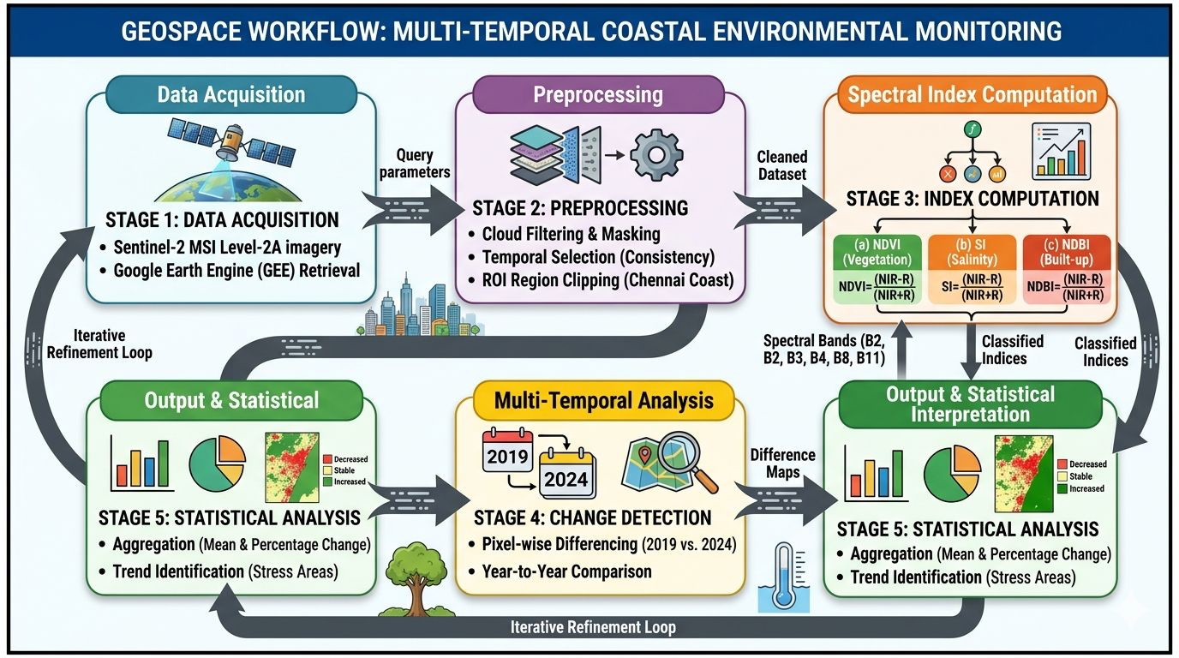
Fig. 1. Geospace Workflow for Multi-Temporal Coastal Environmental Monitoring

A. System Overview
The proposed framework follows a structured analytical pipeline with five main stages: (1) Satellite Data Acquisition, which involves retrieving Sentinel-2 MSI Level-2A surface reflectance imagery; (2) Preprocessing and Spatial Clipping, which includes filtering images based on cloud coverage and clipping them to the study area; (3) Spectral Index Computation, which is the calculation of SI, NDVI, and NDBI using spectral band combinations; (4) Year-to-Year Comparison, which involves pixel-wise differencing between baseline and current time periods; and (5) Statistical Analysis and Interpretation, which aggregates results to identify changes in environmental conditions over time.
B. Satellite Data Acquisition
Sentinel-2 MultiSpectral Instrument (MSI) Level-2A imagery served as the main dataset. The Level-2A product provides atmospheric corrections and surface reflectance values that are suitable for quantitative land surface analysis (Drusch et al., 2012). Sentinel-2 has a resolution of 10 m for visible and near-infrared bands. Imagery was collected for consistent monthly time windows over selected years to minimize seasonal variability, with cloud filtering applied to ensure accurate reflectance measurements.
C. Preprocessing and Region of Interest Selection
Preprocessing included cloud filtering, temporal filtering to consistent time periods, and region clipping to defined coastal study areas. The region of interest covers several environmentally sensitive coastal zones in Chennai: Marina Beach, Besant Nagar, Elliot Beach, Royapuram, and the Cooum River estuary. These areas were chosen because they have different levels of urbanization, vegetation coverage, and closeness to marine influence.
D. Spectral Index Computation
Three spectral indices were used to capture different environmental characteristics. The Salinity Index (SI) identifies saline soil conditions using:
SI = (Red + Blue) / Green (1)
The Normalized Difference Vegetation Index (NDVI) measures vegetation health and density (Pettorelli et al., 2005):
NDVI = (NIR – Red) / (NIR + Red) (2)
The Normalized Difference Built-up Index (NDBI) detects impervious surfaces and urban areas (Chen et al., 2012):
NDBI = (SWIR – NIR) / (SWIR + NIR) (3) After change detection, statistical summaries were created, including mean index values for baseline and current periods, mean change, and percentage change across time periods. This provides insights into spatial patterns and environmental trends.

Results and Discussion
The multi-temporal analysis framework was applied to selected coastal regions in Chennai to evaluate environmental changes using SI, NDVI, and NDBI. The structured year-to-year comparison methodology uncovered significant environmental changes across the study areas.
A. Salinity Index Analysis
The SI results show noticeable spatial variations in coastal regions. Higher SI values were mainly found in areas closer to the coastline and estuarine zones, especially near Marina Beach, Royapuram, and the Cooum River estuary. The temporal comparison shows a moderate increase in SI values in several coastal locations, possibly due to seawater intrusion, rising groundwater salinity, and less natural drainage because of urban development. This suggests that coastal soils may gradually accumulate salt.

B. Vegetation Health Assessment
The NDVI analysis provides essential information about vegetation density and health in the study regions (Pettorelli et al., 2005). Areas with thick vegetation, like parks and coastal green belts, showed higher NDVI values. However, several urbanizing areas had lower NDVI values, indicating vegetation loss. Temporal comparisons reveal a gradual decline in NDVI values near Besant Nagar and Royapuram, suggesting that vegetation cover is decreasing due to more infrastructure development and urban expansion.
C. Built-up Area Expansion
NDBI results reveal clear patterns of urban expansion across the study areas (Chen et al., 2012). Higher NDBI values were found in densely populated regions like Royapuram and areas around Marina Beach. The year-to-year comparison indicates an overall rise in NDBI values, confirming the growth of built-up surfaces over time. Urban expansion replacing natural land surfaces increases surface runoff and changes drainage patterns, possibly leading to secondary effects like soil salinization and vegetation degradation.
D. Integrated Environmental Interpretation
When analyzed together, the three spectral indices show interconnected environmental processes. Areas with rising NDBI values often correspond with declining NDVI values, showing that urban development is replacing vegetated surfaces. In addition, regions with increasing SI values frequently overlap with areas undergoing significant urban expansion, indicating that infrastructure growth affects soil salinity patterns by changing groundwater dynamics. The integrated multi-index analysis thus provides a better understanding of environmental change than analyzing individual indicators alone (Bruzzone and Prieto, 2000; Wulder et al., 2019).
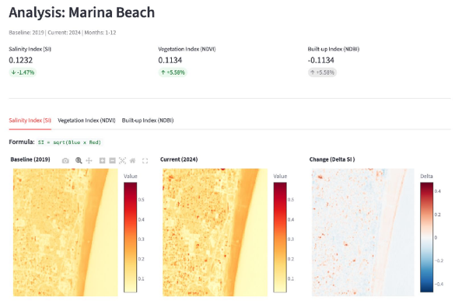
Fig. 2. User interface of the Geospace Chennai Coastal and Fertility Monitoring system showing vegetation and fertility classification

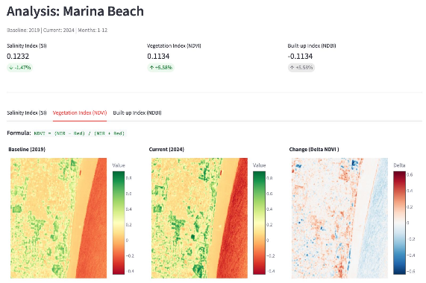
Fig. 3. Sample satellite dataset visualization used for coastal salinity and soil fertility assessment

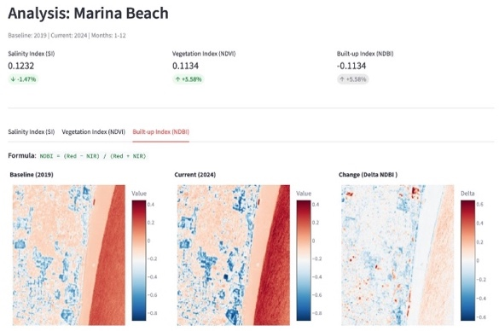
Fig. 4. Multi-temporal Analysis of Built-up Index (NDBI) for Marina Beach (2019–2024)

Comparison with Existing Models
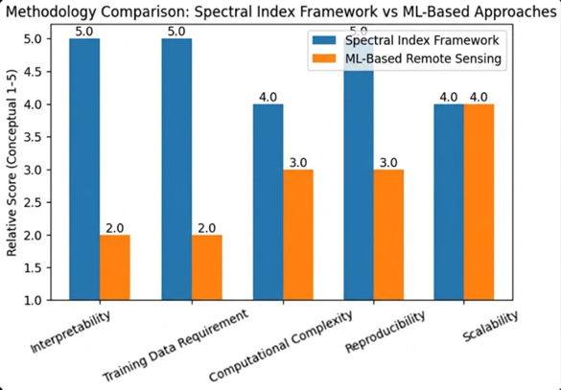
Fig. 5. Comparative Performance Analysis: Spectral Index Framework vs. ML-Based Remote Sensing Approaches

Conventional environmental monitoring of coastal environments usually takes place using field-based surveys, single index-based satellite analysis, and static remote sensing. Some of these techniques may present problems with scalability, temporal analysis, and consideration of multiple environmental indices. The model proposed herein improves on these conventional techniques through multi-temporal and multi-index satellite-based analysis of Sentinel-2 imagery and GEE.
The major limitation of field surveys is their low spatial extent and infrequent repeatability. However, although single index satellite analysis offers valuable information concerning vegetation and land cover changes, it cannot account for interactions among multiple environmental parameters. This is precisely what the new model does through its assessment of soil salinity, vegetation health, and urban growth using SI, NDVI, and NDBI, respectively.
Some of the main strengths of this model include: (1) multi-index satellite analysis based on SI, NDVI, and NDBI; (2) systematic multi-temporal analysis to quantify environmental changes; (3) high resolution images from Sentinel-2 satellites at 10 m spatial resolution; (4) cloud computing capability using GEE; and (5) interpretability and linkages between spectral index changes and environmental processes.

Conclusion
This study introduced a deterministic multi-temporal approach to monitor coastal environmental changes utilizing Sentinel-2 satellite images and physics-based spectral indices. The suggested methodology is based on SI, NDVI, and NDBI to assess environmental indicators associated with soil salinity, vegetation status, and urban growth in coastal areas. The application of several spectral indices within a specific methodology allows one to conduct a comprehensive environmental condition assessment in coastal areas.
As per the experimental analysis of selected coastal regions in Chennai, certain environmental changes were recorded, including: increased salinity in some coastal areas; degraded condition of vegetation due to intensifying urbanization; increasing NDBI values, indicating the growing area of urbanized land. Hence, it became evident how interconnected are the processes of urbanization, vegetation degradation, and soil salinity increase in coastal zones (Drusch et al., 2012; Zhu, 2019).
Being deterministic, this approach does not depend on the assumptions made while employing mathematical models, which makes it applicable in case of assessing environmental issues and creating policies based on obtained data. In addition, future research might consider applying such satellite technology as SAR, along with data on groundwater levels and field measurements, together with integrating machine learning-based change detection into a proposed approach.

References
Drusch, M., Del Bello, U., Carlier, S., Colin, O., Fernandez, V., Gascon, F., Hoersch, B., Isola, C., Laberinti, P., Martimort, P., Meygret, A., Spoto, F., Sy, O., Marchese, F., & Bargellini, P. (2012). Sentinel-2: ESA’s optical high-resolution mission for GMES operational services. Remote Sensing of Environment, 120, 25–36.
Pettorelli, N., Vik, J. O., Mysterud, A., Gaillard, J.-M., Tucker, C. J., & Stenseth, N. C. (2005). Using the satellite-derived NDVI to assess ecological responses to environmental change. Trends in Ecology & Evolution, 20(9), 503–510.
Rouse, J. W., Haas, R. H., Schell, J. A., & Deering, D. W. (1974). Monitoring vegetation systems in the Great Plains with ERTS. NASA Special Publication.
Zha, Y., Gao, J., & Ni, S. (2003). Use of normalized difference built-up index in automatically mapping urban areas from TM imagery. International Journal of Remote Sensing, 24(3), 583–594.
Metternicht, G., & Zinck, J. A. (2003). Remote sensing of soil salinity: Potentials and constraints. Remote Sensing of Environment, 85(1), 1–20.
Allbed, A., & Kumar, L. (2013). Soil salinity mapping and monitoring using remote sensing. Remote Sensing, 5(12), 6029–6055.
Zhu, Z. (2019). Change detection using Landsat time series: A review. Remote Sensing of Environment, 231, 111179.
Bruzzone, L., & Prieto, D. F. (2000). Automatic analysis of the difference image for unsupervised change detection. IEEE Transactions on Geoscience and Remote Sensing, 38(3), 1171–1182.
Coppin, P., Jonckheere, I., Nackaerts, K., Muys, B., & Lambin, E. (2004). Digital change detection methods in ecosystem monitoring. International Journal of Remote Sensing, 25(9), 1565–1596.
Wulder, M. A., Coops, N. C., Roy, D. P., White, J. C., & Hermosilla, T. (2019). Current status of Landsat program, science, and applications. Remote Sensing of Environment, 225, 127–147.

