A STUDY ON THE IMPORTANCE OF PEDAGOGICAL APPROACHES FOR STUDENTS’ WELLBEING FOR EFFECTIVE LEARNING

Author’s: Chaithra. N, Varsha V, Bhavana D.S.
Bengaluru North University
Masters Of Business Administration (MBA)
Patel Institute of Science and Management (PISM)
Bengaluru, India.

ABSTRACT

In recent era, the education system rapidly recognizes the students' wellbeing as a fundamental component in effective teaching. Contemporary teaching does not focus solely on academic performances and students also emotional stability, mental health . Teaching methods focus on creating a supportive learning environment, the students feel safe, motivated, confident, making them more useful and easier to understand. This examines various pedagogical methods which increases students’ wellbeing like positive learning, classroom learning method, teacher student’s healthy relationships. Which motivates the students to actively take part in everything, feel comfortable to communicate, share their opinions, ideas that help to collaborate deeply in the learning process. When teachers incorporate empathy and supportive teaching approaches, students may increase a strong sense of belonging, and trust the classroom. A strong environment fosters emotional resilience and supports students to cope up with effective academic challenges. Students’ wellbeing cantered teaching methods which actively engage and strengthen students cognitive and emotional outcomes. When students feel that they are supported, they are valued and concentrated on having creative problem-solving techniques, which naturally improves the effective learners. The study reinforces for the educational institution to enhance the wellbeing of students as a central component of learning practice. This adaptation helps the students to feel motivated, valued, supported and participated. Moreover, this study focuses on the role of effective classroom interaction and continuous interaction and guidance in maintaining students' engagement. By focusing on well-being and pedagogical methods they can support holistic development, enhance lifelong learning skills. Ultimately, this research concludes the priorities of student’s wellbeing is essential to create inclusive, engaging and cultivates both personal and academic growth.

Keywords: Student wellbeing, Pedagogical approaches, Effective learning, Learning environment, Classroom learning.

INTRODUCTION

The pedagogical approach plays a vital role; it not only focuses on academic learning but also on student wellbeing. Student wellbeing mainly includes emotional, social, mental and physical aspects that are essential for effective learning and development. Which directly affects the ability of effective learning. Pedagogical approaches help students to feel emotionally secure, respected and motivated so it leads to active participation and also helps to improve learning outcomes. However, lack of wellbeing can lead to stress, lack of interest and reduce the academic performances.

Pedagogical approaches also known as Teaching methods. It plays an important role in supporting students' well-being. The method of teaching the lesson plan, interacting with students can either lack in learning experience. Supportive and inclusive teaching practices which enhance confidence, cooperation, and create a healthy learning environment.

Effective learning also helps to gain subjective knowledge, which involves life skill development, awareness and emotional stability. It also helps to increase the student wellbeing for long- term learning. It emphasizes the vital role of contributing to effective learning processes. This adaptation helps the students to feel motivated, valued, supported and participated. Moreover, this study focuses on the role of effective classroom interaction and continuous interaction and guidance in maintaining students' engagement.

OBJECTIVES OF THE STUDY

- To know about different methods of pedagogical approaches to influence students’ well-being in an educational setting.
- To explore the various roles in effective learning for students' wellbeing.
- To illustrate the pedagogical strategy that helps students social, emotional and academic wellbeing.
- To analyze the relationship between students' learning outcomes and pedagogical approaches.
- To identify the impact of teaching practices on students' motivation and academic performance.

SCOPES OF THE STUDY

- It is a student-centered approach which helps to have constructive based learning and collaborative learning.
- It helps to improve attention and emotional wellbeing.
- This is the systematic effort of promoting self-esteem, motivation and academic performance.
- Teachers should be trained to understand the needs of students and adopt instruction effectively.
- It enables students to develop skills, and understanding of subjects.

REVIEW LITERATURE

Taylor and Francis, (2024). The author embraced by realizing the students’ thoughts, feelings and experiences, between the conversations with the students or by observing the students. Improving in academics and also focusing on their mental health, where the teachers need to support the students and discuss with them, to handle the complex problems and solving the problem and guide them how to face the real world challenges without any fear.

Narav Jones, (2025). In this article the author focused on the fact that students should have the freedom to ask what they want and in which area they are interested to learn so that they learn with mindfulness and interest, they feel their opinions and interests are also matters. By discussing journals students will analyze and understand the experiences, adapt that to real life situations and learn from those experiences it helps students to grow mentally apart from academically.

Muath A Aldosari and Zainab Al-Ghamdi, (2021). The author embraced that where students should be more engaging and experience practically connected to real-life situations, that encourages active participation, promotes teamwork and discussion connected to classrooms, makes students confident about themselves and they start critical thinking and become better problem solvers.

HYPOTHESIS OF THE STUDY

H1: Overall the teaching methods such as, activity-based learning, Group decision, lecture method, audio - visual learning, project based learning, academic workload, would significantly influence the student wellbeing for positive learning.

H0: Overall the teaching methods such as, activity-based learning, Group decision, lecture method, audio - visual learning, project based learning, academic workload, would not significantly influence the student wellbeing for positive learning

RESEARCH METHODOLOGY

This research adopted quantitative research that designs to know the students' insights for pedagogical approaches and how they are influenced on student wellbeing and effective learning. The data were collected through a structured data questionnaire using google forms, mainly consisting of close ended questions for opinions to ensure objective and measurable responses. The questionnaire was circulated to students online, and a total 133 responses were received, which formed a sample of the study. The convenience sampling technique was followed. The collected data were analyzed using descriptive statistical tools to report. The data were considered using percentages, voluntary participation and student confidentiality was respected.

DATA ANALYSIS AND INTERPRETATION

The collected data were analyzed and interpreted that how many students are selected the lecture method, group discussion, activity based learning, audio based learning or project based learning. It’s about whether the students are agreed or disagreed or chosen neutral for emotional well-being, motivation, and linked between pedagogy and long term success these analyzes and helps to understand which pedagogical approaches will improves the student’s well-being and learning in effective way, so that teachers know in which area need to support the students in better way.

Figure 1: It represents which teaching methods helps you learn best.

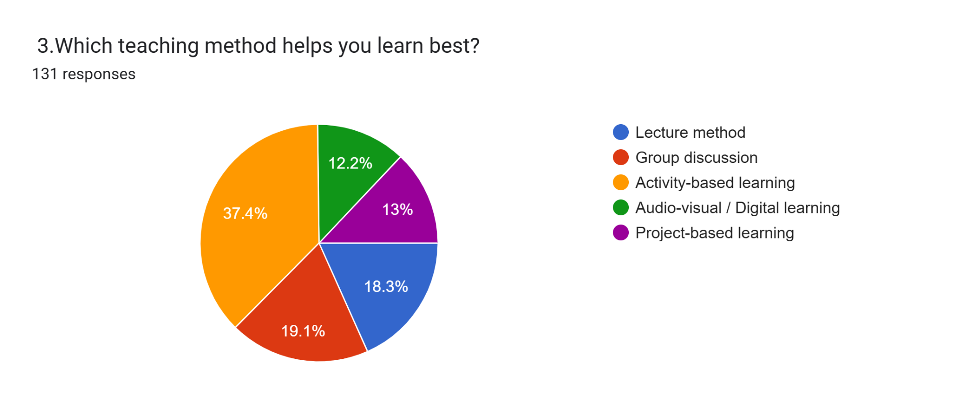
The above chart indicates that among 133 respondents, 12.2% are audio visualized learning, 13% are project based learning, 18.3% are lecture methods, 19.1% group discussion, 37.4% is activity based learning, where the respondents are feeling that Activity based learning will helps to learn in best way in teaching method.

Figure 2: It represents which pedagogical approach improves your emotional well-being the most.

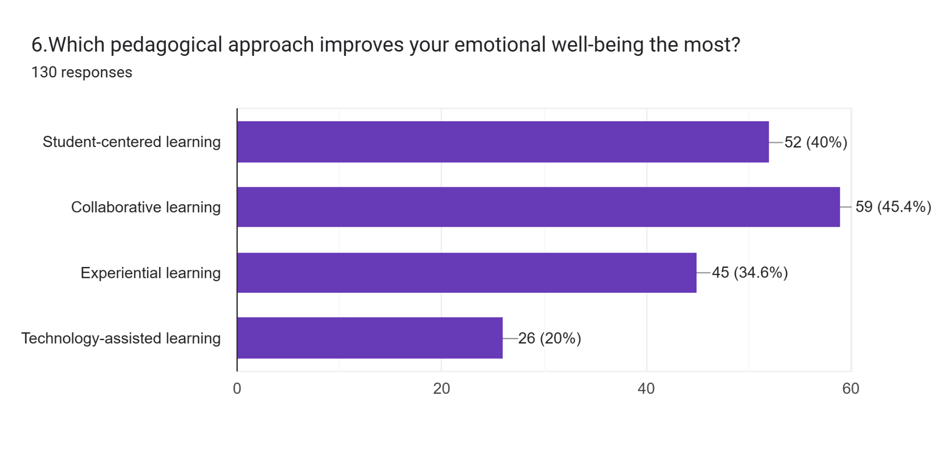
In the above chart says that among 133 respondents, 40% of respondents are choosing student centered learning, 45.4% respondents chosen collaborative learning, 34.6% respondents are for experimental learning and 20% respondents are technology assisted learning, but where the majority, respondents are feeling that student centered learning pedagogical approach improves their emotional well-being the most by emphasizing by their interests, active participation of the students.

Figure 3: It represents, Does linking pedagogy to student well-being improve long-term student success

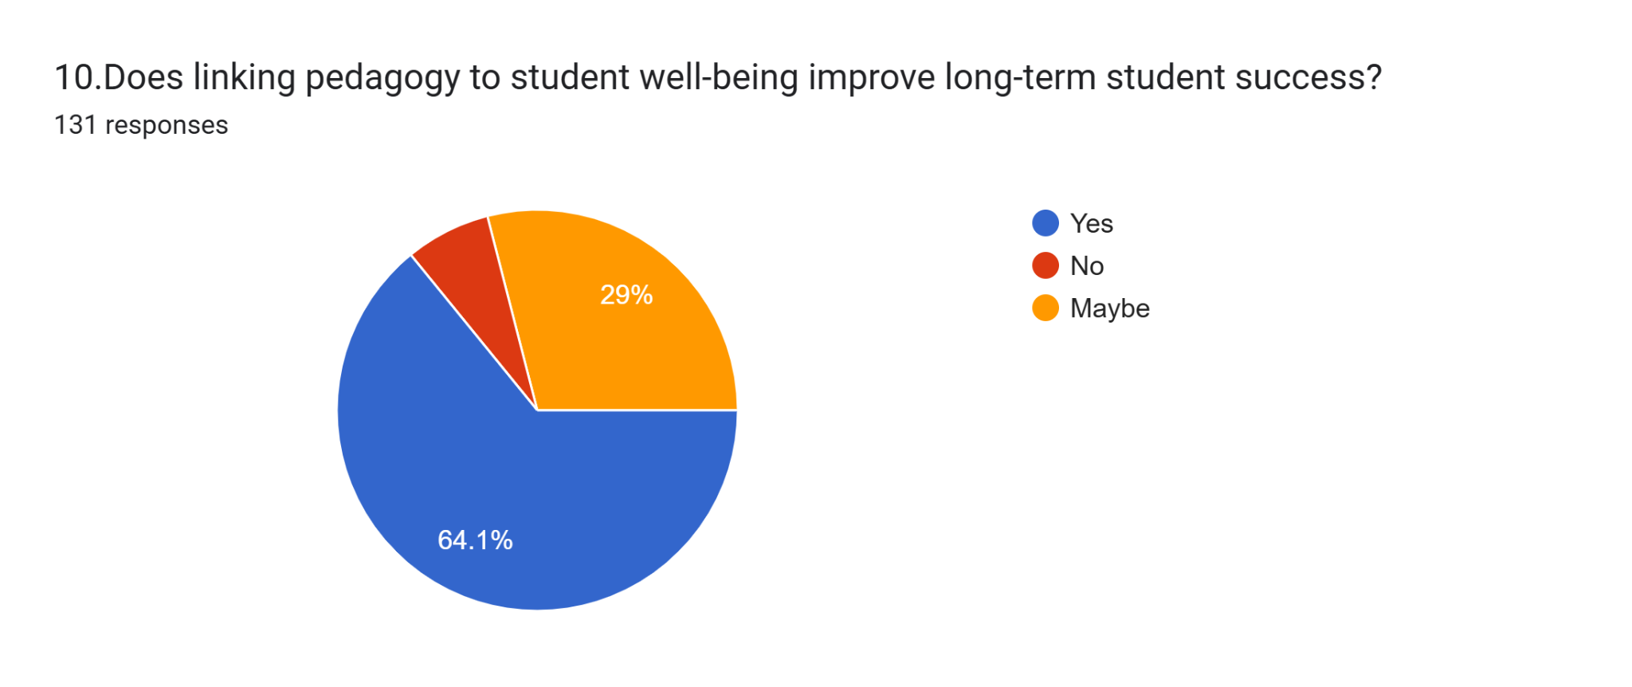
The above chart states that among 133 respondents, 64.1% of respondents feel that linking the pedagogy approach for students' well -being improves long term student success, students are more likely to stay motivated, engaged and perform better in academics. Whereas, the 29% of respondents feels that maybe it depends and the remaining respondents are disagreeing that linking pedagogy for students' well-being does not improve students' long term success.

FINDINGS

- Teaching methods focus on only academics without considering the wellbeing of students. It can negatively affect a student's interest and performance.

- Student - centered pedagogical approaches increase student participation and understanding.

- The student’s emotional and academic success and the teachers play an important role.

- A positive learning environment enhances students' motivation and increases the student's participation and focus.

- Pedagogical approaches supportive interaction between teachers and students builds confidence in learners.

- A student Centre pedagogical approach helps to reduce academic stress by creating a positive and interactive learning environment and clearly guidance and positive feedback helps a students feel confident and it helps to balance the academic performance and personal life.

- The findings indicate that clear teaching methods and continuous evaluation reduce exam related anxiety and ellipse students feel more comfortable and emotionally balanced in the learning process.

SUGGESTIONS

- Based on the findings, it is suggested that educational institutes consider the students well-being along with academic performance.

- Teachers should adopt student- centered and interactive teaching methods to encourage active participation of the students.

- Training programs should be provided to teachers to help them understand a student's emotional and mental needs.

- Teaching Strategies should include interactive teaching methods or activities such as activity-based learning, Group decision, lecture method, audio - visual learning, project based learning, academic workload, help to improve the student wellbeing.

- The study further recommends that pedagogical approaches remain flexible and adaptive, allowing educators to respond to various learning, academic level and well-being related challenges.

- A continuous ideological reflection and evaluation are suggested as Essential practices for improving teaching effectiveness and sustaining supportive learning environments.

- Institutional support Institutional support is needed to encourage innovative ideological practices. Search support enables teachers to implement well-being oriented teaching approaches.

CONCLUSION

This research paper explains that student wellbeing plays an important role in effective learning. Learning is not only used for exams and marks, but also about how the students feel. If students feel learning is stressed and pressured then learning will not be effective. When students learn happily, safely and mindfully with concentration then learning will be effective.

Pedagogical methods play a vital role in students' wellbeing. They should use some teaching methods which helps students to understand easily, share their feedback, which supports learning and also helps to concentrate properly in the classroom. According to this research we conclude that Activity-based learning methods are more effective for better learning. This approach emphasizes a balanced focus on academic achievements and personal development.

Hence, this research paper presents activity-based learning, group discussion, lecture method, audio-visual learning, project based learning would significantly influence the student wellbeing for positive learning. Where this method of teaching helps to focus on learning, wellbeing, so the education becomes more meaningful and effective. This not only helps the students for their academic wellbeing but also for their future growth.

REFERENCES

- Olson, M.H. (2015), Introduction to theories of learning. Routledge, 1-3.
- Orakcl, S. (2020). Paradigm shifts in 21st century teaching and learning. (Ed.) Information Science Reference, 2-4.
- Taylor and Francis (2024). Pedagogical approaches in education, 42-47.

