Visual Language of Animation: Exploring Props as Semiotic Tools for Storytelling

Abstract

This study investigates the vital significance of props as narrative devices in animated storytelling. Props are sometimes viewed as basic background components or tools for action, but this study underlines their ability to express deeper narrative meaning, help character development, and improve storytelling. Based on qualitative analysis, the study looks into how props influence the emotional tone, thematic depth, and plot advancement of animated storytelling. This thesis uses case studies of chosen animated films and series to identify several prop types and narrative roles, such as symbolic representation, foreshadowing, and world-building. The findings show that props are active storytelling agents who slightly affect viewer interpretation and enrich the visual narrative. This research contributes to a more nuanced understanding of animation as a storytelling medium and offers insights for animators, writers, and scholars on the strategic use of props to elevate narrative complexity and audience engagement.
Keywords: Props, Animation Storytelling, Semiotics, Narrative Devices, Visual Language, Peirce’s Model, Todorov’s Structure
Introduction
Storytelling in animation is a complex process that combines narrative structure, visual communication, and artistic expression to create engaging and immersive experiences for audiences. While significant attention has been given to elements such as character development, plot construction, and background design, the role of props in animation remains relatively underexplored. Props are more than decorative objects placed within a scene; they contribute to the construction of narrative meaning and help establish the world in which characters operate. Bancroft (2006) argues that props play a vital role in defining characters, supporting story progression, and reinforcing thematic messages. Similarly, Baek (2005) emphasizes that props function as active storytelling agents capable of communicating information and emotions to the audience. Through their visual presence, props can provide contextual clues, symbolize abstract ideas, and influence audience interpretation of a narrative.
Given their narrative potential, props can be examined through a semiotic perspective to understand how they generate and communicate meaning within animated works. Semiotics allows researchers to analyse props as signs and symbols that convey cultural, emotional, and narrative significance beyond their practical functions. Therefore, this study investigates the symbolic and structural functions of props in animation and their contribution to visual storytelling. Specifically, the study aims to identify the role of props in storytelling, analyse the symbolic meanings conveyed through props using semiotic analysis, and establish the importance of props as visual tools for communicating narrative meaning in animation. By exploring the relationship between props, semiotics, and storytelling, this research contributes to a deeper understanding of how visual elements enrich narrative experiences and support effective communication in animated media.
Literature Review
Storytelling is the nature of animation storytelling, which beautifully combines visual and audio content to deliver meaningful stories. Phuc (2023) defines animation storytelling as a union of characters, plots, and emotions to construct compelling stories with animated pictures. Aminian (2024) agrees with this view by stressing on creating coherent narratives and genres of characters that the audience relates to, accompanied by visual and audio design. These aspects combine to appeal to varied audiences of all ages, rendering storytelling a key aspect of the animation form.
Animation storytelling relies on several key elements, including character development, visual design, sound, and narrative structure. Characters play a central role in conveying themes and creating emotional connections with the audience, while plots drive the story through a sequence of events, conflicts, and resolutions. The relationship between character and plot forms the foundation of effective animated storytelling (Phuc, 2023). Visual elements such as character design, backgrounds, and colour schemes contribute to mood, theme, and symbolism, while sound and music enhance emotional impact and audience immersion (Phuc, 2023). There are also various other ways to make an animated story. Typically, this can take the form of classical or nonlinear structures. Traditional structures, with linear chronologies and predictable story progression, are known to audiences and thus extensively used in animation (Caldwell, 2013). It usually follows a three-act format: setup, conflict, and resolution, which makes it easy to develop and follow a story, as well as characters. On the other hand, non-linear narrative structures include flashbacks, parallel narratives, and fractured timelines. These techniques generate tension, introduce emotion, and enable richer storytelling. As noted by Saberi (2024), these types of structures provide a fresh alternative to Todorov's traditional narrative and allow animators to engage audiences more deeply through temporal control and character introspection.
One of the theoretical frameworks most commonly employed when examining narrative within animation is Todorov's theory of narrative structure. As defined by Todorov (1971), narratives are broken down into five key phases. The initial balance, upset, realization of the upset, restoration, and creation of a new balance. This approach is especially convenient for animated stories because visual aspects, such as props, can represent transitions from one stage of the story to the next. Props in the animated television show Steven Universe (2013-2020) are Steven's gem and his home in Beach City, and represent initial stability, tranquility, and identity acquired from his mother, Rose Quartz. With tainted gems and foes comes upheaval, represented by gem shards and weaponry, indicating the rupture of harmony. Items like Rose's sword and Lion's dimension-key assist Steven by identification and fixing, both on a narrative and symbolic level. They serve to mark Steven's origin and as goads for individual and story epiphanies (Bordwell & Thompson, 2010). Therefore, props are not accessories but visual signals of narrative progression.
Animation props are not only examined for their function in the story but also for their semiotic value. Deguzman (2021) defines props as non-human objects to which characters respond. These are classified as hand props, personal props, stage props, set dressings, trim props, green props, and breakaways. Hand props are items handled or utilized by actors, personal props incorporate actor identification, set props and set dressings incorporate depth into the setting, trim and green props add realism, and breakaways are intended for physical use. Anne's pointed stick, for example, is a hand prop on the television series Amphibia, whereas Sprig's slingshot is a personal prop. These props enhance the character's identity, social background, and emotional status, rooting them in their cartoon world. According to Bancroft (2006) and Thomas and Johnston (1981), props play an important role in establishing setting, atmosphere, and narrative progression. They enhance the realism and continuity of the animated world while also conveying thematic meanings. For instance, Woody’s sheriff badge and the name “Andy” written on his boot in Toy Storysymbolize identity and a sense of belonging. In Howl’s Moving Castle, steampunk-inspired objects and fantastical props contribute to the film’s unique visual style and thematic depth. Similarly, the “Calamity Box” in Amphibia functions as a crucial plot device, while props in Looney Tunes are often used to create humour and make scenes more memorable.
The semiotic role of props can be widely studied using Charles Sanders Peirce's triadic sign model. Peirce categorized signs into icons, indices, and symbols (Chandler, 2007). An icon simulates its subject, such as a map or a face. An index explicitly refers to its object, such as smoke indicating fire or a broken window indicating a break-in (Atkin, 2006). A symbol is based on cultural convention, such as a red rose for love or sadness (The Indexer, 2011; Kramer, 2018). Props function on all three levels in animation. A toy vehicle can be employed iconically to represent an actual car, a blood spot can be employed as an index of violence, and a dove can symbolically represent peace. Props also serve symbolic purposes in character development, theme presentation, and narrative devices. Props can symbolize an emotional condition, such as a nervous character who constantly plays with a locket, or a change of character, such as a frayed map yielded to a globe. Iconic film props, such as the ruby slippers of The Wizard of Oz or the sled "Rosebud" in Citizen Kane, symbolize desire, domination, and identity (Grauso, 2023). Thematic symbols are wilting flowers for lost love or cages for being trapped (Fiveable, 2024). At a narrative level, props are employed to incite action or create foreshadowing. A mysterious letter or broken mirror can initiate plot progression or foreshadowing of later events (Stone, 2019).
In addition, the appearance of props dictates the general mood and overall appearance of an animation. Shiny, stylish accessories mark a more carefree era, while old, broken relics mark loss or deterioration. Deguzman (2021) theorizes that the amount of realism as opposed to stylization used in props contributes to the definition of the characters' world and the rules governing it. Props then serve as signifiers that point towards deeper connotations (Chandler, 2019). Props can be employed to embed levels of narrative information with iconic resemblance, indexical trace, or symbolic convention. Peirce's framework allows for infinite interpretation, or semiosis, wherein one prop can lead to another level of meaning in the narrative process.
This literature review finds that props are a central component of animated storytelling. Props are not mere background elements but dynamic narrative devices that allow for character development, structure the development of the story, and support thematic investigation. If examined through Todorov's stages of narrative and Peirce's semiotic theory, their function in animation is made more complex and measurable. While significant, props as a subject remain a lesser-researched area in animation research. This absence presents fertile ground for further research on how props build meaning and influence audience interpretation in animated narratives.
Methodology
Research is a systematic process of generating knowledge through structured inquiry and scientifically valid procedures. Methodology refers to the theoretical and procedural principles that guide the research process (Ishak & Alias, 2005). A clear methodology ensures transparency, reliability, validity, and adherence to ethical standards. This study employed a qualitative research approach to examine the narrative and semiotic functions of props in animation. Qualitative research is suitable for exploring symbolic meanings and visual elements, as it focuses on interpreting meanings and patterns rather than numerical data (Sreekumar, 2023). Both primary and secondary data sources were utilized.
Primary data were collected through observation of animated films and television series to examine how props function within different narrative contexts. This method enabled the researcher to identify the categories, narrative roles, and symbolic significance of props throughout the story. Secondary data were obtained from scholarly literature and previous studies to provide theoretical support and contextual understanding of props in storytelling. Content analysis served as the main analytical method, allowing for a systematic examination of visual and narrative content (GÜR, 2023). The study was further guided by storytelling and semiotic theories, particularly Todorov’s narrative model and Peirce’s semiotic typology, to analyse how props contribute to meaning-making and narrative development. By combining qualitative observation, literature review, and content analysis, this methodology provides a structured and reliable approach to investigating the role of props as semiotic and narrative devices in animation.
Result and Finding
The results and findings of this study offer an in-depth examination of the types and functions of props in animation, drawing exclusively on data collected from eight scholarly sources and expert perspectives. The analysis aimed to understand how props serve as narrative tools that both shape and enhance storytelling in animated series.
Table 1: Summary Of Similarity: The Function and Types of Props by Experts and Scholars
Title | Author | Type of Props | Function of Props
Elements Of Film Production | Prof. Babson Ajibade, Dr Venatus Nosike Agban  (2021) | - Prop Weapons  - Circumstance Props  - Character-Driven Props  - Functional Props | - Storytelling Enhancement  - Character Development  - Creating Atmosphere
Prop Sourcing in Europe: The Significance of Prop Hire Companies to Film Industry  Productions and Professionals | Eve Koivurinta  (2019) | - | - Visual Storytelling  - Character and Place establishment  - Atmosphere Creation
What Are the Different Types of Props? | Liz Johnson  (28 April 2021) | - Hand Props  - Personal Props  - Greens  - Set Props  - Trim  - Set Dressing | - Driving the Narrative  - Creating Authenticity  - Maintaining Continuity
What is a Movie Prop — Types of  Film Props & Why They Matter | Kyle DeGuzman  (14 November 2021) | - Hand props  - Personal props  - Set props  - Trim props  - Breakaways | - Set the time and place  - Determine the genre  - Further the plot  - Define a character  - Symbolize themes or concepts
What are Props in Film? Types of Props and Uses | Sarang Padhye  (22 February 2024) | - Hand Props  - Personal Props  - Greens  - Set Props  - Trim  - Set Dressing | - Setting the Time and Place  - Determining the Genre  - Furthering the Plot  - Defining a Character  - Symbolizing Themes or Concepts
What Is A Movie Prop Definition | Jens Jacob  (31 January 2022) | - Practical Props  - Hero Props  - Background Props | - Enhancing Actor Performances  - Central to the Plot  - Creating the Film's Environment
Animation: A True Art | Elyse Warnecke  (2016) | - Functional Props  - Decorative Props | - Enhancing Storytelling  - Creating Atmosphere  - Supporting Character Actions
The specificity of the prop in the comic book on the example of Andi Watson’s The Book Tour | Marcin Kowalczyk  (29 December 2023) | - Illustrative Props  - Instrumental Props | - Illustrative Function  - Instrumental Function  - Symbolic or Metaphorical Function  - Variable Function

The data were presented in several tables, which summarized the viewpoints of experts regarding the classification and narrative function of props. Table 1 presents the diversity of prop types and their functions according to scholars. Among these, hand props, personal props, and set props emerged as the most frequently cited categories, while defining character, establishing a world and setting, and serving as plot devices were the most commonly mentioned functions. This pattern demonstrates the consistency across the literature in recognizing props as critical elements that extend beyond mere decoration (Jacob, 2022).
Table 2: Most Frequently Mentioned Type of Props in Previous Studies
Author | Keywords
Author | Hand props | Personal props | Set props | Trim props | Set dressing | Breakaways props | Green
Prof. Babson Ajibade, Dr Venatus Nosike Agban  (2021) | ✔ | ✔
Eve Koivurinta
(2019)
Liz Johnson  (28 April 2021) | ✔ | ✔ | ✔ | ✔ | ✔ |  | ✔
Kyle DeGuzman  (14 November 2021) | ✔ | ✔ | ✔ | ✔ |  | ✔
Sarang Padhye  (22 February 2024) | ✔ | ✔ | ✔ | ✔ | ✔ |  | ✔
Jens Jacob  (31 January 2022) | ✔ | ✔ | ✔
Elyse Warnecke  (2016) | ✔ | ✔ | ✔
Marcin Kowalczyk  (29 December 2023) |  | ✔ | ✔

Table 3: Most Frequently Mentioned Function of Props in Previous Studies
Author | Keywords
Author | To define character | To establish a world and a setting | Symbolize thematic ideas | Plot devices | Determine the genre
Prof. Babson Ajibade, Dr Venatus Nosike Agban  (2021) | ✔ | ✔ |  | ✔
Eve Koivurinta  (2019) | ✔ | ✔
Liz Johnson  (28 April 2021) |  |  |  | ✔
Kyle DeGuzman  (14 November 2021) | ✔ | ✔ | ✔ | ✔ | ✔
Sarang Padhye  (22 February 2024) | ✔ | ✔ | ✔ | ✔ | ✔
Jens Jacob  (31 January 2022) | ✔ | ✔ |  | ✔
Elyse Warnecke  (2016) | ✔ | ✔ |  | ✔
Marcin Kowalczyk  (29 December 2023) | ✔ | ✔ | ✔

Additional tables clarified which prop types and functions appeared most often across the studies. Table 2 identified hand props, personal props, and set props as the most prominent, while Table 3 showed that defining character, establishing the world, and driving the plot were the most frequent narrative purposes attributed to props. These summaries highlighted the prevalence of these elements in animation and confirmed their multi-purpose significance.
Table 4:Steven Universe Prop Analysis (Peirce’s Semiotics + Todorov’s Narrative + Prop Function)
Prop (Type) | Semiotic Analysis (Peirce’s Type) | Function in Narrative | Narrative Role (Todorov)
Steven's Shield (Hand Prop) | Symbol: Represents Steven’s inherited values and the legacy of Rose Quartz. | Plot device: Used in battles; reflects Steven’s pacifism. | Equilibrium: Symbolizes inherited legacy.  Disruption: Used in conflicts.  Repair: Shows struggle with nonviolence.  New Equilibrium: Steven redefines his role.
Rose’s Sword (Hand Prop) | Symbol: Represents rebellion and resistance. | Plot device: Reveals truths about Rose’s past and her dual identity. | Disruption: Represents rebellion.  Recognition: Steven questions Rose’s choices.  Repair: Clarifies Steven’s moral path.
The Warp Pad (Set Prop) | Symbol: Indicates movement between locations, connected to Gem technology. | To establish world and setting: Shows intergalactic travel and scope of the Gem world. | Equilibrium: Used for missions.  Disruption: Explores new territories and threats.  Repair: Helps bridge the Earth and Gem society.
Gemstones (Personal Prop) | Symbol: Represents the core essence and identity of each Gem. | To define character: Embodies their powers, essence, and personality. | Equilibrium: Characters operate as normal.  Disruption: Damaged gems affect identity.  Repair: Healing reflects character recovery.
Rose’s Room (Set Prop) | Symbol: Reacts to Steven’s emotional state; creates simulations. | To establish world and setting: Projects inner desires and fears. | Disruption: Creates illusions.  Recognition: Steven confronts truths.  Repair: Accepts reality over fantasy.
Greg’s Van (Personal Prop) | Symbol: Simplicity, humanity, and grounded lifestyle. | To define character: Highlights Greg’s humble nature and contrast to Gem world. | Equilibrium: Greg’s normal life.  Disruption: Used to interact with Gems.  Repair: Connects Steven to both human and Gem identities.
Rejuvenator (Hand Prop) | Symbol: Erasure of identity and control by Homeworld. | Plot device: Used to reset Gems’ memories and loyalty. | Disruption: Used against Crystal Gems.  Recognition: Sparks resistance.  Repair: Steven helps restore identity.
Connie’s Training Sword (Personal Prop) | Symbol: Empowerment and growth. | To define character: It represents Connie’s transformation from civilian to fighter. | Equilibrium: Normal Connie.  Disruption: Begins sword training.  Repair: Becomes Steven’s equal in battle.
The findings also included specific examples drawn from the animated series Steven Universe, where props were analyzed using Peirce’s semiotics and Todorov’s narrative structure. For instance, Steven’s Shield was categorized as a hand prop symbolizing inherited values and pacifism. It acted as a plot device during conflicts and redefined Steven’s role as he struggled with nonviolence. Rose’s Sword served as another hand prop symbolizing rebellion and revealing truths about Rose’s past, creating narrative disruption that eventually led to Steven clarifying his own moral path. Similarly, the Rejuvenator, also a hand prop, embodied the erasure of identity and control imposed by Homeworld and functioned as a device that reset the Gems’ memories, sparking resistance and driving the story forward.
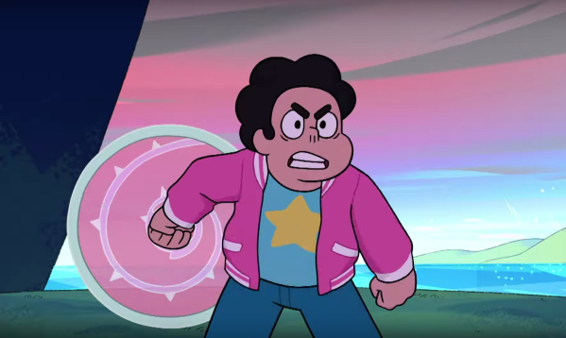 |  | 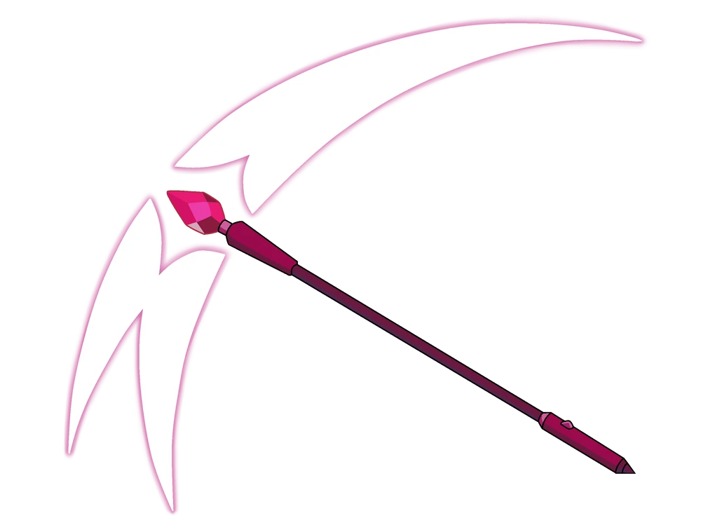
Image 1: Steven using his shield | Image 2: Rose’s swords and shield | Image 3: Gem Rejuvenator
Personal props were shown to play an essential role in defining character identity. For example, the gemstones represented the core essence and powers of each Gem character, and their damage disrupted identity until healed. Greg’s van symbolized a simple, human lifestyle and helped connect Steven to both his human and Gem heritage. Connie’s training sword illustrated empowerment and personal growth, marking her transformation from a civilian into a capable fighter alongside Steven.
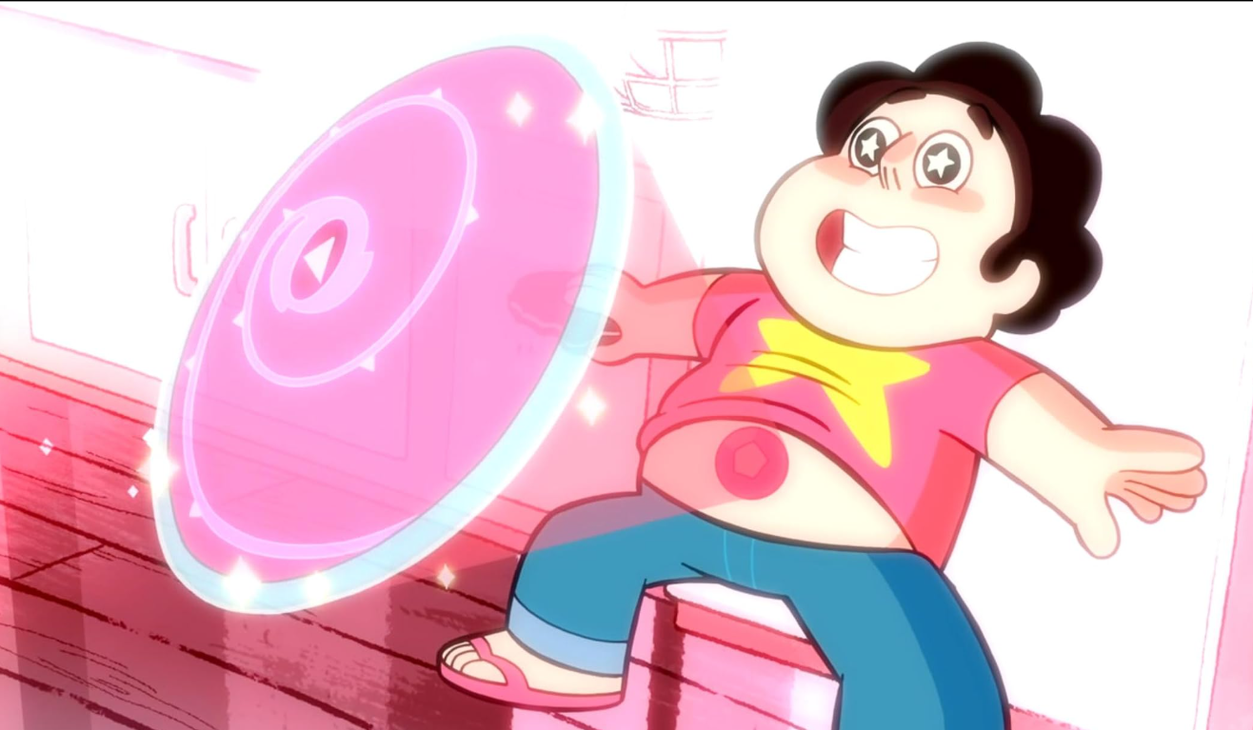 | 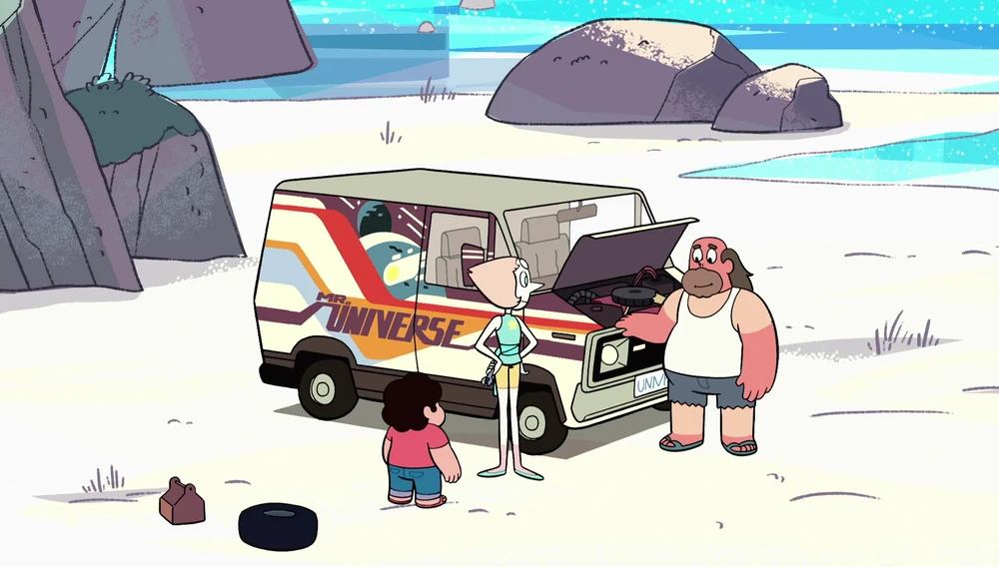 | 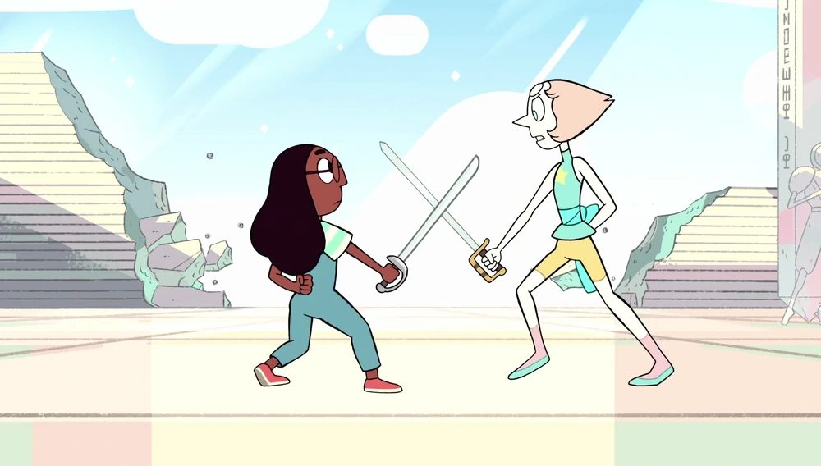
Image 4: Steven Gemstone projecting his shield | Image 5: Greg’s van | Image 6: Connie training with Pearl began
Set props contributed to establishing the world and the environment of the narrative. The Warp Pad, as a set prop, visually demonstrated intergalactic travel and the broader scope of the Gem world. Its use for exploring new territories served as a narrative disruption that expanded the story’s universe. Rose’s Room, another set prop, projected characters’ inner desires and fears, creating illusions that challenged Steven until he ultimately accepted reality over fantasy.
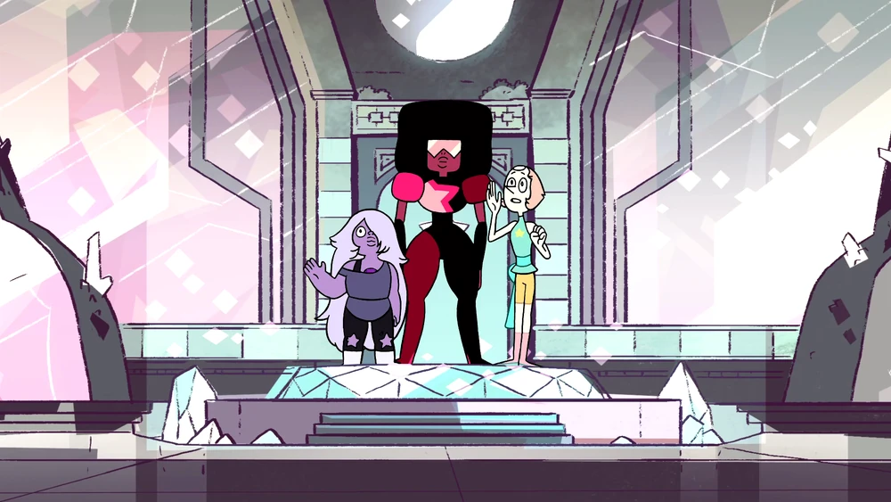 | 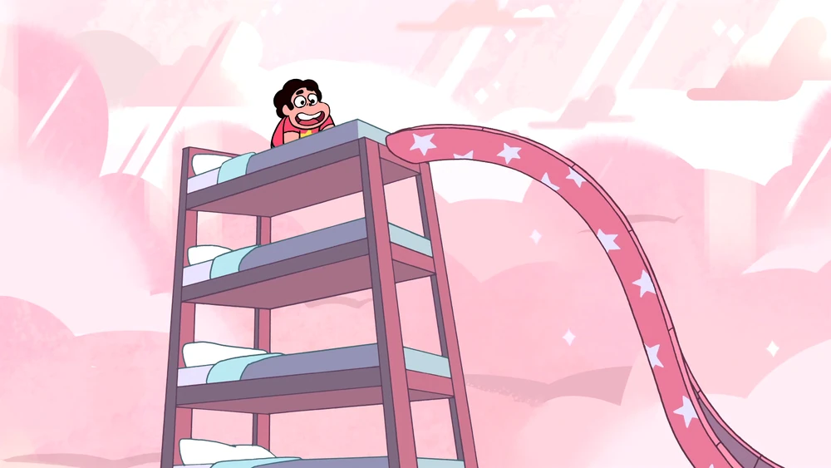
Image 7: Amethyst, Garnet, and Pearl standing on Warp Pad | Image 8: Steven's imagination has a lot of beds with a slide inside Rose’s room
Overall, the study confirmed that props are integral to animated narratives, serving to define characters, establish immersive worlds, and advance plotlines. The reliance on qualitative content analysis, while comprehensive, is acknowledged as a limitation in that it does not provide statistical generalizability. Nonetheless, the consistent findings across multiple expert sources support the credibility and relevance of the conclusions. In summary, the results demonstrate that the strategic use of hand props, personal props, and set props significantly enriches animated storytelling, transforming simple objects into powerful narrative devices that engage audiences and communicate thematic meaning (Jacob, 2022).

Conclusion
This study examined the role of props as semiotic resources in animated narratives, highlighting their functions in character development, world-building, and plot progression. The findings demonstrate that props are not merely decorative elements but meaningful narrative devices that communicate themes, support storytelling, and enhance audience engagement through semiotic functions such as signs, icons, indexes, and symbols. The study contributes to animation research by bridging narrative theory and semiotics, offering a deeper understanding of how visual objects generate meaning within animated works. Practically, the findings encourage animators and storytellers to use props more intentionally to strengthen narrative depth and emotional impact.
Despite these contributions, the study is limited by its qualitative approach and restricted range of case studies, which may not represent the diversity of animation contexts. Future research should explore prop usage across different genres, cultures, and emerging media environments, as well as audience interpretations of prop symbolism. Overall, this study reaffirms that props are essential storytelling tools that enrich narrative meaning, support characterisation, and contribute to the effectiveness of visual storytelling in animation.

References
Aminian, P. (2023, November 29). Storytelling in Animation | Technical & Psychological Sides. Pixune. https://pixune.com/blog/storytelling-in-animation/#elementor-toc__heading-anchor-8
Atkin, A. (2006, October 13). Peirce’s Theory of Signs. Stanford Encyclopedia of Philosophy. https://plato.stanford.edu/entries/peirce-semiotics/
Baek, S.-G. (2005). A Study on the Function of Props in Animation 1. SciSpace. https://typeset.io/papers/a-study-on-the-function-of-props-in-animation-1-rg521le959
Bancroft, T. (2006). Creating characters with personality. Watson-Guptill. https://archive.org/details/20240502_20240502_1347/page/n3/mode/2up
BBC Bitesize. (2017, January 27). What is narrative? - Narrative - GCSE Moving Image Arts (CCEA) Revision - BBC Bitesize. BBC Bitesize. https://www.bbc.co.uk/bitesize/guides/zysrrdm/revision/1
Bordwell, D., & Thompson, K. (2010). Film art: an introduction. In Internet Archive.
NewYork: McGraw-Hill. https://archive.org/details/filmartintroduct0000bord/page/n5/mode/2up
Caldwell, C. (2013). Story content. Story Content: It’s Not Just for Writers... Anymore. https://doi.org/10.1145/2542266.2542271
Carlsson, R. (2018). The narrative functions of props. Portable communication devices in Die Hard (1988) & Die Hard2: Die Harder (1990). The Narrative Functions of Props. Portable Communication Devices in Die Hard (1988) & Die Hard2: Die Harder (1990).
Chandler, D. (2007). Semiotics: The Basics. Routledge.
Chandler, D. (2019, July 31). Semiotics for Beginners: Signs. Princeton.edu. https://www.cs.princeton.edu/~chazelle/courses/BIB/semio2.htm
Deguzman, K. (2021, November 14). Types of Movie Props Explained — And How They Work. StudioBinder. https://www.studiobinder.com/blog/what-is-a-movie-prop-definition/
Eisner, W. (1985). Comic and Sequential Art (p. 166). POORHOUSE PRESS. https://alphalight.wordpress.com/wp-content/uploads/2010/07/will-eisner-theory-of-comics-sequential-art.pdf
Fernando, B. S. C. (2023). Creating realistic and safe “Dummy Props” for medical drama and action scenes. Creating Realistic and Safe “Dummy Props” for Medical Drama and Action Scenes, 10–11. https://doi.org/10.31705/idr.2023.5
Fiveable. (2024, August 1). Prop significance - (Intro to Film Theory) - Vocab, Definition, Explanations | Fiveable. Fiveable.me. https://fiveable.me/key-terms/introduction-to-film-theory/prop-significance
Grauso, A. (2023, August 19). The Meaning Of Rosebud In Citizen Kane Explained. ScreenRant. https://screenrant.com/citizen-kane-rosebud-meaning-explained/
GÜR, G. (2023). Content Analysis As A Method Of Social Sciences To Describe Communicational Contents. Zeitschrift Für Die Welt Der Türken / Journal Of World Of Turks / Türkleri̇n Dünyasi Dergi̇si̇, 15(3), 237–255. https://doi.org/10.46291/zfwt/150315
Hendrykowski, M. (2023). Rekwizyt – atrybut – gadżet. O społecznych funkcjach znaków addytywnych. Przestrzenie Teorii, 40(40), 13–28. https://doi.org/10.14746/pt.2023.40.1
Huening, D. (2006). symbol-index-icon. Csmt.uchicago.edu. https://csmt.uchicago.edu/glossary2004/symbolindexicon.htm
Ishak, I. S., & Alias, R. A. (2005). Designing A Strategic Information Systems Planning Methodology For Malaysian Institutes Of Higher Learning (Isp-Ipta). Issues in Information Systems, 6(1). https://doi.org/10.48009/1_iis_2005_325-331
Jacob, J. (2022, January 31). What Is A Movie Prop Definition. Saturation.io; Saturation. https://saturation.io/blog/what-is-a-movie-prop-definition
Kramer, L. (2018, February 13). Color Meanings and the Art of Using Color Psychology. 99designs; 99designs. https://99designs.com/blog/tips/color-meanings/
Lasseter, J. (1987). Principles of traditional animation applied to 3D computer animation. ACM SIGGRAPH Computer Graphics, 21(4), 35–44. https://doi.org/10.1145/37402.37407
Leech, N. L., & Onwuegbuzie, A. J. (2008). Qualitative data analysis: A compendium of techniques and a framework for selection for school psychology research and beyond. School Psychology Quarterly, 23(4), 587–604. https://doi.org/10.1037/1045-3830.23.4.587
Macdonald, S., Headlam, N., & Cles, C. (2008). Research Methods Handbook Introductory guide to research methods for social research. https://cles.org.uk/wp-content/uploads/2011/01/Research-Methods-Handbook.pdf
Otto, W. (2019). Krzysztof Kieślowski’s film props in the triptych “Three Colours.” Images. The International Journal of European Film, Performing Arts and Audiovisual Communication, 24(33), 73–85. https://doi.org/10.14746/i.2018.33.07
Padhye, S. (2024, February 22). What are Props in Film? Types of Props and Uses. Miracalize Media. https://miracalize.com/film-props-types-uses/#Types_of_Props
Phuc, D. (2023, December 11). What is Storytelling in Animation and Its Elements? Animost Studio. https://animost.com/ideas-inspirations/storytelling-in-animation/
Robertson, L. (2023). Props. Cambridge University Press EBooks, 113–147. https://doi.org/10.1017/9781009225137.006
Rosli, H. (2023). Animation History and Technology (p. 90). Ts.Dr. Hafizah Rosli.
Saberi, E. (2024). Modern narrative structure in animated short films: a tool to increase suspense. AVANCA | CINEMA, 14, 253–259. https://doi.org/10.37390/avancacinema.2023.a500
Sreekumar, D. (2023). What is Research Methodology? Definition, Types, and Examples. Paperpal Blog. https://paperpal.com/blog/academic-writing-guides/what-is-research-methodology#penci-What_is_research_methodology
Stone, P. (2019, September 16). Props Drive Plots. Dramatics Magazine Online. https://dramatics.org/props-drive-plots/
The Indexer. (2011, December 18). Index, icon, symbol: a tale of abduction. Sesquiotica. https://sesquiotic.com/2011/12/18/index-icon-symbol-a-tale-of-abduction/
Thomas, F., & Johnston, O. (1981). Disney Animation: The Illusion of Life. Walt Disney Productions. https://archive.org/details/TheIllusionOfLifeDisneyAnimation/page/n3/mode/2up
Todorov, T. (1971). The 2 Principles of Narrative. Diacritics, 1(1), 37–44. https://doi.org/10.2307/464558
Webmaster. (2025, March 7). What is a Prop in Acting? Acting Magazine. https://actingmagazine.com/2025/03/what-is-a-prop-in-acting/
Whitaker, H., Halas, J., & Sito, T. (2009). Timing for Animation (Second edition). Elsevier Ltd. https://jo2bigornia.tripod.com/download/TimingAnimation.pdf
Woroch, A. (2023). Mocny przedmiot pożądania. O istotnej roli rekwizytu we współczesnych filmach elevated genre. Przestrzenie Teorii, 40, 153–168. https://doi.org/10.14746/pt.2023.40.8

