A Study on Socio-Economic Challenges Faced by Persons Living with Tuberculosis (TB) in Kamareddy District of Telangana State, India

ABSTRACT
India is noted for having the highest tuberculosis (TB) burden in the world, contributing to over 20% of global cases. TB not merely affects the physical health of individuals but also has detrimental effects on their social, economic, and psychological well-being. As it primarily targets individuals in their working years, it negatively impacts households. The social ramifications include job loss, divorce, social ostracism, and homelessness. Discrimination, whether it is directly experienced or anticipated, is linked to heightened levels of anxiety and depression, diminished life contentment, higher unemployment, and reduced income. This study aims to examine the socioeconomic and demographic characteristics of tuberculosis (TB) patients. The researcher has purposefully selected the Kamareddy District of Telangana State as the area of study. A stratified random sampling method was employed to define the entire population, which includes six tuberculosis units, and simple random sampling techniques were used for the collection of primary data. The findings of this research could be utilized to formulate innovative strategies for policymakers, prospective donors, and healthcare professionals to enhance the effectiveness of tuberculosis control efforts, thus contributing to the achievement of Sustainable Development Goals 3 and 5, which focus on Good Health and Well-being, and Gender Equality.
Keywords- Socio-economic, Tuberculosis, Health service, social consequences, Discrimination

INTRODUCTION
Tuberculosis (TB) is a pristine curse. Its roots can be traced to ancient eras. Scholars have proposed that Mycobacterium tuberculosis (MTB) emerged over 150 million years ago (Daniel T, 2006). The WTO defines TB as a communicable bacterial infection instigated by MTB, with a primary focus on the lungs. The transmission of the disease occurs when a person suffering from active TB releases droplets containing bacterial into the air through coughing, speaking and sneezing (World Health Organization, 2023). India has seen a 21 percent reduction in tuberculosis (TB) incidence, with new cases dropping from 237 per lakh in 2015 to 187 per lakh in year 2024, nearly double the global average of 12% reported by the WHO’s Global TB Report 2025. This decline is among the most significant globally, exceeding reductions in other high-burden countries. Innovative strategies for case identification in India, including advanced technologies, decentralized healthcare, and community resource mobilization, have increased treatment coverage from 53 percent in 2015 to over 92 percentages in 2024. In 2024, 26.18 lakh tuberculosis (TB) patients were diagnosed, closely matching the estimated 27 lakh cases, significantly reducing 'missing cases' from 15 lakh in 2015 to under one lakh in 2024. Additionally, there has not been a notable increase in multidrug-resistant (MDR) TB patients, with a treatment success rate of 90% under the ‘TB Mukht Bharat Abhiyan’, surpassing the global average of 88 per cent. The mortality rate associated with TB in India has declined from 28 per lakh in 2015 to 21 per lakh in 2024, indicating substantial advancements in the reduction of TB-related fatalities, attributed to a nearly ten-fold increase in funding for TB programs over the past nine years. Since its launch in December 2024, the TB Mukt Bharat Abhiyan has screened over 19 crore vulnerable individuals, identifying more than 24.5 lakh TB patients, including 8.61 lakh asymptomatic cases, based on evidence of asymptomatic TB prevalence in high-burden regions (PIB Delhi, 2025).
India is acknowledged as the country with the highest incidence of tuberculosis (TB) globally, representing more than one-fifth of all cases worldwide. This alarming rate has significant implications that reach beyond the physical health of those infected. The ramifications of this infectious disease are extensive and complex not merely affects the physical health of individuals but also has effects on social, economic, and psychological well-being. The population most affected primarily includes individuals in their economically active years, suggesting that the effects are experienced by patients and their families. Families often endure significant negative consequences, such as financial strain from medical expenses and loss of income, leading to poverty and instability. The social implications of TB are profoundly serious and can manifest in various ways, significantly affecting lives. One immediate consequence is job loss, resulting in reduced financial autonomy and self-worth. When individuals cannot keep their jobs due to illness, they frequently face a chain of negative effects that go beyond economic hardship. The loss of employment undermines financial security and erodes an individual's identity and purpose, leading to feelings of inadequacy and despair. The stigma surrounding tuberculosis (TB) can result in significant social consequences, including divorce and isolation from family and community. Those with TB may face ostracism as friends and family withdraws due to fear or misunderstanding, complicating their situation. In severe cases, this rejection can lead to homelessness, leaving individuals without a support network. Such isolation amplifies feelings of loneliness and hopelessness, creating a challenging cycle. Both perceived and actual discrimination against TB patients are linked to increased anxiety and depression, hindering recovery and reintegration into society. These mental health issues make it difficult for individuals to seek assistance. The psychological effects of TB are significant, resulting in lower life satisfaction, higher unemployment, and reduced income levels. These factors contribute to a persistent cycle of disadvantage, as individuals face both the physical and emotional consequences of TB. Thus, the implications of tuberculosis in India extend beyond public health; they represent a profound social challenge requiring comprehensive strategies to address medical and socio-economic obstacles faced by affected individuals and families. Addressing these interconnected issues requires a multifaceted approach, including public education to reduce stigma, mental health support, and policies to enhance economic opportunities for those recovering from TB (Chauhan et al, 2006).
M. Muniyandi et al. (2006) reported that tuberculosis (TB) primarily affects the economically productive age group, leading to significant economic costs. Despite free diagnostic and treatment services, patients often incur out-of-pocket expenses. Ramya Ananthakrishnan et al. (2012) noted that DOTS implementation has reduced the number of patients mortgaging assets or taking loans. While absenteeism from work has decreased, ongoing absenteeism in schools highlights the need for integrating TB control with educational health services. In India, there is a belief that TB mainly affects the poor, particularly in slums. Wealthy individuals must recognize that their domestic staff may be asymptomatic carriers, exposing them to TB. The consumption of unpasteurized milk poses a risk for TB transmission, as bovine TB (Mycobacterium bovis) can be transmitted to humans. In their 2016 study, Premkumar. S et al. examined socioeconomic factors related to tuberculosis, identifying illiteracy, indoor occupations, and contact with TB cases as significant contributors. Understanding the socio-economic dimensions of TB is crucial, as it is often viewed as a disease of poverty, especially in resource-limited countries. This research used household income to measure socio-economic status, revealing that women as homemakers outnumbered those in outdoor occupations among TB patients. This suggests that women may be at a higher risk of infection within the home environment compared to outside, potentially leading to a greater infectious dose, which could explain the increased incidence of the disease among women who primarily work at home. The study highlighted three critical risk factors: exposure to confirmed tuberculosis cases, levels of literacy and socioeconomic conditions among non-smoking rural women affected by TB. Therefore, it is imperative that TB interventions are tailored to effectively reach those who are most vulnerable. R. Duarte et al (2017) underscored that socioeconomic determinants influence the extent of exposure, risk behaviors, and access to healthcare. Furthermore, TB adversely impacts individual productivity and socioeconomic standing. Identifying the risk factors and determinants associated with tuberculosis is crucial, especially as a growing number of low and middle-income countries transition epidemiologically, with non-communicable diseases and conditions superseding infectious diseases as the primary causes of morbidity and mortality.
METHODS
Even today, in India, the devastating impact of tuberculosis (TB) is starkly evident, as it claims two lives every three minutes, a statistic reported by The Times of India on June 20, 2016. This alarming rate underscores the urgent need for effective interventions and highlights the multifaceted challenges that hinder the control of TB within the country. The primary obstacles to managing TB in India are numerous and complex, encompassing a range of systemic issues. These include the inadequate primary health-care infrastructure that is particularly pronounced in rural regions across various states, which limits access to essential health services for those most in need. Furthermore, the unregulated private health sector contributes significantly to the problem, as it fosters an environment where there is widespread irrational use of both first-line and second-line anti-TB medications, complicating treatment regimens and potentially leading to drug resistance. The increasing prevalence of HIV further exacerbates the situation, as co-infection with TB and HIV can lead to more severe health outcomes and complicate treatment efforts. Additionally, the pervasive issue of poverty plays a critical role, as it often restricts individuals' access to healthcare and resources necessary for effective treatment. Insufficient political commitment to addressing these health challenges, coupled with corrupt administrative practices, further undermines efforts to combat TB. In response to these pressing issues, a collaborative initiative is currently underway between the National Tuberculosis Control Program (NTCP) and the National Rural Health Mission (NRHM). This initiative aims to enhance the quality and accessibility of primary health care in rural locales, thereby improving the overall management of TB. Moreover, the NTCP has launched various initiatives in partnership with the private sector and the Indian Medical Association (IMA) to advance TB care, reflecting a concerted effort to engage multiple stakeholders in the fight against this disease (Sandhu, 2020).

DESIGN
To gain a deeper understanding of the socio-economic status of tuberculosis patients, a cross-sectional study was meticulously conducted, utilizing both primary and secondary data sources. The collection of primary data was achieved through extensive fieldwork, which involved direct engagement with the community and the patients affected by TB. The research methodology employed in this study comprises two distinct phases: the first phase is exploratory, aimed at gathering preliminary insights, while the second phase is descriptive, focusing on detailed data collection and analysis. For this investigation, the researcher purposefully selected Kamareddy District in Telangana State as the study area, recognizing its relevance to the broader context of TB management in India. To ensure a representative sample, the researcher employed a stratified random sampling procedure, a form of probability sampling, to define the entire population area, which includes six tuberculosis units within the district. Following this, simple random sampling techniques were utilized for the collection of primary data, ensuring that each participant had an equal chance of being selected. A substantial sample was drawn for this study, with a modest effort made to gather data through various sampling methods to enhance the reliability of the findings. Out of a total of 435 sample respondents, each subunit within Kamareddy District constitutes 40 percent of the sample, providing a comprehensive overview of the socio-economic conditions faced by TB patients in this region. The researcher specifically chose Kamareddy District as the focal point of the study, which comprises six tuberculosis units, to ensure that the findings would be relevant and applicable to the local context. For further details please see the table below.

LIST OF TUBERCULOSIS UNITS IN
S.NO | Name of the Tuberculosis Unit | No of Tuberculosis Patients | No of Respondents
S.NO | Name of the Tuberculosis Unit | No of Tuberculosis Patients | Male | Female | Total
1 | PITLAM | 101 | 21 | 19 | 40
2 | YELLAREDDY | 183 | 43 | 30 | 73
3 | DOMAKONDA | 144 | 27 | 31 | 58
4 | GANDHARI | 148 | 35 | 25 | 60
5 | BICHKUNDA | 166 | 33 | 33 | 66
6 | KAMAREDDY | 346 | 76 | 62 | 138
Total |  | 1088 | 235 | 200 | 435
Table-1. Source: nikshay.in (Central Tuberculosis Division, GOI, NTEP-2018)
COLLECTION OF DATA

This research employed a combination of primary and secondary data sources. Primary data was collected via an interview scheduled, and census data. Secondary data was sourced from published and unpublished research, annual reports, periodicals, library resources, and governmental websites. The research methodology combined these data types for a comprehensive analysis. Primary data collection aimed to obtain firsthand information, while secondary data provided broader context for the study. Overall, integrating both data types enhances the reliability and depth of the findings presented in this research.

RESULTS

Despite the advent of advanced diagnostic and therapeutic modalities for tuberculosis (TB), it is regrettable that millions continue to endure and succumb to this illness. TB ranks among the three leading infectious diseases responsible for mortality globally: HIV/AIDS claims 3 million lives annually, TB accounts for 2 million deaths, and malaria results in 1 million fatalities. Although the tubercle bacilli were discovered almost 130 years ago, a comprehensive understanding of the disease's pathogenesis remains inadequate. Treatment seeking behavior of patients has always remained an important research agenda, but in-depth analysis of the process of seeking treatment, factors influencing it and its consequences on health outcomes has rarely been investigated.

The Study population

The study cohort includes included 435 patients obtained from GH, NGO and PVT facilities, with breakdown of 235 males and 200 females. Information concerning the sources of patient intake and the study population is listed in Table 1.
Economic  Characteristics | No. of patients
Economic  Characteristics | Male  n |  | Female  n | Male  (%) |  | Female  (%)

Occupation
Salaried | 47 | 12 |  |  | 20 | 6
Waged | 73 | 26 |  |  | 31 | 13
Self-employed | 49 | 20 |  |  | 21 | 10
Other | 66 | 142 |  |  | 28 | 71
Total | 235 | 200 |  |  | 100 | 100

Patient income (rupees)
Nil | 47 | 128 |  |  | 20 | 64
˂ 500 | 19 | 26 |  |  | 8 | 13
500–2000 | 141 | 42 |  |  | 60 | 21
˃2000 | 28 | 4 |  |  | 12 | 2
Total | 235 | 200 |  |  | 100 | 100

Table 2, Distribution of patients according to economic characteristics
Table 2 presents the allocation of patients based on their economic attributes: 28% of males and 71% of females were identified as non-earning family members (which encompasses students, retirees, and the unemployed), whereas 8% of males and 13% of females indicated a family income falling below Rs.500/. The mean monthly income of the study cohort was Rs.875/- ± 1148/-.
DISCUSSION
In 1992, the Government of India, in collaboration with the World Health Organization (WHO) and the Swedish International Development Agency (SIDA), conducted a review of the national tuberculosis program. The review revealed several deficiencies, including managerial shortcomings, insufficient funding, and excessive dependence on x-ray diagnostics, non-standardized treatment protocols, low treatment compliance and completion rates, as well as a lack of systematic data on treatment outcomes. Simultaneously, in 1993, the WHO proclaimed tuberculosis a global emergency and formulated the Directly Observed Treatment, Short-course (DOTS) strategy, recommending its adoption by all countries. This strategy is based on five essential pillars: political commitment and ongoing funding for tuberculosis control programs, diagnosis through sputum smear tests, a reliable supply of high-quality anti-tuberculosis drugs, direct observation of drug intake, and accurate reporting and recording of all registered cases.
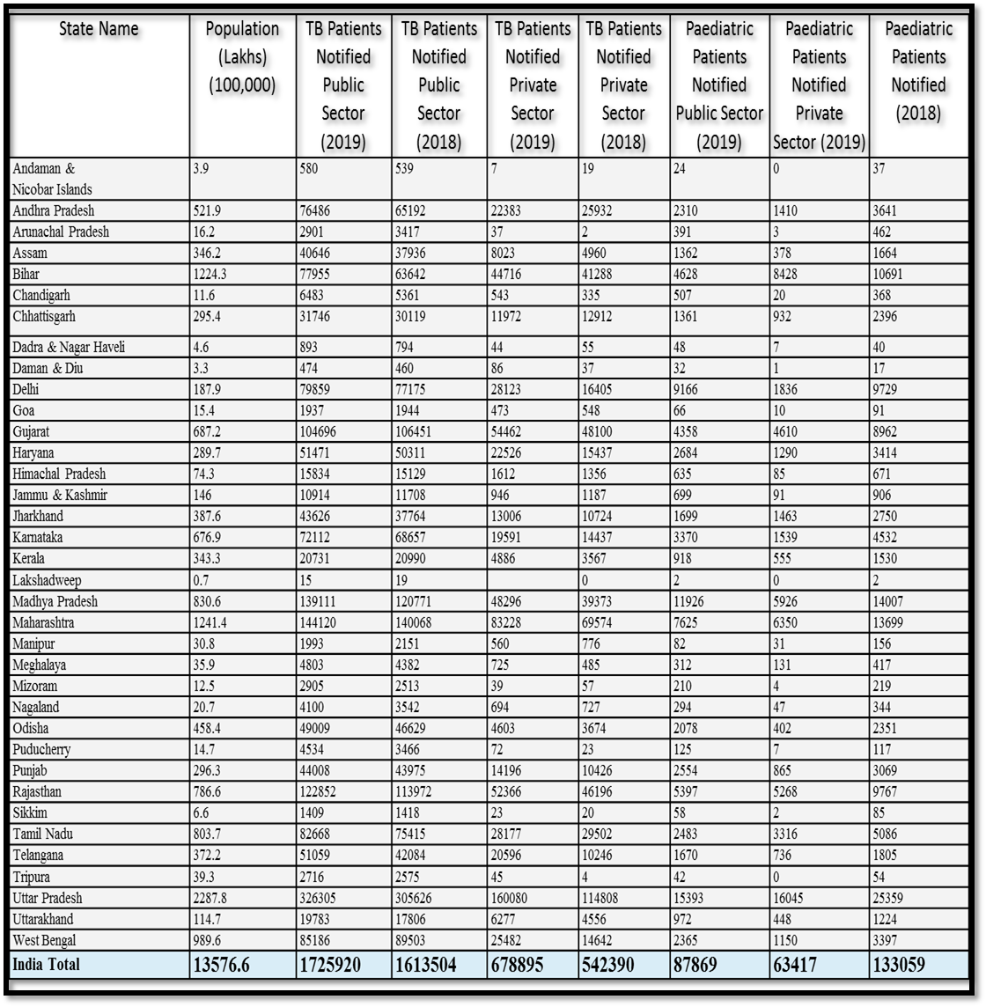
Table-3, Indian state wise TB statistics.
The social and economic burden of tuberculosis follows from its unique age distribution (Murray, 1991) tuberculosis affects all age groups, but has its greatest impact on productive adults. It is widely recognized that individuals between the ages of 15 and 59 are the most economically productive members of society; they also serve as the primary caregivers upon whom the survival and growth of children rely. Thus, tuberculosis has the potential to impede the development of both individuals and society (Connolly, 1996). This study has recorded the total expenses faced by tuberculosis patients. The significance of this research is underscored by the substantial sample size of patients examined (n= 435), encompassing both urban and rural environments, who are receiving care at government hospitals, non-governmental organizations, and private health facilities. Other studies have used larger numbers of patients, but have attempted to identify only sub-components of total costs, such as direct costs, including consultation, travel, etc. (Nair et al, 1997 & Uplekar et al, 1996). On the other hand, a study by Dholakia forecasts the impact of these costs on the health system without going into the details of the societal impact of the disease (Dholakia,1997). The sampling method ensured participants were from the productive age demographic. Of the 435 patients analyzed, 46% were female and 54% were male, consistent with prior research indicating a male-to-female ratio of 3:1. In a survey done in South India, 72% of bacillary cases were men and 28% were women (Frimodt, 1962). This study assessed the disease's effect on 235 men, whose male proportion aligns with the broader TB patient population. A significant percentage (40–50%) faced financial burdens while seeking diagnosis in the private sector (PVT), despite being treated in government hospitals (GH). Treatment costs were similar at GH and NGO facilities, where anti-TB medications are free, while PVT expenses were 10–15 times higher.
This research provides indirect evidence for incorporating private practitioners into the National Tuberculosis Programme (NTP). Patients using private services incur costs about 6.5 times higher than those at government health (GH) facilities, likely due to the diagnostic and treatment methods of private practitioners. If these practitioners adhered to standardized protocols like those in the programme, direct costs could significantly decrease. Furthermore, non-medical expenses, such as travel and specialized food, impose a heavy financial burden on impoverished households, as these costs are paid out-of-pocket. The study demonstrates that tuberculosis results in productivity losses and increased debt levels. Similarly, in Uganda, Saunderson reported that most of the time lost from work was prior to diagnosis (Saunderson, 1995). Economic considerations have become increasingly important in the healthcare sector. This study outlines the socio-economic difficulties and financial strains encountered by patients with tuberculosis. The results may guide the development of innovative approaches for policymakers, donors, and healthcare practitioners to improve tuberculosis management efforts, so with these achievements the objective of Sustainable Development Goal no.3 and 5, i.e. Good Health and Well-being, & Gender Equality can be achieved
CONCLUSIONS
The cumulative costs, particularly the indirect expenses related to tuberculosis (TB), were quite substantial. On average, individuals experienced a wage loss period of three months. The caregiving roles of female patients significantly declined, and 20 percent or one-fifth of schoolchildren halted their studies. More than medical, sociological changes and awareness are required. With strong and friendly counseling, the TB affected people can be gainfully employed as skilled or semi-skilled labourers. Any suitable profession based upon the actual occupation of person will be economically helpful to the society. TB cannot cause sudden death, but they must learn to lead normal life with routine- medication, so that these patients will not become economic parasites in the society.
REFERENCES
Anderson, S. (1962). Some aspects of the economics of tuberculosis in India. Indian J Tuberc, 9, 176–180.
Ananthakrishnan, R., Jeyaraj, A., Palani, G., & Sathiyasekaran, B. (2012). Socioeconomic impact of TB on patients registered within RNTCP and their families in the year 2007 in Chennai, India. Lung India, 29, 221–226.
Chauhan, A., Parmar, M., Dash, G. C., Solanki, H., Chauhan, S., Sharma, J., Sahoo, K. C., Mahapatra, P., Rao, R., Kumar, R., Rade, K., & Pati, S. (2023). The prevalence of tuberculosis infection in India: A systematic review and meta-analysis. The Indian journal of medical research, 157(2&3), 135–151. https://doi.org/10.4103/ijmr.ijmr_382_23
Clark, M. D. (1996). Tuberculosis: economic factors and social challenges—The case of India. World Bank.
Connolly, M., & Nunn, P. (1995). Women and tuberculosis. World Health Stats Quart, 492, 115–119.
Daniel T, M. (2006). The history of tuberculosis. Respir Med, 100(11), 1862–1870. https://doi.org/10.1016/j.rmed.2006.08.006. (Retrieved on 14.06.2026).
Dholakia, R. (1997). Tuberculosis research. The potential economic benefits of DOTs against TB in India. In Global TB Programme. WHO, Geneva.
Duarte Carlos M., Wu Jiaping, Xiao Xi, Bruhn Annette, Krause-Jensen Dorte. Can Seaweed Farming Play a Role in Climate Change Mitigation and Adaptation?. Frontiers in Marine Science 2017; 4:100. https://www.frontiersin.org/article/10.3389/fmars.2017.00100. (Retrieved on 14.12.2025).
Frimodt-Müller, J. (1961). Tuberculosis situation in India today. Tubercle, 43, 88–94.
Heffernan J, F., Nunn A, J., Peto, J., & Fox, W. (1976). A two-year follow up of a national sample of new cases of respiratory tuberculosis notified in Scotland in 1968. Tubercle, 57, 161–175.
Murray C J, L. (1991). Social, economic and operational research on tuberculosis. Recent studies and some priority questions. Bull Int Union Tuberc Lung Dis, 66(4), 149–156.
Muniyandi, M., Ramachandran, R., Balasubramanian, R., & Narayanan P, R. (2005). Socio-economic dimensions of tuberculosis control: review of studies over two decades from Tuberculosis. Research Center. J Commun Dis, 38(3), 204–215.
Nair D, M., George, A., & Chacko K, T. (1997). Tuberculosis in Bombay.New insights from urban poor patients. Health Policy Plan, 12, 77–85.
National Sample Survey Organisation (NSSO). (1987). Morbidity and utilisation of medical services. 42nd round, July 1986–June 1987. In Department of Statistics, New Delhi: Government of India (Report No. 364).
Premkumar, S., Ramaswamy, P., & Johnson, P. (2015). A descriptive study of socioeconomic factors among nonsmoking rural female tuberculosis patients. Scholars Journal of Applied Medical Sciences (SJAMS), 4(12B), 4307–4310.
PIB Delhi. (2025, November 12). TB incidence in India drops by 21% from 237 per lakh population in 2015 to 187 per lakh population in 2024 – almost double the rate of decline observed globally. Ministry of Health and Family Welfare. Retrieved June 14, 2026, from https://www.pib.gov.in/PressReleasePage.aspx?PRID=2189415®=48&lang=2
Rajeswari, R., Balasubramanian, R., Muniyandi, M., & Venkatesan, P. (1997). Socio-economic impact of tuberculosis on patients and family in India. The International Journal of Tuberculosis and Lung Disease : The Official Journal of the International Union Against Tuberculosis and Lung Disease, 3, 869–877.
Sandhu G, K. (2010). Tuberculosis: current situation, challenges and overview of its control programs in India. Journal of Global Infectious Diseases, 3(2), 143–150.
Saunderson P, R. (1995). An economic evaluation of alternative programme designs for TB control in rural Uganda. Soc Sci Med, 40, 1203–1212.
Sen P, K. (1990). Economics of health—the cost of TB. Indian J Tuberc, 37, 69–71.
Subramaniam, T. (1990). Sample survey of awareness of symptoms and utilisation of health facilities by chest symptomatics. Indian J Tuberc, 37, 69–71.
Steward W, F., Lipton R, B., & Sinon, D. (1996). Work-related disability: results from the American migraine study. Cephalalgia, 16, 231–238.
Uplekar, M., Juvekar, S., Morankar, S., Rangan, S., & Nunn, P. (1998). Tuberculosis patients and practitioners in private clinics in India. The international journal of tuberculosis and lung disease : the official journal of the International Union against Tuberculosis and Lung Disease, 2(4), 324–329.
Pinto, L. M., & Udwadia, Z. F. (2010). Private patient perceptions about a public programme; what do private Indian tuberculosis patients really feel about directly observed treatment?. BMC public health, 10, 357. https://doi.org/10.1186/1471-2458-10-357.
World Health Organization. (2023). Global TB Report 2023. Retrieved June 4, 2026, from https://www.who.int/publications/i/item/9789240083851
World Health Organization. (1996). TB: A clinical manual for South East Asia. Chapter I: Background Information on TB. WHO/TB/96-200 (SEA), 1996.
World Health Organisation. (1998). Global Tuberculosis Control : WHO Report 1998. Global Tuberculosis Programme. Retrieved May 23, 2026, from https://www.who.int/publications/i/item/WHO-TB-98.237
The Times of India. (2016, June 20). Every three minutes two people are dying of Tuberculosis in India. The Times of India. https://timesofindia.indiatimes.com/city/nashik/every-three-minutes-two-people-are-dying-of-tuberculosis-in-india/articleshow/52825855.cms

Corresponding Author and Assistant Professor of Social Work, CDOE, Maharaja Sriram Chandra Bhanja Deo University, Baripada, Mayurbhanj, Odisha. Phone No.- 9234462619. Email-get2sujoy1979@gmail.com.
HoD & Assistant Professor-II, Dept. of Santhali Maharaja Sriram Chandra Bhanja Deo University, Baripada, Mayurbhanj, Odisha, Phone : +91-9437593831e-mail: jatindra.nathbesra@gmail.com

