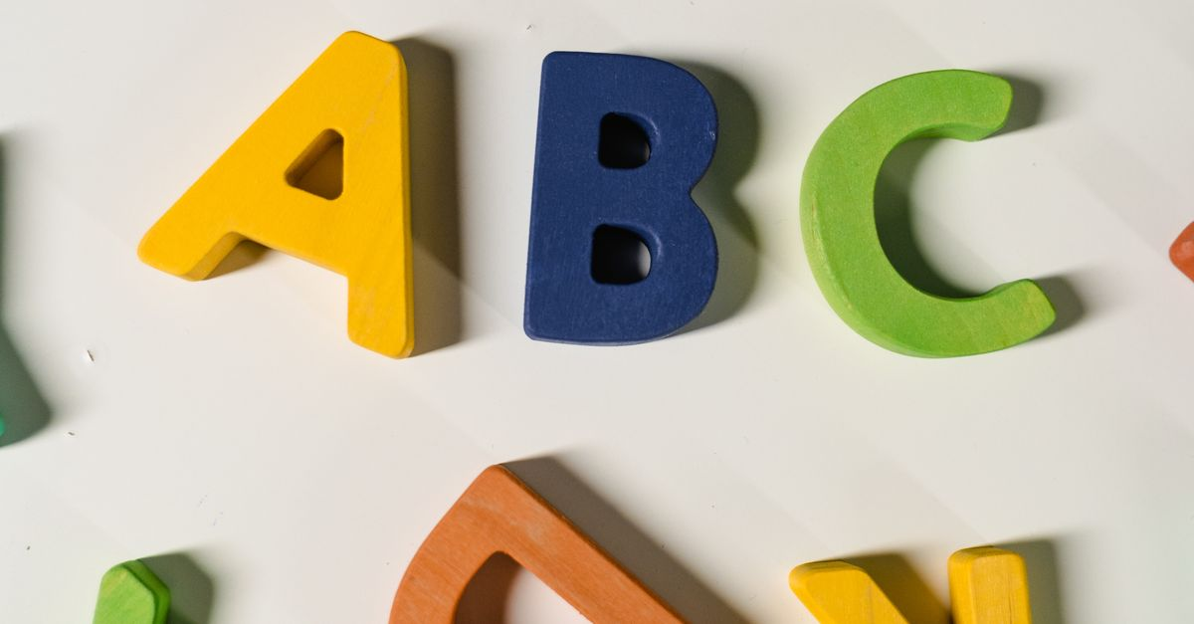
[INTRO: Sci-Fi Themed Opening]
[Scene opens with a futuristic city skyline, neon lights flickering against a starry sky. A voiceover begins as the camera zooms in on a holographic display of the AGWEP Alphabet.]
Narrator (V.O.):
"In a universe where communication transcends the boundaries of time and space, one alphabet reigns supreme—the AGWEP Alphabet. Welcome, fellow travelers of the cosmos, to a journey through the intricate symbols that connect worlds and civilizations."
[Cut to the host standing in a sleek, sci-fi studio filled with holographic screens displaying the AGWEP Alphabet.]
Host:
"Greetings, Earthlings and intergalactic explorers! Today, we delve into the fascinating realm of the AGWEP Alphabet—a unique script that holds the key to understanding the languages of the future. Buckle up as we embark on this linguistic adventure!"
---
[SECTION 1: The Strong Script]
[The screen displays the Strong Script letters as the host gestures to them.]
Host:
"First up, we have the Strong Script. This is where the magic begins! The AGWEP Alphabet consists of a series of powerful symbols, each representing a distinct sound or concept. Let’s take a closer look at these characters:"
[The camera zooms in on each letter as the host pronounces them.]
- A B C D E F G H I Ⅎ K L M N O P Q R S T U V W X Y Z Ǝ Ʌ Ө Ð Ŧ Ⴈ Ԉ И Ŋ Ƨ Ƶ Æ Ͻ П 𐐅 Ⳙ Ⱗ Ꝏ Ѥ Ꞇ Ø Є Э Ш Ѧ
Host:
"Each letter is not just a symbol; it’s a gateway to understanding the cultures and histories of the civilizations that use them. Imagine a world where every letter tells a story—a narrative woven through the fabric of time."
---
[SECTION 2: The Small Script]
[The screen transitions to display the Small Script letters.]
Host:
"Next, we have the Small Script. This variant is more compact, designed for quick communication in fast-paced environments—perfect for interstellar travelers!"
[The camera highlights each letter as the host pronounces them.]
- a b c d e f g h i ⅎ k l m n o p q r s t u v w x y z ǝ ʌ ө ð ŧ ⴈ ԉ и ŋ ƨ ƶ æ ͻ п 𐐭 ⳙ ⱗ ꝏ ѥ ꞇ ø є э ш ѧ
Host:
"Whether you’re sending a message across galaxies or jotting down notes in a bustling spaceport, the Small Script is your trusty companion. Its efficiency is unmatched, allowing for seamless communication in the vastness of space."
---
[SECTION 3: Pronunciation]
[The screen shifts to a cosmic backdrop with sound waves visualizing the pronunciation.]
Host:
"But what good is an alphabet without the ability to pronounce it? Let’s explore the pronunciation of the AGWEP Alphabet, a melodic symphony that resonates across the stars."
[The host begins to pronounce the letters in a rhythmic manner.]
- ए बी सी डी ई एफ जी एच आय जे के एल एम एन ओ पी क्यू आर एस टी यू व्ही डब्ल्यू एक्स वाय झेड ऐ औ यूटा डीटा टीटा एल्फा एन्फा एन्स एन्ज एस्फा झेस्फा ॲ ऑ ॲय ऑय ऑव डब्ली डब्लो केच सेच फाय इक्वल डीव उइ एम्न
Host:
"Each sound carries the essence of its meaning, echoing through the cosmos. From the elegant curves of ‘ए’ to the sharp edges of ‘झेड’, the AGWEP Alphabet is a testament to the beauty of language."
---
[SECTION 4: The Significance of AGWEP Alphabet]
[The screen displays various alien landscapes and cultures using the AGWEP Alphabet.]
Host:
"The AGWEP Alphabet is more than just a collection of letters; it’s a bridge between worlds. In a universe filled with diverse species and cultures, this alphabet serves as a universal language, fostering understanding and cooperation."
[The camera pans to the host, who looks directly into the camera.]
Host:
"Imagine a future where communication barriers are shattered, where beings from different planets can share their stories, ideas, and dreams. The AGWEP Alphabet is a step towards that reality."
---
[CONCLUSION: Call to Action]
[The screen fades to a starry background with the AGWEP Alphabet glowing.]
Host:
"Thank you for joining me on this exploration of the AGWEP Alphabet! If you enjoyed this journey through language and the cosmos, don’t forget to like, subscribe, and hit that notification bell for more interstellar content. Until next time, keep your minds open and your hearts ready for adventure!"
[The screen fades to black with the channel logo and social media links.]
[END]

