Development and Pilot Evaluation of DICT-EAAS: A Web-Based Employee Attendance and Accomplishment System for Document Workflow Automation
Ver Raquepo, John Albert Blanco, Christian Jaylord Lumanog, Marc Justine Soriano, King Christian D. Antonio and Reymond C. Dalupang
College of Information Technology, University of La Salette, Inc., Santiago City, Philippines
*Corresponding author: Reymond C. Dalupang, rdalupang@uls.edu.ph
ABSTRACT
This paper presents the development and pilot evaluation of the DICT Employee Attendance and Accomplishment System (DICT-EAAS), a web-based platform designed to improve the preparation, compilation, submission, and review of attendance-related Daily Time Records (DTRs) and accomplishment documents. In the participating DICT offices in Santiago, Cauayan, and Nueva Vizcaya, attendance is already captured through a biometric scanner that exports a PDF file. However, employees still have to transfer the entries into official DTR forms and prepare accomplishment reports, adjustment slips, and supporting files in separate applications. This fragmented workflow takes time, increases the risk of encoding and formatting errors, and makes submission tracking harder to manage. DICT-EAAS was developed to bring these tasks into one process through biometric attendance PDF upload, automated DTR generation in the required format, accomplishment report creation, adjustment slip preparation, PDF compilation, reviewer routing, and administrator monitoring. The system was developed using a layered web architecture with a React + Vite frontend, Laravel backend, Python-based document processing module, relational database, and file/template storage. Pilot testing involved six purposively selected DICT employees who were part of the intended users of the system and completed a guided role-based walkthrough before rating the prototype. Using an adapted ISO/IEC 25010-based five-point survey instrument covering selected quality characteristics, the system obtained an overall mean of 4.78 (SD = 0.35), while the instrument showed high internal consistency in the pilot sample (Cronbach’s alpha = 0.972). Functional suitability received the highest mean (4.94), followed by performance efficiency (4.83). Compatibility obtained the lowest mean (4.58), but it remained within the very high range. These pilot results suggest that DICT-EAAS can support more organized attendance-related document handling in the participating DICT offices, while larger-scale validation is still needed.
Keywords: attendance system, biometric attendance, daily time record, document workflow automation
INTRODUCTION
In many offices, attendance capture is already digital, but the documents that follow are still prepared through separate files or applications. In the participating DICT offices, the biometric scanner produces a PDF attendance record, yet employees still have to transfer the entries into official Daily Time Record (DTR) forms and prepare accomplishment reports and adjustment slips in other files. This takes time, increases the chance of encoding and formatting errors, and makes file control more difficult. When deadlines are tight, the lack of one connected process also makes it harder for employees, reviewers, and administrators to track submission status and accountability.
Recent studies show that digital attendance and document management systems can improve monitoring, reduce manual work, and support more reliable record handling. In the Philippine setting, QR-based attendance systems have improved monitoring accuracy and reduced manual errors, while digital attendance and accomplishment reporting platforms have shown the value of linked reporting processes [2, 4]. Other Philippine studies on document management also point to the benefits of shared repositories, routing visibility, and automated tracking in institutional work [1, 5, 8, 9]. These studies show the value of digital attendance and document systems, but many of them cover only one part of the workflow. Some focus on attendance monitoring, others on accomplishment reporting, and others on routing or tracking. In the DICT offices involved in this study, the work does not stop after attendance capture. The biometric scanner produces a PDF record, the DTR must still be prepared in the official format, related documents must be completed, and the full set must move through review. The gap, therefore, is not the absence of digital tools in general. It is the lack of one connected workflow that starts with the biometric attendance PDF and carries the process through DTR generation, accomplishment reporting, adjustment handling, file compilation, and review.
ISO/IEC 25010 continues to be widely used in software quality evaluation, including studies on automation and information systems [7, 11]. Recent work on digital transformation in higher education and public institutions also points to the importance of usability, quality assurance, maintainability, and security when new systems are introduced [3, 6, 10, 12, 13].
In response to this need, the study developed and pilot-tested the DICT Employee Attendance and Accomplishment System (DICT-EAAS). The system was designed to convert biometric attendance PDFs into standardized official-format DTRs, support accomplishment report generation, prepare adjustment slips, compile the required files, and route the document set for review and monitoring. Its main contribution lies in bringing attendance conversion, official-format DTR generation, accomplishment reporting, adjustment handling, file compilation, and reviewer routing into one office workflow. Specifically, the study aimed to: (1) develop a web-based system for processing attendance and accomplishment documents; (2) describe its major modules, workflows, and design artifacts; and (3) gather initial pilot feedback on the developed system using selected ISO/IEC 25010 quality characteristics.
METHODOLOGY
This study used a developmental research approach for the design, development, and pilot testing of DICT-EAAS. System development followed the System Development Life Cycle (SDLC), particularly the stages of planning, analysis, design, implementation, and pilot evaluation. Requirements were identified through project meetings and stakeholder consultations with the participating DICT offices in Santiago, Cauayan, and Nueva Vizcaya. These consultations confirmed the main workflow problem: although attendance is captured through biometric devices, the exported PDF record still has to be manually transferred into official Daily Time Record (DTR) forms before accomplishment reports, adjustment slips, and the complete document set can be prepared. Other concerns raised during consultation included fragmented file handling, delayed submission, and limited visibility of review status.
During the analysis phase, the study team prepared an Entity-Relationship Diagram, use case diagrams, and activity or workflow diagrams to represent the system requirements and the interaction of the three main user roles: employee, reviewer, and administrator. The design phase translated these requirements into a modular web-based solution. The implemented modules included biometric attendance PDF upload, automated generation of employee-specific DTRs based on the required office format, accomplishment report creation, DTR adjustment slip generation, PDF compilation, submission to a reviewer, approval or return-for-revision actions, notifications, and administrative monitoring.
The prototype follows a layered web architecture. The React + Vite frontend provides the browser-based interface where employees, reviewers, and administrators log in, upload biometric attendance PDFs, prepare documents, submit files, and monitor workflow status. The Laravel backend serves as the main application and API layer. It handles authentication, role-based access, reviewer assignment by office, document routing, notifications, activity logs, and file requests. For document-processing tasks, Laravel calls a separate Python module. This module parses the uploaded biometric attendance PDF, extracts time entries, generates official-format DTRs and related report files from templates, and merges the outputs into submission-ready PDFs. Structured records are stored in the relational data layer, while uploaded and generated files are kept in the file and template layer.
For the pilot evaluation, the study involved six purposively selected DICT employees from the participating offices in Santiago, Cauayan, and Nueva Vizcaya. These respondents were among the intended users of the system and were included because they were directly involved in preparing, submitting, reviewing, or handling attendance and accomplishment documents in office work.
Before completing the evaluation form, the respondents were first oriented to the purpose of the pilot and were given access to the system through their assigned user accounts. They then completed a guided role-based walkthrough and carried out the core tasks covered by their user role, including navigating the interface, working with attendance-derived documents, preparing or reviewing files, checking workflow status, and completing the main submission flow. This hands-on try-out ensured that the ratings were based on direct use of the system rather than on first impressions alone.
The evaluation instrument was anchored on the ISO/IEC 25010 product quality model and was constructed by adapting relevant items from several prior ISO/IEC 25010-based software evaluation studies rather than adopting one questionnaire in full [7], [14], [15], [16]. The wording of the final items was then adjusted to match the actual modules, workflow, and office use of DICT-EAAS. The instrument contained 29 closed-ended items grouped into a system-features category and selected ISO/IEC 25010 quality characteristics, namely functional suitability, performance efficiency, compatibility, reliability, security, and usability. A five-point rating scale was used, and mean scores were interpreted as follows: 4.21-5.00 = Very High, 3.41-4.20 = High, 2.61-3.40 = Moderate, 1.81-2.60 = Low, and 1.00-1.80 = Very Low. Open-ended items were also included to capture encountered problems, useful features, and suggestions for improvement.
Closed-ended responses were summarized using mean and standard deviation. Cronbach's alpha was computed to examine the internal consistency of the instrument, while open-ended responses were reviewed and summarized descriptively. Participation was voluntary, and results were reported in aggregate form.
System design and key features
The database structure of DICT-EAAS places the users table at the center of the workflow and links it with office locations, positions, submitted documents, notifications, messages, shared PDFs, and activity logs. This design supports role-based access, office-level reviewer assignment, and document traceability from preparation to submission and review.
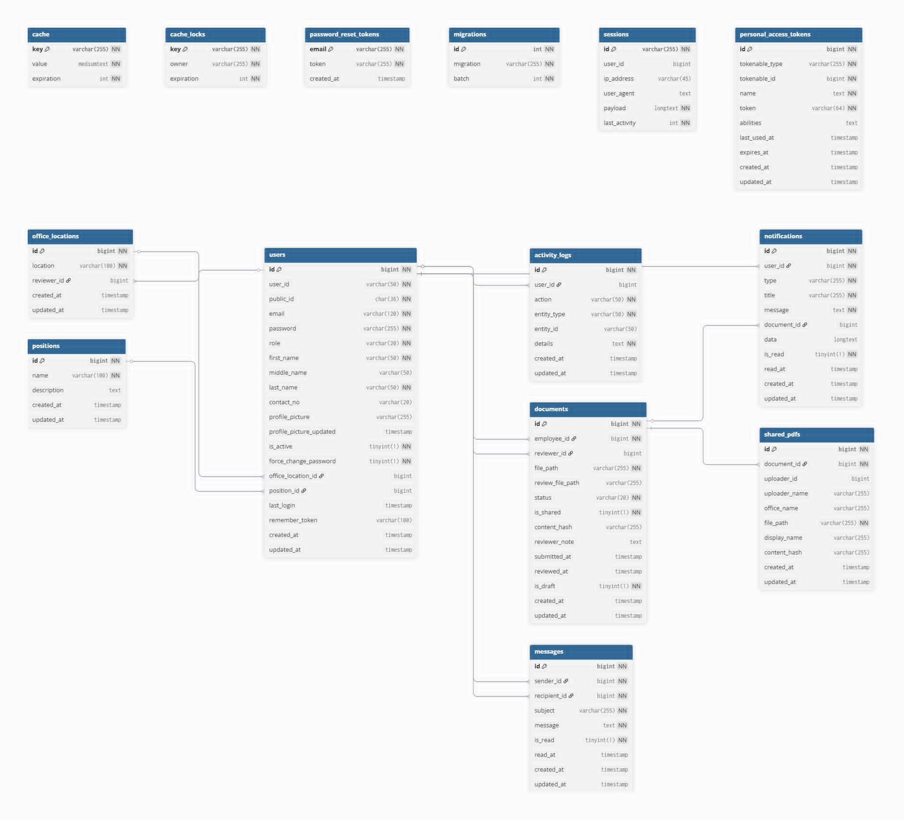
Figure 1. Entity-Relationship Diagram of the implemented DICT-EAAS database structure.
The use case models show a clear division of responsibilities across the employee, reviewer, and administrator roles. Employees prepare and submit documents, reviewers inspect and decide on submissions, and administrators manage users and monitor overall system activity.
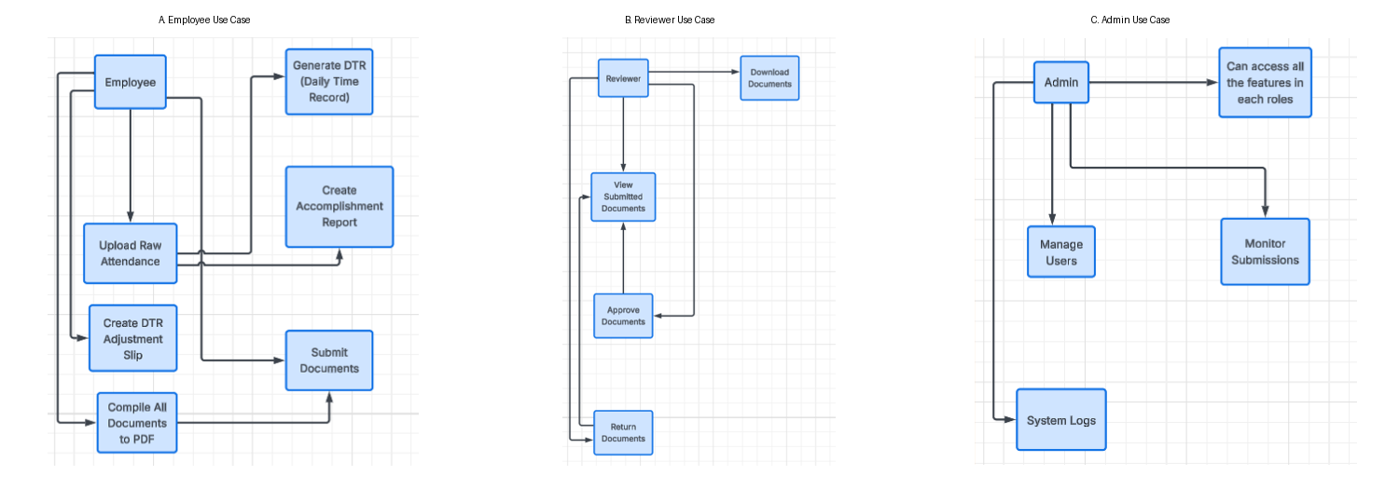
Figure 2. Selected use case views for employee, reviewer, and administrator roles.
The workflow model shows how DICT-EAAS turns the existing biometric-attendance-to-document process into a continuous digital process. Instead of manually re-encoding the PDF attendance export from the biometric scanner into office-specific DTR forms, an employee uploads the attendance PDF to the system, which extracts and converts the record into the required individual DTR. The employee can then generate the accomplishment report, prepare an adjustment slip when needed, compile the required files into a single PDF, and submit the package for evaluation. Reviewers can inspect, approve, sign, or return the document set for revision, while administrators can monitor submissions, statuses, and user actions.
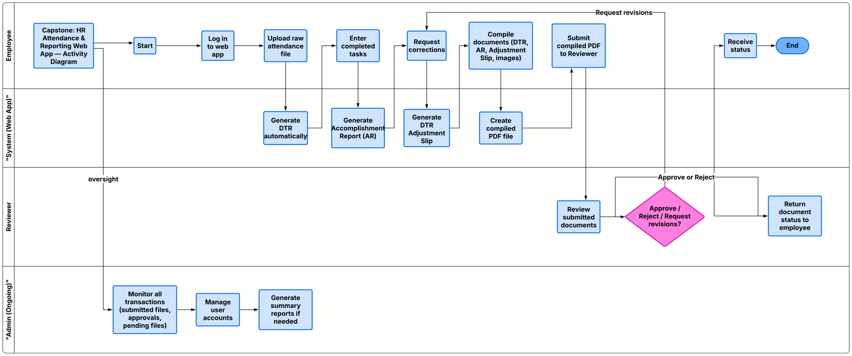
Figure 3. Activity diagram of attendance-derived document processing and approval workflow in DICT-EAAS.
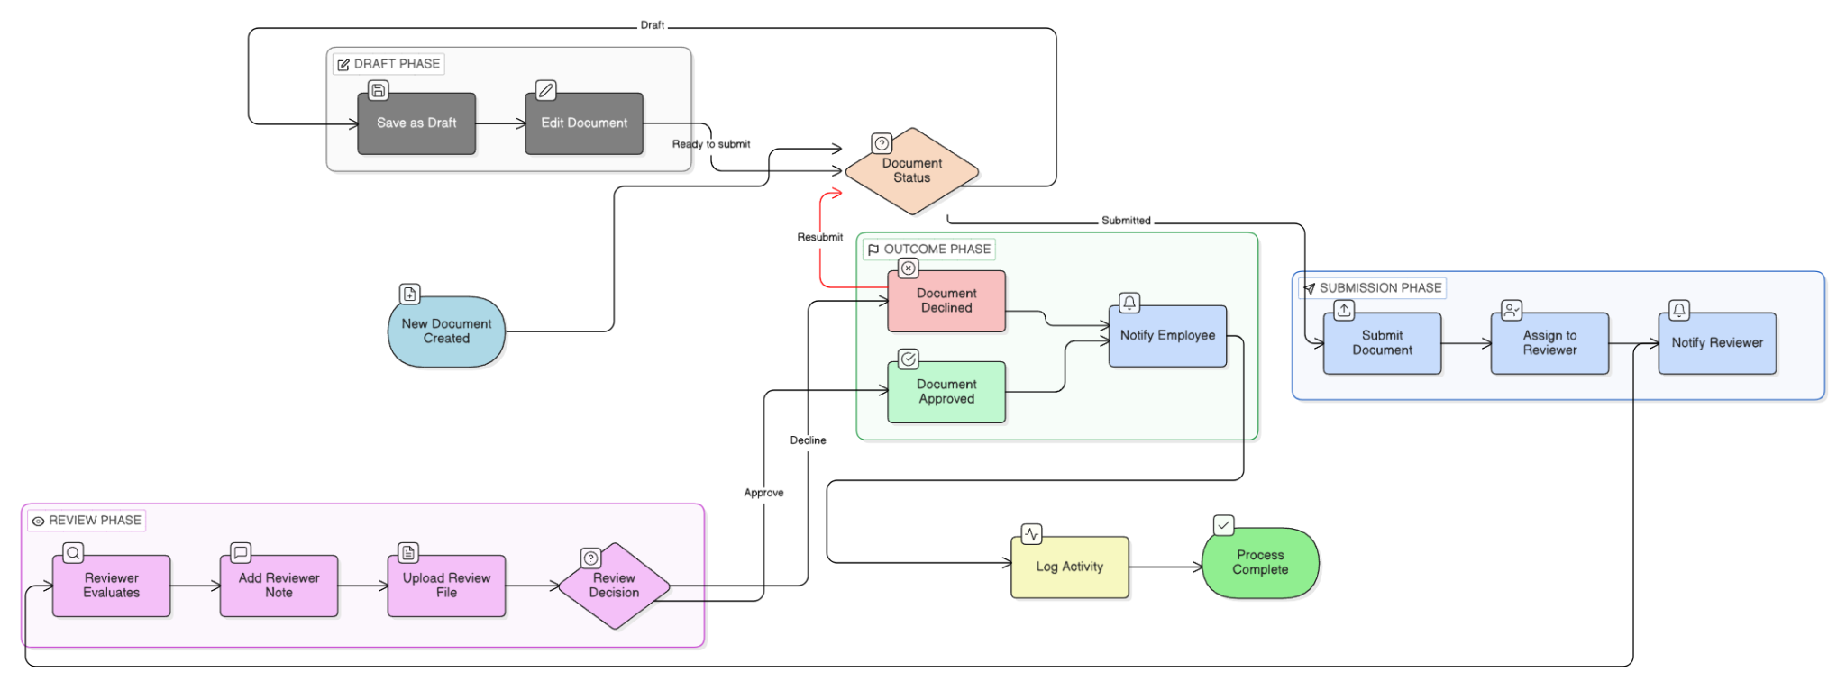
Figure 4. System flow showing draft, submission, review, and outcome handling in DICT-EAAS.

Prototype system architecture
Figure 5 presents the prototype architecture through an icon-based view of the main system components and their interactions. On the left, employees and administrators access the system through the web interface and upload the biometric attendance PDF generated by the existing scanner. At the center, the React + Vite frontend sends requests to the Laravel backend, which manages authentication, role-based access, reviewer assignment by office, document routing, notifications, and audit logging.
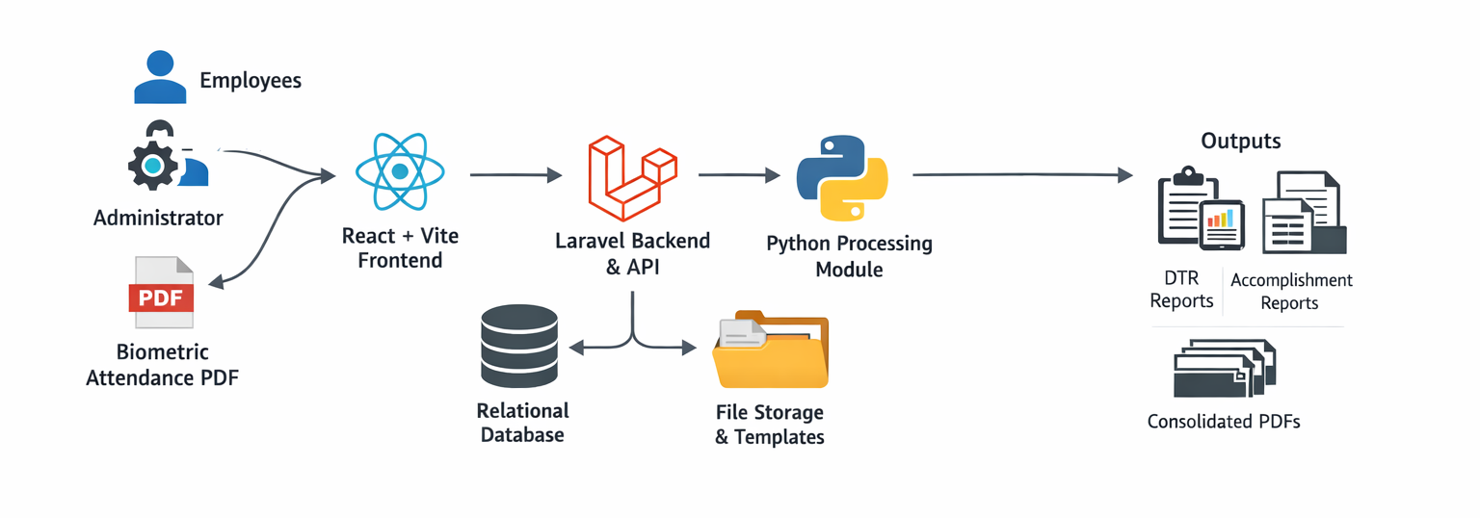
Figure 5. System architecture of the DICT-EAAS prototype.
As shown in the figure, Laravel serves as the coordinating application layer between the browser-based interface and the document-processing services. Whenever attendance conversion or report generation is requested, Laravel calls a separate Python module to parse the uploaded biometric PDF, extract time entries, prepare official-format DTRs and related report files from templates, and merge the outputs into submission-ready PDFs. Structured records such as users, office assignments, submissions, notifications, and activity logs are stored in the relational database, while uploaded files, generated documents, and reusable templates are kept in file storage. This setup keeps the presentation layer, workflow control, document processing, and storage functions clearly separated within the prototype.
The main modules of the system are summarized in Table 1.
Module | Primary Function | Main User(s) | Output / Result
Biometric Attendance PDF Upload and DTR Generation | Uploads the attendance PDF exported from the biometric scanner and converts it into an employee-specific Daily Time Record using the official format. | Employee | Generated official-format DTR for review or download
Accomplishment Report Generator | Creates a standardized accomplishment report from user-supplied task details. | Employee | Formatted accomplishment report
DTR Adjustment Slip | Prepares correction requests for attendance discrepancies. | Employee | Adjustment slip document
PDF Compiler | Combines the generated DTR, accomplishment report, adjustment slip, and supporting attachments into a single submission-ready PDF. | Employee | Compiled PDF submission package
Submission and Review Workflow | Routes compiled documents to the assigned reviewer and records approval actions. | Employee, Reviewer | Approved, returned, or pending submission
Administrative Monitoring | Tracks user accounts, submission status, and system activities. | Administrator | Monitoring dashboard and audit visibility
Table 1. Core modules of DICT-EAAS and their functions.
Interface views
Figures 6 to 8 present selected interface screenshots captured from the implemented React frontend for the employee, administrator, and reviewer roles.
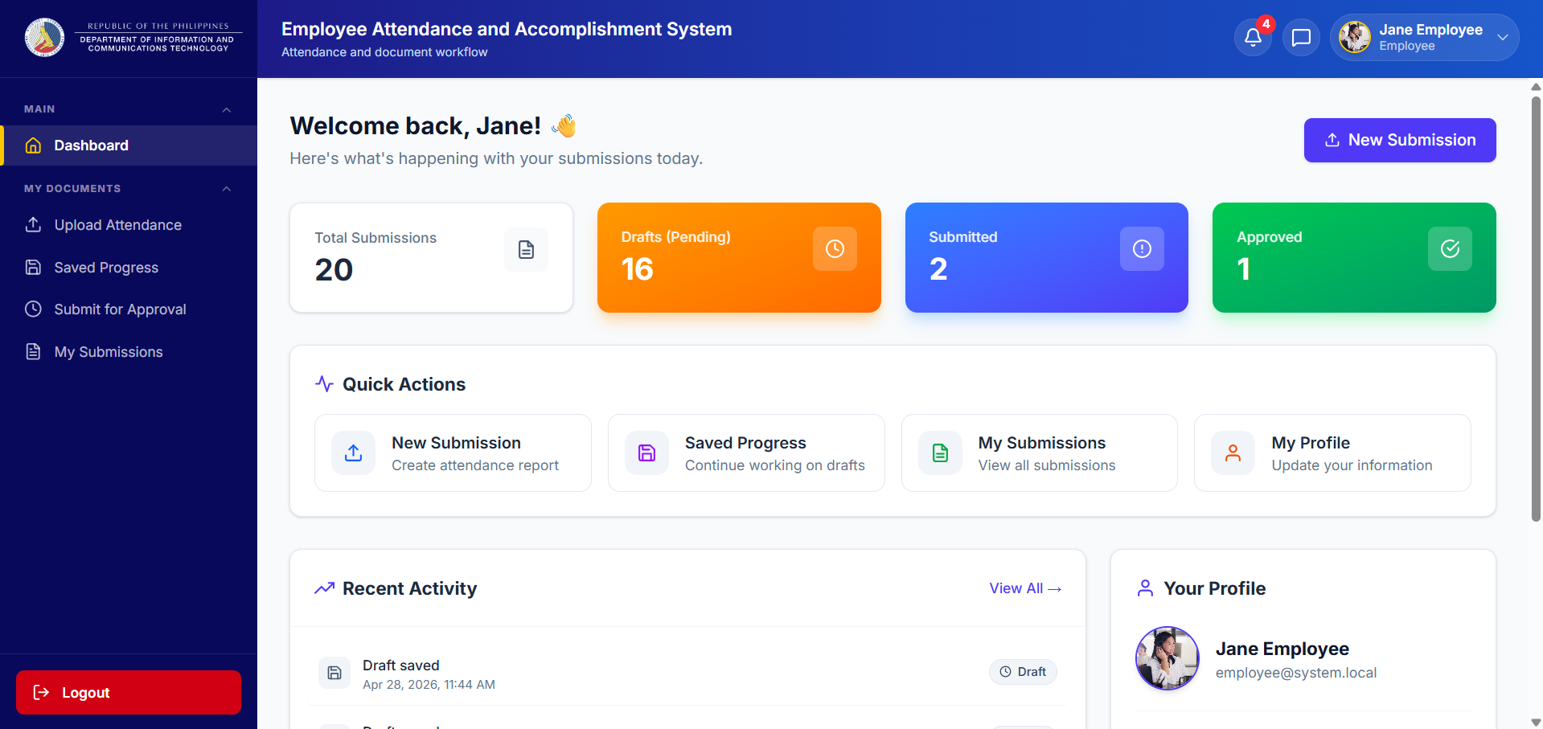
Figure 6. Employee dashboard of DICT-EAAS.
The employee dashboard is the main working page for regular users in the web interface. It shows a summary of total submissions, drafts, submitted files, and approved documents. It also provides quick access to common actions such as creating a new submission, continuing saved work, checking submitted files, and updating profile information.
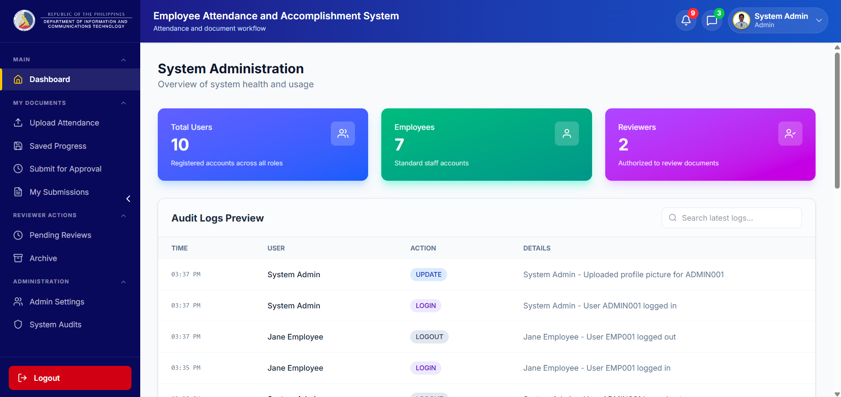
Figure 7. Administrator dashboard of DICT-EAAS.
The administrator dashboard supports platform monitoring and control. It summarizes the number of users by role and shows recent audit log entries. This view helps the administrator track activity, review access records, and oversee daily system operations.
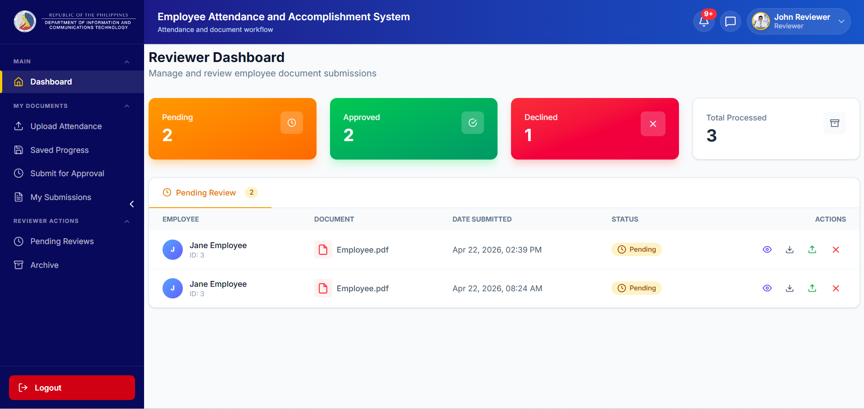
Figure 8. Reviewer dashboard of DICT-EAAS.
The reviewer dashboard shows the pending, approved, declined, and total processed submissions for the assigned reviewer. It also displays the pending review list with actions for viewing, downloading, approving, uploading, or declining submitted documents. This view supports the review and decision stage of the document workflow.
RESULTS
Pilot testing was conducted with six purposively selected DICT employees from the participating offices. The system received strong ratings in all assessed categories. The survey results showed an overall mean of 4.78 and an overall standard deviation of 0.35 based on respondent-level mean scores. The pilot instrument also obtained a Cronbach's alpha of 0.972, suggesting high internal consistency in this pilot sample. Since the evaluation involved only a small group of intended users, the findings should be treated as early evidence of usability and practical fit, not as broad proof of effectiveness.
Category | Items | Mean | SD | Interpretation
System Features | 9 | 4.81 | 0.32 | Very High
Functional Suitability | 3 | 4.94 | 0.14 | Very High
Performance Efficiency | 3 | 4.83 | 0.41 | Very High
Compatibility | 2 | 4.58 | 0.66 | Very High
Reliability | 3 | 4.78 | 0.40 | Very High
Security | 5 | 4.67 | 0.52 | Very High
Usability | 4 | 4.79 | 0.51 | Very High
Table 2. Pilot testing summary based on the survey workbook (n = 6).
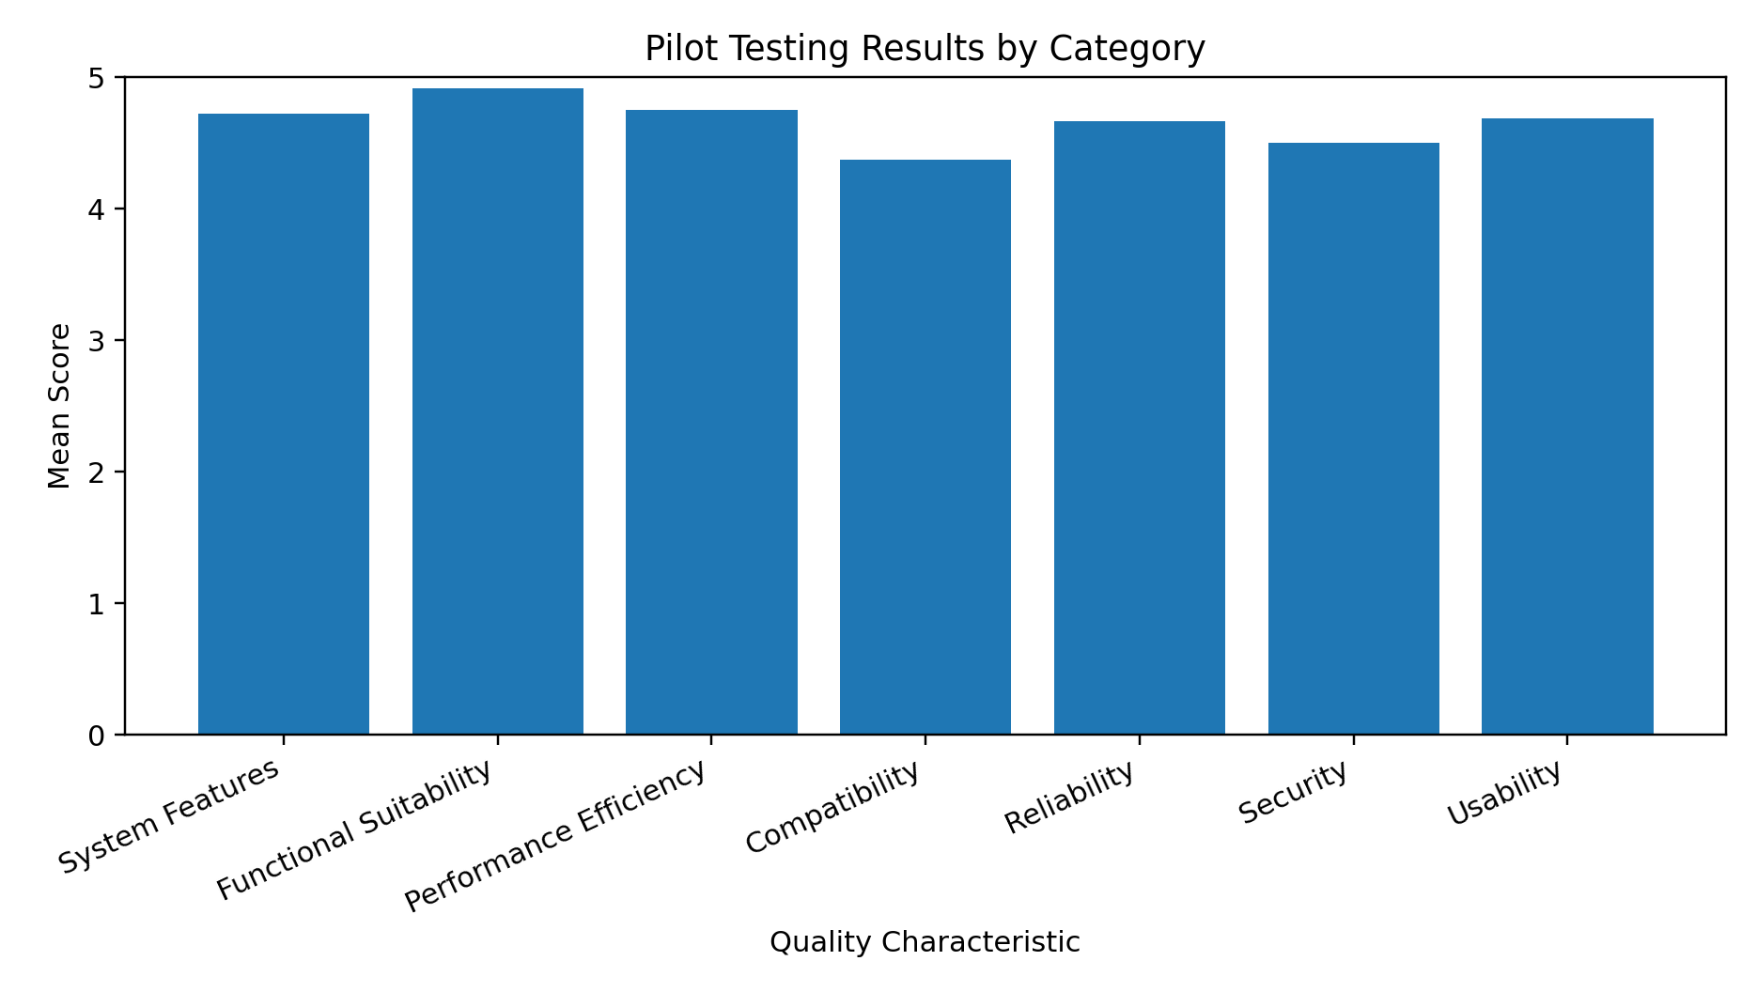
Figure 9. Mean pilot scores by quality category.
Among the rated dimensions, functional suitability obtained the highest mean (4.94), suggesting that users found the system able to perform its intended tasks accurately and appropriately. Performance efficiency followed with a mean of 4.83, indicating that the system responded well during pilot use. System features (4.81), usability (4.79), reliability (4.78), and security (4.67) also received strong ratings. Compatibility obtained the lowest mean (4.58), but it still remained within the very high range. This suggests that the core functions of the system were already strong, while future refinement may focus more on interoperability and data-sharing concerns.
DISCUSSION
The pilot results suggest that DICT-EAAS fits the document workflow needs of the participating DICT offices. Its practical value is not in attendance capture alone, since attendance data are already generated through the existing biometric device, but in reducing the manual work that follows. By helping users generate the official DTR, prepare related documents, compile the required files, and move submissions through review in one system, the prototype offers a more orderly and traceable way of handling attendance-related documents.
The quantitative findings show strong early user acceptance across the assessed categories. Functional suitability received the highest mean, which indicates that respondents found the system able to perform the tasks expected of it during pilot use. Performance efficiency, system features, usability, reliability, and security also received high ratings. Compatibility obtained the lowest mean among the measured dimensions, but it still remained within the very high range. Taken together, these results provide initial support for the practical fit of the prototype in its intended office setting, but they should not be treated as evidence of large-scale effectiveness.
The open-ended feedback generally supported the survey results. Most respondents reported no major difficulty during the pilot. The few comments raised were limited to manageable concerns such as bullet formatting in the accomplishment report, the default DTR download type, and one PDF extraction issue that had already been addressed. In the positive comments, respondents pointed to the usefulness of automatic time-log extraction, DTR generation, and the clarity of the interface. These observations suggest that the prototype was understandable and workable for its intended users during the try-out.
The findings are also in line with earlier work showing that attendance systems, records systems, and document-tracking platforms become more useful when they reduce repetitive manual handling and make workflows easier to follow [1, 5, 8, 13]. In the case of DICT-EAAS, the contribution of the prototype lies in bringing attendance conversion, document preparation, compilation, and reviewer handling into one connected office process. This does not yet establish broad organizational impact, but it does show that the developed system is workable and relevant to the needs identified during planning and consultation.
Limitations
This paper should be read as a development-and-pilot validation study. The pilot involved only six employee respondents from the participating DICT offices, so the results provide early user feedback but do not support broad generalization. The evaluation also relied mainly on descriptive statistics and internal consistency results, which suit an initial prototype check but do not yet show wider organizational impact. In addition, the guided try-out was conducted with the developers present, which may have helped respondents complete tasks and may also have influenced some ratings. A later study may include more respondents, longer actual office use, independent evaluators, and comparative measures such as time saved, error reduction, and submission speed before and after implementation.
CONCLUSION
DICT-EAAS was developed as a practical response to a workflow in which biometric attendance data are already available, but the preparation of official DTRs and related documents remains separate and largely manual. By combining biometric attendance PDF upload, automated official-format DTR generation, accomplishment report preparation, adjustment slip creation, PDF compilation, reviewer routing, and administrative monitoring, the system addresses the main operational issues identified during planning and analysis. The pilot results show strong early acceptance, especially in functional suitability, performance efficiency, and system features. Overall, the findings support the practical pilot value of DICT-EAAS for attendance-related document workflow automation in the participating DICT offices, while broader validation through larger-scale and longer-term use remains necessary.
ETHICAL CONSIDERATIONS
Administrative permission to conduct the study and pilot implementation was obtained from the participating DICT offices before the system try-out and data collection. The activity was conducted as a workplace-based pilot system evaluation under agency approval and coordination. Participation was voluntary, the purpose of the study was explained before the activity, and the results were reported only in aggregate form.
CONFLICT OF INTEREST
The authors declare no conflict of interest related to this study.
DATA AVAILABILITY
The data supporting the findings of this study are not publicly shared because they include internal workflow materials, pilot evaluation records, and system-related documents obtained and used with agency permission during the development and initial validation of DICT-EAAS. De-identified summary data and selected supporting materials may be made available by the corresponding author upon reasonable academic request, subject to agency approval and any applicable institutional restrictions.
ACKNOWLEDGEMENTS
The authors thank the Department of Information and Communications Technology (DICT) offices in Santiago, Cauayan, and Nueva Vizcaya for their cooperation during the development and initial validation of the system, especially the OJT supervisors who provided guidance and support during the project. The authors also thank the College of Information Technology of the University of La Salette, Inc. for the internship opportunity, guidance, and support throughout the completion of the project.
REFERENCES
1. Acoba, A. G., Cunanan, C. F., Merencilla, N. E., Tejada, R. R., & Ligayo, M. A. D. (2020). JuCo-IS: A development of web-based information system in judicial regional trial court. In 2020 IEEE 10th International Conference on System Engineering and Technology (ICSET) (pp. 22-25). IEEE. https://doi.org/10.1109/ICSET51301.2020.9265362
2. Agripa, D. J. B., & Astillero, S. F. (2022). Development of employee attendance and management system using quick response (QR) code in Sorsogon State University, Castilla Campus, Philippines. European Journal of Education Studies, 9(11), 307-320. https://doi.org/10.46827/ejes.v9i11.4545
3. Alenezi, M. (2023). Digital learning and digital institution in higher education. Education Sciences, 13(1), Article 88. https://doi.org/10.3390/educsci13010088
4. Amora, E. N. O., Romero, K. V., Amoguis, R. C., Olandria, J. E., Olandria, E. N., Bernales, A. M. J., & Romero, P. J. B. (2021). Digital attendance and accomplishment report monitoring system (DIGIATT). IOER International Multidisciplinary Research Journal, 3(2), 123-133. https://doi.org/10.54476/iimrj293
5. Castro, F. V., Quilon, E. R. C., & Arruejo, A. C. (2022). DocTrack: A dynamic document tracking system for the University of Northern Philippines. Journal of Innovative Technology Convergence, 4(2), 23-34. https://doi.org/10.69478/JITC2022v4n2a03
6. Das, D., Banerjee, S., Chatterjee, P., & Ghosh, U. (2023). A comprehensive analysis of trust, privacy, and security measures in the digital age. In 2023 5th IEEE International Conference on Trust, Privacy and Security in Intelligent Systems and Applications (TPS-ISA) (pp. 360-369). IEEE. https://doi.org/10.1109/TPS-ISA58951.2023.00051
7. ISO/IEC. (2023). ISO/IEC 25010:2023. Systems and software engineering - Systems and software quality requirements and evaluation (SQuaRE) - Product quality model. International Organization for Standardization. https://www.iso.org/standard/78176.html
8. Libadia, M., Botangen, K. A., Lucero, P. J., & Tecson, J. (2025). Development of a web-based records management system: An ERMS initiative for the Office of Senior Citizen Affairs in the Philippines. Records Management Journal, 35(2), 160-179. https://doi.org/10.1108/RMJ-06-2023-0031
9. Lingaya, S. R. (2019). Towards a bespoke document tracking system for Philippine higher educational institutions. International Journal of Recent Technology and Engineering, 8(2), 1568-1574. https://doi.org/10.35940/ijrte.B2255.078219
10. Mishra, V. P., & Purohit, H. (2025). ICT-enabled information management system (IMS) in educational organizations. In 2025 International Conference on Computational Intelligence and Knowledge Economy (ICCIKE) (pp. 603-608). IEEE. https://doi.org/10.1109/ICCIKE67021.2025.11318254
11. Salomón, S., Duque, R., Montaña, J. L., & Tenés, L. (2023). Towards automatic evaluation of the quality-in-use in context-aware software systems. Journal of Ambient Intelligence and Humanized Computing, 14(8), 10321-10346. https://doi.org/10.1007/s12652-021-03693-w
12. Syed-Mohamad, S. M., Ngah, A., Ali, A.-F. M., & Keikhosrokiani, P. (2025). Measuring software maintainability: An exploration of metrics and continuous practices. Journal of Advanced Research in Applied Sciences and Engineering Technology, 63(2), 181-195. https://doi.org/10.37934/araset.63.2.181195
13. Vega-Quintana, C. A., Gallardo-Andrés, J. A., & Chinga-Ramos, C. E. (2024). Implementing a web-based document management system to optimize operational efficiency in engineering. Pakistan Journal of Life and Social Sciences, 22(2), 13715-13725. https://doi.org/10.57239/PJLSS-2024-22.2.00984
14. Canlas, R. B., Piad, K. C., & Lagman, A. C. (2022). An ISO/IEC 25010 based software quality assessment of a faculty research productivity monitoring and prediction system. In Proceedings of the 2021 9th International Conference on Information Technology: IoT and Smart City (ICIT ’21) (pp. 238-242). Association for Computing Machinery. https://doi.org/10.1145/3512576.3512619
15. Manglapuz, S. J. R., & Lacatan, L. L. (2019). Academic management android application for student performance analytics: A comprehensive evaluation using ISO 25010:2011. International Journal of Innovative Technology and Exploring Engineering, 8(12), 5086-5090. https://doi.org/10.35940/ijitee.L2735.1081219
16. Handayani, F., & Mustikasari, M. (2021). Quality assurance of Sayurbox mobile application using model ISO 25010. International Research Journal of Advanced Engineering and Science, 6(3), 176-180. https://irjaes.com/wp-content/uploads/2021/08/IRJAES-V6N3P148Y21.pdf

