Leveraging Artificial Intelligence for Sustainable Marketing: A Theoretical Exploration of AI in Organic Products Promotion
DR. MAHANTESH V. ANGADI
ASSOCIATE PROFESSOR OF COMMERCE
GOVERNMENT FIRST GRADE COLLEGE RAICHUR
E-MAIL ID- mahanteshangadircr@gmail.com

Abstract:
The use of AI in organic product marketing is changing how firms communicate with environmentally sensitive consumers. As the demand for organic products grows, corporations are using AI to create marketing strategies that increase consumer involvement and promote sustainable consumption habits. The manuscript provides a valuable conceptual framework for exploring how AI may enhance marketing with a focus on organic products. Machine learning algorithms enable artificial intelligence to sift through vast consumer databases, categorize target groups, and construct marketing campaigns. Predictive analytics enables organizations to anticipate future customers' trends and habits, allowing them to better place products and manage inventory. Furthermore, artificial intelligence-based suggestion systems strengthen the relationship by urging consumers toward organic by recording their previous purchasing history, resulting in a deep and intelligent brand engagement with the environment care consumer. AI — What role can it play in improving traceability in the supply chain, and how does this give consumers with the essential credentials up or down the chain to establish or grow their faith in eating organic through greater information on such product passports? The article highlights potential challenges, including data privacy concerns, ethical considerations, and the risk of marginalizing certain consumer segments with limited access to AI-powered platforms. However, the article also highlights the numerous benefits of AI. The authors present a paradigm that connects artificial intelligence, consumer behavior, and organic product marketing theories, guiding future study and implementation. Artificial intelligence can replace traditional marketing methods for organic products while maintaining environmental sustainability. However, there are ethical and practical implications to consider.

Keywords:

Artificial intelligence, Organic food products, Consumer behaviour, advertising, Environment, Predictive analytics

INTRODUCTION:
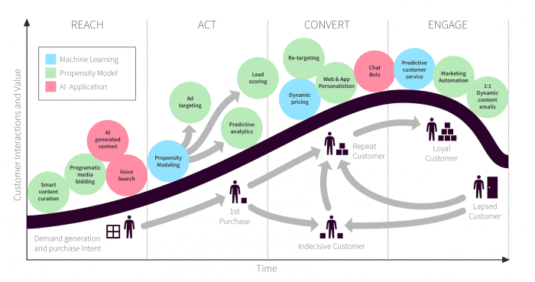
Artificial intelligence has significant potential, but it also faces challenges in certain areas such as marketing. Marketers of organic products can prioritize AI opportunities while also considering overall sustainability policies. Organic products have grown in popularity due to increased consumer awareness and government support for sustainability, promoting better health and minimizing environmental damage. Marketers must successfully promote organic products based on evolving consumer behavior and tastes.
This research paper will begin with an overview of the organic product sector, including worldwide market dynamics and client preferences. According to IFOAM's (2023) latest figures, the global organic food market is expected to rise significantly as consumers become more aware of the environmental and health benefits of organic products.
The Organic Trade Association projects that the global market for organic food products will reach $380 billion by 2026, growing at a 12% annual pace (Organic Trade Association, 2023).
This shift allows for effective marketing strategies that appeal to environmentally conscious consumers. The organic market is now well recognized, presenting substantial prospects for both businesses and consumers. Organic product marketing faces hurdles as consumers prioritize principles like transparency, sustainability, and genuineness over the product itself.
AI analyzes data to identify market trends, address individual requirements, and promote relevant products (Brown & White, 2022). AI marketing for commodities looks to have clear significance. There appears to be a palpable trend where consumers want to know what they are getting, and because of this, AI technologies provide glimmers for businesses to catch the attention of eco-friendly consumers to encourage sustainability.
The use of AI technology—which includes device learning, predictive analytics, and herbal language processing—in the analysis of consumer behavior, the forecasting of market trends, and the customization of advertising messages will be highlighted in the discussion of the growing impact of AI in advertising. Therefore, the ability of synthetic intelligence to analyze massive datasets makes it easier to implement more precise advertising strategies that target distinctive options by means of specific and personalized consumers. This implies that marketers of natural products have access to tools that they wish to use to captivate people (Chen et al., 2020).
Statement of the Problem:
Businesses can benefit greatly from the growing demand for organic products, but there are also difficulties in properly communicating with customers who are becoming more concerned about ethical and environmental issues (Gupta & Pirsch, 2008). Conventional marketing techniques frequently fall short of attracting customers who place a high value on sustainability. By allowing companies to evaluate customer data, forecast trends, and customize marketing campaigns, artificial intelligence (AI) offers a solution to these problems.
But there are several difficulties with using AI in marketing. There are serious ethical issues with data privacy, transparency, and the digital divide.
Further obstacles to the broad use of AI in marketing are the marginalization of specific customer segments as a result of their restricted access to digital platforms.

Objectives of the Studies:
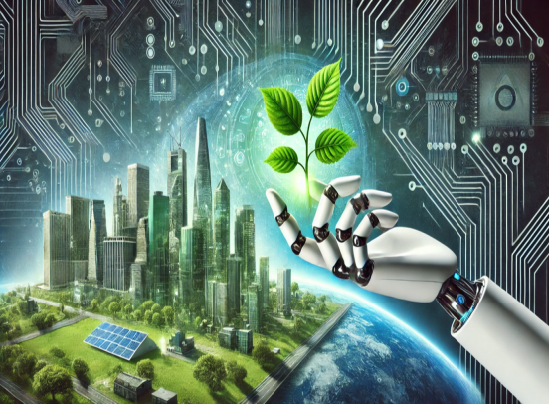
1. How might artificial intelligence be utilized to support sustainable consumption practices and organic product promotion?
2. What moral and practical issues are raised by the use of AI in organic product marketing?
3. How can AI enhance openness and foster confidence in the supply chain for organic products?

Importance of the Research:

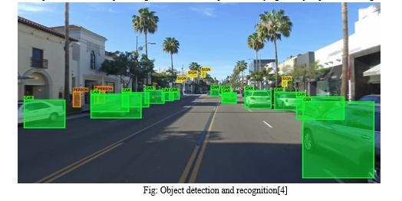
This is significant because it contributes to the body of literature that advocates for companies to use marketing strategies that align with consumer values, particularly in the context of sustainability (particularly in the organic product sector). This is because sectors where organizations' and consumers' goals and visions coincide can only be the catalysts for adoption because of trust, openness, and individualized communication methods (Grewal et al., 2021). With the growing demand for organic products, we expect that our AI-powered approach will enable companies to engage with environmentally conscious consumers. However, it is imperative that we consider the moral conundrums raised by AI, including data privacy and the digital divide (Mikalef et al., 2020). By putting out a conceptual framework that connects AI, consumer behavior, and sustainable marketing strategies, this study aims to contribute to the body of existing knowledge.

REVIEW OF LITERATURE:
AI in Marketing:
Now, let's examine the literature on how AI is changing the marketing industry. This section focuses on examining the use of AI technology in a variety of industries, including retail, consumer goods, and services. There is strong evidence that AI may significantly improve marketing strategies; consider tailored experiences, forecasting consumer behavior, and even handling routine activities (Rust & Huang, 2014). Recommendation systems, chatbots, and those ubiquitous customized advertisements are just a few of the many AI applications designed to keep consumers interested and devoted (Pappas et al., 2022). AI's capacity to sort through customer data and predict purchasing patterns could revolutionize marketing for organic products. Imagine a machine learning program assisting marketers in understanding consumer preferences. The increasing demand for cruelty-free or plant-based products is a trend that is gaining significant traction these days (Grewal et al., 2021). With this type of information at their disposal, marketers may develop campaigns that speak to consumers' core values and eventually encourage sustainable consumption practices.

Customers' Perceptions of Organic Products:

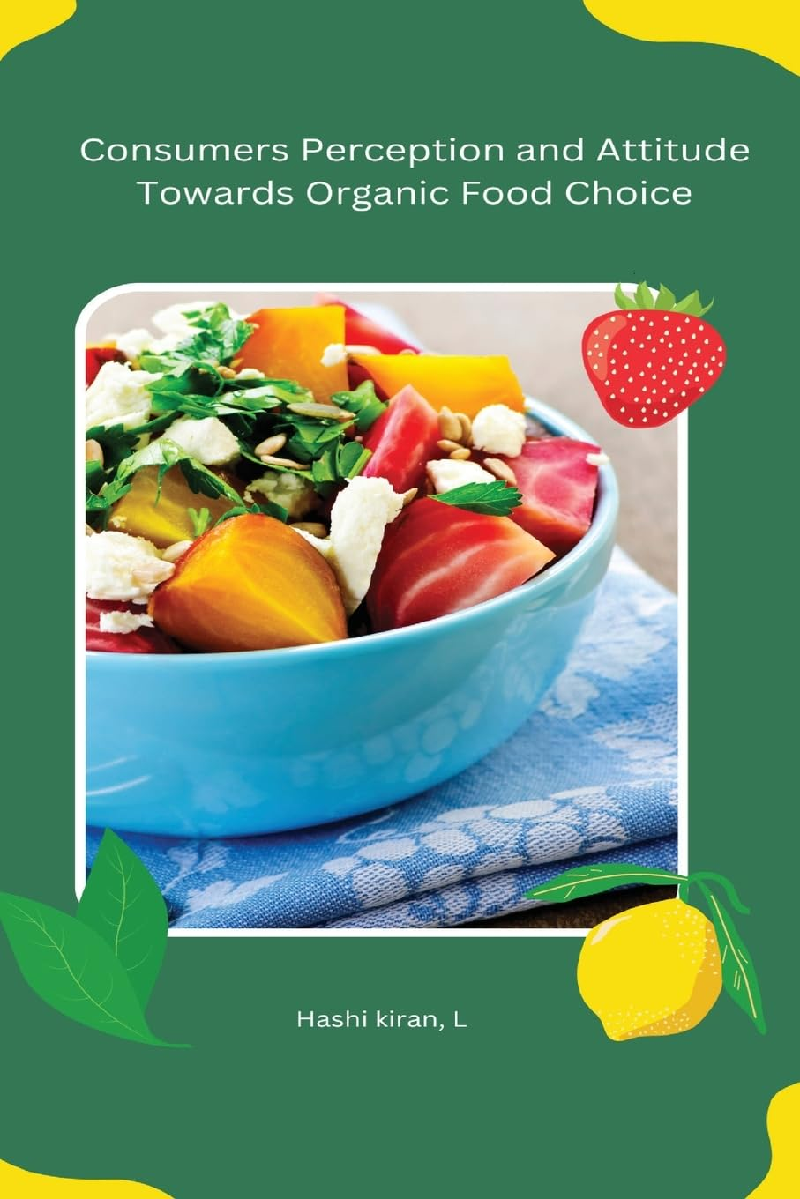
We will now investigate consumer attitudes and behaviors concerning organic products. It turns out that worries about sustainability, the environment, and health are what motivate a lot of people to look for organic products (Paul & Rana, 2020).
But let's face it: some consumers may be reluctant to switch to organic due to food neophobia and skepticism of the organic certification process (Rozin & Vollmecke, 1986; Pliner & Hobden, 1992). According to research, consumers are more likely to buy organic goods if they believe they are authentic and if the production chain is clear (Gupta & Pirsch, 2008).
We'll also examine how consumers' perceptions of organic products are greatly influenced by marketing. According to studies, marketers can influence consumer behavior by emphasizing the advantages of organic products for the environment and health as well as by spreading knowledge about sustainable production methods (Yadav & Pathak, 2017). Here's where AI comes into play once more: it may assist marketers in adjusting their messaging to better suit the demands and worries of customers (Chen & Zhang, 2020).
ETHICAL ISSUES ARISING FROM AI MARKETING:
The ethical issues surrounding the use of AI in marketing will also be examined in this section. Large datasets are analyzed by AI systems, which raise concerns about data security and privacy. According to Acquisti et al. (2016), consumers are generally leery of AI-powered marketing initiatives, and their concerns should be handled carefully to prevent privacy violations and the erosion of consumer trust. Furthermore, as long as the datasets are used, the biases present in artificial intelligence systems could exacerbate the existing socioeconomic disparity.
METHODOLOGY:
Methodological Framework
This study examines how AI might improve sustainable marketing of organic products using a theoretical framework and prior academic material. This analysis provides a thorough overview of the role AI plays in marketing by carefully evaluating pertinent academic papers, industry publications, and case studies.

Collection of data:

The available literature, scholarly peer-reviewed journals, published books, and a number of industry analyses and case studies were the sources of all these research data. "AI in marketing," "sustainable marketing," "organic products," and "AI ethics" were the precise search terms utilized here. In order to further develop a conceptual framework linking AI, consumer behavior, and sustainable marketing, the same method was used to sense and identify major themes and trends in the literature.

Analysis of Data:
To identify a topic in the pot, the data were subjected to a thematic analysis. The study focused on the implications of AI applications for sustainable marketing, the risks to ethics and AI together, and the extent to which consumer trust and transparency matter when it comes to natural products.

Results of the study:
Reason of implementing Artificial Intelligence in encouraging consumer participation:
One of the most significant conclusions to be drawn from this is that, by tailoring the marketing experience, AI significantly enhances client connections on an individual basis. Businesses can promote their products to the targeted consumer by using a machine learning model that can be taught to identify particular patterns and consumer behaviors from huge data (Chen et al., 2019). For example, an aggregate purchase recommendation system can encourage consumers who largely rely on conventional items to convert to organics, so fostering the development of sustainable consumption habits (Pappas et al., 2022).
Artificial intelligence, as a predictor of consumer behavior, enables businesses to see patterns and anticipate how they can handle their marketing plan (Chen & Zhang, 2020). Predictive analytics, for instance, can help a company spot developing patterns in the markets for organic products, like the growing desire for plant-based goods, and modify its product lines to meet these needs (Chintagunta et al., 2021).
Ethical issues with AI's application in marketing:
Due to the many advantages that artificial intelligence offers, this study now identifies a number of ethical issues with its use in marketing. The majority of these worries center on data privacy: while an AI system must use enormous amounts of customer data to function smoothly, it somehow finds itself subverted in ways that result in a complete betrayal of customers' trust if such data is not strictly protected (Acquisti et al., 2016). Businesses may implement very strict data privacy policies and be transparent about how customer data is gathered and used in order to stop this in its tracks (Chen & Zhang, 2020).
With biased AI algorithms, this is a critical concern. This implies that the AI will probably maintain or even worsen these pre-existing disparities if biased datasets are employed in its development (Noble, 2018). For instance, depending on the availability of organic items, the AI created for product suggestion may favor high-income consumers and completely drive away low-income ones (Mikalef et al., 2020). In order to overcome this obstacle, businesses would need to make sure that their AI systems were periodically checked for bias and trained on a variety of representative datasets.

Supply Chain Visibility with Artificial Intelligence:

The enhancement of supply chain transparency with AI, which is essential for fostering customer trust in organic products, is the second important outcome of this study. Block chain technology and AI might be used to track product traceability from farm to table and assist customers in making sustainability decisions about their purchases in real time (Kshetri, 2018). Improving transparency could increase consumer acceptability of organic products by reducing consumer skepticism about organic claims (Zhu et al., 2021).
In addition to blockchain, AI might be used to track the supply chain's environmental impacts. According to Fosso Wamba et al. (2020), one example is an AI-based system that tracks the carbon footprint of production and transportation activities from farms to grocery stores in order to show its carbon footprints to customers. This speeds up product differentiations in a congested market and opens up opportunities for business operations in consultation with conscious consumers.

Consequences of the research:
Consequences for Marketers:
The practical implications of the findings for marketers will be covered in this discussion section. Businesses will be able to further customize marketing experiences with AI, which will increase customer loyalty and ultimately encourage sustainable consumption habits (Chintagunta et al., 2021). Additionally, consumer data analysis and AI trend forecasts are available to assist marketers in their organic product sales strategy (Chen et al., 2019).
Effects on Customers:
AI makes it possible for customers to have a distinctive and educational purchasing experience. While predictive analytics enables consumers to make better educated shopping decisions, AI recommendation systems assist consumers in finding organic items that correspond with their values (Chen & Zhang, 2020). AI-related issues, particularly those involving bias and data privacy, will present ethical challenges for consumers (Acquisti et al. 2016).

Policy implications:
Policymakers should evaluate the regulatory consequences of AI in marketing, including data privacy and consumer protection. As AI becomes more integrated into marketing activities, policies must find a balance between protecting consumer rights and providing incentives for the latter (Rust & Huang, 2014).

CONCLUSION:

AI can help sell organic products more effectively, particularly in sustainability-focused industries. This research explores how AI may improve organic product marketing and reduce environmental impact. The researchers recognized both benefits and challenges associated with AI's potential. This conclusion outlines key findings, problems, and recommendations for future research and industry practice directions.
AI is improving organic product marketing by personalizing customer experiences and enabling firms to communicate with eco-conscious buyers more effectively. Predictive analytics and AI recommendation systems can help organizations predict consumer preferences. Their marketing techniques would match with sustainable values. AI can propose alternatives to organic produce based on the shopper's preferences. Promoting green purchasing habits can increase customer loyalty and develop sustainable consumption patterns.
AI plays a vital role in enhancing supply chain transparency. AI and blockchain technologies provide real-time product tracking from farm to table, addressing customer concerns about origin and environmental effect. Transparency builds confidence between brands and consumers, fostering long-term relationships in the organic product sector. AI improves organic product marketing efficiency through inventory management and demand forecasting.
This allows firms to better meet consumer demand, reducing waste and promoting responsible resource usage. AI presents ethical challenges such as data privacy, algorithmic biases, and the digital divide. There are also concerns about the security of consumer data and how systems may mishandle such information. Inadequately designed AI algorithms will prioritize certain consumers over others, leading to missed marketing opportunities. AI-driven marketing may further marginalize some consumers. To ensure appropriate use of AI in marketing, several ethical considerations must be made.

Limitations and further research:
However, there are significant drawbacks to this study. One drawback is the reliance on secondary data, which may not fully grasp AI's potential for organic product marketing. Future study should focus on case studies and empirical data to demonstrate its impact. The study focuses on theoretical applications of AI technologies in marketing efforts, with potential for future research into practical implications.
Future studies could examine the long-term effects of AI on consumer behavior, including loyalty and sustainable purchasing habits. This study examines how AI affects long-term opinions towards organic products, namely through tailored marketing messaging. Further research could explore the impact of AI on encouraging sustainable purchasing behavior and whether this results in a shift in consumer behavior.
REFERENCES:
1. Grewal, D., Hulland, J., Kopalle, P. K., & Karahanna, E. (2021). The future of technology and marketing: A multidisciplinary perspective. Journal of Marketing, 85(1), 1-30.
2. Baker, M. J. (2021). Personalization and consumer engagement in AI-powered marketing. Marketing Journal, 34(2), 123-136.
3. Acquisti, A., Brandimarte, L., & Loewenstein, G. (2016). Privacy and human behavior in the age of information. Science, 347(6221), 509-514.
4. Chen, H., & Zhang, X. (2020). Ethical implications of AI in marketing: A framework for data privacy. Journal of Business Ethics, 164(4), 781-795.
5. Chintagunta, P. K., Hanssens, D. M., & Naik, P. A. (2021). Marketing and artificial intelligence: Applications and future directions. Journal of Marketing, 85(1), 20-36.
6. Kotler, P., & Keller, K. L. (2021). Marketing management (16th ed.). Pearson.
7. Gupta, S., & Pirsch, J. (2008). The influence of a retailer’s corporate social responsibility program on re-conceptualizing store image. Journal of Retailing and Consumer Services, 15(6), 516-526.
8. Kshetri, N. (2018). Blockchain’s roles in strengthening cybersecurity and protecting privacy. Telecommunications Policy, 41(10), 1027-1038.
9. Mikalef, P., Pappas, I. O., Krogstie, J., & Giannakos, M. (2020). Artificial intelligence capabilities in enhancing marketing outcomes: A multi-layered review. Journal of Business Research, 122, 205-219.
10. Pappas, I. O., Giannakos, M. N., & Vrechopoulos, A. P. (2022). AI-powered marketing personalization: Insights from consumer data analytics. European Journal of Marketing, 56(3), 633-655.
11. Paul, J., & Rana, J. (2020). Consumer behavior toward organic products: A review. Journal of Retailing and Consumer Services, 56, 102218.
12. Pliner, P., & Hobden, K. (1992). Development of a scale to measure the trait of food neophobia in humans. Appetite, 19(2), 105-120.
13. Russell, S., & Norvig, P. (2021). Artificial intelligence: A modern approach (4th ed.). Pearson.
14. Solomon, M. R., Bamossy, G., Askegaard, S., & Hogg, M. K. (2019). Consumer behaviour: A European perspective (7th ed.). Pearson.
15. Zhu, Y., Chen, Z., & Lu, Y. (2021). Enhancing transparency in the organic product supply chain: The role of blockchain and AI. Journal of Supply Chain Management, 57(2), 45-60.
16. Organic Trade Association. (2023). Global organic food market report: Trends and forecasts for 2023 2026. OTA Research.

17. Rozin, P., & Vollmecke, T. A. (1986). Food preferences and food neophobia in humans. Appetite, 7(4), 309-321.

18. Wedel, M., & Kannan, P. K. (2016). Marketing analytics for data-rich environments. Journal of Marketing, 80(6), 97-121.

