The Rise of Superbugs: A Comprehensive Review of Antimicrobial Resistance Mechanisms and Management

Abstract
The rapid emergence and global spread of antimicrobial-resistant microorganisms—commonly termed “superbugs”—pose a critical threat to public health, modern medicine, and global economies. This integrated review examines the multidimensional factors driving antimicrobial resistance (AMR), including microbial evolution, misuse and overuse of antibiotics in humans and animals, inadequate infection control, and environmental dissemination of resistance genes. Key pathogens such as MRSA, VRE, CRE, ESBL-producing Enterobacteriaceae, and drug-resistant Mycobacterium tuberculosis are discussed in terms of their epidemiology, mechanisms of resistance, and clinical impact. The review also highlights the role of horizontal gene transfer, mobile genetic elements, and biofilms in accelerating resistance. Current diagnostic challenges, treatment limitations, and the socio-economic implications of AMR are explored. Finally, emerging solutions—including rapid diagnostics, antimicrobial stewardship, novel drug discovery, bacteriophage therapy, probiotics, vaccines, and global policy initiatives—are evaluated. This comprehensive synthesis underscores the urgent need for coordinated global action to control the rise of superbugs and safeguard the effectiveness of existing antimicrobials.
Keywords
Antimicrobial resistance (AMR), Superbugs, MRSA, VRE, CRE, Antibiotic misuse, Antimicrobial stewardship, Global health

Introduction
Antimicrobial-resistant bacteria, or superbugs, are an extremely uncommon yet unstoppable worldwide issue that poses a hazard to both the community and hospitals. In 2024, Dilip Chandrasekhar et al. Antimicrobial resistance (AMR) is emerging as a new danger to economic growth, food security, and human health as the globe tries to recover from the recent COVID pandemic. The World Health Organization (WHO) states that superbugs and multidrug-resistant organisms pose a major global health risk. (Sakshi Painuli et al., 2023). Superbugs are microorganisms, usually bacteria, that have become resistant to medications meant to eradicate them, making diseases difficult to cure. A superbug, also known as a multidrug-resistant microorganism, is any type of illness that is difficult to eradicate due to its resistance to existing treatments. Because of this resistance, symptoms may increase or prolong and regular antibiotics may not be effective. Additionally, some fungal superbugs are resistant to antifungal drugs. (Clinic in Cleveland). This can be caused by a number of factors, such as overprescribing antibiotics, misusing them or using them without a prescription, poor medication quality, genetic mutations in microorganisms, patients not taking their antibiotics as prescribed or not fully adhering to the recommended schedule, prolonged hospital stays, Preventive antibiotic treatment and inadequate sanitation and hygiene. (Dilip Chandrasekhar et al., 2024).
This review's main goal is to present a thorough and current understanding of superbugs, with an emphasis on their emergence, antimicrobial resistance mechanisms, global distribution, clinical impact, and current detection, prevention, and control techniques. In order to tackle antimicrobial resistance (AMR), the review also seeks to highlight recent developments in research, treatment advances, and policy measures.

Historical Background

Sulphonamides were first used therapeutically in the 1930s, marking the beginning of the clinical usage of antibiotics (Kardos et al., 2011). The antimicrobial revolution also started with the discovery of penicillin in the early 20th century. Subsequently, a variety of synthetic and semi-synthetic antibacterial agents as well as more modern antimicrobials were discovered. Numerous cases of potentially fatal bacterial infections have been treated using antimicrobial medications, which has lessened the suffering of the patients. Unfortunately, over the past 50 years, the unchecked use of antibiotics has put pressure on vulnerable bacterial populations, resulting in the persistence of drug resistance, with some strains being resistant to multiple medications.

Even before antibiotics were used therapeutically, it was well known that bacteria exposed to antimicrobials produced by other bacteria in their surroundings might develop resistance as a strategy of survival. Antibiotic resistance is making it more difficult to treat infectious diseases caused by bacteria, fungi, viruses, and parasites. All commonly used antibiotics are now vulnerable to bacterial resistance, and some more recent agents, such as new generation fluoroquinolones and streptogramins, are also experiencing high levels of resistance due to the recent use of related substances in agriculture and medicine. (Wright et al., 2000). Superbugs are currently considered an epidemic and are widespread all over the planet. Methicillin-Resistant Staphylococcus aureus (MRSA) and Multidrug-Resistant (MDR) Mycobacterium tuberculosis, Klebsiella pneumoniae, Streptococcus pneumoniae, Clostridium difficile, Neisseria gonorrhoeae, A. baumannii, Salmonella spp., E. coli, P. aeruginosa, and vancomycin-resistant Enterococcus spp. are examples of superbugs. ([Figure 1]). (Medina et al., 2016).
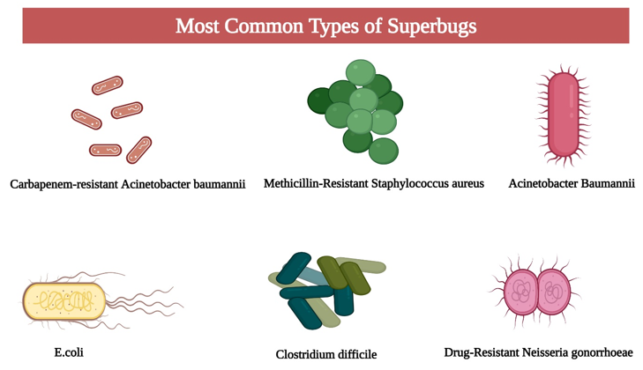
Figure 1: Type of superbugs
AMR is referred to as multidrug-resistant (MDR), extensively drug-resistant (XDR), and pan-drug-resistant (PDR) microorganisms (Magiorakos et al., 2012). The seven bacteria—MRSA, carbapenem-resistant Klebsiella pneumonia, and others—are the main culprits behind common, dangerous illnesses like sepsis, diarrhea, pneumonia, urinary tract infections, and gonorrhea. The WHO's 2014 publication, "Antimicrobial resistance: global report on surveillance," supports this. ([Figure 2]). (Wise et al., 1998).

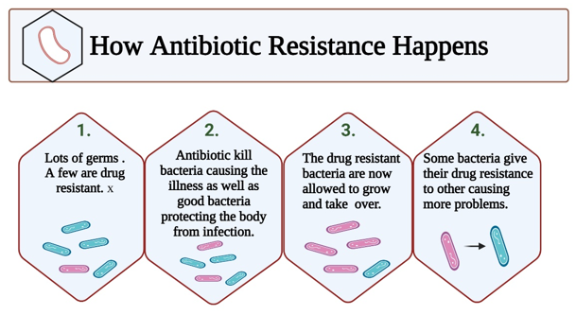
Figure 2: Antibiotic resistance

Major resistant strains
The number of drugs to which a superbug is resistant is referred to as its "degree." Superbugs can raise the risk of morbidity and mortality as well as result in financial loss. Methicillin-resistant Staphylococcus aureus (MRSA), multidrug-resistant Pseudomonas aeruginosa, carbapenam-resistant Enterobacteriaceae, ESBL-producing Enterobacteriacea, Vancomycin-resistant Enterococcus, EcoliHx30, and other major organisms exhibit antibiotic resistance superbugs in hospital settings.

According to a list published by WHO several types of bacteria are rapidly developing resistance to antibiotics and these bacteria have been categorized into three priority groups including Acinetobacter baumannii (carbapenem resistant), Pseudomonas aeruginosa (carbapenem resistant), Enterobacteriaceae (carbapenem resistant), and Extended‐spectrum beta‐lactamases producing bacteria as priority 1 pathogens; Neisseria gonorrhoeae (cephalosporin and fluoroquinolone resistant), Enterococcus faecium (vancomycin resistant), nontyphoidal Salmonella (fluoroquinolones resistant), Staphylococcus aureus (methicillin and vancomycin resistant), Helicobacter pylori (clarithromycin resistant), and Campylobacter spp. (fluoroquinolone resistant) as priority 2 pathogens; and Haemophilus influenzae (ampicillin resistant), Shigella species (fluoroquinolones resistant) and Streptococcus pneumoniae (penicillin resistant) as priority 3 pathogens (https://www.who.int/en/news-room/detail/27-02-2017-who-publishes-list-of-bacteria-for-which-new-antibiotics-are-urgently-needed;2022). Along with them, Klebsiella pneumoniae (carbapenems and cephalosporin resistant), Escherichia coli (fluoroquinolones and cephalosporin resistant), and Mycobacterium tuberculosis (fluoroquinolone, rifampicin, and isoniazid resistant), showed the highest resistant rates.
Early signs of resistance
One of the things that is making antimicrobial treatment more challenging every day is the emergence of antibiotic resistance. It has already been identified as a global public health risk by numerous organizations, such as the World Health Organization (WHO), the Centers for Disease Control and Prevention (CDC), the Infectious Diseases Society of America, and the World Economic Forum (Frieden 2013; World Health Organization 2014; Dellit 2007; Global Risks 2013; Michael et al. 2014; Spellberg et al. 2016). A tiny percentage of bacteria acquire the capacity to thwart the effects of a newly created and commonly used antibacterial agent by a variety of resistance mechanisms, including restricting uptake, altering the drug target, inactivation, and active efflux.(Reygaert 2018; Dever and Dermody 1991).
The most versatile form of bacteria is this one. By opposing that impact, they develop resistance genes or genetic alterations. The genetically altered bacteria then proliferate the antibiotic-resistant bacteria. Newly cultivated resistant bacteria have the ability to spread their resistance gene to other bacterial species. The creation of novel bacterial strains that are resistant to the effects of current antibiotics is known as conjugation. These deadly and infectious organisms are frequently referred to as superbugs or multidrug-resistant (MDR) bacteria. Because superbugs occupy such interconnected niches, they cause resistant infections to arise in the human, animal, and environmental domains (Reygaert 2018; Dever and Dermody 1991). Morbidity and fatality rates, as well as treatment expenses, are elevated due to the restricted therapeutic choices against superbugs (Aslam et al. 2018; Spellberg and Gilbert 2014; Rossolini et al. 2014; Sengupta et al. 2013). Bacteria that are resistant to antibiotics are raising death rates and straining the world economy.

Mechanisms of Antimicrobial Resistance

Antimicrobial overuse or extended administration created selection pressure that encouraged the emergence of resistant strains, which in turn led to the spread of those strains across the environment. The formation of strains resistant to both the same antibiotics and other related antibiotics has been facilitated by the prolonged administration of a single antibiotic (Levy and Miller, 1989). The existence of mobile genetic elements such as bacteriophages, plasmids, bare DNA, transposons, etc. causes resistance traits to spread across various ecological and taxonomical groupings. (Levy 1985, 2002). The synthesis of hydrolyzing enzymes, such as βlactam hydrolysis by various types of βlactamases, is one of the primary mechanisms of resistance to numerous antibiotics in Acinetobacter spp. and other superbugs.
(Class A to D β-lactamases), (ii) modifications to penicillin-
binding proteins (PBPs) that block the action of β-lactams; (iii) changes in the number and structure of porin proteins that cause the bacterial cell's outer membrane to be less permeable to antibiotics; and (iv) the activity of efflux pumps that further reduce the concentration of antibiotics inside the bacterial cell (Livermore and Woodford, 2006). Through the mutation of
target sites, they are resistant to the effects of fluoroquinolones, and they are resistant to aminoglycosides due to bacterial enzyme alteration.
[Peleg and Hooper 2010, Padhy et al., 2016]. Antibiotic resistance is exhibited by MDR, XTR, and TDR TB bacteria through spontaneous mutation in several genes (Kunz and Brook, 2010). The r RNA alteration that causes macrolides and related antibiotics to bind to ribosomes is primarily responsible for resistance to these drugs. (Palomino and Martin, 2014).

Various steps for mechanism of action of antibiotic resistance are shown in figure 3 (Gaetano, et al., 2023)
1. drug inactivation by enzymes
2. drug target modification
3. plasmid-carrying genes conferring antibiotic resistance
4. Changes in drug permeability following cell wall and
cell membrane modification
5. Expression of efflux pumps that expel drugs outside.

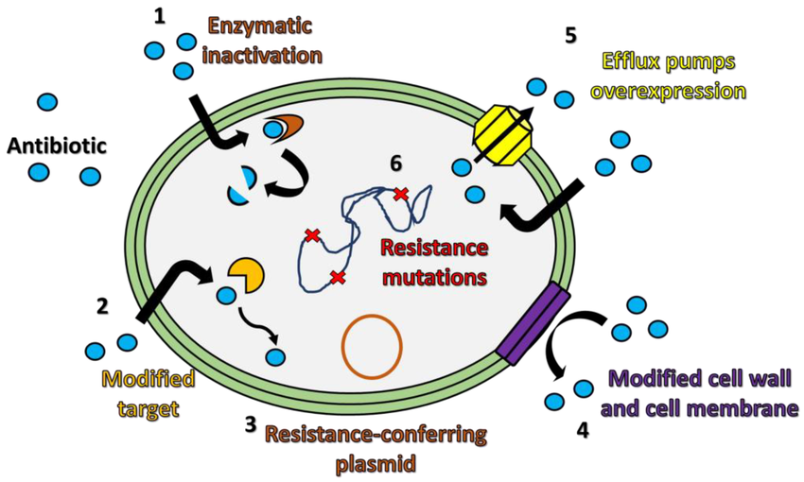
Figure 3: Mechanism of Antibiotic resistance

Symptoms of Antibiotics Resistance

A bacterial infection can affect almost any system of the body and cause symptoms such as (Rajendran, 2022):
• Fever.
• Chills.
• Night sweats.
• Pain.
• Fatigue.
• Headache.
• Skin flushing or soreness.
• Nausea.
• Vomiting.
• Diarrhoea.
• Belly pain.

Prevention (Ishan Thakar and Khushbu Patel, 2025)

Rational use of antibiotics
A major worldwide issue is the irrational use of medications. Less than 40% of patients in the public sector and less than 30% of patients in the private sector receive primary care in developing nations in compliance with established treatment guidelines. This requires professional and public education regarding the prudent use of antibiotics.

Over-The-Counter (OTC) antibiotics
Antimicrobial efficacy preservation measures are primarily aimed at hospitals, pharmaceutical companies, and non-prescription antibiotic use. In a thorough analysis of the use of over-the-counter antibiotics.

Guidelines for use of antibiotics at local levels
Regarding the usage of antibiotics in everyday circumstances, Bhagwati talked about how an empirical antibiotic therapy should be initiated taking into account the patient's clinical state as well as the common infection and resistance pattern in the area. Depending on the microbe's sensitivity, the antibiotic must be changed appropriately. Therefore, antibiotic guidelines are essential for optimizing the choice of antibiotics in terms of dosage, mode of administration, and length of treatment.

Standards of hygiene
Hand washing and the use of alcohol-based hand massages have been shown to be effective in preventing infections. This element may limit the transmission of infection and, consequently, AMR. The requirement of the hour is a willingness to tolerate high standards of hygiene.

Other approaches: These include identifying residents who have MDR illnesses, managing them with a regular treatment regimen, immunization, infection control techniques, and prohibiting the over-the-counter sale of antibiotics.

Infection prevention and control within health-care facilities
The goal of infection prevention and control strategies is to lessen the transmission of infections, including resistant ones, both inside and outside of healthcare facilities.
This can stop the spread of AMR and other illnesses.

Recommended measures to prevent and control infection in a health-care facility
• Establishing an Infection prevention and control committee (IPC).
• Good hand hygiene practices.
• Effective diagnosis and treatment of infection.
• Rational antimicrobial use.
• Surveillance of antibiotic resistance and antibiotic use.
• Improving the antimicrobial quality and supply chain.
• Good Microbiology Practices.

Treatment Strategies against Critical Superbugs
Antimicrobial polymeric biomaterials products, combinatorial pharmacological techniques, bio-nanotechnology approaches, and many more are used in the recent advancements in the treatment of antimicrobial resistance. Table 1 summarizes the most successful treatment approaches currently used to combat a variety of serious superbugs, including methicillin-resistant S. aureus (MRSA), carbapenem-resistant Enterobacteriaceae (CRE), vancomycin-resistant Enterococcus (VRE), multidrug-resistant P. aeruginosa (MRPA), and multidrug-resistant E. coli (MREC), along with their likely mechanisms.

Table 1
Current treatment strategies against major superbugs
Superbug | Mechanism of resistance | Drug of choice | Mechanism of drug action
Methicillin-resistant Staphylococcus aureus (MRSA) | Production of Penicillin-Binding Protein (PBP2a) | Vancomycin | Inhibits cell wall synthesis by binding to the D-Ala-D-Ala terminal of the growing peptide chain (Dharmaratne et al., 2018)
Carbapenem-resistant Enterobacteriaceae (CRE) | β-Lactamase activity and production of carbapenemases | Polymyxin, Tigecycline, and Aminoglycosides | Disrupt the membrane by binding to lipopolysaccharide. Inhibition of protein synthesis (Rohatgi and Gupta, 2021)
Vancomycin-resistant Enterococcus (VRE) | Production of low-affinity pentapeptide precursor of cell wall | Daptomycin | Disrupting the membrane potential (Baptista et al.  , 2018)
Multidrug-resistant Pseudomonas aeruginosa | Genetic alterations | Ceftazidime–avibactam and Ceftolozane–tazobactam | Inhibits penicillin-binding proteins and also inhibits many serine β-lactamases. Inhibition of cell wall biosynthesis (Gabrielyan et al., 2019)
Multidrug-resistant Escherichia coli | Presence of resistance genes | Mecillinam | Inhibits penicillin-binding protein 2 (Eraikhuemen et al., 2021)

Current Challenges and Future Directions

The overuse and misuse of antibiotics, poor infection control, a lack of new drug research, and gaps in global surveillance are some of the current issues with superbugs. Antibiotic misuse and misprescription lead to the emergence of superbugs, making conventional treatments in critical care ineffective. AMR in critical care results in higher expenses, longer hospital stays, and fewer alternatives for therapy. A multimodal strategy is needed to combat AMR, involving strict infection control procedures, research and development of new antibiotics and alternative treatments, and antibiotic stewardship. Effective methods depend on stakeholder participation and public education. Improving antibiotic stewardship, bolstering infection prevention, creating novel antibiotics and alternative treatments, and boosting international cooperation and surveillance are all future directions. A paradigm change toward antibiotic stewardship, antimicrobial innovation, and infection control is essential for future success. Legislation and antimicrobial stewardship (AMS) initiatives must be put into action. There are still unanswered questions about how the environment affects AMR. Future directions include improved drug combinations, quicker diagnostics, and new families of antibiotics. In research, surveillance, and policy formation, international cooperation is crucial. (Bipin Puri et al., 2025)

Conclusion
One of the most pressing global health issues of the twenty-first century is superbugs, which are germs that have become resistant to several antibiotic drugs. The interchange of resistance genes across many biological niches, inadequate infection-control methods, incorrect antibiotic use, and restricted drug development are the main causes of the fast establishment and spread of antimicrobial resistance (AMR). Superbugs increase morbidity and mortality, represent a danger to the efficacy of current treatments, and cause significant socioeconomic burdens globally, as this review makes clear.
A coordinated, multidimensional approach is needed to address this situation. To reduce the emergence of resistance, it is crucial to strengthen antimicrobial stewardship, improve diagnostics, improve surveillance systems, and make sure that stringent infection-prevention procedures are followed. However, new antimicrobial compounds, phage treatment, immunomodulators, antimicrobial peptides, and microbiome-based interventions are promising ways to overcome present therapeutic constraints. To speed up research and guarantee fair access to innovative therapies, international cooperation between scientists, physicians, legislators, and the pharmaceutical sector is essential.
Ultimately, public awareness, interdisciplinary action, and persistent dedication are necessary to defeat superbugs. These steps can protect public health for future generations and maintain the effectiveness of antimicrobial medications if they are carried out successfully.

References
- Aslam B, Wang W, Arshad MI et al (2018) Antibiotic resistance: a rundown of a global crisis. Infect Drug Resist 11:1645. https://doi.org/10.2147/IDR.S173867
- Baptista PV, McCusker MP, Carvalho A, Ferreira DA, Mohan NM, Martins M, Fernandes AR. Nano-strategies to fight multidrug resistant bacteria—“A Battle of the Titans”. Front Microbiol. 2018;9:1441. doi: 10.3389/fmicb.2018.01441. [DOI] [PMC free article] [PubMed] [Google Scholar]
- Bipin Puri 1, Raju Vaishya 2, Abhishek Vaish (2025). Antimicrobial resistance: Current challenges and future directions. Med J Armed Forces India, 81(3):247-258. doi: 10.1016/j.mjafi.2024.07.006. Epub 2024 Sep 19.
- De Gaetano GV, Lentini G, Fama A, et al. Antimicrobial resistance: two-component regulatory systems and multidrug efflux pumps. Antibiotics. 2023;12:965.
- Dellit TH (2007) Infectious diseases society of america and the society for healthcare epidemiology of america guidelines for developing an institutional program to enhance antimicrobial stewardship. Infect Dis Clin Pract 15:263–264. https://doi.org/10.1097/IPC.0b013e318068b1c0
- Dever LA, Dermody TS (1991) Mechanisms of bacterial resistance to antibiotics. Arch Intern Med 151:886–895. https://doi.org/10.1001/archinte.1991.00400050040010
- Dharmaratne MP, Manoraj A, Thevanesam V, Ekanayake A, Kumar NS, Liyanapathirana V, Abeyratne E, Bandara BR. Terminalia bellirica fruit extracts: in-vitro antibacterial activity against selected multidrug-resistant bacteria, radical scavenging activity and cytotoxicity study on BHK-21 cells. BMC Complement Altern Med. 2018;18(1):1–2. doi: 10.1186/s12906-018-2382-7. [DOI] [PMC free article] [PubMed] [Google Scholar]

Dilip Chandrasekhar d, ChristyMary Joseph, JafferChalil parambil , Sarath Mural, Mohammed Yahiya, Shafeera K (2024). Superbugs: An invicible threat in post antibiotic era. Clinical Epidemiology and Global Health, 28, 101499
- Eraikhuemen N, Julien D, Kelly A, Lindsay T, Lazaridis D. Treatment of community-acquired pneumonia: a focus on lefamulin. Infect Dis Ther. 2021 doi: 10.1007/s40121-020-00378-3. [DOI] [PMC free article] [PubMed] [Google Scholar]
- Frieden T (2013) Antibiotic resistance threats in the United States. Centers Dis Control Prev, 114.
- Gabrielyan L, Hakobyan L, Hovhannisyan A, Trchounian A. Effects of iron oxide (Fe3O4) nanoparticles on Escherichia coli antibiotic-resistant strains. J Appl Microbiol. 2019;126(4):1108–1116. doi: 10.1111/jam.14214. [DOI] [PubMed] [Google Scholar]
- Global Risks (2013) Global Risks 2013 Eighth Edition an initiative of the risk response network insight report.
- Health Sci Rep, 6(8):1480. doi: 10.1002/hsr2.1480.
- https://my.clevelandclinic.org/health/diseases/superbug
- https://www.who.int/en/news-room/detail/27-02-2017-who-publishes-list-of-bacteria-for-which-new-antibiotics-are-urgently-needed
- Ishan Thakar and Khushbu Patel (2025). Superbugs: Understanding the mechanisms and consequences of antibiotic resistance. IJPPS; 7(1): 45-49. DOI: https://doi.org/10.33545/26647222.2025.v7.i1a.150
- Kardos N, Demain A. Penicillin: the medicine with the greatest impact on therapeutic outcomes. Appl Microbiol Biotechnol. 2011;92(4):677-87. [Google Scholar]
- Kunz AN, Brook I. Emerging resistant Gram-negative aerobic bacilli in hospital-acquired infections. Chemotherapy. 2010;56:492-500.
- Levy SB, Miller RV. Gene Transfer in the Environment. McGraw Hill, New York; c1989.
- Levy SB. Ecology of plasmids and unique DNA sequences. In: Halvorson HO, Pramer D, Rogul M, editors. Engineered Organisms in the Environment: Scientific Issues. Washington DC: ASM Press; c1985. p. 180-90.
- Levy SB. The Antibiotic Paradox: How Misuse of Antibiotics Destroys Their Curative Powers. Perseus, Cambridge; c2002.
- Livermore DM, Woodford N. The β-lactamase threat in Enterobacteriaceae, Pseudomonas and Acinetobacter. Trends Microbiol. 2006;14(9):413-420.
- Magiorakos A, Srinivasan A, Carey R, Carmeli Y, Falagas M, Giske C. Multidrug-resistant, extensively drug-resistant and pandrug-resistant bacteria: an international expert proposal for interim standard definitions for acquired resistance. Clin Microbiol Infec. 2012;18(3):268-81. [Google Scholar]
- Medina E, Pieper D. Tackling Threats and Future Problems of Multidrug-Resistant Bacteria. Curr Top Microbiol Immunol. 2016;398:3-33. [Google Scholar]
- Michael CA, Dominey-Howes D, Labbate M (2014) The antimicrobial resistance crisis: causes, consequences, and management. Front Public Health. https://doi.org/10.3389/fpubh.2014.00145
- Padhy A, Sahu AR, Ranabijuli S, Ganguly S. Superbug, an emerging global threat in current scenario: A review. Int J Res Stud Microbiol Biotechnol. 2016;2(2):15-19.
- Palomino JC, Martin A. Drug resistance mechanisms in Mycobacterium tuberculosis. Antibiotics. 2014;3:317-340.
- Peleg AY, Hooper DC. Hospital-acquired infections due to gram-negative bacteria. N Engl J Med. 2010;362(19):1804-1813.
- Rajendran R. Superbug information. World J Pharm Res. 2022;7(6):275-287.
- Reygaert WC (2018) An overview of the antimicrobial resistance mechanisms of bacteria. AIMS Microbiol 4:482–501. https://doi.org/10.3934/MICROBIOL.2018.3.482
- Rohatgi A, Gupta P. Natural and synthetic plant compounds as anti-biofilm agents against Escherichia coli O157: H7 biofilm. Infect Genet Evol. 2021;95:105055. doi: 10.1016/j.meegid.2021.105055. [DOI] [PubMed] [Google Scholar]
- Rossolini GM, Arena F, Pecile P, Pollini S (2014) Update on the antibiotic resistance crisis. Curr Opin Pharmacol 18:56–60. https://doi.org/10.1016/J.COPH.2014.09.006
- Sakshi Painuli, Prabhakar Semwal, Rohit Sharma, Shopnil Akash (2023). Superbugs or multidrug resistant microbes: A new threat to the society.
- Sengupta S, Chattopadhyay MK, Grossart HP (2013) The multifaceted roles of antibiotics and antibiotic resistance in nature. Front Microbiol. https://doi.org/10.3389/FMICB.2013.00047
- Spellberg B, Gilbert DN (2014) The future of antibiotics and resistance: a tribute to a career of leadership by John Bartlett. Clin Infect Dis 59:S71. https://doi.org/10.1093/CID/CIU392
- Spellberg B, Srinivasan A, Chambers HF (2016) New societal approaches to empowering antibiotic stewardship. JAMA J Am Med Assoc 315:1229–1230
- Wise R, Hart T, Cars O, Streulens M, Helmuth R, Huovinen P. Antimicrobial resistance. BMJ. 1998;317(7159):609-10. [Google Scholar]
- World Health Organization (2014) Antimicrobial resistance: global report on surveillance. http://www.who.int/drugresistance/documents/surveillancereport/en/
- Wright G. Resisting resistance: Resisting resistance: new chemical strategies for battling superbugschemical strategies for battling superbugs. Chem Biol. 2000;7(6):127-32. [Google Scholar]

