Evaluating the Screening Efficiency and Assessment of Non-Communicable Disease Risk Factors Among Clients Attending Healthy Lifestyle Clinics in the Colombo District

Abstract
Background: Non-communicable diseases (NCDs) present a critical global healthcare crisis, accounting for 74% of all annual deaths worldwide, with a disproportionate 86% of premature fatalities occurring in low- and middle-income countries (LMICs). In Sri Lanka, an accelerated epidemiological transition driven by rapid urbanization and a rapidly aging population has positioned NCDs as the leading public health challenge, responsible for an estimated 83% of annual deaths. Cardiovascular diseases alone dictate 34% of national mortality. In response, the Ministry of Health operationalized Healthy Lifestyle Clinics (HLCs) within the primary healthcare network to target individuals aged 35 and older. This strategy aims to shift the medical paradigm from expensive, tertiary-level curative interventions to localized, community-based risk modification. This study evaluates the screening performance, risk patterns, and institutional variances across 11 frontline centers in the Colombo Regional Health Services (RDHS) area during the 2024 screening period.
Methods: This evaluation utilized a mixed-methods, cross-sectional descriptive design. Quantitative data were retrospectively extracted from the formal 2024 HLC Annual Review Data across 11 selected facilities, consisting of two secondary care centers (District General Hospital Avissawella and Base Hospital Homagama) and nine primary care Divisional Hospitals (DH
Wethara, DH Piliyandala, DH Thalangama, DH Nawagamuwa, DH Padukka, DH Moratuwa, DH Maligawatta, DH Kosgama, and DH Athurugiriya). The study population encompassed all 17,212 eligible clients screened during the calendar year. Qualitative data were gathered via a systematic desk review of institutional documents (monthly returns and clinic logs) alongside semi-structured Key Informant Interviews (KIIs) with institutional stakeholders, Medical Officers, and Public Health Nursing Officers to contextualize administrative challenges and data recording fidelity.
Results: A total of 17,212 clients were screened across the region. Primary care centers bore the vast majority of the preventative volume, led by DH Moratuwa (20.80%) and DH Kosgama (14.05%). Conversely, specialized secondary care centers demonstrated very low preventative outreach; DGH Avissawella contributed only 2.25% of total regional screenings, acting primarily as an overburdened curative centre.
Tobacco smoking prevalence was highest in high-density urban or industrial zones, led by DH Moratuwa at 19.08% . Culturally embedded betel chewing showed strong clustering in agricultural or semi-urban cohorts, peaking proportionately at DGH Avissawella (21.65%) and DH Nawagamuwa (18.97%). Harmful alcohol consumption emerged as a widespread behavioral threat, with the highest relative density documented at DH Maligawatta (27.09%).
Elevated blood pressure represented an immense physiological burden, heavily concentrated at DH Kosgama where 32.34% () of the screened cohort presented with high blood pressure. Institutional obesity rates peaked at DH Wethara (18.65%) and DH Maligawatta (16.58%), reflecting an ongoing urban nutritional transition.
The evaluation exposed a critical operational vulnerability in diabetes tracking. While BH Homagama reported a realistic high FBS rate of 7.23%, high-volume clinics like DH Moratuwa reported an epidemiologically impossible rate of 0.34%, and DH Kosgama reported 0.00% across 2,418 clients. Qualitative triangulation revealed this gap was driven by frequent glucometer strip shortages and drop-outs among non-fasting walk-in clients requested to return a subsequent morning, leading to blank fields erroneously aggregated as zero cases.
Conclusion: While the HLC framework succeeds in shifting medical focus toward community-based screening, its execution remains highly uneven across the Colombo district. High-volume primary care centers effectively mobilize the community but are highly vulnerable to supply-chain disruptions and diagnostic recording failures. Secondary centers possess stable diagnostics but fail to establish proactive preventative outreach.
Keywords: Non communicable diseases, Healthy Lifestyle clinics, Screening efficiency, Primary healthcare, Obesity, Hypertension.

Introduction
Non-communicable diseases (NCDs)—primarily cardiovascular diseases, cancers, chronic respiratory diseases, and diabetes—have transitioned from a health challenge of the affluent to a defining global pandemic of the 21st century. According to the World Health Organization (WHO) and the Global Burden of Disease (GBD) studies, NCDs are collectively responsible for approximately 74% of all deaths worldwide, translating to over 41 million fatalities annually.
While historically associated with high-income countries, the epidemiological landscape has shifted dramatically. Today, over three-quarters (86%) of all premature NCD deaths (occurring between the ages of 30 and 70 years) happen in low- and middle-income countries (LMICs). In these resource-constrained settings, NCDs create a double burden alongside infectious diseases, rapidly overwhelming fragile primary healthcare infrastructure and driving households into poverty due to catastrophic out-of-pocket health expenditures. Recognizing this crisis, the United Nations established Sustainable Development Goal (SDG) Target 3.4, which aims to reduce premature mortality from NCDs by one-third by 2030 through prevention and treatment.
The global rise of NCDs is not random; it is driven by an intersection of socioeconomic determinants, rapid urbanization, population aging, and a specific set of shared, preventable risk factors. Epidemiologically, these are categorized into Behavioral (Modifiable) Risk Factors and Metabolic (Physiological) Risk Factors. Behavioral risks drive the physiological alterations that ultimately manifest as chronic disease.

Modifiable Behavioral Risk Factors
These represent individual habits and culturally embedded lifestyles that directly accelerate tissue damage and metabolic decline:
- Tobacco Use: Tobacco remains the leading cause of preventable death globally, accounting for over 8 million deaths annually (including second-hand smoke exposure). Nicotine and associated toxins induce systemic endothelial dysfunction, atherosclerosis, and cellular mutations that lead to malignant neoplasms.
- Harmful Alcohol Consumption: Excessive alcohol intake contributes to multi-system pathology, acting as a major risk factor for cardiovascular disease, hepatic cirrhosis, and several forms of cancer.
- Unhealthy Diet: The global nutritional transition away from high-fiber, whole foods toward ultra-processed foods, saturated fats, refined sugars, and high-sodium diets is a critical vector for disease. Excessive salt intake is direct fuel for global hypertension, while high-calorie, nutrient-poor diets drive metabolic storage failures.
- Physical Inactivity: Sedentary lifestyles driven by urbanization, mechanized transport, and desk-based occupations significantly diminish insulin sensitivity, slow lipid metabolism, and increase systemic inflammation.
B. Metabolic (Physiological) Risk Factors
When behavioral risks persist over time, they lead to quantifiable metabolic alterations. These serve as the clinical parameters measured by frontline screening programs to intercept full-blown NCD development:
- Raised Blood Pressure (Hypertension): According to GBD data, high systolic blood pressure is the leading risk factor for age-standardized Disability-Adjusted Life Years (DALYs) globally. It is the silent precursor to ischemic heart disease, cerebrovascular accidents (strokes), and chronic kidney disease.
- Overweight and Obesity: Measured primarily through Body Mass Index (BMI) and waist circumference, obesity has seen the sharpest increase among global risks over the last three decades.
- Elevated Fasting Blood Glucose: Reflective of the global type 2 diabetes epidemic, impaired fasting glucose and insulin resistance cause microvascular and macrovascular destruction, leading to blindness, limb amputations, and cardiovascular death.
- Dyslipidemia: Abnormal circulating lipid profiles (high LDL cholesterol and triglycerides) directly cause the arterial plaque deposition responsible for coronary artery disease.

The Burden of Non-Communicable Diseases (NCDs) in Sri Lanka
Sri Lanka presents a unique health profile within South Asia, often celebrated for achieving advanced health indicators—such as low maternal and infant mortality rates and a high life expectancy—despite low healthcare spending. However, this success, paired with a rapidly aging population and swift urbanization, has triggered an acute epidemiological transition. Today, Non-Communicable Diseases (NCDs) are the leading public health challenge in Sri Lanka, accounting for an estimated 83% of all annual deaths. The mortality and morbidity landscape is heavily dominated by four major chronic conditions:
- Cardiovascular Diseases (CVD): The single largest contributor, responsible for roughly 34% of national mortality, with ischemic heart disease and cerebrovascular accidents (strokes) topping hospital death registries.
- Neoplasms (Cancers): Accountable for approximately 14% of annual deaths.
- Diabetes Mellitus: Directly causing 9% of deaths, alongside a growing burden of microvascular and macrovascular complications.
- Chronic Respiratory Diseases: Contributing to 8% of deaths.
Furthermore, complications arising from poorly managed diabetes and hypertension have fueled an epidemic of Chronic Kidney Disease (CKD), which affects an estimated 10% of the population aged 20 and older, heavily straining tertiary healthcare resources.

The Socio-Behavioral and Metabolic Risk Factor Profile
Data from national population-based surveillance, including the World Health Organization (WHO) STEPS surveys, reveals a high and deeply gendered prevalence of NCD risk factors across the island. These risks are divided into modifiable behaviors and the physiological changes they trigger:

Frontline Operational Strategy: Healthy Lifestyle Clinics (HLCs)
In response to this mounting crisis, the Ministry of Health developed the National Multisectoral Action Plan for the Prevention and Control of NCDs. A core mechanism of this policy was the introduction of Healthy Lifestyle Clinics (HLCs) across the primary care network.
Targeting individuals aged 35 and older, HLCs function as a community defense system designed to intercept chronic disease early. They systematically screen asymptomatic citizens for behavioral risks (such as smoking and betel chewing) and metabolic risk markers (such as obesity, high blood pressure, and elevated blood sugar). By shifting the care model from high-cost, tertiary curative interventions to localized, primary-level risk modification, HLCs aim to curb premature mortality. This case study evaluates the specific screening realities and institutional variances across 11 such centers within the Colombo RDHS area.
Because these risk factors are largely modifiable, the World Health Organization advocates for population-level screening and early behavioral interventions. In Sri Lanka, this strategy is operationalized through the primary healthcare network via Healthy Lifestyle Clinics (HLCs). Set up in primary health care institutions, these clinics serve as the frontline defense mechanism. They screen eligible adult populations for asymptomatic metabolic alterations (such as hypertension and obesity) and behavioral risks (tobacco and alcohol use), shifting the health system focus from expensive, tertiary-level curative care to community-based preventive medicine. This case study evaluates the institutional screening outcomes across 11 health care centers in the Colombo RDHS area to identify regional risk factor variations and system delivery challenges.

General Objective:
To evaluate the screening performance and patterns of non-communicable disease risk factors among clients attending Healthy Lifestyle Clinics across primary healthcare institutions within the Colombo Regional Health Services area in 2024.

Specific objectives
- To determine the prevalence of modifiable behavioral risk factors among eligible clients attending Healthy Lifestyle Clinics.
- To estimate the prevalence of metabolic risk markers among the screened population across the selected clinics.
- To compare the patterns and variations of NCD risk factors across different primary and secondary care frontline facilities (District General Hospital, Base Hospital, and individual Divisional Hospitals) within the region.
- To evaluate the screening performance and data completeness of clinical markers—with a specific focus on fasting blood sugar monitoring and potential diagnostic gaps—across the participating institutions.
- To provide evidence-based recommendations for healthcare administrators to optimize risk-targeted resource allocation and strengthen the service delivery of HLCs in the Colombo district.

Methodology
Study Design
This study utilized a mixed-methods, cross-sectional descriptive design to evaluate the screening performance and patterns of non-communicable disease (NCD) risk factors. The study combined quantitative and qualitative methodologies:
- Quantitative Component: A retrospective secondary data review of routine Healthy Lifestyle Clinic (HLC) screening registries.
- Qualitative Component: A desk review of institutional institutional documents alongside key informant interviews (KIIs) to contextualize screening performance, administrative challenges, and systemic variations.

Study Setting
The study was conducted within the administrative boundary of the Regional Department of Health Services (RDHS) Colombo. The evaluation focused on 11 healthcare institutions implementing HLC services, representing different tiers of the public healthcare delivery system:
Secondary Care Centers: District General Hospital (DGH) Avissawella and Base Hospital (BH) Homagama.
Primary Care Centers: Nine Divisional Hospitals (DH), including DH Wethara, DH Piliyandala, DH Thalangama, DH Nawagamuwa, DH Padukka, DH Moratuwa, DH Maligawatta, DH Kosgama, and DH Athurugiriya.

Study Population and Unit of Analysis
- For Quantitative Data: The study population consisted of all eligible clients (males and females, primarily aged 35 years and older) who attended and underwent lifestyle screening at the selected 11 HLC clinics between January 1, 2024, and December 31, 2024.
- For Qualitative Data: The study population comprised institutional stakeholders, healthcare administrators, and frontline clinical staff directly involved in managing or executing HLC screening routines.
Data Collection Methods and Tools
Secondary Quantitative Data Review
Quantitative data was extracted retrospectively from the formal HLC Annual Review Data (2024) of each institution. A standardized data extraction sheet was developed to capture aggregate institutional metrics. The primary variables extracted included:
- Denominator Asset: Total number of eligible clients registered/screened.
- Behavioral Risk Markers: Frequency of tobacco smoking, harmful alcohol consumption, and betel chewing.
- Metabolic Risk Markers: Frequency of elevated blood pressure, obesity (BMI more than 30), and elevated Fasting Blood Glucose (FBS more than 126mg/dl).
Document Review
A systematic desk review of institutional documents was carried out at each facility. Documents reviewed included:
- Institutional HLC monthly returns sent to the RDHS.
- Clinic attendance logs and patient registers.
This review served to verify data consistency, assess record-keeping quality, and cross-reference clinical gaps noted in the raw data.
Key Informant Interviews (KIIs)
To understand the factors influencing screening performance and the structural variations behind the data, qualitative insights were gathered via Key Informant Interviews.
- Participants: Purposive sampling was used to select key informants, including Medical Officers of Health (MOH), Medical Officers in charge of NCD clinics (MO-NCD), institutional Nursing Officers-in-charge, and public health nursing officers.
- Tool: Semi-structured interview guides were utilized, focusing on resource availability, challenges in patient mobilization, diagnostic shortages, data recording fidelity, and institutional best practices.
- Process: Interviews were conducted in a private setting at the respective institutions, lasting approximately 20–30 minutes, and field notes were compiled immediately afterward.

Ethical Considerations
As this study was based on aggregate, routinely collected institutional review data, direct patient contact was avoided, and no personally identifiable information (e.g., patient names, addresses, or identification numbers) was extracted, ensuring strict confidentiality. Formal administrative permission to access registries, document archives, and conduct staff interviews was obtained from the Regional Director of Health Services (RDHS) Colombo and the heads of the respective medical institutions.

Results

Overview of Total Screening and Institutional Contribution
During the 2024 screening period, a total of 17,212 eligible clients were screened across the 11 participating Healthy Lifestyle Clinics in the Colombo RDHS area.

Table 1: Institutional Contribution to Total Regional HLC Screenings
Rank | Institution | Facility Tier | Number of Clients Screened (n) | Percentage of Total Regional Screening (%)
1 | DH Moratuwa | Divisional Hospital | 3,580 | 20.80%
2 | DH Kosgama | Divisional Hospital | 2,418 | 14.05%
3 | DH Wethara | Divisional Hospital | 1,925 | 11.18%
4 | DH Padukka | Divisional Hospital | 1,661 | 9.65%
5 | DH Piliyandala | Divisional Hospital | 1,536 | 8.92%
6 | BH Homagama | Base Hospital | 1,244 | 7.23%
7 | DH Athurugiriya | Divisional Hospital | 725 | 4.21%
8 | DH Nawagamuwa | Divisional Hospital | 643 | 3.74%
9 | DH Maligawatta | Divisional Hospital | 561 | 3.26%
10 | DH Thalangama | Divisional Hospital | 558 | 3.24%
11 | DGH Avissawella | District General Hospital | 388 | 2.25%

Institutional Profiles

Table 2-DGH Avissawella HLC Screening Profile (2024)

Data Summary Matrix
Metric Type | Clinical Parameter | Count (n) | Percentage/Prevalence (%)
Denominator | Total Eligible Clients Screened | 388 | 100%
Metabolic Risk Markers | High Blood Pressure | 81 | 20.88%
 | Obesity | 39 | 10.05%
Behavioral Risk Markers | Alcohol Consumption | 119 | 30.67%
 | Betel Chewing | 84 | 21.65%
 | Tobacco Smoking | 76 | 19.59%

Table 3-Base Hospital Homagama
Metric Type | Clinical Parameter | Count (n) | Percentage/Prevalence (%)
Denominator | Total Eligible Clients Screened | 1,244 | 100%
Metabolic Risk Markers | High Blood Pressure | 242 | 19.45%
 | Obesity | 168 | 13.50%
Behavioral Risk Markers | Alcohol Consumption | 304 | 24.44%
 | Betel Chewing | 112 | 9.00%
 | Tobacco Smoking | 129 | 10.37%

Table 4-DH Wethara
Metric Type | Clinical Parameter | Count (n) | Percentage/Prevalence (%)
Denominator | Total Eligible Clients Screened | 1,925 | 100%
Metabolic Risk Markers | High Blood Pressure | 197 | 10.23%
 | Obesity | 359 | 18.65%
Behavioral Risk Markers | Alcohol Consumption | 249 | 12.94%
 | Betel Chewing | 141 | 7.32%
 | Tobacco Smoking | 84 | 4.36%

Table 5-DH Piliyandala
Type | Clinical Parameter | Count (n) | Percentage/Prevalence (%)
Denominator | Total Eligible Clients Screened | 1,536 | 100%
Metabolic Risk Markers | High Blood Pressure | 238 | 15.49%
 | Obesity | 171 | 11.13%
Behavioral Risk Markers | Alcohol Consumption | 229 | 14.91%
 | Betel Chewing | 120 | 7.81%
 | Tobacco Smoking | 144 | 9.38%

Table 6-DH Thalangama
Metric Type | Clinical Parameter | Count (n) | Percentage/Prevalence (%)
Denominator | Total Eligible Clients Screened | 558 | 100%
Metabolic Risk Markers | High Blood Pressure | 135 | 24.19%
 | Obesity | 42 | 7.53%
Behavioral Risk Markers | Alcohol Consumption | 103 | 18.46%
 | Betel Chewing | 64 | 11.47%
 | Tobacco Smoking | 94 | 16.85%

Table 7-DH Nawagamuwa
Metric Type | Clinical Parameter | Count (n) | Percentage/Prevalence (%)
Denominator | Total Eligible Clients Screened | 643 | 100%
Metabolic Risk Markers | High Blood Pressure | 188 | 29.24%
 | Obesity | 100 | 15.55%
Behavioral Risk Markers | Alcohol Consumption | 126 | 19.60%
 | Betel Chewing | 122 | 18.97%
 | Tobacco Smoking | 93 | 14.46%

Table 8-DH Padukka
Metric Type | Clinical Parameter | Count (n) | Percentage/Prevalence (%)
Denominator | Total Eligible Clients Screened | 1,661 | 100%
Metabolic Risk Markers | High Blood Pressure | 252 | 15.17%
 | Obesity | 198 | 11.92%
Behavioral Risk Markers | Alcohol Consumption | 205 | 12.34%
 | Betel Chewing | 231 | 13.91%
 | Tobacco Smoking | 122 | 7.34%

Table 9-DH Moratuwa
Metric Type | Clinical Parameter | Count (n) | Percentage/Prevalence (%)
Denominator | Total Eligible Clients Screened | 3,580 | 100%
Metabolic Risk Markers | High Blood Pressure | 1,014 | 28.32%
 | Obesity | 515 | 14.39%
Behavioral Risk Markers | Alcohol Consumption | 942 | 26.31%
 | Betel Chewing | 451 | 12.60%
 | Tobacco Smoking | 683 | 19.08%

Table 10-DH Maligawatta
Metric Type | Clinical Parameter | Count (n) | Percentage/Prevalence (%)
Denominator | Total Eligible Clients Screened | 561 | 100%
Metabolic Risk Markers | High Blood Pressure | 168 | 29.95%
 | Obesity | 93 | 16.58%
Behavioral Risk Markers | Alcohol Consumption | 152 | 27.09%
 | Betel Chewing | 59 | 10.52%
 | Tobacco Smoking | 66 | 11.76%

Table 11-DH Kosgama
Metric Type | Clinical Parameter | Count (n) | Percentage/Prevalence (%)
Denominator | Total Eligible Clients Screened | 2,418 | 100%
Metabolic Risk Markers | High Blood Pressure | 782 | 32.34%
 | Obesity | 394 | 16.29%
Behavioral Risk Markers | Alcohol Consumption | 222 | 9.18%
 | Betel Chewing | 70 | 2.89%
 | Tobacco Smoking | 150 | 6.20%

Table 12-DH Athurugiriya
Metric Type | Clinical Parameter | Count (n) | Percentage/Prevalence (%)
Denominator | Total Eligible Clients Screened | 725 | 100%
Metabolic Risk Markers | High Blood Pressure | 48 | 6.62%
 | Obesity | 87 | 12.00%
Behavioral Risk Markers | Alcohol Consumption | 77 | 10.62%
 | Betel Chewing | 62 | 8.55%
 | Tobacco Smoking | 37 | 5.10%

Graph 1- prevalence of tobacco smoking
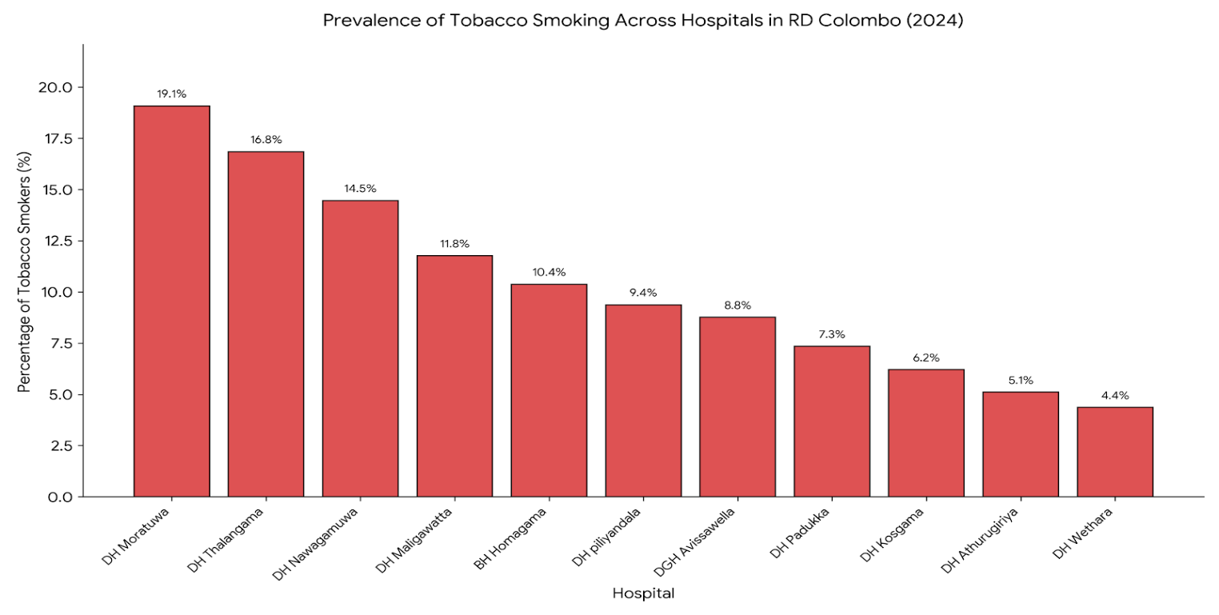
Graph 2- prevalence of betel chewing

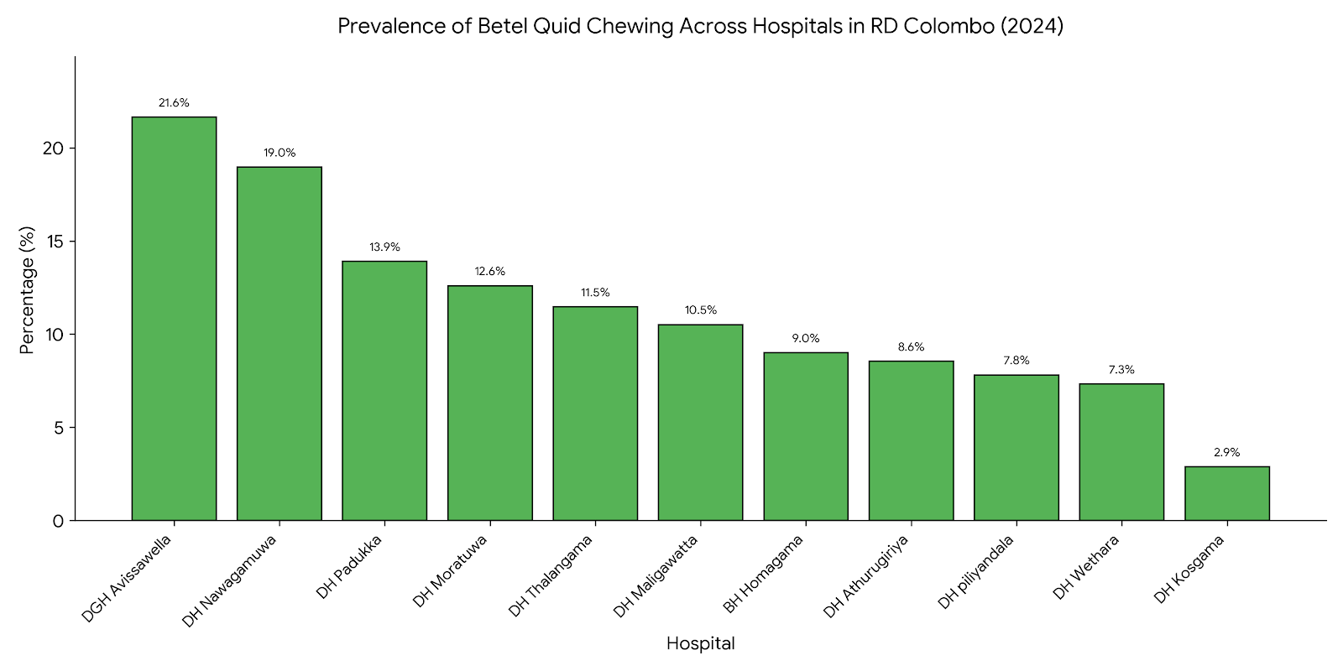

Graph 3- prevalence of alcohol consumption
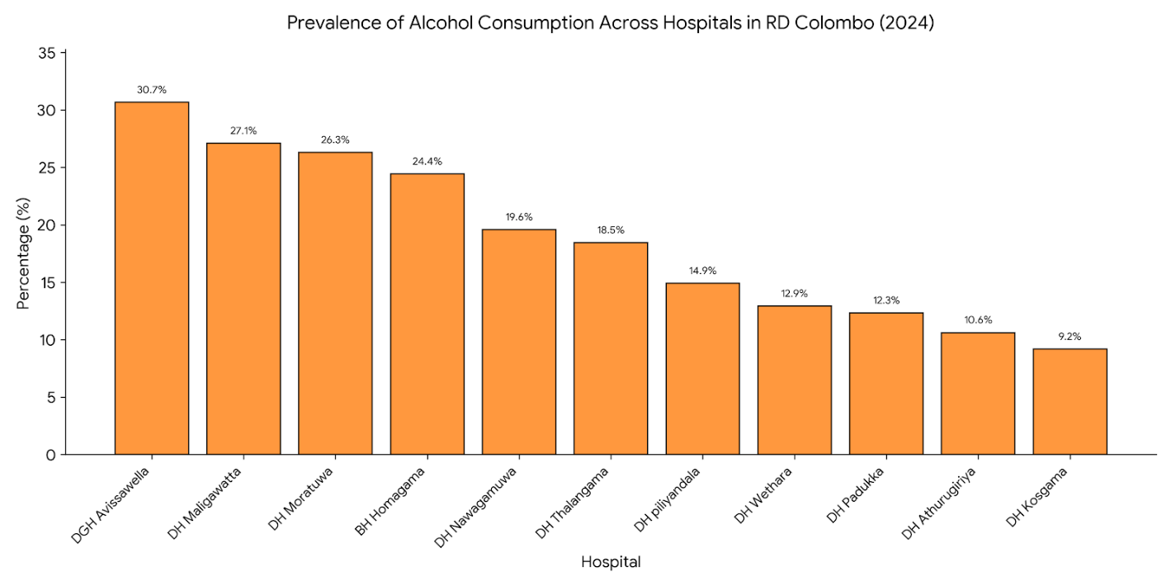

Graph 4- prevalence of obesity
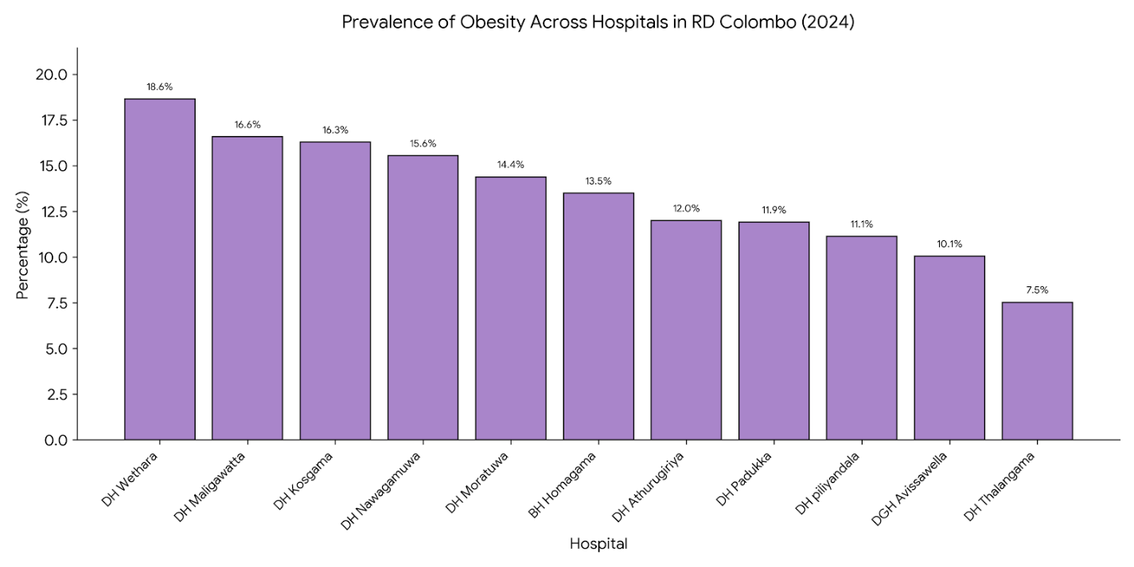

Graph 5 – prevalence of high blood pressure

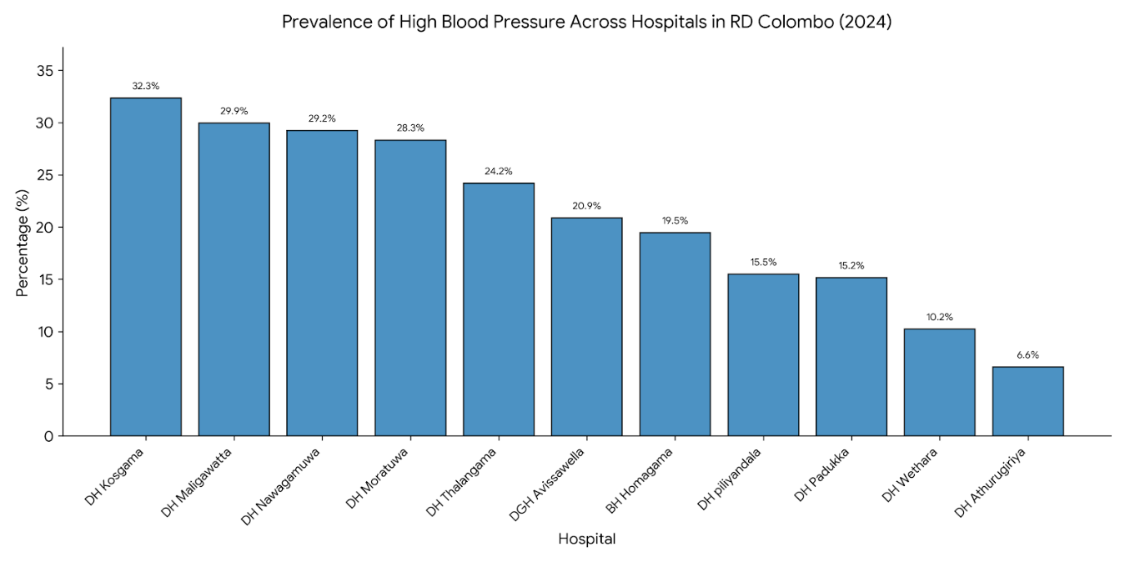

Graph 6 – prevalence of high fasting blood sugar

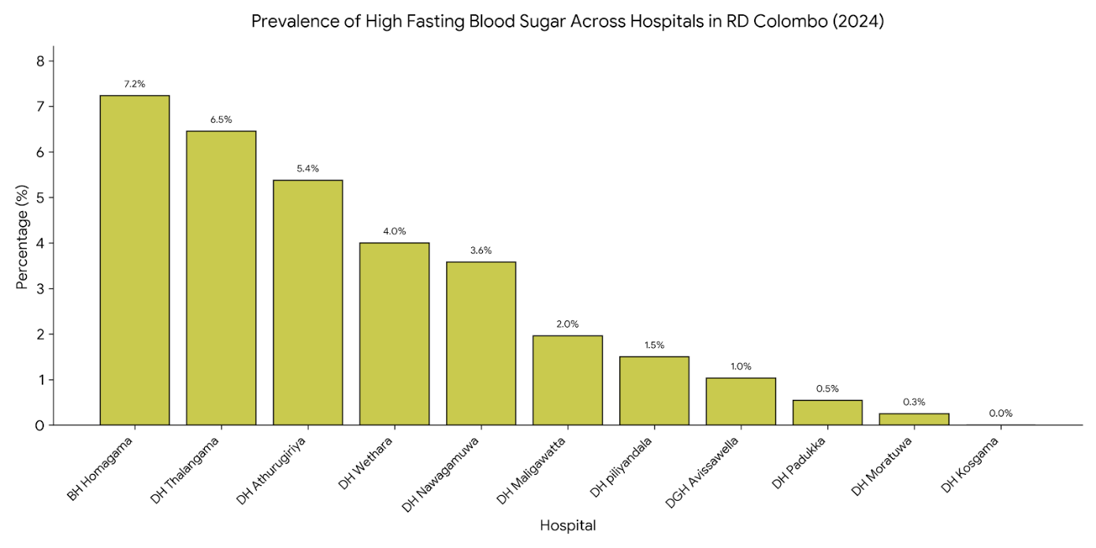

Institutions with the Highest Risk Factor Burden
Risk Factor / Parameter | Highest Absolute Count (n) | Highest Prevalence Rate (%)
Tobacco Smokers | DH Moratuwa (683 cases) | DH Moratuwa (19.08%)
Beetle Chewers | DH Moratuwa (451 cases) | DGH Avissawella (21.65%) (84 out of 388)
Alcohol Users | DH Moratuwa (942 cases) | DH Maligawatta (27.09%) (152 out of 561)
Obesity (BMI >30) | DH Moratuwa (515 cases) | DH Maligawatta (16.58%) (93 out of 561)
High Blood Pressure | DH Moratuwa (1,014 cases) | DH Nawagamuwa (29.24%) (188 out of 643)
High FBS (Fasting Blood Sugar) | BH Homagama (90 cases) | BH Homagama (7.23%) (90 out of 1,244)

Discussion
This study evaluates the screening performance and epidemiological patterns of non-communicable disease (NCD) risk factors across 11 Healthy Lifestyle Clinics (HLCs) in the Colombo district. By contextualizing the quantitative variations alongside systemic realities extracted via document reviews and key informant interviews (KIIs), this chapter aligns directly with the study's specific objectives to provide a comprehensive analysis of the regional primary healthcare delivery framework.
Prevalence and Patterns of Modifiable Behavioral Risk Factors
The first objective of this study was to determine the prevalence and institutional distributions of modifiable behavioral risk factors—specifically tobacco smoking, harmful alcohol consumption, and betel quid chewing—among clients attending the HLCs. Behavioral risks serve as the upstream drivers of physiological alterations, establishing habits that directly accelerate chronic tissue damage and metabolic decline.

Tobacco Smoking
The data revealed a marked disparity in smoking prevalence across the region. DH Moratuwa presented the highest absolute burden with 683 active smokers, followed by DH Kosgama (150 cases) and DH Piliyandala (144 cases). However, examining prevalence percentages demonstrates that tobacco habits are heavily concentrated in specific communities: DH Moratuwa leads with a prevalence of 19.08%, followed closely by secondary care facility DGH Avissawella at 19.59% and DH Thalangama at 16.85%.
From an epidemiological standpoint, these variations reflect the socioeconomic catchments of the respective clinics. DH Moratuwa and DGH Avissawella serve highly dense urban and semi-urban industrial workforces, including coastal fishing communities and plantation/factory laborers. National surveillance data, such as the World Health Organization (WHO) STEPS surveys, consistently verifies that tobacco use in Sri Lanka is heavily segregated by socioeconomic status and gender. The high rates at DH Thalangama (16.85%), an area undergoing rapid urbanization, point toward changing urban lifestyles where smoke-based nicotine dependencies persist despite extensive public health anti-smoking campaigns.
Betel Chewing
Betel chewing remains a deeply culturally embedded lifestyle risk factor across Sri Lanka. In this study, the highest absolute numbers were clustered at DH Moratuwa (451 clients) and DH Padukka (231 clients). Proportionately, however, DGH Avissawella exhibited the highest prevalence at 21.65%, followed by DH Nawagamuwa at 18.97%.
This distinct spatial clustering highlights a sharp contrast between urban centers and agricultural/semi-urban areas. DGH Avissawella sits on the border of the Western Province and serves a substantial population tied to agricultural sectors and estate labor, where betel chewing is traditionally utilized to sustain physical stamina during long working hours. Similarly, DH Nawagamuwa and DH Padukka encompass rural pockets where betel chewing is tied to localized social habits. Key informant interviews highlighted that because betel chewing is socially acceptable and often perceived as a benign traditional habit, clients rarely view it with the same degree of health concern as tobacco smoking, presenting a major hurdle for clinical counseling.

Alcohol Consumption
Alcohol use emerged as a widespread behavioral threat across the district, topping the list of behavioral risk frequencies in several areas. DH Moratuwa recorded a staggering 942 cases, while BH Homagama followed with 304 cases. The highest percentage of alcohol consumption was documented at DGH Avissawella (30.67%), followed by DH Maligawatta (27.09%) and DH Moratuwa (26.31%).
The high prevalence in DH Maligawatta—an inner-city urban settlement in Colombo—corresponds with public health literature linking high-density, low-income urban environments with elevated rates of substance and alcohol use. Key informants noted that chronic alcohol use among these cohorts functions as a maladaptive coping mechanism for economic stress, which directly compounds household poverty due to out-of-pocket spending on alcohol and eventual healthcare needs.
Estimation and Clustering of Metabolic Risk Markers
The second objective targeted the estimation of metabolic risk markers—specifically high blood pressure and obesity—which signify the physiological transition from behavioral habits to established chronic pathologies.

Raised Blood Pressure (Hypertension)
The absolute numbers of detected hypertension cases were remarkably high: DH Moratuwa recorded 1,014 hypertensive individuals, while DH Kosgama registered 782 cases. When evaluating relative density, DH Kosgama presented the highest prevalence rate at 32.34%, with DH Maligawatta (29.95%) and DH Nawagamuwa (29.24%) following closely.
The fact that nearly one-third of the screened clients at DH Kosgama, DH Maligawatta, and DH Nawagamuwa suffer from elevated blood pressure points to a profound public health concern. According to global data, high systolic blood pressure is the primary driver of disability-adjusted life years (DALYs). In Sri Lanka, where cardiovascular diseases dictate 34% of national mortality, these high-density pockets of hypertension represent an impending surge in specialized hospital admissions if left unmanaged. Key informants from DH Kosgama indicated that their catchment population is exposed to high dietary sodium intakes often via preserved and traditional foods—exacerbating blood pressure control.

Obesity
Obesity is a major catalyst for insulin resistance and cardiovascular strain, showing a rapid upward trend over the last three decades. Universally across the dataset, absolute counts were led by DH Moratuwa with 515 obese clients, followed by DH Kosgama with 394 clients and DH Wethara with 359 clients. In terms of percentage prevalence, DH Wethara recorded the highest rate at 18.65%, followed by DH Maligawatta at 16.58% and DH Kosgama at 16.29%.
The high prevalence in DH Wethara and DH Maligawatta underscores the nutritional transition altering Sri Lankan health profiles. Rapid urbanization has replaced high-fiber diets with ultra-processed, energy-dense foods rich in saturated fats and refined sugars. Simultaneously, shifting transport and employment patterns have institutionalized sedentary lifestyles, diminishing insulin sensitivity across these communities. The dual presence of high obesity (16.58%) and high alcohol consumption (27.09%) in DH Maligawatta indicates a high risk for metabolic syndrome within inner-city populations.

Institutional Variations and Care level Comparisons
The third objective of this study was to compare risk factor patterns across different levels of the public healthcare delivery system, contrasting secondary care centers (DGH Avissawella, BH Homagama) against primary care Divisional Hospitals.
The quantitative findings revealed a sharp distinction in healthcare utilization:
Secondary Care Centers:
- BH Homagama: 1,244 screened (7.23%)
- DGH Avissawella: 388 screened (2.25%)

Primary Care Centers (Top Performers):
- DH Moratuwa: 3,580 screened (20.80%)
- DH Kosgama: 2,418 screened (14.05%)
This distribution highlights an operational paradox within the Colombo RDHS framework. Secondary care institutions like DGH Avissawella possess broader diagnostic facilities and specialists, yet their HLC screening volume accounted for only 2.25% of the regional total (388 clients). Conversely, primary care facilities like DH Moratuwa and DH Kosgama shouldered 20.80% and 14.05% of the total regional screening volume, respectively.
Qualitative insights from Key Informant Interviews explain this structural variation. Secondary care centers function primarily as overburdened curative hubs. At DGH Avissawella and BH Homagama, the vast majority of outpatient and inpatient traffic consists of symptomatic patients seeking urgent care. Consequently, preventive units like HLCs are frequently under-prioritized, under-staffed, and clear patient mobilization mechanisms are often lacking.
On the other hand, the high performance of DH Moratuwa and DH Kosgama demonstrates the success of localized primary care integration. KIIs revealed that DH Moratuwa established an aggressive community outreach program, collaborating with local Medical Officers of Health (MOH) and Public Health Nursing Officers to systematically channel asymptomatic citizens aged 35 and older into the clinic. This aligns with the strategic intent of the Ministry of Health's National Multisectoral Action Plan: utilizing primary care networks as community defense systems to modify risks early, thereby protecting high-cost tertiary hospitals from avoidable admissions.

Data Completeness, Diagnostics, and the Fasting Blood Sugar (FBS) Gap
The fourth objective addressed a critical quality metric: evaluating screening performance and data completeness of clinical markers, with an intentional focus on fasting blood sugar (FBS) monitoring and diagnostic gaps.
Elevated Fasting Blood Glucose is the principal diagnostic parameter for type 2 diabetes, a condition that accounts for 9% of annual deaths in Sri Lanka and acts as a primary cause of blindness, amputations, and the national CKD epidemic. However, the institutional data exposed a severe operational vulnerability:
Institution | Total Clients Screened | High FBS Count (n) | High FBS Prevalence (%)
BH Homagama | 1,244 | 90 | 7.23%
DH Thalangama | 558 | 36 | 6.45%
DH Moratuwa | 3,580 | 12 | 0.34%
DH Kosgama | 2,418 | 0 | 0.00%

The clinical reality implied by these numbers is epidemiologically impossible. It is highly improbable that DH Moratuwa—the leader in almost every behavioral and metabolic risk category—has a diabetes/impaired glucose prevalence of just 0.34%, or that DH Kosgama has a prevalence of 0.00% across 2,418 screened clients.
The document review and Key Informant Interviews exposed this systemic gap. The near-zero reporting of high FBS at facilities like DH Kosgama and DH Moratuwa does not represent a diabetes-free population; rather, it indicates a diagnostic and data collection failure. Frontline staff revealed several compounding issues:
- Glucometer Strip Shortages: Frequent supply chain ruptures left primary clinics without glucometer strips for months at a time.
- The "Fasting" Barrier: HLCs function primarily as walk-in clinics. Many clients attend afternoon sessions or arrive without maintaining the mandatory 8-to-12-hour fast, preventing accurate blood sugar testing during their visit.
- Subsequent Drop-out: When non-fasting clients are requested to return on a subsequent morning for an FBS check, compliance drops precipitously. The missing follow-up data is rarely updated in the primary HLC registries, leading to blank fields that are later aggregated as zero cases during annual reporting.
In stark contrast, BH Homagama (7.23%) and DH Thalangama (6.45%) maintained much more realistic and complete tracking. KIIs at BH Homagama indicated that as a secondary care Base Hospital, they maintained more stable laboratory supply lines and utilized centralized laboratory testing alongside point-of-care glucometers, minimizing diagnostic gaps. This diagnostic divide undermines the utility of primary care tracking, masking the true scale of the type 2 diabetes burden in high-volume clinics.

Methodological Triangulation: Insights from Qualitative Reviews
Utilizing a mixed-methods design allowed this study to look beyond numbers and isolate the structural elements influencing HLC performance across the district. The desk review of institutional documents and KIIs identified three overarching themes affecting data fidelity and clinical impact:
- Staffing and Training Deficits: Across several primary care Divisional Hospitals, HLCs are run by general nursing staff without formal, updated training in NCD risk calculation or behavioral counseling. Staff rotations frequently disrupt clinic continuity.
- Data Recording Fidelity: Registry reviews showed that tracking forms are often filled out partially during peak clinical hours. Behavioral habits like alcohol units or smoking frequency are often documented simply as binary parameters, losing vital clinical nuance regarding usage levels.
- Infrastructure Limitations: While primary clinics excel at community mobilization, their physical infrastructure often compromises patient privacy. Key informants noted that discussing sensitive behavioral risks—such as harmful alcohol consumption—in open, crowded spaces often leads to underreporting by clients due to social stigma.

Recommendations
To improve the clinical efficiency, data fidelity, and preventative impact of the Healthy Lifestyle Clinics (HLCs) within the Colombo Regional Department of Health Services (RDHS) network, the following evidence-based strategic interventions are recommended:
Mitigating Diagnostic Gaps and Optimizing Diabetes Tracking
- Implement Mandatory Buffer Stock Management for Point-of-Care Diagnostics: The Regional Department of Health Services (RDHS) Colombo should establish a strict, automated inventory system for HLC supplies, specifically prioritizing point-of-care glucometer strips. To eliminate the epidemiologically impossible "zero-prevalence" reporting anomalies caused by stock ruptures at high-volume primary centers like DH Kosgama and DH Moratuwa, supply chains must maintain a minimum two-month reserve buffer.
- Introduce Glycated Hemoglobin (HbA1c) Screening for High-Risk Cohorts: For high-volume primary clinics, the Ministry of Health should introduce targeted point-of-care HbA1c testing specifically for walk-in clients who exhibit clustered metabolic risk factors (e.g., overlapping obesity and hypertension) but are non-fasting. This entirely bypasses the logistical barrier of fasting requirements and secures immediate diagnostic completeness.
Strengthening Institutional System Balance and Patient Mobilization
- Re-engineer Patient Mobilization Channels at Secondary Care Centers: Specialized secondary institutions, such as DGH Avissawella and BH Homagama, must actively scale up their preventative footprint to balance their heavy curative loads. It is recommended to establish a mandatory intra-hospital referral system where asymptomatic companions accompanying inpatients, or individuals presenting with minor ailments to the general Outpatient Department (OPD), are systematically routed to the hospital’s internal HLC for screening.
- Expand Community Outreach via MOH Partnerships: High-performing primary care centers should formalize their outreach strategies into a replicable framework. Divisional Hospitals with lower screening volumes should closely collaborate with their corresponding Medical Officer of Health (MOH) offices, mobilizing Public Health Nursing Officers (PHNOs) and field staff to conduct targeted workplace or community-based screening camps, systematically channeling eligible adults aged 35 and older into the primary care network.
Risk-Targeted Resource Allocation and Clinical Intervention
- Establish Tailored Behavioral Interventions Based on Spatial Risk Clustering: Rather than employing a generalized public health approach, public health administrators should allocate specific counseling resources based on localized community risks.
  - Dedicated Tobacco Cessation Counseling Hubs and specialized clinical protocols should be heavily resourced at high-density urban/industrial stations like DH Moratuwa, DH Thalangama, and DGH Avissawella.
  - Culturally tailored Betel Chewing Cessation Campaigns, emphasizing oral cancer screening awareness, must be prioritized and expanded within agriculturally tied catchments such as DGH Avissawella, DH Nawagamuwa, and DH Padukka.
  - Nutritional Transition and Lifestyle Modification Clinics must be paired with metabolic counseling at urban inner-city sites like DH Maligawatta and DH Wethara to address high localized rates of obesity and harmful alcohol use.
Enhancing Capacity Building and Data Fidelity
- Provide Standardized Training on Comprehensive Risk Calculation: The Directorate of Non-Communicable Diseases should conduct regular, mandatory capacity-building workshops for HLC nursing officers. Training must focus heavily on the accurate use of total cardiovascular risk prediction charts (such as the WHO/ISH risk prediction charts) to ensure that clinical assessments shift from managing isolated risk markers to implementing holistic, total risk-based patient management.
- Improve Data Recording Fidelity and Registry Infrastructure: To safeguard data completeness, standard institutional monthly returns should transition from simple binary fields to structured registries that capture clinical nuances (e.g., specific units of alcohol consumed or smoking frequency). Additionally, institutions must optimize clinic floor layouts to provide private counseling spaces, minimizing the social stigma that frequently leads to the underreporting of behavioral risk habits like harmful alcohol consumption.

References
- GBD 2019 Risk Factors Collaborators, 2020. Global burden of 87 risk factors in 204 countries and territories, 1990–2019: a systematic analysis for the Global Burden of Disease Study 2019. The Lancet, 396(10258), pp. 1223-1249.
- United Nations General Assembly, 2015. Transforming our world: the 2030 Agenda for Sustainable Development. Resolution A/RES/70/1. New York: United Nations.
- World Health Organization, 2022. Invisible numbers: The true scale of noncommunicable diseases. Geneva: World Health Organization.
- Katulanda, P., Ranasinghe, P., Jayawardena, R. and Matthews, D.R., 2018. The prevalence, patterns and predictors of obesity among Sri Lankan adults. Diabetes & Metabolic Syndrome: Clinical Research & Reviews, 12(4), pp. 491-497.
- Ministry of Health, Nutrition and Indigenous Medicine Sri Lanka, 2018. National Multisectoral Action Plan for the Prevention and Control of Non Communicable Diseases 2016-2020. Colombo: Ministry of Health.
- World Health Organization, 2016. Noncommunicable Diseases Risk Factor Survey Sri Lanka 2015 (WHO STEPS Survey). Colombo: Ministry of Health, Sri Lanka and World Health Organization Regional Office for South-East Asia.
- Directorate of Non-Communicable Diseases, 2024. Annual Review of Healthy Lifestyle Clinics and NCD Surveillance Data. Colombo: Ministry of Health, Sri Lanka.
- Ministry of Health, Sri Lanka, 2011. Manual on Healthy Lifestyle Centers (HLC) for screening of Non-Communicable Diseases. Colombo: Management Development and Planning Unit, Ministry of Health, Sri Lanka.
- Regional Department of Health Services (RDHS) Colombo, 2024. HLC Annual Review Data: Institutional Screening Profiles and Clinical Registries. Colombo: RDHS. (This directly references the local district dataset you analyzed).

