Subcutaneous Phaeohyphomycosisdue torarefungusMedicopsisromeroi: A Case Report

Introduction:
Phaeohyphomycosisinfections caused by melanised fungi.The common causative fungal agents are Exophialajeanselmei, Exophialadermatitidis, Phialophoraspp. and Cladophialophora spp. While Medicopsisromeroi is an uncommon melanised fungus causing subcutaneous infection. Its clinical spectrum is wide from local to systemic dissemination. The cases ofPyrenochaetaromeroi and Pyrenochaetamackinnonii had been reported from clinical material obtained from patients with mycetoma before 40 years ago andlater on sporadically.^{1,2,3}Many fungi are causing re-emerging infections and often affects the patients with immunosuppressive conditions particularly kidney transplant and rheumatoid arthritis, diabetes mallitus.^{4,5,6,7}Identification of melanised fungi at the species level is important because species may have affinity to cause disease in various organs.it is also reported from keratitis patients .⁸
Herewith, studied therare case and first case of subcutaneous Phaeohyphomycosis due toMedicopsisromeroi in immunocometent patient from Chhattisgarh state.
Case:A 44-year-old male patient presented to the medicine OPD of the institute on June, 2018 with complains of subcutaneous nodules in the left thumb (Figure. 1)since one year along with presence of many subcutaneous nodules in the abdomen.The nodules were associated with difficulty in movement during day to day work. On local examination the nodule present on the left thumb was approximately 5x 4 cm size, subcutaneous, non-tender, firm in consistency, freely mobile over the overlying area. Local examination of the abdomen revealed presence of diffuse small nodules which were also had the similar characteristics as that present on the left thumb. Fine needle aspiration was done from the nodule of left thumb under all aseptic precautions and sent for cytology, KOH Mount,Gram stain,ZN stain, bacterial and fungal culture. Blood sample was sent for routine hemogram and serological investigations for viral markers.
On 10% KOH mount of the aspirated fluid shows few very thin, slender, hyphal structure. Gram stain of the fluid showed plenty of pus cells but no bacteria. ZN stain showed no acid-fast bacilli.Serological investigations for HIV, HbsAg and HCV was negative. Aerobic bacterial culture was sterile after 48hrs of incubation. The fungal culture done on Sabouraud’s dextrose agar (SDA) slant without Actidioneshowed growth of white, velvety filamentous growth with dark reverse at both 25°C and 37° C temperature.(figure 2 a&b) Lactophenol cotton blue mount (LPCB) of the growth showed very thin, hyaline, septate hyphae only with no other structures. Slide culture was done on potato dextrose agar and the SDA tubes were incubated furtherto allow for sporulation. After 1 week the slide culture was mounted in LPCB to see any sporulation, but there was no sporulation except the presence of very thin, hyaline, septate hyphae(figure 3). The SDA tubes with fungal growth was sub-cultured on PDA slant, oat meal agar to enhance sporulation.same kind of growth was seen on PDA as SDA. Morphology of the growth was observed in LPCB mount every week till 6 weeks of incubation, but it did not show any sporulation. Surgical exision&Itraconazole was advised to the patient.Therapeutic response of patient of the lesion on thumb as well subcutaneous nodules on abdominal area could not be pursued.
The fungal isolate was sent to PGIMER, Chandigarh for identification (Isolate no, IL-3509). Phenotypic identification was also not successful at PGIMER, Chandigarh as the isolate failed to sporulate. Genotypic identification was then done there by gene sequencing and the isolate was identified to be Medicopsisromeroi.
Discussion:
Medicopsisromeroi (Borelli) has common synonym as Pyrenochaetaromeroi.⁹It is widely distributed in the environment in soil or in association with wood and plant debris.Due toits non-sporulatingnature, it is difficult to identify by conventional phenotypicmethods.So, possibility of unidentified and less reporting of the cases could not deny.
It is a rarely reported fungus but from most of the cases reported are from India.¹⁰Chanyachailert et al reviewed eleven cases of subcutaneous phaeohyphomycosis due to Pyrenochaetaromeroi for the last 10 years amongst which 6 were Indian patientswith thepredominance of female while in our study it was male.^{10,11} It communicates us to be more vigilant about this emerging fungal agent. Prevalent age group reported was 40-60years which was consistent with our case.
Trauma is one of predisposing factor of itsimplantation. History of which was not obtained by patient in the study. But the site was thumb which was commonly affected siteby trauma and it might be remained unnoticed. Other associated predisposing factors like immunosuppressed, organ transplant, diabetic, onchemotherapeuticpatient, with Acute Lymphocytic Leukemia(ALL) has been found in the while these predisposing factors were also absent in our patient.^{4,,5,6,11}Badali et al alsodetected thisagent in healthy male patient.¹²
Identification of non-sporulating moulds is very difficult & Molecular tools plays vital role in identification of all the cases reported till date.It may misidentified phenotypicallyas Madurellagrisea showing sterile mycelium orNigrogranamackinii having smaller conidia with restricted conies when clinical presentation is Mycetoma .³
Khan et al ¹³& Sharma ⁷et al reported similar cases of subcutaneous phaeohyphomycotic cyst in an Indian female patient. Various kinds of clinical presentation due to the etiological agents has been reported like multiple nodules, involvement of multiple sites.in our case the similar subcutaneous nodules on abdomen were observed but could not investigate due to failure in tracing the patient for follow up.
Regarding management, repeated drainage of the exudates without antifungal therapy successfully recovered of the lesion was observed byBadali et al.¹¹ However various antifungals Terbinaffine, or itraconazole or AmbhotericinB alone as well as in combinations were used.
To conclude ,Medicopsisramorai remains the rare fungus causing subcutaneous pheohypomycoses.As non-sporulating phenotypically difficult to identify and molecular methods areneeded to identifyit.Laboratory vigilance is required to detect cases due to this rare fungal agent. Paucity of cases remained cause behind the indeterminate antifungal response.

References
- Thammayya, A., Sanyal, M. &Basu, N. 1979. Pyrenochaetaromeroi causing mycetoma pedis in India. J. Indian Med. Assoc. 73, 66-67
- Mohanty, J.C., Mohanty, S.K., Sahoo, A., Ghosh, S.K. &Pattnaik, K.L. 2000. Eumycetoma caused by Pyrenochaetaromeroi - a case report. Indian J. Dermatol. 45, 76-77
- Cerar, D., Malallah, Y.M., Howard, S.J., Bowyer, P. & Denning, D.W. 2009. Isolation, identification and susceptibility of Pyrenochaetaromeroi in a case of eumycetoma of the foot in the UK. Int. J. Antimicrob. Agents 34, 617-6185.
- 4.Joshua A. Lieberman, Joseph Fiorito, Doug Ichikawa, Ferric C. Fang, Robert M. Rakita and Lori Bourassa, Long-Term Carriage of Medicopsisromeroi, an Agent of Black-Grain Mycetoma, Presenting as Phaeohyphomycosis in a Renal Transplant Patient, Mycopathologia, 10.1007/s11046-019-00379-y, (2019)
- Thiyagarajan, U.M., Bagul, A. & Nicholson, M.L. 2011. A nodulo-cystic eumycetoma caused by Pyrenochaetaromeroi in a renal transplant recipient: A case report. J. Med. Case Rep. 5, 460-460
- Yadav, S., Agarwal, R., Singh, S. & Goel, S. 2015. Pyrenochaetaromeroi causing subcutaneous phaeohyphomycotic cyst in a diabetic female. Med. Mycol. Case Rep. 8, 47-49
- Sharma, S., Capoor, M.R., Singh, M., Kiran, D. & Mandal, A.K. Subcutaneous phaeohyphomycosis caused by Pyrenochaetaromeroi in a rheumatoid arthritis patient: a case report with review of the literature. 2016Mycopathologia 181, 735-743
- C. Ferrer and J. L. Alió, “Evaluation of molecular diagnosis in fungal keratitis. Ten years of experience,” Journal of Ophthalmic Inflammation and Infection, vol. 1, no. 1, pp. 15–22, 2011.
- De Hoog GS, Guarro J, Gene J, Figueras MJ. Online Atlas of Clinical Fungi. (beta version)
- ChanyachailertP,LeeyaphanªC,BunyaratavejS,Chongtrakool P. Subcutaneous phaeohyphomycosis from Medicopsisromeroi in a diabetic patient Medical mycology case report 2019; 26:69-72
- Ocampo, M.A., Kanitakis, J., Bienvenu, A.L., Chauvet, C. &Euvrard, S. 2012. Phaeohyphomycosis caused by Pyrenochaetaromeroi mimicking a plantar wart in a kidney transplant recipient. Transpl. Infect. Dis. 14, E173-4
- Badali, H., Chander, J., Gulati, N., Attri, A., Chopra, R., Najafzadeh, M.J., Chhabra, S., Meis, J.F. & de Hoog, G.S. 2010. Subcutaneous phaeohyphomycotic cyst caused by Pyrenochaetaromeroi. Med. Mycol. 48, 763-768
- Ziauddin Khan, Suhail Ahmad, Kusum Kapila, Noorni V. Ramaswamy, PreethaAlath, Leena Josephl and Rachel ChandyPyrenochaetaromeroi: a causative agent of phaeohyphomycotic cyst.Journal of Medical Microbiology (2011), 60, 842–846

Acknowledgement:Authors thank National Culture Collection of Pathogenic Fungi (NCCPF), Postgraduate Institute of Medical Education and Research (PGIMER), Chandigarh for molecular confirmation by sequencing of the culture
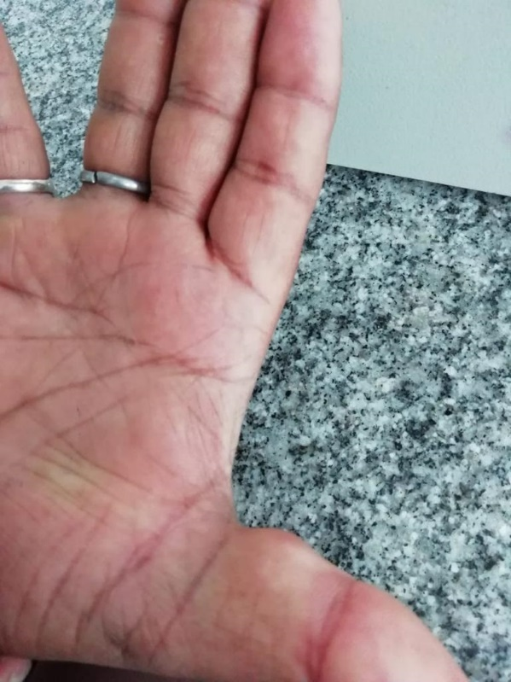
Figure 1.Subcutaneous nodule on the thumb

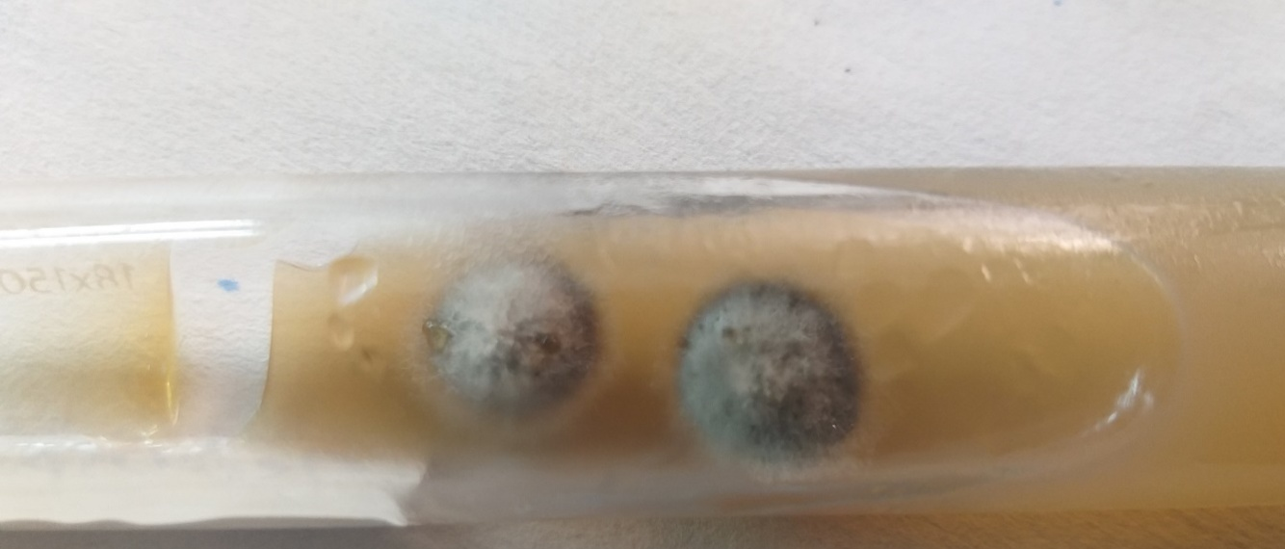
Figure 2(a) Colony morphology on obverse of SDA after two weeks of incubation
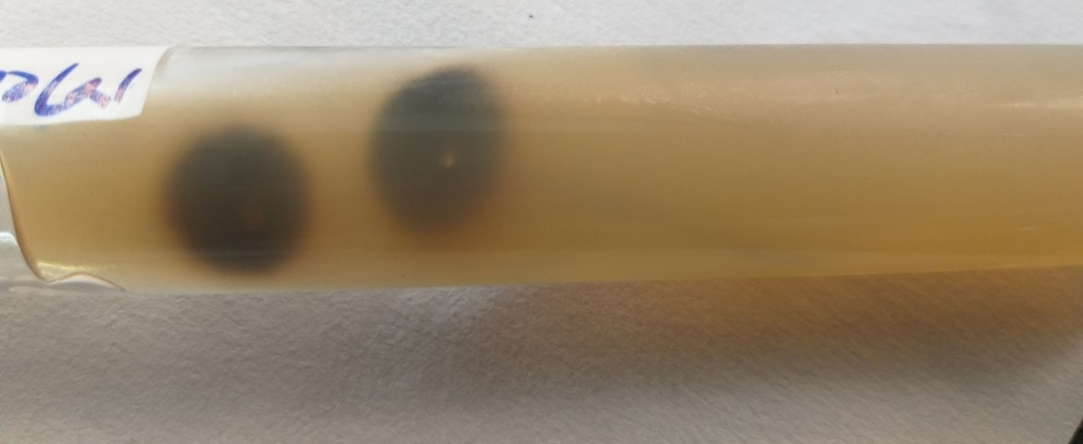
Figure 2(b)Colony morphology on reverse of SDA after two weeks of incubation
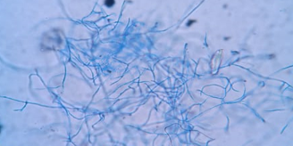
Figure 3 LPCB mount of slide culture showing only thin septate hyphae

Author’s detail
Correspondence Author-
1.Dr Archana Keche , Professor Department of Microbiology, AIIMS Raipur
City Raipur(Chhattisgarh),India
Pin code 492099
Email ID-archukeche@gmail.com
Mobile number:881887119,9822726822
orcid id -DR ARCHANA 0000000156422788
Authors in sequence
1.Dr Archana Keche , Professor Department of Microbiology, AIIMS Raipur
City Raipur(Chhattisgarh),India
Pin code 492099
Email ID-archukeche@gmail.com
Mobile number:881887119,9822726822
2.Dr.Priyadarshini Patro
Assistant Professor Department of Microbiology, AIIMS Mangalagiri
City -Raipur,(Chhattisgarh),India
Pin code 492099
Email ID: priyadarshani.patro@gmail.com

3. Dr.Anuniti Mathias
- Assistant Professor ,Department of Microbiology , Bharat Ratna Late Shri Atal Bihari Vajpayee Memorial Govt Medical College, Pendri, Rajnandgaon
City -Raipur(Chhattisgarh),India
Pin code 492099
Email ID :anunitimathias@gmail.com
Conflict of Interest-Nil
Contribution Details (to be ticked marked as applicable):

 | author1 | author 2 | author 3
Concepts | $$√$$
Design | $$√$$
Definition of intellectual content | $$√$$
Literature search | $$√$$
Clinical studies | $$√$$ | $$√$$ | $$√$$
Experimental studies | $$√$$ | $$√$$ | $$√$$
Data acquisition | $$√$$ | $$√$$ | $$√$$
Data analysis | $$√$$
Statistical analysis | $$√$$
Manuscript preparation | $$√$$ |  | $$√$$
Manuscript editing | $$√$$
Manuscript review | $$√$$ | $$√$$ | $$√$$
Guarantor | $$√$$

Ethical statement-applied for exemption
Data Availability-yes
Funding-Non funded
orcid id -DR ARCHANA 0000000156422788

