Cultural and Creative Design Applications of Yuan Blue-and-White Porcelain: A Case Study of the Gao’an Museum
Liping Xu¹, Mohammad Puad bin Bebit¹*, Meifeng Zhang ², Imelda Ann binti Achin¹
¹Academy of Arts and Creative Technology, Universiti Malaysia Sabah, Sabah, Malaysia
²College of Modern Economics and Management Jiangxi University of Finance and Economics, Jiangxi, China
*Corresponding Author
DOI: https://doi.org/ doi.org/xxxx/xxxx
Received: XX April 2026; Accepted: XX May 2026; Published: XX May 2026
ABSTRACT
This study takes the Yuan blue-and-white porcelain collection of the Gao’an Yuan Blue-and-White Porcelain Museum as its research object. As an artistic treasure of the Yuan Dynasty, these ceramics are renowned for the distinctive coloration of Sumaliqing cobalt, intricate and well-structured decorative patterns, and the expressive elegance of their classic forms. However, they currently face challenges in cultural transmission, including lagging cultural and creative product development, limited forms of expression, and insufficient appeal to younger audiences. Through a systematic analysis of the cultural elements of Gao’an Yuan blue-and-white porcelain, this study identifies three core design dimensions. Based on these traditional elements, this study develops a series of contemporary ceramic blind box IP products. By analyzing current trends in the blind box market and the development of museum cultural and creative products, representative motifs from Gao’an Yuan blue-and-white porcelain are incorporated into the IP concept. These traditional motifs are innovatively embedded into blind box design, balancing cultural authenticity with the aesthetic preferences and collecting habits of younger consumers, thereby revitalizing Yuan blue-and-white culture in a contemporary context. This design practice not only provides new insights into the modern transformation of cultural heritage but also explores feasible pathways for developing cultural and creative products rooted in tradition. By integrating traditional ceramic craftsmanship with modern blind box design, the study both preserves the cultural essence of Gao’an Yuan blue-and-white porcelain and opens new avenues for its sustainable development, offering a valuable practical reference for the contemporary museum cultural and creative industry.
Keywords: Gao’an Yuan blue-and-white porcelain; ceramic blind boxes; IP image; cultural and creative design culture, integrative innovation
INTRODUCTION
In the course of human civilization, ancient ceramic craftsmanship has served as a vital cultural carrier, reflecting the evolution of social culture, aesthetic values, and technological development across different historical periods (Showkat et al., 2025). With the rise of China-chic culture and the rapid growth of the cultural and creative industries, design practice has increasingly emphasized cultural connotation, artistic expression, and emotional value, positioning these as key links between traditional culture and younger generations (Jian et al., 2025). In the contemporary design context, museum artifacts are gradually shifting from static display to dynamic transformation (Xu et al., 2025; Yang & Guo, 2024). In particular, against the backdrop of the booming blind box economy and IP-driven design, the integration of cultural heritage elements with trendy collectible products has become an important pathway for cultural dissemination and industrial transformation (Chunlan et al., 2025; Pattakos et al., 2023). This integration not only revitalizes traditional cultural resources but also facilitates the reinterpretation and transmission of cultural heritage in contemporary contexts.
As an outstanding representative of Yuan Dynasty blue-and-white porcelain, the collection of the Gao’an Yuan Blue-and-White Porcelain Museum is renowned for its richness in quantity, diversity of forms, exquisite decorative patterns, and well-preserved condition (Li et al., 2022; Wen et al., 2007). It is particularly distinguished by the unique coloration of Sumaliqing cobalt, intricate multi-layered ornamentation, standardized classic forms, and profound historical significance (Yan, 2024). However, compared with its substantial artistic value and cultural importance, its cultural and creative product development and market transformation remain relatively underdeveloped, lacking a product system with strong market influence and appeal to younger audiences. At present, most related products remain at a preliminary stage characterized by replication, surface-level pattern application, or simple derivatives (Bonifazi et al., 2024; Ye et al., 2025). There is a lack of systematic exploration and design translation of pattern narratives, formal language, and cultural symbolism, as well as insufficient alignment with contemporary consumption contexts, especially in the rapidly growing field of trendy collectibles and blind box products. These limitations have resulted in narrow dissemination channels and reduced effectiveness in reaching younger consumers, thereby constraining the contemporary transformation and sustainable transmission of its cultural value.
A review of existing studies shows that scholarship has largely focused on the historical value, craftsmanship, and aesthetic analysis of Yuan blue-and-white porcelain, or on its symbolic meanings from a cultural semiotics perspective. In the field of cultural and creative design, research has mainly examined the application of traditional motifs in graphic design, packaging, or tourism souvenirs. Although these studies provide a valuable foundation for understanding Yuan blue-and-white porcelain, several gaps remain: (1) a lack of systematic design translation approaches that integrate patterns, forms, and functions; (2) limited exploration of cross-disciplinary applications in emerging cultural forms such as blind box IP design; and (3) insufficient attention to user experience and emotional consumption in the innovation of cultural products. Therefore, how to achieve formal innovation and functional transformation while preserving cultural authenticity has become a critical issue requiring further investigation.
Based on the above context and research gaps, this study takes the collection of the Gao’an Yuan Blue-and-White Porcelain Museum as its primary research object and focuses on the modern transformation of traditional cultural elements through design. Specifically, the objectives of this study are to: First, systematically analyze and extract representative design elements from patterns, forms, and cultural meanings of Yuan blue-and-white porcelain; Second, construct a design translation framework that transforms traditional elements into a design language suitable for contemporary trendy contexts; Third, explore the functional transformation of artifacts from display objects to interactive products through the medium of ceramic blind boxes; and (4) develop a series of IP-based cultural and creative products to test the feasibility and market adaptability of the proposed design strategies.
Analysis Of Vessel Forms And Decorative Patterns Of Gao’an Yuan Blue-And-White Porcelain
Blue-and-White Lidded Jar with Animal-Shaped Handles
As shown in Figure 1, the upper and lower sections of the lid are decorated with scrolling vine motifs, while the primary pattern consists of lotus petal designs rendered in a double-outline technique, also known as double-contour lotus petals. The rim of the lid is embellished with key-fret (meander) patterns, and the interior of the lid remains undecorated. The mouth of the vessel corresponds with the lid rim, both featuring key-fret decoration. The neck is adorned with scrolling chrysanthemum motifs, separated by string lines. The shoulder features paired cloud-and-dragon motifs, while the body is decorated with scrolling peony patterns. The lower section is encircled by upward-facing lotus petals, with double-outline coin patterns serving as transitional elements. Notably, while dragon motifs on Yuan blue-and-white porcelain are typically depicted with four claws, the dragons on this vessel have three claws, reflecting a distinctive period characteristic.
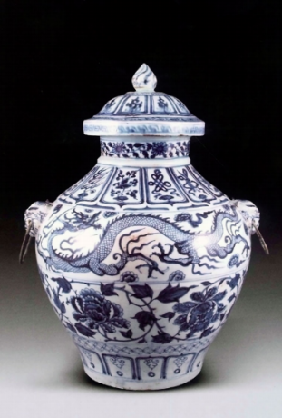
Figure 1. Pattern display
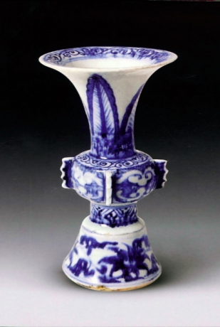
Figure 2. Pattern display
Blue-and-White Gu Vase with Plantain Leaf Motifs
The inner rim of the vessel mouth is decorated with a band of scrolling vine motifs in Figure 2, with the edge delineated by string lines. The neck features plantain leaf patterns as the primary decorative element, with scrolling motifs serving as transitional designs. The body is divided into four sections, each separated by symmetrical curled leaf motifs resembling ruyi forms. The lower body is decorated with upward-facing lotus petals, and the base is adorned with scrolling lotus motifs. The overall decorative scheme is clearly layered and well-organized.
Blue-and-White Lotus-Leaf-Covered Jar
This type of vessel is dignified in form, featuring a straight mouth, a bulging body, and a shallow ring foot, paired with a lotus-leaf-shaped lid (with a stem-like knob and inner flange). The lid is painted with leaf veins, along with fish and crab motifs rendered in multiple tones in Figure 3. The main decorative motif on the body is two dragons playing with a pearl, with one dragon turning its head and cloud motifs interspersed between them. The neck, shoulder, and lower body are further embellished with scrolling peony motifs, with reserved blank spaces enhancing the visual focus. The porcelain body is dense and white, while the glaze exhibits a bluish-white tone with crackle patterns. The unglazed base shows characteristic reddish fire spots. The cobalt blue decoration is vibrant, slightly diffused, and richly layered, demonstrating the typical features of Sumaliqing pigment. With its distinctive form and decoration, this piece possesses strong artistic appeal and represents a rare and valuable example of Yuan blue-and-white porcelain.
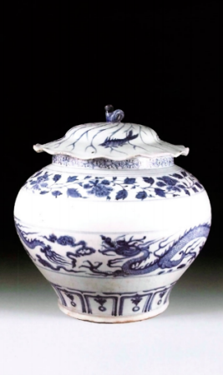
Figure 3. Pattern display
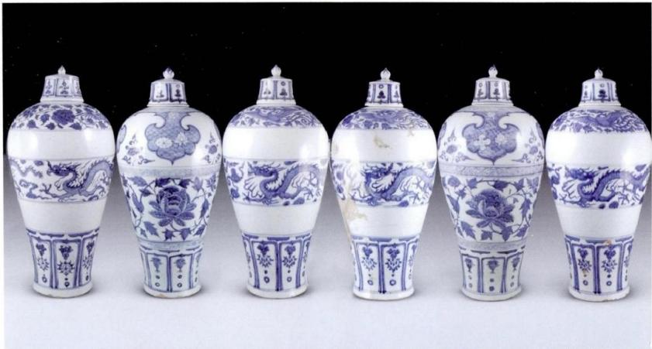
Figure 4. Pattern display
Blue-and-White Meiping Vase with Lid
The lid knob of this type of vessel is shaped like a flower bud, specifically resembling a lotus bud, with lotus motifs decorating its edges in Figure 4. The lid surface is covered with scrolling vine patterns, while the lid rim and walls are primarily defined by double string lines, supplemented by lotus motifs in Figure 4. The decorative patterns on the vessel body can be categorized into two types. In four examples, the shoulder features finely painted phoenix-and-peony motifs, the body is decorated with cloud-and-dragon designs, and the lower section is adorned with lotus patterns, with each section separated by string lines. In the other two examples, the shoulder is decorated with scrolling motifs above a band of square patterns. The central decorative zones are divided by ruyi cloud motifs and wave patterns, interspersed with lotus imagery. The body is primarily decorated with scrolling peony motifs, and the lower section again features lotus patterns, separated by scrolling motifs. The entire decorative scheme is arranged in nine layers. Notably, the six vases bear the characters engraved on the interior of the lids and the bases, distinguishing each piece and reflecting the cultural values and ritual system of the Yuan Dynasty.
Blue-and-White Stem Cup
The decorative patterns on these vessels display considerable diversity. Among them, three are decorated with the “Three Friends of Winter” motif (pine, bamboo, and plum), one features key-fret patterns, one is adorned with square patterns, and the remaining examples are decorated with scrolling vine motifs. The base decorations are equally varied: three pieces feature scrolling chrysanthemum motifs, one displays double-layer chrysanthemum designs, three are decorated with lotus motifs, one with passionflower motifs, and one with scrolling peony patterns. Most notably, one example bears a cursive inscription reading, “A hundred years of life are often spent in intoxication; in total, there are thirty-six thousand such occasions,” seamlessly integrating literary expression with ceramic decoration and demonstrating the fusion of literati culture and ceramic craftsmanship in the Yuan Dynasty.
Creative Design Practice Of Ceramic Blind Box Cultural Products
Overall Design Practice Process
Based on the established overall design strategy and core concept of the ceramic IP blind box derived from the Gao’an Yuan Blue-and-White Porcelain Museum collection, this stage enters the specific design practice phase. Through iterative rounds of sketch development, IP character refinement, product form exploration, and derivative system completion, the research outcomes and design strategies are progressively translated into tangible outputs. By continuously optimizing and iterating the design, the study achieves an integrated fusion of Yuan blue-and-white cultural elements with contemporary trendy toy aesthetics, ultimately forming a complete and implementable visual and product design system.
Blind Box IP and Motif Sketch Design
In the sketch development stage, based on prior research and the extraction of visual elements from Yuan blue-and-white porcelain, the conceptual construction and design exploration of blind box IP characters were systematically conducted. IP characters and hidden edition character were developed in a series of sketches. All IP designs are derived from representative ceramic artifacts in the Gao’an Yuan Blue-and-White Porcelain Museum collection. The design follows the principles of “form translation, motif simplification, stylistic essence retention, and trendy reconstruction,” transforming traditional ceramic vessel forms and decorative culture into stylized and playful Q-version IP characters (Deng, 2022; Zhan, 2024). This process achieves an integrated expression of cultural significance, narrative potential, and contemporary visual appeal.
The regular IP characters are based on representative vessels such as cloud-dragon patterned meiping vases, scrolling peony meiping vases, cloud-dragon lidded jars, stem cups, and chrysanthemum-pattern stem cups (Pu, 2025; Wei & Yu, 2025; Xu, 2025). Their structural forms are geometrically abstracted and proportionally optimized, reducing complex structural details while enhancing cartoon-like proportions and dynamic postures. At the same time, extracted traditional motifs such as cloud dragons, scrolling peonies, chrysanthemums, and key-fret patterns are simplified and reconstructed. These motifs are translated into flowing linear elements and applied to character costumes, decorative patterns, and accessory details. The overall color system is dominated by the characteristic Yuan blue-and-white cobalt blue and porcelain white, ensuring visual consistency across the entire series.
The hidden edition IP is based on a plantain-leaf patterned gu vase. Its silhouette is more elongated and refined, with a restrained and calm “closed-eye, high-cool” expression design. Compared with the regular editions, its structural composition, motif layering, and detailing are more sophisticated and carefully refined, thereby enhancing its sense of rarity, collectability, and ritual significance. All sketches underwent multiple iterative refinements, with a focus on optimizing character proportions, dynamic posture, motif arrangement, and visual balance. This ensures appropriate levels of cuteness, strong recognizability, and clear visual identity. While aligning with contemporary trendy toy aesthetics, the final designs accurately and comprehensively convey the formal characteristics, decorative meanings, and cultural essence of Gao’an Yuan blue-and-white porcelain.
The motif sketching process follows the principle of simplicity and clarity. Representative motifs of Gao’an Yuan blue-and-white porcelain are extracted and simplified, preserving their original outlines and core structural composition while removing excessive decorative details. This results in concise and clearly defined basic motif forms. This stage focuses on the initial visual translation of traditional patterns, establishing foundational shapes and visual structures, as shown in Figure 1. These sketches provide an essential basis for subsequent iterative refinement, element integration, and innovative design development.
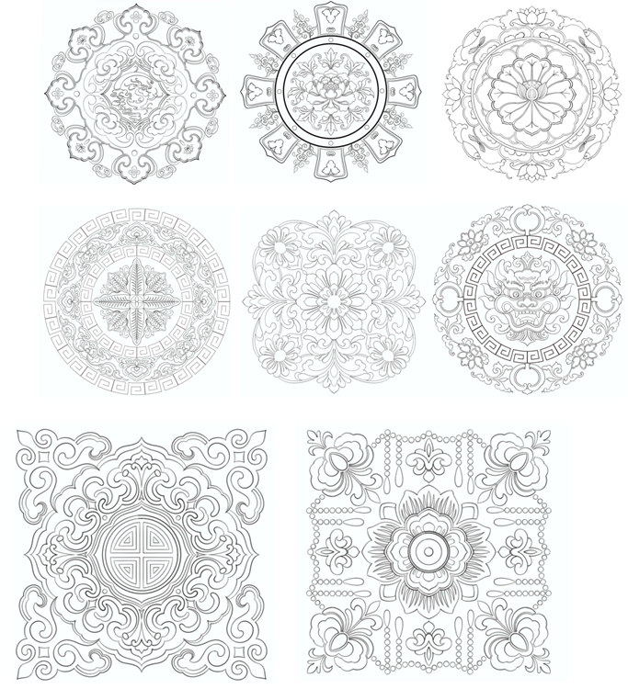
Figure 1. Pattern extension sketch design
Color Rendering of Blind Box IP Characters and Motifs
Based on the completed sketch designs, the color rendering of blind box IP characters and decorative motifs was developed. This stage strictly follows the previously established color scheme, systematically applying the primary tones of cobalt blue and porcelain white, along with carefully controlled auxiliary colors, to both IP characters and motif designs. The color application ensures consistency with the cultural characteristics of Yuan blue-and-white porcelain while simultaneously aligning with the aesthetic preferences of contemporary young audiences. Through the balanced integration of traditional color identity and modern visual sensibilities, the design achieves a harmonious coexistence of cultural authenticity and trendy expression.
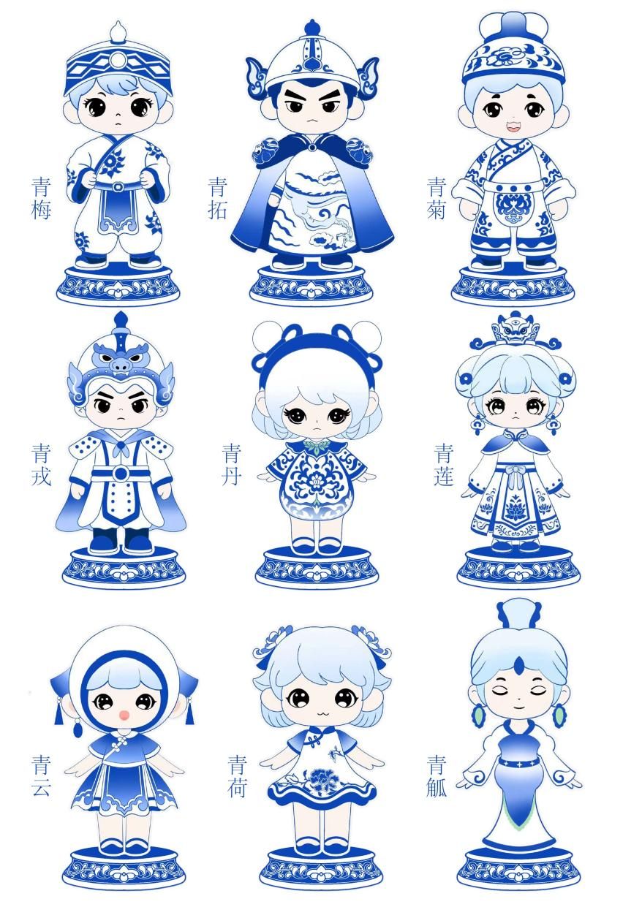
Figure 2. IP coloring draft
Design Development of Blind Box IP
On the basis of the two-dimensional sketch designs, 3D digital prototypes of the blind box IP characters were constructed using software such as Rhino 7 and Blender. This process enables the transformation from planar design schemes to three-dimensional forms, facilitating a more accurate visualization of spatial structure and volume expression in Figure 3.
During the modeling stage, emphasis was placed on optimizing contour lines, proportional relationships, and structural details. In addition, the curvature of surfaces and overall form texture were adjusted in accordance with the material characteristics of ceramics, ensuring that the models are compatible with ceramic production and firing processes. The preliminary 3D models were evaluated from multiple perspectives, including front, side, and top views, allowing a comprehensive representation of overall form, motif distribution, color relationships, and dimensional proportions. Through multiple rounds of iterative refinement, issues such as disproportionate structure and insufficient detailing were effectively resolved, ensuring accurate translation of the design concept into three-dimensional form.
After completing the 3D modeling phase, Keyshot rendering software was employed for material and lighting simulation. This stage focused on reproducing the warm and smooth texture of ceramics, the gradient variations of cobalt blue glaze, and the fine details of decorative motifs. Carefully designed lighting setups were used to enhance spatial depth and visual realism. The final outputs include individual character close-ups, group compositions of regular editions, exclusive presentations of the hidden edition, and enlarged detail views. Post-production adjustments were applied to ensure color accuracy and image clarity. The final rendered results effectively demonstrate the integration of Gao’an Yuan blue-and-white cultural elements with contemporary blind box IP design, while the comparison between raw models and rendered outputs clearly illustrates the visual optimization process and design refinement outcomes.
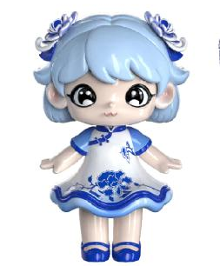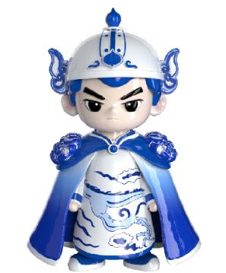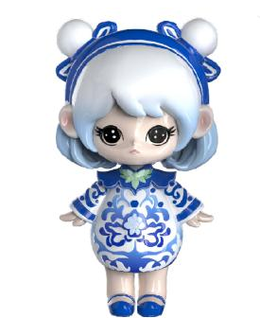
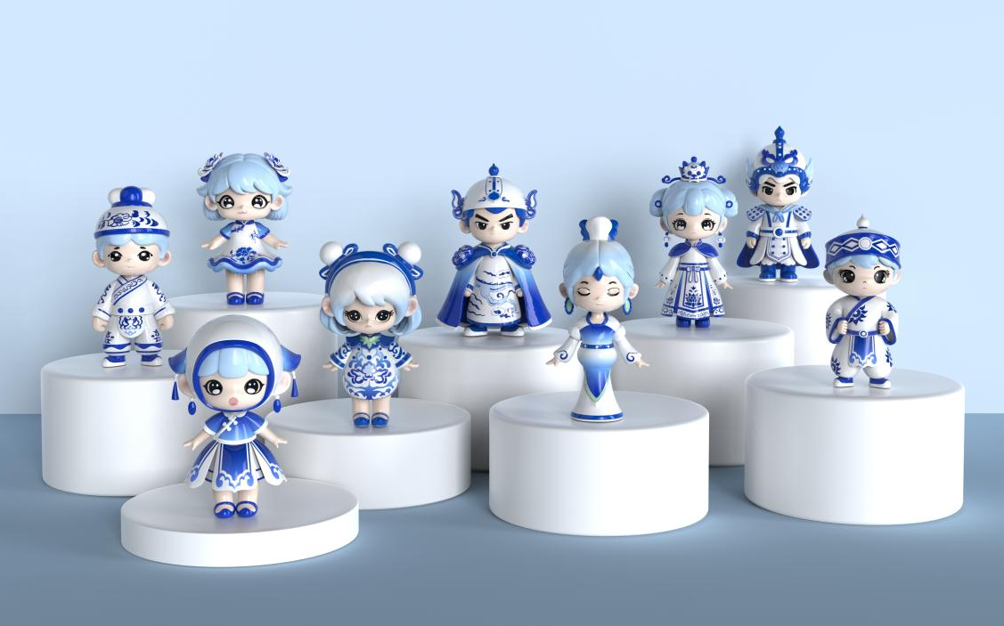
Figure 3. Blind box 3D rendering display
Blind Box Poster Design
The poster is themed “Hidden Charm of Blue-and-White: Blind Box Exploration,” highlighting the innovative integration of Gao’an Yuan blue-and-white cultural heritage with the blind box design format. The overall visual system adopts cobalt blue and porcelain white as the primary color scheme, while the background incorporates simplified cloud-dragon and scrolling peony motifs to create a strong sense of traditional cultural continuity and visual depth. The main composition presents a combined display of regular IP characters and hidden edition character, forming a complete product narrative system in Figure 4. The upper-left corner features the design title, while the upper-right corner indicates the museum provenance of the collection. The lower section is supplemented with motif interpretations and cultural explanations, ensuring clear communication of the design concept and cultural background.
The overall poster design is characterized by a clean layout, balanced visual hierarchy, and strong readability, effectively integrating cultural expression with modern communication needs. It is suitable for both digital dissemination on social media platforms and physical exhibition display in museum or cultural spaces, enhancing both the cultural impact and communicative efficiency of the design.
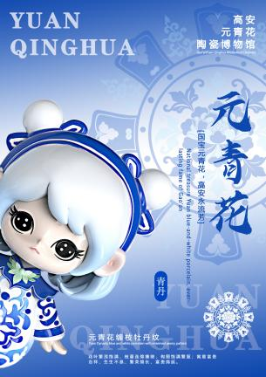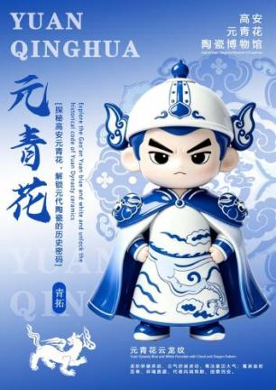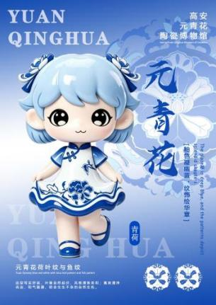

Figure 4. Blind box poster design
Blind Box Packaging Design
The packaging design of the blind box series is centered on the cultural elements of Gao’an Yuan blue-and-white porcelain, integrating functionality, aesthetics, and cultural communication. It is divided into two formats: individual packaging and a complete gift box set in Figure 5. The individual packaging adopts a rectangular paper box with dimensions of 120 mm *100 mm*120 mm. The front side is decorated with IP character silhouettes and simplified blue-and-white motifs, while the side panels display essential product information such as name and material. The back side provides a brief introduction to Yuan blue-and-white porcelain culture, achieving a dual function of product presentation and cultural dissemination. Inside the package, shock-absorbing protective cotton is used to ensure the safety of the ceramic figure during transportation and to prevent damage. In addition, a cultural information card is included, explaining the historical background of the corresponding Yuan blue-and-white artifact, thereby further enhancing the cultural value of the product.
The complete gift box measures 295 mm*275 mm*115 mm. The exterior features representative motifs from the Gao’an Yuan Blue-and-White Porcelain Museum collection, combined with IP character compositions, reinforcing the overall visual identity of the series. The interior is designed with customized compartments to securely accommodate eight regular edition figures and one hidden edition figure. Each blind box is also accompanied by an individual character information card, providing detailed explanations of historical context and motif symbolism, thereby increasing the cultural depth and collectible value of the product system.

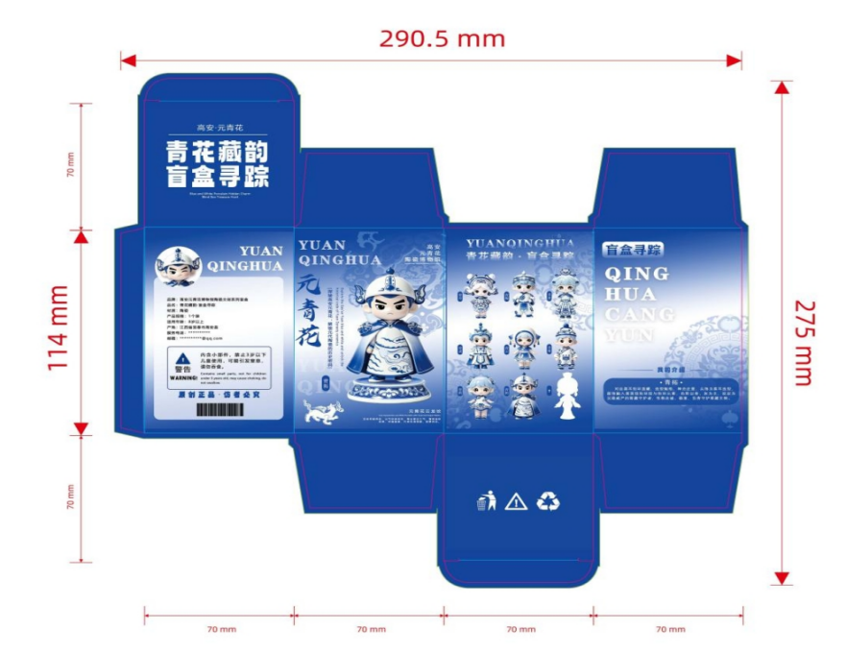
Figure 5. Blind box packaging design
CONCLUSION
This study demonstrates that Gao’an Yuan blue-and-white porcelain possesses rich, multi-layered cultural and visual resources that can be systematically translated into contemporary cultural and creative design. Through the analysis of vessel forms and decorative motifs, it is found that Yuan blue-and-white porcelain is characterized by highly structured narrative patterns, hierarchical ornamental systems, and strong symbolic meanings, including cloud-dragon motifs representing authority and vitality, lotus and peony motifs symbolizing auspiciousness and prosperity, as well as plantain leaf and chrysanthemum motifs reflecting natural and literati aesthetics. The research further reveals that these traditional elements can be effectively reorganized into three core design dimensions: pattern narrative, form translation, and functional transformation. In particular, the study confirms that complex ceramic forms such as meiping vases, stem cups, and lidded jars can be successfully abstracted into IP character structures, while decorative motifs can be simplified and reconstructed into visual identity systems suitable for blind box products. Moreover, the transformation from static cultural relics to interactive blind box IP products significantly enhances cultural engagement, especially among younger audiences. The design practice also shows that the integration of digital tools (Rhino 7, Blender, Keyshot) enables a complete workflow from cultural extraction to 3D visualization, ensuring both aesthetic consistency and production feasibility. Overall, the project proves that Yuan blue-and-white porcelain can be effectively revitalized through IP-based design systems.
Based on the findings, several recommendations are proposed for museum cultural and creative development. First, museums should strengthen systematic cultural extraction frameworks, moving beyond superficial pattern application toward deeper structural and narrative interpretation of artifacts. Traditional motifs should not only be decorative resources but also story carriers embedded in IP systems. Second, in product development, designers should further integrate form, function, and user experience, especially in emerging markets such as blind boxes and collectible toys. Cultural products should shift from static souvenirs to interactive, narrative-driven experiences. Third, it is recommended to enhance cross-disciplinary collaboration among museums, designers, and industry enterprises. Such cooperation can improve the commercialization and scalability of cultural heritage products while maintaining authenticity. Finally, attention should be given to aesthetic adaptation for younger consumers, ensuring that traditional cultural elements are translated into simplified, expressive, and emotionally engaging visual languages.
Despite the contributions, this study still has several limitations. First, the research focuses primarily on the Gao’an Yuan Blue-and-White Porcelain Museum collection. Although representative, the findings may not fully reflect the diversity of Yuan blue-and-white porcelain across other regions or collections, which limits broader generalizability. Second, the design outcomes are mainly based on conceptual and visual development. While 3D modeling and rendering have been completed, the study lacks large-scale user testing and market validation, including targeted market research and consumer feedback that could better understand how younger audiences perceive and respond to ceramic blind box products inspired by Yuan blue-and-white porcelain, as well as experimental studies or product testing to evaluate the attractiveness, usability, and commercial potential of the designs, which limits the ability to fully evaluate commercial performance and consumer acceptance. Third, although the study constructs a systematic design translation framework, the transformation process still relies heavily on designer interpretation. The absence of a fully standardized quantitative evaluation system for motif extraction and design conversion may introduce a degree of subjectivity.
Future research can be expanded in several directions. First, cross-regional comparative studies should be conducted to explore differences in Yuan blue-and-white porcelain styles and to enrich the diversity of design resources. This will help establish a more universal cultural and creative design framework. Second, future work should incorporate empirical user studies and market testing, particularly in blind box consumption behavior, emotional engagement, and collecting motivation among younger groups, integrating market research and consumer feedback to deeply grasp younger audiences’ perceptions and responses to Yuan blue-and-white porcelain-inspired ceramic blind boxes, and conducting experimental studies and product testing to assess the designs’ attractiveness, usability, and commercial potential. This will help validate the practical effectiveness of IP-based cultural products. Third, with the rapid development of digital technologies, future research may integrate AI-assisted design, generative modeling, and immersive technologies (AR/VR) to further enhance interactive cultural experiences. Finally, future studies should explore a more comprehensive ecosystem, examining the economic aspects of production to strengthen the sustainability of cultural heritage transformation and promote long-term cultural value dissemination.
REFERENCES
- Bonifazi, G., Gasbarrone, R., Palmieri, R., & Serranti, S. (2024). A characterization approach for end-of-life textile recovery based on short-wave infrared spectroscopy. Waste and Biomass Valorization, 15(3), 1725-1738.
- Chunlan, Y., Tengku Wook, T. S. M., & Rosdi, F. (2025). Advancing cultural heritage: a decadal review of digital transformation in Chinese museums. NPJ Heritage Science, 13(1), 189-199.
- Deng, X. (2022). Emotional design in blind box for reference and development of cultural and creative products. Highlights Art Des, (8)1, 6-10.
- Jian, L., Enda, T., & Yuxuan, C. (2025). Cultural Heritage and Craftsmanship: An In-Depth Analysis of Traditional Thai Ceramics. Cultura: International Journal of Philosophy of Culture and Axiology, 22(1), 43-56.
- Li, Q., Zhang, M., Wang, L., Yu, Y., Xiong, L., Zhou, J., & Yuan, F. (2022). Analyzing the formation mechanism of ‘Huoshihong’characteristics in the blue-and-white porcelain of the Yuan Dynasty from Jingdezhen. Journal of the European Ceramic Society, 42(15), 7360-7368.
- Pattakos, A., Zidianakis, E., Sifakis, M., Roulios, M., Partarakis, N., & Stephanidis, C. (2023). Digital interaction with physical museum artifacts. Technologies, 11(3), 65-76.
- Pu, Z. (2025). The Premium Effect Driven by Investor Sentiment and Psychology—A Case Study of Labubu Blind Boxes. Finance & Economics, 1(6):88-98.
- Showkat, M., Nagina, R., & Nori, U. (2025). Crafting Heritage: The Journey of Women Pottery Workers in Multi-Cultural Entrepreneurship. In Multi-Cultural Artisanal Entrepreneurship (pp. 62-82). Routledge.
- Wei, Z., & Yu, B. (2025). Why do you engage in blind box consumption? Exploring the group interactions and psychological motivations in blind box consumption. Current Psychology, 44(18), 15168-15182.
- Wen, R., Wang, C., Mao, Z., Huang, Y., & Pollard, A. (2007). The chemical composition of blue pigment on Chinese blue‐and‐white porcelain of the Yuan and Ming dynasties (AD 1271–1644). Archaeometry, 49(1), 101-115.
- Xu, J. (2025). Unmasking Masks An Analysis of Psychological Physical and Virtual Masks as applied to Intellectual Property (IP) Character Design in Branding and Marketing Strategies University of Wales Trinity Saint David]
- Xu, J., Shan, C., & Lv, Y. (2025). Reconstruction of Visual Appeal and Renewal of Dynamic Environments: Computational Methods and Innovative Strategies in the Future-oriented Digital Transformation of Heritage Museums. Journal of Combinatorial Mathematics and Combinatorial Computing, 127, 6429-6447.
- Yan, C. (2024). Blue-and-White Porcelain of the Yuan Dynasty. In A Brief History of Chinese Imperial Porcelain: From Song Dynasty to Qing Dynasty (pp. 71-97). Springer.
- Yang, H., & Guo, L. (2024). Evolution of exhibition space strategies in smart museums: A historical transition from traditional to digital. Herança, 7(1), 1-11.
- Ye, X., Chen, Y., Peng, L., Yang, X., & Bai, Y. (2025). Application of spectroscopy technique in cultural heritage: systematic review and bibliometric analysis. NPJ Heritage Science, 13(1), 169.
- Zhan, H. (2024). Research on the impact of blind box on consumers and marketing strategies. SHS Web of Conferences.

