EVOLUTION OF OLFACTION AS A ROUTE OF ADMINISTRATION IN HOMOEOPATHY: A NARRATIVE REVIEW FROM HAHNEMANNIAN CONCEPTS TO CONTEMPORARY PERSPECTIVES

Abstract
The route of administration plays a significant role in homoeopathic therapeutics, influencing the interaction between the medicinal stimulus and the susceptible individual. While oral administration remains the most widely employed method, olfaction occupies a distinctive place in homoeopathic philosophy and practice. Samuel Hahnemann introduced olfaction as an alternative means of administering potentised medicines, particularly in sensitive patients and in situations where repeated oral doses were undesirable. This narrative review explores the historical evolution of olfaction as a route of administration in homoeopathy, tracing its development from the Hahnemannian doctrine of minimum dose to contemporary interpretations based on olfactory neurobiology. Classical references from the Organon of Medicine, Materia Medica texts and homoeopathic pharmacy literature are examined alongside current scientific knowledge regarding olfactory pathways and psychoneurophysiological responses. The review also highlights selected homoeopathic medicines possessing aromatic characteristics that have traditionally been associated with sensory and nervous system responses. Understanding olfaction within both historical and modern frameworks may contribute to a broader appreciation of individualized drug administration in homoeopathic practice.

Keywords: Olfaction, Homoeopathic Pharmacy, Route of Administration, Minimum Dose, Organon of Medicine, Aromatic Medicines, Neurophysiology

Introduction
Administration of medicines through different routes has been an important consideration in both conventional and homoeopathic therapeutics. Homoeopathy emphasizes the principle of administering the smallest effective dose capable of stimulating a curative response. Hahnemann repeatedly stressed that excessive dosing may aggravate symptoms and interfere with the healing process.¹

Among the various methods of administration described in homoeopathic literature, olfaction represents a unique approach. Rather than introducing the medicine through ingestion, the patient is exposed to the medicinal stimulus through the sense of smell. This method was especially advocated by Hahnemann for highly sensitive individuals and in situations where medicinal repetition required careful adjustment.²

The evolution of olfaction in homoeopathy illustrates the interplay between pharmacy, physiology and therapeutic philosophy. Furthermore, modern neuroscience has demonstrated that olfactory pathways possess direct connections with limbic and autonomic centers, offering an interesting perspective on sensory influences and human responses.

Review Methodology
A narrative review was conducted using classical homoeopathic texts, including the Organon of Medicine, Materia Medica Pura, Chronic Diseases, standard materia medica compilations and homoeopathic pharmacy references. Contemporary biomedical literature concerning olfactory physiology, limbic system interactions and psychoneurobiology was also reviewed to provide a broader scientific context.

Historical Evolution of Olfaction in Homoeopathy
Hahnemann's therapeutic philosophy centred on individualization, minimum dose and gentle restoration of health. During the later stages of his work, he sought methods that would permit subtle medicinal action while minimizing aggravations. In the sixth edition of the Organon, he described olfaction as an effective mode of administering potentised medicines.¹
According to Hahnemann, smelling a medicinal preparation could produce therapeutic effects even when the quantity of medicine was extremely small. This concept aligned with his belief that the dynamic action of a medicine could be transmitted through minimal contact with the organism.

Table 1. Hahnemannian Concepts Supporting Olfactory Administration

Homoeopathic Principle | Relevance to Olfaction
Law of Similars | Selection of medicine based on symptom similarity
Minimum Dose | Administration through minimal medicinal exposure
Individualization | Useful in highly sensitive patients
Gentle Cure | Reduces risk of medicinal aggravation
Potentisation | Dynamic medicinal action independent of material quantity

The concept gradually became incorporated into homoeopathic practice, particularly for patients exhibiting marked sensitivity to medicines and during long-term management of chronic diseases.

Physiological Basis of Olfaction
The olfactory system consists of specialized sensory receptors located within the nasal mucosa. These receptors transmit signals through the olfactory nerve directly to the olfactory bulb and subsequently to higher brain centres.
Unlike many sensory pathways, olfactory impulses maintain close anatomical relationships with the limbic system.

Figure 1. Schematic representation of olfactory pathways linking the nasal mucosa, olfactory bulb, limbic system and autonomic nervous system.

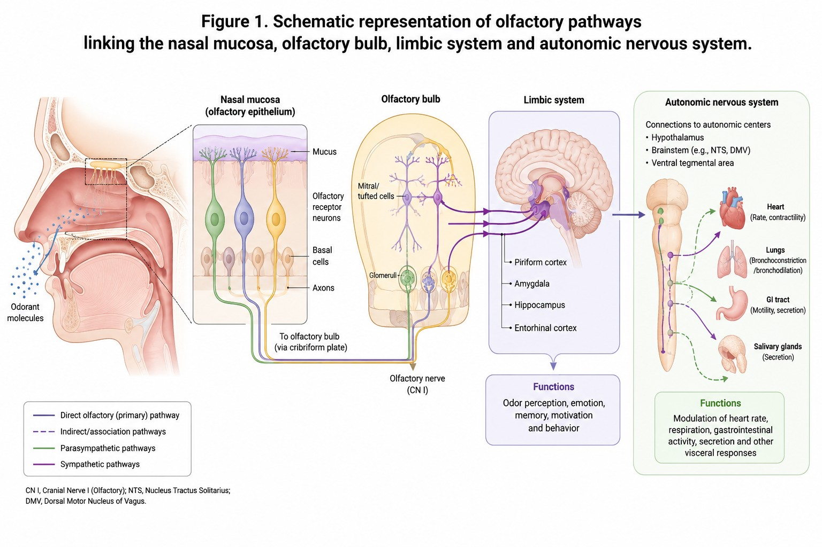

Table 2. Major Neurophysiological Functions Associated with Olfaction

Structure | Function
Olfactory Receptors | Detection of odorant molecules
Olfactory Bulb | Initial signal processing
Amygdala | Emotional responses
Hippocampus | Memory formation
Hypothalamus | Autonomic and endocrine regulation

These neural connections explain why odours may influence mood, memory, emotional responses and autonomic functions.

Olfaction in Homoeopathic Pharmacy
Within homoeopathic pharmacy, olfaction represents an alternative route of administration rather than a separate therapeutic principle. It may be considered in situations involving:
- Hypersensitive patients
- Infants and elderly individuals
- Difficulty in oral administration
- Need for gentle medicinal repetition
- Chronic disease management
The method reflects Hahnemann's attempt to adapt administration according to patient susceptibility.

Homoeopathic Medicines Traditionally Associated with Aromatic Properties
Several medicines discussed in homoeopathic materia medica possess volatile or aromatic characteristics in their crude state.

Table 3. Selected Aromatic Medicines and Their Principal Homoeopathic Indications

Medicine | Source | Principal Indications
Camphora | Camphor | Collapse states, coldness, nervous disturbances
Coffea cruda | Coffee bean | Sleeplessness, mental excitement, hypersensitivity
Amylenum nitrosum | Amyl nitrite | Flushing, palpitations, anxiety
Nux moschata | Nutmeg | Drowsiness, confusion, altered sensations
Valeriana | Valerian root | Nervous excitement, restlessness
Lavandula | Lavender | Nervous complaints, headache
Mentha piperita | Peppermint | Nausea, digestive complaints
Eucalyptus globulus | Eucalyptus leaves | Catarrhal and respiratory conditions
Aconitum napellus | Monkshood | Acute fear, anxiety and restlessness
Cina | Artemisia cina | Irritability and nervous sensitivity

These remedies are cited not because their homoeopathic action depends on aroma, but because their source substances possess distinctive aromatic properties and have historically been associated with sensory responses.

Psychoneurophysiological Perspectives
Contemporary research has established that olfactory stimulation influences multiple brain regions involved in emotion, cognition and autonomic regulation. Odours may evoke memories, alter mood states and modify physiological responses through neural pathways linking the olfactory system and limbic structures.³⁻⁵
The relationship may be conceptualized as:

Olfactory stimulus → Neural processing → Emotional/autonomic response → Subjective experience
Although this framework does not directly explain the mechanism of potentised medicines, it highlights the biological significance of olfactory pathways and provides a basis for future interdisciplinary research.

Current Status and Research Opportunities
Modern homoeopathic practice predominantly employs oral administration. Nevertheless, olfaction continues to be mentioned in homoeopathic literature as an alternative route in selected cases.
Potential research areas include:
- Comparative studies of oral versus olfactory administration
- Patient acceptability and compliance
- Neurophysiological responses to olfactory stimulation
- Historical analysis of Hahnemannian dosing methods
- Clinical outcomes in hypersensitive individuals

Limitations
The available evidence regarding olfaction in homoeopathy is largely historical and theoretical. Contemporary controlled clinical studies evaluating olfactory administration of potentised medicines remain scarce. Furthermore, current scientific understanding of olfactory neurobiology does not directly address the mechanisms proposed within homoeopathic theory. Consequently, conclusions regarding efficacy and mechanism require cautious interpretation.

Conclusion
Olfaction occupies a unique place in the historical development of homoeopathic therapeutics. Rooted in Hahnemann's principles of minimum dose, individualization and gentle cure, it represents an alternative route of medicinal administration designed to accommodate patient sensitivity. Modern neuroscience has demonstrated important connections between olfactory pathways, emotional processing and autonomic regulation, providing a contemporary perspective on the significance of smell in human physiology. Although further scientific investigation is required, the study of olfaction remains an important area linking homoeopathic pharmacy, sensory physiology and therapeutic philosophy.

References
- Hahnemann S. Organon of Medicine. 6th ed. New Delhi: B Jain Publishers; 2002.
- Hahnemann S. Chronic Diseases: Their Peculiar Nature and Their Homoeopathic Cure. New Delhi: B Jain Publishers; 2004.
- Shepherd GM. Neurogastronomy: How the Brain Creates Flavor and Why It Matters. New York: Columbia University Press; 2012.
- Doty RL. Handbook of Olfaction and Gustation. 3rd ed. Hoboken: Wiley-Blackwell; 2015.
- Herz RS. The role of odor-evoked memory in psychological and physiological health. Brain Sci. 2016;6(3):22.
- Boericke W. Pocket Manual of Homoeopathic Materia Medica. New Delhi: B Jain Publishers; 2007.
- Clarke JH. A Dictionary of Practical Materia Medica. New Delhi: B Jain Publishers; 1995.
- Hering C. The Guiding Symptoms of Our Materia Medica. New Delhi: B Jain Publishers; 1993.
- Allen TF. Handbook of Materia Medica and Therapeutics. New Delhi: B Jain Publishers; 2000.
- Kent JT. Lectures on Homoeopathic Materia Medica. New Delhi: B Jain Publishers; 2002.
- Mandal A, Mandal S. Human olfactory system: structure and function. Indian J Otolaryngol Head Neck Surg. 2020;72(Suppl 1):1–8.
- Purves D, Augustine GJ, Fitzpatrick D, et al. Neuroscience. 6th ed. New York: Oxford University Press; 2018.

