Efficient Routing Using the Open Shortest Path First (OSPF) Protocol
Renuka Sunil Kapare
Department of Computer Science
Dr.D.Y.Patil ACS College Pimpri, Pune
Kapare.renuka92@gmail.com
ABSTRACT —
Open Shortest Path First (OSPF) is a widely deployed link-state Interior Gateway Protocol (IGP) designed for routing IP packets within a single Autonomous System (AS). This report details the methodology of implementing OSPF, highlighting its mechanism of building a topological map of the network and using Dijkstra’s Shortest Path First (SPF) algorithm to calculate optimal routes. Key aspects such as LSA flooding, neighbor adjacency formation, and multi-area design are examined. Results indicate OSPF provides fast convergence, efficient path determination, and loop-free topology, making it ideal for large enterprise networks.
Keywords —Cisco Router, Routing Table, Network Topology, Packet Tracer, OSPF
1. INTRODUCTION
The process of selecting the most effective paths for network traffic is known as routing. In compared to distance-vector protocols that exchange routing tables, OSPF is a link-state protocol in which routers exchange details about their direct links, enabling each router to create an identical, comprehensive picture of the network topology. OSPF is an open standard protocol (RFC 2328) designed to address RIP's weaknesses in regards to bandwidth efficiency, scalability, and convergence speed.
2. LITERATURE REVIEW
OSPF has been created to supply TCP/IP networks with a dependable, open-standard IGP. It functions within an Autonomous System (AS) and uses Area Zero, or the backbone, to link different network components.
Link-State Routing: frequently referred to as link-state advertisements or LSAs, each router acts as a node, flooding the other routers with data about its connected links.
Dijkstra's Algorithm: Routers employ Dijkstra's algorithm to find the shortest path to each destination using the link cost (bandwidth) as the metric.
Support for variable-length subnet masks (VLSM), CIDR, classless routing, and quick, low-second convergence are important features. There are various essential components involved in OSPF routing implementation:
Neighbor Discovery: To find and create adjacencies with nearby routers on a single link, OSPF routers issue Hello packets. Link State Advertisements (LSAs), which contain the state of their links, is shared by routers through LSA exchange and synchronization. A Link State Database (LSDB), which is synchronized across all routers in a region, stores these LSAs.
1. SPF Calculation: To determine the optimal loop-free route to each destination, each router independently processes the LSDB to create a Shortest Path Tree.
2. Routing Table Improvement: The routing table is revised using the determined shortest pathways.
3. Multi-Area Configuration: OSPF can be divided into areas, with Area 0 acting as the backbone, to handle huge networks. These regions are connected by Area Border Routers (ABRs), which lower LSDB size and routing traffic.
3. METHODOLOGY
Diagram
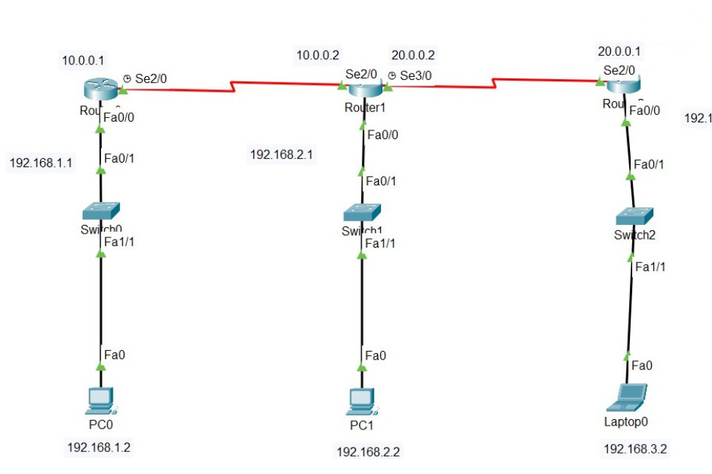
Figure 1. Dynamic Routing implementation using (OSPF)on Cisco Packet Tracert
configured interface 1 (Router0) with Host 1 which is PC0 and the Serial port.
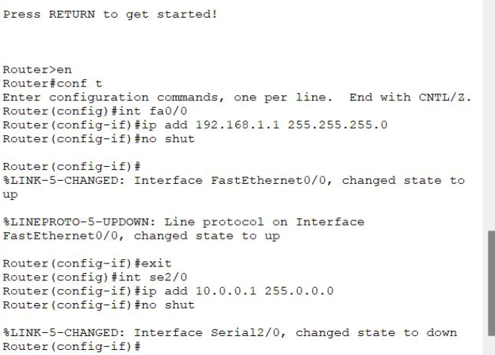

Configuring the Interface 2 which is router1.

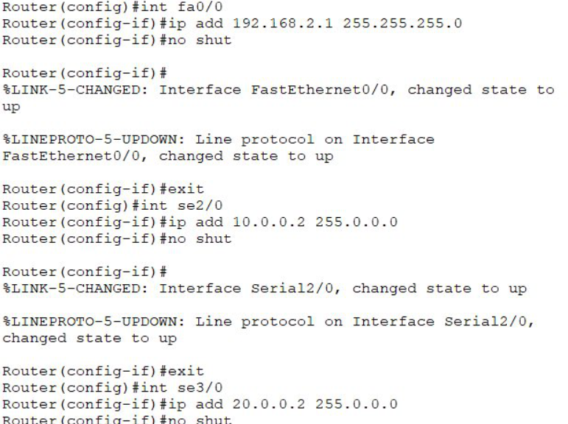

Configuring the Interface 3 which is router2.

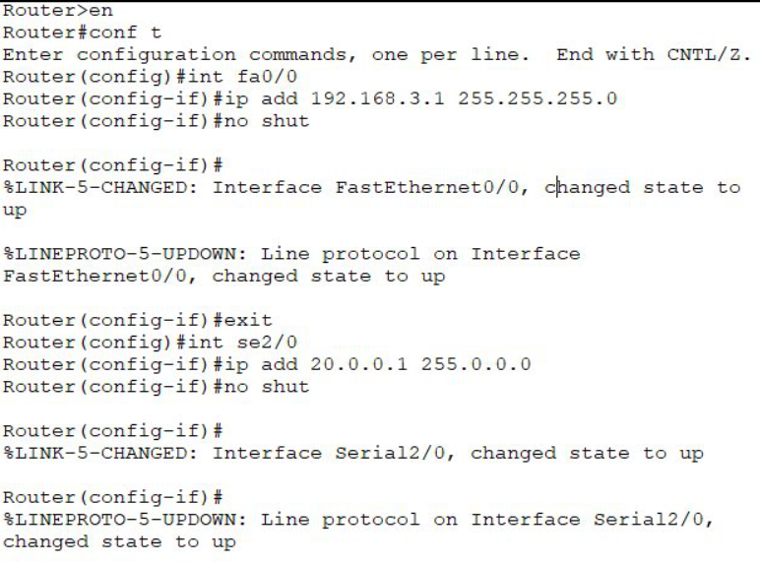
Configure the Router0 and create router OSPF 1 and then add network id with wildcard mask.

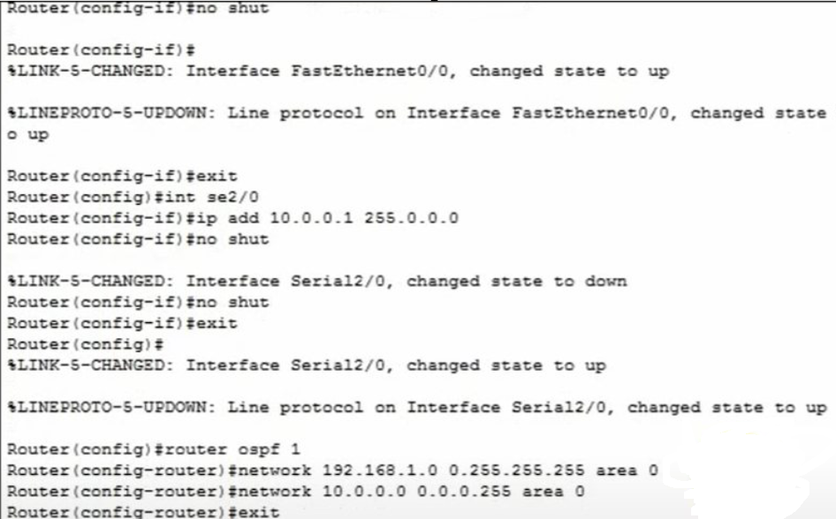

Configure the Router1 and create router OSPF 1 and then add network id with wildcard mask.

Router(config)#router ospf 1
Router(config-router)#network 10.0.0.0 0.0.0.255 area 0
Router(config-router)#network 20.0.0.0 0.0.0.255 area 0
Router(config-router)#network 192.168.2.0 0.255.255.255 area 0

Configure the Router2 and create router OSPF 1 and then add network id with wildcard mask.

Router(config)#router ospf 1
Router(config-router)#network 192.168.3.0 0.255.255.255 area 0
Router(config-router)#network 255.0.0.0 0.0.0.255 area 0
4. RESULTS AND DISCUSSION
The following OSPF performance characteristics are displayed via experiments and network simulations:
Rapid Convergence: After a topology change, OSPF typically converges in less than a second, overtaking traditional distance-vector protocols.
Effective Path Determination: Even in intricate, redundant network topologies, OSPF accurately determines the lowest-cost path.
Robustness: OSPF rapidly floods new LSAs in the event of an association failure, rerunning the SPF algorithm in order to discover a different path.
Packet Loss Analysis: Studies reveal that during re-convergence, OSPF-routed networks sustain low packet loss (~2.09% in simulated test settings).
Area Optimization: Compared to a single large area, dividing large networks into many areas reduces CPU load by needing less SPF computations per router.
5. CONCLUSION
For large-scale enterprise networks, OSPF is a strong and efficient link-state routing system. Rapid convergence, effective bandwidth-based pathfinding, and automatic route reconfiguration are made possible by the ability to produce a consistent network topology map. The advantages of free of loops path calculation and high stability make it better for dynamic, large-scale networks, regardless of whether it is more difficult to configure than static or RIP routing.
6.REFERENCES
- J. Moy, The Internet Engineering Task Force (Internet Engineering Task Force), April 1998, RFC 2328, OSPF Version
- Cisco Systems' OSPF Configuration Guide is accessible via official literature and the Cisco Networking Academy.
- OSPF Packet Analysis Manual and Wireshark documentation. formal networking standards and documentation, as well as the Internet Engineering Task Force (IETF). Jeff Doyle, Routing the Transmission Control Protocol/ Volume I, Cisco Press.
- Kurose, J. F., and Ross, K. W., Computer Networking: A Top-Down Approach, 7th Edition, Pearson Education, 2016.
- Cisco Systems, Cisco Packet Tracer User Guide, Cisco Networking Academy.
- Stallings, W., Data and Computer Communications, 10th Edition, Pearson Education, 2013.
- RFC 2453, RIP Version 2, Internet Engineering Task Force (IETF).

