Targeting Cancer Signaling Pathways with Plant-Derived Agents: A Review
Tusharkumar Sangada ¹, Kishan Rathod¹, Shivani Chaudhary¹, Gautam Kardani¹, Savankumar Donga¹, Sucheta Karande¹
¹ Department of Botany, Faculty of Science, Mehsana Urban Institute of Sciences (MUIS),
Ganpat University, Mehsana, Gujarat, India.

Corresponding Author: Dr. Sucheta Karande
Email: snk01@ganpatuniversity.ac.in
tusharsangada20@gmail.com

Abstract
Cancer remains a major global health concern, with existing therapies like chemotherapy and radiation often limited by serious side effects and the development of drug resistance. These challenges have prompted growing interest in natural alternatives, particularly plant-derived compounds known for their broad range of biological activities. Many of these phytochemicals including curcumin, epigallocatechin-3-gallate (EGCG), withaferin-A, kaempferol, and quercetin have shown the ability to interfere with crucial signalling pathways that cancer cells depend on for growth, survival, and metastasis. Unlike single-target drugs, these natural agents frequently act on multiple cellular pathways, making them especially valuable in the fight against drug-resistant cancers. However, their clinical application faces hurdles such as poor bioavailability, variable pharmacokinetics, and tumor heterogeneity. To address this challenges, recent studies have explored innovative drug delivery approaches, such as nano- formulations, along with the strategic use of combination therapies. Network pharmacology and personalized medicine are also emerging as promising tools for optimizing the therapeutic potential of compounds derived from the plants. This review investigates the processes through which these agents exert their anticancer effects and highlights the advances and remaining challenges on the path to integrating them into advanced oncology.
Keywords: signalling, anticancer, pharmacology, curcumin,

Introduction
Globally cancer stands out as a major health challenge that claiming millions of lives each year, primarily due to dysregulated cellular proliferation and the disruption of normal cellular functions (I. C. Lee & Choi, 2016; Shrihastini et al., 2021). There are several traditional cancer therapies like radiation and chemotherapy are most often associated with drug resistance and cause serious negative impact. Consequently, there is increasing interest in exploring substitute therapeutic methods, including the utilization of plant derived compounds. These natural compounds, known for their potent bioactive properties, present a viable path for targeted cancer treatment by modulating the key signaling pathways involved in the development of cancer (Farghadani et al., 2021) and progression (Farooqi et al., 2020b; Qattan et al., 2022a). This review offers in-depth examination of the current comprehend of medicine derived from plants for targeting cancer signaling pathways, along with a particular emphasis on their pathway of action, effectiveness, drawbacks, and future research directions.
Plant-Derived Compounds and Their Anti-Cancer Properties
Various compound derived from plants have exhibited significant anticancer activity in both in vivo and in vitro studies (Asgharian et al., 2021a; Farghadani & Naidu, 2021b; Qattan et al., 2022b). These compounds, which are often classified as phytochemicals, contain a broad spectrum of chemical structures and biological functions. For example, flavonoids, such as kaempferol (Qattan et al., 2022b) and quercetin (Asgharian et al., 2021a), possess notable anti-inflammatory, anti-cancer, and antioxidant qualities. They show these types of effects by controlling diverse mechanisms related to cancer, like metastasis angiogenesis, oxidative stress, apoptosis, proliferation, and cell cycle regulation (Qattan et al., 2022b). Other important secondary metabolites with different mechanisms of action and therapeutic potential include curcumin (Farghadani & Naidu, 2021b), epigallocatechin-3-gallate (EGCG) (Farooqi et al., 2020a), and withaferin-A (I. Lee et al., 2016). Although further investigation is required to comprehensively clarify their mechanisms of action, alkaloids, another class of phytochemicals, also shows promising effect for cancer treatment (Tilaoui et al., 2021).
Mechanisms of Action
Medicines obtained from the plant plays important role by showing anticancer effects by disrupting oncogenic signaling pathways crucial for cancer cell survival, growth, and spread (Farghadani & Naidu, 2021b; Farooqi et al., 2020a; Qattan et al., 2022b). These compounds frequently target multiple pathways simultaneously, thereby enhancing their effectiveness (Farghadani & Naidu, 2021b; Farooqi et al., 2020a). For instance, curcumin has been shown to affect the Phosphatidylinositol 3-kinase (PI3K)/ Protein Kinase B (Akt)/ mammalian target of rapamycin (mTOR), Janus Kinase (JAK)/ Transducers (Farghadani et al., 2021) and Activators of Transcription (STAT), MAPK, NF-κB, p53, and Wnt/β-catenin (Farghadani et al., 2021) pathways in hormone-independent breast cancer (Farghadani & Naidu, 2021b). in the same way, EGCG regulates the Janus Kinase (JAK)/ Transducers and Activators of Transcription (STAT), Wnt/β-catenin, TGF/SMAD, SHH/GLI, (Farghadani et al., 2021) and NOTCH pathways in different cancers. Kaempferol affects several pathways, involving Phosphatidylinositol 3-kinase (PI3K)-(AKT) Protein Kinase B, VEGF, STAT, p53, and nuclear factor kappa-light-chain-enhancer of activated B cells (NF-κB) (Qattan et al., 2022b). By modulating these pathways, which are often disrupted in cancer cells, plant-based medicines can inhibit metastasis, can trigger apoptosis, and can prevent cell proliferation (Farghadani & Naidu, 2021b; Qattan et al., 2022b). Furthermore, certain phytochemicals may exert their anticancer effects through epigenetic pathways by affecting DNA methylation, histone modification, and chromatin remodeling (Bouyahya et al., 2022). Though, the certain mechanisms of action can be different based on a compound, form of the cancer, and the cellular environment (Chirumbolo et al., 2018).
Targeting Specific Signaling Pathways
Phosphoinositide 3-kinase (PI3K)/Protein Kinase B (Akt)/Mammalian Target of Rapamycin (mTOR) Pathway
This signaling pathway is often activated in a range of cancers, facilitating the cell growth, survival, and formation of new blood vessels (Cancers & 2015, 2015; Farghadani & Naidu, 2021b). various plant derived compounds have shown their effectiveness by blocking this pathway (Cancers & 2015, 2015; Farghadani & Naidu, 2021b; Qattan et al., 2022b). For exmple, curcumin inhibits the activity of PI3K, Akt, & mTOR, leading to reduce growth and enhance apoptosis in breast cancer cells (Farghadani & Naidu, 2021b). similarly, also the anti-cancer effects of kaempferol include its ability to inhibit the PI3K-AKT signaling pathway (Qattan et al., 2022b). The utilization of plant-derived treatments to target this pathway holds significant promise for cancer therapy.
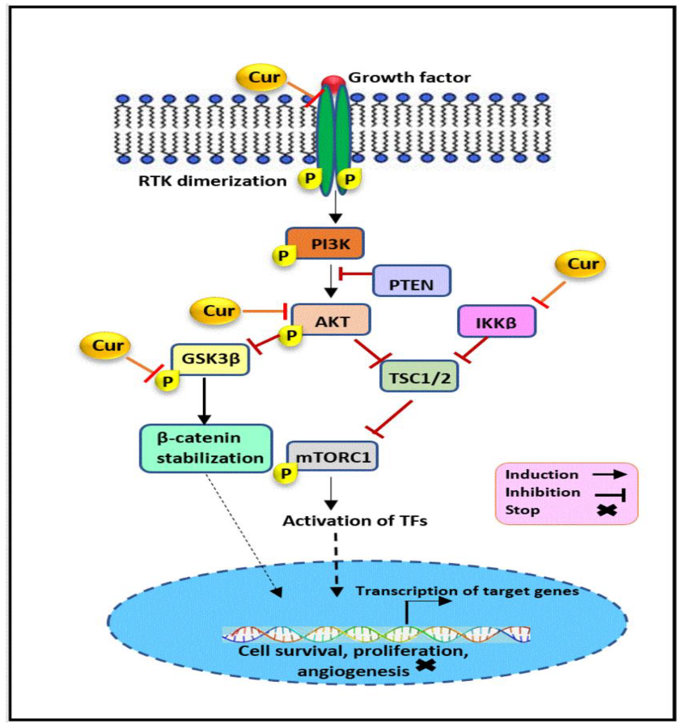
Figure 1. Curcumin suppress the PI3K/Akt/mTOR pathway by downregulating IKKβ, AKT, GSK3β, and HER2, invasion, suppressing cellular growth and metastasis in hormone receptor-negative breast cancer. (Farghadani et al., 2021)
Key elements involve Curcumin, PI3K, AKT (PKB), mTORC1, IKKβ, PTEN, TSC, RTK, GSK3β, and TFs (Farghadani & Naidu, 2021a).
Janus Kinase (JAK)/Signal Transducers and Activators of Transcription (STAT) Pathway
This pathway is integral to the regulation of cell Proliferation, survival, and inflammation (Farghadani & Naidu, 2021b; Farooqi et al., 2020a). The Dysregulation of this pathway is commonly observed in diverse cancers (Farghadani & Naidu, 2021b; Farooqi et al., 2020a). Research has indicated that curcumin and EGCG inhibit the JAK/STAT pathway, thereby impeding cancer cell development and promoting apoptosis. furthermore, the compound derived from the plant Brassinin influences the JAK/STAT pathway in colorectal cancer cells (Yang et al., 2021). additionally, investigation is warranted to explain the function of this pathway in cancer and explore the ability of plant-derived compounds as effective therapeutic agents.
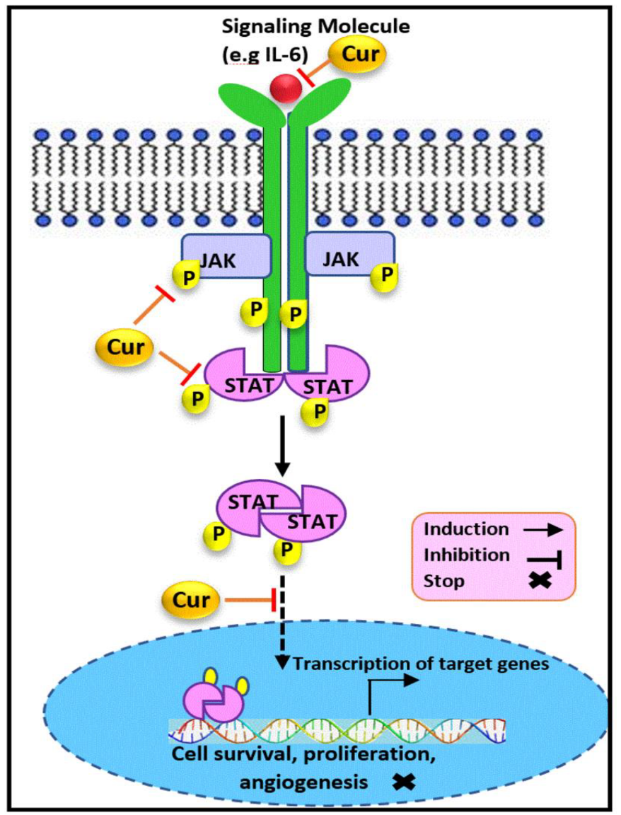
Figure 2. Curcumin suppress the JAK/STAT3 pathway by downregulating STAT, JAK, and IL-6, preventing STAT nuclear translocation and suppressing growth, invasion, and metastasis in hormone receptor-negative breast cancer Important elements include Curcumin, IL-6 , JAK, and STAT (Farghadani & Naidu, 2021a).
Mitogen-Activated Protein Kinase (MAPK) Pathway
The mitogen-activated protein kinase pathway is a crucial signaling sequence that notably impacts cell growth, differentiation, and survival (Cancers & 2015, 2015; Choi et al., 2010; Farghadani & Naidu, 2021b). This pathway repeatedly gets aberrantly activated in cancer, resulting in unrestricted cell growth and tumor development (Cancers & 2015, 2015; Choi et al., 2010; Farghadani & Naidu, 2021b). Curcumin inhibits the MAPK pathway, contributing to its anticancer effects (Farghadani & Naidu, 2021b). Aditional investigation is need to elucidate the specific mechanisms by which plant-derived compounds affect the MAPK pathway and their potential therapeutic advantages. Recent studies have examined the impact of other plant-derived compounds on the MAPK pathway, yielding promising findings for cancer prevention and treatment. Organic materials, such as resveratrol from grapes and EGCG from green tea, have been shown the effect numerous elements of the MAPK cascade. Understanding how these secondary metabolites interact with the MAPK pathway at the molecular level could clear the way to create new targeted treatments for cancer and other illnesses associated with aberrant MAPK signaling.
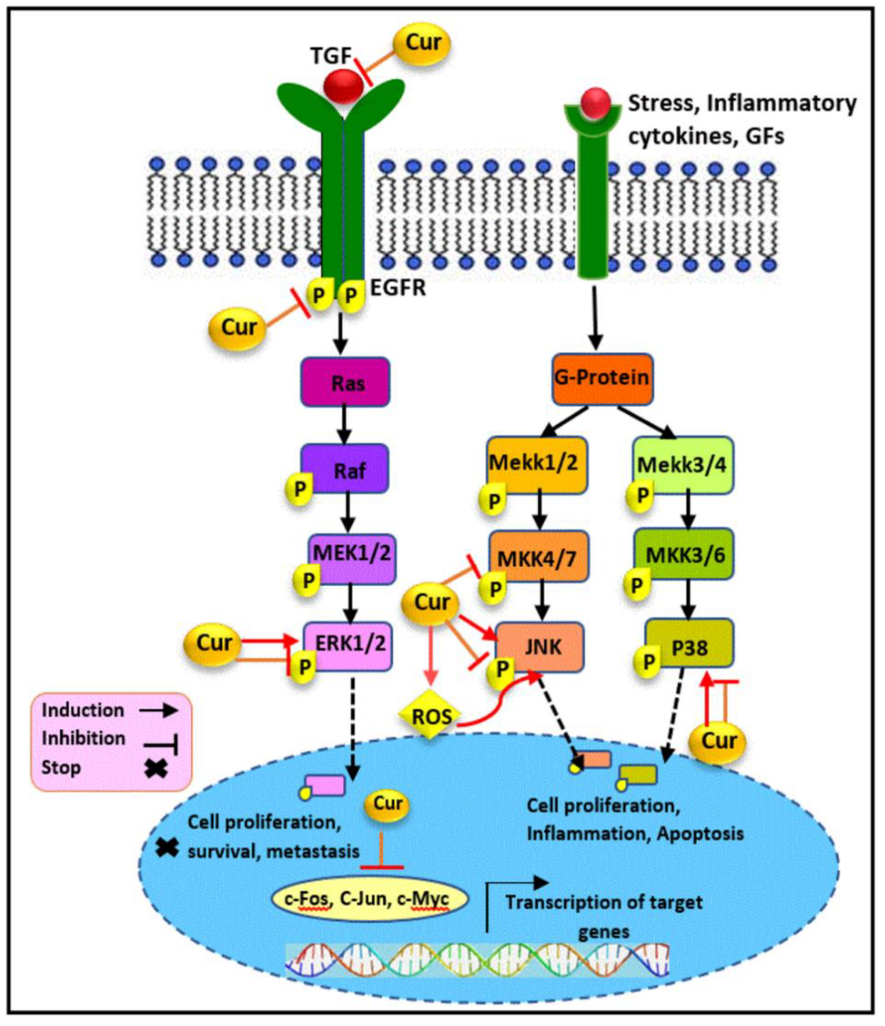
Fig. 3. Curcumin's modulation of the MAPK pathway inhibits cancer progression by targeting TGF, EGFR, MKK4/7, ERK1/2, JNK, and P38, reducing expression of c-Myc, c-Fos, and c-Jun. This subduing obstructs migration, proliferation and influence apoptosis in hormone receptor-negative breast cancer (Farghadani & Naidu, 2021a).
Wnt/β-catenin Pathway
With the altercations in the Wnt/β-catenin pathway, naturally originated compounds provide great opportunities for the cancer treatment (Farghadani et al., 2021). Combination therapies engaging quite a few organic substances that target this pathway may boost their anticancer effectiveness. Moreover, illuminating the molecular mechanisms by which these compounds attach with the Wnt/β-catenin pathway (Farghadani et al., 2021) could facilitate the development of influential and targeted treatment plans. The Wnt/β-catenin pathway serves a fundamental function in managing cell growth, distiction, and stem cell maintenance (Farghadani & Naidu, 2021b; Farooqi et al., 2020a; Liu et al., 2020). Abnormal triggering of this pathway is repeatedly observed in numerous cancers, encouraging tumor growth and metastasis (Farghadani & Naidu, 2021b; Farooqi et al., 2020a; Liu et al., 2020). Curcumin and EGCG have been proven to inhibit the Wnt/β-catenin pathway, thereby reducing cancer cell augmentation and amplifying apoptosis (Farghadani & Naidu, 2021b; Farooqi et al., 2020a). Another substance that comes from plants, Pheonol, also targets this pathway in Colorectal cancer cells (Liu et al., 2020). Further examination is call for to explore the therapeutic efficacy of plant derived agents targeting this pathway.
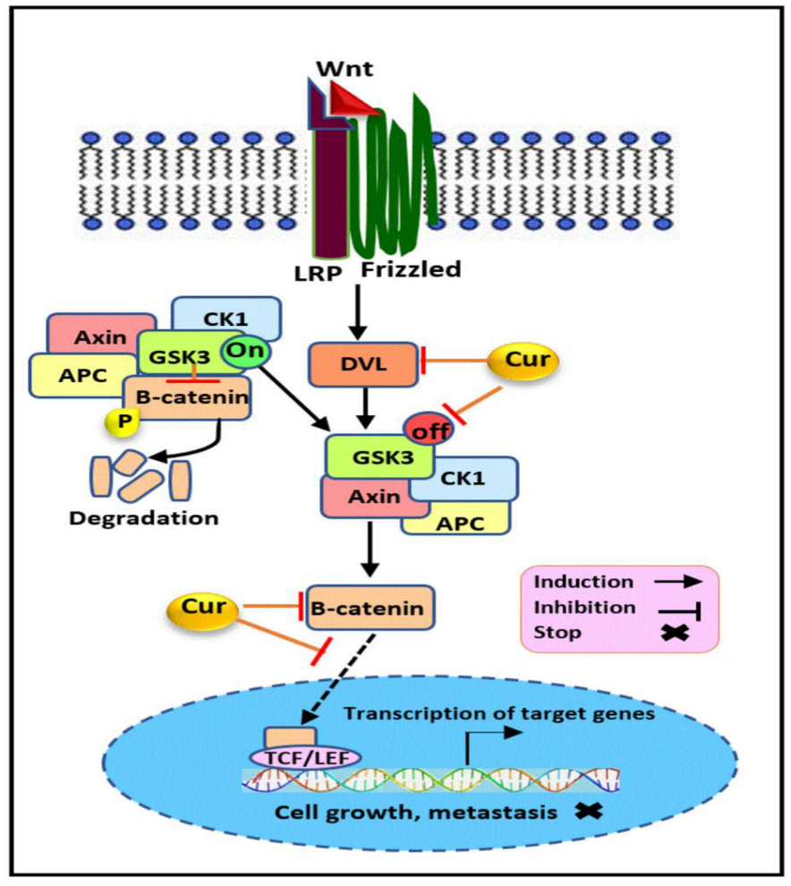
Fig 4. Curcumin subdues the Wnt/β-catenin pathway by downregulating Dvl, β-catenin, and inert GSK3, blocking β-catenin's nuclear translocation. This inhibition minimizes growth and metastasis in hormone receptor-negative breast cancer (Farghadani & Naidu, 2021a).
Other Signaling Pathways
Other signaling pathways related to cancer, such as the p53 (Farghadani & Naidu, 2021b; Qattan et al., 2022b; Singh et al., 2026), NF-κB (Denlinger et al., 2004; Farghadani & Naidu, 2021b; Qattan et al., 2022b), and different receptor tyrosine kinase (RTK) signaling pathways have also demonstrated to be regulated by plant derives agents (Cancers & 2015, 2015; Choi et al., 2010). These pathways play important roles in managing cell growth, apoptosis, survival, and their dysregulation contribute to the development of cancer and its progression. Alteration of these pathways by plant-derived compound can subdue cancer cell growth, induce apoptosis, and inhibit metastasis (Cancers & 2015, 2015; Choi et al., 2010; Denlinger et al., 2004).
Clinical Significance and Future Directions
Although several preclinical examinations have indicated the inspiring anti-cancer properties of substances derived from plants (Asgharian et al., 2021a; Farghadani & Naidu, 2021b; Farooqi et al., 2020a; I. Lee et al., 2016; Qattan et al., 2022b), their clinical conveyance has been challenging (Farghadani & Naidu, 2021b; Farooqi et al., 2020a) due to the complex pharmacokinetics and bioaccessibility of these compounds, the need for improved drug delivery systems, and the ingrained heterogeneity of cancer (Farooqi et al., 2020a; Mondal et al., 2023). Additionally, these medicines and their pleiotropic nature presents difficulties in directing their exact mechanisms of action and forecasting their clinical success, even though it is beneficial in addressing many pathways (Chirumbolo et al., 2018; I. Lee et al., 2016). However, current investigations efforts are addressing these restrictions. The evolution of nano formulations to intensify bioavailability and target drug delivery is the notable area of focus (Farooqi et al., 2020a; Mondal et al., 2023). To combat drug resistance and improve therapeutic efficacy, combinatorial medicines that combine plant-derived compounds with traditional chemotherapeutic agents or other targeted therapies are also being investigated (pharmacology &nh 2020, 2020; Uzoigwe et al., 2012; Yang et al., 2021). Moreover, the use of network pharmacology approaches provides worthwhile insights into the complex interactions between plant-derived compounds and their molecular targets, paving the way for the development of more efficient and personalized cancer therapies (Jenča et al., 2024; Zheng et al., 2018).
Overcoming Challenges in Clinical Translation
The translation of promising preclinical findings to clinical success requires addressing several challenges. A major obstacle is the low bioavailability and poor absorption of many plant-derived compounds (Farooqi et al., 2020a; Mondal et al., 2023). This necessitates the evolution of inventive drug delivery systems such as nano formulations to enhance their uptake and distribution in the body (Farooqi et al., 2020a; Mondal et al., 2023). Another notable challenge is the heterogeneity of cancer, with divergent tumors displaying distinct genetic and molecular attributes (Farghadani & Naidu, 2021b; Wang et al., 2020). This requires the development of personalized therapies customized to the particular molecular profile of each patient's tumor (Farghadani et al., 2021; Wang et al., 2020). Furthermore, it is challenging to predict the clinical efficacy and possible unfavourable effects of plant-derived medicines due to their pleiotropic effects, even though they may be advantageous in addressing many pathways (Chirumbolo et al., 2018; I. Lee et al., 2016). Thus, thorough preclinical research is necessary to work out the best dosage, delivery method, and possible medication interactions (Chirumbolo et al., 2018; I. Lee et al., 2016)
Nanotechnology and Drug Delivery
Enhancing the delivery of plant-derived compounds to cancer cells is made possible by Nanotechnology (Farooqi et al., 2020a; Mondal et al., 2023; Singh et al., 2026). By summarizing these substances, nanoparticles can prevent deterioration and increase their bioavailability (Farooqi et al., 2020a; Mondal et al., 2023). Additionally, to minimize off-target effects, nanoparticles can be modified with targeting ligands to deliver plant-derived compounds to cancer cells accurately (Farooqi et al., 2020a; Mondal et al., 2023). This targeted delivery approach can notably escalate therapeutic effectiveness and reduce side effects. Research on the application of natural polymeric nanobiocomposites for medication delivery is very exciting (Mondal et al., 2023). These biocompatible and biodegradable substances provide a secure and environmentally friendly substitute for artificial nanoparticles (Mondal et al., 2023).
Combination Therapies
The use of plant-based agents in combination with traditionall cancer therapies or other targeted agents holds important assurance for improving treatment outcomes (pharmacology & 2020, 2020; Siddiqui et al., 2025; Singh et al., 2026; Uzoigwe et al., 2012; Yang et al., 2021). Merging these agents can result in synergistic effects, enhancing their anticancer activity and overcoming drug resistance (pharmacology & 2020, 2020; Uzoigwe et al., 2012; Yang et al., 2021). For instance, Brassinin amplify the anti-cancer effects of paclitaxel in colorectal cancer cells (Yang et al., 2021). This symbiotic effect can be accredited to the capability of plant-based agents to regulate numerous signaling pathways, often distinct from those targeted by traditional therapies. To determine the best combinations of plant-based drugs and traditional medications and to understand the underlying processes of their synergistic interactions, more study is mandatory (pharmacology & 2020, 2020; Uzoigwe et al., 2012; Yang et al., 2021).
Network Pharmacology and Personalized Medicine
Network pharmacology offers an effective approach for understanding the complex interactions between plant-derived agents and their molecular targets in cancer cells (Siddiqui et al., 2025; Zheng et al., 2018). This systems biology perspective allows for the identification of principal pathways and networks taking part in the anticancer effects of these compounds (Zheng et al., 2018). By merging proteomic, genomic, and metabolomic data, network pharmacology can provide insights into the mechanisms of action and potential synergistic interactions of plant-based agents (Zheng et al., 2018). The development of personalized treatments based on the unique molecular characteristics of each patient’s tumor benefits greatly from these details. Additionally, useful biomarkers for predicting treatment outcomes and refining therapeutic approaches can be found with the aid of network pharmacology (Zheng et al., 2018).
Specific Plant-Derived Agents and Their Targets
Using specific examples of plant-derived agents and their mechanisms of action in targeting cancer signaling pathways, this section highlights some of the most extensively researched compounds from the existing literature, though it should be noted that this is not a comprehensive list, as many other plant-derived agents are currently being studied. These substances have shown encouraging results in preclinical and clinical research, suggesting that they could be used as anti-cancer treatments. The substances discussed here were selected because of their capacity to modulate key signaling pathways involved in cancer development, including angiogenesis, cell proliferation, and apoptosis. By explaining the mechanisms of action of these plant-derived agents, researchers aim to develop more powerful and targeted cancer treatments with minimal side effects than conventional chemotherapy.
Curcumin
Curcumin, a polyphenol derived from turmeric, has attracted considerable attention for its wide-ranging anti-cancer properties (Farghadani et al., 2021; Jenča et al., 2024; Tsai et al., 2016). It acts by regulating multiple signaling pathways, including JAK/STAT, PI3K/Akt/mTOR, NF-κB, p53, MAPK, and Wnt/β-catenin (Farghadani et al., 2021). In hormone- independent breast cancer, curcumin has been shown to block cell proliferation, angiogenesis, survival, and metastasis (Farghadani et al., 2021). Despite these promising effects, its low bioavailability and rapid metabolism limit its clinical impact. Ongoing research is focused on developing improved formulations that enhance absorption and maximize its therapeutic potential (Farghadani et al., 2021).
Epigallocatechin-3-gallate (EGCG)
Catechuic acid, a compound found in tea, is another promising plant derived agent with anti-cancer properties. It influences several keys signaling pathways, including JAK/STAT, Wnt/β-catenin, NOTCH, TGF/SMAD, and SHH/GLI (Farghadani et al., 2021; Farooqi et al., 2020a). EGCG, in particular, has been shown to slow cancer cell growth, trigger apoptosis, and suppress metastasis across different cancer types. Yet, like curcumin, its low bioavailability remains a major challenge for clinical use. To address this, researchers are developing nano- formulations aimed at improving drug delivery and enhancing its therapeutic effectiveness (Farooqi et al., 2020a).
Kaempferol
Kaempferol, a flavonoid present in many fruits and vegetables, shows strong anti-cancer activity. It regulates several signaling pathways-including VEGF, STAT, NF-κB, p53, and P13K-AKT (Qattan et al., 2022b; Tsai et al., 2016). And has been found to inhibit cell proliferation, trigger apoptosis, and angiogenesis in different cancer cell lines (Qattan et al., 2022b). to fully realize its therapeutic potential, further research is needed to assess its clinical application and to optimize delivery methods (Qattan et al., 2022b).
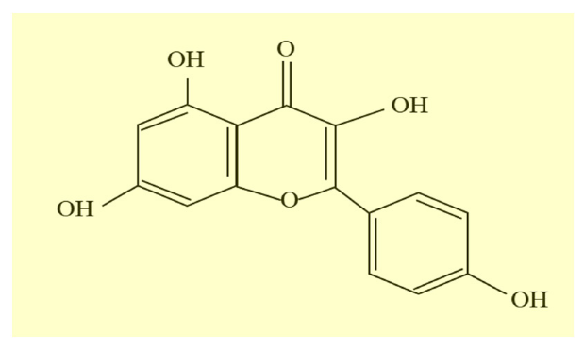
Figure 5. Chemical structure of Kaempferol (Qattan et al., 2022a).
Withaferin-A
Withaferin-A, a steroidal lactone derived from withania somnifera, has shown promise as an anticancer agent (I. Lee et al., 2016; Tsai et al., 2016). It act by modulating multiple signaling pathways, leading to reduced cell growth, induction of apoptosis, and greater sensitivity of cancer cells to standard chemotherapy drugs, however, more research is needed to fully understand its toxicity and potential side effects before it can be safely applied in clinical settings (Jenča et al., 2024; I. Lee et al., 2016; Tsai et al., 2016).
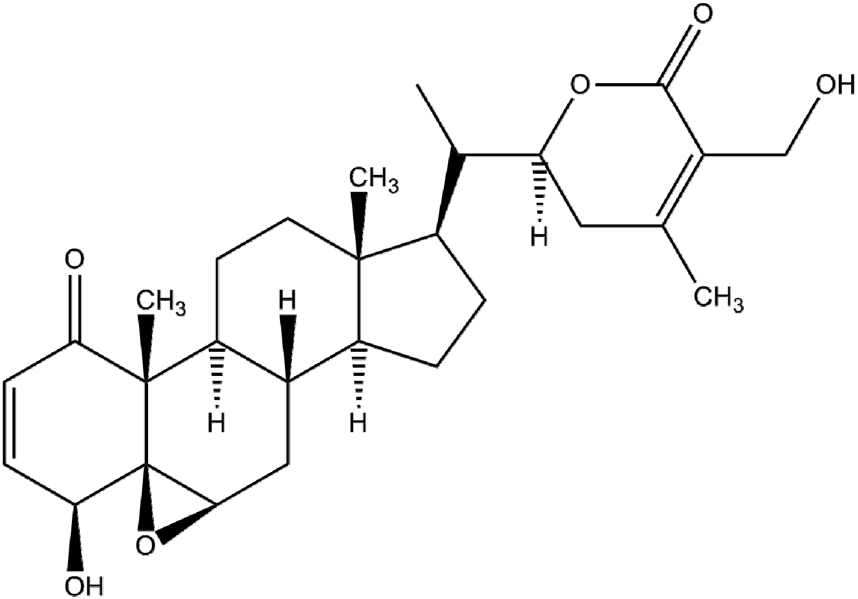
Fig 6. Structure of withaferin-A (I. C. Lee & Choi, 2016).

Quercetin
Quercetin, a flavonoid widely distributed in plants, demonstrates significant anticancer activity against many types of cancer, including pancreatic cancer (Asgharian et al., 2021a). it influences several cellular processes-including autophagy, apoptosis, redused cell growth, epithelial mesenchymal transition (EMT), and oxidative stress and also increases the sensitivity of cancer cells to chemotherapy (Asgharian et al., 2021a). its effectiveness in both cancer cell lines and animal models underscores its potential as a supportive therapy, especially when used alongside other treatments. Still, like many flavonoids, challenges such as bioavailability and clinical translation need further exploration (Asgharian et al., 2021a).

Sr. no. | Activity | Administration | Model | Dose (in)
1 | Apoptosis induction and anticancer effect | Direct treatment | MCF-7 and MDA-MB-231 | 25 μM (Asgharian et al., 2021a)
2 | autophagy and promoted cell survival | Direct treatment | Human umbilical vein endothelial cells (HUVECs) | 20 μM  (Asgharian et al., 2021a)
3 | ROS and free radical scavenging activity | Direct treatment | Erythrocystes | 5.7 μM  DPPH Assay
4 | Supressed autophagic flux, decreased liver injury by ethanol consumption | gavage | C57BL/6J mice on ethanol containing liber De Carli liquid diet | 100 mg kg⁻¹  (Asgharian et al., 2021a)
5 | Antimicrobial effect against streptococcus suis | Subcutaneous | Streptococcus suis infected mice | 100 mg kg⁻¹  (Asgharian et al., 2021a)
6 | Decreased fat accumulation in liver (ethanol induced) | Oral | Chronic ethanol feeding C57BL/6J MICE | 100 mg kg⁻¹  (Asgharian et al., 2021a)
7 | Higher insulin levels, improved dyslipidaemia, reduced serum blood glucose levels, decreased oxidative stress | Intraperitoneal | STZ induced diabetic rats | 30 mg kg⁻¹  (Asgharian et al., 2021a)
8 | Controlled insulin resistance, reduced blood sugar, pancreatic cells protection | Oral | STZ induced diabetic wistar rats | 100- 200 mg kg⁻¹  (Asgharian et al., 2021a)
9 | Controlled body weight and blood glucose, performance in the Morris water test | Oral | STZ induced diabetic rats | 5- 20 mg kg⁻¹  (Asgharian et al., 2021a)
10 | Enhanced the time spent by mice in the target quadrant in the Morris water maze task | Oral | STZ induced diabetic mice in the Morris water maze task | 40 mg kg⁻¹  (Asgharian et al., 2021a)

Table 1: A number of pharmacological activities of quercetin reported in recent studies (Asgharian et al., 2021b).

Other Intriguing Agent
Many other compounds which are derives from plants are currently being investigated for their ability to target signaling pathways in cancer. Among these are, but are not restricted to, resveratrol, genistein, and other flavonoids and polyphenols (Mohan Shankar et al., 2022). The different chemical structure of phytochemicals and the different biological activities of thes phytochemicals provide a great potential for developing novel cancer therapies. Further study is needed to fully interpret their mechanisms of action, effectiveness, and safety profiles before clinical application.
Limitations and Future Research Directions
Although there has been considerable advancement in the understanding the anti-cancer properties of plant-based compounds, several obstacles persist. Further investigation is required to better understand (Farghadani et al., 2021) the bioavailability and pharmacokinetics of these compounds to maximize their therapeutic potential (Farooqi et al., 2020a; Mondal et al., 2023). Developing targeted drug delivery systems, such as nano formulations, is essential for improving their delivery to cancer cells while reducing unintended effects (Farooqi et al., 2020a; Mondal et al., 2023).
Further, the different types of cancer cells for the development of customized and personalized treatments tailored to the tumor having unique and different molecular characters (Farghadani & Naidu, 2021b; Singh et al., 2026; Wang et al., 2020). Further studies are required to identify predictive biomarkers for treatment response and to comprehend the interaction between compounds derived from the plants and the tumor microenvironment (Farghadani & Naidu, 2021b; Wang et al., 2020). Combining plant-derived agents with traditional treatments may provide synergistic effects and help to overcome drug resistance. Clinical trials are essential for evaluating the safety and effectiveness of these natural agents across different cancer types and to validate their potential as anticancer therapies. Investigating the molecular mechanisms of compound derived from the plant can lead to the discovery of novel therapeutic approaches and pharmacological targets for the cancer treatment. Integrating interdisciplinary techniques is essential for future of plant derived medicines in cancer treatment. Network pharmacology brings together computer-based analysis and lab experiments, helping us better understand how these compounds interact with their molecular targets (Zheng et al., 2018). This approach can help uncover useful biomarkers and pave the way for more personalized treatments (Zheng et al., 2018). Developing innovative drug delivery systems- such as nano formulations and other advanced technologies is crucial for boosting bioavailability and ensuring that these compounds reach their intended targets (Farooqi et al., 2020a; Mondal et al., 2023). In addition, combining plant derived agents with conventional cancer therapies or other targeted tratments shows strong potential to improve patient outcomes (pharmacology & 2020, 2020; Uzoigwe et al., 2012; Yang et al., 2021). By tackling these challenges and pursuing new research directions, we can unlock the full therapeutic promise of plant-based agents in the fight against cancer.
Conclusion
Plant derived agents represent a promising alternative to conventional cancer therapies, showing strong anti-cancer effects by influencing key signalling pathways. Their ability to act on multiple pathways at once, combined with lower toxicity compared to standard chemotherapy, makes them compelling candidates for treatment. Still, challenges remain-such as improving bioavailability, achieving precise delivery, and fully understanding their complex behavior within the tumor microenvironment. Future studies should aim to overcome these hurdles through advanced drug delivery systems, personalized medicine strategies, and the use of network pharmacology. By bringing these approaches together, we can unlock the full therapeutic potential of plant-based agent to improve cancer care and enhance patients’ quality of life.

references
Asgharian, P., Tazehkand, A. P., Soofiyani, S. R., Hosseini, K., Martorell, M., Tarhriz, V., Ahangari, H., Cruz-Martins, N., Sharifi-Rad, J., Almarhoon, Z. M., Ydyrys, A., Nurzhanyat, A., Yessenbekova, A., & Cho, W. C. (2021a). Quercetin impact in pancreatic cancer: an overview on its therapeutic effects. Wiley Online LibraryP Asgharian, AP Tazehkand, SR Soofiyani, K Hosseini, M Martorell, V Tarhriz, H AhangariOxidative Medicine and Cellular Longevity, 2021•Wiley Online Library, 2021. https://doi.org/10.1155/2021/4393266
Asgharian, P., Tazehkand, A. P., Soofiyani, S. R., Hosseini, K., Martorell, M., Tarhriz, V., Ahangari, H., Cruz-Martins, N., Sharifi-Rad, J., Almarhoon, Z. M., Ydyrys, A., Nurzhanyat, A., Yessenbekova, A., & Cho, W. C. (2021b). Quercetin Impact in Pancreatic Cancer: An Overview on Its Therapeutic Effects. Oxidative Medicine and Cellular Longevity, 2021, 4393266. https://doi.org/10.1155/2021/4393266
Bouyahya, A., Mechchate, H., Oumeslakht, L., Zeouk, I., Aboulaghras, S., Balahbib, A., Zengin, G., Kamal, M. A., Gallo, M., Montesano, D., & El Omari, N. (2022). The role of epigenetic modifications in human cancers and the use of natural compounds as epidrugs: Mechanistic pathways and pharmacodynamic actions. Mdpi.ComA Bouyahya, H Mechchate, L Oumeslakht, I Zeouk, S Aboulaghras, A Balahbib, G ZenginBiomolecules, 2022•mdpi.Com, 12(3). https://doi.org/10.3390/BIOM12030367
Cancers, T. R.-, & 2015, undefined. (2015). Targeting RTK signaling pathways in cancer. Mdpi.ComT RegadCancers, 2015•mdpi.Com, 7(3), 1758–1784. https://doi.org/10.3390/CANCERS7030860
Chirumbolo, S., Bjørklund, G., Lysiuk, R., Vella, A., Lenchyk, L., & Upyr, T. (2018). Targeting cancer with phytochemicals via their fine tuning of the cell survival signaling pathways. Mdpi.ComS Chirumbolo, G Bjørklund, R Lysiuk, A Vella, L Lenchyk, T UpyrInternational Journal of Molecular Sciences, 2018•mdpi.Com, 19(11). https://doi.org/10.3390/IJMS19113568
Choi, E. J., Ryu, Y. K., Kim, S. Y., Wu, H. G., Kim, J. S., Kim, I. H., & Kim, I. A. (2010). Targeting epidermal growth factor receptor–associated signaling pathways in non–small cell lung cancer cells: Implication in radiation response. Aacrjournals.OrgEJ Choi, YK Ryu, SY Kim, HG Wu, JS Kim, IH Kim, IA KimMolecular Cancer Research, 2010•aacrjournals.Org, 8(7), 1027–1036. https://doi.org/10.1158/1541-7786.MCR-09-0507
Denlinger, C. E., Rundall, B. K., & Jones, D. R. (2004). Modulation of antiapoptotic cell signaling pathways in non-small cell lung cancer: the role of NF-κB. Elsevier, 16(1), 28–39. https://doi.org/10.1053/J.SEMTCVS.2003.12.004/ASSET/BCF95FED-38CD-4EC0-B3B5-F994F72FD3F2/MAIN.ASSETS/GR4.SML
Farghadani, R., & Naidu, R. (2021a). Curcumin: Modulator of Key Molecular Signaling Pathways in Hormone-Independent Breast Cancer. Cancers 2021, Vol. 13, Page 3427, 13(14), 3427. https://doi.org/10.3390/CANCERS13143427
Farghadani, R., & Naidu, R. (2021b). Curcumin: Modulator of Key Molecular Signaling Pathways in Hormone-Independent Breast Cancer. Cancers 2021, 13, 3427. Mdpi.Com, 13(14). https://doi.org/10.3390/CANCERS13143427
Farghadani, R., Naidu, R., Farghadani, R., & Naidu, R. (2021). Curcumin: Modulator of Key Molecular Signaling Pathways in Hormone-Independent Breast Cancer. Cancers 2021, Vol. 13, 13(14). https://doi.org/10.3390/CANCERS13143427
Farooqi, A. A., Pinheiro, M., Granja, A., Farabegoli, F., Reis, S., Attar, R., Uteuliyev, Y. S., Xu, B., & Ahmad, A. (2020a). EGCG mediated targeting of deregulated signaling pathways and non-coding RNAs in different cancers: Focus on JAK/STAT, Wnt/β-Catenin, TGF/SMAD. Mdpi.ComAA Farooqi, M Pinheiro, A Granja, F Farabegoli, S Reis, R Attar, UY Sabitaliyevich, B XuCancers, 2020•mdpi.Com, 12(4). https://doi.org/10.3390/CANCERS12040951
Farooqi, A. A., Pinheiro, M., Granja, A., Farabegoli, F., Reis, S., Attar, R., Uteuliyev, Y. S., Xu, B., & Ahmad, A. (2020b). EGCG Mediated Targeting of Deregulated Signaling Pathways and Non-Coding RNAs in Different Cancers: Focus on JAK/STAT, Wnt/β-Catenin, TGF/SMAD, NOTCH, SHH/GLI, and TRAIL Mediated Signaling Pathways. Cancers, 12(4), 951. https://doi.org/10.3390/CANCERS12040951
Jenča, A., Mills, D. K., Ghasemi, H., Saberian, E., Forood, A. M. K., Petrášová, A., Jenčová, J., Velisdeh, Z. J., Zare-Zardini, H., & Ebrahimifar, M. (2024). Herbal Therapies for Cancer Treatment: A Review of Phytotherapeutic Efficacy. Biologics : Targets & Therapy, 18, 229–255. https://doi.org/10.2147/BTT.S484068
Lee, I. C., & Choi, B. Y. (2016). Withaferin-A—A Natural Anticancer Agent with Pleitropic Mechanisms of Action. International Journal of Molecular Sciences 2016, Vol. 17, Page 290, 17(3), 290. https://doi.org/10.3390/IJMS17030290
Lee, I., sciences, B. C.-I. journal of molecular, & 2016, undefined. (2016). Withaferin-Aa natural anticancer agent with pleitropic mechanisms of action. Mdpi.Com, 17(3). https://doi.org/10.3390/IJMS17030290
Liu, L. H., Shi, R. J., & Chen, Z. C. (2020). Paeonol exerts anti-tumor activity against colorectal cancer cells by inducing G0/G1 phase arrest and cell apoptosis via inhibiting the Wnt/β-catenin signaling pathway. International Journal of Molecular Medicine, 46(2), 675–684. https://doi.org/10.3892/IJMM.2020.4629/DOWNLOAD
Mohan Shankar, G., Swetha, M., Keerthana, C. K., Rayginia, T. P., & Anto, R. J. (2022). Cancer Chemoprevention: A Strategic Approach Using Phytochemicals. Frontiers in Pharmacology, 12. https://doi.org/10.3389/FPHAR.2021.809308/FULL
Mondal, A., Nayak, A. K., Chakraborty, P., Banerjee, S., & Nandy, B. C. (2023). Natural polymeric nanobiocomposites for anti-cancer drug delivery therapeutics: A recent update. Mdpi.ComA Mondal, AK Nayak, P Chakraborty, S Banerjee, BC NandyPharmaceutics, 2023•mdpi.Com, 15(8). https://doi.org/10.3390/PHARMACEUTICS15082064
pharmacology, E. S.-E. review of clinical, & 2020, undefined. (2020). Cancer prevention and treatment using combination therapy with natural compounds. Taylor & FrancisER SauterExpert Review of Clinical Pharmacology, 2020•Taylor & Francis, 13(3), 265–285. https://doi.org/10.1080/17512433.2020.1738218
Qattan, M. Y., Khan, M. I., Alharbi, S. H., Verma, A. K., Al-Saeed, F. A., Abduallah, A. M., & Al Areefy, A. A. (2022a). Therapeutic Importance of Kaempferol in the Treatment of Cancer through the Modulation of Cell Signalling Pathways. Molecules 2022, Vol. 27, Page 8864, 27(24), 8864. https://doi.org/10.3390/MOLECULES27248864
Qattan, M. Y., Khan, M. I., Alharbi, S. H., Verma, A. K., Al-Saeed, F. A., Abduallah, A. M., & Al Areefy, A. A. (2022b). Therapeutic importance of kaempferol in the treatment of cancer through the modulation of cell signalling pathways. Mdpi.ComMY Qattan, MI Khan, SH Alharbi, AK Verma, FA Al-Saeed, AM Abduallah, AA Al AreefyMolecules, 2022•mdpi.Com, 27(24). https://doi.org/10.3390/MOLECULES27248864
Shrihastini, V., Muthuramalingam, P., Adarshan, S., Sujitha, M., Chen, J. T., Shin, H., & Ramesh, M. (2021). Plant Derived Bioactive Compounds, Their Anti-Cancer Effects and In Silico Approaches as an Alternative Target Treatment Strategy for Breast Cancer: An Updated Overview. Cancers, 13(24), 6222. https://doi.org/10.3390/CANCERS13246222
Siddiqui, A. J., Alshammari, A. M., Patel, M., Ghoniem, A. E. M., Siddiqui, M. A., Abdalla, R. A. H., Ghorbel, M., Badraoui, R., Bardakci, F., & Adnan, M. (2025). Anti-cancer effects of Plumbago zeylanica L. against human triple-negative breast cancer: Insights from network pharmacology and in-vitro experimental validation. South African Journal of Botany, 180, 795–810. https://doi.org/10.1016/J.SAJB.2025.03.051
Singh, V. Kumar., Singh, A. Kumar., & Garg, Neha. (2026). Plant-derived anticancer drugs.
Tilaoui, M., Ait Mouse, H., & Zyad, A. (2021). Update and New Insights on Future Cancer Drug Candidates From Plant-Based Alkaloids. Frontiers in Pharmacology, 12. https://doi.org/10.3389/FPHAR.2021.719694/FULL
Tsai, F. S., Lin, L. W., & Wu, C. R. (2016). Lupeol and its role in chronic diseases. Advances in Experimental Medicine and Biology, 929, 145–175. https://doi.org/10.1007/978-3-319-41342-6_7
Uzoigwe, J., pharmacology, E. S.-E. review of clinical, & 2012, undefined. (2012). Cancer prevention and treatment using combination therapy with plant-and animal-derived compounds. Taylor & FrancisJ Uzoigwe, ER SauterExpert Review of Clinical Pharmacology, 2012•Taylor & Francis, 5(6), 701–709. https://doi.org/10.1586/ECP.12.62
Wang, X., Semba, T., Phi, L. T. H., Chainitikun, S., Iwase, T., Lim, B., & Ueno, N. T. (2020). Targeting signaling pathways in inflammatory breast cancer. Mdpi.ComX Wang, T Semba, LTH Phi, S Chainitikun, T Iwase, B Lim, NT UenoCancers, 2020•mdpi.Com, 12(9), 1–19. https://doi.org/10.3390/CANCERS12092479
Yang, M. H., Baek, S. H., Ha, I. J., Um, J. Y., & Ahn, K. S. (2021). Brassinin enhances the anticancer actions of paclitaxel by targeting multiple signaling pathways in colorectal cancer cells. Wiley Online LibraryMH Yang, SH Baek, IJ Ha, JY Um, KS AhnPhytotherapy Research, 2021•Wiley Online Library, 35(7), 3875–3885. https://doi.org/10.1002/PTR.7095
Zheng, J., Wu, M., Wang, H., Li, S., Wang, X., Li, Y., Wang, D., & Li, S. (2018). Network pharmacology to unveil the biological basis of health-strengthening herbal medicine in cancer treatment. Mdpi.Com, 10(11). https://doi.org/10.3390/CANCERS10110461

