Sustainable Resource Management Practices in Malaysian Higher Education Institution: A Case Study of Universiti Tun Hussein on Malaysia
Nur Irdina Fatini Abdul Halim¹, Abdul Jalil Omar^{1*}, Marlina Mohamad²
¹Faculty of Technology Management and Business,Universiti Tun Hussein Onn, Malaysia
²Faculty of Technical and Vocational EducationUniversiti Tun Hussein Onn, Malaysia
*Corresponding Author
DOI: https://doi.org/10.47772/IJRISS.2026.1015EC00013
Received: 06 February 2026; Accepted: 13 February 2026; Published: 23 February 2026
ABSTRACT
This study examines sustainable resource management practices at Universiti Tun Hussein Onn Malaysia (UTHM), identifies factors affecting their implementation, and proposes improvement strategies. A mixed-methods design was employed: an online questionnaire completed by 139 respondents (students and staff) and semi-structured interviews with representatives from the Sustainable Campus Office (SCO) and the Development and Maintenance Office (PPP). Triangulated analysis indicates that while UTHM has implemented multiple sustainability initiatives, effectiveness varies across domains. Senior-management support, campus community awareness, and stakeholder collaboration emerged as key enablers; policy alignment, infrastructure and financing, and performance monitoring were identified as areas requiring strengthening. Based on these findings, the study recommends reinforcing institutional policies and KPIs, adopting and scaling green technologies (e.g., energy monitoring and storage systems), and enhancing communication and incentive mechanisms to boost stakeholder engagement.
Keywords: sustainable resource management, sustainable campus, higher education institutions.
INTRODUCTION
Sustainable resource management practices have become a critical agenda in higher education institutions worldwide, including Malaysia. Universities today operate not only as centres of learning and research but also as catalysts for sustainability, particularly in relation to behavioural change, learning and educational tools, and physical infrastructure. In Malaysia, scholarly attention towards sustainability practices has been increasing, as demonstrated in research conducted at the University of Malaya that highlights waste management and external collaboration as significant sustainability initiatives. At Universiti Tun Hussein Onn Malaysia (UTHM), sustainable resource management initiatives such as waste management, energy utilisation, and recycling have been introduced; however, questions regarding the effectiveness of these practices and the factors influencing their implementation remain insufficiently explored (Abu Samah & Mohammad, 2025).
Despite growing commitments among higher education institutions to support sustainability agendas, the practical implementation of sustainability practices often encounters barriers. Research by Mohammadi et al. (2023) emphasises the significant roles of leadership, organisational culture, and the knowledge and attitudes of students and staff in integrating sustainable development within universities (Mohammadi et al., 2023). Furthermore, findings from metaphor analysis among students indicate that lack of commitment, knowledge, and supportive structures are central challenges in advancing sustainable campus concepts (Kızıloğlu & Cici Karaboğa, 2025). Within UTHM, empirical research focusing on sustainable resource management remains limited, with current initiatives largely centred on physical elements such as green building improvements, while behavioural, educational, and organisational dimensions including human resources, financial support, infrastructure, and external collaboration receive comparatively less attention.
Accordingly, this study focuses on identifying the sustainable resource management practices at UTHM, determining the factors influencing their implementation, and proposing strategies for improvement. The study uses UTHM’s main campus in Parit Raja, Johor, as a case, covering four core dimensions of resource sustainability: energy management, water management, solid waste management, and recycling practices. Data collection involves staff as primary respondents and students as supporting respondents, using questionnaires and interviews conducted in 2025. The study aligns with the context of Malaysian public universities and UTHM’s commitment to supporting the Sustainable Development Goals (SDGs), particularly SDG 12 (Responsible Consumption and Production) and SDG 13 (Climate Action).
This research contributes new insights to UTHM, the academic community, and relevant stakeholders. For UTHM, it provides an integrated assessment of existing sustainable resource management practices, identifies strengths and weaknesses, and offers strategic recommendations to enhance sustainability performance at the campus level. From an academic perspective, the study enriches existing sustainability literature by foregrounding sustainable resource management within Malaysian higher education institutions, an area less examined compared to general green campus research. The findings also benefit policymakers, campus administrators, students, and university staff by enhancing awareness of their respective roles in promoting more effective and holistic sustainable resource management practices.

LITERATURE REVIEW
This chapter presents a comprehensive review of previous research related to the study topic. The literature review consists of references and findings from past studies that support the development of the research framework. Its primary purpose is to understand the current state of knowledge in the field and to identify gaps that warrant further investigation.

Concept and Definition of Sustainable Resource Management Practices
Sustainable resource management practices refer to the efficient and responsible utilisation of energy, water, materials, and waste within the campus environment. In higher education institutions, such practices encompass not only physical and operational aspects (such as infrastructure and facilities) but also educational dimensions and the cultivation of a sustainability culture among students and staff. Prior studies indicate that sustainable campus development may be analysed based on behavioural dimensions, learning or educational tools, and physical facilities (Sugiarto & Lee, 2022), while modelling and indicator development in Malaysia is still at an early stage (Husaini & Jusoh, 2017). Accordingly, this study focuses on energy and water usage, solid waste management, material reduction, recycling, and sustainability-oriented educational and cultural initiatives within universities.

Sustainable Resource Management Practices in Higher Education Institutions
The literature shows that higher education institutions play a vital role in implementing sustainable resource management across various campus operational domains. Key sustainability focus areas include carbon neutrality, energy consumption, water and waste management, and circular economy approaches (Oliveira & Proença, 2025). In Malaysia, sustainable campus initiatives in public universities encompass several core domains such as buildings, energy systems, water, waste, air-conditioning systems, and transportation (Sa’adi et al., 2025), but implementation faces challenges related to commitment, knowledge, and institutional support (Mohd Muhiddin et al., 2023).

Factors Influencing the Implementation and Effectiveness of Sustainable Resource Management Practices
Various studies have identified multiple factors influencing the implementation and effectiveness of sustainable resource management practices in higher education institutions. In this study, these factors are classified as independent variables that potentially affect the dependent variable, namely sustainable resource management practices. The key factors identified in the literature are as follows:

Leadership and Management Support
The literature highlights that top management commitment is critical to the success of sustainability practices,
reflected through sustainable policies, the establishment of sustainability offices, integration into university strategies, and sufficient resource allocation (Oliveira & Proença, 2025; Bauer et al., 2021). The establishment of dedicated units such as Green Offices may strengthen coordination, communication, and sustainability programming, although effectiveness depends on institutional support and alignment with existing structures (Filho et al., 2019). The integration of sustainability into strategic planning and university missions ensures continuity, although such efforts are often challenged by structural fragmentation and limited coordination (Galvin Kuan Sian Lee, 2025). Furthermore, financial constraints and capacity limitations among staff represent common barriers, making financial resources and human capacity development essential elements for successful implementation (Price et al., 2021).
Campus Community Attitudes, Awareness, and Culture
The awareness and attitudes of campus stakeholders including academic staff, administrative staff, and students significantly influence sustainable behaviours such as recycling, reducing energy and water consumption, and participating in sustainability activities. Studies in Thailand indicate that awareness of green campus policies correlates with participation levels, whereby individuals with higher awareness are more likely to engage actively (Jirathananuwat et al., 2025). Furthermore, literature emphasises the role of psychosocial factors such as personal values, attitudes, and social norms in promoting pro-environmental behaviour, including relationships between education, intentions, and sustainable behaviours in higher education contexts (Sugiarto et al., 2022).
Infrastructure and Financial Resources
The implementation of energy-efficient systems, recycling programmes, water management, and waste management requires suitable infrastructure, technology, and sustained financing. Studies indicate that changes in university strategies, proactive leadership, and good governance structures are essential for integrating investments in green infrastructure and resource monitoring systems into daily operations (Magdalena Maria Popowska, 2023; Oliveira & Proença, 2025). Additionally, financial sustainability including diversified income streams beyond government funding is considered crucial to ensure long-term sustainability projects and infrastructure (OECD, 2025). Without sufficient technical and financial support, sustainability initiatives are difficult to scale or maintain.
Policy, Strategy, and Curriculum Integration
Holistic approaches emphasise that sustainability should not be viewed solely as an operational issue but should be embedded across policies, strategies, curricula, and research activities. Sugiarto et al. (2022) note that sustainable campus development encompasses educational and learning dimensions, in addition to physical facilities. Similarly, Oliveira & Proença (2025) demonstrate that without curriculum integration, the adoption of sustainability values and practices becomes limited as campus stakeholders lack exposure to sustainability competencies. Institutional strategies, therefore, must integrate teaching, research, and operations to ensure sustainability becomes an ongoing organisational culture.
Stakeholder Engagement and External Partnerships
Campus sustainability relies not only on internal efforts but also on engagement and collaboration with diverse stakeholders, including local communities, students, university administrators, government bodies, and industry partners. Studies in Thailand indicate that external collaboration, administrative support, and active engagement from the entire campus community are significant drivers of green campus success (Jirathananuwat et al., 2025). Furthermore, Razman et al. (2018) emphasise that internal and external collaboration is critical for resource mobilisation and the sharing of best practices. Such multi-stakeholder engagement ensures more effective and sustainable implementation of campus sustainability initiatives.
THEORETICAL AND CONCEPTUAL FRAMEWORK
The theoretical framework explains how factors such as leadership, campus stakeholder awareness, technical and financial resources, and stakeholder collaboration influence sustainable resource management practices in higher education institutions.
i. Resource-Based View (RBV)
The Resource-Based View highlights that organisations achieve competitive advantages when managing resources that are valuable, rare, inimitable, and strategically aligned. In universities, these resources include leadership, organisational culture, infrastructure, technology, and external collaborations that support sustainability practices. Studies show that RBV explains how sustainable leadership and green innovation improve institutional sustainability performance (Umar et al., 2025). Therefore, management support, infrastructure, and stakeholder engagement are considered strategic resources influencing sustainability outcomes at UTHM (Umar et al., 2025).
ii. Institutional Theory
Institutional Theory focuses on how organisations, including universities, respond to external institutional pressures such as government regulations, societal expectations, global rankings, and internal structures such as organisational culture and governance. Within campus sustainability, this implies that universities may adopt sustainability policies or units in response to societal or sectoral pressures and expectations (Galleli et al., 2021).
iii. Systems Thinking Theory
Systems Thinking views organisations as complex systems where interconnected components influence overall behaviour. In campus sustainability, it positions universities as ecosystems linking operations, culture, technology, and communities (Koral Kordova et al., 2018). For UTHM, sustainable practices are thus seen as requiring integration across operations, teaching, research, and external collaboration. The combination of RBV, Institutional Theory, and Systems Thinking forms a robust theoretical foundation for understanding sustainable resource management practices in higher education.
iv. Sustainable Campus Framework
The Sustainable Campus Framework provides comprehensive guidance for universities to incorporate sustainability across teaching, research, operations, and community engagement. UNEP identifies four core domains environment and climate, teaching and research, society and people, and governance to ensure systematic implementation of sustainability principles (UNEP, 2021). In Malaysia, A. Nifa et al. (2015) propose an initial framework for Universiti Utara Malaysia using Integrated Project Delivery, emphasising collaboration across units and campus functions in sustainable development planning and execution. Overall, these frameworks demonstrate that building a sustainable campus requires holistic approaches integrating infrastructure, operations, academic functions, and external relations to support long-term sustainability.
Summary of Past Studies and Research Gaps

Summary of Past Studies
Previous research shows that the concept of sustainable campuses has been explored through various dimensions and approaches. Sugiarto and Lee (2022) identify three primary dimensions of sustainable campus development: behaviour, learning and educational tools, and physical facilities, all of which reflect strategies and programmes used by global universities. From an operational perspective, Oliveira & Proença (2025) highlight themes such as carbon neutrality, energy usage, waste, and environmental management, although comparative studies and financial mechanisms remain limited. In Malaysia, Sa’adi et al. (2025) find that public universities have sustainability action plans, but implementation and SDG alignment vary significantly. From a curriculum perspective, Said & Sabri (2024) demonstrate that curriculum integration increases understanding and awareness of sustainable development among campus communities.
Research Gaps
Despite growing interest in campus sustainability research, several gaps persist. First, there is a lack of comparative studies among universities, particularly technical universities such as UTHM (Oliveira & Proença, 2025). Second, financial mechanisms and funding models for sustainability remain underexplored, including sustainable resource allocation strategies (Oliveira & Proença, 2025). Third, sustainability performance reporting and data measurement are inconsistent, limiting assessment and cross-institutional comparison (Oliveira & Proença, 2025). Fourth, although curriculum integration improves sustainability awareness, attitudes, organisational culture, and behavioural aspects require deeper investigation (Said & Sabri, 2024; Putra & M. Ulkhaq, 2025). Finally, most studies focus on general universities, while the context of Malaysian technical universities remains under-researched. Hence, this study offers empirical and conceptual contributions to understanding factors influencing sustainability practices at UTHM.
This section summarises literature on sustainable resource management practices in universities, highlighting five major influencing factors: leadership and management support; campus community attitudes and awareness; infrastructure and technological resources; institutional policies and strategies; and stakeholder collaboration. The section also outlines the theoretical and conceptual frameworks explaining relationships between independent and dependent variables, and identifies research gaps in the context of Malaysian technical universities, particularly UTHM. Overall, this section provides the theoretical and empirical foundation for the research methodology.

RESEARCH METHODOLOGY
This section presents the research design, research approach, population and sampling, instruments and data collection procedures, methods of analysis, ethical considerations, and quality assurance measures. This study adopts a mixed-methods approach, combining quantitative and qualitative methods to allow for measurement of the level of sustainability practices and an in-depth understanding of the driving factors and barriers to their implementation at UTHM.
1. Research Design and Justification
This study employs a mixed-methods approach to integrate quantitative and qualitative data, enabling a comprehensive understanding of the implementation factors of sustainable resource management practices and the relationships between methods (Saul McLeod, 2024). Quantitative data are collected through questionnaires to analyze patterns and statistical relationships, while interviews are used for qualitative data to provide context and explanations for the quantitative findings. This approach also allows for data triangulation and complementarity, enhancing accuracy and understanding of complex phenomena. Additionally, secondary data from databases, journal articles, and reports are used to support the analysis and address the research questions.
2. Data Collection
Data were collected through multiple methods, including questionnaires, observations, interviews, and document analysis. Instruments used include audio recordings during interviews to ensure data accuracy and reliability. Quantitative questionnaire instruments and qualitative interview instruments were developed separately according to the requirements of each data collection method.
i. Primary Data
Primary data refers to original data collected specifically to address the research questions and is considered an unprocessed source, such as observations, interviews, and questionnaires (Hua, 2013). In this study, interviews are used as a method to obtain in-depth information through personal interaction between the researcher and informants, which is then analyzed through transcription, categorization, and theme generation. In addition, structured observations are used to identify sustainable resource management practices and factors influencing their implementation at UTHM, using a checklist developed based on literature and research objectives.
Observations are conducted systematically at specified times and locations, allowing data to be recorded consistently and analyzed descriptively, thereby enhancing the objectivity and reliability of the research findings.
ii. Secondary Data
Secondary data refers to data previously collected by others that can be reused by the researcher, usually processed or published in the form of reports, official statistics, books, journals, government documents, or digital sources (U. Jerinabi, n.d.). In this study, secondary data were obtained through internet searches. Internet searches allow the researcher to gather theories, ideas, and previous research findings relevant to the study, helping to build the theoretical framework and provide an initial understanding of the research subject. Additionally, it is used to obtain information from official websites and online sources, including policies, guidelines, current programs, and official university statistics that support the analysis and discussion of the study.
3. Research Respondents
This section explains that the respondents of this study consist of individuals involved in sustainable resource management practices at UTHM, including the Sustainable Campus Office (SCO) and the Office of Development and Maintenance (PPP). These respondents were selected because they are directly involved and have experience in implementing sustainable resource management practices at UTHM. In this study, two (2) respondents, one from each office, were selected to align with the qualitative approach, which emphasizes the depth of information related to the research topic.
4. Data Analysis
Data analysis is a crucial research process, as stated by Anuar et al. (2023), involving the systematic management and processing of data to transform raw data into meaningful information that answers research questions and supports conclusions. This process includes data examination, cleaning, transformation, and modeling using appropriate techniques to obtain useful information, identify themes, and support the development and testing of hypotheses. In this study, qualitative data were processed and analyzed to achieve a deeper understanding of the research findings. Descriptive analysis was used to explain the research data through mean values to determine the level of implementation and respondents’ agreement with the items studied. Table 3.1 shows that the same research methods were applied to all three research objectives, as they are interrelated and analyzed using a combination of quantitative and qualitative methods.
Table 1: Data Analysis
Items | Objectives | Methodology
1 | Identify sustainable resource management practices at UTHM. | Interview  Sustainable Campus Office (SCO) and Development and Maintenance Office (PPP)
2 | Identify factors in the implementation of sustainable resource management practices at UTHM. | Survey Using Questionnaire  139 sets of sample questionnaires using Cochran Formula (1977)
3 | Propose strategies for improving sustainable resource management practices at UTHM. | Secondary Data  References, journal articles, official documents, reports, and online sources.

DATA ANALYSIS AND DISCUSSION
This section discusses the research findings derived from the analysis of quantitative and qualitative data. The analysis aims to address the three research objectives: identifying sustainable resource management practices at Universiti Tun Hussein Onn Malaysia (UTHM), determining the factors influencing the implementation of these practices, and proposing strategies to improve sustainable resource management at UTHM. The findings were obtained through online questionnaires and semi-structured interviews, and are presented in the form of tables, graphs, and descriptive narratives.
Questionnaire Analysis: Sustainable Resource Management Practices at UTHM
This section addresses the second and third research objectives, namely the factors affecting the implementation of sustainable resource management practices at UTHM and recommendations for their improvement. The questionnaire was conducted to obtain data and perspectives from the UTHM community regarding the level of sustainability practices and suggestions for enhancement. The questionnaire was administered online using Google Forms. A total of 139 respondents, comprising students, academic staff, and non-academic staff, participated in the study, providing complete and cooperative feedback.
Section A: Respondent Demographic Information
The findings indicate that respondents came from various faculties, genders, categories, lengths of service or study, education levels, and residential locations within UTHM. Participation from different faculties reflects broad engagement across the university community, while gender balance allows for a more representative perspective on sustainable resource management practices. Respondents included students as well as academic and non-academic staff, enabling the study to evaluate sustainability practices across different institutional roles. Analysis of the length of service or study highlights varying levels of experience, with experienced individuals providing insights based on the history of practice implementation, while newer members offer fresh perspectives. The diversity of education levels allows the study to assess understanding and awareness of sustainability issues, while differences in residential location provide an indication of respondents’ exposure to campus sustainability facilities and initiatives. Overall, these findings are representative and comprehensive.
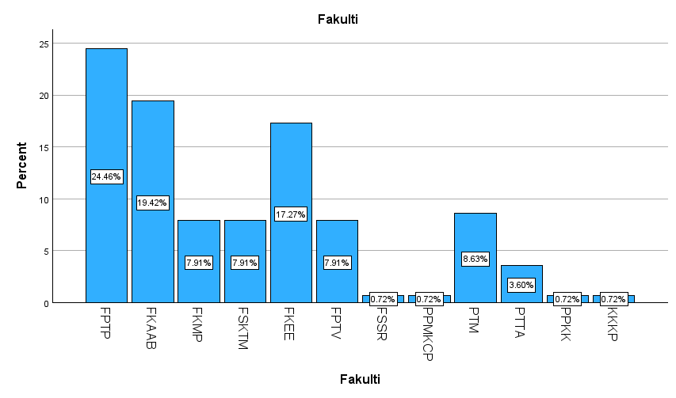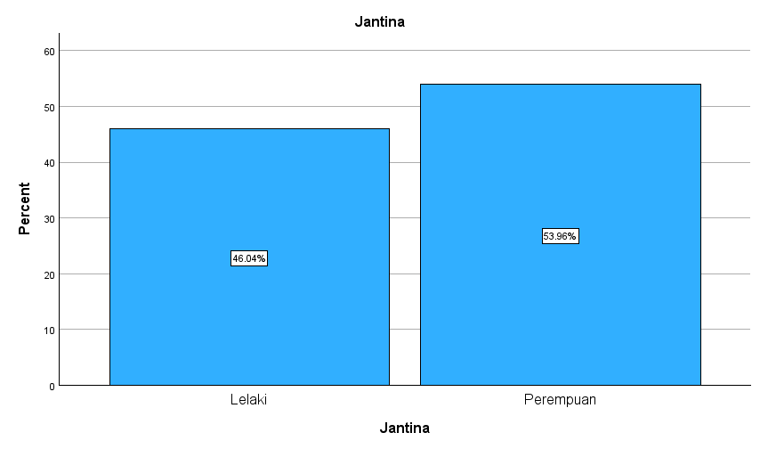
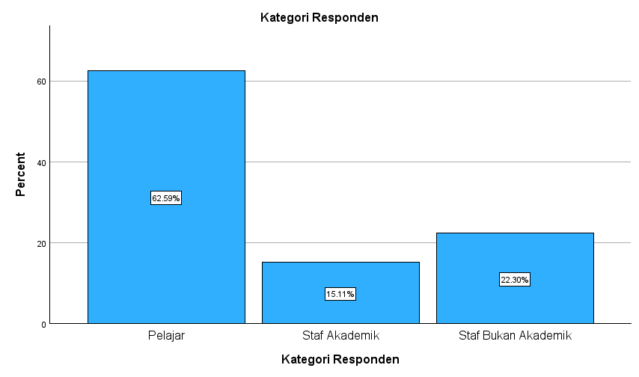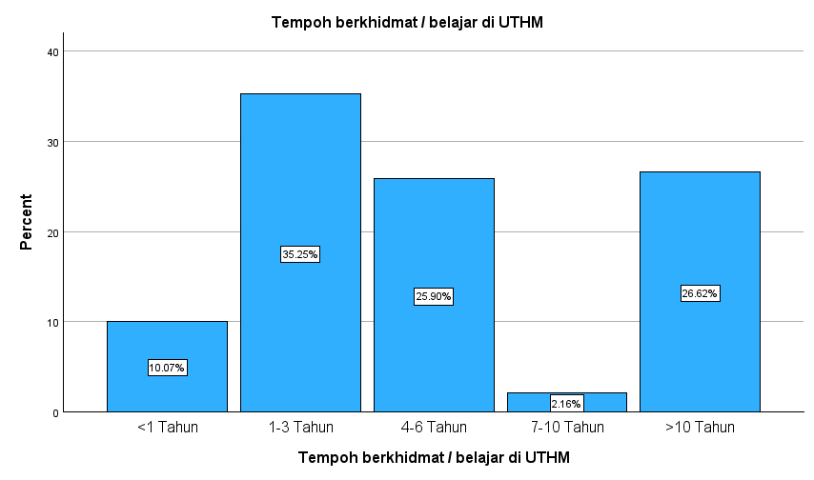
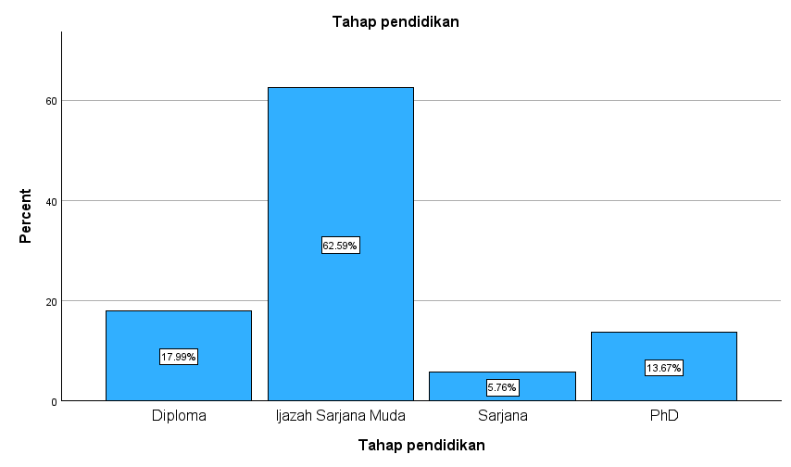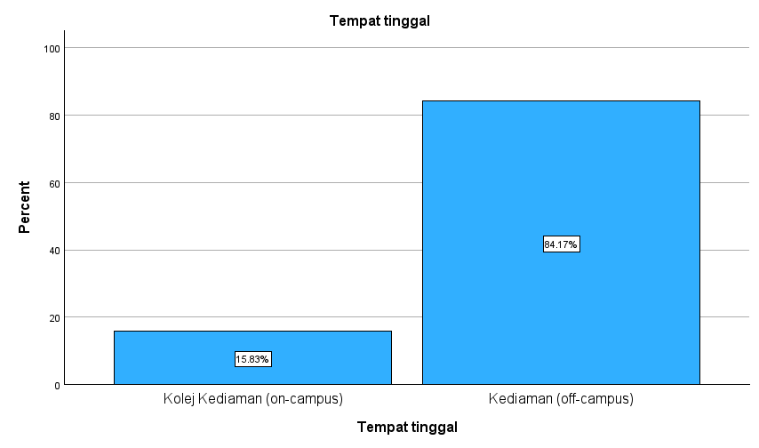
Figure 1: Respondent Demographic Information
ii. Section B: Descriptive Analysis of Factors Influencing the Implementation of Sustainable Resource Management Practices at UTHM
Table 2: Factors Influencing the Implementation of Sustainable Resource Management Practices at UTHM
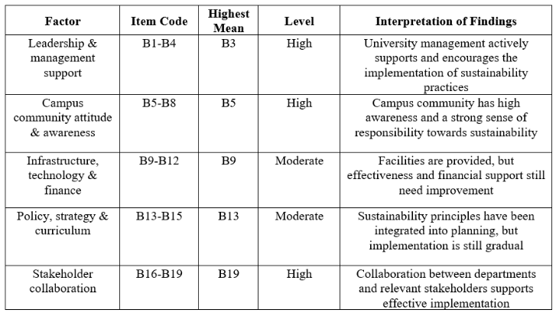
Based on Table 4.1, the quantitative findings indicate that management leadership, campus community awareness, and stakeholder collaboration are at a high level, whereas aspects of infrastructure, technology, financial support, and policy implementation still require improvement to enhance the effectiveness of sustainability practices at UTHM.
iii. Section C: Descriptive Analysis of Recommendations for Improving Sustainable Resource Management Practices at UTHM
Table 3: Recommendations for Improving Sustainable Resource Management Practices at UTHM
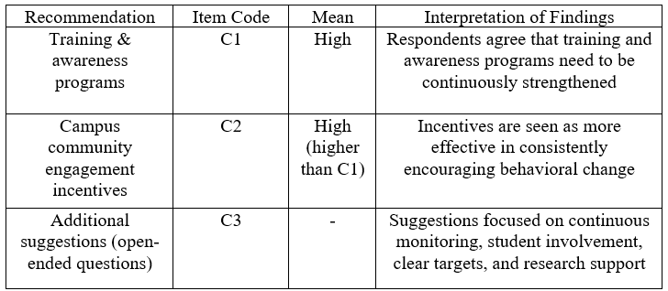
2. Qualitative Study Analysis
Qualitative analysis was conducted on information obtained from two key informants: a representative from the Sustainable Campus Office (SCO) and a representative from the Office of Development and Maintenance (PPP), both with over 10 years of service at UTHM. Interview data were audio-recorded, transcribed, and analyzed to identify categories, themes, and patterns of experience and perspectives regarding policies, strategies, practices, and challenges in implementing sustainability. This qualitative analysis enables the researcher to understand the context, enrich quantitative findings, and support practical recommendations for improvement.
Table 4: Respondent Background
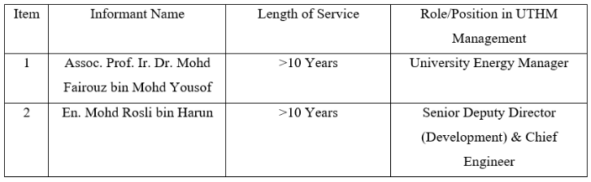
i. Findings for Objective 1: Identifying Sustainable Resource Management Practices at UTHM
Based on interviews with the two key informants at UTHM, the findings show that sustainable resource management practices are implemented gradually and systematically.
Table 5: Interview Findings on Sustainable Resource Management Practices at UTHM

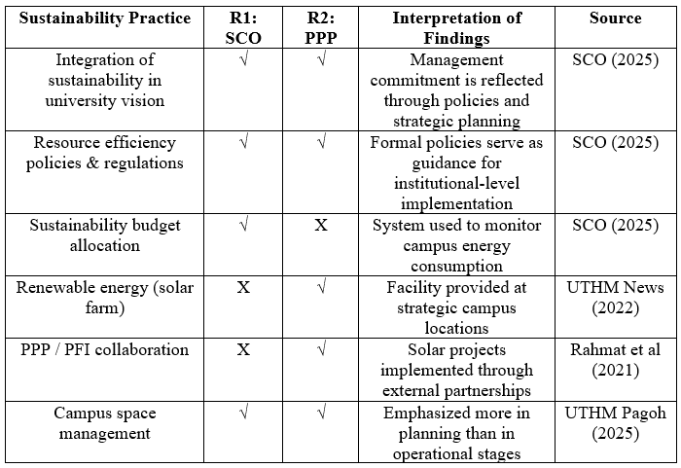

ii. Findings for Objective 2: Identifying Factors Influencing the Implementation of Sustainable Resource Management Practices at UTHM

Table 6: Interview Findings on Factors Influencing the Implementation of Sustainability Practices at UTHM
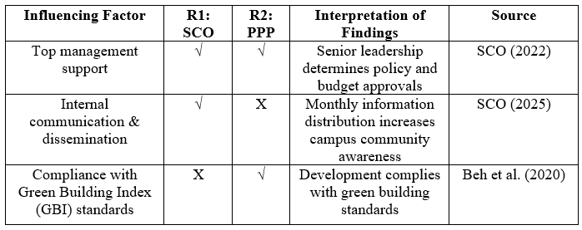
iii. Findings for Objective 3: Recommendations and Strategies for Improving Sustainable Resource Management Practices at UTHM

Table 7: Interview Findings on Recommendations & Improvement Strategies for Sustainability Practices at UTHM
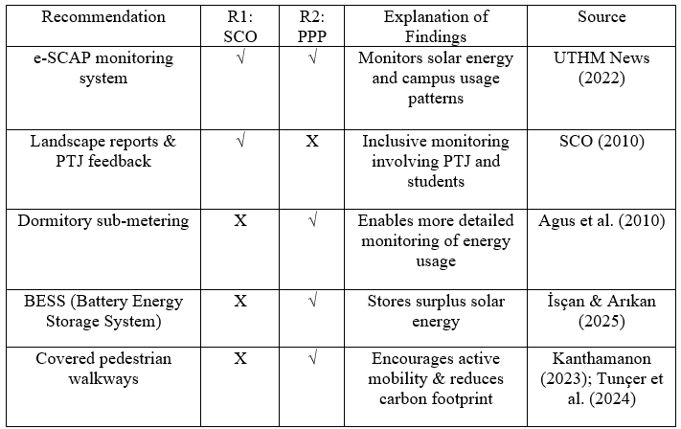
DISCUSSION
This discussion evaluates the research findings comprehensively by integrating both quantitative and qualitative analyses to address all three research objectives. This triangulated approach enables a more holistic understanding of the practices, implementation factors, and improvement strategies related to sustainable resource management at Universiti Tun Hussein Onn Malaysia (UTHM).
For Research Objective 1, the qualitative findings show that UTHM has implemented sustainable resource management practices in stages and in a structured manner. Support from top management, reflected through the integration of sustainability in the university vision, policy formulation, and dedicated budget allocation, demonstrates the institution’s commitment to the sustainable development agenda. The implementation of initiatives such as the use of renewable energy through solar farm projects, Public-Private Partnership (PPP/PFI) collaborations, and more efficient campus space management indicates a holistic approach to resource administration. These findings align with the view that sustainability in higher education institutions must be supported by institutional policies, strategic planning, and systematic asset management to ensure long-term effectiveness.
For Research Objective 2, quantitative results indicate that leadership and management support, campus community attitudes and awareness, and stakeholder collaboration are at a high level, while infrastructure, technology, financial support, and policy implementation are at a moderate level. These findings are reinforced by interview results which highlight that top management support is the primary driver of successful sustainability implementation, particularly through policy approval, financial allocation, and consistent internal communication. However, limitations in maintenance costs, technological capacity, and physical campus challenges, such as soft soil conditions, hinder operational effectiveness. The gap between strategic planning and operational execution suggests that the success of sustainability initiatives depends not only on policy commitment but also on the technical and financial capabilities of the institution.
For Research Objective 3, quantitative findings demonstrate strong respondent support for improvement recommendations, particularly incentives to enhance campus community participation and the strengthening of training and awareness programs. The qualitative findings provide more practical and technical improvement strategies, including the use of the e-SCAP energy monitoring system, installation of sub-metering in student dormitories, deployment of Battery Energy Storage Systems (BESS), and improvement of supporting infrastructure such as covered pedestrian walkways. Taken together, these findings indicate that improving sustainability practices requires an integrated approach encompassing technological solutions, behavioral management, financial planning, and campus community involvement.
Overall, this discussion shows that sustainable resource management practices at UTHM are on a strong foundational trajectory in terms of policy and institutional commitment. However, continuous improvements are required in aspects of implementation, monitoring, and campus community participation. The integration of quantitative and qualitative findings strengthens the conclusion that effective campus sustainability requires a balance between strategic leadership, operational capability, and behavioral change among university stakeholders.

CONCLUSION AND RECOMMENDATION
This section presents the overall conclusions of the study based on the research objectives, limitations encountered during the research process, and recommendations for future improvement related to the research topic.
1. Conclusion on the Achievement of Research Objectives
Overall, this study successfully achieved all three research objectives. For the first objective, which was to identify sustainability practices in resource management at Universiti Tun Hussein Onn Malaysia (UTHM), both quantitative and qualitative findings indicate that sustainability initiatives have been implemented progressively and in a structured manner through institutional policies, the use of renewable energy, systematic spatial management, and strategic collaboration with external stakeholders.
For the second objective, the study found that top management support, compliance with green building standards, availability of infrastructure and technology, as well as the level of awareness among campus communities, are the primary factors influencing the effectiveness of sustainability implementation at UTHM. These factors act as enablers that support the successful execution of sustainability strategies, particularly in the context of campus resource management.
Furthermore, the third objective was achieved through the identification of improvement strategies that are both realistic and implementable, including the enhancement of monitoring systems, upgrading of supporting infrastructure, provision of incentives, and stronger engagement of the campus community. In conclusion, the findings demonstrate that sustainability resource management at UTHM is on a positive trajectory, but continuous improvement is necessary to attain a more comprehensive, effective, and sustainable level of implementation.
2. Research Limitations
Several limitations were identified throughout the study, including:
Research Design
This study employed a cross-sectional research design, where data were collected at a single point in time. As such, the findings only reflect current implementation status and do not capture behavioural changes, developmental progress, or long-term impacts of sustainability resource management initiatives at UTHM.
Scope and Sample Size
The scope of this study is limited to a single higher education institution, Universiti Tun Hussein Onn Malaysia (UTHM), involving 139 respondents and two key informants. This limitation restricts the generalisability of findings to other higher education institutions that may differ in organisational structure, management practices, and institutional culture.
Data Collection Methods
Data collection relied on questionnaires and interviews, which may be subject to response bias, particularly social desirability bias where respondents tend to provide positive or socially acceptable answers. Additionally, interview findings were based on the perspectives and experiences of specific informants, which may not fully represent the views of the entire university population.

Access to Internal Data and Documents
Access to strategic documents, energy performance data, and financial information was restricted due to confidentiality considerations. These constraints limited the researcher’s ability to conduct more in-depth analyses on the actual effectiveness of sustainability resource management practices.
Recommendations for Improvement
Based on the findings, several recommendations can be considered to strengthen sustainability resource management practices at UTHM. These include establishing clearer monitoring mechanisms through the development of Key Performance Indicators (KPIs) for each sustainability initiative. In addition, sustainability training and awareness programmes should be enhanced and supported with incentives to encourage more active participation among the campus community. The utilisation of technological solutions, such as energy monitoring systems, should also be maximised to improve resource management efficiency. For future research, longitudinal studies or comparative studies between institutions are recommended to evaluate the long-term effectiveness of sustainability initiatives and to improve generalisability.
Closing Remarks
In conclusion, this study provides a clear understanding of the current state of sustainability resource management practices at Universiti Tun Hussein Onn Malaysia (UTHM), as well as the factors influencing their implementation. The findings reveal that institutional support, policy frameworks, and community engagement play critical roles in advancing the sustainability agenda at the campus level. It is anticipated that the results of this study will serve as a reference and guidance for the university and future researchers in strengthening campus sustainability practices in a more systematic, structured, and sustainable manner.

ACKNOWLEDGEMENT
The author would like to express sincere appreciation to Universiti Tun Hussein Onn Malaysia, the Sustainable Campus Office (SCO), and the Development and Maintenance Office (PPP) for their cooperation and support.

Conflict Of Interest
The author confirms that there is no conflict of interest regarding the publication of this paper.

REFERENCES
- Abdul Nifa, F. A., Mohd Nawi, M. N., Osman, W. N., & Abdul Rahim, S. (2015). Towards Development Of Sustainable Design In Malaysian University Campus: A Preliminary Framework For Universiti Utara Malaysia. Jurnal Teknologi, 77(5), 1–9. https://doi.org/10.11113/jt.v77.6115
- Abu Samah, A. S., & Mohammad, M. (2025). Environment, Social and Governance (ESG) Implementation at A Malaysian Public University: An Exploratory Case Study. 6(1), 173–181. https://doi.org/https://doi.org/10.30880/rpmme.2025.06.01.018
- Anuar, M. A. M. S. A., Musa, S. M. S., Kasim, N., & Abd Rahim, M. H. I. (2023). Kajian Kepentingan Pembinaan Sistem Saliran di Sesebuah Projek Pembinaan Bagi Mengatasi Masalah Banjir. Research in Management of Technology and Business, 4(1), 1422–1439.
- Bauer, M., Rieckmann, M., Niedlich, S., & Bormann, I. (2021). Sustainability Governance at Higher Education Institutions: Equipped to Transform? Frontiers in Sustainability, 2(April), 2019–2022. https://doi.org/10.3389/frsus.2021.640458
- Filho, W. L., Will, M., Salvia, A. L., Adomßent, M., Grahl, A., & Spira, F. (2019). The role of green and Sustainability Offices in fostering sustainability efforts at higher education institutions. Journal of Cleaner Production, 232, 1394–1401. https://doi.org/10.1016/j.jclepro.2019.05.273
- Galleli, B., Semprebon, E., Santos, J. A. R. dos, Teles, N. E. B., Freitas-Martins, M. S. de, & Onevetch, R. T. da S. (2021). Institutional Pressures, Sustainable Development Goals and COVID-19: How Are Organisations Engaging? Sustainability, 13(21), 12330. https://doi.org/10.3390/su132112330
- Galvin Kuan Sian Lee. (2025). Embedding sustainability in higher education: A review of institutional strategy, curriculum reform, and digital integration. International Journal of Science and Research Archive, 15(2), 420–426. https://doi.org/10.30574/ijsra.2025.15.2.1396
- Hua, A. K. (2013). Pengenalan Rangkakerja Metodologi Dalam Kajian Penyelidikan. Journal of Chemical Information and Modeling, 53(9), 1689–1699.
https://media.neliti.com/media/publications/322466-pengenalan-rangkakerja-metodologi-dalam-675009ac.pdf
- Husaini, M. Z., & Jusoh, A. (2017). The Review of Sustainability Model and Indicators for Higher Education Institutions in Malaysia. International Journal of Academic Research in Business and Social Sciences, 7(11), 1070–1082. https://doi.org/10.6007/ijarbss/v7-i11/3555
- Jirathananuwat, A., Hengyotmark, A., Saenmontrikul, S., Sricoth, T., & Prapaipornlert, C. (2025). Understanding policy and participation in the development of a green university: insights from an urban university in Thailand. Humanities and Social Sciences Communications, 12(1), 1–8. https://doi.org/10.1057/s41599-025-05624-y
- Kızıloğlu, E., & Cici Karaboğa, E. N. (2025). Making sense of the sustainable campus through student generated metaphors. Discover Sustainability, 6(1). https://doi.org/10.1007/s43621-025-01594-y
- Koral Kordova, S., Frank, M., & Nissel Miller, A. (2018). Systems Thinking Education—Seeing the Forest through the Trees. Systems, 6(3), 29. https://doi.org/10.3390/systems6030029
- Magdalena Maria Popowska, M. S. (2023). Universities’ journey towards sustainability- systematic literature review. 25(3), 596–615. https://doi.org/https://doi.org/10.1108/IJSHE-08-2022-0280
- Mohammadi, Y., Monavvarifard, F., Salehi, L., Movahedi, R., Karimi, S., & Liobikienė, G. (2023). Explaining the Sustainability of Universities through the Contribution of Students’ Pro-Environmental
Behavior and the Management System.Sustainability(Switzerland) ,15(2),1–23.
https://doi.org/10.3390/su15021562
- Mohd Muhiddin, A. A., Mohd Isa, H., Md Sakip, S. R., Mohd Nor, O., & Sedhu, D. S. (2023). Green Campus Implementation In The Malaysian Public Universities: Challenges And Solutions. Planning Malaysia, 21(1), 274–298. https://doi.org/10.21837/pm.v21i25.1239
- OECD. (2025). The Financial Sustainability of Higher Education. OECD Publishing. https://doi.org/10.1787/f544ccfe-en
- Oliveira, M. C., & Proença, J. (2025). Sustainable Campus Operations in Higher Education Institutions: A Systematic Literature Review. Sustainability (Switzerland), 17(2), 1–33.
https://doi.org/10.3390/su17020607
- Price, E. A. C., White, R. M., Mori, K., Longhurst, J., Baughan, P., Hayles, C. S., Gough, G., & Preist, C. (2021). Supporting the role of universities in leading individual and societal transformation through education for sustainable development. Discover Sustainability, 2(1). https://doi.org/10.1007/s43621-021-00058-3
- Putra, A. I. A., & Mujiya Ulkhaq, M. (2025). Assessing campus sustainability practices. A systematic literature review. Visions for Sustainability, 2025(23), 93–121. https://doi.org/10.13135/2384-8677/11515
- Razman, R., Ramli, M. Z., Abdullah, A. H., & Zen, I. S. (2018). Critical success factors (CSFs) in implementing sustainable campus operation (SCO) initiatives at Malaysian public universities. 020238. https://doi.org/10.1063/1.5066879
- Sa’adi, N., Abd Gapor, S., Tamrulan, F., & Mohamad Bohari, A. A. (2025). an Analytical Review on Initiatives for a Sustainable Campus Operation in Malaysian Public Higher Education Institutions. Journal of Surveying, Construction & Property, 16(sp), 64–75. https://doi.org/10.22452/jscp.vol16sp.5
- Sa’adi, N., Gapor, S. A., Tamrulan, F., & Bohari, A. A. M. (2025). Towards a Sustainable Campus: A Review of Plans, Policies, and Guidelines on Sustainability in Malaysian Public Higher Education Institutions. Journal of Design and Built Environment, 2025(Special Issue VI), 1–22.
- Said, M., & Sabri, S. S. (2024). Empirical Study on Sustainability Integration Effectiveness Within Universities Curricular. Mahiah-206. https://doi.org/10.15405/epsbs.2024.05.17
- Saul McLeod. (2024). Mixed Methods Research Guide With Examples. Research Methods in Labour Law: A Handbook, 399–414. https://doi.org/10.4337/9781803925257.00037
- Sugiarto, A., Lee, C. W., Huruta, A. D., Dewi, C., & Chen, A. P. S. (2022). Predictors of Pro-Environmental Intention and Behavior: A Perspective of Stimulus–Organism–Response Theory. Sustainability (Switzerland), 14(23), 1–17. https://doi.org/10.3390/su142316047
- Sugiarto Agus, Lee Cheng-wen, A. D. H. (2022). behavioral sciences A Systematic Review of the Sustainable Campus Concept.
- The United Nations Environment Programme. (2021). The UNEP Sustainable University Framework. https://www.eauc.org.uk/global_alliance
- U. Jerinabi. (n.d.). Secondary Data Collection – Published Sources.
https://ebooks.inflibnet.ac.in/hsp16/chapter/secondary-data-collection-published-sources/
- Umar, S. B., Ahmad, J., Mohd Bukhori, M. A. Bin, Ali, K. A. M., & Hussain, W. M. H. W. (2025). Transforming Higher-Education-Intitutes: Impact of Change Management on Sustainable Performance Through Transformational Leadership and Knowledge Management. Sustainability, 17(6), 2445. https://doi.org/10.3390/su17062445
- Abdul Nifa, F. A., Mohd Nawi, M. N., Osman, W. N., & Abdul Rahim, S. (2015). Towards Development Of Sustainable Design In Malaysian University Campus: A Preliminary Framework For Universiti Utara Malaysia. Jurnal Teknologi, 77(5), 1–9. https://doi.org/10.11113/jt.v77.6115
- Abu Samah, A. S., & Mohammad, M. (2025). Environment, Social and Governance (ESG) Implementation at A Malaysian Public University: An Exploratory Case Study. 6(1), 173–181. https://doi.org/https://doi.org/10.30880/rpmme.2025.06.01.018
- Anuar, M. A. M. S. A., Musa, S. M. S., Kasim, N., & Abd Rahim, M. H. I. (2023). Kajian Kepentingan Pembinaan Sistem Saliran di Sesebuah Projek Pembinaan Bagi Mengatasi Masalah Banjir. Research in Management of Technology and Business, 4(1), 1422–1439.
- Bauer, M., Rieckmann, M., Niedlich, S., & Bormann, I. (2021). Sustainability Governance at Higher Education Institutions: Equipped to Transform? Frontiers in Sustainability, 2(April), 2019–2022.
https://doi.org/10.3389/frsus.2021.640458
- Filho, W. L., Will, M., Salvia, A. L., Adomßent, M., Grahl, A., & Spira, F. (2019). The role of green and Sustainability Offices in fostering sustainability efforts at higher education institutions. Journal of Cleaner Production, 232, 1394–1401. https://doi.org/10.1016/j.jclepro.2019.05.273
- Galleli, B., Semprebon, E., Santos, J. A. R. dos, Teles, N. E. B., Freitas-Martins, M. S. de, & Onevetch, R. T. da S. (2021). Institutional Pressures, Sustainable Development Goals and COVID-19: How Are Organisations Engaging? Sustainability, 13(21), 12330. https://doi.org/10.3390/su132112330
- Galvin Kuan Sian Lee. (2025). Embedding sustainability in higher education: A review of institutional strategy, curriculum reform, and digital integration. International Journal of Science and Research Archive, 15(2), 420–426. https://doi.org/10.30574/ijsra.2025.15.2.1396
- Hua, A. K. (2013). Pengenalan Rangkakerja Metodologi Dalam Kajian Penyelidikan. Journal of Chemical Information and Modeling, 53(9), 1689–1699.
https://media.neliti.com/media/publications/322466-pengenalan-rangkakerja-metodologi-dalam-
675009ac.pdf
- Husaini, M. Z., & Jusoh, A. (2017). The Review of Sustainability Model and Indicators for Higher Education Institutions in Malaysia. International Journal of Academic Research in Business and Social Sciences, 7(11), 1070–1082. https://doi.org/10.6007/ijarbss/v7-i11/3555
- Jirathananuwat, A., Hengyotmark, A., Saenmontrikul, S., Sricoth, T., & Prapaipornlert, C. (2025). Understanding policy and participation in the development of a green university: insights from an urban university in Thailand. Humanities and Social Sciences Communications, 12(1), 1–8. https://doi.org/10.1057/s41599-025-05624-y
- Kızıloğlu, E., & Cici Karaboğa, E. N. (2025). Making sense of the sustainable campus through student generated metaphors. Discover Sustainability, 6(1). https://doi.org/10.1007/s43621-025-01594-y
- Koral Kordova, S., Frank, M., & Nissel Miller, A. (2018). Systems Thinking Education—Seeing the Forest through the Trees. Systems, 6(3), 29. https://doi.org/10.3390/systems6030029
- Magdalena Maria Popowska, M. S. (2023). Universities’ journey towards sustainability- systematic literature review. 25(3), 596–615. https://doi.org/https://doi.org/10.1108/IJSHE-08-2022-0280
- Mohammadi, Y., Monavvarifard, F., Salehi, L., Movahedi, R., Karimi, S., & Liobikienė, G. (2023). Explaining the Sustainability of Universities through the Contribution of Students’ Pro-Environmental Behavior and the Management System. Sustainability (Switzerland) , 15(2), 1–23.
https://doi.org/10.3390/su15021562
- Mohd Muhiddin, A. A., Mohd Isa, H., Md Sakip, S. R., Mohd Nor, O., & Sedhu, D. S. (2023). Green Campus Implementation In The Malaysian Public Universities: Challenges And Solutions. Planning Malaysia, 21(1), 274–298. https://doi.org/10.21837/pm.v21i25.1239
- OECD. (2025). The Financial Sustainability of Higher Education. OECD Publishing.
https://doi.org/10.1787/f544ccfe-en
- Oliveira, M. C., & Proença, J. (2025). Sustainable Campus Operations in Higher Education Institutions: A Systematic Literature Review. Sustainability (Switzerland), 17(2), 1–33.
https://doi.org/10.3390/su17020607
- Price, E. A. C., White, R. M., Mori, K., Longhurst, J., Baughan, P., Hayles, C. S., Gough, G., & Preist, C. (2021). Supporting the role of universities in leading individual and societal transformation through education for sustainable development. Discover Sustainability, 2(1). https://doi.org/10.1007/s43621-021-00058-3
- Putra, A. I. A., & Mujiya Ulkhaq, M. (2025). Assessing campus sustainability practices. A systematic literature review. Visions for Sustainability, 2025(23), 93–121. https://doi.org/10.13135/2384-8677/11515
- Razman, R., Ramli, M. Z., Abdullah, A. H., & Zen, I. S. (2018). Critical success factors (CSFs) in implementing sustainable campus operation (SCO) initiatives at Malaysian public universities. 020238. https://doi.org/10.1063/1.5066879
- Sa’adi, N., Abd Gapor, S., Tamrulan, F., & Mohamad Bohari, A. A. (2025). an Analytical Review on Initiatives for a Sustainable Campus Operation in Malaysian Public Higher Education Institutions. Journal of Surveying, Construction & Property, 16(sp), 64–75. https://doi.org/10.22452/jscp.vol16sp.5
- Sa’adi, N., Gapor, S. A., Tamrulan, F., & Bohari, A. A. M. (2025). Towards a Sustainable Campus: A Review of Plans, Policies, and Guidelines on Sustainability in Malaysian Public Higher Education Institutions. Journal of Design and Built Environment, 2025(Special Issue VI), 1–22.
- Said, M., & Sabri, S. S. (2024). Empirical Study on Sustainability Integration Effectiveness Within Universities Curricular. Mahiah-206. https://doi.org/10.15405/epsbs.2024.05.17
- Saul McLeod. (2024). Mixed Methods Research Guide With Examples. Research Methods in Labour Law: A Handbook, 399–414. https://doi.org/10.4337/9781803925257.00037
- Sugiarto, A., Lee, C. W., Huruta, A. D., Dewi, C., & Chen, A. P. S. (2022). Predictors of Pro-Environmental Intention and Behavior: A Perspective of Stimulus–Organism–Response Theory. Sustainability (Switzerland), 14(23), 1–17. https://doi.org/10.3390/su142316047
- Sugiarto Agus, Lee Cheng-wen, A. D. H. (2022). behavioral sciences A Systematic Review of the Sustainable Campus Concept.
- The United Nations Environment Programme. (2021). The UNEP Sustainable University Framework. https://www.eauc.org.uk/global_alliance
- U. Jerinabi. (n.d.). Secondary Data Collection – Published Sources.
https://ebooks.inflibnet.ac.in/hsp16/chapter/secondary-data-collection-published-sources/
- Umar, S. B., Ahmad, J., Mohd Bukhori, M. A. Bin, Ali, K. A. M., & Hussain, W. M. H. W. (2025). Transforming Higher-Education-Intitutes: Impact of Change Management on Sustainable Performance Through Transformational Leadership and Knowledge Management. Sustainability, 17(6), 2445. https://doi.org/10.3390/su17062445

