A Non-Linear Fractional-order Mathematical Model of Ebola Virus Disease Transmission with Quarantine, Vaccination and Condom-Use.
Precious C. Agina¹, Kingsley K. Ibeh², Doris I. Ezeora³, Elias I. Chukwuma¹, Godwin C.E. Mbah³
¹Department of Mathematics, Chukwuemeka Odumegwu Ojukwu University, Uli, Nigeria,
²Department of Mathematics, Kingsley Ozumba Mbadiwe University, Ideato, Nigeria
³Department of Mathematics, University of Nigeria Nsukka, Nigeria.
Corresponding author’s email: pc.agina@coou.edu.ng
Abstract
This paper presents a non-linear fractional-order mathematical model for the transmission dynamics of Ebola Virus Disease (EVD), incorporating key control measures such as quarantine, vaccination, and condom use. The model employs fractional calculus to account for memory effects in disease progression and divides the population into relevant epidemiological compartments governed by a system of fractional differential equations. Analytical results, including the derivation of the basic reproduction number and stability analysis of equilibrium points, are used to determine conditions for disease control or persistence. Numerical simulations highlight the influence of the fractional order and demonstrate that the combined implementation of intervention strategies significantly reduces disease spread. The study emphasizes the relevance of fractional-order modeling in capturing realistic dynamics and provides insights for effective EVD control strategies.
Keywords: Ebola Virus Disease (EVD), Fractional-order model, Disease transmission dynamics, Basic reproduction number, Fractional calculus
Introduction
Ebola Virus Disease (EVD) remains one of the most severe and fatal infectious diseases affecting human populations, particularly in parts of sub-Saharan Africa [1]. Characterized by high transmission rates and significant mortality, past outbreaks have exposed critical gaps in public health preparedness and response systems [2]. The complexity of EVD transmission dynamics driven by human-to-human contact, cultural practices, and limited healthcare infrastructure necessitates robust mathematical frameworks capable of capturing both biological and social factors influencing the spread of the disease [3, 4]. Traditional integer-order models have been widely used to study infectious disease dynamics; however, they often fail to adequately represent memory effects and hereditary properties inherent in biological systems [5,6]. In this regard, fractional-order calculus has emerged as a powerful tool, offering improved flexibility and accuracy in modeling real-world epidemiological processes. [7] By incorporating non-local operators, fractional-order models allow for a more realistic description of disease progression and control interventions over time [8].
In this study, we develop a non-linear fractional order mathematical model for Ebola Virus Disease transmission that integrates key intervention strategies, including quarantine, vaccination, and condom use. Quarantine plays a crucial role in isolating infected individuals and reducing contact rates, while vaccination provides immunity and decreases susceptibility within the population [9, 10]. Additionally, condom use is considered as a preventive measure to mitigate transmission through sexual contact, particularly in the later stages of infection where viral persistence has been observed [10].
Several researchers have successfully applied fractional calculus to epidemic modeling, demonstrating improved flexibility and accuracy in describing transmission behavior. Despite these developments, there remains a need to further explore fractional-order approaches that integrate multiple control measures simultaneously, which this study aims to address. [11] develops a nonlinear fractional-order model for Ebola virus transmission and applies the homotopy perturbation method to obtain approximate solutions, demonstrating its effectiveness in capturing memory effects and providing insights into disease dynamics. [12] presents a fractional-order SIRS model with a nonlinear incidence rate, proving existence and uniqueness of solutions, analyzing equilibrium stability, and illustrating results through a numerical example. [13] develops a Caputo-Fabrizio fractional-order model for Ebola transmission, proving existence and uniqueness of solutions, analyzing stability, and using numerical and Sumudu transformation methods to explore the effects of model parameters. [14] uses a fractional-order Atangana–Baleanu–Caputo model to analyze Ebola transmission, establish solution existence and uniqueness, and obtain approximate numerical solutions. [15] demonstrates that an Atangana-Baleanu fractional-order model effectively captures inflation persistence and memory effects, providing more accurate CPI forecast dynamics than classical integer-order models. [16] presents a fractional-order SIR model with nonlinear incidence, proving solution existence, positivity, and stability of equilibria, and illustrating results through numerical simulations. [17] applies the homotopy perturbation method to obtain fast-converging approximate solutions for a nonlinear Ebola virus transmission model. [18] formulates a nonlinear compartmental model for Ebola transmission and derives the basic reproduction number using the next-generation matrix method, providing a threshold for disease control and insights into the impact of interventions such as vaccination and quarantine. [19] develops a deterministic Ebola virus model with vital dynamics, showing through numerical simulations that quarantining and improved personal hygiene effectively control disease spread, with hygiene being the most impactful.
Despite extensive modeling of Ebola Virus Disease (EVD) using classical and fractional-order approaches, most studies focus on single interventions or linear incidence rates and often overlook the combined effects of multiple control strategies such as quarantine, vaccination, and condom use. Additionally, while fractional-order models capture memory effects in disease dynamics, there remains limited exploration of non-linear transmission with integrated public health interventions. This gap motivates the present study, which develops a non-linear fractional-order model to analyze the combined impact of multiple control measures on EVD transmission.
Methodology
This section outlines the development of a non-linear fractional-order compartmental model for Ebola Virus Disease transmission. The model integrates intervention measures such as quarantine, vaccination, and condom use, and is formulated using fractional differential equations. The nonlinear fractional-order system can be solved numerically using iterative techniques to ensure convergence and computational efficiency [20]. Qualitative and numerical analyses are conducted to study the model’s dynamical properties.
Mathematical Background
In this section, we introduce key mathematical concepts and definitions necessary for the formulation and analysis of the non-linear fractional-order Ebola virus model. This includes basic properties of fractional derivatives and relevant operators.

Fractional Calculus
Fractional calculus is a branch of mathematics that investigates the properties of derivatives and integrals of non-integer orders called fractional derivatives and integrals [21]. In particular, this discipline involves the notion and methods of solving differential equations involving fractional derivatives of the unknown function (called fractional differential equations). A fractional differential equation is an equation which contains fractional derivatives; a fractional integral equation is an integral equation containing fractional integrals while a fractional-order system means a system described by a fractional differential equation or a fractional integral equation or by a system of such equations [22].
The Fractional Derivative
In this section, we review commonly used definitions of fractional derivatives along with their key properties. Several approaches exist for defining fractional derivatives and integrals, each named after its originator.
The Riemann-Liouville definition
A popular definition of the fractional derivative is the one by Riemann-Liouville:
${{}_{a}^{}D}_{t}^{α}f(t)=\frac{1}{Γ\left(n-α\right)}{\left(\frac{d}{dt}\right)}^{n}\int_{a}^{t}{\frac{f(τ)dτ}{(t-τ)^{α-n+1}}}\left(n-1≤α<n\right)$ [23].
The subscripts, denote two limits related to the operation of fractional differentiation.
This operator has the following important properties:
For a function f,
${{}_{a}^{}D}_{t}^{α}{{}_{a}^{}D}_{t}^{β}f(x)={{}_{a}^{}D}_{t}^{α+β}$
Fractional differential equations in terms of the Riemann-Liouville derivatives require initial conditions expressed in terms of initial values of fractional derivatives of the unknown function.
The Caputo Derivative
The Caputo Derivative was introduced by M. Caputo in his 1967 paper [24]. In contrast to the Riemann Liouville fractional derivative, when solving differential equations using Caputo's definition, it is not necessary to define the fractional order initial conditions. Caputo's definition is illustrated as follows.
${{}_{a}^{C}D}_{t}^{α}f(t)=\frac{1}{Γ\left(α-n\right)}\int_{a}^{t}{\frac{f^{(n)}(τ)dτ}{(t-τ)^{α+1-n}},\left(n-1≤α<n\right)}$ [24].
where $α$ is a parameter describing the order of the fractional derivative. Initial conditions for the Caputo derivative are expressed in terms of initial values of integer order derivatives.
The Grunwald-Letnikov definition
This is another joined definition which is sometimes useful.
${{}_{a}^{}D}_{t}^{α}f(t)=\lim_{h→0}h^{-α}\sum_{j=0}^{\left[\frac{t-a}{h}\right]}{(-1)^{j}}\left(\begin{matrix}α \\ j\end{matrix}\right)f(t-jh)$ $=\frac{1}{Γ(-α)}\int_{a}^{t}{(t-τ)^{-α-1}f(τ)dτ}$ [24].
It is known that for zero initial conditions the Riemann-Liouville, Caputo and Grunwald-Letnikov fractional derivatives coincide.
The Fractional Integral
According to the Riemann-Liouville approach to fractional calculus, the notion of fractional integral of order $α$, $(α>0)$ is a natural consequence of the well-known formula (usually attributed to Cauchy), that reduces the calculation of the n-fold primitive of a function $f(t)$ to a single integral of convolution type. The Cauchy formula reads
${{}_{a}^{}J}_{t}^{n}f(t):=f_{n}(t)=\frac{1}{(n-1)!}\int_{a}^{t}{(t-τ)^{n-1}f(τ)dτ,t>0,n∈Ν}$ [25]
where $Ν$ is the set of positive integers.
From this definition, we note that $f_{n}(t)$ varnishes at $t=0$ with its derivatives of order $1,2,...,n-1.$ For convention, we require that $f(t)$ and henceforth $f_{n}(t)$ be a causal function, i.e. identically varnishing for $t<0$.
We can extend the above formula from positive integer values of the index to any positive real values by using the Gamma function. Noting that $(n-1)!=Γ(n),$ and introducing the arbitrary positive real number $α,$ we define the fractional integral of order $α>0$:
${{}_{a}^{}J}_{t}^{α}:=\frac{1}{Γ(α)}\int_{a}^{t}{(t-τ)^{α-1}f(τ)dτ},t>0,α∈R^{+}$ [25]
where $R^{+}$is the set of positive real numbers.
This formulation of the fractional integral carries with it some very important properties that will later show importance when solving equations involving integrals and derivatives of fractional order. First, we consider integrations of order $α=0$ to be an identity operator, i.e.
$J^{0}f(t)=f(t)$.
Also, given the nature of the integral’s definition, and based on the principle from which it came (Cauchy Repeated Integral equation), we can see that just as
$J^{n}J^{m}=J^{m+n}=J^{m}J^{n};m,n∈Ν$
So too,
$J^{α}J^{β}=J^{α+β}=J^{α}J^{\begin{aligned}& \\ &β\end{aligned}};α,β∈R$.
The one presupposed condition placed upon a function $f(t)$ that needs to be satisfied for these and other similar properties to remain true, is that $f(t)$ be a causal function, i.e. that it is varnishing for $t<0$. Although this is a consequence of convention, the convenience of this condition is especially clear in the context of the property demonstrated in the above equation. The effect is such that $f(0)=f_{n}(0)=f_{α}(0)≡0$
The Fractional Derivative
Denoting by $D^{n}$ with $n∈Ν$, the operator of the derivative of order $n,$ we first note that
$D^{n}J^{n}=I,J^{n}D^{n}≠I,n∈Ν$
i.e. $D^{n}$ is left-inverse (and not right-inverse) to the corresponding integral operator $J^{n}$. As a consequence, we expect that $D^{α}$is defined as left inverse to $J^{α}$. For this purpose, introducing the positive integer $m$such that $m-1<α≤m$, we define the fractional derivative of order $α>0:$ ${{}_{a}^{}D}_{t}^{α}f(t):=D^{m}J^{m-α}f(t),$ namely
${{}_{a}^{}D}_{t}^{α}f(t):=\left\{\begin{aligned}&\frac{d^{m}}{dt^{m}}\left[\frac{1}{Γ\left(m-α\right)}\int_{a}^{t}{\frac{f(τ)}{{\left(t-τ\right)}^{α+1-m}}dτ}\right],m-1<α<m \\ &\frac{d^{m}}{dt^{m}}f(t),α=m\end{aligned}\right.$ [25].
The subscripts $a$and $t$ denote the two limits related to the operation of fractional differentiation. We note the semigroup property $D^{α}D^{β}=D^{α+β};α,β≥0$ which implies the commutative property $D^{β}D^{α}=D^{α}D^{β}$. [25].

The SEIR Model Formulation of Ebola Dynamics
This section presents the SEIR compartmental framework for modeling Ebola virus transmission, defining the susceptible, exposed, infectious, and recovered populations and their interactions. The model is based on the following assumptions:
- The total population is divided into four main compartments: susceptible, exposed, infectious, and recovered individuals.
- The susceptible population is further subdivided into vaccinated individuals, those who refuse vaccination and do not adhere to preventive measures, and those who strictly observe preventive measures and are assumed to be protected unless they default.
- The vaccinated susceptible group and those who refuse vaccination are each further categorized based on condom use.
- The infectious population consists of individuals receiving treatment and those not receiving treatment.
- Recovered individuals may lose immunity and return to the susceptible class, as reinfection is possible.
Let $S(t),E(t),I(t),$and $R(t)$denote the number of susceptible, exposed, infectious, and recovered individuals at time $t$, respectively. The total population is given by $N(t)=S(t)+E(t)+I(t)+R(t)$, where $N(t)$is assumed to be constant, and $I\left(t\right)=I_{T}+I_{nT}$
The Flow Diagram
Presented below is a schematic representation of the transmission dynamics of Ebola virus disease.
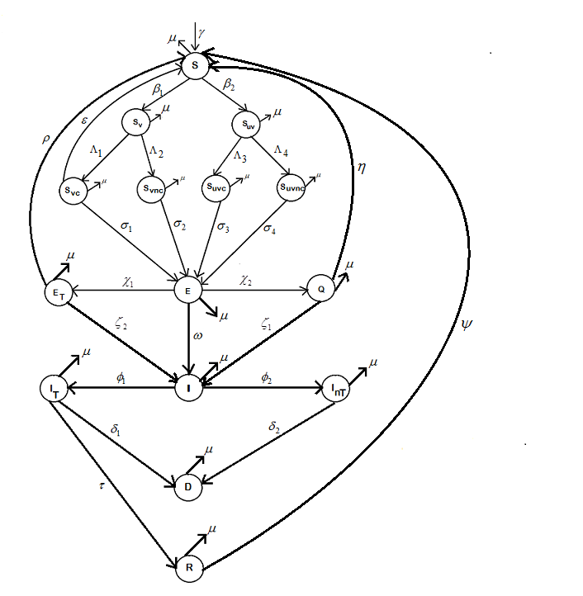
Figure 1: Flow diagram of the non-linear fractional-order model for Ebola virus disease transmission with quarantine, vaccination, and condom use
Table 1: Description of Model Variables and Parameters
Variables/  Parameters | Description
$S$ | Susceptible individuals who strictly observe preventive measures and are not at risk of infection.
$S_{v}$ | Susceptible individuals who have accepted vaccination.
$S_{uv}$
  Susceptible individuals who reject both vaccination and preventive measures.
$S_{vc}$ | Vaccinated susceptible individuals who use condoms.
${ S}_{vnc}$
  Vaccinated susceptible individuals who do not use condoms.
${ S}_{uvc}$ | Unvaccinated susceptible individuals who reject preventive measures but use condoms.
$S_{uvnc}$ | Unvaccinated susceptible individuals who reject preventive measures and do not use condoms.
$E$ | Exposed individuals
$E_{T}$
  Exposed individuals undergoing treatment.
$Q$ | Quarantined individuals
$I$ | Infectious individuals
${ I}_{T}$ | Infectious individuals receiving treatment.
${ I}_{nT}$
  Infectious individuals not receiving treatment.
$D$ | Deceased individuals who remain infectious due to improper burial
$R$ | Recovered individuals
$γ$ | Recruitment rate into the susceptible population.
$β_{1}$ | Proportion of susceptible individuals who are vaccinated (vaccination rate).
${ β}_{2}$ | Proportion of individuals who refuse vaccination.
${ Λ}_{1}$ | Proportion of vaccinated individuals who use condoms.
${ Λ}_{2}$ | Proportion of vaccinated individuals who do not use condoms.
$Λ_{3}$ | Proportion of unvaccinated individuals who use condoms.
${ Λ}_{4}$ | Proportion of unvaccinated individuals who do not use condoms.
$σ_{1}$ | Force of infection for $S_{vc}$ due to contact with $I_{T}$, $I_{nT}$ and $D$.
${ σ}_{2}$ | Force of infection for $S_{vnc}$due to contact with $I_{T}$, $I_{nT}$ and $D$.
$σ_{3}$ | Force of infection for $S_{uvc}$ due to contact with $I_{T}$, $I_{nT}$ and $D$.
$σ_{4}$ | Force of infection for $S_{uvnc}$ due to contact with $I_{T}$, $I_{nT}$ and $D$.
$χ_{1}$
  Proportion of exposed individuals receiving treatment.
${\begin{aligned} \\ χ\end{aligned}}_{2}$ | Proportion of exposed individuals who are quarantined.
$ω$ | Rate at which exposed individuals become infectious.
$ζ_{1}$ | Rate at which quarantined individuals become infectious.
${ ζ}_{2}$ | Rate at which treated exposed individuals become infectious.
${ φ}_{1}$ | Proportion of infectious individuals who accept treatment.
$φ_{2}$ | Proportion of infectious individuals who refuse treatment.
${ δ}_{1}$ | Disease-induced death rate of treated infectious individuals.
$δ_{2}$ | Disease-induced death rate of untreated infectious individuals.
$τ$ | Recovery rate of treated infectious individuals.
$ε$ | Rate at which vaccinated susceptible individuals using condoms return to the susceptible class.
$ρ$
  Rate at which treated exposed individuals return to the susceptible class.
$η$ | Rate at which quarantined individuals return to the susceptible class.
$ψ$ | Rate at which recovered individuals return to the susceptible class.
$μ$ | Natural death rate

Model equations
$$\left.\begin{aligned}D^{α}S\left(t\right)=γ-\left(β_{1}+β_{2}+μ\right)S+ρE_{T}+εS_{2}+ηQ+ψR \\ D^{α}S_{V}\left(t\right)=β_{1}S-\left(Λ_{1}+Λ_{2}+μ\right)S_{V} \\ D^{α}S_{1}\left(t\right)=β_{2}S-\left(Λ_{3}+Λ_{4}+μ\right)S_{1} \\ D^{α}S_{2}\left(t\right)=Λ_{1}S_{V}-\left(ε+σ_{1}+μ\right)S_{2} \\ D^{α}S_{3}\left(t\right)=Λ_{2}S_{V}-\left(σ_{2}+μ\right)S_{3} \\ D^{α}S_{4}\left(t\right)=Λ_{3}S_{1}-\left(σ_{3}+μ\right)S_{4} \\ D^{α}S_{5}\left(t\right)=Λ_{4}S_{1}-\left(σ_{4}+μ\right)S_{5} \\ D^{α}E\left(t\right)=σ_{1}S_{2}+σ_{2}S_{3}+σ_{3}S_{4}+σ_{4}S_{5}-\left(χ_{1}+χ_{2}+ω+μ\right)E \\ D^{α}E_{T}\left(t\right)=χ_{1}E-\left(ρ+ζ_{2}+μ\right)E_{T} \\ D^{α}Q\left(t\right)=χ_{2}E-\left(η+ζ_{1}+μ\right)Q \\ D^{α}I_{T}\left(t\right)=φ_{1}\left(ωE+ζ_{1}Q+ζ_{2}E_{T}\right)-\left(δ_{1}+τ+μ\right)I_{T} \\ D^{α}I_{nT}\left(t\right)=φ_{2}\left(ωE+ζ_{1}Q+ζ_{2}E_{T}\right)-\left(δ_{2}+μ\right)I_{nT} \\ D^{α}D\left(t\right)=δ_{1}I_{T}+δ_{2}I_{nT}-μD \\ D^{α}R\left(t\right)=τI_{T}-\left(ψ+μ\right)R\end{aligned}\right\} \left(1\right)$$
$\text{where }0<α≤1.$
$Let S_{1}≡S_{uv}, S_{2}≡S_{vc}, S_{3}≡S_{vnc}, S_{4}≡S_{uvc}, S_{5}≡S_{uvnc}$
With initial conditions
$$\left.\begin{aligned}&s_{0}=S\left(0\right)=k_{1},S_{V0}=S_{V}\left(0\right)=k_{2},S_{1,0}=S_{1}\left(0\right)=k_{3},S_{2,0}=S_{2}\left(0\right)=k_{4},S_{3,0}=S_{3}\left(0\right)=k_{5}, \\ & \\ &S_{4,0}=S_{4}\left(0\right)=k_{6},S_{5,0}=S_{5}\left(0\right)=k_{7},E_{0}=E\left(0\right)=k_{8},E_{T0}=E_{T}\left(0\right)=k_{9},Q_{0}=Q\left(0\right)=k_{10}, \\ & \\ &I_{T0}=I_{T}\left(0\right)=k_{11},I_{nT0}=I_{nT}\left(0\right)=k_{12},D_{0}=D\left(0\right)=k_{13},r_{0}=R\left(0\right)=k_{14}\end{aligned}\right\} \left(2\right)$$
$where σ_{i}=\text{the forces of infection, with}$
$\left.\begin{aligned}&σ_{1}=a_{1}I_{T}+a_{2}I_{nT}+a_{3}D \\ & \\ &σ_{2}=b_{1}I_{T}+b_{2}I_{nT}+b_{3}D \\ & \\ &σ_{3}=c_{1}I_{T}+c_{2}I_{nT}+c_{3}D \\ & \\ &σ_{4}=d_{1}I_{T}+d_{2}I_{nT}+d_{3}D\end{aligned} \right\} \left(3\right)$
Existence and Uniqueness of Solution
Consider the fractional-order system (1) with initial conditions (2), where $0<α≤1$.
Let the state vector be defined as:
$X(t)=(S,S_{V},S_{1},S_{2},S_{3},S_{4},S_{5},E,E_{T},Q,I_{T},I_{nT},D,R)^{T}$
Then system (1) can be written in compact form as:
$D^{α}X(t)=F(X(t)),X(0)=X_{0}$
where $F:R^{14}→R^{14}$is a nonlinear vector function.
Using the Caputo fractional derivative, the system is equivalent to the Volterra integral equation:
$X(t)=X_{0}+\frac{1}{Γ(α)}\int_{0}^{t}{(t-τ})^{α-1}F(X(τ)) dτ$
From system (1), each component of $F(X)$is composed of:
- Linear terms (e.g., $μS,τI_{T}$)
- Bilinear terms (e.g., $σ_{i}S$, where $σ_{i}$ depends linearly on $I_{T},I_{nT}, and D$)
Since all parameters are non-negative constants and all functions are polynomial in $X$, it follows that:
$F(X)∈C(R^{14})$
Thus, $F$ is continuous.
We now show that $F(X)$satisfies a Lipschitz condition.
Let $X,Y∈R^{14}$. Then:
$∥F(X)-F(Y)∥≤L∥X-Y∥$
Each nonlinear term (e.g., $σ_{i}S$) is at most quadratic, but since:
$σ_{i}=a_{i}I_{T}+b_{i}I_{nT}+c_{i}D$ and
all variables are biologically bounded (population size is finite),
there exists a constant $L>0$ such that:
$∥F(X)-F(Y)∥≤L∥X-Y∥$
Hence, $F$ is Lipschitz continuous in a bounded region.
Next, we apply the Fixed-Point Theorem.
Theorem 1:
Banach Fixed Point Theorem
Let $X$ be a complete metric space and $T:X→X$ a contraction mapping, i.e., there exists $0<L<1$ such that
$∥T\left(x\right)-T\left(y\right)∥≤L∥x-y∥,∀ x,y∈X.$
Then $T$ has a unique fixed point in $X$.
Define the operator:
$(TX)(t)=X_{0}+\frac{1}{Γ(α)}\int_{0}^{t}{(t-τ})^{α-1}F(X(τ)) dτ$
Then:
- $T$ maps a Banach space into itself
- $T$ is a contraction under the Lipschitz condition
By the Banach Fixed Point Theorem, there exists a unique function $X(t)$such that:
$TX=X$
Therefore, the fractional-order Ebola transmission model (1) with initial conditions (2) admits a unique solution on $t≥0$.
So, by the Banach Fixed Point Theorem, the system admits a unique solution. This approach is consistent with existing studies on fractional-order epidemic models, such as in [26].
Hence, by standard results on fractional differential equations and the Banach fixed point theorem, the proposed nonlinear fractional-order Ebola model admits a unique solution for the given initial conditions.
Basic Reproduction Number
The basic reproduction number, $R_{0}$, represents the average number of new infections generated by a single infected individual in a population made up entirely of susceptible people [27]. In other words, it measures the expected number of secondary cases produced by one primary infectious individual in a fully susceptible population [28]. This quantity helps determine whether a disease can spread within a population. For example, if $R_{0}>1$, each infected individual produces more than one new case on average, leading to the spread of the disease. Conversely, if $R_{0}<1$, each infected individual generates fewer than one new case on average, and the disease will eventually die out [29, 30]. The approach for calculating the basic reproduction number using the next generation matrix was developed by [30] and later refined by [31].
For brevity, we omit the detailed derivation of the basic reproduction number $R_{0}$ in this work. The complete derivation using the next generation matrix approach can be found in the published study titled Derivation of the Basic Reproduction Number Using the Next Generation Matrix for a Non-linear Ebola Virus Transmission Model (see [18]). The methodology presented therein is directly applicable to our model. By following the same analytical framework and computational steps as outlined in that study, the basic reproduction number for the present model is obtained as:
$$R_{0}= \left[\begin{aligned}&\left(\frac{a_{1}Λ_{1}β_{1}γ}{dba-Λ_{1}β_{1}ε}+\frac{b_{1}qΛ_{2}β_{1}}{abe}+\frac{c_{1}qΛ_{3}β_{2}}{acg}+\frac{d_{1}qΛ_{4}β_{2}}{ach}\right)\left(\frac{χ_{2}φ_{1}ζ_{1}jnμ+χ_{1}φ_{1}ζ_{2}knμ+φ_{1}ωjknμ}{ijkmnμ}\right) \\ &+\left(\frac{a_{2}Λ_{1}β_{1}γ}{dba-Λ_{1}β_{1}ε}+\frac{b_{2}qΛ_{2}β_{1}}{abe}+\frac{c_{2}qΛ_{3}β_{2}}{acg}+\frac{d_{2}qΛ_{4}β_{2}}{ach}\right)\left(\frac{χ_{2}φ_{2}ζ_{1}jmμ+χ_{1}φ_{2}ζ_{2}kmμ+φ_{2}ωjkmμ}{ijkmnμ}\right) \\ &+\left(\frac{a_{3}Λ_{1}β_{1}γ}{dba-Λ_{1}β_{1}ε}+\frac{b_{3}qΛ_{2}β_{1}}{abe}+\frac{c_{3}qΛ_{3}β_{2}}{acg}+\frac{d_{3}qΛ_{4}β_{2}}{ach}\right)× \\ &×\left(\frac{χ_{2}φ_{1}ζ_{1}jδ_{1}n+χ_{1}φ_{1}ζ_{2}kδ_{1}n+φ_{1}ωjkδ_{1}n+χ_{2}φ_{2}ζ_{1}jmδ_{2}+χ_{1}φ_{2}ζ_{2}kmδ_{2}+φ_{2}ωjkmδ_{2}}{ijkmnμ}\right) \end{aligned}\right]$$
Thus, the step-by-step construction of the matrices, linearization at the disease-free equilibrium, and evaluation of the spectral radius can be found in the cited work.
The basic reproduction number $R_{0}$ measures the average number of secondary Ebola infections produced by a single infected individual in a fully susceptible population, accounting for factors such as vaccination, condom use, treatment, quarantine, and burial practices. It is composed of three parts, each representing different transmission pathways. Each component reflects both the rate of new infections among various susceptible groups and the duration of infectiousness across disease stages. These are influenced by behavioral factors (e.g., vaccination and condom use) and control measures such as treatment, quarantine, recovery, and mortality. Furthermore, $R_{0}$highlights how transmission depends on both contact patterns and infectious periods, emphasizing that improving preventive measures and reducing infectious duration are key to controlling Ebola outbreaks.
Disease-Free Equilibrium
The disease-free equilibrium (DFE) of a model represents the steady-state condition in which no infection is present in the population. At the DFE, all exposed, infectious, and recovered compartments are zero, leaving the susceptible population equal to the total population. Accordingly, the disease-free equilibrium points of our model (1) can be determined. Let $X^{*}$ denote the DFE; then, by setting the derivatives in the first seven equations of model (1) to zero and solving, we obtain from the first equation:
$γ-\left(β_{1}+β_{2}+μ\right)S^{0}+ρE_{T}^{0}+ϵS_{2}^{0}+ηQ^{0}+ψR^{0}=0$
$γ-\left(β_{1}+β_{2}+μ\right)S^{0}+ ϵS_{2}^{0}=0$
$S^{0}=\frac{γ+εS_{2}^{0}}{\left(β_{1}+β_{2}+μ\right)}$
$S^{0}=\frac{γ+εS_{2}^{0}}{a}$
And from the second equation,
$β_{1}S^{0}-\left(Λ_{1}+Λ_{2}+μ\right)S_{V}^{0}=0$ $⇒S_{V}^{0}=\frac{β_{1}S^{0}}{\left(Λ_{1}+Λ_{2}+μ\right)}$
$S_{V}^{0}=\frac{β_{1}}{b}\left(\frac{γ+εS_{2}^{0}}{a}\right)$
In the same manner, setting the remaining equations in $S$ to zero and solving, the disease-free equilibrium points are obtained as
$E^{dfe}=\left(\begin{aligned}&\frac{1}{a}\left(γ+\frac{εΛ_{1}β_{1}γ}{dba-Λ_{1}β_{1}ε}\right),\frac{β_{1}}{ab}\left[γ+\frac{εΛ_{1}β_{1}γ}{dba-Λ_{1}β_{1}ε}\right],\frac{β_{2}}{ac}\left(γ+\frac{εΛ_{1}β_{1}γ}{dba-Λ_{1}β_{1}ε}\right), \\ &\frac{Λ_{1}β_{1}γ}{dba-Λ_{1}β_{1}ε},\frac{Λ_{2}β_{1}}{abe}\left[γ+\frac{εΛ_{1}β_{1}γ}{dba-Λ_{1}β_{1}ε}\right],\frac{Λ_{3}β_{2}}{acg}\left(γ+\frac{εΛ_{1}β_{1}γ}{dba-Λ_{1}β_{1}ε}\right), \\ &\frac{Λ_{4}β_{2}}{ach}\left(γ+\frac{εΛ_{1}β_{1}γ}{dba-Λ_{1}β_{1}ε}\right),0,0,0,0,0,0,0\end{aligned}\right)$
$=\left(\frac{q}{a},\frac{qβ_{1}}{ab},\frac{qβ_{2}}{ac},\frac{Λ_{1}β_{1}γ}{dba-Λ_{1}β_{1}ε},\frac{qΛ_{2}β_{1}}{abe},\frac{qΛ_{3}β_{2}}{acg},\frac{qΛ_{4}β_{2}}{ach},0,0,0,0,0,0,0\right)$
$where q=\left(γ+\frac{εΛ_{1}β_{1}γ}{dba-Λ_{1}β_{1}ε}\right) , a=\left(β_{1}+β_{2}+μ\right) , b=\left(Λ_{1}+Λ_{2}+μ\right) , c=\left(Λ_{3}+Λ_{4}+μ\right) , d=\left(ε+σ_{1}+μ\right) , e=σ_{2}+μ$ , $g=\left(σ_{3}+μ\right) ,$ and $h=\left(σ_{4}+μ\right).$

Local Stability of the Disease-Free Equilibrium
An equilibrium point of a system of differential equations is locally asymptotically stable if all eigenvalues of the Jacobian matrix, evaluated at that point, are negative or have negative real parts in the case of complex eigenvalues. Conversely, the equilibrium is unstable if at least one eigenvalue is positive or has a positive real part.
The Jacobian matrix of a system of differential equations is the matrix of partial derivatives of the system’s right-hand side with respect to its state variables.
$J=D_{x}f=f_{x}=\frac{∂f_{i}}{∂x_{j}}=\left(\begin{matrix}\frac{∂f_{1}}{∂x_{1}} & \frac{∂f_{1}}{∂x_{2}} & ⋯ & \frac{∂f_{1}}{∂x_{n}} \\ \frac{∂f_{2}}{∂x_{1}} & \frac{∂f_{2}}{∂x_{2}} & ⋯ & \frac{∂f_{2}}{∂x_{n}} \\ ⋮ & ⋮ & ⋱ & ⋮ \\ \frac{∂f_{n}}{∂x_{1}} & \frac{∂f_{n}}{∂x_{2}} & ⋯ & \frac{∂f_{n}}{∂x_{n}}\end{matrix}\right)$ ,
all derivatives are evaluated at the equilibrium point. Its eigenvalues determine linear stability properties of the equilibrium.

Theorem 2:
An equilibrium point of a system of differential equations is locally asymptotically stable if all eigenvalues of the Jacobian matrix evaluated at that point have negative real parts, and unstable if at least one eigenvalue has a positive real part.
Proof:
Consider the system of equations (1) written in vector form as
$\frac{dX}{dt}=f(X),$ where
$X=(S,S_{V},S_{1},S_{2},S_{3},S_{4},S_{5},E,E_{T},Q,I_{T},I_{nT},D,R)^{T}.$
The Jacobian matrix of the system is defined as $J=\left[\frac{∂f_{i}}{∂x_{j}}\right].$
Evaluating the partial derivatives at the disease-free equilibrium, the Jacobian matrix takes the form:
$$J_{DFE}=\left[\begin{matrix}-a & 0 & 0 & ε & 0 & 0 & 0 & 0 & ρ & η & 0 & 0 & 0 & ψ \\ β_{1} & -b & 0 & 0 & 0 & 0 & 0 & 0 & 0 & 0 & 0 & 0 & 0 & 0 \\ β_{2} & 0 & -c & 0 & 0 & 0 & 0 & 0 & 0 & 0 & 0 & 0 & 0 & 0 \\ 0 & Λ_{1} & 0 & -d & 0 & 0 & 0 & 0 & 0 & 0 & 0 & 0 & 0 & 0 \\ 0 & Λ_{2} & 0 & 0 & -e & 0 & 0 & 0 & 0 & 0 & 0 & 0 & 0 & 0 \\ 0 & 0 & Λ_{3} & 0 & 0 & -g & 0 & 0 & 0 & 0 & 0 & 0 & 0 & 0 \\ 0 & 0 & Λ_{4} & 0 & 0 & 0 & -h & 0 & 0 & 0 & 0 & 0 & 0 & 0 \\ 0 & 0 & 0 & σ_{1} & σ_{2} & σ_{3} & σ_{4} & -i & 0 & 0 & 0 & 0 & 0 & 0 \\ 0 & 0 & 0 & 0 & 0 & 0 & 0 & χ_{1} & -j & 0 & 0 & 0 & 0 & 0 \\ 0 & 0 & 0 & 0 & 0 & 0 & 0 & χ_{2} & 0 & -k & 0 & 0 & 0 & 0 \\ 0 & 0 & 0 & 0 & 0 & 0 & 0 & ϕ_{1}ω & ϕ_{1}ζ_{2} & ϕ_{1}ζ_{1} & -l & 0 & 0 & 0 \\ 0 & 0 & 0 & 0 & 0 & 0 & 0 & ϕ_{2}ω & ϕ_{2}ζ_{2} & ϕ_{2}ζ_{1} & 0 & -m & 0 & 0 \\ 0 & 0 & 0 & 0 & 0 & 0 & 0 & 0 & 0 & 0 & δ_{1} & δ_{2} & -μ & 0 \\ 0 & 0 & 0 & 0 & 0 & 0 & 0 & 0 & 0 & 0 & τ & 0 & 0 & -n\end{matrix}\right].$$
$where$
$a≡\left(β_{1}+β_{2}+μ\right) , b≡\left(Λ_{1}+Λ_{2}+μ\right) , c≡\left(Λ_{3}+Λ_{4}+μ\right) , d≡\left(ε+σ_{1}+μ\right) , e≡σ_{2}+μ$, $g≡\left(σ_{3}+μ\right) ,h≡\left(σ_{4}+μ\right), i≡\left(χ_{1}+χ_{2}+ω+μ\right), j≡\left(ρ+ζ_{2}+μ\right), k≡\left(η+ζ_{1}+μ\right), l≡\left(δ_{1}+τ+μ\right),$ $m≡ \left(δ_{2}+μ\right), and n≡ \left(ψ+μ\right).$
The eigenvalues are obtained from the characteristic equation:
$det⁡(J_{DFE}-λI)=0.$
Due to the block lower-triangular structure of $J_{DFE}$, the determinant simplifies to the product of diagonal terms, yielding:
$\begin{matrix}det⁡(J_{DFE}-λI) & =\prod_{i=1}^{14}{(λ+}k_{i})=0,\end{matrix}$
where each $k_{i}>0$ corresponds to the total outflow rate from each compartment.
Solving the characteristic equation gives the eigenvalues:
$\begin{matrix}λ_{1} & =-(β_{1}+β_{2}+μ), & λ_{2} & =-(Λ_{1}+Λ_{2}+μ), \\ λ_{3} & =-(Λ_{3}+Λ_{4}+μ), & λ_{4} & =-(ε+σ_{1}+μ), \\ λ_{5} & =-(σ_{2}+μ), & λ_{6} & =-(σ_{3}+μ), \\ λ_{7} & =-(σ_{4}+μ), & λ_{8} & =-(χ_{1}+χ_{2}+ω+μ), \\ λ_{9} & =-(ρ+ζ_{2}+μ), & λ_{10} & =-(η+ζ_{1}+μ), \\ λ_{11} & =-(δ_{1}+τ+μ), & λ_{12} & =-(δ_{2}+μ), \\ λ_{13} & =-μ, & λ_{14} & =-(ψ+μ).\end{matrix}$
Since all eigenvalues satisfy
$λ_{i}<0, i=1,2,…,14.$
It follows that the disease-free equilibrium is locally asymptotically stable, meaning that if the system is slightly disturbed from this state, such as by the introduction of a small number of infected individuals, the resulting deviations will gradually diminish over time. All infected compartments $\left(E , E_{T} , Q , I_{T} , I_{nT}, D\right)$will tend to zero, while the susceptible and other non-infected compartments return to their equilibrium values. Consequently, the infection cannot sustain transmission within the population, and any initial outbreak will eventually die out. Biologically, this implies that the combined effects of control measures, including vaccination, treatment, quarantine, and safe practices, are sufficient to suppress the spread of the disease, ensuring that it cannot invade or persist in the population under these conditions.
Numerical Simulation
In this section, numerical simulations are performed to investigate the impact of varying the fractional-order parameter $α$ on the model dynamics. Since $α$ captures memory effects in the system, different values within $0<α≤1$are considered to examine how they influence the spread and progression of the disease. The results provide insight into the role of fractional dynamics in shaping the behavior of the model.
Results
The impact of different values of the fractional order $α$ on the model
In this section, we want to investigate the impact of the different values of fractional order $α$ on the model. Let us see the following illustrations below.
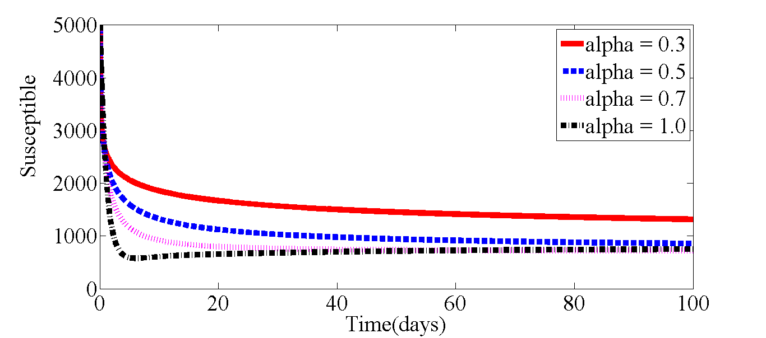
Figure 2: The Graph of the Susceptible population for different values of $α$
Here we can see the graph of the Susceptible population for different values of $α$ranging from 0.3 to 1.0. From the graph, the population of the Susceptible is decreasing as $α$ increases from 0.3, it decreases further as $α$ gets to the integer order 1. Therefore, increasing the value of $α$causes a decrease in the Susceptible population, in other words as the rate of change in susceptibility increases there is a corresponding decrease in the population of those who are susceptible to the disease.

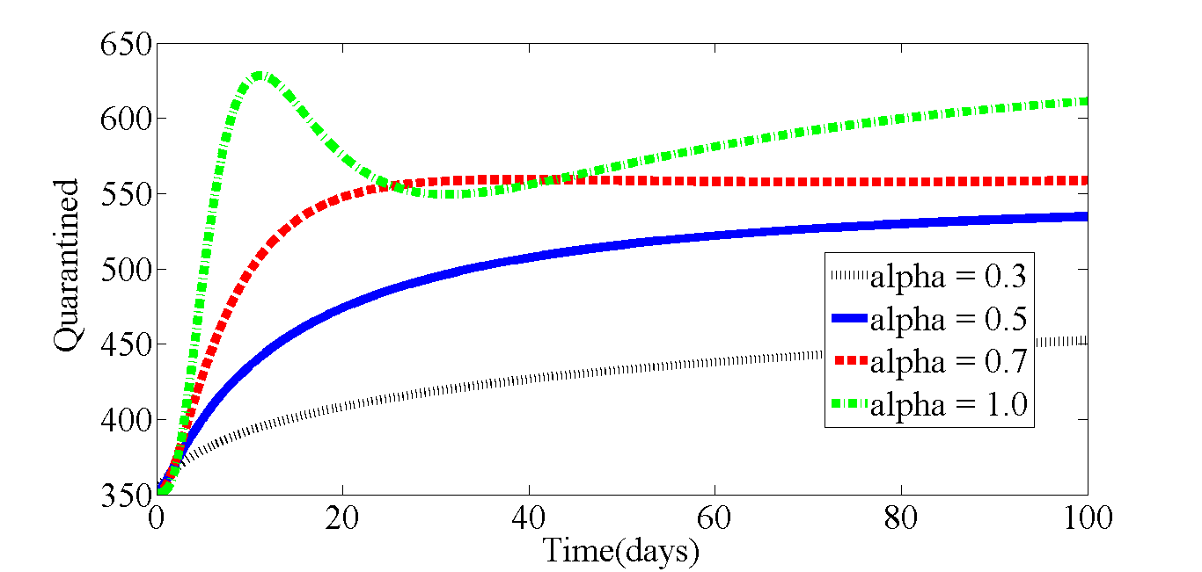
Figure 3 The Graph of the Quarantined Population for different values of $α$
A continuous increase in the population of the quarantined is observed here as $α$increases from 0.3 to 0.7. At the integer order, the population reaches its peak, with a downward slope to the curve observed after some days before a continuous increase is observed later.

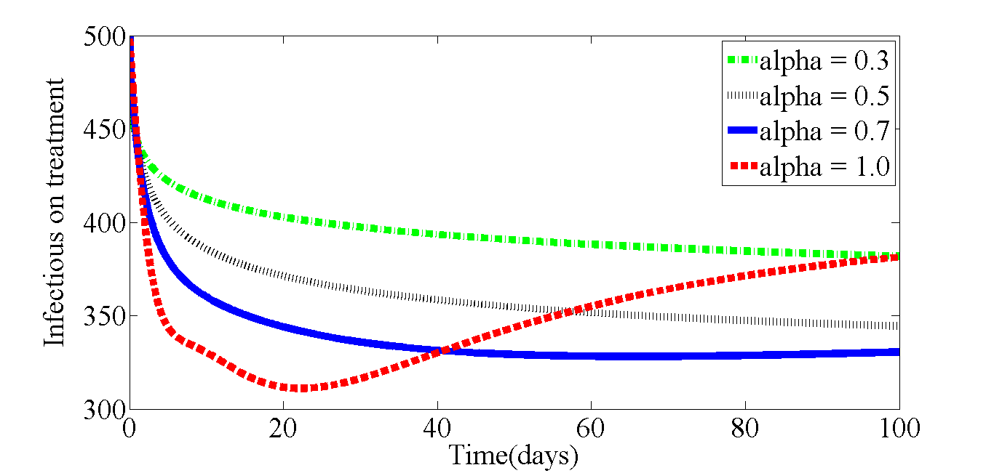
Figure 4 The Graph of the Infectious on treatment for different values of $α$
The graph of the infectious on treatment in figure 4.26, decreases with an increase in $α$, as $α$increases from 0.3 to 0.7, the population goes down while at $α=1$ we also observe a further decrease in population which is subsequently followed by a gradual increase in the population.
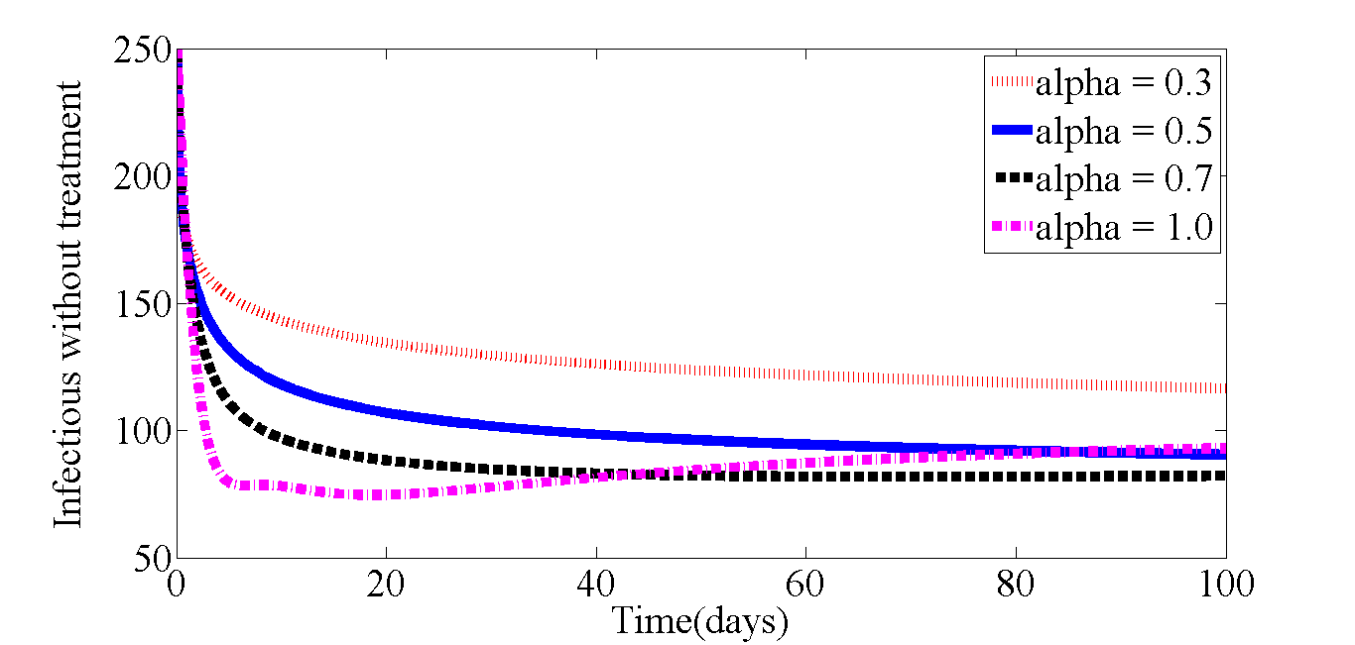
Figure 5 The Graph of the Infectious without treatment for different values of $α$
In figure 5 above, we can observe that as the value of $α$increases there is a corresponding decrease in the population of the infectious individuals who are not undergoing any form of treatment. Though at $α=1$, we do not have a steady decrease in the population, a slight increase is observed after some time.
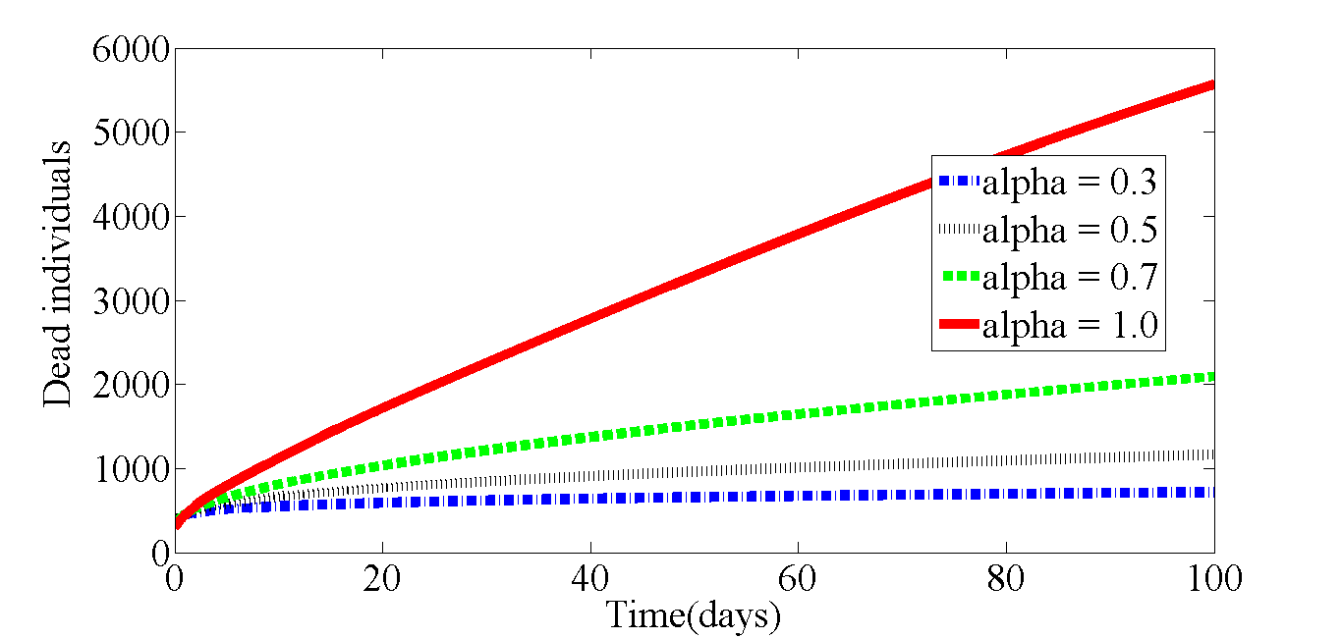
Figure 6 The Graph showing population of Dead individuals for different values of $α$
Here in figure 6, we can observe that an increase in the value of $α$causes an increase in the population of the dead individuals. The population is at its peak when $α=1$ and also is at the lowest when $α=0.3$.
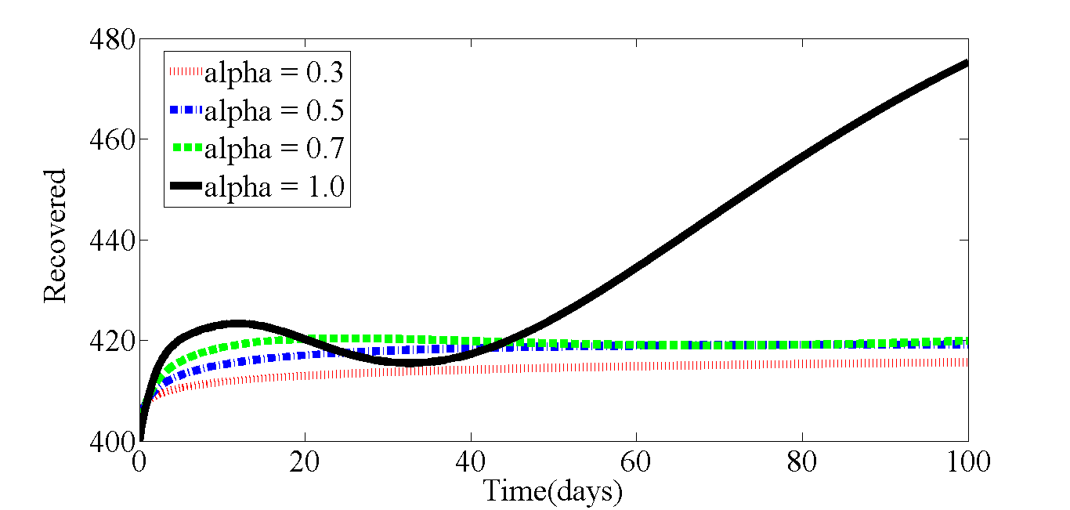
Figure 7 The Graph of the Recovered for different values of $α$
An increase in population is observed in the number of those who recover from the disease as $α$increases. At the integer order of 1, there is an irregular behavior in the population of the recovered, the size of the population increases initially but then a considerable decrease is observed, followed by a rapid and continuous growth in the population. So far, we have seen that the fractional derivative order $α$affects the dynamics of the transmission of the disease; an increase in the value of $α$ causes either a decrease or an increase in the size of population of model compartments, as the case may be.
Discussion
This study examined the role of the fractional-order parameter $α$ in shaping the transmission dynamics of Ebola Virus Disease within a framework that incorporates quarantine, vaccination, and condom-use. The numerical simulations clearly demonstrate that the fractional order significantly influences time-dependent dynamics of all the disease compartments, highlighting the importance of memory effects in disease progression. The results show that as $α$ increases from 0.3 to 1.0, the susceptible population declines steadily. This suggests that higher fractional orders, which correspond to reduced memory effects and a shift toward classical integer-order dynamics, accelerate the transition of individuals out of the susceptible class. Epidemiologically, this may reflect faster exposure or more efficient transmission processes when past states exert less influence on current dynamics. In contrast, the quarantined population initially increases with increasing $α$, reaching a peak at the integer order before exhibiting a temporary decline and subsequent growth. This behavior indicates that quarantine measures become more impactful as the system approaches classical dynamics, possibly due to quicker identification and isolation of exposed individuals. The fluctuating pattern observed at $α=1$ further suggests the presence of complex interactions between quarantine implementation and disease progression over time.
For infectious individuals undergoing treatment, an overall decrease in population size is observed as $α$ increases, although a delayed rise occurs at $α=1$. This implies that higher fractional orders enhance the effectiveness of treatment interventions initially, but long-term dynamics may allow for resurgence due to system non-linearities or delayed responses in treatment outcomes. Similarly, the population of infectious individuals not receiving treatment decreases with increasing $α$, indicating improved control of untreated infections as the system transitions toward integer-order behavior. However, the slight increase observed at later times for $α=1$ suggests that untreated cases may persist or re-emerge if intervention strategies are not sustained. The mortality dynamics reveal a direct relationship between $α$ and the number of deaths, with higher values of $α$ leading to increased mortality. This outcome may be attributed to faster disease progression and reduced damping effects associated with fractional memory, resulting in more severe outbreaks when the system behaves more classically. On the other hand, the recovered population increases with $α$, reflecting improved recovery rates or transitions into the recovered class. The irregular pattern observed at $α=1$, characterized by an initial increase, a temporary decline, and subsequent rapid growth, demonstrates the complex interplay between infection, treatment, and recovery processes in the absence of fractional memory effects. In general, these findings emphasize that the fractional-order parameter $α$ plays a critical role in modulating disease dynamics. Lower values of $α$, which incorporate stronger memory effects, tend to smooth and delay epidemic progression, while higher values lead to faster, more pronounced changes in compartment populations.
Conclusion
This study developed and analyzed a nonlinear fractional-order model for Ebola Virus Disease transmission incorporating quarantine, vaccination, and condom-use. The numerical simulations demonstrate that the fractional-order parameter $α$ significantly influences the behavior of all epidemiological compartments. An increase in $α$ generally accelerates disease dynamics, leading to reductions in susceptible and infectious populations, while increasing the number of quarantined, recovered, and deceased individuals. These results highlight the critical role of memory effects in epidemic modeling, where lower fractional orders provide a more realistic representation of delayed responses and historical dependence in disease spread. The findings suggest that incorporating fractional-order dynamics into epidemiological models can offer deeper insights into the effectiveness of intervention strategies. In particular, the interplay between quarantine, treatment, and behavioral interventions such as condom-use is strongly affected by the system’s memory characteristics.
In conclusion, fractional-order models provide a powerful and flexible framework for understanding complex infectious disease dynamics. Future work may focus on parameter estimation using real epidemiological data and extending the model to include additional control strategies or geographical effects to enhance its applicability in public health decision-making.
References
[1] Ahmad, M.D., Usman, M., Khan, A., & Imran, M. (2016). Optimal control analysis of Ebola disease with control strategies of quarantine and vaccination. Infectious Diseases of Poverty, 5(72). [2] World Health Organization (WHO). (2023). Ebola virus disease. Retrieved from https://www.who.int/news-room/fact-sheets/detail/ebola-virus-disease .
[3] UK Health Security Agency. (2023). Ebola: overview, history, origins and transmission. Retrieved from https://www.gov.uk/government/publications/ebola-origins-reservoirs-transmission-and-guidelines/ebola-overview-history-origins-and-transmission.
[4] Breman, J.G., Heymann, D.L, Loyd, G., McCormick, J.B., Miatudila, M., Murphy, F.A., … & Johnson, K.M. (2016). Discovery and description of Ebola Zaire virus in 1976 and relevance to the West African epidemic during 2013 – 2016. Journal of Infectious Diseases, 214, 93–101. doi:10.1093/infdis/jiw207
[5] Otugene, V.B., Mbah, G.C.E, Owhenagbo, P., Idoko, P.I., Adedoyin, J.D., Enyejo, L.A., & Agina, P.C. (2024). Mathematical Analysis of Hepatitis B Virus Transmission Dynamics in the Absence of Therapy with Atangana-Baleanu Fractional-order SPQWXY Model. Journal of Advances in Mathematics and Computer Science, 39(11), 1–28.
[6] Agina, P.C., Chukwuma, E.I., Chuka-Obidiegwu, B.E., Otugene, V.B., Ibeh, K.K., & Mbah, G.C.E. (2026). Local and Global Stability Analysis of the Disease-Free Equilibrium in a Fractional-Order Ebola Virus Transmission Model. International Journal of Applied Science and Mathematical Theory, 12(3), 30 – 48.
[7] Olaniyi, S., Chuma, F.M., & Abimbade, S.F. (2025). “Asymptotic stability analysis of a fractional epidemic model for Ebola virus disease in Caputo sense,” Journal of the Nigerian Society of Physical Sciences, 7, 2025. DOI:10.46481/jnsps.2025.2304
[8] Pan, W., Li, T., & Ali, S. (2021). A fractional order epidemic model for the simulation of outbreaks of Ebola. Advances in Difference Equations, 161, 1- 21.
[9] Andrawus, J., Abdulrahman, S., Singh, R.V.K., & Manga, S. S. (2022). Sensitivity analysis of a mathematical modeling of Ebola virus population dynamics in the presence of vaccine. Dutse Journal of Pure and Applied Sciences, 8. https://dx.doi.org/10.4314/dujopas.v8i2a.5
[10] Ahman, Q.O., Omale, D., Asogwa, C.C., Nnaji, D.U., & Mbah, G.C.E. (2021). Transmission dynamics of Ebola virus disease with vaccine, condom use, quarantine, isolation and treatment drug. African Journal of Infectious Diseases, 15(1), 10–23.
[11] Agina, P.C., Chuka-Obidiegwu, B.E., Chukwuma, E.I., Ibeh, K.K., Otugene, V.B., & Mbah, G.C.E. (2026). An Approximate Solution of a Fractional-order Epidemic Model using the Homotopy Perturbation Method. International Journal of Applied Science and Mathematical Theory, 12(3).
[12] Sidi-Ammi, M.R., Tahiri, M., & Torres, D.F.M. (2021). Global stability of a Caputo fractional SIRS model with general incidence rate. Mathematics in Computer Science ,15(9), 91-105. https://doi.org/10.1007/s11786-020-00467-z
[13] Farman, M., Bin Rasheed, Q., Saleem, M.U., & Ahmad, A. (2020). Modelling and Analysis of the Fractional Order Ebola Virus Model with Caputo-Fabrizio Derivative. Punjab University Journal of Mathematics, 52(10), 25-45.
[14] Yadav, P., Jahan, S., & Nisar, K.S. (2023). Fractional order mathematical model of Ebola virus under Atangana–Baleanu–Caputo operator. Results in Control and Optimization, 13.
[15] Otugene, V.B., Agina, P.C., Ezeora, D.I., & Ibeh, K.K. (2026). Modeling Inflation Dynamics with Atangana-Baleanu Fractional Derivatives: A Memory-Driven Approach to Consumer Price Index Forecasting. Iconic Research and Engineering Journals, 9(9), 2000–2022.
[16] Mouaouine, A., Boukhouima, A., Hattaf, K. & Yousfi, N. (2018). A fractional order SIR epidemic model with nonlinear incidence rate. Advances in Difference Equations, 2018(160). https://doi.org/10.1186/s13662-018-1613-z
[17] Didigwu, N. Mbah, G. & Abonyi, M. (2021). Solution of Ebola virus disease transmission dynamics mathematical model using homotopy perturbation method. Academic Journal of Statistics and Mathematics, 7(1), 1–8.
[18] Agina, P.C., Otugene, V. B., Adedoyin, J. D., Chukwuma, E.I., Chuka-Obidiegwu, B. E., Ezeora, D. I., & Mbah, G. C. E. (2025). Derivation of the basic reproduction number using the next generation matrix for a non-linear Ebola Virus transmission model. International Journal of Mathematical Analysis and Modelling, 8(2), 555-573.
[19] Ndanusa, A., Abdulrahman, S., & Abdulmalik, A. (2015). A mathematical model for controlling the spread of Ebola virus disease in Nigeria. International Journal of Humanities and Management Sciences, 3(3).
[20] Agina, P.C. & Echezona, G.N. (2022). Comparative analysis of the Gauss-Seidel and Jacobi methods for solving linear systems. COOU Journal of Physical Sciences, 5(1), 60–79.
[21] Gupta, R., Gupta, R., & Verma, D. (2024). Solving general differential equations of fractional orders via Rohit transform. Kirkuk Journal of Science, 9(2), 1–16. doi: 10.32894/kujss.2024.146592.1137
[22] Podlubny, I. (1999). Fractional differential equations. California, CA: Academic Press.
[23] Kilbas, A.A., Srivastava, H.M., & Trujillo, J.J. (2006). Theory and applications of fractional differential equations. Amsterdam, Netherlands: Elsevier.
[24] Rahimy, M. (2010). Applications of Fractional Differential Equations. Applied Mathematical Sciences, 4(50), 2453–2461.
[25] Gorenflo, R., & Mainardi, F. (2008). Fractional calculus: Integral and differential equations of fractional order. Mathematical Physics, arXiv: 0805.3823, 223–276. https://doi.org/10.48550/arXiv.0805.3823
[26] Otugene, V.B., Agina, P.C., Edogbanya, H., & Digwo, D.C. (2022). Existence and uniqueness analysis of Atangana-Baleanu fractional order network model of Noro virus. International Journal of Mathematical Analysis and Modelling, 5(2), 63–75.
[27] Dauhoo, M., Dumas, L., Gabriel, P., & Lafitte, P. (2018). An introduction to the basic reproduction number in Mathematical epidemiology. ESAIM: Proceedings and Surveys, 62, 123–138.
[28] Jones, J. H. (2007). Notes On R₀. Department of Anthropological Sciences, Stanford University.
[29] Watmough, J. (2021). The Basic Reproduction Number. University of New Brunswick. (watmough@unb.ca). Fields-CQAM Thematic Program on Integrative Modelling of EID, Fields Institute.
[30] Diekmann, O., Heesterbeek, J.A.P., & Metz, J.A.J. (1990). On the definition and the computation of the basic reproduction ratio R₀ in models for infectious diseases in heterogeneous populations. Journal of Mathematical Biology, 28, 365–382.
[31] Driessche, P. & Watmough, J. (2008). Further Notes on the Basic Reproduction Number. 10.1007/978-3-540-78911-6_6.

