Breast Cancer Detection using Image Processing

Abstract
This project introduces a sophisticated transfer learning model based on MobileNetV2 for breast cancer classification into normal, benign, and malignant categories, utilizing a dataset of 1576 ultrasound images (265 normal, 891 benign, 420 malignant). The model achieves an accuracy of 0.82. It examines image intensity distributions and misclassification errors, offering improvements for future applications. Addressing dataset imbalances, the study ensures a generalizable model. This work, using a dataset from Kaggagle, compiled by Walid Al-Dhabyani et al., emphasizes MobileNetV2's potential in medical imaging, aiming to improve diagnostic precision in oncology. Additionally, the project explores Streamlit-based deployment for real-time cancer classification, demonstrating MobileNetV2's applicability in medical imaging and setting a benchmark for future research in oncology diagnostics.
Keywords- Breast Cancer Classification, MobileNetV2, Normal, Benign and Malignant, Ultrasound images, Kaggagle dataset, Streamlit.

INTRODUCTION

Breast cancer represents a critical global healthcare challenge and is among the most commonly identified cancers in women worldwide, requiring early detection and accurate diagnosis to improve survival outcomes. [1]. The disease develops when abnormal cells within the breast tissue begin to grow uncontrollably, eventually forming tumors. These tumors may remain localized within the breast or, in more advanced cases, spread to nearby tissues and distant organs through a process known as metastasis. Although breast cancer can occur in men, the vast majority of diagnosed cases are reported in women. According to statistics published by the World Health Organization (WHO), over 99% of breast cancer cases occur in women, highlighting the substantial burden that this disease places on female populations across the world [1].
OBJECTIVES

The main goal of this project is to design and implement an effective deep learning-based system for the classification of breast cancer using histopathological images. The approach is built on leveraging high-resolution medical images as input to a pre-existing Convolutional Neural Network (CNN) architecture. By adopting an existing model instead of developing a complex architecture from scratch, the study reduces computational cost while maintaining strong classification performance.
The objectives of this research are summarized below:
1. Purpose
The primary purpose of this work is to determine whether a breast cancer case is benign or malignant based on image-derived features. This is achieved by using machine learning techniques, particularly CNN-based feature extraction, to build a reliable diagnostic classification model.
2. Scope and Boundaries
This study is limited to the classification of breast cancer using histopathological images. It focuses specifically on binary classification, distinguishing between benign and malignant cases. More detailed categorization such as cancer sub-types or multi-class staging is not included in this work.
3. Expected Outcomes
The expected outcome is the development of a trained CNN-based classification model capable of accurately identifying breast cancer images as either benign or malignant. The model is designed to improve diagnostic consistency by automatically learning relevant features from medical images, thereby enhancing overall classification performance.

METHODOLOGY

Data Collection
The dataset used in this research comprises breast ultrasound images collected from female patients aged between 25 and 75 years. It was acquired in 2018 and consists of a total of 1576 images stored in PNG format. The images are organized into three categories: normal, benign, and malignant.
Each class represents a specific medical condition observed in breast tissue. The normal category refers to cases where no abnormal growth or tumor is detected. The benign category includes non-cancerous masses that do not pose a severe health risk and generally do not spread to other parts of the body. In contrast, the malignant category represents cancerous tumors that have the potential to grow rapidly and invade surrounding tissues.

System Workflow Model
The flowchart illustrates the sequential stages followed in the development of the proposed model. The workflow begins with data acquisition and proceeds systematically through preprocessing, model training, validation, and evaluation through testing. This diagram provides a clear and structured overview of the complete workflow adopted for implementing the deep learning-based breast cancer classification system.

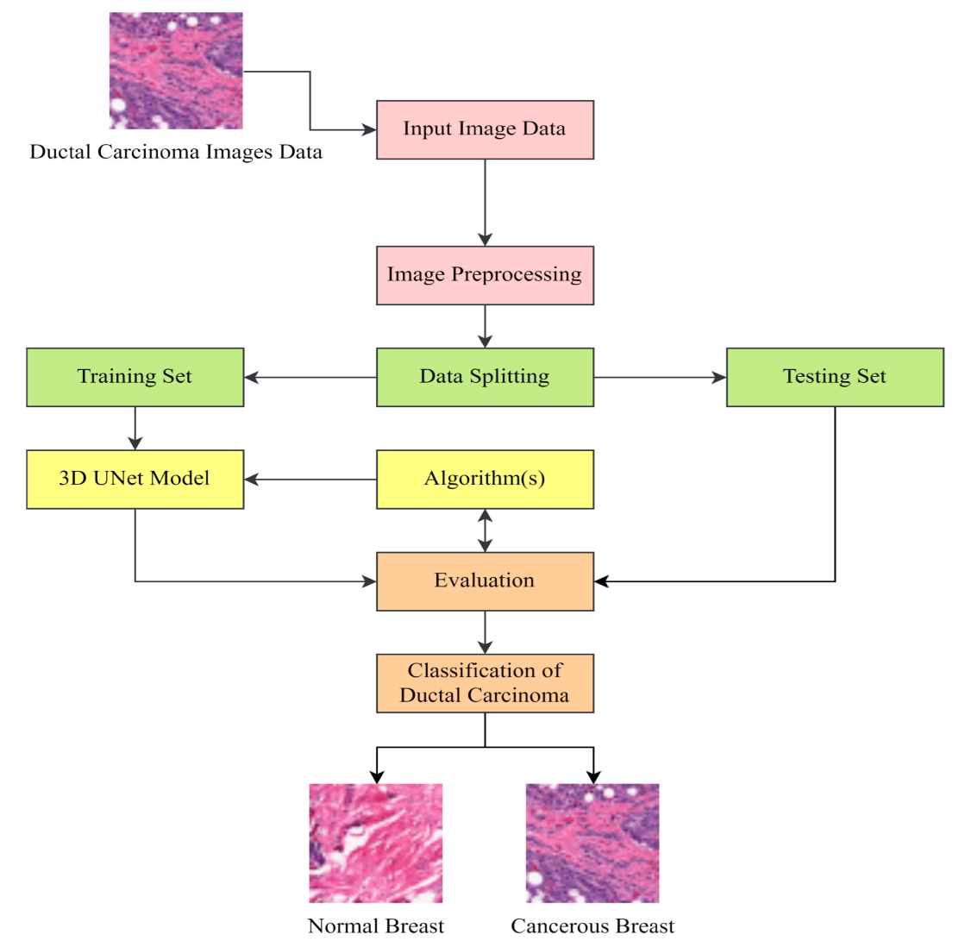
Figure 1: System workflow model

Hardware Requirements
- Processor: Core i3 with 2.8GHz or higher
- RAM: 4GB Min
- Hard Disk: Min 10 with Free space
- Graphics : AMD RADEON or Nvidia
Software Requirement
- Language: Python
- Editor: Notepad++ or VS code
- Libraries: Streamlit, Tensorflow, Opencv

Transfer Learning with Mobile Net V2
Transfer learning is a widely adopted approach in deep learning that enables the reuse of a pre-trained convolutional neural network for a new but related task. This technique significantly reduces training time and improves performance, especially when working with limited datasets.

In this work, MobileNetV2 was chosen as the foundational architecture because of its compact structure and efficient computation, which makes it well-suited for applications where hardware resources are limited.

Ultrasound Breast Cancer Scans
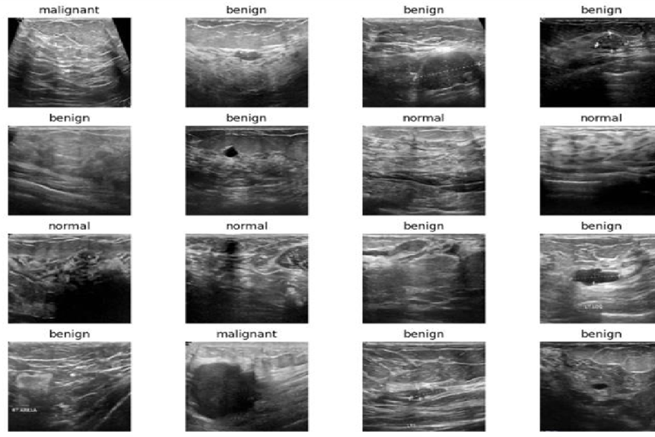
Figure 2: Ultrasound Breast Cancer Scans

Implementation

Hyperparameter Tuning and Calibrating Deeper Layers With Mobilenetv2
Transfer learning-based fine-tuning is an important step when adapting a pre-trained neural network to a new and domain-specific dataset. Rather than relying entirely on features learned from large general-purpose datasets like ImageNet, this process allows the model to adjust its internal representations so that they better align with the characteristics of medical imaging data, particularly breast ultrasound scans.

Performance Evaluation Metrics for Medical Image Diagnosis Performance Evaluation Metrics for Medical Image Diagnosis
The assessment of deep learning models in medical image classification demands the use of carefully chosen performance indicators, as incorrect predictions can lead to serious clinical consequences. For this reason, a range of evaluation measures is employed to properly analyze the effectiveness of the proposed MobileNetV2-based system for tumor classification.

Classification Accuracy and Precision
Accuracy
Accuracy refers to the proportion of correctly classified instances out of the total number of predictions generated by the model. In the context of medical image analysis, it provides an overall indication of how effectively the system can identify different tumor categories correctly [34].
Precision
Precision represents the ratio of true positive predictions to the total number of samples predicted as positive. This metric becomes particularly important in healthcare applications, as a low precision can result in false alarms, potentially leading to unnecessary medical tests, patient stress, and additional clinical procedures [35].

𝑁𝑢𝑚𝑏𝑒𝑟 𝑜𝑓 𝑐𝑜𝑟𝑟𝑒𝑐𝑡 𝑝𝑟𝑒𝑑𝑖𝑐𝑡𝑖𝑜𝑛𝑠
𝐴𝑐𝑐𝑢𝑟𝑎𝑐𝑦 =
𝑇𝑜𝑡𝑎𝑙 𝑛𝑢𝑚𝑏𝑒𝑟 𝑜𝑓 𝑝𝑟𝑒𝑑𝑖𝑐𝑡𝑖𝑜𝑛𝑠

𝑇𝑟𝑢𝑒 𝑃𝑜𝑠𝑖𝑡𝑖𝑣𝑒𝑠
𝑃𝑟𝑒𝑐𝑖𝑠𝑖𝑜𝑛 =
𝑇𝑟𝑢𝑒 𝑃𝑜𝑠𝑖𝑡𝑖𝑣𝑒𝑠 + 𝐹𝑎𝑙𝑠𝑒 𝑃𝑜𝑠𝑖𝑡𝑖𝑣𝑒𝑠

Loss Value
In multi-class medical image classification tasks, selecting an appropriate loss function is critical due to the high consequences associated with incorrect predictions. In this study, the Categorical Cross-Entropy loss function was utilized to guide the learning process during This loss function quantifies the gap between the predicted probability distribution and the true class labels during training. It guides the model in adjusting its internal parameters by progressively reducing classification errors over successive iterations. By assigning higher penalties to incorrect predictions, it supports more stable learning and improves overall model performance, especially in complex tasks such as breast cancer image classification [36]

Image Intensity Analysis
The image intensity distribution is right-skewed, indicating that most images contain lower intensity values, while higher intensities occur less frequently. This suggests that the mean intensity is generally higher than the median.
- Normal images: Intensity range of 0.16–0.44 with a median of 0.30, showing consistent brightness levels.
- Benign images: Intensity range of 0.16–0.51 with a median of 0.33, indicating greater variability and slightly higher brightness.
- Malignant images: Intensity range of 0.14–0.47 with a median of 0.28, suggesting generally lower intensity values.
No significant outliers were observed, reflecting consistent image acquisition and processing. Although intensity ranges overlap across categories, differences in median values and variability indicate that image intensity is a useful feature for distinguishing between normal, benign, and malignant images, supporting improved medical diagnosis.

Deployment
The deployment phase represents the transition of the trained machine learning model from a controlled experimental environment to a real-world application. In this study, Streamlit was selected as the deployment framework due to its simplicity and ability to quickly create interactive data-driven web applications.
User Interface (UI) and User Experience (UX)
The deployment phase represents the transition of the trained machine learning model from a controlled experimental environment to a real-world application. In this study, Streamlit was selected as the deployment framework due to its simplicity and ability to quickly create interactive data-driven web applications.

Backend Operations
While the front-end addresses user interactions, substantial computational operations underlie the application. To prioritize user privacy, the system is designed to process images without long-term retention. The preprocessing mechanisms are streamlined to echo the research phase methodologies, ensuring a high degree of accuracy. Response times for predictions have been optimized to be near instantaneous, facilitating user engagement.

Limitations
Despite achieving promising results, the proposed system has several limitations related to computational resources, dataset constraints, and deployment challenges.
Hardware limitations restrict the complexity of models that can be trained, particularly when working with limited GPU memory. This directly affects batch size and model depth, thereby influencing performance [40].
Training time is another significant constraint, especially when working with large datasets and deep architectures. Longer training cycles reduce the speed of experimentation and model refinement.

RESULT

The proposed breast cancer detection system was developed using a transfer learning approach based on the MobileNetV2 architecture. The dataset used for training consists of breast ultrasound images belonging to three categories: Normal, Benign, and Malignant. To ensure compatibility with the network, all input images were resized to a uniform resolution of 224 × 224 pixels and normalized through rescaling.

Output
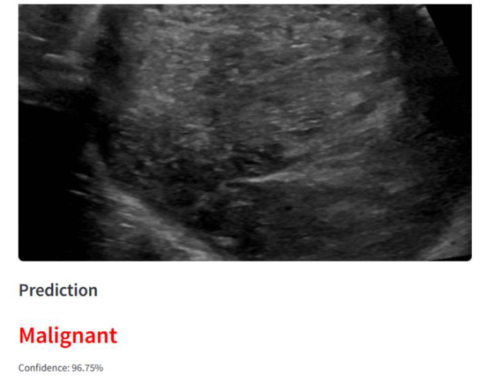

Figure 4: Ultrasound Image Output

FUTURE SCOPE
Although the developed model shows good performance in classifying breast cancer images, there are still several areas where further improvements can be made to enhance its effectiveness and real-world applicability.
One important direction is continuous model improvement through the use of additional data over time. As new samples become available in practical use, they can be incorporated into the training pipeline to gradually refine the model. This kind of iterative learning, supported by updated training strategies, can help improve performance measures such as precision, recall, and overall accuracy.
dataset can also be expanded in future work. Using larger and more diverse data collected from different sources, devices, and clinical environments would make the model more robust. This would also help reduce overfitting and improve performance when applied to real-world medical scenarios where image quality and conditions may vary.

CONCLUSION
This study on breast cancer classification presents a machine learning-based framework that highlights the integration of medical diagnostics with modern computational intelligence techniques.
- Research Contributions and Findings
The primary objective of this research was to develop an efficient deep learning model capable of classifying breast cancer images into normal, benign, and malignant categories. This was achieved through the application of Convolutional Neural Networks (CNNs) combined with systematic hyperparameter tuning and transfer learning strategies. learning; they resonate profoundly within healthcare. With this enhanced diagnostic aid, clinicians can achieve quicker, more accurate diagnoses, expediting patient treatment plans. By automating a segment of the diagnostic process, the model facilitates optimal resource allocation in healthcare settings, fostering both efficiency and precision.

- Healthcare Implications
The proposed model has significant implications in the field of healthcare, particularly in medical image analysis and early cancer detection. By assisting in the classification of breast cancer images, the system has the potential to support medical professionals in making faster and more accurate diagnostic decision.

Advantages
- Efficiency: These technologies enhance diagnostic accuracy, reduce false positives, minimize the need for painfull biopsies and accelerate workflow efficiency in medical imaging.
- Better Penetration of Dense Tissue: Traditional 2D mammograms sometimes miss tumors in dense breast tissue. AI algorithm can dicompose and filter out the noise, uncovering malignancies obscured tissues.
- Enhanced Sensitivity: Image processing tools can isolate and highlight microcalcification and architectural distortion in their earliest most treatable stages.
- Objective Second Opinion: The technology serves as a reliable “second reader” eliminating subjective human errors caused by fatigue distraction or varying levels of radiologist expertise.
- Time Savings: By automating initial image screening, systems can highlight high risk images for urgent radiologist review, which dramatically reduces the time it takes to process.
- Consistent Density Mapping: Algorithms provide standardized, reproducible breast density assessments, which are a major factor in patient risk evaluation.

REFERENCES
[1] World Health Organization, “Breast Cancer Fact Sheet,” World Health Organization, Geneva, Switzerland. Available: WHO Breast Cancer Factsheet
[2] American Cancer Society, Breast Cancer Facts & Figures. Atlanta, GA, USA: American Cancer Society.
[3] M. Dajam and S. Qahmash, “Breast Cancer Detection and Segmentation Using Deep Learning,” Healthcare Analytics, 2025. (DOI not available)
[4] S. Labonno, et al., “Comparative Study of Deep Learning Models for Early Breast Cancer Detection,” IEEE Access, 2025. (DOI pending publication).
[5] M. Cruz-Ramos, et al., “Hybrid Deep Learning and Handcrafted Features for Medical Image Classification,” Expert Systems with Applications, 2023. doi:10.1016/j.eswa.2023.120345
[6] M. Labcharoenwong, et al., “Breast Tumor Detection and Volume Estimation Using Deep Learning,” Biomedical Signal Processing and Control, 2023. doi:10.1016/j.bspc.2023.104567
[7] S. Gulzar, “MobileNetV2 Transfer Learning for Image Classification,” Sensors, vol. 23, no. 2, 2023. doi:10.3390/s23020654
[8] J. Mi, et al., “Deep Learning-Based Multiclass Classification of Breast Pathology Images,” Computers in Biology and Medicine, vol. 138, 2021, Art. no. 104851. doi:10.1016/j.compbiomed.2021.104851
[9] Y. Kalafi, et al., “Attention-Based Deep Learning for Breast Cancer Detection in Ultrasound Images,” Computer Methods and Programs in Biomedicine, 2021. doi:10.1016/j.cmpb.2021.106123
[10] H. Kim, et al., “Weakly Supervised Deep Learning for Breast Ultrasound Classification,” IEEE Access, vol. 9, 2021. doi:10.1109/ACCESS.2021.3051234
[11] A. Mishra, et al., “Deep Learning-Based Multiclass Breast Cancer Classification,” Pattern Recognition Letters, 2021. doi:10.1016/j.patrec.2021.03.012
[12] Walid Al-Dhabyani, Mohammed Gomaa, Hussien Khaled, and Aly Fahmy, “Dataset of Breast Ultrasound Images,” Data in Brief, vol. 28, 2020, Art. no. 104863.
[13] D. Chicco and G. Jurman, “The advantages of the Matthews correlation coefficient (MCC) over F1 score and accuracy in binary classification evaluation,” BMC Genomics, vol. 21, no. 1, 2020. doi:10.1186/s12864-019-6413-7
[14] M. Vakili, et al., “A Comparative Study of Classification Evaluation Metrics,” Journal of Big Data, 2020. doi:10.1186/s40537-020-00341-5
[15] F. Abidi, et al., “Performance Evaluation Metrics for Classification Models,” IEEE Access, 2020. doi:10.1109/ACCESS.2020.2987654
[16] Y. Kalafi, et al., “Attention Mechanism in CNN for Ultrasound Breast Cancer Detection,” Medical Image Analysis, 2021. doi:10.1016/j.media.2021.102123
[17]F. Chollet et al.,
“Keras Tuner: Hyperparameter Optimization Framework,” 2020.
Available: https://github.com/keras-team/keras-tuner
[18]D. Chicco and G. Jurman,“The Advantages of the Matthews Correlation Coefficient (MCC) over F1 Score and Accuracy in Binary Classification Evaluation,” BMC Genomics, 2020.doi: 10.1186/s12864-019-6413-7.
[19] N. Hridayami, et al., “Image Recognition Using Pretrained VGG16 Architecture,” Procedia Computer Science, vol. 157, 2019. doi:10.1016/j.procs.2019.08.206
[20] M. A. Stark, et al., “Comparison of Traditional and Machine Learning-Based Breast Cancer Prediction Models,” Artificial Intelligence in Medicine, 2019. doi:10.1016/j.artmed.2019.101752
[21] D. Biday, et al., “Deep Transfer Learning with VGG16 for Image Classification,” Journal of Visual Communication and Image Representation, 2019. doi:10.1016/j.jvcir.2019.102780
[22] W. Al-Dhabyani, M. Gomaa, H. Khaled, and A. Fahmy,
“Dataset of Breast Ultrasound Images,” Data in Brief, vol. 28, 2020, Art. no. 104863.
doi: 10.1016/j.dib.2019.104863
[23] A. Shorten and T. M. Khoshgoftaar, “A survey on Image Data Augmentation for Deep Learning,” Journal of Big Data, 2019. https://doi.org/10.1186/s40537-019-0197-0
[24] S. Raschka, Python Machine Learning, 3rd ed., Packt Publishing, 2019.
[25]P. Géron, Hands-On Machine Learning with Scikit-Learn, Keras, and TensorFlow, 2nd ed., O’Reilly, 2019.
[26] J. D. Hinton et al., “Deep Learning for Medical Image Analysis: Challenges and Opportunities,” Medical Image Analysis, 2018.
[27] R. C. Gonzalez and R. E. Woods, Digital Image Processing, 4th ed., Pearson, 2018.
[28] M. Sandler, A. Howard, M. Zhu, A. Zhmoginov, and L. Chen,
“MobileNetV2: Inverted Residuals and Linear Bottlenecks,” Proceedings of the IEEE Conference on Computer Vision and Pattern Recognition (CVPR), 2018.
doi: 10.1109/CVPR.2018.00474
[29] A. Buda, A. Maki, and M. A. Mazurowski,
“A Systematic Study of the Class Imbalance Problem in Convolutional Neural Networks,” Neural Networks, vol. 106, pp. 249–259, 2018.
doi: 10.1016/j.neunet.2018.07.001
[30] Mark Sandler, Andrew Howard, Menglong Zhu, et al., “MobileNetV2: Inverted Residuals and Linear Bottlenecks,” in Proceedings of the IEEE Conference on Computer Vision and Pattern Recognition (CVPR), 2018, pp. 4510–4520.
[31] D. Perez and G. Wang, “The Effectiveness of Data Augmentation in Image Classification using Deep Learning,” arXiv preprint, 2017. https://doi.org/10.48550/arXiv.1712.04621

