Design and Development of a Standards-Based Holistic Electronic Health Record Application for Integrated Hospital Clinical Workflows

INTRODUCTION

Recent developments in technology have impacted the digitalization of health data and facilitated the adoption of electronic health record (EHR) application, which have become mandatory in some countries [1] . A modern EHRS is not simply a digitized paper chart, rather, it is a digital application that can actively interact with providers and patients and is composed of a series of data fields that lend themselves to analysis, processing, and reporting to support communication, appropriate clinical interventions, quality improvement, and patient safety [2]. EHR emerged as a result of the rapid development of Internet technology and the advancement of medical information, gradually replacing the complicated hand-written medical records, which has become an indispensable part of the hospital. EHR is generated in the clinical treatment process. It refers to the digital medical record based on the application of the medical information system and the comprehensive information of medical records based on the corresponding pictures, texts, forms, images, data and data [3].

Large-scale collection and use of medical information for the development of artificial intelligence machines is actively underway in various countries. In Japan, collection systems have been built to collect data for medical image analysis and disease repositories. Technically, a large-scale medical information collection system is essentially used to standardize electronic medical data for immediate use upon collection [5]. In Iran, the development of an Integrated Care Electronic Health Record (ICEHR or EHR) and the approach adopted by Ministry of Health have paved the way for the creation of a standardized set of Application Programming Interfaces (APIs) based on openEHR and ISO13606 standards. [6]. The development of a patient summary application that summarizes and visualizes patient information collected by existing systems and evaluated in common use cases in Japan is also a form of development of current EHR features. Efficient sharing of the minimum patient information required by doctors is expected to reduce information overload, workload and fatigue [7]. Specific in Tuberculosis (TB) disease, TB EHR system is also developed to collect patient information thus reducing data incompleteness and low accuracy and eventually improving patients’care in Angola [8].

Developing an anesthesia module in the operating room is one of the significant steps toward the implementation of EHR in health care centers [9]. Anesthesia module can manage a patient’s anesthesia information by recording procedures, physiological changes, key events, and drug prescriptions that occur during the pre-intra and post-operative period [10]. ﻿Utilization of EHR is used to aid the early detection of diabetes by develop an interoperable EHR that uses of Machine Learning (ML) algorithms. A decision support system developed using many ML algorithms results in optimizing the decision in preventive care in the health information system [11].

The advancement of EHR in pharmaceutical care has progressed substantially, broadening pharmacists’ responsibilities from merely dispensing medications and managing inventory to serving as integral contributors to holistic patient care [12]–[14]. The design and development of a mobile application for drug information and user health data have the potential to enhance equitable access to high-quality pharmaceutical services by providing accessible, reliable, and person-centered technological solutions [4].

The development of EHR is also implemented in the psychiatrics sector, ﻿according to research findings from many countries, mental health application increase health literacy, improve access to health information, and improve health quality [15]. These mental health apps have also been shown to improve patients’ lives by monitoring symptoms, well- being, sleep quality, and medication adherence [16]. However, those mental health application assist users in managing their mental health when the features are customized to meet their requirements [17].

EHR present notable challenges in their utilization, including the risk of inadequate data quality [18], ensuring that biases in the data is well understood [19][20] and their ability to accommodate the complexity of business processes across different medical services, not only in general hospitals, but also in specialized hospitals such as psychiatric hospitals [21]. Although many EHR application for specific medical services or specific diseases have been developed by researchers, there is a need for holistic EHR application development that can represent all business processes based on real-world clinical data in hospitals.

METHODOLOGY

Methodology in developing EHR application consist of several stage, start from requirements analysis, design, construction and implementation [22]. Requirements analysis is the initial phase where stakeholders gather to define the high-level requirements and scope of the EHR application. This phase focuses on capturing the essential features and functionalities that the EHR application must have. Design is a collaborative process focused on creating and refining EHR application design based on user feedback. Start from creation of EHR database structure, application prototypes and allows users to visualize and interact with the design early in the process. Construction is focuses on building the system through iterative cycles, allowing for rapid prototyping and frequent feedback. EHR application prototypes is built based on the designs and requirements gathered in earlier phases. Implementation and evaluation were carried out on environment in one of the hospitals in Riau Province, Indonesia. Evaluation using expert judgement tests aims to measure the acceptance of the application that has been built.

RESULT

The following will explain the results of the EHR application development according to the methodology.

Requirement Analysis

This phase focuses on identifying the essential features and functionalities that the EHR application must have. Medical service running in a hospital consists of 5 main processes and 21 sub-processes, as shown in the business process diagram in Figure 1.

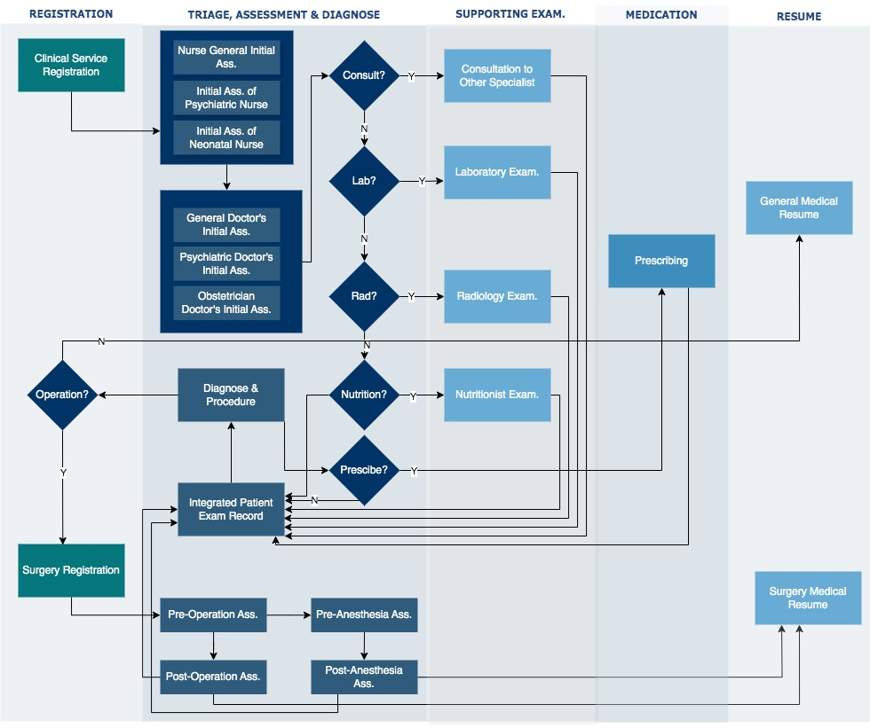
Figure. 1 Medical Services Business Process

1st Process – Patient Registration.
This phase covers the procedures required for registering patients, which can be further divided into the following sub-steps: Clinical Service Registration, Surgery Registration.

2nd Process – Comprehensive Clinical Assessment and Diagnosis
This stage encompasses the systematic evaluation, diagnosis, and integration of the patient’s overall condition by the entire multidisciplinary medical team. It can be further divided into the following sub-steps: Initial Assessment by General Nurses, Initial Assessment by Neonatal Nurses, Initial Assessment by Psychiatric Nurses, Initial Assessment by General Doctor, Initial Assessment by Obstetricians, Initial Assessment by Psychiatrists, Pre-Operative Assessment, Pre-Anesthesia Assessment, Post-Operative Assessment, Post Anesthesia Assessment, Diagnose and Procedure, Integrated Patient Examination Records.

3rd Process – Request for Supporting Examinations (If Required)
This stage involves submitting formal requests for ancillary or supporting diagnostic examinations when deemed necessary, conisst of: Consultation to other specialists, Laboratory Examination, Radiology Examination, Nutritionist Examination.

4th Process – Prescription Request
This stage involves submitting a formal request for medications to the pharmacy, based on the physician’s clinical assessment and treatment plan.

5th Process – Final Reporting
This concluding stage encompasses the preparation and submission of the patient’s comprehensive, consist of: General Medical Resume and Surgery Medical Resume.

  - Design
The medical service process in the EHR application will follow the guidelines for the national health data set and data model for Indonesian EHR System [21]. The national EHR data set and data model represent the medical service form used in accordance with the hospital's clinical workflow, as explained by the activity diagram in Figure 2.

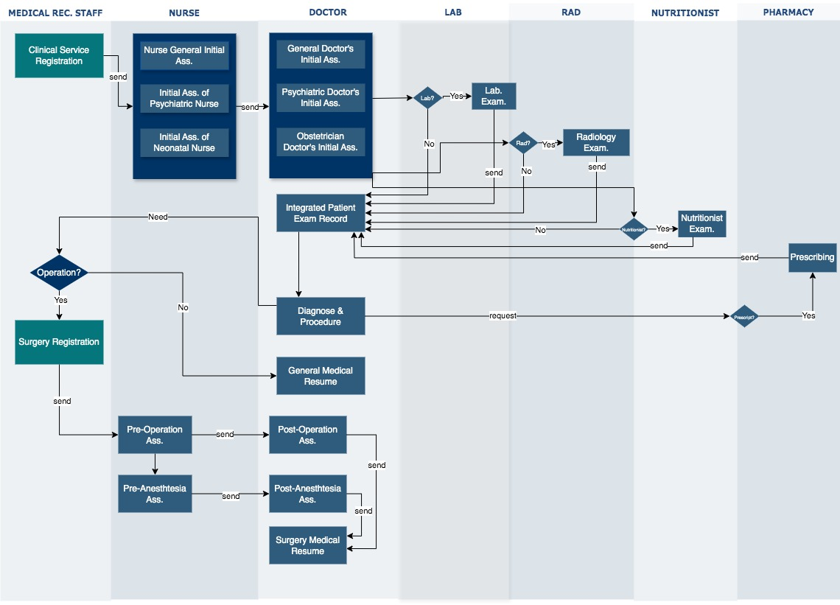
Figure. 2 Activity Diagram of Clinical Workflows

Figure 2 showing the interactions between Medical Record Staff, Nurses, Doctors, Laboratory staff, Radiographer, Nutritionists, and Pharmacist. The clinical workflow begins with medical record staff registering patients according to the appropriate service unit, including surgical services when required. Nurses then perform initial assessments general, psychiatric, or neonatal based on specialization, and in surgical units they also conduct pre-operation and pre-anesthesia evaluations.

Doctors subsequently carry out specialized initial assessments, establish diagnoses, determine medical procedures, and produce a general medical resume; in surgical contexts, they additionally complete post-operation and post-anesthesia assessments and prepare a surgical medical resume. When indicated, laboratory and radiology personnel conduct diagnostic examinations. Finally, if medication is prescribed, pharmacists manage the dispensing process. After the medical service process is defined, the next step is designing the database structure for the EHR application. A descriptive overview of the EHR application physical database can be seen in Figure 3.

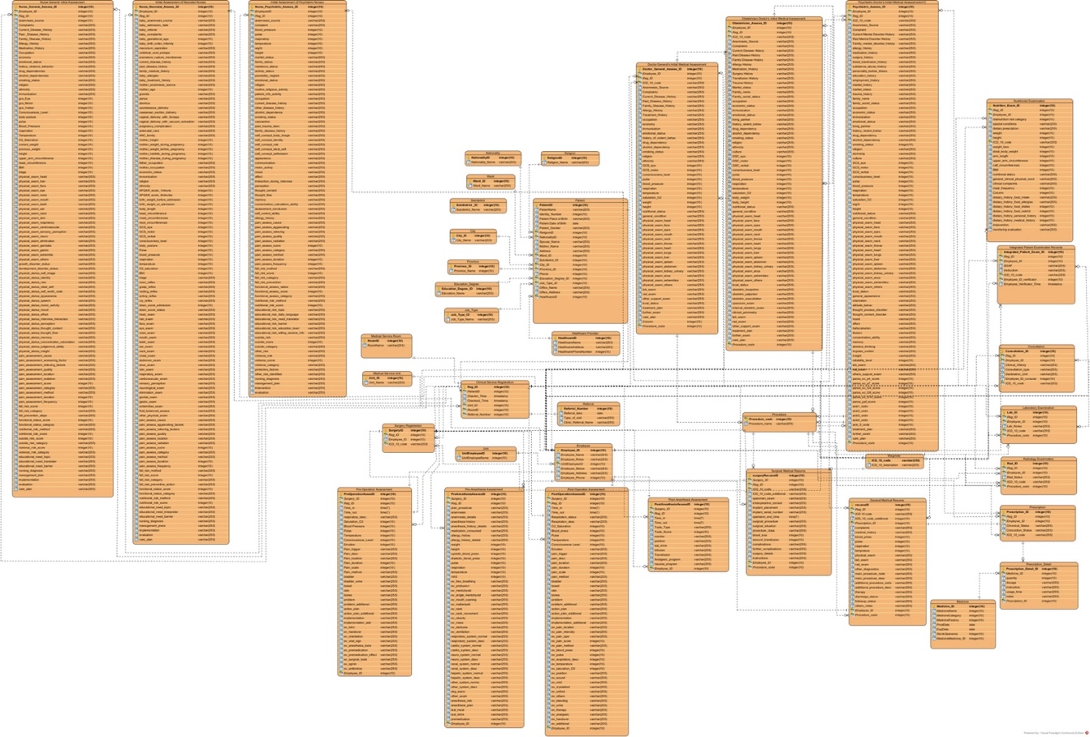
Figure. 3 Physical Database of EHR Application

Construction

The results of the EHR application development can be seen in Figures 4, 5, 6. Figure 4 is a brief overview of the initial medical assessment by general doctor form on the EHR Application which is filled out by the doctor, used to collect data: anamnesis, vital signs examination, physical examination, supporting examinations, diagnosis, management and follow-up plans for the patient.

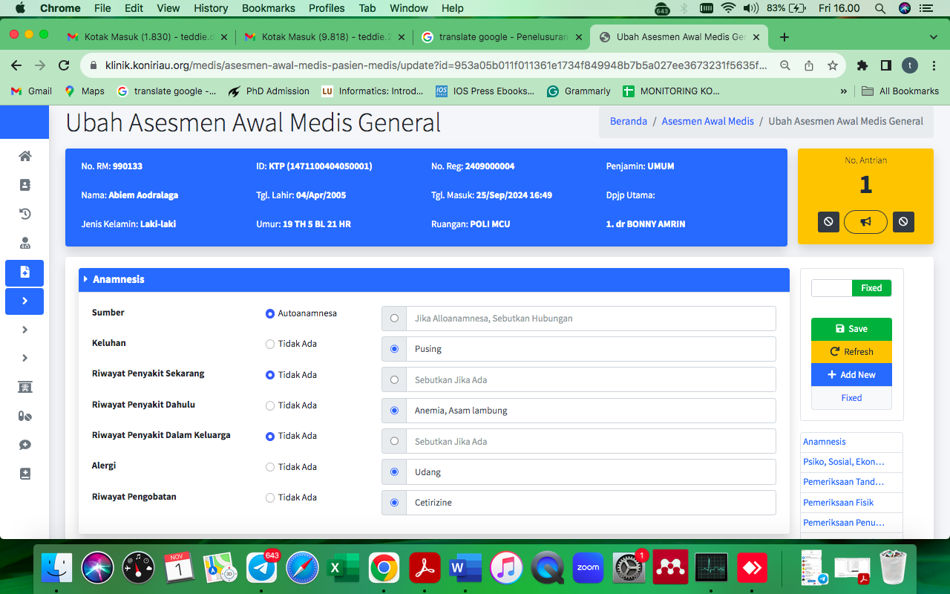
Figure. 4 Initial Medical Assessment by General Doctor

Figure 5 is the Laboratory and Radiology Support Examination Form in the EHR Application. This form will record and forward examination requests from doctors to the laboratory or radiology department. After the examination is carried out, the laboratory and radiology will send back the results of the examination to be read again by the requesting doctor

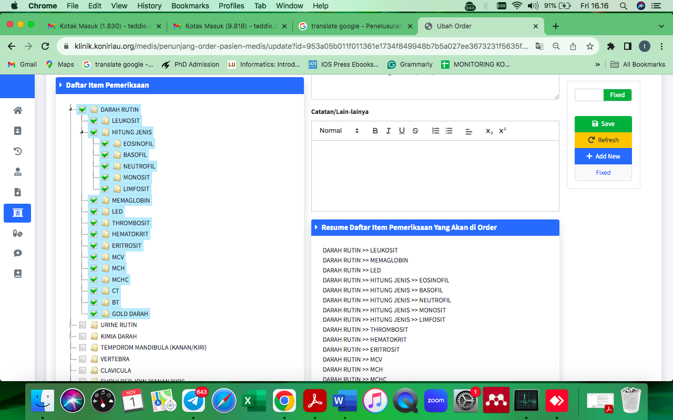
Figure. 5 Laboratory and Radiology Support Examination

Figure 6 is the Integrated Patient Examination Record Form. This is a form that is filled out by all providers of medical services for a patient.

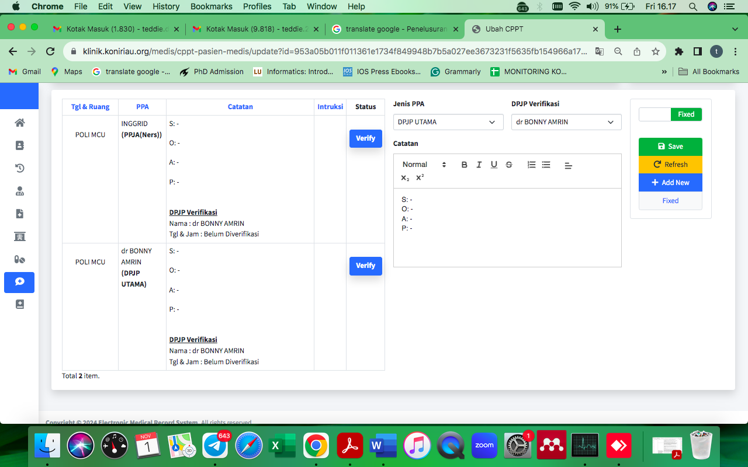
Figure. 6 Integrated Patient Examination Record

Implementation and Evaluation

The implementation and evaluation process are carried out with 8 (eight) expert’s judgements with professions as General Doctor, Psychiatrist, General Nurse, Psychiatric Nurse, Medical Record Staff, and Nutritionist through the 10 (ten) indicators: user interface design, accessibility, interactivity, personalization, social learning, usability, performance, user feedback, user satisfaction, and user motivation. The result is shown in Table I.

Table I. Evaluations Results
Expert | Indicator |  |  |  |  |  |  |  |  |  | Amount Score/ expert | % Score  (Amount / Total Max.Score *100%)
Expert | 1 | 2 | 3 | 4 | 5 | 6 | 7 | 8 | 9 | 10
1st Expert  (Nutritionist) | 5 | 4 | 5 | 5 | 5 | 5 | 6 | 6 | 6 | 5 | 52 | 86,6%
2nd Expert  (Nurse) | 5 | 5 | 5 | 6 | 5 | 5 | 4 | 5 | 5 | 6 | 51 | 85%
3nd Expert  (Nutritionist) | 4 | 5 | 4 | 5 | 6 | 6 | 6 | 6 | 5 | 6 | 53 | 88,3%
4nd Expert  (Psychiatric Nurse) | 6 | 6 | 5 | 5 | 4 | 6 | 6 | 6 | 6 | 6 | 56 | 93,3%
5nd Expert  (Head of Medical Record Dept.) | 6 | 6 | 6 | 6 | 6 | 6 | 5 | 6 | 6 | 6 | 59 | 98,3%
6nd Expert  (Medical Record Staff) | 5 | 6 | 5 | 6 | 6 | 6 | 5 | 6 | 6 | 6 | 57 | 95%
7nd Expert  (Psychiatrist) | 5 | 4 | 3 | 3 | 3 | 4 | 5 | 6 | 3 | 5 | 41 | 68,3%
8nd Expert  (General Doctor) | 5 | 5 | 4 | 4 | 4 | 5 | 5 | 5 | 5 | 5 | 47 | 78,3%
Average per indicator | 41 | 41 | 37 | 40 | 40 | 43 | 42 | 46 | 43 | 45 | 416 | 86,63%

The evaluation results indicate that most experts evaluators consider the system well aligned with user requirements, with six of eight experts assigning scores above 85%, reflecting strong performance in design, usability, functionality, and readiness for real-world hospital implementation. The highest ratings were given by the Head of the Medical Record Department (98.3%), followed by Medical Record Staff (95%) and a Psychiatric Nurse (93.3%), supporting the robustness of the data model. Nutritionists and a general nurse also reported high satisfaction (85–88.3%), highlighting system stability and interface quality. Lower scores from the psychiatrist (68.3%) and general doctor (78.3%) pointed to concerns about interactivity, personalization, and social learning features, suggesting areas for improvement. Overall, the findings confirm that the EHR system is largely deployment-ready, though enhancements in engagement and personalization could further strengthen adoption across medical professionals.

DISCUSSIONS

The findings of this study demonstrate that the developed holistic Electronic Health Record (EHR) application successfully addresses the need identified in the introduction for integrated digital systems capable of representing comprehensive hospital business processes. Prior literature emphasized that modern EHR systems should function not merely as digitized records but as interactive platforms supporting clinical communication[23][24], decision-making [11][25], and patient safety[3][26]. The results confirm this requirement, as the proposed system incorporates multidisciplinary workflows covering registration, assessment, diagnostics, prescriptions, and reporting. By structuring these processes into five phases and twenty-one sub-processes [21], the application operationalizes the conceptual definition of EHR as a comprehensive and analyzable digital health information environment.

The design outcomes also align with earlier studies highlighting the importance of standardized datasets [27][28][29] and interoperable architectures for large-scale health information utilization [30][31][32]. The incorporation of national health datasets and data models in this EHR Application ensures structural consistency and supports interoperability, which is essential for secondary uses such as analytics, artificial intelligence, and cross-institutional data exchange. This confirms previous claims that standardized electronic data collection improves usability and facilitates immediate clinical and research applications. Furthermore, the modular and iterative construction approach reflects recommended software development practices for health systems.

The Evaluation Test results further validate the system's effectiveness in meeting clinical needs and real-world EHR implementation challenges [2][20][29][33][34][35]. High evaluation scores from most experts indicate that the application’s interface design, usability, performance, and reliability correspond with expectations for hospital deployment. These findings support earlier assertions that well-designed EHR systems enhance healthcare delivery efficiency and data accessibility. Particularly strong ratings from medical record professionals suggest that the underlying data model is robust and structurally sound, which is critical given documented concerns about data quality and validity in EHR-based research.

Nevertheless, moderate scores from physicians highlight persistent challenges consistent with those discussed in the introduction and literature, especially regarding personalization, interactivity, and collaborative features. These limitations suggest that while structural and functional components are well established, user-centered enhancements remain necessary to optimize clinical engagement [36]. Prior research indicates that inadequate usability or insufficient customization can hinder adoption, even when technical performance is satisfactory [37][38]. Therefore, improving adaptive interfaces and professional collaboration tools could increase acceptance across diverse clinical roles [39].

Overall, this study contributes empirical evidence that a holistic, standards-based EHR application can effectively integrate complex hospital workflows while achieving strong user acceptance. The results reinforce existing scholarship emphasizing the importance of interoperability, data quality, and multidisciplinary usability, while also extending prior work by demonstrating how these principles can be operationalized within a unified system [40].

CONCLUSIONS

This study demonstrates that the development of a holistic Electronic Health Record (EHR) application based on standardized datasets and real-world clinical workflows can effectively represent comprehensive hospital business processes. The system successfully integrates multidisciplinary medical services into a unified digital platform encompassing patient registration, clinical assessment, diagnostic support, prescription management, and reporting. These findings confirm that a structured and standards-based design approach can operationalize theoretical EHR concepts into a functional application capable of supporting integrated healthcare delivery.

The evaluation results indicate strong overall acceptance among healthcare expert professionals, particularly medical record personnel, nurses, and nutritionists, suggesting that the application’s architecture, usability, and performance meet practical requirements for hospital implementation. The high scores across most indicators validate the robustness of the data model and demonstrate that iterative development combined with user feedback can produce reliable and clinically relevant health information systems.

In conclusion, the proposed holistic EHR application provides empirical evidence that integrated, standards-compliant health information systems can support complex hospital clinical workflow while achieving high levels of user acceptance.

Acknowledgements
We express our sincere appreciation to the Health Practitioners of the Riau Psychiatric Hospital who have given us the valuable opportunity to access and utilize their knowledge and knowledge in this research.

REFERENCES

[1] R. R. Aguirre, O. Suarez, M. Fuentes, and M. A. Sanchez-Gonzalez, “Electronic Health Record Implementation: A Review of Resources and Tools,” Cureus, vol. 11, no. 9, 2019, doi: 10.7759/cureus.5649.
[2] R. S. Janett and P. P. Yeracaris, “Electronic medical records in the american health system: Challenges and lessons learned,” Cienc. e Saude Coletiva, vol. 25, no. 4, pp. 1293–1304, 2020, doi: 10.1590/1413-81232020254.28922019.
[3] X. He, L. Cai, S. Huang, X. Ma, and X. Zhou, “The design of electronic medical records for patients of continuous care,” J. Infect. Public Health, vol. 14, no. 1, pp. 117–122, 2021, doi: 10.1016/j.jiph.2019.07.013.
[4] R. Agudelo, J. Granados, and M. Ceballos, “Exploratory Research in Clinical and Social Pharmacy Design and development of a mobile application for drug information and other health data for users and patients of pharmacies and outpatient pharmaceutical services,” vol. 20, no. September, 2025, doi: 10.1016/j.rcsop.2025.100661.
[5] K. Tanaka, M. Mukai, R. Yamamoto, and N. Mihara, “Data-Sharing Gateway System Design for Large-Scale Medical Information Collection with Distributed EMR Storage,” Stud. Health Technol. Inform., vol. 290, pp. 205–209, 2022, doi: 10.3233/SHTI220062.
[6] S. Abedian, A. Biglarkhani, A. Azami Ghadikolaei, and M. Barahmand, “Development and Implementation of an Integrated Standard e-Prescription Model in Alignment with Iranian National EHR,” Stud. Health Technol. Inform., vol. 314, pp. 139–143, 2024, doi: 10.3233/SHTI240077.
[7] C. Song and M. Nakayama, “Implementation of a Patient Summary Web Application According to the International Patient Summary and Validation in Common Use Cases in Japan,” J. Med. Syst., vol. 47, no. 1, 2023, doi: 10.1007/s10916-023-01993-6.
[8] C. Robbiati et al., “Improving TB Surveillance and Patients’ Quality of Care Through Improved Data Collection in Angola: Development of an Electronic Medical Record System in Two Health Facilities of Luanda,” Front. Public Heal., vol. 10, no. March, pp. 1–8, 2022, doi: 10.3389/fpubh.2022.745928.
[9] M. Sheykhotayefeh et al., “Development of a Minimum Data Set (MDS) for C-section Anesthesia Information Management System (AIMS),” Anesthesiol. Pain Med., vol. 7, no. 2, 2017, doi: 10.5812/aapm.44132.
[10] M. Jokar, M. A. Sahmeddini, F. Zand, R. Rezaee, and A. Bashiri, “Development and evaluation of an anesthesia module for electronic medical records in the operating room: an applied developmental study,” BMC Anesthesiol., vol. 23, no. 1, pp. 1–11, 2023, doi: 10.1186/s12871-023-02335-2.
[11] J. G, S. R, G. H L, V. Ravi, M. Almeshari, and Y. Alzamil, “Electronic Health Record (EHR) System Development for Study on EHR Data-based Early Prediction of Diabetes Using Machine Learning Algorithms,” Open Bioinforma. J., vol. 16, no. 1, pp. 1–18, 2023, doi: 10.2174/18750362-v16-e230906-2023-15.
[12] A. Ahmed, P. Guo, and Z. Jalal, “A systematic review investigating the role and impact of pharmacist interventions in cardiac rehabilitation,” Int. J. Clin. Pharm., vol. 45, no. 2, pp. 320–329, 2023, doi: 10.1007/s11096-022-01517-1.
[13] H. Bakhsh, “Impact of Pharmacist Interventions on Health Outcomes of Patients with Type 2 Diabetes Mellitus in the Middle East : A Systematic Review,” no. May, 2025.
[14] M. Lambert et al., “A systematic literature review and meta-analysis of community pharmacist-led interventions to optimise the use of antibiotics,” no. January, pp. 2617–2641, 2022, doi: 10.1111/bcp.15254.
[15] Y. D. Guracho, S. J. Thomas, and K. T. Win, “Mobile mental health application use, and app feature preferences among individuals with mental disorders in Ethiopia: A cross-sectional survey,” Int. J. Med. Inform., vol. 192, no. September, p. 105628, 2024, doi: 10.1016/j.ijmedinf.2024.105628.
[16] M. Eisenstadt, S. Liverpool, E. Infanti, R. M. Ciuvat, and C. Carlsson, “Mobile apps that promote emotion regulation, positive mental health, and well-being in the general population: Systematic review and meta-analysis,” JMIR Ment. Heal., vol. 8, no. 11, 2021, doi: 10.2196/31170.
[17] A. Polhemus et al., “Health Tracking via Mobile Apps for Depression Self-management: Qualitative Content Analysis of User Reviews,” JMIR Hum. Factors, vol. 9, no. 4, 2022, doi: 10.2196/40133.
[18] S. L. Feder, “Data Quality in Electronic Health Records Research : Quality Domains and Assessment Methods,” pp. 1–14, 2017, doi: 10.1177/0193945916689084.
[19] M. A. Gianfrancesco and N. D. Goldstein, “A narrative review on the validity of electronic health record-based research in epidemiology,” BMC Med. Res. Methodol., pp. 1–10, 2021, doi: 10.1186/s12874-021-01416-5.
[20] K. Honeyford et al., “Challenges and recommendations for high quality research using electronic health records,” Front. Digit. Heal., vol. 4, no. August, pp. 1–9, 2022, doi: 10.3389/fdgth.2022.940330.
[21] T. Darmizal, N. H. Ubaidullah, and A. Saad, “Designing Minimum Data Set and Data Model for Electronic Health Record Systems in Indonesia,” Int. J. Adv. Comput. Sci. Appl., vol. 16, no. 3, pp. 554–563, 2025, doi: 10.14569/IJACSA.2025.0160355.
[22] M. Eva, “Requirements acquisition for rapid applications development,” Inf. Manag., vol. 39, no. 2, pp. 101–107, 2001, doi: 10.1016/S0378-7206(01)00082-9.
[23] D. Xiao, C. Song, N. Nakamura, and M. Nakayama, “Development of an application concerning fast healthcare interoperability resources based on standardized structured medical information exchange version 2 data,” Comput. Methods Programs Biomed., vol. 208, p. 106232, 2021, doi: 10.1016/j.cmpb.2021.106232.
[24] A. N. Gohar, S. A. Abdelmawgoud, and M. S. Farhan, “A Patient-Centric Healthcare Framework Reference Architecture for Better Semantic Interoperability Based on Blockchain, Cloud, and IoT,” IEEE Access, vol. 10, no. August, pp. 92137–92157, 2022, doi: 10.1109/ACCESS.2022.3202902.
[25] S. Medlock, R. Schermer, and R. Cornet, “Implementation of an open-source electronic health record for decision-support education in medical informatics,” Stud. Health Technol. Inform., vol. 270, pp. 981–985, 2020, doi: 10.3233/SHTI200308.
[26] D. R. Murphy, A. N. D. Meyer, D. F. Sittig, D. W. Meeks, E. J. Thomas, and H. Singh, “Application of electronic trigger tools to identify targets for improving diagnostic safety,” BMJ Qual. Saf., vol. 28, no. 2, pp. 151–159, 2019, doi: 10.1136/bmjqs-2018-008086.
[27] A. Mawji et al., “Common data elements for predictors of pediatric sepsis: A framework to standardize data collection,” PLoS One, vol. 16, no. 6 June, pp. 1–12, 2021, doi: 10.1371/journal.pone.0253051.
[28] S. Batra and S. Sachdeva, “Organizing standardized electronic healthcare records data for mining,” Heal. Policy Technol., vol. 5, no. 3, pp. 226–242, 2016, doi: 10.1016/j.hlpt.2016.03.006.
[29] J. Lai et al., “Existing barriers and recommendations of real-world data standardisation for clinical research in China: a qualitative study,” BMJ Open, vol. 12, no. 8, pp. 1–9, 2022, doi: 10.1136/bmjopen-2021-059029.
[30] S. Jung, S. Bae, D. Seong, and B.-K. Yi, “Standard Document Development for Health Information Exchange in Korea,” Appl. Clin. Inform., vol. 13, no. 3, pp. 592 – 601, 2022, doi: 10.1055/s-0042-1749331.
[31] M. Vucha and A. L. Siridhara, “High speed cryptography architecture for health information exchange,” Int. J. Adv. Trends Comput. Sci. Eng., vol. 8, no. 4, pp. 1443–1448, 2019, doi: 10.30534/ijatcse/2019/63842019.
[32] P. Plastiras and D. O’Sullivan, “Exchanging personal health data with electronic health records: A standardized information model for patient generated health data and observations of daily living,” Int. J. Med. Inform., vol. 120, pp. 116–125, 2018, doi: 10.1016/j.ijmedinf.2018.10.006.
[33] A. B. Hamdan, R. A. Manaf, and A. Mahmud, “Challenges in the use Electronic Medical Records in Middle Eastern Countries: A Narrative Review,” Malaysian J. Med. Heal. Sci., vol. 19, no. 3, pp. 334–340, 2023, doi: 10.47836/MJMHS.19.3.43.
[34] A. Aliabadi, A. Sheikhtaheri, and H. Ansari, “Electronic health record–based disease surveillance systems: A systematic literature review on challenges and solutions,” J. Am. Med. Informatics Assoc., vol. 27, no. 12, pp. 1977–1986, 2020, doi: 10.1093/jamia/ocaa186.
[35] M. Tayefi et al., “Challenges and opportunities beyond structured data in analysis of electronic health records,” Wiley Interdiscip. Rev. Comput. Stat., vol. 13, no. 6, pp. 1–19, 2021, doi: 10.1002/wics.1549.
[36] S. M. Abdel-Rahman et al., “Design and Usability of an Electronic Health Record-Integrated, Point-of-Care, Clinical Decision Support Tool for Modeling and Simulation of Antihemophilic Factors,” Appl. Clin. Inform., vol. 11, no. 2, pp. 253 – 264, 2020, doi: 10.1055/s-0040-1708050.
[37] Z. Pruitt, J. L. Howe, S. A. Krevat, S. Khairat, and R. M. Ratwani, “Development and pilot evaluation of an electronic health record usability and safety self-assessment tool,” JAMIA Open, vol. 5, no. 3, pp. 1–7, 2022, doi: 10.1093/jamiaopen/ooac070.
[38] R. Salari, F. Fatehi, and H. Mehdizadeh, “Development and Usability Evaluation of COVID-Iran: A Mobile Application for Mitigating COVID-19 Misinformation,” Healthc. Inform. Res., vol. 30, no. 4, pp. 312–323, 2024, doi: 10.4258/hir.2024.30.4.312.
[39] R. Richter Lagha et al., “Usability Testing a Potentially Inappropriate Medication Dashboard: A Core Component of the Dashboard Development Process,” Appl. Clin. Inform., vol. 11, no. 4, pp. 528–534, 2020, doi: 10.1055/s-0040-1714693.
[40] C. Waldron et al., “Personal Electronic Records of Medications (PERMs) for medication reconciliation at care transitions: a rapid realist review,” BMC Med. Inform. Decis. Mak., vol. 21, no. 1, 2021, doi: 10.1186/s12911-021-01659-8.

