Artificial Intelligence and Future of Ethical Governance
Ms.M.Sri Soundharyaa MCA.,M.Phil.,(PhD.,) Assistant Professor
Department of Computer Science with Cyber Security
Sri Ramakrishna College of Arts and Science Coimbatore

M.Aswitha 23130006
Department of Computer Science with Cyber Security
Sri Ramakrishna College of Arts and Science
Coimbatore

S.Dharani
231300008
Department of computer science with Cyber Security
Sri Ramakrishna College of Arts and Science
Coimbatore

A.Abhilasha 23130003
Department of Computer Science with Cyber Security
Sri Ramakrishna College of Arts and Science
Coimbatore

S.Samwesly
23130038
Department of computer science with Cyber Security
Sri Ramakrishna College Of Arts and Science
Coimbatore
Abstract. Artificial intelligence (AI) has changed our lives significantly and will continue to do so. AI is being used in many areas including autonomous driving, healthcare, media, finance, industrial robots, and online services. The broad use of AI and its integration into the economy and society have improved efficiency and created benefits. However, it also affects the social order and raises ethical concerns. Issues like privacy breaches, discrimination, unemployment, and security risks linked to AI systems have troubled many. Therefore, AI ethics, which studies the ethical issues surrounding AI, has become an important topic in research and a general concern for individuals, organizations, countries, and society. This article provides an overview of this field by summarizing and analyzing the ethical risks and issues raised by AI, ethical guidelines and principles from various organizations, ways to address these issues, and methods to evaluate the ethics of AI. Additionally, we discuss challenges in implementing ethics in AI and some future perspectives. We aim for our work to offer a clear overview of AI ethics for researchers and practitioners in this field, especially beginners.
Index Terms: AI ethics, Artificial intelligence, Ethical Issue, Ethical principle, Ethical Guidelines.

INTRODUCTION
Artificial intelligence (AI) has developed
quickly and impressively over the past decade. Technologies like machine learning (ML), natural language

processing, and computer vision are
expanding into various fields of our society. AI is taking over tasks typically one the rapid growth and application of AI are already affecting our daily lives and society.

done by humans and is influencing chatbot can answer customer inquiries
around the clock, leading to higher customer satisfaction and increased sales. AI enables doctors to treat patients in remote areas through telemedicine services. Clearly, the rapid growth and application of AI are already affecting our daily lives and society.
However, AI also presents significant
ethical risks for users, developers, and society. In recent years, there have been many instances where AI caused negative outcomes. For example, in 2016, the driver of a Tesla was killed in an accident when its Autopilot failed to detect an oncoming truck. Microsoft’
s AI chatbot, Tay.ai, was taken offline
because it became racist and sexist within a day of joining Twitter. Various other examples illustrate failures, fairness issues, bias, privacy concerns, and ethical dilemmas related to AI systems. More alarmingly, criminals have begun using AI technology to inflict harm. For instance, criminals utilized AI software to imitate a CEO’
s voice, resulting in a fraudulent transfer of $243,000. It is essential to tackle the ethical concerns or risks associated with AI to ensure its ethical development and application.
AI ethics, or machine ethics, is an
emerging field focused on addressing the ethical issues of AI. AI ethics involves studying ethical theories, guidelines, policies, principles, rules, and regulations related to AI, as well as ensuring that AI respects ethical standards and operates ethically. The ethics of AI is a foundation for creating ethical AI. It addresses the moral
decision-making processes. It is widely
used in sectors such as business, logistics, manufacturing, transportation, healthcare, education, and government. The use of AI has led
to improvements in efficiency and reduced costs, benefiting economic growth, social development, and human well-being. For instance, an AI
values and principles that help
determine what is right and wrong. By implementing the right ethics for AI, we can develop ethical AI through various methods and technologies.
Even though interdisciplinary researchers have extensively discussed AI ethics for several years, the field is sti l in its early stages. AI ethics is broad and rapidly evolving, attracting more attention from researchers recently. While several review papers have been published, they often focus on specific aspects of AI ethics. There is sti l a need for comprehensive reviews that offer a complete view of this area. For instance, one brief review covered ethical issues in AI, while others addressed ethical guidelines and principles, bias and fairness in ML, safety in reinforcement learning, and privacy and security concerns in deep learning. Thus, this article aims to provide a systematic overview of AI ethics from various angles, offering useful guidance for the community to practice ethical AI moving forward. We hope it will inform scientists, researchers, engineers, practitioners, and other interested parties, especially newcomers to this discipline, so they can pursue further research and improvements.

The main contributions of this article are as follows.
- We summarize the ethical issues and risks linked to AI, proposing a new categorization of AI ethical issues in Section III. This categorization helps in recognizing, understanding, and analyzing the ethical challenges in AI, leading to potential solutions. We also discuss ethical issues tied to different stages of an AI system’ s lifecycle.
- Section IV presents a current global overview of AI ethics guidelines and principles based on 146 guidelines released by various organizations and governments. These guidelines offer high-level guidance for the planning, development, production, and use of AI and directions for addressing ethical issues.
- Section V reviews multidisciplinary
approaches to solving AI ethical challenges, including ethical, technological, and legal perspectives. This section not only summarizes these approaches but also suggests various solutions to AI ethical issues beyond just technological solutions.
- We review methods for assessing or
evaluating AI ethics in Section VI. Testing whether an AI system meets ethical standards is an important part of AI ethics, but is often overlooked in
the literature. To our knowledge, this article is the first to summarize the evaluation of ethical AI.
- Finally, we highlight challenges in AI ethics and provide several future
perspectives, offering research questions and directions for further
exploration. This will assist researchers
government, have begun to discuss
and seek possible frameworks,
and practitioners interested in diving
deeper into the field of AI ethics.
The rest of the article is organized as follows. After this introduction, we describe the scope and methodology of the review in Section II. Section III offers a detailed summary of the ethical issues and risks linked to AI. We review AI ethical guidelines and principles in Section IV. Section V covers approaches to address ethical issues in AI. Section VI discusses evaluating the morality of AI systems or products. Section VII outlines the cha lenges of implementing ethics in AI and discusses future perspectives on designing ethical AI. Finally, Section VIII concludes the article.

SCOPE AND METHODOLOGY
In this section, we first clarify the aspects and topics covered in this review and the links between these topics. Then, we describe the methodology used in conducting this survey, including the literature search strategy and selection criteria.

Scope
The scope and topics of this article are outlined as follows. The investigation of ethical issues and risks of AI is the starting point of this review. The presence of ethical issues in AI gives rise to the field of AI ethics. Therefore, it is necessary and important to clarify and understand the ethical problems that exist in AI. Next, we review the ethical guidelines and principles that guide the development and use of AI. As attention to the ethical issues of AI increases across various sectors of society, many organizations, including those in academia, industry, and

guidelines, and principles to address AI ethics issues. These guidelines and principles provide valuable direction for practicing ethical AI. After clarifying the existing ethical issues and guidelines, we review the approaches to solving ethical problems in AI.
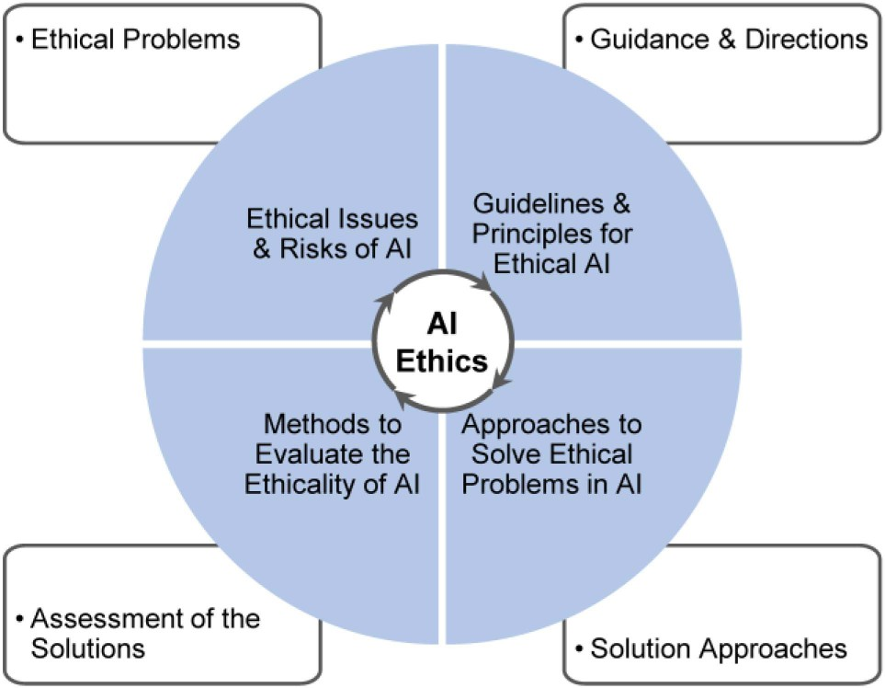
Fig. 1.Ethical in AI
We covered ethical, technological, and legal approaches but focus more on the first two types (ethical and technological) because researchers in the AI community may be more interested in those categories. Finally, we summarize how to evaluate ethical AI, assessing the ethical quality of AI systems. This involves determining how well the ethical problems are addressed and whether an AI system meets ethical requirements. These four aspects are essential for tackling ethical issues in AI. Thus, the four aspects form the main content of this article and offer a systematic overview of AI ethics. The topics covered in this article and their connections are illustrated in Fig. 1.

Methodology
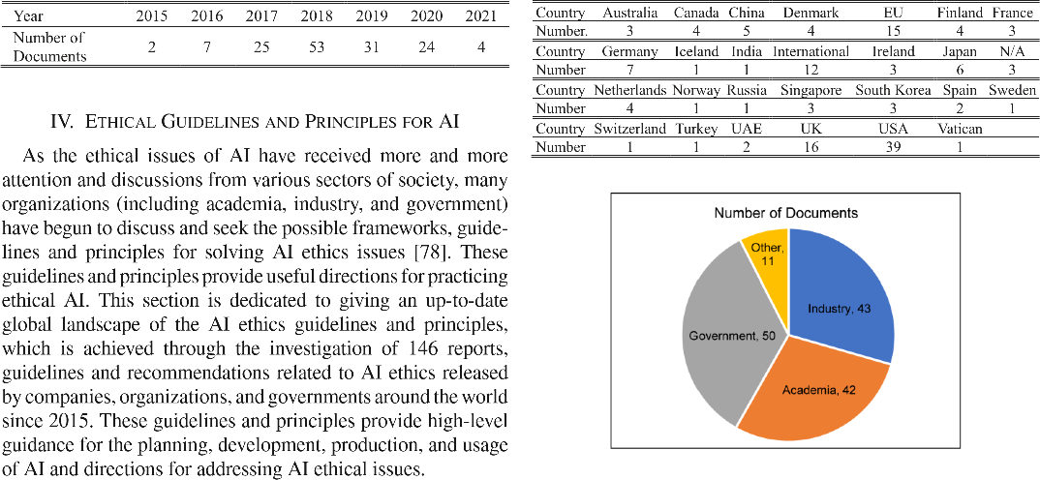
This review includes many documents,
including academic, organizational, government, grey literature sources, and news reports. The search for relevant literature took place in two phases. In the first phase, we used entries or keywords that reflect different terms related to AI ethics to search Google Scholar, Web of Science, IEEE Xplore, ACM Digital Library, Science Direct, Springer Link, arXiv, and Google. The entries included: (ethics, ethical, responsibility, responsible, trustworthiness, trustworthy, transparent, explainable, fair, beneficial, robust, safe, private, sustainable) AND/OR (issues, risks, guideline, principle, approach, method, evaluation, assessment, challenge) AND (artificial intelligence, AI, machine learning, ML, intelligent system, intelligent agent). We mainly considered literature published since 2010 and included as many related keywords as possible in titles. In the second phase, we examined the related works found in the first phase, such as cited articles and other works by the same authors.
For the ethical AI guidelines, we only co lected documents in English (or with official English translations) that can be accessed or downloaded online. A complete list with URL links to the collected ethical AI guidelines is provided in the Supplementary Materials of this article.

ETHICAL ISSUES AND RISKS OF AI
To tackle the ethical problems of AI, we must first recognize and
understand the potential ethical issues

or risks that AI may present. Then, we
can properly formulate the necessary AI ethical guidelines, policies, principles, and rules (i.e., Ethics of AI). With proper ethics, we can design and build AI that behaves ethically (i.e., Ethical AI). The ethical issues of AI generally refer to morally problematic outcomes related to AI that need to be addressed. Many ethical issues, such as lack of transparency, privacy and accountability, bias and discrimination, safety and security concerns, and the potential for criminal and malicious use, have been identified from various applications and studies.
Table 1
This section focuses on the ethical issues and risks of AI. We review four different categorizations of AI ethical issues from the literature in Section III-A. Since these four categorizations often overlook some ethical issues or are too complex to understand, we propose a new categorization that classifies AI ethical issues into individual, societal, and environmental levels in Section III-B. Our proposed categorization comprehensively covers existing ethical
issues and is easy to grasp, which aids
in understanding and analyzing the ethical problems caused by AI. Additionally, we attempt to map the ethical issues associated with different stages of an AI system’ s lifecycle in Section III-C. This mapping helps identify issues during the AI development process.
The main goal of this section is to discuss and clarify the ethical issues of AI so practitioners can recognize and
understand these problems. This
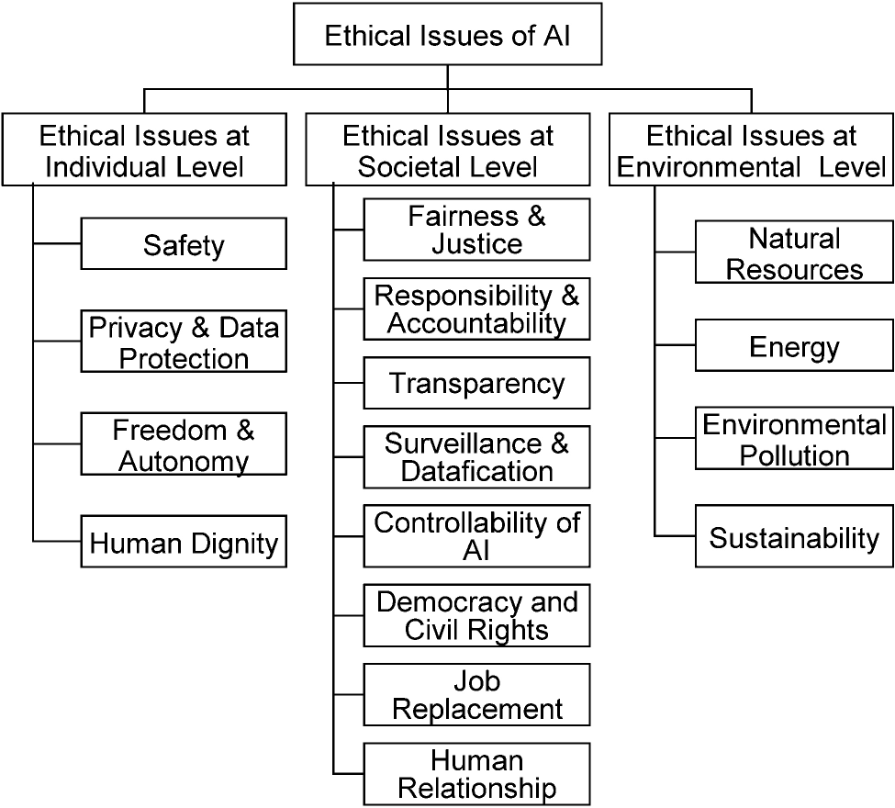
understanding will aid them in further studying how to address AI ethical issues. The main contribution of this section is our proposed categorization of AI ethical issues, which presents the ethical problems in a clear and easy-to-understand way. Additionally, we discuss the ethical issues related to the stages of an AI system’ s lifecycle.

METHODS TO EVALUATE ETHICAL AI
The aim of AI ethics is to create ethical AI systems that behave ethically and follow moral principles. Evaluating or measuring the ethicality and moral competence of designed AI systems is crucial. These systems need to be tested to ensure they meet ethical requirements before deployment. However, this aspect is often overlooked in existing literature. This section reviews three types of approaches for evaluating the ethics of AI: testing, verification, and standards.

Testing
Testing is a common method used to assess the ethical capabilities of an AI

system. Typically, when testing a
system, its output must be compared against a ground truth or expected result. This section focuses on testing approaches for evaluating ethical AI.
- The Moral Turing Test (MTT): Proposed by Allen et al., is designed to evaluate whether an artificial moral agent can exhibit moral reasoning comparable to humans. Similar to the original Turing Test, where a machine passes if it can be mistaken for a human in conversation, the MTT limits the discussion to moral questions. If a human interrogator cannot distinguish the AI’ s moral judgments from a human’ s, the AI is considered a moral agent. However, the MTT has been criticized for focusing too much on the articulation of moral reasoning rather than moral actions, a concern particularly for consequentialists. To address this, Allen et al. introduced the Comparative Moral Turing Test (cMTT), where interrogators compare mora ly significant actions by humans and machines without knowing which is which. If the AI’ s actions are consistently judged as less moral, it fails the test. Despite criticisms that the standard may be too lenient, Wallach and Allen view the cMTT as a practical step toward evaluating AI morality in the absence of universally accepted criteria.
- Expert and Nonexpert Tests: In
addition to MTT, researchers have aimed to assess AI systems' moral competence through expert or nonexpert tests. In these assessments, system outcomes are compared with the ground truth provided by either
experts in normative ethics or nonexperts. Expert tests use established ethical standards, while nonexpert tests align with public morals, allowing citizens to evaluate an AI system’ s ethical capabilities based on their own ethical beliefs.

Verification
Another category of approaches for evaluating AI morality involves demonstrating that the AI behaves correctly according to known specifications. Seshia et al. discussed this approach. A typical formal verification process illustrates how the system model is verified against the environment model and the properties to be checked. The verification process yields a Yes or No answer, indicating whether the system meets the specified property in the given environment. Typically, a No answer includes a counterexample showing how the system fails to meet the property. A Yes answer may also include a proof of correctness in some formal verification tools.Arnold and Scheutz explored the limitations of MTT and noted that MTT evaluations may fall prey to deception, poor reasoning, and low moral performance. They proposed the idea of "design verification" to assess an AI system’ s moral competence.For evaluating AI's ethical design, diverse criteria can be employed. Regardless of how AI carries out moral reasoning, it is essential that its moral actions align with the goals of ethical design.

Standards
Numerous industry standards have been proposed to guide the

development and use of AI and to
assess AI products. This section introduces some AI-related standards.
- In 2014, the Australian Computer Society created the ASC Professional Code of Conduct for a l information communication technology professionals. This code identifies six key ethical values and the requirements for professional conduct associated with them.
- In 2018, ACM updated the ACM
Code of Ethics and Professional Conduct to reflect changes in the computing profession since 1992. This code expresses the profession's conscience and aims to inspire and guide the ethical behavior of all computing professionals, including current and future practitioners, instructors, students, influencers, and anyone using computing technology in a significant way. Additionally, it serves as a foundation for addressing violations when they occur. The code outlines principles as statements of responsibility, emphasizing that the public good is always the primary concern. Each principle is supported by guidelines that help computing professionals understand and apply the principle.
- The IEEE Global Initiative on Ethics
of Autonomous and Intelligent Systems has approved the development of the IEEE P7000TM standards series, which cover topics from data co lection to privacy, algorithmic bias, and more.
- The ISO/IEC JTC 1/SC 42 is a joint
committee between ISO and IEC responsible for standardizing AI. This
group is committed to creating a
broad set of standards that include foundational AI standards, big data, AI trustworthiness, use cases, applications, and ethical and societal concerns. The standards published and under development by ISO/IEC JTC 1/SC 42 are listed in Table IV of the Supplementary Materials.
As concerns about AI ethics grow,
interest in AI standards to shape the design, deployment, and assessment of AI has also increased. However, despite many proposed standards, a significant gap still exists between standards and practice. Currently, only some large corporations, like IBM and Microsoft, have established their own industrial standards, frameworks, and guidelines to foster an AI culture. Smaller businesses, which often lack resources, face a major challenge in applying principles. Therefore, much work is still needed. On one hand, it is important to develop we l-structured standards; on the other hand, there is a need to promote the practical application of these standards.

CHALLENGES AND FUTURE PERSPECTIVES
As AI ethics is an emerging field, many
challenges and issues still need addressing. In this section, we discuss some difficulties in AI ethics and share our future perspective. The goal of this section is to present potential research questions and directions for future studies, aiding progress in AI ethics research. Challenges in AI Ethical Guidelines and Principles: As mentioned in Section IV, many guidelines have been proposed by

various organizations, companies, and
governments, revealing different principles in these guidelines. However, there is currently no guideline that has been approved and adopted widely across different sectors. In other words, different organizations and companies, even within the same fields, hold different views on AI ethics. A consensus on AI ethics has not yet been achieved, and it remains unclear what common principles and values AI needs to follow. Moreover, different ethical principles may be necessary depending on the area of AI application. Currently, discussions on AI ethics in specific application areas are rarely seen in the literature.
Thus, it is crucial to establish basic and
common ethical principles for AI through discussions and collaborations among various organizations, sectors, and governments. Based on these foundational principles, each field can further refine them for better relevance. Clarifying the ethical principles that an AI system must follow is essential for designing systems that comply with these requirements.
B. Challenges in Implementing Ethics in
AI: Implementing ethics in AI faces multiple challenges across various ethical frameworks. In virtue ethics, assessing AI morality is difficult since motives behind AI actions are unclear, and defining or measuring virtuous traits is complex. Deontological ethics struggles with identifying appropriate moral rules and resolving conflicts between them, as ranking their importance subjective.
Consequentialism faces the challenge of predicting and quantifying the outcomes of AI actions, particularly in opaque models like neural networks. Additionally, coordinating differing ethical standards across cultures and organizations is difficult. Technologically, most AI ethics research focuses on isolated aspects like fairness or explainability, lacking integration across principles, which often conflict. Finally, evaluating AI ethics remains challenging since ethics are qualitative and culturally influenced, making precise and objective assessment nearly impossible.

E. Future Perspectives

Future research in ethical AI should
adopt a flexible, multi-theory approach, enabling AI systems to understand and switch between different ethical frameworks depending on the situation, much like humans do. Combining normative ethics with domain-specific ethics ensures user acceptance and practical relevance. Technologically, developing AI and machine learning models guided by multiple ethical principles is essential, though challenging, for building truly ethical systems. Effective evaluation methods are also crucial before deployment, with domain-specific benchmarks playing a key role in sensitive areas like healthcare and autonomous vehicles. Lastly, integrating normative ethics (innate moral reasoning) with evolutionary ethics (learning-based moral development)
could enable AI systems to continuously acquire and refine moral competencies, offering a promising direction for future ethical AI development.

CONCLUSION

Based on our review of AI ethics and the many complexities and challenges described in this article, it is clear that attempting to address ethical issues in AI and to design ethical AI systems that are able to behave ethically is a tricky and complex task. However, whether AI can play an increasingly important role in our future society largely depends on the success of ethical AI systems. The discipline of AI ethics requires a joint effort of AI
Scientist, engineers, philosophers, users, and government policymaker scientists, engineers, philosophers,
users, and government policymakers. This article provides a comprehensive overview of AI ethics by the summarizing and analyzing the ethical risks and issues raised by AI, ethical guidelines and principles
issued by different organizations, approaches for addressing ethical issues in AI or fulfilling ethical principles of AI, and methods for evaluating the ethics (or morality) of AI.

REFERENCES
• Liu, Zhiyi & Zheng, Yejie. AI Ethics and Governance: Black Mirror and Order. Springer Singapore (2022). — Interdisciplinary examination of ethical issues and governance approaches in AI.
• Floridi, Luciano & Cowls, Josh (eds.). Ethics, Governance, and Policies in Artificial Intelligence. Springer Nature (2020). — A comprehensive book covering frameworks and policies shaping AI governance and ethical principles.
• Coleman, Flynn. A Human Algorithm: How Artificial Intelligence Is Redefining Who We Are. Counterpoint Press (2019). — A philosophical and human-rights focused take on embedding human values into AI systems.
- Batool, Amna, Zowghi, Didar & Bano, Muneera. Responsible AI Governance: A Systematic Literature Review. arXiv (2023). — Meta-analysis of literature on governance frameworks and ethical principles in AI.
- Amna Batool, Didar Zowghi & Muneera Bano. AI governance: a systematic literature review. AI and Ethics (2025). — State-of-the-art research on elements, mechanisms, and stages of ethical AI governance.
- Ximeng Chen. Ethical Governance of AI: An Integrated Approach via Human-in-the-Loop Machine Learning. Comput. Sci. Math. Forum (2023). — Discusses integrated frameworks and stakeholder participation in ethical governance.
- Jie Zhang & Zong-Ming Zhang. Ethics and governance of trustworthy medical artificial intelligence. BMC Med Inform Decis Mak (2023). — Healthcare case study highlighting ethical governance challenges in AI systems.
- Shashank Singh & Hitesh Mohapatra. AI Ethics Governance and Privacy in a Rapidly Advancing Digital World. Systemic Analytics (2025). — Overview of ethics, governance, bias, and privacy issues in AI-ML applications.

