Knowledge, Attitude, and Digital Literacy of Agriculture Students
Anecil S. Quijano-Pagutayao¹, Maryjoy S. Bacus²
James Karlo S. Maiso³, Wenielyn G. Nilo⁴, Dexter Neil Guden⁵

1Central Mindanao University, College of Agriculture
Department of Agricultural Education and Extension
anecil_cmu@cmu.edu.ph/0009-0002-5615-4597
https://scholar.google.com/citations?user=pjgDMBQAAAAJ

2Central Mindanao University, College of Agriculture
Department of Agricultural Education and Extension
maryjoybacus1979@gmail.com

3Central Mindanao University, College of Agriculture
Department of Agricultural Education and Extension
James Karlo S. Maiso jksmaiso@yahoo.com 0009-0004-7478-2874

4Central Mindanao University, College of Agriculture
Department of Agricultural Education and Extension
wencemydocs@gmail.com 0009-0007-2446-1054

5Central Mindanao University, College of Agriculture
Department of Agricultural Education and Extension
dexterneilbarcelona25@gmail.com 0009-0000-1238-4361

Abstract. This study was conducted at Pangantucan Bukidnon Community College (PBCC) in the Philippines. The objective of the study is to determine the students' knowledge, attitudes, and digital literacy on digital mass media. The data were collected personally by research from the 2nd-year and 3rd year students of Pangantucan, Bukidnon Community College. A total of 108 students served as respondents in the study. Frequency counts, Likert scale and ranks were employed. Findings show that the primary devices used by the participants were phones(97.22%) with secondary devices being laptops. The average screen time spent by students in using mass media is four hours. The most accessed digital platforms are Facebook, YouTube, and TikTok, while the webpage from the state and universities is moderately utilized. Digital mass media were perceived by Students positively with a positive attitude on digital tools with high level of knowledge. The level of usage was moderate (overall mean = 2.97), with Facebook groups, YouTube tutorials and TikTok content being used the most for agricultural information. The sample was overwhelmingly male (53.21%) as are the demographics of the agricultural workforce nationally.Digital mass media was considered very useful in learning about agriculture by the students (with overall mean score 4.18) because it is relevant, convenient and can make learning more easy for complex topics. The attitudes expressed were overwhelmingly positive, with a strongly agree rating with an overall mean of 4.68, which means that digital media helps to increase involvement, motivation and independent learning. The overall mean of the knowledge level was also rated as high (3.88), which indicates students' ability to use digital tools for academic and agricultural activities, as well as evaluate information retrieved from the internet. The frequency of digital mass media exposure was also high (overall mean 3.48), with numerous uses across multiple platforms and seeking out agricultural information. Challenges faced by the students include rampant fake news, intermittent internet connection, and limited research on agriculture students’ digital self-efficacy.

Keywords: Digital Mass Media, Agricultural Education, Digital Literacy, Student Perception

Introduction

Background of the Study

The growing digital mass media has transformed the agricultural communication environment and redefined the processes of information creation, reception, and sharing amongst a continuum of stakeholders. Facebook, YouTube, Tik Tok, and online news sources are the new media channels, which have become leading channels through which the agricultural knowledge, market insights, climate alerts, and technology innovations can spread in the recent years (Aker et al., 2021). These media have democratized the provision of information, and the interactive mode of communication has been very quick and has eliminated the limitations associated with the traditional modes of extension. With the further integration of digital tools in the world of agriculture, the role of digital mass media in strengthening the process of learning, decision-making, and extension becomes even more relevant especially to the younger generations who are digital natives.
The use of digital media in the agricultural sector in Philippine is gaining momentum, but there are still unequal distributions, connectivity, and digital literacy, particularly in rural areas where many State Universities and Colleges (SUCs) are located (Talandron et al., 2023). Although national programs encourage the use of digital agriculture and ICT-based extension, the degree to which the learners of agriculture are involved in and take advantage of digital mass media has not yet been decided. There is thus a need to understand how they perceive and therefore, to be able to design responsive curricula, enhance the digital literacy programs and prepare them to work in agricultural careers that are technology driven.
Although the current importance of digital mass media in the area of agricultural education is increasing, there is limited research on the specific perception of agricultural students concerning the use of the digital mass media. The current literature mainly focuses on the farmers, young people in general, or even students who do not pursue agricultural studies (Ernest and Kuta, 2021; Mercado and Osbahr, 2020). This gap indicates the need to conduct empirical studies which explore how students of agriculture assess, use and implement digital mass media in scholarly and pre-professional environments. They are invaluable in improving agricultural education, optimizing digital extension plans, and national plans to modernize agriculture.
Most studies that have been conducted focus on farmers or general students population, thus failing to represent the needs and context of agriculture students that are very different. The literature that has been found provides very little information regarding the perception of credibility of digital media by students. The spread of agricultural influencers, vloggers, and user-generated content has intensified the concerns upon misinformation (Aranguri et al., 2022). However, the majority of studies analyze the perception of accuracy, credibility, and applicability of online agricultural information by agriculture students. There is a lack of studies dealing with digital mass media as an extension tool among students. Students as future extension professionals should be ready to use digital platforms as means of communication and transferring knowledge. However, their apparent preparedness, self-confidence and proficiency in utilization of digital media to create extensions are not clear. Socio-psychological variables, including digital self-efficacy, technology motivation, attitudes toward technology, and perceived usefulness are scarcely studied in the area of agricultural education. These variables that have been known to affect the adoption of technology (Davis, 1989) are poorly researched in determining the perception of digital mass media by agriculture students. Taken together, these gaps highlight the need to conduct an all-encompassing research that examines This study was conducted to assess the perceptions of agriculture students on digital mass media as sources of agricultural information; To determine the Knowledge, Attitude, and Digital Literacy Among Agriculture Students in Bukidnon; To identify the digital mass media platforms most commonly used by agriculture students and examine how these platforms influence their learning and engagement in Philippine LUCs. By filling these gaps, it will aid in improving the state of agricultural education. The rapid expansion of digital mass media has fundamentally transformed agricultural communication, redefining how information is synthesized and shared across the value chain.

Methodology
Bukidnon is a landlocked province in Northern Mindanao, positioned in the Mindanao heartland. It's far linked to Davao in the south and north of the island. The topography is mostly grassland with a median elevation of 915 meters. Low plains and hills, valleys, and deep canyons represent the terrain. It lies among the parallels 7 '25' and 8 '38' north range and meridians 124'16' east longitude. The vicinity is characterized by means of mountainous terrains that are often taken into consideration as marginal farmlands. The sloping farmlands of Bukidnon are home to Indigenous and smallholder farmers and data some of the best poverty incidents within the region. Bukidnon is a province that provides a selection of sources and viable engagement for diverse resources and profits. It is the home of the sector's widest pineapple plantation, boasting a conventional golfing route dating back to 1928. it's also the most essential livestock-producing province in the vicinity. It's miles adequately endowed with herbal points of interest, particularly Kitanglad stages that include Mt. Dulang-Dulang, the second maximum top in the country. it's been diagnosed as one of the country's healthiest biodiversity and richest endemic species of fauna and plants.
The study area was conducted in Pangantucan Bukidnon Community College. Pangantucan Bukidnon Community College (PBCC) -Pangantucan, Bukidnon (LUCs). It was chosen as it offers agriculture degree program in rural area with a service to rural and agricultural communities and represent the digital divide and ICT access issues recorded in the region. It is under the Municipality of Pangantucan, Bukidnon. The study employed a combination of methods in order to measure the knowledge and attitude of students. A purposive sampling technique was utilized to select 108 respondents from the 2nd and 3rd-year levels, specifically targeting those training to become future extension specialists and agripreneurs in rural Bukidnon. The data collection tool was an expanded structured questionnaire validated to measure not only general digital usage but also specific indicators of SDG 4 (Quality Education) and SDG 2 (Zero Hunger). Figure 1 presents the map showing the locale of the study.
​ 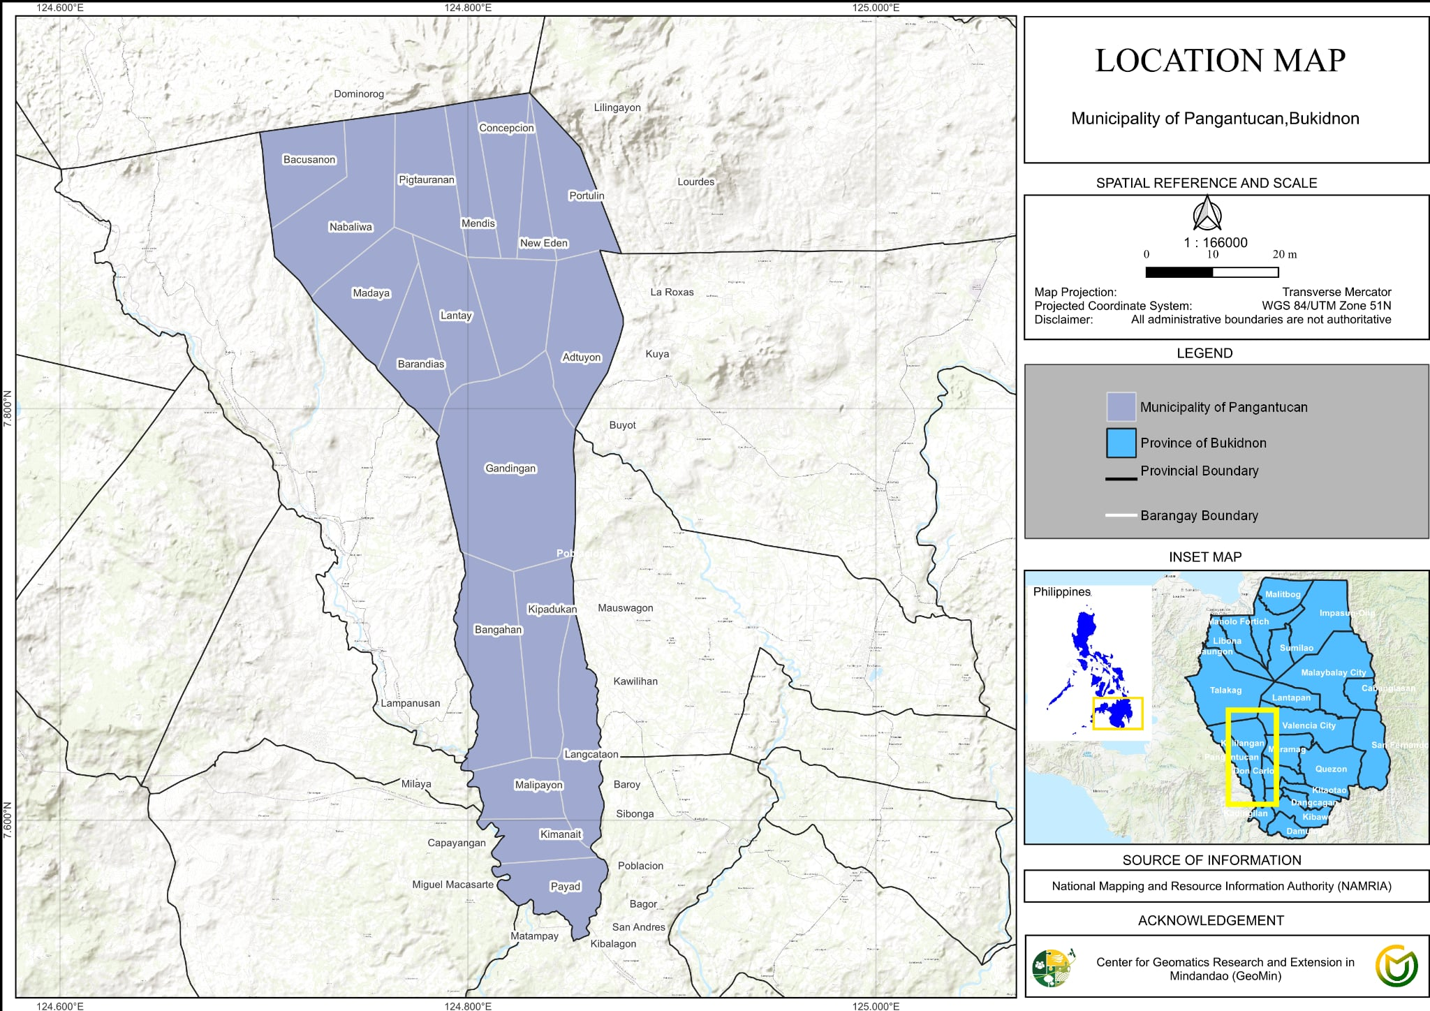

Figure 1. Map of the Philippines and Bukidnon showing the locale of the study

Results and Discussion

Primary Devices used in digital Mass Media. Figure 2 presents the primary devices used by the participants in accessing agriculture related information. It can be gleaned that the majority(97.22%) of the participants uses cellphone. While the remaining participants use laptops. It means that most of the participants' available devices were cellphones, as it is most accessible and affordable devices to use. This result is similar to the study of Al-Maroof and Al-Emran (2018), students prefer cellphones to support quick online access to resources and learning applications. While Lau et al. (2020), phones were reported that phones were used as primary ICT tools in accessing online applications, which surpasses laptops and desktop computers.

Figure 2. Primary Devices used in digital Mass Media

Other devices used in accessing Digital Mass Media. Figure 3 presents the other devices used to access digital mass media for agricultural-related information. More than one half of the participants uses laptops as their secondary device. This means that the second available device for the students was laptops. This result is consistent with the study of Panganiban et al. (2022), who mentioned that laptops were preferred secondary and supplementary devices of college students to access digital learning resources. Dela Peña and Escoto (2021), laptops have a larger screen, document processing, and online accessibility. Carbado (2021) access to digital modules, research articles, and online extension materials that are difficult to navigate on mobile phones.

Figure 3. Other devices used in accessing Digital Mass Media

Average Daily Hours spent on digital Mass Media. Figure 4 presents the average daily hours spent by the students in accessing digital mass media. It can be gleaned that 37% of the participants are using their devices for four hours in order to access digital mass media. (Pacis & Alidayo (2025) reports that Filipino students average three to five hours a day on the internet on academic work, communicating, and seeking information. On the same note, Dizon and Santos (2022) found that online learning and the use of digital resources make college students spend between four and six hours a day on the screen. All the studies positively support the fact that a four-hour per day use pattern is common among Filipino students who use digital academic environments.

Figure 4. Distribution of the participants' average daily hours spent on digital mass media

Usage Patterns of Digital Mass Media for agriculture related information. Table one presents the usage patterns of agriculture students of mass media for agriculture related information. Based on the result, participants showed an overall mean of 2.97, which means moderately agree. The participants rated all the indicators as very high or moderately agree. This implies that these platforms were used moderately by the participants.

Table 1. Distribution of the participants' usage patterns of Digital Mass Media for agriculture related information
INDICATORS | WEIGHTED MEAN | DESCRIPTIVE RATING
1. Facebook agriculture pages/groups | 3.32 | Moderately Agree
2. YouTube agriculture tutorials | 3.31 | Moderately Agree
3. TikTok agriculture content | 3.18 | Moderately Agree
4. Government/DA/ATI online platforms | 2.87 | Moderately Agree
5. SUC-based digital extension materials | 2.64 | Moderately Agree
6. Online news outlets on agriculture | 2.89 | Moderately Agree
7. Podcasts/webinars on agriculture | 2.59 | Moderately Agree
OVERALL MEAN | 2.97 | Moderately Agree
Legend: 4.51-5.00 Strongly Agree 3.51-4.50 Agree 2.51-3.50 Moderately Agree 1.51-2.50 Disagree 1.00- 1.50 Strongly Disagree

Sex. Figure 4 shows the distribution of the participants according to sex. More than one half (53.21%) of the students were males. This implies that the students were male-dominated. Montecillo (2016) stated that in the field of agriculture, males were traditionally more dominant than women. Additionally, the Philippine Statistics Authority (2005) states that males made up the majority of agricultural operators compared to females.

Figure 5. Distribution of the students according to sex

Usefulness of Digital mass media for agriculture students. Figure 5 shows the distribution of the participants according to the usefulness of digital mass media as source of information. More than one half (53%) of the participants agreed that they were using digital mass media as source of information in agriculture related information for class purposes.

Figure 5. Distribution of the usefulness of Digital mass media for agriculture students

Perception towards Digital Mass Media
Table 7 shows the participants perception towards Digital Mass Media. Based on the result, students showed very high attitude towards Digital Mass Media with an overall mean of high (4. 39) . The students rated high on all the indicators. This implies that the students has a positive attitude toward Digital mass media.

Table 7. Perception of students towards Digital Mass Media
INDICATORS | WEIGHTED MEAN | DESCRIPTIVE RATING
I believe that digital mass media is useful for learning agricultural concepts. | 4.39 | High
I believe that digital mass media keeps me updated on agricultural information. | 4.17 | High
I believe that digital mass media enhances my communication skills with others. | 4.17 | High
I believe that digital mass media is relevant to my academic needs. | 4.43 | High
I believe that digital mass media helps simplify complex agricultural topics. | 4.04 | High
I believe that digital mass media is an effective tool for agricultural education. | 3.56 | High
I believe that digital mass media exposes me to diverse information about agriculture. | 4.29 | High
I believe that digital mass media helps me access information on agricultural innovations quickly and conveniently. | 4.37 | High
OVERALL MEAN | 4.18 | High
Legend: 4.51-5.00 Very High 3.51-4.50 High 2.51-3.50 Moderate 1.51-2.50 Low 1.00- 1.50 Very Low

Attitudes Towards Digital Mass Media. Table 8 presents the students attitudes towards digital mass media in agriculture learning. The participants strongly agree with all the statements regarding the Attitude towards Digital Mass Media with an overall mean of 4.68. The participants express a strong agreement that they enjoy using Mass media in Agriculture (4.77), digital Mass Media makes agriculture learning more engaging (4.75). This implies that the students has positive attitude towards digital mass media.

Table 8. Attitude towards Digital Mass Media
INDICATORS | WEIGHTED MEAN | DESCRIPTIVE RATING
I enjoy using digital media to learn about agriculture. | 4.77 | Strongly Agree
Digital media makes agricultural learning more engaging. | 4.75 | Strongly Agree
I feel positive about integrating digital media into education. | 4.72 | Strongly Agree
Digital media is a valuable tool for agricultural students. | 4.70 | Strongly Agree
I prefer digital media over traditional sources. | 4.66 | Strongly Agree
Digital media motivates me to explore agricultural content. | 4.66 | Strongly Agree
Digital media encourages independent learning. | 4.66 | Strongly Agree
OVERALL MEAN | 4.68 | Strongly Agree
Legend: 4.51-5.00 Strongly Agree 3.51-4.50 Agree 2.51-3.50 Moderately Agree 1.51-2.50 Disagree 1.00- 1.50 Strongly Disagree

Knowledge on Digital Mass Media Exposure

Table 9 shows the Knowledge of students on Digital Mass media. The participants rated 3.88 their knowledge on digital mass media which means high. This implies that the participants has knowledge on Digital mass Media. Students are generally knowledgeable on the content. This implies that students has knowledge on digital mass media.

Table 9. Knowledge of Digital Mass Media
INDICATORS | WEIGHTED MEAN | DESCRIPTIVE RATING
I have knowledge in using digital mass media for agricultural learning purposes. | 3.83 | High
I have practical skills in acquiring farming information from online content. | 3.93 | High
I have a broad knowledge of digital media, which enhances my problem-solving in agriculture. | 3.94 | High
I apply what I learn from digital media in academic tasks. | 3.83 | High
Digital media provided me with knowledge in exploring new agricultural technologies. | 3.61 | High
I have digital skills in evaluate fake and legit online agriculture content. | 3.81 | High
I can use digital tools to collect and analyze field data (e.g., surveys, mobile apps, Google Forms,). | 3.99 | High
I can confidently conduct online or virtual activities (e.g., webinars, online consultations). | 4.00 | High
I have sufficient exposure and skills to digital platforms used in agricultural extension. | 3.94 | High
OVERALL MEAN | 3.875 | High
Legend: 4.51-5.00 Very High 3.51-4.50 High 2.51-3.50 Moderate 1.51-2.50 Low 1.00- 1.50 Very Low

Digital Mass Media Exposure. Table 9 shows the Distribution of students according to Digital Mass Media Exposure. The Students rated the digital mass media exposure with an overall mean of 3.48 which means high. In particular, the students rated as high on all the indicators.

Table 10. Distribution of students according to Digital Mass Media Exposure
INDICATORS | WEIGHTED MEAN | DESCRIPTIVE RATING
I frequently use digital media such as Facebook to access agricultural information. | 3.39 | High
I am following legit agricultural pages, channels, or influencers online for learning purposes. | 3.86 | High
I am using multiple platforms such as YouTube, TikTok, Facebook, Instagram, web, and etc for agricultural learning. | 3.64 | High
I encounter agricultural content on social media. | 3.61 | High
I mostly use digital mass media rather than the traditional sources for agricultural information. | 3.45 | High
I actively search for agricultural tutorials or demonstrations online. | 3.68 | High
I participate in online groups or communities related to agriculture. | 3.24 | High
I receive agricultural information through messaging apps. | 2.94 | Moderate
OVERALL MEAN | 3.48 | High
Legend: 4.51-5.00 Very High 3.51-4.50 High 2.51-3.50 Moderate 1.51-2.50 Low 1.00- 1.50 Very Low

Conclusion
Based on the findings of the study, the following conclusions were drawn:

The study confirms digital mass media as a vital element of agriculture learning, as agriculture students are very reliant on mobile technologies to access information. Cellphones proved to be the most popular device (97.22%), due to their affordability, availability and suitability for accessing the internet quickly. Laptops were the main secondary device used for work that did not require the larger screens and document processing power of the primary device. Students also reported an average of 4 hours per day of digital mass media usage, which is similar to the national pattern for student online academic engagement.

The students' perception, attitude, knowledge and exposure with digital mass media were high to very high overall mean = 4.58, 4.57, 4.56, and 4.32, respectively with moderately low use of specific digital platforms for agriculture-related information of students (overall mean = 2.97). They found digital media to be useful, relevant and effective in learning, and they enjoyed and were motivated to use digital tools, exhibiting good digital skills from evaluating online information to applying digital tools for academic and agricultural purposes. They are also very active on platforms like Facebook, YouTube and TikTok, further highlighting the importance of digital environments in their learning ecosystem.

The male dominance of the demographic profile is indicative of the overall trend in agriculture and highlights the key role that digital platforms play in supporting traditionally male-dominated agricultural fields. The overall results showed that digital mass media is not only to improve the access of agricultural information but also to increase the digital literacy of agriculture students, engagement and independent learning.

Acknowledgements
The author extends heartfelt gratitude to various individuals who have played pivotal roles in her academic journey. The author would like to thank her family, John Rae, Zeanne Rae, and Rae Emil for their boundless love, unwavering support.

References (APA 7th ed)

Al-Maroof, R. A., & Al-Emran, M. (2018). Students’ acceptance of Google Classroom: An exploratory study using PLS-SEM approach. International Journal of Emerging Technologies in Learning, 13(6), 112–123. https://doi.org/10.3991/ijet.v13i06.8275

Carbado, J. M. (2021). Digital learning access and challenges among college students in rural communities. Philippine Journal of Education and Human Development, 9(2), 45–56.

Dela Peña, R. P., & Escoto, M. C. (2021). Device preference and digital readiness of higher education students in flexible learning. Asia Pacific Journal of Education, Arts and Sciences, 8(1), 1–10.

Dizon, M. A., & Santos, R. J. (2022). Screen time and academic engagement among Filipino college students in online learning. Journal of Educational Technology and Innovation, 5(3), 22–34.

Lau, J., Sim, K., & Tan, B. (2020). Mobile phone usage as primary ICT tool for online learning among university students. Journal of Learning and Development Studies, 3(4), 15–27.

Montecillo, N. (2016). Gender roles in Philippine agriculture: A review of participation and labor distribution. Philippine Journal of Rural Sociology, 34(1), 55–70.

Pacis, R. A., & Alidayo, J. M. (2025). Internet use patterns of Filipino students in digital learning environments. Philippine Information and Communication Research Journal, 12(1), 30–42.
Panganiban, M. L., Cruz, A. P., & Villanueva, S. R. (2022). Device preference and digital study habits of college students in flexible learning. Journal of Educational Research and Practice, 10(2), 88–101.

Philippine Statistics Authority. (2005). Gender statistics on agricultural operators in the Philippines. PSA Publications.

