MACHINE LEARNING TECHNIQUE FOR 5G CELL DEPLOYMENT IN URBAN ENVIRONMENTS

Abstract
The deployment and optimization of 5G networks present substantial challenges due to the complexity of designing efficient base station placement strategies. This study develops predictive models using Support Vector Machine (SVM) and Random Forest (RF) algorithms, leveraging a real-world dataset from MTN Nigeria comprising geospatial, environmental, and demographic variables that affect network performance and user distribution. The data set underwent preprocessing, including data imputation, normalization, and feature extraction to ensure high-quality input for model training and evaluation. Experimental results indicated that the RF model achieved the highest accuracy of 93.4% with the lowest root mean square error (RMSE) of 0.156, outperforming the SVM model, which recorded an accuracy of 88.5%. The models effectively identified high-suitability zones for 5G cell site deployment, with key predictors including population density, signal strength, and terrain elevation. These findings provide a robust, scalable, and interpretable decision-support framework for network operators, contributing to cost-effective 5G cell deployment and improved connectivity in emerging economies. The proposed approach highlights the significance of machine learning in enhancing 5G network optimization while reducing infrastructure deployment costs.
Keywords: 5G deployment; network optimization, machine learning, Random Forest; Support Vector Machine, predictive modeling.
- Introduction
The mobile communication systems have experienced appreciable innovations from first generation (1G) to fifth generation (5G) network as a result of massive need for higher data rates, ultra-low latency, ever increasing connectivity and stability. The adaptation of 5G network from the previous generations of network communication architectures promotes the advancement of new technologies such as network slicing, base-station densification, massive MIMO (Multiple Input Multiple Output) and millimeter-wave communication (Mohamed et al., 2021). However, the 5G technology is challenged with significant intricacy in the planning, deployment and optimization(Ahamed & Faruque, 2021). The 5G network require dense network of mini base station, which will cover limited areas for high-speed connectivity and quality services (Khatiwoda et al., 2024). Hence making the deployment of this technology a critical challenge for operators. The conventional base station planning and deployment depend largely on manual optimization, rule-based algorithms and experimental models which are usually limited in managing the dynamic, data-intensive, and diverse nature of 5G ecosystem(Sapkota et al., 2024). Complex multi-dimensional problem such as topographical variation, user mobility patterns, interference management, and band allocation requires adaptive and intelligent solutions(Al-Khalsh, 2023). Thereby creating an increasing interestfor Machine Learning (ML) and Artificial Intelligence (AI) application in the 5G network design and operation.Recent studies have demonstrated the relevance of Machine learning techniques in data drive decision making, which enables system to learn from past and real time data(Thillaigovindhan et al., 2024). The 5G cell deployment is largely assisted by ML in various stages which includes site selection, coverage prediction, traffic forecasting, beamforming optimization, and resource allocation (Ali et al., 2024). These ML techniques such as supervised learning, unsupervised learning and reinforcement learning are extensively implemented, which shows its relevance in automating and optimizing the 5G cell deployment processes(Al-Khalsh, 2023). By utilizing MLtechnology, network operators can minimize costs, reduce deployment time, and as well as optimize energy efficiency and thegeneral performance of the system(Thantharate et al., 2022).Therefore, exploring machine learning techniques for 5G cell deployment provides the bases for building feasible, scalable and sustainable communication network that satisfies demand of next generation applications such as smart cities, autonomous vehicles, Internet of Things (IoT) and overall digital experiences. The study seeks to investigate and deploy ML predictive model to optimize the decision-making process involved in the 5G cell deployment, as well as improving the system performance, reducing operational costs and creating room for intelligent network automation.
- Related works
This section carried out investigation of other related works to have an overview of diverse areas research work done by other researchers.Sapkota et al., (2024) presented a study on metaheuristic based 5G base station deployment and visualization enhancement by carryingout comparative analyses on machine learning algorithms such as Swarm Optimization (PSO), Simulated Annealing (SA), and Grey Wolf Optimizer (GWO) in both Urban Macro (UMa) and Remote MacroAntenna (RMa) ecosystem to address the ever increasing demand of high data rates and low latency thereby mitigating the current shortcomings of the conventional 5G deployment method of using Non-Standalone Architecture (NSA) with emphases on population density. The outcome of the analysis disclosed that the PSO and GA demonstrated optimal balance in coverage and capacity.In addition, 28 GHz and 3.6 GHz carrier frequencies were compared UMa to ascertain their efficiencies. Finally, an optimized 5G multi-Tier Radio Access Network (RAN) planning was devised using 2.6 GHz carrier frequency for RMa deployment. The system provided a practical solution for infrastructural reduction while optimizing network performance in a precise geographical setting.
Zamzami et al., (2023) deployed three deep learning models such as deep reinforcement (DR), long-short term memory (LSTM), and a convolutional neural network (CNN) in predicting the basic effect of the spread of 5G networks using channel metrics, context metrics, cell metrics and throughput data as primary indicators for determining the adoption of 5G technology. The DR model and CNN model results demonstrated their efficiency in predicting the elements that would affect 5G adoption.
Yazar et al (2025) deployed the use of machine learning based technique in meeting the diverse communication requirements from a human-centric perspective, considering terrestrial networks and non-terrestrial networks focusing of 5G networks. The machine learning algorithms utilized a synthetic dataset for the development of the model, and the simulation results revealed that the approach in this study will be effective not just in 5G networks, but can also be utilized in 6G.
Chabira et al., (2025) carried out an investigation on the application of ML and Deep learning (DL) on handover management and load balancing optimization while considering smart city ecosystem and ultra-dense networks. The result of this study revealeda significant reduction in latency, network congestion and handover failures, as well as optimized prediction of handover decisions and real time adaptive load distribution. The general performance of the model enhanced the overall user experience and quality of service (QoS).
Alaa et al., (2025) utilized telecom Italia big data coordination in developing eight models which includes seasonal-Autoregressive-integrated-moving-average, Facebook-prophet, adaptive-boosting (AdaBoost), extreme-gradient-boosting (XGBoost), Long-short-term memory (LSTM), convolutional-neural-network (CNN), hybrid CNN-LSTM, and ensemble model that combined of the outputs of CNN and LSTM. for cellular network traffic prediction for urban telecommunication in Milan City. The models were deployed to predict different types of network traffic such as the internet, SMS and distinct call traffic in a geographic area like city center, commercial, residential and business. The models were evaluated using performance metrics and computational time. The result of CNN+LSTM disclosed the most accurate with R2 values of f 0.990 for Internet, 0.986 for call, and 0.976 for SMS, followed by the hybrid CNN-LSTM and LSTM models. These models are associated with a high level of computational density. while, the AdaBoost and XGBoost models obtain practical alternatives for balancing accuracy with computational efficiency.
Mohamed et al., (2023) carried out an investigation on 5G wireless network to determine the most capable methods and algorithms that can satisfy the quality of services required for the heterogeneous traffic flows across the 5G wireless network. The investigations reveal reinforcement learning as a promising machine learning algorithm that is supportive in the 5G mobile network. In addition, the combination of reinforcement learning in real-time network slicing, and network virtualization allows for the deployment of QoS-aware network schedulers, which are dynamic and capable of adapting to the heterogeneous environment of 5G networks.
- Methodology
This research employs a machine learning-based methodology aimed at developing a predictive model for optimal 5G cell deployment, building upon both conventional planning methods and contemporary artificial intelligence techniques. A review of related literature underscores the suitability of machine learning approaches for addressing the complexities of 5G network design, particularly in heterogeneous and high-density environments. Accordingly, the proposed methodological framework adopts a supervised learning paradigm. It encompasses five key stages: data acquisition, preprocessing, model training, prediction, and performance evaluation. This structured pipeline is designed to enhance deployment accuracy, reduce planning latency, and provide data-driven decision support for 5G infrastructure optimization. The block diagram of the methodology is presented in the figure 1.
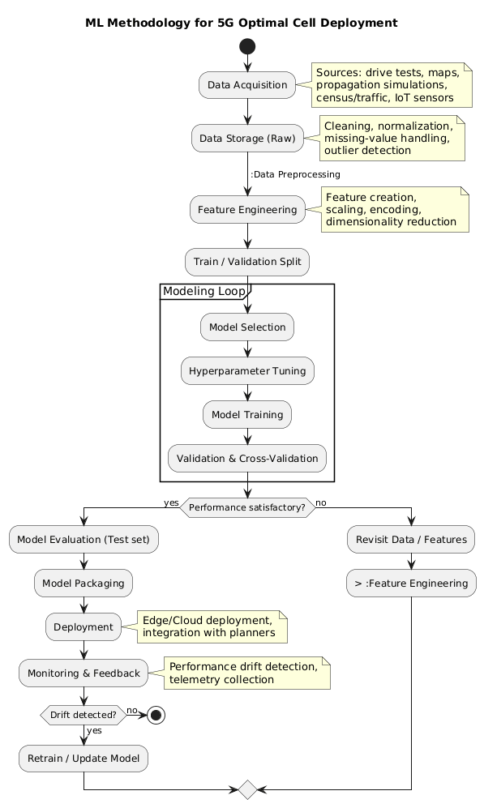
Figure1: Model development of the 5G optimal cell deployment

Data collection
The dataset deployed for the development of the proposed model in this study was acquired from MTN base stations in Enugu Urban Area, as raw data, considering the drive test data conducted from the company previous base station area, population density and network performance indicators. The raw data covers relevant features for 5G cell deployment. The dataset description is presented in table 1 and table 2.
Table 1: Dataset description
Data Name | Description | Data Type
Time (m:s:ms) | Time stamp indicating when the data was recorded | Time (mm:ss.ms)
Location | Geographical coordinates (latitude, longitude) | Latitude, Longitude
Coverage Area (km²) | The area covered by the cell site | Numeric (km²)
Signal Strength | Received Signal Strength Indicator (RSRP) | Numeric (dBm)
Signal Quality | Received Signal Quality Indicator (RSRQ) | Numeric (dB)
Cell Location | Location of the cell site | Text (address or code)
Transmit Power | Power level at which the cell site transmits | Numeric (dBm)
Interference Levels | Levels of interference experienced at the location | Numeric or Categorical
Table2: Feature Test data
Data Name | Description | Data Type
Population Density | Indicating human-centric service demand (eMBB) | Numerical
Building Density | The total built-up area or volume within a defined geographic unit. Indicating possible signal obstruction and propagation loss. | Numerical
Terrian Elevation | The vertical height of the ground surface relative to sea level. Affects signal line-of-sight and propagation coverage | Numerical
Signal Strength | Received Signal Strength Indicator (RSRP) | Numerical (dBm)
Distance to Existing Base station. | The physical distance from a potential new site to the nearest existing 4G/5G tower. | Numerical (m/km)

Data Processing
The data processing was achieved by carrying out the imputation technique on the collected data to remove missing values, then data normalization was performed to improve the data compatibility, and subsequently, feature extraction was carried out to get the necessary variable data in a standardized format. This step ensures a clean and well-structured dataset for themodel training and validation.

Machine learning Algorithms
The processed data was divided into training and testing dataset. Two supervised learning algorithms namely: Support Vector Machine (SVM) and Random Forest (RF) were applied to the processed data. The SVM in figure 2 was utilized in classifying regions into high, medium and low suitability areas for 5G deployment, considering high and low priority zones. The RF in figure 3 acts as the collaborative algorithm deployed for feature ranking and predictive regression in optimal cell density, expected coverage radius and expected throughput. These models are trained on the dataset to learn the patterns between environmental, demographic, and performance for deployment decisions.
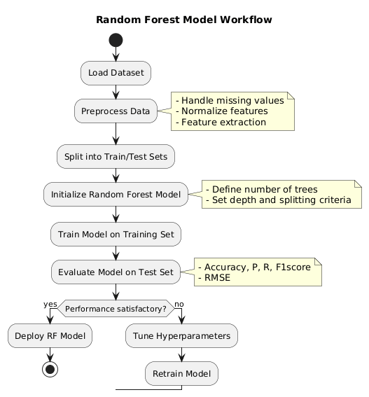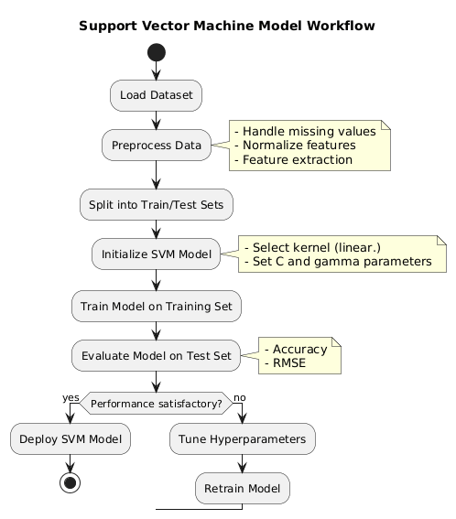
Figure 2: The RF flow chart Figure 3: the SVM low chart
Model Evaluation and Prediction
The testing dataset was used in evaluating the models after training. The performance evaluations were based on the following metrics namely: accuracy, precision, recall, F1-score, and Root Mean Square Error (RMSE). The prediction models were able to recommend ideal cell locations that minimize interference and maximize coverage areas, as well as expected Quality of Service (QoS) levels. The predictive models support data driven 5G cell deployment planning which reduces site survey cost and enables adaptive deployment strategies. The developed models were further tested on feature data to evaluate their generalization capabilities.
- Result and Discussion
The proposed SVM and RF machine learning algorithms were trained and tested using processed supplied dataset from MTN Nigeria database. The dataset contains features such as coverage area (Kms), signal quality, cell location, transmit power and interference levels. The study utilized the following evaluation metrics.
Classification Metrics
These metrics evaluates the model’s ability to correctly categorize regions based on suitability or priority. The classification metrics is usually used by the SVM and RF to carry out classification tasks. The following are classification metrics used in this study:
Accuracy: The measures the proportion of total correct predictions including the true positives and true negatives. The calculation formula is given as 1.
$Accuracy= \frac{True Posities+True Negatives}{Total Samples}$ 1
Precision: This metrics calculates the quality of positive prediction by evaluating how many were actually suitable, thereby minimizing false positives. The precision formula is given as 2.
$Precision= \frac{True Posities}{True Positives+False Positives}$ 2
F1-Score: This metrics combine the precision and recall metrics into a single balanced metric. It is very useful when dealing with imbalanced datasets. The calculation formula is given as 3.
$F1−Score= 2×\frac{TPrecision ×Recall}{Precision+Recall}$ 3
Regression Metrics: These metrics evaluates the model’s ability to accurately predict the cell density, RSRP, throughput and SINR.
Root Mean Square Error (RMSE): This metrics measures the square root of the average of squared errors between predicted and actual values, making it highly sensitive to outliers due to the squaring of errors This is usually utilized by RF models in carrying out prediction tasks. The calculation formula is given as equation 4.
$RMSE=\sqrt{\frac{1}{n}\sum_{i=1}^{n}{{(y_{i}−{\hat{y}}_{i})}^{2}}}$ 4
The model was evaluated using across the standard metrics including accuracy, precision, recall, F1-score, and Root Mean Square Error (RMSE) as presented in table 3.

Table 3: Summary of results for SVM and RF model evaluation
Metric Type | Metric | Support Vector Machine (SVM) | Random Forest (RF) | Interpretation
Classification | Accuracy (%) | 88.5 | 93.4 | Overall correctness in classifying site suitability
Classification | Precision (%) | 86.7 | 92.2 | Overall quality of positive prediction for all the predicted site suitable for 5G deployment.
Classification | Recall (%) | 84.9 | 90.7 | The overall completeness of the positive predictions.
Classification | F1-Score (%) | 85.8 | 91.4 | Balance between precision and recall for suitable sites.
Regression | RMSE (Throughput Prediction) | 0.214 | 0.156 | Average magnitude of error in predicting expected cell throughput.
Visual presentation of SVM model results
The graphs in figure 4, represents the classification performance metrics of the of SVM model in a bar chart which shows the accuracy and robustness of the model in classifying site suitability, separate from the regression metric which is also presented in figure 5. The result of the model as shown in the chart demonstrated a strong performance in accuracy by 88.5% and F1-score of 85.8%. the scores for precision (86.7%) and recall 84.9% also indicates efficiency in correctly identifying suitable sites and avoiding false deployments. The regression metric chart represents the Root Mean Square Error (RMSE) with 0.214 values measure the prediction error of the model. However,it evaluates the SVM model’s accuracy in predicting the expected throughput in Mbps.
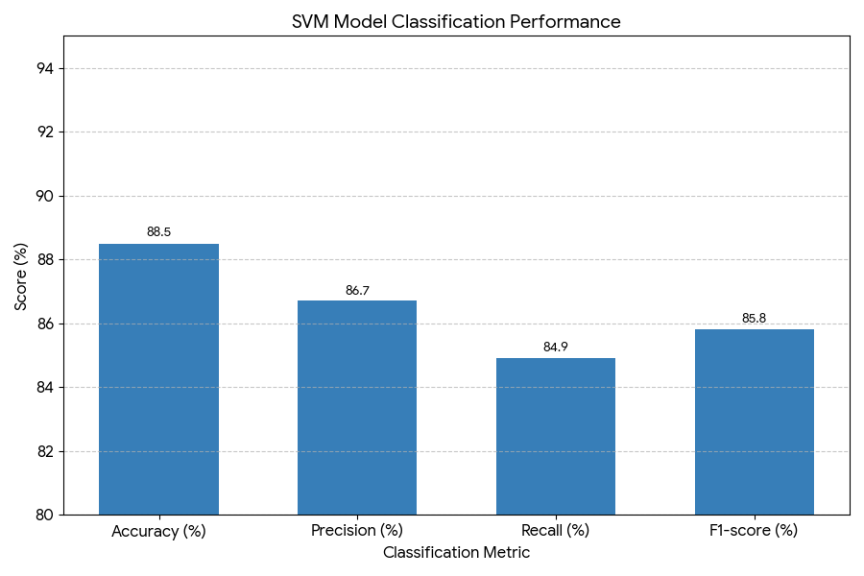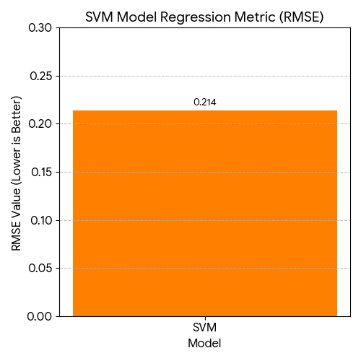
Figure 4: Performance of the SVM Figure 5: the Regression metric of the SVM model
The FR classification performance metrics chart shows the high performance of the model across the key classification metrics used in assessing site suitability as presented in figure 6. The RF mode demonstrated an overall accuracy of 93.4%, the F1-score is 91.4%, indicating reliability and strong balance between the precision score of 92.2% and recall score of 90.7. This outstanding performance makes the RF model ideal for identifying optimal 5G deployment regions.
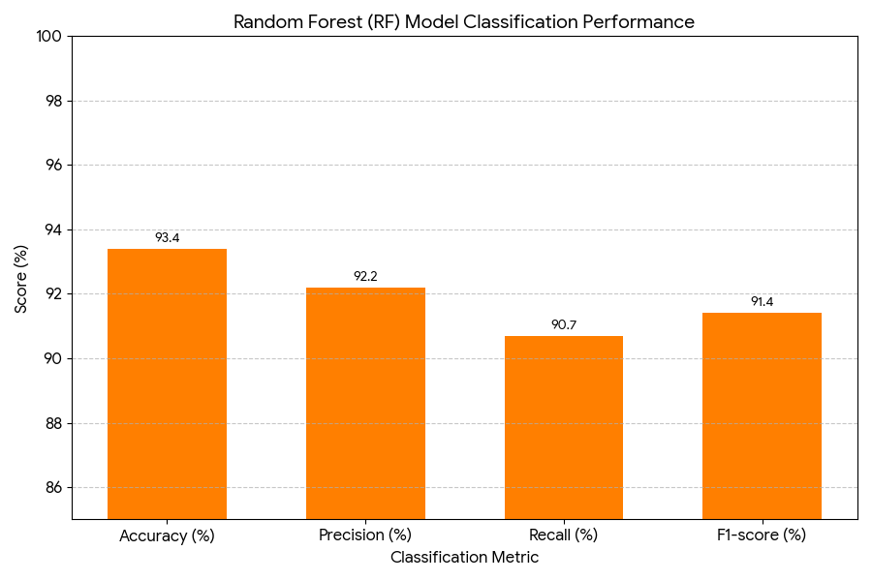Figure 6: the classification performance metric of the RF model
The RF regression metric (RMSE) chart presented in figure 7 shows the Root Square Error (RMSE) value of 0.156, indicating an excellent result in measuring the average error in predicting the network throughput. This makes the model suitable for data driven capacity and QoS planning in 5G network deployment.
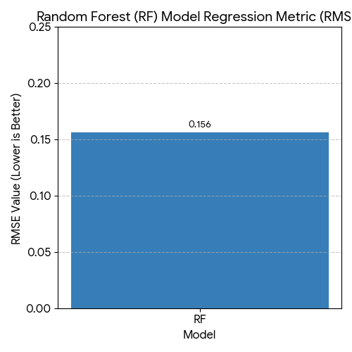
Figure 7: the Regression metric of the RF model
Comparative results of the models
The RF model outperformed the SVM in all key performance indicators as present in the summary of results. The RF covered complex non-linear relationships between the input features and the deployment suitability index. The 0.156 RMSE value indicated a low prediction error compared to the SVM model RMSE of 0.214. Figure 8 and 9 shows the visual presentation the result metrics.
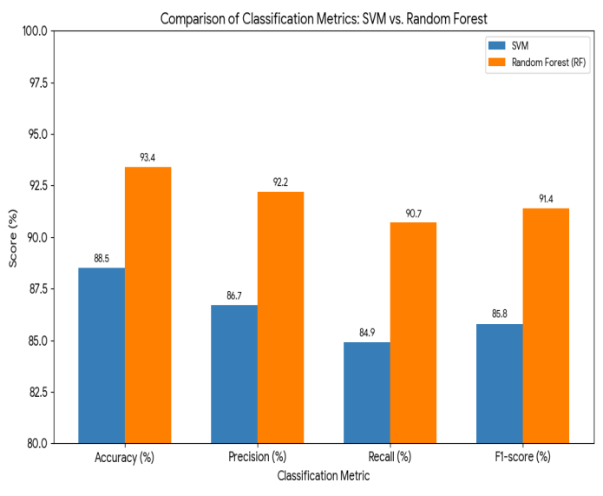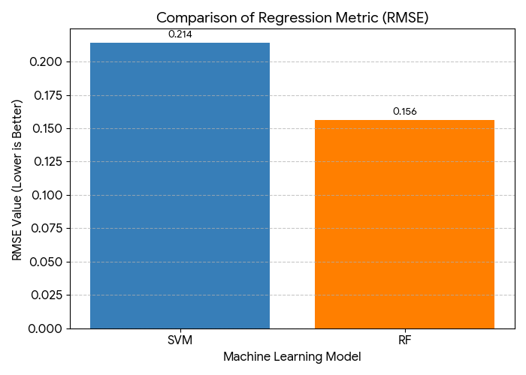
Figure 8: Performance of SVM and RF model Figure 9: RMSE comparison of SVM and RF
In addition, the trained models generated cell deployment zones classified into three categories, namely; (1) The high suitability regions with high population density, (2) the moderate suitability areas requiring additional infrastructure and (3) low suitability locations known for low user density, high terrain obstruction, or poor network accessibility. The models were further analyzed using the feature test data presented in table 2. The prediction outcomes of RF model revealed the result of the following variables to be Population density (28%), Signal strength (RSRP) (22%), Building Density (17%), Terrain Elevation (15%) and Distance to existing base station (10%). These outcomes indicate that human concentration and signal quality are major factors in deciding optimal 5G cell sites. Meanwhile, the topography and infrastructure serve as the secondary factor. Furthermore, the models revealed a scalability and flexibility which supports integration with real time network data for continuous optimization. This makes it particularly ideal for fast growing cities, where demographic and infrastructural changes significantly influence network behaviors.
- Conclusion
This study presents a hybrid machine learning based predictive models using SVM and RF algorithms for 5G cell deployment optimization. The developed methodology for this work involved the acquisition of dataset from MTN Nigeria which consist of geographical, environmental, and demographic parameters. the dataset was further preprocessed through imputation, normalization and feature extraction techniques. followed by model training and testing procedures. The result of the models demonstrated an effective capability in capturing nonlinear variables suitable for base station deployment such as population density, signal strength, terrain elevation, and building density. Moreover, the RF model demonstrated a stronger accuracy of 93.4%, outperforming the SVM, and with a lower prediction error of 0.156 RMSE value. These findings reassure the robustness of the techniques in effectively carrying out a complex geospatial prediction tasks for 5G network base station deployment. The proposed framework offers viable methodology for network operators in identifying and predicting optimal base station, thereby minimizing cost of manual deployment and ensuring reliable network coverage majorly in the urban and semi urban regions of Nigeria where network expansion is of great essence. In addition, this work contributes significantly to the rapidly growing telecommunications planning particularly in recent 5G cell development innovation by disclosing the efficiency of machine learning techniques in mitigating the scalability, precision, and adaptability required for 5G network expansions. Based on these findings, the expansion to Non terrestrial networks (NTN) is recommended to support implementation of terrestrial and satellite based 5G deployment, basically for remote areas where terrestrial infrastructure is limited.
Reference
Ahamed, M. M., & Faruque, S. (2021). 5G network coverage planning and analysis of the deployment challenges. Sensors, 21(19), 6608. https://doi.org/10.3390/s21196608.
Alaa A. H., Heba N., Rehab F. A. (2025) Machine learning techniques for spatiotemporal traffic prediction in 5G cellular networks. Discover Applied Sciences. Published online; https://doi.org/10.1007/s42452-025-06746-3.
Ali, M., Wang, Y., Ahmed, F., & Hassan, S. (2024). Machine learning-based optimization for intelligent 5G network management: A comprehensive review.Sensors, 24(7), 2654. https://doi.org/10.3390/s24072654.
Al-Khalsh, M. M. H. (2023). An Overview of Mobility Management Mechanisms and the Related Challenges in 5G Networks and Beyond. Journal of Telecommunications and Information Technology, 92(2), 53-62. https://doi.org/10.26636/jtit.2023.171723
Chabira, C., Shayea, I., Nurzhaubayeva, G., Aldasheva, L., Yedilkhan, D., & Amanzholova, S. (2025). AI-Driven Handover Management and Load Balancing Optimization in Ultra-Dense 5G/6G Cellular Networks. Technologies, 13(7), 276. https://doi.org/10.3390/technologies13070276.
Chabira, C.; Shayea ,I.; Nurzhaubayeva, G.; Aldasheva,L.; Yedilkhan, D.; Amanzholova, S. AI-Driven Handover Management and Load Balancing Optimization in Ultra-Dense 5G/6GCellular Networks. Technologies 2025, 13, 276. https://doi.org/10.3390/ technologies13070276.
Khatiwoda, N. R., Dawadi, B. R., & Joshi, S. R. (2024). Capacity and Coverage Dimensioning for 5G Standalone Mixed-Cell Architecture: An Impact of Using Existing 4G Infrastructure. Future Internet, 16(11), 423. https://doi.org/10.3390/fi16110423.
Mohamed H.M. (2021). Review of 5th Generation Wireless Mobile Network. Advances in Wireless Communications and Networks, 7(2), 9-14. https://doi.org/10.11648/j.awcn.20210702.11.
Mohamed M., F., Wai L., P., Gwo C., C., Mardeni R., (2023) Critical Review on Machine Learning in 5G Mobile Networks. International Journal of intelligent systems and applications in engineering. ISSN:2147-67992147-6799. www.ijisae.org.
Sapkota, B.; Ghimire, R.; Pujara, P.; Ghimire, S.; Shrestha, U.; Ghimire, R.; Dawadi, B.R.; Joshi, S.R. 5GNetwork Deployment Planning Using Metaheuristic Approaches. Telecom 2024, 5, 588–608. https:// doi.org/10.3390/telecom5030030.
Thantharate, A., Tondwalkar, A. V., Beard, C., & Kwasinski, A. (2022). ECO6G: Energy and Cost Analysis for Network Slicing Deployment in Beyond 5G Networks. Sensors, 22(22), 8614. https://doi.org/10.3390/s22228614
Thillaigovindhan, S. K., Roslee, M., Mitani, S. M. I., Osman, A. F., & Ali, F. Z. (2024). A comprehensive survey on machine learning methods for handover optimization in 5G networks. Electronics, 13(16), 3223. https://doi.org/10.3390/electronics13163223.
Yazar, A. Machine Learning-Based Adaptive Wireless Network Selection for Terrestrial and Non-Terrestrial Networks in 5Gand Beyond. Telecom2025,6, 71. https://doi.org/10.3390/ telecom6040071.
Zamzami, I.F. Deep Learning Models Applied to Prediction of 5G Technology Adoption. Appl. Sci. 2023, 13, 119. https://doi.org/10.3390/app13010119.

