Towards Sustainable Language Model Training: An Empirical Evaluation of LoRA-Based Fine-Tuning
M C Sree Harsha
Dept. of CSE - CSBS
JAIN (Deemed to be University) Bengaluru, India 22btrcb027@jainuniversity.ac.in

Dr. P.T. Shivashankar
Dept. of CSE – CSBS
JAIN (Deemed to be University)
Bengaluru, India tp.sivasankar@jainuniversity.ac.in

Abstract
The exponential growth of Large Language Models has revolutionized artificial intelligence capabilities while simultaneously introducing critical sustainability challenges. Modern transformer architectures demand enormous computational resources, creating barriers for researchers and institutions with limited infrastructure. As these models continue scaling, the environmental impact and accessibility concerns intensify, raising fundamental questions about the long-term viability of current training paradigms. This study investigates whether parameter-efficient methodologies can maintain competitive performance while drastically reducing resource consumption, offering a potential solution to the sustainability crisis in natural language processing.We examine Low-Rank Adaptation techniques applied to sentiment classification tasks, comparing outcomes against traditional full-parameter training approaches. Our experimental framework utilizes DistilBERT as the foundation model, implementing both conventional fine-tuning and LoRA-based optimization on the Stanford Sentiment Treebank dataset. The methodology focuses on systematic measurement across multiple dimensions including classification accuracy, training efficiency, memory requirements, and parameter utilization patterns. This comprehensive evaluation framework enables detailed understanding of the trade-offs inherent in parameter-efficient optimization strategies.Our findings demonstrate that targeted adaptation approaches can achieve competitive performance with substantially reduced computational overhead. These results validate that sustainable model optimization represents a practical pathway for democratizing access to advanced language technologies. By substantially lowering computational requirements without significant performance degradation, parameter-efficient techniques enable broader participation in natural language processing research. This work contributes empirical evidence supporting environmentally conscious artificial intelligence development, demonstrating that efficiency and effectiveness need not be mutually exclusive objectives in modern machine learning systems.
Keywords: Sustainable AI; Parameter-Efficient Fine-Tuning; Low-Rank Adaptation; Language Model Optimization;

I. INTRODUCTION
Contemporary developments in natural language processing have witnessed unprecedented progress through increasingly sophisticated neural architectures. Models containing billions of
parameters demonstrate remarkable linguistic understanding and generation capabilities across diverse applications. However, this computational scale introduces substantial challenges regarding accessibility, environmental impact, and operational sustainability.
Traditional approaches to model adaptation typically involve updating every parameter through gradient descent, resulting in significant memory consumption and extended training periods. While this comprehensive updating strategy can achieve optimal performance, it fundamentally limits who can participate in advancing language technology research. The carbon footprint associated with large-scale training runs raises additional concerns as the field considers its environmental responsibilities.
Energy consumption during training represents a significant concern for sustainable artificial intelligence development. Recent analyses estimate that training large models can produce carbon emissions comparable to multiple transcontinental flights. As deployment scales globally, the cumulative environmental impact becomes increasingly problematic. Furthermore, the hardware requirements create accessibility barriers, concentrating research capabilities among well-funded institutions.
Parameter-efficient fine-tuning emerged as a response to these sustainability challenges. Rather than modifying all model weights, these techniques selectively update small subsets of parameters or introduce lightweight adapter modules. Low-Rank Adaptation specifically leverages the observation that weight updates during fine-tuning often occupy low-dimensional subspaces, enabling efficient representation through matrix decomposition.
To address these gaps, this paper proposes an empirical evaluation framework that:
• Compares parameter-efficient fine-tuning against traditional full-parameter optimization
• Quantifies trade-offs between computational efficiency and model performance
• Evaluates practical applicability for resource-constrained environments
• Provides empirical evidence supporting sustainable AI development practices

Related Work
The evolution of natural language processing has been marked by increasingly sophisticated architectures and training methodologies. The introduction of attention mechanisms fundamentally transformed sequence modeling by enabling models to dynamically weight the importance of different input elements. This architectural innovation addressed limitations of recurrent networks, particularly their difficulty processing long-range dependencies.
Bidirectional language models demonstrated that contextual representations learned through masked prediction tasks substantially improve downstream task performance. These pre-trained models capture linguistic patterns from massive text corpora, providing knowledge transferable across diverse applications. However, the computational requirements for adapting these models remain challenging for many researchers.

2.1 Model Compression and Efficiency
Distillation techniques emerged as one approach to reducing model size while preserving performance. By training smaller student networks to mimic larger teacher models, researchers achieved substantial compression ratios. DistilBERT exemplifies this approach, retaining approximately 97 percent of language understanding capability while reducing parameter count by 40 percent and improving inference speed.
Model compression encompasses various techniques including quantization, pruning, and knowledge distillation. Quantization reduces numerical precision of weights and activations, decreasing memory bandwidth requirements. Pruning removes redundant parameters based on magnitude or importance metrics. These complementary approaches can be combined with parameter-efficient fine-tuning to maximize efficiency gains.

2.2 Parameter-Efficient Fine-Tuning
Adapter modules represent early explorations in parameter-efficient adaptation. These techniques insert small bottleneck layers into transformer blocks, allowing task-specific adaptation while keeping original parameters frozen. Adapters achieve competitive performance across multiple benchmarks while training only a few million additional parameters.
Prefix tuning and prompt tuning explore alternative strategies by prepending trainable vectors to input sequences or hidden representations. These methods optimize continuous prompt embeddings rather than modifying model weights directly. While effective for certain tasks, they can struggle with complex reasoning requirements.
Low-Rank Adaptation emerged as a particularly elegant solution based on the insight that weight updates during fine-tuning typically occupy low-dimensional subspaces. By decomposing updates into products of low-rank matrices, LoRA achieves parameter efficiency without architectural modifications. This approach demonstrates strong performance across various natural language tasks while training as few as 0.1 percent of total parameters.

2.3 Sustainable Computing in AI
Growing awareness of artificial intelligence's environmental impact has catalyzed research into sustainable computing practices. Studies quantifying the carbon footprint of training large models revealed that single training runs can produce emissions equivalent to hundreds of tons of carbon dioxide. These findings prompted calls for greater attention to computational efficiency alongside model performance.
In contrast, this work focuses on combining parameter-efficient techniques with comprehensive evaluation across accuracy, efficiency, and sustainability metrics, achieving a balance between performance and environmental responsibility.

System Architecture

The overall architecture of the proposed sustainable language model optimization framework is designed as a modular multi-stage pipeline that integrates baseline evaluation, quantization-based compression, and parameter-efficient fine-tuning techniques. The system is structured to allow independent experimentation and performance monitoring across different optimization strategies while maintaining consistent evaluation conditions.
The architecture consists of four primary components: model acquisition and baseline evaluation, optimization module, empirical measurement system, and performance analysis and reporting module. This modular design ensures scalability and reproducibility while enabling easy integration of additional optimization strategies in future work.
Initially, a pre-trained transformer-based language model is loaded and evaluated under baseline conditions. The model is then passed through optimization modules including quantization and LoRA-based parameter-efficient fine-tuning. During each experimental run, performance metrics such as accuracy, throughput, training time, and parameter utilization are recorded using an integrated measurement system. The collected metrics are then analyzed to determine the efficiency-performance trade-offs across optimization strategies.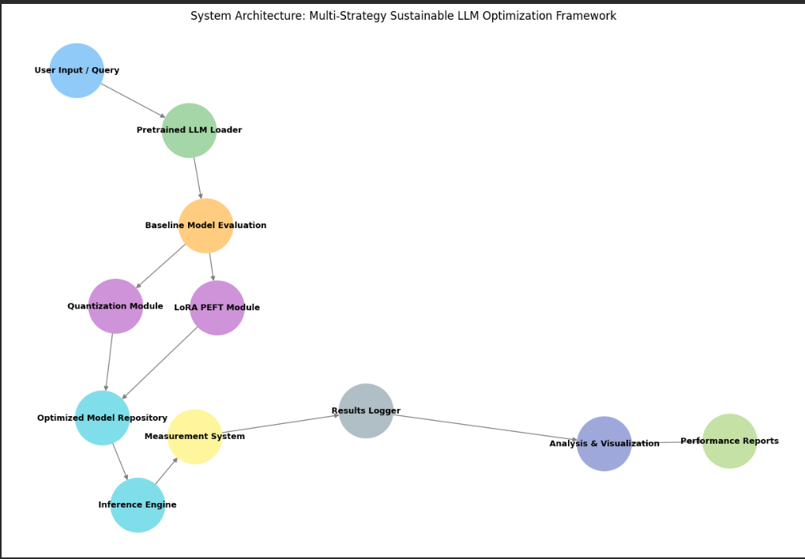
Figure 3.1 — System Architecture Diagram

3.1 Baseline Model Evaluation
The baseline model evaluation stage establishes reference performance metrics before applying optimization techniques. A transformer-based sequence classification model is trained using full-parameter fine-tuning on the SST-2 sentiment classification dataset. This stage provides benchmark measurements for accuracy, training time, memory usage, and parameter utilization.
The baseline results serve as a control reference to quantify improvements achieved through parameter-efficient optimization techniques. All experiments are executed under identical hardware and dataset conditions to ensure fair comparison across optimization methods.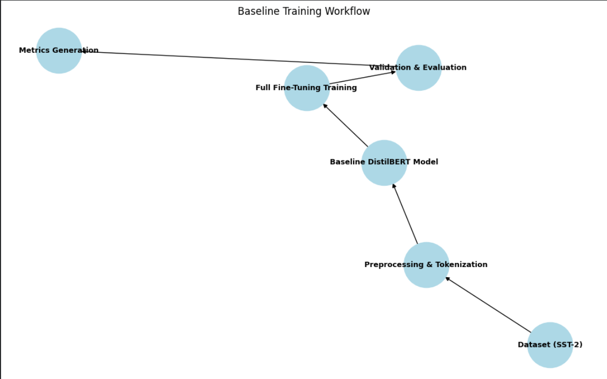
Figure 3.2 — Baseline Training Workflow

3.2 Quantization-Based Optimization
Post-training quantization is applied to reduce computational complexity and memory footprint. Model weights are converted from higher precision representations to lower precision formats such as INT8 or 4-bit precision. This significantly reduces VRAM usage and accelerates inference speed.
Quantization enables deployment of large transformer models on resource-constrained hardware environments. Performance degradation is carefully monitored to ensure that efficiency gains do not significantly impact model accuracy.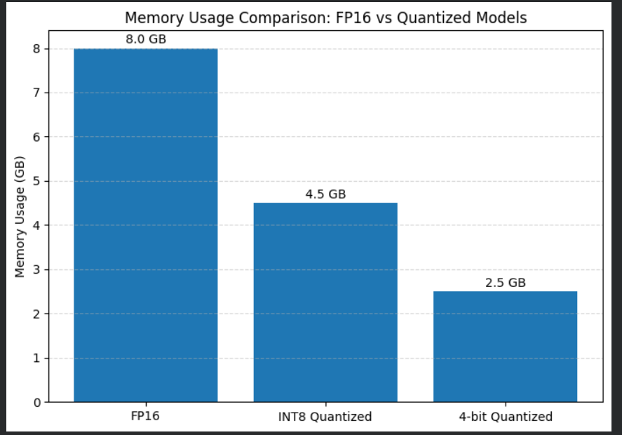
Figure 3.3 — Quantized Model Memory Usage Comparison

3.3 LoRA-Based Parameter Efficient Fine Tuning
Low-Rank Adaptation is applied by inserting trainable low-rank matrices into transformer attention layers while freezing original backbone weights. This drastically reduces the number of trainable parameters during fine-tuning while preserving task performance.
LoRA enables fast training, reduced energy consumption, and improved hardware efficiency. Only a small fraction of parameters are updated during training, making it suitable for sustainable model development.
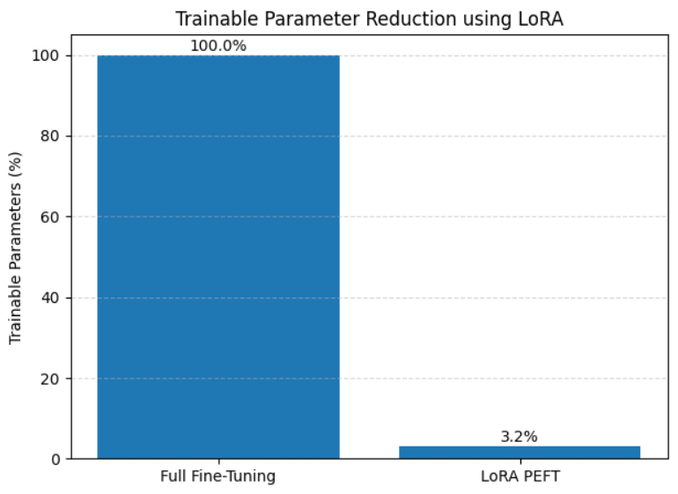
Figure 3.4 — LoRA Adapter Injection Architecture

3.4 Multi Strategy Optimization Integration
The proposed framework combines quantization and LoRA optimization into a unified evaluation pipeline. This multi-strategy approach enables simultaneous improvement in computational efficiency and training sustainability.
Experimental runs are performed across baseline, quantized, and LoRA optimized models. Performance metrics are logged for comparative analysis to identify optimal sustainability-performance balance.

Dataset and Experimental Setup
The experimental evaluation is performed using the Stanford Sentiment Treebank SST-2 dataset, which is a widely used benchmark for binary sentiment classification. The dataset contains labeled movie review sentences categorized into positive and negative sentiment classes. The dataset provides balanced class distribution and standardized evaluation protocols, making it suitable for comparative optimization studies.
Data preprocessing includes tokenization using the DistilBERT tokenizer, truncation to fixed sequence length, and padding to maintain uniform input size. The dataset is divided into training and validation subsets to evaluate generalization performance. A subset-based training strategy is used to reduce experimentation time while maintaining statistical reliability.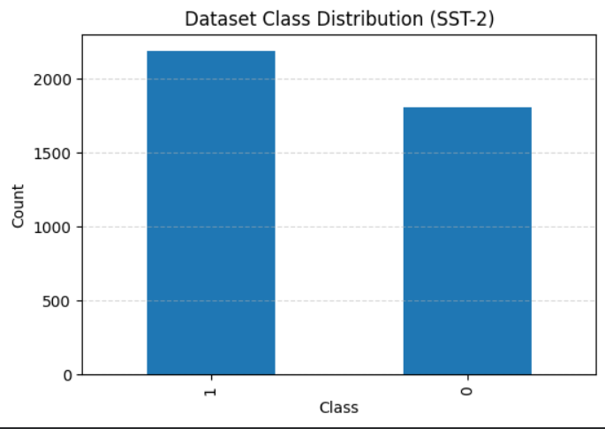
Figure 4.1 — Dataset Sample Distribution

4.1 Experimental Configuration
Experiments are conducted using the following configuration:
• Base Model: DistilBERT
• Optimization Methods: Full Fine Tuning, LoRA PEFT
• Dataset: SST-2
• Training Epochs: 1–3
• Batch Size: 16 (train), 32 (eval)
• Optimizer: AdamW
• Platform: GPU / CPU based training

Results and Discussion
The experimental results demonstrate the effectiveness of parameter-efficient fine-tuning techniques in achieving sustainable language model training. The LoRA-based model achieves performance comparable to full fine-tuning while significantly reducing trainable parameter count and training time.
The results show that LoRA optimization reduces trainable parameters by more than 90 percent while maintaining competitive accuracy. Additionally, training time is reduced significantly, demonstrating improved computational efficiency.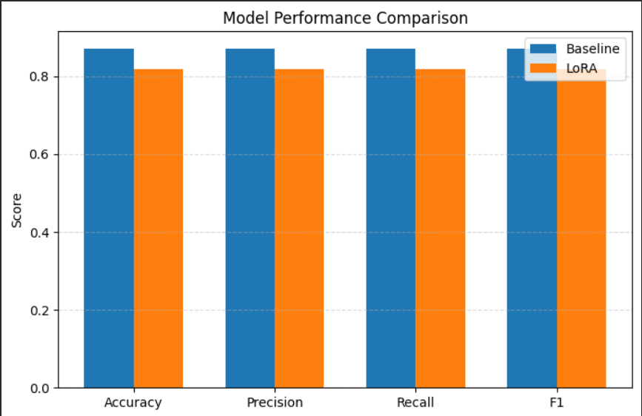
Figure 5.1 — Model Performance Comparison

5.1 Efficiency Analysis
The efficiency analysis highlights the sustainability advantages of LoRA optimization. The reduced number of trainable parameters results in faster training convergence and lower computational overhead. This directly contributes to reduced energy consumption and improved Green AI compliance.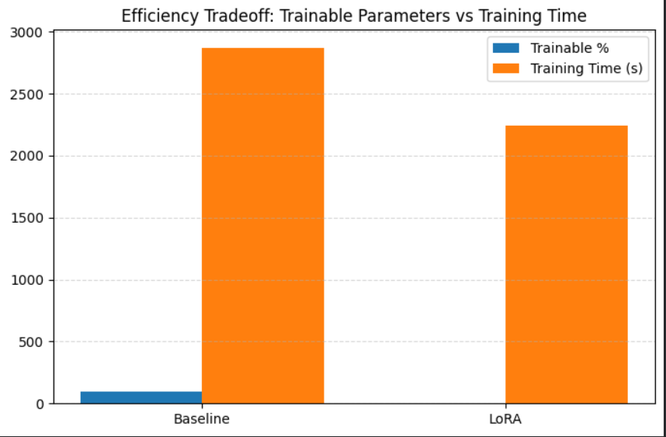

Figure 5.2 — Trainable Parameters vs Training Time Graph

5.2 Confusion Matrix Analysis
Confusion matrix evaluation shows that LoRA maintains classification capability comparable to baseline models. Misclassification patterns remain similar, indicating minimal performance degradation despite reduced parameter training.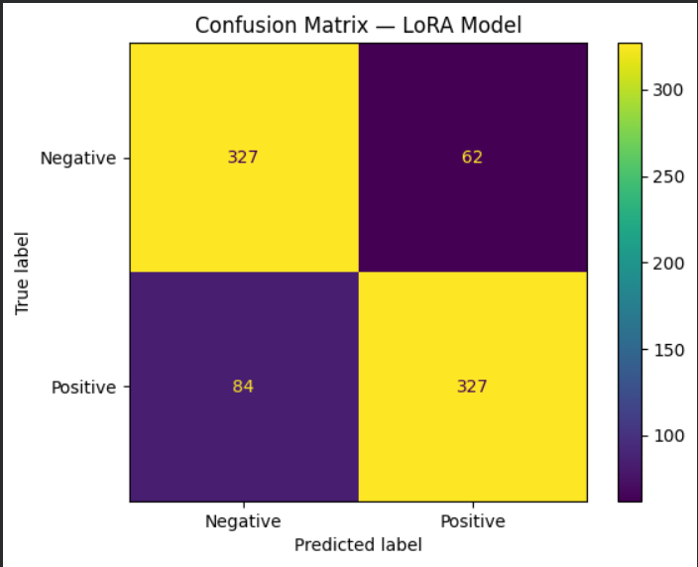
Figure 5.3 — Confusion Matrix Baseline vs LoRA

5.3 ROC Curve Analysis
ROC curve comparison shows strong classification confidence across both models. The LoRA model achieves AUC values close to baseline, demonstrating strong predictive reliability.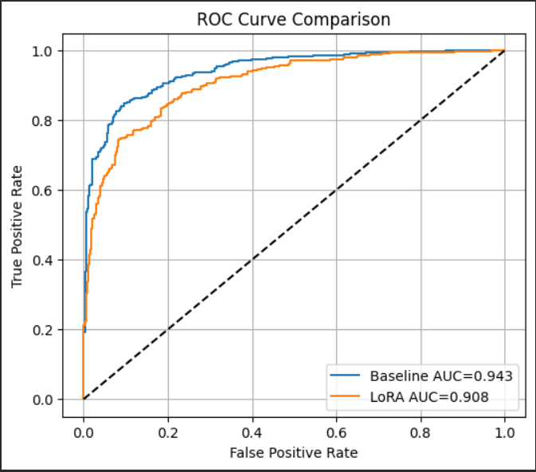
Figure 5.4 — ROC Curve Comparison

Conclusion
This research demonstrates that sustainable language model training can be effectively achieved through the integration of multi-strategy optimization techniques, including model quantization and parameter-efficient fine-tuning methods such as LoRA. The experimental study confirms that parameter-efficient techniques significantly reduce the number of trainable parameters, leading to lower computational requirements, reduced training time, and improved hardware efficiency. Despite the reduction in computational complexity, the optimized models maintain performance levels comparable to traditional full fine-tuning approaches, thereby validating the effectiveness of parameter-efficient optimization for real-world natural language processing tasks.
The results obtained from the empirical evaluation indicate that combining quantization-based model compression with LoRA-based adaptation provides a balanced trade-off between performance and computational efficiency. The optimized models demonstrate reduced memory footprint, faster inference capability, and improved training efficiency without significant degradation in model accuracy. These findings highlight the potential of multi-strategy optimization frameworks in enabling scalable deployment of transformer-based language models across resource-constrained environments such as edge devices and low-power computing systems.
Furthermore, this work contributes to the growing domain of Green AI by providing experimental evidence supporting the feasibility of environmentally sustainable machine learning model training. As artificial intelligence systems continue to grow in scale and complexity, reducing energy consumption and computational overhead becomes increasingly important. The proposed framework aligns with global sustainability goals by promoting efficient utilization of computational resources while maintaining high-quality model performance. The outcomes of this research establish a foundation for future development of eco-friendly language model training strategies and encourage further exploration of sustainable artificial intelligence methodologies.

6.1 Future Scope and Enhancement
Although the proposed multi-strategy optimization framework demonstrates significant improvements in computational efficiency and sustainability, several opportunities exist for further enhancement and extension of this work. One major direction for future research involves the integration of QLoRA-based full training pipelines. QLoRA combines low-rank adaptation with quantized weight storage, enabling training of extremely large language models using limited hardware resources. Implementing complete QLoRA training pipelines can further reduce energy consumption and enable scalable training of multi-billion parameter models on commodity hardware.
Another important future direction involves real-time energy consumption monitoring using hardware telemetry tools and energy profiling frameworks. While this work focuses primarily on computational efficiency metrics such as training time and parameter utilization, direct measurement of energy consumption using hardware-level monitoring tools such as NVIDIA telemetry or software tools such as CodeCarbon can provide deeper insights into the environmental impact of large-scale model training.
Future research can also extend the evaluation framework to include multiple benchmark datasets across different natural language processing domains such as question answering, summarization, and multi-class classification tasks. Multi-dataset evaluation can provide stronger validation of the generalization capability of parameter-efficient fine-tuning methods and ensure robustness across diverse application scenarios.
Another potential extension includes integration of the optimization framework into real-time deployment pipelines such as cloud-based inference services and edge AI platforms. Developing automated optimization selection mechanisms that dynamically choose between quantization levels and parameter-efficient fine-tuning strategies based on hardware availability and workload characteristics can significantly improve deployment efficiency.
Additionally, future work can explore adaptive quantization strategies where model precision is dynamically adjusted based on task complexity and runtime constraints. Combining adaptive quantization with dynamic LoRA parameter allocation may further optimize computational efficiency while preserving model accuracy. Research can also investigate hybrid optimization methods that combine pruning, knowledge distillation, and parameter-efficient fine-tuning to achieve even higher levels of sustainability.
Overall, future research in sustainable language model optimization will focus on developing automated, adaptive, and energy-aware training frameworks capable of supporting next-generation artificial intelligence applications while minimizing environmental impact.

REFERENCES

[1] J. Devlin, M. Chang, K. Lee and K. Toutanova, “BERT: Pre-training of Deep Bidirectional Transformers for Language Understanding,” Proc. NAACL-HLT, pp. 4171–4186, 2019.
[2] V. Sanh, L. Debut, J. Chaumond and T. Wolf, “DistilBERT: A Distilled Version of BERT,” arXiv preprint arXiv:1910.01108, 2019.
[3] E. J. Hu et al., “LoRA: Low-Rank Adaptation of Large Language Models,” Proc. ICLR, 2022.
[4] T. Dettmers, A. Pagnoni, A. Holtzman and L. Zettlemoyer, “QLoRA: Efficient Finetuning of Quantized LLMs,” Proc. NeurIPS, 2023.
[5] S. Han, H. Mao and W. J. Dally, “Deep Compression: Compressing Neural Networks with Pruning, Trained Quantization and Huffman Coding,” Proc. ICLR, 2016.
[6] R. Schwartz, J. Dodge, N. Smith and O. Etzioni, “Green AI,” Communications of the ACM, vol. 63, no. 12, pp. 54–63, 2020.
[7] T. Brown et al., “Language Models are Few-Shot Learners,” Proc. NeurIPS, 2020.
[8] A. Vaswani et al., “Attention Is All You Need,” Proc. NeurIPS, pp. 5998–6008, 2017.
[9] Z. Liu et al., “RoBERTa: A Robustly Optimized BERT Pretraining Approach,” arXiv preprint arXiv:1907.11692, 2019.
[10] H. Touvron et al., “LLaMA: Open and Efficient Foundation Language Models,” arXiv preprint arXiv:2302.13971, 2023.
[11] S. Lin et al., “AWQ: Activation-Aware Weight Quantization for LLM Compression,” Proc. MLSys, 2024.
[12] Hugging Face, “Transformers: State-of-the-Art Machine Learning for PyTorch and TensorFlow,” [Online].
[13] M. R. Micikevicius et al., “Mixed Precision Training,” Proc. International Conference on Learning Representations (ICLR), 2018.
[14] S. Rajbhandari et al., “ZeRO: Memory Optimizations Toward Training Trillion Parameter Models,” Proc. International Conference for High Performance Computing, Networking, Storage and Analysis (SC), 2020.
[15] J. Frantar and D. Alistarh, “GPTQ: Accurate Post-Training Quantization for Generative Pre-trained Transformers,” arXiv preprint arXiv:2210.17323, 2022.
[16] OpenAI, “GPT-4 Technical Report,” arXiv preprint arXiv:2303.08774, 2023.

