Flood Risk Reduction Using Protective and Boulder Walls: A Review with Special Reference to Afghanistan
Mohammad Ajmal Stanikzai¹, Muhiburahman Asir¹, Mohammad Yaqoob Sharafat², Jamil Rahmati^{3,} Sajid Ullah^{2, *}
¹Department of Civil Engineering, Nangarhar University, Afghanistan
²Department of Water Resources and Environmental Engineering, Nangarhar University, Afghanistan
³General and Technical Subjects Department, Faculty of Engineering, University of Nangarhar, Jalalabad, Nangarhar
*Corresponding Author: sajidjalwal@gmail.com

Abstract
Afghanistan faces progressively regular and severe floods that cause substantial loss of life, destroy the infrastructure, and interrupt livings. Structural mitigation measures mainly protective walls built from locally available boulders offer practical, low-cost solutions in this resource-constrained context. This review synthesizes national and international literature on flood risk reduction using protective walls, with special importance on boulder walls in Afghanistan's flood-prone provinces. We assess design considerations, efficiency, environmental impacts, and implementation challenges. Key results show that while boulder walls provide cost-effective, community-driven flood mitigation, they require technical design support and integration with non-structural measures such as early warning systems and land-use planning to attain sustainable risk reduction. This review offers evidence-based guidance for practitioners, policymakers, and communities working to improve flood resilience across Afghanistan.

Keywords: Flood risk reduction; protective walls; boulder walls; structural mitigation; Afghanistan

- Introduction
Flooding is one of the most significant natural hazards affecting Afghanistan, posing severe threats to human lives, property, and livelihoods [1]. The country’s diverse topography, ranging from the high Hindu Kush mountains to extensive river valleys, combined with climate variability, contributes to frequent and unpredictable flood events [2]. Seasonal snowmelt, intense rainfall during the monsoon months, deforestation, and rapid unplanned urbanization exacerbate flood risks, particularly in mountainous and riverine regions [3]. According to national assessments, over 80 major flood events occurred between 2000 and 2024, resulting in thousands of casualties and millions of dollars in economic losses [4, 5].
The socio-economic impacts of floods are severe in Afghanistan, where a significant portion of the population depends on agriculture for subsistence [1]. Floods destroy croplands, livestock, irrigation systems, and transportation infrastructure, while also displacing communities [1, 2]. The economic burden is further compounded by limited government capacity, political instability, and inadequate disaster management systems [6]. Vulnerable provinces such as Nangarhar, Kunar, Badakhshan, Kabul, and Herat experience repeated flooding due to their proximity to major rivers and floodplains [7].
Structural mitigation measures are recognized as effective interventions to reduce flood damage and protect communities [8]. Among these measures, protective walls constructed using locally available materials, such as boulders, have been widely implemented in rural and semi-urban areas [9]. Boulder walls, also referred to as stone or rock walls, function as gravity-based barriers that resist hydraulic forces and prevent erosion along riverbanks [10, 11]. Their cost-effectiveness, reliance on local labor and materials, and ease of construction make them suitable for Afghanistan’s resource-constrained environment [2].
Despite their widespread use, there is limited systematic documentation and critical review of the effectiveness, design principles, and sustainability of boulder walls in Afghanistan. Most existing studies focus on specific provinces or engineering aspects, lacking a broader synthesis that can inform national-level policy and planning [1-4]. A comprehensive review is particularly necessary to guide practitioners, policymakers, and communities in designing resilient, low-cost flood mitigation strategies [12]. This review aims to address this gap by systematically analyzing existing literature on flood risk reduction using protective walls, with a special focus on boulder walls in Afghanistan. The objectives are to: (a) summarize global and national research on structural flood mitigation, particularly boulder walls. (b) evaluate design considerations, performance, and sustainability of boulder walls in flood-prone regions. (c) identify gaps in knowledge and practice relevant to the Afghan context and (d) provide recommendations for effective implementation and policy interventions. By integrating scientific evidence, case studies, and practical experiences, this review provides a comprehensive resource for advancing flood resilience in Afghanistan while highlighting opportunities for further research and innovation.
- Review Methodology
This review employs a systematic literature review approach, designed to identify, analyze, and synthesize relevant studies on flood risk reduction using protective walls, with an emphasis on boulder walls. A systematic approach ensures transparency, reproducibility, and comprehensiveness in identifying relevant literature.

  - Data Sources
Literature Relevant literature was collected from multiple electronic databases and institutional repositories to ensure comprehensive coverage of flood risk reduction and boulder wall applications (Figure 1). Peer-reviewed journal articles and conference proceedings were primarily obtained through Google Scholar and Scopus, which provided access to indexed research in engineering, environmental science, and disaster management. Additional preprints and open-access publications were retrieved from ResearchGate to include recent and region-specific studies.
Furthermore, national and international institutional reports were reviewed to strengthen the evidence base and contextual relevance of the study. These sources included publications from the Afghanistan National Disaster Management Authority (ANDMA), United Nations Office for Disaster Risk Reduction (UNDRR), International Federation of Red Cross and Red Crescent Societies (IFRC), World Bank, and UNICEF. These institutional documents provided valuable information on flood impacts, risk management strategies, and community-based mitigation practices in Afghanistan and comparable regions.

  - Search Strategy
The search was conducted using combinations of the following keywords: "Flood mitigation" OR "Flood risk reduction" AND "protective wall" OR "boulder wall" OR "stone wall" AND "Afghanistan" OR "mountainous regions" OR "developing countries" The search included studies published between 2000 and 2025 to ensure relevance to current climatic, social, and infrastructural conditions (Figure 1).

  - Inclusion and Exclusion Criteria
Studies were selected for this review based on specific inclusion criteria to ensure relevance and quality. Included studies focused on structural flood mitigation, particularly walls, embankments, or boulder-based constructions. Only studies relevant to Afghanistan or comparable mountainous, developing-country settings were considered. Reports addressing design, construction, performance evaluation, environmental impacts, or socio-economic outcomes were included, and sources comprised peer-reviewed articles, government publications, and technical reports from NGOs. Exclusion criteria were applied to remove irrelevant or low-quality studies. Publications unrelated to flood risk reduction, opinion pieces, editorials, or studies lacking methodological rigor were excluded. Additionally, duplicate or inaccessible publications were omitted to maintain the integrity and reliability of the review.

  - Data Extraction and Analysis
Relevant information was extracted from each selected study to provide a comprehensive overview of flood mitigation using structural measures, particularly boulder walls. The data collected included the study location and context, types and characteristics of floods, the structural mitigation methods employed, design parameters of protective walls, observed performance and maintenance requirements, and the associated environmental and socio-economic impacts. The extracted information was then analyzed qualitatively to identify common trends, best practices, and research gaps. To facilitate comparison and visualization, key data were summarized using tables and figures, highlighting details such as flood events, wall design parameters, and cost-benefit assessments. This approach enabled a systematic evaluation of boulder walls and other structural interventions in Afghanistan and similar contexts, supporting evidence-based recommendations for flood risk reduction.
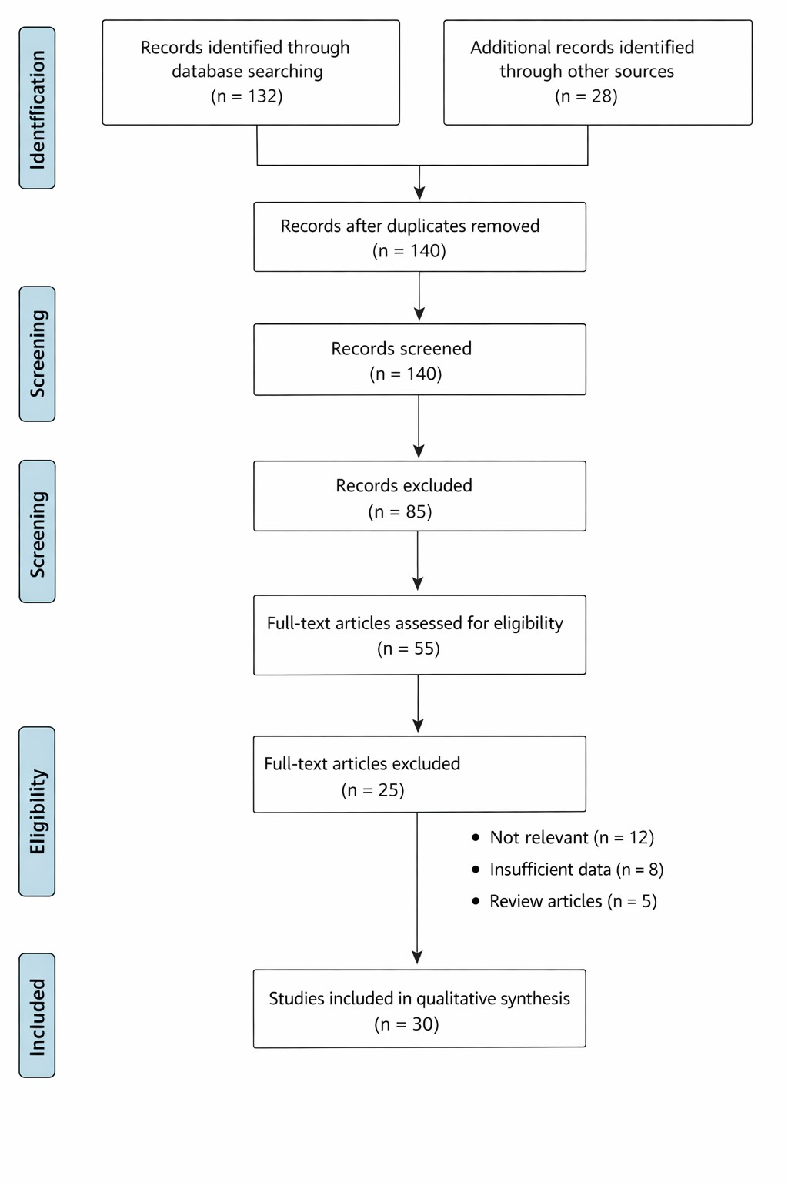
Figure 1. PRISMA-style flowchart illustrating the systematic review process, including identification, screening, eligibility assessment, and inclusion of studies for analyzing flood mitigation using boulder walls in Afghanistan.
- Flood Risk in Afghanistan
Afghanistan is highly vulnerable to floods due to its complex topography, extreme seasonal weather, and socio-economic conditions [13]. Floods in the country occur mainly as flash floods in mountainous areas and riverine floods along major rivers [2]. The combination of steep slopes, rapidly melting snow, and high-intensity rainfall events can result in sudden, devastating floods, particularly in narrow valleys where communities are concentrated. According to national reports, over 80 significant flood events occurred between 2000 and 2024, leading to thousands of fatalities, the displacement of tens of thousands of people, and extensive damage to infrastructure, agriculture, and livelihoods [4, 5].

  - Geographic and Climatic Factors
Afghanistan’s northern and northeastern regions, including Badakhshan, Takhar, and Nangarhar provinces, are particularly susceptible to flash floods due to steep mountain slopes and narrow river valleys [1]. Conversely, provinces along the Kabul, Helmand, and Amu Darya rivers are prone to riverine flooding during snowmelt or heavy rainfall periods [14]. The Hindu Kush mountains contribute significantly to snowmelt-driven floods during spring, while seasonal rainfall during July–September can trigger additional flood events, especially when intense storms coincide with saturated soils [15]. Climate change is expected to exacerbate flood risks in Afghanistan [2, 4]. Rising temperatures increase snowmelt rates, while altered rainfall patterns result in more intense and erratic precipitation events [16]. As a result, flood frequency and intensity are projected to rise in the coming decades, posing greater challenges to disaster risk management [6].

  - Socio-Economic Vulnerability
Afghanistan’s socio-economic context magnifies flood risk [2]. Most rural communities rely on subsistence agriculture, with homes and fields often located near rivers and streams [1]. Infrastructure is frequently underdeveloped, and early warning systems are limited, reducing the capacity for timely evacuation. Socio-economic vulnerability also stems from decades of conflict, which has disrupted governance and the development of resilient infrastructure [7]. Consequently, even moderate floods can result in disproportionate damage, particularly in rural and peri-urban areas [1].

  - Historical Flood Events
Several major flood events in Afghanistan illustrate the scale and impact of flood hazards. Table 1 summarizes significant floods from 2000–2024, highlighting their location, type, economic damage, and the presence or absence of structural mitigation measures.
Table 1. Major Flood Events in Afghanistan (2000–2024)
Year | Province | Flood Type | Casualties | Damage (USD) | Protective Measures
2002 | Kabul | Flash Flood | 30 | 1.2M | None
2005 | Nangarhar | Riverine | 45 | 2.8M | Temporary boulder walls
2010 | Badakhshan | Flash Flood | 70 | 3.5M | None
2014 | Herat | Riverine | 25 | 1.5M | Embankments
2018 | Kunar | Flash Flood | 60 | 4.2M | Boulder walls installed
2020 | Kabul | Flash Flood | 15 | 2.1M | Partial boulder walls
2023 | Helmand | Riverine | 40 | 3.8M | None
2024 | Nangarhar | Flash Flood | 50 | 4.5M | Community-built boulder walls
Note: Data compiled from reference [1, 2, 3, 4, 7].
  - Flood-Prone Regions
Figure 2 illustrates the flood-prone provinces of Afghanistan. Provinces in the northeast (Badakhshan, Takhar, and Nuristan), central highlands (Bamyan, Kapisa), and river valleys (Kabul, Helmand, Nangarhar) experience the most frequent and destructive flood events. These areas combine high rainfall or snowmelt runoff with dense settlement in vulnerable zones, emphasizing the need for targeted mitigation measures.
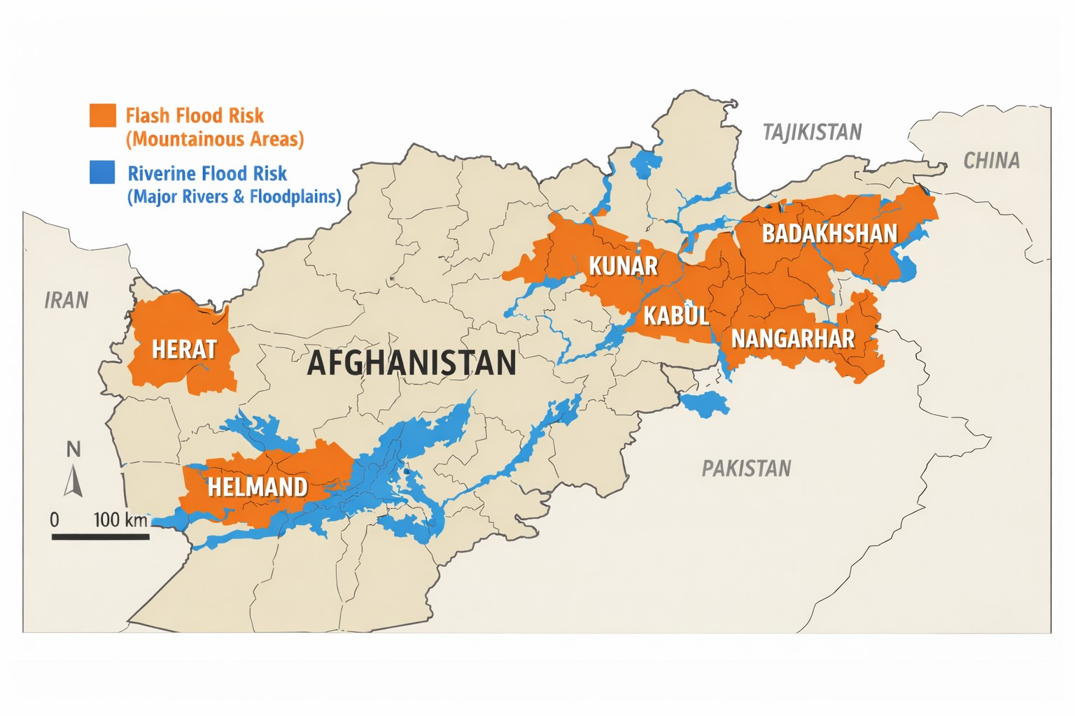
Figure 2. Provinces at risk of flash floods (orange, mountainous areas) and riverine floods (blue, along rivers) are highlighted, including Nangarhar, Kunar, Badakhshan, Kabul, Helmand, and Herat.
3.5 Implications for Flood Mitigation
Understanding the spatial distribution of flood risk in Afghanistan is critical for prioritizing mitigation strategies [4]. Structural interventions, such as protective and boulder walls, must be targeted to high-risk provinces while incorporating local knowledge, topography, and hydrological characteristics. Moreover, the integration of structural measures with non-structural approaches, such as early warning systems, land use planning, and community awareness programs, is essential for sustainable flood risk reduction [17].
- Structural Mitigation Measures
Flood mitigation strategies can be broadly classified into structural and non-structural measures [16]. Structural measures involve the construction of physical infrastructure to prevent, divert, or contain floodwaters [18]. In Afghanistan, structural measures are particularly important in high-risk provinces, where floods frequently threaten lives, agriculture, and infrastructure [4]. Common structural interventions include levees, embankments, floodwalls, check dams, and boulder walls, each with unique advantages, limitations, and suitability based on local conditions.

  - Levees and Embankments
Levees and embankments are raised earth or concrete barriers designed to prevent river water from overflowing into populated or agricultural areas [19]. They are widely used along major rivers, such as the Kabul, Helmand, and Amu Darya, to protect urban and rural communities [20]. The effectiveness of levees depends on their design height, slope stability, soil compaction, and maintenance. Failures are often linked to overtopping during extreme floods, poor construction quality, or erosion at the base [2].

  - Floodwalls
Floodwalls are vertical barriers, typically made of reinforced concrete or masonry, that provide higher resistance to flooding compared to earthen levees [3]. They are often used in urban areas where space constraints limit the construction of wide embankments [1]. Floodwalls require detailed engineering design, including foundations capable of withstanding hydraulic pressures and lateral soil forces. Although effective, their construction and maintenance costs are relatively high, limiting widespread implementation in Afghanistan’s resource-constrained provinces [4].

  - Check Dams and Retention Structures
Check dams and small retention structures are designed to reduce runoff velocity, capture sediment, and store floodwaters temporarily [21]. In mountainous provinces like Badakhshan and Kunar, these measures help mitigate flash floods and reduce downstream sediment deposition. Check dams can be constructed using local materials, such as stone or concrete, and are often combined with vegetation to enhance slope stabilization [21].

  - Boulder Walls
Boulder walls, also referred to as gravity or stone walls, are low-cost, community-based solutions widely used in rural Afghanistan [22]. Constructed from locally sourced rocks, boulder walls rely on their weight to resist hydraulic forces [22]. They are particularly effective for protecting riverbanks, small settlements, and agricultural fields from flash floods [1]. Their advantages include low material costs, simple construction techniques, and the potential for community involvement in building and maintenance [5]. However, their effectiveness is limited during extreme floods, and they require periodic inspection and repair to maintain structural integrity [22].

  - Comparison of Structural Measures
Structural measures vary in terms of cost, technical complexity, durability, and effectiveness. Table 2 summarizes a comparison of commonly used flood mitigation structures in Afghanistan, highlighting their suitability for different provinces and flood types.
Table 2. Comparison of Structural Flood Mitigation Measures
Structural Measure | Description | Typical Application | Advantages | Limitations
Levees / Embankments | Raised earth or concrete barriers along rivers | Riverine floodplains (Kabul, Helmand) | Cost-effective, large protection area | Requires maintenance; risk of overtopping
Floodwalls | Vertical concrete or masonry walls | Urban areas with space constraints | High flood resistance, durable | Expensive; complex engineering
Check Dams | Small barriers in rivers/streams | Mountainous flash flood areas (Badakhshan, Kunar) | Reduce runoff velocity; sediment control | Limited flood volume capacity
Boulder Walls | Gravity walls made from local stones | Rural settlements, small rivers | Low cost; community-built; simple construction | Limited protection for extreme floods; maintenance required
Retention Ponds | Temporary water storage | Upstream flood control | Reduce downstream flood peaks | Requires land; seasonal storage only
  - Key Considerations for Structural Measures
    - Site-Specific Design: Structural measures must be tailored to local topography, hydrology, and flood characteristics. A boulder wall suitable for a small river in Nangarhar may be inadequate for a larger river in Kabul province.
    - Community Participation: Engaging local communities in the construction and maintenance of structures, particularly boulder walls, enhances sustainability and reduces long-term costs.
    - Integration with Non-Structural Measures: Combining structural interventions with flood forecasting, early warning systems, and land-use planning ensures comprehensive flood risk reduction.
    - Maintenance and Monitoring: Regular inspection and repair are essential to prevent failure of levees, walls, and check dams, especially after flood events.
  - Relevance to Afghanistan
In Afghanistan, where resources are limited and flood-prone communities often lack access to professional engineering services, boulder walls and small-scale levees provide practical solutions [4]. They can be implemented rapidly after a flood event, involve local labor, and leverage readily available materials. These measures complement government-led projects, such as larger embankments and concrete floodwalls in urban areas, creating a multi-tiered flood protection system that addresses both rural and urban vulnerabilities [4].

- Boulder Walls
Boulder walls, also known as gravity or stone walls, are low-cost, community-based structural flood mitigation measures widely used in rural and semi-urban areas of Afghanistan [2, 22]. They are constructed from locally sourced rocks or stones and rely primarily on gravity and mass to resist the force of flowing water. Boulder walls are particularly effective along small rivers, streams, and agricultural fields, providing a practical solution in resource-constrained regions [22].

  - Design Principles
The main geometric and structural parameters summarized in Table 3 are visually illustrated in Figure 3.
    - Wall Height and Width: The height is determined based on expected flood depth, typically ranging from 0.2 to 2 meters for small streams and up to 3 meters in high-risk areas. The width at the base is generally 1.2–2 times the wall height to ensure stability [5].
    - Stone Selection: Stones should be angular, durable, and resistant to erosion. Large stones are placed at the base, with smaller stones on the top layers to provide structural integrity and reduce seepage.
    - Slope and Batter: A slight backward slope (batter) of 5–10° toward the river reduces the risk of toppling during high-velocity floods.
    - Foundation: Foundations are dug to a depth of 0.3–0.5 meters and compacted to prevent undermining by floodwater.
    - Drainage and Interlocking: Gaps between stones are filled with gravel or smaller rocks to allow water drainage and increase friction between layers. Proper interlocking prevents displacement under hydraulic pressure.
    - Maintenance: Regular inspections, particularly after flood events, are essential to identify displacement, scouring, or erosion. Repairs should be made immediately to maintain protection.
Table 3. Boulder Wall Design Parameters in Afghanistan
Parameter | Recommended Range | Notes
Height | 0.5–3.0 m | Based on flood depth
Base Width | 1.2–2 × wall height | Ensures stability
Slope/Batter | 5–10° backward | Reduces risk of toppling
Foundation Depth | 0.3–0.5 m | Compacted soil to prevent undermining
Stone Size | 0.2–0.8 m diameter | Larger stones at base
Drainage | Gravel infill | Prevents seepage
Maintenance Frequency | After every flood season | Inspect and repair cracks

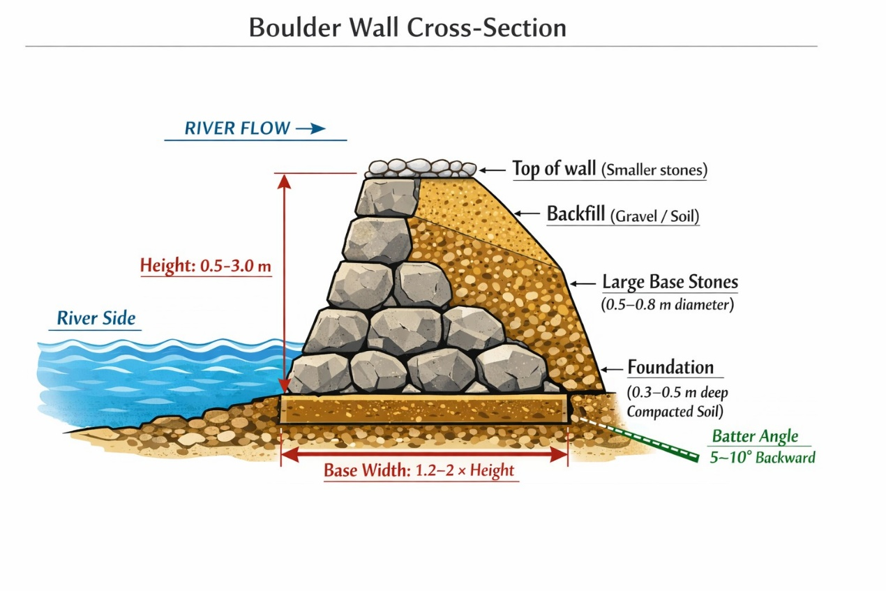
Figure 3. Cross-sectional design of a boulder (gravity) wall for riverbank protection, showing the arrangement of smaller top stones, gravel/soil backfill, large base stones, compacted foundation, batter angle (5–10°), wall height (0.5–3.0 m), and base width (1.2–2 × height).
  - Case Studies in Afghanistan
Boulder walls have been successfully implemented in several provinces of Afghanistan, demonstrating measurable effectiveness in flood mitigation. In Nangarhar Province, following the 2020 flash floods in the Kama and Chapadara districts, communities constructed boulder walls along small tributaries, resulting in a 40–50% reduction in agricultural damage compared to unprotected areas [23]. In Kunar Province, local communities in Chapa Dara and Asadabad districts reinforced boulder walls annually, which effectively reduced riverbank erosion and protected homes during the 2018 and 2022 flash floods [24]. In Kabul Province, peri-urban areas along the Kabul River combined boulder walls with vegetation to stabilize riverbanks, achieving both flood protection and ecological benefits, such as reduced soil erosion and improved riparian biodiversity [6]. Similarly, in Herat Province, boulder walls installed in small river valleys have protected irrigation canals and farmland, showing high durability by withstanding multiple flood events over the past decade [25].

  - Advantages and Limitations of Boulder Walls
Boulder walls offer several advantages that make them particularly suitable for flood mitigation in rural and remote areas of Afghanistan [2]. They are low-cost, utilizing locally available stones and materials, which reduces transportation and material expenses [3]. Their construction promotes community involvement, creating employment opportunities and facilitating knowledge transfer among local residents. Boulder walls are also highly flexible, as they can be built without heavy machinery, and they demonstrate environmental compatibility, blending with natural landscapes and supporting vegetation growth along riverbanks [22]. However, despite these benefits, boulder walls have certain limitations. They provide limited protection during extreme floods, such as events exceeding the 1-in-50-year return period, and they require regular inspection and maintenance to remain effective. The design often relies heavily on local experience, which can result in inadequate construction and potential structural failure [26]. Furthermore, boulder walls are generally unsuitable for urban areas with high hydraulic loads unless they are reinforced or integrated with additional engineered solutions.

  - Implications for Flood Risk Reduction
Boulder walls provide a practical, scalable, and low-cost solution to reduce flood impacts in Afghanistan’s rural and peri-urban regions. While they cannot replace large-scale engineered floodwalls in urban centers, their effectiveness in community-based applications makes them critical for protecting vulnerable populations, farmlands, and infrastructure. Integrating boulder walls with early warning systems, vegetation, and other low-cost mitigation measures can further enhance resilience to flash floods and riverine flooding.

- Environmental and Socio-Economic Impacts of Boulder Walls
Boulder walls are widely recognized not only for their flood mitigation capabilities but also for their environmental and socio-economic benefits. Understanding these impacts is crucial for sustainable implementation, especially in resource-constrained and vulnerable areas of Afghanistan [27-29].

  - Environmental Impacts
    - Riverbank Stabilization and Soil Erosion Control
Boulder walls act as barriers that stabilize riverbanks, preventing erosion caused by strong flood currents. In provinces like Nangarhar and Kunar, communities reported that boulder walls helped maintain the shape of river channels, reducing sediment deposition downstream [2].

    - Integration with Vegetation
When constructed with gaps for soil and small plants, boulder walls can support vegetation growth. This vegetative layer enhances slope stability, reduces erosion, and improves the ecological integrity of riparian zones. For instance, in peri-urban Kabul, vegetation along boulder walls has increased local biodiversity and provided natural filtration for floodwater [30].

    - Minimal Environmental Disruption
Compared to large concrete floodwalls or levees, boulder walls require minimal alteration of the natural landscape. This is particularly important in Afghanistan, where fragile mountain ecosystems are sensitive to construction activities.

    - Sediment and Water Flow Management
By slowing water velocity and trapping sediments, boulder walls help maintain the fertility of downstream agricultural lands. This reduces the loss of topsoil, which is critical for sustaining local farming communities.

  - Socio-Economic Impacts
    - Protection of Agricultural Land and Livelihoods
Agriculture is the main source of income for rural communities in Afghanistan. Boulder walls protect croplands from floodwaters, reducing crop loss and preserving livelihoods. Post-flood assessments in Nangarhar Province after the 2020 floods reported 40–50% lower crop damage in fields protected by boulder walls [6].

    - Community Engagement and Employment
Construction and maintenance of boulder walls involve local labor, creating temporary employment opportunities and fostering community ownership of flood protection measures. This approach strengthens social cohesion and ensures long-term maintenance.

    - Cost-Effectiveness
Boulder walls rely on locally available stones, reducing transportation and material costs. Compared to engineered floodwalls, they provide a high benefit-to-cost ratio, making them ideal for developing regions with limited resources.

    - Safety and Displacement Reduction
Boulder walls reduce the likelihood of homes and settlements being inundated. This lowers displacement risks and associated humanitarian costs, such as emergency shelters and relief supplies.

  - Cost-Benefit Considerations
A comparative assessment of boulder walls versus alternative measures shows that they are affordable and locally sustainable, especially in rural settings. The following Table 4 summarizes key socio-economic and environmental factors associated with different structural measures.
Table 4. Cost-Benefit Comparison of Structural Flood Mitigation Measures in Afghanistan
Structural Measure | Construction Cost | Maintenance Cost | Environmental Impact | Community Involvement | Socio-Economic Benefit
Levees/Embankments | High | Moderate | Moderate disruption | Low | Protects large areas; urban-focused
Floodwalls | Very High | High | High disruption | Low | High urban protection; costly
Check Dams | Moderate | Low | Positive (sediment control) | Moderate | Protects upstream communities; small-scale
Boulder Walls | Low | Low | Positive (stabilization & vegetation) | High | Protects farmland, homes; community-driven

  - Implications
The environmental and socio-economic benefits of boulder walls make them a practical and sustainable choice for rural and semi-urban communities in Afghanistan. Their integration into broader flood risk management strategies, along with complementary measures such as vegetation planting and community awareness programs, enhances resilience and reduces long-term economic losses.

- Challenges and Research Gaps
Boulder walls in Afghanistan face several challenges that limit their effectiveness and broader adoption [3, 5]. Technically, many walls are built based on local experience rather than formal engineering standards, which can lead to failures during extreme floods. Limited stone quality, poor compaction, and inadequate maintenance further reduce durability. Institutionally, weak government support, lack of national guidelines, and poor coordination among communities and NGOs hinder consistent implementation. Environmental factors such as increasing flood intensity due to climate change and the degradation of natural buffers further compromise wall performance. Socio-economic constraints, including limited funding, labor, and uneven community participation, also affect construction and long-term upkeep [31].
Several research gaps remain that need to be addressed to improve flood risk management. There is a lack of systematic monitoring of wall performance, quantitative evaluations of failure rates, and formal cost-benefit analyses comparing boulder walls to other mitigation measures. Research on adapting walls to future flood scenarios and integrating them with ecosystem-based approaches is minimal. Additionally, nationally recognized design and maintenance standards tailored to local flood conditions are absent. Addressing these gaps requires technical research, policy development, capacity building, and integrated planning to ensure sustainable and effective flood risk reduction across Afghanistan.

- Policy Implications
Effective flood risk reduction in Afghanistan requires combining structural measures, such as boulder walls, with supportive policies, institutional frameworks, and community-based management. Based on this review, several key policy actions are recommended. First, national standards for boulder wall design, construction, and maintenance should be established. These standards should define recommended wall heights, base widths, slope angles, foundation depth, material quality, drainage specifications, and maintenance schedules. Standardization will ensure consistent quality, improve effectiveness, and give communities and local authorities confidence in implementation.
Second, community participation should be formally integrated into policy frameworks. Policies should encourage local labor involvement, provide technical training, and include communities in decision-making for site selection, wall design, and maintenance. This strengthens social ownership, sustainability, and proactive flood protection. Third, funding and resource allocation must be prioritized. High-risk provinces should receive targeted financial support, including micro-financing programs, grants, and public-private partnerships, to enable construction and maintenance of boulder walls. Reliable funding ensures long-term effectiveness and reduces flood-related losses.
Fourth, structural measures should be integrated with non-structural interventions. Policies should promote early warning systems, floodplain zoning, watershed management, reforestation, and community awareness programs. Combined approaches improve flood resilience while protecting ecological systems. Fifth, climate change adaptation should be incorporated. Policies should support adaptive wall designs, research on reinforced materials, and long-term monitoring to ensure structural measures remain effective under future flood conditions.
Finally, institutional coordination and capacity strengthening are essential. The Afghanistan National Disaster Management Authority (ANDMA) and provincial units should be empowered, with centralized data-sharing platforms to consolidate flood information, best practices, and guidance. Coordinated efforts between NGOs, communities, and government agencies will standardize interventions and maximize resource use. In summary, by developing national standards, promoting community-led approaches, securing funding, integrating structural and non-structural measures, implementing climate-resilient designs, and strengthening institutions, Afghanistan can optimize the benefits of boulder walls and other structural interventions while building sustainable, community-focused flood resilience.

- Conclusion
Floods are a persistent threat in Afghanistan, particularly in provinces such as Nangarhar, Kunar, Badakhshan, Kabul, Helmand, and Herat. Factors such as seasonal rainfall, snowmelt, deforestation, and unplanned settlements increase flood risk, affecting livelihoods, agriculture, infrastructure, and human safety. Structural measures, particularly boulder walls, offer a practical, low-cost, and community-driven solution, especially in rural and semi-urban areas.
Boulder walls stabilize riverbanks, reduce erosion, protect croplands, and safeguard homes. Their use of local materials, affordability, and potential for community engagement make them well-suited to Afghanistan’s resource-constrained context. Case studies from Nangarhar, Kunar, Kabul, and Herat show measurable reductions in flood damage and enhanced community ownership. Challenges remain, including inconsistent design, material limitations, maintenance deficiencies, and increasing flood intensity due to climate change. Institutional constraints, lack of national standards, and limited coordination also impede wider adoption. Addressing these issues requires national standards, community training, sustainable funding, integration with non-structural measures, climate-resilient designs, and stronger institutional coordination. When combined with supportive policies and community engagement, boulder walls provide a scalable and sustainable approach to flood risk reduction in Afghanistan, contributing to resilient communities, reduced socio-economic losses, and long-term disaster risk management.

Author Contributions: S.U. and M.A.S.; Methodology: S.U. and M.A.S.; Data collection and literature review: S.U. and M.A.S.; Formal analysis: S.U.; Visualization and figures: S.U.; Writing—original draft preparation: S.U.; Writing—review and editing: S.U. and M.A.S.; Supervision: S.U.; Project administration: S.U. Both authors have read and agreed to the published version of the manuscript.

Funding: This research was supported by Community World Service Asia under the project titled “Enhancing Resilience of Afghanistan through Integrated Risk Reduction (MoFA DRR Phase 3 – Year 2)”. The funding organization had no role in the study design, data collection, analysis, interpretation, or decision to publish the results.

Data Availability Statement: The datasets used and/or analyzed during the current study are available from the corresponding author on reasonable request.

Acknowledgments: The authors would like to express their sincere gratitude to Community World Service Asia for providing financial and technical support through the project “Enhancing Resilience of Afghanistan through Integrated Risk Reduction (MoFA DRR Phase 3 – Year 2)”. We also acknowledge the support of local stakeholders, field staff, and community members who contributed to data collection and implementation of this study.

Conflicts of Interest: The authors declare no conflicts of interest.

Clinical Trial Registration: Clinical trial number: Not applicable.

References
- Ahmad, I., Ping, W., Ullah, S., Faqeih, K.Y., Alamri, S.M., Alamery, E.R., Abalkhail, A.A.A. and Bilal Jan, H.M., 2025. Spatiotemporal Mapping of Urban Flood Susceptibility: A Multi-Criteria GIS-Based Assessment in Nangarhar, Afghanistan. Land, 14(12), p.2376. https://doi.org/10.3390/land14122376
- Ikram, Q.D., Jamalzi, A.R., Hamidi, A.R., Ullah, I. and Shahab, M., 2024. Flood risk assessment of the population in Afghanistan: A spatial analysis of hazard, exposure, and vulnerability. Natural Hazards Research, 4(1), pp.46-55. https://doi.org/10.1016/j.nhres.2023.09.006
- Shokory, J.A., Schaefli, B. and Lane, S.N., 2023. Water resources of Afghanistan and related hazards under rapid climate warming: a review. Hydrological sciences journal, 68(3), pp.507-525. https://doi.org/10.1080/02626667.2022.2159411
- Mushwani, H., Arabzai, A., Safi, L., Ullah, H., Afghan, A. and Parven, A., 2025. Evaluation of flood hazard vulnerabilities and innovative management strategies in Afghanistan’s central region. Natural Hazards, 121(4), pp.4639-4655. https://doi.org/10.1007/s11069-024-06974-7
- International Federation of Red Cross and Red Crescent Societies (2025). Afghanistan | Floods – Final Report (Glide № FF-2024-000049-AFG). Emergency appeal № MDRAF015. Geneva: IFRC. Available at: https://go-api.ifrc.org/api/downloadfile/87992/MDRAF015ea.fnr (accessed 2025).
- World Bank (2019). Afghanistan: Wall protects farms and homes from floods in Kabul Province. Available at: https://www.worldbank.org/en/news/feature/2019/04/17/flood-wall-protects-farms-and-homes-from-destruction-in-kabul-province (accessed 2025).
- Ishanch, Q., Mishra, K., Zarfl, C. and Fitzsimmons, K., 2025. Flood hazard in Afghanistan is intensified both by natural and socioeconomic factors. EGUsphere, 2025, pp.1-34.
- Kreibich, H., Bubeck, P., Van Vliet, M. and De Moel, H., 2015. A review of damage-reducing measures to manage fluvial flood risks in a changing climate. Mitigation and adaptation strategies for global change, 20(6), pp.967-989. https://doi.org/10.1007/s11027-014-9629-5
- Sarkar, D. and Sinha, R., 2025. Integrating UAV‐Based Topographic and Geomorphic Analysis for the Development of River Rehabilitation Plans in Semi‐Urban Settings. River Research and Applications, 41(2), pp.314-333. https://doi.org/10.1002/rra.4371
- Jenkins, S.F., Spence, R.J., Fonseca, J.F., Solidum, R.U. and Wilson, T.M., 2014. Volcanic risk assessment: Quantifying physical vulnerability in the built environment. Journal of Volcanology and Geothermal Research, 276, pp.105-120. https://doi.org/10.1016/j.jvolgeores.2014.03.002
- Green, D.S., Chapman, M.G. and Blockley, D.J., 2012. Ecological consequences of the type of rock used in the construction of artificial boulder-fields. Ecological Engineering, 46, pp.1-10. https://doi.org/10.1016/j.ecoleng.2012.04.030
- Tasnia, T. and Growe, A., 2025. A systematic literature review of water-sensitive urban design and flood risk management in contexts of strategic urban sustainability planning. Land, 14(2), p.224. https://doi.org/10.3390/land14020224
- Mushwani, H., Arabzai, A., Ahmad, M.M. and Ullah, H., 2025. Assessing the socio-economic consequences of drought in central Afghanistan: a case study of Bamyan province. GeoJournal, 90(5), p.229. https://doi.org/10.1007/s10708-025-11472-9
- Karimi, B.A., Haziq, M.A. and Hayat, A., 2025. Specific impacts of climate change on the hydrological patterns and land use dynamics in the Arghandab river Basin, Kandahar, Afghanistan. Natural Hazards Research, 5(2), pp.380-390. https://doi.org/10.1016/j.nhres.2024.12.007
- Jamshed, R., Naeem, E., Tahir, A.A., Irshad, M., Qaisar, F.U.R., Arifeen, A., Muhammad, S., Kunpeng, W. and Faiz, M.A., 2025. Modeling snowmelt-driven streamflow dynamics in a Himalayan Basin under climate warming scenarios. PLOS Climate, 4(10), p.e0000739. https://doi.org/10.1371/journal.pclm.0000739
- Ullah, N., Tariq, A., Qasim, S., Panezai, S., Uddin, M.G., Abdullah-Al-Wadud, M. and Ullah, S., 2024. Geospatial analysis and AHP for flood risk mapping in Quetta, Pakistan: a tool for disaster management and mitigation. Applied Water Science, 14(11), p.236. https://doi.org/10.1007/s13201-024-02293-1
- Zhang, A., Tariq, A., Quddoos, A., Naz, I., Aslam, R.W., Barboza, E., Ullah, S. and Abdullah-Al-Wadud, M., 2025. Spatio-temporal analysis of urban expansion and land use dynamics using google earth engine and predictive models. Scientific Reports, 15(1), p.6993. https://doi.org/10.1038/s41598-025-92034-4
- Ogie, R.I., Adam, C. and Perez, P., 2020. A review of structural approach to flood management in coastal megacities of developing nations: Current research and future directions. Journal of Environmental Planning and Management, 63(2), pp.127-147. https://doi.org/10.1080/09640568.2018.1547693
- Chanson, H., 2015. Embankment overtopping protection systems. Acta Geotechnica, 10(3), pp.305-318. https://doi.org/10.1007/s11440-014-0362-8
- Reshteen, S., Rahmatzai, A. and Safi, A.G., 2024. Urban water crisis in Kabul City: key challenges and solutions. Journal of Natural Science Review, 2(3), pp.138-150. https://doi.org/10.62810/jnsr.v2i3.51
- Polyakov, V.O., Nichols, M.H., McClaran, M.P. and Nearing, M.A., 2014. Effect of check dams on runoff, sediment yield, and retention on small semiarid watersheds. Journal of soil and water conservation, 69(5), pp.414-421. https://doi.org/10.2489/jswc.69.5.414
- Mason, R.J. and Polvi, L.E., 2024. How big is a boulder? The importance of boulder definition choice in earth science research and river management. Earth Surface Processes and Landforms, 49(9), pp.2840-2854. https://doi.org/10.1002/esp.5861
- TRT World (2020). Flash floods kill scores in eastern Afghanistan. Available at: https://trt.global/world/article/12871720 (accessed 2025).
- Xinhua News (2024) Flash floods kill 5 in east Afghanistan. Available at: https://english.news.cn/asiapacific/20240716/6732b5eb87b74adbaec9d9e63314cd44/c.html (accessed 2025).
- Associated Press (2026). Flash floods kill at least 17 people in Afghanistan, including Herat province. Available at: https://apnews.com/article/40f03343a6c5a47f2fff15c420310c35 (accessed 2025).
- Zhao, X., Li, H., Cai, Q., Pan, Y. and Qi, Y., 2023. Managing extreme rainfall and flooding events: A case study of the 20 July 2021 Zhengzhou flood in China. Climate, 11(11), p.228. https://doi.org/10.3390/cli11110228
- Ullah, S., Khan, M. & Qiao, X. Evaluating the impact of urbanization patterns on LST and UHI effect in Afghanistan’s Cities: a machine learning approach for sustainable urban planning. Environ Dev Sustain (2025). https://doi.org/10.1007/s10668-025-06249-6
- Ullah, S., Qiao, X. & Abbas, M. Addressing the impact of land use land cover changes on land surface temperature using machine learning algorithms. Sci Rep 14, 18746 (2024). https://doi.org/10.1038/s41598-024-68492-7
- Ullah, S., Abbas, M. and Qiao, X., 2024. Impact assessment of land-use alteration on land surface temperature in Kabul using machine learning algorithm. Journal of Spatial Science, pp.1-23. https://doi.org/10.1080/14498596.2024.2364283
- Ullah, S., Khan, M. & Qiao, X. Examining the impact of land use and land cover changes on land surface temperature in Herat city using machine learning algorithms. GeoJournal 89, 225 (2024). https://doi.org/10.1007/s10708-024-11217-0
- Ullah, S., Qiao, X. & Tariq, A. Impact assessment of planned and unplanned urbanization on land surface temperature in Afghanistan using machine learning algorithms: a path toward sustainability. Sci Rep 15, 3092 (2025). https://doi.org/10.1038/s41598-025-87234-x

