Ecology and Associate Plant Species of Terminalia chebula Retz. (Combretaceae) in Bhutan’s South-Central Region

Abstract
Terminalia chebula Retz. is a highly revered medicinal plant and is commonly referred as “King of Medicines” due to its high potent medicinal properties. However, its distribution and habitat in the country are poorly understood. Therefore, this study aimed to investigate the associated plant species, the influence of environmental factors on its growth and distribution, and suitable habitat modeling of the species in Bhutan. A total of 36 plots were laid using sampling along the transect lines covering different slopes and aspects along altitudinal gradient in three districts (Sarpang, Tsirang, and Dagana). A major plot size of 20 x 20 m was laid for the collection of tree data and for understory vegetation. Within the major plot, smaller nested plots were designed measuring 5 x 5 m for shrub and 1 x 1 m for herb data collections. Soil samples (N = 36) were collected from the center of the major plot from a depth of 25–30 cm. A total of 164 plant species belonging to 61 families were recorded. Kendall association of CCA ordination showed maximum influence of soil pH (r = 0.65) and rainfall (r = 0.63) followed by soil phosphorus (r = 0.41). Annual mean temperature had moderate influence (r = 0.18) and altitude showed maximum negative correlation with the growth and distribution of T. chebula (r = -0.72) in the study area. Suitable habitat was obtained using Fuzzy Overlay in ArcGIS. Overall, 6.10% of country’s area was found to be suitable for growth and development of the species that could be used for protection and management of species in future.
Keywords: Dominance, ecology, south-central Bhutan, suitable habitat, Terminalia chebula

Introduction
A Swedish Naturalist, Anders Jahan Retzius described Terminalia chebula Retz. in 1822 (Quattrocchi, 2012). Terminalia chebula, commonly known as Haritaki is an economically important medicinal plant species belonging to the genus Terminalia under the family Combretaceae. The tree is highly valued as an excellent source of tannins and provides good quality wood (Bag et al., 2013). The Combretaceae is a large family that covers herbs, shrubs, and trees in globally distributed 20 genera and 600 species and has been the subject of extensive scientific research and investigation (Bulbul et al., 2022).
More than 50 species are said to be fit for human consumption (Fan et al., 2015). T. chebula, commonly known as chebulic or black myrobalan is referred as “King of Medicines” due to its potent medicinal values and is native to South Asia from India and east of Nepal to southwest China (Yunnan), south to Sri Lanka, Malaysia, and Vietnam (Kumar, 2020). Along with T. bellirica and Phyllanthus emblica, it is a crucial ingredient in Triphala medicines. It is used to treat various health issues like asthma, sore throat, vomiting, diarrhoea, bleeding piles, ulcers, bladder, and heart diseases (Bag et al., 2013). The increasing demand for herbal remedies and organic dyes in the international market has led to extensive extraction of fruits and galls from T. chebula in recent years (Kailash et al., 2022).
In Bhutan, the natural distribution of T. chebula has been recorded from various parts of the country including Sarpang, Dagana, Tsirang, Punakha, Samdrup Jongkhar, Samtse, and Wangdue Phodrang Districts (Krug and Milliken, 2008). Furthermore, traditional medical practice in Bhutan stands as one of the nation's tangible heritages, comprising two distinct forms: local healing practices and the official traditional medical system called sowa rigpa, which translates to “the science of healing” (Lhamo and Nebel, 2011).
As such, the literature on T. chebula provides information on the environmental requirements of the species mostly from other parts of the world where it has been studied. However, there is no such information regarding the species from Bhutan. This study will look preferably into the environmental requirements of T. chebula in the context of Bhutan.
As per the study conducted by Kailash et al. (2022) using maximum entropy modeling (MaxEnt) about the potential global distribution and conservation areas for Terminalia chebula, the model predicted that, Bhutan has the moderate to highly favorable climatic conditions for the growth of species within the tropical regions of the country.
According to the World Health Organization (WHO), about 85% of the world's population uses plant-based traditional medicine for their primary healthcare. It is regarded as the top medicinal plant species because of its extraordinary power of healing. The whole plant possesses high medicinal value and is traditionally used for the treatment of various ailments (Bag et al., 2013).
Globally, T. chebula has been identified in tropical regions and mostly the outer skin (pericarp) is used in different pharmacological preparations (Khalil et al., 2023). In Bhutan, there are four types of Terminalia species as per the Flora of Bhutan (Grierson and Long, 1983). From them, two species with high medicinal values, namely Terminalia chebula and Terminalia bellirica has been reported from Bhutan. However, no in-depth study on T. chebula has been conducted in the country thus far and only a very sparse information and literature is available regarding the species growth and distribution in the country. The differences in environmental variables between locations are predicted to contribute differently to the species’ growth and development.
T. chebula is one of the highly traded tropical forest species that has been listed as a priority species in need of management intervention and has become locally endangered in several regions of India with its uncertain current status and thus requires a thorough study of its population size and rigorous assessment of threatened status (Kailash et al., 2022). Additionally, increased efforts must be made to conserve the species (both in–situ and ex–situ) and cultivate it in order to stop further depletion and maintain a steady supply for local, regional, and global market needs (Hossain et al., 2013).
It is a highly sought-after medicinal plant species worldwide and in Bhutan traditionally. However, little is known about its distribution and habitat in the country. Therefore, this study aimed to determine the suitable habitat, biodiversity of its associated species, and influence of environmental variables on growth and distribution of the species and the information generated through this study is expected to provide relevant information about species to interested researchers, relevant agencies, planners, and nation at large for the management and conservation of this important species.

Materials and Methods

Study site
The current study concentrated on three districts, namely Sarpang, Tsirang, and Dagana (Figure 1) where the natural stand of species are found, which are the focus of the current study due to its limited distribution of species throughout the country (Krug and Milliken, 2008). Sarpang district is located in the south–central part of Bhutan and covers an area of 1,655 km² and has an elevation ranging from 200–3,600 m a.s.l. It is adjacent to the Indian state of Assam and Tsirang district. It also shares borders internally with Zhemgang to the east, Tsirang to the west, and Trongsa to the north (RGoB, 2023). The district is known for its rich biodiversity, with 88% of its land covered in forests. The district is host to Royal Manas National Park and Phibsoo Wildlife Sanctuary, which protect a variety of animal species facing global extinction (DoFPS, 2023). Situated on Central Bhutan (RGoB, 2023), Tsirang district covers an area of 639 km² and has an elevation ranging from 600–1,700 m a.s.l. It is adjacent to Dagana and Wangdue Phodrang districts and one of Bhutan's longest rivers, Punatsang Chhu or Sunkosh River flows through the district (RGoB, 2023). Dagana district is situated in the southwest region of the country and is nestled between the deep valleys of the Wangdue Phodrang and Thimphu districts. It also shares a border with an Indian state of Assam in the southern part of the country (RGoB, 2023). The district's elevation ranges from 100–4,700 m a.s.l experiencing cool winter and hot summer. The annual temperature ranges from 13.2ºC to 22.4ºC with a total annual rainfall of 1,316.7 mm (NHMC, 2020). Almost 89.14% of the district is under forest cover (FRMD, 2023).

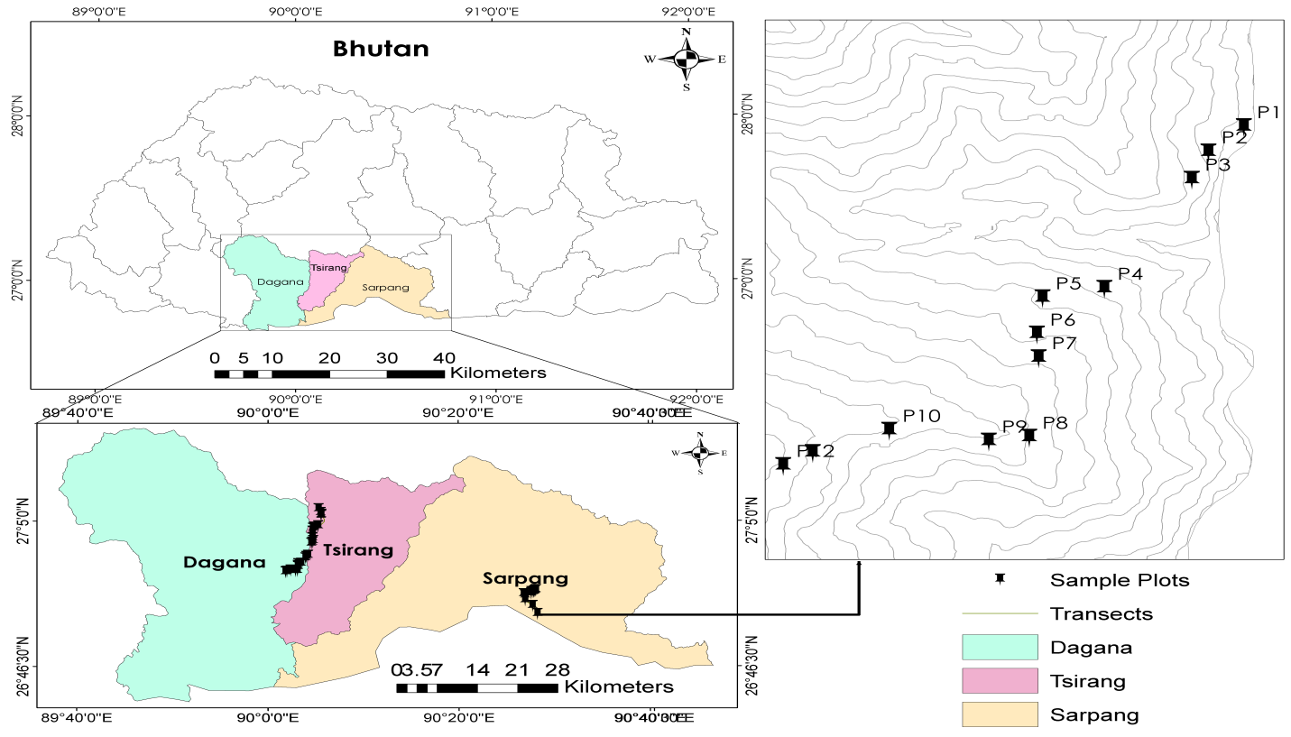
Plot layout and vegetation survey
Figure 1: Study area showing three districts and sample plots
To evaluate the distribution of the natural stand of medicinal plants, a sampling along the transect line ensures that each habitat type has an equal probability of inclusion in the sample (Buckland et al., 2007). The sampling with three transects was used to collect the primary ecological attributes, namely, climatic, edaphic, biotic, and topographic features influencing the growth and distribution of the species (Acharya et.al., 2013; Rabgay et al., 2020; DoFPS, 2023), one each in three different study areas (Sarpang, Tsirang, and Dagana). The survey covered different aspects and slopes along altitudinal gradient starting from valley bottom to ridge top.
The study area covered an altitude ranging of 261–1,361 m a.s.l under Sarpang District. From 285–1,385 m a.s.l under Tsirang District and from 280–1,380 m a.s.l under Dagana District with first sampling plot being the lowest point and last plot in each study area being the highest survey point. The sampling plots were assigned along the altitude gradient maintaining an altitude interval of 100 m between sample plots. A total of 36 plots in three different districts were established (twelve plots in each district).
The study adopted the plot design following the method employed by Shalisaheb and Manjula (2023) for the study of ecology of different shrubs which involved laying out a plot size of 400 m² (20 x 20 m) at each sampling site. Within each 20 x 20 m plot, smaller nested plots were designed measuring 5 x 5 m for understory (shrub) and 1 x 1 m for groundcover (herb) data collections (Shalisaheb and Manjula, 2023). Soil samples were obtained from the center of the main plot from a depth of 25–30 cm (Clay et al., 2002).
From the major plots, all tree species with diameter of ≥10 cm at Diameter at Breast Height (DBH) and height of 1.3 m and above were documented (Kaka et al., 2014). In addition to the tree species, all shrub species were also recorded by taking individual count of each species (DoFPS, 2020). All herbaceous plants were enumerated from the minor plot.

Climatic and topographic data collection
The growth of the species was assessed by recording various environmental variables, such as slope, aspect, altitude, and location having significant influence on distribution and growth of T. chebula. The slope, aspect, altitude, and location data were collected using compass, clinometer, altimeter, and Global Positioning System (GPS) respectively. For the collection of climatic variables such as rainfall and temperature which effect the growth of the species, the model developed by Dorji et al. (2016) was used.
Vegetation data analysis
The primary vegetation data gathered from the field were subjected to cleaning and sorting using Microsoft Excel. The Basal Area (BA) computation was performed using the Diameter at Breast Height (DBH) of trees with ≥10 cm and a height of ≥ 1.3 m (Kaka et al., 2014). Additionally, the Relative Basal Area (RBA) for each tree species (in percentage) was determined accordingly. The RBA obtained was used to determine stand structure and explain floristic compositions in the natural stand of Terminalia chebula. The analyses of DBH class distribution and vegetation structure were conducted using the DBH data (Wangda and Ohsawa, 2006). To explain the floristic composition of shrubs and herbs, the count and cover percentage of individual species was utilized to establish stand density and relative density (RD).

Soil data analysis
The soil samples were analyzed using a range of soil testing methods at Soil, Water, and Air Testing (SWAT) laboratory, College of Natural Resources (CNR), Royal University of Bhutan. A comprehensive assessment of eight soil parameters, namely soil moisture content (SMC), soil pH, soil electric conductivity (EC), soil organic matter (SOM), soil organic carbon (SOC), soil nitrogen (N), soil phosphorus (P), and soil potassium (K) were conducted. These parameters play a crucial role in promoting the growth of species and on its associated biodiversity.
Soil pH was analyzed using an automatic pH meter (Pakale et al., 2018). Soil nitrogen (N) was determined using the Kjeldhal method (Bremner, 1960), Soil phosphorus (P) using the Bray-II extraction method (Bray and Kurtz, 1945), and soil potassium (K) using the flame photometric method (Knudsen et al., 1983), following multiple extraction procedures (Bhattarai and Tomar, 2009). Soil organic carbon (SOC) and soil organic matter (SOM) was determined using Loss on Ignition method (Dean, 1974).

Habitat modeling
Using Fuzzy Overlay in ArcGIS, suitable habitats for T. chebula growth and development in Bhutan was analyzed. For the modeling, both vector and raster variables were employed. Vector data such as land use cover, river, and road were obtained using Land Use and Land Cover of Bhutan (LULC) 2020. The Digital Elevation Model (DEM) was used to extract raster data, including temperature, precipitation, aspect, and slope using the spatial analyst tool in ArcMap (Rabgay et al., 2020). For roads and rivers, a proximity buffer of 150 m and 30 m was maintained respectively.
Statistical analysis
The data collected from the field was processed in Microsoft Excel and analyzed using PC-ORD v5.10. Cluster analysis was conducted using the Relative Sorensen’s (Bay-Curtis) method as the Distance Measure and the Group Average as the linkage method to determine different cluster types (Tobgay, 2013). To examine the relationship between T. chebula and environmental variables, Canonical Correspondence Analysis (CCA) ordination (Mapaure, 2012) was performed taking RBA of species. The RBA from each plot was used as main matrix, while the environmental variables were included as secondary matrix and subsequently correlated (Wangda and Ohsawa, 2006). The strength of correlation between axes was assessed using Pearson and Kendall correlation coefficients (r) (Wangda and Ohsawa, 2006).
Results and Discussion
Vegetation composition of T. chebula
The quantitative inventory of floristic composition, diversity, dominance, indicator species, and distribution pattern of associate plant communities were assessed in each Terminalia chebula growing areas. A total of 164 plant species belonging to 61 families were found and recorded from 36 plots covered in three districts. The floristic vegetation was classified under three major growth forms viz., tree, understory (shrubs), and ground cover (herbs).
Figure 2: Plant species family in T. chebula growing areas
The most dominant families in the T. chebula growing areas were Pinaceae (n=190, 23%) followed by Combretaceae and Theaceae (n=54, 6%) each. The top three least dominating families in decreasing order were Menispermaceae, Selaginellaceae, and Betulaceae family.
Sharma and Thakur (2016) conducted a study on ecological variation among natural populations of T. chebula in Sirmour and Una Districts, Himachal Pradesh and reported that the species occurred mostly where the top storey of forest was occupied with Pinaceae (Pinus roxburghii) followed by Combretaceae. The current study also found T. chebula sharing its habitat with Pinus roxburghii and Terminalia bellirica.
The major life form tree in all the areas covered during the survey recorded a total of 52 tree species belonging to 24 families. The most dominating life form was deciduous trees covering 55.14% followed by evergreen trees covering 44.86%. Majority of the plots (n = 33) were covered with mixed deciduous and evergreen trees except plot P25, P26, and P27 which were completely dominated by deciduous trees (RBA = 100 %) (Figure 3).
The understory vegetation consisted of 57 species belonging to 32 families. Deciduous shrub constituted the maximum proposition of understory vegetation composition covering 47.18% followed by evergreen shrubs covering 15.98%. The least dominating understory vegetation was found to be climbing shrub and sub-shrubs covering 2.91% and 6.04% respectively. The three most dominating species in the understory vegetation were Asteraceae (Chromolaena odorata R. King & H. Rob), Cycadaceae (Cycas pectinata Buch.-Ham.), and Rutaceae (Murraya koenigii L.) and the least dominating species was Malvaceae (Urena lobata L.).
Figure 3: Vegetation composition and distribution of major life form tree in T. chebula habitat

Figure 4: Vegetation composition and distribution of major life form understory (shrub) in T. chebula habitat
The groundcover vegetation comprised of 55 species belonging to 24 families. Perennial herb constituted the majority of groundcover vegetation covering 46.27% followed by grass covering 21.20% while the least dominating groundcover vegetation was found to be annual herb, fern and climbing herb covering 5.85%, 13.21%, and 13.48% respectively.
The top most dominating species under groundcover vegetation were Poaceae (Oplismenus compositus (L.) P. Beauv), Asteraceae (Mikania micrantha Kunth.), and Orchidaceae (Arundina graminifolia). While the least dominating species was Lycopodiaceae (Lycopodium japonicum Thunb. ex Murray).

Associated dominant plant species
Figure 5: Vegetation composition and distribution of major life form underground (herb) in T. chebula habitat
The IVI of all the 52 species recorded from 36 plots showed Pinus roxburghii Sarg. (IVI = 75.91) (Table 1) as the most dominating species signifying strong association of the species with T. chebula followed by Schima wallichii (DC.) Korth. (IVI = 20.87) and Mangifera sylvatica Roxb. (IVI = 11.60). The top three least dominating species was found to be Toxicodendron hookeri (K.C.Sahni and Bahadur) C.Y.Wu and T.L.Ming (IVI = 0.79), Litsea monopetala (Roxb. ex Baker) Pers. (IVI = 0.81), and Melia azedarach (IVI = 0.83) indicating weak association of the species with T. chebula.
Table 1: Important Value Index (IVI) (Guariguata et al., 1997; Ajayi and Obi 2016)
Species | RD | RF | RDo | IVI | Remarks
Pinus roxburghii | 34.30 | 5.88 | 35.74 | 75.91 | Highest
Schima wallichii | 7.04 | 7.06 | 6.78 | 20.87 | Highest
Mangifera sylvatica | 1.62 | 1.76 | 8.21 | 11.60 | Highest
Melia azedarach | 0.18 | 0.59 | 0.06 | 0.83 | Lowest
Litsea monopetala | 0.18 | 0.59 | 0.04 | 0.81 | Lowest
Toxicodendron hookeri | 0.18 | 0.59 | 0.02 | 0.79 | Lowest
Stand structure and distribution pattern of T. chebula
Stand distribution types were found comprising of Inverse-J (showing excellent stand status) (Teketay, 2005) followed by Sporadic (showing good stand structure pattern), and J-Shaped showing bad status/pattern (Rabgay, 2019) (Figure 6).
Through the analysis of stand structure and distribution pattern of T. chebula in all the districts indicate that the overall distribution pattern of stands in and around T. chebula was performing well with excellent natural stand pattern/structure; portraying an inverse-J distribution pattern in two districts (Tsirang and Dagana). However, Sarpang district displayed J-Shaped distribution pattern showing bad status but with human intervention (Tesfaye et al., 2010) in natural T. chebula growing area.
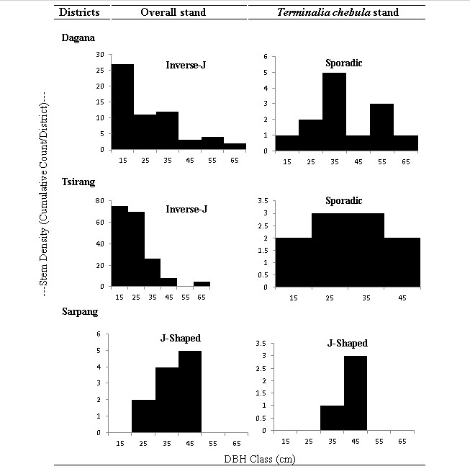
The distribution pattern of Terminalia chebula stand showed that two districts (Tsirang and Dagana) had sporadic distribution pattern (good stand structure) and one district (Sarpang) had J-Shaped which signifies unstable distribution due to less regeneration and existence of very sparse natural stands (Teketay, 2005) of T. chebula population thereby limiting the continuous establishment of the species (Rao et al., 1990). Though T. chebula is being valued for its multipurpose wood and other medicinal values human intervention in the form of environment destruction and developmental works has caused its natural population to decline (Singh et al., 2020). Additionally, overharvesting due to its medicinal values might have resulted in lack of mother trees in the wild thus extremely affecting the natural re-establishment of T. chebula stands.
Figure 6: Stand structure and distribution pattern of T. chebula

Environmental variable assessment
The study covered an altitude ranging from 261–1,385 m a.s.l (SD ± 70.71). However, species were found within elevation ranging from 261 m a.s.l with Lekithang, under Gelephu Gewog, Sarpang district being the lowest point and Sergithang under Tsirang district being the highest point at 1,285 m a.s.l displaying a wide range of altitude variations, which allows the species to grow and spread. A study conducted by Shrestha et al. (2021) reported that the T. chebula was found growing well at the altitude range of 250–1,500 m a.s.l in Nepal. Comparably, T. chebula was found growing in slightly acidic soils with pH ranging between 6.06–7.24 with mean pH value of 6.77 (SEM ± 0.07) indicating requirement of acidic soil for the growth of T. chebula. The findings are in line with a study conducted across Garhwal Himalaya, Uttarakhand by Shakith et al. (2023) which reported the optimum soil pH requirement for the proper growth of T. chebula was acidic ranging between 5.2–6.52.
Other edaphic factors such as soil nitrogen (N) availability and its content can often provide hindrance to the growth of the species (Aggarwal and Chauhan, 2014). Bremner (1960) reported that any soil with N content less than 0.7% is considered to be low. The current study also found relatively low soil N content ranging between 0.02–0.07% with an average N content of 0.04% (SEM ± 0.003) rendering exceptionally high limitation to the growth and development of the species. According to Claassen and Carey (2013), a low soil N content weakens the root system and prevents regeneration. Similarly, the study found relatively low species regeneration across the whole study area, which could be attributed to inadequate soil N.
The soil moisture content ranged from 0.4–5% with average moisture content of 2.34% (SEM ± 0.24) indicating lower water requirement of the species and high drought stress (Vahdati et al., 2009). A study conducted by Shrestha et al. (2021) in Nepal found that the species is found growing well at the altitude range of 250–1,500 m a.s.l and the current study also revealed similarities in the altitudinal requirements of the species with altitude range 261–1,385 m a.s.l (SEM ± 70.50).
The climatic factor such as rainfall plays a significant role in the development of the species (Kailash et al., 2022). Singh and Malhotra (2017) claimed that the species requires an optimum precipitation between 1,000–3,300 mm per year and the current study area also found a similar annual precipitation range of 1,275–4,299 mm. Singh and Malhotra (2017) further reported that under ideal condition the species requires 22–35°C of average annual temperature for the growth and cultivation, the current study also found the annual temperatures ranging between 18.66–23.99°C with a mean temperature of 21.72°C (SEM ± 0.38) (Table 2).
Table 2: Environmental attributes of the study area
Environmental attributes | N | Maximum | Minimum | Mean | ± SEM
Altitude (m a.s.l) | 36 | 1285 | 261 | 695.76 | 70.5
Aspect | 36 | 319 | 49 | 171.33 | 15.03
Slope (°) | 36 | 71 | 8 | 36.05 | 4.42
Soil pH | 36 | 7.24 | 6.06 | 6.78 | 0.07
Soil Moisture Content (%) | 36 | 5 | 0.4 | 2.34 | 0.24
Soil Organic Carbon | 36 | 0.77 | 0.24 | 0.46 | 0.04
Nitrogen (%) | 36 | 0.07 | 0.02 | 0.04 | 0.003
Phosphorus (mg/kg) | 36 | 16.7 | 0.002 | 2.56 | 0.93
Potassium (mg/kg) | 36 | 492.1 | 287.1 | 376.25 | 14.16
Temperature (°C) | 36 | 23.99 | 18.66 | 21.72 | 0.38
Precipitation (mm) | 36 | 4299 | 1275 | 2462.97 | 181.38
Electric Conductivity (EC) | 36 | 0.1 | 0.02 | 0.05 | 0.005
Note: SEM = Standard error of mean

Cluster classification of Terminalia chebula
The cluster analysis was carried out to check if there are homogenous plant communities based on their abundance in the 20 x 20 m plots by similarity index in Dendrogram using the RBA of each species across all plots in PC-ORD. The similarity index was performed using the distance measure of Relative Sorensen and Group Linkage Method using group average to determine cluster (class) types in the T. chebula growing habitat.
The clusters were classified and named based on the dominant species occurring in the cluster groups showing four cluster solutions with their indicator species. Cluster I: Heynea trijuga, Cluster II: Pinus roxburghii, Cluster III: Ostodes paniculata, and Cluster IV: Bridelia retusa.
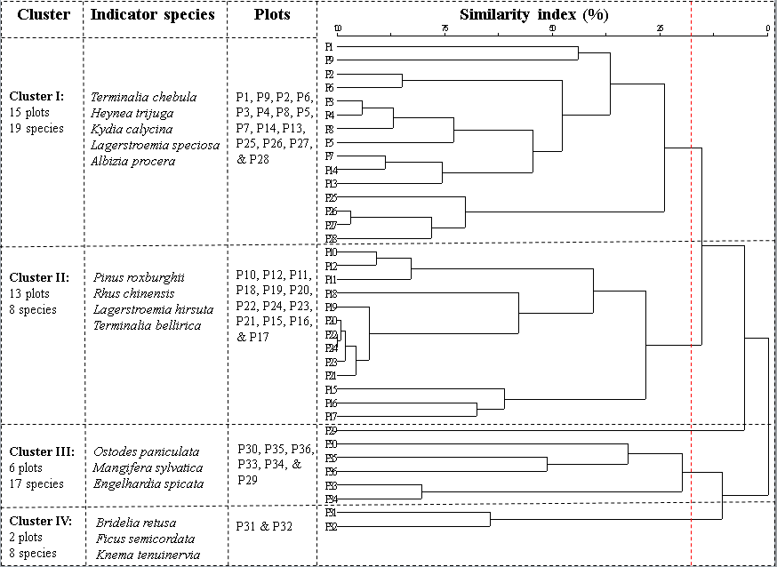
Figure 7: Cluster Dendrogram showing four different clusters in T. chebula growing areas and their indicator species.

Indicator species
Monte Carlo test of indicator species was calculated following Dufrene and Legendre Method to identify indicator species in each cluster group (Table 3). The Cluster–I consisted of 15 plots with 19 species and is characterized by the presence of indicator species such as Heynea trijuga with Indicator Value (IV = 33.3, SD = 12.37, p = 0.013). Moreover, the highest composition of Terminalia chebula is found in this Cluster (IV = 64.2, SD = 10.09, p = 0.008) with the mean value of 31.5%.
Similarly, Cluster–II has a total of 13 plots with 8 species recorded with an indicator species of Pinus roxburghii (IV = 76.9, SD = 12.31, p = 0.002). The Cluster–III is the third group with 6 plots and 17 species characterized by the occurrence of Ostodes paniculata (IV = 80, SD = 12.25, p = 0.007). While the Cluster–IV is the smallest group with 2 plots and 8 species. The indicator species in this cluster are Bridelia retusa (IV = 50, SD = 10.61, p = 0.043).
Table 3: Indicator species for each cluster solution
Cluster | Indicator Species | Value (IV) | Mean | SD | P*
Cluster I | Terminalia chebula | 64.2 | 31.5 | 10.09 | 0.008*
 | Heynea trijuga | 33.3 | 20.1 | 12.37 | 0.013*
Cluster II | Pinus roxburghii | 76.9 | 24.6 | 12.31 | 0.002*
 | Rhus chinensis | 28.6 | 19.9 | 12.6 | 0.196
Cluster III | Ostodes paniculata | 80 | 18.6 | 12.25 | 0.007*
 | Mangifera sylvatica | 60 | 17 | 11.75 | 0.006*
Cluster IV | Bridelia retusa | 50 | 11.5 | 10.61 | 0.043*
 | Terminalia myriocarpa | 50 | 11.5 | 10.61 | 0.058

Influence of environmental variables on the growth and distribution of T. chebula
The Canonical Correspondence Analysis (CCA) Ordination was used to determine the relationship between the vegetation structure and environmental attributes (Wangda and Ohsawa, 2006) of plots (Table 4; Figure 8) where T. chebula was found. The RBA was taken as main matrix and environmental attributes and soil data were taken as secondary matrix for the analysis.
The Axes with highest percentage of variance and eigenvalues were considered to extract Axes 1 and 2. Eigenvalues for Axis 1 was 0.852, for Axis 2 was 0.800, and for Axis 3 was 0.623 with percentage variance of 27.9%, 24.5%, and 20.8% respectively. The biplots of CCA ordination clearly reflects that Axis 1 is mostly related with temperature, soil pH, and Phosphorus (P), and Axis 2 is mostly related with precipitation, altitude, and slope.
From the Pearson and Kendall tau Correlation with ordination axis shown in Table 4, soil pH had the maximum influence (r = 0.65) on five plots (P16, P14, P9, P18, and P11) with species comprised of Terminalia bellirica, Lagerstroemia hirsuta, and Mallotus philippensis. Similarly, temperature had the strong influence (r = 0.179) on twelve plots (P28, P2, P7, P6, P4, P1, P8, P27, P13, P15, P26, and P25) in which T. chebula was the most dominating species indicating greater influence of temperature on the growth and distribution of T. chebula. Some of the species associated with T. chebula in these plots were Albizia lucidior, Heynea trijuga, Acer campbellii, Toxicodendron hookeri, and Castanopsis hystrix which perform well in dry areas (Xue et al., 2023). Soil P was also found to have influence (r = 0.406) in plot P17, P12, and P10 indicating strong influence of the parameter in the growth of the species in those plots.
Similarly, ordination biplot showed influence of rainfall in three plots including P29, P5, and P3 with strong Pearson and Kendall correlation (r = 0.627) indicating maximum positive influence with Terminalia chebula distribution and growth in those plots. Additionally, altitude had strong negative influence (r = -0.722) in seven plots (P30, P34, P35, P33, P36, P31, and P32) in the opposite direction indicating that the species occurrence decreases with an increase in altitude. In the ordination plot slope has the shortest arrow length (r = -0.484) with Pearson Kendall correlation indicating moderate negative influence of the parameter on the growth and distribution of the species. Soil parameters such as soil organic carbon, soil K, soil N, and soil moisture had negligible influence on the growth and distribution of vegetation in the study area, thus they were eliminated from the ordination biplot.
Table 4: Kendall association with ordination axes (N = 36)
Axis: |  | 1 |  |  | 2
 | r | r² | tau | r | r² | tau
Soil pH | 0.65 | 0.422 | 0.259 | 0.215 | 0.046 | 0.177
Temperature (°C) | 0.179 | 0.032 | -0.057 | 0.716 | 0.512 | 0.54
Altitude (m) | -0.132 | 0.017 | 0.117 | -0.722 | 0.522 | -0.568
Slope (°C) | -0.287 | 0.082 | 0.022 | -0.484 | 0.234 | -0.346
Soil Organic C (%) | -0.309 | 0.095 | -0.207 | 0.088 | 0.008 | 0.032
Precipitation (mm) | -0.079 | 0.006 | -0.251 | 0.627 | 0.393 | 0.46
Soil Moisture (%) | -0.058 | 0.003 | -0.096 | 0.199 | 0.04 | 0.145
Soil N (%) | -0.278 | 0.077 | -0.183 | 0.052 | 0.003 | -0.003
Soil P (mg/kg) | 0.406 | 0.165 | 0.26 | -0.538 | 0.289 | -0.148
Soil K (mg/kg) | 0.118 | 0.014 | 0 | 0.96 | 0.009 | 0.44

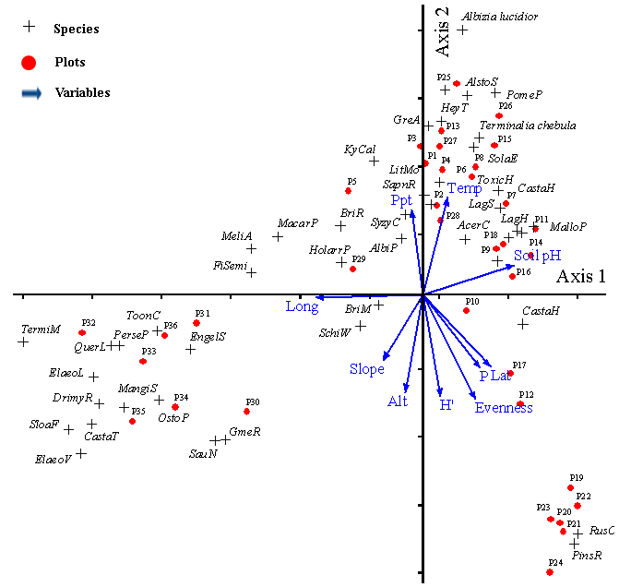
The CCA ordination biplot indicates that the growth and distribution of Terminalia chebula in the study area is influenced by soil pH, rainfall, soil phosphorus, and temperature followed by altitude (Alt) indicating better performance, growth and distribution of the species at warm and lower altitudes. The findings are in line with the study conducted by Singh et al. (2020) in southern India where it reported that the species is seen occurring typically in deciduous forests up to 1450 meters where temperature and precipitation have direct influence on the growth and distribution of T. chebula with variation in temperature and precipitation of 15–37°C and 750–3,250 mm respectively. Furthermore, the study also found that the species is a strong light demander and drought resistant to a considerable extent and adapts well in clayey as well as sandy soils which are in line with the field reality of current study.
Figure 8: Canonical Correspondence Analysis (CCA) ordination biplot showing influence of environmental variables on the growth and distribution of T. chebula

Suitable habitat mapping for the growth and distribution of Terminalia chebula in Bhutan
The environmental factors contributing to the growth and development of Terminalia chebula in the country were actual field data collected from the 36 plots surveyed in three districts. Using reclassifying tool in ArcGIS all the raster data were converted in suitable range favoring the growth of the species.
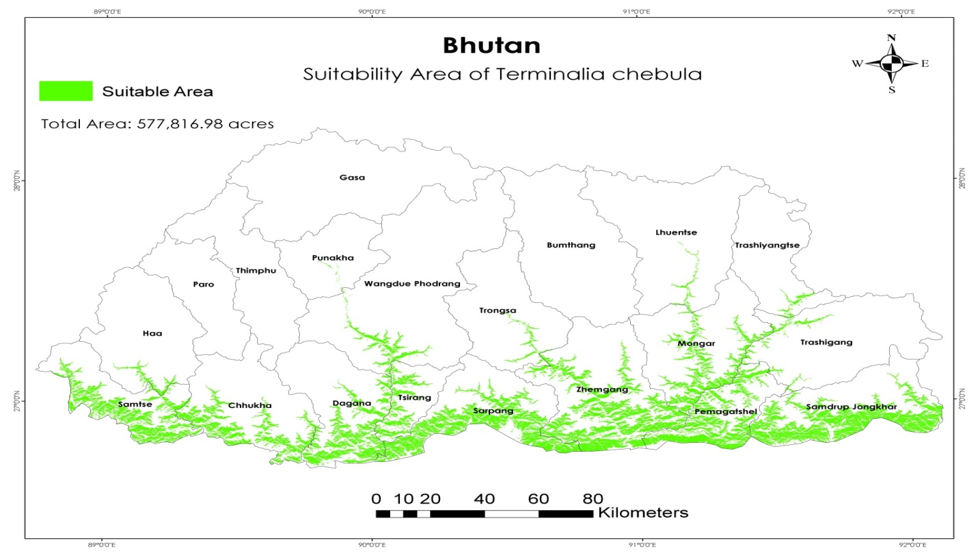
The ArcGIS suitability analysis resulted a total area of 577,816.98 acres (2,338.34 km²) (6.10% of total area of the country) as a potential habitat for the growth and development of T. chebula. The analysis revealed that sixteen districts harbor the suitable habitat for the growth of T. chebula in the country. On the other hands, four districts were completely unsuitable for the growth of species including Bumthang, Gasa, Paro, and Thimphu. Samdrup Jongkhar district has the largest suitable habitat for the growth of T. chebula with total feasible area of 83,345.21 acres (337.29 km²) while Punakha district has the lowest suitable area with just 64.38 acres (0.26 km²).
Figure 9: Suitable habitat of Terminalia chebula in Bhutan

Conclusion
A total of 164 plant species belonging to 61 families were recorded from 36 plots surveyed in three different districts. The understory vegetation was dominated by deciduous shrubs, evergreen shrubs, and perennial herbs. The study revealed that the growth and distribution of Terminalia chebula was predominantly influenced by rainfall, soil pH, soil phosphorus, and temperature. However, the increase in altitude had strong negative influence on the growth and distribution of T. chebula. The species was mostly found growing in areas with high soil phosphorus (P) and preferred slightly acidic soil pH. A total area of 2,338.34 km² in the country was found to be suitable habitat for the growth and development of Terminalia chebula indicating significantly less coverage for the protection and management of the species in near future. The current study could cover only three districts. Further study covering larger area and with more sample size is required. The study needs to consider including different season.
Authors’ contribution statement
Mr. Bir Bdr. Rai and Mr. Ngawang Yonten were involved in developing general idea, study design, data collection, analysis and manuscript drafting. Prof. Dhan Bdr. Gurung (PhD) was also involved in study design while his main contribution was on editing the contents.
Acknowledgement
The authors would like to thank faculty members of Department of Forestry, College of Natural Resources (CNR) for their necessary supervision and assistance. Department of Forests and Park Services (DoFPS) for the timely issuance of research permit to carry out the study without any obligations. We remain indebted to the Chief Forestry Officers of Sarpang Forest Division, Tsirang Forest Division and Dagana Territorial Division for allowing us to collect field data without any obstacles.
Our sincere gratitude to Mr. Tenzin Jamtsho (Forest Ranger, Gelephu Range Office, Sarpang) and Mr. Karna Bdr Ghalley (Forest Ranger, Drujeygang Range Office, Dagana) for their technical and logistic support rendered during the entire period of research data collection.

References
Acharya, A. S., Prakash, A., Saxena, P. & Nigam, A. (2013). Sampling: Why and How of it? Indian Journal of Medical Specialities. 4(2): 330–333.
Aggarwal, A. & Chauhan, S. (2014). Carbon Sequestration and Economic Potential of the Selected Medicinal Tree Species: Evidence from Sikkim, India. Journal of Sustainable Forestry, 33(1), 59–72. https://doi.org/10.1080/10549811.2013.816968.
Ajayi, S. & Obi, R. (2016). Tree species Composition, Structure and Importance Value Index (IVI) of Okwangwo Division, Cross River National Park, Nigeria, International Journal of Science and Research, 5(12), 82–85.
Bag, A., Bhattacharyya, S. K. & Chattopadhyay, R. R. (2013). The development of Terminalia chebula Retz. (Combretaceae) in clinical research. Asian Pacific journal of tropical biomedicine, 3(3), 244–252. https://doi.org/10.1016/S2221-1691(13)60059-3.
Bhattarai, B. P. & Tomar, C. S. (2009). Effect of Integrated Nutrient Management on Leaf Nutrient Status of Terminalia chebula Retz., Nepal Journal of Science and Technology. 10(1): 63–67.
Buckland, S. T., Borchers, D. L., Johnston, A., Henrys, P. A. & Marques, T. A. (2007). Line transect methods for plant surveys. Biometrics, 63(4), 989–998. https://doi.org/10.1111/j.1541-0420.2007.00798.x.
Bulbul, M. R. H., Chowdhury, M. N. U., Naima, T. A., Sami, S. A., Imtiaj, M. S., Huda, N. & Uddin, M. G. (2022). A comprehensive review on the diverse pharmacological perspectives of Terminalia chebula Retz. Heliyon, 8(8), 1–16. https://doi.org/10.1016/j.heliyon.2022.e10220.
Bray R.H & Kurtz L.T. (1945): Determination of total, organic, and available forms of phosphorus in soils, Soil Science, 59, 39–46.
Bremner, J. M. (1960). Determination of nitrogen in soil by the Kjeldahl method. Journal of Agricultural Sciences. 55(1): 11–33.
Claassen, V. P. & Carey, J. L., 2013. Regeneration of Nitrogen Fertility In Disturbed Soils Using Composts. Compost Science & Utilization, 12(2): 145–152.
Clay, D. E., Kitchen, N., Carlson, C. G., Kleinjan, J. L. & Tjentland, W. A. (2002). Collecting Representative Soil Samples for N and P Fertilizer Recommendations, Crop Management, 1(1), 1–5. https://doi.org/10.1094/cm-2002-1216-01-ma.
Dean, W. E. (1974). Determination of carbonate and organic matter in calcareous sediments and sedimentary rocks by loss on ignition: comparison with other methods, Journal or Sedimentary Petrolog, 44(1), 242–248.
DoFPS. (2020). Biodiversity Monitoring and Social Survey Protocol of Bhutan. Thimphu, Bhutan: Nature Conservation Division, Department of Forests and Park Services, Ministry of Agriculture and Forests, Royal Government of Bhutan.
DoFPS. (2023). Phibsoo Wildlife Sanctuary. https://www.dofps.gov.bt/introduction-phibsoo-wildlife-sanctuary/. Accessed 09 October, 2023.
Dorji, U., Olesen, J. E., Bøcher, P. K. & Seidenkrantz, M. S. (2016). Spatial variation of temperature and precipitation in Bhutan and links to vegetation and land cover, Mountain Research and Development, 36(1), 66–79. https://doi.org/10.1659/MRD-JOURNAL-D-15-00020.1.
Fan, C., Dong, Y., Xie, Y., Su, Y., Zhang, X., Leavesley, D. & Upton, Z. (2015). Shikonin reduces TGF-β1-induced collagen production and contraction in hypertrophic scar-derived human skin fibroblasts. International journal of molecular medicine, 36(4), 985-991. https://doi.org/10.3892/ijmm.2015.2299.
FMID. (2023). Land Use and Land Cover of Bhutan, Maps and Statistics. Thimphu, Bhutan: Forest Resources Management Division, Department of Forests & Park Services, Ministry of Agriculture and Forests.
Guariguata, M. R., Chazdon, R. L., Denslow, J. S., Dupuy, J. M. & Anderson, L. (1997). Structure and floristics of secondary and old-growth forest stands in lowland Costa Rica, Plant Ecology. 132: 107–120.
Hossain, M. A., Uddin, M. S., Rahman, M. M. & Shukor, N. A. A. (2013). Enhancing seed germination and seedling growth attributes of a medicinal tree species Terminalia chebula through depulping of fruits and soaking the seeds in water. Journal of Food, Agriculture & Environment, 11(4), 2573–2578.
Kailash, B. R., Charles, B., Ravikanth, G., Setty, S. & Kadirvelu, K. (2022). Identifying the potential global distribution and conservation areas for Terminalia chebula, an important medicinal tree species under changing climate scenario. Tropical Ecology, 63(4), 584–595. https://doi.org/10.1007/s42965-022-00237-x.
Kaka, Gurung, D. B., Yeshey, K., Katel, O., Chhetri, P. B. & Wangda, P. (2014). Population Structure of Cupressus tortulosa Griffith along the Altitudinal Gradients of Tsendenanag Ridge in Punakha, Bhutan, Bhutan Journal of Natural Resources and Development, 1(1), 24–31.
Khalil, E., Sultan, M. T., Khalid, W., Khalid, M. Z., Rahim, M. A., Saleem, S. R., Luca, M.-I., Mironeasa, C., Batariuc, A., Ungureanu-Iuga, M., Coţovanu, I. & Mironeasa, S. (2023). Evaluation of different Terminalia chebula varieties and development of functional muffins. Frontiers in Sustainable Food Systems, 7, 1227851. https://doi.org/10.3389/fsufs.2023.1227851.
Krug, I. & Milliken, W. (2008). Guidelines for Identification & Collection of Medicinal Plants in Bhutan. Ministry of Agriculture.
Kumar, M. (2020). Phytochemical and Pharmacological Profile of Terminalia chebula. International Journal of Pharmacognosy & Chinese Medicine, 4(3), 1–25. https://doi.org/10.23880/ipcm-16000208.
Lhamo, N. & Nebel, S. (2011). Perceptions and attitudes of Bhutanese people on Sowa Rigpa, traditional Bhutanese medicine: a preliminary study from Thimphu. Journal of Ethnobiology and Ethnomedicine, 7, 1–9.
Mapaure, I. (2012). Determinants of vegetation composition and diversity of a moist forest-savanna boundary in south-eastern Zimbabwe. International Journal of Biodiversity and Conservation, 4(14), 584-591.https:/doi.org/10.5897/IJBC12.071.
NHMC. (2020). Bhutan State of the Climate 2020. National Center for Hydrology and Meterology, Royal Government of Bhutan, Thimphu Bhutan, p.38. https://www.nchm.gov.bt/.
Pakale, A. A., TanajiJadhav, P. & Jadhav, P. (2018). Digital pH meter, Journal of Electronic Design Engineering, 4(1), 1–4. https://doi.org/10.1016/s0026-0576(04)90035-9.
Quattrocchi, U. (2012). CRC World Dictionary of Medicinal and Poisonous Plants: Common Names, Scientific Names, Eponyms, Synonyms, and Etymology (5 Volume Set). CRC Press. https://doi.org/10.1201/b16504.
Rabgay, T. (2019). Natural Habitat Assessment of Agarwood (Aquilaria Malaccensis Lamark, 1783) in the tropical forest of Bhutan, Himalaya. (Bachelor's thesis). College of Natural Resources, Royal University of Bhutan, Lobesa, Punakha, Bhutan.
Rabgay, T., Gurung, D.B., Jambay, Wangchuk, K., Thinley, P., Tshering, B., … Raut, N. (2020). Environmental Factors Affecting Growth of Agarwood (Aquilaria malaccensis Lamarck, 1783). Forests of Bhutan, Bhutan Journal of Natural Resources and Development. 7(1), 12–25. https://doi.org/10.17102/cnr.2020.42.
Rao, P., Barik, S. K., Pandey, H. N., & Tripathi, R. S. (1990). Community composition and tree population structure in a sub-tropical broad-leaved forest along a disturbance gradient, Vegetation. 88: 151–162.
RGoB. (2023). Sarpang Dzongkhag Administration. http://www.sarpang.gov.bt/. Accessed 09 October 2023.
RGoB. (2023). Tsirang Dzongkhag Administration. http://www.tsirang.gov.bt/node/1. Accessed 09 October 2023.
RGoB. (2023). Dagana Dzongkhag Administration. http://www.dagana.gov.bt/node/1. Accessed 09 October 2023.
Shakith, M., Chanda, S., Butola, J. S., Vempally, P., Bijlwan, V., Chiluveri, M. & Chandra, M. (2023). Impact of Edaphic Parameters on the Natural Regeneration of Terminalia chebula Retz. across Garhwal Himalaya. International Journal of Plant & Soil Science, 35(19), 1433–1440.
Shalisaheb, T. & Manjula, M. (2023). A study of phytosociological attributes of shrubs plant resources in nallamalais. International Journal of Phytology Research, 3(1), 19–25. Retrieved from https://www.dzarc.com/phytology.
Shrestha, R., Acharya, R. P., Bussmann, R. W. & Paniagua-Zambrana, N. Y. (2021). Terminalia bellirica (Gaertn.) Roxb. Terminalia chebula Retz. Combretaceae. In Ethnobotany of the Himalayas (pp. 1–10). Cham: Springer International Publishing.
Singh, P. & Malhotra, H. (2017). Terminalia chebula: a review pharmacognistic and phytochemical studies. Intern J Recent Sci Res, 8(11), 21496–21507. http://doi.org/10.24327/ijrsr.2017.0811.1085.
Singh, S., Bhatia, A. K., Sharma, K. & Sharma, D. (2020). A Review on Terminalia chebula Retz. (Harar) - An Important Multipurpose Tree. International Journal of Economic Plants, 7(2), 049–052.
Teketay, D. (2005). Seed and regeneration ecology in dry Afromontane forests of Ethiopia: I. Seed production–Population structures, Tropical Ecology. 46(1): 29–44.
Tesfaye, G., Teketay, D., Fetene, M., & Beck, E. (2010). Regeneration of seven indigenous tree species in a dry Afromontane forest, southern Ethiopia, Flora: Morphology, Distribution, Functional Ecology of Plants. 205(2): 135–143. https://doi.org/10.1016/j.flora.2008.12.006.
Thakur, D. S. S. (2016). Ecological variation among natural populations of Terminalia chebula Retz in Sirmour and Una districts, Himachal Pradesh. International Journal of Farm Sciences, 6(1), 140–147.
Tobgay, K. (2013). Structure and Floristic Composition of the Cool broad- Leaved Forest along the altitudinal gradient , Lungchozeykha to Lumitsawa , Western-Central Bhutan. (Dolphin (P.G) Institute of Bio-Medical and Natural Sciences, Dehradun, Uttarkhand,India).
Vahdati, K., Lotfi, N., Kholdebarin, B., Hassani, D., Amiri, R., Mozaffari, M. R. & Leslie, C. (2009). Screening for drought-tolerant Genotypes of Chebulic myrobalan (Terminalia chebula Retz.) during seed Germination, HortScience. 44(7): 1815–1819. https://doi.org/10.21273/hortsci.44.7.1815.
Wangda, P. & Ohsawa, M. (2006). Gradational forest change along the climatically dry valley slopes of Bhutan in the midst of humid eastern Himalaya, Plant Ecology, 186(1), 109–128. https://doi.org/10.1007/s11258-006-9116-5.
Xue, G., Wu, J., Zhou, B., Zhu, X., Zeng, J., Ma, Y., ... & Jia, H. (2023). Effects of Shading on the Growth and Photosynthetic Fluorescence Characteristics of Castanopsis hystrix Seedlings of Top Community-Building Species in Southern Subtropical China. Forests, 14(8), 1659.

